A FRAMEWORK TOWARDS THE DEVELOPMENT OF AN AUTOMATED ATTENDANCE MANAGEMENT SYSTEM USING FACENET

BY

FADUMO, ADEMOLA OLUWASEUN

16010301021

A PROJECT SUBMITTED IN PARTIAL FULFILLMENT OF THE REQUIREMENT FOR A BACHELOR OF SCIENCE DEGREE (B.Sc. Hons.) IN THE DEPARTMENT OF COMPUTER AND MATHEMATICS AT THE COLLEGE OF BASIC AND APPLIED SCIENCES, MOUNTAIN TOP UNIVERSITY, MFM PRAYER CITY, OGUN STATE.

NOVEMBER 2020

CERTIFICATION
This Project titled A FRAMEWORK TOWARDS THE DESIGN AND IMPLEMENTATION OF AN AUTOMATED ATTENDANCE MANAGEMENT SYSTEM USING FACENET, prepared and submitted by FADUMO, ADEMOLA OLUWASEUN in partial fulfilment of the requirements of the degree of BACHELOR OF SCIENCE (Computer Science), is hereby accepted
__________________________ (Signature and Date)
DR. I. O. AKINYEMI
Supervisor

__________________________ (Signature and Date)
DR. I. O. AKINYEMI
Head of Department

Accepted as partial fulfilment of the requirements for the degree of BACHELOR OF SCIENCE (Computer Science)
______________________ (Signature and Date)
Prof A.I. Akinwande
Dean, College of Basic and Applied Sciences

DEDICATION
This project is dedicated to Almighty God for helping me reach a successful completion of this work.

ACKNOWLEDGEMENTS
I wish to express my profound gratitude to those who contributed to my Parents Mr. Fadumo and Mrs. Fadumo for their encouragement and his advice, may God bless you.
An exceptional gratitude goes to our supervisor in the person Dr I.O. Akinyemi who was always there for us in time of assistance and advice to make this project a successful one.
I also extended my gratitude to our good. H.O.D of computer science department in the person of Dr I.O. Akinyemi and other lecturers, Dr Alaba O. B., Dr (Mrs.) Kasali F.A., Mr. Balogun ., Dr Idowu P.A., Dr (Mrs.) Oladejo F.A., Mr. Ebo I.O, in this department and we pray to God to see them through and I wish to send my regards to my sibling, Debo, to you all I say remain bless.
I will not forget my good friends, well-wishers and loved ones that in one way or the other contributed immensely to success of these projects, I ask almighty God to bless you all Amen.
Finally, I am loyal to the great and everlasting Father in Heaven who has been so faithful and kind in all ramifications of my life and my days in these schools in partial fulfilment of my Bachelor Degree Award. I say may His name alone be exalted. Amen.

TABLE OF CONTENTS
CERTIFICATION ii
DEDICATION iii
ACKNOWLEDGEMENT iv
TABLE OF CONTENTS v
ABSTRACT ix
LIST OF TABLES x
LIST OF FIGURES xi
CHAPTER ONE 1
INTRODUCTION 1
1.1 Background to the Study 1
1.2 Statement of the Problem 2
1.3 Aim and Objectives of the Study 2
1.4 Significance of the Study 3
1.5 Scope of the Study 3
1.6 Definition of Terms 3
CHAPTER TWO 5
LITERATURE REVIEW 5
2.0 Introduction 5
2.1 Conceptual Review 6
2.1.1 Biometrics 6
2.1.2 Face Detection and Recognition 6
2.1.3 Computer Vision 7
2.1.4 FaceNet 8
2.1.5 Integral Image 10
2.1.6 Feature Extraction 12
2.1.7 Automated Attendance System 12
2.2 Theoretical Review 13
2.3 Review of Related Works 14
2.4 Summary of the Literatures Reviewed 16
CHAPTER THREE 19
METHODOLOGY 19
3.0 Introduction 19
3.1 Flowchart of the Automated Attendance Management System 19
3.1.1 Input Images 21
3.1.2 Limitations of the images 21
3.1.3 Pre-processing 22
3.1.4 Feature Extraction 22
3.1.5 Feature Classification 23
3.2 FaceNet Method 23
3.3 Triplet Loss 24
3.4 MTCNN 27
3.4.1 Block Diagram of the proposed system 27
3.5 Use Case Diagram 29
3.5.1 Admin Use Case 29
3.5.2 Lecturer Use Case 29
3.6 Activity Diagram 32
3.6.1 Register Student Activity Diagram 32
3.6.2 Register Lecturer Activity Diagram 34
3.6.3 Register Admin Activity Diagram 36
3.6.4 Take and Record Attendance Activity Diagram 38
3.7 Design Detail of Automated Attendance Management System 40
3.7.1 E-R Diagram 40
3.7.2 Method of Data Collection 42
3.7.3 Secondary Source 42
CHAPTER FOUR 42
IMPLEMENTATION AND RESULT 42
4.0 Introduction and documentation 43
4.1 Implementation 43
4.2 How the Automated Attendance Management System works 44
4.2.1 Functional Requirements 44
4.2.2 Non-Functional Requirements 44
4.3 System Requirements 45
4.3.1 Software Requirements 45
4.3.2 Hardware Requirements 45
4.4 Screenshot of the pages Implemented 46
4.4.1 Authentication Pages 46
CHAPTER FIVE 53
SUMMARY, CONCLUSION AND RECOMMENDATIONS 53
5.0 Summary 53
5.1 Contribution to Knowledge 53
5.2 Limitations 54
5.3 Recommendations for Further Study 54
5.4 Conclusion 55
REFERENCES 56
APPENDIX 60
SOURCE CODE 60

ABSTRACT
This project is based on the Design and Implementation of an Automated Attendance Management System. The purpose of the proposed project is to rid the attendance management system of the manual process therefore instilling reliability and efficiency to the system with the use of Face Recognition algorithms, techniques and other programming techniques to build a software for this system. The use of FaceNet as face detection algorithm and SVM classifier was critical to the functioning of the system. In this project and previously done projects many face detection methods have been used such as Haar-cascade, Histogram of Oriented Gradients, CNN and so on.
MTCNN is one of the most accurate face detection methods used with FaceNet Keras method provides better results in computation and detection of faces. It detects faces across multiple variations and scales.
This project work was built using Django framework which is a python-based framework for the quick deployment of web applications. The use of python libraries such as TensorFlow, Sci-Kit learn, Keras and others made it possible for the system to run more efficiently and accurately as these libraries were built majorly for machine learning purposes.
The Automated Attendance Management System is a far more efficient and quicker way of taking attendances a in classroom.

LIST OF TABLES
Table Page
2.1 Summary of Literatures Reviewed 12
2.1 Summary of Literatures Reviewed 13
2.1 Summary of Literatures Reviewed 14

LIST OF FIGURES
Figure Page
2.1 FaceNet Overall Architecture Block Diagram 9
2.2 Integral image 10 3.1 Flow of the Proposed Approach 20
3.2 Triplet loss 25
3.3 Triplet loss formula 26
3.4 Block Diagram of the System 28
3.5 Admin Use Case 30
3.6 Lecturer Use Case 31
3.7 Register Student Activity Diagram 34
3.8 Register Lecturer Activity Diagram 35
3.9 Register Admin Activity Diagram 37
3.10 Take and Record Attendance Activity Diagram 39
3.11 Model E-R Diagram 41
4.1 Sign Up Page 48
4.2 Login Page 49
4.3 Main Dashboard Page 50

4.4 Take Attendance Page 51
4.5 Register Student Page 52

CHAPTER ONE

INTRODUCTION

1.1 Background to the Study
In the educational system, a lot of processes come into play when student’s academic performance is to be graded. A part of this academic performance grading is on the student’s attendance in class. One of the actors in the attendance grading is the lecturer, who ensures the attendance of students is properly marked, though it wastes time and slows down the teaching process. This becomes more difficult when there are numerous amounts of students in the class, hence attendance marking becomes less effective and accurate. Automating attendance system eradicates the conventional recording of student attendance for example inspecting identification cards, calling out the names of the students, which would interfere with the teaching process and also be disruptive to students during the examination session (Shehu & Dika, 2010).
For many schools and organisations, attendance is a very important requirement and is used to test the performance of students or employees. In this respect, every institution has its own system in taking attendance of their students and employees either by the manual paper and file-based approach or automated attendance approaches. Traditionally, attendances of students are recorded physically using the attendance sheet provided a classroom by lecturers, a procedure that takes time. It is also very difficult to check, in a broad classroom setting, whether or not authenticated students are actively answering. The ability to take proper attendance is a big challenge, because the manual process creates errors and therefore consumes time. The solution required would be an automated attendance management system (Rekha & Chethan, 2014)

1.2 Statement of the Problem
In a number of universities, this Manual attendance system (MAS) is most times unreliable and inefficient.
The grading of student’s performance on attendance is vital and this can be inefficient and unreliable due to the common unautomated attendance system.
This project work is introducing a more efficient way to automate the attendance marking system, with no interference of the teaching process. This system can also be used in examination sittings or other events in which attendance will be necessary.

1.3 Aim and Objectives of the Study
This project work is to efficiently mark student’s attendance with a facial recognition system, with specific objectives below;
- To build an electronic student attendance system via face recognition algorithms and deep learning.
- Students faces are accurately detected and captured by comparing with a stored and identified student image database.
- Implementing and test the system in a live environment with a high-resolution camera with students in a class room.
- To test the system with students in a class room.

1.4 Significance of the Study
This project is being created to propose a new automated attendance management system with facial recognition and computer vision techniques. A database that records all student’s attendance efficiently and reliably without interference with the teaching process.

1.5 Scope of the Study
This project work surrounds the solution to the problems of student attendance marking in the educational sector.

1.6 Definition of Terms

FaceNet – is a face detection method used to better detect and draw out faces in an image with the use of improved neural network algorithms known as MTCNN.
Face detection – faces in images are detected by use of numerous applications developed and improved over the years.
Face recognition – is a technology capable of identifying or verifying a person from digital image or a video frame from a video source.
Computer Vision – is a field of artificial intelligence that trains computers to interpret and understand the visual world.
Deep learning – A broader part of machine learning methods based on artificial neural networks with representation learning. Learning could be supervised, semi supervised or unsupervised.
Machine learning – is the use of artificial intelligence (AI) that allows systems the ability to learn and develop automatically from experience without being directly programmed.
Database – is an organized collection of data, generally stored and accessed electronically from a computer system.
OPENCV – it is an open source computer vision and a machine learning applications library.

CHAPTER TWO

LITERATURE REVIEW

2.0 Introduction
In educational institutions, a minimum percentage of class attendance is necessary and this approach has not been followed because of the numerous difficulties posed by the new system of attendance. This typical approach includes the use of paper sheets or books for student attendance. This approach could easily encourage impersonation, and the attendance sheet could be stolen or destroyed. Taking part is time-consuming and it is difficult to assess the number of students who have made the minimum percentage and are also qualifying for the test. There is also a need for a framework that will remove all of these trouble points. A biometric automated attendance control system will have the appropriate solution. (Shoewu & Idowu, 2012).

2.1 Conceptual Review

2.1.1 Biometrics
Techopedia (2018) defines biometric system as a technological system that uses
information about a person to identify that person. Biometric systems rely on specific
data about unique biological traits in order to work effectively. A biometric system will
involve running data through algorithms for a particular result, usually related to a
positive identification of a user or other individual. There are different types of biometric
systems from fingerprint, iris, vein, palm, voice, signature, and face recognition.

2.1.2 Face Detection & Recognition
Difference between face detection and recognition are often misunderstood. Face
detection is to determine only the face segment or face region from image, whereas
face recognition is to identify the owner of the facial image. S. Aanjanadevi et al. (2017)
and Wei-Lun Chao (2007) presented a few factors which cause face detection and face
recognition to encounter difficulties.
Other researchers have worked on few face detection methods. However, most of them used the images consisting of frontal faces because of its high accuracy level. The face region is completely exposed without any interference making it easy to detect and recognize.
Akshara Jadhav et al. (2017) & P. Arun Mozhi Devan et al. (2017) stated the use of the Viola-Jones algorithm in their paper for facial detection “Face detection for student attendance system”. They found that in various lighting situations, the Viola-Jones algorithm is very efficient and easy to execute. In addition to the Viola-Jones algorithm, Varsha Gupta and Dipesh Sharma (2014) studied Local Binary Pattern (LBP), Adaboost algorithm, Local Successive Mean Quantization Transform (SMQT) Functions and Face Detection Methods for Neural Network. They concluded that the Viola-Jones algorithm has the fastest accuracy of all the methods.

2.1.3 Computer Vision
The aim of computer vision is to collect information about a scene by analyzing images of that scene. Multidisciplinary area dealing with how computers can be built to obtain a strong understanding of digital images or photos. Computer vision is an artificial intelligence field that works to allow computers to perceive, recognize, and interpret images in the same manner as human vision does, and then produce the correct result. Applications of computer vision include Automotive, Healthcare, Robotics, Security and Remote Sensing (Rosenfeld, 2015).
Computer vision includes many fields such as image restoration, 3D scene modeling, Object-recognition, Video tracking, Event detection. This project is focusing on object detection with respect to face detection and recognition. Human beings have the ability to process visual information either by extracting meaningful features such as shapes, line-segments, boundaries, shadows and so on. Computers cannot detect these kinds of features as humans do because they cannot see in the literal sense. The most important aspect to computer vision is images and videos, which is simply a combination of different images. In order for a computer to “see”, it processes images as a combination of 0s and 1s known as pixels.
When digital images are taken, they are stored as a combination of pixels. An image in grayscale (black and white) contains only one channel, which has a value between 0 and 255. An image that is colored contains pixels with three channels (Red Green and Blue) each of them with values between 0 and 255. This is how a computer understands and image. When it comes to the computer describing what is in the image, identifying and object or person in the image, or describing in detail what the image is about or what it contains. This is where machine learning algorithms, object detection algorithms come in.

2.1.4 FaceNet
FaceNet was created by Google researchers to efficiently overcome the challenges to face recognition and verification and is a highly evolutive neural network. The FaceNet algorithm turns the face image into a Euclidean, 128-dimensional space equivalent to the integration of work. The model FaceNet is designed to catch triplet loss in the image data set given by similarities and variations. The 128-dimensional embeddings, provided by the model, could be used for a very efficient and accurate clustering of the faces. (Edwin et al. 2019).

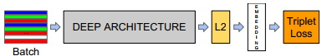
Figure 2.1 FaceNet Overall Architecture Block Diagram (Ivan et al., 2020)

2.1.5 Integral Image
The integral image is a method of calculating the Haar-like features on an image at any scale or location in constant time. Since Haar-like features are rectangles a single value result, which representing each feature can be computed by subtracting the sum of the white rectangle(s) from the black rectangle(s) (Mekha Joseph et al., 2016). The illustration is shown in Figure 2.2.

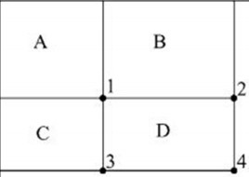
Figure 2.2 Integral image (P. Viola, M. Jones, 2001)

The features can be computed rapidly by using the integral image. The value of integrating image in a location is the sum of the pixels on the left and top of the respective location. To further illustrate, the value of the integral image at location 1 is the sum of the pixels in rectangle A. The values of integral image at the rest of the locations are cumulative. For instance, the value at location 2 is summation of A and B, (A + B), at location 3 is summation of A and C, (A + C), and at location 4 is summation of all the regions, (A + B + C + D). P. Viola, M. Jones, (2001). This means that the sum within the D region can be computed with only addition and subtraction of diagonal at location 4 + 1 − (2 + 3) to eliminate rectangles A, B and C.

2.1.6 Feature Extraction
The feature is a set of data that represents the information in an image. Extraction of
facial feature is most essential for face recognition. However, selection of features
could be an arduous task. Feature extraction algorithm has to be consistent and stable
over a variety of changes in order to give high accuracy result.
The Region of Interest (ROI) are parts of the face from where features are extracted. Information about the gradients in the face is captured. The image of a person’s face is divided cells comprising of 8 pixels. Each pixel present has a gradient and compares itself with its neighbor pixels. Rajath et al., (2019).

2.1.7 Automated Attendance System
An attendance management system is a technology developed for day-to-day student attendance in schools and institutions. It facilitates access to the participation of a particular student in a particular class. The system would also help to generate reports and determine the student's eligibility for attendance. (Shoewu & Idowu, 2012).
Facial recognition in an automated attendance program eliminates physical interaction with a person who takes part, unlike RFID (Radio Frequency Identification), which also allows an individual's identification card to be checked one at a time, and this time is often inefficient. This issue also affects the identification of fingerprints where the individual's prints are scanned and then registered in a database. It still needs the physical contact of the participant, and every time the attendance is taken, it will be finished. This will also be difficult given the large number of students in the classroom.

2.2 Theoretical Review
Rajath et al., (2019), based on the introduction of an automated attendance program using facial recognition in educational institutions, where student attendance was taken manually by calling the student's names to test who is present and who is not. This approach is referred to as the roll call process which is time-consuming and unreliable.
Adding facial recognition to the attendance process can improve time efficiency and provide a hassle-free way of marking attendance. Their system proposed to outgrow the constraints of existing systems and provide features such as detection of faces, extraction of features, detection of extracted features and analysis of the attendance of students.
Sajid et al. (2014), The use of real time face recognition is done once the image is captured and stored in a database. These images are then matched with the already stored images in the database to mark the attendance using some statistical techniques such as that of Principal Component Analysis (PCA), Linear Discriminant Analysis (LDA) and Local Binary Algorithm (LBA). A web camera and a database are critical in the development of the system.
Varadharajan et al. (2016), Face-recognition technology has also been listed in their study. During this method, a camera was installed in the classroom to take images. If the faces in the database are detected and recognised, participation would be marked as present. When the attendance is found to be unavailable, a letter of absence from the student may be sent to their guardians.
According to Kennedy et al. (2017), Universities place great emphasis on class attendance and it is so important that students who fail to meet the cut off mark or percentage for that class attendance is not allowed to take the examination therefore an automated attendance system (AAS).
Attendance is perceived to be a significant factor for both the student and the instructor of the educational organization. Through the development of deep learning technologies, the computer automatically senses the student attendance results and keeps track of the data obtained (Nandhini et al., 2019)
In the study of Jadhav et al. (2017), they developed an automatic attendance management system using facial recognition technology. This system recognizes students immediately as soon as they enter the classroom, and marks the attendance by identifying the face. These faces are matched with an existing authenticated student image database.

2.3 Review of Related Works
Sajid et al. 2014, The attendance marking in a classroom during a lecture is not only burdensome, but also time-consuming. Owing to the usual large number of students present in the lecture hall, there is also a possibility of proxy involvement. It is extremely difficult for lecturers to manually identify students who sometimes skip their lectures. In recent years, attendance management by students using conventional methods has been a challenge.
Automated attendance management systems have made a number of improvements in the changing world. Smart Attendance using Real-Time Face Recognition is a real-world solution that includes day-to-day student attendance control of the system. Face recognition-based attendance system is a method of identifying students' faces for attendance with the use of high-definition video monitors and other face biometry based on information technology. In this face-recognition project, a computer system will be able to easily and accurately find and recognize human faces in photos or videos taken by a surveillance camera. Numerous algorithms and methods have been developed to increase the performance of facial recognition, but Deep Learning is the concept to be applied here. This helps to convert the video frames into images so that the student's face can be easily recognized for their attendance, so that the attendance record can be easily mirrored automatically. (Nandhini et al., 2019).
Shehu & Dika, 2010, It is proposed to develop a system for attendance management using biometrics. Regulation of student attendance during lecture periods has become a challenging task. Since the manual calculation causes mistakes and therefore takes a lot of time, the ability to calculate the percentage of attendance is a major challenge. An efficient framework for the management of attendances using biometrics is planned for the reasons specified. With the aid of a finger printing unit, the machine collects attendance electronically and attendance records are stored in a database. Attendance after recognition of the student is suggested.

2.4 Summary of the Literatures Reviewed

S/No. | Author(s) | Title of Paper | Problem Statement | Algorithm used | Results | Contribution | Limitation
1. | A L, Rekha & H K, Chethan | Automated Attendance System Using Face Recognition Through Video Surveillance. | Increasing the efficiency of existing attendance management systems and replacing the old manual method. | Holistic Matching Methods – Correlation Technique | The system solved the problems associated with the existing manual system. | Developing an efficient and reliable attendance management system. | The facial recognition system anti-proxy process wasn’t included.
2. | Nandhini, R., Duraimurugan, N., Chokkalingam S.P. | Face Recognition Based  Attendance System. | The use of a machine to increase the speed of identifying faces in images or videos. | Holistic Matching Methods – CNN. | The system was able to convert video captured to images and detect faces. | A more reliable face detection, recognition and database with validation to remove proxies. | Poor lightning affect image quality which indirectly degrades system performance.
3. | S., Sawhney, K., Kacker, S., Jain, S., Narayan Singh, R., Garg. | Real-Time Smart Attendance System using Face Recognition Techniques. | The use of Face recognition as a biometric solution to eliminate proxy attendance by students. | Holistic Matching Methods – Eigenfaces, PCA and CNN. | The system was able to improve existing face recognition algorithms and check for proxy attendances. | A second camera is installed inside the classroom to help cancel out the proxies. | This will require two High definition cameras and it will be more expensive.
4. | V., Shehu & A., Dika. | Using Real Time Computer Vision Algorithms in Automatic Attendance Management Systems. | a) Non-intrusive attendance management system.  b) Less time consuming than traditional methods. | Holistic Matching Methods – Eigenfaces. | The system was able to counter the issue of unidentified faces caused by limitations of face recognition algorithm used. | The face recognition algorithm required manual check for unidentified faces. | Fixed placement of the student if the student exchanges the seat, easily able to mark proxy attendance.
5. | S., HariPrasath, S., Bharathan, T., Bharathi Raja, V., Gopinath, R., Kishore. | Automated Attendance Entry System by Detection and Recognition of the Face using OpenCV. | Improving the automated attendance systems with the use of better algorithms for identifying faces properly. | Feature-based (Structural) Methods – Haar-cascade and LBPH techniques. | The system was able to identify faces better eliminating appearance related issues. | Providing a more efficient automated attendance system through better facial detection. | There was no check (validation) for proxies in the attendance management system.
6. | Sajid, M., Hussain, R., Usman, M. (2014). | A Conceptual Model for Automated Attendance  Marking System using Facial Recognition. | The reliability lacked by other automated attendance system which is validation to remove proxies. | Hybrid Methods (Holistic & Feature-based) – PCA, LDA, LBA and Facial Fiducial Points technique. | The system solved the issue of validation and verification in previously existing attendance systems. | Validation and verification were done by taking the attendance more than once throughout the class to remove proxies. | The systems processes of taking attendance more than once will cause resources to be used more and costs more.

Table 2.1: Summary of Literatures Reviewed

CHAPTER THREE

METHODOLOGY

3.0 Introduction
The methodology flow begins with the capture of image by using simple and handy interface, followed by pre processing of the captured facial images, then feature extraction from the facial images, subjective selection and lastly classification of the facial images to be recognized.

3.1 Flowchart of the Automated Attendance Management System
The flowchart for the proposed system, shown in Figure 3.1.

Figure 3.1 Flow of the Proposed Approach

3.1.1 Input Images
Images provided into the system consists of different variations of students faces which include change in lightning conditions, facial hair, facial accessories such as glasses or masks and other features a human face may possess to optimize and increase the accuracy of the model.
The database consists of both training set and testing set images to assess the performance and increase accuracy of model being trained. For our own database, images of students are captured using pc built-in web camera.
While our own database can be used to build a framework for student identification in real-time, the datasets presented by previous researchers can offer a more reliable, efficient and evaluative design of the system.

3.1.2 Limitations of the images
The input images for the proposed approach has to be multiple frontal faces with different lightning conditions to train the model but doesn’t require too many images. Students who use glasses or have other facial features have to provide images for all these to increase the accuracy of the model. Images used for training and testing should be from the same capturing device to remove quality difference. All students have to enrol and captured in order to be recognized.

3.1.3 Pre-processing
Images used for training and testing are captures using a camera. There are obstructions and lightning conditions that affect face detection which makes face recognition impossible. Therefore, multiple pre-processing steps are very important before proceeding to feature extraction.
Pre-processing steps include aligning of images which involves cropping and size reduction, conversion of colour images to grayscale images for face detection.

3.1.4 Feature Extraction
Feature extraction is the most significant and rudimentary stage in initialisation for face recognition. There are two approaches in this stage, they are;
- Shallow Approach
- Deep Approach
This proposed system uses Deep approach for feature extraction. In the Deep approach we have VGG, Face Recognition API and FaceNet Keras methods. FaceNet Keras is a one-shot learning model. It obtains embeddings from images as 128-vector as a feature extractor. It works well when there’s a scarcity of datasets with good accuracy.

3.1.5 Feature Classification
The proposed system uses a classification by SVM (Support Vector Machine) which separates the classes from extracted feature through FaceNet’s face detection algorithm by calculating the distance. Sklearn is used to implement the SVM algorithm in a fast, easy to achieve task and majorly used for multi-class classification difficulties from large datasets. (Nyein & Nway, 2019).

3.2 FaceNet Method
The proposed system face alignment is based on the algorithm proposed in. There are 68 landmark points on the face and the image is rotated and scaled to match the face. The aligned faces would be saved in a folder. Third, face encoding, facial recognition study concludes that the use of an artificial neural network for facial recognition has very good precision. Face encoding is done on the basis of the FaceNet algorithm. The FaceNet algorithm is best of all the CNN (Convolutional Neural Network) algorithms. Aligned faces are given as input to the FaceNet and generate unique 128-dimensional embedding for each face image. Fourth, train the classifier, the SVM classifier is trained with a 128-dimensional embedding generated in the previous stage for classifying students (Ivan et al., 2020).

3.3 Triplet Loss
This is a loss function in which the distance between an anchor image and positive image is decreased, this indicates the image are of the same identity and increases the distance between the anchor image and negative image which indicates they are of a different identity. (Schroff et al. 2015).

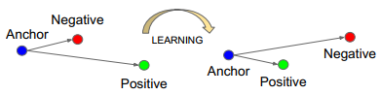
Figure 3.2: Triplet loss, (Schroff et al. 2015).

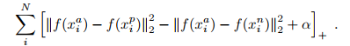
Figure 3.3: Triplet loss Formula, (Schroff et al. 2015).

3.4 MTCNN
The MTCNN algorithm for facial and face characterizations is in three steps and uses one neural network for every phase. This algorithm senses face and side characteristics. The initial component of the analysis was a proposal network which would estimate the possible location of the face and their boundary boxes in the same manner as an attention network in Faster R-CNN. The second component uses images and outputs from the first forecast to optimize the outcome so that the bulk of false detection and bounding boxes are removed. The last section refines the forecasts even further and provides the initial MTCNN implementation predictions of the face landmarks. (Edwin et al. 2019).

3.4.1 Block Diagram of the proposed system
The following processes includes OpenCV reading frames, MTCNN face identification, Siamese network face embedding, and FaceNet algorithm Recognition using FaceNet, saving the recognised face for examination and tracking intrusive alert. Real time face detection & recognition is achieved. In order to find out the proxy presence, the detected face is exported to Excel, along with the local ID of the position of the target person. The target position is linked to or located at the camera ID (Edwin et al. 2019).

Figure 3.4 Block Diagram of the System, Edwin et al. (2019).

3.5 Use Case Diagram
A UML case diagram for use of a new software application underdeveloped is the key type of system / software necessity. Use cases to determine what action is anticipated and not how to do it. A core principle of case modeling is that it lets one build a system with an eye to the end user. It is an efficient way to express system actions in the user's words with all system behavior that is apparent externally (Visual Paradigm, 2020).

3.5.1 Admin Use Case
The admin shall be able to login to the system, view and interact with what the system has to offer. Admins shall be able to manage lecturers, manage students, manage attendance, update database, edit profile and other admin privileged features.

3.5.2 Lecturer Use Case
The Lecturer shall be able to sign up for the system, then login to the system, view and interact with what the system has to offer. Lecturers shall also be able to manage students and manage attendance.

Figure 3.5: Admin Use Case

Figure 3.6: Lecturer Use Case

3.6 Activity Diagram
The fundamental principle of activity diagrams is used to represent the movement from one activity to another. These events are used to define the function of the machine. They catch the complex actions of the machine. They are not only used to simulate the complex design of the system, but also to build the executable system using forward and reverse engineering. (Tutorialspoint, 2020).

3.6.1 Register Student Activity Diagram
The diagram shows activities involved in registering students in the system, Figure
Figure 3.7: Register Student Activity Diagram

3.6.2 Register Lecturer Activity Diagram
The diagram shows activities involved in registering lecturers in the system, Figure

Figure 3.8: Register Lecturer Activity Diagram

3.6.3 Register Admin Activity Diagram
The diagram shows activities involved in registering admins in the system, Figure

Figure 3.9: Register Admin Activity Diagram

3.6.4 Take and Record Attendance Activity Diagram
The diagram shows activities involved in taking and recording attendance in the system, Figure

Figure 3.10: Take and Record Attendance Activity Diagram

3.7 Design Detail of Automated Attendance Management System
The automated attendance management system was developed on Django framework. Django is a python web framework used to create and efficiently run a good web application. This framework uses an architectural pattern called MVC which separates the Model (data), the View (user interface) and the Controller (application logic) from each other. This creates clean code and gives a better foundation for developers looking to improve on the system. (Techopedia, 2020)

3.7.1 E-R Diagram
The entity relationship diagram, also known as the ERD, ER model or ER diagram, is a type of structural diagram for use in database design. The ERD includes various symbols and connectors that visualize two essential information: the main entities within the framework of the scheme, and the inter-relationships between those entities (Tutorialspoint, 2020).

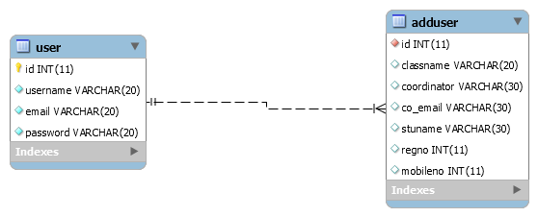
Figure 3.11: Model E-R Diagram

3.7.2 Method of Data Collection
The method of data collection used for this project work are from secondary sources only.

3.7.3 Secondary Source
This includes the use of journals, internet and books with related articles on attendance management system to enlighten my understanding in developing the system.

CHAPTER FOUR

IMPLEMENTATION AND RESULT

4.0 Introduction and documentation
This chapter demonstrates the information of implementing an automated attendance management system. Designing and implementing an automated attendance management system considers some aspect which attempt to provide alternatives to the issues recognized and indicated in attendance management systems. It describes the tools used in developing and implementing the system. These tools assisted in system design and development of the system’s primary idea and functionality to accomplish its defined mission.
It describes a variety of functionalities step beneath every module with their outputs. The entire notion is a system. Which are set of things working together as components of a mechanism or an interconnecting system, which are set of matters working collectively as parts of mechanisms or an interconnecting system, it is a set of interacting or interdependent issue forming a set of elements to other elements.

4.1 Implementation
The system was built using Django framework. The implementation was divided into three main parts which are frontend, backend and database. The frontend was built using HTML, CSS and Bootstrap. The frontend files were stored in the templates folder in root SRC. The backend was built using Django which is a python framework. SQLite database was used for the implementation of the system in which the database codes were stored in models.py file of the framework.

4.2 How the Automated Attendance Management System works
The application works based on the functional and non-functional requirements. This application includes the core phases of software development life cycle.

4.2.1 Functional Requirements
This section describes the system’s anticipated features. To execute a number of high-level tasks. For the planned use of this application, the following specifications are expected.
- Registration: All users of the system can successfully register on the system by filling in their details.
- User Management: Modify rights, creating user ids, adding/deleting existing users.
- Attendance: Lecturers can take attendance for any class they are teaching.
- Attendance Reports: Admins and Lecturers can obtain attendance reports of students as needed.

4.2.2 Non-Functional Requirements
This deals with the characteristics of the system, which cannot be expressed as functions.
- Security: Access permissions for users are only granted when the email matches with password.
- Reliability: The database update process must rollback all related updates when any update process fails.
- Performance: The system performs best based on the system specifications provided.

4.3 System Requirements
For the efficient use of the system, certain hardware components and software components must be present on the system. The system requirement is made up of the software and hardware parts that makes the system to developed effectively.

4.3.1 Software Requirements
One of the key elements in building a system is the section of compatible software. The following software are recommended for the successful implementation of the system.
Front-end technologies: HTML, CSS, Bootstrap
Backend technologies: Python, Django Framework, TensorFlow
Database Management System: SQLite
Local Server: Django
IDE: IntelliJ PyCharm
Face-Recognition System: FaceNet
Libraries Used: NumPy, PIL, MTCNN, Sklearn, Keras

4.3.2 Hardware Requirements
Hardware specification is an important aspect to bear in mind when designing a system.
The proposed system requires a CUDA graphics processing unit and sufficient random-access memory to allow the system perform close to its specified benchmark. The processor should be powerful enough to handle the entire operations and also have sufficient hard disk drive availability to store files and applications required for the system to run.
Processor: Pentium (Minimum)
Processor speed: 2.3 GHz (Minimum)
GPU: CUDA Nvidia
RAM: 4GB (Minimum)
GPU RAM: 2GB (Minimum)
Hard disk: 50GB (Minimum)
Monitor Display: LED
Mouse: USB or PS/2

4.4 Screenshot of the pages Implemented
The screenshots of the implemented pages show the different views of the users depending on their roles with a brief description of what it entails. It consists of the Authentication Pages, Main Dashboard, Take Attendance Page, Register Student Page.

4.4.1 Authentication Pages
The authentication pages consist of both the signup and login page

- Signup Page
The sign-up form is used to register the credential of users before granting them access to their rights. The registration form includes a name, username, password and position area.
- Login Page
The login form is used to authenticate users’ credentials before giving them access to their privileges. The login form contains a field for the email and another for the password.
- Main Dashboard
This page contains the buttons that navigate to “Add New Class” and “Take attendance” pages. This is the first page the user sees before accessing any other page.
- Take Attendance Page
This page contains the buttons used to initiate the recognition phase and take attendance of students available in the classroom.
- Register Student Page
This page includes forms used to register students for a class before taking attendance. It contains name of the student, matric no., parents no. and other information required.

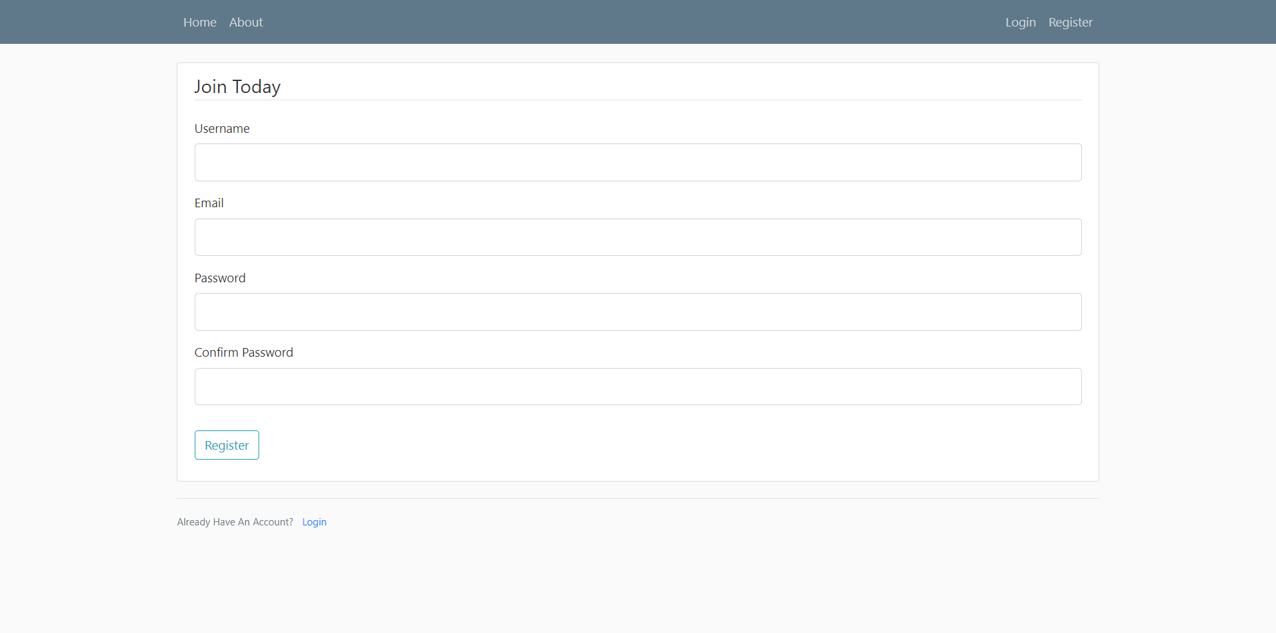
Figure 4.1: Sign Up Page

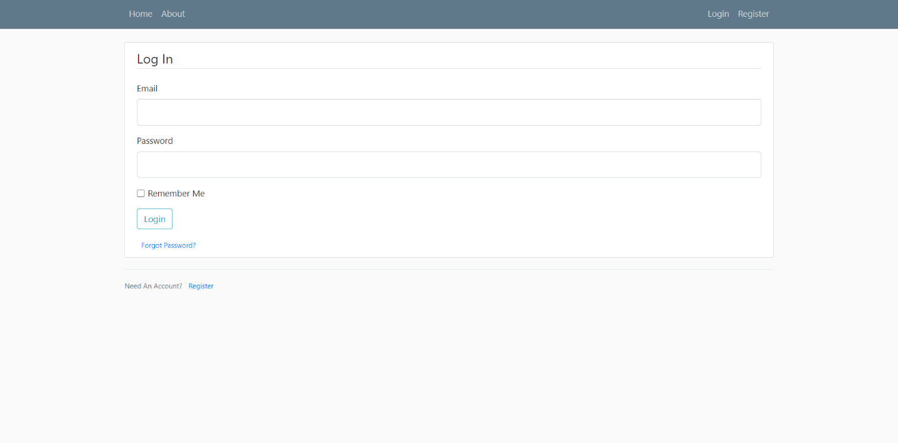
Figure 4.2: Login Page

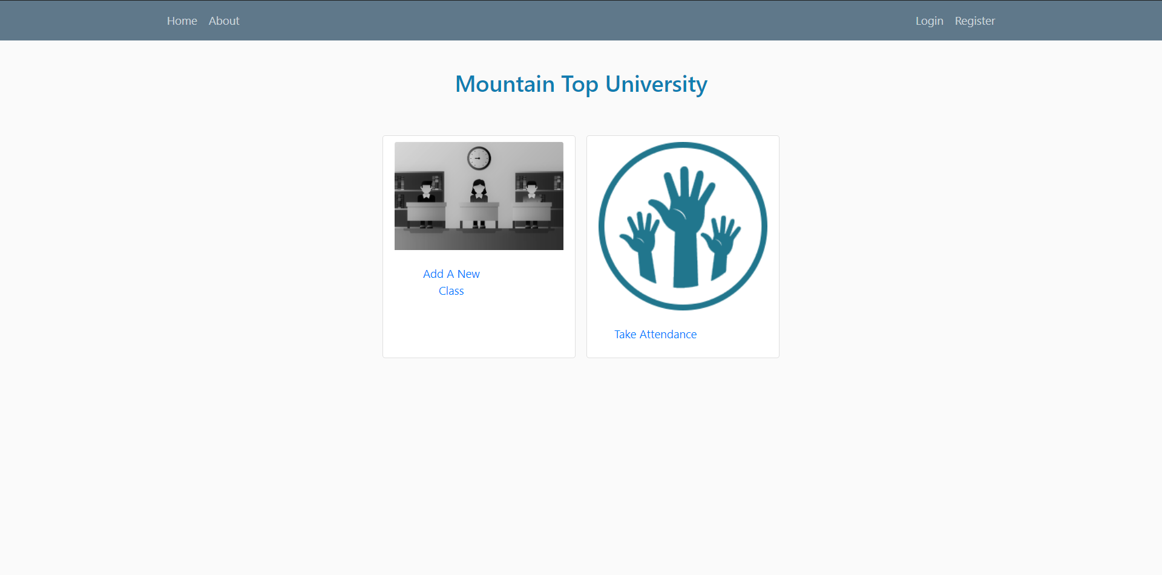
Figure 4.3: Main Dashboard Page

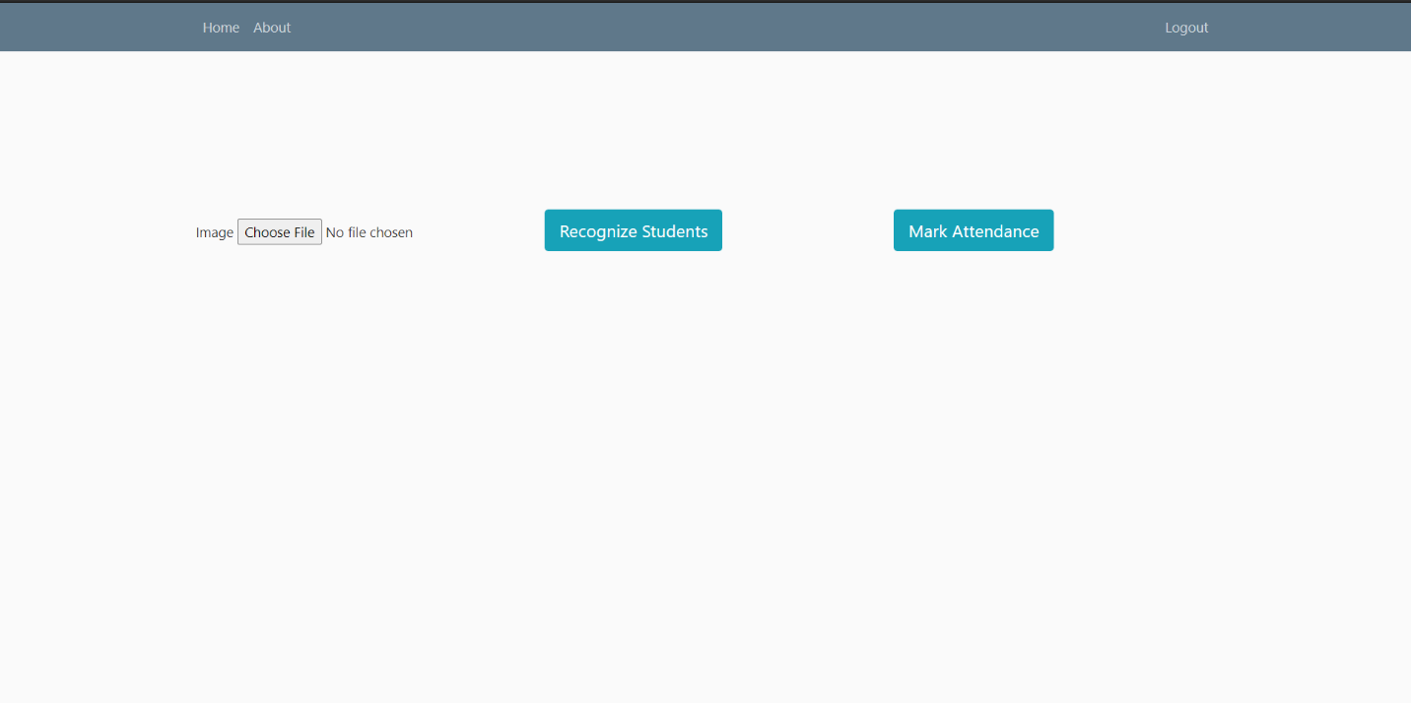
Figure 4.4: Take Attendance Page

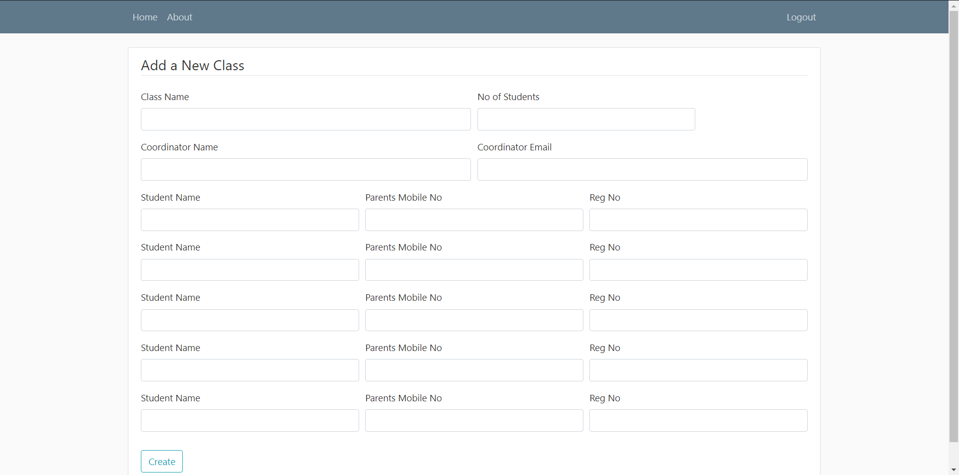
Figure 4.5: Register Student Page

CHAPTER FIVE

SUMMARY, CONCLUSION AND RECOMMENDATIONS

5.0 Summary
The proposed system is supposed to help eliminate the issues associated with the manual way of recording attendance by the introduction of an automated attendance management system which increases documentation efficiency and effectiveness and aids lecturers in having a better means of carrying out attendance operations. The automated attendance management system decreases workload, error in data compilation and adds values to both students and lecturers. It can capture data, store, and view, add and delete records into the database when required. During the development of this system, there were some challenges, some of which included the system not being able to properly detect faces due to reduced capturing device quality and export features that were not fully implemented.

5.1 Contribution to Knowledge
The main contribution of knowledge was the ability to implement an automated attendance management system using FaceNet recognition system. With the help of FaceNet, the system uses better face detection algorithms using MTCNN which has higher accuracy than other CNNs implemented and Face detection algorithms.

5.2 Limitations
i. The proposed approach (FaceNet) uses one-shot learning as this could be a disadvantage when best accuracy is required.
ii. The system does not have as much functionality to work as intended due to lack of better understanding of programming techniques and prowess.

5.3 Recommendations for Further Study
As years go by, the use of newer and more sophisticated face detection and recognition methods in improving this system is highly recommended. Automated attendance management system should be pushed continuously into replacing the old manual methods as global trends change the school needs to fit into these changing systems. The following are also recommended.
- The use of other face detection methods such as HOG, CNN, Haar-cascade
Should be used to test and improve the performance of the current system.
- Other frameworks (Flask, Pyramid, Web2py) like Django used to build the web-app should be implemented with the proposed system.
- SQLite3 is a lightweight database management system, there are more improved and robust DBMS that can be used to improve security and reliability, this should be implemented also.

5.4 Conclusion
The proposed system accomplishes good accuracy for numerous face recognition when FaceNet is used as a feature extractor and SVM is used as a classifier. The proposed system objectives are to get a reliable and efficient system by using multi-face recognition and substitute a manual system with an automated system. This is a system that will continuously be improved upon over the years and fully implementing this is system in a classroom will be a breakthrough all over the world. It will substantially reduce the amount of time taken and paper-work the lecturers have to do.

REFERENCES
Shehu, V., & Dika, A. (2010). “Using real time computer vision algorithms in automatic
attendance management systems”, International Conference on Information Technology Interfaces (ITI), 397-402.
Visual Paradigm (2020). what is an ER diagram (ERD)? Retrieved from https://www.visual-
paradigm.com: https://www.visual-paradigm.com/guide/data-modeling/what-is-entity-relationship-diagram/
A L, Rekha, & H K, Chethan. (2014). “Automated Attendance System Using Face Recognition
Through Video Surveillance”, International Journal for Technological Research in Engineering (IJTRE), 1(11), 1327-1330.
Opencv (2018). Figure 2.1 Haar-like Features? Retrieved from docs.opencv.org:
https://docs.opencv.org/3.4/db/d28/tutorial_cascade_classifier.html
Varadharajan, E., Dharani, R., Jeevitha, S., Kavinmathi, B., & Hemalatha, S. (2016). “Automatic
Attendance Management System Using Face Detection”, Online International Conference on Green Engineering and Technologies (IC-GET), 1-3.
O, Shoewu, & O A, Idowu. (2012). “Development of Attendance Management System using
Biometrics”, The Pacific Journal of Science and Technology (PJST), 13(1), 300-307.
Nandhini, R., Duraimurugan, N., Chokkalingam S.P. (2019). “Face Recognition Based
Attendance System”, International Journal of Engineering and Advanced Technology (IJEAT), 8(3S), 575-577.
Jadhav, A., Jadhav, A., Ladhe, T., Yeolekar, K. (2017). “Automated Attendance System Using
Face Recognition”, International Research Journal of Engineering and Technology (IRJET), 4(1), 1467-1471.
Sajid, M., Hussain, R., Usman, M. (2014). “A Conceptual Model for Automated Attendance
Marking System using Facial Recognition”, International Conference on Digital Information Management (ICDIM), 7-10.
Arun, K., Sudesh, K.V., Amar, P. Z., Nikhil, D. B., Chetan, J. B. (2017). “Attendance System
Using Face Recognition and Class Monitoring System”, International Journal on Recent and Innovation Trends in Computing and Communication, 5(2), 273-276.
Rosenfeld, A. (1988). “Computer Vision: Basic Principles”, In proceedings of the IEEE,
76(8), 863-868.
P. Viola, M. J. Jones. (2004). “Robust Real-Time Face Detection”, International
Journal of Computer Vision 57(2), 137–154.
P. Arun Mozhi Devan et al., (2017). “Smart Attendance System Using Face Recognition”,
Advances in Natural and Applied Sciences. 11(7), 139-144.
Wei-Lun Chao. (2007). “Face Recognition”, GICE, National Taiwan University.
Tutorialspoint (2020). Purpose of Activity Diagrams? Retrieved from www.tutorialspoint.com:
https://www.tutorialspoint.com/uml/uml_activity_diagram.htm.
Varsha Gupta, Dipesh Sharma. (2014). “A Study of Various Face Detection Methods”,
International Journal of Advanced Research in Computer and Communication
Engineering). 3, (5).
Viola, P., & Jones, M. (2001). “Rapid object detection using a boosted cascade of simple
features”, IEEE Computer Society Conference on Computer Vision and Pattern Recognition. 1(1), 1-9.
Joseph, M.B., Joseph, N.M., Sajeev, S., & Mahesh, T.Y. (2016). “Children's Transportation
Safety System Using Real Time Face Recognition”, International Journal of Advanced Research in Computer and Communication Engineering. 5, (3).
Techopedia (2018, July 17). What is a Biometric System?. Retrieved from www.techopedia.com:
https://www.techopedia.com/definition/26990/biometric-system.
Rajath S B, Tejus S R, Vinay T R. (2019). “Attendance Management Using Facial
Recognition”, International Journal of Innovative Technology and Exploring. 8(6), 1619-1623.
Balcoh, Naveed Khan, et al. “Algorithm for efficient attendance management: Face Recognition
Based Approach”. International Journal of Computer Science Issues. 9(4).
E. A. Abusham, A. T. B. Jin, W. E. Kiong, (2008). “Face Recognition Based on Nonlinear
Feature Approach”, American Journal of Applied Science. 5(5).
Visual Paradigm (2020). what is a use case diagram? Retrieved from https://www.visual-
paradigm.com: https://www.visual-paradigm.com/guide/uml-unified-modeling-language/what-is-use-case-diagram/
A. Nigam, P. Gupta, (2009). “A New Distance Measure for Face Recognition System”, Fifth
International Conference on Image and Graphics. 696-701.
J. Edwin, M. Greeshma, T. P. Mithun Haridas, M. H. Supriya, (2019). “Face Recognition based
Surveillance System Using FaceNet and MTCNN on Jetson TX2”, Fifth International Conference on Advanced Computing & Communication Systems. 608-613.
Schroff, F., Kalenichenko, D., Philbin, J. (2015). “FaceNet: A unified embedding for face
recognition and clustering”, IEEE Conference on Computer Vision and Pattern Recognition. 815-823.
Techopedia (2020). What does Django mean? Retrieved from www.techopedia.com:
https://www.techopedia.com/definition/28227/django.
William, I., Ignatius Moses Setiadi, D. R., Rachmawanto, E. H., Santoso, H. A., & Sari, C. A.
(2019). “Face Recognition using FaceNet (Survey, Performance Test, and Comparison)”, International Conference on Informatics and Computing (ICIC).
Nyein, T., & Oo, A. N. (2019). “University Classroom Attendance System Using FaceNet and
Support Vector Machine”, International Conference on Advanced Information Technologies (ICAIT). 171-176.

APPENDIX

SOURCE CODE
from datetime import datetime
from attendance import app, db, login_manager
from flask_login import UserMixin
@login_manager.user_loader
def load_user(user_id):
return User.query.get(int(user_id))
class User(db.Model,UserMixin):
id = db.Column(db.Integer,primary_key=True)
username = db.Column(db.String(20),unique=True,nullable=False)
email = db.Column(db.String(20),unique=True,nullable=False)
password = db.Column(db.String(20),nullable=False)
def __repr__(self):
return "User('{self.username}','{self.email}')"
class Add(db.Model):
id = db.Column(db.Integer, primary_key=True)
classname = db.Column(db.String(20),unique=True)
#students = db.Column(db.Integer, unique=True, nullable=False)
coordinator = db.Column(db.String(30), unique=True)
co_email = db.Column(db.String(30),unique=True)
stuname = db.Column(db.String(30),unique=True)
regno = db.Column(db.Integer,unique=True)
mobileno = db.Column(db.Integer,unique=True)
def __repr__(self):
return "Add('{self.classname}','{self.coordinator}','{self.co_email}','{self.stuname}','{self.regno}','{self.mobileno}')"

