A WEB BASED HOSPITAL MANAGEMENT SYSTEM

BY

OTOMEWO PAUL EFE
16010301003

BEING A PROJECT SUBMITTED IN THE DEPARTMENT OF COMPUTER SCIENCE AND MATHEMATICS, COLLEGE OF BASIC AND APPLIED SCIENCES IN PARTIAL FUFILLMENT OF THE REQUIREMENTS FOR THE AWARD OF DEGREE OF BACHELOR OF SCIENCE MOUNTAIN TOP UNIVERSITY KILOMETER 12, LAGOS IBADAN EXPRESSWAY, IBAFO, PRAYER CITY, OGUN STATE, NIGERIA

NOVEMBER, 2020

CERTIFICATION
This Project titled, A WEB BASED HOSPITAL MANAGEMENT SYSTEM, prepared and submitted by OTOMEWO PAUL EFE in partial fulfilment of the requirements of the degree of BACHELOR OF SCIENCE (Computer Science), is hereby accepted

__________________________ (Signature and Date)
DR. O.A. OJESANMI
Supervisor

__________________________ (Signature and Date)
DR. I. O. AKINYEMI
Head of Department

Accepted as partial fulfilment of the requirements for the degree of BACHELOR OF SCIENCE (Computer Science)

__________________________ (Signature and Date)
Prof. A. I. AKINWANDE
Dean, College of Basic and Applied Sciences

Dedication
I dedicate this project to God Almighty.

Acknowledgement
I appreciate the Almighty God for His unending display of love in my life, for the divine strength, enduing me with wisdom and understanding up until this moment, the grace to have started and successfully completed this research work. May His name be highly magnified in Jesus name.

Abstract

This study designed a web based NHIS hospital management system for the medical records department of Lagos State University (LASUTH). The objectives of this study involve to: develop a fully automated medical records operating system; achieve good computing skills for the management and staff; improve accurate record keeping; and provide timely access to patients and personnel records in the Lagos State University of Lagos. The study used Windows Operating System; MySQL for the database and Python for the backend, JavaScript and Cascading Style Sheet (CSS) for design purposes, working with a database schema and interface for querying records and data. The study was designed with reliability and efficiency as the mainstay, was directed at correcting the weaknesses and anomalies which exist in the manual method so as to improve accurate records keeping. It also addressed the timely access to patients and personnel records. Achievements of the design can be summarized as: The outcome of high processing speed of the computerized system; patient’s records can be retrieved easily; billing system in the hospital will be more effective; similarly, there is easy access to clinical reports for research purpose and decision making. This system will look forward to managing, storing and sharing of medical records. Finally, appropriate techniques, training and high-quality training materials will be required for a successful implementation and usage of the system.

TABLE OF CONTENT

CERTIFICATION 2
Dedication 3
Acknowledgement 4
Abstract 4
TABLE OF CONTENT 6
CHAPTER ONE 10
INTRODUCTION 10
1.1 Background to the Study 10
1.2 Statement of the Problem 11
1.3 Aim and Objectives of the Study 12
1.4 Methodology 12
1.5 Scope of the Study 13
1.6 Significance of the Study 13
1.7 Definition of Terms 13
CHAPTER TWO 15
LITERATURE REVIEW 15
2.0 Introduction 15
2.1 Electronic Medical Records 17
2.2 System Architecture: 20
2.3 Development Methodology: 21
2.4 Strategic Planning Factors: 23
2.5 Critical Success Factors 23
2.6 Problem Areas 23
2.7 Corporate Planning Objects 23
2.8 Hospital Information System Sample Modules 24
2.8.1 Capturing Demographic Details 25
2.8.2 Change of Department: 25
2.8.3 Modification Request 25
2.8.4 Billing Module 25
2.8.5 Diagnostics Module 26
2.9 Acquisition Test Results from Laboratory Equipment 31
2.10 Status Report 32
2.11 Overview of Lagos State University Teaching Hospital 33
2.12 Online Booking System 35
2.13 Hospital Management System 36
2.14 Security of Medical Records System 38
2.14.1 Security of Medical Records When Accessed by Patients 39
2.15 Training and its Impact on Hospital Information System 40
CHAPTER THREE 43
METHODOLOGY 43
3.1 Overview 43
3.2 Software Development Life Cycle (SDLC) 43
Software Development Life Cycle (SDLC) is a mechanism used to design, build, validate and deploy an information system. It requires a systematic framework explaining how complex software can be created, retained, substituted, updated or enhanced. The life cycle represents a plan to enhance the efficiency of the program and the overall method of production. 44
3.2.1 Requirement Analysis 44
At this point, all potential specifications of the device to be built are reported at this stage and documented in the specification manual for requirements. 44
3.2.2 System Design At this stage, the specification of the specifications is studied from the first stage and the configuration of the device is planned. This combines two important elements which are the functional and non-functional specifications required to make the framework functionalities especially compelling and effective in order to guarantee that the customer's requirements are met. The configuration of the framework helps to describe both the system specifications and the overall system architecture. 44
3.2.3 Implementation 44
This stage includes the programming and writing of the software code. At this level, the structure is split into smaller sections called units. Each unit is developed and tested for its functionality. This is considered a research machine. 44
3.2.4 Integration and Testing 44
3.2.6 Deployment 46
Once the device has been tested as a whole it is launched to the market as a commodity for use by consumers. 46
3.2.7 Maintenance 46
When consumers make use of the software product, problems may continue to emerge and need to be resolved. At this point, care is taken to make improvements and give courses of action to different consumer concerns. In addition, improvements to better versions of the device are performed to boost the product. 46
3.3 Analysis of Existing System 46
3.3.1 Problems of Existing System 46
3.3.2 Proposed System 47
3.3.3 Advantages of The Proposed System 47
3.4 Application Requirements Analysis This process involved getting to know and understand what consumers expect the system to do for them and then specifying what the system needs in order to operate correctly and efficiently. This includes learning to know the system's working and non-functional specifications. 47
3.4.1 Functional Requirements 47
3.4.2 48
3.4.2 Non-Functional Requirements 48
CHAPTER FOUR 48
SYSTEM DESIGN 48
4.1 Introduction 48
4.2 Database Design 48
4.3 Patients Registration 50
4.4 Patients Database 50
4.5 Patients Record 51
4.6 Patients Table 51
4.7 System Flowchart 52
4.8 Procedure Chart 53
4.9 Choice of Programming Language 55
4.10 Hardware and Operating System Requirement 55
4.10.2 Software Requirement 56
CHAPTER FIVE 57
SUMMARY AND CONCLUSION 57
5.0 Introduction 57
5.1 Summary 57
5.2 Conclusion 58
5.3 Limitations of the Study 58
5.4 Contribution to Knowledge 58
5.5 Suggestion for Further Studies 59
References 59
FIGURES 62
APPENDIX 63

CHAPTER ONE

INTRODUCTION

1.1 Background to the Study
The aim of every system development is to improve and execute the system economically; the essence of this method is user-friendly and better for user research. Analyzes are the analysis of the separate activities conducted within and outside the system. The files, decision points and transactions processed by the system will be presented during review. The Lago State Teaching University (LASUTH) is a renowned, patient-friendly hospital in the heart of Ikeja, Lagos, Nigeria. With every day, this amount grows at a steady rate. The hospital administration reflects on the intensified attempts to maintain patients records and monitor their events. In general, wellbeing is called abundance. It takes healthier individuals to produce the richness the nation needs for its people's general well-being. Adequate clinical care is also necessary in the field of diagnosis and treatment in particular.

Unfortunately, owing to the poor level of technical competence and the handling of most health conditions, proper medical care is scarce in most developed countries such as Nigeria. "Very often in developed countries that are seriously ill, people are rushed to special treatment overseas because the world finds emergency care centres to be ineffective, as Opara 2006 and Shafiu 2011 observes. This was partially because in many developing countries computer-aided drugs were a reality." It is well-known that there is a rising production of trained physicians and other health care providers, but this is not enough to fulfill the growing public's health needs. The doctor-patient ratio tends to be reduced.

Considering population development patterns, the available treatment services and the health needs of patients, computerized drugs are inevitable in order to offer more detailed and accurate statistical information. Moreover, it is important to predict the potential use of a complex electronic machine: the device with this change to a knowledge society. This is important because the machine easily approaches all areas of human operation, including medicine. Patient treatment and security, hospital management, comprehensive emergency monitoring, operations, diagnosis and integration of medical records are all facets of its implementation. For example, during a complicated procedure as demonstrated in Sanusi and Awe (2009), the machine watches operators and discloses any vital signs of concern to their theatrical doctors (pressure, blood pressure, breathing rates, etc to enable them to be more precise and successful in their function. This may be achieved with an interactive input keyboard (VDU), a Video Display Machine (VDU), or an alarm." The vast spectrum of computer use is due to its flexibility as a data processing system and its ability to do things quicker, easier and more efficiently than humans, even complex tasks.

1.2 Statement of the Problem
It has been seen that patients queue for several hours from one hospital unit to another starting from the latest hospital folder or recalling an old folder before seeing a doctor, to the laboratory for the laboratory examination and to the pharmacy to have the medications administered. It has also found that to get medical attention at most hospitals Much of them waste the entire day in the hospital during managing procedures involved. Very several times patients leave home very early in the morning to be in the first party to see their specialist, or they may end up spending the entire day without proper treatment.

This is disincentive for most patients and often forces them to take care of non-professionals or even use self-medication for accelerated healing. In comparison, hospital staff work is too extensive. Patients outweigh those that lack too much, physicians, nurses and other medical professionals. In this respect, the doctor hastens to test all his patients without due consideration and experience for his customers. He's still tired by the end of the day.

Furthermore the diagnosis and prescribing depend on the recollection of the doctor and the medication of choice. Their heads are also full of illnesses, signs, symptoms, complications, different medications and so forth. Some of them are also like that. It is a very important job to remember and process the tremendous knowledge of his professional practice. Precise diagnosis and recruiting can not always be achieved for this cause.

In most of our clinics, reliable records are maintained and retrieved on patients terribly. The files may be incorrect; their record may be filled incorrectly. Accurate and timely knowledge or information is often not easy to access.

This is also the case when other medical data are obtained, especially when new directories and numbers are obtained each year. Finally, it takes a long time and money to manually manage the folder for each patient and some of the information is repetitive. Both these have a net impact on hospital administration inefficiencies and thus the hospital's medical record department needs to be improved.

1.3 Aim and Objectives of the Study
The aim of this project is to design a web based hospital management system.
The main objectives of the study are to:
- Develop a fully automated medical records operating system in the Lagos State University Teaching Hospital.
- Achieve good computing skills for the management and staff of Lagos State University Teaching Hospital.
- Improve accurate record keeping in Lagos State University Teaching Hospital.
- Provide timely access to patients and personnel records in Lagos State University Teaching Hospital.

1.4 Methodology
Research Methodology is the approach by which difficulty of research is completely and consistently solved. This means the methodology is the scientific approach by which research is carried out. A web application is to enhance patient records in the Lagos University State Teaching Hospital the hospital information management system (LASUTH). The framework would have timely access to patients and staff information. The MySQL database can be used to store hospital records, patients and inventory in a single database. The system maintains an inventory of patients containing the structure or organisation of personnel and patients in the file and warehouses, which includes the input of stock, the prescription code of each prescription. the database. The output of this framework would be to update, incorporate, erase, clear and summarize the complete weekly, annual and even regular activities in the hospital's divisions.
This framework is being built using a Windows operating system, the Apache server is to be used for design purposes to access the database, MySQL for the database and the Python backend, JavaScript and Cascading Style Sheet (CSS). It will be used to query data and records through database schema and device. The files and documents would include the incident information conducted in each department by each module or form.

1.5 Scope of the Study
This study is designed to help the whole range of the hospital processes such as users of medical records information, hospital administrators, doctors, nurses, patients on the one hand and other users of hospital services on the other hand. Study includes all information and the health sector that relies on the Site- and Internet-based operations to provide its resources and the privacy and anonymity of its customers.

1.6 Significance of the Study
This study is significant in helping to address the issues of obtaining accurate and timely medical information or data. It also helps to keep consistent and reliable record of entries and exits.

1.7 Definition of Terms

Hospital Management - It primarily includes the administration of all the hospital aspects; the organization of all hospital components. This can vary from patient treatment to reports of prescription supply and cleanliness.
Medical Care - Availability of a doctor, nurse or other healthcare provider for the health and well-being of an individual.
Medical Doctors - A individual specialized in diagnosing and treating sick people.
Patient - A individual who seeks or is eligible for care.
Efficient Service - Comparing the delivery results of delivery mechanisms such as doctor's appointments, relative units of value or health results with inputs such as expense, time or material

CHAPTER TWO

LITERATURE REVIEW

2.0 Introduction

Hospitals can be considered as high-tech and information-intensive organisations. According to Dyer (2002) such institutions are mostly based on the processes of democracy regulation, with an institutionalized presence in decision-makers, and are not hierarchically organized bureaucracies. A survey of European clinic managers reveals that technologies can affect hospital practices and facilities greatly (Luxford, 2012). The healthcare budgets and finances are required to rely on sophisticated patient classifications and diagnostics. In diagnosis and recovery systems, the use of information technology helps build networks of clinical, hospital and healthcare processes (Smith and Gert van der Pijl, 2009).

Health care administration is a rising profession with growing prospects in direct and non-direct healthcare environments. The building of medical knowledge is critical if medical attention, management decision-making level in health care and operating performance in hospitals are to be improved. Comprehensive patient knowledge and technology platforms, concentrating on electronic medical records and the medical continuum, have been developed today. The design and implementation of such information systems plays an important role in enhancing patient satisfaction, increased hospital performance and quality of public, safeguarding healthcare safety as well as reducing the costs of healthcare.

Increasingly, the Hospital Information System (computerized) is an evolving medical method for effectively providing high-quality health care. These programs include computerized databases that are mostly used for correspondence and health storage and administrative information. HIS consists of a wide variety of modules and structures from a department (a health or financial system) to systems that provide assistance and involvement in the diagnostic and patient care sectors. It is assumed that HIS application is an internal mechanism for IT in the consumer environment. The healthcare user community comprises several different user categories (physicians, nurses, administrators, managers, researchers, etc). None of these parties entail a shortage of appropriate knowledge, skills, know-how, needs and aspirations. It is required and important to see and learn about the system and to understand how the system operates. Studies suggest that addressing consumer needs is a distinctive aspect to ensuring that the HIS is implemented effectively (Farzandipour, Sadoughi and Meidani, 2010).

A wide range of experiences and competing interests arise in healthcare institutions with diverse customers (physicians, administrators, supervisors, radiologists, Pharmacists, etc.). Implementation of a hospital information system can't take place without an examination of individuals' emotions and expectations (Ndira, Rosenberger, and Wetter, 2008).

In the face of industry challenges, healthcare management services are becoming a new need for care institutions to thrive. In addition, the evolving face of technology has enabled medical organisations, with upgraded services, to show their contribution to quality health services. In the execution of these programs, there are several challenges. Capital constraints and lack of standard databases became a concern. Often the handwritten and dictated medical records of various hospitals without a standard system of style and variability vary from other ones. In addition, in addition to project execution problems, big programs, people's views of IT and IT and so on, make the project monotonous and long-term.

An HIS aims at gathering, processing and recalling patient care and administratory knowledge from different departments via a net of computers in all hospital operations that meet all stakeholders' practical requirements. It further promotes the development of systematic healthcare strategies for cost effectiveness and reliability as a decision support mechanism for the hospital authorities.

Hospitals are aimed at delivering healthcare IT programs to ensure patients will be the leading recipients of health services. A hospital may be regarded as a "paper machine that could suffer from severe perils that are not easily checked or seen" without a proper management information system. It is important to help management decision-making so that it can determine accurately to increase the efficiency of the hospitals by optimizing patient care and minimizing the risk of data loss and enhancing knowledge consistency.

2.1 Electronic Medical Records
Electronic Medical Record (EMR) is a developing term, according to Oates (2009), and describes itself as a systemic gathering of electronic medical records about particular patients or communities. It is a public record that can be shared in multiple health contexts by being integrated in networked web-based information systems. This data may include in a complete or summarized format, demographics, medical records, asthma, immunization state, lab test reports, radiology photographs, vital signs, personal details such as age and weight, and billing information. These can include all data. Its aim can be seen as a detailed record of patient experiences that automates and rationalizes working flows in health care environments and promotes protection by promoting evidence-based decisions, quality control and results monitoring (Green, 2007). Although a distinction is described between the word EHR, EPR and EMR (Electronic Health Record) are often used interchangeably. The EMR can be described as the patient registry created by the HMR in hospitals and ambulatory settings (Habib, 2010). It is essential for patients, doctors and other healthcare professionals, employees and payers/insurers to access the patient's medical history through their services, that an EMR is created and retained within the organization, like an institutional hospital, integrated service network, clinic or physician department.

Hospitals in some areas aim to standardize EHR processes by supplying area healthcare facilities with cheaper versions of hospital applications. A resistance to this activity was posed as a breach of strong laws banning hospitals from funding neighborhood sources of medical care (Siegler, 2010). However, exceptions to the Stark Law were adopted in 2006, which allowed hospitals to provide community providers with software and training, largely eliminating this legal barrier. The long-term processing and handling of these documents must be a significant factor in the creation of electronic health records. The area must be settled upon the duration of the stored EHRs, how archived records can be retrieved and made complimentary to current recall processes, and how the physical and virtual protection of the database can be ensured.. The findings can be collected.
EMR is a computerized patient database in an institution that offers treatment, for example a hospital (Jones, 2004). E-Medical documents are typically used in a regional independent health information system that allows records to be saved, accessed and updated.

For most US hospitals and practices, manual recordings are still by far the primary way for capturing patient records (Health Metrics Network, 2007). Some clinicians also find data entry easy and low costs impossible to separate. However they do require substantial physical space in contrast to digital records as easily as possible for the doctor to record patient evidence at the point of attention. In the US, most countries require a minimum of seven years of physical record keeping. Per unit of content, the costs of storage media like paper and film are very different from electronic storage mediums. When manual notes are saved in multiple areas, it is time intensive and difficult to compile them for healthcare providers at a centralized location for analysis, while electronic records will simplify the process. This is especially true with person-centered documents, which cannot be stored if not electronically (thus difficult to centralize or federate). When manual documents in several locations are required, substantial costs for copying, faxing and transportation are compared to electronic document duplications and transfers. Because of these numerous "after entry" advantages, the federal and state governments and insurance providers are actively encouraging electronic medical reports as well as other major health institutions.

The electronic medical records are expected to increase the overalls performance by 6% a year and the monthly expense of an EMR can be covered by a few "unnecessary" examinations or admissions only (depending on the cost for the EMR) (Arizona, 2011). The improved portability of electronic medical records and their usability can also improve the ease with which unlicensed individuals or unscript users can access and stolen them versus manually recognized medical records as recognized by the increasing safety requirements for electronic health records found in the Health Information and Accessibility Act and in recently introduced major steps (1999). Health issues lead to the pervasive recognition opposition.

Manual health records can be related to inaccurate reading, which can lead to medical mistakes. The effectiveness of manual medical documents has been promoted by pre-printed formats, abbreviation standardisation and penmanship standards. The standardization of types, words and abbreviations and data input is assisted by electronic documents. Digitizing forms makes epidemiological evidence and research trials easier to collect. EMRs should instead be changed regularly (within certain legal limitations). Facilitating coordination of healthcare delivery in non-affiliated health centers will be the opportunity to share records among various EMR (interoperability) systems. Moreover, anonymous data from an automated registry can be used to monitor information on topics such as increased quality, control of services and public health surveillances of communicable diseases (Achampong, 2013).

Medical records consist on personal and social data systematically recorded by a patient, the details of his or her condition, psychiatric results, investigations, diagnosis and rehabilitation, follow-up accounts and outcomes. Patient reports generating medical stats represent the hospital management as eyes and ears. In order to assess the facilities and better results, medical records are of considerable significance for the hospital. They are also a guide for doctors and others' education and training and are also a conduit for clinical study. Analysis includes objectively reported findings as expressed in the medical record in order to be successful. And it is clear that medical documents are relevant for legitimate purposes. The different facets of preservation of medical records were clarified (Zhang, Patel and Johnson, 2002) in the report "Management of medical records." Hospital documents are one of the most critical factors in almost any medical-legal fight. If accurately written, the doctor will get the advise on the accuracy of the procedure.
Both Nigerian health and medical institutions, including any size hospitals, are expected to equip themselves with the web-based WHO information system publication for the management of each medical report. Without a web-based database system there can be no patient record.

2.2 System Architecture:
The architecture of the Hospital Information System (HIS) requires a modular solution in both hardware and software design. The improvement of the device configuration is important to increase understanding of the use of IT. Features such as data store, and data mining can be used for web-based applications such as telemedicine, e-consulting, radiological storage and so on. Automation is required in patient registration, bed distribution, pathology, ICU, medical records, shops, etc. for a seamless and error free data flow in the hospital. 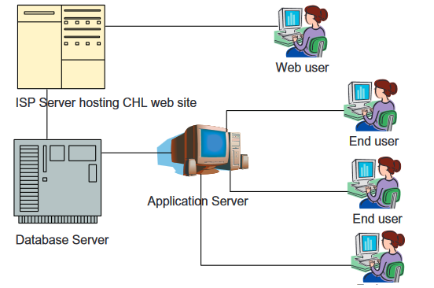
Fig. 2.1 - The System Architecture Design

A main database server with latest technological features is integrated into the hardware infrastructure to reduce data loss opportunities, connecting to end devices with necessary configuration to enable front-end technologies.

2.3 Development Methodology:
In recent decades, automated systems have explosed. The experience with the production of information technology was not so good, it was a poor taste. One analysis reveals that only 16 percent of the IT projects will fulfill their time, scale and expense limitations (Kathy, 2005). Many systems need continuous updating, correction of errors, the introduction of new user specifications, program modification to be used on new or upgraded platforms, etc. This bad record of IT projects demands particular consideration in IT projects. A research in the United Kingdom Hospitals on software ventures in 2006 (Connolly, Begg, and Strachan, 2012) also found this:

• 80 - 90% do not meet their performance goals.
• About 80% of systems are delivered late and over budget.
• Around 40% of developments fail or are abandoned.
• Under 40% fully address training and skills requirements.
• Less than 25% properly integrate business and technology objectives.
• Just 10 - 20% meet all their success criteria.

The key reasons why software tasks have struggled include incomplete standards, a lack of acceptable programming methods, a bad specification and the lack of a vision of information architecture (Claudia, 2003). The standard method is first to develop the hospital's knowledge infrastructure and then develop the approach. Information Management Architecture provides the philosophical basis for the optimal configuration of hospital information systems. It includes the mission, priorities, business operations, people, places and information-related areas of the hospital. Typically, it consists of:
• Information subjects (e.g. Data, Enterprise Data Model)
• Hospital Processes – Goals, Business functions, business entities, business processes
Hospital locations, data flow diagrams, process decomposition, etc.
• Data Network – Network structure.
• People – people management using project management tools (PERT, Gantt charts, etc.).
• Events and points in time (when processes are performed).
• Reasons for events and rules (e.g. decision tables).

The top-down approach following SDLC is suggested for defining the large IS projects that are to be carried out. It would also be of benefit to match/relate the achievement of the help of information system hospital targets and also allow studying the effect on the organization of a specific information system (Phillips, 2002; Nicholas, 2004).

The architectural designing of the Information System consists of four steps: planning, study, design and implementation. The creation of a company data model to display understanding in the enterprise by pictures and to create a shared understanding of the market flow among all stakeholders in the system is a significant step in the full understanding of hospitals and the study of IS needs. The Top Management will be confident of the correctness of its company procedure, and engineers can use this for more design practice. For a database creator, the business data model is a starting point. Before continuing, it is important that the EDM validation is made. An integrated EDM includes thorough breakdown of each business process, such as patient admission, patient accounts and so on. An enterprise data model (EDM) is developed by means of the processes that define high-level individuals and their relationships.

The SDLC-built information systems are primarily used in high level assessments by the organizations listed. Because more than one information system can use the same individuals, the interrelation of numerous information system components, done by the planning matrix process, needs to be seen. Many diverse matrices are prepared with this approach that demonstrates the interrelation of the parameters involved. For instance, a matrix between data entities and business functions may be prepared. In multiple information structures this matrix will easily illustrate the use of the same person. In addition, this matrix will explain the complexity of the different functions demonstrating which market functions are utilized by important organizations and the creation needs to be prioritized. Matrixes such as positions, unit-to-functions, information system-to-goals and so forth may be available. Likewise, these matrices will also allow any secret or incomplete object to be found in any hospital feature.

2.4 Strategic Planning Factors:
The goal of strategic planning factors is to establish a planning structure and connect ISPs with strategic business plans. The objectives defined are: to provide a preliminary understanding of the market circumstances of hospitals; to record current business operations; to evaluate the functions and needs of the hospital and its records and to prove (through an experiment, the information collection is feasible) and to expand the conventional framework.

2.5 Critical Success Factors
The determinants are easy-to-operate and practical, but also aesthetic and easy to use and to learn. Any required support and documentation is available electronically with limited training criteria. Intervention is minimally necessary. The framework is built to the extent that enables the user to use as many attractive features (i.e., some features may be used later after competencies are developed). Moreover the provision of new documents is present in nature, i.e., the archive status does not indicate obsolete material. The hospital administration is able to develop such a structure of management support and actively help to plan and execute it accordingly.

2.6 Problem Areas
Since the system is complex and wide in scale, it may have a rapid response in real time, provided that the customer cannot wait before the system is processed and in some situations, the data availability could be immediately required. — On the safety issue, the device should have a fair safety standard for unauthorized activities. The size of the data then grows exponentially and must be handled separately for historical reasons using data archiving.

2.7 Corporate Planning Objects
Such objects describe the scope of the hospital sector and restrict the scope for the following processes review and improvements in the information system. High-level medical facilities classified in areas such as admissions, diagnoses, patient treatment, procedure, ward administration, transportation, accounting and accounts, etcetera. The functionality of hospitals is expanded to 23 modules derived from documents on a whole organisation's functionality. However few modules are defined as an apriory in discussions with the management. These modules are planned for Oracle-9i & VB.Net. We remember that the user interface and management support are two critical elements of the effective program delivery in the development of the project and software (Kathy, 2005). The EDM is being established for various agencies to further improve the E-R framework for the departments concerned. In order to reduce probability of loss, the SDLC strategy and the quality management procedure at CMM-2 are implemented.

2.8 Hospital Information System Sample Modules
Registration module: Patient recording is the most critical activity of the Hospital Management System in general. Each patient approaching a hospital has to be registered before consultation, treatment and hospital investigations are undertaken. Patient identification requires the acknowledgement of some general and demographic patient records. A single central identification number shall be issued to the patient.

A Patient ID card known as Identification Card, Regional Personnel Emergency, VIP/Senior Citizen Regular registers are also issued at routine OPD timings. Emergency checks are made on all people in need of emergency medical treatment. Patients registering in this classen are primarily outpatients whose unit is closed on the particular day who are registered as emergency patients, Medicine/Legals Cases in which patients require urgent medical care and patients who arrive beyond the hours of the OPD. The Registration Team will be responsible for registrations for all the hospital staff. Input/output are some of the functions of this method.

2.8.1 Capturing Demographic Details: The registration module gathers the patient's demographic data. A one-digit central identifying code is assigned to a patient. Visit Old Patients' Creation: Every time a patient is admitted in the hospital a visit is stamped.
2.8.2 Change of Department: This facility documents the patient identification update in the hospital. Duplicate card prints: There's a way to reprint the card as the OPD card continues to fill.
2.8.3 Modification Request: A provision is made to comply with future demands for alteration of registration records.
- Reports/Graphical Output: Printing of Normal OPD registration card.
- Printing of OPD register department wise.
- Printing a report on number of registrations department wise.
- Printing a report on number of total emergency registrations.
- Printing a report on number of registrations User wise.
- Cash collection department-wise on a daily basis.
- Cash collection user-wise on a daily basis.

2.8.4 Billing Module: Billing module is one of the most complementary modules to enable patients from the beginning before they are released. It supports multiple features, such as patient transfers on ward multiplied (while current software supports only 3 transfers), advance payments collection on counters, and is automatically modified during billing download times during payment. Patients are also fortunate to provide discount options in many areas for the sick, life care and so forth.
The key feature of the billing module is the production and flawless consistency of the final bill. If any requested evaluation cannot be done, the fee is deducted from the final bill immediately. If a request is made in the respective module, any facility including medications, room facilities etc is immediately paid. Payment services are also provided by cheque, ATM card and draft. Reports to the billing department allow workers to update the regular purchase problems in a very short period. The feature reports are the following: wise sets of tariff, departmental, in-patient or out-patient reports and even report to the level of the trial balance.

2.8.5 Diagnostics Module: Different forms of study are conducted in the normal operation of a hospital. A number of clinical trials and the timely availability of the findings are very important if patients are to gain access to medical status and determine how they can continue. Figure displays the electronic diagnostic module from the data architecture. 2.2 used for designing the ER model as further shown in Figure 2.3.

There are 6 major departments under diagnostics namely, Pathology, Radiology, Cardiology, Urology, Neurology and CT-scan, salient features of this module are:
- Accepting investigation requisition
- Sending samples to laboratories
- Entry of test results
- Validation and printing of test results

The data entry facility enables the entry of the results in multiple formats such as single parameters, multi parameter and tests with sub-parameters, textual results etc. The confirmation facility assures the right print/transmission results. The results are ready. The diagnostics module interfaces with the registration module in order to gather important patient information. The Billing Module holds all payment information for the inquiry. His main characteristics are:
- Integration of all departments of diagnostic unit
- Report generation for investigations
- Facility to suspend/resume an investigation
- Adding new investigations at a mouse click in a simplified way
- Adding and updating of normal values
- Form generation at runtime
- Facility for sample entry – in case of pathology
- Facility to add the master entries for new investigation in a simplified way
- Facility to add the alias name for an investigation
- Easy validation and updating of test results
- Facility to print multiple reports on a single page according to the tests selected (pathology)
- Facility to view comparative values of an investigation for a single patient for future referencing (pathology)
- Generation of various MIS reports for administrative purpose
- Integration of the department with Registration, Stores and Billing

The flow diagram is depicted below in Fig 2.2, while ER model made out from the study of this department is shown in Fig 2.3.
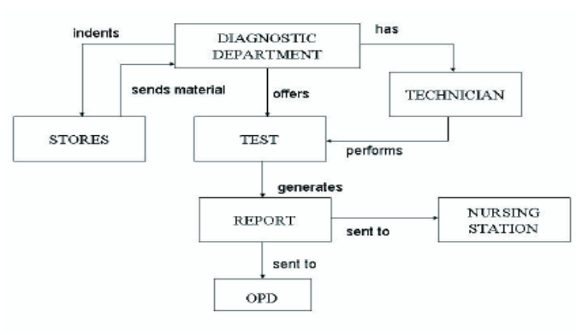
Fig. 2.2 – Flow Diagram indicating connectivity of different departments

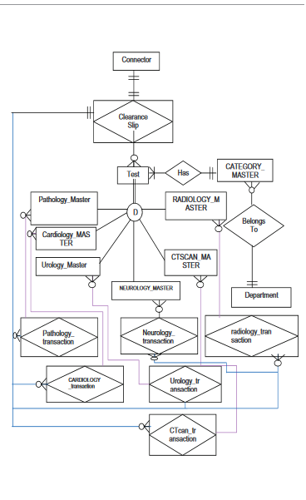
Fig. 2.3 Diagram of Model for Diagnostic System

2.8.6 Patient Management: It is also a very complicated module that incorporates information systems integration for both the hospital and the out-patient, each defined as follows: The stationary module starts when a bed is allocated to the patient. It deals with the patient's full recovery whilst in the hospital. This module interfaces with the modules OPD, Accounting, Census, OT and pharmacy.
This module depends on the OPD module for admission details, and is integrated with the following modules:
• Pharmacy module for requisition of drugs and consumables.
• Investigation module for requisitions and report viewing.
• Operation Theatre Module for requisitioning operations.
• Billing module for admission advance and discharge settlements. It mainly includes the room charges, charges made during medical investigations.
Its salient features are:

2.8.7 Bed Allotment: The module can be invoked from the OPD module and tracks available beds in the wards. The module also guarantees that accidents during bed distribution are avoided. It displays a number of beds vacant, such as private, general and so on according to their categories. It also helps to retain records made during bed assignment. It blocks a patient's room. The same module will be used for de-allocating the bed if payment for that bed has not been made.
2.8.8 Inter-Departmental Consultation: It transmits feedback on individual patient issues to other agencies. Monitors the status of each submission (whether sent, received, accepted or rejected). This function is mainly useful in demanding and accepting some test from one hand, such as laboratories and offices. Each device or the findings of requested testing may be checked by a doctor.
2.8.9 Transfer of Patient between Wards and Beds: If a consultation between departments is submitted and the consultation department thinks that the patient needs to be moved to its department, the patient's data is transferred to the new department for this module. In the same section, this machine can also be used to move the patient to a new room. It helps to also simultaneously measure room costs.
2.8.10 Raising Investigations and Report Viewing: For patients admitted to the ward, an inquiry order is submitted. This module also allows the selection and distribution of sample numbers. Reports for tests whose findings are entered are displayed and printed through this module. In the meantime, past studies and medical history of patients are still available.
2.8.11 Maintenance of Billing Sheets for Patients: Maintenance automatically to all patient costs. Automatic check of the credit cap in hospital accounts for the patient. The module offers tools to request additional sums that can be deposited in your account if the balance is not enough. One of the main functionality is to print the declaration of account indicating each deposit and cost. Hospital management can also use services such as fine for patients, a voucher or protection when final billing is carried out.
2.8.12 Discharge of Patients: The key objective is to prepare a discharge report, review patient records and transmit an extra payment request to the billing counter, if appropriate. A refund request can be submitted to the account count if credit balance of the patient's account is present; bed allocation; patient records may be submitted to the Medical Archives, reports such as Ward Census, Bed Occupancy and so forth. The full discharge report is printed. Report on the cumulative number of releases and mortality and the number of days spent in the hospital by the patient.
Figure 2 presents the web-based Hospital device algorithm flowchart. Next, if the patients are new to the registration station the machine is making a new patient PID, a white registration database and a new PID Username and Password. First the patient will be given the PID in the general medical station. On the basis of the PID, the practitioner can log into the database to search fundamental patient knowledge for health evaluation. If further medical tests are required, the practitioner will place a test application on the patients' folder. The patient is then configured for examinations that meet the physician's order. At the test station, the medical professionals will sign up for the appropriate details in the database. If the submission is correct, checks are conducted and results are displayed in the database. The patient then returns back to the emergency department to receive the findings of the medical test and medication. Patients go to the drug station if necessary before they exit the hospital to purchase medication. At home or anywhere, patients can use the Username and Password given in the hospital to log into the system to check their clinical history, diagnosis and medications at home and in another hospital, and in other locations where the Internet is available.

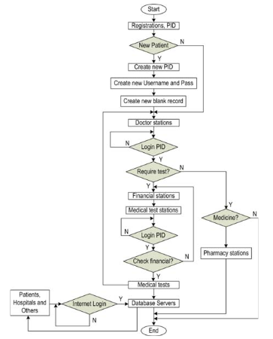

Fig. 2.4 Algorithm of the System for Medical Record Management

To collect image data on machines, two issues have to be resolved:(1) hardware architecture for the computer, to connect with different peripheral devices; (2) the design, to be transmitted from the peripheral to the computer, of software for data stream acquisition. The most current surgical equipment is fitted with a composite camera or S-video picture signal output2. In addition, current ports will also acquire image data via normal USB, PCI, LPT, LAN and WiFi. A circuit was then designed to communicate with both image data from image equipment and data to the device using industry standards. The standard video input and output in this model circuitry in compliance with the PCI standard. This is an easy-to-use, stable and economical process. It meets the high speed transmission criteria for real-time image images.

2.9 Acquisition Test Results from Laboratory Equipment
Data from test results derived from laboratory instruments is easier to manage, which is the case for the image data acquisition mentioned above, as in text format. The data communication rate is also slower and often received as a message. Most laboratory equipment sends output data to COM ports using RS232. The laboratory and computer are linked via the RS232 interface as the connectivity is required for the collectance of data on the computer. The app will read the data you send to your computer. However the data type of the machinery maker must be competent in order to create the program for interpreting the message and then to decide precisely the conditions of examination. This detail is also available in the manufacturer's technical support materials (the service manual). If the information is not accessible, then the data stream format is pre-analyzed using the program (e.g. Terminal, Collecting, Virtual Serial Port Package and others), then it is linked to the data frame structure results shown on the equipment.

2.10 Status Report
The framework has been developed using the SQL Server2000 languages ASP.Net, VB.Net, and C++. The experimental results show the robustness of the method, the length of data collection and transmission rate are fast, due to the web-based hospital computer network capacities and to the proper functioning of the software statistical modules for information storing, printing and reporting. The web-based patient information system addresses the hospitals' present needs and is able to respond to their needs in the near future. The modules that are now functional in the Hospital system web-based include PID registration and development, ultrasound photography and scanning and processing, DR, CT and MRI, hematology analyzer stations, biochemical stations, immunology, microbiological stations, cellular and endocrine test stations, and urine stations. The creation, testing and execution of the Hospital web-based framework for the shop, monitoring and distribution of patient information as seen in Figures 2.6 and 2.7.
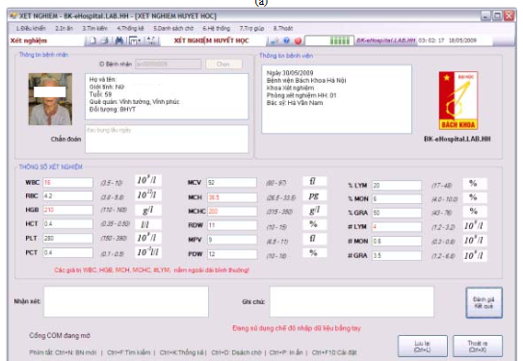
Fig. 2.5 - Design, Testing and Implementation of the Web Based Hospital System

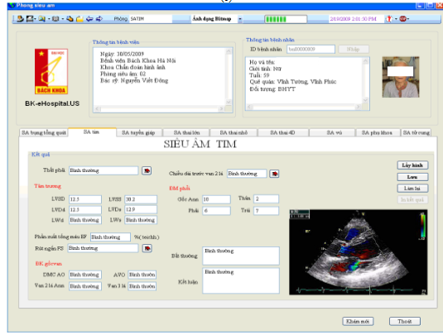
Fig. 2.6 - Design, Testing and Implementation of the web-based Hospital System

2.11 Overview of Lagos State University Teaching Hospital

LASUTH is a State Teaching Hospital of the Lagos State University , Nigeria, and is part of the State Lagos State University. LASUTH is popular with Lagos State. It is situated in Ikeja, the capital of the state. In 1955, a hospital from a small medical center in the Old West Cottage was built. In July 2001 she was turned into a doctrinal hospital for the provision of quality health care. This hospital is operated by the Ministry of Health of the State of Lagos and acts as a Medical Center for medical stages (homework). The State Teaching Hospital of the University of Lagos is situated in the metropolis of Ikeja, the State City of Lagos, which makes people easier access to their climate. The hospital is directed by a CMD and consists of the following specialties and departments:

a. Medical Records: Increased computerization and other policies involve classified material. This segment is a vital part of existing and future medical treatment of the patient. It contains a written compilation of medical health and recovery records necessary for the patient's existing and continued care.
b. Surgical: pertaining to or involving surgery or surgeons.
c. Medical: Applied research or practice of diagnosis, care and illness prevention is concerned with the science or practice of medicine. It comprises a range of clinical activities which have been introduced to preserve and recover the health of human beings by avoiding and managing disease. The word medicine derives from the Latin medicinal arts, which means healing.
d. Pediatrics: Children's and their diseases' medicine branch.
e. Gynecology: the medical practice dealing with the health of the female reproductive system.
f. Dental: The teeth-related division of medicine. The dental section includes general dental condition and patient's overall dental wellbeing. This section frequently develops an early recovery schedule and returns to the doctor for more advanced counseling.
g. Ophthalmic: pertaining to eye and its diseases.
h. Nursing: Health and skills security, promotion and optimisation, disease prevention and accident.
i. Pharmacy: Science or practice of herbal medicinal preparation and delivery. Patients are mentioned in the pharmacy column. This ensures that a patient needs to see the hospital first in order to get the medications needed to treat the disease before arriving in this section.
j. Laboratory: A house that is designed for science, teaching and drug or chemical processing. The section for the monitoring of patients, such as blood or urine, is responsible. The doctor must order an examination to be carried out on a patient.
k. Maintenance: is the method of repairing or maintaining something in good shape.
l. Social services: government service of those in need, which is the welfare of society as a whole.
m. X-ray: Short wavelength electromagnetic radiation generated by electrons striking a solid goal with high speed.
n. Public Health: Community wellbeing, hygiene, immunization and preventive medicine strengthening and protecting health facilities.
o. Administration: The management of the hospital as a corporation is the hospital administration. It consists of administrators of health and emergency care. It is clear that in order to manage patient records at this pace, the number of patients handled is growing and hence requires some technologies to electronically computerise patient records and medical history to facilitate service effectively and efficiently.

2.12 Online Booking System
Often known as a web-based system is an internet system. A website is a programming program that operates on a web-server and allows links to a group of linked websites. A website is a web page generally referred to as a website or website and (Alex, 2000). A framework is a collection of modules that work together to meet a shared purpose. A web-based system is also a user-accessible system over the Internet to perform a certain role for a certain reason. The Internet is a machine and computer network connecting device. It helps link millions of computer networks around the world and enables people to store information from a long distance from other machines (James, 1999).

The public appetite for quality healthcare and the alarming amount of missing appointments have helped the hospitals realize how they provide care, according to Obadofin (2006). With today's implementation of IT and healthcare as a strategic infrastructure, hospital quality is the crossroads for ensuring efficient, secure and timely access to healthcare. The increasing penetration of the internet is leading the health care sector to the use of an online system.

In addition, hospital administration must translate manual, semi-manual and distinct applications to a single electronic (web-based) structure to take advantage of the advantages of technical enhancement. The administrator supports keeping medical records, diagnostic data including medication prescribing and billing, system search processes, alerts and retrieval.

2.13 Hospital Management System

The Hospital Management System is a variety of difficulties for most hospitals and they do use manual procedures and those who use the computerized approach still face the difficulty to adapt to this. That includes the following:
• Product creation, distribution and upgrade costs are high;
• Trouble migrating from the manual systems, since personnel as well as patients can't manage the modern method easily and are instead utilized for manual processes;
• There are also many problems posed by the lack of IT friendly medical personnel;
• Great influx of people entering state hospitals makes it incredibly difficult to switch to electronic systems.
Often patients do not have to wait for registration and data entry and also do not understand how electronic procedures work. Provided that computerized hospital information systems must be improved, as they will assist in the provision and adaptation of clinical data, make it easier for ready-made models to be diagnosed quicker, allow doctors to adopt advanced medical prescription trends, etc. The software framework model that saves, acquires, handles and exchanges medical data automatically seen in figure 2.6.

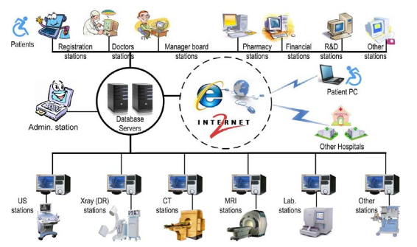
Fig. 2.7 - Software System Model to automatically store, acquire, manage and share
Patients’ Medical Data

Management was defined as the operation of social and technological roles and operations in organisations, which are carried out by human beings and other resources to achieve pre-determined objectives (Hughes and Cotterell, 2009). Both primary and secondary health practitioners use healthcare excellence and patient protection as the universal motto. Over the years numerous models and systems have been deployed in hospitals for patient strategies and growth (Wood, 2001). Increased operations, enhanced maintenance and supervision, superior patient care, close control of costs and increased profitability, all give the advantages of the Hospital Management System. The phase of the Hospital Management System consists of multiple modules. These include:
- Patient management
- Services management
- Appointment scheduling
- Store management
- Pharmacy management
- Admission management
- Ambulatory
- Laboratory
- Account management
- Payroll and Human Resources Management

Building medical knowledge is essential to enhance critical care skills in hospitals, health policy decision making and operating performance in hospitals. Today we have developed robust hospital information systems and a management network focused on electronic medical records and clinical trajectories. In order to boost the patient satisfaction rate, increase hospital productivity and improve the quality of services, safeguard healthcare safety and decrease medical spending, the establishment and use of these information systems played an important part.
The Hospital Management System (computerized) becomes more and more an evolving method for the delivery of high-quality services in the area of healthcare. These networks provide broad computerized data bases intended mostly for health and administrative information correspondence and storage. HMS has various elements that encompasses wide-ranging and departmental (a health or financial-specific system) to knowledge-based programs that offer diagnostic assistance and intervention to patient care activities. The introduction of HMS is assumed to be an internal mechanism for IT in the consumer environment. The healthcare user community consists of a number of various user groups, including medical doctors, clinicians, administrators and researchers. Failure to do so means a lack of appropriate experience, abilities, information needs and aspirations. What consumers see and hear of the system and interpret how the system operates with them emerges from preferences and specifications. Studies suggest that addressing consumer preferences is a distinct factor in ensuring that HMS is effectively used (Farzandipour, Sadoughi and Meidani, 2010).

2.14 Security of Medical Records System
In the web-based healthcare system, patient safety is of paramount importance. The SQL Server 2005 administrative database with user information table is used. A high-level system administrator called Super Admin" is the default name for Microsoft SQL Server 2005 and will log into the system as "sa." Super Admin should change the password of "sa" as collection. Super Admin is allowed to both build or erase and distribute device users access to databases. Which encompasses the enrollment for physicians, nurses, technicians, personnel with medical records, technicians and all associated staff members. The administrator of the individual hospital shall decide specific access privileges granted to users of the database system.
Only the Super Admin will interfere explicitly in the database system, but the system controls all activities of the Super Admin. Other users can only add and show the record of the patient but do not edit previous records. With a medical log, the machine tracks all operations. Therefore any user is responsible for the operations on the database after logging into the system. In certain instances, username and password will be given to the user to enter the account and machines will be kept safe to avoid unauthorized use. Hospitals would invest in two computers in two separate cities, to guarantee that information from patient history is safeguarded in the Hospital system network. In each of these repositories, patient care records are constantly backed up.

2.14.1 Security of Medical Records When Accessed by Patients

The Hospital web-based framework generates and automatically provides the patient's user name and password, based on a patient name and random code. During the first registration the medical personnel print out access cards and password information. After the first login the patient will change the password. In order to keep medical records confidential, patients are encouraged not to share their username and password. Under the discretion of the hospital, patients can access only part of their medical history, including vital examination findings, therapy recommended by the doctor, and pharmacy documents. Different hospitals will exchange patient records based on coordination between the two hospitals.

There are PCs, LAN systems and at least two servers necessary for introducing the Web-based Hospital. Relevant PC, LAN and server specifications are calculated according to the size of each hospital. When the hospital is 500 or less bedded, approximately 50 PCs, LAN and two small or medium sized servers are needed for equipment. The specifications for equipment include about 100 PCs, the LAN and two wide and powerful servers as the hospitals measure 500 to 1000 beds.

Web-based hospital is built in an open-source model, enabling quick availability and deployment of applications in other developed countries. Each module needs to be mounted at the respective stations, as the device operates in a module. Based on the size and the needs of each hospital, the number of stations can vary. The web-based hospital is primarily introduced in English. However it can conveniently be translated where a hospital needs other languages.

2.15 Training and its Impact on Hospital Information System
In order to increase productivity and efficiency by using information technology, organisations of all kinds are operating. Time and resources was invested tremendously on designing and integrating information systems in an organisation (Hurd, 2001). The influence on the health sector of the IT sector has been substantially positive (Ismail, Jamil, Rahman, Bakar and Saad, 2010)
In hospitals, large divisions and units overseeing patient care are highly complex (Amin, Hussein, Wan Mohd Isa, 2011). Hospital Medical Records (HMRs), can be described as a large, interconnected framework that supports the detailed requirements on hospital information (Hayajneh, Hayajneh, Matalka, Jaradat, Bachabsheh, 2006), including patients, clinical, ancillary and financial information (Ismail, Jamil, Rahman, Bakar and Saad, 2010) to store, manipulate, obtain information from the administrative and clinical aspects. Hospitals are becoming increasingly dependent on HMR's capacity for better services and practice in management and education (Farzandipour, Sadougi, Meidani, 2011).
In order for the decisions to be taken to be efficient and effective, the HIS shall include the requisite details to each management level on time, in the correct form and in the right place. In arranging, facilitating, coordinating and managing the activities of hospital subsystems, the HIS plays an important part, providing a synergistic organisation. It allows a hospital to step backwards towards a competitive quality and suitability of treatment by reviewing data and making decisions for care. HIS increases patient care (Ajami, 2003). HIS aims at ensuring the best possible support for patient care and administration through electronic data processing; improving the quality and cost reduction; providing effective health services; promoting health services and providing knowledge-based frameworks which support diagnosis and intervention in patient care activities (Baus, 2004). The successful use of HIS lowers costs and increases treatment for patients (Connolly, Begg, and Strachan, 2002).
HIS aims at ensuring the best possible support for patient care and administration through electronic data processing; improving the quality and cost reduction; providing effective health services; promoting health services and providing knowledge-based frameworks which support diagnosis and intervention in patient care activities (Baus, 2004). The successful use of HIS lowers costs and increases treatment for patients (Connolly, Begg, and Strachan, 2002).
Training was described as one of the main components for effective IT use. Research has shown that teaching improves the use of the programs and makes consumers more relaxed with their use and thus implicitly increases their adoption. It has also proven empirically that teaching is closely linked to a) system utilization and decision-making progress, (b) performance and efficiency of users, (c) good customer satisfaction (d) behaviour of users and (e) success of the Knowledge System (Olusanya, Elegbede, and Gunseye, 2015).
Continued recruitment of consumers of a particular organisation is thus a primary determinant of IS's long-term sustainability. Training costs and small budgets for execution will sadly lead to minimal training before practical use (Idowu, Adagunodo, and Adedoyin, 2006). It can propagate faster in a system if training is readily available.
A number of applications crashed due to insufficient preparation of customers. Training needs to be tailored to respond to consumers' needs (such as doctors); therefore it is important that physician leadership in training is actively supported. Other seasoned doctors also tend to be qualified one by one by one. However, complex systems can include team-based training or staggered training. Training schemes, in addition to addressing attitudes and generating an excitement about the use of the method, should teach people. Effective framework implementation includes suitable procedures, preparation and quality training materials (Adeleke, Asiru, Oweghoro, Jimoh, and Ndana, 2015).
Hurd, (2001) has suggested that users typically achieve a high degree of computer system awareness by successful teaching or training or both and that users are often concerned about the widespread role and participation of users in the management of computer systems.
HIS plays an important part in the efficiency and cost-effectiveness of health care. There are many obstacles that obstruct the introduction of HIS, such as the dismissal by users of emerging technologies, lack of user involvement and interest in design and framework implementation (commonly referred to as User Focused Design, UCD), health workflow integration, and untrained users. The findings underline that teaching is a crucial factor in the effectiveness of HIS. Untrained consumers worry that they can't cope and lose work with the HIS, and so avoid the change. One approach to eliminate obstacles to the HIS is: first to instruct consumers to familiarize them with the role and advantages of HIS; secondly, to include more people in the execution and facilitation of HIS needs, and to defend them against potential grievances (Crane and Raymond, 2003). Hospital must then be constantly prepared to teach patients about how to use the method, to correct attitudes and to generate passion for this. For effective system installation and use, suitable procedures, training and high-quality training materials are required. Computer literacy, machine preparation, clinical specialty, occupation and job satisfaction are variables which correlate positively with attitudes. Device sophistication has historically been shown to be adversely linked to attitudes, and gender has not had any effect on physicians' machine attitudes.

CHAPTER THREE

METHODOLOGY

3.1 Overview

The on-line hospital management system is state-of-the-art, hospital management tailored for patients, staff personnel, and administrators. The research aims to give hospitals new possibilities for change of patient processes by means of interconnected knowledge and medical technology that go beyond advanced medical devices, paper-free strategies and centralisation/sharing of information. Healthcare practices are changing with increased improvement in information and technology. This chapter explains the requisite step-by-step explanation of how solutions are applied to meet the specified goals of the research work. It outlines the different steps taken carefully in the achievement of the research goals alongside the reasoning behind the approaches followed.

3.2 Software Development Life Cycle (SDLC)

Software Development Life Cycle (SDLC) is a mechanism used to design, build, validate and deploy an information system. It requires a systematic framework explaining how complex software can be created, retained, substituted, updated or enhanced. The life cycle represents a plan to enhance the efficiency of the program and the overall method of production.

Requirement Analysis

At this point, all potential specifications of the device to be built are reported at this stage and documented in the specification manual for requirements.

3.2.2 System Design At this stage, the specification of the specifications is studied from the first stage and the configuration of the device is planned. This combines two important elements which are the functional and non-functional specifications required to make the framework functionalities especially compelling and effective in order to guarantee that the customer's requirements are met. The configuration of the framework helps to describe both the system specifications and the overall system architecture.

3.2.3 Implementation

This stage includes the programming and writing of the software code. At this level, the structure is split into smaller sections called units. Each unit is developed and tested for its functionality. This is considered a research machine.

Integration and Testing
After each unit is evaluated, all units are coupled together to create a device. The whole system is then checked for defects and errors.

3.2.5 Web Page Testing

Checking the web page is mainly used to test the reliability of the framework

Table of checks for the website feature
Table 3.1: Table for website function testing
Test number | Description | Expected outcome | Pass/Fail
1 | Register a user with all the information fulfilled:  1)Input all the information in the text box and scroll all Seekbars to a certain value  2)press the submit button | A successful message shows on the screen, indicates register successfully | Pass

2 | Register a user without all the information fulfilled: 1) Input the information in one text box  2. Press the submit button | An error message should pop up on the screen that indicates registering data unsuccessfully | Pass
3 | Register a user with the password less than 7 byte | An error message should pop up on the screen that indicates minimum password should be 7 | Pass
4 | Change the password with the security answered the same when the user registered | A successful message shows on the screen, indicates change the password successfully | Pass
5 | Change the password with the security answered not the same when the user registered | An error message should pop up on the screen that indicates the security answer is not correct | Pass
6 | Change the password with the old password not the same when the user registered | An error message should pop up on the screen that indicates the old password is not correct | Pass
7 | Cancel the data fields  1) Click the cancel button | Seekbar’s and EditText’s values need reset to default values | Pass
8 | Cancel the data fields  1) Input the data in one of the data field or scroll one Seekbar  2) Click cancel button | Seekbar’s and EditText’s values need reset to default values | Pass
9 | Forget the password with the choosing the correct security question and typing the security answer correctly | An email with old password will e sent from the official health email | Pass
10 | Forget the password with choosing the wrong security question | An error message should pop up on the screen that indicates the security question is not correct | Pass
11 | Forget the password with typing the security answer wrongly | An error message should pop up on the screen that indicates the security answer is not correct | Pass

12 | Zooming in and out  1) Visiting the website with iPhone and iPad  2) Turn the device in different orientation | The website will display well whether the iPhone or iPad visits, and whether it is portrait or landscape | Pass
13 | Search the physician and give the specified physician authority to access the patients specified items | The authenticated physician will view the specific items of the patient | Pass

Deployment

Once the device has been tested as a whole it is launched to the market as a commodity for use by consumers.

Maintenance

When consumers make use of the software product, problems may continue to emerge and need to be resolved. At this point, care is taken to make improvements and give courses of action to different consumer concerns. In addition, improvements to better versions of the device are performed to boost the product.

3.3 Analysis of Existing System
The existing method requires the use of pen and paper methods to maintain patient and personnel records.

Problems of Existing System
After analyzing the current method, the following problems were found.
1. Data Loss: Documentation is required to maintain a record of patients entering and exiting. This may lead to a lack of data when the papers can be lost or destroyed.
2. Time Wasting: The pen and paper process used is time intensive.
3. Error Prone: The new system can contain errors.

Proposed System
The web-based hospital information system is a web-based program where hospitals will be able to register their patients to maintain adequate medical records and to take acceptable transaction records. The framework uses the output prototype to provide the customer with the required reports and suggested resources. The specifications of the device are as follows:
i. The hospital registers the bio-data of its patients.
ii. The patient is asked to enter when they come in and log out when they leave.
iii. The supervisor is responsible for viewing the records of the patient.

Advantages of The Proposed System
The proposed method has been identified with some merits that improve the nature of the system. Some of them are listed below: It is bias-free (every user is served equally).
- It is faster.
- It is more efficient.
- It is more secure.

Application Requirements Analysis This process involved getting to know and understand what consumers expect the system to do for them and then specifying what the system needs in order to operate correctly and efficiently. This includes learning to know the system's working and non-functional specifications.

Functional Requirements
This is used to define the actual functions or behavior of the proposed system. The system's functional specifications are as follows:
i. The device must provide a tab displaying the bio-data of the patient. The interested party should then be able to sign up.
ii. The system could give the administrator unrestricted access to the database, produce reports and display patient information.

Non-Functional Requirements
This explains the actions of the program as it applies to its features. It points out the output characteristics of the program. Any of the system's non-functional specifications are implemented at each stage of the software development process. The most non-functional criteria for this work to be tackled is performance and safety.

CHAPTER FOUR

SYSTEM DESIGN

4.1 Introduction
This chapter demonstrates the results of the goals listed above. It shows a web-based hospital management framework.

4.2 Database Design
The architecture of the user interface is the point of interaction between the user and the device, the entities have various characteristics, data types and relationships that are specified on the basis of user requirements.

Column | Datatype
Hospital No | int(10)
Surname | Varchar(60)
First name | Varchar(60)
Other names | Varchar(60)
Gender | Varchar(6)
Date of Birth | int(11)
Home Address | Varchar(250)
Occupation | Varchar(30)
Place of Origin | Varchar(15)
Nationality | Varchar(15)
Religion | Varchar(15)
Phone number | Varchar(100)
Date | Datetime
Fig. 4.1 - User Database design

Column | Datatype
Patient Hospital No. | int PRIMARY KEY
Hospital_Department | int FOREIGN KEY
Name | Varchar(50)
Gender | Varchar(6)
Patient _Status | Varchar(25)
Surgeon | Varchar(30)
Findings | Varchar(150)
Date of Discharge | Datetime
Time of Discharge | Varchar(5)
Total Bill | Varchar(5)
Fig. 4.2 - Reports Database design

Column | Datatype
Username | Varchar(30)
Password | Varchar(50)

Fig. 4.3 Admin Database design

4.3 Patients Registration

- 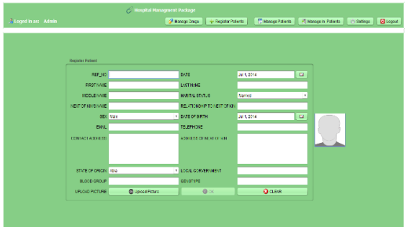

Fig. 4.4 Patient Register and Login Page

4.4 Patients Database
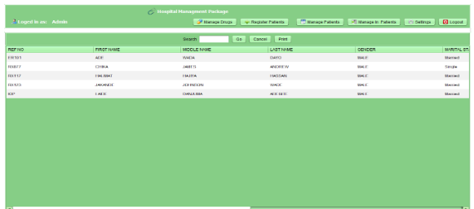

Fig. 4.5 - Patients Database

4.5 Patients Record

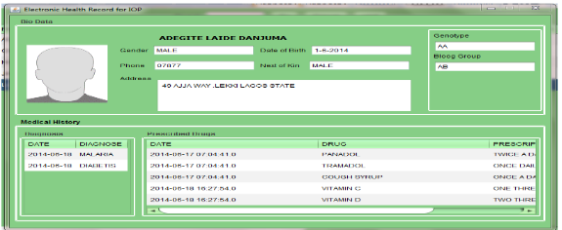

Fig. 4.6 - Patients Records

4.6 Patients Table

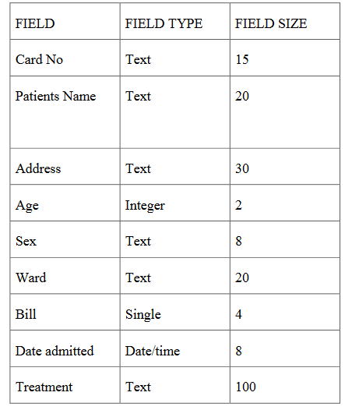
Fig. 4.7 - Patients Table

4.7 System Flowchart

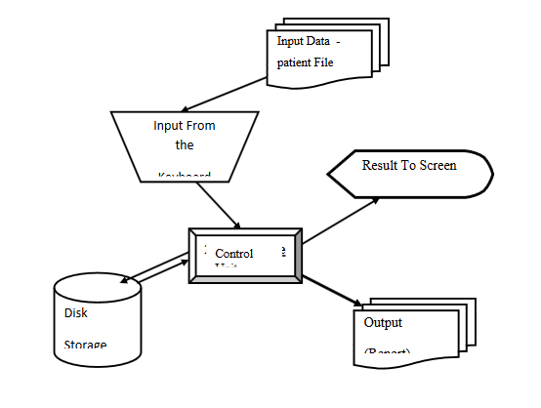

Fig. 4.8 - Systems Flowchart

4.8 Procedure Chart
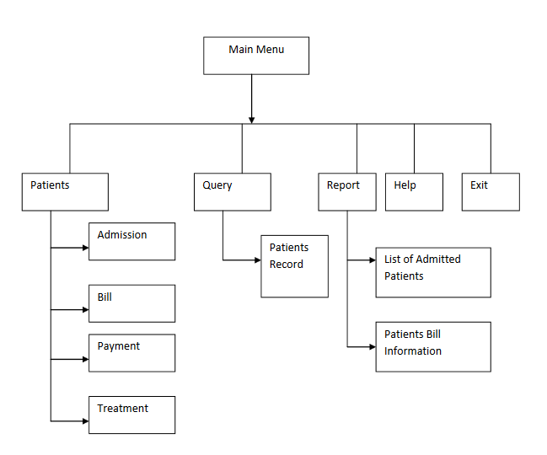

Fig. 4.9 - Procedure Chart

4.9 Choice of Programming Language

The new framework is being introduced using Microsoft C#. This is because the programming language has the benefit of being easy to create. Flexibility and the ability to offer future clues to the developer/programmer and create a graphical user interface.

4.10 Hardware and Operating System Requirement

The computing machine consists of modules that are put together to function as one to accomplish a shared purpose. There are two pieces of the operating system, that is.
- The Hardware
- The Software
4.10.1 Hardware Requirement

The software for this project is in the Visual Basic Programming Language. 6.0. 6.0. It's designed to run on an IBM personal computer. The following minimum hardware specification is required.
- Intel Pentium 1. MMX technology
- 14” VGA or SVGA Monitor
- 16 MB RAM
- USB Drive
- 24 x CD ROM Drive
- 2.1 GB Hard Drive
- Keyboard
- Printer

4.10.2 Software Requirement

The following minimum software specification is needed:
- Microsoft windows 98 or later versions
- Microsoft Access 97
- Microsoft C#

CHAPTER FIVE

SUMMARY AND CONCLUSION

5.0 Introduction
This chapter focuses on the following sub-headings: summary, conclusion, limitations of the study and suggestions for further studies.

5.1 Summary

This study developed a web-based NHIS Hospital Management System for the Lagos State University Medical Records Service (LASUTH). Without the use of the computerized system in the healthcare industry, the healthcare sector of the country's economy will undergo backward integration. The introduction of the health information system is more beneficial than detrimental to a country particularly to the health sector. Therefore, not only does it offer improved health with the aid of considerations such as precision, versatility, and ease of care, but it is also a tremendous comfort for physicians, nurses, and medical records officers while treating patients. This research is well planned as a mainstay of durability and performance, and aims at fixing the limitations and inconsistencies that occur in the manual system in order to increase the quality of the record keeping. It also discussed prompt access to patient and employee information. The contributions of the design can be summarized as follows:

a. Result of high processing speed of the computerized system.
b. Patient’s records can now be retrieved easily.
c. Billing system in the hospital will be more effective.
d. Similarly there is also easy access to clinical reports for research purpose and decision making.
The framework is very easy to design and execute. It takes very low machine resources and can operate in almost all of the setups. Data security; and data consistency. Administrators can monitor the whole system; the system eliminates computer damage; minimizes manual data entry; guarantees better performance and is user-friendly and collaborative. Minimum time is needed for successful service.

5.2 Conclusion
The Health Information System plays a vital part in delivering reliable patient coverage, lowering costs and supporting information on medical history. There is also a need for a web-based hospital information system at Lagos State University (LASUTH) to make medical data available to hospital medical personnel and patients in order to make the healthcare system more effective and functional. The system will eliminate errors related to the manual entry of patient medical records through automatic data acquisition of medical information from medical devices such as laboratory equipment, Ultrasound, DR, CT, MRI machines and others. The system enables patients to view their medical records through the Internet and to provide timely information about their medical examinations and the care prescribed by clinicians for accelerated recovery. The device is supposed to maintain, archive and distribute medical records. Effective procedures, preparation and high-quality training materials are needed for efficient implementation and use.

5.3 Limitations of the Study
The major limitations of this study include:
1. Time
2. Financial constraint
3 Scarcity of previous works

5.4 Contribution to Knowledge
The principle of technological and manual record keeping focus on high-quality practice, including in the medical record keeping of hospitals in relation to hospital administration. Quality of medical records maintained in recent times has been symbolized by a variety of approaches related to authenticity and appropriateness, resulting in stakeholders regularly challenging the quality of available records generated by technical and manual routines that may have been implemented by the Medical Records Department. It can also be interpreted that there is no clear evidence to suggest that there is a realistic connection between the consistency of the health information system and the preservation of manual records and the efficiency of medical treatment in Nigeria. In accordance with the general opinion that there is a favorable association between hospital knowledge management and the consistency of medical records based on numerous observational research, it might be difficult to conclude on the effect of web-based NHIS hospital management. As a result, the academic methodology of the research needs to be expanded.

5.5 Suggestion for Further Studies

According to estimated figure, the number of smartphone subscribers in Nigeria has grown quite rapidly. In the light of this it is recommended that more study should be done into how to enable patients to access their medical records via their cell phones. Where patients can login to their healthcare system by using their cell phone to check their condition status, as well as contact medical professionals for advice, which may require the electronic acquisition of medical record records from the system website.

References

Achampong, E. K. (2013). Electronic Health Record System: A Survey in Ghanaian Hospitals. Open Access Scientific Reports 1(2); 1-4.
Adeleke, I.T., Asiru, M.A., Oweghoro, B.M., Jimoh, A.B. and Ndana, A.M. (2015). Computer and Internet Use among Tertiary Healthcare Providers and Trainees in a Nigerian Public Hospital. American Journal of Health Research, 3, 1-10.
Ajami, S. (2003). The Role of Health Information Systems on heart diseases prevention & treatment. Proceeding of the first AIMS international Conference. Banglour, India: Indian Institute of Management, Bangalour.
Alex, C. (2000). What is a web application (or "webapp")? Retrieved 2008-07-27.
Amin, I.M., Hussein. S.S., Wan Mohd Isa, W.A.R. (2011). Assessing User Satisfaction of using Hospital Information System (HIS) in Malaysia. Proceedings of the International Conference on Social Science and Humanity 5:
Arizona, R. (2011). Electronic Health Records, about $500 Million at stake in digital move England: Smith and Sons.
Baus, A. (2004). Literature Review: Barriers to the Successful Implementation of Healthcare Information Systems
Claudia, I., and Jonathan, G. G. (2003). Data Management: Why Your Organization Must Understand and Achieve It. Available http://www.dataflux.com/resources.
Connolly, T., Begg, C. and A. Strachan (2002). Database systems: A Practical Approach to Design, Implementation and Management. 3rd ed. 2002: Addison-Wesley.
Crane, R.M. and Raymond, B. (2003). Fulfilling the Potential of Clinical Information Systems. The Permanente Journal, 7, 62-67.
Farzandipour, M., Sadougi, F., Meidani, Z. (2011) Hospital Information Systems User Needs Analysis: A Vendor Survey. Journal of Health Informatics in Developing Countries.
Fernandes, C., Daya, M., Barry, S., and Palmer, N. (2004). Emergency Department Patients who leave without seeing a Physician: The Toronto Hospital experience. Annual Emergency Medicine, 24, 1092-1096.
Green A (2007) An Introduction to Health Planning for Developing Health Systems. 3rd Ed Oxford University Press. Does National Health Insurance Promote Access to Quality Health Care?
Habib, J.L. (2010). EHRs, Meaningful Use, and A Model EMR. Drug Benefit Trends. May 22(4):99-101.
Hayajneh, Y.A., Hayajneh, W.A., Matalka, I.I., Jaradat, H.Z., Bashabsheh, Z.Q. (2006). Extent of Use, Perceptions, and Knowledge of a Hospital Information System by Staff Physicians Evaluation.
Health Metrics Network (2007). Framework and Standards for Country Health Information Systems. 2nd Edition WHO: Geneva.
Hughes, B. and Cotterell, M. (2009). Software Project Management. London: McGraw-Hill Education.
Hurd, L.E. (2001). Evaluation of User Information Satisfaction of the Composite Health Care System: DTIC Document.
Idowu, B., Adagunodo, R. and Adedoyin, R. (2006). Information Technology Infusion Model for Health Sector in a Developing Country: Nigeria as a Case. Journal of Technology and Healthcare, 14, 69-77.
Ismail, A., Jamil, A.T., Rahman, A.F.A., Bakar, J.M.A., Saad, N.M. (2010). The implementation of Hospital Information System (HIS) in tertiary hospitals in Malaysia: A Qualitative Study 10: 1
James, B. B, (1999). Object Relational Database Design: An application to the National Health Insurance Scheme Information system”, An Unpublished M.Sc. Thesis, University of Port Harcourt.
Jones, M. (2004). Learning the lessons of history: Electronic records in the United Kingdom acute hospitals Health Informatics Journal SAGE Publications 10(4); 253-263.
Kathy, S. (2005). Information Technology Project Management”, Fourth edition, Course Technology, USA.
Lawrence, E.I., and Dyer, S. (2000) ‘Assessing Health Information Systems’ Design and Implementation of Health Information Systems. World Health Organisation, Geneva. 5, 73-87
Luxford, K. (2012). What does the patient know about quality? International Journal for Quality in Health Care, 24(5); 439-440.
Shafiu. M. (2011). Understanding client satisfaction with a health insurance scheme in Nigeria: factors and enrollees experiences, Health Research Policy and System. 20(9) 1-8.
Ndira, S.P., Rosenberger, K.D., and Wetter, T. (2008). Assessment of Data Quality of and Staff Satisfaction with an electronic health record system in a developing country (Uganda): A Qualitative and Quantitative Comparative Study.
Oates, B. J. (2009). Researching Information Systems and Computing. London: SAGE
Obadofin, M.O. (2006). NHIS - An Overview. A paper presented at an NHIS awareness seminar in Jos University Teaching Hospital.
Olusanya, O. O., Elegbede, A. W. and Gunseye, A. A, (2015). Design and Implementation of Hospital Management System Using Java, available from: Http://Iosrjournals.Org/Iosr-Jmca/Papers/Vol2-Issue1/F0213236.
Oparah, C. C. (2006). Genesis of Computer. Nigeria, Pradses Books & Press.
Phillips, J. (2002). Information Technology Project Management, First edition, Tata McGraw Hill, India.
Praveen, K.A. and Gomes, L.A. (2006). A Study of the Hospital Information System (HIS) In the Medical Records Department of A Tertiary Teaching Hospital, Journal of the Academy of Hospital Administration, 18(1), 1 -12.
Sanusi, R. A. and Awe, A. T. (2009). An Assessment of awareness level of National Health Insurance Scheme among Health Care Consumers in Oyo State, Nigeria, The Social Science. 4(2); 143-148.
Siegler, E.L. (2010). The Evolving Medical Record, Annals of Internal Medicine, 153 (10); 671-677.
Smith, M. and Gert van der Pijl, (2009). Developments in Hospital Management and Information Systems. Tilburg University School of Economics, Netherlands.
Wood, D. L. (2001). Documentation Guidelines: Evolution, Future Direction, and Compliance, American Journal of Medicine, 110 (4); 332-334.
Zhang, J., Patel V.., and Johnson T.R (2002). Medical Error: Is the Solution Medicalor Cognitive. Journal of the American Medical Informatics Association, 9(6); 75–77.

FIGURES

Fig. 2.1: The System Architecture Design 14
Fig. 2.2: Flow Diagram indicating connectivity of different departments 22
Fig. 2.3: Diagram of Model for Diagnostic System 23
Fig. 2.4: Algorithm of the System for Medical Record Management 27
Fig. 2.5 Design, Testing and Implementation of the web based hospital system 29
Fig. 2.6: Design, Testing and Implementation of the Hospital 30
Fig. 2.7: Software System Model to automatically store, acquire, manage and share
Patients’ Medical Data 34
Fig. 4.1: User Database design 48
Fig. 4.2: Reports Database design 49
Fig. 4.3: Admin Database design 49
Fig. 4.4: Patient Register and Login Page 50
Fig. 4.5: Patients Database 50
Fig. 4.6: Patients Records 51
Fig. 4.7: Patients Table 51
Fig. 4.8: Systems Flowchart 52
Fig. 4.9: Procedure Chart 53

APPENDIX

PROGRAM SOURCE CODE
using System;
using System.Collections.Generic;
using System.Linq;
using System.Windows.Forms;
using Program;
namespace KlinicBookApplication{
public static class KlinicBook{
// {XML Documentation}
/// <summary>
/// this is the main entry point of the KlinicBook application
/// </summary>
[STAThread]
//COMPILATION UNIT
public static void Main(string[] args){
AppInit kbook = new AppInit();
Application.EnableVisualStyles();
//Application.SetCompatibleTextRenderingDefault(false);
Application.Run(kbook);
}
}
}
KLINICBOOK ENTRY POINT (MAIN METHOD)
/**
* Generic AppName: CMHC-PMS-CDSS [Clinical/Medical Health Center –
Patient Management System -Clinical Decision Support System]
* Product AppName: KlinicBook™
* Product Version: 1.0.0.0
* Product Type: Prototype
*/
///<remark>
/// <para>This is a main class file for the KlinicBook Application</para>
///</remark>
using Microsoft.Win32;
using System;
using System.Data;
using System.Collections.Generic;
using System.Text;
using System.Diagnostics;
using System.Drawing.Printing;
using System.Diagnostics.CodeAnalysis;
using System.ComponentModel;
using System.Drawing;
using System.Drawing.Drawing2D;
using System.Windows;
using System.Windows.Input;
using System.Threading;
using System.Runtime;
using System.Globalization;
using System.Windows.Forms;
using DBClass;
using FileClass;
using Helpers;
namespace Program{
///<summary>
/// This class is called by KlinicBook's {Main method} which is the class that contains
/// the compilation unit for this application software.All initialisation is synchronous
///</summary>
public partial class AppInit : Form{
/* MENUBAR */
private MenuStrip kb_menu;
/* MENUS */
/* MENU ITEMS */
private ToolStripMenuItemsub_file5;
/* MAIN CONTROLS */
private TableLayoutPanel tlp;
private Panel kb_panel;
private Button kb_ptnhistory;
private Button kb_new_staff;
private Button kb_summaries;
private Button kb_new_appmt;
private Button kb_consult;
private StatusStrip kb_strp;
private System.Windows.Forms.Timer kb_timer;
private ToolStripStatusLabel kb_stlbl;
private ToolStripProgressBar kb_progb;
private TabControl kb_tabc;
private TabPage kb_tbpg1 =null;
private TabPage kb_tbpg2 = null;
private PictureBox kb_pic;
/* COMPONENT FORMS */
private FormAppmt frmap = null;
private FormLogon frml = null;
private FormSummaries frmsum = null;
private FormSetup frmset = null;
private FormPntRegister freg = null;
private FormPntConsult fconsl = null;
private FormUpdate frmupt = null;
private FormAdmissions frmadms;
private FormPntHistory frmphis;
/* TABCONTROL -{TABS CONTROLS} */
private Label kb_rep_lbl = new Label();
private TextBox kb_rep_pid = new TextBox();
private Label kb_bill_lbl = new Label();
private ComboBox kb_bill_cmb = new ComboBox();
private Button kb_rep_go = new Button();
private DataGridView kb_data_gd = new DataGridView();
private GroupBox kb_grbx = new GroupBox();
/// <summary>///
This constructor creates an instance of the KlinicBook Application form.
/// This constructor has no arguments
/// </summary>
/// <param name=""></param>
///<see cref=""></see>
/// <return>void</return>
//PUBLIC CONSTRUCTOR
public AppInit(){
InitComponents();
}
private void kbookClosed(object o, EventArgs e){
this.Dispose();
}
// CLASS METHODS
/**
* FORM LOAD EVENT HANDLER
*/
private void kb_FormLoad(object o, EventArgs e){
/* CONFIGURATION */
string content = FileManager.ReadStringFromFile(@"lib\config.rtc");
if (!content.Contains("Database-Name:")){
frmset = new FormSetup();
DialogResult res = frmset.ShowForm();
switch(res){
case DialogResult.OK: /* If and only if success from [frmset] */
string[] confige= {"\n","{Network Database}","Database-ID:MHC-PMS-011E7i;","Database-Name:hospital;","Database-Path:Provider=Microsoft.ACE.OLEDB.12.0;Data Source="+frmset.getPath()+";","Database-Encode:"+frmset.getEncoding()+";","Database-Server:"+frmset.getServer()+";","Database-Type:"+frmset.getType()+";","\n","{Network Server}"};

FileManager.WriteStringToFile(@"lib\config.rtc","a",confige);
string conn = extractString();
//show login form
frml = new FormLogon(this, conn);
DialogResult ret1 = frml.ShowForm();
// check for success...
if(ret1 == DialogResult.OK){
// frml.Close(); // destroy the login form!!
Break;
default:
break;
}else{ /* If and only if [config.rtc] contains database config string */
// parse the file and retrieve the database connection string
string conn = extractString();
//show login form
frml = new FormLogon(this, conn);
DialogResult ret2 = frml.ShowForm();
// check for success...
if(ret2 == DialogResult.OK){
// write details of currently logged user to [users.rtc] and maintain state using this file.
///<summary>
///This is the initialisation method for KlinicBook Application
/ //</summary>
///<return>void [return nothing]</return>
private void InitComponents(){

kb_menu = new MenuStrip(); // MENUBAR
//============================================//

tlp = new TableLayoutPanel(); // LAYOUT
tlp.SuspendLayout();
kb_panel = new Panel();
kb_panel.Location = new Point(0,0);
kb_panel.Size = new Size(200, 550);
//===========================================//

//===============================================//
kb_summaries = new Button(); // SUMMARIES OPTION
kb_new_staff = new Button(); // ADD STAFF USER OPTION
kb_ptnhistory = new Button(); // REPORTS OPTION
kb_new_appmt = new Button(); // CREATE APPOINTMENT OPTION
kb_consult = new Button(); // NEW CONSULTATION OPTON
//==============================================//
//=============================================//
kb_strp = new StatusStrip(); // STATUSBAR
kb_strp.SuspendLayout();
kb_stlbl = new ToolStripStatusLabel(); // DIGITAL CLOCK
kb_progb = new ToolStripProgressBar();
kb_timer = new System.Windows.Forms.Timer(); // TIMER
kb_timer.Enabled = true;
kb_pic= new PictureBox(); // AVATAR
/ /==============================================//
//===================== BEGIN MENUBAR DETAILS
====================//
ToolStripMenuItem file = new ToolStripMenuItem();
file.Text = "&File";
ToolStripMenuItem sub_file1 = new ToolStripMenuItem("New Patient Record");
sub_file1.Image = Image.FromFile(@"img\archive.png");
sub_file1.ImageAlign = System.Drawing.ContentAlignment.MiddleLeft;
sub_file1.TextAlign = System.Drawing.ContentAlignment.MiddleRight;
sub_file1.ShowShortcutKeys = true;
sub_file1.ShortcutKeyDisplayString = "Ctrl-N";
sub_file1.ShortcutKeys = Keys.Control | Keys.N;
file.DropDownItems.Add(sub_file1);

