AN ONLINE ATTENDANCE SYSTEM USING COMPUTER VISION WITH FACE DETECTION AND RECOGNITION

BY

ADEMUWAGUN, OLUWASEYIFUNMI TEMITOPE
16010301015

BEING A PROJECT SUBMITTED IN THE DEPARTMENT OF COMPUTER SCIENCE AND MATHEMATICS, COLLEGE OF BASIC AND
APPLIED SCIENCES IN PARTIAL FUFILLMENT OF
THE REQUIREMENTS FOR THE AWARD OF
DEGREE OF BACHELOR OF SCIENCE
MOUNTAIN TOP UNIVERSITY,
IBAFO, OGUN STATE,
NIGERIA

2020

CERTIFICATION

This Project titled, AN ELECTRONIC ATTENDANCE SYSTEM USING COMPUTER VISION AND FACE DETECTION AND RECOGNITION, prepared and submitted by ADEMUWAGUN OLWASEYIFUNMI TEMITOPE in partial fulfilment of the requirements for the degree of BACHELOR OF SCIENCE (Computer Science), is hereby accepted.

______________________ (Signature and Date)
Dr. Okunoye B. O
Supervisor

Accepted as partial fulfilment of the requirements for the degree of BACHELOR OF SCIENCE (Computer Science)

______________________ (Signature and Date)
Dr. I.O. Akinyemi
Head of Department, Department of Computer Science and Mathematics

______________________ (Signature and Date)
Prof A.I. Akinwande
Dean, College of Basic and Applied Sciences

DEDICATION
This Project is dedicated to God Almighty

ACKNOWLEDGMENTS

I owe all glory to God almighty for his immeasurable grace and mercy over me and the strength, wisdom and courage from the beginning to the completion of this work. I express gratitude to my project supervisor, Mr. Okunoye B. O, for his extra effort, advice and valuable guidance to the successful completion of this project. In addition, my gratitude goes to all the lecturers in my department who have been influential to my knowledge in one way or the other. The Head of Department, Dr I.O. Akinyemi, the Dean, College of Basic and Applied Sciences – Professor. Akinwande, A. I., and all other staff members of the department of Computer Science: Professor Idowu, P. A., Dr. Ojesanmi, O. A., Dr. Adamu, O. B., Dr, Okunoye, O. B., Late Dr. Oyetunji, M. O., Dr. Alaba, O. B., Dr.(Mrs.) Olaniyan, O. O., Dr. Kasali, F. A., and Mr. Falana, O. J. May GOD continue to add to your wisdom, knowledge and understanding.
My sincere gratitude goes to my supportive parents Mr. C.O & Mrs. T. A. Ademuwagun and to my beloved siblings for their unprecedented love, help and support which has been shown unto me. I pray that your generosity will be greatly rewarded by the Almighty God. I want to also use this opportunity to say a big thank you to all my friends and to all those who touched my life in several ways while in college. My appreciation goes to every course mate for the four years well spent together.

TABLE OF CONTENTS
CERTIFICATION ii
DEDICATION iii
ACKNOWLEDGMENTS iv
ABSTRACT viii
LIST OF TABLES ix
LIST OF FIGURES x
CHAPTER ONE 1
INTRODUCTION 1
1.1 Background to the Study 1
1.2 Statement of the Problem 2
1.3 Aim and Objective of the Study 2
1.4 Research Methodology 3
1.5 Scope of the Study 3
1.6 Significance of the Study 3
1.7 Arrangement of Study 4
1.8 Definition of Terms 4
CHAPTER TWO 6
LITERATURE REVIEW 6
2.0 Introduction 6
2.1 Conceptual Review 7
2.1.1 Biometrics 7
2.1.2 Computer Vision 7
2.1.3 Face Recognition 8
2.1.4 Face Detection 9
2.1.5 Viola-Jones Algorithm 12
2.1.6 Integral Image 14
2.1.7 Feature Extraction 16
2.2 Automated Attendance System 18
2.3 Theoretical Review 19
2.4 Review of Related Works 21
CHAPTER THREE 20
RESEARCH METHODOLOGY 20
3.0 Introduction 20
3.2 Flowchart of the Attendance Management System 20
3.2 Use Case Diagram 22
3.2.1 Admin Use Case 22
3.2.2 Lecturer Use Case 22
3.2.3 Student Use Case 22
3.3 Class Diagram 26
3.4 Design Details 26
3.5 Software Development Life Cycle 28
3.6 Method of Data Collection 30
3.6.1 Primary Source 30
3.6.2 Secondary Source 30
3.7 Methodology Flow 30
3.7.1 Load Images 32
3.7.2 Face Detection 32
3.7.3 Pre-Processing 32
3.7.4 Scaling of Image 33
CHAPTER FOUR 34
IMPLEMENTATION AND RESULT 34
4.0 Introduction and documentation 34
4.1 Implementation 34
4.1 How the Automated Attendance Management System works 35
4.2.1 Functional Requirements 35
4.2.2 Non-Functional Requirements 36
4.3 System Requirements 36
4.3.1 Software Requirements 37
4.3.2 Hardware Requirements 37
4.4 Screenshots of the pages Implemented 38
CHAPTER FIVE 44
SUMMARY, CONCLUSION AND RECOMMENDATIONS 44
5.0 Summary 44
5.1 Contribution to Knowledge 44
5.2 Limitations 45
5.3 Recommendation for Further Study 45
5.4 Conclusion 45
References 46
APPENDIX 48

ABSTRACT
Over the last ten years, face recognition has become a common field in computer vision science and one of the most promising image processing and comprehension applications. This project is based on the implementation of computer vision for an Electronic Attendance System using automatic face recognition technologies as a form of biometrics. Face recognition based attendance system is a process of identifying the students face for taking attendance.
The aim of this project is to create an efficient and reliable facial recognition software that would be able to detect a person with high accuracy. A large amount of algorithms and techniques have been developed for improving the performance of face recognition but the concept to be implemented here is Deep Learning. It helps to transform the frames of the video into images so that the attendance database can remember the identity of the student.
This project was built using OpenCV (open computer vision) and Python with other frontend and backend technologies using Pycharm 2019 as the Integrated Development Environment. The E-attendance system created is useful in helping the school, lecturers and students to keep accurate records of the attendance properly.

LIST OF TABLES
Table Page
2.1 Face Detection Difficulties 10
2.2 Advantages and Disadvantages of Face Detection Methods 11
2.3 Summary of Literatures Reviewed 19

LIST OF FIGURES
Figure Page
2.1 Haar-like Features 13
2.2 Integral image 15
3.1 Flowchart of Attendance Management System 21
3.2 Admin Use Case 23
3.3 Showing the Lecturer Use Case 24
3.4 Student Use Case 25
3.5 Class Diagram 27
3.6 Iterative and Incremental Model 29
3.7 Flowchart of proposed system 31
4.1 Student database 39
4.2 Attendance database 40
4.3 Login Form 41
4.4 User interface of attendance system 42
4.5 Attendance recorded 43

CHAPTER ONE

INTRODUCTION

1.1 Background to the Study
The attendance of a student is a significant aspect of a student’s grade either for a particular course or the final grade of the ending semester. An efficient attendance system gives the lecturer feedback on the number of students that attend and actually participate during lectures and others that only attend during tests or examinations. Recording student’s attendance manually is not only time-consuming but also not very efficient because another student can mark a student who is absent, this is known as a fake attendance, as well as being able to manipulate the attendance and thus affects the integrity of the data. The automation of students attendance maintains and increases the precision of records in a quick manner there by improving productivity and efficiency by keeping real-time record of time checks, work hours and productivity for both the students and the staff (N.Sudhakar Reddy,2018).
Managing an electronic attendance system addresses many issues such as excluding paper usage; the system also helps the faculty to maintain records in a large database instead of a traditional register-keeping system, which further simplifies the search process for a specific record. Record keeping is the systematic method by which the documents of an organization are documented and are generated, captured, maintained, and disposed of. You will be able to keep track of both the teaching and non-staff with the help of the attendance program. This way, you'd find it easier to measure the amount of leaves they've used and keep track of the number of days and hours they've been using as well. This system also provides the attendance history of the students and staff (S.Suresh Babu, 2018).

1.2 Statement of the Problem
Many challenges are faced with the manual method of recording attendance. These challenges include time wastage in searching through registers for a particular student or staff, the records may be prone to damage, or being misplaced, to make changes to errors is going to be difficult. All these could lead to the inefficiency of the information. This project is aimed at providing a system that will solve the above problems and improve the efficiency as well as the productivity of staff, students and school at large.

1.3 Aim and Objective of the Study
The aim of this study is to develop an electronic attendance system that implements facial recognition for the university’s members of staff and students, for the storage and retrieval of information regarding attendance, in order to enhance efficiency and performance.
The research objectives are to:
- To identify the requirements of the attendance management system based on the system users.
- To specify the design of the system based on (i)
- Design and maintain the records in a large database instead of conventional method of maintaining registers.
- To develop a prototype system based on the design.
- To test and evaluate the system.

1.4 Research Methodology
The following approaches would be implemented to achieve the above aims of this report.
- Reviewing related works regarding the development of Face Recognition Attendance System.
- The framework was graphically depicted with different system models, such as meaning, interaction and structured models.
- The system was implemented using a combination of Hypertext Mark-Up Language (HTML), Bootstrap for responsiveness and Cascading Style Sheets (CSS) for the web based interface.
- The server-side was implemented using the Django framework to connect the web interface to the database, SQLite and PostgreSQL supported by django for the database implementation.

1.5 Scope of the Study
The scope of the project covers the development of a web-based database application for use at the Mountain Top University educational sector to replace the old paper attendance recording system or manual recording system.

1.6 Significance of the Study
The researcher during the course of this investigation found out that the recording of attendance was done manually and having seen the problem the manual attendance system, the researcher calls for a different approach in the related services.

The significance of this study is to improve the efficiency of the attendance system of the institution using different web technologies that will help the financial and administrative needs with the goal of reducing the time and the more complicated paper work. This study will improve most of the operations that take place in the faculties and every other area that it may concern.

1.7 Arrangement of Study
The introductory feature of the project is presented in this chapter. Chapter two presents the literature reviews and the review of related works involving facial recognition and attendance management. Chapter three presents the methods that required for the development of the system and the materials needed. Chapter four presents the results of the implementation of the database of the system and the user end or frontend interface of the prototype for the face recognition attendance system. Chapter five presents the summary, conclusion and recommendation of the study.

1.8 Definition of Terms
Automated Attendance System: is an electronic attendance system is a software that has been designed to manage all the areas of an organizations attendance records and work hours for employees but in this case for students, teaching and non-teaching staff.
Computer Vision: An interdisciplinary field in artificial intelligence that deals with the ability of computers to gain high-level knowledge from digital images and videos.
Face recognition: The ability of a program to recognise or validate an individual from a digital image or video frame by matching selected facial features with faces inside a database from given photographs.
Deep Learning: A larger section of machine learning approaches of representation learning focused on artificial neural networks. It can further be divided into supervise, semi-supervise or unsupervised learning.
Database: An structured collection of interrelated data from a computer device that is commonly collected and retrieved electronically.

Principal Component Analysis (PCA): A means of separating critical variables from a wide number of variables present in a data set (in the form of components).

Haar Features: Haar-like characteristics are visual image functions used in object recognition. They include edge features, line characteristics, and four rectangular features that are detected in grayscale by the degree of whiteness and blackness of an image.

Viola-jones algorithm: The Viola-Jones algorithm is used for computer vision. It involves training and detection of images. It is the foundation of the OpenCV python library that is used for computer vision.

CHAPTER TWO

LITERATURE REVIEW

2.0 Introduction
This chapter provides a review of the literature on the factors influencing the successful implementation of the Automated Attendance System (AAS). The presentation of this chapter begins with the conceptual review, theoretical review, review of related literature and the summary of the literature reviewed.
The Automated attendance system (AAS) handles all the necessary information regarding the attendance of both the students and staff. Online-automated attendance systems are meant to complement current (paper based) attendance records that are being used in most educational organizations. A number of advantages exist for online-automated attendance systems such as “error reduction when marking attendance, overall cost reduction, time efficiency, increase in employee productivity and security” (Eilisys Technologies, 2020). The use of other biometric identification and verification systems such as RFIDs (Radio Frequency Identification) and fingerprint analysis are also used in schools and other organizations for recording attendance (Akshara Jadhav, 2017). Over the past decade, facial recognition has gained more importance in delivering reliable identity information in many fields such as health and the potential to recognize a vast number of individuals at a given time.
Unlike fingerprint analysis and Radio Frequency identification that has the attendance taken individually, which could as well be time consuming. Attendance records are crucial to the organization since it gives the administrators necessary information, which it can use to monitor and manage both student and staff performance (Tushar Ladhe, 2017).

2.1 Conceptual Review
This sub-chapter splits the definitions and presents them with detailed clarity. The definition of the face recognition, face detection, biometrics, and all its associated concepts are better clarified.

2.1.1 Biometrics
The term "biometrics" originated in Greek and can be split into two roots: "bio" meaning life, and "metrics"–to be calculated (www.biometrics.gov, 2012). Biometrical authentication or just biometrics is process of identification of individuals with the use of different techniques and technologies. Authentication of identity of the user can be done in three ways: the first way is through something that the person knows perhaps a password for example;
Something that the person has such as an identification card and something the person is i.e. fingerprint (Aleksandra Babich, Haagaa-helia, 2015). Biometrics is based on a individual's anatomical individuality, which can be used to recognize an individual. Biometric identifiers are identifying, observable properties that are used to identify and define individuals. These identifiers are often categorized as physiological and behavioural characteristics such as fingerprint, palm print, hand geometry and face recognition for physiological and in terms of behavioural includes voice, typing rhythm(Aleksandra Babich, Haagaa-helia, 2015).

2.1.2 Computer Vision
Computer Vision is an artificial intelligence field which involves training computers to comprehend the visual world. It is the study of visual data. It is an interdisciplinary field which addresses how computers can be created with digital images and videos using deep learning models and machine learning algorithms to accurately identify and classify objects and then react to what they “see” (Azriel Rosenfeld, 2015). Computer vision includes many fields such as image restoration, 3D scene modelling, Object-recognition, Video tracking, Event detection. This project is focusing on object detection with respect to face detection and recognition. Human beings have the ability to process visual information either by extracting meaningful features such as shapes, line-segments, boundaries, shadows and so on. Computers cannot detect these kind of features as humans do because they cannot see in the literal sense. The most important aspect to computer vision is images and videos, which is simply a combination of different images. In order for a computer to “see”, it processes images as a combination of 0 s and 1s known as pixels.
When digital images are taken, they are stored as a combination of pixels. An image in grayscale (black and white) contains only one channel, which has a value between 0 and 255.
An image that is coloured contains pixels with three channels (Red Green and Blue) each of them with values between 0 and 255. This is how a computer understands and image. When it comes to the computer describing what is in the image, identifying and object or person in the image, or describing in detail what the image is about or what it contains. This is where machine learning algorithms, object detection algorithms come in.

2.1.3 Face Recognition
Facial recognition is a Biometric Artificial intelligence based application that can identify a particular individual in a digital image by analysing and comparing patterns in a given database. Facial recognition is a field in computer vision and artificial intelligence that deals with the ability of the computer to process the image or video and identify, differentiate the faces of individuals in an image using machine learning and deep learning. There are different algorithms and tools used in facial recognition. One of the most popular and used in this project is the Viola Jones algorithm and a tool known as OpenCV (Open Computer Vision). To recognize the face in an image, the computer identifies specific features known as Haar like features on the face to predict if there is a face in that image.

2.1.4 Face Detection
Face recognition and face detection are most often confused or misunderstood. Face detection involves identifying a face in an image i.e. only the face segment in the image. S.Aanjanadevi et al. (2017). Whereas face recognition is actually determining the owner of the face in the image. S.Aanjanadevi et al. (2017). Wei-Lun Chao (2007) discussed the factors that can affect face detection and recognition factor, which are background, expression, rotation, scaling and translation, pose, illumination. The table below defines the factors in a little more detail.
Other researchers have worked on few face detection methods. However most of them used the frontal face image because of its high accuracy level. The face region is completely exposed without any interference making it easy to detect and recognize.
Akshara Jadhav et al. (2017) and by P. Arun Mozhi Devan et al. (2017) made mention of how useful the Viola-Jones algorithm is for face detection in their paper “face detection for student attendance system”. They concluded that the Viola-Jones algorithm is very efficient in different lightning conditions and it is fast in its execution. In addition to the Viola-Jones algorithm. Varsha Gupta and Dipesh Sharma (2014) studied Local Binary Pattern (LBP), Adaboost algorithm, Local Successive Mean Quantization Transform (SMQT) Functions and Face Detection Methods for Neural Network. They concluded that the Viola-Jones algorithm has the fastest accuracy of all the methods.

Table Factors that cause Face Detection Difficulties (S.Aanjanadevi et al., 2017)
Illumination | Illumination is one of the most important aspects of face recognition and detection. The various lighting effects in an environment cause it. These effects can either improve or degrade the face detection feature.
Pose | This involves the different angles that are acquired in the facial image. Some recognizers such as the Eigen face recognizer rely on a frontal face pose like that of a passport.
Expression | Different facial expressions can cause a change in the features or shape of the face, which might lead to difficulty in recognizing the face.
Background | When identifying the features of a face, different elements or variations in the background of the image can also have the same of that particular face. For example the Viola jones algorithm converts images to grey scale to get the intensity of the image by doing so some of the features in the background can be mistaken for features of a face.
Occlusion | This simply refers to the areas of the face that cannot be observed because of an obstruction. This will obviously affect the performance of the face recognition system

Table 2.1 Face Detection difficulties

Table 2.2 Advantages and Disadvantages of Face Detection Methods Varsha Gupta and Dipesh Sharma (2014)
Face detection method | Advantages | Disadvantages
Local Binary Pattern | - Computational Simplicity  - Good performance | - The structural information captured is limited.  - Not invariant to rotations
Viola-Jones Algorithm | - High accuracy  - High detection speed | - It cannot detect dark faces.  - It is limited to frontal face position.
AdaBoost (Adaptive Boosting part of the Viola-Jones Algorithm) | - Improves the algorithm’s training process  - Does not require prior knowledge of the face structure | The outcome depends heavily on the training data and is influenced by poor classifiers.
SMQT Features and SNOW Classifier Method | - Efficient in computation  - Capable to deal with problems in lightning conditions | Areas that have any similarity to grey areas will be misidentified as a face.

Table 2.2 Advantages and Disadvantages of Face Detection Methods

2.1.5 Viola-Jones Algorithm
Paul Viola and Michael Jones created the Viola-Jones algorithm in 2001 and it has been, and still being used for computer vision. It is the most popular algorithm that identifies the face segment from static images or video frame. This algorithm is the foundation of the Open-CV library that is written in python which is used for computer vision. The algorithm is also designed to look for frontal faces. It consists of four parts. The first part is the Haar-like features, the second part is the integral image the following is the AdaBoost (adaptive boosting) and lastly the cascading.
Viola-Jones algorithm analyses a given image using Haar features consisting of multiple rectangles (Mekha Joseph et al., 2016). Figure 1.1 shows the set of Haar features. The Viola-Jones algorithm obtains these features by converting the image into grey-scale. This process ensures the maximum effectiveness of the algorithm to be able to locate these features before returning the image to its original form. These features perform as a window function mapping onto the image. This means a rectangle will be placed at the top left corner of the image and begins to search for the features from the top left corner to the bottom right corner of the image. The size of the rectangle varies in size depending on the image.

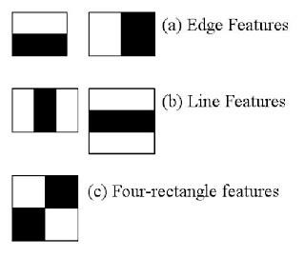
Figure 2.1 Haar-like Features (Docs.opencv.org, 2018)

2.1.6 Integral Image
The integral image is a method of calculating the Haar-like features on an image at any scale or location in constant time. Since Haar-like features are rectangles a single value result, which representing each feature can be computed by subtracting the sum of the white rectangle(s) from the black rectangle(s) (Mekha Joseph et al., 2016). The illustration is shown in Figure 2.2.
The features can be computed rapidly by using the integral image. The value of integrating image in a location is the sum of the pixels on the left and top of the respective location. To further illustrate, the value of the integral image at location 1 is the sum of the pixels in rectangle A. The values of integral image at the rest of the locations are cumulative.
For instance, the value at location 2 is summation of A and B, (A + B), at location 3 is summation of A and C, (A + C), and at location 4 is summation of all the regions, (A + B + C + D). P. Viola, M. Jones, (2001). This means that the sum within the D region can be computed with only addition and subtraction of diagonal at location 4 + 1 − (2 + 3) to eliminate rectangles A, B and C.
P. Viola, M. Jones, (2001). Mentioned in their paper “Rapid Object Detection using a Boosted Cascade of Simple Features” that Adaboost also known as, “Adaptive Boosting” is a technique, which is a learning algorithm that is used to boost the classification performance of a simple or “weak” learning algorithm. This helps to reduce the amount of false positives, which occur when the features of a face are found where a face does not exist in the image.

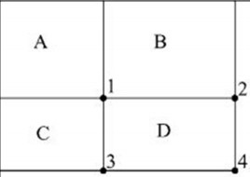
Figure 2.2 Integral image (P. Viola, M. Jones, 2001)

2.1.7 Feature Extraction
The features are the set of data that represents the information in an image. Facial feature extraction is very essential for face recognition. The selection of these features can be a very difficult task. To give high precision performance, the feature extraction algorithm must be consistent and stable over a variety of changes. There are quite a few feature extraction methods or algorithms for face recognition. In the paper of Zhao W, Krishnaswamy A and Sk. Tejus S Rao, Vinay T R (2019), N.Sudhakar Reddy, 2018 and S.Suresh Babu and NirmalyaKar, MrinalKantiDebbarma, AshimSaha, they proposed the use of the Eigen face algorithm which is based on the PCA (Principal Component Analysis) for face recognition.
Lahiru Dinalankara, (2017) in his paper “FACE DETECTION & FACE RECOGNITION USING OPEN COMPUTER VISION CLASSIFIRES” stated it is important that the images are in the same lightning condition and the eyes match in each image and the images used in this method must contain the same number of pixels and be in grayscale.
PCA feature extraction process includes all trained facial images. Hence, the extracted feature contains correlation between facial images in the training set and the result of recognition of PCA highly depends on training set image. Training images and test images are then projected onto Eigen face space to obtain projected training images and projected test image respectively.
The Local Binary Pattern Histogram (LBPH) is also another popular algorithm for face recognition. Lahiru Dinalankara, (2017) stated in his paper that local binary pattern was proposed as classifiers in computer vision and in 1990 by Li Wang. In the paper by Md. Abdur- Rahim et al. (2013), they proposed LBP to extract both texture details and contour to represent facial images. LBP divides each facial image into smaller regions and histogram of each region is extracted. The combination of LBP with histogram-dependent gradients was introduced in 2009 and has enhanced performance in some datasets.
Nandhini R, Duraimurugan N, S.P.Chokkalingam, (2019) stated in their paper “FACE RECOGNITION BASED AUTOMATED STUDENT ATTENDANCE SYSTEM” that the histograms of every region are concatenated into a single feature vector. This feature vector is the representation of the facial image and Chi square statistic is used to measure similarities between facial images. The smallest window size of each region is 3 by 3. It is computed by thresholding each pixel in a window where middle pixel is the threshold value.
The neighbourhood larger than threshold value is assigned to one (1) whereas the neighbourhood lower than threshold value is assigned to 0. Then the resulting binary pixels will form a byte value representing centre pixel.
LBP has a few advantages, which make it popular to be implemented. It has high tolerance against the monotonic illumination changes and it is able to deal with variety of facial expressions, image rotation and aging of persons. These overwhelming characteristics cause LBP to be prevalent in real-time applications.
The Local Discriminant Analysis (LDA) is another algorithm for face recognition. Also known as, the Fisherface technique the Fisherface algorithm builds upon the Eigenface technique. It is based on LDA derived from Ronald Fishers’ linear discriminant technique used for pattern recognition Rajath S Bharadwaj, (2018). The LDA extracts features by grouping images of the same class and separates the images of different classes. LDA is able to perform well even with different facial expressions, illumination and pose due to its class separation characteristic. Same class is defined by facial images of the same individual, but with different facial expressions, varying lighting or pose, whereas facial images of person with different identity are categorized as different classes. Same class images yield within-class scatter matrix meanwhile different class images yield between-class scatter matrix.

2.2 Automated Attendance System
It is a known fact that attendance is very important in the modern educational system. This, therefore, increases the need for an attendance system that does not require paper and physical interaction.
Attendance systems have been used to estimate the productivity and the effort put in by workers or employees of an organization and students in an educational set up for a long time. The advancement in technology has made it very clear that the traditional method or manual method of recording attendance, which involves physical books, registers and so on are becoming not only inefficient but also time wasting.
An automated attendance system is proposed to solve these problems by automatically taking the attendance of all employees and students, updating the attendance when needed and provide a report or assessment on a particular attendance.
The use of facial recognition in an automated attendance system reduces the physical contact with the individual who is having his/her attendance taken unlike RFID (radio frequency identification) which still requires the identification card of an individual to be scanned one at a time, this is also time inefficient. This problem also affects fingerprint identification where by the prints of an individual are scanned and then recorded in a database. It still requires the physical contact of the person and it will be done every time the attendance is to be taken. This will also be difficult considering there is a large number of students in the classroom. To use facial recognition for attendance, prior or during registration an image of should be taken alongside their matriculation number and other important information to be saved in the organizations database. By doing this each student will already have a recorded image in the organization’s database and once he/she passes through the recognition system or camera in a classroom the attendance will automatically be taken. This system will also be able to record more than one student at a time therefore saving time and increasing efficiency.

2.3 Theoretical Review
Rajath S Bharadwaj ( 2019), focused on the implementation of the automated attendance system using face recognition in educational institutions, where the attendance of the students was taken manually by calling out the student's names to check who is present and who is not. This method is referred to as the roll call method and it is time-consuming and inefficient.
Adding facial recognition to the attendance process can improve time efficiency and provide a hassle-free way of marking attendance.
Their suggested method sought to solve the limitations of existing programs by offering functionality such as face recognition, attribute extraction, derived features detection and student attendance analysis.
Tejus S Rao and Vinary T R (2019) stated in a study on the automated attendance system that most companies and organizations have their employees use identification (ID) cards to log their time of entry and exit. In the height of time during work hours, the number of people entering and exiting the office are usually high.
This will cause some kind of congestion in the workplace as people queue up to await their turn. Facial recognition systems provide a more efficient way to handle this attendance process.
Employees need not worry about logging their time because it is an automatic process. The system will take note of the time when an employee enters or exits the office.
E.Varadharajan (2016) laid emphasis on the implementation of Background Subtraction facial recognition. It is one of the most common image processing techniques in computer vision in which the background of an image remains static, which allows the foreground of the image to be extracted for further processing. This is done for accurate face detection, to check for images under different conditions. After background subtraction, the image is used for facial recognition.
S.Jeevitha (2016) developed an automated attendance system using Eigen faces in its face recognition techniques. The Eigen face method is very common due to its speed, learning ability and simplicity. By using this method, each image is reduced into small set of characteristic features, which are principle components of the initial training set of face image.
E.Varadharajan (2016) identified the success of the Viola Jones algorithm in face detection and how it has improved accuracy.
This algorithm consists of two stages training and detection. It converts the original coloured image into grayscale to determine the features of the face before converting it back to its original form while detecting a face in an image. It uses a cascade classifier and PCA (Principal Component Analysis) algorithm for feature selection and SVM (Support Vector Machine) for classification Kalyan Sourav Dash. (2014).
Paul Viola & Michael Jones (2001) implemented the use of integral image, which is used to calculate a Haar like features in an image. Images are represented in pixels and each pixel has a value. Haar like features can be represented as an array or a matric of numbers in an image. To calculate the Haar like features of an image, you calculate the sum of the intensities (Degree of Blackness and Whiteness) of the image which can be represented in matrices for example a 3*4 matric. To calculate this for a large number of features on an image will be computationally expensive. Paul Viola & Michael Jones stated that calculating the sum of the Haar features could be possible using the integral method. The integral method involves the summation of the pixels above and to the left of any pixel selected in an image.
They also stated to calculate the summation of a sub-region of an image you could use the corresponding region of its integral image.

2.4 Review of Related Works
Abdullahi Abdulkadir and Muazzamu (2019) were fully aware of the disadvantages in the manual method of recording attendance, which were time wasting, inefficiency in the attendance process, difficulty in accessing information, and these could lead to other issues in the end in any organization. They developed an attendance system with face recognition using the Retinex Algorithm. The Retinex algorithm is an algorithm that is used for image enhancement and for improving the quality of images. They stated that there are two Retinex algorithms called the Single Scale Retinex (SSR) and Multiple Scale Retinex (MSR) algorithm.
Their system used Single Scale Retinex with the bi-histogram equalization to enhance the quality of the face captured and then later apply a face recognition algorithm to detect and recognize the face that have been captured in the database. The system was created using MATLAB. The system met all the necessary requirements that were set for it, although it had limitations such as not being user friendly.
Godswill Ofualagba and Ise Anderson (2018) focused their system on solving the computational cost of image processing in face detection and recognition in a large-scale real time system by using Cloud-Computing. They stated to minimize the burden of having to maintain costly facilities for enrolment and recognition, it is suggested that the organization transfers the responsibility to third-party vendors that can maintain cloud-computing infrastructures for recognition.
Godswill Ofualagba and Ise Anderson (2018) stated that cloud computing would make efficient usage of resources by allowing easy, on-demand network access to a common pool of configurable computing resources such as networks, servers, storage, software and services that can be easily supplied and released with minimal management effort or contact with service providers.
Their program provided three people, the pupil, the teacher or the professor and the administrator, with online access. The students and instructors were allowed to create a personal account and enrol their faces into the system while it is the administrator’s responsibility to set the cameras in different classrooms on the system as well as other activities like account management and course management. The system was implemented using .NET technology on Visual Studio and Azure SDK.
Rekha A L, Dr Chethan H K (2014), designed an automated attendance system using face recognition through video surveillance.
The system was implemented to improve the efficiency of the attendance as well as the security of the organization with the aid of video surveillance. They made use of a moving object detection algorithm, which can extract moving objects that are interesting out of a background that can be static or dynamic. The system was able to detect moving objects with two methods, which were changes at pixel level, and the other is based on feature comparison. The system was able to perform the following functions:
- Generate data for training using a web camera, which the captured images will undergo, face detection and will be stored in the database.
- Monitor the movements in the video using a frame difference algorithm.
- Recognize the detected faces by undergoing a face recognition process where the test images will be compared with training images to perform recognition.
- After identification of the faces, refresh the attendance registry.
Although the system performed its necessary functions Rekha. A L, Dr Chethan H K did not use a recognizer that can perform under conditions with poor lightning therefore reducing the accuracy of the recognition process.

S/No. | Author(s) | Title of Paper | Problem Statement | Method used | Results | Contribution | Limitation
1. | Abdullahi Abdulkadir and Muazzamu | Attendance system with face recognition using the Retinex Algorithm | a) Eliminating the manual method of taking attendance using an automated attendance system with advanced face recognition techniques.  b) Reducing the time wasted in retrieving records that contain the attendance of the students and staff. | This system made use of the Single Scale Retinex with bi-histogram equalization to enhance the quality of the face captured and then applied face recognition algorithm to detect and recognize the captured face | The system solved the problems associated with the problems associated with the manual method of taking attendance. Security was also enhanced using authentication. | Included the Retinex algorithm that was used to enhance the quality of the images captured for face recognition. | The system constantly ran into errors and did not have a good user interface design.
2. | Godswill Ofualagba and Ise Anderson | Reduction of the face recognition aspect of automated attendance with the use of cloud computing. | Replacing the manual method of keeping files with an automated database system | This system used a cloud computing approach to enable convenient, on-demand network access. | As a result of the implementation of cloud computing image processing was performed at a much faster rate. The system was able to analyse more faces and yield better results quickly. | Developing a system that can manage both the attendance records and offers large storage space for the organization’s files | The maintenance cost of the system was high because of the required  Expertise in doing so.
3. | Rekha A L, Dr Chethan H K | Designed an automated attendance system using face recognition through video surveillance. | Increasing efficiency and interactivity in any area of specialization in the organization. | This system made use of the moving object detection algorithm for its video surveillance. | The system was able to generate its own training data and differentiate between faces and objects | Developing a computerized system that can reduce some of the manual work done by the staff | The system could not perform under poor lighting conditions.
Table 2.3: Summary of Literatures Reviewed

CHAPTER THREE

RESEARCH METHODOLOGY

3.0 Introduction
This section presents the methodology of the system. The presentation of this chapter begins with the capture of the image of the student using a simply user interface, which leads to the next step that is detecting the faces in the images using the Histogram of Oriented Gradients. Followed by extraction of features from the facial images using an algorithm called Facial Landmark Estimation, then subjective selection and finally classification of the face images that are going to be recognized. The use of automated attendance systems in institutions has aided in determining the level of participation of the students. The design of a secured online attendance management system is to improve the quality of the services rendered in the University. The process by which automated management systems are built is changing dramatically with the improved changes in information and technology.

3.2 Flowchart of the Attendance Management System
The flowchart displays control flow in the system modules. It is a visual or symbolic representation of a process. The flowchart makes no mention of how the data flows through the system.

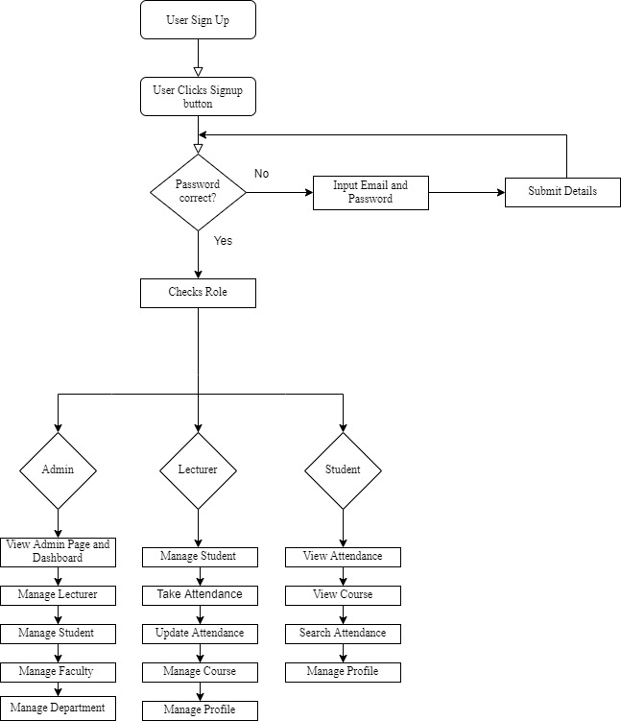

Figure 3.1: Flowchart of Attendance Management System

3.2 Use Case Diagram
The use case diagram is a graphical representation of the relationship between the elements of the system. A use case is also a technique used to identify, explain and coordinate system requirements in system analysis. Below are the different use case diagrams for this system.

3.2.1 Admin Use Case
The Admin will be able to login to the system, add users to and as well delete users from the system, interact with the dashboard and view other necessary details with the system. The Administrator will be able to manage the lecturers, students, faculties, departments and other aspects of the university.

3.2.2 Lecturer Use Case
The lecturer will be able to sign up for the system and also login to the system, search the attendance for specific students, view attendance, interact with the dashboard and update the attendance.

3.2.3 Student Use Case
The Student shall be able to sign up for the system, then login to the system, add their profile pictures to the system as well as other necessary details that is required of them to upload into the system. Students can view the attendance, search the attendance and update their profile when necessary.

Figure 3.2: Admin Use Case

Figure 3.3: Showing the Lecturer Use Case

Figure 3.4: Student Use Case

3.3 Class Diagram
This section presents the class diagram which outlines a class 's attributes and operations and the limits placed on the system as well. In the diagram shown below in Fig 3.5, It was used in the sense of the proposed scheme to describe the different categories of classes, objects and their respective instances alongside their relationships. The system has a class called the admin or the administrator that has the ability to add, delete and update records and checks the user login credentials. The system has a class called Student, that shows the attributes of the student class such as the registration number, student name and level (year). The figure also shows the attendance that stores the student registration number, status either present or absent and other functions such as searching the attendance list for students.

3.4 Design Details
The automated attendance system was developed on the Django Framework. Django is a Model-View-Template (MVT) or Model-View-Controller (MVC) python framework used to design and develop web applications. The MVC or MVT pattern mentioned earlier is a software architectural pattern that aids in separating the application into three main components which include The Model (contains the data), the View (contains the logic or functionality), and the Template (contains the user interface). This approach helps to unravel problems of going through different files during development. It helps keep track of the components of the application and system as a whole. The Model component is responsible for managing application data. The View is responsible for the functionality of the application its acts as the coordinator between the Model and the Template. A user requests a page through the template the corresponding view to that page will provide the information from the model it is assigned to before rendering the page to the user.

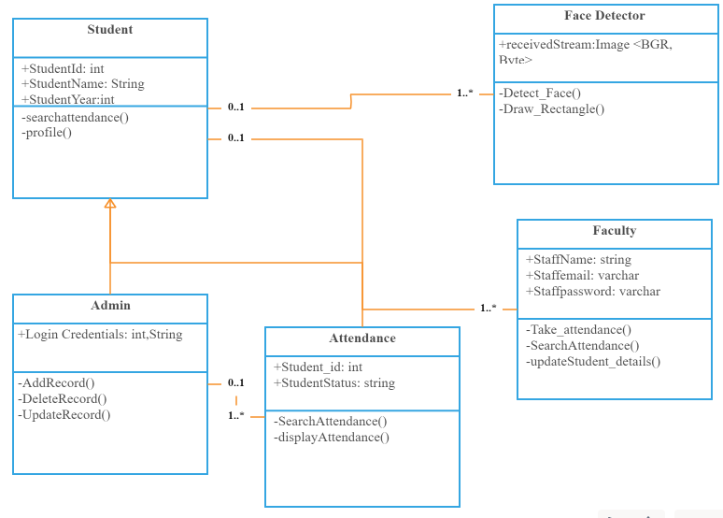
Figure 3.5: Class Diagram

3.5 Software Development Life Cycle
During the development of the system the iterative and incremental model were adopted and put to use. Iterative process starts with the basic implementation of a subset of software specifications and enhances iteratively the evolving versions until the full system is implemented. An iterative model of a life cycle does not seek to start with a complete specification of requirements. Design starts with only a part of the defined and implemented program, which is checked to determine additional specifications. This cycle is replicated, and a new version of the program is created at the end of each iteration phase.
The advantages of this model:
- Generates working software quickly and early during the software life cycle.
- Progress can be measured.
- Testing and debugging is easy during smaller iteration.
- More flexible – less costly to change scope and requirements.
The disadvantages of the model:
- Highly skilled resources are required for risk analysis.
- Although cost of change is lesser, but it is not very suitable for changing requirements.
- It is not suitable for smaller projects.
- More management attention is required.

Figure 3.6: Iterative and Incremental Model

3.6 Method of Data Collection
The method of data collection used for this project work are from both primary and secondary sources.

3.6.1 Primary Source
This method of data collection was used to collect data from the lecturers and students at the university. Some of the course representatives were interviewed on the methods of taking attendance during or after lectures.

3.6.2 Secondary Source
This includes the use of journals, internet and books with related articles on attendance management system to broaden my understanding in developing the system.

3.7 Methodology Flow
This project incorporates a method of student attendance based on face recognition. The flow of methodology starts with image capturing using a simple and functional interface, followed by pre-processing of the captured facial images, then extraction of facial images, subjective collection and finally classification of the facial images to be recognized. The project makes use of a face recognition module created by Adam Geitgey. This module uses OpenCV Haarcascades and the Histogram of Oriented Gradients algorithm to extract the features of the face in the image. Another algorithm called face landmark estimation will be used to come up with 68 unique points known as landmarks) that appear on each face, such as the outer edge of each eye, the inner edge of each eyebrow and the top of the chin, etc. The flow chart for tFhe proposed system is categorized into two parts, first is the image training process followed by the testing of the images to recognize the known from the unknown faces. The flow chart of the process will be presented below.

Figure 3.7: Flowchart of Proposed system

3.7.1 Load Images
The students upon registration will provide the images that are going to be used for this project. The images provided by the students will be used for the facial recognition process. The images provided will stored in folders with other necessary information concerning the student such as the matric number, department etc.

3.7.2 Face Detection
The OpenCV python library uses the Viola-Jones object detection framework which can be used to detect faces in video frame. The limitation to this framework is in the fact that the image (facial image) has to be a frontal image at which the individual’s face points towards the camera.

3.7.3 Pre-Processing
The training images are captured using a camera. This stage is used to improve the image quality. Therefore, some steps have to be considered before extracting the facial features in the image. These steps include conversion of colored images to grayscale, as we do not need color to find the face, re-scaling the image as the images have to be the same size before they are trained to ensure a more precise result.

3.7.4 Scaling of Image
One of the frequent tasks of image processing is the scaling of images. To avoid the lack of spatial information, the scale of the images needs to be carefully manipulated. In order to perform facial recognition, the scale of the image needs to be equalized (Rajath S Bharadwaj, 2019). This has become critical, particularly in the process of feature extraction, to ensure the precise result, the test images and training images must be of the same size and dimension. In this proposed approach the test images are standardized at size 250 × 250 pixels.

CHAPTER FOUR

IMPLEMENTATION AND RESULT

4.0 Introduction and documentation
This chapter presents the information of implementing an automated attendance management system. The design and implementation of an automated attendance management system takes into account several aspects that aim to include solutions to the challenges understood and established in academic institutions. It defines the methods and tools used in the system's development and implementation. These tools helped to design the system and improve the primary concept and functionality of the system in order to accomplish its defined objective.
This defines a series of functionality measures with their outputs within each module. The whole idea is a structure, a collection of objects that function together as components of a mechanism or an interconnecting system, a set of things that operate together as components of mechanisms or an interconnecting system, a series of interacting or interdependent issues that shape a set of components with other components.

4.1 Implementation
The system was built using the Django Framework. The implementation was divided into three main components which are frontend, backend and database. The Django framework used in this system makes use of the MVC/T (Model-View-Controller/Template) pattern. The Models deal with the database classes using the ORM (Object Relational Mapper) provided by the framework. It essentially allows for database interaction using object oriented programming languages.
The View handles the application logic and functions and the Controller or Template deals with the frontend and the user interaction. The MySQL and SQLite database backend which are supported by the framework were used for the implementation of the database. A Git repository was set up for configuration management.

4.1 How the Automated Attendance Management System works
The system works based on the functional and non-functional requirements that must be met by the users and the system. This system includes the core phases of software development cycle.

4.2.1 Functional Requirements
This section presents the service that the system must offer. It describes what the system does or must not do. It deals with the inputs to the software system, its behaviour, and output. The functional requirements for the development of the system are as follows:
- User Registration: the system users can register successfully with the system by filling in their information.
- User Account Management: Modify privileges, build user IDs, add or delete current accounts.
- Attendance: It provides detailed report of the attendance taken in the classroom.
- The system allows lecturers to view the attendance records.
- The system enables users (students) to view the course details – Department and Description.

4.2.2 Non-Functional Requirements
- The non-functional specifications are the constraints that specify the parameters that are used rather than specific activities to judge the system's operation. Security: the system implements measure to securely protect and safeguard information. Access permissions for users are only granted when the email matches with password.
- Reliability: The database update process must rollback all related updates when any update process fails.
- Performance: The webpage a low response which provides better quality for the users. It also has a responsive design meaning it provides dynamic pages that allow users to view necessary information on devices with different screen size.
iv. Dependability: the system’s ability to provide a service that consumers can justifiably believe.

4.3 System Requirements
The efficient use of the system required some hardware components and software components which must be present on the system. The system requirement is made up of the software and hardware parts that makes the system to be developed effectively.

4.3.1 Software Requirements
This section presents one of the most important elements in building a system which is compatible software. The following software are recommended for the successful implementation of the system.
Front- end technologies: ` HTML, CSS, Bootstrap, JavaScript, jQuery,
Backend technologies: Django database framework.
Database Management System: SQLite, MySQL
Version Control Tool: Git and Git hub.
IDE: Visual Studio Code 2019
Web Browser: Google Chrome, Mozilla Firefox
Face Recognition. Face-recognition python library, dlib C++ Library, CMake.

4.3.2 Hardware Requirements
When designing a device, hardware configuration is an important aspect to remember. The speed and efficacy of the whole machine can be compromised by inadequate random-access memory. To handle the complete operations, the processor should be powerful. The hard disk should also have ample file and device storage space. The following are the minimum hardware requirements.
Processor: Core i3 (Minimum)
Processor speed: 2.5GHz (Minimum)
RAM: 4GB (Minimum)
Hard disk: 500GB (Minimum)
Monitor Display: LED
Mouse: Touchpad with multi-touch gesture support, USB or PS/2

4.4 Screenshots of the pages Implemented
This section presents the proposed approach to the face recognition student attendance system with a user-friendly interface that was designed using Django framework. For specific functionality, some buttons were designed for their implementation. For example, a take attendance button to start or initialize the attendance process by activating the camera and perform the face recognition immediately, the add student button allows the registration of the student details, the search attendance button is to look through the attendance that has been taking earlier and the update button is to update the student details.
The results of the implemented Table called students as shown in Figure 4.1 was used to manage the information concerning the student’s records. The table contains attributes, such as: student’s first name, last name, year (level), registration number i.e. matriculation number, section (semester) and profile picture. The table in figure 4.2 was used to manage the information concerning the attendance records. It contains attributes such as the registration number of the student, the level of the student, the status of the attendance either present or absent. Figure 4.3 show the system Login page. The login form contains a field for the username and another field for the password which users are to provide to gain access to the system. Figure 4.4 shows the user interface of the system when user has been granted access. It presents the different buttons that would be used to begin the attendance process, register student details, update student details and search the attendance list for any student. Figure 4.5 shows the record generated when the attendance process is complete, it displays the student registration number, year, status.
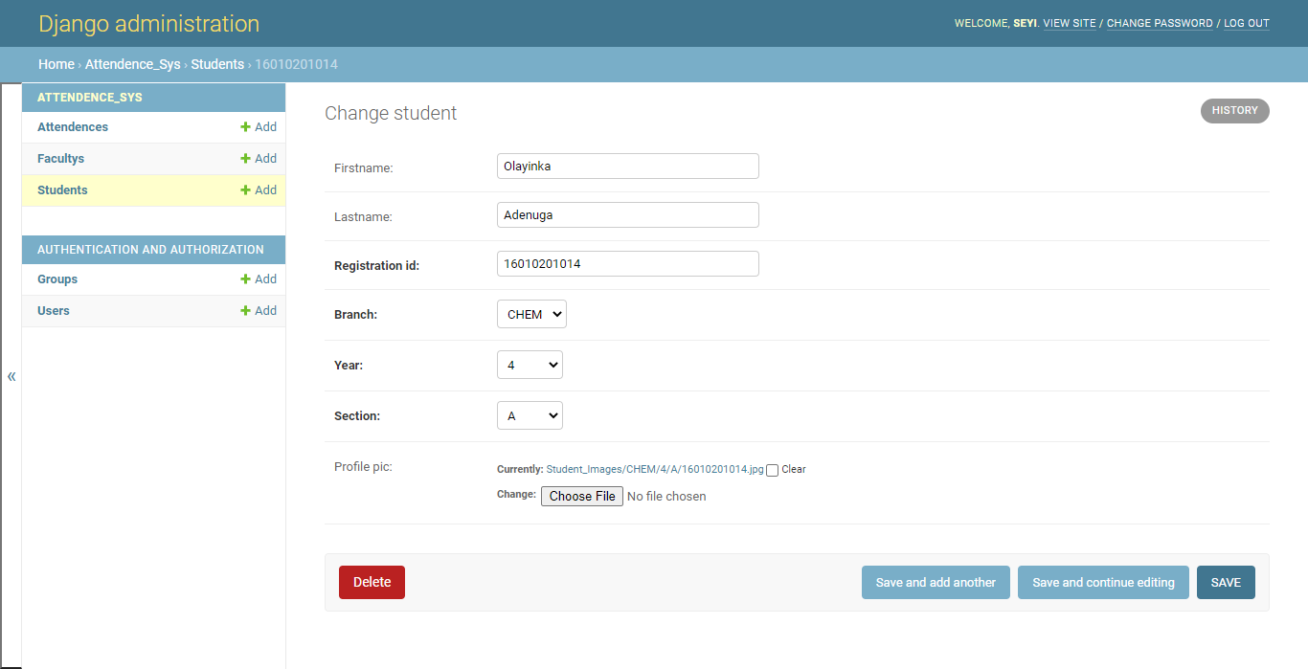
Figure 4.1: student database

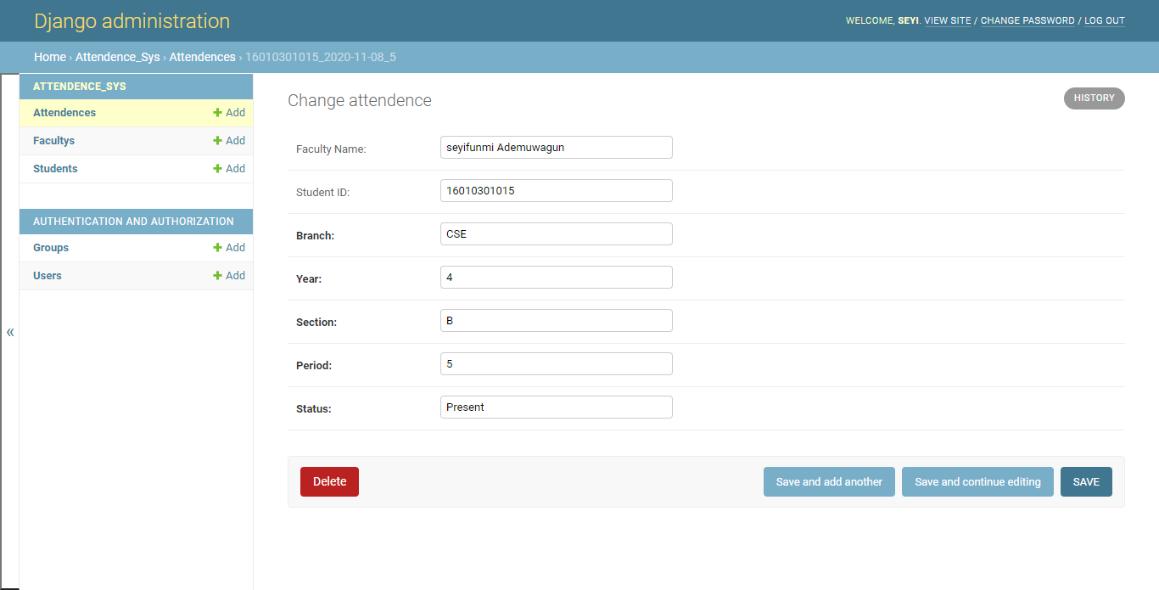

Figure 4.2: attendance database


Figure 4.3: Login Form

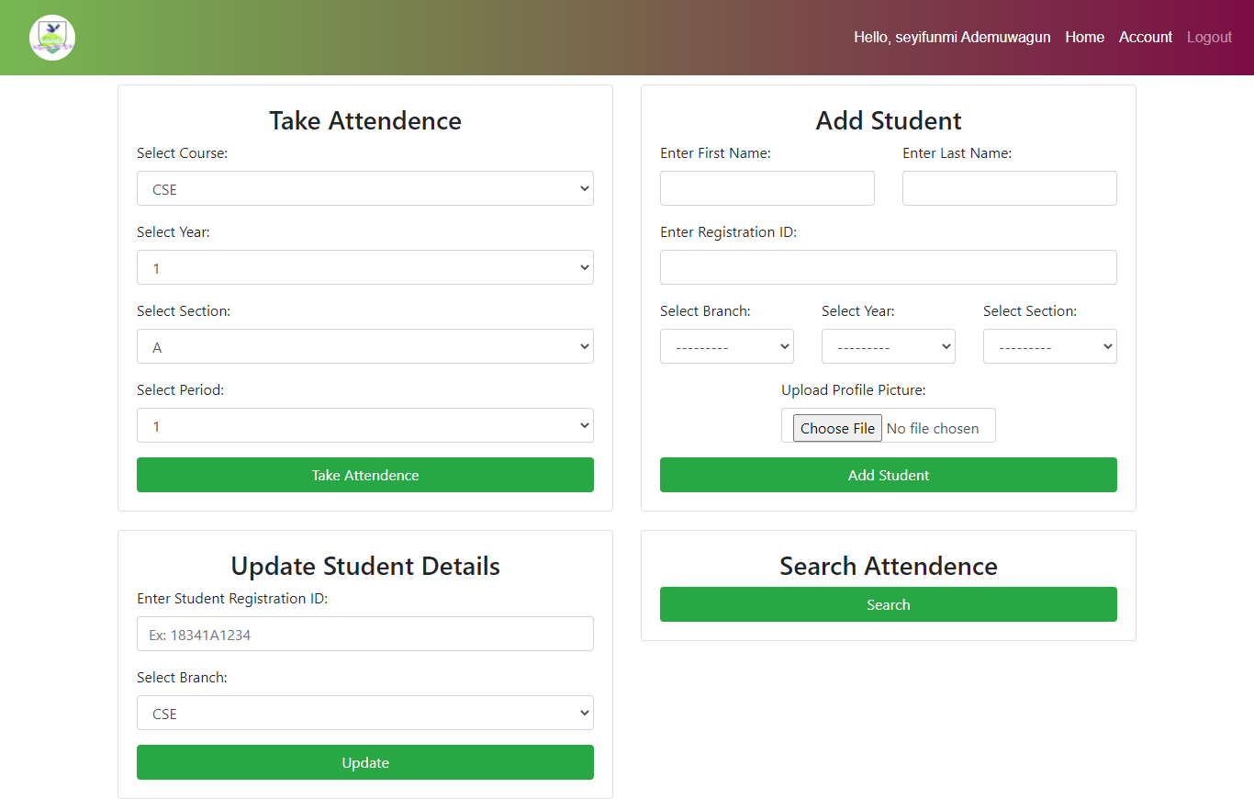
Figure 4.4: User interface of attendance system


Figure 4.5: attendance recorded

CHAPTER FIVE

SUMMARY, CONCLUSION AND RECOMMENDATIONS

5.0 Summary
Having reviewed the challenges encountered through the manual methods of taking attendance and keeping records in the university, this proposed system is believed to help eradicate the problems associated with the manual method by the introduction of an online system which manages the attendance process and makes documentation more efficient and more effective. The facial recognition attendance system adds value to the university as a whole as it reduces the workload of having to manually take the attendance of each student in the classroom and aids in the reduction of data error and manipulation. It can capture data. Store, and view, add and delete records into the database when required. During the development of this system, some challenges where encountered, some of them includes training a large dataset of faces to improve the accuracy of the face recognition system, and extracting facial features from low quality images.

5.1 Contribution to Knowledge
The main contribution of knowledge was the ability to implement a facial recognition attendance management system using Django Framework and Python face-recognition library. With the help of Django, the system is protected from security risks like cross site scripting, cross site request forgery.

5.2 Limitations
- large dataset of faces required to improve the face recognition algorithm.
- Videos captured before and during the attendance process occupy large disk space.
- Input images must be frontal and upright facing and

5.3 Recommendation for Further Study
It is recommended that universities and academic institutions currently practicing the manual system of recording attendance should switch to the electronic system because it is more efficient and easier to use. Also, since the use of computers is growing and improving globally, introducing the electronic system will enable the universities to fit into the current global trend. Other frameworks such as (Web2py, pylon, TurboGears) can be used in building attendance management system.

5.4 Conclusion
In conclusion, this study takes a look at the various problems associated with the existing system of taking attendance which is the manual method that mostly leads to false attendances, times wastage, loss of information and manipulation of the attendance records amongst others. With all these problem being critically analysed, a solution has been initiated to eliminate these issues. This study has designed and implemented a system for recording the attendance of the students in the university to eradicate these issues. The face recognition attendance management system doesn’t just eradicate the need for paper based attendance but also can increase the efficiency and productivity of the organization. The university administrators would be able to significantly monitor the operations.

References

Abdullahi Abdulkadir and Muazzamu Ibrahim (2019). Attendance system using the Retinex Algorithm. International Research Journal of Engineering and Technology (Oct 2019).
Akshara Jadhav et al. (2017) and P. Arun Mozhi Devan et al. (2017). Face detection for student attendance and the importance of the Viola Jones algorithm for face recognition.
Aleksandra Babich, Haagaa-helia, (2015). Various methods of User Authentication. Aleksandra Babich, Haagaa-helia, (2015). Types of Biometric Identifiers.
Aleksandra Babich, Haagaa-helia, (2015). Various methods of User Authentication. Aleksandra Babich, Haagaa-helia, (2015). Types of Biometric Identifiers. International Research Journal of Engineering
Attendance Management Using Facial Recognition Rajath S Bharadwaj, Tejus S Rao, Vinay T R (2019)
Azriel Rosenfeld, 2015. Definition of Computer Vision and its various fields. Wei-Lun Chao (2007). Factors that can affect face detection and recognition.
Central. [online] Mathworks.com. Available at:
Lahiru Dinalankara, (2017). Face Detection & Face Recognition Using Open Computer Vision Classifies https://www.researchgate.net/publication/318900718_Face_Detection_Face_Recognition_Using_Open_Computer_Vision_Classifies.
Face Recognition Based Attendance System Nandhini R, Duraimurugan N, S.P.Chokkalingam (2019)
Godswill Ofualagba and Ise Anderson Orobor (Sept 2018). Face Recognition Automated Attendance Management System.

Adrian Rosebrock (2018), OpenCV Face Recognition retrieved from https://www.pyimagesearch.com/2018/09/24/opencv-face-recognition/
Kalyan Sourav Dash. (2014). Face recognition using PCA - File Exchange - MATLAB
N.Sudhakar Reddy, 2018 and S.Suresh Babu. Face Recognition Based Attendance System.
NirmalyaKar, MrinalKantiDebbarma, AshimSaha, and DwijenRudraPal ,Study of Implementing Automated Attendance System Using Face Recognition Technique,International Journal of Computer and Communication Engineering, Vol. 1, No. 2, July 2012.
P. Arun Mozhi Devan et al., (2017). Smart Attendance System Using Face Recognition. Advances in Natural and Applied Sciences. 11(7), Pages: 139-144
Rekha A L, Dr Chethan H K (2014). Automated attendance system using face recognition through video surveillance.
Zhao W., Krishnaswamy A., Chellappa R., Swets D. L. and Weng J., " principal components for face recognition", Face Recognition, Springer 73-85.(1998) 4

APPENDIX
SOURCE CODE
from django.db import models
from django.contrib.auth.models import User
def user_directory_path(instance, filename):
name, ext = filename.split(".")
name = instance.firstname + instance.lastname
filename = name + '.' + ext
return 'Faculty_Images/{}'.format(filename)
class Faculty(models.Model):
user = models.OneToOneField(User, null=True, blank=True, on_delete=models.CASCADE)
firstname = models.CharField(max_length=200, null=True, blank=True)
lastname = models.CharField(max_length=200, null=True, blank=True)
phone = models.CharField(max_length=200, null=True)
email = models.CharField(max_length=200, null=True)
profile_pic = models.ImageField(upload_to=user_directory_path, null=True, blank=True)
def __str__(self):
return str(self.firstname + " " + self.lastname)
def student_directory_path(instance, filename):
name, ext = filename.split(".")
name = instance.registration_id # + "_" + instance.branch + "_" + instance.year + "_" + instance.section
filename = name + '.' + ext
return 'Student_Images/{}/{}/{}/{}'.format(instance.branch, instance.year, instance.section, filename)
class Student(models.Model):
BRANCH = (
('CSE', 'CSE'),
('IT', 'IT'),
('ECE', 'ECE'),
('CHEM', 'CHEM'),
('MECH', 'MECH'),
('EEE', 'EEE'),
)
YEAR = (
('1', '1'),
('2', '2'),
('3', '3'),
('4', '4'),
)
SECTION = (
('A', 'A'),
('B', 'B'),
('C', 'C'),
)

firstname = models.CharField(max_length=200, null=True, blank=True)
lastname = models.CharField(max_length=200, null=True, blank=True)
registration_id = models.CharField(max_length=200, null=True)
branch = models.CharField(max_length=100, null=True, choices=BRANCH)
year = models.CharField(max_length=100, null=True, choices=YEAR)
section = models.CharField(max_length=100, null=True, choices=SECTION)
profile_pic = models.ImageField(upload_to=student_directory_path, null=True, blank=True)

def __str__(self):
return str(self.registration_id)
class Attendence(models.Model):
# student = models.ForeignKey(Student, null = True, on_delete= models.SET_NULL)
Faculty_Name = models.CharField(max_length=200, null=True, blank=True)
Student_ID = models.CharField(max_length=200, null=True, blank=True)
date = models.DateField(auto_now_add=True, null=True)
time = models.TimeField(auto_now_add=True, null=True)
branch = models.CharField(max_length=200, null=True)
year = models.CharField(max_length=200, null=True)
section = models.CharField(max_length=200, null=True)
period = models.CharField(max_length=200, null=True)
status = models.CharField(max_length=200, null=True, default='Absent')
def __str__(self):
return str(self.Student_ID + "_" + str(self.date) + "_" + str(self.period))

