AN ONLINE HOSTEL MANAGEMENT SYSTEM

OLAWUYI VICTOR AYOMIDE
i

AN ONLINE HOSTEL MANAGEMENT SYSTEM

OLAWUYI VICTOR AYOMIDE
16010301009

BEING A PROJECT SUBMITTED IN THE DEPARTMENT OF COMPUTER SCIENCE AND MATHEMATICS, COLLEGE OF BASIC AND APPLIED SCIENCES
IN PARTIAL FUFILLMENT OF THE REQUIREMENTS FOR THE AWARD OF DEGREE OF BACHELOR OF SCIENCE
MOUNTAIN TOP UNIVERSITY, IBAFO, OGUN STATE, NIGERIA

2020

CERTIFICATION

This Project titled, AN ONLINE HOSTEL MANAGEMENT SYSTEM,
prepared and submitted by OLAWUYI VICTOR in partial fulfilment of the requirements for the degree of BACHELOR OF SCIENCE (Computer Science), is hereby accepted

(Signature and Date)

Adekola Olubukola Daniel

Supervisor

(Signature and Date) Dr. Akinyemi I.O.

Head of Department

Accepted as partial fulfilment of the requirements for the degree of BACHELOR OF SCIENCE (Computer Science)

(Signature and Date) Prof. Akinwande A.I.
Dean, College of Basic and Applied Sciences

DEDICATION

This Project is dedicated to God Almighty

ACKNOWLEDGMENT

I owe my profound gratitude to God Almighty who gave the strength, wisdom and courage, divine help and provision to me from the beginning to the completion of this work. I express gratitude to my supervisor, Adekola Olubukola Daniel, Head of Department, Computer Science and Mathematics, for his teachings, guidance, counsel and fatherly support in ensuring the successful completion of this research. God bless you Sir. My heart-felt gratitude goes to the Dean, College of Basic and Applied Sciences – Prof. Akinwande, A. I., and all other staff members of the department of Computer Science: Prof. Idowu, P. A., Dr. Ojesanmi, O. A., Dr. Adamu, O. B., Dr, Okunoye, O. B., M. O., Dr. Alaba, O. B., Dr.(Mrs) Olaniyan, O. O., Dr. Kasali, F. A., and other members of staff.

I acknowledge the constant support of my mentors who had contributed to my academic achievement. I pray God would continue to increase their knowledge. I will forever be grateful to my parents Mr. and Mrs. Olawuyi, who sacrificed wealth and enjoyable moments of their lives for the sake of my success; and my siblings – Prosperity and Progress for their prayers and support.
I heartily thank my parents and siblings, thank you all for your moral and financial support. I am grateful for all the investments into my education and future. I would not forget to remember all the students in the Department of Computer Science and Mathematics, for making my stay a worthwhile one, I say God bless you all richly.

I would also like to thank my very good friends who contributed by assisting me in my project. God bless you all!

ABSTRACT

This project is based on the Design and Implementation of an Online Hotel Management System for use at the Mountain Top University Hostel. It evolved from the manual file record system used to store hostel details, room details, student records, hostel allocation and other data in the hostel. With the help of the internet, computers and other mobile devices are used to manage hostel records and help the administrator effectively access these records. This project aims to create an efficient and reliable hostel management system that can do all the manual work with ease. In order to achieve its aim and objectives, a database was created, and design steps were taken using the iterative and incremental model. This project is carried out using PHP, MySQl with other frontend and backend technologies using Visual Studio Community 2017 as the Integrated Development Environment.

The Hostel Management System created is useful in helping hostel administrators, record officers monitor and manage their respective operations properly. It is also a faster and more efficient way of keeping hostel records and monitor them.

Keywords: Allocation, Application, Data, Database, File Management, Hostel

TABLE OF CONTENTS

Content Page

Title Page i

Certification ii
Dedication iii
Acknowledgment iv
Abstract v
Table Of Contents vi
List of Tables ix
List of Figures x
CHAPTER ONE: INTRODUCTION
  - Background to the study 1
  - Statement to the problem 1
  - Aim and objectives 2
  - Scope of the study 2
  - Significance of the study 2
  - Definition of terms 2
  - Organization of subsequent chapters 4
CHAPTER TWO: LITERATURE REVIEW
  - Introduction 5
  - History of Hostel 5
2.1. Impact of Hostel 5
  - Existing system 11
    - Analysis of the existing system 11
    - Problems of the existing system 12
  - Review of information system 12
    - Management information system 12
    - Transaction processing system 13
    - Decision Support system 13
    - Workflow automation 13
    - Process reengineering 13
  - File organization 14
  - Review of related words 16
  - Summary of literature review 16
CHAPTER THREE: METHODOLOGY
  - Introduction 17
  - Requirement gathering 17
  - Implemented system 17
  - Database structure and development 19
    - Database design(the table structure) 20
  - Input design 20
  - Process design 21
CHAPTER FOUR: SYSTEM DESIGN AND IMPLEMENTATION
  - Introduction 24
  - System design objective 24
  - System design 24
    - Logical design 24
    - Conceptual design 25
    - Physical design 25
  - System requirement and model 25
    - Software requirement and constraints 25
    - Hardware platform 26
    - Networking requirements 27
  - System development 27
    - Student login module 27
CHAPTER FIVE: SUMMARY, CONCLUSIONS AND RECOMMENDATIONS
  - Introduction 39
  - Summary 39
  - Conclusions 40
  - Recommendation 41
  - Contribution to knowledge 41
  - Limitation of the study 42

References Appendix

 | LIST OF | TABLES
Table |  |  | Page
3.1 | Students table showing students details |  | 20
3.2 | Admins table showing admins details |  | 20

 | LIST OF FIGURES
Figure |  | Page
3.1 | Context-level DFD | 21
3.2 | Registration process | 22
3.3 | Admin module | 22
3.4 | Allotment process | 22
3.5 | Use case diagram | 23
4.1 | Showing the Home page | 27
4.2 | Showing the user registration | 28
4.3 | showing the User login dashboard | 29
4.4 | Showing the admin login interface | 30
4.5 | Showing the book hostel interface | 31
4.6 | Showing the room details | 32
4.7 | Showing the students test profile | 33
4.8 | Showing the Admin interface | 34
4.9 | Showing the add room interface | 35
4.1.1 | Showing the Manage rooms interface | 36
4.1.2 | Showing the registered students | 37
4.1.3 | Showing the access log | 38

CHAPTER ONE INTRODUCTION

BACKGROUND TO THE STUDY

Hostels are concerned with human life, provides cheap food and lodging for people and also students who stay away from home. It has large well ventilated dormitories and single rooms and is situated in the school premises (Advanced Dictionary). Providing clean and calm hostel accommodation is one of the key responsible of school management. To manage the hostel facilities, a lot of data need to be maintained such as number of student hostel can accommodate, hostel rules and regulation, hostel fee, hostel in and out of student, guest and visitor record and so on (Ayaka, 2015). Hostel porters and can easily maintain the data. Hostel Management in schools often involves administering of all activities of students. All these still remain difficult and require some job for the top management. Hostel Management functions and responsibilities in modern day schools have always been a problem in managing, because of the manual system method of tools they use.

Hostel Management System is well designed specially to meet challenges of administrative set up of any school. Hostel Management System (HMS) can be used to assist in student’s allocation, setup hostel information, hostel application, and visitor management. In short, this system would assist the staff in managing some of the hostel activities (Ayaka 2015). Hostel Management system simply implies the way in which the allocation and management of the system is being done. In this context, this project examines how we can automate the allocation of rooms in Mountain Top University, since the University kicked off in 2015, the rate at which students are being admitted seem to increase every session, therefore, there is a need to develop an application which would make the allocation of rooms to the students much more easier than the traditional method being used, this application would allow students who have payed their fees be given allocation without need for physical application.

STATEMENT OF THE PROBLEM

Many challenges are faced with the manual method of keeping records. The challenges faced with this manual system include time wastage in searching for registers, inadequate use of statistical data, error prone calculations, and redundancy of information. Discovery also showed that an institution like Mountain Top University still use the traditional method (paper and pen) for collection and storing of students’ hostel information.

Also, The process of student’s registration for accommodation is stressful. A student will have to move from one office to the other, whereas this can be done online. This project is aimed at devising a system that will eradicate these above problems and improve efficiency.

AIM AND OBJECTIVES

The aim of this research is to design and implement an online hostel management system using Mountain Top University as a case study. The specific objectives are to:

- Identify and model the requirements specification to develop the system.
- Design and develop a central database system that would serve as hostel database, which will contain all the records related to Hostel.
- Providing data integrity of the student using approved login.

SCOPE OF THE STUDY

This project is focused on the development of an online hostel management system for Mountain Top University. The modules considered are: room allocation, rooms registration, student reports; and student data records.

SIGNIFICANCE OF THE STUDY

The project is aim at enhancing easy and accurate room allocation to the students. Apart from the project which is majorly significant to Mountain Top University Hostel allocation system, it will also benefit other institutions who want to change from the manual method of room allocations. The program code can also be useful to those who intend to develop a similar application.

DEFINITION OF TERMS

Allocate: To give a portion of something to an individual.
Computer data: Data and information are stored on a computer using a hard drive. Its is basically an information stored on a computer.
Computer Program: are instructions given to a computer.
Data: small unit of information collected for reference or analysis.
Databases: interrelated set of information or data collected and stored.
Hostel Management System: is a software developed for managing various activities in the hostel. It helps hostel admin in managing records of the hostel in an efficient manner.
Hostel: is a form of low-cost place where guests can rent a bed, usually a bunk bed in a dormitory.
Management Information System (MIS): is a broadly used and applied term for a three-resource system required for effective organization management. The resources are people, information and technology, from inside and outside an organization, with top priority given to people.
System: A set of detailed methods, procedures and routines created to carry out a specific activity, perform a duty, or solve a problem.
Students: Someone who is learning a school or other educational institution.

CHAPTER TWO

LITERATURE REVIEW

INTRODUCTION

This chapter briefly discusses the review of the technique used for the existing system, and also techniques used in the development of the new system, here the projects that has been carried out concerning the hostel management system would be discussed, and also researches that had been done on the project work

HISTORY OF HOSTEL

Hostels are popular forms of lodging for students. Its also a shelter for the students who come from a far place. According to (Slovenia) The first hostel was recorded in 1909, Germany. Richard Schirmann, a teacher, felt the need for an affordable place to stay for his students while they are on short vacations.
He also wanted them to experience things that were not typically taught in school. In 1912, he opened the first hostel, which was located in the Altena Castle in Germany. He made it a point that students learn how to do household chores by letting them help in cleaning and cooking. The hostel was also affordable because they sleep together in a dorm room, so they saved money. Students also live there with each other and learn various values and skills

    - IMPACT OF HOSTEL

In a situation whereby a student go for further studies in another institution or stays away from home, they live in a new place for a particular time which can be referred to a hostel life. The atmosphere of a hostel in more preferable by students because of growth, independence and freedom.
Been in a hostel brings different opportunities as the students meets new people in a new environment. Hostel life also involves interacting with different people. For an introvert it’s challenging to build interaction, but with time one ends up having friends and making memories. Hostel environment gives an opportunity for socialization among students (Mimrot, 2012).

Boarding or hostel life is a combination of different cultural backgrounds, in the hostel life students learns to live with different cultural background people (Shah, 2010).

There is a popular quotation “Times change people changes” it is best applicable for the hostel students. Hostel life going to change the way a student is, its effect on the personality behavior, thinking, and dressing as well. In hostel students are surrounded by other students of about the same age as they are, all those students have different characteristics. In hostel life all students have to adjust to the other students stayed in the hostel (Thakkar, 2012).

OBJECTIVES
The objective of the proposed system is to help automating hostel management activities. The system which will consist of two modules; Administrator Module and Student Module should have individual access.
For effective functionality, the program needs to include some basic features:
Allocation and checking of room availability: This is one of the major aspects of HMS which the current system lack, the students have to walk up to their house keepers and porters for enquiry about their room allocation which is a waste of time.
Checking in and out of hostel: The system will ease checking in and out of the hostel instead of going to the hostel office. The process can easily be done by the students on the system.
Complaints: There is also no automated system for lodging of complaints and appointments when hostel matters of issues arise. The system will ease the process. Other interface that would be included in the system are:

Administrator module:

This module should be able to manage the main data and information. Other activities like:
Login in as an Admin: Only the authorized user is allowed access to the portal with a user account and password for verification.
Accept the application of students: They should be able to accept the hostel applications of students
Reject applications: Application of students who are not qualified, unauthorized or haven’t paid the required fees will be rejected by the admin.
Allocate rooms: The system should be able to allocate rooms to qualified students.
View hostel applications: The system should also allow the staff to view the hostel applications.
View and reply the complaints of the students: Student complaints should be able to be viewed and replied by the admin.
Add and delete from the database: name or details of a student can be deleted by the staff.
Broadcast message: The relevant should be able to send a message/ announcement to the students.

Student Module:

Students should be able to check room status and other activities like:
Login to Student Profile: Only authorized students are allowed to access the information to the website once he/she verifies themselves by providing user account and password.
View Profile: Students can only view their profile and are not allowed to make any changes. If any changes they want to make, they must approach to administrator or warden.
Change Password: Students can change or update their password by entering old and new password.
Enroll their complaints: Students can make register complaints regarding various hostel facilities like electrical, plumbing, others.
Submit application form for rooms: Student can submit applications for rooms or change of rooms.
Checking Broadcast message: Student can check a broadcast message send the portal/staff.

View Application Module:

This module is where students can view their application status, if the application has been approved on status below it would appear approved, otherwise it would appear pending.
The Project Deliverable is web-based system, which would be integrated under MYIIUM website, which is similar to hotel systems, where students can check room availability and perform booking, payment and many other processes online without any physical interaction which cause time and effort wastage.
Key functionalities of the suggested system are listed below as follows:

The proposed system contains two modules namely

(I) Student module and

(ii) Admin Module.

It is proposed that both work in an integrated manner to enhance work activities and facilitate the functionalities of the various units in the HRMS.

EXISTING SYSTEM

Hostel administration work all should be done online which the existing system lacks. The yearly increase of students in the University will definitely bring about data redundancy, human error, bad record keeping and more drawbacks on the long run.
Checking of room allocations, enrolling of complaints, student registration, hostel dues registration among others are done physically and requires manual entry. With an online hostel management system, the workload will reduce. The system is user-friendly and GUI- oriented.

ANALYSIS OF THE EXISTING SYSTEM

In different universities, there are various mechanical methods in which rooms could be distributed evenly to students. The most common method used follows steps;
- Getting the total number of halls available
- Taking not of the maximum capacity of each hall
- Taking note of the number of rooms available in each hall
- Taking note of the available bed spaces in each room

Most students are allocated based on the first room in the halls, but levels and course of study are also taken into consideration, in some situations, students offering the same courses or on the same level are not allowed to stay together in the same room, while some students are given rooms based on health issues, whatever happens, when the first room allocated is filled up, we’ll have to move to the next room, till all the rooms are filled up, then we move to another hall of residence.

LIMITATIONS OF THE EXISTING SYSTEM

During a review of the existing system, there are some drawbacks in the allocation of rooms, record management and other activities.
- Record management and searching is a very difficult job.
- Lodging of complaints regarding hostel facilities.
- The process of checking of room allocations is tedious

The development of the new application will eradicate all these drawbacks. The development of the application would make easy the allocation of hostels to the students

REVIEW OF INFORMATION SYSTEM

Information system which is a collection of multiple pieces of equipment are used by enterprises and corporations to interact with their customers, perform operations and carry out their marketing campaigns.
It can also be used by individuals who rely on Information System to interact with friends on social networks and other day-to-day activities.
A good example is the database management system (DBMS) which is a combination of software and data that makes it possible to organize and analyse data.

MANAGEMENT INFORMATION SYSTEM

A management information system (MIS) is a computer-based system that supports the information’s needed of different levels of the management. This type of systems is designed to help the management make formal decisions. Most management information systems are designed to work with transaction processing systems. They produce reports that tell managers how well they are meeting goals.
Although, management information systems continue to play an important role in organizations, they have drawbacks. They generate predefined reports that may not be available when it is needed and it might be buried in reams of printout.

TRANSACTION PROCESSING SYSTEM (TPS)

A transaction processing system (TPS) also called an operational system or a data processing system handles day-to-day accounting needs of an organization. In commercial organizations, a TPS is often linked with an inventory control system so that sales personnel would know whether an item is in stock. Transaction processing systems date to the earliest years of business computing, and the cost saving they introduced help create a huge market for business computers. A TPS saves money by automating routine, labor intensive record keeping.

DECISION SUPPORT SYSTEM (DSS)

A decision support system (DSS) addresses the deficiencies of management information systems by enabling questions to be asked that cannot be answered by fixed, predefined MIS reports, for example, a retail chain manager can ask how an advertising campaign affect sales of advertised versus non-advertised items. Many DSS applications enable managers to create simulations that begin with real data and ask what-if questions, such as ‘what would happen to profits if we went with a shipper who could cut our packaging costs by certain percentage? Online analytical processing (OLAP) provides decision support by enabling managers to import up-to-the minute data from transaction databases.

WORKFLOW AUTOMATION

In most organizations, important documents must go through a series of personnel for approval. For example, in a department of a university, every student collects a course registration form. The students fill the form and take it to a course handler for approval, on approval of all the courses the student is registering for he/she takes it to the class coordinator before the student satisfies the process of registration. Workflow automation can greatly speed this process by automatically sending a document to the next person who needs to see it and approve it.

PROCESS REENGINEERING

Process reengineering, also known as re-engineering, refers to the uses of information technology to bring about a major change in an organization’s structure. At the core of re-engineering is the principle that information technology (IT) does not bring big payoffs if you simply automate existing work processes. The key to big payoffs lies in using IT to change existing processes.

FILE ORGANIZATION

The advent of modern software was celebrated for its unique characteristics of been able to store information for a considerable long-time. Initially, the major method of storage, which could be relied upon for a period, was physical records, files and magnetic tapes that were rather cumbersome. Thus, the introduction of modern devices such as compact disc, Flash drive, External hard-drive and so on, information storage on long term basis got into a new dimension. Information security and protection was a necessity since the first time a programmer has actually wiped out an already debugged program, was loaded with other one still under developing due to problems yet to be ascertained with the latter.

Student management

According to Marvish, (2003), Student Information Management System (SIMS) is a student-level data collection system that allows the department to collect and analyze more accurate and comprehensive information, to meet federal and state reporting requirements, and to inform policy and programmatic decisions. Student Information Management System provides the complete information and management for the students, parents, faculties, and other staffs of the institution. Some of the features of the Student Information Management System for management are provide management information for decision making, provide easily accessible information for all appropriate, provide information that is accurate, consistent, timely, reliable, and complete, reduce administrative costs, provides information about new management policies, fee structure, date of payment, new rules and helps management keep track of profiles and performance of all students in the institutions. These are some recommendations which merit further consideration, though they cannot yet stand on their own and these are identified in the attached analysis.

Students have a range of choice in the room’s allocation system. First-years fill in a form that provided by UiTM before arrival, indicating the rent band of the room they would prefer. They also can contact Student Affair office if they need house to rent and not interested to stay at the college or maybe college did not provide to them.

REVIEW OF RELATED WORDS

Ezzat F. Guirgius. A review of the hostel situation in county down. Northern Ireland Queen Street Mental Health Centre, Toronto, Ontario, Canada. In 1992, the working party was set up to report on the hostel situation in co. down, Northern Ireland and to make recommendations regarding future needs. The hostels have been in existence in co. down since 1963 and have increased from four beds to 102 beds at the time of the report.
Smithey. PN (1999). Empower and Partification: A contextual analysis of resident management in public housing, 150.
A journal has been written by Smithey.P discuss about a contextual analysis of resident management in public housing. Resident management is a policy that allows the tenants of the apartment to act wisely fully to settle the community problem, gain the support from public and some funding. By using black empowerment cities as a research, Smithey find out a suitable way to manage resident in public housing. By using this journal, one can know what was needed in an apartment or hostel for students to live and what are the requirements for a good resident.

Bowman k. (2007) A new role for student housing, revitalizing a mid-sized city core, 174. The journal has been written by Bowman K. the journal discusses about students residence. The survey from 380 respondents’ shows 1.6% expressed a desire to live in a student residence. Majority of students’ response indicate that they want to choose their own living environment than dormitory standard space. The other results shows that they would like to add the parking lot, restaurants and grocery store as the additional facilities at their resident. The apartments that are provided to students have occupancy range from one to four people. The individual rooms were organized suitable to the student’s activities in their rooms.

Pulvis C.L. (2008). The ecological footprint of hostel tourists in Ontorio and Quebec. This journal had been written by Pulvis C. and it discusses about hostels survey. This survey required detailed information on sample hostels. The survey was designed appropriately to collect the information about the hostel. A qualitative questionnaire was designed to get their opinion about the sample hostels. The collected information includes the occupants, the month that gets higher occupants, and the facilities of the sample hostels. After the survey, the manager will make the analysis about the sample hostels.

SUMMARY OF LITERATURE REVIEW

Is a review of literature relevant to the research topic; introduction to the chapter, overview of hostel and brief history of hostel would be discussed. Also to be discussed are the type of hostels and a quick look on several literatures on this work before ending with my proposed contribution.

CHAPTER THREE METHODOLOGY

INTRODUCTION

This chapter provides a methodology of the Hostel Management System to be built. The presentation of this chapter begins with flowchart, use case diagrams, design details, software development life cycle and Requirement gathering.

Methodology of research is the concept within which research is planned or organized(Okwor 2012). The design of a secured online hostel management system, is to improve activities in the hostels

REQUIREMENT GATHERING

The way the requirement of the system that is being used and the one that is to be created were thoroughly gathered through personal interview with the hostels House keepers, portals, security personnel’s and other hostel workers, by knowing their views and what is wrong with the current system, and what improvement that can be made to the new system that is about to be created.

IMPLEMENTED SYSTEM

The system was based on different system programs and software’s

Technology Implemented: Apache Server

Language Used: PHP 5.3

Database: My SQL 5.5

User Interface: HTML, AJAX

Web Browser: Chrome or Internet Explorer 8(or newer)

Software: XAMPP Server

Operating System: Windows XP or higher versions.

This project work is also aimed at the development of a system which would keep records and show information about or in a hostel, this system is designed to help the officers (House keepers and porters) manage the affairs of things going on in the hostel, the system provides the full information needed about a student in a hall of residence, it would show available and unavailable
rooms and the number of students allocated to a particular room. Also would include the user modules for the officers (Housekeepers and porter). There would be an administrator module which would be accessed by the administrator and has the ability to delete and edit the records of the students. This system was based on Software Development Life Cycle(SDLC) with HTML and CSS used for the front end of the development of the application, while PHP and MY SQL server would be used for the backend development of the application. PHP is good for the development and designs of web based applications and SQL is good in the usage of databases because its security reliant and because the improved, advance property and features.
Here we are going to give basic definition of some terms used in this methodology:

HTML:HTML stands for Hyper Text Markup Language, HTML is the standard markup language for Web pages, HTML element are the building blocks of HTML pages, HTML elements are represented by <> tags.

CSS:CSS stands for Cascading Style Sheets, CSS describes how HTML elements are to be displayed. CSS is a stylesheet language that describes the presentation of an HTML (or XML) document. CSS describes how elements must be rendered on screen, on paper, or in other media. CSS saves a lot of work. It can control the layout of multiple web pages all at once. External stylesheets are stored in CSS files

MYSQL: MySQL is an Oracle-backed open source relational database management system (RDBMS) based on Structured Query Language (SQL). MySQL runs on virtually all platforms, including Linux, UNIX and Windows. Although it can be used in a wide range of applications, MySQL is most often associated with web applications and online publishing. SQL is a standard language for accessing databases

PHP: PHP (recursive acronym for PHP: Hypertext preprocessor) is a widely-used open source general-purpose scripting language that is especially suited for web development and can be embedded into HTML.

XAMPP: Xampp is a free and open source cross-platform web server stack package developed by Apache Friends, consisting mainly of the Apache HTTP Server, Maria DB database, and interpreters for scripts written in the PHP and Perl programming.

DATABASE STRUCTURE AND DEVELOPMENT

A database is a collection of interrelated date stored with minimum redundancy to serve many users quickly and efficiently. The general objective is to make data access easy, quick inexpensive and flexible for user. Relationships are established between the data access easy, quick, inexpensive and flexible for the user Relationships are established between the data items and unnecessary date items are removed. Normalization is done to get an internal consistency of data and to have minimum redundancy and maximum stability. This ensures minimizing data storage required, minimizing chances of data inconsistencies ad optimization for updates. The MySQL database was chosen for developing relevant databases. In the creation of the database for this project,.5 the most suitable database platform to use for this project was MYSQL (My structured query language) which was used to store username and passwords for the different modules (i.e. the Admin and the Student module), Also the use of PHP (Hypertext processor) would be used to connect to the SQL database.

INPUT DESIGN

The design of input focuses on controlling the amount of input required, detecting errors, avoiding delay, avoiding extra steps and keeping the process simple. The system needs data regarding the asset items, depreciation rates, asset transfer, verification/validation checks, calculation and report generation. The error detection method included in the software helps to raise flag when wrong entry is fed into the system.

Flowchart of the Hostel Management System

The flowchart shows the flow of control in program modules. It is a visual or symbolic representation of a process.

No
Yes
User Sign Up for the system
User clicks on the Sign In button
Password correct?

Input email and password
User submits the form
Check Role
Manage Student
Application verifying verifying
Allot or vacate
Manage Profile
Allotment
Make complains
Application filling
Manage Profile
Yes

Yes
Student

View Student Dashboard
Admin

View Admin Dashboard

Figure 3.1: Flowchart of the Hostel Management System

Use Case Diagram
A use case diagram is a graphical representation of the relationship between the elements of a system. A use case is also a methodology used in system analysis to define, clarify, and organize system requirements (WhatIs, 2015). The following are the different use case diagrams for the system:

Admin Use Case
The Admin should be able to sign up for the system, login to the system, interact with the dashboard and view what the system has to offer. Record Officers shall also be able to view students records in the hostel, check students requests or complaints, make announcement and update profile.


Admin
Sign Up
Sign In
View Dashboard
Manage Student Records

Check Requests
Announcement
Change Password
Edit Profile

Fig 3.2: Admin Use Case

Student Use Case
The Student should be able to login into the system using their matric number, interact with the dashboard, check room availability, report complaints, report maintenance, view broadcast messages, change password and update profile.

Student
Sign In
View Dashboard

Check Room Availability
Report Complaints
View Messages
Check in/out
Change Password
Edit Profile

Fig 3.3: Student Use Case

Design Details
The language used on the online hostel management system is PHP, Technology Implemented is Apache Server Language with a functional My SQL database. The User interface was created using HTML, AJAX Web Browser.
Basic definition of some terms used in this methodology:
HTML: HTML stands for Hyper Text Markup Language, HTML is the standard markup language for Web pages, HTML element are the building blocks of HTML pages.
CSS: CSS stands for Cascading Style Sheets, CSS describes how HTML elements are to be displayed. CSS is a stylesheet language that describes the presentation of an HTML (or XML) document.
MYSQL: MySQL is an Oracle-backed open source relational database management system (RDBMS) based on Structured Query Language (SQL).
PHP: PHP (recursive acronym for PHP: Hypertext preprocessor) is a widely-used open source general-purpose scripting language that is especially suited for web development and can be embedded into HTML.
XAMPP: Xampp is a free and open source cross-platform web server stack package developed by Apache Friends, consisting mainly of the Apache HTTP Server, Maria DB database, and interpreters for scripts written in the PHP and Perl programming.

Software development life cycle

The iterative and incremental model was adopted and used for the development of the system. In this model, the iterative process begins with a simple implementation of a small set of software requirements and iteratively enhances the evolving versions until the entire system is implemented and ready for deployment. An iterative life cycle model does not attempt to begin with a full requirements specification. Instead, development begins with only part of the software specified and implemented, which is then reviewed to identify additional requirements.
This process is then repeated and at the end of each iteration model, a new version of the software is produced.

The following diagram is a representation of the iterative and incremental model. (Tutorialspoint, 2019).

Design & Development
Testing
Implementation
Design & Development
Testing
Implementation
Design & Development
Testing
Implementation
Build 1
Requirements
Build 2
Build 3

Figure 3.4: Iterative and Incremental Model

Requirement gathering
The requirement of the system was gathered through the hostel House keepers, portals, security personnel’s and other workers.
The hostel officers shared their thoughts on the issues and problem of the current and possible improvement which can be implemented into the new system.

CHAPTER FOUR

SYSTEM DESIGN AND IMPLEMENTATION

INTRODUCTION

This section talks about the implantation of this project, this chapter discussed about the system design and analysis, it includes pictures from the application and the interfaces involved in the development of the application and also the methods used in the development, the whole object is building a system which are set of things working together as. parts of a mechanism or an interconnecting system, it is a set of interacting or interdependent component forming an integrated whole or a set of elements to other elements.
Some characteristics of a system include:
    - A system has a particular behavior; it contains processes that transforms inputs to outputs.
    - A system has interconnectivity, the parts and processes are connected by structural and behavioral relationship

SYSTEM DESIGN OBJECTIVE
The hostel management system is a software application that would offer help and assist the students in an effective way, which would give them less stress and trouble in the allocation of their hostel rooms.

SYSTEM DESIGN
The system design is majorly the implementation of the application to be developed and this is divided into 3 parts:
    - Logical design
    - Conceptual design
    - Physical design

LOGICAL DESIGN
This model was developed indicating all the vital steps the system development went through. In this step, used case tools like flow charts and data flow diagrams were used. These models were vital and important in the development of the system. This stage included the graphical user interface design, input design in which the user inputs in data, the output design which displays the results of what a user would or have entered and database design where data is stored for easy

management. These designs provided the technical blueprint from which the system was built. A combination of layout tools such as hand sketches and CASE tools were used to come up with both input, output designs and the view of the system. The database management system employed was MySQL.

CONCEPTUAL DESIGN
This was just a description of the proposed system in terms of a set of integrated ideas and concepts about what the system is expected to do, behave and look like, that would easily be comprehended by the users in the manner intended. This process was started by identifying several entities required by the users and also identifying all the important relationships that exist between the entities. The result was the model of the user interface that has been developed.

PHYSICAL DESIGN
This was the physical realization of logical design. Forms, reports and tables were created and relationships defined among these tables and security constraints set. During the physical the expected schemas were translated into actual database structure.

SYSTEM REQUIREMENT AND MODEL SPECIFICATION
Usually, when developing software, it is expedient to develop it around the target users of the software. Administrative staff of the university would use this software, so it is important that it requires minimal experience or know-how on their part order to be able to use this system.
Our hall allocation system was implemented using HTML and CSS for the front end of the application and MYSQL database end was incorporated.
It is noteworthy to state that the system is designed to be used in a networked environment. To this end, we shall discuss the different specific requirements of the system

SOFTWARE REQUIREMENT AND CONSTRAINTS
This system was designed using Brackets. Although Brackets allows compilation and packaging of software into executables that can be setup or installed on a system, for reason of this project, the system was let alone with its open-source code state. This then implies that to run the program, the local computer on which it must run must have at least the enterprise edition of Brackets installed on it.

A prior edition of Brackets may not be able to effectively run the program, although a more recent version or Brackets would.
In addition, the database end was developed using MYSQL (my structured query language). This invariably implies that the local machine must have XAMPP server installed. The good thing about XAMPP is that prior versions would support databases built in more recent versions. So this software would run perfectly.

HARDWARE PLATFORM
The section of hardware configuration is an important task related to the

software development insufficient random access memory may affect adversely on the speed and efficiency of the entire system. The process should be powerful to handle the entire operations. The hard disk should have sufficient capacity to store the file and application.
      - Processor: Pentium IV and above
      - Processor speed: 1.4 GHz Onwards
      - System memory: 128 Mb minimum 256 Mb recommended
      - Cache size: 512 KB
      - RAM: 512 MB(Minimum)
      - Network card: Any card can provide a 100mbps speed
      - Network connection: UTP or Coaxial cable connection
      - Printer: Inkjet/Laser Color printer provides at least 1000 Dpi
      - Hard disk: 80Gb
      - Monitor: SVGA Color 15”
      - Mouse: 104 keys US Key Serial, USB or PS/2
      - Modem: 56.6 Kbps

NETWORKING REQUIREMENTS

As stated earlier, it is expected that the system is used in a networked environment. By design, it is expected that at least on a machine with a minimum of the specification enumerated above would be in each of the Students Affairs’ department, the Students representative council and the Health center. In addition, all these systems are networked in a local area network (LAN). This may be through optic fibers or radio links. Coaxial cables may not be appropriate regarding the distance between these sections of the institution. With coaxial cables, attenuation sets in at a certain distance

SYSTEM DEVELOPMENT
The design of the system was discussed in chapter three and the system requirements and model specifications were enumerated earlier in this chapter. Now we shall look into the system development and discuss the hard core coding involved. We would deal with the system window- by-window or form-by-form

4.4.1 STUDENT LOGIN MODULE

- Home Page
This is the welcome page of the project, it is opened when the URL of the hostel management system, when you open this page, it would bring the User registration, User login and the Admin login interfaces.
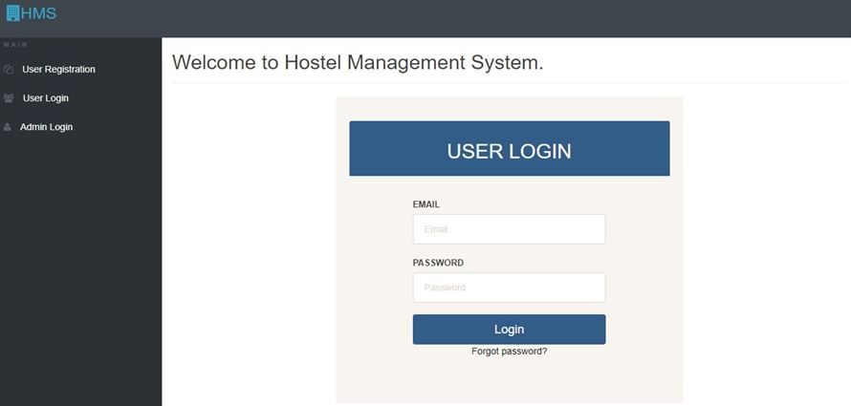
Figure 4.1 Showing the Home page

User registration

Before a user can login into the application interface, he/she has to create an account, that is, he/she has to register, this page includes the registration number (matric number), first name, middle name, last name, gender, college, department and level.

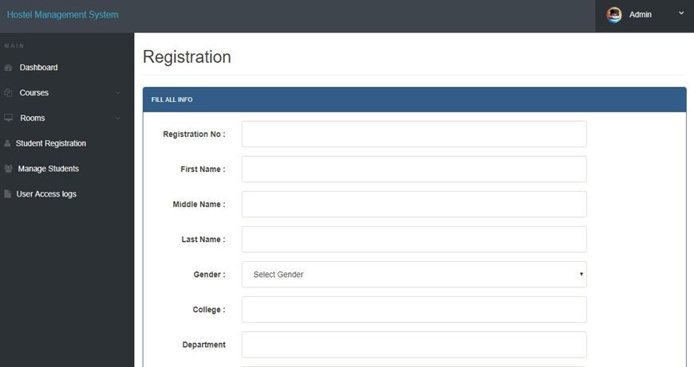

Figure 4.2 Showing the user registration

User login

This interface is accessed by clicking on the login, which is on the homepage, and it brings you to the place where you see your profile and also request for room, it comprises of the profile, change password, book hostel, room details and access log
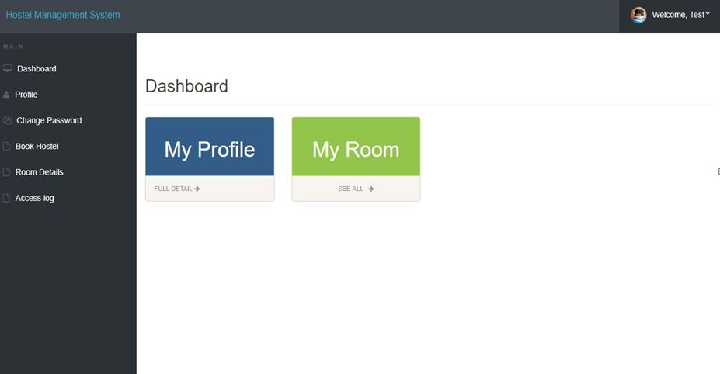

Figure 4.3 showing the User login dashboard

Admin login

This is the interface where the admin logs in to check the students that are about to book rooms and the rooms that are being booked
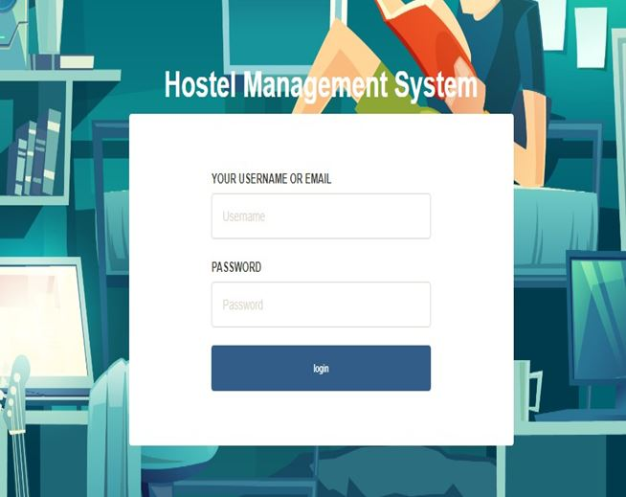
Figure 4.4 Showing the admin login interface

Book hostel interface

This is the part of the app, where you request and book for room, it is part of the login interface section
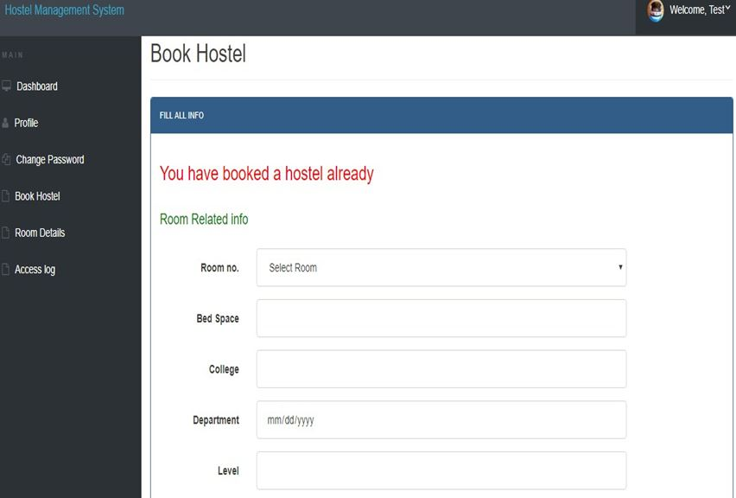

Figure 4.5 Showing the book hostel interface

Room details

This is the section where you see the room that you booked and the information about the room booked, and also personal information and so on
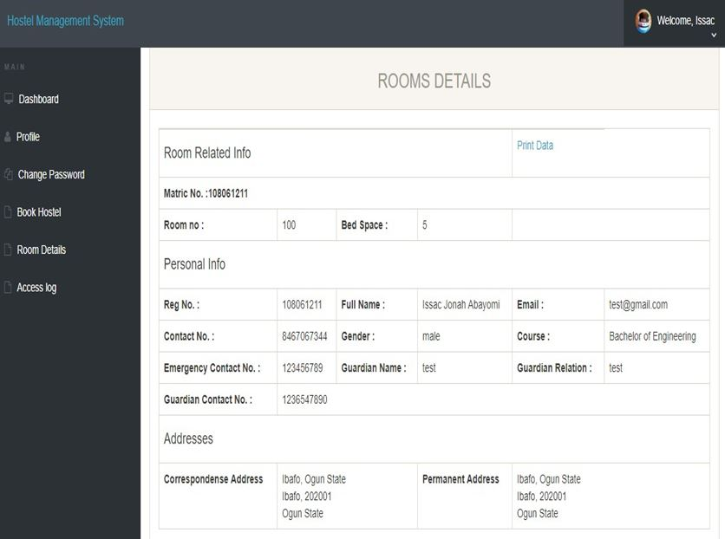

Figure 4.6 Showing the room details

Test profile

This section comprises of the filled form from the registration module, it shows the profile of the test.
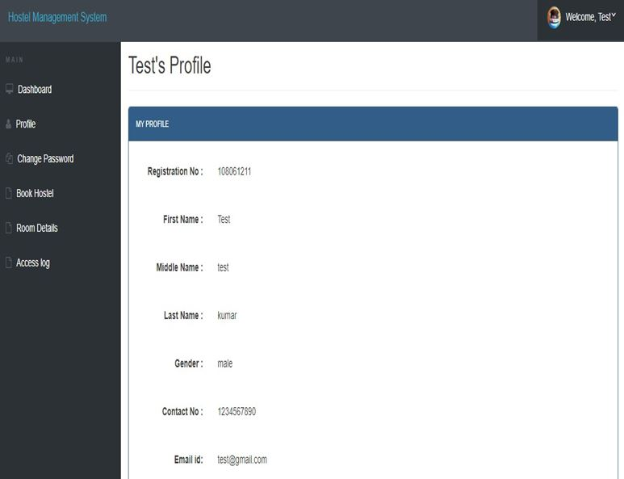

Figure 4.7 Showing the students test profile

Admin profile

This module is the page that appears after which the admin logs in to the interface, it comprises of the username, which cannot be changed, the email of the admin, the registration date, and It also has the change password interface in it.
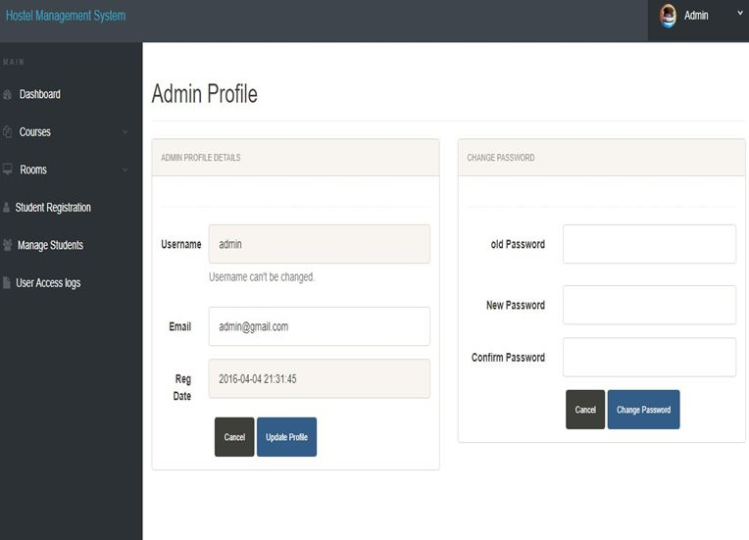

Figure 4.8 Showing the Admin interface

Add room

This interface is in the admin region, where the admin adds room, or create rooms that should be included in the rooms that should be booked, while applying for allocation
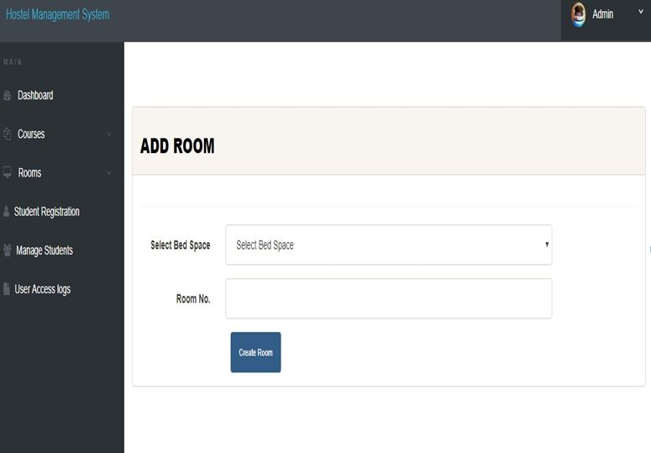
Figure 4.9 Showing the add room interface

Manage rooms

This interface shows all the rooms that have been included and created, the ones that have been allocated to students and the ones that are yet to be allocated to students, and also viewing of the application status of the students
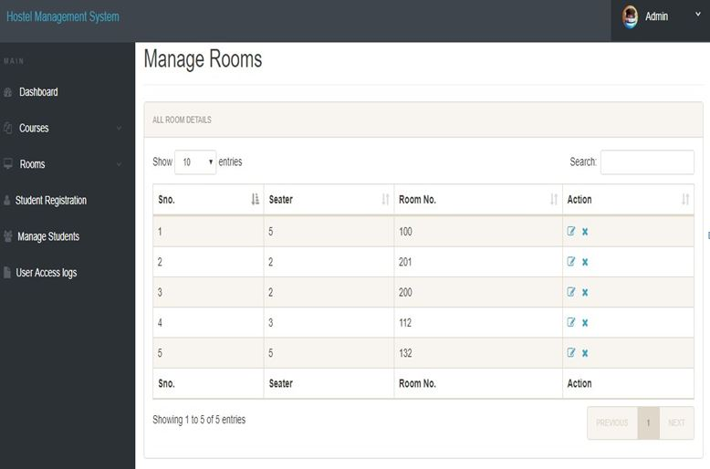
Figure 4.1.1 Showing the Manage rooms interface

k. Registered students

This interface shows the students that have booked and registered for hostel, showing their details, that is, room number, matric number and so on.
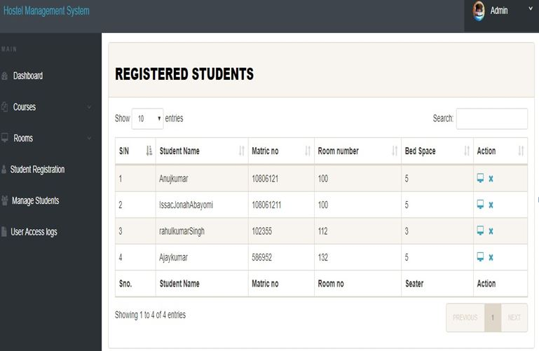

Figure 4.1.2 Showing the registered students

Access log

This interface shows access logs, that is the times a user logs in and log out of the system.
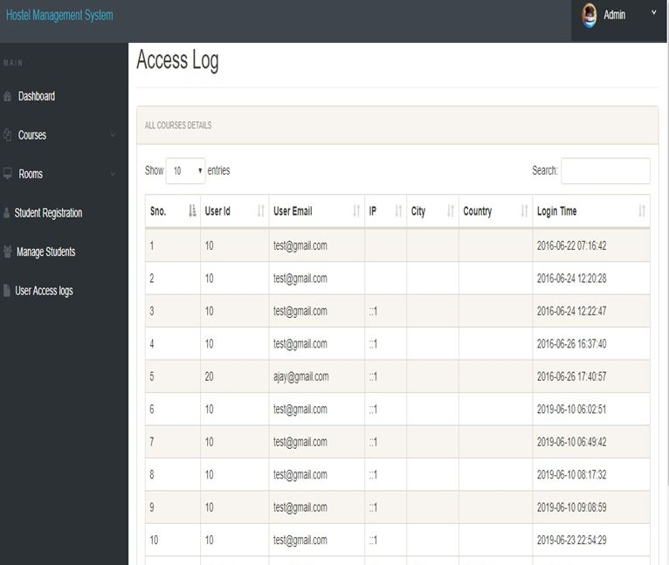

Figure 4.1.3 Showing the access log

CHAPTER 5

SUMMARY, CONCLUSIONS AND RECOMMENDATIONS

INTRODUCTION

This chapter gives a summary about what has been discussed so far, starting from the Chapter 1 of the project to the Chapter 4 of the project, and also it gives conclusions about the entire projects, what has been found out during the research work and the results gotten so far from the research work.

SUMMARY

This project work titled “ONLINE HOSTEL MANAGEMENT SYSTEM” developed, is based on the user requirement specification and the analysis of the existing system, acknowledging the issues with the existing system leads to the new design of a computerized system which would be compatible with the existing system, and it is more user friendly and more Graphic user interface oriented. This research project was done on able to build an online hostel application and allocation platform for Mountain Top University, having a large and robust database, it has to store every information relating to the hostel management system, it also allows updating of information, as it applies to file processing and to the characteristics of databases. So also the online application of hostels by the students is made possible
The system developed allows:

    - Rooms to be allocated automatically
    - Hostel allocation to be done on a computer device through the internet
    - Human error would reduce
    - A layman would be able to use the system without issues
    - The students would be more familiar with the use of the hostel application
    - The student’s data and information is kept safe and highly maintained

Chapter one of this project simply talks about Background to the study, the statement of problem, the aim and objectives, the scope of study, the significance of study and the definition of terms. Chapter two talks about the literature review, the existing system, etc. Chapter 3 talks about the methodology, the system analysis and design, etc. Chapter four simply talks about the

implementation of the system, and here we have chapter five which brings us to the conclusion, summary and recommendation of this project

CONCLUSIONS

Hostel Accommodation Management System is a user-friendly computer-based system for managing hostel facilities in institutions. It has been designed to automate, manage and look after the overall processing of records of students residing in a large hostel. It is capable of managing Enquiry details, Student Details, etc. The developed system provides solution to manual hostel management problems and also provides information such as hostel information, hostel room information, and hostel accounts information. The software offers stability, cost-effectiveness and usability. It provides the most flexible and adaptable standards management system solutions for hostel. In short about the framework, the project was created utilizing HTML, PHP, JavaScript and MySQL is in light of the prerequisite detail of the user and the research of the current framework, with adaptability for future improvement. The functionality of the present programming requires a proper approach towards programming advancement. This Hostel administration website is intended for individuals who need to handle different activities in the hostel. As from last few years’ numbers of colleges/universities are increasing and so is students number which require an automated system which can reduce human effort and make administration easy and in more technological way.

RECOMMENDATIONS

I would like to recommend that other people and associations to make further research and look into this problem very well, because as the day goes by, new problems arises, therefore we need new solutions to tackle these problems that are likely to come up, I would also recommend that people should try using other methods to solve this problem so that there can be alternative ways in which the problem can be solved without much stress.

CONTRIBUTION TO KNOWLEDGE

This project has contributed to my knowledge, by having to pick up new programming languages to solve the problem of the HOSTEL MANAGEMENT SYSTEM, it has also taught about keeping the database and having to keep and organize files for record keeping in managing the system.

LIMITATION OF THE STUDY

The limitation to this study includes

- A computer is needed for this system to function
- Without Electricity this system cannot be used
- Without the internet, this system cannot be used
- A computer illiterate would not be able to use this system

REFERENCES

Ala’ Abbadi, Al-Hammadi Y., Abdul-Rahman A. D. and Mior N. Hostel, Business Model,
and IIUM Hostel Room Management System: A Conceptual Transformation Proposal Program.( Faculty of Communication and Information Technology International Islamic University Malaysia), Gombak, 53100, Kuala Lumpur, Malaysia (2017)
Automated resource management system for hostel allocation (https://iproject.com.ng
/computer-science/automated-resource-management-system-for-hostel-allocation) (Accessed May 22, 2019)
College Hostel Management Software by Initio (2010)

Mishra, A.N. (1994). Students and Hostel Life. New Delhi: Mittal publications.
Kozaei, F., Ayub, N., Hassan, A.S., & Kozaei, Z. (2010). The factors predicting students satisfaction with university hostels, case study, university Sains Malaysia. Asian Culture and History, 2(2), 148-158

(http://listdose.co/top-10-advantages-hostel-life/) http://indianexpress.com/article/lifestyle/feelings/15-thingsthat-are-true-for-any-hosteler-in-india/ http://www.icytales.com/delight-hostel-life/

O. Shoewu; S.A. Braimah; and O. Duduyemi, “Design and Implementation of Hostel Management System (HOMASY): LASU as Case Study”

College Hostel Management Software by Initio (2010)

Design and implementation of hostel allocation system(https://www.projecttopics.org/hostelalloction-system.html) (Accessed May 22, 2019)

https:/www.quora.com/What-is-the-use-of-XAMPP (Accessed June 23, 2019)

Indocon Hostel Management Software by Indocon Micro Engineers Limited.

Mishra,A. N. (1994). Students and Hostel Life.New Delhi: Mittal publications.

R. Radhakrishhan, P.A Rinsha, R Roopersree (2014). Online Hostel Management System: Mini Project.
Thakkar, D. (2012).Diary of a fresher-2.DhirubhaiAmbani Institute of information and Communication, Gundhinagar.http://www.coolage.in/2012/06/02/diary-of-a-fresher-2

Design and implementation of hostel allocation system(https://www.projecttopics.org/hostel- alloction-system.html) (Accessed May 22, 2019)
Felke-Morris. Basics of Web Design: HTML5 & CSS3, 2nd Edition, Addison-Wesley, 2013. Hampton, David R. 1977. Contemporary Management, McGraw-Hill Series in Management.
Hostel manager by Laisikwa W.O. (2015) https://searchoracle.techtarget.com/definition/MySQL (Accessed June 23, 2019)
https://www.php.net/manual/en/intro-whatis.php (Accessed June 23, 2019)

https://www.vocabulary.com/dictionary/hostel (accessed 24, july 2019)

https://www.w3schools.com/whatis/whatis_css.asp (Accessed June 23, 2019)

https://www.w3schools.com/whatis/whatis_html.asp (Accessed June 23, 2019)

https:/www.quora.com/What-is-the-use-of-XAMPP (Accessed June 23, 2019) Indocon Hostel Management Software by Indocon Micro Engineers Limited.
K.A. Muhammed Shaheer, A. Muhammed Shiras, R. Vinod Raj, G.V Prashobh (2009). Project Report on Hostel Management System.

Kola, A., Shoewu, O., Segun, O. O., Olusegun, O., Damilola, D. B. (2014). Development of an automated hostel facility management system. Journal of Science and Engineering
, 5(1), 1-10.

Kozaei,F., Ayub, N., Hassan, A.S., &Kozaei, Z. (2010). The factors predicting students satisfaction with university hostels, case study, university Sains Malaysia. Asian Culture and History,2(2), 148-158.
Loventis Booking System by Loventis Systems (2005).

Mishra,A. N. (1994). Students and Hostel Life.New Delhi: Mittal publications.

R. Radhakrishhan, P.A Rinsha, R Roopersree (2014). Online Hostel Management System: Mini Project.
Radhakrishnan, R. (2014). Online hostel management system (doctoral dissertation, cochin university of science and technology)
S.R Ahmad, A.K Ghalib and S.A. Mahmood (2013). Pakistan Journal of Science (Vol 65 No. 1)
: GIS Based Hostel Management System for Punjab University. W. N. H. B. W. JA’AFAR (2012). Hostel Management system.
Thakkar, D. (2012).Diary of a fresher-2.DhirubhaiAmbani Institute of information and Communication, Gundhinagar.http://www.coolage.in/2012/06/02/diary-of-a-fresher-2/.
Whitten, Bentley, and Dittman. 2004. System Analysis and Design Methods (5th edition).
McGrawHill: New York, NY

APPENDIX

Home Page
<?php session_start();
include('includes/config.php'); if(isset($_POST['login']))
{
$matricno=$_POST['matricno'];
$password=$_POST['password'];
$stmt=$mysqli->prepare("SELECT matricno, password FROM registration WHERE matricno=? AND password=? ");
$stmt->bind_param('ss',$matricno,$password);
$stmt->execute();
$stmt -> bind_result($matricno,$password);
$rs=$stmt->fetch();
$stmt->close();
$_SESSION['matricno']=$matricno;
$uip=$_SERVER['REMOTE_ADDR'];
$ldate=date('d/m/Y h:i:s', time()); if($rs)
{
$matricno = $_SESSION['matricno'];
$ip=$_SERVER['REMOTE_ADDR'];
$geopluginURL='http://www.geoplugin.net/php.gp?ip='.$ip;
$addrDetailsArr = unserialize(file_get_contents($geopluginURL));
$city = $addrDetailsArr['geoplugin_city'];
$country = $addrDetailsArr['geoplugin_countryName'];
$log="insert into userlog(matricno, userIp, city, country) values('$matricno','$ip','$city','$country')";

$mysqli->query($log); if($log)
{
header("location:dashboard.php");
}

}

password');</script>";

}

else
{

}

?>

echo "<script>alert('Invalid Username/Email or

<!doctype html>
<html lang="en" class="no-js">
<head>
<meta charset="UTF-8">
<meta http-equiv="X-UA-Compatible" content="IE=edge">
<meta name="viewport" content="width=device-width, initial-scale=1, minimum- scale=1, maximum-scale=1">
<meta name="description" content="">
<meta name="author" content="">
<meta name="theme-color" content="#3e454c">
<title>Student Hostel Registration</title>
<link rel="stylesheet" href="css/font-awesome.min.css">
<link rel="stylesheet" href="css/bootstrap.min.css">
<link rel="stylesheet" href="css/dataTables.bootstrap.min.css">>
<link rel="stylesheet" href="css/bootstrap-social.css">

<link rel="stylesheet" href="css/bootstrap-select.css">
<link rel="stylesheet" href="css/fileinput.min.css">
<link rel="stylesheet" href="css/awesome-bootstrap-checkbox.css">
<link rel="stylesheet" href="css/style.css">
<script type="text/javascript" src="js/jquery-1.11.3-jquery.min.js"></script>
<script type="text/javascript" src="js/validation.min.js"></script>
<script type="text/javascript" src="http://code.jquery.com/jquery.min.js"></script>
<script type="text/javascript"> function valid()
{
if(document.registration.password.value!= document.registration.cpassword.value)
{
alert("Password and Re-Type Password Field do not match !!"); document.registration.cpassword.focus();
return false;
}
return true;
}
</script>
</head>
<body>
<?php include('includes/header.php');?>
<div class="ts-main-content">
<?php include('includes/sidebar.php');?>
<div class="content-wrapper">
<div class="container-fluid">

<div class="row">

<div class="col-md-12">

<h2 class="page-title">Welcome to Mountain Top University Hostel Management System. </h2>
<div class="row">
<div class="col-md-6 col-md-offset-3">
<!-- <bk-light> -->
<div class=" panel panel-primary well row pt-2x

pb-3x">

Login</h2>

<div class="panel-heading">
<h2 class="text-center">User

offset-2">
</div>
<div class="panel-body col-md-8 col-md-

method="post">

uppercase text-sm">Matric No</label>
<form action="" class="mt"

<label for="" class="text-

<input type="text"

placeholder="Matric No" name="matricno" id="matricno" class="form-control mb">
<label for="" class="text-
uppercase text-sm">Password</label>
<input type="password"
placeholder="Password" name="password" id="matricno" class="form-control mb">

<input type="submit" name="login" class="btn btn-primary btn-block text-lg" value="Login" >
</form>

style="color:black;"> style="color:black;">Forgot password?</a>

</div>
</div>

</div>
</div>
</div>
</div>
</div>
<div class="text-center text-light"

<a href="forgot-password.php"

</div>
</div>
</div>

</div>
</div>
</div>

<script src="js/jquery.min.js"></script>
<script src="js/bootstrap-select.min.js"></script>
<script src="js/bootstrap.min.js"></script>
<script src="js/jquery.dataTables.min.js"></script>
<script src="js/dataTables.bootstrap.min.js"></script>
<script src="js/Chart.min.js"></script>
<script src="js/fileinput.js"></script>
<script src="js/chartData.js"></script>
<script src="js/main.js"></script>
</body>

</html>

REGISTRATION
<?php session_start();
include('includes/config.php'); if(isset($_POST['submit']))
{
$matricno=$_POST['matricno'];
$fname=$_POST['fname'];
$mname=$_POST['mname'];
$lname=$_POST['lname'];
$gender=$_POST['gender'];
$college=$_POST['college'];
$dept=$_POST['dept'];
$programme=$_POST['programme'];
$level = $_POST['level'];
$password=$_POST['password'];
$query="insert into registration(matricno,firstName,middleName,lastName,gender,college,dept,programme,year,pas sword) values (?,?,?,?,?,?,?,?,?,?)";
$stmt = $mysqli->prepare($query);
$rc=$stmt-
>bind_param('ssssssssss',$matricno,$fname,$mname,$lname,$gender,$college,$dept,$programm e,$level,$password);
$stmt->execute();
echo"<script>alert('Student Succssfully Registered');</script>";
}
?>

<!doctype html>
<html lang="en" class="no-js">
<head>
<meta charset="UTF-8">
<meta http-equiv="X-UA-Compatible" content="IE=edge">
<meta name="viewport" content="width=device-width, initial-scale=1, minimum- scale=1, maximum-scale=1">
<meta name="description" content="">
<meta name="author" content="">
<meta name="theme-color" content="#3e454c">
<title>User Registration</title>
<link rel="stylesheet" href="css/font-awesome.min.css">
<link rel="stylesheet" href="css/bootstrap.min.css">
<link rel="stylesheet" href="css/dataTables.bootstrap.min.css">>
<link rel="stylesheet" href="css/bootstrap-social.css">
<link rel="stylesheet" href="css/bootstrap-select.css">
<link rel="stylesheet" href="css/fileinput.min.css">
<link rel="stylesheet" href="css/awesome-bootstrap-checkbox.css">
<link rel="stylesheet" href="css/style.css">
<script type="text/javascript" src="js/jquery-1.11.3-jquery.min.js"></script>
<script type="text/javascript" src="js/validation.min.js"></script>
<script type="text/javascript" src="http://code.jquery.com/jquery.min.js"></script>
<script type="text/javascript"> function valid()
{
if(document.registration.password.value!= document.registration.cpassword.value)
{
alert("Password and Re-Type Password Field do not match !!"); document.registration.cpassword.focus();

return false;
}
return true;
}
</script>
</head>
<body>
<?php include('includes/header.php');?>
<div class="ts-main-content">
<?php include('includes/sidebar.php');?>
<div class="content-wrapper">
<div class="container-fluid">

<div class="row">
<div class="col-md-12">

<h2 class="page-title">Student Registration </h2>

<div class="row">
<div class="col-md-12">
<div class="panel panel-primary">
<div class="panel-
heading"><b>Please fill all fields</b></div>
<div class="panel-body">
<form method="post" action="" name="registration" class="form- horizontal" onSubmit="return valid();">

<div class="form-group">
<label class="col-sm-2 control-label"> Matric No </label>
<div class="col-sm-8">
<input type="text" name="matricno" id="matricno" class="form-control" onBlur = "checkAvailability()" required="required" >
<span id="user-availability-status" style="font-size:12px;"></span>
</div>
</div>

<div class="form-group">
<label class="col-sm-2 control-label">First Name </label>
<div class="col-sm-8">
<input type="text" name="fname" id="fname" class="form-control" required="required" >
</div>
</div>

<div class="form-group">
<label class="col-sm-2 control-label">Middle Name </label>
<div class="col-sm-8">
<input type="text" name="mname" id="mname" class="form-control">
</div>
</div>

<div class="form-group">
<label class="col-sm-2 control-label">Last Name </label>
<div class="col-sm-8">
<input type="text" name="lname" id="lname" class="form-control" required="required">
</div>

</div>

<div class="form-group">
<label class="col-sm-2 control-label">Gender </label>
<div class="col-sm-8">
<select name="gender" class="form-control" required="required">
<option value="">Select Gender</option>
<option value="male">Male</option>
<option value="female">Female</option>
<option value="others">Others</option>
</select>
</div>
</div>

<div class="form-group">
<label class="col-sm-2 control-label">College </label>
<div class="col-sm-8">
<input type="text" name="college" id="college" class="form-control" required="required">
</div>
</div>

<div class="form-group">
<label class="col-sm-2 control-label">Department </label>
<div class="col-sm-8">
<input type="text" name="dept" id="dept" class="form-control" onBlur="" required="required">
</div>
</div>

<div class="form-group">
<label class="col-sm-2 control-label">Programme </label>
<div class="col-sm-8">
<input type="text" name="programme" id="programme" class="form-control" onBlur="" required="required">
</div>
</div>

<div class="form-group">
<label class="col-sm-2 control-label">Level </label>
<div class="col-sm-8">
<input type="text" name="level" id="level" class="form-control" onBlur="" required="required">
</div>
</div>

<div class="form-group">
<label class="col-sm-2 control-label">Password </label>
<div class="col-sm-8">
<input type="password" name="password" id="password" class="form-control" required="required">
</div>
</div>

<div class="form-group">
<label class="col-sm-2 control-label">Confirm Password </label>
<div class="col-sm-8">
<input type="password" name="cpassword" id="cpassword" class="form-control" required="required">

</div>
</div>

<div class="col-sm-6 col-sm-offset-4">
<input type="submit" name="submit" Value="Register" class="btn btn-primary btn-md text- lg">
<button class="btn btn-default btn-md text-lg" type="reset">Cancel</button>
</div>
</form>

</div>

</div>

</div>

</div>

</div>

</div>

</div>

</div>

</div>

</div>
</div>
</div>

<script src="js/jquery.min.js"></script>
<script src="js/bootstrap-select.min.js"></script>
<script src="js/bootstrap.min.js"></script>
<script src="js/jquery.dataTables.min.js"></script>

<script src="js/dataTables.bootstrap.min.js"></script>
<script src="js/Chart.min.js"></script>
<script src="js/fileinput.js"></script>
<script src="js/chartData.js"></script>
<script src="js/main.js"></script>
</body>
<script>
function checkAvailability() {

$("#loaderIcon").show(); jQuery.ajax({
url: "check_availability.php", data:'matricno='+$("#matricno").val(), type: "POST", success:function(data){
$("#user-availability-status").html(data);
$("#loaderIcon").hide();
},
error:function ()
{
event.preventDefault(); alert('error');
}
});
}
</script>

</html>

LOGIN
<?php session_start();
include('includes/config.php'); if(isset($_POST['login']))
{
$matricno=$_POST['matricno'];
$password=$_POST['password'];
$stmt=$mysqli->prepare("SELECT matricno, password FROM userregistration WHERE matricno=? AND password=? ");
$stmt->bind_param('ss',$matricno,$password);
$stmt->execute();
$stmt -> bind_result($matricno,$password);
$rs=$stmt->fetch();
$stmt->close();
$_SESSION['user']=$matricno;
$uip=$_SERVER['REMOTE_ADDR'];
$ldate=date('d/m/Y h:i:s', time()); if($rs)
{
$uid=$_SESSION['id'];
$uemail=$_SESSION['login'];
$ip=$_SERVER['REMOTE_ADDR'];
$geopluginURL='http://www.geoplugin.net/php.gp?ip='.$ip;
$addrDetailsArr = unserialize(file_get_contents($geopluginURL));
$city = $addrDetailsArr['geoplugin_city'];
$country = $addrDetailsArr['geoplugin_countryName'];

$log="insert into userLog(matricno, userIp, city, country) values('$matricno','$ip','$city','$country')";
$mysqli->query($log); if($log)
{
header("location:dashboard.php");
}

}

password');</script>";

}

else
{

}

?>

echo "<script>alert('Invalid Username/Email or

<!doctype html>
<html lang="en" class="no-js">
<head>
<meta charset="UTF-8">
<meta http-equiv="X-UA-Compatible" content="IE=edge">
<meta name="viewport" content="width=device-width, initial-scale=1, minimum- scale=1, maximum-scale=1">
<meta name="description" content="">
<meta name="author" content="">
<meta name="theme-color" content="#3e454c">
<title>Student Hostel Registration</title>
<link rel="stylesheet" href="css/font-awesome.min.css">
<link rel="stylesheet" href="css/bootstrap.min.css">

<link rel="stylesheet" href="css/dataTables.bootstrap.min.css">>
<link rel="stylesheet" href="css/bootstrap-social.css">
<link rel="stylesheet" href="css/bootstrap-select.css">
<link rel="stylesheet" href="css/fileinput.min.css">
<link rel="stylesheet" href="css/awesome-bootstrap-checkbox.css">
<link rel="stylesheet" href="css/style.css">
<script type="text/javascript" src="js/jquery-1.11.3-jquery.min.js"></script>
<script type="text/javascript" src="js/validation.min.js"></script>
<script type="text/javascript" src="http://code.jquery.com/jquery.min.js"></script>
<script type="text/javascript"> function valid()
{
if(document.registration.password.value!= document.registration.cpassword.value)
{
alert("Password and Re-Type Password Field do not match !!"); document.registration.cpassword.focus();
return false;
}
return true;
}
</script>
</head>
<body>
<?php include('includes/header.php');?>
<div class="ts-main-content">
<?php include('includes/sidebar.php');?>
<div class="content-wrapper">
<div class="container-fluid">

<div class="row">
<div class="col-md-12">

<h2 class="page-title">User Login </h2>

<div class="row">
<div class="col-md-6 col-md-offset-3">
<div class="well row pt-2x pb-3x bk-light">
<div class="col-md-8 col-md-offset-2">

method="post">

uppercase text-sm">Matric No</label>
<form action="" class="mt"

<label for="" class="text-

<input type="text"

placeholder="Matric No" name="matno" class="form-control mb">
<label for="" class="text-
uppercase text-sm">Password</label>
<input type="password"
placeholder="Password" name="password" class="form-control mb">

<input type="submit"
name="login" class="btn btn-primary btn-block" value="login" >

</div>

</div>
</form>

light">Forgot password?</a>
<div class="text-center text-light">
<a href="forgot-password.php" class="text-

</div>

</div>

</div>

</div>

</div>

</div>

</div>
</div>

</div>

</div>

</div>

<script src="js/jquery.min.js"></script>
<script src="js/bootstrap-select.min.js"></script>
<script src="js/bootstrap.min.js"></script>
<script src="js/jquery.dataTables.min.js"></script>
<script src="js/dataTables.bootstrap.min.js"></script>
<script src="js/Chart.min.js"></script>
<script src="js/fileinput.js"></script>
<script src="js/chartData.js"></script>
<script src="js/main.js"></script>
</body>

</html>

