ASSESSMENT OF SAFETY DRINKING WATER AND PUBLIC HEALTH STATUS OF BOREHOLE BENEFICIARIES

BY
KEKU OLUWATOSIN C.
MATRIC NO: 16010101013

PROJECT SUBMITTED IN PARTIAL FUFILMENT OF THE
REQUIREMENT FOR A BACHELOR OF SCIENCE DEGREE (B.Sc. Hons.) IN MICROBIOLOGY
IN THE DEPARTMENT OF BIOLOGICAL SCIENCES AT THE COLLEGE OF BASIC AND APPLIED SCIENCES, MOUNTAIN TOP UNIVERSITY,
MOWE, IBAFO, OGUN STATE.

NOVEMBER, 2020

CERTIFICATION

This is to certify that this report on MICROBIOLOGICAL AND PHYSICOCHEMICAL CHARACTERISTICS OF BOREHOLE WATER carried out by KEKU OLUWATOSIN C. with MATRIC NO 16010101013 was prepared in accordance to the regulations guiding the preparation of reports in the Department of Biological Sciences, Mountain Top University under the supervision of Late Dr. A. A. Adeiga and Dr. O.E. Fayemi

________________________ _________________________
STUDENT’S NAME SIGN/DATE

__________________________ _________________________
SUPERVISOR’S NAME SIGN/DATE

ACKNOWLEDGEMENT
First and foremost, to whom I owe all indebtedness the Almighty God, creator and originator, able and capable, one and ever living God. To Him I give my candid gratitude and appreciation for His love, protection and faithfulness towards me, His grace and Holy Spirit, granted me strength, wisdom, knowledge and understanding throughout my training.
I appreciate my able Supervisor Dr A. A. Adeiga. I also appreciate the intervention and supervision of Dr. O.E. Fayemi in completing this project after my supervisor passed away.
My sincere Appreciation to my parent Dr B.O. & Mrs E.C. Keku for their unflinching support, love and encouragement towards me in my academic pursuit and in all spheres of my life. God bless you.
I appreciate my brothers; Toba Keku and Timilehin Keku for their moral support.
I appreciate Victoria Aririguzoh, fellow student under the same Supervisor.
My course mates; Bola, Smiggles, Oyinda, Osasa, Divine, Scott, Timbo and many others who at every time watched my back and supported me during my project work, I appreciate you guys.

DEDICATION
I dedicate this project to God Almighty and to my family.

TABLE OF CONTENTS
CERTIFICATION ii
ACKNOWLEDGEMENT iii
DEDICATION iv
LIST OF TABLES viii
LIST OF FIGURES ix
ABSTRACT x
CHAPTER ONE 1
1.0 INTRODUCTION 1
1.1 BACKGROUND OF STUDY 1
1.2 STATEMENT OF PROBLEM ARISING FROM BOREHOLE WATER 2
1.3 RATIONALE OF STUDY 2
1.4 AIM OF THIS STUDY 2
1.5 OBJECTIVES OF THE STUDY 2
CHAPTER TWO 4
2.0 LITERATURE REVIEW 4
2.1 IMPORTANCE OF WATER 4
2.2 BOREHOLE AS A GROUNDWATER 4
2.3 NEED FOR GROUNDWATER EXPLOITATION 5
2.4 HOW GROUNDWATER STARTED 6
2.5 GROUNDWATER POLLUTION 6
2.6 QUALITY OF GROUNDWATER 7
2.7 BOREHOLE WATER PARAMETERS 7
2.8 PHYSICO-CHEMICAL PARAMETER 8
2.8.2 TASTE AND ODOUR 9
2.8.3 TOTAL DISSOLVED SOLIDS 9
2.8.4 NITRATES 10
2.8.5 CALCIUM CARBONATE 10
2.8.6 TEMPERATURE 11
2.8.7 COLOUR 11
2.8.8 CHLORIDES 12
2.8.9 IRON 12
2.9 HEAVY METALS 13
2.10 EFFECTS OF HEAVY METALS IN BOREHOLE WATER 13
2.10.1 LEAD 14
2.10.2 ZINC 14
2.10.3 IRON 14
2.10.4 COPPER 14
2.10.5 NICKEL 14
2.11 MICROBIOLOGICAL PARAMETER 15
2.11.1 TOTAL COLIFORM 15
2.11.2 FEACAL COLIFORM 15
2.11.3 MICROBIAL CONTENT TO DETERMINE WATER QUALITY 16
2.12 EFFECTS OF CONSUMING CONTAMINATED WATER 16
2.13 SELECTION OF SITE FOR BOREHOLE 17
2.14 RECOMMENDED DISTANCE BETWEEN BOREHOLE AND SOURCES OF 17
CONTAMINATION 17
2.15 HOW THE SOIL PURIFIES GROUNDWATER 17
CHAPTER THREE 19
3.0 MATERIALS AND METHOD 19
3.1 STUDY AREA 19
3.1 SAMPLE COLLECTION SITE 20
3.3 EQUIPMENTS USED 20
3.4 REAGENTS AND AGAR USED 20
3.7 PHYSICOCHEMICAL PARAMETERS 21
3.8 DETERMINATION AND DIGESTION OF THE HEAVY METALS 21
3.8.1 DIGESTION OF SAMPLES FOR Zn, Pb, Cr, Fe and Mn 21
3.9 MICROBIOLOGICAL PARAMETER 22
3.9.1 PREPARATION OF MEDIA 22
3.9.2 TOTAL COLIFORMS 22
3.9.3 FEACAL COLIFORM 22
3.9.4 SUB-CULTURING OF THE ISOLATES 23
3.9.5 IDENTIFICATION OF THE ISOLATES 23
3.9.6 GRAMS STAINING 23
3.9.7 CATALASE TEST 24
3.9.8 OXIDASE TEST 24
3.9.9 STARCH HYDROLYSIS TEST 24
3.10 IMMUNOLOGICAL TESTS 24
3.10.1 INOCULATION OF ALBINO MICE 24
CHAPTER FOUR 26
4.0 RESULTS AND DISCUSSSION 26
4.1 PHYSICOCHEMICAL PARAMETERS OF BOREHOLE WATER 26
4.2 HEAVY METAL CONTENT OF SAMPLES ANALYSED 26
4.4 MICROBIOLOGICAL ANALYSIS 27
4.5 REACTIONS OF THE IMMUNE CELLS 28
4.6 INTERPRETATION OF THE SURVEY 29
CHAPTER FIVE 35
5.1 CONCLUSION AND RECOMMENDATION. 35
5.2 RECOMMENDATION 35
6.0 REFERENCES 36

LIST OF TABLES

Table 2.1. Classification of water hardness as CaCO3………………………………………10
Table 2.2. Classification of water microbiological limits……………………………………15
Table 2.3. Safe distance between boreholes / wells and source of contaminants……………16
Table 4.1 The Physicochemical of borehole water samples within the campus of Mountain Top University…………………………………………………………………..24
Table 4.2 Levels of heavy metals in borehole water samples (mg/L).....................................25
Table 4.3 the total viable count of borehole water samples within the Mountain Top University Campus……………………………………………………………...26
Table 4.4 Reaction of the Immune cells……………………………………………………..26
Table 4.5 Morphological characteristics of bacteria isolated from borehole water
Samples within Mountain Top University Campus…………………………….27
Table 4.6 Age of Respondent……………………………………………………………….27
Table 4.7 Course level of respondents…………………………………………………….28
Table 4.8 How long respondents have used borehole water in school……………………...28
Table 4.9 Do you experience itching or rashes when bathing with borehole water in school.28

LIST OF FIGURES

Figure 4.1. Gender of respondents that use the boreholes on regular basis……………...29
Figure 4.2 Age group of respondents…………………………………………………….29
Figure 4.3 Academic level of respondents……………………………………….….…...30
Figure 4.4 Duration of borehole water usage by respondents.....................................…...30
Figure 4.5 Domestic usage of the borehole water by respondent………………………....31
Figure 4.6 Safety of the domestic usage of borehole water by respondent..........................31

ABSTRACT

The quality of borehole water from three hostels in the Mountain Top University were analysed for physicochemical and Microbiological parameters using standard methods. The water samples were analysed for temperature, pH, turbidity, conductivity, total dissolved solids, total and faecal coliforms and the immune responses while the heavy metals were determined using Atomic Absorption Spectrophotometric analysis (AAS). The results indicate that the pH of the water was slightly acidic (4.8-5.4). The temperature ranged from 27.7 and 27.8⁰C, conductivity between 0.005 and 0.006 while the total dissolved solids and turbidity ranged between 017and 021 and 0.11, 0and 0.15 Ms/c, respectively. The heavy metals detected were; Lead (<0.012), Iron (0.144 and <0.005), Chromium (<0.005), Zinc (0.156, 0.190 and 0.349), Manganese (0.170, 0.218 and 0.239). All the heavy metals detected except manganese were below the acceptable limits set by WHO. The microbiological analyses revealed a high presence of total viable bacteria in all the water samples. The borehole water within the Mountain Top University hostels are not portable and hence proper treatment is needed before they can be safe for drinking.

CHAPTER ONE

1.0 INTRODUCTION

1.1 BACKGROUND OF STUDY
Borehole water is a groundwater which is clean and clear obtained by means of a narrow hole drilled down through the earth. The borehole is drilled to reach the water in an aquifer; these are porous rocks filled with water. It is therefore important that portable water be provided in rural and urban areas to reduce disease and water borne infections in developing countries like Nigeria. Nigeria’s estimated replenish able clean water supplies are 319 billion cubic metres, with groundwater measured at 52 billion cubic metres. Despite various strategies provided by the government to improve access to potable clean water in Nigeria, approximately 58% of urban and 39% of rural settings have access to clean and potable drinking water due to the rapidly growing population. Thus, the borehole water remains an unavoidable source of drinking water in Nigeria. However, contamination of groundwater remains a global public health threat and chemical intoxication also cannot be underestimated. The effects of drinking contaminated borehole water is more dangerous on children than tuberculosis and malaria. Its effect is not only on children but can lead to several water-borne diseases like cholera, typhoid, gastroenteritis etc. and ultimately the loss of life. In fact, the sources of borehole and underground water contamination have been reported as faecal contamination, domestic waste water, livestock manure, refuse dumps, and chemical pollution. There are parameters to determine the safety of a borehole water which are Physico-chemical parameters and Microbiological parameters. The physico-chemical parameter test for some parameters like hardness, alkalinity, and dissolved oxygen, total dissolved solid, chloride and other heavy metals which have adverse health effects such as lead, ammonia, nitrate, zinc, etc. (WHO, 2002). The microbiological parameter test for some pathogenic microorganisms (coliforms) found in water which are capable of causing diseases; drinking water should therefore be free from pathogenic microorganisms like salmonella spp., shigella spp., coliforms. Coliforms are used as indicator organisms to test for drinking water quality because contaminated water majorly contains coliform most especially the bacteria E.coli. (Gwimbi, 2008)

Water exists in several forms in the environment; water can exist as sea water, sea-ice, fresh water, and water vapour as clouds and mist. Water moves through the environment in an endless cycle and as so doing it picks up gases and elements, flows to the sea and through ground and back to the atmosphere. This cycle is known as the hydrologic/water cycle. The water cycle ensures that water available on the earth passes through a process of evaporation, condensation, precipitation and transpiration, this process is endless and renewable. Groundwater occurs as part of this hydrologic cycle. The underground area where groundwater exists is referred to as an aquifer. Groundwater comes from three major aquifer zones which are generally situated from 300 to 1,500 feet below land surface. This groundwater is protected from surface contamination by the soil profile (a layer of clay and fine-grained sediments). The level of ground water in the borehole may undergo changes due to the recharge and discharge rate. The rate at which a borehole is recharged may vary due to responses to withdrawal from groundwater (wells, borehole) through pumping, and also through leakage to vertically adjacent aquifers.

1.2 STATEMENT OF PROBLEM ARISING FROM BOREHOLE WATER
Beneficiaries in some areas where borehole water is established complained of discomfort, skin reactions and stomach upset after consuming and using the water.

1.3 RATIONALE OF STUDY
An investigation of ill-health of the beneficiaries using the borehole water is necessary in order to know the agents causing the ill-health. This is done by conducting laboratory investigation of the pathogenic microbes in the contaminated borehole water to identify potential pathogens causing the ill-health.

1.4 AIM OF THIS STUDY
This study is aimed at determining the physico-chemical and microbiological quality of potable water from selected boreholes in different regions of Ogun state.

1.5 OBJECTIVES OF THE STUDY
- To determine the physicochemical parameter of the selected borehole water samples i.e. temperature, total dissolved solids, colour, pH, turbidity etc.
- To determine the amount of heavy metals in the borehole water samples that can pose a risk to humans.
- To determine the level of faecal and total coliforms in the selected borehole water samples.
- To assess the demography of the beneficiaries i.e. of the people affected and the degree of impact of the effect.

CHAPTER TWO

2.0 LITERATURE REVIEW

2.1 IMPORTANCE OF WATER
Water is an essential natural resource vital for the functioning of the ecosystem and for human well-being. Water is a critical constituent of life. Water is one of the basic elements of human life, and without enough water, the body cannot live more than a few days. As such, we cannot ignore the need to ensure that individuals have access to clean water. Improved access to safe water in Nigeria, however, remains slow because of several corruption-related issues pervading every sector of the economy. Nigeria is Africa's most populous country with an estimated population of over 170 million, growing at 2 per cent annually. Accompanying the fast-growing population was not improved access to adequate water supply. The gap has widened between the areas with access to safe water supply and those without. Worldwide, its availability has a drawback and this is growing and duplicating itself while intensifying the fight for scarce water resources as discussed by Olukanni et al, (2009). Water is a must-have. It's required for consumption of humans and animals. It is needed for the growth of agricultural produce that sustains earthly life. Water is used for many other purposes, including the construction of hydropower, navigation, and recreation. If water is harnessed and used properly, it can be a blessing and of great benefit to mankind. If the water isn't properly controlled, though, it can be a curse and cause destruction and misery. Management of water quality is an important phase of water resources engineering, without which pollution can threaten its usefulness. (Arora & Gupta, 2013).

2.2 BOREHOLE AS A GROUNDWATER
Groundwater refers to the water below the surface of the earth. Infiltration is the primary source of groundwater. After reaching the deficiency of soil moisture the infiltrated water percolates deeply and becomes groundwater. Groundwater is emission free, and is very useful in small towns and remote farms for domestic use. It can be made available at a low cost of capital, and at least possible time as well. During the ages, groundwater has been an important supply of water and it is not unlimited like any other natural resource. Gbadebo & Akinhanmi (2010) said groundwater resource management is a must to any home that consumes water. Reddy (2010) claimed that groundwater must be handled carefully and protected from pollution and salt water being polluted and poisoned inedible. The key source of water / groundwater for the borehole is meteoric water, meaning; (rain, sleet, snow and hail precipitation), juvenile water and connate water (Gleick, 1993). In several geological formations surface water exists. Almost all the rocks in the upper part of the crust of the earth have voids or pores filled with water or air; this is the unsaturated region. At higher depths, all empty voids are filled with water, this is the saturated zone, and thus groundwater only refers to the saturated area below the water table.

2.3 NEED FOR GROUNDWATER EXPLOITATION
Borehole is a groundwater type that forms an integral part of water supply systems in rural and urban areas especially in Africa, and therefore are indispensable because of inadequate public water supply systems (Pickering and Owen, 1995; MacDonald et al., 2005; Calow et al., 2010). Over one billion people lack access to clean safe water worldwide, up to 300 million rural people in Sub Saharan Africa have no access to safe water supplies and this is on the rise (NAS, 2009). There is an increasing demand for large amounts of water as health and sanitation improve (Agnew and Anderson, 1992). Without safe water near households, the health and livelihood of families can be severely affected (United Nations, 2010; MacDonald et al., 2005). Borehole water use is associated with a lower childhood risk to diarrhoea compared to surface water in Bangladesh (Wu et al., 2011). To solve such issues relating to water borne diseases, boreholes can provide safe and convenient water supply since it is evenly distributed, affordable with quiet good quality and not affected by seasonal changes hence its sustainable (Cloutier and Rowley, 2011; Akpoveta, 2011; Adekunle et al., 2007). The only practical way of meeting rural water demand is by exploiting groundwater (MacDonald et al., 2005). A large population of the world especially in sub-Saharan Africa depends on groundwater as their main source of domestic water (Sha, 2004), this is because it is accessible anywhere, less capital intensive to develop and maintain and is less susceptible to pollution and seasonal fluctuation, naturally has good quality (Bresline, 2007) Water resources availability is of significance to regional social-economic development and is seen as a limiting factor in human development (Xinghui et al., 2009; McDonald and Kay, 1988; Clarke, 1991). Groundwater plays a vital role in the development of arid and semi-arid zones (Ranjana, 2010) and its development especially borehole water in Africa is seen as more amenable to poverty targeting than surface water (Kai and Jeroen, 2009). A greater proportion of household income may need to be spent on water delivered from private sources, such as tankers to supplement lack of water locally (Sirila et al., 2010).

2.4 HOW GROUNDWATER STARTED
In the ancient times, the exploitation of groundwater was with man way back. Most of the ancient civilizations used both groundwater and surface water for their water sources. It is reported that Crusade prisoners in Egypt built wells from excavated bedrock in 1183 BC, which they called the Josephs well to ensure the water supply at the citadels (Osiakwan, 2002). The Holy Bible refers to groundwater, first in the story of Moses hitting a rock with his rod and bringing forth a water fountain (Exodus 17:6). The exploration started in the 12th century with the successful exploration of a well at Artois, France in 1226, instead of the normal digging of wells. Usually used for drilled wells the term artesian comes from this village’s name. An artesian well that was completed at Grenelle near Paris in 1841 was the deepest well in the world for several years. Another well-known location is the St. Augustine, located in the United States of America in Florida (Osiakwan, 2002).

2.5 GROUNDWATER POLLUTION
Groundwater pollution is a growing problem for the environment, particularly in developing countries. The urbanization process threatens the groundwater quality because of the impact of domestic and industrial waste disposal. This results in aquifer deterioration, since some of the waste products, including sewage and cesspool may be discharged directly into the aquifer system. Through precipitation, irrigation waters can dissolve water soluble waste and other materials that are dumped, spilled or stored on the surface of the land or in sewage disposal pits or liquid waste and ultimately contaminate the groundwater through the soil in the unsaturated region (AIRBDA, 2012). It is important to note that the presence of objectionable tastes, odour, colour as well as harmful substances in such water no matter how abundant it is, renders it unsuitable for domestic, industrial and agricultural uses. The assessments of the physical and chemical characteristics of water are important parameters as they may directly or indirectly affect its quality. Bad quality of water is considered to be a significant cause of disease outbreaks and health effects (Hunter et al. 2010; Galadima et al. 2011). The Joint Monitoring Programme (JMP) estimated that 1.8 million people globally use a source of drinking water that is faecal contaminated (WHO/UNICEF 2014). It further indicated that 1.1 billion people drink water that is at least of ‘moderate’ risk (>10 cfu/100 ml Escherichia coli). Groundwater contains some impurities, even though it is not impaired by human activities. Natural impurity forms and concentrations depend on the nature of the geological materials through which the groundwater passes, and the consistency of the recharge water. Groundwater that moves through sedimentary rocks and soils can accumulate a wide range of compounds such as magnesium, calcium, and chlorides. Some aquifers have a high natural dissolved constituent concentration, such as arsenic, boron, and selenium. The effect of these natural contamination sources on the quality of the groundwater depends on the type and concentration of the contaminants. Among the naturally occurring pollutants are: Copper, fluoride, aluminium, arsenic, barium, chloride, chromium, coliform bacteria, Iron, Lead. Manganese, mercury, nitrate, selenium, sodium, sulphate, silver, Zinc (USEPA, September 1997). The landowner or applicator controls the application of pesticides, fertilizer, or some other chemical. Methods of application and dosage can influence chemical leaching. The introduction or injection of a pesticide into the soil presents a greater danger to groundwater than vegetation or application on the surface. Reducing the amount of the pesticide that is added using successful alternatives would also protect groundwater supplies. This can be achieved with the use of pesticides that are less susceptible to leaching and surface runoff. Timing of application of pesticides can be critical in mitigating groundwater risk. Application before heavy rain or irrigation can lead to leaching (Van dre, 1995).

2.6 QUALITY OF GROUNDWATER
Water quality is of major importance to humanity, as it is directly related to human well-being. In line with Ranjana (2010), the standard of public health depends to a larger extent on the standard of groundwater. Although groundwater quality is believed to be quite sensible compared to surface water, its quality is that the sum of natural earth science of the setting and man actions withdrawal, land use amendment, and solid waste merchandising (Chapman, 1996). The water quality parameters reflect the level of water resource contamination and show whether water is safe for human consumption. Contaminated water is unacceptable because of health effects, poor style and aesthetic worth to shoppers (Suthra et al., 2009).

2.7 BOREHOLE WATER PARAMETERS
There are parameters that determine the portability of borehole water. Physico-chemical and micro-biological water parameters indicate the safety of drinking water (Macdonald and Kay, 1986), and their analysis is important for studies on public health and pollution (Kot et al., 2000).

2.8 PHYSICO-CHEMICAL PARAMETER
Temperature, pH, colour, turbidity, total dissolved solids, electrical conductivity, odour, and taste are groundwater's most important physico-chemical properties in terms of quality.
2.8.1 PH
The hydrogen ion (H+) measurement available in water is pH. Groundwater acidity is attributed to the presence in the soil of organic acids, as well as those of chemical origin introduced into the water (Chapman and Kimstach, 1996). Acid rain contains dissolved carbon dioxide (CO2), nitrogen dioxide (NO2) or sulphur dioxide (SO2) which often yields elevated concentrations of hydrogen ions (H+) ions and carbonic acid (HCO) and may pose a serious threat to groundwater pH (Hamil and Bell, 1986). The rainwater pH is at about 5.7 (Krauskopf and Bird, 1994). Increased acidity is also due to the oxidation in region soils of reduced Sulphur compounds (Efe et al., 2005). Through affecting the chemical kinetics of essential constituents, the pH influences the solubility and toxicity of metals. Other acids such as HNO3, HNO2 and humic acid are formed as a result of organic matter decomposition, and when minerals such as pyrite (FeS2) break down, sulphuric acid is produced. High pH levels make it less corrosive to water (Gustafsson, 2003). Alkalinity is a water attribute that indicates the water's ability to neutralize acids by accepting Hydrogen ions (H+) and preventing abrupt increases in water acidity levels. Alkalinity is due to two forms of Carbonate Anions (HCO3-), (CO32-) and (OH) which act as a buffer system (Chris, 2012). When found in groundwater, borates, phosphates, silicates and other bases also contribute to the alkalinity. This eliminates free divalent toxic metal ions such as Cd2 +, Cu2 +, Pb2 +, Zn2 + or methyl-metal complexes, forming inorganic ligands (anions) with metals (cations). Metal complexes are not available biologically, and thus are not toxic. Alkalinity is measured in CaCO3 mg / L. The pH near neutral (pH 7) is indicative of unpolluted water, according to Fakoyode (2005). The carbon dioxide (CO2) dissolves readily in water as shown in equation 1. The dissolved CO2 (aq) leads to the formation of carbonic acid (H2CO3) with water molecules as shown by equation 2 and Carbonic acid is very unstable and dissociates easily into H+ and Bicarbonate ion (HCO3⁻), as shown in equation 3. At pH 6.3, the CO2 dissolved in water is equivalent to the bicarbonate ion (HCO3-). Dissolved carbon dioxide dominates with a pH < 6.3. HCO3- dissociates at higher pH base water to yield H+ and a Carbonate ion (CO32-) according to equation 4.
CO2 _{(G)} ↔ CO2 _{(aq)}…………………………………………. (1)
CO2 _{(aq)}+ H2O ↔ H2CO3_{(aq)}……….………………….........(2)
H2CO3 ↔ H⁺ + HCO3⁻ (pH 6.3).…………………...……... (3)
HCO3 ↔ H⁺ + CO3²⁻(pH 10.3).…………………….……… (4)

2.8.2 TASTE AND ODOUR
Individuals generally have a more acute sense of smell than taste. Water taste problems are caused by total dissolved solids (TDS) and metals such as iron, copper, manganese or zinc are present. Chloride from manganese and bicarbonate from magnesium are essential in terms of taste. Fluoride can also induce a significant shift in taste. Problems of taste and odour can be found in drinking water of several different forms. Disturbing compounds can result from biological growth or from individual activities. Taste and odour can be produced from reactions with treatment chemicals in the water supply, in the water treatment plant, in the distribution system and/or in consumer plumbing. Mineral contaminants in the water, such as salty taste of water, can cause taste and odour when chlorides are 500mg / l or above. The most common source of taste and odour in surface water sources is probably the deteriorating vegetation. Chlorine can react with organics in treated water supplies, and cause problems with taste and odour.

2.8.3 TOTAL DISSOLVED SOLIDS
Total Dissolved Solids (TDS) is the concentration of all the minerals dissolved in the water. Natural waters contain a number of different concentrations and proportions of both ionic and uncharged species that make up the Total Dissolved Solids (Agbaire and Oyibo 2009). TDS in groundwater is due to increased weathering of minerals from acids produced as degradation by-products. Thus, TDS is a geochemical parameter that closely links the conductivity of the bulk to microbial hydrocarbon degradation (Atekwanna et al., 2004). High TDS, over 1000 mg / L, is usually unacceptable or unpleasant to taste. TDS is a function of temperature and pH. More minerals dissolve at higher temperatures and lower pH in the groundwater. Ion TDS sources include hard water ions (Ca2 +, Mg2+, HCO3- and CO32-), agricultural runoff fertilizer (NH4 +, NO3, PO43, and SO42-), urban runoff/ salinity from tidal mixing, minerals or irrigation water (Na+, Cl- and K-) and acidic rainfall.

2.8.4 NITRATES
Groundwater nitrate pollution is the product of fertilizer leaching, septic tank leachate, unsewn drainage, pit latrines, animal waste or human waste mineralization of decomposition or oxidation of rotting matter by soil microorganisms (Beauchamp, 2003; Spalding and Exner, 1993; Suthra et al., 2009). Unutilized urea leached to groundwater for microorganisms to degrade is also another source of groundwater nitrate (Singh, 2012). According to USGS (2012), nitrate concentrations of greater than 3mg-N/L indicate a fairly direct connection of water with source of pollution. Nitrate can readily be transported beneath the soil zone because it is relatively soluble and not prone to ion exchange (Stumm and Morgan, 1996). Nitrate can be endogenously reduced to nitrite, which can then undergo nitrosation reaction in the stomach with amines to form a variety of Nitroso compounds (NOC). These compounds are carcinogens, thereby causing health hazards like impairing the ability of the blood to carry oxygen (Blue-baby syndrome or infantile methemoglobinemia), gastrointestinal cancer, Alzheimer disease, vascular dementia, adsorptive secretive functional disorders of the intestinal mucosa, multiple sclerosis, Non-Hodgkin’s lymphoma and hypertrophy of thyroid (Suthra, 2009) and (Macdonald and Kay, 1986). In Aalborg Denmark, water had a relatively high nitrate content of about 30mg/l and there was a slightly greater frequency of stomach cancer (Hamil and Bell, 1986). Nitrate contamination can be treated by technologies such as ion exchange; denitrification and reverse osmosis or anaerobic reduction in the subsurface which can limit Nitrate contamination of groundwater (Kapoor and Viraraghavan, 1997).

2.8.5 CALCIUM CARBONATE
Hardness refers to the ability of water to form suds with soap. Hard water leaves a ring in the bathtub, forms soap curds in clothing, and builds up scale in boilers and kettles (Wittmann et al., 1998). Hardness is divided into two: Carbonate hardness Ca (HCO3)2 and noncarbonate hardness Mg (HCO3)2. Non hardness is due to presence of salts such as Calcium Chloride (CaCl2), Magnesium Sulphate (MgSO4) and Magnesium Chloride (MgCl2) (APHA, 1998; Burton and Pitt, 2002; Chris 2012). Any hardness greater than the alkalinity represents noncarbonate hardness is measured as Calcium Carbonate mg/L. Hardness is classified as soft, moderately hard, hard and very hard (EPA, 1986). Areas with limestone formations have a higher hardness and alkalinity due to the dissolution of Bicarbonates and Carbonates. Calcium in groundwater is derived from Calcite, Aragonite, Dolomite, Anhydrite and Gypsum. In igneous and metamorphic rocks calcium is supplied by the feldspars, pyroxenes and amphiboles and the less common minerals such as Apatite and Wollaston (Chris, 2012). Water hardness is an important component of water because it has a bearing on the portability of water. Water can be classified based on its hardness according to table 2.1. This helps to distinguish water for human consumption and other uses.
Table 2.1. Classification of water hardness as CaCO3 mg/L (EPA, 1986).
CLASSIFICATION | CaCO3 equivalent (mg/L)
SOFT | < 75
MODERATELY SOFT | 75 – 150
HARD | 150 – 300
VERY HARD | >300

2.8.6 TEMPERATURE
Temperature is a measure of the hotness or coldness of water. This is measured in degree Celsius or Fahrenheit with a thermometer (APHA, 1985). To a large extent the temperature of the water determines the extent of microbial activity. The freezing point of water at 0ºC and its boiling point is at 100º.

2.8.7 COLOUR
In nature water is colourless, and colour in water is mostly due to the presence of foreign material to a greater degree. Usually derived from rotting wood, suspended and rotting organic and inorganic materials add colour and odour to the water. Colour is common in supplies of surface water. While practically non-existent due to content screening in spring and deep wells. Colour in water supply can also result from natural metal ions (iron and manganese) a yellow water tint suggests that humic acids are present, referred to as reddish tannins, suggesting the presence of precipitated iron. Stains on bathroom fixtures and laundry are also connected with colour as well as reddish-brown ferric hydroxide (iron) may precipitate when the water is exposed to air. The manganese develops dark brown to black stains. Excess copper can make the stains blue. The observed water colour is the result of light back from the water scattered upwards after passing through different depths and selective absorption. In water systems, colour and turbidity determine the depth to which light penetrates. In water, light intensity or irradiance at a particular depth (Iz) is a function of the surface intensity (I o) to the exponent of the negative extinction coefficient at depth distance z which is called the Iz = Ioe-nz beer-lambert law (Freifelder, 1985). The visible colour of a water sample is the light refracted, reflected, released or re-emitted by water-borne substances since it was not absorbed to create heat or chemical reactions. True colour is due to minerals like ferric hydroxide and organic dissolved substances like humic or fulvic acids. Colour measured in suspended matter containing water is known as apparent colour (APHA, 1992). The water colour measured by colorimetric methods is based on water sample calibration or absorption at a variety of single wavelengths, usually against the Pt-Co Standard measurement. The sealed containers may be used to make comparisons. Carbon water in very clean water ranges from < 5m / L Pt to 1200mg / L in dark peaty waters (Keysre, 1997).

2.8.8 CHLORIDES
Chlorides (Cl-) is one of the major water anions, and is usually combined with calcium, magnesium, or sodium. Because nearly all chloride salts are highly water soluble, the chloride content ranges from 10 to 100 mg / l. Seawater contains more than 30,000mg / L of NaCl. Corrosion of piping systems is associated with chloride. As the water content of NaCl increases, the corrosion rate and the iron dissolved in the water from the piping increases. The proposed maximum chloride contaminant level (SMCL) is 250mg / l, due strictly to the intolerable salty taste contained in drinking water (USEPA, 1994).

2.8.9 IRON
Iron is not toxic, but it gives water an objectionable taste, and may leave brown stains on porcelain and in clothing. Due to reduced shape (Fe2 + and HS), water becomes reddish brown on exposure to air due to Ferric hydroxide and prolonged consumption of this water can lead to liver disease (Ranjana, 2010). Minerals contained within the underlying bedrock, soil and sand are the largest contributors of iron in groundwater, the most common being ferrous iron and borehole, calcareous, shale and coal, which often contain Iron rich mineral pyrite, and acidic rain also releases Iron into groundwater (BGS, 2003; Lenntech, 2009). Depth increases in Iron content (Dennis, 2002). An aquifer in which groundwater is in a strongly oxidized state and a near-neutral pH, Iron is most likely Fe3+ and is bound in solid phases (BGS, 2003). Moving from their oxidized form / giving up of electrons (Fe3 + and SO2-) to the reduced form (accepting electrons) at a given temperature requires a reduction in the redox potential (dissolved oxygen) or a reduction in pH. Methane formation occurs at nitrate to nitrogen gas, Fe 3 + (insoluble) to Fe2 + (soluble), Sulphate to hydrogen sulphide and with very low redox potential (Drever, 1982). Using a water softener, potassium permanganate or green sand filters and aeration (addition of oxygen to water) both helps in Iron precipitation can be done in reducing iron treatment. Following evaporation and transpiration, salts may be concentrated in the groundwater. This depends on the vegetative cover, heat, type of soil, and climate (Soveri, 1985).

2.9 HEAVY METALS
Heavy metals in water refer to the heavy, solid, metallic elements that exist in trace levels but are very toxic and appear to accumulate, so they are generally called trace metals. Industrial waste from mining fields, manufacturing and metal finishing plants, domestic wastewater and acid rain runoff from roads are the main anthropogenic sources of heavy metals. Many of these trace metals are highly toxic to humans, for example Lead (Pb), Mercury (Hg), Chromium (Cr), Nickel (Ni), Cadmium (Cd), Arsenic (As), and Tin (Sn). Its presence in surface water and underground water at unacceptable concentration above the norm (Radojavic et al, 1992).
Heavy metal is a common term that defines the category of metals and metalloids with atomic density greater than or greater than 4 g / cm3, or 5 times or more, than water. Heavy metal is not really concerned with density according to Duruibe et al., (2007), but concerns chemical properties. However, when exposed to them, lead, cadmium, mercury and arsenic constitute the main threats to human health. Because of rapid industrialisation, heavy metals were unnecessarily released into the atmosphere and created a major global concern (Wan Ngah and Hanafiah, 2007).

2.10 EFFECTS OF HEAVY METALS IN BOREHOLE WATER
Heavy metals affect the nervous system, damage the kidney, liver and even skin and bones. Exposure to high mercury and lead levels may cause various cancers and even death. It has also been linked to the development of autoimmune disease, in which the immune system begins to attack its own cells, mistaking them for foreign bodies (Yasar et al., 2010).

2.10.1 LEAD
Lead ingested in small quantities over a long period of time and may accumulate in the body to a degree while reaching the threshold level, causes a long-delayed symptom of toxicity. Moreover, infants are considered to be more vulnerable to lead poisoning, mentally retarded, unstable behaviour and serious brain damage. In adults, if not tested, high dose results in general metabolic pain, irritable anaemia, convulsion and even death (Underwood and Pollack, 2009).

2.10.2 ZINC
Zinc is an essential element for both animals and humans, and is crucial in the functioning of different enzyme systems, for example alkaline phosphates. Acute human Zn toxicity involves diarrhoea, fatigue, drowsiness, lethargy, electrolyte deficiency, stomach pain, nausea, loss of muscle control, and failure of the renal system. Chronic Zn dose raises the risk of developing anaemia, pancreatic damage (Athar and Vohora, 1995).

2.10.3 IRON
Iron is an active compound in human which plays an important role in biological processes. Iron forms complexes with molecular oxygen in haemoglobin and myoglobin; these two compounds are common oxygen transport protein in vertebrate.

2.10.4 COPPER
Copper is central to human enzyme creation. The ingestion of overly large doses of Cu contributes to extreme inflammation and degradation of the mucosa, wide-spread capillary damage, hepatic and renal damage and central discomfort of the nervous system following depression. Copper toxicity involves the blue green diarrhoea stool and saliva, as well as acute haemolysis and kidney disorders. Wilson 's disease is an inborn metabolism disorder where the inherited deficiency is the absorption of Cu2 + into apo ceruloplasmin to form ceruloplasmin and often impaired liver capacity to excrete Cu into the bile, resulting in Cu accumulation in liver, brain , kidney and cornea tissues resulting in organ damage (Scheiber and Julian, 2013).

2.10.5 NICKEL
Nickel is a chemical and common element on earth, most specifically the iron / nickel nucleus of the planet. This is used in the manufacture of many stainless-steel alloys and goods, ceramic paint, shoes, kitchenware, batteries, textiles, and coins. Nickel is released into the atmosphere by power plants, metal mills, and waste incinerators (EPA, 2002). It induces conjunctivitis, eosinophilic pneumonitis, asthma and local or system reaction to Ni that includes prostheses such as joint replacements, buttons, and replacements of cardiac valves EPA (2002).

2.11 MICROBIOLOGICAL PARAMETER

2.11.1 TOTAL COLIFORM
Total and faecal coliforms: According to Bodoczi (2010), the presence or absence of pathogenic microorganisms indicated by the presence of coliforms appreciates the sanitary quality of the water. There is virtually no geological environment on or near the surface of the Earth where pH does not support some sort of organic life, and even in this depth water pressure is not high enough to prevent microbial activity (Chapman, 1996). Pathogenic bacteria can live long underground and can last for approximately 4 years (Hamil and Bell, 1986). Coliform group of bacteria are a large group of bacteria that causes diseases that inhabit human and animal intestines (Sigh et al., 2011). WHO (1985), stated that potable drinking water in any given water source should be free of total and faecal coliforms, MPN (maximum permissible number) of 0cfu/100ml.

2.11.2 FEACAL COLIFORM
The existence of Faecal Coli is the most accurate marker of surface and groundwater pollution of faecal bacteria in different countries (WHO, 1989). Faecal coliform bacteria are bacteria found in faeces, they are subsets of a wider group of species known as coliform bacteria that are facultative anaerobes that can live in the absence of oxygen, gram negative, non-spore forming, rod-shaped bacteria that ferment lactose, produce gas and acid at approximately 35^{O}C high temperature. Water-borne illnesses such as diarrhoea, typhoid, hepatitis and flu-like symptoms such as nausea, vomiting, fever (FAO, 1995). High counts of coliforms in water samples are an indicator of poor environmental sanitation conditions. Inadequate and unhygienic treatment of solid waste in rural and urban areas leads, according to Adekunle et al., (2007) and (Hamil and Bell, 1986), to high concentrations of microbial species.
In 2006, the United States Environmental Protection Agency (EPA) published the groundwater rule to keep microbial pathogens out of public water sources to reduce the incidence of disease associated with microorganism-causing disease (EPA, 2012).

2.11.3 MICROBIAL CONTENT TO DETERMINE WATER QUALITY
Because of its bearing on human health, the microbial content is a very important water quality parameter. Water can be graded according to microbial content as shown in table 2.2; healthy for human use.
Table 2.2. Classification of water microbiological limits (DWAF, 1996)
PARAMETER | GOOD | MARGINAL | POOR
TOTAL COUNT | 10 cfu.100 ml⁻¹ | 11-100 cfu.100 ml⁻¹ | > 100 cfu.100 ml⁻¹
FEACAL COUNT | 0 cfu.100 ml | 1-10 cfu.100 ml⁻¹ | > 10 cfu.100 ml⁻¹
Cfu = colony forming units, good = fit for human consumption, poor = poses a health risk
1. Good (negligible risk of microbial infection; fit for human consumption)
2. Marginal (slight risk of microbial infection; must be treated before consumption)
3. Poor (risk of infectious disease transmission; not fit for human consumption)

2.12 EFFECTS OF CONSUMING CONTAMINATED WATER
The effect on children of waterborne diseases is greater than the combined effects of HIV/AIDS, tuberculosis and malaria (WGAASD, 2010). Many people drink borehole water without any sort of care, due to lack of access to proper water treatment methods and ignorance of the hazards associated with polluted water consumption (Anaele, 2004).
Several cases of infection by pathogenic bacteria due to the ingestion of infected water have been reported in many parts of the world, often causing epidemics accompanied by loss of human life (Angulo et al., 1997). In Britain in the 19th C, obtaining groundwater and disposing of sewage through earth closets was a common practice; this resulted in groundwater pollution and cholera outbreak. After an infected worker defecated into a borehole, typhoid broke out in Corydon, while chlorination equipment broke in. In 1980 Yorkshire was affected by gastroenteritis as a result of contamination of the Braham borehole by leaking sewer and a polluted surface stream that passed within 8m of the well (Angulo et al., 1997). In the third world at least 30,000 people die per day because they have insufficient access to clean water (UN, 2010). In developing countries regulating water pollution is a requirement.

2.13 SELECTION OF SITE FOR BOREHOLE
Boreholes location away from any possible source of pollution limits water contamination (Akpoveta, 2011). Assessment of the type and loads of contaminants transported from the landfill site to the adjacent aquifer and the extent of leachate plumes in the groundwater are used for site investigation and borehole positioning based on geophysical measurements and positioning based on the Bayesian expert flow field modelling system (Abbaspour et al., 2000).

2.14 RECOMMENDED DISTANCE BETWEEN BOREHOLE AND SOURCES OF

CONTAMINATION
Soil water pollutants have the potential to travel to groundwater via soil particles, soil purification processes can fail, and rendering groundwater highly vulnerable to contamination. Therefore, as in Table 2.3, the need to locate the boreholes and wells at recommended safe distances from potential contaminants
Table 2.3. Safe distance between boreholes / wells and source of contaminants (Romero, 1970).
SOURCES OF POLLUTION | DISTANCE (M)
Septic tank | 15
Latrines | 45
Cemetery | 250
Sewage farms | 30
Dry wells | 15
Other pipes | 15
Infiltration ditches | 30

2.15 HOW THE SOIL PURIFIES GROUNDWATER
The impurities are removed by filtration as water passes through fine grained porous media such as soil and rock. Some substances in the soil / rock react with minerals, and others are oxidized and precipitated by solution (Homsby 1999). Adsorption can also occur in organic or argillaceous material (Adekunle et al., 2007). According to Vladimir (2003), there is no constant capacity to retain, adsorb, detoxify and immobilize micro pollutants like nutrients, organic chemicals, and metals. Land use can affect the capacity for soil retention of micro pollutants. High content of organic matter in soil allows high potential for accumulation of micro-pollutants (Vegter, 1995). A higher content of organic matter allows high potential for survival of micro-pollutants. Organic carbon decreases with soil being depleted (MacDonald and Kay, 1986). Artificial groundwater recharge in addition with pre-treatment, can be used in order to improve the purification of groundwater (Balke et al., 2000; Preuß and Schulte-Ebbert, 2000).
Physical barriers can be used for the containment of subsurface groundwater contaminants. The design of these barriers usually emphasizes achieving low hydraulic conductivity in order to minimize the transport of advective pollutants (Hillel and Rabideau, 2000).

CHAPTER THREE

3.0 MATERIALS AND METHOD

3.1 STUDY AREA
The water body is located within Mountain Top University Campus which is bounded with Latitudes 743700 and 744100mN and Longitude 545100 and 545900mE. The Mountain Top University Campus is located at Prayer City, Kilometre 12 Lagos- Ibadan Expressway, Ogun State.
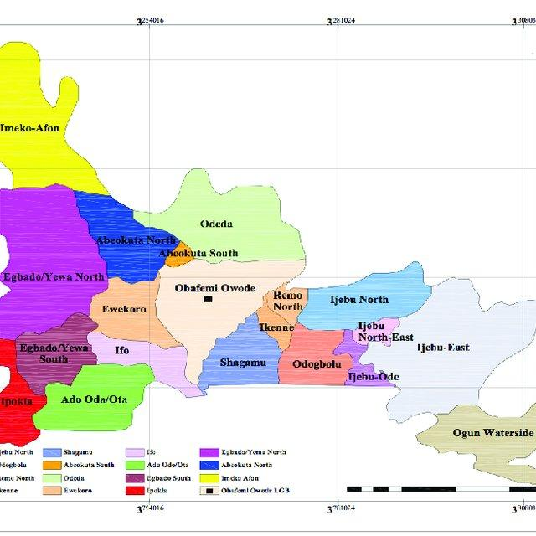Fig 3.1 The map of Ogun State where Mountain top University is located.

3.1 SAMPLE COLLECTION SITE
Water samples were taken from the target boreholes using sterile cereline bottles. Two (2) water samples were taken from three (3) locations; 2samples from Daniel 1 hostel, 2 samples from Daniel 2 hostel, and 2 samples from Guest house hostel all within Mountain top University.
Each borehole was opened and allowed to run for 2 minutes to remove any externally induced contamination. The taps of the borehole were disinfected with ethanol to eliminate any contamination due to man-made activities and any other natural sources. Water from the borehole was now collected into the cereline bottles leaving 2.5 cm of air space to make room for oxygen so that the microbes will not die until I test it in the laboratory. For identification the bottles were marked with the labels for each borehole. Physical parameters like pH and temperature were analysed in-situ. The bottles were then transported to the laboratory in an insulated box to avoid altering any of the water parameters through external factors such as high temperatures. Analysis started within 8hrs of being sampled (Abu and Wondikom, 2018).
3.2 MATERIALS USED
The following materials were used for the experiment: petri dishes, cereline bottles, cotton wool, tuberculin syringes, test tubes, cover slips, slides, conical flask, inoculating needle, dropper, inoculating loop, test tubes, ice bags, Durham tubes.

3.3 EQUIPMENTS USED
The equipment used were: Bunsen burner, water bath, incubator, autoclave, magnetic stirrer, weighing balance, hot air oven, pH meter, Thermometer, Microscope, spectrophotometer.

3.4 REAGENTS AND AGAR USED
The following reagents were used: Gram’s reagent, Leishman stain, Eriochrome black T, starch indicator, hydrogen peroxide, ethanol, ammonium chloride.
Agar media used: Chromo cult broth media, salmonella/shigella agar, nutrient agar and MacConkey agar.

3.7 PHYSICOCHEMICAL PARAMETERS
Each borehole was first allowed to pour for 2 minutes to flush out the water that had got external contamination. A bucket was then filled with the borehole water and the physical parameters were determined immediately in situ. The water samples pH readings were taken using a pH meter after standardizing the pH meter with 4, 7 buffers. The temperature of each sample was measured using a mercury-bulb thermometer, and this was reported at the sample collection point prior to transportation to the laboratory. WagWT3020 turbidimeter was used to assess both colour and turbidity of each of the samples. TDS meter was used to determine the Total Dissolved Solids in the bucket containing the borehole water.

3.8 DETERMINATION AND DIGESTION OF THE HEAVY METALS
The sample was measured using a measuring cylinder, 50ml of water was poured into a beaker and heated to evaporate at 100⁰c in a fume cupboard, then removed from the heating mantle and allowed to cool. In addition, 10ml of aqua regia was added to the beaker and its contents, and heated to dryness. The beaker was removed and cooled and then 25ml of distilled was added to the beaker, stirred and filtered in 50ml volumetric flask and labelled. The digested samples were transferred to the sample bottle and labelled. The heavy metals including Cu, Ni, Fe, Zn, and Pb were measured using the Atomic Absorption Spectrophotometry (AAS) in the Mountain top University Laboratory.

3.8.1 DIGESTION OF SAMPLES FOR Zn, Pb, Cr, Fe and Mn
In a 100ml beaker, an aliquot of 5ml concentrated nitric acid was added to a 50ml water sample. The solution was heated to a boil on a hot plate until its volume reached around 20 ml. An additional 5ml of concentrated nitric acid was applied and a watch glass protected the beaker and the heating continued for another 10 minutes. A final 5ml of acid was used to clean the beaker's slides. The solution was poured into a volumetric flask of 50ml and filled to the mark with deionized water. A blank solution was prepared in a similar way. Prior to all the analysis, the absorbance of the blank was obtained.

3.9 MICROBIOLOGICAL PARAMETER

3.9.1 PREPARATION OF MEDIA
The media chosen for isolation were: Nutrient agar, MacConkey agar, blue Eosin Methylene Agar (EMB), Shigella /Salmonella agar. At 160⁰c for 1hr, the Petri dishes and Durham bottles to be used for insolation were sterilized using the dry heat sterilization (Oven) process. Media preparation, 2.8 g of Nutrient Agar, 5.2 g of MacConkey agar, 6.3 g of salmonella shigella were weighed using a measuring scale in Durham bottles, and 100ml of distilled water were measured in Durham bottles. These are stirred and held respectively in the 10mins water bath to homogenize after which all expect salmonella shigella agar were moved into the autoclave for 15min to sterilize at 120mmHg while salmonella shigella agar was held in the water bath for 5 minutes at 70⁰c. They were then moved to the water bath to retain their temperature and prevent them from solidifying until they were required.

3.9.2 TOTAL COLIFORMS
The media used is the MacConkey broth. Using a new, aseptically sterile pipette tip for each add 1ml of each dilution of water sample given to 5ml MacConkey broth. 1ml of water sample to 3 MacConkey broth tubes and 1ml of 10-1 dilution to 3 MacConkey broth tubes. 1ml of 10-2 dilution to 3 MacConkey tubes and continued to 10-6. The bottle and tubes for gas collection holding the Durham tubes ensured there was no gas in the inverted tubes until they were incubated. The samples were labelled for 48 hours at 37⁰c, and incubated. Gas present in the inverted Durham tubes and Colour change from pink to yellow is a positive result for coliforms. Tubes with no colour change and no gas is a negative result. Using the colony counter, the colonies were countered and the result read from tables with the most probable number (MPN).

3.9.3 FEACAL COLIFORM
The count of faecal coliforms was obtained using Eosin Methylene Blue media, using the technique of pour plate. On Eosin Methylene Blue (EMB) E. Coli strains appeared as green metallic sheen colonies and this was further supported by the organism's ability to ferment lactose at 44.5⁰c while Aerobacter aerogenes appeared as large mucoid colonies of pink. Isolates were identified using standard methods as described by (APHA, 2010).

3.9.4 SUB-CULTURING OF THE ISOLATES
Distinct colonies of interest were picked from the heterotrophic colony in the media used and transferred into a new culture medium and allowed to grow and multiply for proper identification of a bacterium. The purpose of subculturing is to isolate a colony from various colonies inside a medium and plate it inside a fresh nutrient medium so it can grow without being restricted by the presence of other microorganisms and multiply for further microbiological analysis on the isolate. The sub-cultured colonies were viewed after 24hrs for colonies standing distinct not clustered and these pure colonies were subcultured again. The pure isolates were transferred onto agar slant in McCartney, inoculated for 14-18hrs before transferred into a refrigerator at 4°C to serve as stock culture for subsequent tests during identification. The sub-culturing process was carried out aseptically to prevent contamination. These cultured dishes were inverted and transferred into the incubator at 37^{O}C for 24hrs.

3.9.5 IDENTIFICATION OF THE ISOLATES
The isolates were identified using their morphological and biochemical characteristics. Their morphology was based on their appearance. For their biochemical characterization, pure colonies of each bacteria were picked for identification using standard biochemical tests which included Gram’s stain, catalase, oxidase test, Methyl red-Vogues Proskauer (MRVP), starch hydrolysis (Olutiola et al., 2000; Forbes et al., 2007). The test cultures for the biochemical tests were prepared by inoculating nutrient agar with each isolate from the stock culture. This was incubated for 18-24 hour at 37^{O}C.

3.9.6 GRAMS STAINING
The most common and useful staining procedure is the gram stain which separates bacteria into two groups according to the composition of their cell walls and were done as described by William et al., (2001). A film was made on a clean slide by emulsifying part of a colony in a loop full of distilled water. The film was then air dried and fixed by slight flaming and stained as with crystal violet solution for 1-2 minutes. The smear was rinsed rapidly with water and gram’s iodine solution was added and left for 1-2 minutes. Iodine was poured off and the slide was washed with 70% ethanol for 5-15 sec. The smear was then washed with tap water and stained with safranin solution for 20 sec. The slide was washed with water and allowed to dry. On microscopic examination the gram-positive organisms appeared purple and gram-negative organisms appeared pink (Ogeneogaga and Solomon, 2017).

3.9.7 CATALASE TEST
The reagent used is hydrogen peroxide. Catalase test is aimed at identifying organisms that produce the enzyme catalase, which converts hydrogen peroxide to water and oxygen bubbles. In this test a small amount of the test organism was smeared from the petri-dish onto the head of a sterile slide using a sterile wire loop. Then a drop of hydrogen peroxide was added to the smear and mixed. If bubbles are seen, this concludes that the organism produces catalase. Lack of bubbles indicates negative results (Abu and Wondikom, 2018).

3.9.8 OXIDASE TEST
Using a sterile wire loop, some amount of the pure culture was swabbed into one of the ends of an oxidase dry slide. Colour changes to purple or blue after 30s to 1 min is evidence that the result is positive. The lab test is based on detecting the production of enzyme cytochrome oxidase by Gram negative bacteria (Ogeneogaga and Solomon, 2017).

3.9.9 STARCH HYDROLYSIS TEST
20ml of molten starch agar was aseptically poured into each sterile Petri dish, allowed to set and was inverted in an incubator at 37⁰C. The organism was streaked across the surface of the plate and incubated at 370C for 24-48 hours. Afterwards, the plates were flooded with some quantity of Gram’s Iodine. Unhydrolyzed starch formed a blue-black colour, hydrolysed starch appeared as a clear zone and reddish-brown zones around the colony indicated partial hydrolysis of starch (Olutiola et al., 2000).

3.10 IMMUNOLOGICAL TESTS

3.10.1 INOCULATION OF ALBINO MICE
Thirty healthy mice were used for the experiment for a period of 4 weeks to see their immune response to the borehole water sample. The mice were grouped into 3 cages of 10 each, the mice in the first cage were inoculated with pure (sachet) water, and the mice in the second and third cage were inoculated with the borehole water samples for the experiment. The mice were inoculated with a syringe passed into the underneath of the abdomen of the mice weekly for 4 weeks.
After the fourth week the blood of the mice was taken and a smear made. Examination of the smear was done by observing under the microscope to examine the immune cells and the reactions of the immune cells.

CHAPTER FOUR

4.0 RESULTS AND DISCUSSSION

4.1 PHYSICOCHEMICAL PARAMETERS OF BOREHOLE WATER
The aim of this study is to assess the safety of borehole water in the Campus of Mountain top university and its public health implications on the students. This chapter shows the data generated from the survey and tests. The result findings are enumerated in the tables below. Table 4.1 shows the Physico-chemical results. The pH of the three Hall of residence ranged from 4.8-5.3. The highest pH of 5.4 was recorded in Guest house and the lowest pH of 4.8 was recorded in Daniel 2. The pH of the three halls of residence were slightly acidic. The temperature of the hall of residence was at 27.7⁰C. The conductivity of the three halls of residence recorded 0.005 and 0.006. The total dissolved solids recorded from the three halls of residence were 017,021 and 018. Daniel 2 had the highest level of total dissolved solids amongst the three halls of residence and Daniel 1 with the least of 017.
Table 4.1 The Physicochemical of borehole water samples within the campus of Mountain Top University
Hall of residence | pH | Ms/cm | PPM | ⁰C | Conductivity | TDS
Daniel 1 | 5.3 | 0.11 | 090 | 27.7 | 0.005 | 017
Daniel 2 | 4.8 | 0.15 | 117 | 27.7 | 0.006 | 021
Guest house | 5.4 | 0.13 | 100 | 27.8 | 0.005 | 018

4.2 HEAVY METAL CONTENT OF SAMPLES ANALYSED
The level of zinc in the water samples analysed ranged from 0.156 to 0.349 (Table 4.2). The highest value of 0.349mg/l was recorded at Guest house and Daniel 2 recorded the lowest value of 0.156mg/l (Table 4.2). The values were within the acceptable limit of 3.00 mg/l prescribed by WHO.
The level of manganese in the water samples ranged from 0.170 to 0.239 mg/l (Table4.2). The highest value of 0.239 mg/l was recorded at Daniel 1 and Daniel 2 recorded the lowest value of 0.170 mg/l. These values are higher than the standards set by WHO. Manganese in water is responsible for the dark, brown colour in water and it is also responsible for odour and unpleasant taste.
The level of Lead in the water samples was <0.012 mg/l (Table 4.2). These values were within the acceptable limit of 0.01 mg/l prescribed by WHO.
The level of Chromium in the water samples were <0.005 mg/l (Table 4.2).
The level of Iron in the water samples ranged from <0.005 to 0.144 mg/l (Table 4.2). The highest value of 0.144 mg/l was recorded at Daniel 1 while Daniel 2 and Guest house recorded the same value of <0.005 mg/l. These values were within the acceptable limit of 0.3 mg/l prescribed by WHO.
All the heavy metals observed were within the acceptable limit allowed by WHO
Table 4.2 Levels of heavy metals in borehole water samples (mg/L)
Hall of residence | Lead (Pb) | Iron (Fe) | Manganese (Mn) | Zinc (Zn) | Chromium (Cr)
Daniel 1 | <0.012 | 0.144 | 0.239 | 0.190 | <0.005
Daniel 2 | <0.012 | <0.005 | 0.170 | 0.156 | <0.005
Guest house | <0.012 | <0.005 | 0.218 | 0.349 | <0.005
WHO permissible limits | 0.01 0.3 0.05 3.0 0.3

4.4 MICROBIOLOGICAL ANALYSIS
Table 4.3 shows the microbial counts in the halls of residence. Daniel 1 and Daniel 2 had a high level of microbial load after culturing, the microbial count was too numerous to count (TNTC) while the microbial count in Guest house is LND (level not detected). The borehole water in Guest house conforms to the WHO standards for potable water (WHO, 2010). The colonies were mostly creamy, round, small single colonies as seen in table 4.5.

Hall of residence | Microbial counts
Daniel 1 | TNTC
Daniel 2 | TNTC
Guest house | LND

Table 4.3 The total viable count of borehole water samples within the Mountain Top University Campus.

4.5 REACTIONS OF THE IMMUNE CELLS
Table 4.4 shows the immune cells of the mice reacted to the borehole water samples for a period of four (4) weeks. After the baseline assessment of the immune cells where the cells were not present, after the first week we could see the presence of the immune cells (Basophils, Eosinophils and Neutrophils) as seen in table 4.4. Consequent weeks the number of immune cells increased (Table 4.4), the immune cells of the mice were reacting to the borehole water sample but considerably.

Table 4.4 Reaction of the Immune cells
Immune cells | Wk. 1(Amount) | Wk. 2(Amount) | Wk. 3(Amount) | Wk. 4(Amount)
Basophils | 1 | 2 | 3 | 3
Eosinophils | 2 | 3 | 3 | 4
Neutrophil | 1 | 2 | 3 | 3

Table 4.5 Morphological characteristics of bacteria isolated from the borehole water
Samples within Mountain Top University Campus
Isolate code | Colour | Shape | Elevation | size | Texture | Opacity | Margin
Dan 1 | creamy | round | flat | Small  single colonies | smooth | opaque | entire
Dan 2 | creamy | round | flat | Small single  colonies in chains | smooth | opaque | entire
GH | creamy | round | flat | small | smooth | opaque | entire

4.6 INTERPRETATION OF THE SURVEY
A survey was taken to determine the effect of the borehole water by Questionnaires which were given out to students of Mountain Top University that stay in the various male hostels and make use of the borehole water daily to ascertain the level of portability of the borehole water.
Table 4.6 Age of Respondent
Age(years) |  | Frequency | Percent (%)
 | 16-17 | 4 | 8.0
 | 18-19 | 13 | 26.0
 | 20-21 | 27 | 54.0
 | 22-23 | 6 | 12.0
 | Total | 50 | 100.0

The respondents are aged between 16-23. Most of the respondents are between the ages of 20 and 21, followed by those between the ages of 18 and 19. The fewest numbers are those that fall between the age group of 16-17. This may suggest the majority of the male students that make use of the borehole water are in their middle age of 20-21.

Table 4.7 Course level of respondents
Academic level |  | Frequency | Percent (%)
 | 100 | 6 | 12.0
 | 200 | 2 | 4.0
 | 300 | 6 | 12.0
 | 400 | 36 | 72.0
 | Total | 50 | 100.0

Most of the respondents are in 400 level, they are the final year students that have used the borehole water more. Equal number of male students responded in 300 level and 100level and 200level had the least amount of male student respondent

Table 4.8 How long respondent have used borehole water in school
Years |  | Frequency | Percent
 | One Year | 6 | 12.0
 | Two Years | 2 | 4.0
 | Three Years | 6 | 12.0
 | Four Years | 36 | 72.0
 | Total | 50 | 100.0

Majority of the male students that have the borehole water the most are those that have spent four years in the school

Table 4.9 Do you experience itching or rashes when bathing with borehole water in school?
Response |  | Frequency | Percent (%)
 | Yes | 29 | 58.0
 | No | 21 | 42.0
 | Total | 50 | 100.0

A higher percentage of respondents experience itching or rashes when bathing in school.

Figure 4.1 Gender of the respondents that use the borehole water on a regular basis
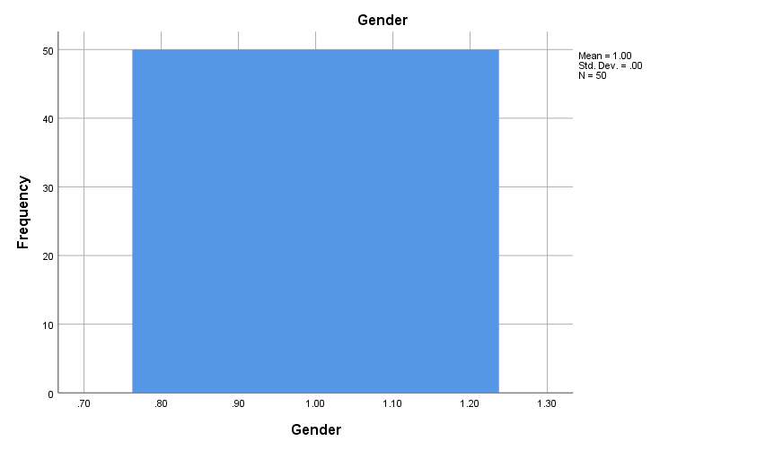

Figure 4.2 Age group of respondents
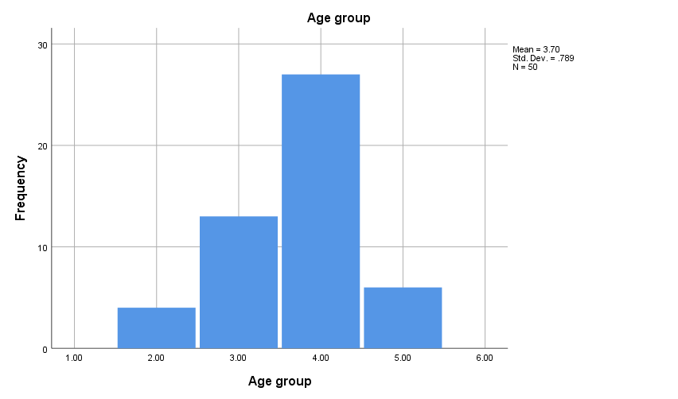

Figure 4.3 Academic level of respondents
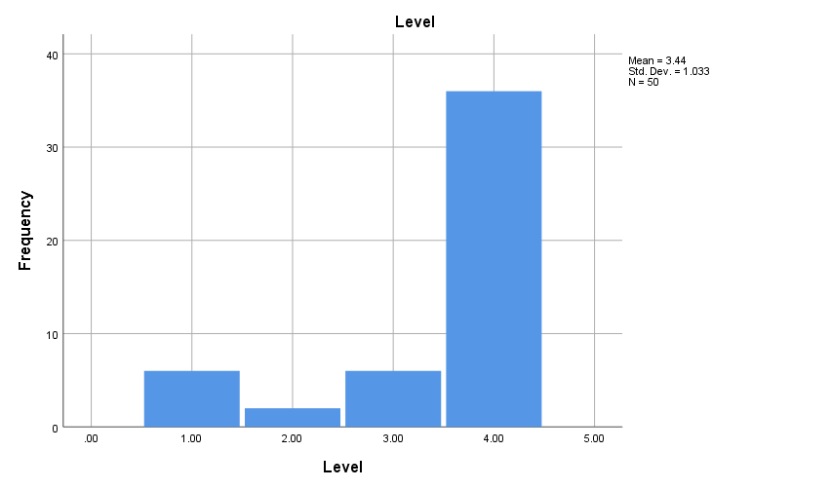

Figure 4.4 Duration of borehole water usage by respondents
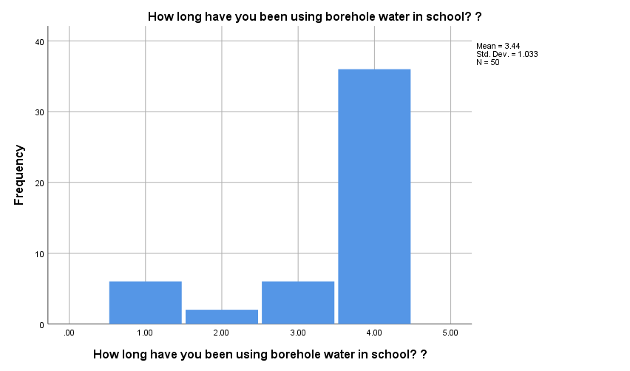

Figure 4.5 Domestic usage of the borehole water by respondents
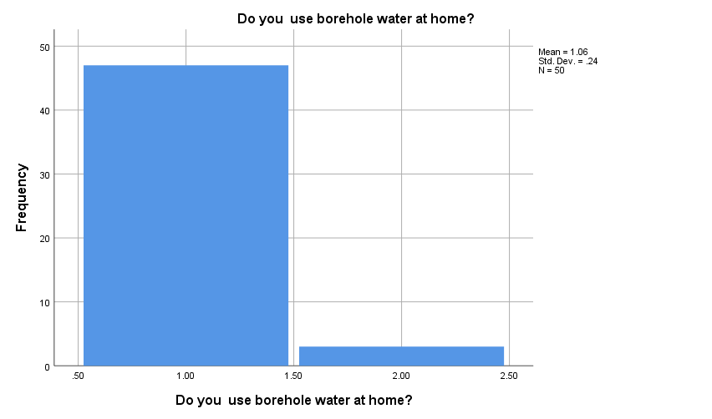

Figure 4.6 Safety of the domestic usage of borehole water by respondents
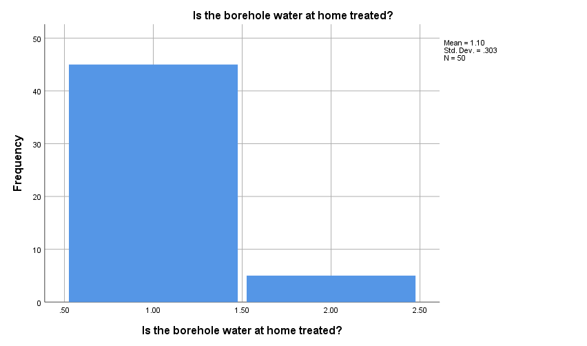

CHAPTER FIVE

5.1 CONCLUSION AND RECOMMENDATION.
In our rapidly growing industrialised world, including Nigeria, water is an important resource. Water pollution has become a major global problem because most water sources are drying up due to excessive pollution, apart from the high costs incurred in the treatment of water. Since borehole water is central to the daily water consumption requirements of individuals living in the community of Mountain Top University, this study highlights the need for improved water quality.
The results showed that the pH of the water samples from the halls of residence were between the range of 4.8 and 5.6 which can be said to be an acceptable level for human consumption. The values of turbidity, TDS, and conductivity found during the study were all within the acceptable WHO limit.
The trace metal levels tested (Mn, Zn, Pb, Cr and Fe) were all lower than the WHO guideline levels except Manganese which was slightly higher than WHO standards, it is responsible for the brown colour of the water in all three boreholes. However, the amount of trace metals does not pose a health threat to consumers.

5.2 RECOMMENDATION
The following is recommended based on the study's outcome;
- It is recommended that water quality analysis be carried out at least once every two years on all the boreholes in the district. This would ensure that pollution incidences are noticed sooner in order to take remedial measures.
- The Mountain Top community should undergo sanitation on the campus every weekend to maintain a clean environment.
- Students should be aware of the effects of contaminated water by the school via seminars and forums to be able to understand the usefulness of keeping the borehole and borehole environment clean.
- Proper treatment of the borehole water in the campus should be done by the school management.

