




SCHOOL OF HUMANITIES, MANAGEMENT AND SOCIAL SCIENCES

Mountain Top University
Kilometre 12, Lagos-Ibadan Expressway, MFM Prayer City, Ogun State.
PHONE: (+234)8053457707, (+234)7039395024, (+234) 8039505596
EMAIL: support@mtu.edu.ng
Website: www.mtu.edu.ng.

Published By:
Mountain Top University


COURSE GUIDE


COURSE TITLE: BASIC PIANO 1
COURSE TITLE: MUS 109
LECTURER: Bayo Ogunyemi

COURSE OBJECTIVES
General Introduction and Course objectives:
Instruction in Basic Piano playing skills for beginners. Class Piano lectures: with about 8 hours of individual (Private) per week is required of each student.
The aim of this course is to introduce the art of Piano playing to the students who are mainly beginners. These include understanding the mechanics of Piano, and the technics of Piano playing. The prerequisite to this curse is Rudiments of Music. Students in the class are expected to have had a fair understanding of the basic theory of Music writing and notation.

Course Contents
Lecture ONE: Introduction to the Piano
Lecture TWO: Techniques of Piano playing
Lecture Three: Technical Exercises to aid Techniques
Lecture Four: Playing the Major scales in C, D A E and F (hands separately)
LECTURE ONE:
- INTRODUCTION TO THE PIANO
This lecture is meant to introduce the students, most of whom are beginners, to the art of Piano playing. The lecture commences by dismantling Piano, for the students to see and examine the belly of the Piano with a view of understanding the mechanism. This is expected to instigate further discuss with the aim of exposing the students to the mechanism of sound production in Piano and the handling techniques.
OBJECTIVES:
At the end of the lecture, students should be able to:
  - Understand the process of sound (tone) production in the piano.
  - Distinguish between Piano and other keyboard related musical instruments, particularly the modes by which they generation sound.
- Explain the differences in Piano and other Keyboard Instruments
Pre-Test
- In what ways can you define Piano?
- Describe the process by which sound is produced on a Piano
- How does one achieve loudness or softness on a Piano

CONTENT:
1.1 BRIEF HISTORICAL BACKGROUND
Piano is an acoustic instrument that has been in existence since 16th Century. It was invented in Florence by an Italian, Bartolomeu Cristofori in 1710. The Piano metamorphosed into the present form in this order; Harpsichord – Clavichord - Virginal and finally, Pianoforte. The word pianoforte is an Italian word which literarily means LOUD and SOFT. This name, presents the instruments as against, so many of its contemporaries, as one that can produce both loud and soft tones. Each of the stages of evolution portrayed different shapes and sizes. But the Pianoforte, has remained largely two major types i.e Upright and Grand Piano (See Images above)
1.2 The Structure of the Piano 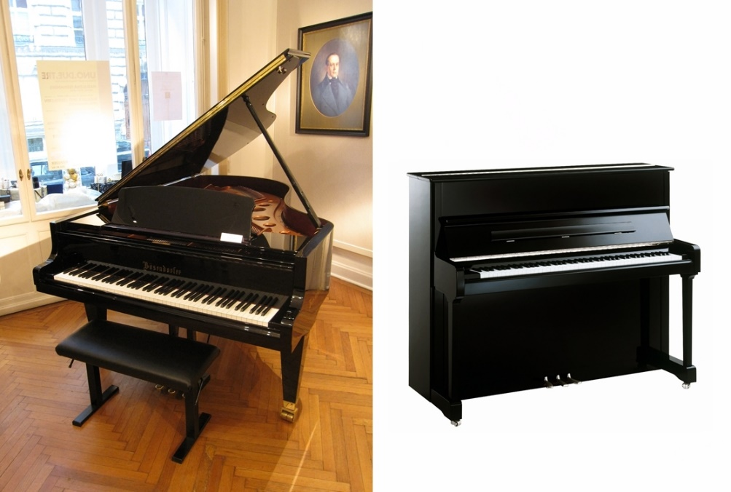
Grand Piano Upright Piano (Source: goggle.com.ng/imghp)

Upright Piano: Piano with a rectangular upright case in which the strings are mounted vertically and a keyboard at right angled to the case (Microsoft Encarta 2009)
Grand Piano: Large Pianos with horizontal strings
  - Main Features Of The Piano
These are also referred to as the mechanism of the Piano. The piano will be opened up for the students to examine and be involved in practical demonstration.
The Keyboard: the keyboard initiates the action on the piano by the player exerting pressure on the keys. (White and Black keys on the outer board of a Piano)The greater the velocity of the keypress, the greater the force of the hammer hitting the strings and the louder the sound of the notes produce. (en.m.wikipedia .org/wiki/piano)
Key Hammer: A major component of the piano. The hammer initiates the process of sound making. It responds to the pressure originating from the player by pressing the keyboard, and goes to strike the strings affixed to the soundboard
The Dampers: the dampers stop the vibration of the strings after the action form the hammer, when keys returns to its normal position
The Strings: This is the length of wire which serves as the main agent of sound production in the Piano. Installed across the sound board and affixed to the sound board.
The Pedal: there are two main pedals in a piano (some latest inventions of piano have three pedals) the two are sustain pedal and damping pedal.
- The sustain pedal are installed on the right hand-side of the piano. It suspends action of damper by allowing strings to vibrate unhindered.
- The damping pedal, installed on the left handside mutes the sound of the piano by hammer closer to the strings to curtail the length of string vibration after hammer stuck

The Keyboard: These contain the black and white keys adorning the outer surface of the Piano. The number of these keys which are tempered according to specification, determines the size of the piano. Some piano have compass of 7 octaves while some modern ones have 7octaves and a minor 3rd
The Sound Board: The natural competency whereby the piano lives is sound and this is radiated in the intended direction by the sound-board: without it the mere vibration of strings would create little or no audible sound’ (Kentner, 24).
1.4 Piano and the Staff.
Components of the musical Staff.
- The lines and the Space/ Staff

- The Clefs The treble, The Bass Clef and the meter Sign

Post-Test

- Identify each notes of the keyboard as they appear of the music staff
- Differentiate between notes meant for the left hand and the right hand on both the Piano and the Staff
- Play the first five notes of the scale starting form Middle C

LECTURE TWO:
TECHNIQUES OF PIANO PLAYING
2.0 INTRODUCTION: This lecture is designed to commence a gradual introduction of the students to the art of Piano playing and performance. The lecture, in practical terms, initiates the interaction of the students with the instrument. Having understood the mechanism of Piano, this lecture is meant to inculcate the right attitude and mien of Pianist into the students.
OBJECTIVES
At the end of this lecture the student are expected to do the following:
  - Sit properly on the Piano
  - Identify the numbers associated with each finger of both arms in the art of Piano playing
  - Identify musical notes on the keyboard in relation to the notes’ appearances on the music staff.
Pre-Test
- Sit on the piano
- Place hands on the keyboard
- Touch middle C

CONTENT
2.1 Understanding How Fingers work on the Piano

Right hand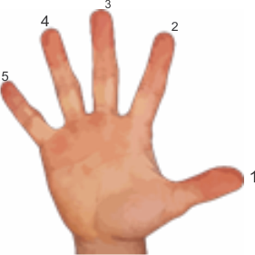
Left Hand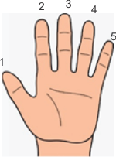
  - The Keyboard
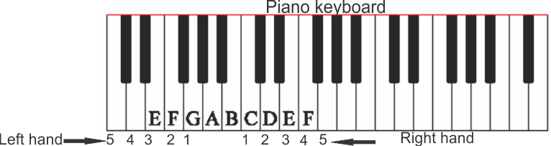
Source: goggle image ((Source: goggle.com.ng/imghp))

FIVE FINGERS ON THE PIANO
RHT= Right hand Thumb
LHI = Left hand Index Finger
These note will be played at different tempos.
Post Test
At the end of this lecture, students are expected to be able to do the following
- Place their fingers of the two arms on the Piano appropriately
- Identify the notes of the Piano
- Play at regular tempo, five note of the Piano starting form Meddle C and C octave lower.

Biblography
-` Goggle Search engine
- Loius Kentner, Yehudi Music Guides : Piano Kahn & Averil London, 1976
- Microsoft Encrata, 2009
- Smallwood Piano Tutor, International Music Publications, 2006

LECTURE THREE:
TECHNICAL EXERCISES TO AID TECHNIQUES
3.1 INTRODUCTION
This lecture is meant to introduce the students to techniques that will make their fingers adaptable to Piano playing.
OBJECTIVES
At the end of this lecture the student are expected to do the following

      - Coordinate fingers of the two arms on the Piano while maintain tempo
      - Attain reasonable tempo in playing the notes
Pre-Test
- Play any strings of notes on the Piano
- Flip the wrist in a way of exerting pressure on the keys of the piano
- Play notes on the Piano as soft as possible and also as loud as possible

CONTENT
  - EXERCISE 1
Right hand
Left Hand
Both Hands

Students are encourage to play these as many times as possible in during their personal practice. They are to change the tempo and use different notes as deemed appropriate
Post-Test
- Take turn to play the exercises
Biblography
-` Loius Kentner, Yehudi Music Guides : Piano Kahn & Averil London, 1976
- Smallwood Piano Tutor, International Music Publications, 2006

LECTURE FOUR:
PLAYING THE MAJOR SCALES
4.1 INTRODUCTION
This lecture is a continuation of study in techniques. Here, attempt will be made to introduce the student to playing of major scales using the correct fingering , style and techniques.
OBJECTIVES
- Coordinate fingers of the two arms on the Piano while maintaining tempo
- Attain reasonable tempo in playing the notes
Pre-Test
      - Play any strings of notes on the Piano
      - Flip the wrist in a way of exerting pressure on the keys of the piano
      - Play notes on the Piano as soft as possible and also as loud as possible

CONTENT
  - PLAYING MAJOR SCALE
C Major Scale (Right Hand)
C Major Scale (Left Hand)

C major Scale BH
N.B The fingering as shown here will be used in playing the following Major Scales C G D E A
The exercises will be playing using different tempos.
Post-Test
Take turn to play the exercises, each hands separately and both hands together.

Biblography`
- Loius Kentner, Yehudi Music Guides : Piano Kahn & Averil London, 1976
- Smallwood Piano Tutor, International Music Publications, 2006

