




COLLEGE OF BASIC AND APPLIED SCIENCES

Mountain Top University
Kilometre 12, Lagos-Ibadan Expressway, MFM Prayer City, Ogun State.
PHONE: (+234)8053457707, (+234)7039395024, (+234) 8039505596
EMAIL: support@mtu.edu.ng
Website: www.mtu.edu.ng.

Published By:
Mountain Top University


COURSE GUIDE

COURSE TITLE: GENERAL BIOCHEMISTRY I
COURSE CODE: BCH 201
LECTURER(S): Prof. I.A. Akinwande, Mrs. I.O
Adefisan, Mrs. O.O. Ayodele

COURSE OBJECTIVES
This course is designed to introduce students to the basic concept of Biochemistry as a discipline. Foundational topics such as the definition and scope of Biochemistry; acidity and alkalinity; and the properties, chemistry and biological functions of the major biomolecules (carbohydrates, proteins, lipids and nucleic acids) will be covered. The course is important for students of Biochemistry, other biological sciences, and Food Science. It will provide students with the foundational knowledge for further studies in Biochemistry and related disciplines.

Learning Outcomes
Upon completion of the course, the student should achieve an understanding of the following:
- Structure of fundamental monosaccharides and polysaccharides, and their chemistry
- The structures of amino acids, their chemical properties and their organization into polypeptides and proteins.
- Methods for isolating and characterizing proteins
- The basic elements of protein structure
- Key principles of protein function.
- Structure and basic functions of nucleotides
- Structure of different classes of lipids and their roles in biological systems.

METHOD OF GRADING
1. Continuous Assessment 30 Marks
- Test 1/ Test 2 15 Marks
- Mid-Semester Test 15 Marks
2. Semester Examination 70 Marks

COURSE CONTENTS
Week | Topic
1 | Introduction and Course Overview; Definition and Scope of Biochemistry; Concepts in Biochemistry
2-3 | Introductory Chemistry of Carbohydrates
4-5 | Introductory Chemistry of amino acids: properties, reactions, biological functions; classification of amino acids
6 | Primary, Secondary, Tertiary and Quaternary Structures of proteins; Biological Functions of proteins.
7 | Assessment
8-9 | Introductory Chemistry of Proteins: methods of isolation, purification, identification; Basic Test Principles for amino acids and proteins
10-11 | Introductory Chemistry of Lipids
12-13 | Introductory Chemistry of Nucleic Acids; Nomenclature of nucleosides and nucleotides; Effect of Acid and alkali on hydrolysis of nucleic acids
14 | Assessment

LECTURE ONE: INTRODUCTION AND COURSE OVERVIEW
- INTRODUCTION
This lecture focuses at introducing the students to basic concept, definition, objectives and Philosophy of Biochemistry. The various aspects of Biochemistry and the Industrial application are considered.
Objectives:
At the end of this lecture, students should be able to:
- Define Biochemistry
- State the philosophy and objectives of Biochemistry
- State the industrial relevance of Biochemistry

Pre-Test
- What is Biochemistry?
- Biochemistry as a discipline is required in food Industry. True or false?

1.1 WHAT IS BIOCHEMISTRY?
- Branch of Science concerned with the chemical and physicochemical processes and substances which occur within living organisms.
- The Science dealing with the chemistry of living matter.
- Chemistry that deals with the chemical compounds and process occurring in organisms.
- The study of chemical process within and relating to living organisms.
- The study of chemical processes occurring in living matter.

1.2 PHILOSOPHY, AIMS AND OBJECTIVES OF B.SC BIOCHEMISTRY DEGREE PROGRAMME
- To provide students with a broad and balanced foundation of biochemical knowledge and practical skills.
- To develop in students the ability to apply knowledge and skills to solving theoretical and practical problems in biochemistry.
- To develop in students a range of transferable skills that are of value in biochemical and non- biochemical employment.
- To provide students with knowledge and skills base from which they can proceed to further studies in specialized areas of biochemistry or multi-disciplinary areas involving biochemistry.
- To provide through training and orientation, an appreciation of the solutory rewards of inter and multi-disciplinary approach to the solution of complex life problems.
- To generate in students an appreciation of the importance of biochemistry in industrial, economic, environmental, technological and social development.
- To instill in students a sense enthusiasm for biochemistry an appreciation of its application in different contexts and to involve them in an intellectually stimulating and satisfying experience of learning and studying.
During degree training, students develop specific skills which include:
- A full and critical understanding of relevant texts.
- The ability to assemble an argument and engage in debate.
- Critical and analytical skills.
- Independent thinking and problem solving.
- Practical skills, team work, communication, presentation and IT skill.
- Self-management and the capacity to lead your own Professorial development.
- Enablement for further study to M.Sc, M.Phil and Ph.D degree programmes.
- Laboratory based work, Final research project and industrial placement (SIWES) prepare students for a Research or Technical Position.

1.3 SCOPE AND DIFFERENT AREAS OF BIOCHEMISTRY

- To understand the functionality of living tissues, cells, organs and the entire living system.
- It deals with chemistry of life.
Various areas, namely:
- Chemistry and metabolism of carbohydrates.
- Chemistry and metabolism of lipids (fat).
- Chemistry and metabolism of proteins (amino acids).
- Chemistry and metabolism of nucleic acids.
- Bioenergetics.
- Biosynthesis of macromolecules.
- Membrane biochemistry.
- Bioinorganic chemistry.
- Food and nutritional Biochemistry
- Special Topics in Biochemistry.
- Microbial Genetics/Molecular Biology.
- Seminar in Biochemistry
- Enzymology
- Biochemical Reasoning
- Tissue and organ Biochemistry
- Advanced Biochemical Methods
- Biotechnology & Genetic Engineering
- Research Projects
- Metabolic Regulations.
- Student Industrial Work Experience
- Plant Biochemistry
- Entrepreneurial Skills.
- Hormones
- Clinical Biochemistry
- Immunology
- Industrial Biochemistry
- Pharmaceutical Biochemistry
*A biochemistry degree opens up a range of highly skilled careers that incorporate aspects of both Biology and Medicine.
Jobs directly related to degree in Biochemistry includes:

- Analytical Chemist
- Biomedical Scientist
- Clinical Research Associate
- Healthcare Scientist
- Clinical Biochemist
- Forensic Scientist
- Research Scientist
- Physician Associate
- Technologist
- Scientific Laboratory Technician
- Health and Safety Inspector
- Quality Manager
- Science Writer

1.4 TYPICAL EMPLOYERS OF BIOCHEMISTRY GRADUATES
- Environmental Agency
- Forensic Laboratories
- Government Departments
- University & Other Tertiary Institutions
- National Health Services
- Food and Drug Agencies
- Public Health Laboratories
- Pharmaceutical Company
- Food and Water Company
- Biotechnology Company
- Self- Employment
- Police and Military
- Scientific & Medical Publisher & Intellectual Property office (as patent examiners).

Post-Test:
- What is Biochemistry?
- List the Philosophy, aims and objectives of B.Sc Biochemistry degree Programme.
- List 5 specific skills that students develop during degree training.

LECTURE TWO: INTRODUCTORY CHEMISTRY OF CARBOHYDRATES
2.0 INTRODUCTION
The lecture introduces students to the chemistry of Carbohydrates, covering topics like chemical composition, classification and nomenclature, biomedical importance, food source and physical properties of carbohydrates.

Objectives:
At the end of this lecture, students should be able to:
- Name the chemical composition of carbohydrates
- State some biomedical importance of carbohydrates
- Classify carbohydrates with examples
- Define basic terms in sugar chemistry

Pre-Test
- Name 5 carbohydrate food you Know
- What are the functions of Carbohydrates?

2.1 CARBOHYDRATES
- Carbohydrates are distinct and large group of organic compounds. They are essential macro molecules made of carbon, hydrogen and oxygen.
- Carbohydrates are poly hydroxy aldehydes or ketones or compounds which yield these on hydrolysis. They are also known as saccharides, or sugar if they exist in small quantities.
- The name "carbohydrate" is derived from 'hydrates of carbon', and they arise from photosynthesis, where they exist as products.
- Carbohydrates are the most abundant aldehyde compounds found in living organisms.
- Carbohydrate chemistry is a sub-discipline of chemistry primarily concerned with the synthesis, structure, and function of carbohydrates.
- Due to the general structure of carbohydrates, their synthesis is often preoccupied with the selective formation of glycosidic linkages and the selective reaction of hydroxyl groups.
- Their structure is composed of the functional groups, aldehyde and ketone, which are attached with various amount of hydroxyl groups. The hydroxyl groups are usually attached to the carbons not a part of the aldehyde or ketone functional groups, to form aldoses and ketoses.

2.2 BIOMEDICAL IMPORTANCE OF CARBOHYDRATES
1. Most abundant dietary source of energy and storage form of energy.
Glucose is a carbohydrate and it is the only energy providing sugar to the body. Glucose is important as it is required by the body for proper cellular functions, and hence the blood glucose levels are kept relatively constant.
Liver maintains the homeostatic levels of blood glucose and yet it stores glucose for a period of twenty-four hours. After this period, the cells and tissues of the body particularly the brain and the skeletal muscle rely on glucose.
When there is lack of glucose, the body cells start using up the fatty acids or the proteins of the body, this may also lead to ketosis due to prolonged fasting. Hence, regular intake of carbohydrates will prevent proteins from being used for energy. Enough carbohydrates will prevent the degradation of skeletal muscle and other tissue of the liver, heart and kidneys and ketosis will be prevented.
2. Also serve as storage form of energy –Glycogen.
3. Derangement of glucose metabolism is seen in diabetes mellitus.
4. Inherited deficiency of certain enzymes in metabolic pathways of different carbohydrates can cause diseases, e.g. galactosemia, glycogen storage diseases (GSDs) lactose intolerance, etc.
5. In plants they are used as energy source and for storage in the form of starch.
6. Cellulose which is a polysaccharide is an important structural component in the cell wall of plants.
7. Sucrose, a disaccharide is a product of photosynthesis and is transported internally.
8. They minimize the use of proteins for energy.
9. They also act as flavour and sweeteners.
10. Certain carbohydrate derivatives are used as drugs, like cardiac glycosides / antibiotics.
11. Help in breakdown of fatty acids and prevents ketosis.
12.Carbohydrates are also important in the form of dietary fibres like cellulose, pectin, mucilage etc. Dietary fibres like pectin and mucilage are important for proper intestinal health. Consumption of fiber makes waste-elimination easier. Excess pressure during defecation may cause haemorrhoids. Fibre intake reduces the risk of obesity and diabetics also benefit from fibre intake. It also decreases absorption of cholesterol.
13. Lactose principal sugar of milk—in lactating mammary gland.
14. Degradation products utilised for synthesis of other substances such as fatty acids, cholesterol, amino acid, etc.
15. Constituents of mucopolysaccharides which form the ground substance of mesenchymal tissues.
2.3 SOURCES OF CARBOHYDRATES
Simple Carbohydrates
- Sugar: fruits, fruit juices, sugar, honey, soft drink
Complex Carbohydrates
- Starch: bread, cereals, rice, potatoes, pasta
- Fibre: whole grains, fruits and vegetables, legumes, nuts and seeds
2.4 CLASSIFICATION AND NOMENCLATURE OF CARBOHYDRATES
- Based on the number of sugar units
- Based on the functional group present
The most important carbohydrate is glucose. In general, monosaccharides have one carbonyl group and the remaining carbons each bear one hydroxyl group. Monosaccharides can be linked together to form very large polymers called polysaccharides. They cannot be hydrolyzed further into simpler forms.
A disaccharide consists of 2 linked monosaccharides i.e yields 2 molecules of the same or different monosaccharide units on hydrolysis.
Oligosaccharides consists of more than 3(few monosaccharides) linked together. Yields 3-10molecules of monosaccharide units on hydrolysis.
Polysaccharides yields more than 10 molecules of the same or different monosaccharide units on hydrolysis:
    - Homopolysaccharides
    - Heteropolysaccharides
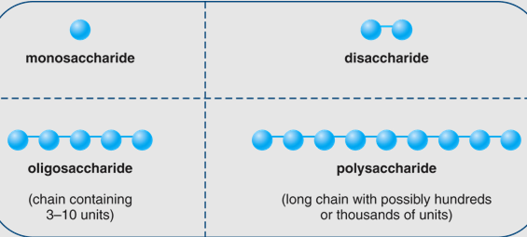
Fig. 2.1 Carbohydrate classification
- The suffix –ose is often used in describing and naming carbohydrates. For example:
A carbohydrate with 6 carbons is called a hexose
A carbohydrate with 5 carbons is called a pentose
- A carbohydrate with an aldehyde as its carbonyl unit is called an aldose (aldehyde functional group)
- A carbohydrate with a ketone as its carbonyl unit is called a ketose (ketone functional group)
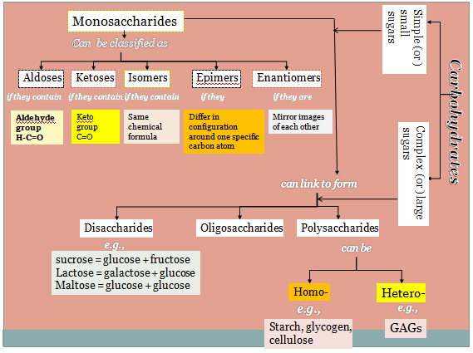
Source: http://slideplayer.com/slide/7633585/
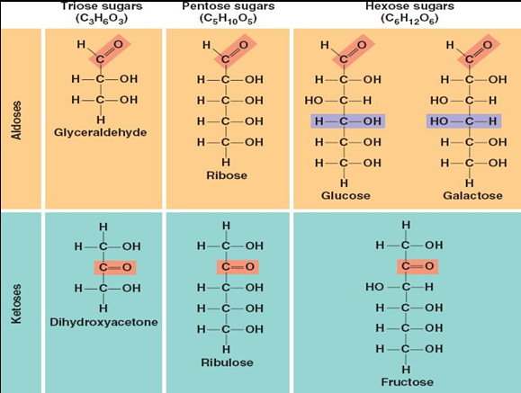
Source: kviz.info

2.4.1 MONOSACCHARIDES
Simple sugars which cannot be hydrolysed further.
The most abundant monosaccharides in nature is the six-carbon sugar, D-glucose, sometimes referred to as dextrose.
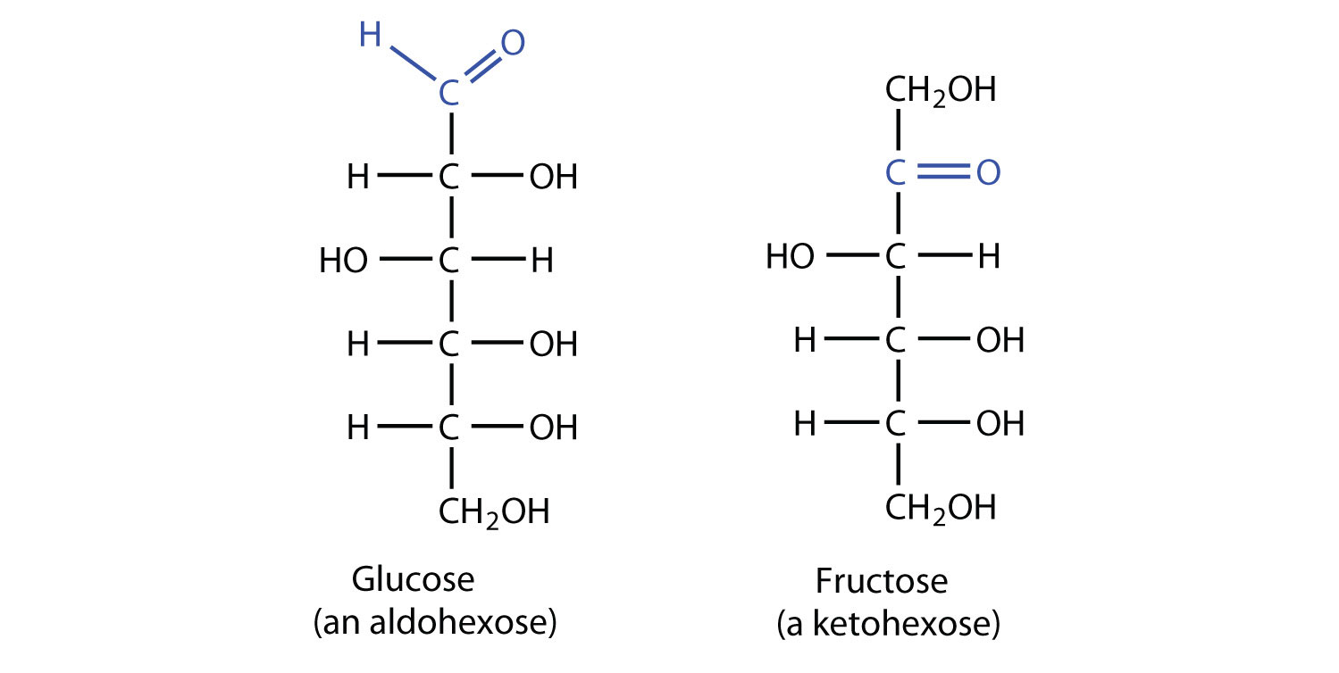
Source: Chemlibretexts.org
The table below explains classification based on the number of carbon atoms present as well as on the presence of functional groups.

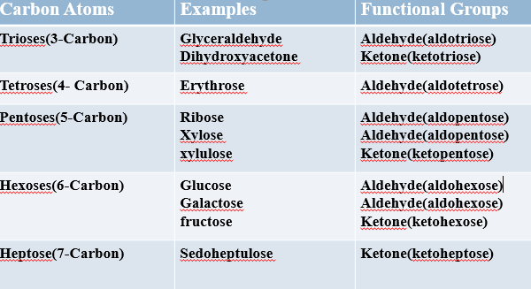.
Three nutritionally important monosaccharides are: glucose, fructose, galactose.
1. Glucose is the most important simple carbohydrate in human metabolism. It is the final product of complex carbohydrate digestion.
Maintenance of an appropriate blood glucose level is essential to human health.
It is a part of every disaccharide and the only monosaccharide in starches.
2. Fructose, often called levulose or fruit sugar, occurs in honey and many fruits. It is the sweetest of natural sugars.
One of the two monosaccharides combined in the disaccharide, sucrose. Fructose is a ketohexose which forms five-membered ring in solution.
3. Galactose is widely distributed in plant gums and pectins, and is a component of the disaccharide lactose. Galactose is an aldohexose; it differs from glucose only in the spatial orientation of the —OH group at carbon 4. In the body, galactose is converted to glucose to provide energy and is synthesized from glucose as needed.
2.5 STEREOISOMERISM
Stereochemistry is the study of orientation of molecules in space relating how atoms are arranged in space relative to each other.
Stereoisomers are isomeric molecules that have the same molecular formula and sequence of bonded atoms (constitution), but differ in the three-dimensional orientations of their atoms in space. This contrasts with structural isomers, which share the same molecular formula, but the bond connections or their order differs.
Two molecules are described as stereoisomers if they are made of the same atoms connected in the same sequence, but the atoms are positioned differently in space.
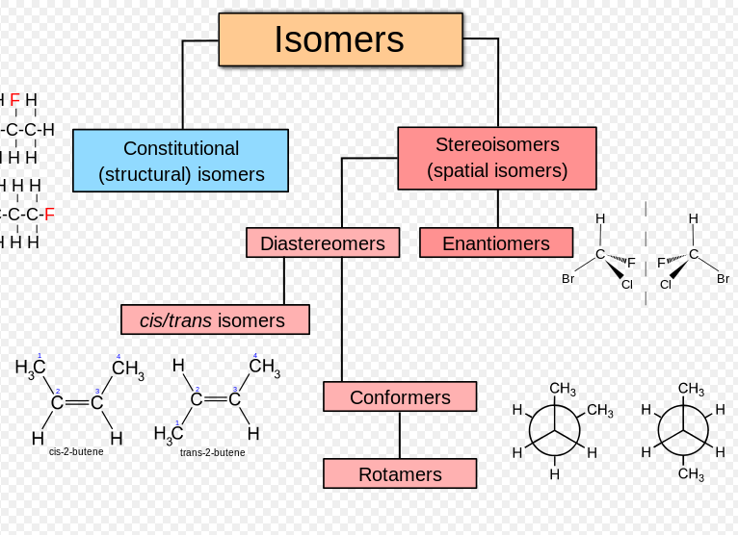
Source: Wikipedia.
Important types of stereoisomerism associated with glucose are:
- Optical isomerism(enantiomers)
- D and L-isomerism
- Epimerism
- Anomerism
2.5.1 Optical Isomers
Optical isomers are molecules which are mirror images of one another. Often these mirror image molecules are referred to as enantiomers. Just as a right-handed glove cannot be superimposed on a left-handed glove, optical isomers cannot be superimposed on one another.
Mirror image configurations(enantiomers) cannot be superimposed. Optical isomers can be described as left- or right-handed. Two compounds that are enantiomers of each other have the same physical properties, except for the direction in which they rotate polarized light and how they interact with different optical isomers of other compounds. As a result, different enantiomers of a compound may have substantially different biological effects.
Pure enantiomers also exhibit the phenomenon of optical activity and can be separated only with the use of a chiral agent. Example of an enantiomer is the D and L isomers of glucose. The blue indicates the D-isomer while the red indicates the L-isomer.
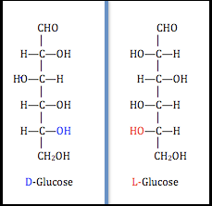
Source: https://byjus.com/chemistry/epimers/
2.5.2 Diastereomers
These are stereoisomers not related through a reflection operation. They are not mirror images of each other. These include cis–trans isomers, they seldom have the same physical properties.
2.5.3 Chirality
Chirality essentially means 'mirror-image, non-superimposable molecules'(chem..libretexts.org). Any molecule or molecules which are not super imposable are chiral and if they can be super imposed then are termed as achiral.
The maximum number of stereoisomers for any compound is calculated as 2n2, where n is the number of chiral atoms.
2.5.4 Optical activity
Optical rotation or optical activity (sometimes referred to as rotary polarization) is the ability of a compound to rotate a plane polarised light to the right or left. The rotation of the plane of polarization may be either:
- clockwise, to the right (dextrorotary — d-rotary), or
- left (levorotary — l-rotary) depending on which stereoisomer is present (or dominant).
If the polarised light on passing through the solution turns left-levorotary, turns right, dextrorotary. Optical activity occurs only in chiral materials. For instance, sucrose and camphor are d-rotary whereas cholesterol is l-rotary.
Optical activity is measured using a polarized source and polarimeter. This is a tool particularly used in the sugar industry to measure the sugar concentration of syrup, and generally in chemistry to measure the concentration of chiral molecules in solution (WIKIPEDIA.ORG/WIKI/OPTICAL_ROTATION).
2.5.5 Epimerism: This is a type of stereoisomerism in which monosaccharides differ from each other in their configuration around a single specific carbon(other than anomeric) atom. Epimers are compounds having the same chemical formula but different spatial arrangement around a single carbon atom. (www.namrata.org).
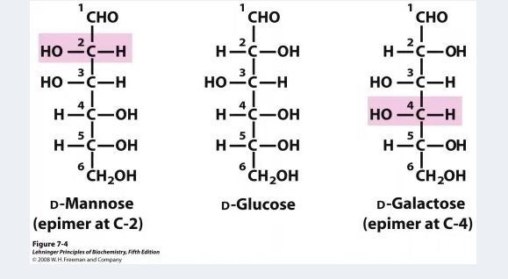

2.5.6 Anomerism
Anomers are isomers obtained from the change of position of hydroxyl group attached to the anomeric carbon e.g. α and β glucose.
The predominant form of sugars (glucose and fructose) in a solution cyclize into rings.i.e they change from straight chain into cyclic chains. During this conversion, the c-1 of glucose becomes a chiral centre which can form 2 possible configurations- (alpha and beta).
The C1= anomeric carbon while the alpha and beta forms=anomers. They have the same composition but different position of groups around the anomeric carbon atom.
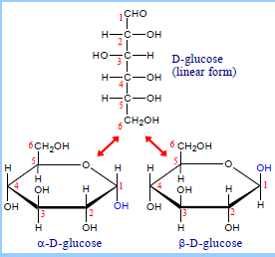
Fig.: Alpha and beta anomers of D-glucose. source: https://biochemjm.wordpress.com

2.5.7 Mutarotation
This refers to change in the optical rotation of a solution of either form of glucose until a constant value is obtained i.e. the interconversion between anomers of a carbohydrate to form an equilibrium mixture.
Mutarotation is defined as the change in the specific optical rotation by the interconversion of α and β forms of D glucose to an equilibrium mixture. Cyclic sugars show mutarotation as α and β anomeric forms interconvert.
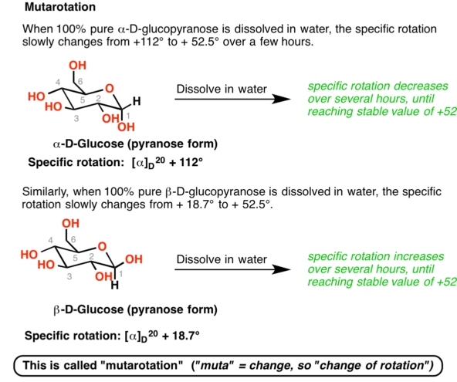
Source: https://www.masterorganicchemistry.com

2.6 DIFFERENT STRUCTURAL REPRESENTATION OF MONOSACCHARIDES
- Fischer projection (straight chain structural formula)
- Haworth's projection (cyclic formula or ring structure
- X-ray diffraction (boat and chair forms)

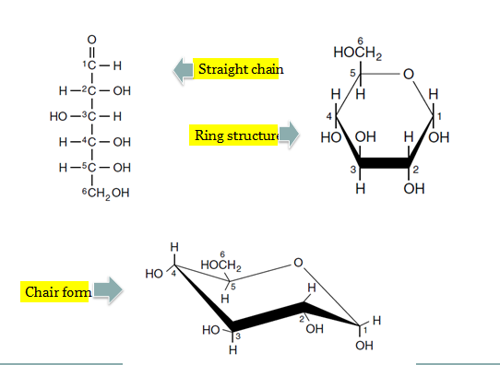
Source: http://slideplayer.com/slide/7633585/

Post-Test:
- Explain with the aid of a diagram, classification of Carbohydrates.
- Define the following terms with relevant example:
- Anomerism
- Epimerism
- Mutarotation
- Draw the different structural representation of Galactose.

Bibliography:
- Lehninger Principle of Biochemistry 5th Ed.
- Voet D., Voet J.G. and Pratt C. Fundamentals of Biochemistry 5th Ed. John Wiley &Sons, 2016.
- Berg J.M., Tymoczko J.L., and Stryer L. Biochemistry 7th Ed. by W.H. Freeman and Company 2012.
- https://biochemjm.wordpress.com

LECTURE THREE: CHEMICAL REACTIONS OF MONOSACCHARIDES
3.0 INTRODUCTION
This lecture deals with chemical reactions of carbohydrates which include oxidation, reduction, esterification etc. Various derivatives of monosaccharides are also considered.
At the end of this lecture, students should be able to:
- State and explain reactions of monosaccharides
- Name and describe some derivatives of monosaccharides
- Define glycosides and differentiate between the N- and O-linked forms.
Pre-Test
- Name 2 monosaccharides, showing their Fischer’s projection.
- What is oxidation? Can glucose undergo oxidation?

3.1 REACTIONS OF MONOSACCHARIDES
The various reactions of monosaccharides include:
- Oxidation
- Reduction
- Tautomerization or Enolization
- Formation of Esters
- Glycoside formation
- Chain shortening and lengthening
- Osazone formation
3.1.1 Oxidation
i. Mild oxidation
Aldehyde/Aldose + Bromine water → AldonicAcid
Glucose + Bromine water → Gluconic Acid
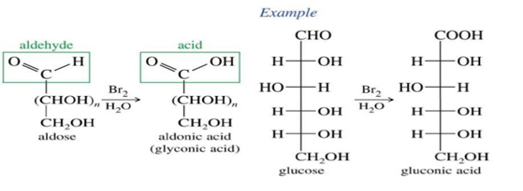
Source: http://slideplayer.com/slide/5268784/

ii. Strong oxidation
Aldehyde/Aldose + conc. HNO₃ → Aldaric acid +water
Glucose + HNO₃ → Glucaric Acid + water
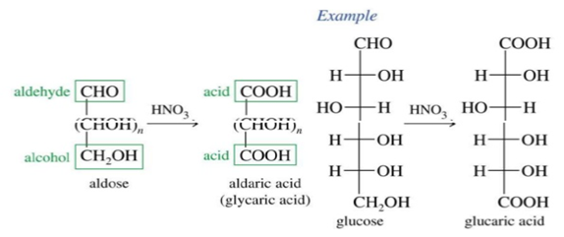
Source: http://slideplayer.com/slide/5268784/

3.1.2 Reduction
C=O of aldoses or ketoses can be reduced by sodium amalgam to C=OH (sugar alcohol)
The sugar alcohol is named by adding –itol to the root name of the sugar
Aldose +NaBH₄ → alditol
D-Glucose+ NaBH4 → D-Glucitol, commonly called D-Sorbitol
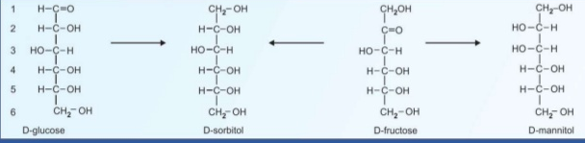
Source: https://www.slideshare.net/ravikiran35977897/chemistry-of-carbohydrates

- Glucose is reduced to sorbitol
- Mannose to mannitol
- Fructose becomes sorbitol and mannitol
- Galactose to dulcitol
- Ribose to ribitol
3.1.3 Tautomerization
This is the process of shifting a hydrogen atom from 1 carbon atom to another to produce enediols. In mild alkaline conditions, carbohydrates containing free sugar group (aldehyde and ketone) will tautomerize to form enediols where 2 hydroxyl groups are attached to the double bonded carbon atoms.
When glucose is kept in alkaline solution for several hours, it undergoes isomerization to form D-fructose and D- mannose. This results in the formation of a common intermediate namely enediol for all the three sugars.
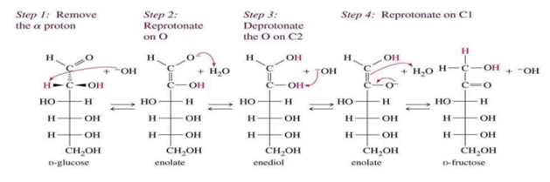
Source: http://wps.prenhall.com/wps/media/objects/340/348272/wade_ch23.html

    - Ester formation (ability to form sugar esters)
Due to the presence of OH group, it can react with anhydrides and chlorides of many organic and inorganic acids to form esters of corresponding acids. The most common esters are phosphate esters e.g. Adenosine triphospahte, glyceraldehyde-3-phosphate useful in carbohydrate metabolism.
Phosphate esters are formed when phosphate groups are added to the OH groups of sugars
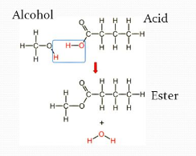
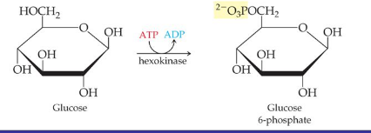
Source: http://slideplayer.com/slide/5291916/

3.1.5 Glycoside formation
Glycosides are formed by the joining of the OH group on the anomeric carbon atom of a monosaccharide with the OH group of another carbohydrate or non-carbohydrate.
The non-carbohydrate moiety is called aglycone (phenol, bases, glycerol, methanol). The bond formed during this process is called glycosidic bond. When an hemiacetal (cyclic monosaccharide) also reacts with an alcohol, acetals(glycosides) are formed. This occurs by the replacement of the hemiacetal carbon (OH group) with an OR group.
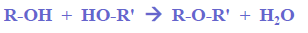
Glycoside produced from:
Glucose = glucoside
Galactose = galactoside
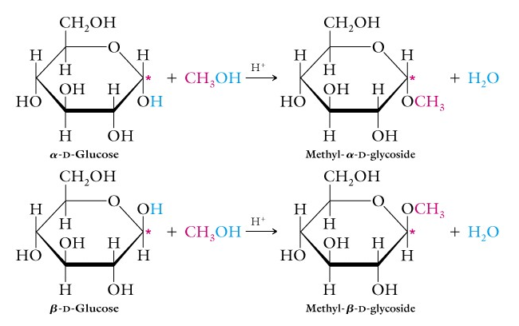
Source: http://plaza.ufl.edu/tmullins/BCH3023/carbohydrates.html

Glycosidic bond could be N-LINKED or O-LINKED:
- O-glycosidic linkage –formed when the OH group on the anomeric carbon of a sugar reacts with an alcohol (or another sugar).It exists in disaccharides, oligosaccharides and polysaccharides
- N-glycosidic linkage-formed when the OH group on the anomeric carbon of sugar reacts with an amine. It is found in nucleotides, RNA and DNA.
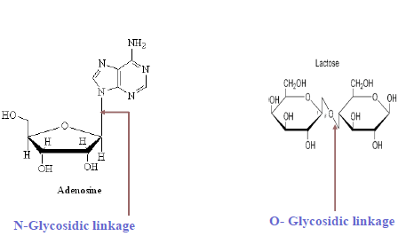
Source: https://www.slideshare.net/WilhelminaAnnieMensa/carbohydrate-structure-52179056

Biomedical Importance of Glycosides
Glycosides are found in many drugs, spices and in the constituents of animal tissues. They are widely distributed in plant kingdom.
In plants, they perform:
- Regulatory function
- Protective function
- Sanitary function
They have various functions in animals which include:
- Cardioactive function (Cardiac glycosides):
- They are derivatives of digitas and strophanthus
- Important in medicine because of their action on heart and thus used in cardiac insufficiency. They all contain steroids as aglycone component in combination with sugar molecules.
- Stimulates cardiac muscle contraction
- Ouabain –Sodium pump inhibitor.
- Streptomycin –Antibiotic
- Phloridzin –
- Causes renal damage, glycosuria.
- Obtained from root & bark of apple tree.
- Blocks the transport of sugar across the mucosal cells of small intestine & also renal tubular epithelium.
3.1.6 Chain Lengthening and Chain Shortening in Monosaccharides
a. Ruff Degradation (Chain Shortening)
This is a one step process which starts with the oxidation of the aldose to aldonic acid with bromine water and decarboxylation of the acid on treatment with hydrogen peroxide and ferric sulphate.
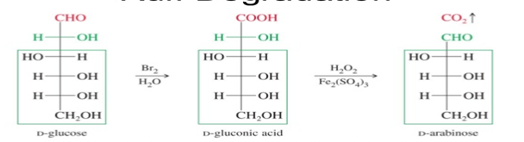
Source: http://slideplayer.com/slide/8929046/
b. Kiliani fischer synthesis (chain lengthening)
This process lengthens the aldose carbon chain by adding 1 carbon atom to the aldehyde end of the aldose. This synthesis is useful for determining the structure of existing sugars and synthesizing new sugars.
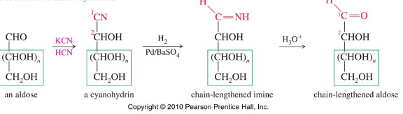
Aldose reacts with aqueous cyanide to get cyanohydrin, the cyanohydrin is reduced with hydrogen, using palladium on barium sulphate as the catalyst and water as the solvent, to form an imine. Due to the presence of water, the imine quickly hydrolyzes to form an aldehyde.
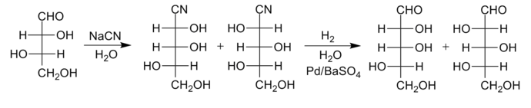
    - Osazone Formation
Osazones are a class of carbohydrate derivatives formed when sugars are reacted with excess of phenyl hydrazine (wikipedia.org). Osazones formation test involves the reaction of a reducing sugar (free carbonyl group) with excess of phenyl hydrazine when kept at boiling temperature. All reducing sugars form osazones.
Sucrose, for example, does not form osazone crystals because it is a non-reducing sugar as it has no free carbonyl group. The reaction can be used to identify monosaccharides.
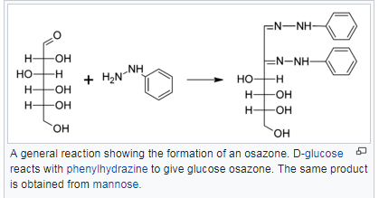
Source: https://en.wikipedia.org/wiki/Osazone
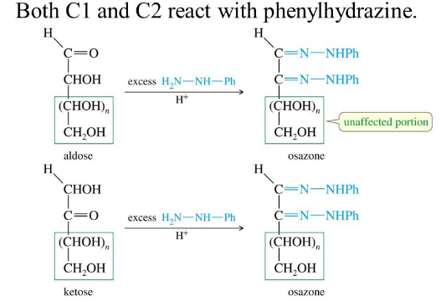
http://slideplayer.com/slide/3377256/
3.2 DERIVATIVES OF MONOSACCHARIDES
Many derivatives of the monosaccharides are found in nature. They include:
- Amino sugars
- Deoxy-sugars
- Sugar Acids
- Sugar Alcohols
- Phosphate esters.
3.2.1. Amino sugars:
These are formed when an amino group (NH₂) replaces one of the hydroxyl groups in the parent monosaccharide. Sometimes the amino group is acetylated. Examples of amino sugars are D-glucosamine, D-galactosamine and D- mannosamine. They commonly occur in glycoconjugates. Several antibiotics contain amino sugars.
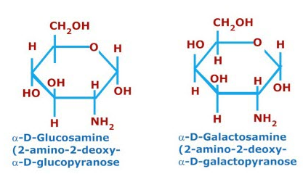
Source:http://usmle.biochemistryformedics.com.
3.2.2 Deoxy sugars:
These are monosaccharides with 1 or more hydroxyl groups replaced with hydrogen atoms. Examples are deoxyribose occuring in nucleic acid DNA, L-Fucose (6-deoxy-L-galactose) is widely distributed in plants, animals and microorganisms; serves as a component of cell wall, rhamnose, a component of oubain, a toxic cardiac glycoside.
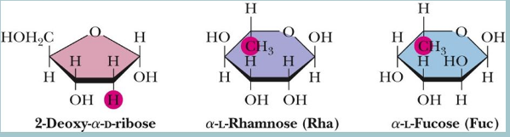
Source: http://slideplayer.com/slide/6646475/

3.2.3 Sugar acids:
Sugar acids are carboxylic acids derived from aldoses, either by the oxidation of C-1 (the aldehyde carbon) or by the oxidation of carbon bearing the primary alcohol.
They are monosaccharides with carboxylic groups. Sugar acids are important components of many polysaccharides. Classes of sugar acids include:
- Aldonic acids (Ascorbic acid Ascorbic acid or Vitamin C: It is derived from D-glucuronate. It is an essential cofactor for many hydroxylation processes)
- Aldaric acid
- Uronic acids
- Ulosonic acids

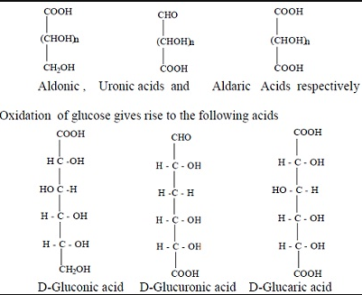
Source: www.tutorsglobe.com
3.2.4 Sugar alcohols:
These are formed by the reduction of aldoses or ketoses. They are white, water-soluble solids that can occur naturally or be produced industrially from sugars. They are used widely in the food industry as thickeners and sweeteners. In commercial foodstuffs, sugar alcohols are commonly used in place of table sugar (sucrose), often in combination with high intensity artificial sweeteners to counter the low sweetness.
The sugar alcohols commonly found in foods are sorbitol, mannitol, xylitol, isomalt, and hydrogenated starch hydrolysates. They also come from plant products such as fruits and berries. Others include glycerol and myo-inositol which are the important components of lipids. Ribitol is a component of FMN and FAD.
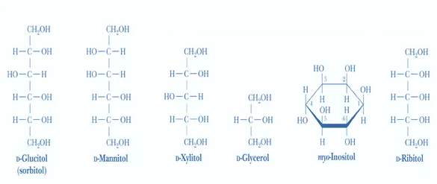
Source: http://slideplayer.com/slide/2752939/.
3.2.5 Phosphate esters:
They are formed by the reaction of an alcohol with phosphoric acid i.e the OH group of a sugar combining with PO₃H₂. Phospho-esters of monosaccharides serve as intermediates of carbohydrate metabolism. They may be mono, di or triester. Also,it may be a di- or triphosphate. When monosaccharides are used as fuel they are metabolized as phosphate esters. For example, triose phosphate, ribose 5-phosphate and glucose 6 phosphate (www.elearnnet.vet).
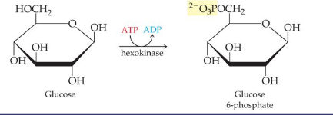
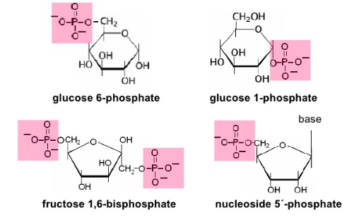
Source: www.elearnnet.vet.

Post-Test
- Describe any 4 reactions of monosaccharides
- Name the classes of sugar acids with examples
- Write a short note on phosphate esters.
- Using appropriate diagram, differentiate between O-and N-linked glycosides.

Bibliography
- Lehninger Principle of Biochemistry 5th Ed.
- www.elearnet.vet
- Voet D., Voet J.G. and Pratt C. Fundamentals of Biochemistry 5th Ed. John Wiley &Sons, 2016.

LECTURE FOUR: DISACCHARIDES, POLYSACCHARIDES AND COMPLEX SUGARS
4.0 INTRODUCTION
This lecture focuses on disaccharides, oligosaccharides, polysaccharides and complex sugars. Various types, composition, reactions and importance are examined as well as qualitative test for carbohydrates.
At the end of this lecture, students should be able to:
- Differentiate between oligosaccharides and polysaccharides
- Differentiate between Homo- and Heteropolysaccharides with examples
- Give examples of polysaccharides and their importance.
- Name and state the principles of qualitative tests for sugars
Pre-test
- What are simple sugars?
- Name 2 disaccharides and their constituents

4.1 DISACCHARIDES
These give two molecules of same or different monosaccharide units on hydrolysis. The two monosaccharides in a disaccharide are connected by a glycosidic bond which may be alpha or beta as in cyclic monosaccharides.
The structures include glycosidic bonds that create a 1,4 link between C1 of one monosaccharide and C4 of the second monosaccharide.
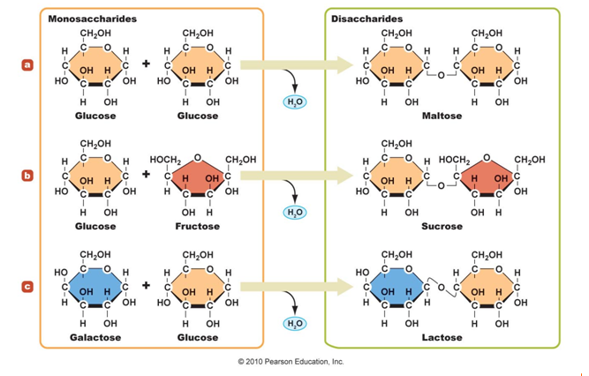
- Maltose: is also called malt sugar. It is produced during digestion of starch by the enzyme amylase. Maltose is formed from two α-D-glucose units held together by α(1→4) glycosidic bond.
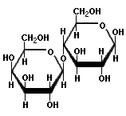
Source: http://www.foodscience-avenue.com.
- Sucrose: also called cane sugar, contains α-D-glucose and β-D-fructose units held together by (α1→β2) glycosidic bond.
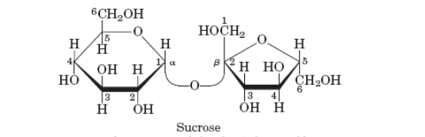
Source: https://ingridpacheco.weebly.com
- Lactose, or milk sugar, is the major carbohydrate in mammalian milk. Structurally, lactose is composed of D-galactose and D-glucose connected by by β(1→4) glycosidic bond. Like maltose, lactose is a reducing sugar.
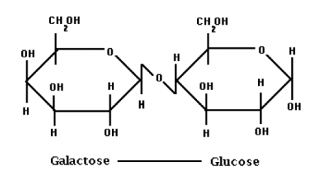
Source: https://www.uoguelph.ca.
4.2 OLIGOSACCHARIDES
This is from the greek word “oligos” meaning “a few”. They are carbohydrate polymers which contain 3 to 10 molecules of monosaccharide units.
Oligosaccharides are similar in length to simple carbohydrates and similar in makeup to polysaccharides. Humans lack the enzymes necessary to digest them. Intestinal microflora digest and ferment them causing bloating, discomfort, and flatulence. E.g. Maltotriose. (Glucose + Glucose + Glucose)
Food sources include: Legumes, beans, cabbage, brussels sprouts, broccoli, onions
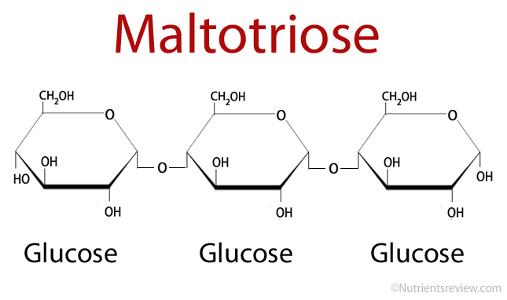
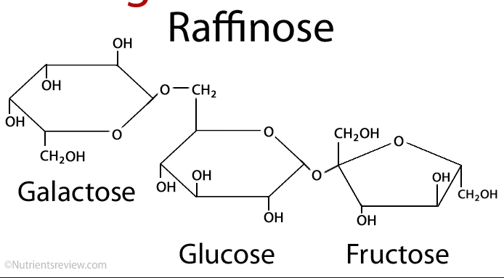
4.3 POLYSACCHARIDES
These are polymeric carbohydrate structures formed by repeating units (mono or di-saccharides) joined by glycosidic bonds. They are polymers of tens, hundreds, or even many thousands of monosaccharides linked together through glycosidic bonds.
Such structures are often linear, but may contain different degrees of branching. Polysaccharides have the general formula of (C₆H₁₀O₅)n. They are not sweet, hence called non-sugars
They are further classified into:
- Homopolysaccharides: polysaccharides composed of a single type of sugar monomer.
Examples | Monosacccharide units | Source
Starch | Glucose | Plant, rice
Glycogen | Glucose | Liver, muscle
Inulin | Fructose | Dahlia roots
Dextrin | Glucose | Starch hydrolysis
Cellulose | Glucose | Plant fibre

- Heteropolysaccharides
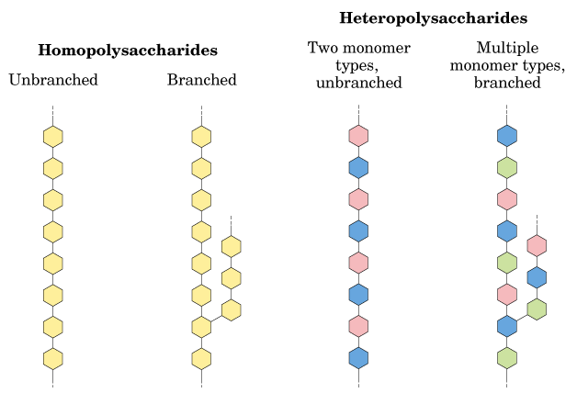
Source: https://www.omicsonline.org
NOTE: Starch, Glycogen and Inulin are storage polysaccharides

4.3.1 Starch:
This is a polymer of glucose units linked in alpha 1 – 4 linkages, fully digestible and is an essential part of the human diet. It is present only in plant material and serves as nutritional reservoir in plants. Major sources are beans, wheat, rice, and potatoes.
Hydrolysis with hot dilute acids or by enzymes give dextrins of varying complexities, maltose and finally glucose. The intact granules are insoluble in cold water but grinding or swelling them in warm water causes them to burst. The released starch consists of a mixture of polysaccharides.
The mixture of polysaccharides includes:
1) Amylose (water soluble) and
2) Amylopectin (water insoluble).
Amylose, accounts for about 20% of starch. It is somewhat soluble in hot water and it reacts with iodine to give a blue colour. It consists of about 200 –20,000 D-glucose units held together by α(1→4) glycosidic linkages.
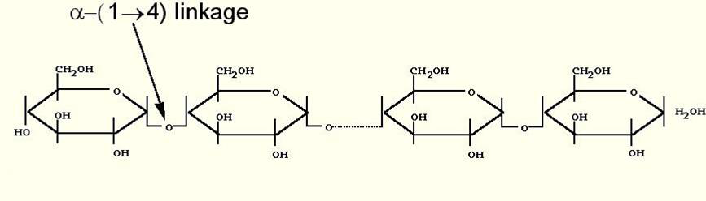
Source: www.chemlibretexts.org
Amylopectin accounts for about 80% of starch. It has up to 100,000 glucose units per molecule and alpha-1,6 branches approximately every 25 units along its chain. It is not soluble and it reacts with iodine to give a reddish violet colour.
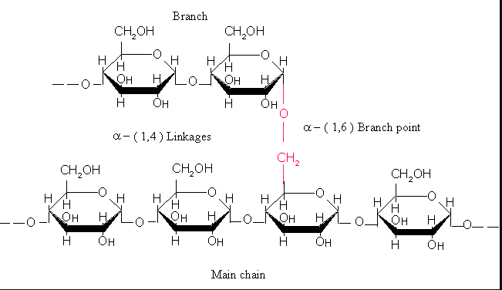
Source: https://thebiochemsynapse.wordpress.com
Action of Amylase (Starch hydrolysis)
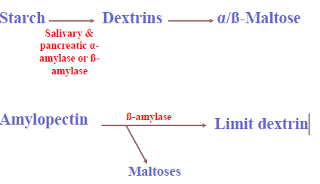

4.3.2. Glycogen
This is a large branched polymer of glucose residues which can be broken down into glucose units when energy is needed (The branches that are formed can be "de-formed" by an enzyme called the "debranching enzyme when energy is needed). Each glycogen molecule contains approximately 100,000 molecules of glucose per molecule of glycogen. It is also a storage polysaccharide of animals that serves as a source of fuel, sometimes called animal starch.
It is stored in liver and muscle and approximately 1/3 of the weight of the human liver is glycogen. On reaction with iodine, it turns reddish brown. It is similar to amylopectin in that it is a branched polysaccharide, but its branch point occurs every 8 – 10 units of glucose i.e. it has more branches than amylopectin.
Glycogen is hydrolysed by alpha and beta amylase and by glycogen phosphorylase. In the liver, glycogen synthesis and degradation is regulated to maintain body glucose levels as needed by the organism. Glycogen is particularly stored in the cells of liver in which it constitutes about 7% of the wet weight where it is synthesized in presence of excess free glucose as well as degraded when glucose levels get lower.
Glycogen in skeletal muscle serves as an instant reserve source of glucose for muscle cells. For glycogen synthesis in liver, insulin acts on the hepatocytes to activate a number of enzymes such as glycogen synthase. Eventually, the excess glucose molecules available in the body are added to the chains of glycogen for storage. When glucose level decreases in the body, many enzymes such as glycogen phosphorylase in liver catalyze the hydrolysis of glycogen in to its monomer unit glucose and transported through blood stream.
Glycogen and starch containing both the forms amylopectin, amylose is rapidly hydrolyzed by breaking the alpha (α1-4) glycosidic linkage through the action of α-amylase secreted by the salivary glands and the pancreas.
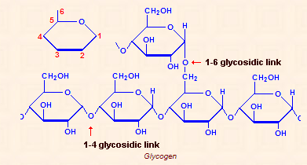
Fig.: Structure of glycogen. Source: http://stainsfile.info/StainsFile/theory/science/carbohydrate.htm

4.3.3 Inulins
These are group of naturally occurring polysaccharides produced by many types of plants. It is made up of D-fructose units with repeating ß-1,2 linkages. The inulins belong to a class of dietary fibers known as fructans (chains of fructose indigestible by our body. i.e. cannot be hydrolysed by intestinal enzymes.
Inulin has a lower molecular weight than starch and turns yellow with iodine. It is used to measure the glomerular filtration rate, a test to assess the function of kidney.
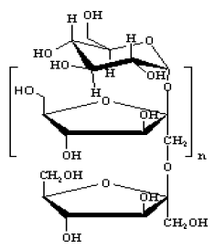
Fig.: Inulin. Source:http://www.epharmacognosy.com
4.3.4. Dextran
This is a homopolysaccharide composed of glucose; commonly found in bacteria, (secreted by certain strains of bacteria as slimes ) and yeast. The structure of an individual dextran varies with the strain of microorganism.
Dextrans constitute polymer of (α1-6)-linked linear chain of glucose with (α1-3) linked branches of glucose, and a few also contain (α1-2) or (α1-4) branches.
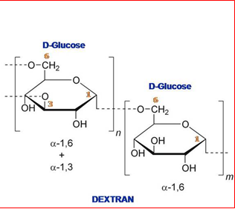
Source: wikipedia

Importance:
- Bacteria growing on the surface of teeth forms plaque that is rich in dextrans.
- Artificial dextrans are utilized in many commercial products such as sephadex which serve in the fractionation of proteins through size-exclusion chromatography.
- The dextrans in commercial products are chemically cross-linked to constitute insoluble materials of different porosity admissible to varying sizes of macromolecules.
- Dextrans can be used as plasma expanders (substitutes for whole blood) in cases of severe shock. In addition, a dextran derivative compound is employed medically as an anticoagulant for blood.
4.3.5. Cellulose:
This is unquestionably the most abundant carbohydrate and the most abundant organic compound in the world, constituting 50% or more of all the carbon in vegetation. Cellulose is an organic compound with the formula (C₆H₁₀O₅)n, a polysaccharide consisting of a linear chain of several hundreds to many thousands of β(1→4) linked D-glucose units.
Some animals, particularly ruminants and termites, can digest cellulose with the help of symbiotic micro-organisms that live in their guts, such as Trichonympha (they contain the enzyme –cellulase which hydrolyzes the links). In human nutrition, cellulose is a non-digestible constituent of insoluble dietary fibre i.e. Humans cannot metabolize these links because they do not produce such enzymes.
Importance
- Cellulose is an important structural component of the primary cell wall of green plants, many forms of algae and the oomycetes.
- Cellulose is mainly used to produce paperboard and paper. Smaller quantities are converted into a wide variety of derivative products such as cellophane and rayon.
- Conversion of cellulose from energy crops into biofuels such as cellulosic ethanol is under investigation as an alternative fuel source.
- Cellulose for industrial use is mainly obtained from wood pulp and cotton.
- The hydrogen bonds within chains and between chains contribute to the rigidity and toughness of cellulose fibres.
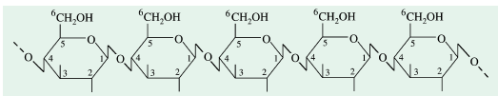
Fig.: Structure of cellulose. Source: fundamentals of biochemistry, p115
4.3.6. Chitin:
This is a linear homopolysaccharide comprised of repeating units of N-acetylglucosamine, modified monosaccharide containing nitrogen and joined through β1-4 glycosidic linkages.
The only difference in structure of chitin and cellulose is that the hydroxyl group at C-2 (in cellulose) is replaced with an acetylated amino group (in chitin).
Like cellulose, chitin also constitutes extended fibres and cannot be digested by vertebrates.
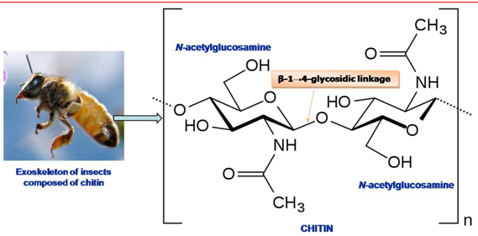
Source: wikipedia.org.
Importance:
Chitin is the chief constituent of the hard exoskeletons of about million species of arthropods.
It might be the second most abundant carbohydrate next to cellulose in biosphere as about 1 billion tons of chitin are produced each year in the biosphere. Chitin is also a main constituent of cell walls of fungus.
Over time it is bio-degradable in the natural environment. Its breakdown may be catalyzed by enzymes called chitinases, secreted by microorganisms such as bacteria and fungi, and produced by some plants.
4.4 QUALITATIVE TESTS FOR CARBOHYDRATES
Most of the tests of the carbohydrates are based on their reducing properties (due to the presence of reducing aldehyde or ketone groups). These tests include:
    - Molisch’s test
    - Iodine test
    - Bial’s test
    - Seliwannof’s test
Reducing Tests:
    - Fehling’s test
    - Barfoed’s test
    - Benedict’s test
Test | Observation | Inference | Reaction
Fehling's test  About 2 ml of sugar solution is added to about 2 ml of Fehling’s solution taken in a test-tube.  It is then boiled for 10 min | A red precipitate is formed | Presence of reducing sugar | formation of cuprous oxide by the reducing action of the sugar.
Benedict’s test  To 5 ml of Benedict's solution, add 1ml of the test solution and shake each tube.  Place the tube in a boiling water bath and heat for 3 minutes.  Remove the tubes from the heat and allow them to cool. | Formation of a green, red, or yellow precipitate | Presence of reducing sugars | If the saccharide is a reducing sugar it will reduce Copper [Cu] (II) ions to Cu (I) oxide, a red precipitate
Barfoed’s test  To 2 ml of the solution to be tested added 2 ml of freshly prepared Barfoed's reagent. Place test tubes into a boiling water bath and heat for 3 minutes. Allow to cool. | A deep blue colour is formed with a red ppt. settling down at the bottom or sides of the test tube. | Presence of reducing sugars. Appearance of a red ppt as a thin film at the bottom of the test tube within 3-5 min. is indicative of reducing mono-saccharide.  If the ppt formation takes more time, then it is a reducing disaccharide. | If the saccharide is a reducing sugar it will reduce Cu (II) ions to Cu (I) oxide
Seliwanoff test  To 3ml of Seliwanoff’s reagent, add 1ml of the test solution.  Boil in water bath for 2 minutes. | A cherry red coloured precipitate within 5 minutes is obtained.  A faint red colour produced | Presence of ketoses  [Sucrose gives a positive ketohexose test]  Presence of aldoses | When reacted with Seliwanoff reagent, ketoses react within 2 minutes forming a cherry red condensation product  Aldopentoses react slowly, forming the coloured condensation product.
Bial's test  Add 3ml of Bial’s reagent to 0.2ml of the test solution. Heat the solution in a boiling water bath for 2 minutes. | A blue-green product  A muddy brown to gray product | Presence of pentoses.  Presence of hexoses. | The furfurals formed produces condensation products with specific colour.
Osazone Test  To 2mls of the test solution, add 3ml of phenyl hydrazine hydrochloride solution and mix. Keep in a boiling water bath for 30mns. Cool the solution and observe the crystals under microscope. | Formation of beautiful yellow crystals of osazone  Needle shaped crystals  Hedgehog crystals  Sunflower shaped crystals | Glucose/fructose  Presence of lactose  Presence of maltose | Reducing sugars forms ozazone on treating with phenylhydrazine

Post-Test
- Differentiate between homopolysacharides and Heteropolysaccharides.
- What are reducing sugars? Give two examples each of reducing and non-reducing sugars.
- Describe the structures and functions of any two homo and heteropolysaccharides.
- Write a short note on each of the storage polysaccharides

Bibliography
- Voet D., Voet J.G. and Pratt C. Fundamentals of Biochemistry 5th Ed. John Wiley &Sons, 2016.
- http://www.epharmacognosy.com
- http://stainsfile.info/StainsFile/theory/science/carbohydrate.htm
- www.chemlibretexts.org
- https://thebiochemsynapse.wordpress.com

LECTURE FIVE: INTRODUCTION TO CHEMISTRY OF AMINO ACIDS
5.0 INTRODUCTION
This lecture introduces the chemistry of amino acids. It begins with definition, basic structure, occurrence and properties of amino acids, and further to classification of amino acids.
At the end of this lecture, students should be able to:
- Define and write the basic structure of amino acids.
- State the properties of amino acids.
- Differentiate between essential and non-essential amino acids
- Name the 20 common amino acids and classify them according to their R-group
Pre-Tests
- What are monomers?
- What do you understand by amino acids?
5.1 DEFINITION
Amino acids are the building blocks of proteins.
All cells contain thousands of types of proteins, and amino acids are the building blocks of these proteins. The sequential order, number, and chemical identity of the amino acids in the protein determine the structure of the protein as well as how the protein functions.
Amino acids are relatively simple molecules containing both an amine group and an acid group. The biologically important amino acids are the α-amino acids that have the amine and acid groups attached to the same carbon atom.
There are more than 100 known natural amino acids; however, only 20 of them are used in protein synthesis. Francis Crick (who with James Watson determined the structure of DNA) labeled this set of amino acids the magic 20. Other amino acids are found in certain proteins, but in almost all cases these additional amino acids result from the modification of one of the magic 20 after the protein formed.
1.2 Occurrence of Amino Acids in Nature
Most amino acids occur naturally in conjugated form as components of proteins. Those that occur commonly in proteins are called common amino acids. These are twenty in number.

Table 5.1: The 20 Common Amino Acids
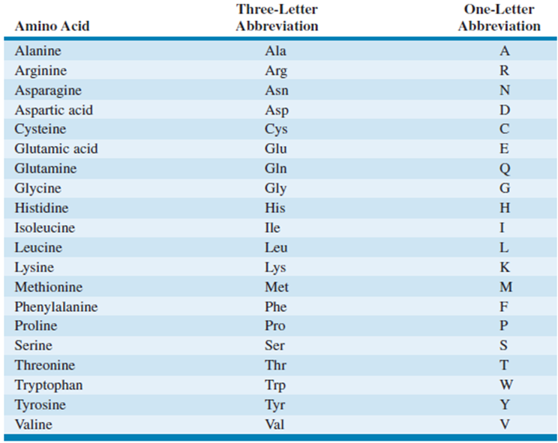
Source: Fundamentals of Biochemistry, 5th Edition.
Certain amino acids and their derivatives, however, are not found in proteins, but they also perform useful biological roles. These are called uncommon amino acids.
Table 5.2: Uncommon Amino Acids
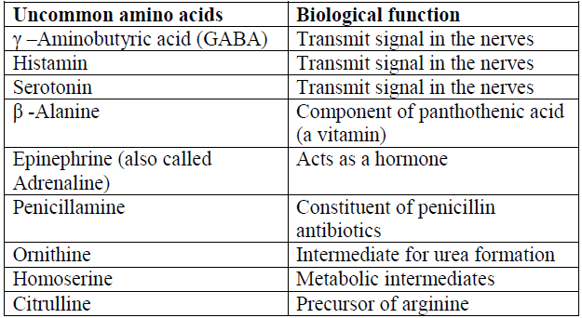
5.3 BASIC STRUCTURE OF AMINO ACIDS
To fully understand the structure of amino acids, the following need to be considered:
- How carbon atoms in organic compounds are named;
- The concept of chirality in organic compounds; and
- The concept of stereoisomerism
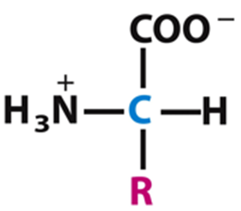Fig. 5.1: Backbone structure of Amino acids

5.3.1 How Carbon Atoms in Amino Acids are named
Carbon atoms in an amino acid, just as in any organic compound, are conventionally named either by using Greek letters such as alpha (α), beta (β), gamma (γ), delta ( δ), epsilom ( ε) e.t.c. or by a simpler Arabic numerals numbering convention (1, 2, 3, 4…).
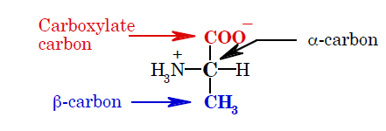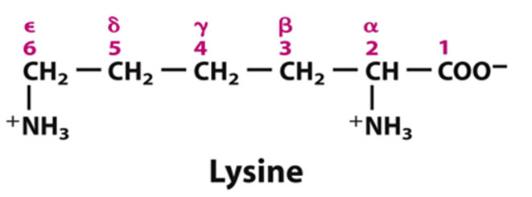
Source: Lehninger principles of Biochemistry, 5th Edition.
5.3.2 Chirality in Amino Acids
Chiral compounds are compounds which possess at least one chiral carbon atom or chiral centre.
A chiral carbon or centre is a carbon atom to which four different functional groups are covalently linked.
For a typical amino acid, the four different functional groups include:
- Carboxyl group (-COOH) or its carboxylate ion form (-COO⁻)
- Amino group(-NH₂) or its ammonium ion form NH₃⁺)
- Hydrogen atom (H)
- A variable side chain (also called R group). The R group gives each amino acid its identity.
All amino acids except glycine possess a chiral centre at the alpha carbon (Cα).

Note:
- The R group must not be –COOH, H₂N, or H for the alpha carbon to be a chiral centre.
- Most of the amino acids (except proline) are alpha amino acids; i.e. the amino group is linked to the same carbon atom to which the carboxyl group is attached (the alpha carbon, Cα).
5.3.3 The Concept of Stereoisomerism
Stereochemistry of biomolecules deals with the three-dimensional arrangement of constituent atoms of the molecule in space. Each fixed spatial arrangement of atoms in a molecule is called the molecule’s configuration.
A Carbon compound may have different forms (configurations) in which the various atoms are arranged differently in space. Such forms of the compound are referred to as its stereoisomers.
The alpha carbon (Cα) of amino acids, due to its tetravalency, is easily bonded to four atoms. When all these atoms are different, the carbon atom is said to be chiral or asymmetric. The number of stereoisomers that can occur in such a chiral compound is given by 2^{n};
where n is the number of chiral carbon(s) in the compound.
Example: Glycine has only one stereoisomer because its n=0, Alanine has one chiral carbon hence; the number of its stereoisomers is 2¹= 2.
Stereoisomers that are mirror images of each other are called enantiomers, while pairs of stereoisomers that are not mirror images of each other are called diastereomers.
5.3.4 D- and L-Configurations of Amino acids
In 1891, Emil Fischer proposed the D, L system of nomenclature for asymmetric/chiral compounds (such as amino acids and sugars). The system specifies the absolute configuration of the substituents around the chiral centre with reference to glyceraldehyde (a three-carbon sugar).
By this system, stereoisomers that have configuration similar to that of D-glyceraldehyde are designated D, and those with configuration identical to L-glyceraldehyde are designated L.
Example: Aligning the carboxyl group (COOH) of the amino acid with the aldehyde group (CHO) of glyceraldehyde as illustrated for Alanine and Tyrosine below:
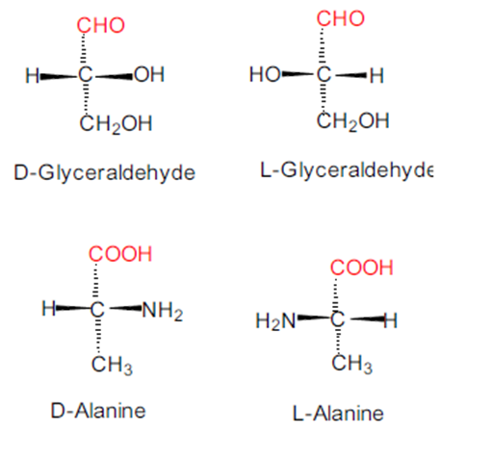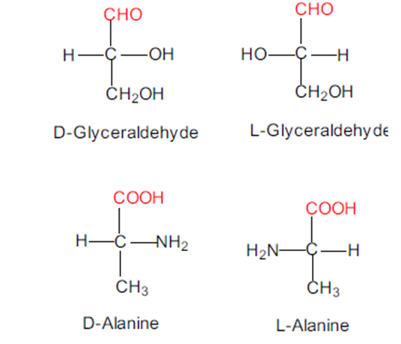
Fig.5.2: Left; Alanine vs Glyceraldehyde by Perspective formulas. Right; Fischer’s Projection. An amino acid is L if its α-amino group is oriented to the left, and is D if it is oriented to the right. Source: Biochemistry by Voet &Voet, 4th Edition.
Amino acids which occur in proteins are usually the L- isomers and only living cells produce this form. This is because biochemical reactions are stereospecific. For example, enzymes are specific in their actions, recognizing only one isomer and not the other.
Points to note about Structures of Amino acids:
- All amino acids are similar structurally.
- They all have carboxyl, amino group, hydrogen atom and a side chain (R group) covalently linked to the alpha carbon atom.
- They differ mainly in the nature of their side chains (R groups); the R groups in amino acids vary in structure, size/length and electric charge.
- Each amino acid can be remembered for a particular feature in its side chain:
- Glycine, the amino acid with the simplest structure, has H as its side chain;
- Alanine contains a methyl group (-CH₃); Valine has an isopropyl R group;
- Phenylalanine and tyrosine have aromatic /benzene ring in their side chain; Tryptophan has a heterocyclic structure with an indole group;
- Cysteine and methionine both have sulphur as part of their side chain e.t.c.
At physiological pH, amino acids are ionic in nature with their amino and carboxyl groups preferring ammonium (NH₃⁺) and carboxylate (COO⁻) states rather than amino (NH₂) and carboxyl (COOH) states respectively.
5.4 PROPERTIES OF AMINO ACIDS
Like any other organic compound, amino acids exhibit some physical and chemical properties that stem from their overall chemical structures.

5.4.1 General Properties of Amino Acids
- They can join to form proteins. The average molecular weight of an amino acid is about 135. Proteins have molecular weights ranging from about 6,000 to several million. Thus, a large number of amino acids must be joined together to produce a protein.
- They all have both an acid and a base. The α-carbon not only has an amine group (–NH₂) and a carboxylic acid group (–COOH), but also two additional groups: a hydrogen atom and an R– group. The side chain, R group, identifies the amino acid.
- They all have variations in what part of the structure is protonated depending on the pH of the solution and the structure of the rest of the molecule.
- They all, except glycine, have a chiral nature, influencing the reactions that the compound will undergo.
5.4.2 Physical Properties:
- At ordinary temperature amino acids are white crystalline solids.
- All amino acids have high melting points (above 200ºC).
- They decompose when heated at high temperature, rather than melting.
- They are stable in aqueous solution, and with few exceptions, they can be heated as high as 120ºC for a short period without decomposition, even in acid or alkaline solution.
- All amino acids are soluble in water and alcohol but insoluble in nonpolar solvents.
5.4.3 Optical Activity:
Apart from glycine, all other amino acids possess a centre of asymmetry at the α-carbon (chiral centre). Such molecules are optically active, i.e. they can rotate the plane of plane- polarized light when they are placed in a Polarimeter (an instrument which measures the specific rotation of an optically active substance).
Amino acid is said to be dextrorotatory if it rotates the plane to the right (clockwise from the point of view of the observer). On the other hand, if the direction of rotation is to the left (anticlockwise), the amino acid is said to be laevorotatory.
Dextrorotatory molecules are designated by the prefix ‘+ or D’ while laevorotatory enantiomers are designated with the prefix ‘- or L’.
5.4.4 Absorption of Light:
Phenylalanine, tryptophan and tyrosine absorb light strongly in the ultraviolet region (100-400 nm). This property is attributable to the presence of aromatic nucleus in their side chains. Amino acids do not absorb visible light (400-800 nm) and are therefore colourless.
5.4.5 Acid-base property:
Because amino acids contain both acidic and basic groups, they are amphoteric (having both acidic and basic properties). The predominant form of the amino acid depends on the pH of the solution.
In solution, an amino acid exhibits ionic property. Both the amino and the carboxyl groups attached to its alpha carbon exist in their ionic states (COO⁻, NH₃⁺), thereby making it a dipolar ion, or a zwitterion (a German term for ‘hybrid ion’).
This zwitterion can act as an acid or as a base.
The net charge of the zwitterion is 0; the acid end of the amino acid with a negative charge (–COO⁻) and a positive charge at the base end (–NH₃⁺). The presence of a charge on the amino acid makes them water-soluble.
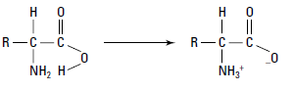
Fig.5.3: Zwitterion formation.
Example: Zwitterionic form of L-Ala
- As an acid (a proton donor):
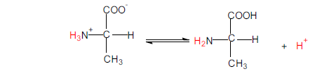

- As a base (a proton acceptor):
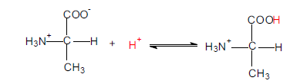

5.5 CLASSIFICATION OF AMINO ACIDS
Each of the twenty common amino acids of protein has a unique side chain but some amino acids could share identical features. Amino acids can be classified based on the following criteria:
i. Functional group of the side chain.
ii. Polarity
iii. Nutritional requirements
    - Classification Based on Structure
Based on the type of functional groups present in their side chains, amino acids can be placed into nine classes.
- Amino acid having hydrogen atom as R group: Glycine
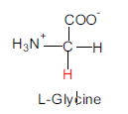

- Amino acids possessing unsubstituted aliphatic chain as their R group: Alanine, Valine, Leucine, and Isoleucine.
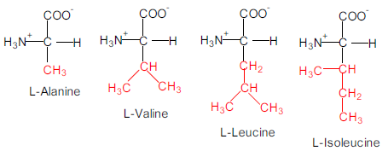
- Amino acids whose R groups possess aliphatic chain bearing a hydroxyl group: Serine, and Threonine.
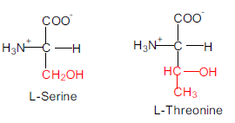

- Amino acids whose R group is an aliphatic chain terminating in an acidic carboxyl Group: Aspartate, and Glutamate.
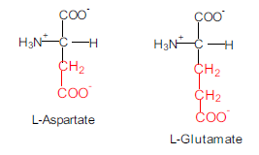
- Amino acids whose side groups are aliphatic chain terminating in basic amino group: Arginine, and Lysine.
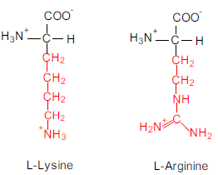

- Amino acids whose side chains are aliphatic chain terminating in amide group: Asparagine, and Glutamine.
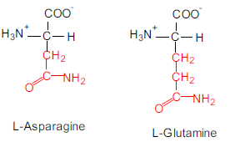
- Amino acids with sulfur-containing aliphatic R groups: Cysteine, and Methionine
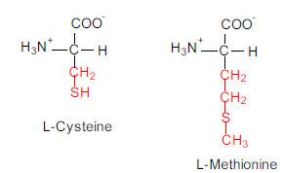

- Amino acids whose side chains terminate in an aromatic ring- Phenylalanine, and Tyrosine.
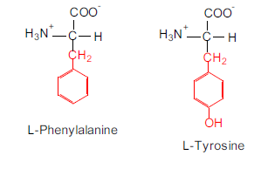
- Amino acids whose side chains terminate in a heterocyclic ring- Tryptophan, Proline, and Histidine
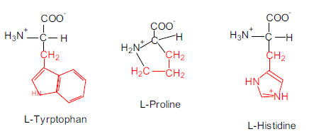

    - Classification Based on Polarity
Amino acids could also be classified according to the polarities of their side chains. Polarity is perhaps the most useful criterion of amino acid classification. This is because protein folding is governed by the tendency of amino acid residues of protein to interact with water. In protein conformation, hydrophobic (water-hating) side chains are removed from contact with water while the hydrophilic (water-loving) ones interact freely with aqueous environment.
Based on the polarity of the R group (side chain), the four main classes are:
1. Non-polar R groups.
2. Polar R groups.
3. Positively charged R groups.
4. Negatively charged R groups.

1. Amino Acid with Non-Polar R Groups:
This family includes nine amino acids: five with aliphatic R groups (Alanine, leucine, isoleucine, valine and proline), two with aromatic rings (phenylalanine and tryptophan), and one containing sulfur (methionine). Glycine is also a non-polar amino acid, which has a hydrogen, instead of any functional group. These are less soluble in water as compared to amino acids with polar R groups.

2. Amino Acids with Uncharged Polar R Groups:
The amino acids of this family contain neutral polar functional groups in their R groups. This family includes six amino acids. Three amino acids contain hydroxyl group (serine, threonine and tyrosine), two contain amide group (asparagine and glutamine) while one contains sulfhydryl group (cysteine) responsible for their polarity.

3. Amino Acids with Positively Charged R Groups:
The amino acids of this family are basic in nature. The R group of these has a net positive charge at pH 7.0, all have six carbon atoms. This family of amino acids consist of lysine, which possess a positively charged amino group on the aliphatic chain; arginine possesses the positively charged guanidium group; and histidine which contains weakly basic imidazole functional group.

4. Amino Acids with Negatively Charged R Groups:
This family contains two members i.e., aspartic acid and glutamic acid, each has a second carboxylic group, which is fully ionized and thus negatively charged at pH 6.0 to 7.0
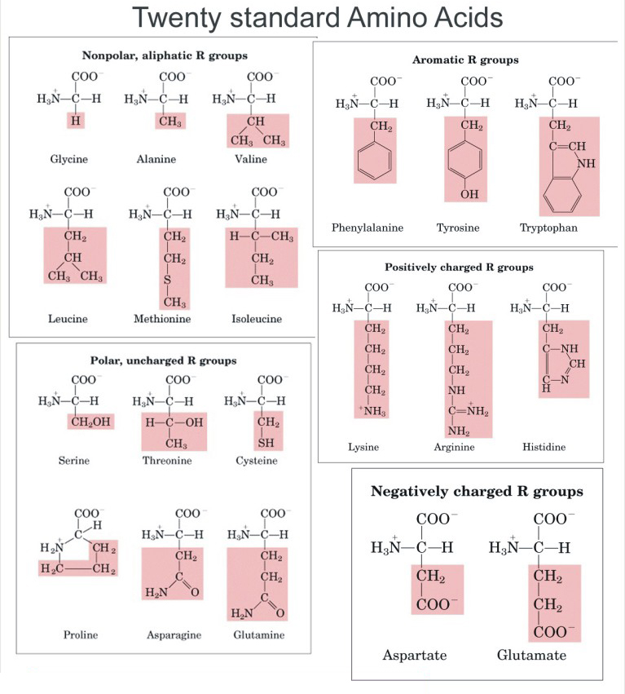
Source: Lehninger principles of Biochemistry, 5th Edition

    - Classification Based on Nutritional Requirements
Some, but not all, of the 20 common amino acids can be synthesized by the body and as such, they may not be included in diet.
Based on their requirements in the diet, amino acids have been grouped into:
(a) Essential amino acids, and
(b) Non-essential amino acids
Non-essential amino acids: these can be synthesized in the body; thus, they may not be included in the diet.
Essential amino acids: these amino acids cannot be synthesized de novo (from existing molecules) in the body. Thus, they must be supplied in the human/animal diet.
The ten essential amino acids are: Arginine (Arg), valine (Val), methionine (Met), leucine (Leu), threonine (Thr), phenylalanine (Phe), histidine (His), isoleucine (Ile), lysine (Lys), and tryptophan (Trp). Proteins that provide all the essential amino acids in about the right proportions for human nutrition are called complete proteins.
Examples include those in meat, fish, milk, and eggs. About 50 g of complete protein per day is adequate for adult humans.
Proteins that are severely deficient in one or more of the essential amino acids are called incomplete proteins. Plant proteins are generally incomplete. Rice, corn, and wheat are all deficient in lysine. Rice also lacks threonine, and corn also lacks tryptophan.

Post-Test:
- State the criteria for amino acids classification
- Classify amino acids based on their polarity.
- Is glycine a chiral compound? Why?
- State the physical properties of amino acids.

Bibliography
- Lehninger Principle of Biochemistry 5th Ed.
- Voet D., Voet J.G. and Pratt C. Fundamentals of Biochemistry 5th Ed. John Wiley &Sons, 2016.
- Voet D., Voet J.G. Biochemistry 4th Edition

LECTURE SIX: CHEMICAL REACTIONS AND BIOLOGICAL ROLES OF AMINO ACIDS
6.0 INTRODUCTION
This lecture focuses on important chemical reactions of amino acids like Esterification, Acylation, Peptide bond formation etc. The biological roles of amino acids and their health significance are also considered.
Objectives:
At the end of this lecture, students should be able to:
- Explain important chemical reactions of amino acids
- Write out the reaction of peptide bond formation
- State some qualitative tests of amino acids and the functional groups involved
- State the biological roles of amino acids with examples.
Pre-Test:
1. Give 1 example of each with structure:
- Amino acids with Sulfhydryl group
- Amino acids with unsubstituted aliphatic chain
- AAs with aromatic ring
- Acidic amino acids
2. What is an amide?
6.1 CHEMICAL REACTIONS OF AMINO ACIDS
Amino acids undergo many of the standard reactions of both amines and carboxylic acids. Conditions for some of these reactions must be carefully selected, however, so that the amino group does not interfere with a carboxyl group reaction, and vice versa.
The two most useful reactions include; esterification of the carboxyl group and acylation of the amino group. These reactions are often used to protect either the carboxyl group or the amino group while the other group is being modified or coupled to another amino acid (during synthesis of peptides or protein).
Amino acids also undergo reactions that are specific to the α-amino acid structure. One of these unique amino acid reactions is the formation of a colored product on treatment with Ninhydrin.
    - Esterification of the Carboxyl Group
Like monofunctional carboxylic acids, amino acids are esterified by treatment with a large excess of an alcohol and an acidic catalyst (often gaseous HCl). Under these acidic conditions, the amino group is present in its protonated form, so it does not interfere with esterification. The following example illustrates esterification of an amino acid:
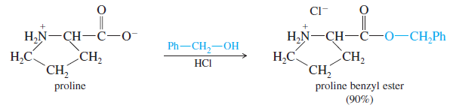
Source: Wade Organic chemistry, 6th Edition
Esters of amino acids are often used as protected derivatives to prevent the carboxyl group from reacting in some undesired manner. Methyl, ethyl, and benzyl esters are the most common protecting groups.
Aqueous acid hydrolyzes the ester and regenerates the free amino acid.

    - Acylation of the Amino Group: Formation of Amides
Like esterification of the carboxyl group of an amino acid by an alcohol, an acylating agent converts the amino group to an amide. Acylation of the amino group is often done to protect it from unwanted nucleophilic reactions. A wide variety of acid chlorides and anhydrides are used for acylation. For example, Benzyl chloroformate acylates the amino group to give a benzyloxycarbonyl derivative, often used as a protecting group in peptide synthesis:
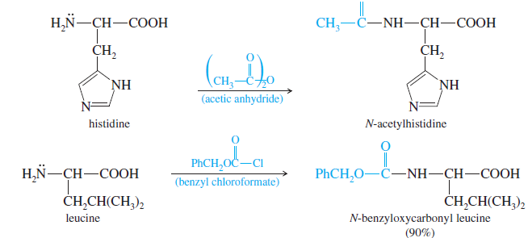
Source: Wade Organic chemistry, 6th Edition
    - Reaction with Ninhydrin
Ninhydrin is a common reagent for visualizing spots or bands of amino acids that have
been separated by chromatography or electrophoresis. When ninhydrin reacts with an
amino acid (by oxidative deamination), one of the products is a deep violet, resonance-stabilized anion called Ruhemann’s purple. Ninhydrin produces this same purple dye regardless of the structure of the original amino acid.
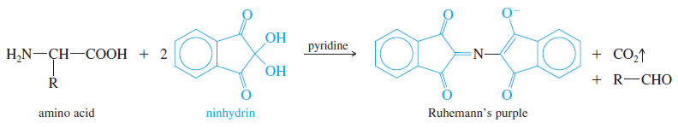
Source: Wade Organic chemistry, 6th Edition
The side chain of the amino acid is lost as an aldehyde.
The importance of this reaction is detection of amino acids on a wide variety of substrates. For example, if a kidnapper touches a ransom note with his fingers, the dermal ridges on his fingers leave traces of amino acids from skin secretions. Treatment of the paper with ninhydrin and pyridine causes these secretions to turn purple, forming a visible fingerprint.

    - Formation of Peptide bonds
This is the most important reaction of amino acids. Amines and acids can condense, with the loss of water, to form amides. Having both an amino group and a carboxyl group, an amino acid is ideally suited to form an amide linkage. Under the proper conditions, the amino group of one molecule condenses with the carboxyl group of another. The product is an amide called a dipeptide because it consists of two amino acids. The amide linkage between the amino acids is called a peptide bond.
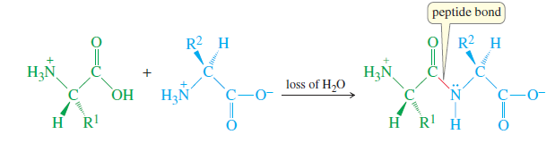
Source: Wade Organic chemistry, 6th Edition

    - Reactions of Specific Functional Groups of the Side Chain
Specific reaction of amino acids is important for degradation, sequencing and chemical synthesis of peptides and proteins. These reactions are useful in identifying specific functional groups and hence specific amino acids possessing such functional groups.
a. Reactions of Sulfhydryl Group
i. Disulfide bond (bridge) formation:
The thiol groups of cysteine can react with one another to form disulfide species.
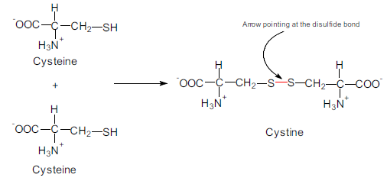

*Disulfide bridges help stabilize many polypeptides and proteins.
ii. Reactions of cysteine with iodoacetic acid:
Cysteine is also known to react with iodoacetic acid to yield S–carboxymethyl cysteine derivatives.
b.Xanthoproteic Reactions of Aromatic Ring
Amino acids with aromatic nuclei form yellow nitro derivatives on heating with concentrated nitric acid. This reaction is based on the nitration of benzene ring with concentrated HNO₃ yielding yellow derivatives of nitrobenzenes. The reaction is characteristic of tyrosine, tryptophan, and polypeptide which contain these amino acids.
Phenylalanine is more difficult to nitrate and so requires H₂SO₄ as a catalyst.

c.Millon’s Reaction
The amino acid called tyrosine, a hydroxybenzene-radical containing compound, reacts with Millon’s reagent (a solution of mercuric and mercurous ions in nitric and nitrous acids) to form red complexes.

d.Sakaguchi Reaction
Arginine, an amino acid containing guanidinium group, reacts with α- naphthol and an oxidizing agent, such as bromine water, to give a red colour compound.

e. Reaction of Tryptophan with Formaldehyde
Tryptophan reacts with formaldehyde reagent in the presence of concentrated H₂SO₄, to form a bluish- purple compound appearing as ring at the interface of the liquids. This reaction is characteristic of the indole- ring of tryptophan.

6.2 BIOLOGICAL ROLES OF AMINO ACIDS
1. Amino acids are the primary building blocks for protein.
2. Amino acids can be metabolized to produce energy. This is especially important during fasting, when the breakdown of muscle protein is a major source of energy and biosynthetic precursors e.g. Ala is a small amino acid, especially suited for diffusing from muscle cells into the blood to be transported by the blood to the liver for utilization in gluconeogenesis.
3. Some amino acids act as neurotransmitters, and some act as starting materials for the biosynthesis of neurotransmitters, hormones, and a wide variety of other important biochemical compounds (e.g. dopamine, serotonin, GABA, epinephrine), local mediators (e.g. the allergy mediator histamine), energy-related metabolites (e.g. creatine, citrulline, carnitine), the oxygen-binding molecule ‘heme‘, and DNA bases called purines.

Examples:
1. Phenylalanine is necessary for the synthesis of the catecholamines; dopa, dopamine, norepinephrine and epinephrine. Some people are born lacking an enzyme that regulates the catabolism of phe. When this happens, a metabolite of phe (phenylpyruvic acid) builds up in nervous tissue and causes severe mental retardation. This condition is known as phenylketonuria (PKU). People with PKU are generally blonde, blue-eyed and fair complexioned. The reason for this is that phe is also necessary for the synthesis of a pigment called melanin that contributes to eye, hair and skin color. People with PKU must eat a diet low in phenylalanine for the rest of their life. Since phe is required by the body to initiate the synthesis of the catecholamines for neurotransmitter and hormonal functions, people who have PKU must add tyrosine (p-hydroxy
Phenylalanine) to their diet. This is a product of the hydroxylation of phe that does not occur in PKU.

2. Cystine is a sulfur containing amino acid that is mostly found in connective tissues. It is also a constituent of hair. The nature of hair is maintained by the presence of disulfide bonds (-S-S-). The disulfide bonds come from the loss of -H from the -SH group of two Cystine molecules in the hair which then bond to hold the hair in its appropriate shape to form Cysteine. Cosmetologists and beauticians utilize this property in perming of hair. They first reduce the natural disulfide bonds in hair, then place the hair in the shape the customer asks and finish the job with an oxidizing agent that forces the formation of the disulfide bonds which result in curly hair from under the curlers or drier.

3. Histidine is positively charged at a pH of approximately 6 or below. It is the precursor molecule to histamine, the compound that causes many allergic reactions and which may be blocked using anti-histamines. Histamine synthesis may be stimulated by the influence of norepinephrine or psychological stress. Because of this, many people who have itching-related health problems may be prescribed a drug like doxepin which has both histamine antagonistic properties and anxiolytic properties: both of which combat the health problem by reducing the anxiety felt by the patient which reduces the itching.
Post-Test
- Predict products of the following reactions of amino acids: Esterification, Acylation, reaction with ninhydrin.
- Highlight the biological roles of amino acids with examples.
- With appropriate diagram, show disulphide bond formation.

Bibliography:
- Wade L.G. Jr. Organic chemistry, 6th Edition. Prentice-Hall/Pearson Publishers.
- Voet D., Voet J.G. Biochemistry 4th Edition

LECTURE SEVEN: INTRODUCTION TO CHEMISTRY OF PROTEINS
7.0 INTRODUCTION
This lecture introduces the basic chemistry of proteins. It starts with differentiating between a peptide and protein and reactions of peptide bond formation. Other considerations include: naming of peptides, biologically active peptides, properties, examples and biological functions of proteins.
Objectives:
At the end of this lecture, students should be able to:
- State the differences between peptide and protein
- Name and describe the functions of some biologically active peptides
- Give example of proteins their properties, and functions.
Pre-Test
- Give two examples of protein and their source
- How are proteins formed from amino acids?
7.1 DIFFERENCES BETWEEN PEPTIDE AND PROTEIN
Proteins are also polymers of amino acids. The basic distinguishing feature between peptide and protein is in respect to their molecular weight. Amino acid polymers (polypeptides) with molecular weight greater than 10000 are termed proteins while those with molecular weight less than 10000 are called peptide. In many proteins, two or more polypeptides are linked via covalent (disulfide bridge) or noncovalent hydrophobic interactions.

7.2 PEPTIDE BOND FORMATION
Peptides are formed through covalent bonding between two or more amino acids’ molecules. This covalent bond, the peptide bond, is an amide linkage. The peptide bond is formed by the elimination of a water molecule from the α-carboxyl group of one amino acid and the α-amino group of another.
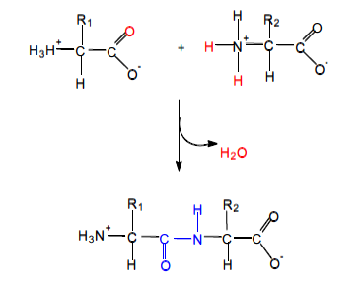
Fig.: Formation of a peptide bond (Dipeptide formation). Source: Voet & Voet.

The peptide bond formation is initiated via an attack of the lone-pair electrons of the amine on the carbonyl carbon of the carboxyl group. If such a condensation polymer consists of two amino acids joined by a peptide bond, it is referred to as dipeptide. Three amino acids can be joined by two peptide bonds to form a tripeptide. Similarly, four amino acids will form a tetrapeptide while five amino acids will produce a pentapeptide etc. Polymers composed of few (3-10) amino acids residues are known as oligopeptide. The term polypeptide refers to a polymer containing many amino acid residues. Amino acid unit that exists as part of a peptide is often called residue (amino acid residue).

7.3 NOMENCLATURE OF PEPTIDES
In a peptide, amino acid residue is linked to its neighbor in a head-to-tail manner, forming linear polymer. The end of the linear polymer with a free α-amino group is the N-terminus while the amino acid residue at this end is called the amino terminal (or N-terminal) residue. In the same way, the opposite end of the polymer with a free carboxyl group and its terminal amino acid are called the C-terminus and carboxyl-terminal residue respectively.
A peptide is named according to the amino acid residues in it and usually begins with the N-terminal residue.
The names of peptides reflect the names of the amino acid residues involved in the amide linkages, beginning at the N terminus. All except the last are given the -yl suffix of acyl groups. For example, the dipeptide below is named Alanylserine. The alanine residue has the –yl suffix because it has acylated the nitrogen of serine.
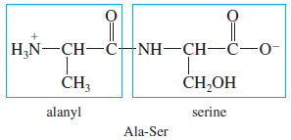
The pentapeptide in the diagram below is named serylglycyltyrosylalanylleucine and abbreviated as Ser-Gly-Tyr-Ala-Leu or SGYAL (using one-letter abbreviation).
Fig.: A Pentapeptide showing the N- and the C- termini. Source: Lehninger principles of Biochemistry, 5th Edition.

7.4 BIOLOGICALLY ACTIVE PEPTIDES
Peptides occur naturally in some biological systems even though synthetic peptides can be produced. Although less structurally complex than the larger protein molecules, peptides have significant biological activities; some interesting examples are listed in the table below:
Table: Biologically Important Peptides
Peptide | No of Amino acid residues
Glutathione | 3
Oxytocin | 8
Vasopressin | 8
Glucagon | 29
Adrenocorticotropic  hormone | 39

7.4.1 Glutathione:
The tripeptide glutathione (γ -glutamyl-L-cysteinylglycine) contains an unusual γ -amide bond.
Note: the γ -carboxyl group of the glutamic acid residue, not the α-carboxyl group, contributes to the peptide bond.
Glutathione (GSH) is found in almost all organisms and is involved in protein and DNA synthesis, drug and environmental toxin metabolism, amino acid transport, and other important biological processes. It protects cells from the destructive effects of oxidation by reacting with substances such as peroxides (R–O–O–R), by-products of O₂ metabolism. For example, in red blood cells, hydrogen peroxide (H₂O₂) oxidizes the iron of hemoglobin to its ferric form (Fe^{3+).}
Methemoglobin, the product of this reaction, is incapable of binding O₂. Glutathione protects against the formation of methemoglobin by reducing H₂O₂ in a reaction catalyzed by the enzyme glutathione peroxidase.

7.4.2 Vasopressin:
This is also called antidiuretic hormone. It contains nine amino acid residues, and it is synthesized in the hypothalamus, a small structure in the brain that regulates a wide variety of functions including water balance, appetite, body temperature, and sleep. In response to low blood pressure or a high blood Na⁺ concentration, osmoreceptors in the hypothalamus trigger vasopressin secretion.
Vasopressin stimulates water reabsorption in the kidneys by initiating a signal transduction mechanism that inserts aquaporins (water channels) into kidney tubule membrane.
Blood pressure rises as water then flows down its concentration gradient through the tubule cells and back into the blood

7.4.3 Oxytocin:
This is another peptide produced in the hypothalamus. It is a signal molecule that stimulates the ejection of milk by mammary glands during lactation. Oxytocin produced in the uterus stimulates the contraction of uterine muscle during childbirth.
Vasopressin and oxytocin have similar structures; they differ only in the amino acids at positions 3 and 8. Thus, the functions of the two molecules overlap. Oxytocin has mild antidiuretic activity and vasopressin has some oxytocin-like activity.
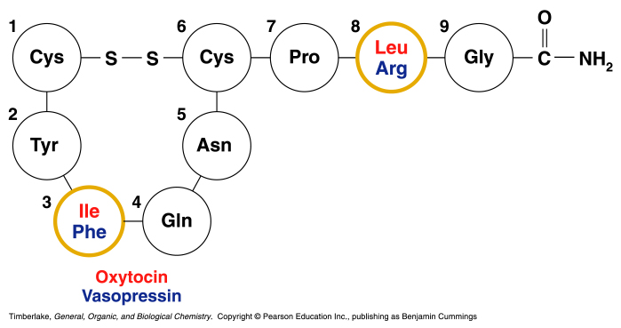

7.4.4 Atrial natriuretic factor (ANF):
This is a peptide produced by specialized cells in the heart in response to stretching, and in the nervous system. It stimulates the production of a dilute urine, an effect opposite to that of vasopressin. ANF exerts its effect, in part, by increasing the excretion of Na⁺, a process that causes increased excretion of water. Also, by inhibiting the secretion of renin by the kidney.
*Renin is an enzyme that catalyzes the formation of angiotensin, a hormone that constricts blood vessels.
Many of the antimicrobial agents produced by microorganisms are peptides that can contain both the D- and L-amino acid residues; Penicillin contains a cyclic peptide as part of its structure.
Other peptide antibiotics include: Gramicidins, the tyrocidins, the polymyxins, the subtilisins and the bacitracins.

7.5 PROTEINS
Proteins are polymers of amino acids. Some proteins exist as single polypeptide chains, while others occur as two or more polypeptides associated non-covalently. Proteins belonging to the latter group are called multi-subunit proteins. Proteins may occur as simple proteins, having only amino acid residues or as conjugated proteins, possessing permanent associated chemical components in addition to amino acids.
The non-amino acid part of a conjugated protein is usually referred to as its prosthetic group. The conjugated proteins could be classified on the basis of the chemical nature of their prosthetic group. For example, in lipoprotein, the prosthetic group is lipid while in metalloprotein, it is a metal. Some examples of conjugated proteins and their prosthetic groups are shown in the table below:
Table: Conjugated Proteins and their Prosthetic Groups
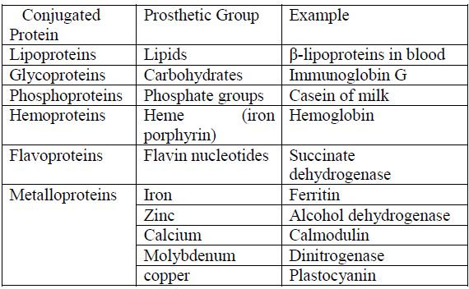

7.6 PROPERTIES OF PROTEINS
Proteins are known to have the following major properties:
- Proteins have varying molecular weights; the molecular weights of insulin, hemoglobin and immunoglobulins are 5700, 68000 and 150000 respectively.
- Absorption of ultraviolet light: They strongly absorb U.V. light in the region between 200 to 240 nm. This is due to the amount of aromatic amino acid residues in them.
- They are charged molecules with characteristic isoelectric points (pI). They could be affected by change in pH. Buffers are therefore, used to stabilize their tertiary structure.
- They vary in size and shape: the shape of some proteins is globular while the shape of some others is fibrous. This is expected since their amino acid sequence and compositions are also quite different. For example, albumin is oval while insulin is globular.
- They have varying solubility property: different agents such as salts, organic solvent such as ethanol, heat, heavy metals and organic acids have been used to precipitate proteins. Protein stability, therefore, could be affected by any of these agents.

7.7 EXAMPLES OF PROTEINS
There are diverse types of proteins occurring in and performing different functions in organisms (both plants and animals). Some examples are listed below:

Protein | Occurrence
Albumin | Egg
Casein | Milk
Hemoglobin | Blood
Melanin | Skin
Transferrin | Blood
Keratin | Hair, scales, horn, nails, wool and feather
Immunoglobulin | Blood
Myosin | Muscle
Actin | Muscle
Rhodopsin | Eye
Collagen | Bones, tendons and ligament
Luciferin | Firefly
Enzymes | Plants and animal cells

7.8 BIOLOGICAL FUNCTIONS OF PROTEINS
Of all the molecules encountered in living organisms, proteins have the most diverse functions; these include:
1. Catalysis. Catalytic proteins called the enzymes accelerate thousands of biochemical reactions in such processes as digestion, energy capture, and biosynthesis. These molecules have remarkable properties. For example, enzymes can increase reaction rates by factors of between 10⁶ and 10¹². They can perform this feat under mild conditions of pH and temperature because they can induce or stabilize strained reaction intermediates. For example, ribulose bisphosphate carboxylase is an important enzyme in photosynthesis, and the protein complex nitrogenase is responsible for nitrogen fixation.
2. Structure. Structural proteins often have very specialized properties. For example, collagen (the major components of connective tissues) and fibroin (silkworm protein) have significant mechanical strength. Elastin, the rubberlike protein found in elastic fibers, is found in blood vessels and skin that must be elastic to function properly.
3. Movement. Proteins are involved in all cell movements. Actin, tubulin, and other proteins comprise the cytoskeleton. Cytoskeletal proteins are active in cell division, endocytosis, exocytosis, and the ameboid movement of white blood cells.
4. Defense. A wide variety of proteins are protective. In vertebrates, keratin, a protein found in skin cells, aids in protecting the organism against mechanical and chemical injury. The blood-clotting proteins fibrinogen and thrombin prevent blood loss when blood vessels are damaged. The immunoglobulins (or antibodies) are produced by lymphocytes when foreign organisms such as bacteria invade an organism. Binding antibodies to an invading organism is the first step in its destruction.
5. Regulation. Binding of hormone molecule or a growth factor to cognate receptors on its target cell changes cellular function. For example, insulin and glucagon are peptide hormones that regulate blood glucose levels. Growth hormone stimulates cell growth and division. Growth factors are polypeptides that control animal cell division and differentiation. Examples include platelet-derived growth factor (PDGF) and epidermal growth factor (EGF).
6. Transport. Many proteins function as carriers of molecules or ions across membranes or between cells. Examples of membrane transport proteins include the enzyme Na⁺-K⁺ ATPase and the glucose transporter. Other transport proteins include hemoglobin, which carries O₂ to the tissues from the lungs, and the lipoproteins LDL and HDL, which transport water-insoluble lipids in the blood from the liver. Transferrin and ceruloplasmin are serum proteins that transport iron and copper, respectively.
7. Storage. Certain proteins serve as a reservoir of essential nutrients. For example, ovalbumin in bird eggs and casein in mammalian milk are rich sources of organic nitrogen during development. Plant proteins such as zein perform a similar role in germinating seeds.
8. Stress response. The capacity of living organisms to survive a variety of abiotic stresses is mediated by certain proteins. Examples include cytochrome P450, a diverse group of enzymes found in animals and plants that usually convert a variety of toxic organic contaminants into less toxic derivatives, and metallothionein, a cysteine-rich intracellular protein found in virtually all mammalian cells that binds to and sequesters toxic metals such as cadmium, mercury, and silver. Excessively high temperatures and other stresses result in the synthesis of a class of proteins called the heat shock proteins (hsps) that promote the correct refolding of damaged proteins. If such proteins are severely damaged, hsps promote their degradation. Cells are protected from radiation by DNA repair enzymes.
9. Toxins: bacterial, plant, snake, insect.

7.9 BASIC TEST PRINCIPLES FOR AMINO ACIDS AND PROTEINS
Certain functional groups in amino acids and proteins can react to produce characteristically colored products. The colour intensity of the product formed by a particular group varies among proteins in proportion to the number of reacting functional or free groups present and their accessibility to the reagent.

- General tests for proteins
1. Ninhydrin test: Ninhydrin reacts with amino acids in proteins at high temperature giving a
Purple colored complex. Ninhydrin is an oxidizing agent which leads to the oxidative deamination of alpha-amino groups. It is very important for the detection and the quantitative analysis of amino acids. Ninhydrin also reacts with primary amines, but the formation of carbon dioxide is specific for amino acids. When ninhydrin reacts with amino acids, CO₂ is released, and a purple colour is produced. Most of the amino acids are hydrolyzed and reacted with ninhydrin except proline (which gives yellow colour).
Ninhydrin is most commonly used as a forensic chemical to detect “fingerprints”, as amines left over from proteins sloughed off in fingerprints react with ninhydrin giving a characteristic purple color.
Forensic fingerprint

2. Biuret test: The biuret test for proteins positively identifies the presence of proteins in solution with a deep violet colour. Biuret, H₂NCONHCONH₂, reacts with copper (II) ions in a basic solution to form a deep violet complex. The biuret reagent (copper sulphate in a strong base) reacts with peptide bonds in proteins to form a blue to violet complex known as the “biuret complex”. Two peptide bonds at least are required for the formation of this complex.
Fig.: Biuret complex

- Colour reactions of proteins and AAs
1. Reduced sulfur test: Proteins containing sulfur (in cysteine and cystine) give a black deposit of lead sulfide (PbS) when heated with lead acetate in alkaline medium.
2. Xanthoproteic acid test: this test is used to determine the presence of tyrosine, trypthopan, and phenylalanine in protein. These amino acids contain aromatic groups that are derivatives of benzene. These aromatic groups can undergo reactions that are characteristic of benzene and benzene derivatives. One such reaction is the nitration of a benzene ring with nitric acid. Tyrosine and tryptophan contain activated benzene rings and readily undergo nitration. Phenylalanine also contains a benzene ring, but the ring is not activated and, therefore, does not readily undergo nitration. Nitric acid gives a color when heated with proteins containing tyrosine (yellow color) or tryptophan (orange color); the color is due to nitration. This reaction is one of the reactions that occur when a concentrated solution of nitric acid is spilled on human skin. The proteins in skin contain tyrosine and tryptophan, which become nitrated and turn yellow.
3. Millon’s test: Millon's reagent (Hg/HNO₃) gives positive results with proteins containing the phenolic amino acid “tyrosine”. Consequently, any protein containing tyrosine will give a positive test of a pink to dark-red colour. The Millon’s reagent is a solution of mercuric and mercurous ions in nitric and nitrous acids (Caution: Millon’s reagent is highly toxic and highly corrosive). The red colour is probably due to a mercury salt of nitrated tyrosine.
4. Hopkins-Colé test: Hopkins-Colé reagent (magnesium salt of oxalic acid) gives positive results with proteins containing the essential amino acid “tryptophan” indicating a high nutritive value. The Hopkins-Cole test is specific for tryptophan, the only amino acid containing an indole group. The indole ring reacts with glyoxylic acid in the presence of a strong acid to form a violet cyclic product. The Hopkins-Cole reagent only reacts with proteins containing tryptophan. The protein solution is hydrolyzed by the concentrated sulphuric acid at the solution interface. Once the tryp­tophan is free, it reacts with the glyoxylic acid to form the violet product.
5. Nitroprusside Test: The nitroprusside test is specific for cysteine and methionine, the amino acid containing a sulfhydryl group (—SH). The group reacts with nitroprusside in alkaline solution to yield a red complex.
6. Folin test: A phosphomolybdo-tungstic acid reagent designed by Folin for phenol has been widely used for detection and analysis of indolyl and phenol groups in amino acids. A characteristic blue color is formed when amino acid solution is warmed with this reagent. The color so formed is due to the reaction of alkaline copper with the amino acid and the reduction of phosphomolybdate by tyrosine and tryptophan present.

7. Sakaguchi test: Arginine and other guanidyl derivatives (glycocyamine, methylgyanidine etc) react with hypo bromide and alpha napthol to give a red colored product.

- Precipitation reactions of proteins
1. Precipitation by heavy metals: Heavy metals (e.g. Hg²⁺, Pb²⁺, and Cu²⁺) are high molecular weight cations. The positive charge of these cations counteracts the negative charge of the carboxylate group in proteins giving a precipitate.
2. Precipitation by alkaloidal reagents: Alkaloidal reagents (e.g. tannate & trichloroacetate) are high molecular weight anions. The negative charge of these anions counteracts the positive charge of the amino group in proteins giving a precipitate.
Note: Precipitation of proteins by heavy metals and alkaloidal reagents indicates the presence of both negative and positive charges and hence the amphoteric nature of proteins.
3. Precipitation by denaturation:
- Denaturation by heat (heat coagulation test): Heat disrupts hydrogen bonds of secondary and tertiary protein structure while the primary structure remains unaffected. The protein increases in size due to denaturation and coagulation occurs.
- Denaturation by acids (Heller’s test): Nitric acid causes denaturation of proteins with the formation of a white precipitate (this differs from the nitration reaction in “xanthoproteic acid test”).

Post-Test
- State 4 properties of proteins
- Describe 4 qualitative test for proteins.
- State 4 functions of proteins with examples.
- Differentiate between simple and conjugated proteins with appropriate examples.

Bibliography:
- Benjamin Cummings. Timberlake General, Organic and Biological Chemistry. Copyright 2007 Pearson Education Inc. publishing.
- Lehninger Principle of Biochemistry 5th Ed.
- Voet D., Voet J.G. and Pratt C. Fundamentals of Biochemistry 5th Ed. John Wiley &Sons, 2016.
- Voet D., Voet J.G. Biochemistry 4th Edition

LECTURE EIGHT: METHODS OF ISOLATION, PURIFICATION AND IDENTIFICATION OF PROTEINS
8.0 INTRODUCTION
This lecture focuses on methods by which proteins can be isolated and purified from biological sources (mostly tissues and cells). Purification methods like Ion-exchange, Affinity and Size-exclusion chromatography, as well as Electrophoretic method for protein characterization are considered.
Objectives
At the end of this lecture, Students should be able to:
- Highlight the steps involved in protein isolation and purification
- Describe column chromatography
- Describe the three-major column chromatographic used in protein purification
- Differentiate between Cation and Anion exchanger with examples
- State methods of protein characterization
8.1 PROTEIN ISOLATION
A pure preparation is essential before a protein’s properties and activities can be determined since cells contain thousands of different kinds of proteins. Methods for separating proteins take advantage of properties including size, charge, and binding properties. The source of a protein is generally tissue or microbial cells. The first step in any protein purification procedure is to break open these cells, releasing their proteins into a solution called a crude extract. If necessary, differential centrifugation can be used to prepare subcellular fractions or to isolate specific organelles. Once the extract or organelle preparation is ready, various methods are available for purifying one or more of the proteins it contains.
Commonly, the extract is subjected to treatments that separate the proteins into different fractions based on a property such as size or charge, a process referred to as fractionation. Early fractionation steps in a purification utilize differences in protein solubility, which is a complex function of pH, temperature, salt concentration, and other factors. The solubility of proteins is generally lowered at high salt concentrations, an effect called “salting out.” The addition of a salt in the right amount can selectively precipitate some proteins, while others remain in solution. Ammonium sulfate ((NH₄)₂SO₄) is often used for this purpose because of its high solubility in water.
Dialysis is routinely used to remove low-molecular-weight impurities such as salts, solvents, and detergents. Dialysis separates proteins from solvents by taking advantage of the proteins’ larger size. The partially purified extract is placed in a bag or tube made of a semipermeable membrane. When this is suspended in a much larger volume of buffered solution of appropriate ionic strength, the membrane allows the exchange of salt and buffer but not proteins. Thus, dialysis retains large proteins within the membranous bag or tube while allowing the concentration of other solutes in the protein preparation to change until they come into equilibrium with the solution outside the membrane.
Dialysis might be used, for example, to remove ammonium sulfate from the protein preparation.
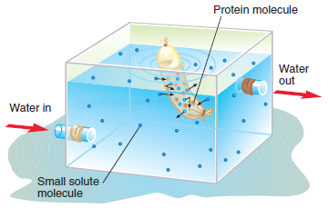
Fig.: Dialysis. Proteins are routinely separated from low-molecular-weight impurities by dialysis. Biochemistry, 4th Edition by Voet & Voet.
As a protein sample becomes progressively purer, more sophisticated methods are used to achieve further purification. Among the most commonly used techniques are chromatography and electrophoresis.
8.2 STEPS IN PROTEIN PURIFICATION
The process of protein purification can be divided into 5 stages:
a) Preparation of the source
b) Knowledge of protein properties
c) Development of an Assay
d) Primary Isolation
e) Final Purification
  - METHODS OF PROTEIN PURIFICATION
The most powerful methods for fractionating proteins make use of column chromatography, which takes advantage of differences in protein charge, size, binding affinity, and other properties. A porous solid material with appropriate chemical properties (the stationary phase) is held in a column, and a buffered solution (the mobile phase) percolates through it. The protein-containing solution, layered on the top of the column, percolates through the solid matrix as an ever-expanding band within the larger mobile phase. Individual proteins migrate faster or more slowly through the column depending on their properties.
The Three chromatographic methods used in protein purification are:
a) Ion – exchange Chromatography
b) Affinity Chromatography
c) Gel filtration (Size exclusion) Chromatography.
8.3.1 Ion-exchange chromatography
This chromatographic technique separates proteins based on their charge. Anion-exchange resins, which consist of positively charged materials, bind reversibly with a protein’s negatively charged groups. Similarly, cation-exchange resins bind positively charged groups. After proteins that do not bind to the resin have been removed, the protein of interest is recovered by washing the column with either a strong salt solution or changing the pH of the wash buffer.
Note: A change in pH alters the protein’s net charge.
Anion exchangers such as DEAE (Diethyl amino ethyl) are used. Attraction of proteins at a pH above the isoelectric point of the protein.
Cation exchangers such as CM (Carboxy methyl) are used. Attraction of protein at a pH below the isoelectric point of the protein.
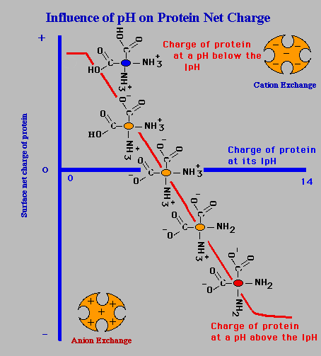

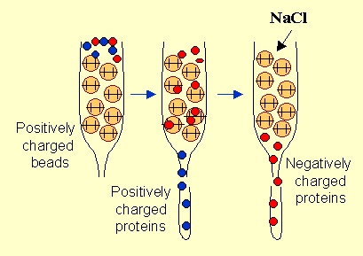
Fig.: Ion-exchange chromatography. Source: Rohan Menon. http//slideshare.com

Examples of Ion Exchangers
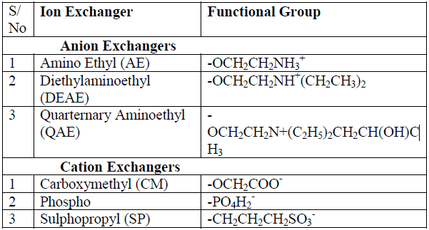
Carboxymethyl-sephadex, phosphocellulose and DEAE-cellulose are ion exchangers of choice for protein /peptide separation.

8.3.2 Affinity chromatography
Proteins are known to have high affinity for various substances such as substrates, prosthetic groups, receptors, inhibitor and antibodies raised against them. Affinity chromatography takes advantage of the unique biological properties of proteins. That is, it uses a special noncovalent binding affinity between the protein and a special molecule (the ligand). When any of these affinity compounds (called ligands) is covalently attached (immobilized) to insoluble resin (matrix), it can be used to purify its conjugate protein by allowing a mixture containing the protein of interest to pass through a column of the immobilized ligand. For example, in immunoaffinity chromatography, antibodies to a specific protein (or its domain) are used as the specialized compound. The ligand is covalently bound to an insoluble matrix, which is placed in a column.
When a mixture of proteins is passed through the column, only those proteins with special affinity for the compound will stick to the column. While the other proteins will pass through the column. After nonbinding protein molecules have passed through the column, the protein of interest is removed (eluted) by changing the ionic strength of the solution (thus affecting the strength of binding of the protein to the column). Alternatively, the special compound can be added to the elution solution and the equilibrium will change so that the protein will no longer stick to the column.
A ligand ideal for affinity chromatography should exhibit the following characteristics:
- Specific and reversible binding;
- Presence of chemically modifiable groups that can be used for attachment to the matrix while it still retains its binding properties;
- Affinity for the binding site of the biomolecule should be within 10⁻⁴ and 10⁻⁸ M in free solution;
- Noncovalent interaction with the biomolecule.
Affinity chromatography can be used to purify proteins and peptide such as enzymes, antibodies, lectins, hormones and even whole cells.
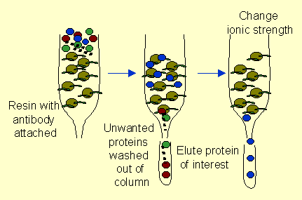
Fig.: Affinity Chromatography. Source: Rohan Menon. http//slideshare.com

8.3.3 Gel-filtration chromatography
This is also called size-exclusion chromatography. It separates proteins on the basis of their molecular weight. The column (a hollow tube) is packed with a porous resin (gel) through which particles in an aqueous solution flow and are separated according to size. Molecules that are larger than the gel pores are excluded and therefore move through the column quickly.
Molecules that are smaller than the gel pores diffuse in and out of the pores, so their movement through the column is retarded. Differences in the rates of particle movement separate the protein mixture into bands, which are then collected separately.
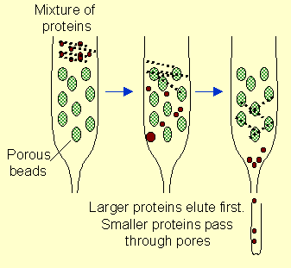
Fig.: Size exclusion Chromatography. Source: Rohan Menon. http//slideshare.com

8.4 Protein Characterization
The methods of protein characterization include:
- Electrophoresis
- Peptide Sequencing
- Tryptic Mapping
- Analytical Ultracentrifugation
- Spectroscopy
- Biosensors
- Mass Spectrometry
    - Electrophoresis
Because proteins are electrically charged, they move in an electric field. In electrophoresis, molecules separate from each other because of differences in their net charge. For example, molecules with a positive net charge migrate toward the negatively charged electrode (cathode). Molecules with a net negative charge will move toward the positively charged electrode (anode). Molecules with no net charge will not move at all. Electrophoresis, one of the most widely used techniques in biochemistry, is nearly always carried out by using gels such as polyacrylamide or agarose. The gel, functioning much as it does in gel-filtration chromatography, also acts to separate proteins based on their molecular weight and shape. Consequently, gel electrophoresis is highly effective at separating complex mixtures of proteins or other molecules.
Bands resulting from a gel electrophoretic separation may be treated in several ways. Specific bands may be excised from the gel after visualization with ultraviolet light. Each protein-containing slice is then eluted with buffer and prepared for further analysis.
Because of its high resolving power, gel electrophoresis is also used to assess the purity of protein samples. Staining gels with a dye such as Coomassie Brilliant Blue is a common method for quickly assessing the success of a purification step.
SDS–polyacrylamide gel electrophoresis (SDS-PAGE) is a widely used variation of electrophoresis that can be used to determine molecular weight. SDS, a negatively charged detergent, binds to the hydrophobic regions of protein molecules, causing the proteins to denature and assume rodlike shapes. Because most molecules bind SDS in a ratio roughly proportional to their molecular weights, during electrophoresis SDS-treated proteins migrate toward the anode (+ pole) only in relation to their molecular weight.
The other method coming up is Capillary electrophoresis. It is conducted in a tubing of very small diameter using high voltage and takes very less time to achieve good separation.

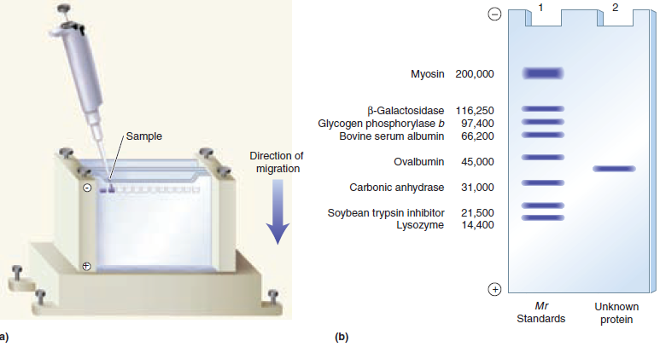
Fig.: Gel Electrophoresis. (a) Gel apparatus. The samples are loaded into wells. After an electric field is applied, the proteins move into the gel. (b) Molecules separate and move in the gel as a function of molecular weight and shape. Source: Biochemistry, 4th Edition y Voet &Voet.

Post-Test
- Highlight the steps involved in protein purification.
- Write a short note on: i) Ion-exchange chromatography ii) Electrophoresis
- Define the following: Ligand, Column, Elution.
- What are characteristics of an ideal ligand?

Bibliography
- Benjamin Cummings. Timberlake General, Organic and Biological Chemistry. Copyright 2007 Pearson Education Inc. publishing.
- Voet D., Voet J.G. Biochemistry 4th Edition

LECTURE NINE: INTRODUCION TO CHEMISTRY OF LIPIDS
9.0 INTRODUCTION
This lecture introduces the chemistry of lipids. It starts with general definition, chemical components, biological importance, and classification of lipids. It proceeds to examine fatty acids as a monomer of lipids under different subtopics like types, significance, Nomenclature and properties. The major quantitative tests for lipids are considered.
Objectives
At the end of this lecture, students should be able to:
- Name lipid compounds
- State the biological importance of lipids
- State different classes of lipids with examples
- Differentiate between saturated and unsaturated fatty acids with examples
- State the properties and reactions of fatty acids
- Describe some quantitative tests of lipids and their importance
Pre-Test
- What do you understand by lipids?
- Is there any difference between fat and oil?
- Name 3 food source of fats and oils
9.1 LIPIDS
Lipids are large and diverse group of naturally occurring organic compounds that are related by their solubility in nonpolar organic solvents (e.g. ether, chloroform, acetone & benzene) and relative insolubility in water. There is great structural variety among the lipids.
Lipid compounds include:
- Fats and Oils (triglyceride)
- Waxes
- Steroids
- Fat- soluble vitamins
- Phospholipid
- Mono- di glycerides
Chemical components of lipids: they are formed of long-chain hydrocarbon groups but may also contain oxygen, phosphorus, nitrogen and sulfur.

9.2 BIOLOGICAL IMPORTANCE OF LIPIDS
- Lipids act as storage form of energy. They are superior to carbohydrates and protein since they yield twice the energy produced by the same weight of carbohydrates or proteins.
- They are natural solvent for fat-soluble vitamins.
- They play a role in protection and fixation of internal organs such as kidney (organ padding).
- They are important dietary components because of their high energy value and also because of the fat-soluble vitamins and the essential fatty acids contained in the fat of natural foods.
- They are structural components of biological membranes
- They serve as thermal insulators in the subcutaneous tissues and around certain organs
- Nonpolar lipids act as electrical insulators, allowing rapid propagation of depolarization waves along myelinated nerves. They make up about 70% of the dry weight of the nervous system and are crucial for the healthy functioning of the nerve cells.
- They provide shape and contour to the body
- They act as metabolic regulators.
- Acetyl CoA derived from fatty acids oxidation is used for biosynthesis of many important compounds e.g. steroids.
- Combinations of lipid and protein (lipoproteins) are important cellular constituents, occurring both in the cell membrane and in the mitochondria, and serving also as the means of transporting lipids in the blood.
- They are involved in blood coagulation
- Dipalmitoyl lecithin, a phospholipid act as surfactant and is required for the normal functioning of the lung alveoli.
Knowledge of lipid biochemistry is necessary in understanding many important biomedical areas, e.g., obesity, diabetes mellitus, atherosclerosis, and the role of various polyunsaturated fatty acids in nutrition and health.

9.3 CLASSIFICATION OF LIPIDS
Lipids are classified into simple, compound (complex), and derived lipids.

9.3.1 Simple lipids
They are esters of fatty acids with various alcohols.
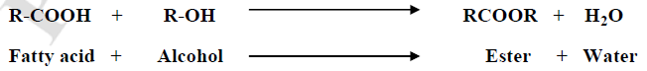
The alcohol may be glycerol or long-chain alcohol. They can be classified according to the type of alcohol:
- Fats and oils: They are esters of fatty acids with glycerol. They are similar chemically, but differ in physical properties; oils are liquid, while fats are solid at room temperature. They are called triglycerides because they are formed of glycerol and 3 fatty acids.
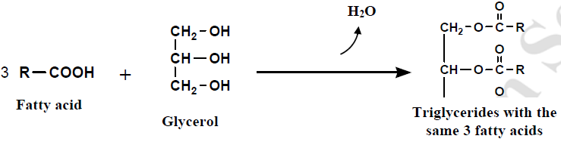
The 3 fatty acids may be the same (e.g. 3 palmitic acid or stearic acid molecules, thus forming tripalmitine or tristearine respectively) or they may be different forming triglycerides with 3 different FAs.
- Waxes: These are esters of fatty acids with long chain (higher molecular) weight monohydric alcohols. They are solid at room temperature. The most important waxes in human body are cholesterol esters which are present in blood and other tissues.
Table 9.1: Differences between fats and waxes are shown in the table below:
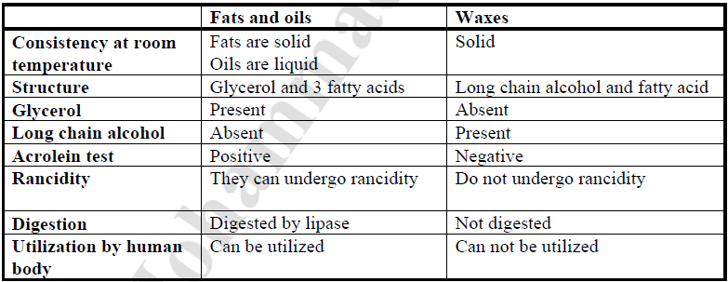
9.3.1.1 Triacylglycerol:
All the commercially important fats and oils of animal and plant origin consist exclusively of this simple lipid. They are esters of fatty acid with the trihydric alcohol glycerol.
Glycerol with one molecule of fatty acid is called monoacylglycerol (monoglyceride), two molecules of fatty acids is diacylglycerol (diglyceride), and three fatty acids is triglyceride.

9.3.1.2 Glycerol
This is a trihydric alcohol. It is a colorless and viscid fluid with sweet taste. It is miscible with water in all proportions. Glycerol can react with strong dehydrating agent (e.g. conc. Sulphuric acid) to form acrolein which has a very irritating odour.
Use of glycerol:
- It is used in pharmaceutical and cosmetic preparations.
- It is used as explosive in the form of trinitoglycerine
- It is used in medicine as a vasodilator agent in coronary heart diseases in the form of nitroglycerine.

9.3.2 Complex lipids:
These are esters of fatty acids containing other groups in addition to an alcohol and a fatty acid. That is, they are formed of simple lipids and other non-lipid parts. These include:
- Phospholipids: Lipids containing, in addition to fatty acids and an alcohol, a phosphoric acid residue. They frequently have nitrogen-containing bases and other substituents, eg, in glycerophospholipids the alcohol is glycerol and in sphingophospholipids the alcohol is sphingosine.
- Glycolipids (glycosphingolipids): Lipids containing a fatty acid, sphingosine, and carbohydrate.
- Other complex lipids: Lipids such as sulpholipids and aminolipids. Lipoproteins may also be placed in this category.

9.3.3 Precursor and Derived lipids:
These are substances derived from simple lipids and compound lipids by hydrolysis, and also substances related to lipids. These include fatty acids, glycerol, steroids, other alcohols, fatty aldehydes, and ketone bodies, hydrocarbons, lipid-soluble vitamins, and hormones. Because they are uncharged, acylglycerols (glycerides), cholesterol, and cholesteryl esters are termed neutral lipids.

9.4 FATTY ACIDS
Fatty acids are molecules characterized by the presence of a carboxyl group attached to a long hydrocarbon chain. They are molecules with a formula R–COOH where R is a hydrocarbon chain. They usually contain an even number of carbon atoms. Fatty acids can be classified as saturated or unsaturated based on the presence or absence of double bonds in their structure.
A. Saturated fatty acids: They have no double bonds, and have a general formula of CH₃-(CH₂)n-COOH. A fatty acid is saturated when every carbon atom in the hydrocarbon chain is bonded to as many hydrogen atoms as possible (the carbon atoms are saturated with hydrogen). Saturated fatty acids are solids at room temperature. Animal fats are a source of saturated fatty acids.
Saturated FAs can be further classified into short chain and long chain Fatty acids according to their number of carbon atoms:

Table 9.2: Differences between short chain and long chain fatty acids.
Properties | Short chain fatty acids | Long chain fatty acids
Number of carbon atoms | Less than 10 | More than 10
Consistency at room temperature | Liquid | Solid
Volatility | Volatile | Non-volatile
Solubility in water | Relatively soluble | Insoluble
Examples | Acetic acid: 2 carbons  Butyric acid: 4 carbons | Palmitic acid: 16 carbons  Stearic acid: 18 carbons

Table 9.3: Saturated Fatty acids
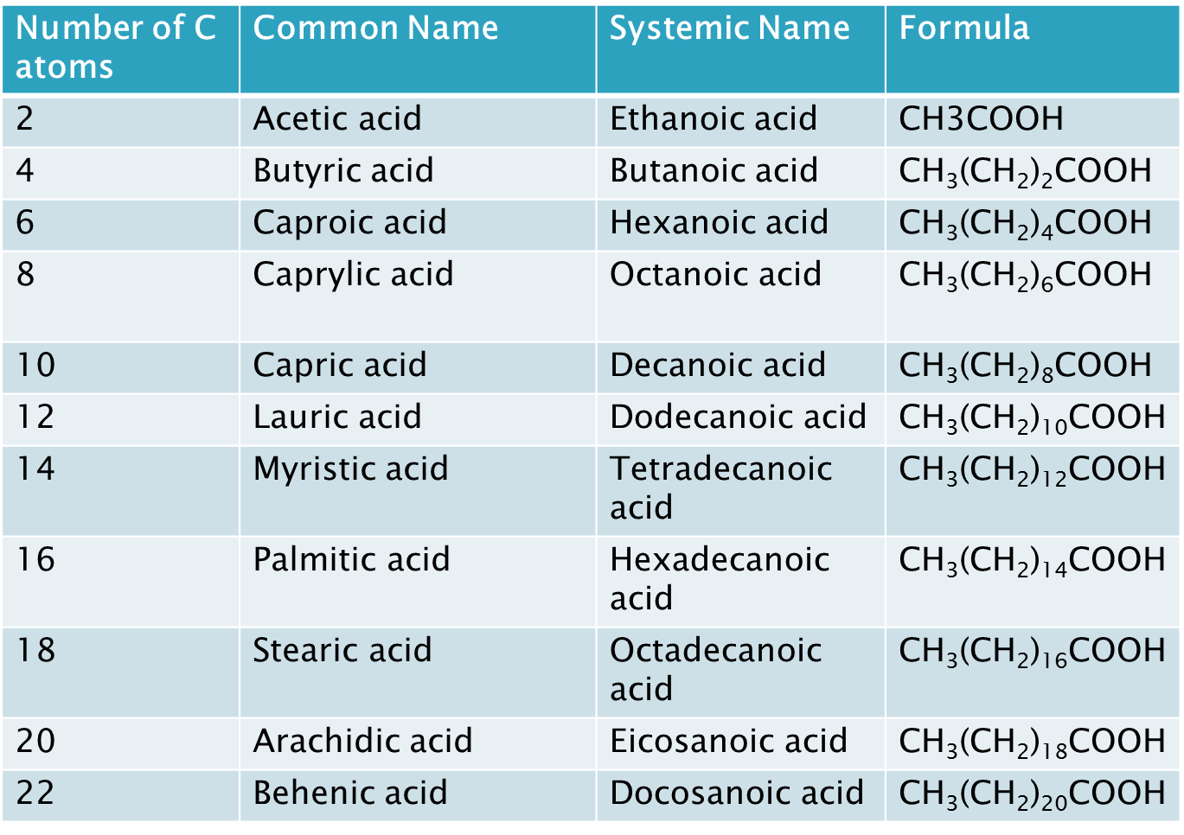
B. Unsaturated fatty acids: they have more than one double bonds along the hydrocarbon chain. Fatty acid with one double bond is called monounsaturated. If it contains two or more double bonds, it is called polyunsaturated FA. The melting point of a fatty acid is influenced by the number of double bonds that the molecule contains and by the length of the hydrocarbon tail; the more double bonds it contains, the lower the melting point. As the length of the tail increases, the melting point increases. Plants are the source of unsaturated fatty acids.
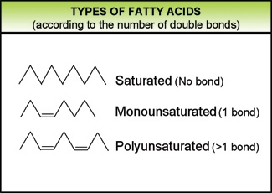
9.4.1 Trans and cis forms:
Naturally occurring fatty acids have cis bonds. Trans-fatty acids are created artificially using a process called hydrogenation. A trans-fatty acid has a trans configuration rather than cis configuration at each double bond. This causes the molecule to straighten. These two stereoisomers can be distinguished in the following way:
- Cis stereoisomer: two similar groups attached to the carbon double bond are found on the same side.
- Trans stereoisomer: two similar groups attached to the carbon double bond are found on opposite sides.

9.4.2 Essential Fatty acids
They are polyunsaturated fatty acids i.e. FAs containing more than one double bond. These include linoleic, linolenic, and Arachidonic acids. They are essential for growth and must be taken in diet because the body cannot synthesize them. This is because the enzymes required for their synthesis are absent in humans.
Arachidonic acid is said to be semi-essential FA because it can be synthesized from linoleic acid. It is important for biosynthesis of prostaglandins.
Essential polyunsaturated fatty acids can be classified as belonging to one of two "families", the omega-6 family or the omega-3 family. Fatty acids belonging to these two families differ not only in their chemistry, but also in their natural occurrence and biological functions.
Significance of essential fatty acids
- They form components of cell membranes, structural elements of gonads and mitochondrial membrane.
- They are required for brain growth and development.
- They play important role in vision
- They have a cardio protective role- Lower serum cholesterol and increase HDL levels
- They prevent fatty liver formation
- Deficiencies of essential polyunsaturated fatty acids may cause a wide variety of symptoms, including retarded growth in children, reduced fertility and pathologic changes in the skin.

9.4.3 Nomenclature of Fatty acids
The systematic name for a fatty acid is derived from the name of its parent hydrocarbon by the substitution of oic for the final e. For example, the C18 saturated fatty acid is called octadecanoic acid because the parent hydrocarbon is octadecane.
A C18 fatty acid with one double bond is called octadecenoic acid; with two double bonds, octadecadienoic acid; and with three double bonds, octadecatrienoic acid. The notation 18:0 denotes a C18 fatty acid with no double bonds, whereas 18:2 signifies that there are two double bonds.

Carbon atoms are numbered from the carboxyl carbon (carbon No. 1). The carbon atoms adjacent to the carboxyl carbon (Nos. 2, 3, and 4) are also known as the α ,β , and γ carbons, respectively, and the terminal methyl carbon is known as the ω or n-carbon. The position of a double bond is represented by the symbol ∆ followed by a superscript number e.g., ∆ 9 indicates a double bond between carbons 9 and 10 of the fatty acid.
Alternatively, the position of a double bond can be denoted by counting from the distal end, with the ω-carbon atom (the methyl carbon) as number 1; ω9 indicates a double bond on the ninth carbon counting from the ω-carbon. In animals, additional double bonds are introduced only between the existing double bond (e.g, 9, 6, or 3) and the carboxyl carbon, leading to three series of fatty acids known as the ω9, ω6, and ω3 families, respectively.
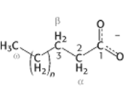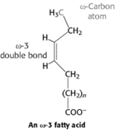

9.4.4 Properties of Fatty acids
General Properties:
- They usually contain an even number of carbon atom.
- They have straight chains.
- They may be saturated or unsaturated. Unsaturated fatty acids are more reactive than saturated fatty acids.
- Some FAs are hydroxylated e.g. cerebronic acid.
- Short chain fatty acids are soluble in water and solubility decrease with increasing chain length.
- Palmitic, stearic and oleic acid make up the bulk of animal fat depot.

Physical Properties
- They are colorless, odorless, and tasteless.
- Solubility in water: short chain fatty acids are soluble in water; the solubility decreases with the increase in chain length. While long chain fatty acids are insoluble in water but soluble in non-polar solvents.
- Melting point: this depends on the length of chain of fatty acid and the degree of unsaturation; short chain and unsaturated fatty acids have lower melting point, and they are liquid at room temperature. While long chain and saturated fatty acids have higher melting point and are solid at room temperature.
- Optical activity: fatty acids containing double bonds can be present in cis and trans stereoisomeric forms. Cis configuration means that the groups around the double bond are on the same side of the bond, while trans configuration means that the groups around the double bond are on the opposite side of the bond. A typical example is oleic acid, which is cis form and its isomer eladic acid, which is trans form.

Chemical Properties:
- Salt formation (Reaction with alkaline):
Being acids, fatty acids react with alkaline to form salts. Salt of fatty acids are called soaps. Sodium and potassium soaps are soluble in water and are referred to as soft soaps. Calcium and magnesium soaps are insoluble in water and are called hard soaps.
- Ester formation (reaction with alcohol):
Fatty acids react with alcohol to form esters. For example, fatty acids react with glycerol to form mono, di, and triglycerides. Also, fatty acids react with long chain monohydric alcohol to form waxes. The most common wax in the body is cholesterol esters.
- Hydrogenation:
Addition of hydrogen to unsaturated fatty acids at the double bond changes it to the corresponding saturated fatty acids.
- Halogenation:
Halogens, such as chlorine Cl), fluorine (F), iodine (I) can be added to unsaturated fatty acids at the double bond to form halogenated fatty acid.
- Reduction:
Fatty acids can be reduced to fatty aldehydes, fatty alcohols, and hydrocarbons.
- Oxidation:
Unsaturated fatty acids are oxidized by oxygen on exposure to air, forming lipid peroxides, fatty aldehydes, ketones and short chain FAs. Oxidation of unsaturated fatty acids with dilute solution of potassium permanganate give dihydroxy fatty acid, then cleaving the fatty acid double bond.

9.5 PROPERTIES OF FATS AND OILS
1. State. Fats containing saturated fatty acids are solid at ordinary room temperature. The animal fats belong to this category. Most plant fats, on the contrary, possess unsaturated fatty acids and are, henceforth, liquid at room temperature.
2. Color, Odor and Taste. When pure, the fats are colorless, virtually odorless and possess an extremely bland taste. They can absorb a variety of odors and hence flavor during storage.
3. Solubility. The fats are only sparingly soluble in water. Thus, described as hydrophobic in contrast to the water-soluble or hydrophilic substances like many carbohydrates and proteins. However, they are freely soluble in organic solvents like chloroform, ether, acetone and benzene. The solubility of the fatty acids in organic solvents decreases with the increase of chain length. The introduction of hydroxyl groups, however, increases solubility.
4. Melting point. The melting point of fats depends on the chain length of the constituent fatty acid and the degree of unsaturation.

Table 9.3: Melting points of the common fatty acids
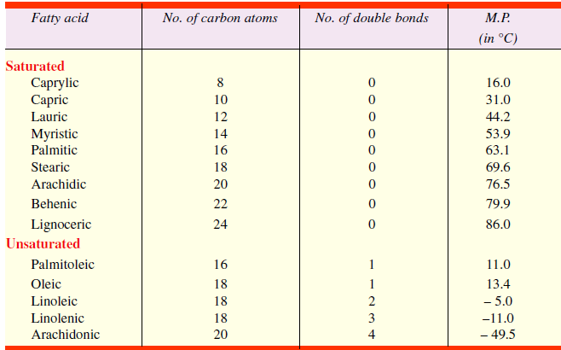

5. Specific gravity. The specific gravity of the fats is less than 1 (about 0.86) and, therefore, they float on water surface. Solid fats are lighter than the liquid fats. Oils spread on water to form thin monomolecular layers. In general, either unsaturation of the fatty acid chains increases or increase in chain length of the fatty acid residues tend to increase the specific gravity.
6. Geometric isomerism. As stated earlier, the presence of double bond (s) in the unsaturated fatty acid part of the fat molecule produces geometric (or cis-trans) isomerism.
7. Insulation. The fats possess high insulating power, i.e., they are bad conductor of heat. A layer of fat below the skin provides a sort of blanket for warm-blooded animals (or homoiotherms).
This is especially important for whales and seals which must maintain a high temperature in cold waters. The fishes are cold-blooded animals (or poikilotherms), thus, do not require maintenance of high temperature and so have very little subcutaneous fat.
8. Emulsification. It is the process by which a lipid mass is converted into a number of small lipid droplets. The fats may be emulsified by shaking either with water or with emulsifying agents like soaps, gums, proteins etc. An emulsifying agent helps in the production of a finely divided suspension of a fat in an aqueous medium. The hydrocarbon portions of the two (the emulsifier and the fat) tend to aggregate. This leaves the water-soluble group of the emulsifier projecting into the aqueous phase. A fat droplet will associate with several molecules of the emulsifier, thus producing a new water-soluble surface. Water molecules, henceforth, tend to be held in a layer or ‘cloud’ around each droplet, thus disallowing the aggregation of the fat droplets.
The process of emulsification is of great metabolic significance. Fats must be emulsified before they can be absorbed by the intestinal wall. The process is accomplished by the bile juice secreted from liver.
9. Surface tension. This is the force with which surface molecules are held together. When liquid fat is poured on water, it spreads uniformly over the surface of water in the form of a unimolecular layer and thus reduces the surface tension of water.

9.6 CHEMICAL REACTIONS
The chemical reactions of the fats reflect the reactivity of the ester linkage and the degree of unsaturation of the hydrocarbon chain.
9.6.1 Reactions involving COOH group
1. Hydrolysis. The fats are hydrolyzed by the enzymes lipases to yield fatty acids and glycerol.
The lipases catalyze this reaction at a slightly alkaline pH (7.5 – 8.5) in a stepwise manner. The fats first split to produce diglycerides, part of these are then split to monoglycerides. Finally, part of the monoglycerides split to yield fatty acid and glycerol.

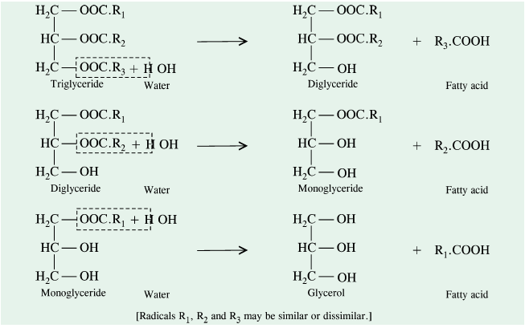
Source: Fundamentals of Biochemistry, 5th Edition.
In the intestine, the absorption of mono-, di and triglycerides is so rapid that very little free glycerol is formed.
2. Saponification. The hydrolysis of fats by alkali is called saponification. This reaction results in the formation of glycerol and salts of fatty acids which are called soaps.
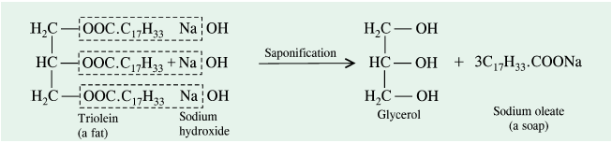
Source: Fundamentals of Biochemistry, 5th Edition.

3. Hydrolytic rancidity. When butter or other fats are stored, they often become rancid and hence unpalatable. Rancidity is caused by the growth of microorganisms which secrete enzymes like lipases. These split the fats into glycerol and free fatty acids. The fatty acids impart unpleasant odour and flavour to the fat. However, butter may be prevented from becoming rancid by refrigeration or by exclusion of water.

9.6.2 Reactions involving double bond
1. Hydrogenation. Unsaturated fatty acids, either free or combined in lipids, react with gaseous hydrogen to yield the saturated fatty acids. The reaction is catalyzed by platinum, palladium or
nickel. The addition of hydrogen takes place at the C—C double bond (s). Thus, 1 mole of oleic, linoleic or linolenic acid reacts with 1, 2 or 3 moles of hydrogen respectively to form stearic acid.
This reaction is of great commercial importance since it permits transformation of inexpensive and unsaturated liquid vegetable fats into solid fats used in the manufacture of candles, vegetable shortenings and of oleomargarine.
2. Halogenation. Unsaturated fatty acids and their esters can take up halogens like Br₂ and I₂ at their double bond (s) at room temperature in acetic acid or methanol solution.
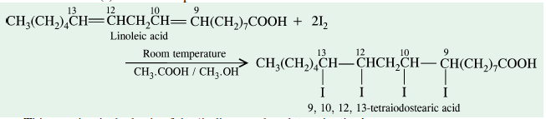
Source: Fundamentals of Biochemistry, 5th Edition.

3. Oxidation. Unsaturated fatty acids are susceptible to oxidation at their double bonds. Oxidation may be carried with ozone or KMnO4.
(a) With ozone – An unstable ozonide is formed which later cleaves by water to give rise to 2 aldehydic groups.
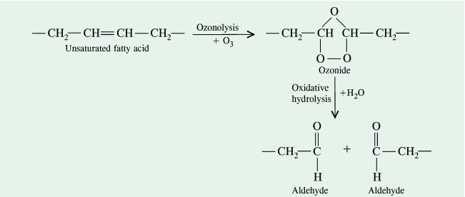
Source: Fundamentals of Biochemistry, 5th Edition.
(b) With KMnO₄ – Under mild conditions, the glycols are formed at the sites of double bonds.
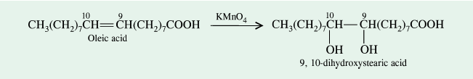
Under vigorous conditions, the same reagent cleaves the molecule at the double bond and oxidizes the terminal portions to the carboxyl group.
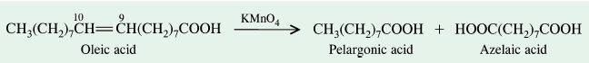
Source: Fundamentals of Biochemistry, 5th Edition.
The oxidation reactions have been extensively used in establishing the position of double bond(s) in the fatty acid chain. This gives important clues regarding lipid structure.
4. Oxidative rancidity. Oils containing highly unsaturated fatty acids are spontaneously oxidized by atmospheric oxygen at ordinary temperatures. The oxidation takes place slowly and results in the formation of short chain fatty acids (C4 to C10) and aldehydes which give a rancid taste and odour to the fats. This type of rancidity or is called ‘oxidative rancidity’ and is due to a reaction called `autoxidation'.
Autoxidation proceeds by a free radical mechanism in which the α - methylene group is primarily attacked. A hydrogen atom is removed from α-methylene group. This initiates a chain of reactions leading to oxidation (Holman, 1954).
Oxidative rancidity is observed more frequently in animal fats than in vegetable fats. This is due to the presence of natural ‘antioxidants’ (such as tocopherols (= vitamin E), phenols, naphthols etc.) in vegetable oils, which check autoxidation. Vitamin E is therefore, sometimes added to foods to prevent rancidity.
.
9.6.3 Reaction involving OH groups
Dehydration (Acrolein test). Fats, when heated in the presence of a dehydrating agent, NaHSO₄ or KHSO₄ produce an unsaturated aldehyde called acrolein from the glycerol moiety. Acrolein is easily recognized by its pungent odour and thus forms the basis of the test for the presence of glycerol in fat molecule.
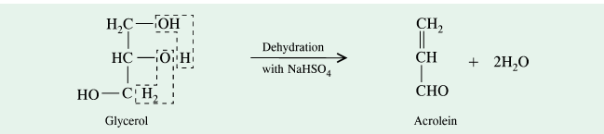
Source: Fundamentals of Biochemistry, 5th Edition.

9.7 QUANTITATIVE TESTS FOR LIPIDS
The reactions described so far give valuable information about the chemical nature of fatty acids and the number of hydroxyl groups present in the fat molecule. Such chemical determinations involve various analytical tests. These are called chemical constants and include the following:
1. Acid value. It is the number of milligrams of KOH required to neutralize the free fatty acids present in 1 gm of fat. The acid number, thus, tells us of the quantity of free fatty acid present in a fat. Obviously, a fat which has been both processed and stored properly has a very low acid number.
2. Saponification number. It is the number of milligrams of KOH required to saponify 1 gm of fat. The saponification number, thus, provides information of the average chain length of the fatty acids in the fat. It varies inversely with the chain length of the fatty acids. The shorter the average chain length of the fatty acids, the higher is the saponification number.
3. Iodine value (or Koettstorfer number). It is the number of grams of iodine absorbed by 100g of fat. The iodine number is, thus, a measure of the degree of unsaturation of the fatty acids in the fat. Oils from soybean, corn and cottonseed have higher iodine numbers (133, 127 and 109, respectively) than the solid fats such as beef fat or tallow (42) because the former possess more unsaturated fatty acids in the fat molecule. However, the iodine number gives no indication as to the number of double bonds present in the fatty acid molecule.
4. Polenske number. It is the number of millilitres of 0.1N KOH required to neutralize the insoluble fatty acids (i.e., those which are not volatile with steam distillation) obtained from 5 gm of fat.
5. Reichert-Meissl number. It is the number of millilitres of 0.1N KOH required to neutralize the soluble, volatile fatty acids derived from 5 g of fat. The Reichert-Meissl number, thus, measures the quantity of short chain fatty acids (up to C 10 inclusive) in the fat molecule. The Reichert Meissl numbers of coconut and palm oils range between 5 and 8. Butterfat is exceptional in having a high Reichert-Meissl number, ranging from 17 to 35. This high value makes possible the detection of any foreign fats which are, sometimes, adulterated in the manufacture of butter.
6. Acetyl number. It is the number of milligrams of KOH required to neutralize the acetic acid obtained by saponification of 1 gm of fat after it has been acetylated (The treatment of fat or fatty acid mixture with acetic anhydride results in acetylation of all alcoholic OH groups). The acetyl number is, thus, a measure of the number of OH groups in the fat. For example, the castor oil has a high acetyl number (146) because of high content of a hydroxy acid, ricinoleic acid, in it.

Post-Test
- What are lipids? Name 5 lipids compounds.
- Differentiate between the following with examples: (a)Saturated and unsaturated fatty acids (b) Tans and cis fatty acids.
- What are essential fatty acids? Name them.
- State 5 chemical reactions of fatty acids
- Describe 3 quantitative tests for lipids and their importance.
Bibliography
- Voet D., Voet J.G. and Pratt C. Fundamentals of Biochemistry 5th Ed. John Wiley &Sons, 2016.
- Burton R.M, and Guerra F.C. Fundamentals of Lipid Chemistry. Webster Groves, Missouri: Bi-Science Publication Division. 1972.
- Gurr M.I, Hardwood J.L. Lipid Biochemistry. An Introduction. 4th ed. Chapman and Hall, London. 1990.

LECTURE 10: LIPOPROTEINS AND MEMBRANE LIPIDS
10.0 INTRODUCTION
This lecture focuses on types of lipoproteins, their composition, and functions. The major types of membrane lipids, their structures and clinical importance are considered.
Objectives
At the end of this lecture, students should be able to:
- State the types of lipoproteins and their compositions
- Explain the terms ‘good’ and ‘bad’ cholesterol.
- Define Apoproteins with examples
- Differentiate between Triglycerides and Phosphoglycerides
- State the major types of phospholipids and their structures
Pre-Test
- What are lipoproteins?
- Is Cholesterol good or bad?
- Biological membranes mainly consist of Phospholipids. True or false?
10.1 LIPOPROTEINS
To transport lipids such as fatty acids, triacylglycerols, steroids and fat-soluble vitamins in the blood plasma, a carrier protein is required. The bulk of the body’s lipids (cholesterol, phospholipids and triacylglycerols), are transported in the plasma by large complexes called ‘lipoproteins’. These lipoproteins consist of a core of hydrophobic lipids surrounded by a shell of phosphotidylglycerols and proteins.
10.1.1 Classification of Lipoproteins
Lipoproteins are classified according to their density:
- Chylomicrons: These are the lowest density lipoprotein
- Very low-density lipoproteins VLDLs: chylomicron remnants,
- Intermediate density lipoproteins, IDLs,
- Low density lipoproteins, LDLs, and
- High density lipoproteins, HDLs.
The densities of these lipoproteins are related to the relative amounts of lipids to proteins in the complex; the higher the protein content the higher the density of the lipoprotein. The largest particles (chylomicrons and VLDLs) have mostly TG in their core and the particles carrying less TG are much smaller in size and denser in buoyancy. Larger lipoproteins are always buoyant compared to small lipoproteins which are comparatively always denser.
10.1.2 Apoproteins
Apolipoproteins (“apo” designates the protein in its lipid-free form) combine with lipids to form several classes of lipoprotein particles. They are spherical complexes with hydrophobic lipids in the core and hydrophilic amino acid side chains at the surface. At least nine different apolipoproteins are found in the lipoproteins of human plasma, distinguishable by their size, their reactions with specific antibodies, and their characteristic distribution in the lipoprotein classes. These protein components act as signals, targeting lipoproteins to specific tissues or activating enzymes that act on the lipoproteins.
The affinities of the apoproteins for the surface components of the lipoprotein change during lipoprotein metabolism. Apoproteins often diffuse from one lipoprotein and bind to another. Only apoprotein B maintains its association with the lipoprotein during the cycle of lipoprotein metabolism.

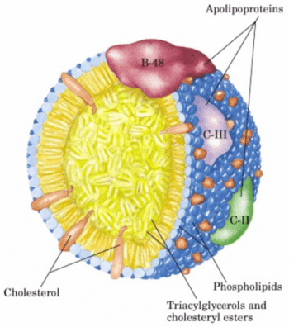
Fig 10.1: Structure of chylomicron.
Source: https://www.slideshare.net/YESANNA/chemistry-of-lipoproteins
10.1.3 Chylomicrons
These lipoproteins are involved in transportation of dietary lipids from the intestinal mucosa cells to other tissues. Chlyomicrons are large and have the lowest protein to lipid ratio and hence have the lowest density of all the lipoproteins. Chylomicrons contain phospholipids and proteins on the surface so that the hydrophilic surfaces are in contact with water, while the hydrophobic molecules are enclosed in the interior.
The apolipoproteins of chylomicrons include apoB-48 (unique to this class of lipoproteins), apoE, and apoC-II. ApoC-II activates lipoprotein lipase in the capillaries of adipose, heart, skeletal muscle, and lactating mammary tissues, allowing the release of free fatty acids to these tissues.
Chylomicrons thus carry dietary fatty acids to tissues where they will be consumed or stored as fuel. The remnants of chylomicrons (depleted of most of their triacylglycerols but still containing cholesterol, apoE, and apoB-48) move through the bloodstream to the liver.

10.1.4 Very Low-Density Lipoproteins
The liver synthesizes fatty acids and cholesterol and packages them for transport in the blood plasma in VLDLs. When the diet contains more fatty acids than are needed immediately as fuel, they are converted to triacylglycerols in the liver and packaged with specific apolipoproteins into very-low-density lipoprotein (VLDL). Excess carbohydrate in the diet can also be converted to triacylglycerols in the liver and exported as VLDLs. VLDLs also contain some cholesterol and cholesteryl esters, as well as apoB-100, apoC-I, apoC-II, apoC-III, and apo-E. These lipoproteins are transported in the blood from the liver to muscle and adipose tissue, where activation of lipoprotein lipase by apoC-II causes the release of free fatty acids from the VLDL triacylglycerols. The liver secretes VLDLs via exocytosis. Like chylomicrons, VLDLs undergo constant changes in the plasma.

10.1.5 Intermediate and Low-Density Lipoproteins (IDL and LDL)
The loss of triacylglycerol converts some VLDL to VLDL remnants, called intermediate density lipoprotein, IDL; further removal of triacylglycerol from VLDL produces low-density lipoprotein (LDL). LDLs are rich in cholesterol and cholesteryl esters and containing apoB-100 as their major apolipoprotein. They are principal plasma cholesterol carrier; transport cholesterol to extrahepatic tissues that have specific plasma membrane receptors that recognize apoB-100.
The concentration of LDLs positively correlates with the incidence of coronary heart disease. Hence, LDL is commonly called the bad cholesterol because it is the carrier of plasma cholesterol to the tissues. LDL serves a source of cholesterol for most tissues of the body. High levels of LDL are associated with the formation of atherosclerotic plaques that occlude blood vessels causing heart attacks and strokes.

10.1.6 High Density Lipoproteins
HDLs are secreted by liver and intestinal cells. These are protein-rich particles that contain relatively little cholesterol and no cholesteryl esters. The nascent HDLs are disked shaped, but they become spherical as they acquire free cholesterol from cell membranes and triacylglycerols from other lipoproteins. The primary function of HDLs is to remove excess cholesterol and carry the excess to the liver to be metabolized into bile salts. This function of cholesterol removal from the tissues underlies the inverse relationship between the plasma concentration of HDLs and the incidence of heart diseases. Thus, HDL is commonly called the good cholesterol.
HDLs contain apoA-I, apoC-I, apoCII, and other apolipoproteins, as well as the enzyme lecithin-cholesterol acyl transferase (LCAT), which catalyzes the formation of cholesteryl esters from lecithin (phosphatidylcholine) and cholesterol. LCAT on the surface of nascent (newly forming) HDL particles converts the cholesterol and phosphatidylcholine of chylomicron and VLDL remnants to cholesteryl esters, which begin to form a core, transforming the disk-shaped nascent HDL to a mature, spherical HDL particle. This cholesterol-rich lipoprotein then returns to the liver, where the cholesterol is unloaded; some of this cholesterol is converted to bile salts.

Table 10.1: Lipoproteins source and components and apolipoproteins.
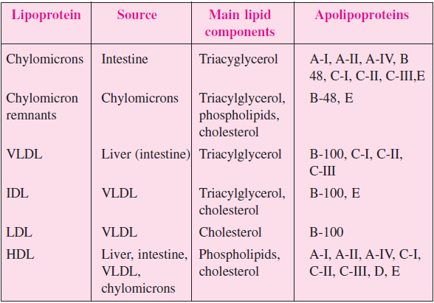
10.2 MEMBRANE LIPIDS
Membranes are lipid bilayers that act as a boundary to various cellular structures; they also control transfer of ions and organic molecules into and out of the cell. Membranes are chiefly made of phospholipids which are Phosphoacylgycerols. Triacylglycerols and phosphoaclyglycerols are similar however the terminal OH group of the phosphoaclyglycerol is esterified with phosphoric acid instead of a fatty acid which leads to the formation of phosphatidic acid.
There are two types of phospholipids: Phosphoglycerides and Sphingomyelin
Phosphoglycerides have glycerol as their backbone; they contain phosphatidic acid with the phosphate group linked to an alcohol, while Sphingomyelins have sphingosine as their backbone (instead of glycerol)
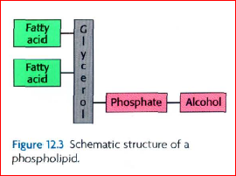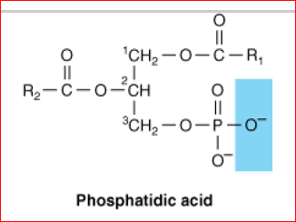
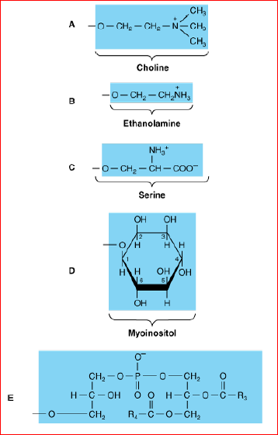
Source: Biochemistry by Lubert Stryer et al. 6th ed

10.2.1 Phosphoglcerides
- Phosphatidyl Choline (Lecithin): These are Phosphoacylglycerols containing choline and are the most abundant phospholipids of the cell membrane. They represent a large proportion of the body's store of choline. Choline is important in nervous transmission, as acetylcholine, and as a store of labile methyl groups. Dipalmitoyl lecithin is a very effective surface-active agent and a major constituent of the surfactant preventing adherence, due to surface tension, of the inner surfaces of the lungs. Its absence from the lungs of premature infants causes respiratory distress syndrome.
- Phosphatidylserine: plays a role in apoptosis (programmed cell death).
- Phosphatidylinositol: is a precursor of second messengers. The inositol is present in phosphatidylinositol as the stereoisomer, myoinositol. Phosphatidylinositol 4,5-bisphosphate is an important constituent of cell membrane phospholipids; upon stimulation by a suitable hormone agonist, it is cleaved into diacylglycerol and inositol trisphosphate, both act as internal signals or second messengers.
- Cardiolipin: this is a major lipid of mitochondrial membranes. This phospholipid is found only in mitochondria and it is essential for mitochondrial function. Decreased cardiolipin levels or alterations in its structure or metabolism cause mitochondrial dysfunction in aging and in pathological conditions including heart failure, hypothyroidism and Barth syndrome (cardioskeletal myopathy).
- Plasmalogens: these constitute as much as 10% of the phospholipids of brain and muscle. Structurally, the plasmalogens resemble phosphatidylethanolamine but possess an ether link on the sn -1 carbon instead of the ester link found in acylglycerols.
10.2.2 Sphingolipid- Ceramide
Sphingolipids represent another class of lipids found frequently in biological membranes. An 18-carbon amino alcohol, sphingosine, forms the backbone of these lipids rather than glycerol. Typically, a fatty acid is joined to a sphingosine via an amide linkage to form a ceramide.
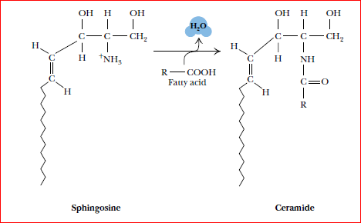
Source: Biochemistry by Lubert Stryer et al. 6th ed

Sphingomyelins represent a phosphorus-containing subclass of sphingolipids and are especially important in the nervous tissue of higher animals. A sphingomyelin is formed by the esterification of a phosphorylcholine or a phosphorylethanolamine to the 1-hydroxy group of a ceramide.
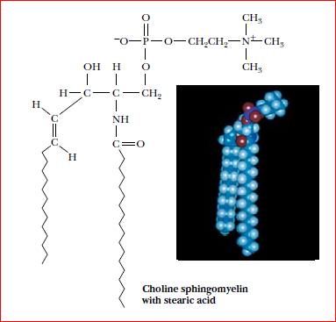
Biochemistry by Lubert Stryer et al. 6th ed

Glycosphingolipids: This is a class of ceramide-based lipids which, like the sphingomyelins, are important components of muscle and nerve membranes in animals. They consist of a ceramide with one or more sugar residues in a -glycosidic linkage at the 1-hydroxyl moiety. The neutral glycosphingolipids contain only neutral (uncharged) sugar residues. When a single glucose or galactose is bound in this manner, the molecule is a cerebroside.
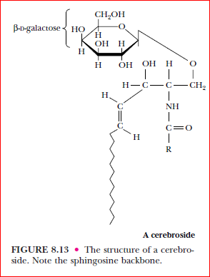

Gangliosides are more complex glycosphingolipids that consist of a ceramide backbone with three or more sugars esterified, one of these being a sialic acid such as N-acetylneuraminic acid. They are referred to as acidic glycosphingolipids, with a net negative charge at neutral pH.
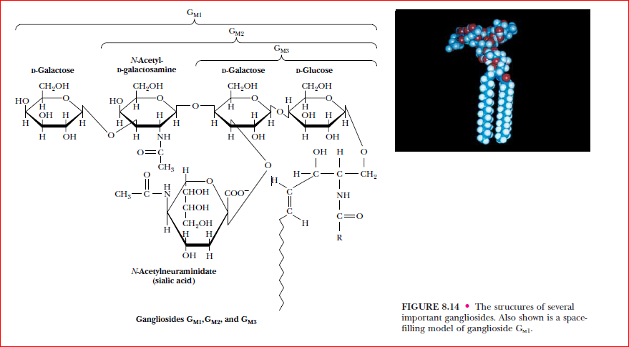
Source: Biochemistry by Lubert Stryer et al. 6th ed

10.3 Clinical Significance of Membrane Lipids
Respiratory Distress Syndrome: Lung surfactant is composed mainly of lipid with some proteins and carbohydrate and prevents the alveoli from collapsing. The phospholipid dipalmitoyl -phosphatidylcholine decreases surface tension at the air–liquid interface and thus greatly reduces the work of breathing, but other surfactant lipid and protein components are also important in surfactant function. Deficiency of lung surfactant in the lungs of many preterm new-borns gives rise to infant respiratory distress syndrome (IRDS). This can be treated by administration of either natural or artificial surfactant is of therapeutic benefit.
Multiple sclerosis: this is a demyelinating disease in which there is loss of both phospholipids (particularly ethanolamine and plasmalogen) and of sphingolipids from white matter. Thus, the lipid composition of white matter resembles that of gray matter. The cerebrospinal fluid shows raised phospholipid levels.
Sphingolipidoses (lipid storage diseases): are a group of inherited diseases that are caused by a genetic defect in the catabolism of lipids containing sphingosine. They are part of a larger group of lysosomal disorders. In this case, complex lipids containing ceramide accumulate in cells, particularly neurons, causing neurodegeneration and shortening the life span.

Post-Test
- What are Lipoproteins? Name the types of Lipoproteins.
- Why is LDL referred to as bad cholesterol?
- Write a short note on Phospholipids.
- Write the structure of: (i) Lecithin (ii) Phosphatidylinositol

Bibliography
- Berg J.M., Tymoczko J.L., and Stryer L. Biochemistry 5th & 6th Ed
- J. Koolman & K.H. Roehm. Color Atlas of Biochemistry 2nd Ed.
- Burton R.M, and Guerra F.C. Fundamentals of Lipid Chemistry. Webster Groves, Missouri: Bi-Science Publication Division. 1972.

LECTURE ELEVEN: INTRODUCTORY CHEMISTRY OF NUCLEIC ACIDS
11.0 INTRODUCTION
This lecture introduces the chemistry of Nucleic Acids covering types, functions and characteristics of Nucleic acids. Other sub-topics include structures of Nucleosides, Nucleotides and the constituent bases, and Nucleic acids; hydrolysis of Nucleic acids.
Objectives
At the end of this lecture, students should be able to:
- Name the types of Nucleic acids
- State the functions and characteristics of Nucleic acids
- Differentiate between Nucleosides and Nucleotides
- List the purine and pyrimidine bases with their respective structure
- Describe the various structures of Nucleic acids
11.1 NUCLEIC ACIDS
Nucleic acids were first discovered in the nuclei of cells. Huge organic molecules that contains C, H, O, N, & P. Nucleic acids are linear polymers made of monomers called NUCLEOTIDES held by 3’ and 5’ phosphate bridges. They are molecules that store information for cellular growth and reproduction These are of two types:
• Deoxyribonucleic acid (DNA)
• Ribonucleic acid (RNA)
11.1.2 Functions of nucleic acids
- DNA is the chemical basis of heredity
- Reserve bank(store) of genetic information
- Responsible for maintaining the identity of different species of organisms over millions of years
- Cellular function is under the control of DNA
- The basic information pathway
- DNA directs the synthesis of RNA, which in turn directs protein synthesis
RNA on the other hand:
- transcribes the genetic information into a form that is easy to understand and read by the cell
- assists in protein synthesis.
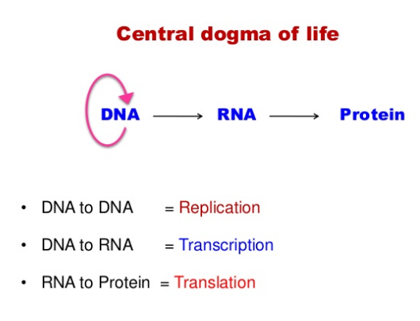
11.1.3 Characteristics of NAs
Linkage: The components of nucleic acids are nucleotides joined by phospho-diester linkage to one another.
Component: Can either be deoxyribonucleic acids in which case they contain deoxy-ribose sugar or ribonucleic acids when the sugar is a ribose one.
The prefix ‘deoxy’ means ‘without oxygen’, as can be seen from the structures that the only difference between them is the absence of an oxygen atom in the deoxyribose sugar (shaded area).
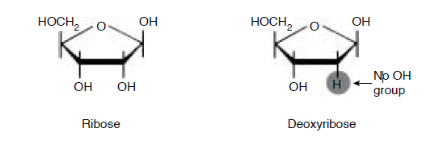
The ‘dash’ or ‘prime’ (') on, for example, the 5 indicates the carbon in the ribose ring. The purine or pyrimidine rings are numbered without primes in order to distinguish them.
Denaturation: DNA undergoes physical change at extreme conditions of pH and temperature. The denaturation of the double helical DNA is called melting as it is associated with the disruption of hydrogen bonds between the paired bases in the DNA.
When temperature is used to denature DNA, the temperature midpoint in the transition is called melting temperature (tm). When the temperature and pH is returned to the range in which the DNA is stable, renaturation occurs. (a rapid one-step process).
UV Absorption: When a double stranded DNA is altered or denatured by change in temperature or pH, the close interaction between stacked bases in the nucleic acid is also affected because there is a decrease in the hydrogen bonding keeping both strands of the DNA together. This process is associated with a marked increase in absorption near the 260nm region, this phenomenon is called hyperchromic effect.
The denatured form of DNA can therefore be detected by monitoring the absorption of UV light.
Size of Nucleic Acids: DNA and RNA molecules are long and un-branched. RNA molecules however have the capacity of forming secondary and tertiary structures.
Their size can be stated in three types of unit:
- length,
- number of base pairs and
- mass
Thus, 1 nm (10⁻⁴cm) of DNA contains 3,000 bases. The length of DNA molecules containing 300 to 300,000 base pairs can be measured directly by electron microscope.
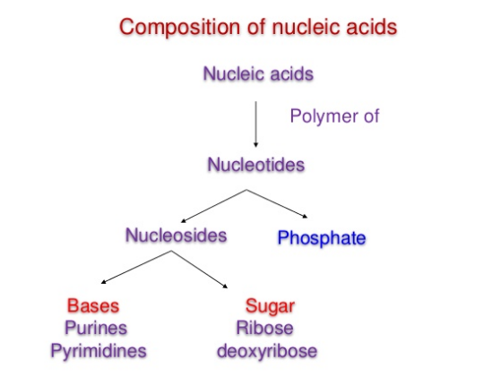
Source: https://www.slideshare.net/YESANNA/nucleic-acid-chemistry-40334502

11.2 NUCLEOTIDES
- They are phosphate esters of nucleosides i.e. Nucleotide= Nucleoside + phosphate
- The esterification occurs at the 3rd or 5th hydroxyl group on the pentose sugar.
- Nucleotides are composed of nitrogenous bases (which could either be a purine or pyrimidine base), pentose sugar and phosphate group.
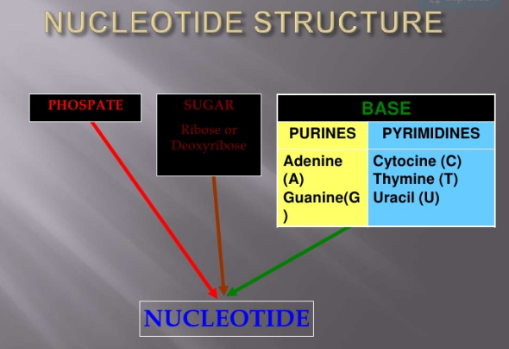
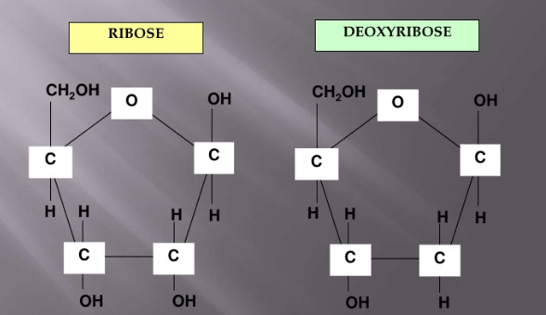
11.3 NUCLEOSIDES
Composed of nitrogenous bases and sugar. The Nitrogenous bases are of 2 types:
- Purine bases
- Pyrimidine bases
The pentose sugar is:
- ribose in ribo-nucleosides (for RNA) or
- 2- deoxyribose in deoxy-ribonucleosides (for DNA)
The N-Glycosidic bond: The linkage of base & sugar for nucleosides involves distinct nitrogen atoms in purine & pyrimidine ring.
Nucleosides containing purine bases= Purine nucleosides (end with the suffix-sine)
Nucleosides containing pyrimidine bases= Pyrimidine nucleosides (end with the suffix-dine)
In purine nucleosides, nitrogen 9 of purine ring is linked to carbon 1 of pentose sugar. While in pyrimidine nucleosides, nitrogen 1 of pyrimidine ring is linked to carbon 1 of pentose sugar.
11.3.1 Purines
They are 9-membered ring structure made of a pyrimidine ring fused to an imidazole ring. The atoms in the purine ring are numbered anti-clockwisely The Purines found in nucleic acids are derived from other substances i.e. they don’t occur naturally.
As seen in their structures;
- Adenine (6-amino purine) i.e. it contains an amino group at the 6th position and
- Guanine (2-amino,6-oxypurine) i.e. it contains an amino group at the 2nd position, oxygen at the 6th position. It is double-ringed
Both are present in DNA and RNA
Other purines include caffeine and theophylline.
Caffeine is a stimulant of the central nervous system, found in tea, coffee. It is also called 1,3,7, tri-methyl-2,6-dioxypurine.
Theophylline-1,3, dimethyl-2,6-dioxypurine, is found in tea. It is used for bronchial asthma.
The end-product of purine metabolism is uric acid.
11.3.2 Pyrimidines
They are 6-membered heterocyclic ring containing 2 nitrogen atoms.3 important derivatives of pyrimidine found in nucleic acids are:
- Thymine (DNA),
- cytosine (both DNA and RNA),
- uracil(RNA)- they are all single rings
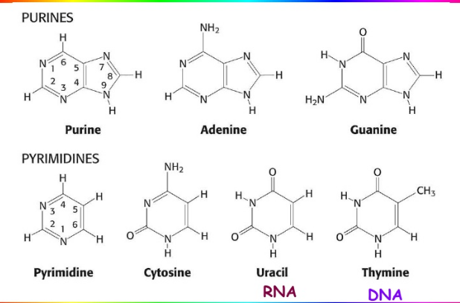
Source: http://pratclif.com/biologie-moleculaire/dna/bases.htm
Note that: Purines always pair up with pyrimidine bases
Adenine will always pair up with thymine with 2 hydrogen bonds (A=T), while Guanine will always pair up with cytosine with 3 hydrogen bonds(G≡C). Adenine and guanine are purines in structure and form a glycosidic bond between the N-9 and the 1' -OH group of the deoxyribose. Cytosine, thymine and uracil are pyrimidines, hence the glycosidic bonds form between their N-1 and the 1' -OH of the deoxyribose.

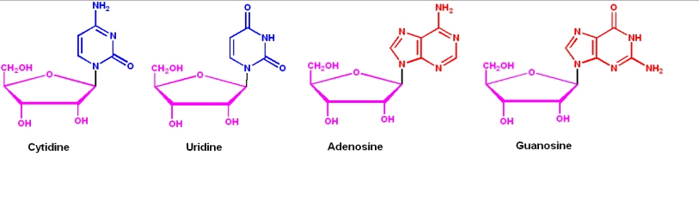
Source: https://www.slideshare.ne

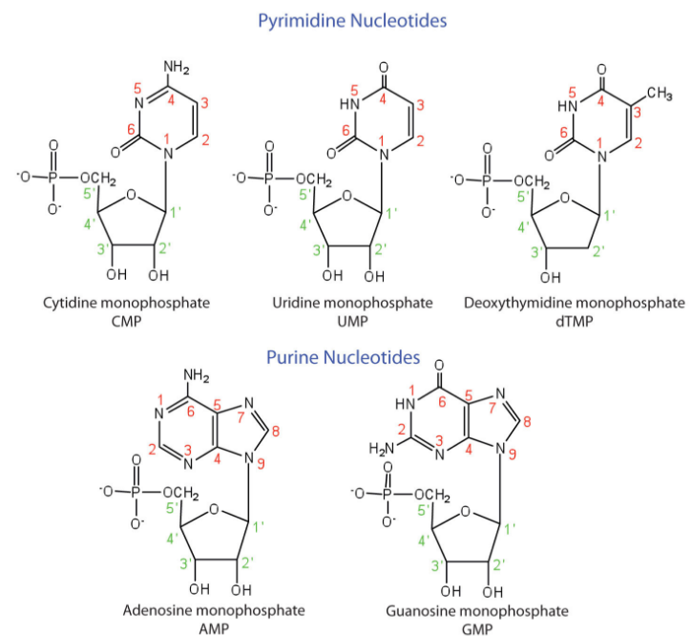
Source: https://2012books.lardbucket.org.
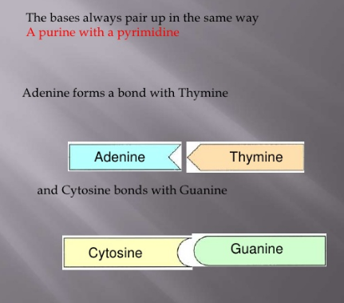

11.4 STRUCTURE OF NUCLEIC ACIDS
Chemically speaking, DNA and RNA are very similar. Nucleic acid structure is often divided into four different levels:
- primary,
- secondary,
- tertiary and
- quaternary structure.
Primary structure: This consists of a linear sequence of nucleotides that are linked together by phospho-diester bonds i.e. the linear sequence of the 4 nucleotides:
  - A-T-G-C in DNA and
  - A-U-G-C in RNA.
A Nucleic acid sequence is the order of nucleotides within a DNA (GACT) or RNA (GACU) molecule that is determined by a series of letters. Sequences are presented from the 5' to 3' end and these determine the covalent structure of the entire molecule. Sequences can be complementary to another sequence in that the base on each position is complementary as well as in the reverse order.
An example of a complementary sequence to AGCT is TCGA.
DNA is formed by the covalent backbone consisting of deoxyribonucleotides linked to each other by phosphodiester bonds. DNAs are long chains of nucleotide units or poly-deoxy-ribonucleotides. The most important clue to the DNA structure came from the discovery made by Erwin Chargaff et al in 1940s. Series of experiments conducted by them led them to postulate a series of results called Chargaffs’ rule.
Chargaffs’ rule:
- DNA specimens isolated from different tissues of the same species have the same base composition.
- DNA base composition varies from one species to another species (different species).
- In a given species, the base composition of DNA does not change with age, nutritional states or change in environment.
- The number of adenine residues in all DNAs irrespective of species is equal to the number of thymine residues(A=T) and the number of guanine residues equal to the cytosine residues(G=C).
From this, the following relation derived
Purines = Pyrimidines; A+G = T+C
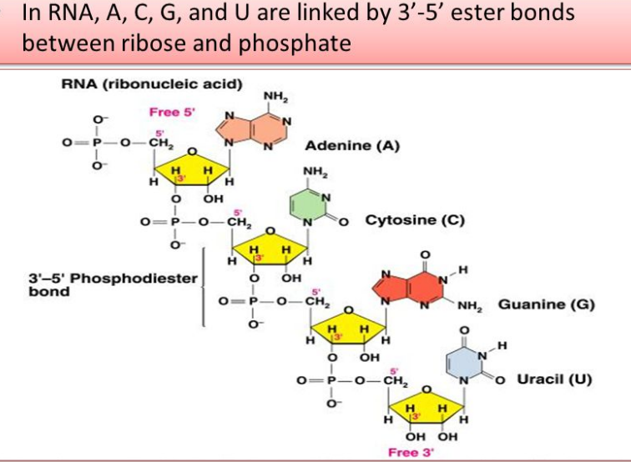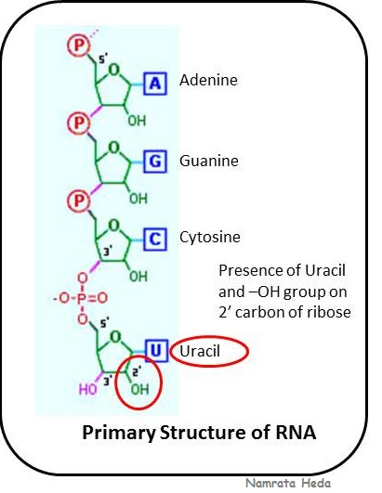
Source: namrataheda.blogspot.com.
The secondary structure: is a complex of two polynucleotide chains twisted around a common axis such that the carbohydrate(sugar) chains are outside and the phosphates and nucleic bases are directed inwards.
Secondary structure is the set of interactions between bases, i.e., which parts of strands are bound to each other. For DNA double helix, the two strands of DNA are held together by hydrogen bonds. The nucleotides on one strand base pairs with the nucleotide on the other strand. The secondary structure is responsible for the shape that the nucleic acid assumes.
Remember that:
- the bases in the DNA are classified as Purines and Pyrimidines.
- A purine base always pairs with a pyrimidine base (Guanosine (G) pairs with Cytosine(C) and Adenine(A) pairs with Thymine (T) or Uracil (U)).
DNA's secondary structure is predominantly determined by base-pairing of the two polynucleotide strands wrapped around each other to form a double helix. There is also a major groove and a minor groove on the double helix.
RNA secondary structures play a major role in gene expression and its regulation;
- base pairing between rRNA and mRNA controls the initiation of protein synthesis,
- base pairing between t RNA and m RNA facilitates translation.
James Watson and Francis Crick postulated the secondary structure of DNA in 1953 in their double helical model. They studied the x-ray diffraction pattern of DNA made by Rosalind Franklin and Maurice Wilkins and arrived at the double helical structure DNA.
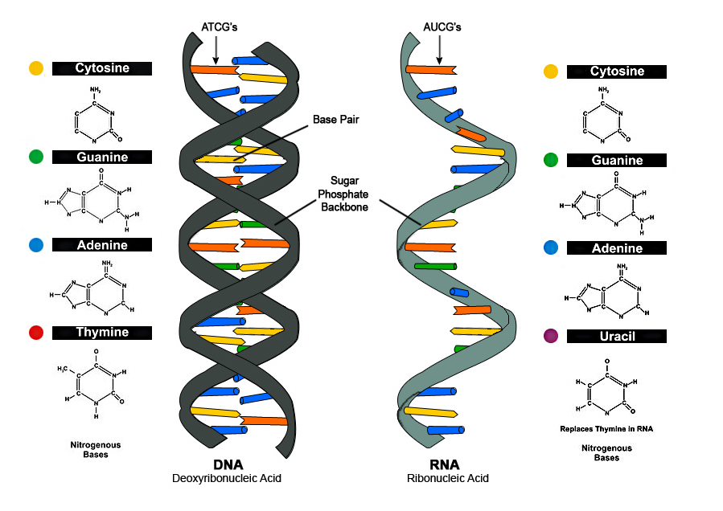
Fig.: Secondary structure of DNA and RNA. Source: https://www.slideshare.net
The following are the characteristics of double helix model of DNA
- DNA consists of two associated polynucleotide strands coiled around each other. – this forms the double helix structure.
- The two sugar-phosphate backbones are on the outside of the double helix, while the bases project into the interior. These bases in each strand stack on top of one another in parallel planes (first diagram on next slide).
- The orientation of the two strands is anti-parallel i.e. 1 strand runs 5’ to 3’ while the other runs 3’ to 5’ (they run in opposite directions)
- The genetic information resides on one of the two strands known as template strand or sense strand. The opposite strand is antisense strand.
- The strands are held by a regular base-pairing between the two strands. In other words, the 2 strands are held together by hydrogen bonds between the bases.
- A is paired with T through two hydrogen bonds; G is paired with C through three hydrogen bonds. The presence of thousands of such hydrogen bonds in a DNA molecule contributes greatly to the stability of the double helix. Hydrophobic and van-der Waals interactions between the stacked adjacent base pairs also contribute to the stability of the DNA structure.
- The base sequence along a polynucleotide chain is variable and a specific sequence of bases carries the genetic information
- The diameter of DNA is 20nm or 20 A. Adjacent bases are separated 0.34 nm or by 3.4 A along the axis. The length of a complete turn of helix is 3.4 nm or 34 A i.e. there are 10bp per turn. (B- DNA-Watson-Crick DNA)
- The DNA helix has a shallow groove called minor groove (-1,2nm) and a deep or wide groove called major groove (- 2.2nm) across.
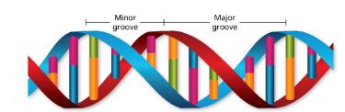
Source: https://hemantmore.org.
To maintain the geometry of the double-helical structure shown in diagram ‘a’, a larger purine (A or G) must pair with a smaller pyrimidine (C or T). In natural DNA, A almost always hydrogen bonds with T and G with C, forming A·T and G·C base pairs often called Watson-Crick base pairs.
Two polynucleotide strands can, in principle, form either a right-handed or a left-handed helix. Natural DNA is a right-handed helix.
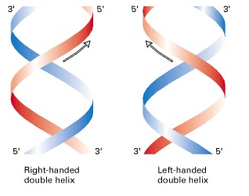
Source: http://web.uconn.edu.
Conformational Variation in the Double Helical Structure Change in conformation provides four different kind of DNA molecules namely:
- A –DNA,
- B-DNA
- C-DNA
- Z-DNA.
The structure discovered by Watson and Crick, referred to as B-DNA, represents the sodium salt of DNA. Under highly humid conditions, DNA can assume different conformations because deoxyribose is flexible and the C-N glycosidic linkage rotates.
A-DNA is formed when DNA becomes partially dehydrated. In A-DNA, the base pairs are no longer at right angles to the helical axis. Instead they lie 20 degrees away from the horizontal. In addition, the distance between adjacent base pairs is lightly reduced, with 11bp per helical turn instead of the 10.4bp found in B-form. Each turn of the double helix occurs in 2.5nm, instead of 3.4nm and the molecules’ diameter swells to approximately 2.6nm from the 2.4nm observed in B-DNA. The A form of DNA is observed when it is extracted with solvent such as ethanol.
The B-DNA is found in fibres of lithium DNA at 66% relative humidity. This also is a right-handed helix. This structure occurs in chromatin and some viruses. The number of residues present per helical turn is 9.3bps. The distance between two base pairs is 0.4nm.
Z-DNA is named for its zigzag conformation, the bases stack in a left handed staggered dimeric pattern, which gives the zigzag appearance and its flattened, non-grooved surface. Considerably slimmer than B-DNA (diameter=1.8nm). Twisted into a left-handed spiral with 12bps per turn. Each turn of Z-DNA occurs in 4.5nm. DNA segments with alternating purine and pyrimidine bases are most likely to adopt a Z configuration.
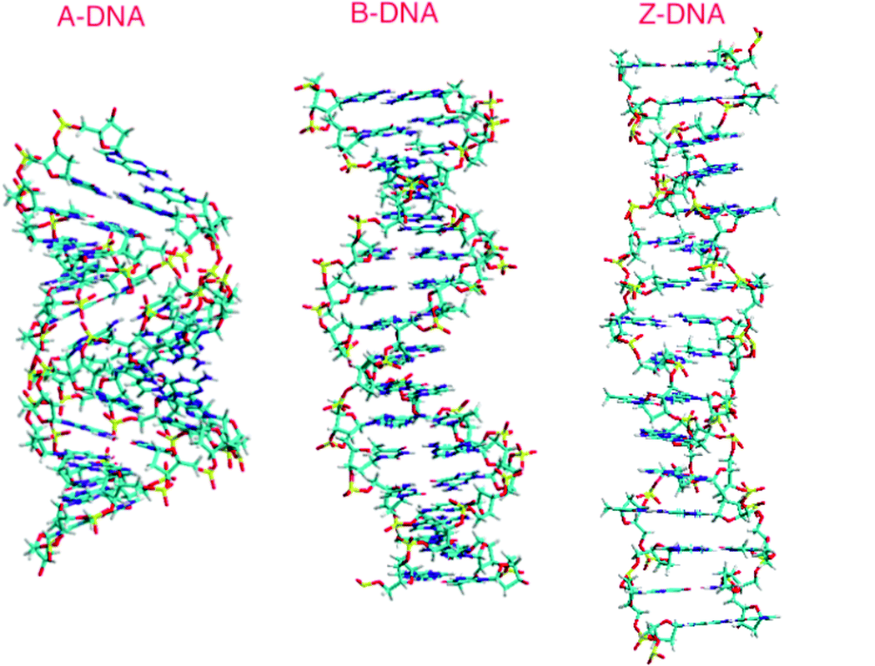
Source: https://www.researchgate.net
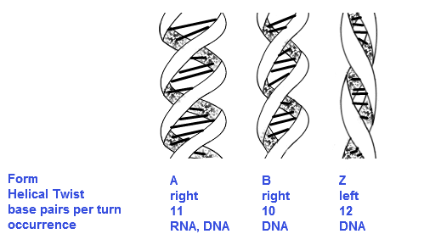
Source: https://www.slideshare.net
11.5 FUNCTIONS OF NUCLEOTIDES
In addition to their roles as the subunits of nucleic acids, nucleotides perform some other functions. These are enumerated below:
As carriers of chemical energy. Nucleotides may have one, two or three phosphate groups covalently linked at 5′-OH of ribose. These are referred to as nucleoside mono-, di- and triphos-phates and abbreviated as NMPs, NDPs and NTPs, respectively. Adenosine triphosphate (ATP) is the most widely used.
As components of enzyme factors. Many enzyme cofactors and coenzymes (such as coenzyme A, NAD+ and FAD) contain adenosine as part of their structure.
As chemical messengers. The cells respond to their environment by taking cues from hormones or other chemical signals in the surrounding medium. The interaction of these chemical signals (first messengers) with receptors on the cell surface often leads to the formation of second messengers inside the cell, which in turn leads to adaptive changes inside the cell.
Often, the second messenger is a nucleotide. One of the most common second messengers is the nucleotide adenosine 3′, 5′- cyclic monophosphate (cyclic AMP or cAMP).
11.5 DIFFERENCES BETWEEN DNA AND RNA
DNA | RNA
1. Found mainly in the chromatin of the cell nucleus | Most of RNA (90%) is present in the cell cytoplasm and a little (10%) in the nucleolus.
2. Base pairing is inevitable during which adenine pairs with thymine and guanine with cytosine. | In case pairing takes place, adenine pairs with uracil and guanine with cytosine
3. DNA is the usual genetic material. | RNA is the genetic material of some viruses only.
4. DNA is alkali-stable. | RNA is alkali-labile
5. Never present in free state in cytoplasm | May be present in free state.
6. Normally double-stranded and rarely single stranded. | Normally single-stranded and rarely double stranded.
7. DNA has both ‘sense’ and ‘antisense’ strands. | The sequence of an RNA molecule is the same as that of the ‘antisense’ strand.
8. Sugar moiety in DNA is 2′-deoxyribose (hence the nomenclature) which contains an H atom at C-2. | Sugar moiety in RNA is ribose (hence the nomenclature) which contains a 2′-hydroxyl group.

11.6 HYDROLYSIS OF NUCLEIC ACIDS
DNA Acid Hydrolysis | RNA Acid Hydrolysis
At pH greater than 3, depurination only occurs.  As pH reduces (greater than 2), complete hydrolysis and cleavage of phosphodiester bonds into its components occur. | More resistant to acid hydrolysis. Its hydrolysis is based on the duration of treatment.  Significant hydrolysis occurs by treating it with 1N HCl or stronger at 100ºC for 1 hr.  Treatment with 1N HCl at 60 degrees celcius for 10 mins will not hydrolyze but only depurinate it.  RNA hydrolysis is more resistant and requires extreme conditions.
DNA Alkali Hydrolysis | RNA Alkali Hydrolysis
Not hydrolysed under alkaline conditions because it lacks 2’-OH for base catalysed hydrolysis mechanism.  Though, at high pH, there is increase in concentration of hydroxyl ions which attracts the hydrogen in DNA towards it, making it to be deprotonated.  The higher the pH (greater than 10), the more extensive the de-protonation, leading to denaturation of the double stranded DNA.  This method of alkali hydrolysis is used to isolate plasmid DNA from bacterial cells | Easily hydrolysed because it contains 2’-OH. Thus, there is cleavage of phosphodiester bonds.  On hydrolysis, it gives 2’-3’ cyclic monophosphate derivatives which on further hydrolysis gives 2’ and 3’ monophosphate derivatives.

Post-Test
- Give 3 differences between the various conformations of DNA
- Give a brief explanation of Nucleic acids composition.
- Differentiate between RNA and DNA acid hydrolysis
Bibliography
- Robert K. Murray et al. Harper’s Illustrated Biochemistry.
- Lehninger Principle of Biochemistry 5th Ed.
- Voet D., Voet J.G. and Pratt C. Fundamentals of Biochemistry 5th Ed. John Wiley &Sons, 2016.

