

MOUNTAIN TOP UNIVERSITY
Kilometre 12, Lagos-Ibadan Expressway, MFM Prayer City, Ogun State.
PHONE: (+234)8053457707, (+234)7039395024, (+234) 8039505596
EMAIL: support@mtu.edu.ng
Website: www.mtu.edu.ng.

Published By:
Mountain Top University

COURSE GUIDE
COURSE TITLE: BIOCHEMISTRY OF NUCLEIC ACIDS
COURSE CODE: BCH 305
LECTURER: AYORINDE J (PhD), ADEFISAN I.O

COURSE OBJECTIVES
The Course is aimed at examining the structure, organization and functions of nucleic acids in details with focus on nucleic acid metabolism. Students already have a background Knowledge from General Biochemistry. Students will also be able to understand protein biosynthesis and some abnormalities associated with nucleic acid metabolism.

COURSE CONTENT
LECTURE 1: Introduction and Course Overview: Review of purine and pyrimidine bases; Nucleosides and Nucleotides; Structure and Function of Nucleic Acids.
LECTURE 2: Metabolism of Purine and Pyrimidine
LECTURE 3: Genetic Code and Protein biosynthesis
LECTURE 4: DNA Organization, replication and Repair
LECTURE 5: Abnormalities of Nucleic Acid Metabolism
LECTURE 6: RNA Synthesis, processing and Modification

LECTURE 1
- Introduction and Course Overview: Review of purine and pyrimidine bases; Nucleosides and Nucleotides; Structure and Function of Nucleic Acids.
Objectives of the Lecture
At the end of the lecture, the students should be able to:
Define Nucleic Acids
Highlight the components of Nucleic Acids
Explain the structure and Function of Nucleic Acids
Pre-Test
List the four major bio-molecules.
What are the components of Nucleic Acids?
Content
  - Nucleic acids
Nucleic acids are biopolymers of high molecular weight with mononucleotides as their repeating units i.e. they are linear polymers made of monomers called NUCLEOTIDES held by 3’ and 5’ phosphate bridges. These are of two types:
• Deoxyribonucleic acid (DNA)
• Ribonucleic acid (RNA)
  - Functions of nucleic acids
DNA is the chemical basis of heredity. It serves as reserve bank (store) of genetic information. Responsible for maintaining the identity of different species of organisms over millions of years.
Cellular function is under the control of DNA. DNA directs the synthesis of RNA, which in turn directs protein synthesis
RNA on the other hand transcribes the genetic information into a form that is easy to understand and read by the cell and assists in protein synthesis.
  - Components of Nucleic Acids
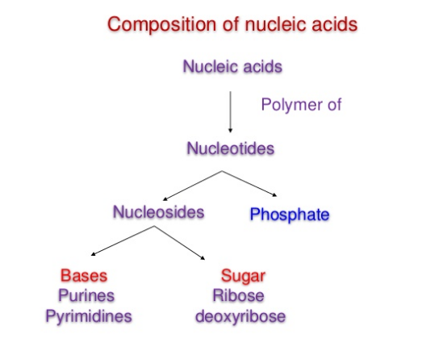
Source: https://www.slideshare.net/YESANNA/nucleic-acid-chemistry-40334502

Nucleotides are energy-rich compounds that drive metabolic processes (esp., biosynthetic) in all cells. They are phosphate esters of nucleosides
i.e. Nucleotide= Nucleoside + phosphate
Nucleotides are composed of nitrogenous bases(which could either be a purine or pyrimidine base), pentose sugar and phosphate group.
Nucleosides are composed of nitrogenous bases and sugar. The Nitrogenous bases are of 2 types: Purine bases and Pyrimidine bases
The pentose sugar is : ribose in ribo-nucleosides (for RNA)or 2- deoxyribose in deoxy-ribonucleosides(for DNA)
Nucleosides containing purine bases are called Purine nucleosides(end with the suffix-sine)
Nucleosides containing pyrimidine bases are called Pyrimidine nucleosides (end with the suffix-dine)
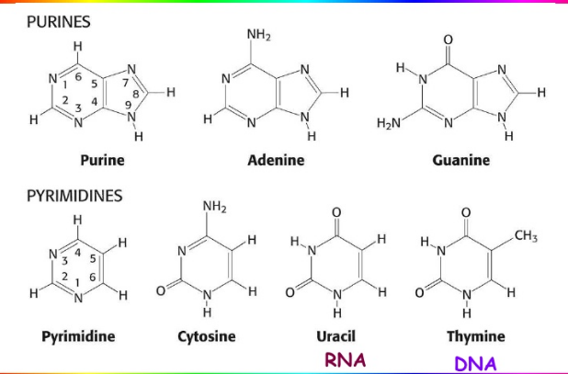
Structure of Purine and Pyrimidine Bases
Source: http://pratclif.com/biologie-moleculaire/dna/bases.htm
Post Test
- Explain the functions of Nucleic Acids
- Differentiate between Nucleosides and Nucleotides
Bibliography
www.cuchd.in/e-library/.../Fundamentals%20of%20Biochemistry/Chap-15.pdf
https://www.slideshare.net/YESANNA/nucleic-acid-chemistry-40334502
http://pratclif.com/biologie-moleculaire/dna/bases.htm

LECTURE 2
Metabolism of Purine and Pyrimidine Nucleotides
Synthesis of Purine and Pyrimidine Nucleotides
- Introduction
Nucleic acid metabolism is concerned with the synthesis and breakdown of purine and pyrimidine nucleotides, their utilisation in DNA and RNA synthesis and the structure, localisation and function of these nucleic acids.
Purine and Pyrimidine nucleotides occupy a central position in cellular metabolism. These nucleotides are constituents of the genetic material, participate as cofactors in enzymatic reactions, serve as intracellular and extracellular signals, function as phosphate donors and are the major carriers of cellular energy. Thus they are critical for virtually every aspect of cellular life; however, they are expensive to synthesize and imbalances between the different nucleotide pools can perturb the normal functioning of the cell, hence the need for regulation.

Objectives of the Lecture
At the end of the lecture, students should be able to:
Differentiate between the de-novo and salvage pathways for purine synthesis
Explain the degradation of pyrimidine nucleotides
Pre-Test
What is Metabolism?
How are Purine Nucleotides synthesized?
Content
  - Synthesis of Purine Nucleotides
This can be explained in two different pathways
- De-Novo Pathway
- Salvage Pathway (also called Dust-bin Pathway)
    - De Novo Purine Synthesis: In this De novo synthesis of purines, each atom in the purine nucleotide comes from different sources. There are 3 major steps are involved in this Purine synthesis pathway.
- Ribose-5-Phosphate to IMP synthesis
- Synthesis of AMP from IMP
- Synthesis of GMP from IMP

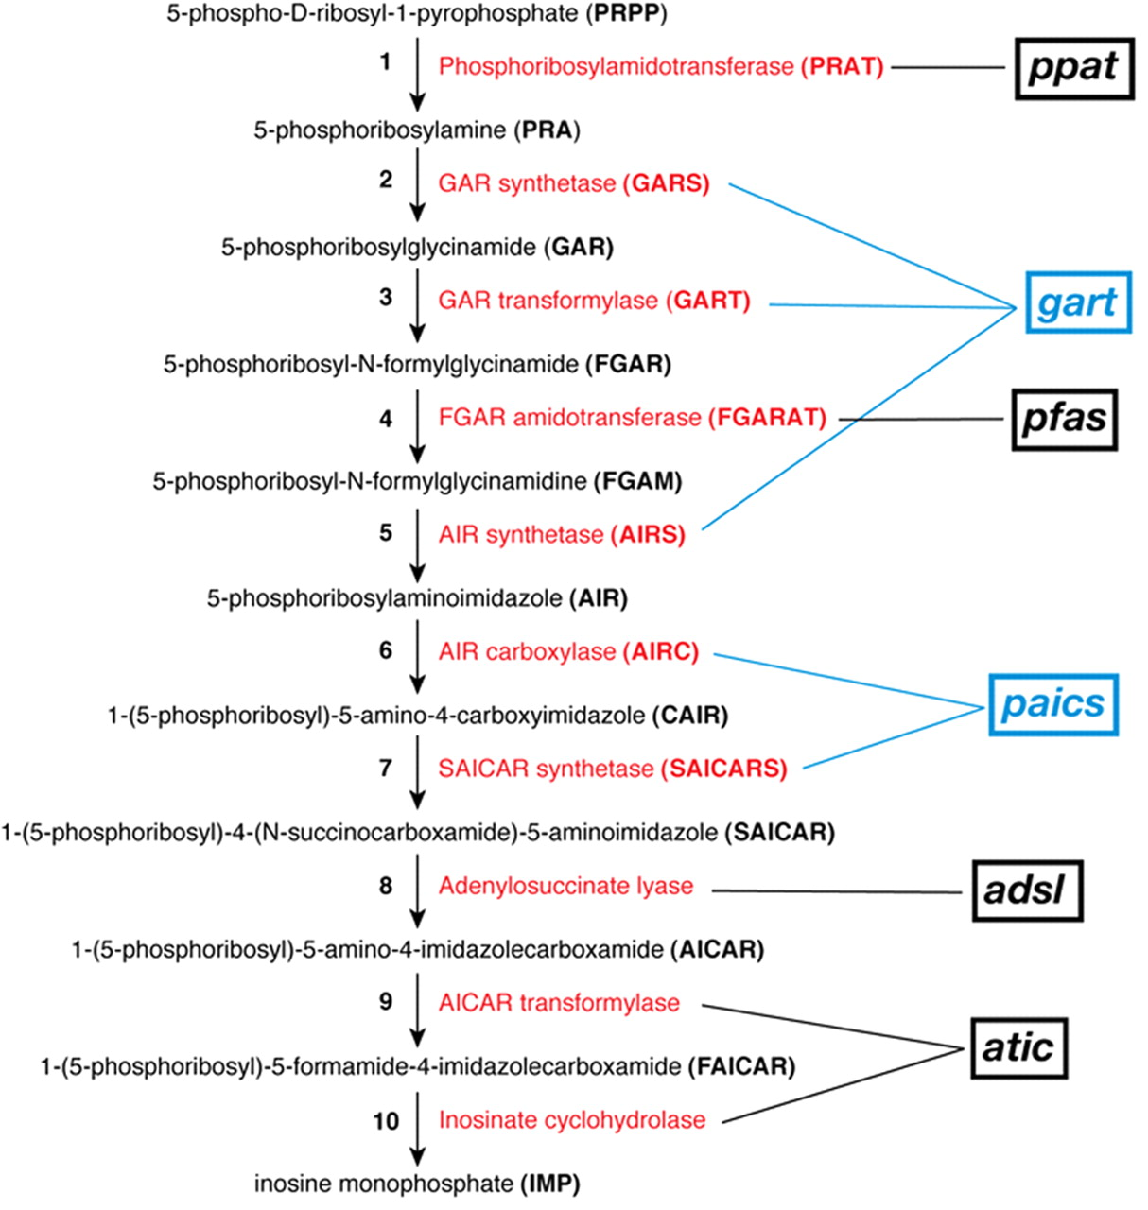
De-novo Pathway for Purine Synthesis
Source: http://ecparker.info/370-de-novo.php
2.1.1a. Synthesis of AMP from IMP
IMP is the central intermediate of both AMP and UMP.
- Step 1: The IMP is converted into adenylosuccinate by taking Aspartate and GTP, this reaction is catalyzed by Adenylo Succinate synthatase.
- Step 2: Adenylo Succinate is converted into AMP by releasing Aspartate in the form of Fumarate(catalyzed by Adenylo Succinate Lyase).
2.1.1b. Synthesis of GMP from IMP:
- Step 1: IMP is converted into Xanthosine Monophosphate in the presence of the enzyme IMP-dehydrogenase. This is the dehydrogenation.
- Step 2: XMP is converted into GMP by the enzyme GMP synthase.(amino group donor is Glutamate).
    - Salvage Pathway for purine synthesis
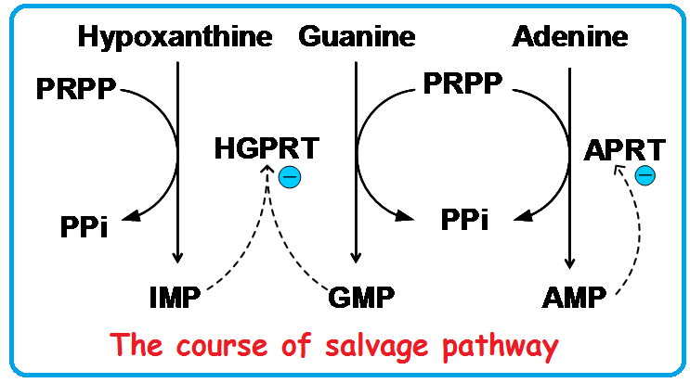
Source: http://slideplayer.com/slide/8003219/
- APRT (Adenosyl Phospho ribosyl Transferase): This enzyme catalyzes in the reaction of Adenine to AMP conversion. In this reaction the secondary substrate is PRPP and by product is PPi.
Adenine + PRPP ↔ AMP + PPi
- HGPRT(Hypoxanthine-Guanine Phospho Ribosyl Transferase): This enzyme catalyzes the reaction of GMP formation from Hypoxanthine and PRPP.
Hypoxanthine + PRPP ↔ IMP + PPi
Guanine + PRPP ↔ GMP + PPi
2.1.2a. Importance of the Salvage Pathway
- It saves fuel
- Some tissues and organs like the brain and bone marrow can only synthesize nucleotides by this pathway.
- Two enzymes are involved in this pathway.
  - Synthesis of Pyrimidine Nucleotides
The pyrimidine synthesis is a similar process than that of Purines. In the de novo synthesis of Pyrimidines, the ring is synthesized first and then it is attached to a ribose-phosphate to for a pyrimidine nucleotide. Pyrimidine rings are assembled from bicarbonate, aspartate and Ammonia.
    - Steps of Pyrimidine Synthesis: The De novo pyrimidine synthesis pathway can be explained by the following steps.
- Synthesis of Carbamoyl Phosphate
- Synthesis of Carbamoyl Aspartate
- Ring Closure to form dihydro orotate
- Oxidation of Dihydro Orotate
- Addition of ribose Phosphate moiety
- De Carboxylation to form UMP
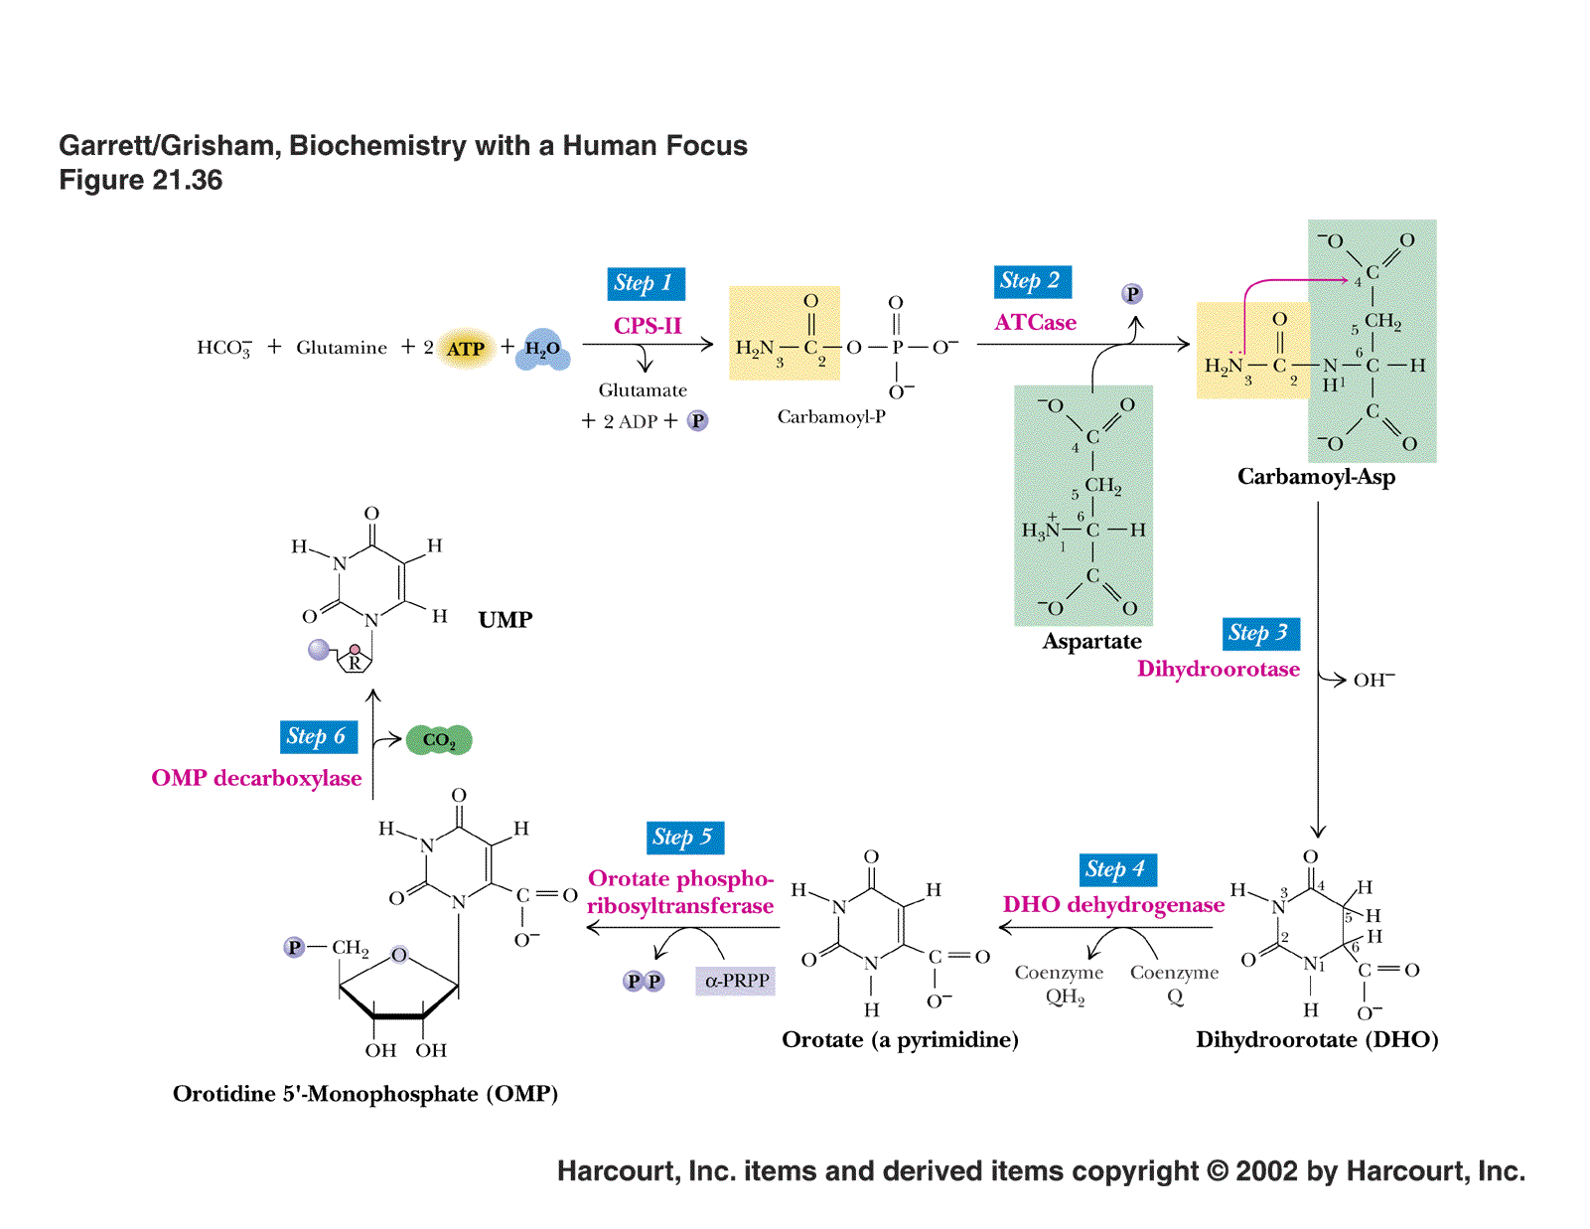 Pathway for pyrimidine Synthesis
Source:http://www.columbia.edu/cu/biology/courses/w3034/Larry/readings/PurineChapter/PurineChapter.html
Degradation of Purine and Pyrimidine Nucleotides
  - PURINE CATABOLISM
The major pathways of Purine catabolism pathway and deoxynucleotide catabolism in animals is explained in 3 stages.
- Dephosphorylation
- Deamination
- Glycosidic bond cleavages
Step 1: Dephosphorylation: The purine molecules AMP, IMP, XMP and GMP are dephosphorylated into their corresponding nucleotides such as Adenosine, Inosine, Xanthosine, Guanosine. This reaction is catalysed by the enzyme “Nucleotidase”
Step 2: De-amination: The AMP (Nucleotide) and Adenosine (Nucleoside) is de-aminated into IMP and Inosine. This reaction is catalyzed by AMP deaminase and Adenosine deaminase. Guanine (nitrogenous base only) is deaminated into Xanthosine in the presence of the “Guanosine deaminase”.
Step 3: Glycosidic bond cleavage: The nucleosides: Inosine, Xanthosine, Guanosine is converted into Hypoxanthine, Xanthine and Guanine. This reaction is catalyzed by “Purine nucleotide phosphorylase”.
In humans and other primates, uric acid is the end product of purine catabolism and is excreted in the urine but in many other vertebrates it is further degraded to Allantoin by the action of Urate Oxidase. Birds, terrestrial reptiles, and many insects also excrete uric acid, but, in these organisms, uric acid represents the major nitrogen excretory compound, because, unlike mammals, they do not also produce urea.
This route of nitrogen catabolism allows these animals to conserve water by excreting crystals of uric acid in paste-like solid form. In bony fishes (teleosts), uric acid degradation proceeds through yet another step wherein allantoin is hydrolyzed to allantoic acid by allantoinase before excretion. Cartilaginous fish (sharks and rays) as well as amphibians further degrade allantoic acid via the enzyme, allantoicase, to liberate glyoxylic acid and two equivalents of urea.
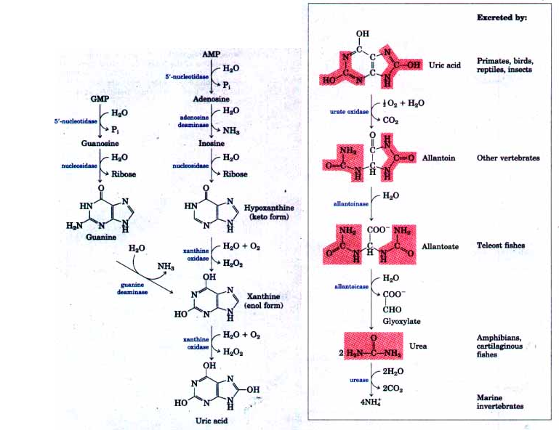
Source: http://www.bioinfo.org.cn/book/biochemistry/chapt21/bio8.htm
  - PYRIMIDINE CATABOLISM
Animal cells degrade pyrimidine nucleotides to their component bases. These reactions, like those of purine nucleotides, occur through Dephosphorylation, Deamination and Glycosidic bond cleavages. After Pyrimidine biosynthesis, the newly synthesized molecules undergoes degradation after certain period.

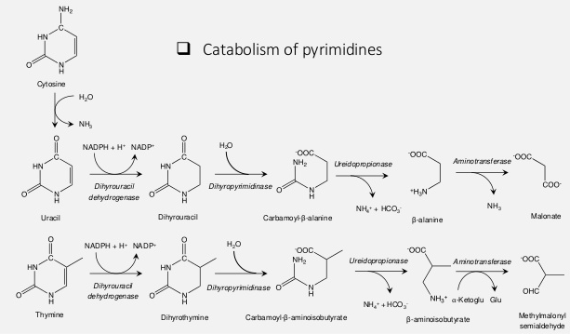
Source: https://www.slideshare.net/sharmapank30/nucleotide-metabolism-70248698

2.5. REGULATION OF PURINE AND PYRIMIDINE METABOLISM
2.5.1. Regulation of purine Synthesis
The essential rate limiting steps in purine biosynthesis occur at the first two steps of the pathway. The synthesis of PRPP by PRPP synthetase is feed-back inhibited by purine-5'-nucleotides (predominantly AMP and GMP).
Combined effects of those two nucleotides are greatest, e.g., inhibition is maximal when the correct concentration of both adenine and guanine nucleotides is achieved. The amido-transferase reaction catalyzed by PRPP amido-transferase is also feed-back inhibited allosterically by binding ATP, ADP and AMP at one inhibitory site and GTP, GDP and GMP at another. Conversely the activity of the enzyme is stimulated by PRPP.
Additionally, purine biosynthesis is regulated in the branch pathways from IMP to AMP and GMP. The accumulation of excess ATP leads to accelerated synthesis of GMP, and excess GTP leads to accelerated synthesis of AMP.

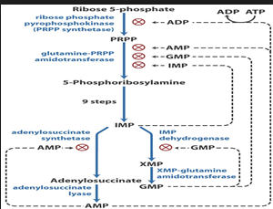
Regulation of purine synthesis
Source: https://www.studyblue.com/notes/note/n/nucleotide-metabolism/deck/1303232

2.5.2. Regulation of pyrimidine Synthesis
The regulation of pyrimidine synthesis occurs mainly at the first step. The ATCase activity of the enzyme is inhibited by CTP and activated by ATP. The carbamoyl synthetase activity of this complex is termed carbamoyl phosphate synthetase II (CPS-II), as opposed to CPS-I which is involved in the urea cycle. The CPS-II domain is activated by ATP and inhibited by UDP, UTP, dUTP, and CTP. ATP levels also regulate pyrimidine nucleotide biosynthesis at the level of PRPP formation. An increase in the level of PRPP results in an activation of pyrimidine synthesis.
There is also regulation of OMP decarboxylase activity of the bi-functional OMP synthase enzyme. The decarboxylase activity domain is competitively inhibited by UMP and, to a lesser degree, by CMP. Finally, CTP synthase is feedback-inhibited by CTP and activated by GTP.

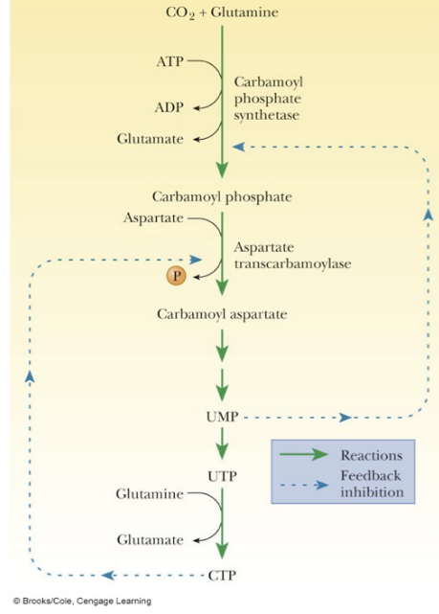
Regulation of pyrimidine synthesis
Source: http://oregonstate.edu/instruct/bb350/textmaterials/ch23.html

  - Inter-conversion of the Nucleotides
This is a fast reversible reaction driven by ATP. During the catabolism of nucleic acids, nucleoside mono- and di-phosphates are released. Nucleoside mono (NMP), di (NDP), and tri (NTP)-phosphate interconvert by trading phosphate groups.
These inter-conversions produce the activated NTPs and dNTPs which are substrates for nucleic acid synthesis. Some inter-conversions require ATP, some just exchange high energy phosphates.
Post-Test
Explain feedback Inhibition
Describe the regulation of nucleic acid metabolism
Highlight the steps involved in pyrimidine synthesis
Give the fate of the end product of purine degradation in various animals
Bibliography
- https://en.wikipedia.org/wiki/Nucleic_acid_metabolism
- Source:http://www.columbia.edu/cu/biology/courses/w3034/Larry/readings/PurineChapter/PurineChapter.html
- https://en.wikipedia.org/wiki/Nucleic_acid_metabolism
- intranet.tdmu.edu.na
- www.bioinfo.org.cn
- https://themedicalbiochemistrypage.org/nucleotide-metabolism.php
- http://oregonstate.edu/instruct/bb350/textmaterials/ch23.html
- https://www.slideshare.net/sharmapank30/nucleotide-metabolism-70248698
- http://www.bioinfo.org.cn/book/biochemistry/chapt21/bio8.htm

LECTURE 3
Genetic Code and Protein biosynthesis
- Introduction
The genetic code is the set of rules used by living cells to translate information encoded within genetic material (DNA or mRNA sequences) into proteins.
Objectives
At the end of this lecture, the students should be able to:
Define Genetic Code
Explain protein synthesis
Pre-test
What do you understand by the term-gene expression?
What are Codons?
Content
Genetic code refers to a nucleotide base sequence on DNA which will be translated into a sequence of amino acids of the protein to be synthesized, this process is termed gene expression. i.e letters of nucleic acids(nucleotide language) being translated into amino acid language. The genetic code is a set of three-letter combinations of nucleotides called codons, each of which corresponds to a specific amino acid or stop signal. Codons: made of 3 bases e.g. ACG or UAG
One codon, AUG serves two related functions:
  - it signals the start of translation
  - it codes for the incorporation of the amino acid methionine (Met) into the growing polypeptide chain
The genetic code can be expressed as either RNA codons or DNA codons. RNA codons occur in messenger RNA (mRNA) and are the codons that are actually "read" during the synthesis of polypeptides (the process called translation).
The genetic code is highly similar among all organisms and can be expressed in a simple table with 64 entries. i.e. there are 64 possible permutations, or combinations, of three-letter nucleotide sequences that can be made from the four nucleotides.
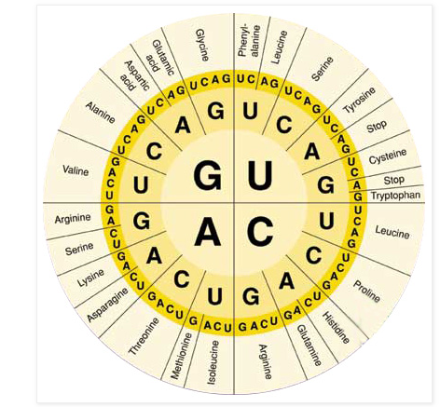
Genetic Code
Source: http://lifeofplant.blogspot.com.ng/2011/04/genetic-code.html

Of these 64 codons, 61 represent amino acids, and three are stop signals. Although each codon is specific for only one amino acid (or one stop signal), the genetic code is described as degenerate, or redundant, because a single amino acid may be coded for by more than one codon.
Translation starts with a chain-initiation codon or start codon. The most common start codon is AUG, which is read as methionine or, in bacteria, as formylmethionine. The AUG codon, in addition to coding for methionine, is found at the beginning of every mRNA and indicates the start of a protein. Most of the 20 amino acids are coded for by more than one codon, thus, the code is called degenerate.
Alternative start codons depending on the organism include "GUG" or "UUG"; these codons normally represent valine and leucine, respectively, but as start codons they are translated as methionine or formylmethionine.
The three stop codons have names: UAG, UGA , and UAA. Stop codons are also called "termination" or "nonsense" codons. They signal release of the nascent polypeptide from the ribosome because no tRNA has anticodons complementary to these stop signals, allowing a release factor to bind to the ribosome instead. (ending the translation process)
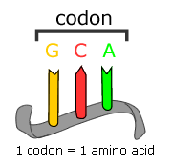
source:http://www.science20.com/curious_cub/evolutionary_transitions_and_codon_bias-82951

  - Protein synthesis
Protein synthesis is one of the most fundamental biological processes by which individual cells build their specific proteins
3.1.1. Steps in Protein Synthesis:
The first step in protein synthesis is the transcription of mRNA from a DNA gene in the nucleus. The various other types of RNA have been synthesized using the appropriate DNA. The RNAs migrate from the nucleus into the cytoplasm. Note that all of the component parts are assembled in the ribosome before protein synthesis starts.
In the cytoplasm, protein synthesis is actually initiated by the AUG codon on mRNA. The AUG codon signals both the interaction of the ribosome with m-RNA and also the tRNA with the anticodons (UAC). The tRNA which initiates the protein synthesis has N-formyl-methionine attached.
The next step is for a second tRNA to approach the mRNA (codon - CCG). This is the code for proline. The anticodon of the proline tRNA which reads this is GGC. The final process is to start growing peptide chain by having amine of proline to bond to the carboxyl acid group of methinone (met) in order to elongate the peptide. Elongation of the peptide begins as various tRNA's read the next codon. When the stop signal on mRNA is reached, the protein synthesis is terminated. The last amino acid is hydrolyzed from its t-RNA.
The peptide chain leaves the ribosome. The N-formyl-methionine that was used to initiate the protein synthesis is also hydrolyzed from the completed peptide at this time. The ribosome is now ready to repeat the synthesis several more times.
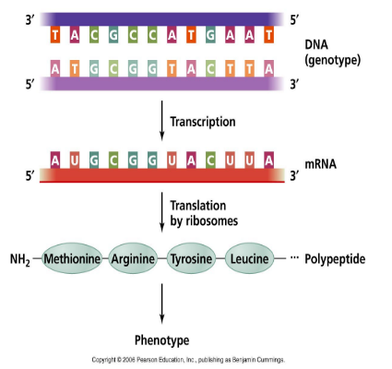Protein synthesis
Source: http://academic.pgcc.edu/~kroberts/Lecture/Chapter%207/dogma.html

Post Test
Explain the term-Genetic Code
Explain the steps involved in Protein Synthesis

Bibliography
http://academic.pgcc.edu/~kroberts/Lecture/Chapter%207/dogma.html
http://www.science20.com/curious_cub/evolutionary_transitions_and_codon_bias-82951
http://lifeofplant.blogspot.com.ng/2011/04/genetic-code.html

LECTURE 4
DNA Organisation, Replication and Repair
- Introduction
DNA is the molecule that holds the instructions for growth and development in every living thing. Its structure is described as a double-stranded helix held together by complementary base pairs. All cells store their genetic information in the base sequence of DNA. The genotype is determined by the sequence of bases.
Replication is the biological process of producing two identical replicas of DNA from one original DNA molecule. This process occurs in all living organisms and is the basis for biological inheritance. The cell possesses the distinctive property of division, which makes replication of DNA essential.

Objectives
At the end of the lecture, the students should be able to
Describe DNA Organisation
Explain DNA Replication Process
Pre-Test
List the two major types of nucleic acids, giving their functions
What do you understand by the term-Replication
Content
DNA is present in the cells of every living thing. However, the DNA is organised differently in different types of organism. At the molecular level, there are 4 nucleotide bases: adenine, guanine, cytosine, and thymine, which are all linked to a ribose sugar and phosphate backbone. These nucleotides are joined in various sequences that are highly important for determining the genetic information that they encode. These strings of double-stranded nucleotides form what we call DNA in most organisms
If left unpackaged, the amount of DNA in a eukaryotic organism would not fit into a eukaryotic cell.Therefore, higher levels of organization are necessary, such as: the wrapping of DNA around histone proteins, forming a nucleosome core. These nucleosomes are further wrapped around each other to condense into what we call a chromatin fiber. The chromatin fiber condenses into what we identify as a chromosome in eukaryotic cells.
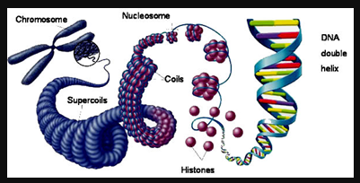
Prokaryotic cells lack the levels of organization that eukaryotes do. They do not have a nucleus, so their DNA, RNA, and ribosomes can all easily interact. Their chromosomes are also not tightly packaged because prokaryotes lack histones, and they typically have extra-chromosomal plasmids that can integrate into the chromosome or can be removed.
Bacteria are prokaryotes. They do not have a membrane-bound nucleus and their DNA is free in the cytoplasm. Bacteria have a single circular chromosome in the centre of the cell that holds all the genes needed for that bacterium. Bacteria also have extra circles of DNA called plasmids.
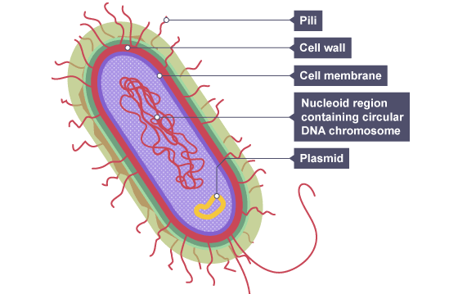
Eukaryotes
Animals, plants and fungi are eukaryotes. They have a membrane-bound nucleus and their chromosomes are linear rather than circular.The DNA found in the linear chromosomes is tightly coiled and packaged around special proteins as shown below.
Interestingly, circular chromosomes are also found in mitochondria and chloroplasts.They both use their own DNA to make some proteins needed for their function. This gives evidence for the theory that mitochondria and chloroplasts originated from prokaryotic cells that were engulfed by a larger cell.
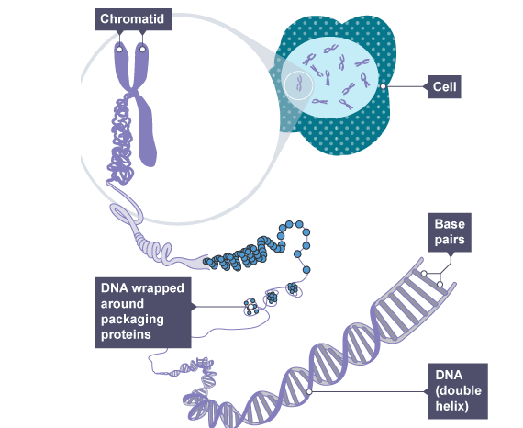

4.1 .DNA Replication
DNA is made up of a double helix of two complementary strands. During replication, these strands are separated with each strand of the original DNA molecule serving as a template for the production of its counterpart, a process referred to as semi-conservative replication.
In a cell, DNA replication begins at specific locations, or origins of replication, in the genome.
DNA replication can also be performed in vitro (artificially, outside a cell). DNA polymerases isolated from cells and artificial DNA primers can be used to initiate DNA synthesis at known sequences in a template DNA molecule. The polymerase chain reaction(PCR), a common laboratory technique, cyclically applies such artificial synthesis to amplify a specific target DNA fragment from a pool of DNA
Cells need to copy their DNA very quickly, and with very few errors (or risk problem such as cancer). To ensure this, different enzymes and proteins work together to make sure the replication process is performed smoothly and accurately.
4.1.1.DNA polymerase
One of the key molecules in DNA replication is the enzyme DNA polymerase. DNA polymerases are responsible for synthesizing DNA: they add nucleotides one by one to the growing DNA chain, incorporating only those that are complementary to the template.
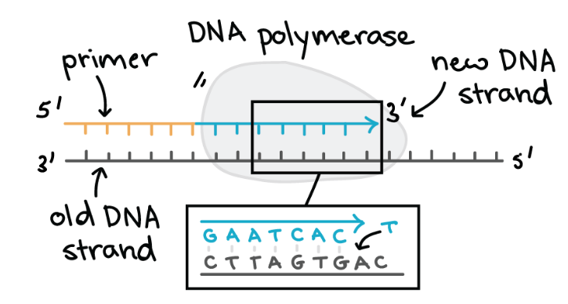
Some key features of DNA polymerases include:
- They always need a template
- They can only add nucleotides to the 3' end of a DNA strand
- They can't start making a DNA chain from scratch, but require a pre-existing chain or short stretch of nucleotides called a primer.
- They proofread, or check their work, removing the vast majority of "wrong" nucleotides that are accidentally added to the chain

The addition of nucleotides requires energy. This energy comes from the nucleotides themselves, which have three phosphates attached to them (much like the energy-carrying molecule ATP). When the bond between phosphates is broken, the energy released is used to form a bond between the incoming nucleotide and the growing chain.

4.2. REPLICATION PROCESS
Replication always starts at specific locations on the DNA, which are called origins of replication and are recognized by their sequence.E. coli, like most bacteria, has a single origin of replication on its chromosome. The origin is about 245,245,245 base pairs long with mostly A/T base pairs (which are held together by fewer hydrogen bonds than G/C base pairs), making the DNA strands easier to separate.Specialized proteins recognize the origin, bind to this site, and open up the DNA. As the DNA opens, two Y-shaped structures called replication forks are formed, together making up what's called a replication bubble. The replication forks will move in opposite directions as replication proceeds.

4.2.1. Helicase is the first replication enzyme to load on at the origin of replication. It functions to move the replication forks forward by "unwinding" the DNA (breaking the hydrogen bonds between the nitrogenous base pairs). Proteins called single-strand binding proteins coat the separated strands of DNA near the replication fork, keeping them from coming back together into a double helix.
4.2.2. Primers and primase :DNA polymerases can only add nucleotides to the 3' end of an existing DNA strand. (They use the free -OH group found at the 3' end as a "hook," adding a nucleotide to this group in the polymerization reaction.)
Addition of the first nucleotide at a new replication fork is made possible by the enzyme called primase. Primase makes an RNA primer,(short stretch of nucleic acid complementary to the template, that provides a 3' end for DNA polymerase to work on).A typical primer is about five to ten nucleotides long. The primer primes DNA synthesis, i.e., gets it started.
Once the RNA primer is in place, DNA polymerase "extends" it, adding nucleotides one by one to make a new DNA strand that's complementary to the template strand.
Leading and lagging strands
In E. coli,(prokaryotes) the DNA polymerase that handles most of the synthesis is DNA polymerase III. There are two molecules of DNA polymerase III at a replication fork, each of them hard at work on one of the two new DNA strands.
Note that these strands are antiparallel i.e. one strand runs in the 5' to 3' direction, while the other runs in the 3' to 5' direction. One new strand, which runs 5' to 3' towards the replication fork, is the easy one. This strand is made continuously, because the DNA polymerase is moving in the same direction as the replication fork.
This continuously synthesized strand is called the leading strand. The other new strand, which runs 5' to 3' away from the fork, is trickier. This strand is made in fragments because, as the fork moves forward, the DNA polymerase (which is moving away from the fork) must come off and reattach on the newly exposed DNA. This tricky strand, which is made in fragments, is called the lagging strand. The small fragments are called Okazaki fragments, named for the Japanese scientist who discovered them.
The maintenance and cleanup crew
Some other proteins and enzymes, in addition the main ones above, are needed to keep DNA replication running smoothly.
4.2.3.Topoisomerase also plays an important maintenance role during DNA replication. This enzyme prevents the DNA double helix ahead of the replication fork from getting too tightly wound as the DNA is opened up. It acts by making temporary nicks in the helix to release the tension, then sealing the nicks to avoid permanent damage.
4.2.4. Finally, there is a little cleanup work to do if we want DNA that doesn't contain any RNA or gaps. The RNA primers are removed and replaced by DNA through the activity of DNA polymerase I, the other polymerase involved in replication. The nicks that remain after the primers are replaced get sealed by the enzyme DNA ligase.

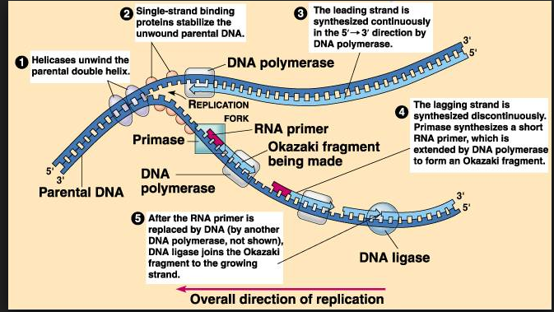

4.3. Summary of DNA replication in E. coli
- Helicase opens up the DNA at the replication fork.
- Single-strand binding proteins coat the DNA around the replication fork to prevent rewinding of the DNA.
- Topoisomerase works at the region ahead of the replication fork to prevent supercoiling.
- Primase synthesizes RNA primers complementary to the DNA strand.
- DNA polymerase III extends the primers, adding on to the 3' end, to make the bulk of the new DNA.
- RNA primers are removed and replaced with DNA by DNA polymerase I.
- The gaps between DNA fragments are sealed by DNA ligase.
4.4. DNA replication in eukaryotes
The basics of DNA replication are similar between bacteria and eukaryotes such as humans, but there are also some differences:
- Eukaryotes usually have multiple linear chromosomes, each with multiple origins of replication. Humans can have up to 100,100,100,000000000 origins of replication
- Most of the E. coli enzymes have counterparts in eukaryotic DNA replication, but a single enzyme in E. coli may be represented by multiple enzymes in eukaryotes. For instance, there are five human DNA polymerases with important roles in replication.

4.5. DNA Damage
DNA is, however, supercoiled and wound around "packaging" proteins called histones (in eukaryotes), and both superstructures are vulnerable to the effects of DNA damage.
Unlike proteins and RNA, DNA usually lacks tertiary structure and therefore damage or disturbance does not occur at that level. The vast majority of DNA damage affects the primary structure of the double helix; that is, the bases themselves are chemically modified.
These modifications can in turn disrupt the molecules' regular helical structure by introducing non-native chemical bonds or bulky adducts that do not fit in the standard double helix.
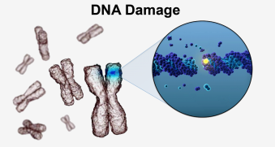
Source: http://exogenbio.com

4.6. Sources of damage
DNA damage can be subdivided into two main types:
- Endogenous Damage
- Exogenous Damage
4.6.1 Endogenous damage arises from attack by reactive oxygen species produced from normal metabolic by-products (spontaneous mutation).
There are several types of damage to DNA due to endogenous cellular processes:
- oxidation of bases [e.g. 8-oxo-7,8-dihydroguanine (8-oxoG)] and generation of DNA strand interruptions from reactive oxygen species,
- alkylation of bases (usually methylation), such as formation of 7-methylguanosine, 1-methyladenine, 6-O-Methylguanine
- hydrolysis of bases, such as deamination, depurination, and depyrimidination.
- "bulky adduct formation" (i.e., benzo[a]pyrene diol epoxide-dG adduct, aristolactam I-dA adduct)
- mismatch of bases, due to errors in DNA replication, in which the wrong DNA base is stitched into place in a newly forming DNA strand, or a DNA base is skipped over or mistakenly inserted.
- Monoadduct damage cause by change in single nitrogenous base of DNA
- Diadduct damage
4.6.2. Exogenous damage caused by external agents such as
- Ultraviolet [UV 200–400 nm] radiation from the sun
UV-B light causes cross-linking between adjacent cytosine and thymine bases creating pyrimidine dimers. This is called direct DNA damage.
UV-A light creates mostly free radicals. The damage caused by free radicals is called indirect DNA damage.
- Other radiation frequencies, including x-rays and gamma rays
- Hydrolysis or thermal disruption: Thermal disruption at elevated temperature increases the rate of depurination (loss of purine bases from the DNA backbone) and single-strand breaks.
- Certain plant toxins
- Human-made mutagenic chemicals, especially aromatic compounds that act as DNA intercalating agents
- Viruses
- Ionizing radiation such as that created by radioactive decay or in cosmic rays causes breaks in DNA strands. Intermediate-level ionizing radiation may induce irreparable DNA damage (leading to replicational and transcriptional errors needed for neoplasia or may trigger viral interactions) leading to pre-mature aging and cancer.
- Industrial chemicals such as vinyl chloride and hydrogen peroxide, and environmental chemicals such as polycyclic aromatic hydrocarbons found in smoke, soot and tar create a huge diversity of DNA adducts- ethenobases, oxidized bases, alkylated phosphotriesters and cross linking of DNA.
Note that damage could be induced or spontaneous
UV damage, alkylation/methylation, X-ray damage and oxidative damage are examples of induced damage while Spontaneous damage can include the loss of a base, deamination, sugar ring puckering(contracting) and tautomeric shift.
4.7. DNA damage and mutation
DNA damage and mutation are fundamentally different. Damage leads to physical abnormalities in the DNA, such as single- and double-strand breaks, 8 hydroxydeoxyguanosine residues, and polycyclic aromatic hydrocarbon adducts.
DNA damage can be recognized by enzymes, and thus can be correctly repaired if redundant information, such as the undamaged sequence in the complementary DNA strand or in a homologous chromosome, is available for copying. If a cell retains DNA damage, transcription of a gene can be prevented, and thus translation into a protein will also be blocked. Replication may also be blocked or the cell may die.
In contrast to DNA damage, a mutation is a change in the base sequence of the DNA. A mutation cannot be recognized by enzymes once the base change is present in both DNA strands, and thus a mutation cannot be repaired.
At the cellular level, mutations can cause alterations in protein function and regulation. Mutations are replicated when the cell replicates. In a population of cells, mutant cells will increase or decrease in frequency according to the effects of the mutation on the ability of the cell to survive and reproduce.
Although distinctly different from each other, DNA damage and mutation are related because DNA damage often causes errors of DNA synthesis during replication or repair; these errors are a major source of mutation.
4.8. DNA repair
DNA repair is a collection of processes by which a cell identifies and corrects damage to the DNA molecules that encode its genome.
In human cells, both normal metabolic activities and environmental factors such as radiation can cause DNA damage, resulting in as many as 1 million individual molecular lesions per cell per day.Many of these lesions cause structural damage to the DNA molecule and can alter or eliminate the cell's ability to transcribe the gene that the affected DNA encodes. As a consequence, the DNA repair process is constantly active as it responds to damage in the DNA structure.
When normal repair processes fail, and when cellular apoptosis does not occur, irreparable DNA damage may occur, including double-strand breaks and DNA cross-linkages (inter-strand cross links or ICLs). This can eventually lead to malignant tumors, or cancer
The rate of DNA repair is dependent on many factors, including the cell type, the age of the cell, and the extracellular environment.
A cell that has accumulated a large amount of DNA damage, or one that no longer effectively repairs damage incurred to its DNA, can enter one of three possible states:
- an irreversible state of dormancy, known as senescence
- cell suicide, also known as apoptosis or programmed cell death
- unregulated cell division, which can lead to the formation of a tumor that is cancerous.
To maintain the integrity of their genomes, cells have therefore had to evolve mechanisms to repair damaged DNA. These mechanisms of DNA repair can be divided into two general classes:
- direct reversal of the chemical reaction responsible for DNA damage, and
- removal of the damaged bases followed by their replacement with newly synthesized DNA.(excision repair system)
Where DNA repair fails, additional mechanisms have evolved to enable cells to cope with the damage.
    - Direct Reversal of DNA Damage
Some lesions in DNA, however, can be repaired by direct reversal of the damage, which may be a more efficient way of dealing with specific types of DNA damage that occur frequently.
Only a few types of DNA damage are repaired in this way, particularly pyrimidine dimers resulting from exposure to ultraviolet (UV) light and alkylated guanineresidues that have been modified by the addition of methyl or ethyl groups at the O⁶ position of the purine ring.
UV light is one of the major sources of damage to DNA and is also the most thoroughly studied form of DNA damage in terms of repair mechanisms. Its importance is illustrated by the fact that exposure to solar UV irradiation is the cause of almost all skin cancer in humans. The major type of damage induced by UV light is the formation of pyrimidine dimers, in which adjacent pyrimidines on the same strand of DNA are joined by the formation of a cyclobutane ring resulting from saturation of the double bonds between carbons 5 and 6. The formation of such dimers distorts the structure of the DNA chain and blocks transcription or replication past the site of damage.
One mechanism of repairing UV-induced pyrimidine dimers is direct reversal of the dimerization reaction. The process is called photoreactivation because energy derived from visible light is utilized to break the cyclobutane ring structure earlier formed.The original pyrimidine bases remain in DNA, now restored to their normal state
The formation of pyrimidine dimers upon irradiation(damage that can be directly reversed) with UV light results in an abnormal covalent bond between adjacent pyrimidine bases. The photoreactivation process directly reverses this damage by the action of the enzyme photolyase, whose activation is dependent on energy absorbed from blue/UV light (300–500 nm wavelength) to promote catalysis.

Another type of damage, methylation of guanine bases, is directly reversed by the protein methyl guanine methyl transferase (MGMT). This is an expensive process because each MGMT molecule can be used only once; that is, the reaction is stoichiometric rather than catalytic.
The third type of DNA damage reversed by cells is certain methylation of the bases cytosine and adenine.
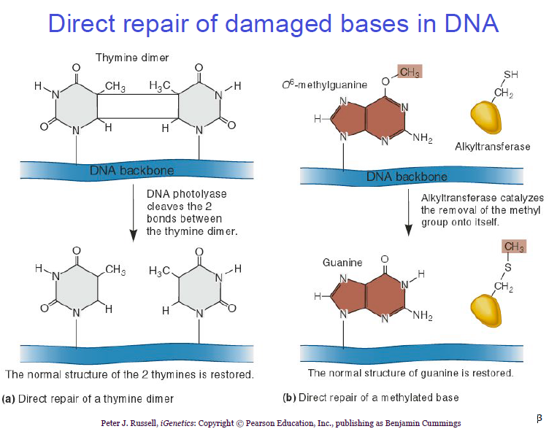
Source: www.slideshare.net

    - Base Excision Repair
Base excision repair (BER) repairs damage to a single nitrogenous base by deploying enzymes called glycosylases. These enzymes can recognize a single damaged base and cleave the bond between it and the sugar in the DNA. It removes a single nitrogenous base to create an apurinic or apyrimidinic site (AP site), excises several around it and replaces with several new bases using Pol adding to 3’ ends then ligase attaching to 5’ end i.e. DNA polymerase then removes the damaged region using its 5’ to 3’ exonuclease activity and correctly synthesizes the new strand using the complementary strand as a template.
Depending on the species,, this repair system can eliminate abnormal bases such as Uracil; Thymine dimmers, 3-methyladenine; 7-methylguanine
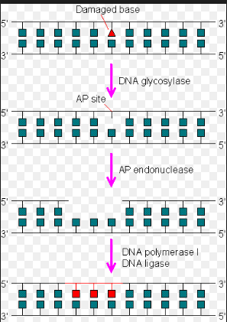
Source: http://drugline.org
    - Nucleotide excision repair (NER) repairs damaged DNA which commonly consists of bulky, helix-distorting damage, such as pyrimidine. Damaged regions are removed in 12–24 nucleotide-long strands in a three-step process which consists of:
recognition of damage,
excision of damaged DNA both upstream and downstream of damage by endonucleases, and
Re-synthesis of removed DNA region.
NER is used in nearly all eukaryotic and prokaryotic cells. In prokaryotes, NER is mediated by Uvr proteins. In eukaryotes, many more proteins are involved, although the general strategy is the same.
Several human diseases have been shown to involve inherited defects in genes involved in NERThese include xeroderma pigmentosum (XP) and Cockayne syndrome (CS). " A common characteristic off both syndromes is an increased sensitivity to sunlight
Xeroderma pigmentosum can be caused by defects in seven different NER genes
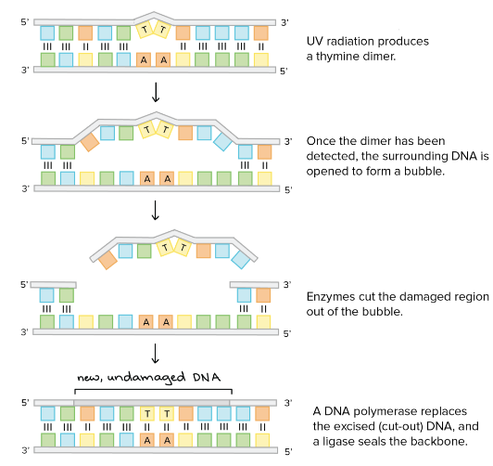
Source: https://www.khanacademy.org

Errors during replication are exceedingly rare, less than once in 109 base pairs. Some enzymes called Proofreading enzymes correct errors made during replication.
– DNA polymerase has 3’ – 5’ exonuclease activity which recognizes mismatched bases and excises them
If errors slip through proofreading:
In bacteria, methyl-directed mismatch repair finds these errors on newly synthesized strands and corrects them
In eukaryotes, mismatch repair finds these errors on newly synthesized strands and corrects them

Source: https://www.khanacademy.org
Source: https://www.khanacademy.org
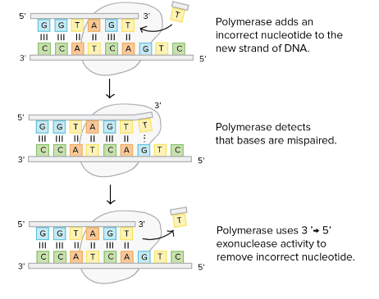
Source: https://www.khanacademy.org

    - Mismatch Repair System
Mismatch repair systems are present in essentially all cells to correct errors that are not corrected by proofreading. If proofreading fails, the methyl-directed mismatch repair system comes to the rescue.
Methyl-directed mismatch repair recognizes mismatched base pairs, excises the incorrect bases, and then carries out repair synthesis. These systems consist of at least two proteins.
In E. coli , the proteins involved are the Mut class proteins. This is followed by removal of damaged region by an exonuclease, resynthesis by DNA polymerase, and nick sealing by DNA ligase.
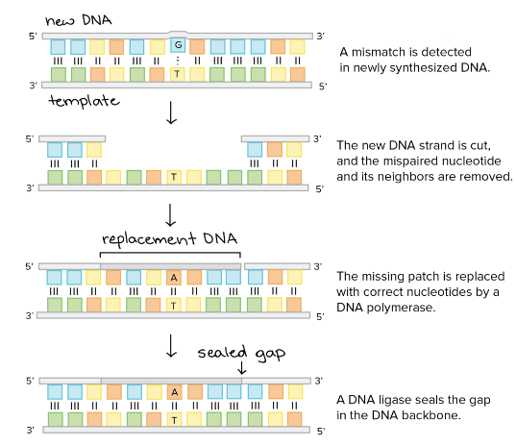
Source: https://www.khanacademy.org
The global response to damage is an act directed toward the cells' own preservation and triggers multiple pathways of macromolecular repair, lesion bypass, tolerance, or apoptosis.
The common features of global response are induction of multiple genes, cell cycle arrest, and inhibition of cell division.

Post-Test
Differentiate between DNA damage and Mutation
Explain the various mechanisms of DNA Repair
Explain DNA Organisation
Bibliography
http://drugline.org
https://www.khanacademy.org
http://exogenbio.com
Wikipedia.org

LECTURE 5
Abnormalities of Nucleic acid metabolism
- Introduction
Purines (adenine and guanine) and pyrimidines (cytosine, thymine, uracil) serve fundamental roles in the replication of genetic material, gene transcription, protein synthesis, and cellular metabolism.
Objectives of the Lecture
At the end of the lecture, the students should be able to:
List the disorders associated with purine and pyrimidine metabolism with their deficient enzymes.
Pre-Test
What are Metabolic Disorders?
List any 2 metabolic disorders
Content
Disorders that involve abnormalities of nucleotide metabolism range from relatively common diseases such as hyper-uricemia and gout, in which there is increased production or impaired excretion of a metabolic end product of purine metabolism (uric acid), to rare enzyme deficiencies that affect purine and pyrimidine synthesis or degradation.
Six major diseases caused due to errors in nucleic acid metabolism. The diseases are:
1. Lesch-Nyhan Syndrome
2. Hereditary Xanthinuria
3. Orotic Aciduria
4. Hypouricemia
5. Von Gierke’s Disease
6. Reye’s Syndrome
5.1. Lesch-Nyhan Syndrome(inborn error of purine metabolism)
Lesch-Nyhan syndrome (LNS) is a rare genetic disorder characterized by an overproduction of uric acid, neurological disability, and behavioral problems.
This condition is characterized by the complete deficiency of phosphoribosyl transferase, which causes hypoxanthine or guanine to form a nucleotide with PRPP (5′- phosphoribosyl – 1′- pyrophosphate),leading to excessive uric acid production The symptoms of LNS typically appear between ages 3 and 6 months; the presence of orange-colored crystal-like deposits (orange sand) in the child’s diaper is usually the first symptom to appear in those affected with the syndrome. Sometimes, It is accompanied by gout.
It can be prevented or diminished by the administration of allopurinol, an analogue of hypoxanthine. Allopurinol inhibits xanthine oxidase due to which uric acid cannot be formed.
5.2. Hereditary Xanthinuria
In this rare genetic disorder, there is the deficiency of xanthine oxidase which leads to the diminished level of blood uric acid (1 mg/100 ml or less). The urinary excretion contains large amounts of xanthine with lesser amounts of hypoxanthine. Urinary calculi composed of xanthine may be produced
5.3. Orotic Aciduria(pyrimidine metabolism)
This is an inherited disorder which causes the excessive production of orotic acid due to the deficiency of orotate phosphoribosyl transferase.
The urine becomes cloudy on cooling with the deposition of needle-shaped crystals of orotic acid.
Children affected by this condition develop a severe megaloblastic anemia with physical and mental retardation.Administration of uridine improves this condition significantly.
5.4. Von Gierke’s Disease
This disease is associated with the purine overproduction and hyperuricemia and also the deficiency of glucose 6-phosphatase (final enzyme in glycogenolysis pathway) which results in accumulation of glycogen, and hypoglycemia.
5.5. Hypo-uricemia
This is due to a genetic defect or to severe liver damage. The deficiency of the enzyme xanthine oxidase causes hypouricemia and increased excretion of hypoxanthine and xanthine.
5.6. Reye’s Syndrome:
This syndrome exhibits inability of severely damaged mitochondria to use carbamoyl phosphate which is available for cystosotic over-production of orotic acid.
Post Test
Explain the following terms: Orotic Aciduria
Hypouricemia

Bibliography
www.biologydiscussion.com
biochimica.bio.uniroma1.it/didattica/
www.academia.edu
intranet.tdmu.edu.ua
Wikipedia.org

