




COLLEGE OF BASIC AND APPLIED SCIENCES

Mountain Top University
Kilometre 12, Lagos-Ibadan Expressway, MFM Prayer City, Ogun State.
PHONE: (+234)8053457707, (+234)7039395024, (+234) 8039505596
EMAIL: support@mtu.edu.ng
Website: www.mtu.edu.ng.

Published By:
Mountain Top University


COURSE GUIDE

COURSE TITLE: METABOLISM OF AMINO ACIDS
AND PROTEINS
COURSE CODE: BCH 311
LECTURER(S): Dr. Ayorinde, Mrs. O.O. Ayodele

COURSE OBJECTIVES
The course will examine the pathways of amino acids and protein metabolism. Focus will be on amino acids as building blocks of proteins, biological functions of proteins; Oxidative degradation of amino acids and metabolism of one carbon unit, as well as biosynthesis of amino acids and derivatives. The reactions of the Urea cycle, metabolism of inorganic nitrogen and disorders of amino acid metabolism will also be taught.
LEARNING OUTCOMES
At the end of this course, the student should be able to:
- Describe amino acid structures, and their physical and chemical properties; covalent backbone of proteins, and their biological functions.
- Define primary, secondary, tertiary and quaternary structure in proteins and identify the types of interactions important in each case.
- Discuss the oxidative degradation of amino acids and metabolism of one -carbon units.
- Describe the reactions of the urea cycle and the regulation.
- Describe the pathways of biosynthesis of amino acids and some derivatives
- Understand the clinical implications of errors of amino acid metabolism.

METHOD OF GRADING
1. Continuous Assessment 30 Marks
- Test 1/ Test 2 15 Marks
- Mid-Semester Test 15 Marks
2. Semester Examination 70 Marks
COURSE CONTENTS
Week | Topic
1 | Introduction and Course Overview
2 | Amino acids as building blocks of proteins; covalent backbone of proteins; Amino acid sequence of proteins.
3 | Structural levels of proteins; protein folding
4 | Biological functions of proteins.
5 | Protein isolation and fractionation
6 | Purification and characterization of proteins
7 | Assessment
8 | Oxidative degradation of amino acids.
9 | Metabolism of one carbon units.
10 | The urea cycle; reactions and regulation
11 | Metabolism of inorganic nitrogen.
12 | Biosynthesis of amino acids and some derivatives;
13 | Disorders of amino acid metabolism.
14 | Assessment

LECTURE ONE: INTRODUCTION AND COURSE OVERVIEW
- Introduction
This is an introductory lecture to the course. Students’ previous knowledge of amino acids and proteins chemistry will be reviewed, which will lead to a general overview of amino acids and protein metabolism.
Objectives:
At the end of this lecture, students should be able to:
- Define amino acids and Proteins
- Know what the course entails.
- State the conditions for amino acid degradation.
- Give an overview of amino acids and protein metabolism.
Pre-Test:
- What are amino acids
- Give 5 examples each of amino acids and proteins.
- What differentiate one amino acid from another?
1.1 INTRODUCTION
- Amino acids, in addition to their role as protein monomeric units, are energy metabolites and precursors of many biologically important nitrogen-containing compounds. Examples include: heme, physiologically active amines, glutathione, nucleotides, and nucleotide coenzymes.
- Amino acids are classified into two groups: essential and nonessential.
- Mammals synthesize the nonessential amino acids from metabolic precursors but must obtain the essential amino acids from their diet.
- Excess dietary amino acids are neither stored for future use nor excreted. Rather, they are converted to common metabolic intermediates such as pyruvate, oxaloacetate, acetyl-CoA, and α-keto-glutarate. Consequently, amino acids are also precursors of glucose, fatty acids, and ketone bodies and are therefore metabolic fuels.
- The course will consider the pathways of amino acid breakdown, synthesis, and utilization.
1.2 OVERVIEW OF AMINO ACIDS METABOLISM
In animals, amino acids undergo oxidative degradation in three different metabolic circumstances:
- During the normal synthesis and degradation of cellular proteins, some amino acids that are released from protein breakdown and are not needed for new protein synthesis undergo oxidative degradation.
- When a diet is rich in protein and the ingested amino acids exceed the body’s needs for protein synthesis, the surplus is catabolized; amino acids cannot be stored.
- During starvation or in uncontrolled diabetes mellitus, when carbohydrates are either unavailable or not properly utilized, cellular proteins are used as fuel.
- Under all these metabolic conditions, amino acids lose their amino groups to form α-keto acids, the “carbon skeletons” of amino acids.
- The α-keto acids undergo oxidation to CO₂ and H₂O or, often more importantly, provide three- and four-carbon units that can be converted by gluconeogenesis into glucose.
- The pathways of amino acid catabolism are quite similar in most organisms. As in carbohydrate and fatty acid catabolism, the processes of amino acid degradation converge on the central catabolic pathways, with the carbon skeletons of most amino acids finding their way to the citric acid cycle.
- In some cases, the reaction pathways of amino acid breakdown closely parallel steps in the catabolism of fatty acids.
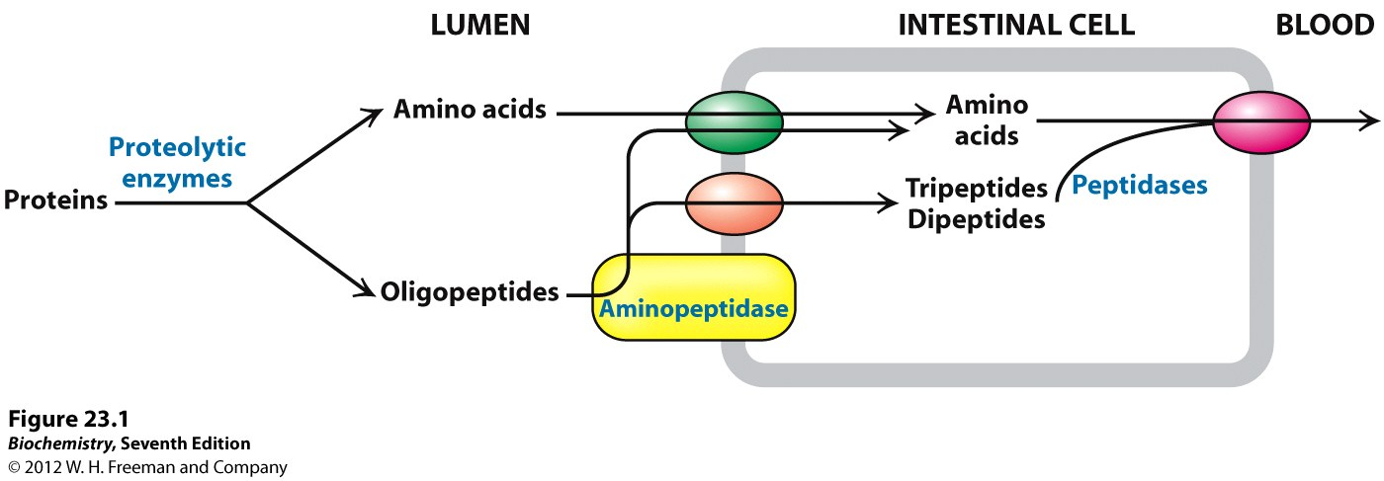
Fig 1.1: Breakdown of dietary Proteins. Amino acids in excess cannot be stored or excreted. Surplus amino acids are used as metabolic fuel. Source: Lehninger Principle of Biochemistry, 5th Ed.
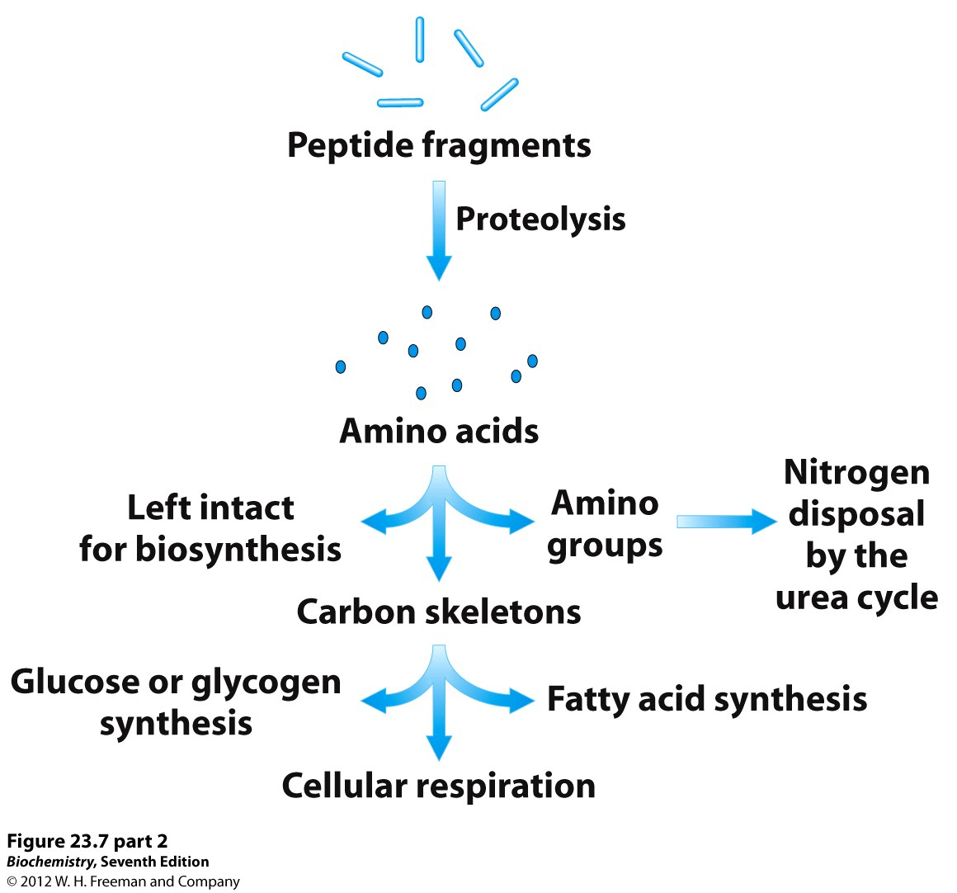
Fig. 1.2: Overview of amino acid metabolism.
Post Tests:
- State the conditions for amino acid degradation
- Describe how protein is digested and absorbed
- Give an overview of amino acids metabolism.
Bibliography:
- Lehninger Principle of Biochemistry 4th Ed.
- Voet D., Voet J.G. and Pratt C. Fundamentals of Biochemistry 5th Ed. John Wiley &Sons, 2016.
- Berg J.M., Tymoczko J.L., and Stryer L. Biochemistry 7th Ed. by W.H. Freeman and Company 2012.

LECTURE TWO
AMINO ACIDS AS BUILDING BLOCK OF PROTEINS
- Introduction
This lecture focuses on description of amino acids, their structures and types. The reactions of peptide bond formation and how peptides are named will also be considered.
Objectives:
At the end of the lecture, students should be able to:
- Write the backbone structure of amino acids
- Name the twenty common amino acids
- Describe the reaction of peptide bond formation and nomenclature of peptides.
Pre-Test
- Amino acids have the same basic structure. True or false?
- Peptides are low-molecular weight proteins. True or false?
- What do you understand by amino acids sequence of a protein?
2.1 AMINO ACIDS
Amino acids are the building blocks of proteins. All cells contain thousands of types of proteins, and amino acids are the building blocks of these proteins. The sequential order, number, and chemical identity of the amino acids in the protein determine the structure of the protein as well as how the protein functions.
Amino acids are relatively simple molecules containing both an amine group and an acid group. The biologically important amino acids are the α-amino acids that have the amine and acid groups attached to the same carbon atom.
There are more than 100 known natural amino acids; however, only 20 of them are used in protein synthesis. Francis Crick (who with James Watson determined the structure of DNA) labeled this set of amino acids the magic 20. Other amino acids are found in certain proteins, but in almost all cases these additional amino acids result from the modification of one of the magic 20 after the protein formed.

Table 2.1: The 20 Common Amino Acids
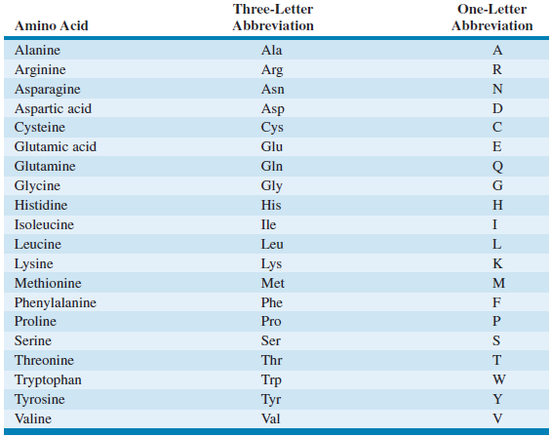
Certain amino acids and their derivatives, however, are not found in proteins, but they also perform useful biological roles. These are called uncommon amino acids.

Table 2.2: Uncommon Amino Acids
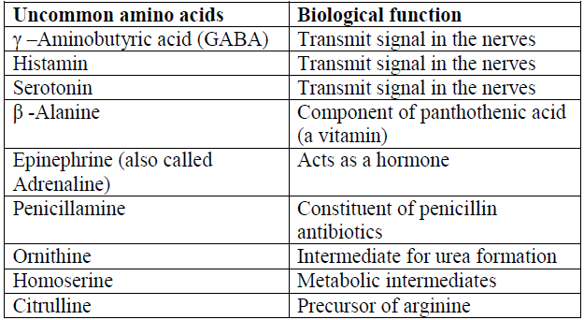

2.1.1 Basic Structure of Amino acids
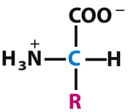
To fully understand the structure of amino acids, the following need to be considered:
- How carbon atoms in organic compounds are named;
- The concept of chirality in organic compounds; and
- The concept of stereoisomerism
How Carbon Atoms in Amino Acids are named
Carbon atoms in an amino acid, just as in any organic compound, are conventionally named either by using Greek letters such as alpha (α), beta (β), gama (γ), delta ( δ), epsilom ( ε) e.t.c. or by a simpler Arabic numerals numbering convention (1, 2, 3, 4…).
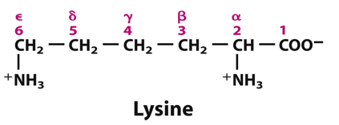

The α-carbon is the central C atom, with 4 different substituents attached:
- α-carboxyl group
- α-amino group
- hydrogen atom
- R group or “side chain” (different structures for the 20 amino acids).

Points to note:
- All amino acids are similar structurally.
- They all have carboxyl, amino group, hydrogen atom and a side chain (R group) covalently linked to the alpha carbon atom.
- They differ mainly in the nature of their side chains (R groups); the R groups in amino acids vary in structure, size/length and electric charge.
- Each amino acid can be remembered for a distinct feature in its side chain: Glycine, the amino acid with the simplest structure, has H as its side chain; Alanine contains a methyl group (-CH₃); Valine has an isopropyl R group; Phenylalanine and tyrosine have aromatic /benzene ring in their side chain; tryptophan has a heterocyclic structure with an indole group; Cysteine and methionine both have sulphur as part of their side chain e.t.c.
At physiological pH, amino acids are ionic in nature with their amino and carboxyl groups preferring ammonium (NH₃⁺) and carboxylate (COO⁻) states rather than amino (NH₂) and carboxyl (COOH) states respectively.

2.2 PEPTIDE BOND FORMATION
Peptides are formed through covalent bonding between two or more amino acids’ molecules. This covalent bond, the peptide bond, is an amide linkage. The peptide bond is formed by the elimination of a water molecule from the α-carboxyl group of one amino acid and the α-amino group of another.
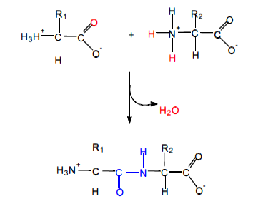
Fig. 2.1: Formation of a peptide bond (Dipeptide formation). Source: Biochemistry 4th Ed. By Voet & Voet.

The peptide bond formation is initiated via an attack of the lone-pair electrons of the amine on the carbonyl carbon of the carboxyl group. If such a condensation polymer consists of two amino acids joined by a peptide bond, it is referred to as dipeptide. Three amino acids can be joined by two peptide bonds to form a tripeptide. Similarly, four amino acids will form a tetrapeptide while five amino acids will produce a pentapeptide e.t.c. Polymers composed of few (3-10) amino acids residues are known as oligopeptide. The term polypeptide refers to a polymer containing many amino acid residues. Amino acid unit that exists as part of a peptide is often called residue (amino acid residue).

2.2.1 Nomenclature of Peptides
In a peptide, amino acid residue is linked to its neighbor in a head-to-tail manner, forming linear polymer. The end of the linear polymer with a free α-amino group is the N-terminus while the amino acid residue at this end is called the amino terminal (or N-terminal) residue. In the same way, the opposite end of the polymer with a free carboxyl group and its terminal amino acid are called the C-terminus and carboxyl-terminal residue respectively.
A peptide is named according to the amino acid residues in it and usually begins with the N-terminal residue.
The names of peptides reflect the names of the amino acid residues involved in the amide linkages, beginning at the N terminus. All except the last are given the -yl suffix of acyl groups. For example, the dipeptide below is named Alanylserine. The alanine residue has the –yl suffix because it has acylated the nitrogen of serine.
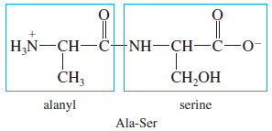
The pentapeptide in the diagram below is named serylglycyltyrosylalanylleucine and abbreviated as Ser-Gly-Tyr-Ala-Leu or SGYAL (using one-letter abbreviation).
Fig. 2.2: A Pentapeptide showing the N- and the C- termini. Source: Lehninger principles of Biochemistry.
2.2.2 Biologically Active Peptides
Peptides occur naturally in some biological systems even though synthetic peptides can be produced. Although less structurally complex than the larger protein molecules, peptides have significant biological activities; some interesting examples are listed in the table below:

Table 2.3: Some Biologically Important Peptides
Peptide | No of Amino acid residues
Glutathione | 3
Oxytocin | 8
Vasopressin | 8
Glucagon | 29
Adrenocorticotropic  Hormone | 39

Post-Test:
- Describe the reaction of peptide bond formation.
- With relevant example(s) describe how peptides are named
- Give 4 examples of biologically important peptides, describing their structures and functions.
- Draw Fischer projection formulas for glycine, aspartate, leucine, isoleucine, methionine, and threonine.

Bibliography:
- Lehninger Principle of Biochemistry 4th Ed.
- Voet D., Voet J.G. and Pratt C. Fundamentals of Biochemistry 5th Ed. John Wiley &Sons, 2016.
- Berg J.M., Tymoczko J.L., and Stryer L. Biochemistry 7th Ed. by W.H. Freeman and Company 2012.
- Reginald H. Garret and Charles M. Grisham. Biochemistry 4th Ed.

LECTURE THREE
STRUCTURAL LEVELS OF PROTEINS
3.0 Introduction
This lecture examines different levels of protein structures, the type of interactions involved and their importance. The process of protein folding in attaining an active form will also be taught.
Objectives:
At the end of the lecture, students should be able to:
- Describe the structural levels of proteins
- State the type of interactions involved in protein structures.
- Know the importance of protein structures
- Explain Denaturation and renaturation of proteins.
Pre-Test:
- Give 3 examples of proteins you know and their functions.
- What do you understand by protein structure?

3.1 PROTEINS STRUCTURE
Proteins are polymers of amino acids. Some proteins exist as single polypeptide chains, while others occur as two or more polypeptides associated non-covalently. Proteins belonging to the latter group are called multi-subunit proteins. Proteins may occur as simple proteins, having only amino acid residues or as conjugated proteins, possessing permanent associated chemical components in addition to amino acids.
The non-amino acid part of a conjugated protein is usually referred to as its prosthetic group. The conjugated proteins could be classified based on the chemical nature of their prosthetic group. For example, in lipoprotein, the prosthetic group is lipid while in metalloprotein, it is a metal.
The properties of a protein are largely determined by its three-dimensional structure, which is a function of its amino acid sequence and the regular folded polypeptide backbone. The four levels of protein structure include: primary structure, secondary structure, tertiary structure and quaternary structures.

3.1.1 Primary Structure of Proteins
The primary structure of a protein is the particular sequence of amino acids, which is the backbone of a peptide chain or protein. The primary structure is defined by all covalent bonds (peptide bonds and disulfide bonds) linking the amino acid residues in a polypeptide chain. The peptide bond is vital to the integrity of the structure of any protein molecule and is the basis of primary structure.
The disulfide bridge is much involved in the cross-linking between different parts of the polypeptide chain.
Ala─Leu─Cys─Met

Examples:
The nonapeptides oxytocin and vasopressin have similar primary structures, but differ only in the amino acids at positions 3 and 8.
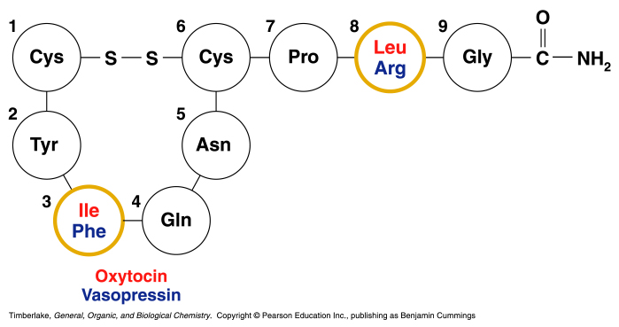
Fig. 3.1: Primary structure of Oxytocin and Vasopresin. Timberlake General, Organic and Biological Chemistry.

Note: Insulin was the first protein to have its primary structure determined. It has a primary structure of two polypeptide chains linked by disulfide bonds. Consists of chain A with 21 amino acids and a chain B with 30 amino acids.
Primary Structure-Protein Function Relationship
The primary structure determines the folding pattern of a protein which in turn determines its function. A classic example in which there is a clear relationship between amino acid sequence of protein and its function is in sickle cell anemia.
Sickle-cell anemia, which is caused by mutant hemoglobin, is a classic example of a group of maladies that Linus Pauling and his colleagues referred to as molecular diseases. (Dr. Pauling first demonstrated that sickle-cell patients have a mutant hemoglobin through the use of electrophoresis.) Human adult hemoglobin (HbA) is composed of two identical α-chains and two identical β-chains. Sickle-cell anemia results from a single amino acid substitution in the β-chain of HbA. Because of the substitution of a hydrophobic valine for a negatively charged glutamic acid at amino acid residue 6 in the β-chain, HbS molecules aggregate to form rigid rodlike structures in the oxygen-free state. The patient’s red blood cells become sickle shaped and are susceptible to hemolysis, resulting in severe anemia.
These red blood cells have an abnormally low oxygen-binding capacity. Intermittent clogging of capillaries by sickled cells also causes tissues to be deprived of oxygen. Sickle-cell anemia is characterized by excruciating pain, eventual organ damage, and early death.
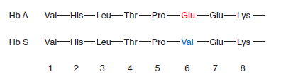
Fig. 3.2: Segments of β-Chain in HbA and HbS.

3.1.2 Secondary Structure of Proteins
The secondary structures of proteins indicate the three-dimensional spatial arrangements of the polypeptide chain. That is, the common regular folding patterns of the polypeptide backbone. A few secondary structures occur widely in proteins, but the most commonly observed types of secondary structure are the α-helix and the β -pleated sheet. Both α-helix and β -pleated sheet patterns are stabilized by localized hydrogen bonding between the carbonyl and N—H groups in the polypeptide’s backbone.

α- Helix
An alpha helix has a coiled shape held in place by hydrogen bonds between the amide groups and the carbonyl groups of the amino acids along the chain, and between the H of a –N-H group and the O of C=O of the fourth amino acid down the chain.
Fig. 3.3: Alpha-helix. Copyright © 2007 by Pearson Education, Inc Publishing as Benjamin Cummings.

β- sheets
β-Pleated sheets -pleated sheets form when two or more polypeptide chain segments line up side by side. Each individual segment is referred to as a β -strand. Rather than being coiled, each β -strand is fully extended. β -Pleated sheets are stabilized by hydrogen bonds that form between the polypeptide backbone N—H and carbonyl groups of adjacent chains. It is typical of fibrous proteins such as silk.
β -Pleated sheets are either parallel or antiparallel. In parallel β -pleated sheet structures, the hydrogen bonds in the polypeptide chains are arranged in the same direction; in antiparallel chains these bonds are arranged in opposite directions. Occasionally, mixed parallel-antiparallel
β -sheets are observed.
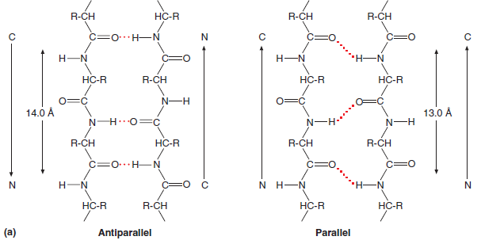
Fig. 3.4: β- sheets. Copyright © 2007 by Pearson Education, Inc Publishing as Benjamin Cummings.

3.1.3. Tertiary Structure of Proteins
The tertiary structure of a protein gives a specific three-dimensional shape to the polypeptide chain.
It involves interactions and cross links between different parts of the peptide chain (i.e. all the bends and folds in the polypeptide chains of the protein). In tertiary structure, different segments of a protein’s polypeptide chains are held by weak forces and sometimes by covalent bonds such as Disulfide Bridge. It is due to their tertiary structures that proteins adopt a globular shape/conformation which gives the lowest surface-to-volume ratio, thus minimizing the interaction of protein with its surrounding.
Protein tertiary structure is stabilized by:
- Hydrophobic and hydrophilic interactions.
- Salt bridges.
- Hydrogen bonds.
- Disulfide bonds.
The interactions of the R groups give a protein its specific three-dimensional tertiary structure.
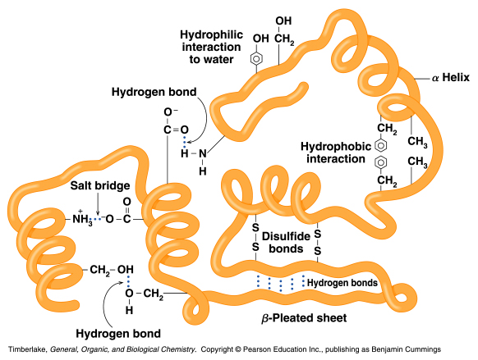
Fig. 3.4. Tertiary structure of protein.

Water soluble proteins fold so that hydrophobic R groups are tucked inside the protein and hydrophilic R groups are on the outside of the protein so that the protein may interact with the solvent (water) and not precipitate or otherwise be inactivated.
Water insoluble proteins fold so that hydrophilic R groups are tucked inside the protein and hydrophobic R groups are on the outside of the protein. This is so that a protein, e.g., an ion channel in a cell membrane, may insert itself in a non-polar environment so that polar particles may be transported into or out of regions compartmentalized from each other.

3.1.4 Quaternary Structure of Proteins
The quaternary structure is the combination of two or more tertiary units. It is stabilized by the same interactions found in tertiary structures. Quaternary structural levels deal with the number of subunits in each protein. These subunits are noncovalently bonded to each other, although there are other interactions among them. A multiunit protein is also referred to as a multimer. Protein with two subunits is called a dimer while one with few subunits is often called an oligomer. Multimer can have identical subunits or repeating groups of non-identical subunits. The repeating structural unit in such a multimeric protein, whether it is a single subunit or a group of subunits, is called protomer.
A typical example is hemoglobin, a tetramer which consists of two alpha chains and two beta chains. The heme group in each subunit picks up oxygen for transport in the blood to the tissues.
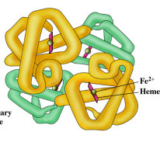 Fig. 3.5: Hemoglobin.

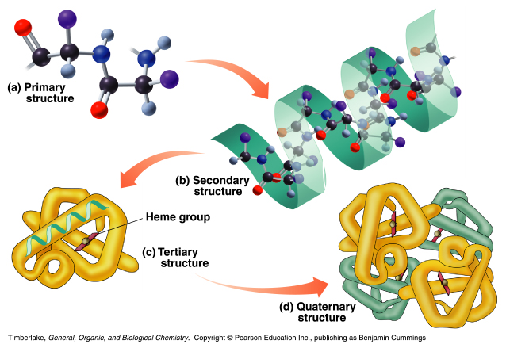Fig. 3.6: Summary of protein structural levels

3.2 DENATURATION OF PROTEIN
Many physical and chemical agents can disrupt a protein’s native conformation. The process of structure disruption, which may or may not involve protein unfolding, is called ‘Denaturation’. Denaturation is not usually considered to include the breaking of peptide bonds. Depending on the degree of denaturation, the molecule may partially or completely lose its biological activity. Denaturation often results in easily observable changes in the physical properties of proteins. For example, soluble and transparent egg albumin (egg white) becomes insoluble and opaque upon heating. Like many denaturation, cooking eggs is an irreversible process.
Proteins can be denatured by the following conditions:
1. Strong acids or bases. Changes in pH alter the protonation state of certain protein side chain groups, which in turn alters hydrogen bonding and salt bridge patterns. As a protein approaches its isoelectric point, it becomes less soluble and may precipitate from solution.
2. Organic solvents. Water-soluble organic solvents such as ethanol interfere with hydrophobic interactions because they interact with nonpolar R groups and form hydrogen bonds with water and polar protein groups. Nonpolar solvents also disrupt hydrophobic interactions.
3. Detergents. Detergents are substances that disrupt hydrophobic interactions, causing proteins to unfold into extended polypeptide chains. These molecules are called amphipathic because they contain both hydrophobic and hydrophilic components.
4. Reducing agents. In the presence of reagents such as urea, reducing agents (e.g., α-mercaptoethanol) convert disulfide bridges to sulfhydryl groups. Urea disrupts hydrogen bonds and hydrophobic interactions.
5. Salt concentration. When there is an increase in the salt concentration of an aqueous solution of protein, some of the water molecules that interact with the protein’s ionizable groups are attracted to the salt ions. As the number of solvent molecules available to interact with these groups decreases, protein- protein interactions increase. If the salt concentration is high enough, there are so few water molecules available to interact with ionizable groups that the solvation spheres surrounding the protein’s ionized groups are removed. The protein molecules aggregate and then precipitate. This process is referred to as salting out. Because salting out is usually reversible and different proteins salt out at different salt concentrations, it is often used as an early step in protein purification.
6. Heavy metal ions. Heavy metals such as mercury (Hg²⁺) and lead (Pb²⁺) affect protein structure in several ways. They may disrupt salt bridges by forming ionic bonds with negatively charged groups. Heavy metals also bond with sulfhydryl groups, a process that may result in significant changes in protein structure and function. For example, Pb²⁺ binds to sulfhydryl groups in two enzymes in the heme synthetic pathway. The resultant decrease in hemoglobin synthesis causes severe anemia.
7. Temperature changes. As the temperature increases, the rate of molecular vibration increases. Eventually, weak interactions such as hydrogen bonds are disrupted and the protein unfolds. Some proteins are more resistant to heat denaturation, and this fact can be used in purification procedures.
8. Mechanical stress. Stirring and grinding actions disrupt the delicate balance of forces that maintain protein structure. For example, the foam formed when egg white is beaten vigorously contains denatured protein.
3.3 RENATURATION
Unfolded proteins under denaturating agents sometimes regain their folded native conformation and biological function if the denaturant(s) is/are removed. This process is called renaturation (e.g. Denaturation of Ribonuclease A by urea). Renaturation clearly shows that the primary structure of protein determines its tertiary functional structure.

Post-Test
- With reference to sickle cell anemia hemoglobin, describe the importance of amino acid sequence (primary structure) to protein function.
- Describe the structural levels of proteins.
- How can proteins be denatured?
- What are the interactions stabilizing the tertiary structure of proteins?

Bibliography
- Benjamin Cummings. Timberlake General, Organic and Biological Chemistry. Copyright 2007 Pearson Education Inc. publishing.
- Lehninger Principle of Biochemistry 4th Ed.
- Voet D., Voet J.G. and Pratt C. Fundamentals of Biochemistry 5th Ed. John Wiley &Sons, 2016.

LECTURE FOUR
BIOLOGICAL IMPORTANCE OF PROTEINS
4.0 Introduction
This lecture focuses on various functions of proteins and how these functions are exerted.

Objectives:
By the end of this lecture, students should be able to:
- State the various functions of proteins
- Classify proteins based on their functions
Pre-Test
- Tertiary structure of proteins is responsible for their activity. True or false?
- Give 5 functions of proteins you know.

4.1 CONTENT
Biological functions of proteins
Of all the molecules encountered in living organisms, proteins have the most diverse functions; these include:
1. Catalysis. Catalytic proteins called the enzymes accelerate thousands of biochemical reactions in such processes as digestion, energy capture, and biosynthesis. These molecules have remarkable properties. For example, enzymes can increase reaction rates by factors of between 10⁶ and 10¹². They can perform this feat under mild conditions of pH and temperature because they can induce or stabilize strained reaction intermediates. For example, ribulose bisphosphate carboxylase is an important enzyme in photosynthesis, and the protein complex nitrogenase is responsible for nitrogen fixation.
2. Structure. Structural proteins often have very specialized properties. For example, collagen (the major components of connective tissues) and fibroin (silkworm protein) have significant mechanical strength. Elastin, the rubberlike protein found in elastic fibers, is found in blood vessels and skin that must be elastic to function properly.
3. Movement. Proteins are involved in all cell movements. Actin, tubulin, and other proteins comprise the cytoskeleton. Cytoskeletal proteins are active in cell division, endocytosis, exocytosis, and the ameboid movement of white blood cells.
4. Defense. A wide variety of proteins are protective. In vertebrates, keratin, a protein found in skin cells, aids in protecting the organism against mechanical and chemical injury. The blood-clotting proteins fibrinogen and thrombin prevent blood loss when blood vessels are damaged. The immunoglobulins (or antibodies) are produced by lymphocytes when foreign organisms such as bacteria invade an organism. Binding antibodies to an invading organism is the first step in its destruction.
5. Regulation. Binding of hormone molecule or a growth factor to cognate receptors on its target cell changes cellular function. For example, insulin and glucagon are peptide hormones that regulate blood glucose levels. Growth hormone stimulates cell growth and division. Growth factors are polypeptides that control animal cell division and differentiation. Examples include platelet-derived growth factor (PDGF) and epidermal growth factor (EGF).
6. Transport. Many proteins function as carriers of molecules or ions across membranes or between cells. Examples of membrane transport proteins include the enzyme Na⁺-K⁺ ATPase and the glucose transporter. Other transport proteins include hemoglobin, which carries O₂ to the tissues from the lungs, and the lipoproteins LDL and HDL, which transport water-insoluble lipids in the blood from the liver. Transferrin and ceruloplasmin are serum proteins that transport iron and copper, respectively.
7. Storage. Certain proteins serve as a reservoir of essential nutrients. For example, ovalbumin in bird eggs and casein in mammalian milk are rich sources of organic nitrogen during development. Plant proteins such as zein perform a similar role in germinating seeds.
8. Stress response. The capacity of living organisms to survive a variety of abiotic stresses is mediated by certain proteins. Examples include cytochrome P450, a diverse group of enzymes found in animals and plants that usually convert a variety of toxic organic contaminants into less toxic derivatives, and metallothionein, a cysteine-rich intracellular protein found in virtually all mammalian cells that binds to and sequesters toxic metals such as cadmium, mercury, and silver. Excessively high temperatures and other stresses result in the synthesis of a class of proteins called the heat shock proteins (hsps) that promote the correct refolding of damaged proteins. If such proteins are severely damaged, hsps promote their degradation. Cells are protected from radiation by DNA repair enzymes.
9. Toxins: bacterial, plant, snake, insect.

Post Test:
- Highlight the Biological functions of proteins
- What are heat shock proteins? What class of proteins do they belong?
- Give three examples of Storage proteins.

Bibliography
- Donald Voet and Judith Voet. Biochemistry 4th Ed.
- Benjamin Cummings. Timberlake General, Organic and Biological Chemistry. Copyright 2007 Pearson Education Inc. publishing.
- Reginald H. Garret, Carles M. Grisham (2010). Biochemistry 4th Ed.
- Lehninger Principle of Biochemistry 4th Ed.

LECTURE FIVE
PROTEIN ISOLATION AND FRACTIONATION
- Introduction
This lecture examines how proteins can be isolated from the source tissues or cells and fractionated. It describes the common chromatographic methods used in protein purification and how to obtain a pure protein for analytical and research purposes.

Objectives:
At conclusion of this lecture, students should be able to:
- Know how to isolate protein from a given source
- Describe the chromatographic methods used in protein purification
- Highlight the steps of protein purification

Pre-Test
- Name the biological sources of proteins
- What do you understand by protein isolation?
- What is ‘salting out’ of protein?

5.1 ISOLATION AND PURIFICATION OF PROTEINS
Protein analysis begins with isolation and purification. The source of a protein is generally tissue or microbial cells. Extraction of a protein requires cell disruption and homogenization. This process is often followed by differential centrifugation and, if the protein is a component of an organelle, by density gradient centrifugation.
Once the extract or organelle preparation is ready, various methods are available for purifying one or more of the proteins it contains. Commonly, the extract is subjected to treatments that separate the proteins into different fractions based on a property such as size or charge, a process referred to as fractionation. Early fractionation steps in a purification utilize differences in protein solubility, which is a complex function of pH, temperature, salt concentration, and other factors. The solubility of proteins is generally lowered at high salt concentrations, an effect called “salting out.”
In salting out, high concentrations of salts such as ammonium sulfate [(NH₄)₂SO₄] are used to precipitate proteins. Because each protein has a characteristic salting-out point, this technique removes many impurities. Unwanted proteins that remain in solution are discarded when the liquid is decanted. When proteins are tightly bound to membrane, organic solvents or detergents often aid in their extraction. Dialysis is routinely used to remove low-molecular-weight impurities such as salts, solvents, and detergents.
As a protein sample becomes progressively purer, more sophisticated methods are used to achieve further purification. Among the most commonly used techniques are chromatography and electrophoresis.
The process of protein purification can be divided into 5 stages:
a) Preparation of the source
b) Knowledge of protein properties
c) Development of an Assay
d) Primary Isolation
e) Final Purification
5.1.1 Preparation of Source
- Selection of raw materials from which proteins will be isolated (microbial or cultured metazoan cell line).
- Protein supplies can be increased by increasing the cultivation volume (by growing more cells per unit volume).
5.1.2 Knowledge of protein Properties
- Source: cell type, intra/ extra cellular location, folding state, presence of proteases / glycosidases
- Stability: to temperature range, pH range, ionic strength, hydrophobic surfaces, aggregation tendency, cofactor of metal ion loss / requirement.
- Size: molecular weight, peptide chain (s), hydrodynamic radius.
- Charge: isoelectric point, titration curve, electrophoretic mobility.
- Binding partners: substrates and cofactors, screening-derived binding agents, metal affinity.
5.1.3 Development of Assay
- An assay for the desired activity or protein is required.
- The assay methods must be convenient, rapid and extremely precise.
5.1.4 Initial Isolation
This mainly consists of separation of proteins from water and other cell components. This include:
i) Concentration
ii) Cell lysis
iii) Refolding
Concentration: Extra cellular proteins are usually concentrated from the cell by ultra-filtration or adsorption. Secreted protein adsorbed to the outside of the cell can be concentrated along with them and then liberated by washing, often with a high salt buffer.
Cell lysis: Intra cellular proteins are liberated by cell lysis; process of disintegration of a cell (French Press – forcing cell through an orifice at high pressure). Soluble proteins are often recovered from cell lysates by precipitation with ammonium sulfate or polyethylene glycol.
Refolding: Recombinant proteins often misfold to form dense, insoluble aggregates of inactive protein. The first step in the renaturation process is the dissolution of the inclusion bodies in a strong chaotrope solution with 6M urea. Dissolution in denaturant is rapid and reliable.
The denatured protein is then allowed to renature to its native confirmation by removing the denaturant through dialysis, dilution or chromatographic separation. Allow the refolding process for 7 to 10 days.

5.1.5 Final Purification
Chromatography is the usual method of preparing highly purified active proteins. Chromatographic operations are classified as low-pressure, medium-pressure, high-pressure depending on the pressure used to force liquid through the packed bed.
In all chromatographic methods the protein mixture is dissolved in a liquid known as the mobile phase. As the protein molecules pass across the stationary phase (a solid matrix), they separate from each other because they are differently distributed between the two phases. The relative movement of each molecule results from its capacity to remain associated with the stationary phase while the mobile phase continues to flow.

The Three chromatographic methods used in protein purification are:
- Ion-exchange chromatography: This exploits differences in the sign and magnitude of the net electric charges of proteins at a given pH. The column matrix is a synthetic polymer containing bound charged groups; those with bound anionic groups are called cation exchangers, and those with bound cationic groups are called anion exchangers. The affinity of each protein for the charged groups on the column is affected by the pH (which determines the ionization state of the molecule) and the concentration of competing free salt ions in the surrounding solution. Separation can be optimized by gradually changing the pH and/or salt concentration of the mobile phase to create a pH or salt gradient.
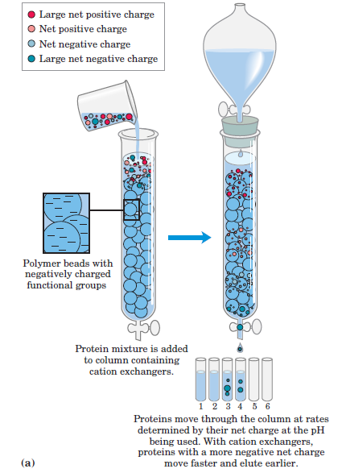
Fig. 5.1: Ion-exchange Chromatography on cation exchanger. Voet &Voet. Biochemistry 4th Edition.

Examples of Ion Exchangers
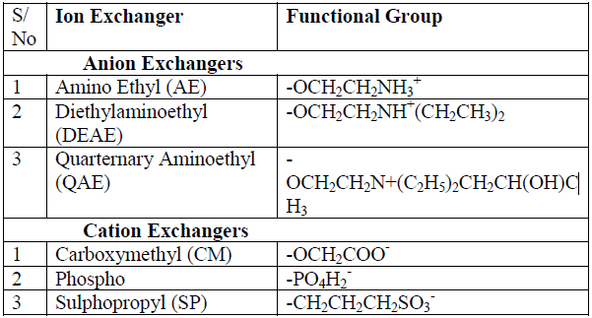
*Carboxymethyl-sephadex, phosphocellulose and DEAE-cellulose are ion exchangers of choice for protein /peptide separation.

- Size-exclusion chromatography: This is also called gel filtration, separates proteins according to size. The column matrix is a cross-linked polymer with pores of selected size. Larger proteins migrate faster than smaller ones, because they are too large to enter the pores in the beads and hence take a more direct route through the column. The smaller proteins enter the pores and are slowed by their more labyrinthine path through the column.
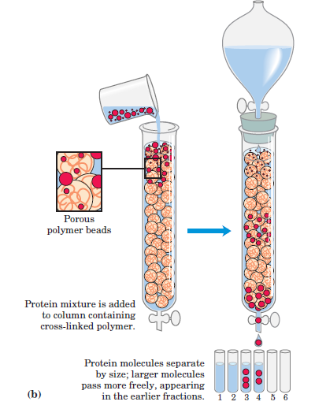
Fig. 5.2: Size-exclusion Chromatography. Voet &Voet. Biochemistry 4th Edition.

- Affinity chromatography: This separates protein by their binding specificities. The proteins retained on the column are those that bind specifically to a ligand cross-linked to the beads. (In biochemistry, the term “ligand” is used to refer to a group or molecule that binds to a macromolecule such as a protein.) After proteins that do not bind to the ligand are washed through the column, the bound protein of interest is eluted (washed out of the column) by a solution containing free ligand.
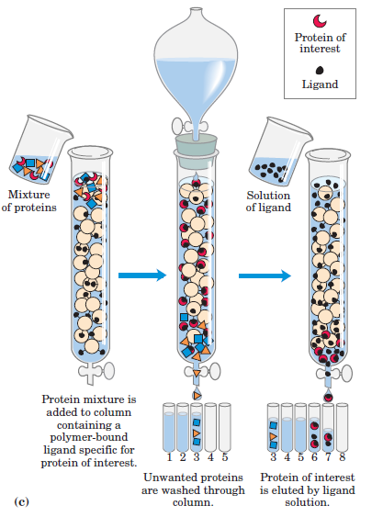
Fig. 5.3: Affinity Chromatography. Voet &Voet. Biochemistry 4th Edition.
Post-Test
- Describe the Steps involved in protein isolation and purification
- What is chromatography? Describe how proteins can be separated by Ion exchange chromatography.
- Give 2 example each of cation exchange and anion exchanger.
- How can a cell be lysed? Define concentration.

Bibliography
- Donald Voet and Judith Voet. Biochemistry 4th Ed.
- Benjamin Cummings. Timberlake General, Organic and Biological Chemistry. Copyright 2007 Pearson Education Inc. publishing.
- Voet D., Voet J.G. and Pratt C. Fundamentals of Biochemistry 5th Ed. John Wiley &Sons, 2016.

LECTURE SIX
CHARACTERIZATION OF PROTEINS
6.0 Introduction:
This lecture focuses on methods of protein characterization. It begins with Electrophoresis which is employed for both purification and characterization of proteins, and further describes other characterization methods.
Objective:
At the end of this lecture, students should be able to:
- Describe the working principle of electrophoresis
- Understand Isoelectric focusing and two-dimensional electrophoresis
- Define spectroscopy and peptide sequencing.
Pre-test
- What is characterization?
- Is Electrophoresis used for quantitative or qualitative determination?
- In electric field, smaller charges migrate slower than bigger charges. True or false?

6.1 METHODS OF PROTEINS CHARACTERIZATION
The methods of protein characterization include:
- Electrophoresis
- Peptide Sequencing
- Tryptic Mapping
- Analytical Ultracentrifugation
- Spectroscopy
- Biosensors
- Mass Spectrometry

6.1.1 Electrophoresis
This is another important technique for the separation of proteins based on the migration of charged proteins in an electric field. These procedures are not generally used to purify proteins in large amounts, because simpler alternatives are usually available and electrophoretic methods often adversely affect the structure and thus the function of proteins. Electrophoresis is, however, especially useful as an analytical method. Its advantage is that proteins can be visualized as well as separated, permitting a researcher to estimate quickly the number of different proteins in a mixture or the degree of purity of a protein preparation. Also, electrophoresis allows determination of crucial properties of a protein such as its isoelectric point and approximate molecular weight.
Electrophoresis of proteins is generally carried out in gels made up of the cross-linked polymer polyacrylamide. The polyacrylamide gel acts as a molecular sieve, slowing the migration of proteins approximately in proportion to their charge-to-mass ratio. Migration may also be affected by protein shape. In electrophoresis, the force moving the macromolecule is the electrical potential, E. The electrophoretic mobility of the molecule, µ, is the ratio of the velocity of the particle molecule, V, to the electrical potential. Electrophoretic mobility is also equal to the net charge of the molecule, Z, divided by the frictional coefficient, f, which reflects in part a protein’s shape.
The migration of a protein in a gel during electrophoresis is therefore a function of its size and its shape.
An electrophoretic method commonly employed for estimation of purity and molecular weight makes use of the detergent sodium dodecyl sulfate (SDS). SDS binds to most proteins in amounts roughly proportional to the molecular weight of the protein, about one molecule of SDS for every two amino acid residues. The bound SDS contributes a large net negative charge, rendering the intrinsic charge of the protein insignificant and conferring on each protein a similar charge-to-mass ratio. In addition, the native conformation of a protein is altered when SDS is bound, and most proteins assume a similar shape. Electrophoresis in the presence of SDS therefore separates proteins almost exclusively based on molecular weight, with smaller polypeptides migrating more rapidly.
After electrophoresis, the proteins are visualized by adding a dye such as Coomassie blue, which binds to proteins but not to the gel itself. Thus, a researcher can monitor the progress of a protein purification procedure as the number of protein bands visible on the gel decreases after each new fractionation step. When compared with the positions to which proteins of known molecular weight migrate in the gel, the position of an unidentified protein can provide an excellent measure of its molecular weight. If the protein has two or more different subunits, the subunits will generally be separated by the SDS treatment and a separate band will appear for each.
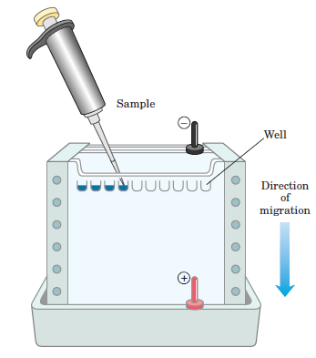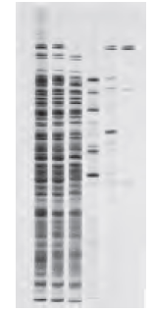
Fig. 6.1: Electrophoresis. Voet &Voet. Biochemistry, 4th edition.
6.1.2 Isoelectric focusing: This is a procedure used to determine the isoelectric point (pI) of a protein. A pH gradient is established by allowing a mixture of low molecular weight organic acids and bases (ampholytes) to distribute themselves in an electric field generated across the gel. When a protein mixture is applied, each protein migrates until it reaches the pH that matches its pI. Proteins with different isoelectric points are thus distributed differently throughout the gel.
Combining isoelectric focusing and SDS electrophoresis sequentially in a process called two-dimensional electrophoresis permits the resolution of complex mixtures of proteins. This is a more sensitive analytical method than either electrophoretic method alone. Two-dimensional electrophoresis separates proteins of identical molecular weight that differ in pI, or proteins with similar pI values but different molecular weights.
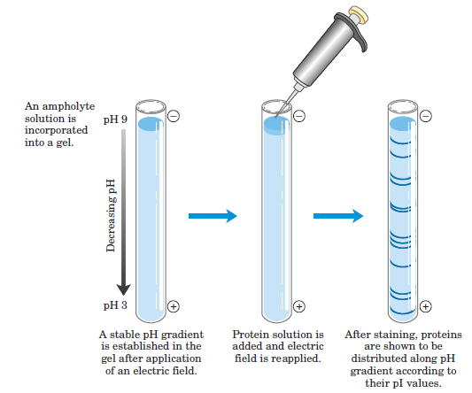
Fig. 6.2 Isoelectric focusing. Voet &Voet. Biochemistry, 4th edition.

The Isoelectric Points of Some Proteins
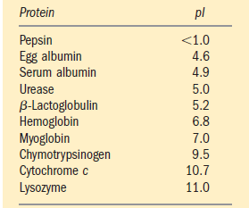

    - Mass spectrometry (MS)
This is a powerful and sensitive technique for separating, identifying, and determining the mass of molecules. It exploits differences in their mass-to-charge (m/z) ratios. In a mass spectrometer, ionized molecules flow through a magnetic field. The magnetic field force deflects the ions depending on their m/z ratios with lighter ions being more deflected from a straight-line path than heavier ions. A detector measures the deflection of each ion. In addition to protein identity and mass determinations, MS is also used to detect bound cofactors and can also detect any important modification (post translational modification) or variation in a protein structure.
Because MS analysis involves the ionization and vaporization of the substances to be investigated, its use in the analysis of thermally unstable macromolecules such as proteins and nucleic acids did not become feasible until methods such as electrospray ionization and matrix-assisted laser desorption ionization (MALDI) had been developed.
    - Peptide Sequencing
- Also known as amino terminal sequencing.
- Used to identify the first few amino acids of the protein.
- This sequence information can be used to confirm the identity of the protein.
- It depends on sequential stepwise removal of N-terminal amino acids by HPLC and then identified by characteristic retention times.
    - Tryptic Mapping
- Small peptides derived from the protein by endoprotease action are separated by high resolution reverse phase HPLC.
- The individual peptides are then subjected to sequencing to confirm the identity of the given peptide.
    - Analytical Ultracentrifugation
- This technique allows measurement of a variety of properties of a protein sample, including solution molecular weight, interaction with other molecules and sample homogeneity.
    - Spectroscopy
- It gives an indication of the fraction of the polypeptide that is composed of specific secondary structural features such as α-helix and β-sheet.
- It is also used for characterizing metal containing protein cofactors.

    - Biosensors
- This is a device used for the detection of protein cells.
- An antibody to a certain protein is immobilized on the sensor surface, addition of sample containing that protein will produce an immediate signal.

Post-Test
- What is the common detergent used in electrophoretic characterization of proteins
- What are the properties that determines protein migration in an electrophoretic field?
- Write a short note on Mass spectrometry
- What are biosensors?
- Briefly describe isoelectric focusing.

Bibliography
- Donald Voet and Judith Voet. Biochemistry 4th Ed.
- Benjamin Cummings. Timberlake General, Organic and Biological Chemistry. Copyright 2007 Pearson Education Inc. publishing.
- Voet D., Voet J.G. and Pratt C. Fundamentals of Biochemistry 5th Ed. John Wiley &Sons, 2016.

LECTURE SEVEN
OXIDATIVE DEGRADATION OF AMINO ACIDS
7.0 Introduction:
This lecture examines the degradation of amino acids starting with Transamination reaction. The role of pyridoxal phosphate in transamination, as well as oxidative deamination and eventual release of Ammonia will be considered.

Objectives:
At the end of the lecture, students should be able to:
- Give an overview of amino acids catabolism
- Describe the reactions leading to release of ammonia in amino acids degradation
- State the diagnostic values of Transaminases.

Pre-Test
- Where are the sites of amino acids absorption and degradation?
- What do you understand by transamination?

7.1 AMINO ACIDS DEGRADATION
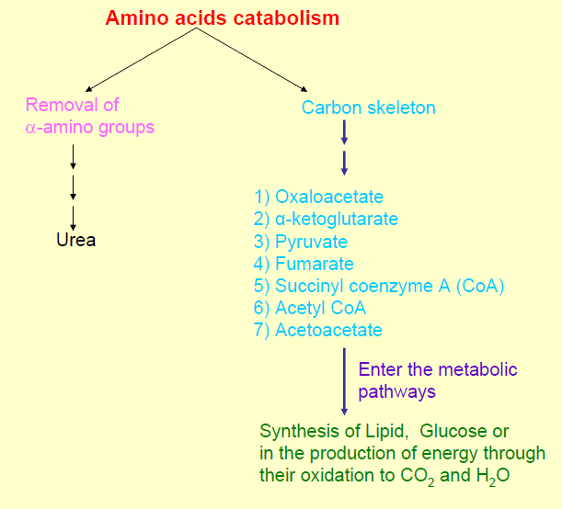

- The α-amino group is transferred to α-ketoglutarate to form glutamate.
- The remaining C skeletons are transformed into major metabolic intermediates.
The major site of amino acid degradation in mammals is the liver, although muscles readily degrade the branched-chain amino acids.
The α-Amino group
- The α-amino group is transferred to α-ketoglutarate to form glutamate.
  - Aminotransferases (also called transaminases) catalyze the tranfer of an α-amino group from an α-amino acid to an α-ketoacid.
- Which is then oxidatively deaminated to yield ammonium ion (NH₄⁺).
  - Some of the ammonium ions are consumed in the biosynthesis of nitrogen compounds.
  - Most of the ammonium ions are converted into urea (by the urea cycle) and then excreted.
The Carbon skeletons
- The C skeletons are transformed into major metabolic intermediates

    - Acetyl CoA
    - Acetoacetyl CoA
    - Pyruvate
    - α-ketoglutarate
    - Succinyl CoA
    - Fumarate
    - Oxaloacetate

These intermediates are converted into glucose or oxidized by the citric acid cycle. Thus, fatty acids, Ketone bodies, and glucose can be formed from amino acids.

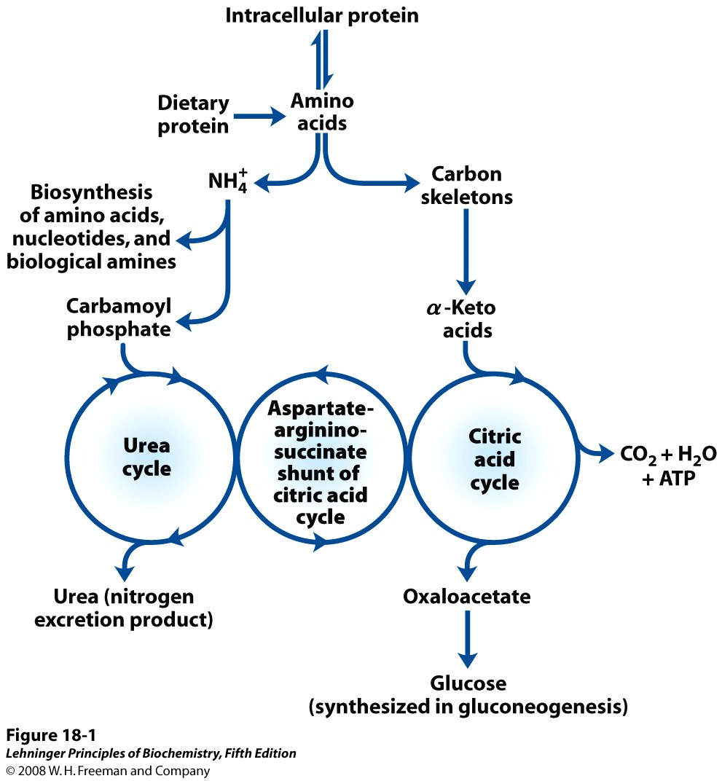
Fig. 7.1: Overview of Amino acids degradation.

- The first step in the catabolism of most L-amino acids, once they have reached the liver, is removal of α -amino groups, promoted by enzymes called aminotransferases or transaminases.

- In these transamination reactions, the α-amino group is transferred to the α carbon atom of α-ketoglutarate, leaving behind the corresponding α-keto acid analog of the amino acid.
- There is no net deamination (loss of amino groups) in these reactions, because the α-ketoglutarate becomes aminated as the α-amino acid is deaminated.
- The effect of transamination reactions is to collect the amino groups from many different amino acids in the form of L-glutamate.
- The glutamate then functions as an amino group donor for biosynthetic pathways or for excretion pathways that lead to the elimination of nitrogenous waste products.
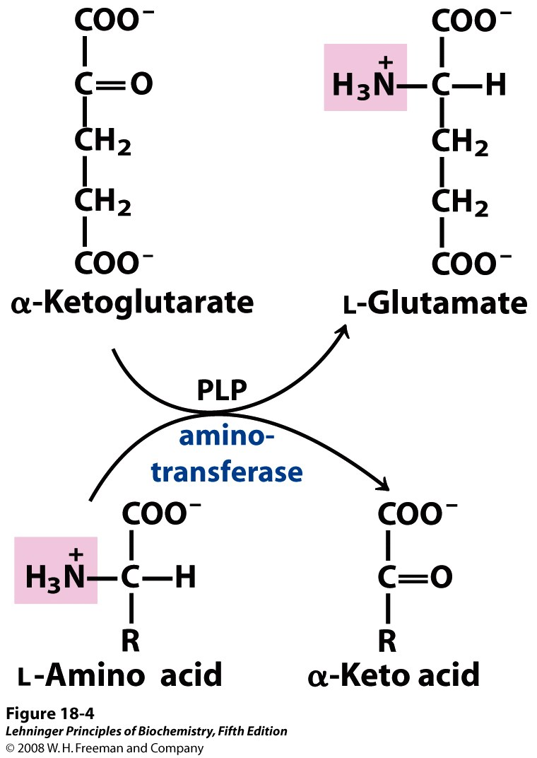
Fig. 7.2: Transamination.

- Cells contain different types of aminotransferases. Many are specific for α-ketoglutarate as the amino group acceptor but differ in their specificity for the L-amino acid. The enzymes are named for the amino group donor (e.g. alanine aminotransferase, aspartate aminotransferase).

- All aminotransferases have the same prosthetic group and the same reaction mechanism. The prosthetic group is pyridoxal phosphate (PLP), the coenzyme form of pyridoxine, or vitamin B6.
7.1.1 Substrate specificity of transaminases:
- Alanine transaminase
  - also called glutamate pyruvate transaminase, GPT
Ala + α-KG pyruvate + Glu
- Aspartate transaminase
  - also called glutamate oxaloacetate transaminase, GOT
Asp + α-KG Oxaloacetate + Glu
7.1.2 Mechanism of action of transaminases:
- All require the cofactor pyridoxal phosphate (a derivative of vitamin B₆)
7.1.3 Diagnostic values of transaminases:
- Transaminases are normally intracellular enzymes. Thus, the presence of elevated levels of transaminase in the serum indicated damage to cells rich in the enzyme.
  - Serum glutamate:oxaloacetate transaminase (SGOT)
  - Serum glutamate;pyruvate transaminase (SGPT)
7.2 Oxidative Deamination; Release of ammonia
The amino groups from many of the α-amino acids are collected in the liver in the form of the amino group of L-glutamate molecules. These amino groups must next be removed from glutamate to prepare them for excretion.
In hepatocytes, glutamate is transported from the cytosol into mitochondria, where it undergoes oxidative deamination catalyzed by glutamate dehydrogenase.
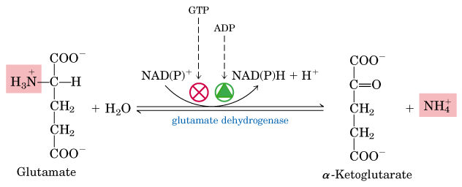
Source: Lehninger Principle of Biochemistry. 5th Edition.

- In mammals, this enzyme is present in the mitochondrial matrix. It is the only enzyme that can use either NAD⁺ or NADP⁺ as the acceptor of reducing equivalents.
- The combined action of an aminotransferase and glutamate dehydrogenase is referred to as trans deamination.
The sum of the reactions catalyzed by aminotransferases and glutamate dehydrogenase:
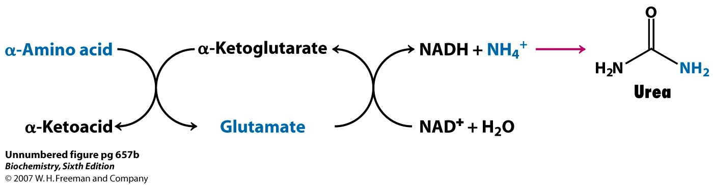

NOTE: A few amino acids bypass the trans-deamination pathway and undergo direct oxidative deamination. For example, Serine and Threonine can be directly deaminated.
- Their deamination is catalyzed by Serine dehydratase and Threonine dehydratase respectively.

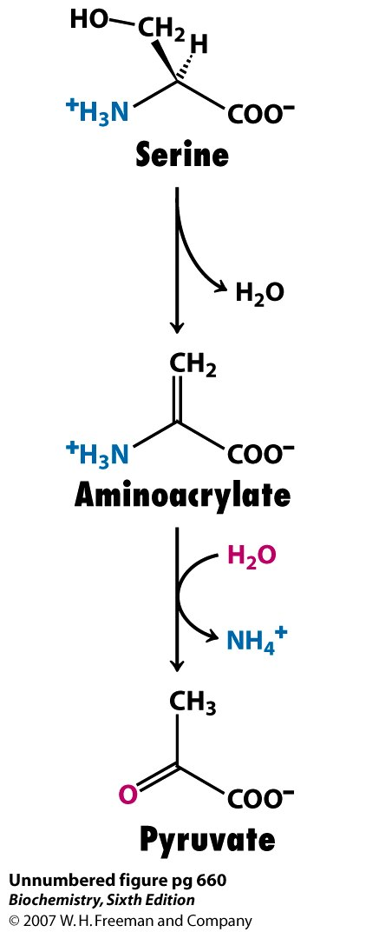

- The α-ketoglutarate formed from glutamate deamination can be used in the citric acid cycle and for glucose synthesis.
7.3 Ammonia Transport to the liver
RECALL:
- α-amino groups are converted into ammonium ions by the oxidative deamination of glutamate.
- NH₄⁺ is very toxic.
- The liver, where most of the amino acid degradation takes place, uses the urea cycle to convert NH₄⁺ into urea which is then excreted from the body.
How is NH₄⁺ carried to liver?
- Glutamine carries ammonia to the liver.
- Alanine carries ammonia from muscles to the liver by Alanine (glucose-alanine) cycle.
7.3.1 Glutamine and Ammonia Transport in the Bloodstream
- Ammonia is quite toxic to animal tissues, and the levels present in blood are regulated.
- In many tissues, including the brain, some processes such as nucleotide degradation generate free ammonia. In most animals much of the free ammonia is converted to a nontoxic compound before export from the extrahepatic tissues into the blood and transport to the liver or kidneys.
- For this transport function, glutamate, critical to intracellular amino group metabolism, is supplanted by L-glutamine. The free ammonia produced in tissues is combined with glutamate to yield glutamine by the action of glutamine synthetase.
- This reaction requires ATP and occurs in two steps:
- First, glutamate and ATP react to form ADP and a Ƴ-glutamyl phosphate intermediate, which then reacts with ammonia to produce glutamine and inorganic phosphate.
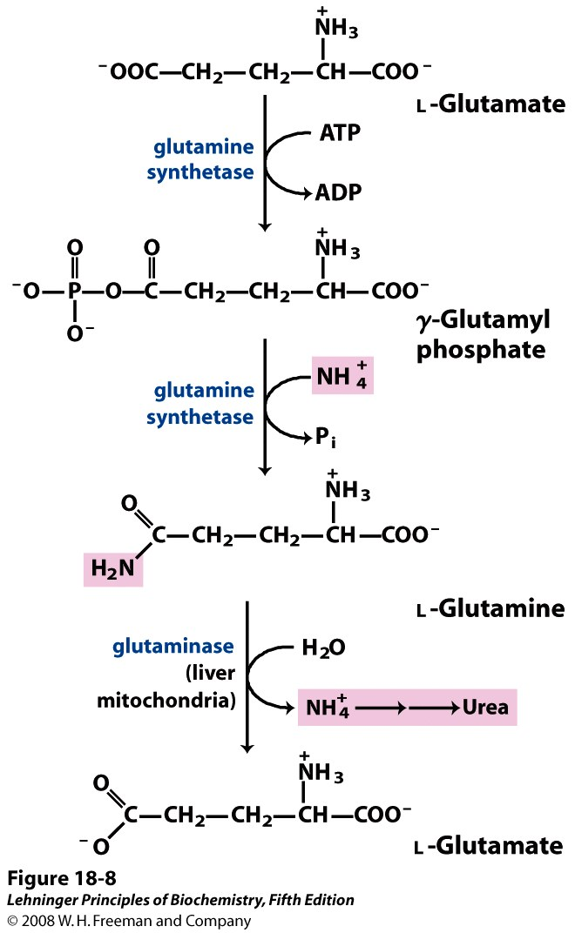
- Glutamine is a nontoxic transport form of ammonia; it is normally present in blood in much higher concentrations than other amino acids. Glutamine also serves as a source of amino groups in a variety of biosynthetic reactions. Glutamine synthetase is found in all organisms, always playing a central metabolic role. In microorganisms, the enzyme serves as an essential portal for the entry of fixed nitrogen into biological systems.
- In most terrestrial animals, excess glutamine (than required for biosynthesis) is transported in the blood to the intestine, liver, and kidneys for processing. In these tissues, the amide nitrogen is released as ammonium ion in the mitochondria, where the enzyme glutaminase converts glutamine to glutamate and NH₄⁺.
- The NH₄⁺ from intestine and kidney is transported in the blood to the liver. In the liver, the ammonia from all sources is disposed of by urea synthesis.
- Some of the glutamate produced in the glutaminase reaction may be further processed in the liver by glutamate dehydrogenase, releasing more ammonia and producing carbon skeletons for metabolic fuel. However, most glutamate enters the transamination reactions required for amino acid biosynthesis and other processes.
- In metabolic acidosis, there is an increase in glutamine processing by the kidneys. Not all the excess NH₄⁺ thus produced is released into the bloodstream or converted to urea; some is excreted directly into the urine. In the kidney, the NH₄⁺ forms salts with metabolic acids, facilitating their removal in the urine. Bicarbonate produced by the decarboxylation of α-ketoglutarate in the citric acid cycle can also serve as a buffer in blood plasma. Taken together, these effects of glutamine metabolism in the kidney tend to counteract acidosis.
7.3.2 Glucose-Alanine Cycle (alanine cycle)

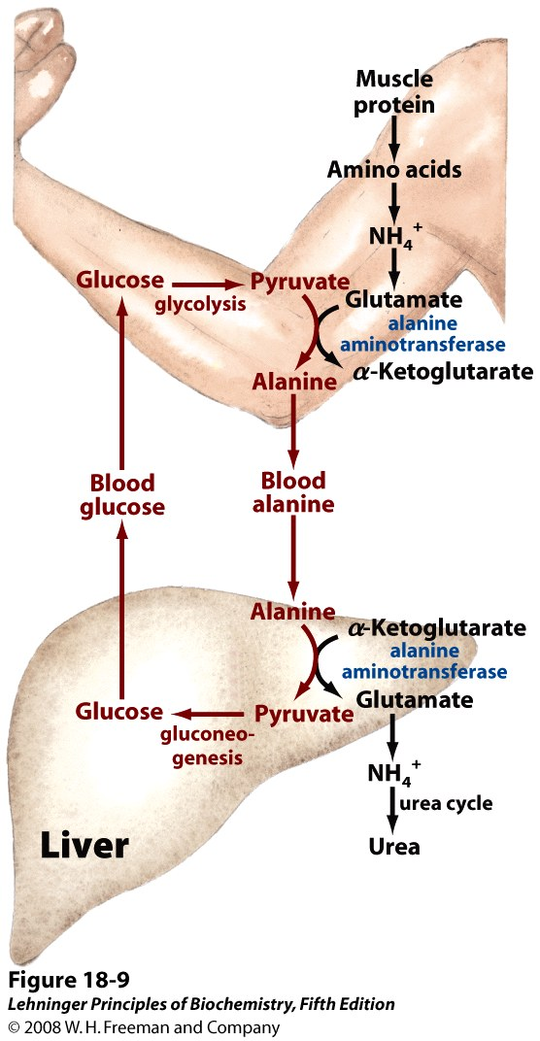

Post Test
- Explain Trans-deamination reaction.
- State the importance of pyridoxal phosphate in amino acid degradation.
- What are the clinical importance of Transaminases.
- Describe the reactions by which ammonia is released and its transport to the liver.

Bibliography
- Lehninger Principle of Biochemistry. 5th and 6th Edition. W.H Freeman and Company
- Voet D., Voet J.G. and Pratt C. Fundamentals of Biochemistry 5th Ed. John Wiley &Sons, 2016.
- Berg J.M., Tymoczko J.L., and Stryer L. Biochemistry 7th Ed. by W.H. Freeman and Company 2012.
- Shyamal D. Desai. Amino acid Synthesis and degradation, sdesai@lsuhsc.edu.

LECTURE EIGHT
NITROGEN EXCRETION AND UREA CYCLE
8.0 Introduction
This lecture examines on how Ammonia is excreted in various organism with major focus on urea synthesis and regulation. The interconnection of urea cycle and TCA cycle will be elucidated.

Objectives
At conclusion of this lecture, students should be able to:
- State the various forms by which amino Nitrogen are excreted from organisms.
- Describe the reactions of the urea cycle and enzymes involved
- Explain how urea cycle is regulated.
- Explain how the urea cycle is interconnected with the TCA cycle

Pre-Test
- How is toxic ammonia excreted from the body?
- Where is the site of urea synthesis in humans?

8.1 EXCRETION OF AMINO NITROGEN
- If not reused for the synthesis of new amino acids or other nitrogenous products, amino groups are channeled into a single excretory end product called urea.
- Most aquatic species, such as the bony fishes, are ammonotelic, excreting amino nitrogen as ammonia. The toxic ammonia is simply diluted in the surrounding water.
- Terrestrial animals require pathways for nitrogen excretion that minimize toxicity and water loss. Most terrestrial animals are ureotelic, excreting amino nitrogen in the form of urea
- Birds and reptiles are uricotelic, excreting amino nitrogen as uric acid.
- Plants recycle virtually all amino groups, and nitrogen excretion occurs only under very unusual circumstances.
- In ureotelic organisms, the ammonia deposited in the mitochondria of hepatocytes is converted to urea in the urea cycle. This pathway was discovered in 1932 by Hans Krebs (who later also discovered the citric acid cycle) and a medical student associate, Kurt Henseleit.
- Urea production occurs almost exclusively in the liver and it is the fate of most of the ammonia channeled there.
The urea passes through the bloodstream to the kidneys and is excreted in the urine.
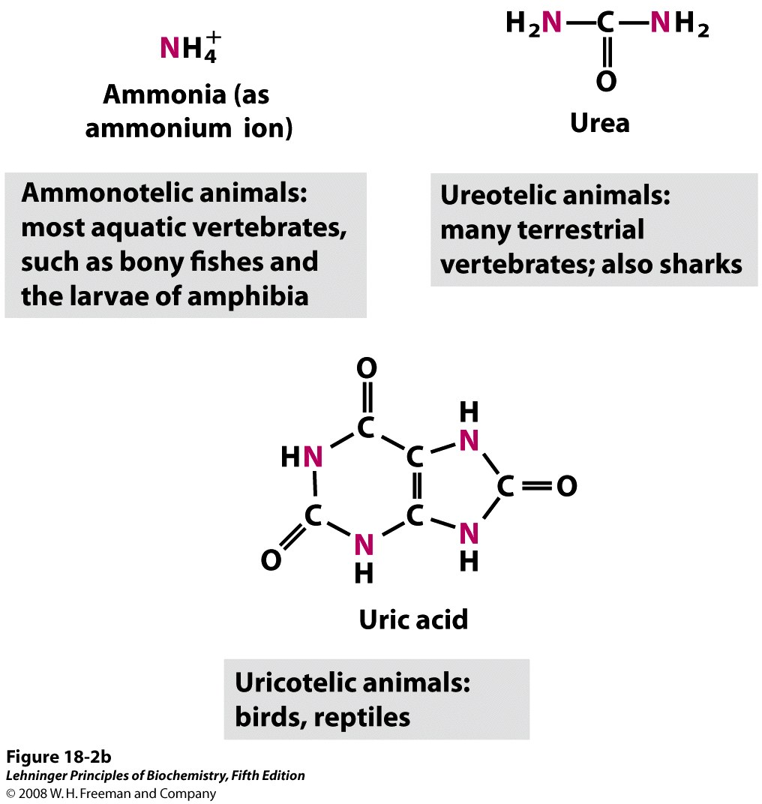

8.2 BIOSYNTHESIS OF UREA
- Urea is the major end product in Nitrogen metabolism in humans and mammals.
- NH3, the product of oxidative deamination reaction, is toxic in even small amount and must be removed from the body.
- Urea cycle a.k.a Ornithine cycle is the conversion reactions of NH3 into urea.
Urea is produced from Ammonia in five enzymatic steps:
- The urea cycle begins inside liver mitochondria, but three of the subsequent steps take place in the cytosol; the cycle thus spans two cellular compartments.
- The first amino group to enter the urea cycle is derived from ammonia in the mitochondrial matrix.
- The NH₄⁺ generated in liver mitochondria is immediately used, together with CO₂ (as HCO₃⁻ ) produced by mitochondrial respiration, to form carbamoyl phosphate in the matrix.
- This ATP-dependent reaction is catalyzed by carbamoyl phosphate synthetase I, a regulatory enzyme.
- The mitochondrial form of the enzyme is distinct from the cytosolic (II) form, which has a separate function in pyrimidine biosynthesis.
- The carbamoyl phosphate, which functions as an activated carbamoyl group donor, now enters the urea cycle. The cycle has four enzymatic steps.
    - Steps in Urea Cycle
- Synthesis of carbamoyl phosphate:
Carbamoyl phosphate synthase I (CPS l) of mitochondria catalyzes the condensation of NH⁴ ⁺ ions with CO₂ to form carbamoyl phosphate. This step consumes 2 ATP and is irreversible, and rate-limiting. CPS I requires N-acetylglutamate for its activity.
Another enzyme, carbamoyl phosphate synthase ll (CPS ll)- involved in pyrimidine synthesis-is present in cytosol. lt accepts amino group from glutamine and does not require N-acetylglutamate for its activity.
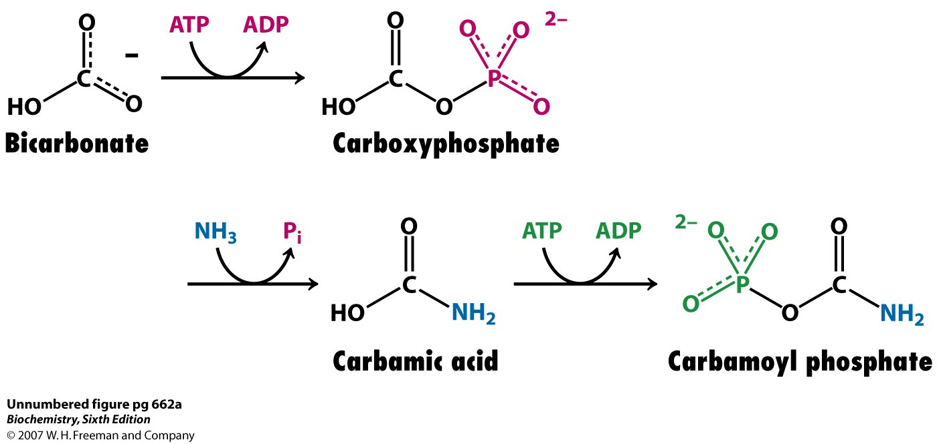
Formation of carbamoyl phosphate:
- Enzyme: carbamoyl phosphate synthetase
- Place: mitochondria
- 2 ATP are used.

2. Formation of citrulline:
Carbamoyl phosphate donates its carbamoyl group to ornithine to form citrulline, with the release of Pi. Ornithine plays a role resembling that of oxaloacetate in the citric acid cycle, accepting material at each turn of the cycle. The reaction is catalyzed by ornithine Transcarbamoylase.
Ornithine and citrulline are basic amino acids (but they are never found in protein structure due to lack of codons). Citrulline produced in this reaction is transported to cytosol by a transporter system.
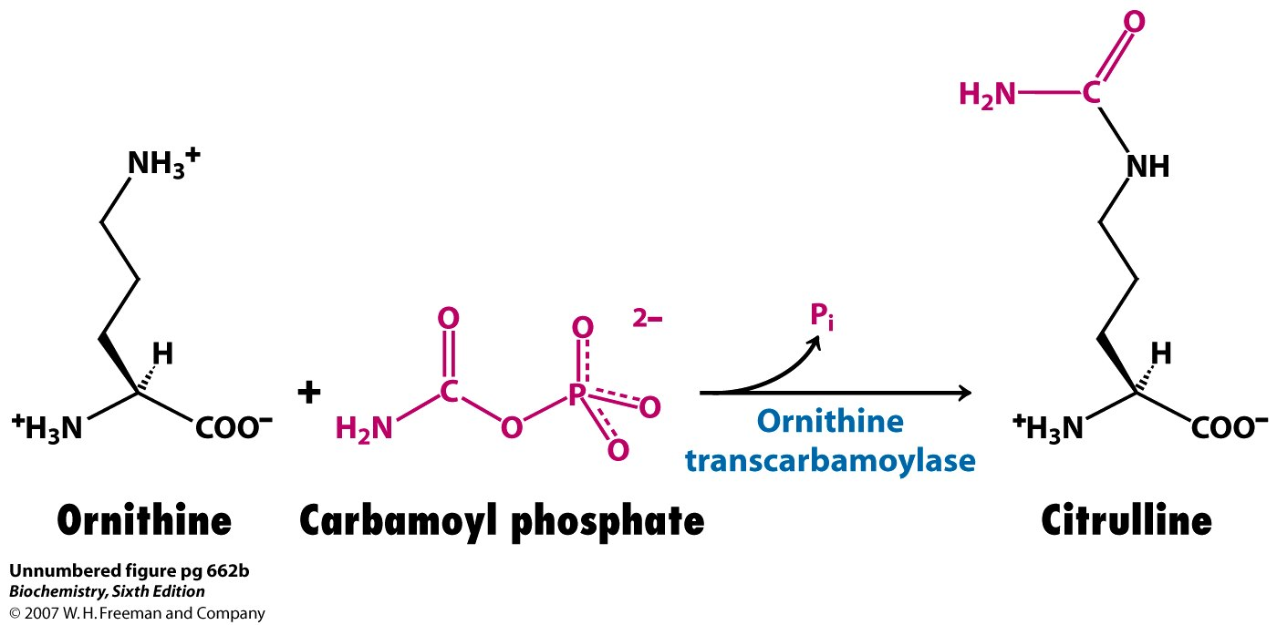
Formation of citrulline:
- Enzyme: ornithine transcarbamoylase
- Place: mitochondria
- No ATP is used.

3. Synthesis of arginosuccinate:
Arginosuccinate synthase condenses citrulline with aspartate to produce arginosuccinate.
The second amino group of urea is incorporated in this reaction. This step requires ATP which is cleaved to AMP and pyrophosphate (PPi). The latter is immediately broken down to inorganic phosphate (Pi).
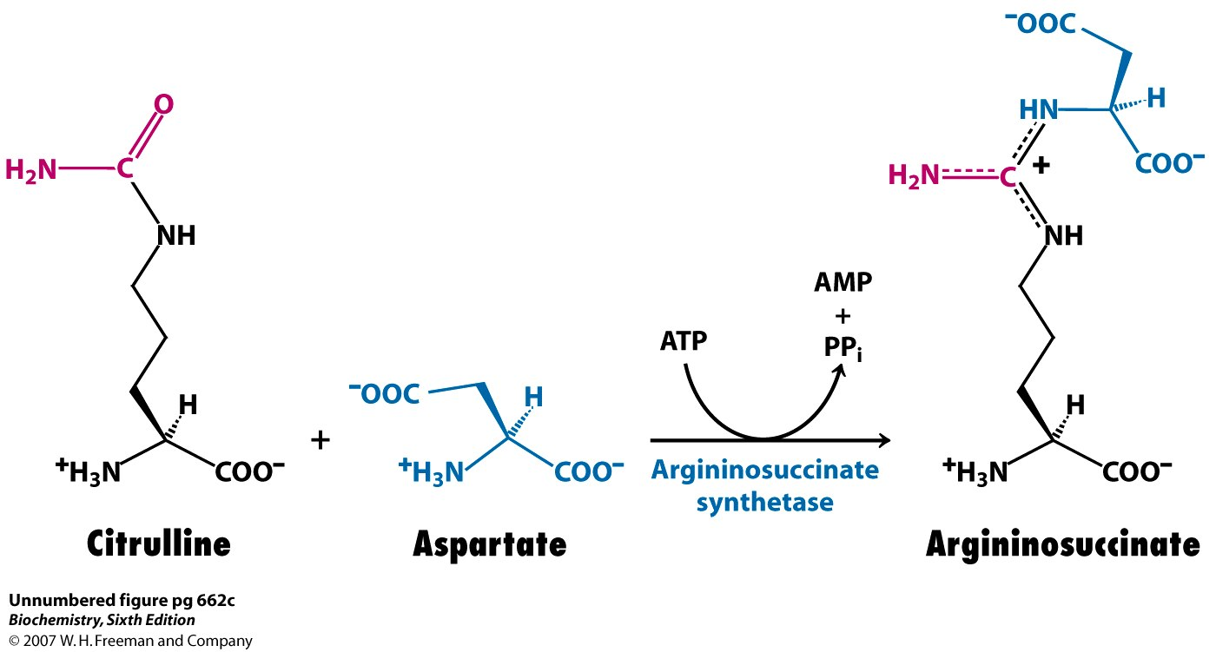
Synthesis of argininosuccinate:
- Enzyme: argininosuccinate synthetase
- Place: Cytosol
- 1 ATP is used.

4. Cleavage of arginosuccinate:
Arginosuccinase cleaves arginosuccinate to give arginine and fumarate. Arginine is the immediate precursor for urea. Fumarate enters the mitochondria to join the pool of citric acid cycle intermediates. Thus, providing a connecting link with TCA cycle, gluconeogenesis etc. This is the only reversible step in the urea cycle.
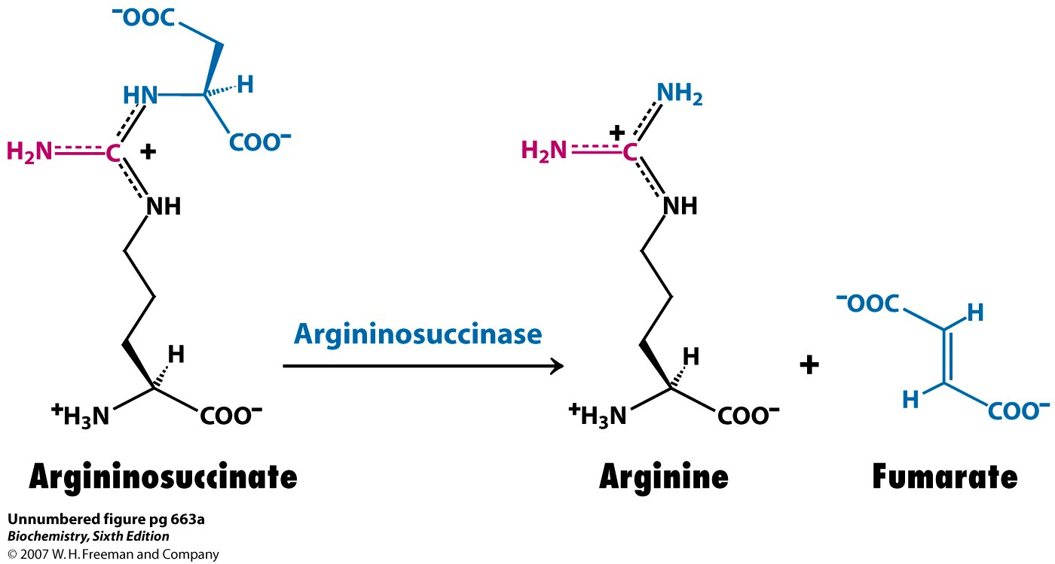
Cleavage of argininosuccinate:
- Enzyme: argininosuccinase
- Place: cytosol
- No ATP is used.

5. Formation of urea:
In the last reaction of the urea cycle, the cytosolic enzyme arginase cleaves arginine to yield urea and ornithine. Ornithine is transported into the mitochondrion to initiate another round of the urea cycle.
Arginase is activated by Co²⁺ and Mn²⁺. Ornithine and lysine compete with arginine (competitive inhibition).
Note: Five enzymes took part in the formation of urea. Out of these the first four are found in all cells. But the last enzyme arginase is found only in the liver cells. For this reason, Arginine synthesis may occur to varying degrees in many tissues. But only the liver can ultimately produce urea.
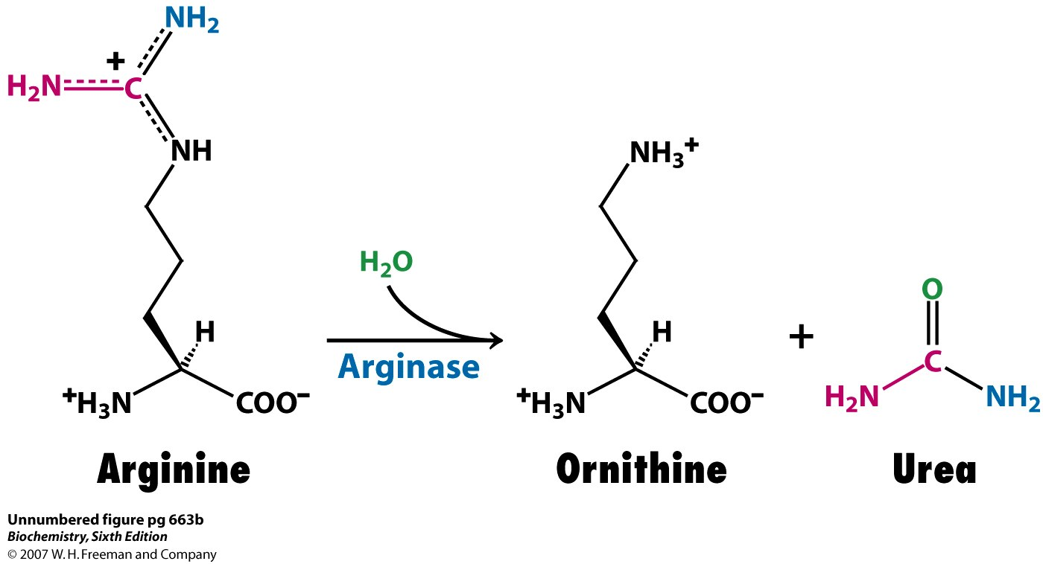
Cleavage of arginine to ornithine and urea
- Enzyme: arginase
- Place: cytosol
- No ATP is used
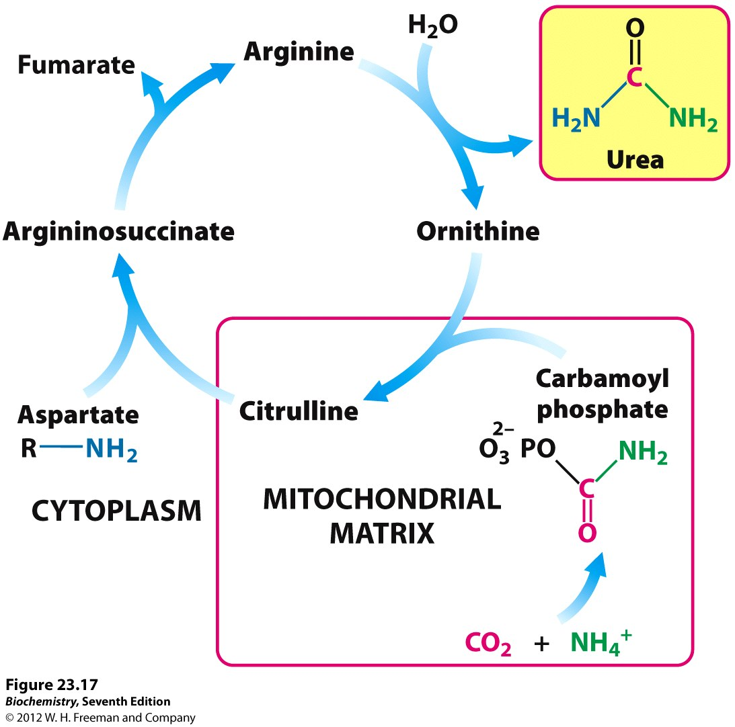
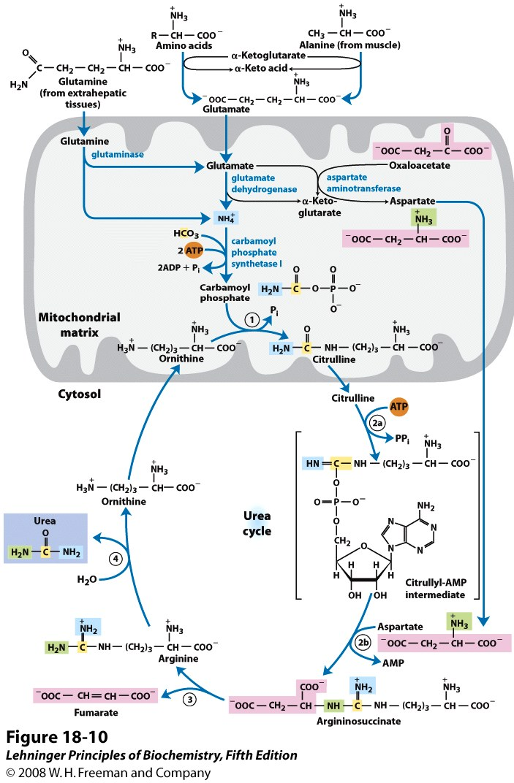
Fig.: The Urea Cycle.

NOTE:
- The enzymes of many metabolic pathways are usually clustered, with the product of one enzyme reaction being channeled directly to the next enzyme in the pathway.
- In the urea cycle, the mitochondrial and cytosolic enzymes appear to be clustered in this way. The citrulline transported out of the mitochondrion is not diluted into the general pool of metabolites in the cytosol but is passed directly to the active site of argininosuccinate synthetase.
- This channeling between enzymes continues for argininosuccinate, arginine, and ornithine. Only urea is released into the general cytosolic pool of metabolites.

    - Interconnectivity between Urea Cycle and Citric Acid Cycle
- Because the fumarate produced in the Argininosuccinase reaction is also an intermediate of the citric acid cycle, the cycles are, in principle, interconnected. However, each cycle can operate independently and communication between them depends on the transport of key intermediates between the mitochondrion and cytosol.
- Several enzymes of the citric acid cycle, including fumarase (fumarate hydratase) and malate dehydrogenase, are also present as isozymes in the cytosol.
- The fumarate generated in cytosolic arginine synthesis can therefore be converted to malate in the cytosol, and these intermediates can be further metabolized in the cytosol or transported into mitochondria for use in the citric acid cycle.
- Aspartate formed in mitochondria by transamination between oxaloacetate and glutamate can be transported to the cytosol, where it serves as nitrogen donor in the urea cycle reaction catalyzed by argininosuccinate synthetase. These reactions, making up the aspartate-argininosuccinate shunt, provide metabolic links between the separate pathways by which the amino groups and carbon skeletons of amino acids are processed.
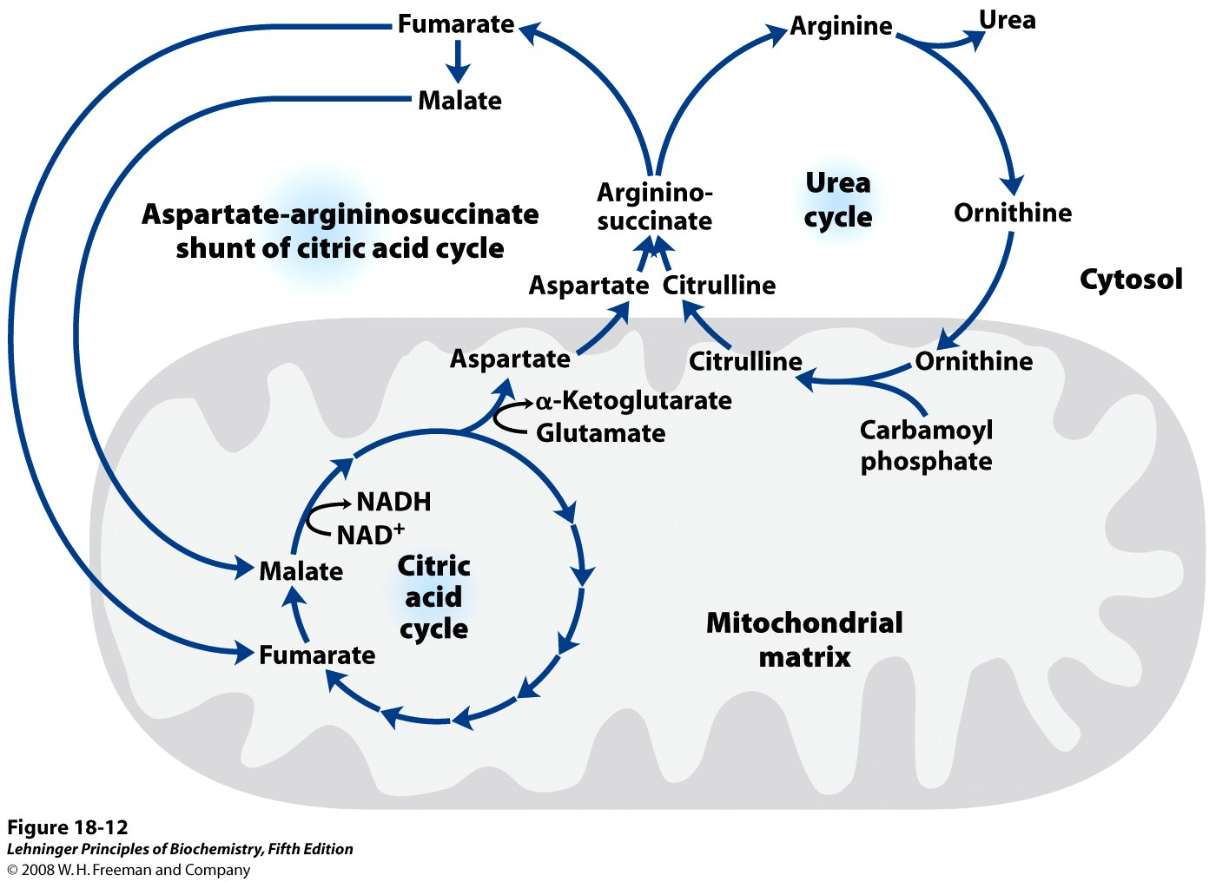
8.2.3 Pathway Interconnections Reduce the Energetic Cost of Urea Synthesis
If we consider the urea cycle in isolation, we see that the synthesis of one molecule of urea requires four high energy phosphate groups. Two ATP molecules are required to make carbamoyl phosphate, and one ATP to make arginosuccinate—the latter ATP undergoing a pyrophosphate cleavage to AMP and PPi, which is hydrolyzed to two Pi. The overall equation of
the urea cycle is:
2NH4⁺ + HCO₃ ⁻ + 3ATP⁴⁻ + H₂O urea + 2ADP + 4Pi + AMP+ 2H⁺
However, the urea cycle also causes a net conversion of oxaloacetate to fumarate (via aspartate), and the regeneration of oxaloacetate produces NADH in the malate dehydrogenase reaction. Each NADH molecule can generate 3 ATP during mitochondrial respiration, greatly reducing the overall energetic cost of urea synthesis.

8.2.4 Rate Limiting Steps of Urea cycle
The conversion of ammonium ions to carbamoyl phosphate catalyzed by carbamoyl synthetase I is a rate limiting step. This enzyme (carbamoyl synthetase I) gets activated by N-acetylglutamate (NAG) which is formed by reaction between acetyl CoA and glutamate catalyzed by the enzyme N-acetylglutamate synthase (activated by arginine). Thus, concentrations of glutamate and acetyl CoA as well as levels of arginine determine the steady state levels of N-acetylglutamate (NAG) which in turn regulates the concentration of urea. When a high protein diet is consumed, levels of NAG increases and in turn urea levels increase. Also during starvation, when muscle proteins start breaking down to source out energy, urea levels increase in response. The rest all enzymes participating in the urea cycle are mostly regulated by the concentrations of their respective substrates.
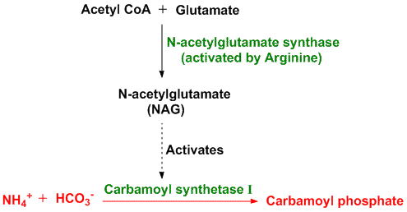
Also, the flux of nitrogen through the urea cycle in an individual animal varies with diet. When the dietary intake is primarily protein, the carbon skeletons of amino acids are used for fuel, producing much urea from the excess amino groups. During prolonged starvation, when breakdown of muscle protein begins to supply much of the organism’s metabolic energy, urea production also increases substantially.
These changes in demand for urea cycle activity are met over the long term by regulation of the rates of synthesis of the four urea cycle enzymes and carbamoyl phosphate synthetase I in the liver. All five enzymes are synthesized at higher rates in starving animals and in animals on very-high-protein diets than in well-fed animals eating primarily carbohydrates and fats. Animals on protein-free diets produce lower levels of urea cycle enzymes.

Post-Test
- What are the various forms by which amino nitrogen are excreted?
- Describe the reactions of urea synthesis in mammals.
- Explain how urea cycle is regulated.

Bibliography
- Lehninger Principle of Biochemistry. 5th and 6th Edition. W.H Freeman and Company
- Voet D., Voet J.G. and Pratt C. Fundamentals of Biochemistry 5th Ed. John Wiley &Sons, 2016.
- Berg J.M., Tymoczko J.L., and Stryer L. Biochemistry 7th Ed. by W.H. Freeman and Company 2012.
- Shyamal D. Desai. Amino acid Synthesis and degradation, sdesai@lsuhsc.edu.

LECTURE NINE
METABOLIC FATES OF CARBON SKELETON
9.0 Introduction:
This lecture focuses what happens to the carbon Skeleton of amino acids after the amino group has been removed.

9.1 FATES OF CARBON SKELETON
- The carbon skeletons of amino acids are broken down into metabolites that can either be oxidized into CO₂ and H₂O to generate ATP, or can be used for gluconeogenesis.
- The catabolism of amino acids accounts for 10 to 15% of the human body’s energy production.
- Each of the 20 amino acids has a separate catabolic pathway, yet all 20 pathways converge into 5 intermediates, all of which can enter the citric acid cycle. From the citric acid cycle the carbon skeletons can be completely oxidized into CO₂ or diverted into gluconeogenesis or ketogenesis.
- Glucogenic amino acids are broken down into one of the following metabolites: pyruvate, α-ketoglutarate, succinyl CoA, fumarate or oxaloacetate. Ketogenic amino acids are broken down into acetoacetate or acetyl-CoA.
- Larger amino acids, tryptophan, phenylalanine, tyrosine, isoleucine and threonine are both glucogenic and ketogenic.
- Only 2 amino acids are purely ketogenic they are lysine and leucine.
- If 2 of the amino acids are purely ketogenic and 5 amino acids are both ketogenic and glucogenic, then that leaves 13 amino acids that are purely glucogenic: Arg, Glu, Gln, His, Pro, Val, Met, Asp, Asn,Ala, Ser, Cys, and Gly.

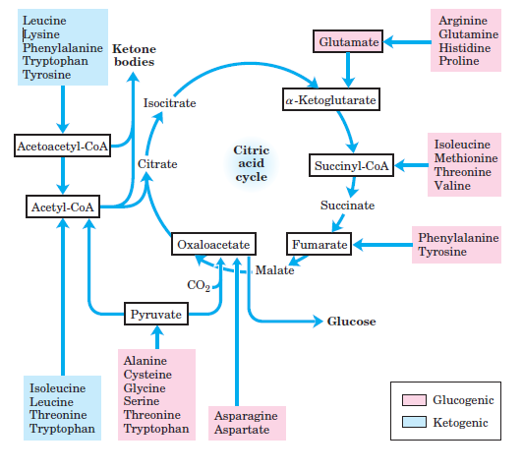
Fig.: Fates of Carbon Skeleton. Lehninger Principles pf Biochemistry. 6th Edition.

Post-Test
- Give 4 Example each of Glucogenic and Ketogenic Aminoacids and state their corresponding point of entrance into TCA cycle.

Bibliography
- Lehninger Principle of Biochemistry. 5th and 6th Edition. W.H Freeman and Company
- Berg J.M., Tymoczko J.L., and Stryer L. Biochemistry 7th Ed. by W.H. Freeman and Company 2012.
- Shyamal D. Desai. Amino acid Synthesis and degradation, sdesai@lsuhsc.edu.

LECTURE TEN
BIOSYNTHESIS OF AMINO ACIDS AND SOME DERIVATIVES

10.0 Introduction
This lecture focuses on pathways of biosynthesis of Non-essential and Essential Amino acids, and some amino acid derivatives including Cathecolamines, Serotonin, Histamine e.t.c. The pathway of creatinine metabolism and its importance was also considered.

Pre-Test
- Differentiate between Essential and Non-Essential Amino acids with examples.
- Which amino acid is a precursor for Histamine?

10.1 BIOSYNTHESIS OF AMINO ACIDS
Most microorganisms such as E. coli can synthesize the entire basic set of 20 amino acids, whereas human beings cannot make 9 of them. The amino acids that must be supplied in the diet are called essential amino acids, whereas the others are termed nonessential amino acids.
These designations refer to the needs of an organism under a particular set of conditions. For example, enough arginine is synthesized by the urea cycle to meet the needs of an adult but perhaps not those of a growing child. A deficiency of even one amino acid results in a negative nitrogen balance. In this state, more protein is degraded than is synthesized, and so more nitrogen is excreted than is ingested.
Non-essential amino acids are synthesized from intermediates of metabolism or, from essential amino acids.
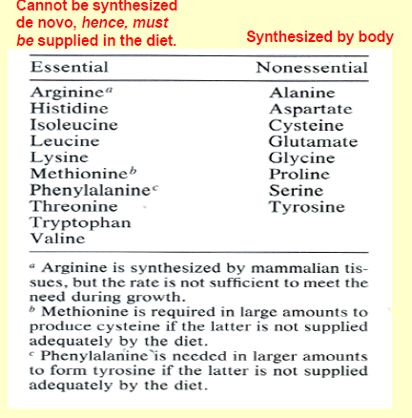

10.1.1. Synthesis from α-ketoacids:
- The three α-ketoacids: α-ketoglutarate, oxaloacetate, and pyruvate can be converted into amino acids in one step through the addition of an amino group.
- α-ketoglutarate can be converted into glutamate by reductive amination. The amino group from glutamate can be transferred to other α-ketoacids by transamination reactions. Thus, aspartate and alanine can be made from the addition of an amino group to oxaloacetate and pyruvate, respectively.
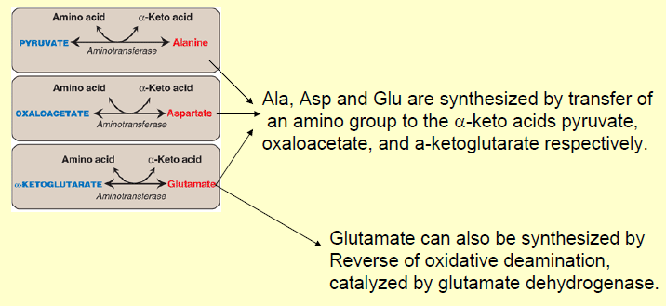
*These reactions are catalyzed by pyridoxal phosphate-dependent transaminases. Transamination reactions participate in the synthesis of most amino acids.
Source: Shyamal D. Desai. Amino acid Synthesis and degradation, sdesai@lsuhsc.edu.
10.1.2. Glutamate Is the Precursor of Glutamine, Proline, and Arginine:
Glutamate act as the precursor of two other non-essential amino acids: proline and arginine (partially non-essential).
First, the γ-carboxyl group of glutamate reacts with ATP to form an acyl phosphate. This mixed anhydride is then reduced by NADPH to an aldehyde.
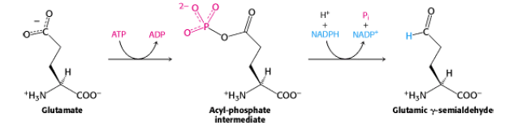
Glutamic γ -semialdehyde cyclizes with a loss of H₂O in a non-enzymatic process to give Δ¹- pyrroline-5-carboxylate, which is reduced by NADPH to proline.
Alternatively, the semialdehyde can be transaminated to ornithine, which is converted in several steps into arginine.
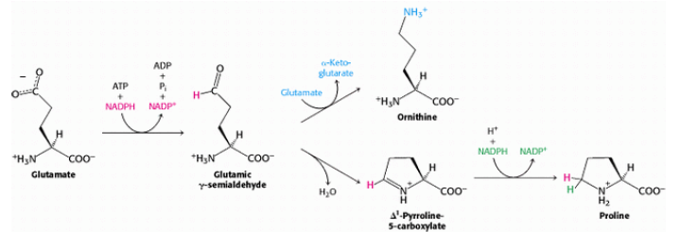
10.1.3. Serine, Cysteine, and Glycine are synthesized from glycolysis 3-Phosphoglycerate:
Serine is synthesized from 3-phosphoglycerate, an intermediate in glycolysis. The first step is an oxidation to 3- phosphohydroxypyruvate. This α-ketoacid is transaminated to 3-phosphoserine, which is then hydrolyzed to serine.

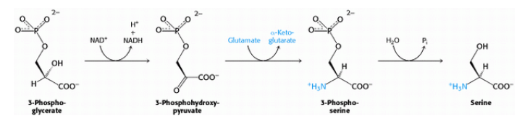
In the formation of glycine, the side-chain methylene group of serine is transferred to tetrahydrofolate, a carrier of one-carbon units.
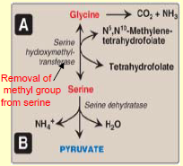
Source: Shyamal D. Desai. Amino acid Synthesis and degradation, sdesai@lsuhsc.edu.
10.1.4. Cysteine is synthesized by two consecutive reactions:
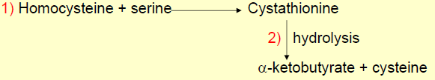
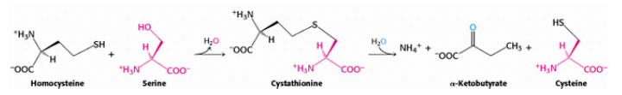
10.2 BIOSYNTHESIS OF ESSENTIAL AMINO ACIDS
Essential amino acids are synthesized by plants and microorganisms, and those in the human diet are ultimately derived primarily from plants.
The essential amino acids are formed by much more complex routes than are the nonessential amino acids. The pathways for the synthesis of aromatic amino acids in bacteria are well understood and exemplify recurring mechanistic motifs. Phenylalanine, tyrosine, and tryptophan are synthesized by a common pathway in E. coli.
The initial step is the condensation of phosphoenolpyruvate (a glycolytic intermediate) with erythrose 4-phosphate (a pentose phosphate pathway intermediate). The resulting seven-carbon open-chain sugar is oxidized, loses its phosphoryl group, and cyclizes to 3-dehydroquinate. Dehydration then yields 3-dehydroshikimate, which is reduced by NADPH to shikimate.
Phosphorylation of shikimate by ATP gives shikimate 3-phosphate, which condenses with a second molecule of phosphoenolpyruvate. This 5-enolpyruvyl intermediate loses its phosphoryl group, yielding chorismate, the common precursor of all three aromatic amino acids.
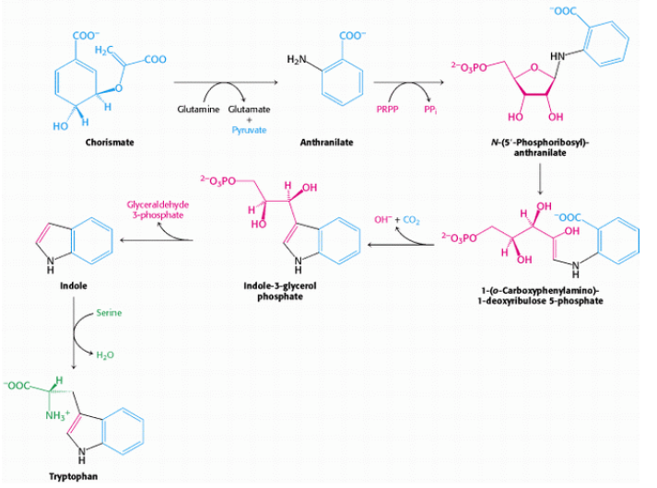
Figure: Synthesis of Tryptophan. Source: Biochemistry. 5th edition. Berg JM, Tymoczko JL, Stryer L. New York: W H Freeman; 2002.
Note: The importance of this pathway is revealed by the effectiveness of glyphosate (Roundup), a broad-spectrum herbicide. This compound inhibits the enzyme that produces 5- enolpyruvylshikimate 3-phosphate and, hence, blocks aromatic amino acid biosynthesis in plants. Because animals lack this enzyme, the herbicide is fairly nontoxic.
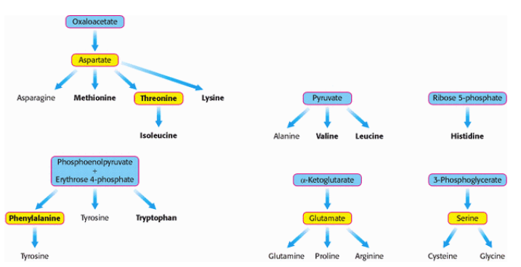
Figure: Biosynthetic Families of Amino Acids in Bacteria and Plants. Major metabolic precursors are shaded blue. Amino acids that give rise to other amino acids are shaded yellow. Essential amino acids are in boldface type. Source: Biochemistry. 5th edition. Berg JM, Tymoczko JL, Stryer L. New York: W H Freeman; 2002.
10.3 BIOSYNTHESIS OF AMINO ACIDS DERIVATIVES
In addition to being the building blocks of proteins and peptides, amino acids serve as precursors of many kinds of small molecules that have important and diverse biological roles.
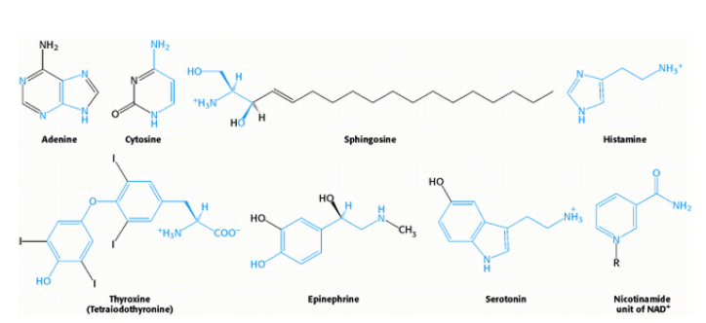
Figure: Selected Biomolecules Derived from Amino Acids. The atoms contributed by amino acids are shown in blue. Source: Biochemistry. 5th edition. Berg JM, Tymoczko JL, Stryer L.
    - Tyrosine-Derived Neurotransmitters / Hormones
Much of the tyrosine that does not get incorporated into proteins is catabolized for energy production. Another significant fate of tyrosine is conversion to the catecholamines. The catecholamines are dopamine, norepinephrine, and epinephrine. All three catecholamines exert effects in numerous locations in the body as either a neurotransmitter or as a hormone. Within the central and peripheral nervous systems (CNS and PNS, respectively) the catecholamines exert their effects as neurotransmitters, in the periphery they do so as hormones. Tyrosine is transported into catecholamine-secreting neurons and adrenal medullary cells where catecholamine synthesis takes place.
The first step in the process requires tyrosine hydroxylase which, like phenylalanine hydroxylase (of tyrosine synthesis), requires tetrahydrobiopterin (H₄B, or written as BH₄) as cofactor. The tyrosine hydroxylase reaction represents the rate-limiting reaction of catecholamine biosynthesis. The dependence of tyrosine hydroxylase on H₄B necessitates the coupling to the action of dihydropteridine reductase (DHPR) as is the situation for phenylalanine hydroxylase and tryptophan hydroxylase.
The product of the tyrosine hydroxylase reaction is 3,4-dihydrophenylalanine (L-DOPA; more commonly just DOPA). The enzyme DOPA decarboxylase then converts DOPA to dopamine. The enzyme dopamine β-hydroxylase then converts dopamine to norepinephrine. Dopamine β-hydroxylase is a major vitamin C and copper (Cu²⁺)-dependent enzyme whose activity is negatively affected in Menkes disease.
The last step of catecholamine biosynthesis is the conversion of norepinephrine to epinephrine which involves a methylation reaction. The enzyme phenylethanolamine N-methyltransferase catalyzes this methylation reaction utilizing SAM as a methyl donor.In addition to epinephrine synthesis, the last reaction generates S-adenosylhomocysteine. Within the substantia nigra locus of the brain, and some other regions of the brain, synthesis proceeds only to dopamine. Within the locus coeruleus region of the brain the end product of the pathway is norepinephrine. Within adrenal medulla chromaffin cells, tyrosine is converted to norepinephrine and epinephrine.
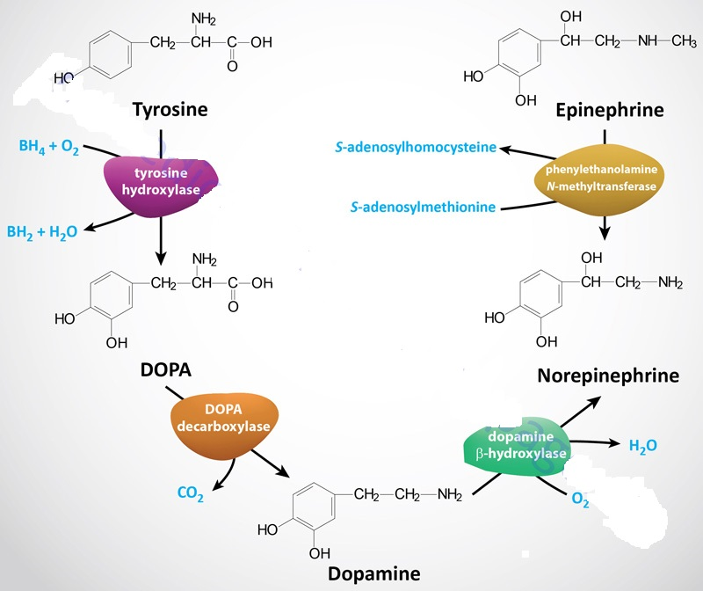Source: themedical biochemistrypage.org.
10.3.2. Serotonin synthesis from Tryptophan
Tryptophan serves as the precursor for the synthesis of serotonin (5-hydroxytryptamine, 5-HT) and melatonin(N-acetyl-5-methoxytryptamine).
Serotonin is synthesized through a two-step process involving a tetrahydrobiopterin-dependent hydroxylation reaction (catalyzed by tryptophan-5-monooxygenase, also called tryptophan hydroxylase), and then a decarboxylation catalyzed by DOPA decarboxylase (also known as aromatic L-amino acid decarboxylase).
Tryptophan hydroxylase is normally not saturated and as a result, an increase in dietary uptake of tryptophan will lead to increased brain serotonin content. It represents the rate-limiting step in serotonin and melatonin synthesis
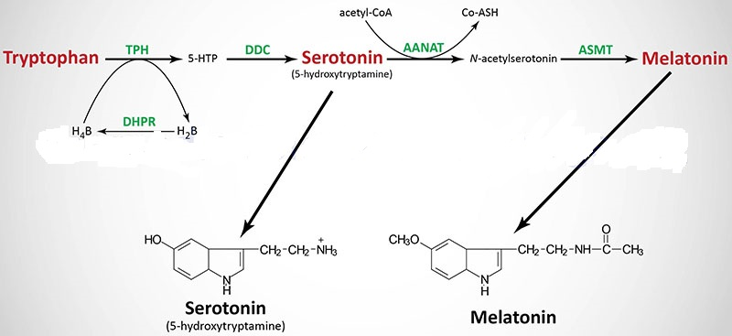
Figure: Pathway for serotonin and melatonin synthesis from tryptophan. Source: themedical biochemistrypage.org.
Serotonin is present at highest concentrations in platelets and in the gastrointestinal tract. Lesser amounts are found in the brain and the retina. Melatonin is derived from serotonin within the pineal gland and the retina, where the rate-limiting enzyme for melatonin synthesis is expressed.
The pineal parenchymal cells secrete melatonin into the blood and cerebrospinal fluid. Synthesis and secretion of melatonin increases during the dark period of the day and is maintained at a low level during daylight hours.
10.3.3. γ-Aminobutyric Acid (GABA) from Glutamate
The amino acid derivative, γ-aminobutyrate (GABA; also called 4-aminobutyrate) is a major inhibitory neurotransmitter responsible for the regulation of presynaptic transmission in the CNS, and in the retina. Neurons that secrete GABA are termed GABAergic. GABA cannot cross the blood-brain-barrier and as such must be synthesized within neurons in the CNS.
The synthesis of GABA in the brain occurs via a metabolic pathway referred to as the GABA shunt. Glucose is the principal precursor for GABA production via its conversion to α-ketoglutarate in the TCA cycle. Within the context of the GABA shunt the α-ketoglutarate is transaminated to the amino acid glutamate by GABA α-oxoglutarate transaminase (GABA-T). Glutamic acid decarboxylase (GAD) catalyzes the decarboxylation of glutamic acid to form GABA.
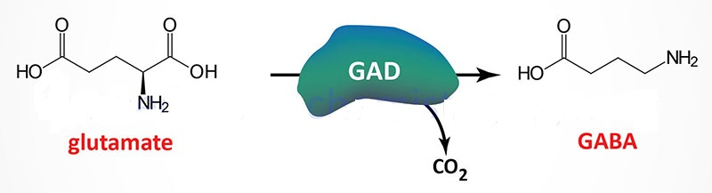
Figure: GABA synthesis. Source: themedicalbiochemistrypage.org.
10.3.4. Histamine from Histidine
Histamine is a potent neurotransmitter that binds to specific histamine receptors.
Histamine is synthesized by the enzymatic decarboxylation of the amino acid histidine by the enzyme L-histidine decarboxylase (HDC). Within the gastrointestinal tract bacteria also produce histamine via a similar decarboxylation reaction.
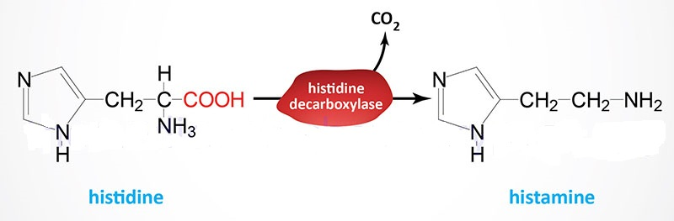
Figure: Synthesis of Histamine. Source:themedicalbiochemistrypage.org.
10.3.5. Nitric Oxide, a Short-Lived Signal Molecule, Is Formed from Arginine
Nitric oxide (NO) is an important messenger in many vertebrate signal-transduction processes. This free-radical gas is produced endogenously from Arginine in a complex reaction that is catalyzed by nitric oxide synthase. NADPH and O₂ are required for the synthesis of nitric oxide. Nitric oxide acts by binding to and activating soluble guanylate cyclase, an important enzyme in signal transduction. This enzyme is homologous to adenylate cyclase but includes a heme-containing domain that binds NO.
10.4 CREATINE
Creatine is a naturally occurring guanidino compound that plays a vital role in the storage and transport of cellular energy. The creatine molecule is a fundamental component of high-energy phosphate metabolism, required for buffering, transport, and regulation of cellular energy.
Creatine is abundant in metabolically active tissue such as muscle, heart, and brain. It is synthesized endogenously and absorbed from dietary sources, with the typical total creatine pool in a 70kg human amounting to approximately 120 g (Walker, 1979). Most of endogenous creatine is stored within muscle and is subject to continuous degradation to creatinine and replenishment by a combination of dietary intake and endogenous synthesis. Creatine is consumed in diets containing fresh meat and fish and, to a lesser extent, dairy products.
10.4.1 Creatine Biosynthesis
Creatine synthesis occurs predominantly in the kidneys and the liver. The synthesis of creatine begins with amino acids arginine and glycine. The formation of guanidinoacetate (GAA) from these two amino acids is catalyzed by the enzyme glycine amidinotransferase, also called L-arginine:glycine amidinotransferase (AGAT).
The synthesis of creatine begins from arginine and glycine via the renal enzyme glycine amidinotransferase (GATM). The product, guanidinoacetate, is transported to the liver where it is methylated via the action of guanidinoacetate N-methyltransferase (GAMT) forming creatine. The methyl group is donated from S-adenosylmethione (SAM). Creatine is released to the blood and picked up by the brain and skeletal muscle cells via the action of the SLC6A8 transporter. Creatine kinase (creatine phosphokinase) transfers a phosphate from ATP generating the high-energy intermediate, creatine phosphate.
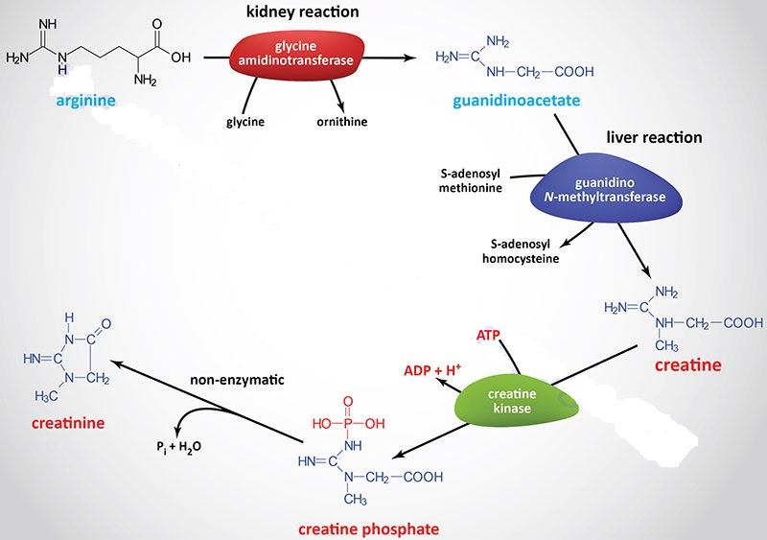
Source: themedical biochemistrypage.org.
Post-Test
- Describe the pathway for biosynthesis of Essential Amino acids
- Why is Arginine is referred to be semi-essential?
- Which amino acids are required for creatine synthesis? Briefly describe the pathway.
Bibliography
- Biochemistry. 5th edition. Berg JM, Tymoczko JL, Stryer L. New York: W H Freeman; 2002.
- Shyamal D. Desai. Amino acid Synthesis and degradation, sdesai@lsuhsc.edu.
- www.themedical biochemistrypage.org.

