




SCHOOL OF BASIC AND APPLIED SCIENCES

Mountain Top University
Kilometre 12, Lagos-Ibadan Expressway, MFM Prayer City, Ogun State.
PHONE: (+234)8053457707, (+234)7039395024, (+234) 8039505596
EMAIL: support@mtu.edu.ng
Website: www.mtu.edu.ng.

Published By:
Mountain Top University


COURSE GUIDE

COURSE TITLE: BIO 204
COURSE CODE: BIOLOGICAL TECHNIQUES
LECTURER: Dr. F. Ibadin

At the end of this course, students should be able to: know and understand the basic techniques relevant to the study of the various branches of biological sciences. Students should be able to collect and preserve biological specimens. Students should also be well knowledgeable in Herbarium techniques. They should be able to carry out the process of collection of specimens from the field with the appropriate instruments and also be able to improvise if the need arises. The student should be able to transport the specimens to the laboratory appropriately, preserve, identify, mount the specimens and store them in their required conditions of storage for future reference.
COURSE OBJECTIVES

COURSE CONTENTS PAGE
Lecture One Collection and Preservation of Biological Specimens 6
Lecture Two Herbarium Techniques 21

LECTURE 1
THE PROCESS OF ACQUIRING ANIMALS FOR BIOLOGICAL SPECIMENS
1.0 Introduction
This lecture focuses on the basic methods of acquiring the specimen used in the biological studies. It highlights the methods of collection as being relative to each organism and the purpose for which the organism is acquired. The materials needed for the collection are also stated and therefore made available prior to the specimen collection trip.
Objectives
At the end of this lecture, students should be able to:
- explain in details the necessary processes of collection of specimen from the field
- differentiate the various means of collection of various specimens
- know the actual types of environment where each specimen is naturally located
Pre-Test
- Why is it necessary for us to collect our specimens personally, if possible?
- Why must we use different methods to collect different specimens?
- Is it necessary to collect variations or different sexes of the same type of specimen? Give reasons for your answer.
CONTENT
1.1 Field Study
It is always better when biologists choose to learn about organisms in their natural habitats. In such places, you can see how they live and relate to others organisms and how they impact on their environment. For this reason it is always advisable to do a field trip to partly see where such organisms inhabit, then collect the organisms, take them to the laboratory for further studies.

1.2 Collection of Specimens
In the collection of field samples, you may need tins or empty clean bottles to put in your specimen. Specimens that can be found readily in our immediate environment include rats, leaves, seeds, fruits, flowers, flies, fish, scorpion, ants, worms, etc. Collection of these different specimens naturally vary with the type of organism and in which state you want to have it and the kind of study you intend to do. If you want to study how a frog or toad breaths; you will have to device means of collecting it without killing it. If on the other hand you wish to collect a fragile flying insect like the butterfly in order to study the difference in their designs and colours, you will have to device or use an instrument to reach them as they fly. The methods used in the collection of specimens depends on the type of study, the type of organism, their habitats and how they live.

1.3 Collection of live animals
Live animals are generally collected from aquatic and land areas. For collection visit a nearby aquatic body (e.g. pond) and land area (e.g. Park/Field).

1.4 Collection of Aquatic Invertebrates
Sources
The sources can be ponds, lakes, rivers for fresh water animals and ocean/sea coasts for marine animals. However, in this section, as an example we will study the collection of animals from ponds.
Materials Required
Nylon nets (Fine weave for small animals and coarse weave for large animals), large clean jars or buckets, shallow white pans or papers
Method
1. Take a clean bucket or a jar and fill it up to about half with the pond water from which you are going to collect the samples.
2. With a trowel, scoop a little amount of mud from the wet edge of the pond and put it in the bucket or jar having pond water.
3. Also put one or two small submerged branches of aquatic plants in the bucket or jar.
4. Take the suitable net and sweep through the water in the pond. You have to sweep more than once.
5. Take out the net. You will see the specimens trapped in the net. Transfer the specimen into the bucket or the jar.
6. Take some extra pond mud, submerged branches or aquatic plants along with some pond water and carry to the laboratory for subsequent use, if needed.
7. In the lab, transfer the live specimens into shallow white pans or place them on a large sheet of paper and spread them out for study.

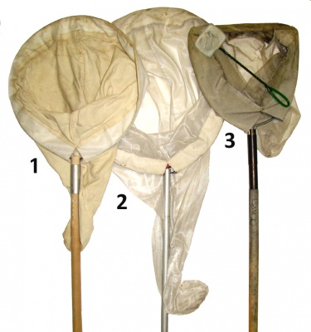
Insect Nets (Sweep nets)
Source: https://wiki.bugwood.org/Collecting_insects
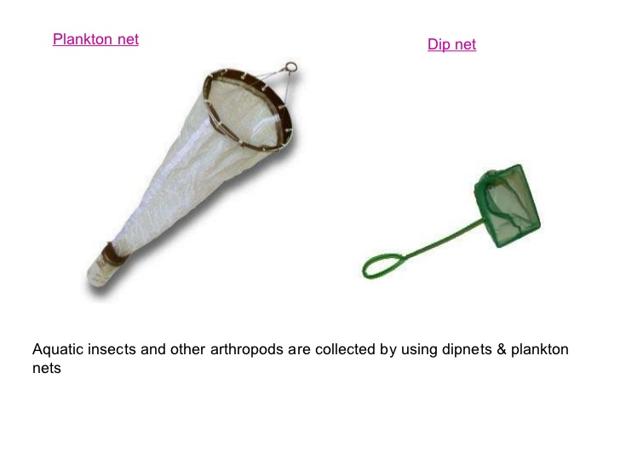
Source: https://www.slideshare.net/KASHMEERA-N-A/taxonomic-procedures-45019825

Collection of Insects
Sources: Terrestrial insects are found in gardens especially during flowering seasons, in the fields and indoors. Aquatic insects can be collected from water bodies like ponds, lakes etc.
There are several methods of collecting insects but in this section you will collect terrestrial insects by three methods using: a net, light trap and aspiration.
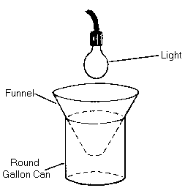Light Trap
Source: https://www.uky.edu/Ag/Entomology/ythfacts/4h/unit2/hotm&ult.htm
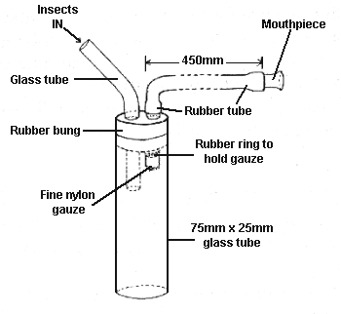
Source: http://www.nhm.ac.uk/our-science/data/chalcidoids/collmethods.html
Methods
(a) Sweep Net Method:
This method is suitable for collecting many insects.
Materials Required: Insect-collecting net and killing jar
Steps:
1. Go to the garden/field and identify the insects to be collected.
2. Approach the specimen(s) very quietly. You should try to avoid chasing the insects overtly as it would alert the insects and make them fly/run away.
3. Sweep the net through the herbage over the specimen(s). You might have to sweep more than once.
4. When the insect(s) is trapped in the net, twist the net or your wrist so that net is closed and the specimen is not able to escape.
5. Transfer the collected insects into the killing jar.
(b) Light Trap Method
In this method the collector is not required to be present. It is mainly used for nocturnal insects like moths, midges, some beetles and winged termites.
Materials Required: Light sources such as an electric bulb (200 W) or a lantern lamp, a large shallow container such as a basin sauce pan, white paper sheet and Killing jar.
Steps
1. Select an area where insects are abundance
2. Hang the light source with the help of a hook.
3. Put the white paper as lining in the shallow container and set the container below the light sources so that electric lamp is shining in the middle of the container.
(In the absence of an electric light keep a lantern lamp in the middle of the container)
4. Soon the insects will be attracted by the light and fall into the container.
(In case the shallow basin saucepan is not available you can keep a collecting jar fitted with a cone made of white sheet under the light source. The most efficient light source for insect-trapping is a mercury vapour lamp)
5. Transfer the collected insects into the killing jar.

1.5 Collection of Lower Plants
Care is to be taken when collecting plant samples, and this is particularly done with the use of a vasculum, polythene bags or in bottles. You will need a pair of secateurs for cutting hard material, a sharp knife for cutting soft parts, pick for digging out underground parts like roots and rhizomes, scalpel and forceps for separating those plants which grow attached to the barks of trees and rocks. The stems and roots are cut into pieces of size about 3 cm long with the aid of sharp razor or knife. Bryophytes are made free from soil particles and debris before storing in some preservative. The smaller leaves can be preserved as such and larger ones can be cut in pieces, and then preserved.
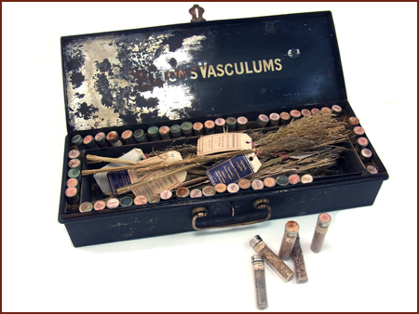
A Vasculum
Source: http://www.oldgardentools.co.uk/?s=vasculum

1.6 Collection of Algae
Sources: Algae occur widely on the soil surface and below it, on the bark of trees, in fresh water, sea water, and a variety of other habitats.
Collection from Bark:
i) In case of bark algae pick up the algae patches from the tree trunk with the help of iron spatula.
ii) Sterilize spatula by swirling it in spirit and then flaming it.
iii) Store various samples collected in separate sterilized bottles after fixing and labeling in their respective shelves.

Collection from Fresh Water:
i) Collect the fresh water algae at the spot in sterilized specimen tubes containing some habitat water.
ii) Never fill the container more than a quarter so that the quantity of oxygen present in the water may be sufficient for respiration.
iii) Fix the material, label them and keep in respective shelves.
Collection from Sea Water:
i) Collection of marine algae is best done during low tides as during this period these are mostly in their reproduction stages.
ii) Collect marine algae in large bottles.
iii) Fix them and label them and keep them in their respective shelves

1.7 Collection of Bryophytes
Bryophytes occur in nature attached to wet soil, rocks and bark of living and dead trees, wood and humus rich in organic substances.
I) Scrape the bryophytes from the place of occurrence with the help of sharp scalpel or knife and keep them in polythene bags within which they remain alive to a number of days.
ii) Keep these bags loosely tied and in damp condition in laboratory.
iii) Wash the soil growing species with ordinary water to remove soil particles and dirt attached to plant.
iv) Keep the bags under illumination at 0ºC – 5ºC to keep the plant alive for a longer duration.
v) Fix the material, label and keep it in the cupboard.

1.8 Collection of Pteridophytes
Pteridophytes are spore-producing vascular plants. They possess the vascular tissues xylem and phloem. They grow in variable habitats. Most of the pteridophytes are terrestrial while a few are epiphytes and some of them are found in aquatic habitats.
i) Collect the pteridophytes from natural habitats in mature spore producing stage.
ii) Collect the plants with or without strobili or mature sporophyll in polythene bags loosely tied at mouth.
iii) If the material is large cut them into pieces, fix label and keep them in a cupboard.

1.9 Collection of Gymnosperms
Gymnosperm belong to seed plants but the seeds are naked with a very conspicuous and independent sporophyte which is the main plant and have very reduced gametophyte dependent on the sporophyte. They have xeric characteristics also.
i) Collect the root, stem, and leaves of male and female gametophytes of the plant.
ii) Cut the material into small pieces of 3 cm, fix them, label them and keep them in a cupboard.
iii) You can collect the dry fruits and cones of gymnosperms and preserve them as such.

1.10 Preparing Specimens for Laboratory Studies
Upon collection or procurement of your specimens, it is necessary to bring them into the laboratory so that they could be well studied. It is often important for the specimens to be kept for a considerable length of time for sufficient studies to be made. For this reason, it is necessary to know how best to keep them preserved. The same methods may not apply to all types of specimens. For example, bones will not be stored the same way as worms. It is however important for you to know that some storage and preservation may be necessary.

1.11 Killing, mounting and display of insect specimens
The incest to be killed is transferred to a bottle contain the killing agent, such as ethyl acetate, chloroform, ether, tetrachloroethane etc. However, the safe and most efficient agent is ethyl acetate.

Source

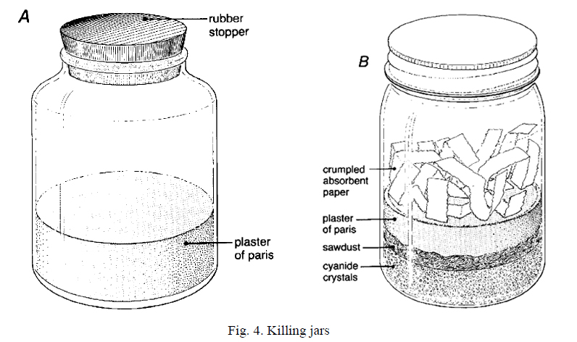
Source: http://insect-collection.com/2012/02/13/killing-jars-or-bottles/

Materials required include an empty glass bottle with an air-tight lid (you can take a jam or Horlicks bottle), ethyl acetate, cotton, blotting paper and forceps.
Steps:
i) Soak a wad of cotton in ethyl acetate. You must hold this cotton wad with forceps and not with hands.
ii) Place the soaked cotton at the bottom of the bottle and cover it with a piece of blotting paper. Blotting paper is used to avoid the direct contact of the specimens with the chemical because it will wet the specimens and spoil them.
iii) Transfer the insects into the bottle and close tightly. The insects should be taken out within 20 mins to prevent them from being decolourised and get unduly hardened. The bottle should not be over crowded, and different bottles should be used for different types of insects.
iv) The bottles should be labelled ‘poison’ and kept out of reach. Bottles that are no longer in use should be buried.

1.12 Mounting of the insects
After being killed the insects are pinned with the help of entomological pins on the pinning board. You can also prepare entomological pins with sewing needles and coloured beads. Take thin sewing needles, heat the eye of needle on a spirit lamp flame and insert the heated end into a coloured bead, which forms the needle head.

1.13 Direct mounting:
Mounting should be done immediately the insect is dead, using the following steps:
i) The entomological pin is pushed through the thorax region of the insect. However, the exact point in the body of the insect through which the pin should pass differs in the different groups of insects.
ii) Insert the pin vertically through the body or sloping in such a way that the front part of the body is raised very slightly.
iii) Push the specimen up in the pin until it’s back slightly away from the top so that it does not have any contact with the back of the insect body.
iv) Mount the pinned insects on the board or on a pinning block. Take care to mount the insects uniformly so that specimens can be examined and compared easily.

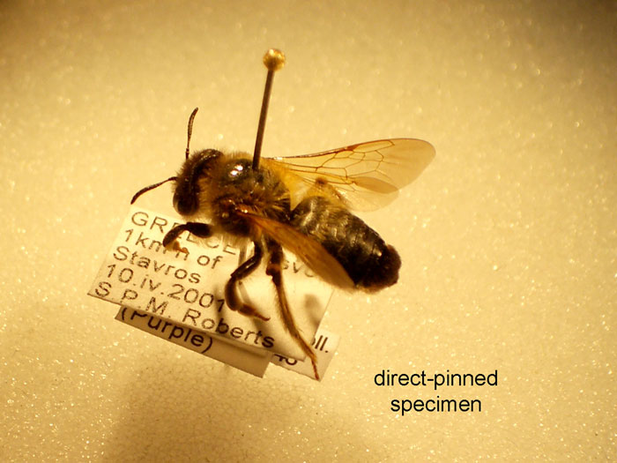
Source: http://alarm.myspecies.info/content/morphology

1.14 Point Mounting:
This method is especially used for mounting small and dried insects.
Take the following steps
i) Take a stiff card paper and cut triangles from it. For a smaller insect the size of the triangle can be 6 mm long, 2 mm wide at base and 0.5 mm wide at the apex (tip). However, the size of the triangle varies depending upon the size of the insect.
ii) Attach the dried specimens to the apical tip of the triangle with the help of a quick drying adhesive like quick-fix. The best places on the insect body for adhesion cab be at the sides of thorax below the wings, margin of the tergum and above or between the bases of the legs.
iii) Insert the entomological pin in the broader end of the triangle and pin this triangle with mounted insect on the display board.
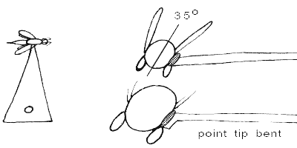
Point mounting of insect
Source: https://entmuseum.ucr.edu/specimen_preparation/index.html

1.15 Spreading
To display the head, abdomen, wings and legs you have to spread the freshly killed insects on the spreading board. In the freshly killed insects the internal parts are soft to allow the pin in and appendages are pliable. The pin is pushed through the thorax region. A spreading board is available in the market but can also be made locally. A simple method is to take a thick sheet of cork or thermocol and cut a groove in it for the body of the insect.

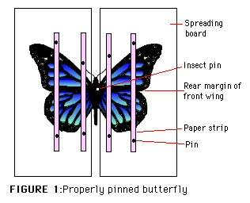
Source: http://www.oocities.org/capecanaveral/Hall/1410/insect-02.html

Steps:
i) The insect is placed in such a way that the body and thorax of insect rest in the groove of the board.
ii) One end of a narrow strip of setting paper is pinned at the front end on each side of the insect body.
iii) The fore wings on the back are drawn forward and each pinned on either side with a fine pin inserted behind one of the strong veins in the wings.
iv) The hind wings are also spread like this and pinned.
v) When the wings are correctly placed the paper strips can be taken over the wings and their other end is pinned on the back of the insect body so that both the wings are held by paper strips and setting pins.
vi) The antennae are also spread symmetrically and pinned under the narrow strip.
vii) Legs (appendages) are also spread and pinned on both sides under the strips. Care should be taken that while spreading, the joints and the shape of the appendages remain intact.
viii) If the abdomen is inclined to fall into the groove it can be supported by crossed pins placed beneath it.
After the pinning and spreading the specimens are dried for few weeks in the open or in drying chambers and stored.

1.16 Displaying
Once the specimens are collected and spread, they should be given permanent labels. These labels should be small and made of white card. The following information should be there on the label of each specimen:
1. Name of the insect.
2. Host plant, crop or the area from where it is found.
3. Locality from where it is found.
4. Date.
5. Collector's name
The ink used for writing should be permanent and not spoiled when in contact with any type of liquid.

1.17 Preservation of Animal Material
For preserving taxonomic material such as laboratory and museum study specimens, different preservation methods can be considered. In the field, there may be limited access to materials and equipment necessary, so preliminary preservation with more simple methods may be necessary before final preparation as a permanent collection specimen.
Examples: procedures for preliminary preservation of a whole animal
1.18 Short-term storage without preservation (of freshly dead animals needed for mounting)
Small animals in a cold to moderate climate may be stored without refrigeration in the shade for 4 -5 hrs. After this period, in warmer climate sooner, the viscera will begin to decompose.

1.19 Preparing Specimens for Laboratory Studies
Upon collection or procurement of your specimens, it is necessary to bring them into the laboratory so that they could be well studied. It is often important for the specimens to be kept for a considerable length of time for sufficient studies to be made. For this reason, it is necessary to know how best to preserve them. The same methods may not apply to all types of specimens. For example, bones will not be stored the same way as worms. It is however important for you to know that some storage and preservation may be necessary.

1.20 Preservation and Storage
Apart from preservation and storage, you might also need to prepare the specimen for the kind of study that is desired. For example, if you want to study the structure of a section through the root of a plant, you need a microscope to view the details of the sections. Besides, you need to make a slide.
Specimen preservation means a long term preservation of organisms either plant or animal in the best possible condition, so that it can be accessed in future as reference collection for scientific purposes. For reference collections, mammals can be prepared as a variety of specimens. The condition of the specimen may determine possible ways to preserve it; if for instance decomposition of the skin has loosened the hair of a carcass so much that it can easily be pulled out or removed by rubbing, it will be very difficult or impossible to produce a study skin or mounted specimen.
The some of the most usual types of specimens are:
1) Entire fluid-preserved animals (for studying anatomy and histology; fluid preservation may change the fur colour)
2) Study of skins with accompanying skulls / partial skeletons (some bones remain in the skin), for studying pelage colour, hair quality and moulting patterns,
3) Mounted skins with accompanying partial or entire skeleton (some bones may remain in the skin, dependent on the method of preservation) or freeze-dried specimens,
4) Entire skeletons, for instance for studying anatomy, geographic variation or for age determination (entire skeletons are poorly represented in collections, so it is recommended that preparation of at least one male and one female skeleton per species.

Many chemical methods are used to preserve both vertebrate and invertebrate specimens.
Why specimens are preserved?
a) Taxonomic reasons
b) For detailed examination.
c) For morphological study of particular animals as each and every animal can't be in researcher’s vicinity.
d) For zoological museum collection

1.21 Steps for Specimen Preservation
1. Killing and relaxing of alcohol,
2. Fixation (stops cellular respiration, kills bacteria within the organism, a good penetrating ability)
3. Storage in bottles, jar vials, trays etc.

1.22 Types of Specimen
1) Entire fluid-preserved animals
Purpose: (for studying anatomy and histology; fluid preservation may change the fur colour)
2) Study skins with skulls / partial skeletons (some bones in skin)
Purpose: for studying colour, hair quality and moulting patterns.
3) Mounted skins with partial or entire skeleton (some bones may remain in the skin, dependent on the method of preservation) or freeze-dried specimens.
4) Entire skeletons, for instance for studying anatomy, geographic variation or for age determination.

1.23 Preservatives and Their Usage
1) Formalin (Fixative mostly)
Formalin is the commercial name of a solution of formaldehyde gas (CH₂O) in water. Formalin must be diluted with water before it is used as a preservative. A strength of 10% formalin is best for most purposes. If the original strength is 40%, it should be mixed at a ratio of nine parts water to one part formalin
Usage:
- It is used for vertebrates only.
- It is avoided for long-term storage since it is acidic and difficult to handle.
- Mostly formalin is used where colour is important since alcohol dissolves most colours almost immediately.
- It penetrates more rapidly, and internal organs remain in better condition.
Procedure:
- Dilution
Conc. formalin (100%) = Water saturated with 40% formaldehyde.
10% formalin = 4% formaldehyde (Used for preservation)
2% formalin with seawater for small specimen
ii. Mix one part concentrated formalin to nine parts water.
iii. Fill about two-thirds the bottle's volume with 10% formalin.
- As formalin is acidic, it should be buffered by adding a pinch or two of sodium bicarbonate.
Precaution:
- Inhalation of formalin fumes is harmful and causes extreme discomfort to nose and eyes.
- Contact with fluid causes severe irritation to the skin
- Contact with sore or raw spots results in extreme pain.
- It is carcinogen.
- Hand should be rinsed after usage.
Storage:
- It should be kept in safe, water-tight, spill-proof bottles, e.g. pep-bottles
- It should always be clearly labelled.

2) Industrial Alcohol (for both fixing and storage)
Usage:
Alcohol is usually not used for killing and fixing vertebrates. But of course used for long-term storage.
Colour of specimen is lost immediately.
A teaspoonful of glycerin in a quart of alcohol helps to preserve natural colours and to keep integuments flexible.
Alcohol usually comes in the 95% concentrated form.
For long-term preservation, 70-75% strength is used.
Warning:
Alcohol is usually safe to handle, it can however cause irritation to the skin in cases of prolonged contact.
Always rinse hands with water after working with alcohol.
Industrial alcohol is toxic and should never be drunk.
Alcohol is highly flammable.
Never work with this fluid in the vicinity of open flames.
It is rapidly evaporated, and receptacles holding it should be securely covered at all times, and not be opened unnecessarily.

3) Isopropyl Alcohol
It is cheap and easy to obtain.
There are different strengths available (70% and 90%), so if you use isopropyl you will have to dilute it to a 40% alcohol solution.
Isopropyl alcohol can be hard on the specimens and tends to make them brittle over time.
Buffering:
It can be buffered with a few drops of glycerin or a pinch of calcium carbonate tablets (crush the tablets to a powder and add).

4) Ethyl Alcohol (for invertebrates)
A better solution for long term storage of invertebrate specimens is in an 80% solution of ethyl alcohol.
Ethyl alcohol can be found in painting supplies.
It is labelled as denatured alcohol.
It should also be buffered with glycerin/antacid tablets.

1.24 Vertebrates Specimen Preservation
1) Fishes
After capture Fishes are placed in 10% formalin for quick killing (painful). It is not needed to relax fish. Fishes dies with its finnature well spread-out, and the body straight and well-stretched.
Examination and counting of fin rays and scales is quite easy on such well-preserved material. For 30cm fish, the following is used
i. Formalin - 1 week (fix soft tissue)
ii. Water - 1 day (leach out the formalin)
iii. Alcohol - long term storage
The length of time for each step may have to be increased with increasing size of specimens.

2) Herptiles (Reptiles and Amphibians)
Herptiles are individually kept in plastic & then killed by freezing or chloroform. Shallow trays are used for herptile specimens.
Snakes should be coiled up, and frogs are to be placed on their bellies with their limbs set at right angles to their body.
Depending on the size of the specimen, the time necessary for complete fixation can be different, from 2 days for small salamanders to a month for something like alligators, salamanders and turtle.
Then added to water for a day or two and then in 75% alcohol for long-term storage.

3) Birds and Mammals:
Usually birds and mammals are skinned.
Skull or Skeletal mounts and flesh can be removed by several means such as boiling or using dermestid beetles. Once bones are defleshed they can be placed in a bleach or hydrogen peroxide solution to whiten.
Then the bones are allowed to dry and placed in a bag or box with complete label tied to skull if possible.

1.25 Invertebrate Specimen Preservation
The easiest way to preserve these animals is to use alcohol.
One should be aware of which kind of alcohol they are using as each animal requires a different concentration for preservation. Most invertebrates, however, will be kept in bottles, and sets of tubes or jars for preservation
1) Coelenterates
Coelenterates are difficult to preserve. They should be preserved in 70% alcohol or 5% formalin. Hydra can be quickly fixed in Bouin's fluid (warm, not hot)

2) Platyhelminthes (Flatworms)
Bouin fluid is used for fixation.
Paraffin is the best long-term preserving and storage medium of all flatworms.
3) Echinoderms
Echinoderms are narcotised by the addition of magnesium sulphate or menthol to the sea water in which they live. When completely insensitive to stimuli such as pricking they should be transferred to 70% alcohol for preservation and storage.
4) Arthropods
They are easy to process, as they are killed immediately and stored in alcohol.
Crabs and prawns may also be killed in formalin, but this renders their joints hard and brittle
The larger arthropods (especially those with hard exoskeletons) sometimes need to be injected with 10% formalin to prevent them from rotting.
Industrial alcohol is used for most arthropods. Insects, crustaceans and arachnids can be simply dropped into alcohol for immediate preservation.
Liquid hand sanitizer can be used for insects. Hand sanitizer is gelled alcohol, hence the usage. Specimen will float inside the vials and do not sink or move despite any amount of handling. It is best to kill the insects in an alcohol solution then transfer them to the hand sanitizer for preservation. The gel will break down over time and become liquid, so it should be replaced occasionally.
5) Molluscs
Relaxed mollusk is used for good preservation. Newly killed molluscs could first be fixed in buffered 10% formalin for two or three days, and then transferred to 75% alcohol after soaking for a few hours in water. Molluscs can also be relaxed in a solution of magnesium chloride, but this does not work very well with land molluscs.

1.26 Precautionary Measures
a.) Do not crowd living animals in small containers - this will result in damage to their appendages.
b.) Features important in the taxonomic study of fish, for example, are easily damaged with contact even after preservation.
c.). Live crabs before preservation should be kept individually as some species will damage each other and other animals which will distort their morphological features.
A reasonable number (about 95%) of the museums of the world use ethanol (drinking or grain alcohol) for long term preservation.
Over 4.9% use isopropyl (rubbing alcohol), while 0.001 percent use methanol, or wood alcohol.

Post-Test
- Which of the following instruments is likely to be required in the collection of crawling insects?
- (a) Briefly describe the process of preparing and using a killing jar for insect specimens
(b) Describe the process of direct mounting of an insect specimen after killing
(c) How do you prepare echinoderm specimens?
(d) What are the following instruments uses for?
i. Trowel
ii. Sweep net
iii. Aspirator
v. Vasculum

Bibliography
- Allan, J., R. Reed and W.Jonathan (2000). Practical Skills in Biology. Second Edition. Longman Group Publishing, London, UK. 292p.
- N. P. O. Green,‎ G. W. Stout and‎ D. J. Taylor (2010). Biological Science 1 & 2. Third Edition. Cambridge University Press, UK. 984p

LECTURE 2
HERBARIUM TECHNIQUES

2.0 Introduction
This lecture focuses on the basic methods of acquiring, processing, preservation and storage of plant specimen used in the biological studies. It highlights the methods of collection as being relative to each specimen type and the purpose for which the specimen is acquired. The materials needed for the collection are also stated and therefore made available prior to the specimen collection trip.
Objectives
At the end of this lecture, students should be able to:
- explain in details the necessary processes of collection of specimen from the field
- differentiate the various means of collection of various specimens
- learn the means of processing, preservation and storage of plant specimen for biological study
Pre-Test
- Why is it necessary for us to collect our specimens personally, if possible?
- Why must we use different methods to collect different specimens?
- What are the primary reasons for preparing a herbarium
CONTENT
2.1 What is an Herbarium?
A herbarium is a collection of preserved plants stored, catalogued, and arranged systematically for scientific study by professionals and amateurs. Herbaria are a vital reference library to aid in current plant identification and future taxonomy.
A Herbarium may include some or all of the collections.
• Herbarium sheets
• Cryptogams on sheets
• Packets – cryptogams
• Lichens, fungi, fruits, seeds and related economic material (boxes of bulky specimens)
• Materia medica (jars containing dried specimens)
• Diatoms (mounted in mica on herbarium sheets or slides) and in ethanol?
• Algae (floated onto mount paper)
• Pith
• Timber (hand sections, planks, tree sections, microscopic sections)
• Pressed and bound collections
• Palm leaf materials
• Mounted slide collections
• Pollen

2.2 Methods of preparation of herbarium specimens
The preparation of a herbarium involves
(i) Field visit
(ii) Collection of specimens
(iii) Drying
(iv) Mounting on a herbarium sheet,
(v) Preservation
(vi) Labelling and
(vii) Proper storage
(a) Field visits and specimen collection
A complete specimen possesses all parts including root system, flowers and fruits. Therefore, regular field visits are necessary to obtain information at every stage of growth and reproduction of a plant species. In the fields, the tools required are mainly trowel (digger) for digging roots, scissors and knife for cutting twigs, a stick with a hook for collection of parts of tall trees, a field note book, polythene bag, old newspaper and magazines.
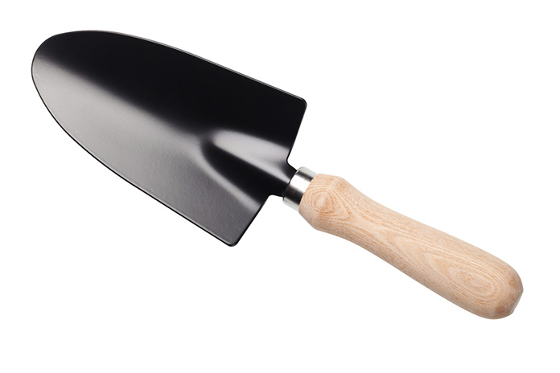 A trowel
Source: http://puffycarrot.com/best-garden-trowel/
The specimens selected should be vigorous, typical specimens. Insect-damaged plants should be avoided. Specimens should be representative of the population, but should include the range of variation of the plants. In collecting large herbs, shrubs and trees, different types of foliage, flowers and fruits should be collected from the same plant. Collect sufficient material to fill an herbarium sheet (450 x 300 mm) and still leave enough room for the label. Plants too large for a single sheet may be divided and pressed as a series of sheets.
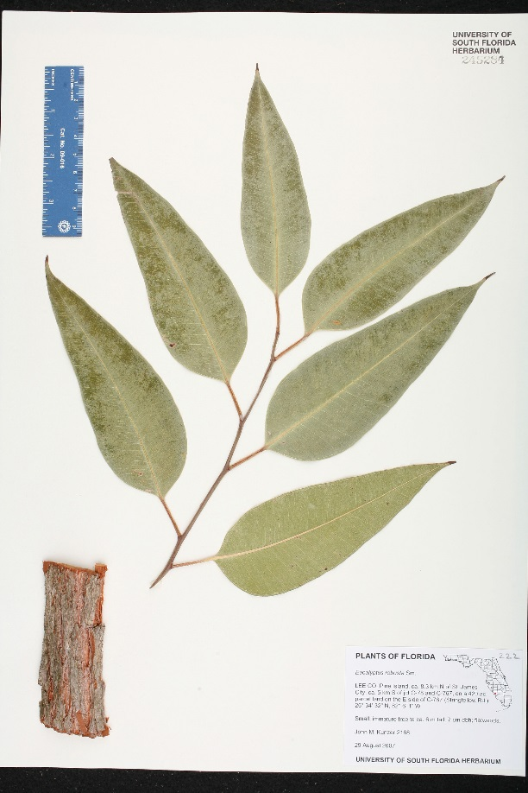
A Herbarium sheet
Source: http://florida.plantatlas.usf.edu/SpecimenDetails.aspx?PlantID=1306
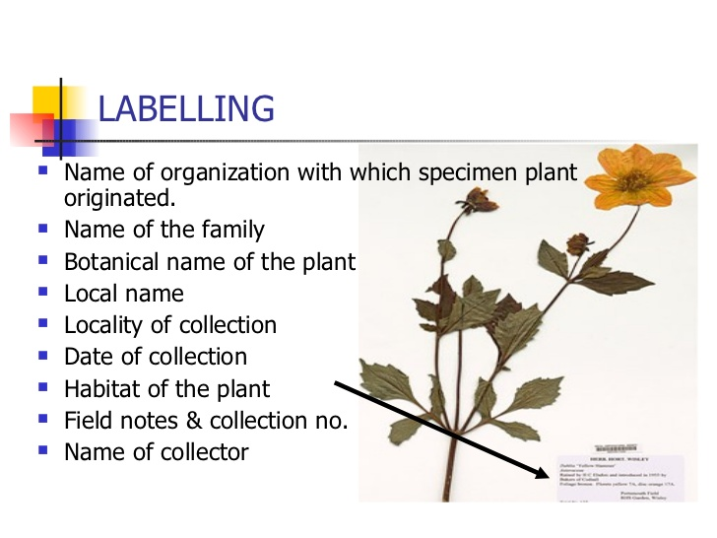
Source: https://www.slideshare.net/BijuCherupuzha/herbarium-10212042
Bark and wood samples are often desirable additions when collecting woody plants. There are special requirements for the identification of some plants. A Eucalyptus specimen, where possible, should include mature leaves, juvenile leaves, buds, fruits, and bark.
Other general hints for collecting are:
1) Bulky plants or parts can often be halved or sliced before pressing. Odd fragments - bark, fruits or seeds - should be kept in numbered or labelled envelopes or packets with the main specimen.
2) Very bushy twigs should be pruned to make a flatter specimen, in such a way that it is obvious where pieces have been broken off.
3) Spiny plants may first be placed under a board and stood on before pressing to prevent tearing the paper.
4) Succulent plants need to be killed first by soaking in methylated spirits for 15-20 minutes. Bulbs should also be killed, or may sprout on herbarium sheet.
5) Water plants must be floated out in a dish of water and lifted out on a sheet of stiff white paper slipped under them in the water; dry excess water, then press the plant in the usual way leaving it on the white paper on which it can remain permanently stuck. A piece of waxed paper over the top of the plant will prevent it adhering to the drying paper.
6) Tall rosette plants and grasses may be pressed complete by bending them once or more into the shape of a "V", "N" or "M".
7) Dioecious plants should be represented by both sexes.
8) Palms - several herbarium sheets are necessary to show the various portions of the leaf, inflorescence and fruit of these species. Photographs of the tree and of each part are essential.
9) Cones of some gymnosperms and Pandanaceae may need to be enclosed in a wire mesh to prevent them falling apart.

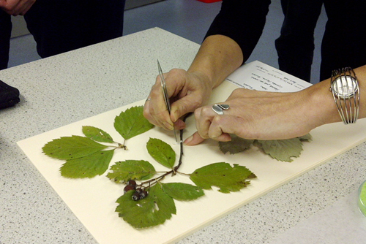
Source: https://www.natsca.org/
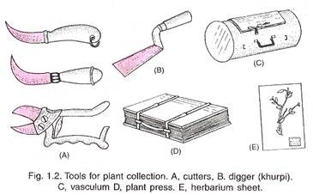
http://www.biologydiscussion.com/living-organism/herbarium/herbarium-seeds-meaning-methods-and-uses/44586
b) Pressing and Care of Specimens (drying)
Specimens should be pressed as quickly as possible after collection. If this is not possible, specimens may be stored in plastic bags preferably wrapped in damp (but not wet) papers. Bags should not be packed tightly, and should be kept cool and moist. Make sure that each bag is correctly labelled for locality.
Place each specimen, with numbered tie-on tag attached, in a fold of several sheets of newspaper, and place in the press. If necessary, occasionally add a sheet of corrugated cardboard to act as a ventilator. As you fill the press, try to keep it level to allow even distribution of pressure. This may mean the use of alternate corners of the fold for bulky roots and other parts, or packing around a bulky specimen with foam. Close the press and exert pressure with the straps.
The plants in the press should be dried fairly quickly, in a warm place if possible. The specimens must not be left in damp papers or they will go moldy. It is therefore necessary to go through the press daily during the first few days and change the plants into dry newspapers. Then continue to inspect press daily and change newspapers as necessary until the plants are dry.
Delicate plants and petals may be lost in changing and should be kept in tissue-paper (or toilet-paper) folders throughout changes. A properly dried plant specimen is brittle.

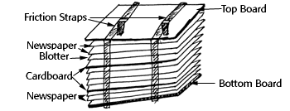
http://herbarium.biol.sc.edu/floracaroliniana/projects/schools/howto.php
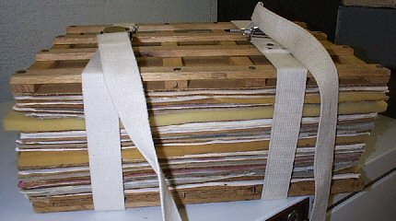

Source: https://www.floridamuseum.ufl.edu/herbarium/voucher.htm

(c) Mounting:
The dried specimens are mounted on herbarium sheets of standard size (41 x 29 cm). Mounting is done with the help of glue, adhesive or cello-tape. The bulky plant parts like dry fruits seeds, cones etc. are dried without pressing and are put in small envelops called fragment packets. Succulent plants are not mounted on herbarium sheets but are collected in 4% formalin or FAA (Formalin Acetic Alcohol).

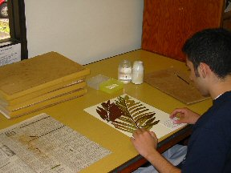
Source: https://www.floridamuseum.ufl.edu/herbarium/voucher.htm
(d) Preservation
The mounted specimens are sprayed with fungicides like 2% solution of mercuric chloride.

(e) Labelling
A label is pasted or printed on the lower right hand corner. The label should indicate the information about the locality, altitude, habit, date and lime of collection, name of collector, common name, complete scientific name etc.
The collection is also recorded in the field notebook together with information about that collection. As much as possible of the following data should be included:
Exact locality - a good plain language description, and latitude and longitude.
Altitude.
Nature of the habitat - type of soil, topography, slope, aspect.
Associated species, vegetation type.
The plant proper - record features which will not be evident from the pressed specimen e.g. whether it is a tree or shrub, height, branching, notes on root system, odour, etc., as well as those features which may be lost on drying e.g. flower colour and odour.
Date of collection

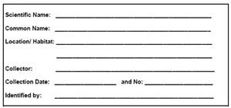
Source: https://www.pinterest.com/pin/113504853090252100/

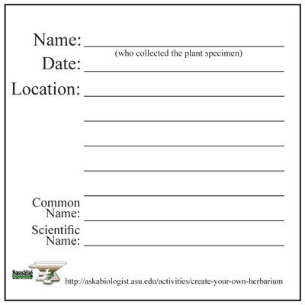
Source: https://www.pinterest.com/pin/471189179735758003/

f) Storage
Properly dried, pressed and identified plant specimens are placed in thin paper folds (specimen covers) which are kept together in thicker paper folders genus overs), and finally they are incorporated into the herbarium cupboards in their proper position according to a well known system of classification.
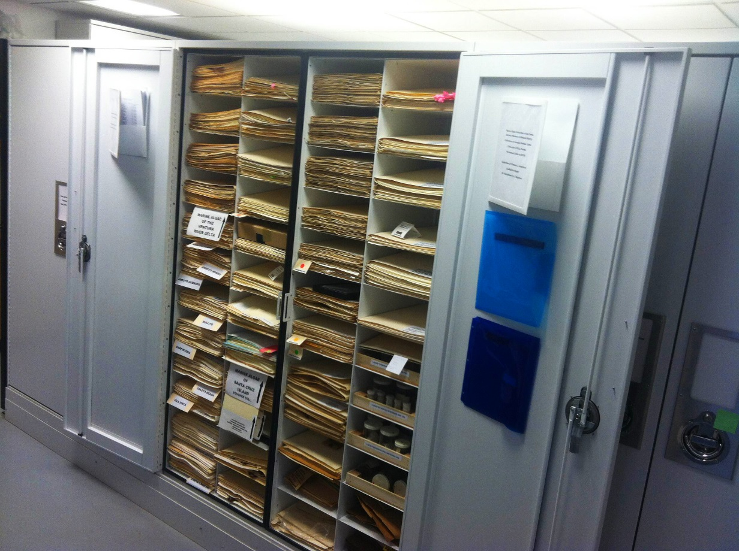
Herbarium cupboard
Source: https://www.ccber.ucsb.edu/collections-botanical-collections-algae/sea-herbarium-preparing-algal-specimens

Post-Test
- What are the tools required in the preparation of an herbarium
- Prepare a herbarium sheet using a local plant

Bibliography
https://en.wikipedia.org/wiki/Herbarium
http://epgp.inflibnet.ac.in/epgpdata/uploads/epgp_content/botany/15._plant_systematics-iii/herbarium/et/5907_et_herbariumet.pdf
http://florida.plantatlas.usf.edu/SpecimenDetails.aspx?PlantID=1306
http://herbarium.biol.sc.edu/floracaroliniana/projects/schools/howto.php
http://herbarium.desu.edu/pfk/page23/page24/files/herbariummaking.pdf
http://puffycarrot.com/best-garden-trowel/
https://www.anbg.gov.au/cpbr/herbarium/collecting/collection-procedures.html
http://www.biologydiscussion.com/angiosperm/methods-of-preparation-of-herbarium-specimens-with-diagram/6532
http://www.biologydiscussion.com/living-organism/herbarium/herbarium-seeds-meaning-methods-and-uses/44586
https://www.ccber.ucsb.edu/collections-botanical-collections-algae/sea-herbarium-preparing-algal-specimens
http://www.ces.iisc.ernet.in/biodiversity/sahyadri_enews/newsletter/issue41/bibliography/plant_collection_and_herbarium_techniques.PDF
https://www.floridamuseum.ufl.edu/herbarium/voucher.htm
https://www.for.gov.bc.ca/hfd/pubs/docs/wp/wp18.pdf
https://www.natsca.org/
https://www.pinterest.com/pin/113504853090252100/
https://www.pinterest.com/pin/471189179735758003/
https://www.slideshare.net/BijuCherupuzha/herbarium-10212042

