CLINIC MANAGEMENT SYSTEM
BY

AGBOMEDARHO JEREMIAH
MATRIC NO: 16010301023

SUBMITTED TO
THE DEPARTMENT OF COMPUTER SCIENCE AND MATHEMATICS,
COLLEGE OF BASIC AND APPLIED SCIENCES,
MOUNTAIN TOP UNIVERSITY, IBAFO, NIGERIA

IN PARTIAL FULFILLMENT OF THE REQUIREMENTS FOR THE AWARD
DEGREE OF BACHELOR OF SCIENCE (B.SC.) IN COMPUTER SCIENCE

OCTOBER 2020

Certification
This is to certify that this project, Clinic Management System was carried by me, AGBOMEDARHO JEREMIAH (Matriculation Number: 16010301023) and duly supervised by Prof. O.A Ojesanmi.

Dedication
This project work is dedicated to the giver of life and wisdom: The Almighty God

Acknowledgement
The success and final outcome of this project goes to the Almighty God for wisdom and understanding.
I specially appreciate my Supervisor Prof O.A Ojesanmi who took keen interest in my project work and guided me all along, and never relented to attend to me anytime I came to him for assistance.
I would like to acknowledge the Head of Department Computer Science and Mathematics Dr. I. O. Akinyemi, and owe him my deepest gratitude for the efforts, constant encouragement, guidance and support of all the academic and non-academic staff of the Department of Computer Science and Mathematics. For the teachings that have brought out positive values in me and making my stay a worthwhile one. I extend my gratitude to Mountain Top University for setting greater heights for me. I say God bless you richly.
I heartily would like to thank my parents, Mr & Mrs Agbomedarho and siblings, thank you all for your moral and financial support. I am grateful for all the investments into my education and future. I would not forget to remember all the students in the Department of Computer Science and Mathematics, for making my stay a worthwhile one, I say God bless you all richly.

TABLE OF CONTENT

COVER PAGE
CERTIFICATION I
ACKNOWLEDGMENT II
ABSTRACT III
TABLE OF CONTENT IV
TABLE OF FIGURES VI
LIST OF TABLES VII
CHAPTER ONE INTRODUCTION 1
1.0 INTRODUCTION 1
1.1 BACKGROUND OF THE STUDY 1
1.2 STATEMENT OF THE PROBLEM 2
1.3 AIM AND OBJECTIVES 2
1.4 SCOPE AND LIMITATION 3
1.5 RESEARCH METHODOLOGY 4
1.6 DEFINITION OF TERMS 4
1.7 CHAPTER LAYOUT 5
CHAPTER TWO LITERATURE REVIEW 6
2.0 INTRODUCTION 6
2.1 CLINIC PRACTICE IN THE PAST 6
2.2 HISTORY OF CLINIC 14
2.3 CATEGORIES OF TECHNOLOGY 17
2.4 BENEFITS OF THE PROPOSED SYSTEM 20
CHAPTER THREE SYSTEM ANALYSIS AND DESIGN 21
3.0 INTRODUCTION 21
3.1 SYSTEM ANALYSIS 21
3.1. ANALYSIS OF EXISTING SYSTEM 22
3.2 REQUIREMENTS DEFINITION 23
3.2.1 METHOD OF INFORMATION GATHERING 23
3.3 SYSTEM DESIGN 24
3.4 SYSTEM MODELLING 25
3.5 SYSTEM FLOWCHART 25
3.5 DATABASE DESIGN 38
CHAPTER FOUR SYSTEM IMPLEMENTATION 42
4.0 INTRODUCTION 42
4.1 CHOICE OF PROGRAMMING LANGUAGE 42
4.3 SYSTEM DOCUMENTATION 44
4.4 HARDWARE REQUIREMENT 44
4.6 DATABASE SPECIFICATION 45
4.7 MODULE DESCRIPTION 45
4.8 SYSTEM MAINTENANCE 53
CHAPTER FIVE CONCLUSION AND RECOMMENDATION 55
5.0 SUMMARY 55
5.1 CONCLUSION 55
5.2 RECCOMMENDATION 56
REFERENCES 57
APPENDIX…………………………………………………………………………..58

LIST OF FIGURES
Figure. 3.3.1 Waterfall Model of System Development Life Cycle……………….24
Figure 3.5.1 Structure Chart……………………………………………………….27
Figure 3.5.2 System flowchart……………………………………………………..28
Figure 3.5.3 Admin flowchart…………………………………….……………….29
Figure 3.5.4 Supervisor Flowchart……………………………...…………………30
Figure 3.5.5 Staff flowchart………………………………………………………..31
Figure 4.1 Homepage………………………………………………………….....45
Figure 4.2 Admin Login Menu…………………………………………………..46
Figure 4.3 Supervisor Login……………………………………………………..47
Figure 4.4 Staff Login……………………………………………………………48
Figure 4.5 Admin Menu Module…………………………………………….….49
Figure 4.6 Drug Registration Form……………………………………………...50
Figure 4.7 Staff registration form………………………………………………..51
Figure 4.8 Store Manager………………………………………………………..52
Figure 4.9 Sales window…………………………………………………………53

LIST OF TABLES

Table 3.1 Administrator Login Table………………………………………………….. 38
Table 3.2 Drug information Table……………………………………………………....39
Table 3.3 Supervisor Login Table………………………………………………………40
Table 3.4 Staff Login Table ……………………………………………………………40
Table 3.5 Staff information Table………………………………………………………41

CHAPTER ONE

INTRODUCTION
The Pharmacy management system is a system designed to improve precision, protection and efficiency of pharmaceutical shop. It is a computer-based system that helps optimize inventory control, cost and patient safety for the clinic.
This method helps the customer to enter the date of production and expiry of a specific product or drug stock opening and sales transaction for a particular product. The system will also include a report showing the list of items expiring before a given date. It also requires manual entry for a certain period of time since the delivery of new sets of drugs and drug shipment from the clinic e.g. every month, the pharmacy will want to produce reports about the shipment of drugs in and out of the clinic, collecting information about the drugs, e.g. expiry date, purchased date, amount of type of drug left, position of the drug in the clinic.
The manual method is used in the pharmacy, as at present. It allows the clinic to track each medication available in the store manually. As the workload increases, this typically leads to errors.

1.1 BACKGROUND OF THE STUDY
The Pharmacy has a large client range due to the scale and quality of operation of the clinic. Such clients tend to visit the pharmacy mostly when they close the job for services. The number of clients patronizing the clinic is large at this time, thereby making the pharmacist’s workload even more boring. This condition makes it harder for the pharmacist to attend to clients within a short period of time.
Meanwhile the pharmacist has to ensure satisfaction in services to keep their clients. The factors mentioned above, results in the delay of services being rendered to the clients, thereby causing the risk of losing valuable clients over time.

1.2 STATEMENT OF THE PROBLEM
In filing cabinets, the pharmacy administration held paper recordings. It would be strenuous and difficult to keep track of the stock of drugs in the pharmacy, the number of drugs available depending on the categories and their functions, to operate a large clinic with paper records.
To replace the already dwindling stock the nurse has to order medicines. Furthermore, prescription ordering is carried out manually. As the nurse has to go through the stock balance and sketch a simple calculation of the sum to order based on the numbers, considerable time is allocated for writing the order.
This project work will inform the nurse about medications that are near expiry, preventing those drugs from being sold and also providing a solution to the problems previously mentioned.

1.3 AIM AND OBJECTIVES
The purpose of this project is to create a web-based pharmacy management system that will be able to achieve the following goals:
- Ensuring effective policing by offering in-stock drug statistics.
- Maintaining a proper database by offering an opportunity to update the stock of drugs.
- Increase the system’s performance by ensuring efficient monitoring of resources and activities.
- To provide optimal control of drug inventory by tracking the flow of drugs in the clinic.
- Ensuring that a degree of restricted access based on features and task exists.
- To ensure that the system is user friendly.
- To be able to generate report within a specified period of time.

1.4 SCOPE AND LIMITATION
The scope of this project is limited to the clinical store’s activities, which include improving patient outcomes, decreasing admission to hospitals and long-term care, improving and making the best use of resources within the school community, using a computer-based management system to increase the performance of a clinic, and it is an integral part of every modern evolution.
The machine will not be able to manage the prescribing of medications, drug to drug interaction. The machine will not be able to cope with the contraindication and concurrent use of medications; this ensures that the nurse will manually administer these services.

1.5 RESEARCH METHODOLOGY
An overview of how the clinic management system for Mountain Top University will be built given in the research method used for this project work.
Therefore, the method used in the design and gather information from different sources is as follows;
- Studying the present system in detail and the organizational style.
- Knowing and understanding the mechanisms of input and output processes of the current system.

1.6 DEFINITION OF TERMS
System: series of interrelated elements that work together to achieve a certain goal.
Drug interaction: is a condition in which one drug’s administration alters another’s clinical results.
Polypharmacy: is a patient’s concurrent use of several drugs.
Contraindication: is a particular case in which a medicine cannot be use as it could be harmful to the individual.

CHAPTER TWO

LITERATURE REVIEW

2.0 INTRODUCTION
A nurse is a medical professional who dispenses drugs tom patients according to a prescription ordered by a physician or other clinician. Nurses have an in- depth knowledge of the chemistry of various drugs and how they react in humans, and also how drugs interact with each other (Charles E. Rosenberg, 1980). Nurses must calculate and package medication correctly, ensuring that its dose and protection are appropriately administered to a patient. Although the nurse usually does not pick or administer the drug; the nurse advices the patient how to take the medication and what reactions or issues to prevent. As pharmacy specialists, in matters relating to drug delivery and use and disease state control, nurses are concerned with safeguarding the welfare of the public. Nurses have a critical role to play via the medication and knowledge they have, improving patient care.

2.1.0 CLINIC PRACTICE IN THE PAST
It provides a summary of events that have taken place in clinical practice over many decades, both in the past and present, and also shows potential future events.

2.1.1 THE HISTORY OF CLINIC
There have been experts and doctors, as long as there have been cultures, whose sole function was to plan and administer medical therapies. In what is now called pharmacognosy, which is the research and use of plants and herbs for healing, the earliest healers participated. Proof that early man used pharmacognosy to cure disease is indisputable, with archaeological finds attesting to the fact that either the growth of agriculture or animal husbandry was pre-dated.
Clinics' origins are old. This art was studied when the first individual conveyed juice from a succulent leaf to be applied to a wound. Asclepius, the god of healing art, entrusted to Hygeia the task of compounding his remedies in Greek mythology. She was an apothecary or nurse for him. Clinics' origins are old. This art was studied when the first individual conveyed juice from a succulent leaf to be applied to a wound. Asclepius, the god of healing art, entrusted to Hygeia the task of compounding his remedies in Greek mythology. She was an apothecary or nurse for him. Egypt's doctor-priests were divided into two classes: those who visited the sick and those who stayed in the temple and prepared patient remedies (Homan, 2008).
The nursing career can be traced back at least as far as the Sumerian population used medicinal plants such as liquorice, mustard, myrrh, and opium, living in modern day Iraq from about 4000 BC. As a different function from diagnosis and care carried out by doctors, there were separate individuals who worked to prepare medicines. They also combined their function with that of a priest with these precursors to nurses. The earliest surviving prescriptions were written by the Sumerians from at least 2700 B.C. – so nearly 5000 years ago (Griggs, 1999).
The Ancient Egyptians, known as Pastophor, had unique medicine preparers. Pharmacy was seen as a medicine branch of high status, and again, these pharmacists, like the Sumerians, were also priests who served and practiced in the temples (Anderson, 2005).
We know from surviving papyrus scrolls, especially the Ebers Papyrus dating from 1500 BC, that infusions, ointments, lozenges, suppositories, lotions, enemas, and pills were made and used by the Egyptians. 875 prescriptions and 700 medications are part of the Ebers Papyrus. Meanwhile, in about the same era in China (2000 BC), the first native herbal, which included details of 365 plant-based drugs, was written by a man named Shen Nung (Anderson, 2005).
Around 1900 B.C., there were stalls and shops selling medical supplies. On the Euphrates River in the town of Sippara. The earliest known shop dealing with medicine sales in London, however, was opened in 1345. The art of healing recognised a separation between the duties of the physician and those of the herbalist, who provided the physician with the raw materials from which to produce medicines, in ancient Greece and Rome and throughout the middle ages in Europe. However, during the 8th century, the Arab influence in Europe culminated in the practice of separate duties for nurses and physicians. A law passed by the town council of Bruges in 1683, forbidding doctors to prepare drugs for their patients, later intensified the movement towards specialization. In America, when he named an apothecary to the Pennsylvania Hospital, Benjamin Franklin took a central step in holding the two occupations apart.
Since World War II, the growth of the pharmaceutical industry has led to the discovery and use of new and successful drugs. It also changed the pharmacist 's position. The need for extemporaneous drug compounding has been greatly reduced and the need for the deceptive skills traditionally applied by the pharmacist to the preparation of tablets, plasters, and potions has been greatly reduced (Rosenberg, 2008). The nurses, however, continue to fulfil the intentions of the prescriber by providing advice and information; by formulating, storing, and providing correct dosage forms; and by ensuring the effectiveness and consistency of the medicinal product dispensed or supplied.

2.1.2 CATEGORIES OF TECHNOLOGIES:
- Clinical decision support tools.
- Advances in technology for bar-coding and even radio-frequency recognition can assist nurses to verify the effective use of drugs.
- Telecommunication networks. To be able to give a text message alert to a patient, for example, to take drugs or measure blood glucose levels. This will contribute to better behaviour in the management of self-care.
- Automation and robotics.
- Connectivity to shared practice, accomplished by a combination of electronic prescribing (e-prescribing) and the opportunity to connect with laboratories and physician offices and share data.
- Support for distribution service, using GPS-driven routing, monitoring, order status, dispatch, location, and oversight telecommunication systems.
- Clinic surveillance and safety systems which, even when nurses are off-site, will provide a higher level of safety for clinics.
In making contributions to patient care, nurses will play an important role and these contributions will be reported and transmitted using technology, and that care will be registered in the future in the EHR (electronic health records). As far as the care of patients is concerned, nurses will be integral team members. The cornerstones of this relationship between nurses and automation would be better treatment and decreased errors.

2.1.3 BENEFITS OF THE PROPOSED SYSTEM
The proposed framework would be structured to promote the comprehensive activities carried out in a pharmacy by supplying in-stock drug statistics, tracking the movement of drugs in the clinic, and ensuring efficient monitoring of clinic activities.
The new framework will be built in the interest of the pharmacy to have the following benefits;
- The scheme would improve management services and enhance productivity.
- The framework would boost the user / system interface.
- The system would be cost effective.
- The system would improve information quality and accessibility.

CHAPTER THREE

SYSTEM ANALYSIS AND DESIGN

3.0.0 INTRODUCTION
The system is a collection of interrelated elements that work together to achieve an objective. System analysis refers to a systematic evaluation or thorough review of a system in order to identify system issues and to suggest changes or solutions to the system using the knowledge collected during the analysis stage.
System design is an abstract representation of a part of a system and its relationship, defining the system 's aggregate functionality and results. System design is also the overall plan or blueprint for how the question being asked will be answered. The design defines which of the different method styles are used.

3.1.1 SYSTEM ANALYSIS
System analysis is the study, including computer systems analysis, of sets of interacting entities. It is also "a specific systematic investigation undertaken to assist someone determine a better course of action and make a better decision than he would have otherwise made." System Analysis is a technique involving the use of systemic methods to gather information about a current system in order to enhance or substitute it with a more effective system in the light of the resources available. In other words, system analysis can also be seen as the system investigation process, the detection of issues and the use of knowledge to suggest system changes.
3.1.2 ANALYSIS OF EXISTING SYSTEM
We need to carefully illustrate the issues of the current system before testing the architecture of the new system, in order to prevent recurrence. This study serves as a guide to how to start building the planned framework that will allow the nurse to provide optimal control of the drug inventory by tracking the clinic 's drug movement and condition. The new system 's issues should be highlighted. Some of the concerns associated with the current system are below;
- As the nurse has to go through the stock balance and make a rough calculation of the quantity to order based on figures, a considerable amount of time is reserved for writing the order.
- It is manually tested for the condition of drugs in stock.
- Error in the marketing to clients of expired medications.
- Too much workload on staff.
- Clinic filing cabinet with paper documents.
3.1.3 ANALYSIS OF PROPOSED SYSTEM
From the problems listed in the existing system, the implementation of the proposed system shall focus on;
- Clinic having access to the proposed system at any time.
- Ensuring effective policing through the provision of stock data on drugs.
- Enhancing the system's performance by ensuring efficient monitoring of facilities and activities.
- Report generation within a defined time span.
- Reducing the workload of the workforce.

3.4 REQUIREMENTS DEFINITION
In establishing a satisfactory criterion, preliminary investigation plays an important role. As a result of a detailed analysis of how the new or existing system operates, the information collected in the preliminary investigation are used to reflect on the possibilities of replacing the current system or strengthening the current system. This assignment includes collecting information.

3.5 METHOD OF INFORMATION GATHERING
In order to be able to compose the project, collecting reality is the act of acquiring and collecting information from different sources. Data used for the design of the device was obtained by several methods. Therefore, the methodology used in the design and processing of data from different sources is as follows:
- Collecting and analysing existing materials written by different experts on the project topic.
- Studying the present method and the organizational style in depth.
- Knowing and understanding the current system's input and output processes.
- Interviews: In the pharmacy, a qualitative form of interview was performed to understand the equipment required and the old system's mode of operation.

3.6 SYSTEM DESIGN
System design is the approach used by system modelling to determine the architecture, components, modules, interfaces, and data for a system to meet defined requirements. One might see it as the application of the theory of systems to produce development. This system 's architecture will be user friendly. It is structured in such a way that workers can quickly navigate through the information given by the system.
In other words, system design consists of design operations that create system specifications that meet the functional requirements established in the process of system analysis. The architecture of the system determines how the system will operate. The structural implementation of the study of the system is system architecture.

IMPLEMENTATION AND SYSTEM TESTING
REQUIREMENT GATHERING
PROJECT PLANNING

PROJECT DEVELOPMENT & INTERFACE DESIGN

MAINTENANCE AND UPGRADING

FIG. 3.3.1 WATERFALL MODEL OF SYSTEM DEVELOPMENT LIFE CYCLE

The diagram above is a system development life cycle that illustrates how the design of the project is broken down into five different phases, which are Project Planning, Requirement Gathering, Project Implementation and Interface Design, Implementation and System Testing, Maintenance and System Upgrading.
The proposed Pharmacy Management System for Mountain Top University Clinic will start with project planning by determining the users of the system, aim and objectives of the project. After these, extensive research will be done to determine how to design an effective system, as well as to review the current system. Then, the design was with an initial prototype of the system, and then refined it based on their suggestions. Phases of analysis, design and implementation were performed iteratively until users and designers agreed on a final system specification. At this point, the project could move to the final implementation phase.

3.4 SYSTEM MODELLING
During the system requirements and design activity, systems may be modelled as a set of components and relationships between these components. These are normally illustrated graphically in a system architecture model that gives the reader an overview of the system organisation. System modelling helps to give more detailed system specifications which are in form of graphical representations that can describe problem to be solved or the system that is to be developed. Because of the graphical representations used, models are often more understandable than detailed natural language description of the system requirements. Examples of such modelling tool is a System Flowchart.

3.5 SYSTEM FLOWCHART
System flowchart is a type of diagram that represents an algorithm or process, showing the steps as boxes of various kinds, and their order by connecting these with arrows. This diagrammatic representation can give a step-by-step solution to a given problem. Process operations are represented in these boxes, and arrows connecting them represent flow of control. Flowcharts are used in analysing, designing, documenting or managing a process or program in various fields. Different symbols are used in the flowchart to represent input, output, decision, connectors and process.

3.5.1 STRUCTURE CHART
SELECT MENU
ADMIN LOGIN
STAFF LOGIN
SUPERVISOR LOGIN
SUPERVISOR MENU

ADMIN MENU
ADD STAFF
ADD DRUG
ADD CATEGORY
GOTO STORE
VIEW DRUGS
MANAGE DRUGS
DRUG STATE
VIEW SALES
VIEW STAFF
ADD CATEGORY

ADD DRUG

GOTO STORE

VIEW DRUGS

MANAGE DRUGS

DRUG STATE

VIEW SALES

VIEW STAFF

STAFF MENU
SELL DRUGS
RESTOCK DRUG
DELETE DRUG

3.5.2 SYSTEM FLOWCHART
SUPERVISOR LOGIN
SELECT LOGIN
AS STAFF?
AS SUPERVISOR?
YES
YES
YES
STAFF LOGIN
ADMIN LOGIN
NO
NO
NO
NO
YES
STOP
EXIT?
AS ADMIN?
START
3.5.3 ADMIN FLOWCHART
2
J
I
H
G
F
E
D
C
B
YES
YES
YES
YES
YES
YES
YES
YES
YES
YES
LOG OUT?
VIEW STAFF?
VIEW SALES?
DRUG STATE?
MANAGE DRUGS?
VIEW DRUGS?
GOTO STORE?
ADD CATEGORY?
ADD STAFF?
ADD DRUG?
VALIDATED?
ENTER LOGIN DETAILS

ADMIN MENU

ADMIN LOGIN
3
3
3
3
3
NO
3
NO
3
NO
3
3
NO
NO
3
NO
NO
NO
NO
NO
3
2

YES
YES
YES
3.5.4 SUPERVISOR FLOWCHART
1
S
R
Q
P
O
N
L
YES
YES
YES
YES
YES
YES
LOG OUT?
VIEW STAFF?
VIEW SALES?
DRUG STATE?
MANAGE DRUGS?
ADD DRUG?
VALIDATED?
ENTER LOGIN DETAILS

SUPERVISORLOGIN
3
3
3
3
3
NO
3
NO
NO
NO
NO
NO
NO
3
1
M
YES
YES
VIEW DRUGS?
NO
YES
GOTO STORE?
ADD CATEGORY?
3
3
3
NO

SUPERVISOR MENU

3.5.5 STAFF LOGIN FLOWCHART

STAFF LOGIN

ENTER LOGIN DETAILS

NO
VALIDATED?

YES

YES
A
ENTER STORE?

A
NO
YES
YES
DISPLAY SUCCESS
DOES QUANTITY EXIST?
ENTER QUANTITY
DISPLAY SOLD
DOES QUANTITY EXIST?
ENTER QUANTITY
2
2
RESTOCK
SELL
DISPLAY STORE

NO

2
2
YES
NO
NO
YES
ENTER STAFF DETAILS
VALIDATED?
DISPLAY SUCCESS
DISPLAY SUCCESS
VALIDATED?
ENTER DRUG DETAILS
C
B

NO
YES
2

DISPLAY SUCCESS
2

DISPLAY SUCCESS
VALIDATED?
EDIT DRUG INFORMATION
ADD NEW DRUG
DISPLAY DRUGS

F

2

2

ADD CATEGORY
DELETE CATEGORY
DISPLAY CATEGORY
D

2

CHECK STOCK
DISPLAY
DISPLAY
DISPLAY
EXPIRED DRUGS
LOW STOCK
ALL STOCK
DISPLAY STORE MANAGER
G

SELECT DRUG
RESTOCK
2

DELETE
ENTER QUANTITY

DISPLAY SUCCESS
NO
VALIDATED?
2
YES

DISPLAY SUCCESS

DOES QUANTITY EXIST?
NO
NO
YES
YES
DISPLAY SUCCESS
DISPLAY SUCCESS
ENTER QUANTITY
ENTER QUANTITY
VALIDATED?
RESTOCK
GOTO STORE
E
2
2
SELL

SELECT DRUG STATE
H
2
DISPLAY DRUG STATE

STOP
DISPLAY STAFF INFORMATION
SELECT VIEW STAFF
DISPLAY SALES
SELECT VIEW SALES
2
J
2
I

3.5 DATABASE DESIGN
This is a shared collection of data that are related or files that are to meet the immediate need of authorized users. These data may be in form of text, numeric, date or encoded images.
ADMINISTRATOR LOGIN TABLE:
Field Name | Field Type | Field Length | Description
Admin_Username | Varchar | (15) | Admin Username
Password | Varchar | (15) | Admin password
Table 3.1 Administrator table
Table 3.1 above serves as a repository for administrator details, that will be able to have access to the entire details on the application. It is a table that stores the administrator login details.

DRUG INFORMATION TABLE
Field Name | Field Type | Field Length | Description
Drug Name | Varchar | (15) | Drug Name
Drug ID | Varchar | (7) | Drug Number in stock
Manufacturer | Varchar | ( ) | Manufacturer
Batch No | Varchar | ( ) | Batch Number
Production Date | Date/Time | ( ) | Production Date
Expiry Date | Date/Time | ( ) | Expiry Date
Dosage | Text | ( ) | Dosage
Reg Date | Date/Time | ( ) | Registration Date
Quantity | Int | ( ) | Quantity
Cost Price | Int | ( ) | Cost Price
Interest Rate | Int | ( ) | Interest Rate
Expected Sale | Int | ( ) | Expected Sale

Table 3.2 Drug information table: This table is named tblDRUG, it depicts the information of the drugs in the pharmacy.
Table 3.2 shows the information about the drugs in the pharmacy and is being queried from the database on the drug registration page to show all the drugs for user to select.

SUPERVISOR LOGIN TABLE
Field Name | Field Type | Field Length | Description
USERNAME | Varchar | (15) | Supervisor username
PASSWORD | Varchar | (15) | Supervisor password
TABLE 3.3 SUPERVISOR TABLE
Table 3.3 above serves as a repository for supervisor details, which will be able to have access to the required details on the application as stipulated by the administrator. It is a table that stores the supervisor login details.
STAFF LOGIN TABLE
Field Name | Field Type | Field Length | Description
USERNAME | Varchar | (15) | Staff Username
PASSWORD | Varchar | (15) | Staff Password
TABLE 3.4 STAFF LOGIN TABLE
Table 3.4 above serves as a repository for a staff details, that will be able to have access to the required details on the application as stipulated by the administrator. It is a table that stores the staff login details.

STAFF INFORMATION TABLE
Field Name | Field Type | Field Length | Description
STAFF_NAME | Varchar | ( ) | Staff Name
REGNO | Int | (6) | Registration number
STAFF_SEX | Varchar | (6) | Staff Sex
NATIONALITY | Varchar | ( ) | Nationality
STAFF_STATUS | Varchar | (15) | Staff Status
DOB | Date | ( ) | Date of Birth
PHONE_NO | Int | (11) | Phone Number
ADDRESS | Varchar | ( ) | Contact Address
STATE | Varchar | ( ) | State
EMAIL | Varchar | ( ) | Email
USERNAME | Varchar | ( ) | Username
PASSWORD | Varchar | (15) | Password

TABLE 3.5 STAFF INFORMATION TABLE
Table 3.5 above consist of information of the list and information of the employed staff in the clinic. The information of staff on the required field can be seen from the table 3.5 above.

CHAPTER FOUR

SYSTEM IMPLEMENTATION

4.0 INTRODUCTION
System implementation is a stage in the life cycle of the system whereby a new system is designed, implemented and prepared for use. It is this stage in which all the information and key points in the definition of the specifications are partialized. The implementation of the system is therefore a very critical stage in which the performance of the new system is primarily determined by its success. In this case, the system is properly ready to be implemented (Pharmacy Management System) after everything is said and done.
In order to accomplish organizational goals, system design is concerned primarily with the arrangement of tasks, job procedures and the use of equipment. This addresses data, processing and interface input and output data.
This stage involves the design of the new Pharmacy Management System

4.1 CHOICE OF PROGRAMMING LANGUAGE
Choosing a programming language depends on the knowledge of your language and the complexity of the application that you are creating. Although small applications are mostly developed using only one language, the creation of large applications using multiple languages is not unusual.
The proposed application to be created is not a web-based application that involves the operation of internet services, but a standalone application.
The programming language options to be used for this application are HTML and CSS.
The structure of the basic programming language, especially with regard to executable code, is quite simple.
HTML stands for Markup Language for Hypertext. It helps the user to build and organize sections for web pages and applications, paragraphs, headings, links, and blockquotes. HTML is not a programming language, which means it has no ability to construct complex features. Instead, it makes it possible, similar to Microsoft Word, to organize and format documents.
CSS stands for Cascading Style Sheets used to define a text presentation written in a markup language such as HTML. CSS is designed to allow presentation and material, including layout, colors, and fonts, to be separated. This separation will enhance usability of content, provide more flexibility and control in the presentation features specification, allow multiple web pages to share formatting by defining the related CSS in a separate format.
4.2 SYSTEM TESTING AND DEBUGGING
Testing is an integral part of software development processes. This is to ensure that the application's quality specifications are not violated by the testing and debugging of software modules until they are integrated, and the system is reviewed to ensure successful interoperability after incorporation. Debugging has to do with correcting errors found during the execution of the program. System monitoring deals with the system 's real life testing, to assess how far it has come in carrying out the intended mission. This was done in two stages. The source code examination that tests the program's logic is number one. Secondly, given particular circumstances, the specification testing includes evaluating the device as to what it should do and how it should be done. This involves inputting data, gathering its output and comparing it with the old system's output and reviewing it to see whether the old system can be replaced.

4.3 SYSTEM DOCUMENTATION
A critical part of the implementation process is device documentation. It defines the functioning of components and acts as a method of communication between developers and users of applications. It also allows for potential application review by either the same or different device analysts and developers. Visual Basic 6.0 software must be installed on the device to set up the system until it can operate.

4.4 HARDWARE REQUIREMENT
- A minimum hard disk space of 20 Gigabytes (GB)
- RAM size of 1GB
- Pentium 4 dual processor CPU
- A VGA colour monitor
- Mouse
- Keyboard
4.5 SOFTWARE REQUIREMENT
- Windows operating system such as Windows 2000, windows XP, Windows Vista, Windows 7.
- Visual basic 6.0 software.

4.6 DATABASE SPECIFICATION
A database is a single file composed of organized data and documents that are stored with minimal to no data replication. Therefore, it is a built, consistent and regulated knowledge pool. For all users, a good database must be common and independent of the programs that use it to produce output. However, for the configuration of the database management system, Microsoft Access was used as the database application tool. The information management system is limited only to the administrator of the database.

4.7 MODULE DESCRIPTION
SAMPLE OUTPUT FORMS
HOME PAGE
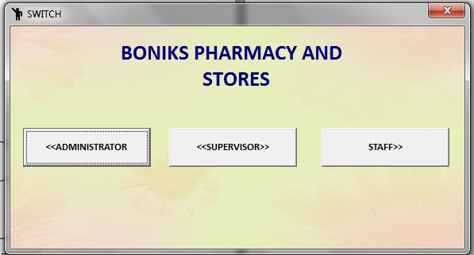
Figure 4.1 showing HOME PAGE
Figure 4.1 shows the select login page. It is the first interface that appears on the screen when the application is being loaded. This interface displays the name of the application and some other information about the software. The page consists of logins that exist for several other levels in the application. They consist of administrator, supervisor and staff login.

ADMIN LOGIN MENU
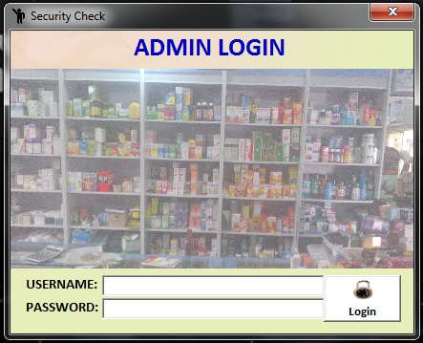
Figure 4.2 Showing Admin login menu
Figure 4.2 above, shows the admin login area of the application. After a successful login supplying the correct username and password, it opens into another page where the activities of the admin module are fully stipulated. The admin controls all the major activitis of this application. Activities such as Addstaff, Add Drugs, Change Username and password, Manage drugs, View sales etc can only be controlled by the admin.
Futhermore,the Admin has control over the supervisor and all other user of the application.

SUPERVISOR LOGIN
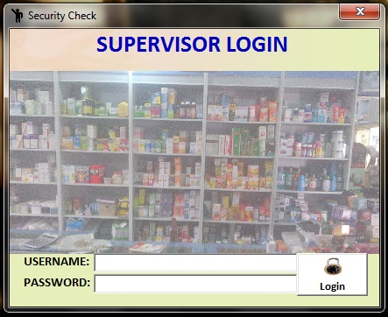
Figure 4.3 above shows the supervisor login.The supervisor is an employee that manages the activities of the pharmacy. After a successfu login, some of the activities that can be performed by the supervisor are Manage drugs, view sales, view drugs etc.
The supervisor has a high level of acces on the application except for addition a new staff.

STAFF LOGIN

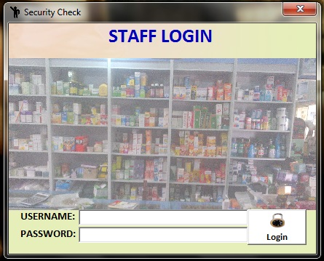

Figure 4.4 Showing Staff login
Figure 4.4 above shows the staff login section.The staff is resonsible for updating the list of drugs in the store.The staff can also engage in buying and selling of drugs.The staff is required to provide a valid username and password in other to be able to perform its activities.

ADMIN MAIN MENU
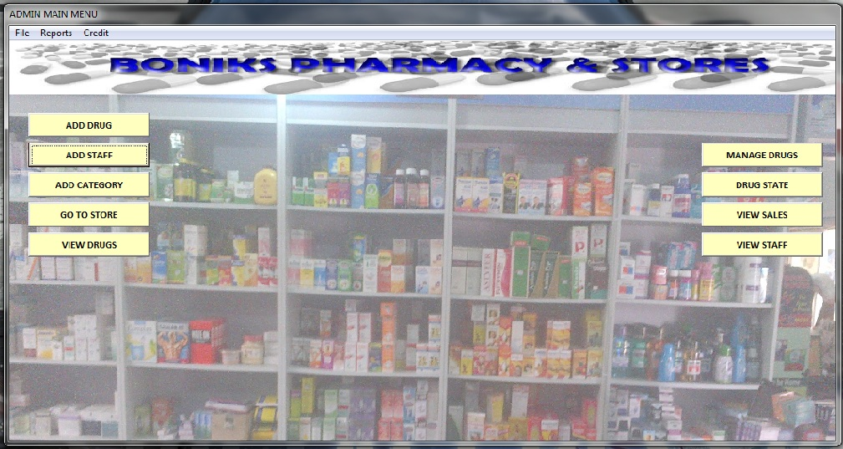

Figure 4.5 Showing Admin Menu Module
Figure 4.5 above shows the Admin module menue. It list activities that can be performed by the administrator.the Administrator is the person responsible for the upgrade,management on the software.the administrator is given an unlimited access as to performing the operations in the pharmacy.

DRUG REGISTRATION FORM
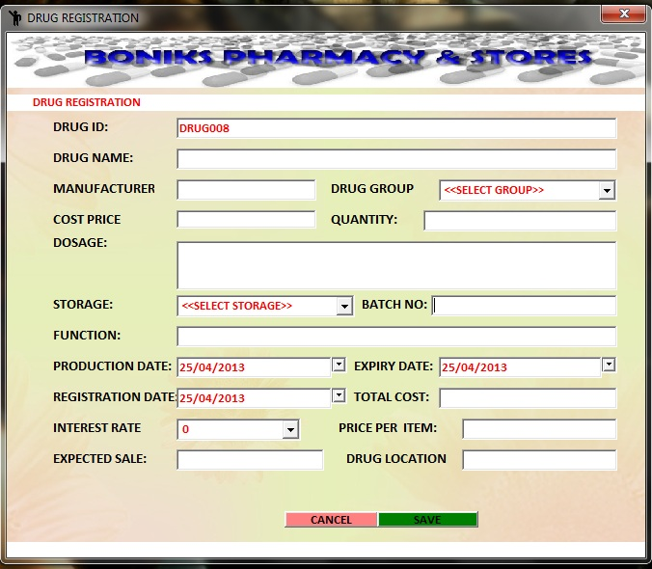
Figure 4.6 Showing Drug Registration Form
Figure 4.6 above shows the drug registration form. New drugs brought to the pharmacy are registered here. It receives the details of new batches of drug in the pharmacy.

STAFF REGISTRATION FORM
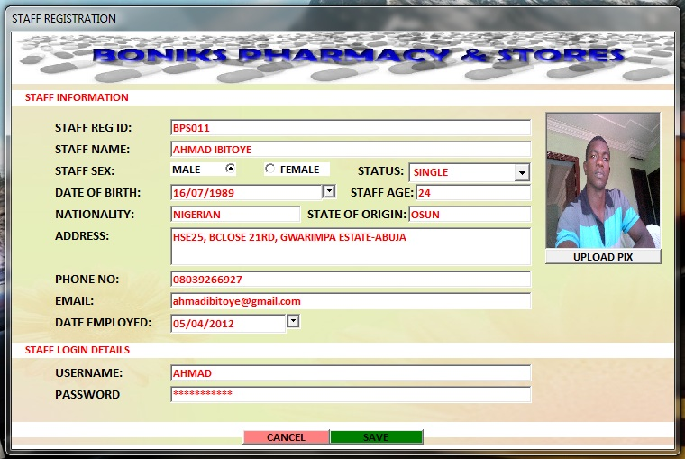
Figure 4.7 Showing Staff Registration Form
Figure 4.7 above shows the staff registration form. Important information like the contact details is collected with this form. A login detail that is, a username and a password is assigned to the new staff as well.

STORE MANAGER
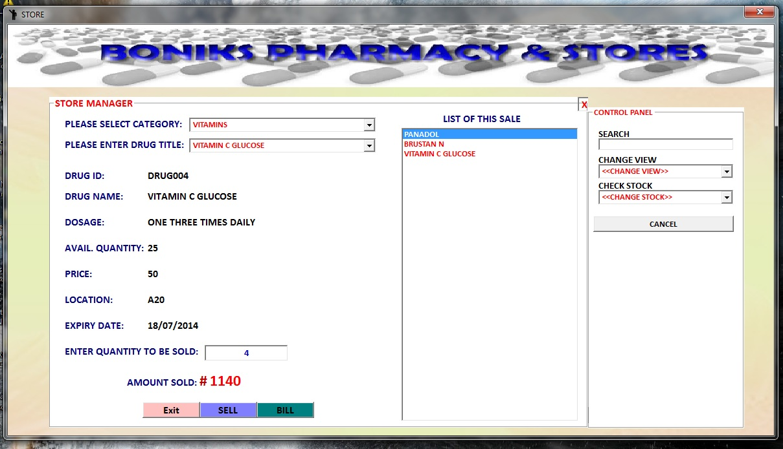
Figure 4.8 Showing the Store Manager
Figure 4.8 above shows the store manager. Here drugs can be sold. The user will be required to select a category of drug to sell. Drugs in the pharmacy are categorised based on their function. When the drug needed to be purchased is selected, the software generates important information about the drug such as dosage, available quantity, selling price, expiry date, location of the drug in the pharmacy etc. Also, the user can sell drugs, print bill, check all stock, low stock or check the expired drugs in stock.

SALES WINDOW
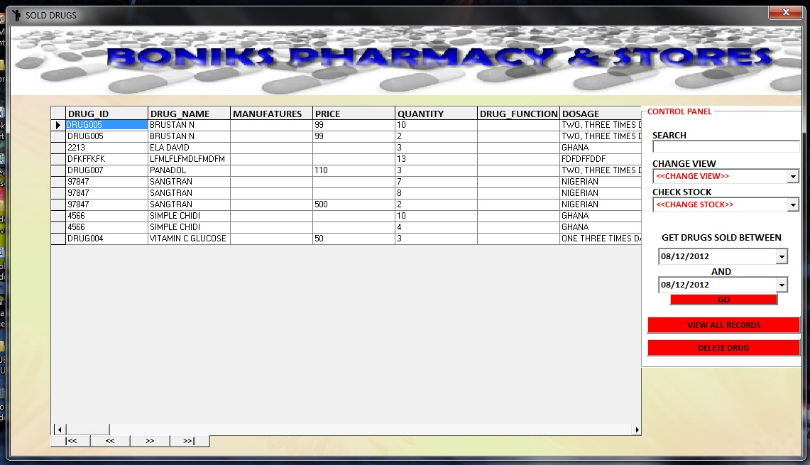
Figure 4.9 Showing Sales
Figure 4.9 shows the list of drugs sold in the pharmacy. There is an option to view the sales in the pharmacy within a specified date.

4.8 SYSTEM MAINTENANCE
Maintenance is an ongoing method of making improvements and updating the program.
This normally begins after the program has been put into use. There are two distinct forms that can be preserved by this program. They include:
- Maintenance of Additive or Enhancement: business processes are complex. Applications that help these processes must adapt to incorporate these changes as business processes shift. Therefore, it must be constantly updated in order for this application to work optimally and to satisfy changing user requirements.
- Corrective maintenance: This is important in the case of an error occurring when the program is in operation. Corrections must be made to the modifications found that can cause the device to malfunction.

CHAPTER FIVE

CONCLUSION AND RECOMMENDATION

5.0 SUMMARY
The clinic management system is designed to improve the accuracy of the pharmaceutical store, to improve safety and efficiency. It is a computer-based system that helps improve inventory control, expense, medical protection, etc. for the clinic.
In order to ensure the confidentiality of information and the reliability of clinic records while accessing and delivering services to customers, a clinic management system was developed. During the data collection, the information collected was thoroughly analyzed and the findings formed the basis for the new method.
In order to ensure the confidentiality of information and the reliability of clinic records while accessing and delivering services to customers, a clinic management system was developed. During the data collection, the information collected was thoroughly analyzed and the findings formed the basis for the new method. The system was tested and found to be functional and it was rewarding to produce the outputs provided by this system. Unlike the current method, the application would also minimize the loss of information and information will also be processed rapidly.

5.1 CONCLUSION
In order to incorporate this program efficiently, the basic specifications of the clinic management system would be taken care of because it is capable of providing an simple and efficient storing of information related to activities in the specified field. With these, the targets of the device design will be met.
In order to allow potential expansion, the system has been built in such a way as to allow possible change, as may be deemed necessary by the management of the clinic if the idea occurs.

5.2 RECCOMMENDATION
Designing this software (Clinic Management System) is not an easy task. It all began from the selection of requirements and passes before completion through so many other processes. The following suggestion will be considered based on the advantages of this method and the immense value it will bring to customer-user satisfaction;
It is recommended that the new device should be used in compliance with the required system requirements and that the availability of an uninterrupted power supply should be made available during the clinic’s operating hours in order to prevent power outages. Basic programming information for the users of the program should also exist.
Particularly in accounting areas, it is recommended that the software be improved as it will have a major impact on the development of retail clinic.

REFERENCES
Barbara Griggs. Green Pharmacy: The History and Evolution of Western Herbal Medicine, Second Edition. Viking press, (1982). Pg. 93-97.
Charles E. Rosenberg, Morris J. Vogel. The Therapeutic Revolution: Essays in the social history of American Medicine, Second Edition. University of Pennsylvania press, (1979). Pg. 174.
Peter G Homan, Briony Hudson, Raymond C Row. Popular Medicines: An illustrated
Leslie G. Mathews. History of Pharmacy in Britain. Edinburgh, E&S. Livingstone (1962). Pg. 213-223.
History, Fourth Edition. Trade paperback, Pharmaceutical press (2008). Pg. 127.
Stuart Anderson. Making Medicines: A Brief History of Pharmacy and Pharmaceuticals, Sixth Edition. Jessica Kingsley publisher, (2005). Pg. 214.
Charles E. Rosenberg. History of Medicine and Allied Sciences, Seventh Edition. University of Pennsylvania press, (2003). Pg. 197.
George A. Bender. Great moments in Medicine, Cambridge university press (1967). Pg. 118.

