CONSTRAINTS TO THE GLOBAL PRODUCTION OF TOMATO

OYEBAMIJI, ADEBOLA EYITAYO
16010101006

A RESEARCH PROJECT SUBMITTED TO THE DEPARTMENT OF BIOLOGICAL SCIENCES, COLLEGE OF BASIC AND APPLIED SCIENCES, MOUNTAIN TOP UNIVERSITY, MAKOGI, IBAFO, OGUN STATE, NIGERIA.

IN PARTIAL FULFILMENT OF THE REQUIREMENTS FOR THE AWARD OF BACHELOR OF SCIENCE (B.Sc) IN MICROBIOLOGY

DECEMBER, 2020
CERTIFICATION

This is to certify that this research project titled “CONSTRAINTS TO THE GLOBAL PRODUCTION OF TOMATO” was carried out by OYEBAMIJI, Adebola Eyitayo, with matriculation number 16010101006. This project meets the requirements governing the award of Bachelor of Science (B.Sc) Degree in Microbiology department of biological sciences of Mountain Top University, Ogun State, Nigeria and is approved for its contribution to knowledge and literary presentation.

DR F. IBADIN
(Project Supervisor) Date

Dr O.E. Fayemi
(HOD) Date

DECLARATION

I hereby declare that this project report written under the supervision of Dr. F. Ibadin is a product of my own research work. Information derived from various sources has been duly acknowledged in the text and a list of references provided. This research project report has not been previously presented anywhere for the award of any degree or certificate.

OYEBAMIJI E. ADEBOLA Date

DEDICATION
I, dedicate this work to God Almighty, for His divine strength, wisdom, and knowledge which saw me through the completion of this work. Also, to my parents, Mr. & Mrs. Oyebamiji, and siblings for their unwavering supports financially, emotionally, and morally and to my colleagues who encouraged me to be strong despite several challenges, these joint efforts helped in the completion of this work.

ACKNOWLEDGEMENT
The success of this work was made possible because of God and his never-ending help-rendered to me through a number of notable people. To the Lord, for His Grace, Mercy, and Favor over my life and academics which am forever grateful to.
I would like to appreciate the efforts of my amazing supervisor, Dr. F. Ibadin, who mentored me throughout the course of this work. I want to thank him for unending support through sacrifices in form of sleep, energy and time.
I would like to appreciate the Dean of the College of Basic and Applied Sciences Prof. A. Akinwande for his support throughout my stay in this school.
I also appreciate Dr. Mrs. Oyebanji for her kind yet disciplined teachings, you have made a great impact in my life, and every lecturer who impacted knowledge into me and to the entire administration of the Department of Biological Sciences.
I would like to express my deep and sincere gratitude to my parents and my lovely siblings for helping me a lot throughout my stay in this school and also helping me in finalizing this project.
Lastly, appreciation goes to my colleagues in the names of Keku Oluwatosin, Oladele Taiwo-Timilehin, Ajose Oyindamola, Esther Tobi, Adegboye Damilola, Korede Joyce, Dada Tomiwa, and Akio Moses for always being there for me throughout my stay in the school.

TABLE OF CONTENTS
CERTIFICATION………………………………………………………………………...2
DECLARATION………………………………………………………………………….3
DEDICATION………………………………………………………….............................4
ACKNOWLEDGEMENTS……………………………………………...............5
LIST OF FIGURES……………………………………………………………………….9
LIST OF TABLES………………………………………………………………………..10
ABSTRACT………………………………………………………………………………11
- INTRODUCTION………………………………………………………………...13
LITERATURE REVIEW……..………………………………………………………...15
- CONSTRAINTS TO TOMATO PRODUCTION………………………………...15
2.1 ABIOTIC STRESS………………………………………………………………….15
2.2 FLOODING………………………………………………………………………....16
2.3 SALINITY…………………………………………………………………………..17
2.4 DROUGHT……………………………………………………………………….…18
2.5 DROUGHT AND SOIL BACTERIA………………………………………….…...19
2.6 BACTERIAL-MEDIATED DROUGHT TOLERANCE…………………….…….20
2.7 BIOTIC STRESS…………………………………………………………….……..21
CHAPTER THREE…………………………………………………………….……….22
3.0 Diseases Affecting Tomato……………………………………........................……22
3.1 Bacterial Diseases of Tomato………………………………………...............……..22
3.1.1 Bacterial Spot………………………………………………..................................22
3.1.2 Tomato Pith Necrosis………………………………………………........………….23
3.2 Viral Diseases of Tomato……………………………………………...…………...24
3.2.1 Tomato Spotted Wilt Virus (TSWV)……………………………...……………….24
3.2.2 Tomato Yellow Leaf Curl Virus (TYLCV)…………………..…………………....25
3.3 Fungal Diseases of Tomato…………………………………..…………............……26
3.3.1 Fungal Leaf Spots……………………………………….….......………………….27
3.3.2 Late Blight................................................................................................................28
3.3.3 Early Blight………………………………………...………………….......………28
3.3.4 Septoria Leaf Spot ……………………………..……………………........……….29
3.3.5 Fusarium Wilt…………………………….……………………….......…………..30
3.4 Fusarium…………………………………………………………………………….31
3.4.1 Effects of Fusarium in Humans…………………………………………………...32
3.4.2 Effects of Fusarium in Animals……………………………….……………….….33
3.4.3 Laboratory Identification of Fusarium sp…………....….………………………...33
3.4.4 Morphological Description………………………….…………………………….33
3.4.5 Molecular Identification………………………….……………………………….34
3.4.6 Species of Fusarium………………………….…………………………………...34
3.5 Fusarium oxysporum complex…………….………………………………………..34
3.6 Fusarium oxysporum lycopersici ………………………….....…………………….35
3.7 Control of Fusarium oxysporum lycopercisi…………….…………………………37
3.7.1 BiologicalL Control of Fusarium oxysporum lycopersici…….….........................37
3.8 Plant Growth Promoting Rhizobacteria (PGPR)……………………….……….….37
3.9 Use of PGPR to Control Fusarium oxysporum lycopersici………..………….…...39
3.10 Rise of New Tomato Disease known as Tomato Ebola (Tuta absoluta)…….…..40
3.11 Tuta absoluta in Africa……………………………………………………....…..42
3.12 Tuta absoluta in Nigeria……………………………………………..…………..43
3.13 Biological control of T. absoluta………………………………..…………….....43
3.13.1 Trichogramma achaeae in control of T. absoluta………..…………………....44
3.13.2 Macrolophus spp in control of T. absoluta………….………………………...44
3.14 Bio-pesticidal Control of T.absoluta………………………….………………....44
CHAPTER FOUR…………………………………………………………………...45
4.0 Discussion………………………………………………………………….……...45
CHAPTER FIVE…………………………………………………………………….48
5.0 Conclusion and Recomendation…………………………………………………..48
REFERENCES…………………………...……………………………………….......47

LIST OF FIGURES
Figure 1.1: Tomato fruit……………………………………………………………….12
Figure 2.1: Drought affected land…………………………………………………......19
Figure 3.1a: Bacterial Spot symptoms on Tomato fruit……………………………….23
Figure 3.1b: Bacterial Spot symptoms on Tomato leaves……………………………..23
Figure 3.2: Tomato pith necrosis…………………………………………………........24
Figure 3.3: Tomato spotted wilt virus………………………………………………….25
Figure 3.4: Tomato plant with Tomato yellow leaf curl virus…………………………26
Figure 3.5: Fungal leaf spot……………………………………………………………28
Figure 3.6: Early blight on tomato foliage……………………………………………..29
Figure 3.7: Septoria leaf spot (Septoria lycopersici) on tomato……………………….30
Figure 3.8: Tomato plant (Solanum lycopersicum) affected by fusarium wilt………...31
Figure 3.9: Fusarium wilt caused by F. oxysporum f. sp. Lycopersici in field conditions………………………………………………………………………………....35
Figure 3.10(a & b): Cultural and morphological features of Fusarium oxysporum f. sp. lycopersici………………………………………………………………………………...36
Figure 3.11: Damage appear as mines and galleries on tomato leaves caused by feeding of T. absoluta…………………………………………………………………………………...41
Figure 3.12: Tunnels in ripe tomato fruits by the larvae of Tuta absoluta….………….41
Figure 3.13: Change in Tomato price during 2015 Tuta absoluta outbreak in Nigeria...43

LIST OF TABLES
Table 3.1: Distribution of T. absoluta in infested Asian countries/regions with year of discovery……………………………………………………………………42
Table 3.2: Distribution of T. absoluta in infested African countries/regions with year of discovery…………………………………………………………………....42

ABSTRACT
Tomato is known to be the second largest vegetable crop after potato in the world. Its uses vary on a large scale as it can be consumed as fresh or in processed forms. It has been recognized to have various beneficial impacts on the human body as it is packed with various minerals, nutrients and bioactive compounds. The growth and yield of tomato fruits are reduced and limited due to several constraints (abiotic & biotic stress) which includes drought, salinity, flooding, bacterial and diseases. Tomato is vulnerable to infection by many diseases, the most important of which are the fungal diseases, out of which the Fusarium wilt disease leads the group with the highest infection rate of tomato. Effective measures have been sought after in order to mitigate the effect of these constraints and improve the overall yield of tomato, and mostly biological control (biocontrol) strategies have proved to be more effective through the use of plant growth-promoting rhizobacteria (PGPR) which are able to colonize the roots of plants and directly improve plant growth through increase in soil fertility and aiding the plant to tolerate drought stress amongst other benefits. Recent outbreak of Tuta absoluta, a tomato disease in 2016 in Nigeria resulted in the scarcity and high cost of tomato, however, the use of bio-control techniques aided to overcome the outbreak. As a result of this, the aim of these research is to show the constraints to the global production of tomato and also the effective use of biological control techniques in mitigating these constraints, thereby improving tomato production.
Keywords: Tomato. Nutrients. Geological zones. Constraints. Fusarium wilt. Biocontrol. Plant growth-promoting rhizobacteria.
Abbreviations Used: PGPR (Plant growth-promoting rhizobacteria), HCN (hydrogen cyanide), IAA (indole acetic acid), ABA (abscisic acid).
CHAPTER ONE
- INTRODUCTION
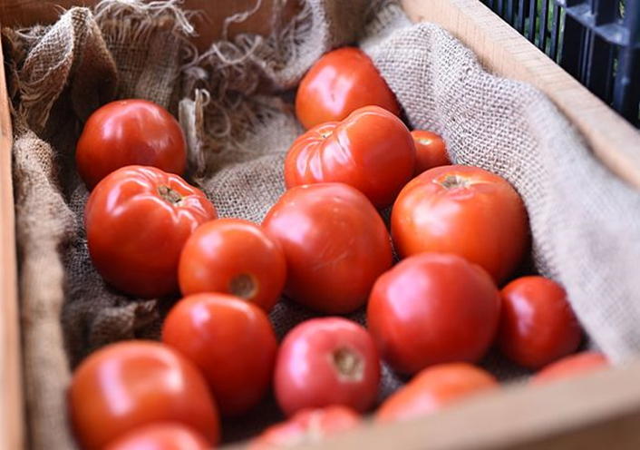
Figure 1.1: Tomato fruit. (Source: Encyclopaedia Britannica. 4 January 2018)
Tomato (Solanum Lycopersicum, earlier, Lycopersicon esculentum Mill.) is the world's most profoundly devoured vegetable because of its status as a fundamental ingredient in a huge assortment of raw, cooked, or handled nourishments, and is the second most basic vegetable harvest after potato on the planet (Dilip and Feng. 2010). Notwithstanding being devoured as a fresh vegetable, it's additionally utilized as a serving of mixed salad, in ketchup, as a puree, a pickle, and in other forms, depending on the growing area. It belongs to the family Solanaceae.
Tomato is rich in minerals, nutrients B and C, iron, and phosphorus, basic amino acids, sugars, and healthful filaments. Consumption of tomato fruits, are essential for the human diet. Tomato fruits are definitely a fundamental source of bioactive compounds with recognized beneficial effects consisting of antioxidants and anti-cancer substances, particularly antioxidant metabolites, a category of vitamins, carotenoids, phenolic compounds and phenolic acid that could provide effective defense by methods to neutralize free radicals, which are unstable molecules (Frusciante et al. 2007).
Tomato can be grown in different geological zones in open fields or nurseries, and the fruit can be harvested by manual or mechanical methods. This crop plant can be perennial or semi-perennial under circumstances (such as revival pruning, weeding, irrigation), but it is known as an annual crop in industrial terms (Geisenberg and Stewart, 1986).
Tomato is cultivated for local consumption or as an export commodity around the world. In 2014, with a production of 171 million tons, the worldwide tomato-grown area was 5 million hectares, with the People's Republic of China ('China and India (FAOSTAT, 2017) becoming the largest tomato-producing nations.
The United States is the world's second-largest tomato producer and the world's leader in the production and export of processed tomatoes. Similarly, with about 1.6 million tons in 2003, the production of fresh tomatoes in the field is equally applicable. In 2003, the United States of America imports were predominantly from Mexico for the span of the winter of the year and from Canada throughout the late spring. Mexico has arisen as the principal provider of field-grown fresh tomatoes (FAOSTAT, 2017)).
In Africa, with a harvest of around 7.6 million tons, Egypt is the largest African producer of tomatoes. Morocco has been an important producer of fresh tomatoes for consumption. Nigeria ranks as the world's 16th largest tomato growing country and has a comparative edge and potential to lead the world in production and exports of tomatoes. Tomato production in Nigeria was approximately 1.8 million metric tons in 2010, accounting for approximately 68.4 percent of West Africa, 10.8 percent of Africa's total capacity, and 1.28 percent of the world's vital input shortages, lack of advanced equipment, poor yield and productivity, unsustainable post-harvest losses, and lack of facilities for manufacturing and marketing. The supply far outweighs the need for tomatoes and their by-products. Nigeria has a large demand for refined tomato products, with a population of over 170 million people, a projected national population development rate of 5.7 percent per year and the annual rate of economic growth of 3.5 percent per year over the last 5 years. The benefit of trade liberalization in the West African economy, in addition to the Nigerian market, may be used to increase the selling of refined tomato products in this area (FAO, 2005, 2017).

LITERATURE REVIEW
2.0 CONSTRAINTS TO TOMATO PRODUCTION
Tomato requires suitable soil and climatic condition for growth. While tomatoes can be grown on different soil types, they grow optimally in thick, medium-textured sandy loam or loamy, fertile, and well-drained soil (Kelley and Boyhan, 2010). The soil offers physical support, nutrients, and water to the crop. This indicates that, in the event where the afore-mentioned factors are deficient, plants will not do well and it's going to cause a reduction in yield or production. Although tomato production appears to be on the increase through the years, yields continue to fall due to numerous production constraints which include biotic and abiotic factors (Faostat. Stat. Database 2018). Whilst the abiotic factors include erratic rainfall, high temperature, and bad soils, among others, the biotic constraints include diseases such as tomato yellow leaf curl virus, bacterial wilt, bacterial spot, early blight, and tomato mosaic viruses.
2.1 ABIOTIC STRESS
Lately, global warming and its effects on crop production have become more prominent and disturbing, agriculture is enormously sensitive to environmental factors and climate extremes which include flood salinity temperature and drought (De La Peña and Hughes, 2007). Activities of humans have affected and changed the atmospheric characteristics and this creates many problems for agriculture production and gives farmers lots of challenges. Ceccarelli et al. (2010). Flooding, saline soil, drought, and heat are fundamental environmental factors plants must bear and overcome to produce good yields. Serrano (1999) reported that major crop yield losses are caused each year even more than insect and weed losses. The magnitude of environmental stress placed on vegetable plants is influenced by climate change (De La Pena and Hughes, 2007).
Tomato is one of the world's most cultivated vegetable varieties. But its productivity is compromised by a wide range of abiotic stresses. The existence of adverse environmental conditions that cause biochemical and physiological effects, such as high temperatures, salinity, or drought. As a tropical species, tomatoes are properly suited to virtually all the world's climatic regions. But the main mitigation of the yield potential of this crop is environmental stress factors. Plant tolerance can be defined as the ability to reduce the harm caused by given stress.
2.2 FLOODING
Soil flooding is a main restricting factor for the growth and development of most crop species (Horchani et al., 2008, 2009). Waterlogging and flooding occur usually in rain-fed ecosystems, particularly in soils with terrible drainage and it can significantly reduce yield (Dennis et al., 2000), They're among the stresses taken into consideration by the food and Agriculture Organisation (FAO) and the International Institute for applied Statistical research in their estimates of worldwide farmable land area and worldwide productivity (Fischer et al., 2001).
Flooding will lead to a decrease of up to 10 percent in tomato yield (Bange et al., 2004) and 40 percent in extreme cases (Hodgson and Chan, 1982). Some of the apparent evidence of flooding is yellowing and death of the leaves, from the lower ones to the stem. According to Kramer, 1951 in between 24 and 48 hours after the soil is flooded, the middle leaves of tomato display epinastic curvature.
Tomato is susceptible to circumstances of floods (Iden, 1956, Bray et al., 2001). Jackson and Draw claimed in 1984 that the primary concern associated with flooding is the lack of oxygen. Hsiao (1973) reported that the ability of plants to consume inorganic nutrients is decreased by flood stress. Soil flooding also prevents the production of flower buds, fruit growth, and fruit enlargement in flood-intolerant tomato species, according to Kozlowski (1997). A tomato analysis found that tomato had the most robust adventitious root growth relative to cucumber, zucchini, and bean. Walter et al. (2004)
In the coastal region of Benin, Ezin (2010) performed a report on tomato production in the coastal region and how floods and salinity impact it. It showed that re-occurring floods have destroyed tomato crops produced in some areas of Benin in these regions. The flooding contributed to plant height and yield loss, leaf yellowing, fruit rot (Ezin et al. 2010).
2.3 SALINITY
Saline water occupies 71% of the Earth's area. In agriculture worldwide, salinity is now one of the most severe environmental issues (Ghassemi et al., 1995). That is one of the key drawbacks of the worldwide growth and production of plants. It is also one of the most extreme abiotic stresses affecting tomatoes' development. Damage brought to plant life through excessive salinity is observed as either loss of plant productivity or plant death. The main impacts of high salinity are reduction in leaf photosynthesis (Maggio et al., 2007), as well as in leaf transpiration and plant water uptake (Romero-Aranda et al., 2001).
Due to the high level of salinity of the soil or of the irrigation water, tomato production has been limited. An increase in soil salinity resulted in the reduction of water uptake by tomato plants which lead to fruit yield reduction. Salt stress has major effects that reduce water capacity and cause ion imbalance and toxicity (De La Peña and Hughes 2007). The tomato plant is sensitive to salinity, although significant variations among cultivars can be determined (Alian et al., 2000). The precise degree of salt concentration may vary relying on cultivar sensitivity (Caro et al., 1991) and environmental situations (Sonneveld and Welles 1988; Ling et al., 2001; Karlberg et al., 2006). But, at very excessive salinity degrees, the quantity of fruits per plant is likewise affected by salinity. The deleterious effects of salinity on tomato biomass production can be improved by improving the calcium supply (Grattan and Grieve, 1999).
Better root aeration, which enhances the oxygen supply to the root cells, might also substantially enhance the salinity tolerance of tomatoes (Bhattarai et al., 2006). Recent techniques in breeding salt-tolerant tomato cultivars focus not only on the choice of dependable nutritional and biochemical signs (Juan et al., 2005) but additionally on the usage of molecular markers and genetic transformation (Cuartero et al., 2006; Xu and Shi, 2006).
2.4 DROUGHT
Drought is one of the most extreme abiotic plant stresses that greatly restricts crop production, according to Calanca (2017). It is the most adverse and widespread environmental factor among the abiotic stresses (Rai et al., 2013a, b). Commonly described as a duration of precipitation below normal which affects plant productivity in an agricultural or natural system. Water is the only base of all life forms on earth, 70% surface of the earth is occupied by water (Chai et al., 2016). However, freshwater is only about 2.5%. The whole global agriculture is completely based on freshwater and, consumes about -thirds of total water withdrawals (Gan et al., 2013).
Tomato has a massive requirement of water (Battilani et al., 2012), especially in the Mediterranean climatic parts. Drought stress impacts the photosynthetic and defense machinery of plants. It inhibits photochemical activities and reduces enzymatic activity. It causes a series of morphological, physiological, biochemical, and molecular modifications in tomato plants. In drought stress, transpiration rate enhances water uptake which results in a decrease in comparative water content and hence cellular dehydration and osmotic stress.
Pervez et al. (2009) proved that seedlings of tomatoes are vulnerable to drought. Plants have advanced mechanisms each to deal with drought independently, and to cooperate with beneficial plant growth-promoting (PGP) microorganisms that provide the plant-host with environment services and activities that mitigate the effects of numerous abiotic stresses (Vergani et al., 2017).

Figure 2.1: Drought affected land (Source: www.britannica.com)
2.5 DROUGHT AND SOIL BACTERIA
Soil microorganisms which include beneficial soil bacteria undergo drought (Barnard et al., 2013). Based on research by Chodak et al. (2015), he stated that drought stress influences soil bacteria via osmotic stress and useful resource competition and may lead to nucleic acid damages which could occur through chemical modifications (alkylation or oxidation), cross-linking, or base removal. Drought stress results in an accumulation of loose radicals which induces protein denaturation and lipid peroxidation that in the long run results in cell lysis. Soil bacteria use several physiological pathways to withstand drought and preserve cellular structures and organelles, including the aggregation of compatible solutes, the production of exopolysaccharides and spore production (Bérard et al., 2015). Accumulation of compatible solutes which includes proline, glycine betaine, and trehalose increases thermo-tolerance of enzymes, inhibits proteins thermal denaturation, and facilitates preservation of membrane integrity (Bérard et al., 2015). Different mechanisms that enable bacteria to cope with water stress are the improved efficiency of the use of resources and reallocation inside microbial cells and extracellular polymeric substances (EPS) development. Extracellular polymeric substances serve to defend the cell as well as the local environment wherein the cell exists. The strategies used by soil bacteria to resist drought stress have also been stated as some of the key adaptation techniques which can be employed by plants to survive drought.
2.6 BACTERIAL-MEDIATED DROUGHT TOLERANCE
The approach used to alleviate the poor effects of drought stress on plants and crop yields has so far been the introduction of drought-tolerant cultivars (Eisenstein, 2013). Through traditional plant breeding methods, the cultivation of high-yielding, drought-tolerant crop varieties has been allowed. The risks of this technique are that it is time-consuming, labor-intensive, might also cause the loss of other desirable traits from the host's gene pool, and that breeding confers benefits to a single crop species that aren't transferrable to other crop systems (Eisenstein, 2013). Theoretically, genetic modification of crops with increased drought resistance could be quicker, but it would come with its own set of problems along with time and energy (Eisenstein, 2013).
The Mycorrhizal fungi (Azcon et al., 2013), Nitrogen-fixing bacteria (Lugtenberg and Kamilova, 2009) and Plant Growth-Promoting Rhizobacteria are the most correctly studied of these plant-associated microbes; the latter constitute a wide range of root-colonizing bacteria that have gained global attention because of their capacity to colonize the root and their ability to produce a large variety of bacteria.
Multitudes of hormonal, molecular or biochemical pathways and quantum traits regulate distinctive metabolic processes including water and nutrient, metabolism of carbohydrates, protein metabolism, horminal metabolism and antioxidant defenses are part of a plant response to drought stress mechanisms (Huang et al., 2014). These crop accommodations have been closely studied during dry tension cycles (Huang et al. 2014).
2.7 BIOTIC STRESS
Biotic stress is according to Flynn 2003, a stress induced by disruption caused by other species, such as microbes, viruses, fungi and fungi, pests, insects that are helpful and dangerous, weeds and plants grown in the area. Biotic stressors are major attention of agricultural research, because of the tremendous economic losses brought about to cash crops. Both economic decisions and a realistic growth are decided by the relation between biotic stress and plant yield. The biotic harm's effect on crop yield has impacts on population dynamics, coevolution from plant stressors and cycling by nutrients in the habitats (Peterson and Higley, 2001). Furthermore, biotic stress impacts the health of plants and natural biological ecosystems. The host receiver often has drastic shifts. While several kinds of biotic stress are present, fungi are responsible for most plant diseases (Carris et al., 2012). Many biotic stresses affect photosynthesis, as chewing insects lessen leaf area and virus infections lessen the rate of photosynthesis per leaf area. Vascular-wilt fungi compromise the water transport and photosynthesis by inducing stomatal closure (Flexas 2012).

CHAPTER 3
3.0 DISEASES AFFECTING TOMATO
Diseases are the main limiting factor for tomato production. The bulk of pathogens of tomato disease are fungal, while some are viral or bacterial. The numerous tomato pathogens in the world have an effect and infection rates depend on many factors, including the wind patterns and the temperature, humidity, tolerance to the variety and the health of plants. Tomato is liable to infection via a variety of diseases, the most vital of which is the fungal diseases which include early blight (Alternaria solani), late blight (Phytophothera infestans), fusarium wilt (Fusarium oxysporum spp. lycopercisi), buckeye rot (Phytopthora parasitica), Crown and root rot (Fusarium oxysporum f.sp radicis lycopercisi). Whitefly (Bemissia tabbacci), which is a virus vector that induces leaf curl, has other economically important biotic restrictions.
3.1 BACTERIAL DISEASES OF TOMATO
3.1.1 Bacterial Spot
The bacterium Xanthomonas vesicatoria invade green tomatoes and not red tomatoes, causes this disease. Peppers are attacked as well. During rainy seasons the disease is more widespread. Plant damage involves leaves and fruit spots that result in lower yields, defoliation and fruit from the light. Symptoms include a variety of tiny angular dots, slightly elevated to the scabbard spots of the fruit and odd spots of water. There may even be a yellow halo throughout the blade spots. The centers dry and tear regularly. The bacteria live on tomato plants and plant particles polluted in winter. The humid climate is favorable to the production of diseases. Extreme rainstorms in the region can be linked to the brunt of epidemic outbreaks. The leaves are tainted by natural holes. Fruit infection must be caused by insect punctures or mechanical damage in multiple forms.
Once it occurs inside the area, a bacterial spot is difficult to monitor. The bacteria will also migrate from diseased to healthy plants during some water transfer from one plant to the other, such as rain drops, overhead irrigation and contact or care of wet plants.
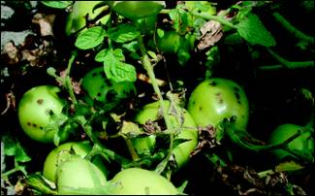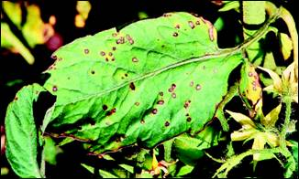
Figure 3.1a: Bacterial Spot symptoms as seen on tomato fruit (Source:www.omafra.gov.on.ca)
Figure 3.1b: Bacterial Spot (Xanthomonas vesicatoria) symptoms on tomato leaves (Source: www.omafra.gov.on.ca)

3.1.2 Tomato Pith Necrosis
Tomato pith necrosis is also the early season disease that develops when tomatoes are grown in a high tunnel and a greenhouse. However for the length of a warm humid spring climate, tomato pith necrosis can also infect tomatoes and peppers in home vegetable gardens. Pith necrosis is caused by more than one species of soil-borne Pseudomonas bacteria, including Pseudomonas corrugata, as well as Pectobacterium carotovorum. These bacteria are known as poor pathogens that rapidly infect tomato plants under gloomy, cool, and humid conditions. The signs suggest that the stems are blackened (necrotic), and could first occur adjacent to leaf pecliols. The blackened regions coalesce along the stem and grow on the leaf smalloles as a band.
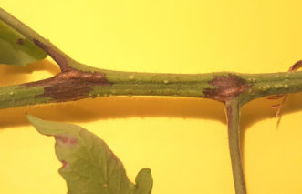
Figure 3.2: With tomato pith necrosis, brown (necrotic) areas on stems often begin where leaves attach and spread down the adjacent leaf petiole (Source https://hgic.clemson.edu/factsheet/tomato-diseases-disorders/)

If the disease progresses, the bacteria colonize the interior of the stalks, which can also cause the stalk to shrink, crack or become hollow. This damage allows the water supply to the upper areas of the tomato plant to turn yellow and to fade the upper leaves.
3.2 VIRAL DISEASES OF TOMATO
3.2.1 Tomato Spotted Wilt Virus (TSWV)
TSWV is spread through a tiny insect referred to as thrips, which acquires the virus through feeding on one of much-infected weed or ornamental hosts, and then spreads it to the growing tomato plants. Several weeks after transplanting the tomato plants into the greenhouse, random seedlings may look stunted, and younger plants may be marked with bronze or dark spots or have conspicuous purple veins. Sometimes as bronze regions increase, the top foliage is twisted and cupped. Yellow spots may also be in grapes.
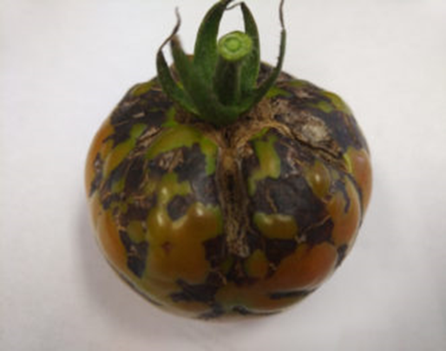
Figure 3.3: TSWV infected vines will bear discolored fruit that may not fully ripen (Source: https://hgic.clemson.edu/factsheet/tomato-diseases-disorders/)

3.2.2 Tomato Yellow Leaf Curl Virus (TYLCV)
TYLCV isn't seed-borne, however, it is transmitted via whiteflies. In both tomatoes and peppers, this disease is highly destructive to fruit production. The disease could also come from nearby tainted weeds, including numerous night shades and jimsonweeds, into the greenhouse. Tomato plants can be symptom-free for as much as 2-3 weeks after infection.
Symptoms and indicators of tomatoes are the outward curling of the stems, the edges of yellow leaves (chlorotic), narrower leaves than regular plants and floral declines. There will be no fruit if tomato plants are corrupted in their early development. Infected plants can be found in the whole garden even at random. Pepper plants can become infected, but they do not show any symptoms.
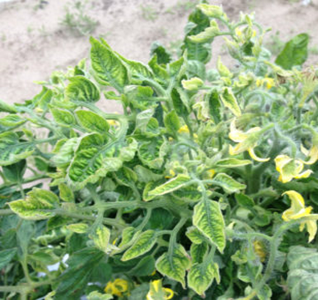
Figure 3.4: Tomato plant with Tomato yellow leaf curl virus
(Source: https://hgic.clemson.edu/factsheet/tomato-diseases-disorders/)

3.3 FUNGAL DISEASES OF TOMATO
Fungi being an imperative group of microorganisms also are accountable for tomato seed-borne diseases and cause a large yield loss. On tomato, numerous seed-borne fungi like Fusarium solani, Aspergillus flavus, Rhizopus stolonifer, and Curvularia spp. and so on occur that cause abnormality to the seeds including seed toxification, seed rotting, necrosis, and seed abortion (Chohan et al., 2017). Different seed health identification assays are used by seed pathologists to test and get rid of infested seeds before planting, considering the economic importance of seed-borne fungi and their impact on seed power. Farmers are going through financial constraints with considerable crop losses due to seed-borne mycoflora on their crops. The number one step in any agricultural crop production and protection program is the control of seed-borne pathogens via diverse techniques. Therefore, considerable control of seed-borne pathogens can be accomplished through the use of single or combination techniques of mechanical, physical, biological, and chemical methods. Seed-borne fungi are microorganisms that could thrive in seeds internally causing infection or externally as a contaminant. Seed-borne mycoflora can be present in the form of hyphae, chlamydospores, oospores, conidia, and sclerotia. Tomato being used as a model plant in genetics is also prone to several seed-borne fungal pathogens.
3.3.1 Fungal Leaf Spots
Plant diseases have an impact of economic losses on the main production, which can be strengthened by the detection of early leafe conditions. It may promote disease identification by an effective procedure. Here new approaches are focused largely on the many essential structures studied from the leaf reports of the host for the early finding of leaf diseases. Around 1 week after they emerge first, leaf spots become apparent. They are white through grayish-white on the outside and surrounded by reddish-brown, brownish, or yellowish margins and develop loose lesions on the leaf (Sarsaiya et al. 2019). These holes could be different in diameter and contour or the original spots could be similar. In general, it is the more recent (younger) leaves that develop with fungal lesions first. There may be a few small spots that enlarge over time.
The main control measure for fungal leaf spot diseases is to preserve the foliage as dry as possible. Plants in greenhouses ought to not be positioned directly beneath overhead watering. Irrigation has to only be applied to the roots in the potting media. The spores of the causative fungi are dispersed with the aid of water droplets, personnel working with moist infected plants, and mites and insects. The spores may additionally germinate in water or within the herbal leaf openings (hydathodes, lenticels, stomata, and so forth.) (Camó et al., 2019).
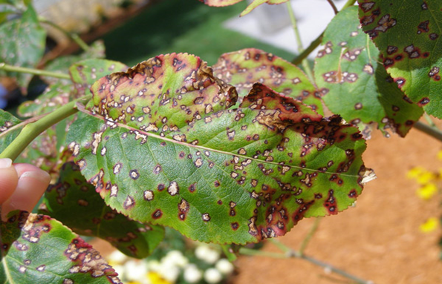
Figure 3.5: Fungal leaf spot (Source: www.extension.umn.edu)
3.3.2 Late Blight
Late blight is a systemic infection resulting from the fungus Phytopthora infestans. At some point in plant growth and development it occurs periodically and can be observed after flora. It begins with the oldest leaves and emerges on the floor surfaces like green and grey spots. The dark and white mycelial masses form on the lower surfaces of the leaf as the disease progresses. The whole plant is contaminated afterwards. Full defoliation of the leaves and stems will occur in 14 days following initial symptoms (brewing and shriveling). Shiny, Dark or Olive colored lesions form in the infected tomato fruit that may cover large sections.
3.3.3 Early Blight
This disease commonly happens on potatoes and tomatoes. The causative agent is Alternaria solani. In the lower epidermis of the older leaves, lesions first emerge. They appear as small brown spots made up of concentrated circles arranged as seen in Figure 8, below. If the illness evolves, burns become yellow, wither and die. The leaves become yellow. In the end, the contamination may also radiate to different parts of the plant. The pathogen is transmitted through rain, irrigation, bugs, and gardening tools. It is also transmitted by infected tomato seeds. Despite its name, early blight may additionally occur at any time all through the plant growth period. It frequently assaults malnourished or distressed flowers (Babu et al., 2015).
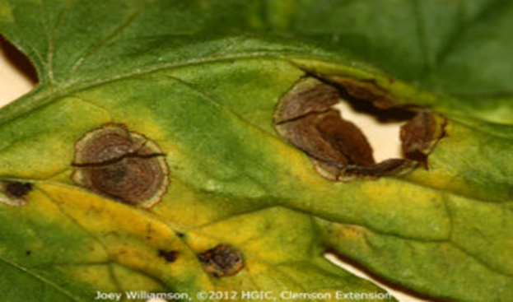
Figure 3.6: Early blight (Alternaria solani) on tomato foliage.
(Source: https://hgic.clemson.edu/factsheet/tomato-diseases-disorders/)
3.3.4 Septoria Leaf Spot
The fungus Septoria lycopersici is a consequence of this harmful disease of tomato foliage, petioles, and stems (fruit is not infected). Typically, infection occurs after plants begin to fruit on the lower leaves near the surface. There are several thin circular patches on the old leaves, with dark borders across a beige-colored core (see Figure 9 below). Minor black dots can be found in the middle of the spots and can be spore-producing corps. The serious leaves turn yellow, die, and break away from the vine. The mushroom is most productive at temperatures from 68 to 77° F, the humidity is high and plants are watered by precipitation or by overhead irrigation. Defoliation decreases plant size and quality and exposes the fruit to sunscald. This reduces plant size and quality. The mushrooms are not often ground-borne, although seed residues of past plants, rotting flowers and certain tomato-associated wild animals may occur.
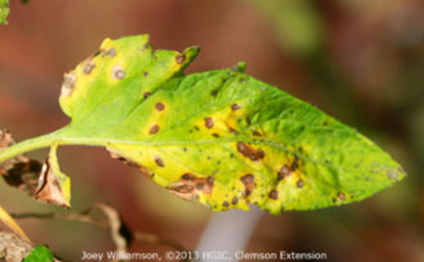
Figure 3.7: Septoria leaf spot (Septoria lycopersici) on tomato.
(Source: https://hgic.clemson.edu/factsheet/tomato-diseases-disorders/)

3.3.5 Fusarium wilt
Fusarium wilt is a serious vascular wilt disease in crop plants. It is caused by Fusarium oxysporum which may be morphologically indistinguishable from nonpathogenic strains. The spores spread through soil, plant debris, and seeds and are difficult to eliminate from infected fields and plants. Fusarium wilt attacks potato, tomato, and other Solanaceae. The leaves and possibly the stems of infected plants lose turgidity, turn light green to greenish-yellow to brown, and finally collapse and die. Biological controls have generally been effective in the management of this disease. Plant resistance proteins also confer protection by directly or indirectly reacting with fungal pathogen virulence proteins (Nalini and Parthasarathi, 2018).
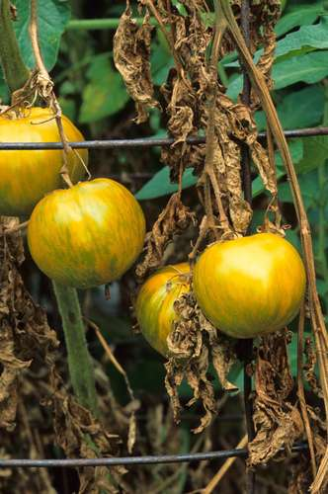
Figure 3.8: Tomato plant (Solanum lycopersicum) affected by fusarium wilt, a fungal plant disease.
(Source: https://www.britannica.com/science/fusarium-wilt)
3.4 FUSARIUM
The vast cosmopolitan genus of imperfect fungus is Fusarium and is particularly important as a wide variety of plant pathogens is widespread in many species (Nelson et al. 1981), they are secondary metabolites, and they induce opportunistic human mice (Austwick 1982; Michniewicz 1989; Vesonder 1989).
Many species of Fusarium are soil fungi and are spread worldwide. It adds root and stem red, vascular wildness, or red berries. Many different species appeared in human beings, causing hyalohyphomycosis (especially in patients with burning bones and bone marrow transplantation), keratitis mycotic, and onychomycoses as significant opportunistic pathogen (Guarro 2013). Some species cause rotten storage and are the major sources of mycotoxin.
At present, the genus Fusarium consists of at least 300 phylogenetically distinct species, 20 species complexes, and 9 monotype lineages (Balajee et al., 2009; O'Donnell et al., 2015). Most of the recognized opportunistic Fusarium pathogens belong to the F. solani complex, F. oxysporum complex, and F. fujikuroi complex. Less frequently encountered are members of the F. incarnatum-equiseti, F. dimerum, and F. chlamydosporum complexes (Van Diepeningen et al., 2015). Fusarium toxins (Venkataramana et al., 2014, Kumar et al., 2016) are the most common natural contaminants in diets containing cereals and other grains and are suspected of being involved in numerous diseases among mammals and other living beings (Nayaka et al., 2010, Kalagatur et al., 2018).
Fusarium attacks several plants and cereals which are essential for human and animal nutrition. It mainly infects certain parts of them, which include grains, seedlings, heads, roots, or stems, and causes diverse diseases, decreased commercial yield, and a decrease in product quality. Fusarium head blight, foot rot, and root rot, and crown rot are some of the major diseases caused by them. Fusarium head blight produced by F. graminearum causes starch and protein losses in cereals. F. oxysporum f.sp. cubense causes Fusarium wilt, which is the most damaging disease of banana. Many Fusarium species from the F. solani species complex are pathogenic and virulent.
3.4.1 Effects of Fusarium on Humans
In human beings, the Fusarium species cause superficial, locally invasive, and diffuse infections. The species in the F. solani complex consist of pathogenic species. F. solani, F. oxysporum, F. verticillioides, and F. proliferatum that infect the immune-compromised patients. Sidhu et al. stated that prevalent meningospondylodiscitis in an aged diabetic patient is a result of F. oxysporum. Guendouze-Bouchefa et al. reported an extraordinary case of perinephric abscess in an infant as a result of F. chlamydosporum.
The members of F. solani and F. oxysporum species complexes are acknowledged to consist of the agents that cause human infections worldwide. F. solani can adhere to and damage the corneal membrane.
3.4.2 Effects of Fusarium in Animals
The development, reproduction, and hormonal state of the animal are impaired by fusarium mycotoxins. The results on animals of these mycotoxins rely on the intake of mycotoxin. These mycotoxins enter the epithelial gastrointestinal cell layer, which is covered using mucosal secretion from goblet cells, following ingestion. In comparison, large doses of mycotoxins in pigs and equine leukoencephalomalacia (ELEM) in horses can cause abdominal pain, diarrhea, heart failure, emesis, or even death.
3.4.3 Laboratory Identification of Fusarium spp.
It is often difficult to classify Fusarium species because of the variations between isolates (e.g. in the shape and size of conidia and colony color) and because not all essential characteristics are always clearly defined (e.g. the absence of macroconidia in some isolates after subculture).
3.4.4 Morphological Description:
With or without a cottony aerial mycelium, colonies are typically fast-growing, pale, or brightly-colored (based on the species). The colour of the thallus ranges from shades of white to yellow, pink, violet, or purple. Types of Fusarium typically create both macro-and microconidia from slender phialides. Hyaline, 2 to numerous-celled, fusiform to sickle-shaped, are Macroconidia, essentially with an elongated apical cell and pedicellate basal cell. Microconidia are single-celled, hyaline, smaller than macroconidia, fusiform to ovoid, pyriform, smooth or twisted. Chlamydospores may be present or absent.
3.4.5 Molecular Identification
Current species identification is based on multilocus sequence data (Guarro, 2013; O'Donnell et al., 2015; Van Diepeningen et al., 2015). FUSARIUM-ID at Pennsylvania State University (http:/www.fusariumdb.org) and Fusarium MLST at the CBS-KNAW Fungal Biodiversity Centre (www.cbs.knaw.nl/Fusarium/) (www.jcm.asm.org/content/48/10) (www.jcm.asm.org/content/48/10) are available as Internet-accessible validated databases devoted to the detection of fusarium via nucleotide BLAST queries.
3.4.6 Species of Fusarium
Some species include;
- Fusarium verticillioides
- Fusarium solani
- Fusarium oxysporum
- Fusarium proliferatum
- Fusarium pseudograminearum
- Fusarium graminearum
3.5 Fusarium oxysporum complex
This complex consists of at least 5 species that are phylogenetically distinct and accounts for nearly 20% of fusaria-induced human infections (Guarro, 2013, Tortorano et al., 2014, Salah et al., 2015). All are omnipresent soil-borne pathogens responsible for a wide array of vascular wilts, rots, and damping-off diseases of plants. Any of these fusariums are often clinically important, causing life-threatening diseases in humans and other animals that are localized or deeply invasive (O'Donnell et al., 2009a). Usually, death is 100 percent of patients who are consistently and seriously neutropenic (Nucci and Anaissie, 2007).
3.6 FUSARIUM OXYSPORUM LYCOPERSICI
Fusarium oxysporum, noted for its phylogenetic richness, is an important soil-inhabiting ubiquitous fungus (Xiong and Zhan, 2018, Nicholas et al., 2017, Arpita et al., 2012). Phytopathogenic strains cause devastating vascular wilt disease and often restrict the production of crops of economic significance (Servin et al., 2015, Shahzad et al., 2017).
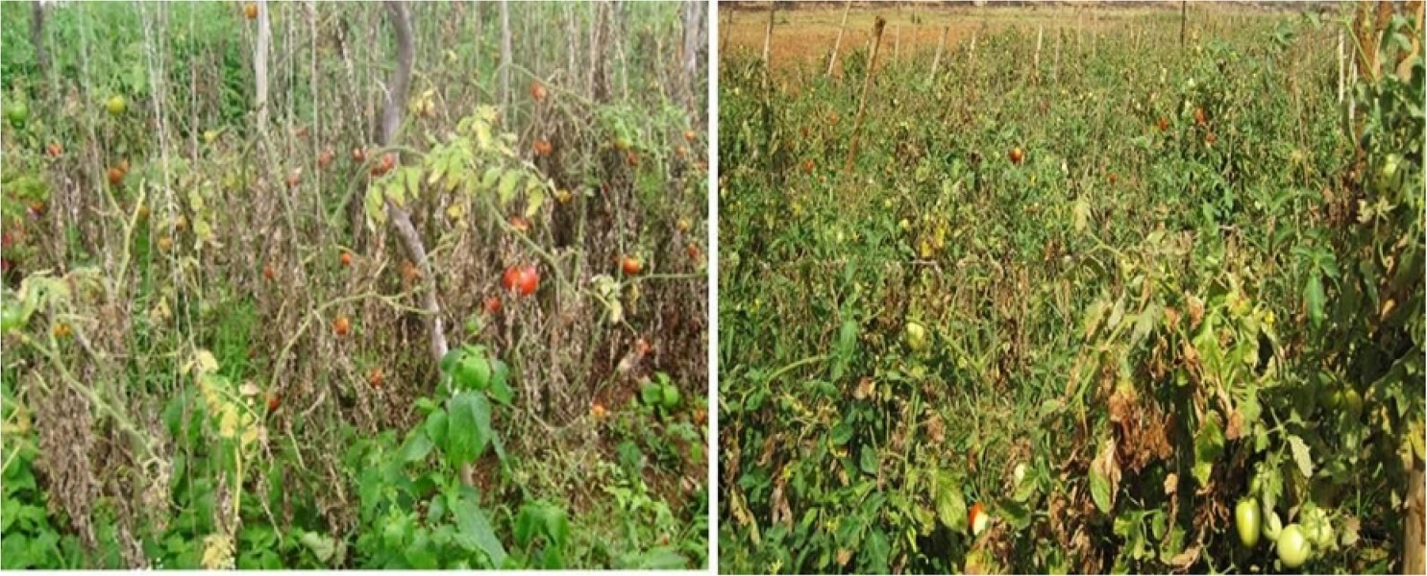
Figure 3.9: Fusarium wilt caused by F. oxysporum f. sp. Lycopersici in field conditions.
(Source: www.doi.org/10.1016/j.sjbs.2019.06.002)
One of the main tomato diseases arising from Fusarium oxysporum lycopersici is tomato wilt (Borisade et al., 2017). The Fusarium oxysporum lycopersici enters the root epidermis, then spreads through the vascular tissue and inhabits the plant's xylem channels, resulting in clogging of vessels and extreme water stress, resulting in symptoms appearing (Singh et al., 2017). The disease is morphologically recognised by wilted plants with reduced or absent crop production, carrying yellow-colored leaves. The development of Fusarium oxysporum plant vascular infection is a complicated phenomenon, and the sequential steps involved in the infection procedure are as follows: (1) root identification through host-pathogen indicators, (2) root hair surface attachment and hyphal propagation, (3) root cortex invasion and vascular tissue and xylem vessel differentiation, (4) eventually oozing of toxins and virulence factors propagation, (3) root cortex invasion and xylem vessel differentiation, (4) Vessel colonization results in the development of diseases and the wilting of the host plant (Di et al., 2016).
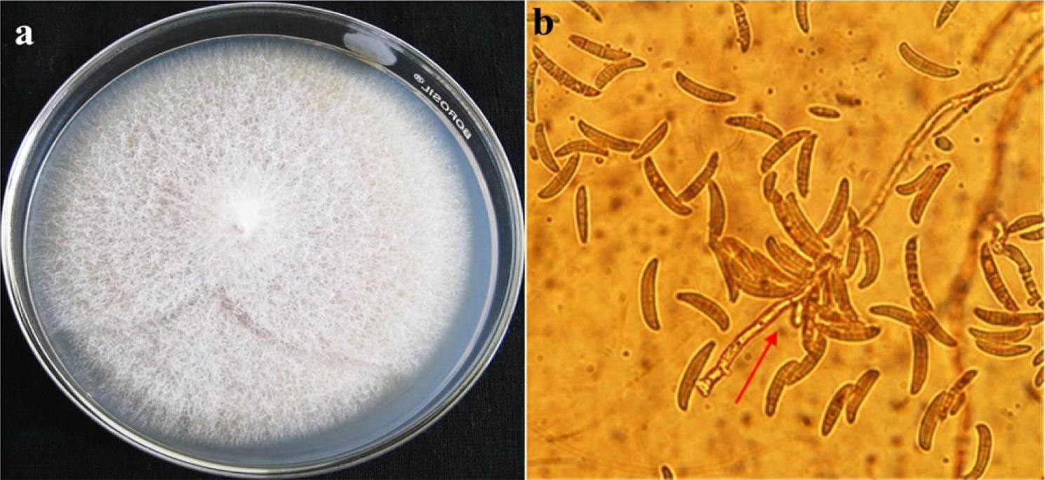
Figure 3.10 (a and b). Cultural and morphological features of Fusarium oxysporum f. sp. lycopersici. (a). F. oxysporum colony of Fusarium sp. on PDA agar; (b). Microscopic view of macroconidia of F. oxysporum f. sp. Lycopersici, macroconidia abundant, commonly three septate and the attachment of the macroconidia to the mycelium is observed
(Source: www.doi.org/10.1016/j.sjbs.2019.06.002).

Scanning electron microscopy of latitude and longitudinal areas through the dried stems of tomato plants colonized uncovered that microconidia were to a great extent connected with the xylem vessels, which sprouted, and the mycelium entered the cortex and vessels 10–14 days after vaccination.
3.7 Control of Fusarium oxysporum lycopersici
To fight the disease caused by this fungus, various techniques are used, from chemical approaches such as the use of benzimidazole and triazole family fungicides, as well as biological methods including the use of microorganisms such as Pseudomonas, Trichoderma, among others. There are many methods for disease management available, such as cultural tactics, biological control, resistant cultivars, crop rotation, and chemical control (Kamal et al., 2009). The most successful measure of managing Fusarium wilt is resistant cultivars (Beckman, 1987; Amini, 2009), but in recently grown cultivars, new breeds of pathogen tend to resolve resistance genes (Tello-Marquina and Lacasa, 1988).
3.7.1 Biological Control of Fusarium oxysporum lycopersici
In the past three decades, there has been much research conducted on the control of Fusarium oxysporum lycopersici, and a large number of commercial biocontrol products have been developed (McSpadden and Fravel, 2002). Beneficial microorganisms identified include both bacteria and fungi; various combinations of each have also been examined.
3.8 PLANT GROWTH PROMOTING RHIZOBACTERIA (PGPR)
The rhizosphere is the limited zone of soil explicitly affected by the root framework (Dobbelaere et al., 2003). This zone is wealthy in supplements when contrasted with the mass soil due to the gathering of an assortment of plant exudates, for example, amino acids and sugars, giving a rich wellspring of energy and supplements for microscopic organisms (Gray and Smith, 2005).
Plant Growth Promoting Rhizobacteria is the soil microbes occupying around/on the root surface and is straightforwardly or by implication associated with advancing plant development and improvement directly or indirectly, either by delivering plant growth phytohormones or other biologically active substances, modifying endogenous degrees of phytohormones, upgrading the accessibility and take-up of supplements through fixation or mobilization, or lessening the destructive impacts of pathogenic microorganisms on plants as well as by utilizing various components of activity. Plant Growth Promoting Rhizobacteria plays an important role to increase soil fertility, bioremediation, and stress management for the development of eco-friendly sustainable agriculture. Plant Growth Promoting Rhizobacteria is a community of bacteria, according to Wu et al. (2005), capable of successfully colonizing the root system of the plant and increasing its growth and yield. Around 2 to 5 per cent of overall rhizospheric bacteria are Plant Growth Stimulating Rhizobacteria (Antoun and Kloepper, 2001).
Kloepper et al. (1980) suggested the term Plant Growth Promoting Rhizobacteria and has been used for quite a while, particularly for fluorescent Pseudomonas involved in organic control of micro-organisms and improving plant production. Afterward, Kapulnik et al. (1981) stretched out this term to the rhizobacteria fit to directly promote plant growth. Today, the term PGPR is used to refer to all microbes living in the rhizosphere and in at least one factor to boost plant growth (Haghighi et al., 2011). A wide scope of soil microbes identified as symbiotic rhizobacteria species include Pseudomonas, Azotobacter, Klebsiella, Enterobacter, Arthrobacter Bacillus, and Serratia are known as Plant Growth Promoting Rhizobacteria (Saharan and Nehra, 2011). Plant Growth Promoting Rhizobacteria can also clean the environment by detoxifying pollutants like heavy metals and pesticides. They can aid plants to tolerate drought stress in so by altering their physiological mechanisms such as plant-hormone status. In stressful conditions, they can control IAA, ABA, ethylene, cytokines, and GA levels within plant tissues. In Gram-negative bacteria, most PGPRs have been found because they are readily isolated and genetic tools are readily available for their analysis.
3.9 USE OF PLANT GROWTH PROMOTING RHIZOBACTERIA TO CONTROL FUSARIUM OXYSPORUM LYCOPERSICI
The utilization of plant growth-promoting rhizobacteria (PGPR) in farming is successful in integrated pest management because of improved nutrient cycling to the plant and effective protection of the crop from phytopathogens (Laslo et al., 2012).
In the use of PGPR microbes to control fusarium wilt of tomato, two bacterial isolates identified as P. aeruginosa JO and JO7 were selected based on plant growth-promoting ability, manufacturing of growth-promoting traits and hydrolytic enzymes, and antagonistic activity towards phytopathogens. The phytohormone IAA is an essential signaling molecule involved in the regulation of plant development. The bacterial isolates P. aeruginosa JO and JO7 can generate IAA, which matches their capability to enhance plant growth (Fatima et al., 2009). HCN is a secondary metabolite of some microbial populations and acts as a standard inhibitor to avoid predation and opposition. Every bacterial isolate developed HCN and could be used without damaging the host plant as agents that regulate soil-borne plant pathogens (Noori and Saud, 2012). The bacterial isolates can produce siderophores that could deprive phytopathogens of iron nutrients, thereby inhibiting them and stimulating plant growth (Beneduzi et al., 2012).
Isolates P. aeruginosa JO and JO7 produced the hydrolytic enzymesβ-1,3-glucanase, protease, chitinase, and cellulase. Gajbhiye et al. (2010) stated that microorganisms degrade the cellular wall of neighboring organisms by producing hydrolytic enzymes and can be a bio-control mechanism against phytopathogens. The suppressive effect of P. aeruginosa JO and JO7 against F. oxysporum in vitro indicated high control efficiency, which can be attributed to the production of lytic enzymes by the bacteria. Treatment of tomato seed with PGPR strains increased germination and growth promotion. Bacterial isolates P. aeruginosa JO and JO7 improved the seed germination rate in comparison to the control. The hormone IAA is a biological plant growth promoter. The plant growth-promoting activity and also suppression of disease of F. oxysporum in tomato by the bacterial isolates P. aeruginosa JO and JO7 were established.
3.10 RISE OF NEW TOMATO DISEASE KNOWN AS TOMATO EBOLA (Tuta absoluta)
The Tomato leaf miner, T. absoluta is native to South America (Peru) and was discovered as a major pest of tomato in 1964 in Argentina. It was first discovered in Spain in 2006, since then, it has spread across Europe, Middle East and rapidly across African countries and is now found everywhere across the world including Nigeria. Tuta absoluta is a leaf-mining moth of the Gelechiidae family, according to Desneux et al. (2010), and is one of the most serious tomato pests. Other cultivated Solanaceae, such as potatoes, tobacco, are also threatened (Tumuhaise et al., 2016). It is known to attack the apical buds, flowers, and new fruits of tomato. Damage can occur at any stage of tomato growth from seedlings to mature plant. Damage done to stem reduces plant growth and development.
The larvae feed on the mesophyll tissue, leaving the epidermis intact, thus creating irregular mines and galleries on the leaves (Biondi et al., 2018) as shown in Fig below, overtime they become necrotic, this leads to reduction of the photosynthetic potential of infested leaves
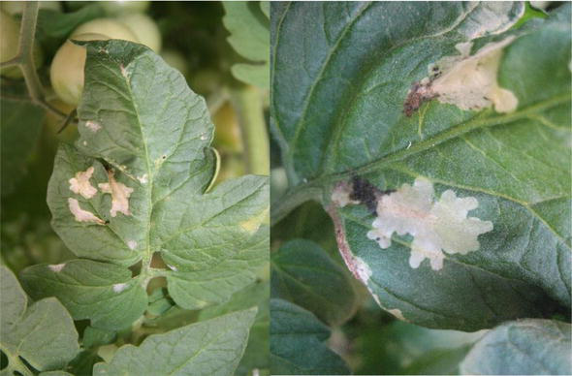
Figure 3.11: Damage appear as mines and galleries on tomato leaves caused by feeding of T. absoluta larvae (Source: DOI: 10.5772/intechopen.93390)
After fruit development, the larvae bores tunnels in the fruits, which may lead to invasion by pathogenic agents, resulting in fruit rot as shown in Figure below.
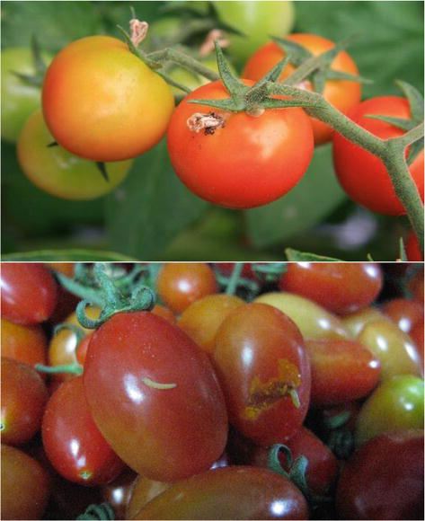
Figure 3.12 Tunnels in ripe tomato fruits by the larvae of Tuta absoluta (Source: DOI: 10.5772/intechopen.93390).

Continent/Country/Region | Origin | Year Reported | Invasive | Reference
India | Introduced | 2014 |  | Sridhar et al. (2014); EPPO (2020)
Karnataka | Introduced | 2014 |  | Sridhar et al. (2014); ICAR (2015); EPPO (2020)
Madhya Pradesh | Introduced | 2017 |  | Swathi et al. (2017)
Table 3.1: Distribution of T. absoluta in infested Asian countries/regions with year of discovery. (Source: https://www.cabi.org/isc/datasheet/49260)
3.11 TUTA ABSOLUTA IN AFRICA
The tomato leaf miner is definetly a threat to tomato production in South Africa. The development of resistance of T. absoluta to diamide insecticides, which is a new insecticide in the market for the control of T. absoluta could result in the complete destruction of tomato farms. Small-scale farmers and home gardeners will be most vulnerable, as many of them may lack the resources needed to fight this pest.
Continent/Country/Region | Origin | Year Reported | Invasive | Reference
Benin | Introduced | 2017 |  | Karlsson et al. (2018)
Lesotho | Introduced | 2018 |  | IPPC (2018); EPPO (2020)
Nigeria |  | 2016 | Invasive | EPPO (2020); Borisade et al. (2017)
Table 3.2: Distribution of T. absoluta in infested African countries/regions with year of discovery
(Source: https://www.cabi.org/isc/datasheet/49260)
3.12 TUTA ABSOLUTA IN NIGERIA
The largest tomato producer in Africa is Nigeria. The major sources of tomatoes are the northern areas. Tomatoes grow well in the northern states of Nigeria, such as the states of Kano, Katsina, Jigawa, Sokoto and Taraba. However, Kano state has the most suitable growth conditions for tomato production in commercial scale. The trigger for T. absoluta arrival Nigeria in 2016 is uncertain and it became the most destructive pest with extreme damage in areas processing tomatoes that contributed to a major economic loss. As a result of its destructive assault, Tuta absoluta has been recognized as causing tomato shortages in Nigeria. The outbreak triggered a crucial reduction in fruit production, resulting in high tomato prices, with a loss of about 80-100 percent of yield recorded.
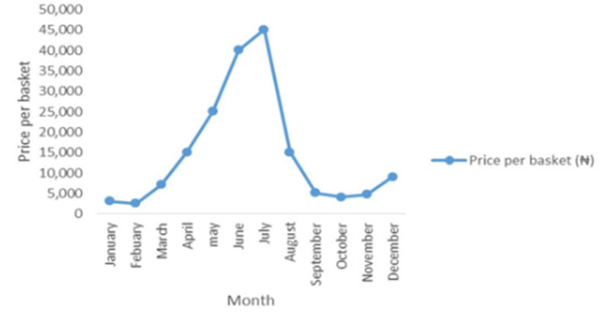
Figure 3.13: Change in Tomato price during 2015 Tuta absoluta outbreak in Nigeria (Naira per basket) (Source: https://doi.org/10.9734/AJAHR/2018/41959)
3.13 BIOLOGICAL CONTROL OF T. ABSOLUTA
One of the bio-control measures put in place is the rearing and use of several bio-agents which prey on the larvae (eggs) of T. absoluta which damages tomato fruit/leaves (Sanda et al., 2018).

Some of these agents include:
3.13.1 Trichogramma achaeae in Control of T. absoluta
In South America, Trichogramma achaeae is being used as a biological agent to control T. absoluta. The research result shows highly efficient damage reduction of up to 91.74% (Castañé et al., 2011).
3.13.2 Macrolophus spp in control of T. absoluta
Macrolophus pygmaeus and M. caliginosus are known to feed on young leaf-miner caterpillars. Combination of M. pygmaeus and N. tenuis as control gave results of reductions up to 75% and 97% of leaflet infestations or 56% and 100% of fruit infestations respectively. (Garcia-del-Pino et al., 2013)
3.14 BIO-PESTICIDAL CONTROL OF T. ABSOLUTA
In stressful conditions, they can control IAA, ABA, ethylene, cytokines, and GA levels within plant tissues. In Gram-negative bacteria, most PGPRs have been found because they are readily isolated and genetic tools are readily available for their analysis.

CHAPTER 4
4.0 DISCUSSION
Abiotic stresses are highly dependent on environmental factors, however, Ceccarelli et al. (2010) stated how human activities have affected the environmental characteristics and made the availability of suitable tomato farming conditions face challenges such as the very dreadful global warming and its effects on crop production, and these stresses acts as part of the problems faced by the agriculture sector. Some of the important abiotic stresses include Flooding, Salinity, and Drought and Temperature (Heat).
Flooding is one of the main challenges faced by tomato farmers, according to the research of Bray et al., 2001 he stated that tomato crops are sensitive to flooding or waterlogging Hsiao (1973) also stated that it impairs the ability of the plant to absorb inorganic nutrients and also reduces the oxygen availability in the soil, which results in reduction of crop yield.
Salinity is a very serious environmental problem of agriculture worldwide as it affects the plants productivity or leads to the death of the plant which in turn reduces yield. De la Peña and Hughes 2007 stated that an increase in soil salinity resulted in the reduction of water uptake by tomato thereby, causing ion imbalance and toxicity. Maggio et al. 2007noted that it majorly limits the ability of the plant to carry out photosynthesis, transpiration and also its water uptake, and this tends to reduce the fruit yield. Although, farmers have been able to come up with subtle ways to improve the saline tolerance of tomato plants and reduce loss of fruits, through better soil aeration and breeding salt-tolerant cultivars.(Bhattarai et al. 2006)
Drought is one of the most feared environmental stress by farmers as it has the most deterrent effect on agriculture crops worldwide and unfortunately, tomato is not left out as it affects one of the major requirements of tomato which Battilani et al., 2012 stated as water. This stress factor affects the ability of the plant to undergo photochemical and enzymatic activities, Rai et al. 2013a stated that it causes a lot of physical, biochemical and molecular changes in the plant, hence leading to desiccation due to cellular dehydration. But, Vergani et al., 2017 researched on the use of Plant Growth-Promoting microorganisms been employed as a bio-control measure which helps the plant to increase water uptake and survive the drought season.
The second family of stresses that also pose a threat to the production of tomato globally is biotic stress. Biotic stress is caused by damage from other living organisms like bacteria, viruses, fungi, insects, and pests. They are known to cause major losses to export crops thereby inquiring economic losses. Diseases caused from these organisms are one of the major challenges limiting tomato production, ranging from bacterial diseases to viral diseases to the most important which is fungal diseases (Carris et al., 2012).
Some of the bacterial diseases and their causative organisms include: (a) Bacterial Spot caused by Xanthomonas vesicatoria, (b) Tomato Pith Necrosis caused by Pseudomonas bacteria like Pseudomonas corrugata, and Pectobacterium carotovorum.
Few of the viral diseases that affect tomato and their causative organisms include: (a) Tomato Spotted Wilt Virus (TSWV) which is spread through a tiny insect referred to as Thrips and (b) Tomato Yellow Leaf Curl Virus (TYLCV) which is transmitted via whiteflies. These two viral diseases are extremely destructive to tomato plants.
The most important of tomato diseases includes those of fungal origin and they are the major causes of tomato seed-borne diseases and fruit loss. Fungal diseases have had adverse financial implications on farmers due to crop losses (Chohan et al., 2017).
Some of these devastating fungal diseases include: (a) Late Blight which is an infection resulting from the fungus Phytopthora infestans. (b) Early Blight which is caused by Alternaria solani and is known to commonly affect tomato. (c) Septoria Leaf Spot, this is an infection caused by fungus Septoria lycopersici and it damages tomato foliage, petioles, and stems except fruits and, (d) Fusarium wilt: this is the most damaging disease among the fungal diseases and it is caused by Fusarium oxysporum lycopersici.
However, bio-control measures are also used as an effective strategy to overcome these biotic stresses, farmers and agricultural industries employ the use of Plant Growth Promothing Rhizobacteria (PGPR) to make crops more resistant to these diseases and they have proved to be effective.
Most recently, new tomato disease arose in the name of Tomato Ebola caused by Tuta absoluta which is also referred to as tomato leaf miner, which was first discovered in Spain in 2006, and later invaded Nigeria in 2016. It affects the apical buds, flowers, and new fruits of tomato, and this devastating outbreak resulted in over 80% yield loss of tomato in Nigeria. However, once again biological control has proved its effectiveness in the agricultural sector, whereby Sanda et al 2018, researched and used bio-control techniques through the rearing and use of several bio-agents which prey on the larvae (eggs) of T. absoluta were used and it resulted in over 97% of reduction of fruit and leaf infestation of T. absoluta. This has therefore proven that the use of control techniques such as biological control is highly effective and should therefore be encouraged.

CHAPTER 5
5.0 CONCLUSION AND RECOMMENDATION
Tomato producing industries and farming communities have been plagued by these abiotic and biotic stresses for a long time and it has heavily limited the overall production yield of tomato especially in the developing countries, thereby making the demand for fresh and processed tomato products outweigh the supply, and this has been an issue of concern in the agricultural business. This work presents some of these setbacks affecting global production of tomato, and also provides insights into the probable effective methods used to overcome these limitations in order to improve yield and quality of harvested crops. Lately, Nigeria faced a tomato disease outbreak which took its toll and left a lasting effect on both the Agricultural and Financial economic, as the country suffered from a major scarcity of tomatoes due to the T. absoluta disease which was named Tomato Ebola, after it led to over 80-100% of crop loss. The scarcity led to sudden increase in the price of tomatoes making it hard for citizens to acquire tomato products. Response of the government to this challenge was really slow, which made it a major problem across the country. But, over time, scientists came up with a solution through the use of biological methods which aided farmers to overcome this devastating outbreak, and it proved effective and helped to revive the tomato agricultural sector.
The effect of T. absoluta and other diseases on global tomato production industries and on the livelihood of small tomato farming communities in Nigeria could still re-occur and become intense in the future. Therefore, government should ensure strategies must be put in place to contain its spread immediately an outbreak is detected. The use of insecticides in the chemical control of T. absoluta seemed ineffective, thus, alternative control mechanisms like biological control methods were employed which involves the use of beneficial soil microorganisms such as Plant Growth-Promoting Rhizobacteria to tackle the problem when they arise, in order to avoid a repeat of scarcity and increase yield and quality of produced tomatoes.

