




COLLEGEOF BASIC AND APPLIED SCIENCES

Mountain Top University
Kilometre 12, Lagos-Ibadan Expressway, MFM Prayer City, Ogun State.
PHONE: (+234)8053457707, (+234)7039395024, (+234) 8039505596
EMAIL: support@mtu.edu.ng
Website: www.mtu.edu.ng.

Published By:
Mountain Top University


COURSE GUIDE

COURSE TITLE: Computer Programming I
COURSE CODE: CSC 201
LECTURER(S): Falana Olorunjube J.
E-mail: ojfalana@mtu.edu.ng

COURSE OBJECTIVES
GENERAL INTORDUCTION AND COURSE OBJECTIVES
CSC 201 – Computer Programming I is a three credit unit course of two hours lecture and three hours of practical class. This course presents an overview of the problem-solving methods and concept of programing and the role of algorithms in program development.
This course is divided into six modules. At the end the course you will be equipped with the basic knowledge of writing efficient programs. Also, you should be able to confidently tackle any programming problem by breaking it into its component parts,
write efficient algorithms to solve the problem and implement the algorithm using C programming language.

Course Contents
MODULE ONE: INTRODUCTION TO PROGRAMMING 5
1.0 INTRODUCTION TO PROGRAMMING 5
Objectives 5
Pre-Test 5
CONTENT 5
1.1 PROGRAM 5
1.2 Levels of Programming Languages 6
1.3 Features of Programming Languages 7
1.4 Basic Principles of Programming 7
Post-Test 8
Bibliography 8
Module 2: Introduction to problem solving methods and algorithm development 8
1.0 INTRODUCTION TO PROBLEM SOLVING 8
1.2 PROBLEM SOLVING 9
1.3 PROBLEM SOLVING STAGES 10
1.4 Properties of Algorithm 13
Bibliography 15
Module 3: C PROGRAMMING LANGUAGE 15
1.0 INTRODUCTION 15
Objectives 15
Pre-test 15
CONTENT 15
1.1 History of C 15
1.2 C Standard Library 16
1.3 Typical C Program Development Environment 16
1.4 A Simple C Program 18
1.5 Data Types 19
Bibliography 20
MODULE FOUR: INPUT AND OUTPUT STATEMENTS 21
1.0 Introduction 21
Objectives 21
Pre-Test 21
CONTENT 21
1.1 INPUT AND OUTPUT 21
1.2 Unformatted Input statements 22
1.3 Unformatted Output statements 22
1.4 Formatted I/O Statements 23
1.5 Formatted Input Statement 23
Bibliography 25
MODULE FIVE: CONTROL STRUCTURES 26
1.0 Introduction 26
Objectives 26
Pre-Test 26
CONTENT 26
1.1 DECISION AND CONTROL STATEMENT 26
1.2 DECISION STATEMENT 26
1.3 REPETITION/LOOP 26
1.2.1 if Selection Structure 27
1.2.2 if-else structure 28
1.2.4 ?: Conditional Expression 30
1.2.5 switch Statement 30
Repetition/Loop 32
Repetition Essentials 33
1.3.1 Loop Type 34
1.3.2 while Loop 34
1.3.3 for Loop 35
1.3.4 do…while Loop 36
1.3.5 Nested Loops 37
1.3.6 break and continue Statements 37
Bibliography 39
MODULE 6 : FUNCTIONS 39
1.0 INTRODUCTION TO FUNCTION 39
Objectives 39
Pre-Test 39
CONTENT 39
1.1 FUNCTION 39
1.2 Function Prototype 39
1.4 Function definition 40
1.5 Function Calling 41
1.5.1 Call by Value 41
1.5.2 Call by Reference 42
Bibliography 44

MODULE ONE: INTRODUCTION TO PROGRAMMING

1.0 INTRODUCTION TO PROGRAMMING
This unit introduces methods and concepts of programming. It also explains how programs are executed by the compilers

Objectives
At the end of this lecture, students should be able to:
- list programs and programming languages
- outline the different levels of programming languages and their characteristics
- outline the conventional features of programming languages
- outline the methods of programming and its application areas

Pre-Test
- What is a program?
- What is the difference between a High level language and a low level language?
- What do you understand by the phrase ‘economic activity’?

CONTENT

1.1 Programming languages
Programming languages are languages through which we can instruct the computer to carry out some processes or tasks. They are also designed to communicate ideas about algorithms between human beings and computers. Programming languages can be used to execute a wide range of algorithms, that is, an instruction could be executed through more than a procedure of execution. The full concept of algorithm will
be explained later.

1.2 PROGRAM
A program is a series of step-by-step instructions that provides a solution to a particular problem and directs the computer on what to do exactly.
- There are generally two major types of programming:
  - System Programming
  - Application Programming
- System Programming. In short, system programs constitute the driving force behind the operations of the Computer System. They are specially designed to facilitate the use of the hardware and to make the Computer System function efficiently and run quickly.
- Operating System:
An Operating System is a collection of system programs that jointly controls the operations of a computer system and its resources. There are two types of programs that make up the Operating System: -
  - Control Programs
  - Processing Programs
- Application Programming
Application Programs are those that perform specific computational tasks or data processing to solve user's problems. From this definition, you can see that application programs concentrate on the particular problems to be solved.

1.3 Levels of Programming Languages
Programs and programming languages have been in existence since the invention of computers, and there are three levels of programming languages. These are:
- Machine Language: Machine language is a set binary coded instruction, which consists of zeros (0) and ones (1). Machine language is peculiar to each type of computer. The first generation of computers was coded in machine language that was specific to each model of computer.
- Low Level Language: This is a level of programming language which is different from the machine language. The instructions are not entirely in binary coded form. It also consists of some symbolic codes, which are easier to remember than machine codes. In assembly language, memory addresses are referenced by symbols rather than addresses in machine language.
Low level programming language is also called assembly language, because it makes use of an assembler to translate codes into machine language.
- High Level Language: This programming language consists of English-like codes. High-level language is independent of the computer because the programmer onlyneeds to pay attention to the steps or procedures involved in solving the problem for which the program is to be used to execute the problem. High-level language is usually broken into one or more states such as: Main programs, sub-programs, classes, blocks, functions, procedures, etc.

1.4 Features of Programming Languages
There are some conventional features which a programming language must possess, these features are:
- It must have syntactic rules for forming statements.
- It must have a vocabulary that consists of letters of the alphabet.
- It must have a language structure, which consists of keywords, expressions and statements.
- It may require a translator before it can be understood by a computer.
- Programming languages are written and processed by the computer for the purpose of communicating data between the human being and the computer

1.5 Basic Principles of Programming
The aims guiding the design of a good computer program are as follows:
- Reliability
- Maintainability
- Portability
- Readability
- Performance
- Memory Saving
- Reliability
By reliability, we mean that you should be able to depend on the program to always do what it has been designed to do.
- Maintainability: By this, we mean that you should be able to modify the program when the need arises.
- Portability
The concept of portability in programming is that a program should be capable of being transferable to different computer platforms with a minimum modification, if any at all.
- Readability
A program should be easy for other programmers to read and understand. For example, a readable program is easier to maintain.
- Performance
A program that doesn't carry out the expected tasks quickly and efficiently has lost the performance aim. Therefore, a major aim in program design is that the program should execute quickly and efficiently too.
- Memory Saving
- What is meant here is simply that a program should not be unnecessarily too long and requiring excessive large memory to execute

Post-Test
- Mention five features of programming language
- Explain the basic principles of programming.
- Differentiate among the levels of programming language.

Bibliography
Deitel, P., & Deitel, H. (2010). C how to program (Vol. 6). Pearson Education Ltd.
Sodiya, A. S., & folorunso, A. (2008). PROGRAMMING AND ALGORITHMS. NATIONAL OPEN UNIVERSITY OF NIGERIA.
Thomas, H. C., Charles, E. L., Ronald, L. R., & Clifford, S. (2009). Introduction to Algorithms (Vol. 3). MIT Press.
Tim, B. (2005). An Introduction to the C Programming Language.

MODULE TWO: INTRODUCTION TO PROBLEM SOLVING METHODS AND ALGORITHM DEVELOPMENT

1.0 INTRODUCTION TO PROBLEM SOLVING
This unit introduces you to problem solving techniques. These include Problem Definition, Solution Design, Program Coding or Writing, Program Testing and Program Documentation. It also introduces you to algorithm development

Objectives
At the end of this lecture, students should be able to:
- outline the step by step process of solving a computer problem
- list the properties of algorithm

Pre-Test
- What is a problem?
- Give two examples of a problem?
- What do you understand by the phrase ‘?

CONTENT

1.1 PROBLEM SOLVING
Can you think of a day in your life which goes without problem solving?
The answer to this question is of course, No. In our life we are bound to solve problems. In our day to day activity such as purchasing something from a general store and making payments, depositing fee in school, or withdrawing money from bank account. All these activities involve some kind of problem solving. It can be said that whatever activity a human being or machine do for achieving a specified objective comes under problem solving.
A problem means an objective or an output that we have to achieve, for example preparing a meal is considered a problem, and we have to follow consecutive steps sequentially to attain the required objective and get the meal. To make it clearer, let us see some other examples.
Example1: If you are watching a news channel on your TV and you want to change it to a sports channel, you need to do something i.e. move to that channel by pressing that channel number on your remote. This is a kind of problem solving.
Example 2: If someone asks to you, what is time now? So seeing time in your watch and telling him is also a kind of problem solving.
Example 3: if some students in a class are planning to go on a picnic and they decided to share the expenses among themselves. So calculating total expenses and the amount an individual will have to give for picnic is also a kind of problem solving.
Here it is necessary to mention that all the problems in the world cannot be solved. There are some problems which have no solution and these problems are called Open Problems. If you can solve a given problem then you can also write an algorithm for it. In next section we will learn what problem stages are.

1.2 What is a Problem?
A problem is defined as the objective or the specific output that we want to attain; through a sequence of steps or activities and, specific input.
Consider the following problem:
The problem is: Baking a cake according to certain specifications, the available input are the ingredients (such as eggs, flour, milk … etc.), then followed by activities or procedures that should be done sequentially, taking into consideration that any mistake in performing one procedure before another will results in an unsuitable and undesirable cake.
In this course, we focus on Problem Solving techniques using the computer.

1.3 PROBLEM SOLVING STAGES
- First Problem Definition
The purpose of the problem definition is to explore available resources, subjectively bound the goals, establish system inputs, and develop a statement of the problem. This step is characterized by research, data analysis, and creative application of the knowledge gained to scope and bound the problem
Problem definition implies the identification of required outputs, available inputs
and, arithmetic and logical operations to be executed.
- Second: Performing step-by-step instructions (Algorithm) to solve a Problem
Algorithm is defined as a group of logically arranged procedures to be
executed to attain a goal or precise output, out of specific inputs
After identifying and analyzing the problem, outputs and, inputs; a plan in the form of a series of successive steps is made, which is called an (Algorithm), devised by the Mathematician and the founder of Algebra “Muḥammed ibn Mūsā al-Jwārizmī”.
- Third: Program Design
Having drawn a “Flowchart”, to solve the problem, using a computer; we have to translate this flowchart into one of the programming languages.
- Fourth: Program Testing
During writing a program we may unintentionally make some mistakes; e.g. writing a minus sign (-) instead of (+). We can’t detect errors unless we begin entering data to the program with previously known results; to compare the results of the current program to those of the well-known results; therefore we check the errors and debug them.
- Fifth: Program Documentation
All steps taken for solving the problem that include: given Input, output, plan for solving the problem, drawn flowchart, programming language used for coding and, instructions, date of last modification of the program and, people who contribute to the program development process, to have the program documented to go back for feedback and correction. The documentation is beneficial when more than one person participate in writing or modifying the program.

1.4 ALGORITHM
Algorithm can be defined as: “A sequence of activities to be processed for getting desired output from a given input.”
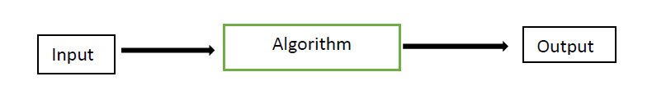
Tersely put, an algorithm, a jargon of computer specialists, is simply a procedure. People of different professions have their own form of procedure in their line of work, and they call it different names. A cook, for instance, follows a procedure commonly known as a recipe that converts the ingredients (input) into some culinary dish (output), after a certain number of steps.
An algorithm, whose characteristics will be discussed later, is a form that embeds the complete logic of the solution. Its formal written version is called a program, or code. Thus, algorithmic problem solving actually comes in two phases: derivation of an algorithm that solves the problem, and conversion of the algorithm into code. The latter, usually known as coding, is comparatively easier, since the logic is already present – it is just a matter of ensuring that the syntax rules of the programming language are adhered to.
The first phase is what that stumbles most people, for two main reasons. Firstly, it challenges the mental faculties to search for the right solution, and secondly, it requires the ability to articulate the solution concisely into step by-step instructions, a skill that is acquired only through lots of practice.
Many people are able to make claims like “oh yes, I know how to solve it”, but fall short when it comes to transferring the solution in their head onto paper.
Algorithms and their alter ego, programs, are the software. The machine that runs the programs is the hardware. Referring to the cook in our analogy again, his view can be depicted as follows:

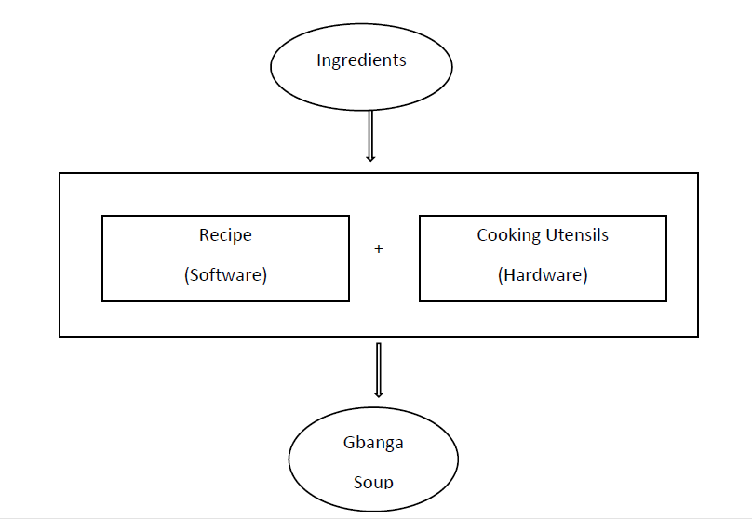

1.5 Properties of Algorithm
Donald Ervin Knuth has given a list of five properties for algorithm, these properties are:
- Finiteness: An algorithm must always terminate after a finite number of steps. It means after every step one reach closer to solution of the problem and after a finite number of steps algorithm reaches to an end point.
- Definiteness: Each step of an algorithm must be precisely defined. It is done by well thought actions to be performed at each step of the algorithm. Also the actions are defined unambiguously for each activity in the algorithm.
- Input: Any operation you perform need some beginning value/quantities associated with different activities in the operation. So the value/quantities are given to the algorithm before it begins.
- Output: One always expects output/result (expected value/quantities) in terms of output from an algorithm. The result may be obtained at different stages of the algorithm. If some result is from the intermediate stage of the operation then it is known as intermediate result and result obtained at the end of algorithm is known as end result. The output is expected value/quantities always have a specified relation to the inputs
- Effectiveness: This means that an algorithm must provide the correct answer to the problem. The Actually operations should be basic, so that it can be solved in a finite amount of time by a person, by using paper and pencil only.
- An algorithm must be general. This means that it must solve every instance of the problem. For example, a program that computes the area of a rectangle should work on all possible dimensions of the rectangle, within the limits of the programming language and the machine.

Post-Test
Write short note on the following:
- Problem Definition
- Algorithm
- Program Design
- Program Testing
- Program Documentation

Bibliography
Sodiya, A. S., & folorunso, A. (2008). PROGRAMMING AND ALGORITHMS. NATIONAL OPEN UNIVERSITY OF NIGERIA.
Thomas, H. C., Charles, E. L., Ronald, L. R., & Clifford, S. (2009). Introduction to Algorithms (Vol. 3). MIT Press.
Tim, B. (2005). An Introduction to the C Programming Language.

MODULE THREE: C PROGRAMMING LANGUAGE

1.0 INTRODUCTION
This module introduces C Programming Language. C is a powerful computer programming language that is appropriate for technically oriented people with little or no programming experience and for experienced programmers to use in building substantial information systems

Objectives
At the end of this lecture, students should be able to:
- Mention ten C standard library
- Explain the origin of C programming language

Pre-test
- What do you understand by C Standard library?
- Explain the origin of C programming language
- What is an identifier?

CONTENT

1.1 History of C
C evolved from two previous languages, BCPL and B. BCPL was developed in 1967 by Martin Richards as a language for writing operating-systems software and compilers. Ken Thompson modeled many features in his B language after their counterparts in BCPL, and in 1970 he used B to create early versions of the UNIX operating system at Bell Laboratories. Both BCPL and B were “typeless” languages—every data item occupied one “word” in memory, and the burden of typing variables fell on the shoulders of the programmer.
The C language was evolved from B by Dennis Ritchie at Bell Laboratories and was originally implemented on a DEC PDP-11 computer in 1972. C uses many of the important concepts of BCPL and B while adding data typing and other powerful features. C initially became widely known as the development language of the UNIX operating system.
Today, virtually all new major operating systems are written in C and/or C++. C is available
for most computers. C is mostly hardware independent. With careful design, it’s possible
to write C programs that are portable to most computers.

1.2 C Standard Library
C programs consist of modules or pieces called functions. You can program all the functions you need to form a C program, but most C programmers take advantage of a rich collection of existing functions called the C Standard Library.
Thus, there are really two pieces to learning how to program in C. The first is learning the C language itself, and the second is learning how to use the functions in the

1.3 Typical C Program Development Environment
C systems generally consist of several parts: a program development environment, the language
and the C Standard Library. The following discussion explains the typical C development
environment shown in Fig. 1.
C programs typically go through six phases to be executed (Fig. 1). These are: edit,
preprocess, compile, link, load and execute.

Phase 1: Creating a Program
Phase 1 consists of editing a file. This is accomplished with an editor program. Two editors widely used on Linux systems are vi and emacs. Software packages for the C/C++ integrated program development environments such as Eclipse and Microsoft Visual Studio have editors that are integrated into the programming environment. You type a C program with the editor, make corrections if necessary, then store the program on a secondary storage device such as a hard disk. C program file names should end with the .c extension.
Phases 2 and 3: Preprocessing and Compiling a C Program
In Phase 2, the you give the command to compile the program. The compiler translates the C program into machine language-code (also referred to as object code). In a C system, a preprocessor program executes automatically before the compiler’s translation phase begins.
The C preprocessor obeys special commands called preprocessor directives, which indicate that certain manipulations are to be performed on the program before compilation.
These manipulations usually consist of including other files in the file to be compiled and performing various text replacements.
Phase 4: Linking
The next phase is called linking. C programs typically contain references to functions defined
elsewhere, such as in the standard libraries or in the private libraries of groups of programmers
working on a particular project. The object code produced by the C compiler typically contains “holes” due to these missing parts. A linker links the object code with
Phase 5: Loading
The next phase is called loading. Before a program can be executed, the program must first be placed in memory. This is done by the loader, which takes the executable image from disk and transfers it to memory. Additional components from shared libraries that support the program are also loaded.
Phase 6: Execution
Finally, the computer, under the control of its CPU, executes the program one instruction at a time. To load and execute the program on a Linux system, type ./a.out at the Linux prompt and press Enter.

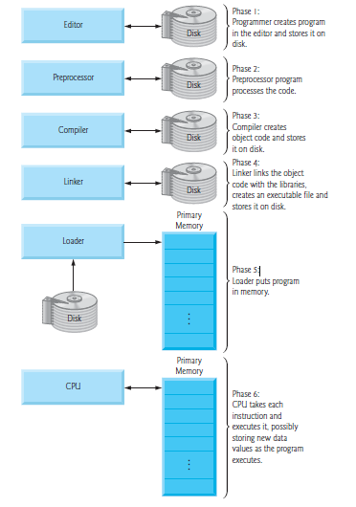
Figure 1 : Typical C program environment

1.4 A Simple C Program
1 #include <stdio.h>
2 int main()
3 {
4 /* my first programming class*/
5 printf(“Hello Class!\n”);
6 return 0;
7 }

The above program has various parts, which are further explained:
- Line 1 of the program #include <stdio.h> is a preprocessor command, which tells a C compiler to include stdio.h file before going to actual compilation.
- Line 2 int main()is the main function where the program execution begins. There must always be at least one definition of a function called main. int is the return type.
- Lines 3 and 7 ({ and }) signals the beginning and end of functions and other code blocks. It can be termed BEGIN and END.
- Line 4 /* ...*/ will be ignored by the compiler because it has been put to add additional comments in the program. Such lines are called comments in the program.
- Line 5 is another function available in C which makes messages to be displayed on the screen. It will make the message “Hello Class!” to be displayed on the screen while \n represents the newline character
- Line 6 return 0; terminates the main() function and returns the value 0.

1.5 Data Types
Data types are used to indicate the type of value represented or stored in a variable, the number of bytes to be reserved in memory, the range of values that can be represented in memory and the type of operation that can be performed on a particular data item.
C supports two classes of data types:
- Primary/ Fundamental/Basic/ Primitive data types
Derived/ Compound data types

Type | Meaning | Size | Range
unsigned char | Unsigned character  (positive) | 8 bits | 0 to 255
signed char  char | Represents single character. | 8 bits | -128 to 127
unsigned int  unsigned short int | Represents positive  integer numbers | 16 bits | 0 to 65,535
Short  signed short  short int  signed short int | represents both positive and  negative integer quantity | 16 bits | -32,768 to 32,767
int | represents positive long  integer | 32 bits | 0 to 4,294,967,295
unsigned long | represents positive long  integer | 32 bits | 0 to 4,294,967,295
long  signed long  long int  signed long int | Represents both positive  and negative long integer | 32 bits | -2,147,483,648 to 2,147,483,647
Float | Floating Point Number. | 32 bits | 3.4 * (10-38) to 3.4 * (10+38)
Double | A more accurate floating point  number than float | 64 bits | 1.7 * (10-308) to 1.7 * (10+308)
long double | Increases the size of double. | 80 bits | 3.4 * (10-4932) to 1.1 * (104932)
void | Defines an empty data type  which can then be  associated with some data  types. It is useful with  pointers.

Post test
- With the aid of label diagram explain C program development environment
- Write a brief history of C programming Language

Bibliography
Deitel, P., & Deitel, H. (2010). C how to program (Vol. 6). Pearson Education Ltd.
Sodiya, A. S., & folorunso, A. (2008). PROGRAMMING AND ALGORITHMS. NATIONAL OPEN UNIVERSITY OF NIGERIA.
Thomas, H. C., Charles, E. L., Ronald, L. R., & Clifford, S. (2009). Introduction to Algorithms (Vol. 3). MIT Press.
Tim, B. (2005). An Introduction to the C Programming Language.

MODULE FOUR: INPUT AND OUTPUT STATEMENTS

1.0 Introduction
In this module, you will be introduced to Reading, processing, and printing of data as well several in-built library functions to perform input and output tasks

Objectives
At the end of this lecture, students should be able to:
- Use printf()
- Use scanf().
- Use getchar()

Pre-Test
- Write syntax for printf()
- Write syntax for scanf()

CONTENT

1.1 INPUT AND OUTPUT
The scanf() function reads formatted input from standard input (keyboard) whereas the printf() function sends formatted output to the standard output (screen).
Example: C Floats Input/Output
#include<stdio.h>
int main()
{
float f;
printf(“ENTER A NUMBER:”);
scanf(“%f”, &f);
printf(“VALUE OF THE NUMBER IS: %f”, f);
return 0;
}
The output of the above code will be:
ENTER A NUMBER: 22.87
VALUE OF THE NUMBER IS:22.870000
The format string “%f” is used to read and display formatted output in case of floats
There are two methods of providing data to the program variables. One method is to assign values to variables through the assignment statements. Another method is to use input functions, which can get data from the keyboard (standard input-stdin).
There are two types of Input and Output (I/O) statements: Unformatted I/O statements and Formatted I/O statements.

1.2 Unformatted Input statements
Character Input
There are several functions available to input a character from the console.
getchar ()
This function accepts a single character from the stream stdin (keyboard buffer). This single
character includes alphabets, digits, punctuations, return, and tab.
Syntax:
char-variable = getchar();

Example
char ch;
ch = getchar();
getch (); - character input from console & doesn’t echo the character.
getche(); - character input from console & echoes the character.
String Input
gets ()
This function accepts a string terminated by a new line character. Blank space is also considered as a character. To get a line of text, this function serves the purpose.
Syntax:
gets(stringvariable); /* string is represented as character array */
Example
char ch[5];
gets(ch);

1.3 Unformatted Output statements
Character Output
putchar()
This function displays a single character in the standard output (stdout), monitor.
Syntax:
putchar(char variable);
Example
char ch;
ch = getchar();
putchar(ch);
String Output
puts()
This function displays the string in the standard output.
Syntax:
puts(str);
Example
char ch[5];
gets(ch);
puts(ch);

1.4 Formatted I/O Statements
Formatted input refers to an input data that has been arranged in a particular format. C has a
special formatting character (%). A character following this defines the format for a value.
Some of the format specifiers are given below:
%c – character
%d – integer
%f, %e, %g – float
%s – string
%ld – long integer
%o – octal
%x – hexadecimal
%hd – short integer
%[..] – string of specified characters
%u – unsigned

1.5 Formatted Input Statement
- scanf()
scanf () function is used to read formatted data items.
Syntax:
scanf (“format string”, list of variables);
Format string specifies the field format in which the data is to be entered.
List of variables specify the address of memory locations where the data is to be stored. Address operator (&) is used before the variables.
Format string and variables are separated by comma. Format string, also known as control string contains field specifications, which directs the interpretation of input data. By default, the delimiter while reading the values is space. Delimiter can be user-defined. To read a string using ‘%s’, ‘&’ need not be used.
sscanf()
sscanf() function to read values from a string. This functions returns the number of inputs read successfully.
Syntax:
sscanf (str, “format string”, list of variables);
Formatted Output Statement
printf()
printf () function is used to output the values. This function returns the number of characters
printed.
Syntax:
printf (“format string”, list of variables);
Example
printf (“char=%c, int=%3d, floating point=%6.2f”,ch, i, x);
printf (“sum = %*.*f”, w, p, sum);

sprintf()
sprintf() function is used to output values to a string.
Syntax:
sprintf (str, “format string”, list of variables);
Example of scanf function
#include <stdio.h>
main()
{
char item[10];
int customerno;
float cost;
……..
scanf(“%s%d%f”, item, &customerno, &cost);
………
}
Within the scanf function, the control string is ”%s%d%f”. it contains three character groups. The first character group %s, indicates that the first argument (item) represents a string. The second character group, %d, indicates that the second argument (&customerno) represents a decimal integer value and the third character group, %f, indicates that the third argument (&cost) represents a floating-point value.
Notice that the numerical variables customerno and cost are preceded ampersands (&) within the scanf function. An ampersand does not precede item, because it is an array name.
The actual data are entered from a standard input device (typical keyboard). The data items must correspond to the arguments in the scanf function in number, in type and in order.
Post -test
A C program contains the following statements:
#include <stdio.h>
main()
{
char x, y, z;
}
- Write the appropriate getchar statements that will allow values for x, y and z to be entered into the compute.
- Write the appropriate putchar statements that will allow the current values of x, y and z to be displayed on the screen.

Bibliography
Deitel, P., & Deitel, H. (2010). C how to program (Vol. 6). Pearson Education Ltd.
Sodiya, A. S., & folorunso, A. (2008). PROGRAMMING AND ALGORITHMS. NATIONAL OPEN UNIVERSITY OF NIGERIA.
Thomas, H. C., Charles, E. L., Ronald, L. R., & Clifford, S. (2009). Introduction to Algorithms (Vol. 3). MIT Press.
Tim, B. (2005). An Introduction to the C Programming Language.

MODULE FIVE: CONTROL STRUCTURES

1.0 Introduction
This module focuses on control structures. Control structures are used to alter the normal sequential flow of control. It provides the ability to decide the order of execution.

Objectives
At the end of this lecture, students should be able to:
- Mention the types of control structure
- Use conditional Expression
- Write a repetitive program

Pre-Test
- What do you understand by ternary operator.
- Write a syntax for do-while statement

CONTENT

DECISION AND CONTROL STATEMENT
Selection statements are used to alter the normal sequential flow of control. It provides the ability to decide the order of execution

1.2 DECISION STATEMENT
- The C language provides three types of decision-making constructs:
  - if-else,
  - conditional expression ?:
  - switch statement.

1.3 REPETITION/LOOP
- It also provides three looping constructs:
  - while,
  - do-while,
  - and for.
- And it has the infamous goto, which is capable of both non-conditional branching and looping.

1.2.1 if Selection Structure

- The basic if statement tests a conditional expression and, if it is non-zero (i.e., TRUE), executes the subsequent statement. For example, in this code segment
- Selection structure
  - Choose among alternative courses of action
  - Pseudocode example:
If student’s grade is greater than or equal to 60
Print “Passed”
  - If the condition is true
    - Print statement executed, program continues to next statement
  - If the condition is false
    - Print statement ignored, program continues
SYNTAX
The syntax of an ‘if’ statement in C programming language is:
If (boolean_expression)
{
/* statement(s) will execute if the boolean expression is true */
}
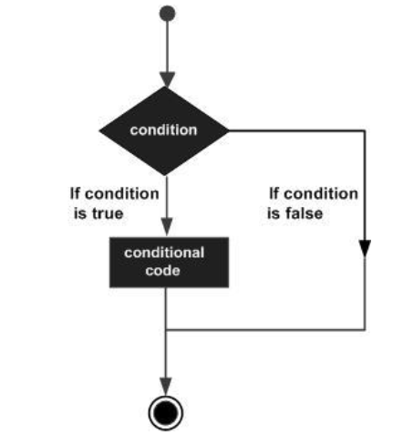

1.2.2 if-else structure
The if else ladder statement in C programming language is used to test set of conditions in sequence. An if condition is tested only when all previous if conditions in if-else ladder is false. If any of the conditional expression evaluates to true, then it will execute the corresponding code block and exits whole if-else ladder.
- Syntax
- The syntax of an if...else statement in C programming language is:
if(boolean_expression)
{
/* statement(s) will execute if the boolean expression is true */
}
else
{
/* statement(s) will execute if the boolean expression is false */
}
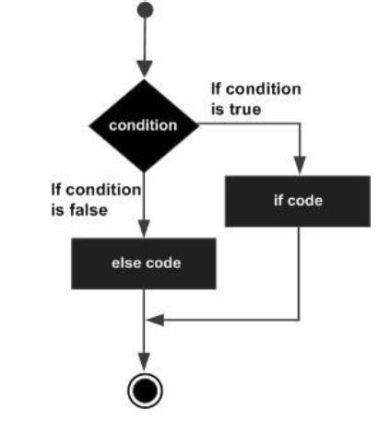
1.2.3 Nested if Statements
It is always legal in C programming to nest if-else statements, which means you can use one if or else if statement inside another if or else if statement(s).
- Syntax
- The syntax for a nested if statement is as follows:
if( boolean_expression 1)
{
/* Executes when the boolean expression 1 is true */
if(boolean_expression 2)
{
/* Executes when the boolean expression 2 is true */
}
}

1.2.4 ?: Conditional Expression
The conditional expression is a ternary operator; that is, it takes three operands. It has the following form
- (expression 1) ? (expression 2) : (expression 3)
If the first expression is TRUE (i.e., non-zero), the second expression is evaluated, otherwise the third is evaluated. Thus, the result of the ternary expression will be the result of either the second or third expressions, respectively.
For example, to calculate the maximum of two values,
c = (a > b) ? a : b; /* c = max(a,b) */
As a branching construct, the ?: operator appears far less frequently than the if-else and switch constructs.

1.2.5 switch Statement
A switch statement allows a variable to be tested for equality against a list of values. Each value is called a case, and the variable being switched on is checked for each switch case.
A switch statement allows a variable to be tested for equality against a list of values. Each value is called a case, and the variable being switched on is checked for each switch case.
Syntax
The syntax for a switch statement in C programming language is as follows:
switch (expression) {
case const-int-expr: statements
break; /* Optional */
case const-int-expr: statements
break; /* Optional */
default: statements
}
Note. The default label is typically the last label in the block. While this is good practice in general, it is not mandatory, and case labels may appear below default.
The statements following a case label are executed until terminated by a break statement, which causes an immediate exit from the switch block. However, if a break is not encountered, execution will flow on through to the next cases until the end of the block. This is termed fall through and is the default behaviour in a switch.
Style Note. It is generally good practice to have a default label even when it is not necessary, even if it just contains an assert to catch logical errors (i.e., program bugs)
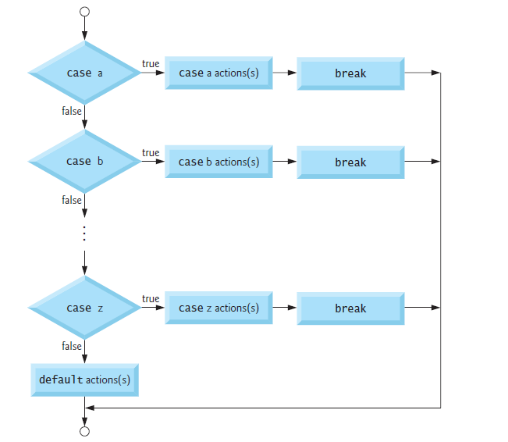
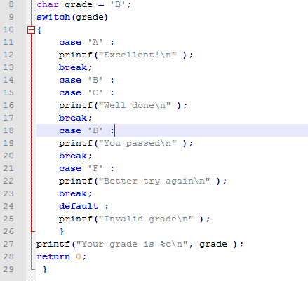

Repetition/Loop
A loop statement allows us to execute a statement or group of statements multiple times. Given below is the general form of a loop statement in most of the programming languages:
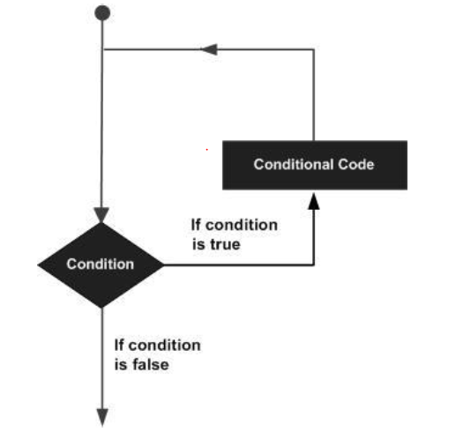

Repetition Essentials
Most programs involve repetition, or looping. A loop is a group of instructions the computer executes repeatedly while some loop-continuation condition remains true.

- We have two means of repetition:
1. Counter-controlled repetition
2. Sentinel-controlled repetition
- Counter-controlled repetition is sometimes called definite repetition because we know in advance exactly how many times the loop will be executed.
- Sentinel-controlled repetition is sometimes called indefinite repetition because it’s not known in advance how many times the loop will be executed.

Counter-Controlled Repetition
- Counter-controlled repetition requires:
- The name of a control variable (or loop counter).
- The initial value of the control variable.
- The increment (or decrement) by which the control variable is modified each time through the loop.
- The condition that tests for the final value of the control variable (i.e., whether looping should continue).
Sentinel-controlled repetition
- Sentinel values are used to control repetition when:
- The precise number of repetitions is not known in advance, and
- The loop includes statements that obtain data each time the loop is performed

1.3.1 Loop Type
C programming language provides the following types of loops to handle looping requirements.
Loop Type | Description
while loop | Repeats a statement or group of statements while a given condition is true. It tests the condition before executing the loop body.
for loop | Executes a sequence of statements multiple times and abbreviates the code that manages the loop variable.
do...while loop | It is more like a while statement, except that it tests the condition at the end of the loop body.
nested loops | You can use one or more loops inside any other while, for, or do..while loop.

1.3.2 while Loop
A while loop in C programming repeatedly executes a target statement as long as a given condition is true.
Syntax :
- The syntax of a while loop in C programming language is:
while(condition)
{
statement(s);
}
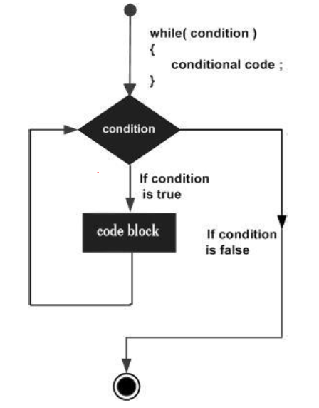

1.3.3 for Loop
A for loop is a repetition control structure that allows you to efficiently write a loop that needs to execute a specific number of times.
- Syntax
- The syntax of a for loop in C programming language is:
for ( init; condition; increment )
{
statement(s);
}
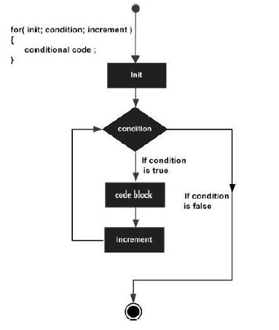

1.3.4 do…while Loop
Unlike for and while loops, which test the loop condition at the top of the loop,
The do...while loop in C programming checks its condition at the bottom of the loop.
A do...while loop is similar to a while loop, except the fact that it is guaranteed to execute at least one time.
Syntax
- The syntax of a do...while loop in C programming language is:
do
{
statement(s);
}while( condition
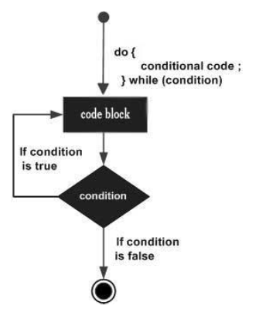

1.3.5 Nested Loops
In programming there exists situations where one need to iterate single or a set of repetitive statement for a number of time
Syntax
The syntax for a nested for loop statement in C is as follows:
for ( init; condition; increment )
{
for ( init; condition; increment )
{
statement(s);
}
statement(s);
}

1.3.6 break and continue Statements
The break and continue statements are used to alter the flow of control.
The break statement, when executed in a while, for, do…while or switch statement, causes an immediate exit from that statement.
- Program execution continues with the next statement.
- Common uses of the break statement are to escape early from a loop or to skip the remainder of a switch statement
Continue Statements
The continue statement, when executed in a while, for or do…while statement, skips the remaining statements in the body of that control statement and performs the next iteration of the loop.
- In while and do…while statements, the loop-continuation test is
- evaluated immediately after the continue statement is executed.
- In the for statement, the increment expression is executed, then the loop-continuation test is evaluated.

Post-test
Find the error in each of the following code segments and explain how to correct it.
- x = 1;
while ( x <= 10 );
x++;
}
- for ( y = .1; y != 1.0; y += .1 )
printf( "%f\n", y );
- switch ( n ) {
case 1:
printf( "The number is 1\n" );
case 2:
printf( "The number is 2\n" );
break;
default:
printf( "The number is not 1 or 2\n" );
break;
}
d) The following code should print the values 1 to 10.
n = 1;
while ( n < 10 )
printf( "%d ", n++ );

Bibliography
Deitel, P., & Deitel, H. (2010). C how to program (Vol. 6). Pearson Education Ltd.
Sodiya, A. S., & folorunso, A. (2008). PROGRAMMING AND ALGORITHMS. NATIONAL OPEN UNIVERSITY OF NIGERIA.
Thomas, H. C., Charles, E. L., Ronald, L. R., & Clifford, S. (2009). Introduction to Algorithms (Vol. 3). MIT Press.
Tim, B. (2005). An Introduction to the C Programming Language.

MODULE 6 : FUNCTIONS

1.0 INTRODUCTION TO FUNCTION
This unit introduces function. Functions are smaller self-contained components which carry out some specific, well defined task

Objectives
At the end of this lecture, students should be able to:
- list the benefits of using functions to modularize a program?
- Declare and call a function within the main program

Pre-Test
- What is the difference between a function’s declaration and its definition?
- When does a function need an include directive?

CONTENT

1.1 FUNCTION
A function can be defined as a collection of statements grouped together to do some specific tasks. Functions are smaller self-contained components which carry out some specific, well defined task. As real world applications become more complex and large, several problems arise.
A function has a name, list of arguments which it takes when called and the block of code it executes when called. C functions are defined in a text file and the names of all the functions in a C program are lumped together in a single, flat namespace. The special function called “main” is where program execution begins.

1.2 Function Prototype
Like variables, functions are declared and declaration of a function is called Function Prototype. Prototype specifies the signature (name) of the function, the return type, and number and data types of the arguments. It helps the compiler to know about the function. Functions must be declared before it is called.
Function prototyping is not mandatory in C. It is mandatory when the function is called prior to its definition. They are desirable, however, because they further facilitate error checking between function calls and the corresponding fu nction definition. Function prototype is also known as function declaration or function signature in C.

Syntax for function declaration
return_type function_name(parameter list);

- return_type defines the data type of value returned by the function. A function does some calculation and may return a resultant value so that the result of one function can be used by anther function. For example, sqrt() function returns square root of given number, which is later used by calling a function.

Note: void return type must be mentioned if your function does not return any value.

- function_name is a valid C identifier that uniquely identifies the function. Naming rules must be followed while naming a function.
- parameter list: a function may accept input. Parameter list contains input type and variable name given to the function. Multiple inputs are separated using comma “,”.
A function declaration must be terminated using “;”. Declaration can be made anywhere in the program. However, it is best to declare functions below pre-processor directives.

1.4 Function definition
Function definition contains block of code to do task that the function is intended to do. Block of code must contain a return statement if return type of the function is not void.
Syntax of function definition
return_type function_name(parameter list)
{
// Function body
}
Function declaration and definition syntax must be same. One is free to put function definition anywhere in your program, below its declaration.

1.5 Function Calling
The most important part of function is its calling. Calling of a function in general is execution of the function. It transfers program control from current function to called function.
Syntax of function call
function_name (parameter list);

- function_name: Name of the function to execute
- parameter list: Comma separated input given to the function. Parameter list must match type and order mentioned in function declaration. Parameter list can be left as blank if function does not accept any input.

1.5.1 Call by Value
Call by value is the default mechanism to pass arguments to a function. In call by value, during function call actual parameter value is copied and passed to formal parameter. Changes made to the formal parameters does not affect the actual. Parameter.

Example of call by value
C program to swap two numbers using call by value

#include <stdio.h>

/* Swap function definition */
void swap(int num1, int num2)
{
int temp;

printf("In Function values before swapping: %d %d\n", num1, num2);

temp = num1;
num1 = num2;
num2 = temp;

printf("In Function values after swapping: %d %d\n\n", num1, num2);
}

/* main() function definition */
int main()
{
int n1, n2;

/* Input two integers from user */
printf("Enter two numbers: ");
scanf("%d%d", &n1, &n2);

/* Print value of n1 and n2 in before swapping */
printf("In Main values before swapping: %d %d\n\n", n1, n2);

/* Function call to swap n1 and n2 */
swap(n1, n2);
printf("In Main values after swapping: %d %d", n1, n2);

return 0;
}

Output
Enter two numbers: 10 20
In Main values before swapping: 10 20
In Function values before swapping: 10 20
In Function values after swapping: 20 10
In Main values after swapping: 10 20

1.5.2 Call by Reference
In this approach, the addresses of actual arguments are passed to the function call and the formal arguments will receive the address. The actual and formal arguments refer to the same memory location. So, changes in the formal arguments are reflected in actual arguments.
Note: Actual arguments are address of the ordinary variable, pointer variable or array name.
Formal arguments should be a pointer variable or array.
This approach is of practical importance while passing arrays to functions and returning back more than one value to the calling function. Passing arrays to functions is call by reference by default.

Example of call by reference
C program to swap two numbers using call by reference

#include <stdio.h>

/**
* *num1 - pointer variable to accept memory address
* *num2 - pointer variable to accept memory address
*/
void swap(int * num1, int * num2)
{
int temp;

printf("In Function values before swapping: %d %d\n", *num1, *num2);

temp = *num1;
*num1 = *num2;
*num2 = temp;

printf("In Function values after swapping: %d %d\n\n", *num1, *num2);
}

/* main() function declaration */
int main()
{
int n1, n2;

printf("Enter two numbers: ");
scanf("%d%d", &n1, &n2);

printf("In Main values before swapping: %d %d\n\n", n1, n2);

/*
* &n1 - & evaluate memory address of n1
* &n2 - & evaluate memory address of n2
*/
swap(&n1, &n2);

printf("In Main values after swapping: %d %d", n1, n2);

return 0;
}

Output
Enter two numbers: 10 20
In Main values before swapping: 10 20
In Function values before swapping: 10 20
In Function values after swapping: 20 10
In Main values after swapping: 20 10

Post-test
- Write and test the following min() function that uses a min(int,int) function to find and return the smallest of four given integers: int min(int,int,int,int);
- Write and test the following average() function that returns the average of up to four positive numbers:

Bibliography
Deitel, P., & Deitel, H. (2010). C how to program (Vol. 6). Pearson Education Ltd.
Sodiya, A. S., & folorunso, A. (2008). PROGRAMMING AND ALGORITHMS. NATIONAL OPEN UNIVERSITY OF NIGERIA.
Thomas, H. C., Charles, E. L., Ronald, L. R., & Clifford, S. (2009). Introduction to Algorithms (Vol. 3). MIT Press.
Tim, B. (2005). An Introduction to the C Programming Language.

