DESIGN AND DEVELOPMENT OF A WEB-BASED DIRECTORY FOR PHARMACIES IN OYO STATE
BY

ADEKANMI TEMILOLUWA DAVID
MATRIC NO: 16010301026

SUBMITTED TO
THE DEPARTMENT OF COMPUTER SCIENCE AND MATHEMATICS,
COLLEGE OF BASIC AND APPLIED SCIENCES,
MOUNTAIN TOP UNIVERSITY, IBAFO, NIGERIA

IN PARTIAL FULFILLMENT OF THE REQUIREMENTS FOR THE AWARD
DEGREE OF BACHELOR OF SCIENCE (B.SC.) IN COMPUTER SCIENCE

2020

Certification
This is to certify that this project, Design and Development of a Web-Based Directory For Pharmacies in Oyo State was carried by me, Adekanmi Temiloluwa David (Matriculation Number: 16010301026) and duly supervised by Dr O.A. Ojesanmi

Dr O.A. Ojesanmi Date
(Supervisor)

Dr. I. O. Akinyemi Date
(Ag. Head of Department)

Dedication
This project work is dedicated to the giver of life and wisdom: The Almighty God

Acknowledgement
The success and final outcome of this project goes to the Almighty God for wisdom and understanding.
I specially appreciate my Supervisor Dr O.A. Ojesanmi who took keen interest in my project work and guided me all along, and never relented to attend to me anytime I came to him for assistance.
I would like to acknowledge the Head of Department Computer Science and Mathematics Dr. I. O. Akinyemi, and owe him my deepest gratitude for the efforts, constant encouragement, guidance and support of all the academic and non-academic staff of the Department of Computer Science and Mathematics. For the teachings that have brought out positive values in me and making my stay a worthwhile one. I extend my gratitude to Mountain Top University for setting greater heights for me. I say God bless you richly.
I heartily would like to thank my parents, Mr and Mrs Adekanmi and siblings, thank you all for your moral and financial support. I am grateful for all the investments into my education and future. I would not forget to remember all the students in the Department of Computer Science and Mathematics, for making my stay a worthwhile one, I say God bless you all richly.

TABLE OF CONTENTS
Certification ii
Dedication iii
Acknowledgement iv
List of Figures vi
1.0 INTRODUCTION 1
1.1 BACKGROUND OF THE STUDY 2
1.2 STATEMENT OF THE PROBLEM 2
1.3 AIMS AND OBJECTIVES 3
1.4 SCOPE AND LIMITATION 3
1.5 SIGNIFICANCE OF THE STUDY 3
1.6 METHODOLOGY 3
1.6 DEFINITION OF TERMS 4
LITERATURE REVIEW 6
2.1 INTRODUCTION 6
2.2 WEB DIRECTORIES 6
2.3 IMPORTANCE OF PHARMACY DIRECTORIES 7
2.4 WHAT IS GEOLOCATION 8
2.4.1. GEOLOCATION: A HISTORICAL PERSPECTIVE 10
2.4.2. BENEFITS OF GEOLOCATION 12
2.4.3. TECHNICAL ADVANTAGES OF GEOLOCATION 13
METHODOLOGY 14
3.1 OVERVIEW 14
3.2 EXISTING SYSTEM 14
3.3 PROPOSED SYSTEM 20
3.3.1 FUNCTIONAL REQUIREMENTS OF THE PROPOSED SYSTEM 21
3.3.2 ELEMENTS OF THE PROPOSED SYSTEM 22
3.4 DEVELOPMENT TOOLS 22
3.5 DESIGN OF THE PROPOSED SYSTEM 23
3.5.2 SYSTEM FLOWCHART 24
3.6 ADVANTAGE OF PROPOSED SYSTEM 25
SYSTEM IMPLEMENTATION AND TESTING 26
4.0 INTRODUCTION 26
4.1 SYSTEM IMPLEMENTATION 26
4.2.1 SYSTEM DEVELOPMENT SOFTWARES 26
4.2.2 HARDWARE REQUIREMENTS 27
4.3 CHOICE OF PROGRAMMING LANGUAGE 27
4.4 INPUT DESIGN 28
4.4.1 LOGIN FORM 28
4.4.2 REGISTRATION FORM 29
4.4.4 ADD ITEMS FORM 31
4.4.4 ADD LOCALITY FORM 31
4.4.4 EDIT LOCALITY FORM 32
4.5 OUTPUT DESIGN 33
4.5.1 THE HOMEPAGE 33
4.5.2 PHARMACY PAGE 36
4.5.3 MAPS 37
4.5.3.1 REGISTRATION MAP 37
4.6 DATABASE DESIGN 38
4.6.1 DATABASE SCHEMA 39
4.8 SYSTEM MAINTENANCE 44
SUMMARY, CONCLUSION AND RECOMMENDATIONS 45
5.0 SUMMARY 45
5.1 CONCLUSION 45
5.2 RECCOMMENDATION 46
REFRENCES 47
APPENDIX SOURCE CODE 49

List of Figures
Figure 2.1: The Components of Geolocation 17
Figure 3.1: Image showing how an interface of Business List 24
Figure 3.2: Image showing interface for Finelib 26
Figure 3.3: Image showing an interface of Skyscanner hotel directory 19
Figure 3.4: Structured chart for the proposed system 23
Figure 4.1: Image showing the Login form 28
Figure 4.2: Image showing the registration form 29
Figure 4.3: Image showing the edit pharmacy form 30
Figure 4.4: Image showing the add items form 31
Figure 4.5: Image showing the add locality form 32
Figure 4.6: Image showing the edit locality form 33
Figure 4.7: Image showing the directory homepage 34
Figure 4.8: Image showing pharmacy page with geographic interface 36
Figure 4.9: Image showing the pharmacy registration map 37
Figure 4.10: Image showing pharmacy page map 38

ABSTRACT
The main aim of any web-based directory in the world is to provide a platform for business owner to list their business under categories that best fit their services. Web-based directories make it easy for customers and potential customers to contact businesses, view available products and services among others and at the same time boosting the online visibility of listed businesses and providing information to search engines for better Search Engine Optimization. Although, in Nigeria, the available web-based directories are multipurpose directories; they provide listing for all business categories and are not intelligent enough to provide listed businesses to users depending on their current location, hence the visitors may find it difficult to locate nearby pharmacies in cases of emergencies. This therefore make the need for a more advanced Pharmacy directory of great importance. An application that uses Geolocation Application Interface (API) to determine a visitor’s current location and provide listed pharmacies nearby to such visitor. The purpose of this project is to develop a web application that has the capability to provide listed pharmacies located in the same locality as a visitor in Oyo state, necessary information about these pharmacies, their locations and also available items in these pharmacies. The application has PHP as its backend language, SQLite as its database, Google geolocation and Big Data Cloud geolocation APIs for Geocoding and Reverse Geocoding respectively.

CHAPTER ONE

1.0 INTRODUCTION
A web directory is an online listing of businesses. The listings provide information about specific businesses such as the name, address, contact information, association and the services and product offered. These businesses are usually categorized by location, activity, or size. (What is an Online Business Directory?, 2020), an online directory displays your business information, logo and (most of the time) link to your websites. Listing your business and managing the listings are extremely important to maintain and build in order to get your site to rank in search engines and ultimately drive leads. (Turner, 2019).
At present, manual system is being utilized on the available web-based directories. It requires visitors to manually select the category under which the business falls, for example Health and also the nearest location to such user which is mostly statewide thereby resulting in time wastage and which could lead to loss of lives in cases of emergency hence making the need for an advanced web-based pharmacy directory of great importance. This project develops a design and development of a web-based directory for pharmacies in Oyo state using geolocation. The application developed used Hyper Text Markup Language (HTML), JavaScript, Cascading Style Sheet (CSS) and Twitter Bootstrap as the front-end, PHP, Laravel (PHP MVC framework) for the back-end and MySQL for database.
When Implemented the developed system when implemented will allow pharmacy owners to provide information such as the map address of the pharmacy and more when registering their pharmacy on the application. The system will also enable visitors to get a list of all listed pharmacies close to their current location.

1.1 BACKGROUND OF THE STUDY
Pharmacist are often face the constant need to ensure satisfaction in service to keep their customers and make their business available with ease to potential customers. Also, customers on their end are faced with the problem of locating nearby pharmacies with ease especially when a particular pharmacy they often visit runs out of an item they would like to purchase and they want to patronize another pharmacy close by. If customers/potential customers find it difficult to locate nearby pharmacy in time this could lead to time wastage, stress and loss of life in cases of emergencies.

1.2 STATEMENT OF THE PROBLEM
In a large state by area such as Oyo state, customers and potential customers do not find it easy to search and locate nearby pharmacies in the state which can lead to time wastage. Also, considering the current state of health in the state, patients are also sometimes force to search for drugs by themselves due to poor maintenance of the pharmacies in the government hospitals and this could be very endangering because such a patient would be subjected to stress as he or she would not find it easy to locate a pharmacy nearby and would most likely reply on directions from people which most times are risky to follow as they might not provide accurate location of nearby pharmacies.

1.3 AIMS AND OBJECTIVES
The aim of this project is to develop a web application for the effective listing of pharmaceutical stores that will be able to achieve the following objectives:
- Ensure pharmacies are registered with locatable addresses.
- Map pharmacies to corresponding visitors
- Ensure that there exists a level of restricted access based on functionality and role.
- ensure that the system is user friendly.

1.4 SCOPE AND LIMITATION
The system is internet based and it provides location-based pharmacy listing to internet users with Global Positioning System (GPS) on their device only, it is limited to pharmacies in Oyo state and customers will not be able to purchase items on the application.

1.5 SIGNIFICANCE OF THE STUDY
This project will go a long way in helping to make pharmacies in Ibadan easily accessible by customers and potential customers. It will also help the pharmacist ensure satisfaction in services to keep their customers.

1.6 METHODOLOGY
The method employed for the web-based directory for pharmacies is the use of geolocation for determining geographic locations of pharmacies and visitors.
The address provided by the pharmacy during registration is sent to a geocoding API (Application Programming Interface) which helps convert the address to geographic coordinates (like latitude and longitude). This coordinate makes it possible to pinpoint the pharmacy’s location on the map for easy accessibility and also determine the pharmacy’s locality which in Oyo state’s case is the Local Government Area. To determine this locality, the coordinates are sent to a reverse-geocoding API which helps convert the coordinates to the corresponding locality, the coordinates and locality are then stored in the database. On the visitor’s end, reverse geocoding frontend JavaScript API client helps to determine the visitor’s current locality by converting the visitor’s coordinates provided by the browser to the corresponding locality which is then used to provide such visitor with nearby pharmacies by mapping the visitor’s current locality to registered pharmacies with the same locality on the directory.

1.6 DEFINITION OF TERMS
Geolocation: This is the process or technique of identifying the geographical location of a person or device by means of digital information processed via the internet.
Geographic Coordinates: This is a unique identifier of a precise geographic location on the earth, usually expressed in alphanumeric characters.
Latitude and Longitude: These are angles that uniquely define points on a sphere.
Geocoding: This is the computational process by which a physical address is converted into geographic coordinates.
Reverse-Geocoding: This is the process of back (reverse) coding of a point location (longitude and latitude) to a readable address or place name.
Global Positioning System (GPS): This is a satellite Positioning system used to determine the ground position of an object
Internet: A massive electronic and telecommunications network connecting the computers of businesses, consumers, government agencies, schools, and other organizations worldwide, this allows seamless information exchanges.
Application Programming Interface (API): This is a set of programming code that enables data transmission between one software product and another.
Directory: This is a listing of individuals, agencies or organizations alphabetically or thematically with details such as addresses and telephone number. It contains descriptive information that allows users to search according to themes or group content.
Database: This is a structured set of data held in a computer, especially one that is accessible in various ways.

CHAPTER TWO

LITERATURE REVIEW

2.1 INTRODUCTION
This primary focus of this chapter is to presents a review of relevant literatures on the importance of directories for pharmacies and the merits of using Geolocation.

2.2 WEB DIRECTORIES
A web directory or link directory is an online list or catalog of websites. That is, it is a directory on the World Wide Web of (all or part of) the World Wide Web. Historically, directories typically listed entries on people or businesses, and their contact information; such directories are still in use today. A web directory includes entries about websites, including links to those websites, organized into categories and subcategories. (Boswell, 2010). Besides a link, each entry may include the title of the website, and a description of its contents. In most web directories, the entries are about whole websites, rather than individual pages within them (called "deep links"). Websites are often limited to inclusion in only a few categories.
There are two ways to find information on the Web: by searching or browsing. Web directories provide links in a structured list to make browsing easier. Many web directories combine searching and browsing by providing a search engine to search the directory. Unlike search engines, which base results on a database of entries gathered automatically by web crawler, most web directories are built manually by human editors. Many web directories allow site owners to submit their site for inclusion, and have editors review submissions for fitness.

Web directories may be general in scope, or limited to particular subjects or fields. Entries may be listed for free, or by paid submission (meaning the site owner must pay to have his or her website listed).

2.3 IMPORTANCE OF PHARMACY DIRECTORIES
According to (Marie, 2017), directories help businesses in area of targeted advertising because customers use directories with a specific use in mind. If thy find a company to be suitable they go ahead with the purchase. Medical emergencies occur at an unexpected point in one's life, pharmacy directory with geolocation comes handy and lifesaving in situations like this.
Also, (Sam, 2019) described benefits of listing pharmacies on directories both to the pharmacy and the public. According to him, directories need to be optimized because when they are fully optimized by the pharmacy it enables hundreds, if not thousands of people to see the pharmacy when they type the name of the pharmacy into an online search.
Pharmacies are categorized based on their individual location by the directory, for example provided you are located in Oyo state you can visit the directory to easily local nearby pharmacies.

2.4 WHAT IS GEOLOCATION
A list of definitions from the internet are as below:
Geolocation is the ability to track a device’s whereabouts using GPS, cell phone towers, Wi-Fi access points or a combination of these. Since devices are used by individuals, geolocation uses positioning systems to track an individual’s whereabouts down to latitude and longitude coordinates, or more practically, a physical address. Both mobile and desktop devices can use geolocation (frankenfield, 2020)
Geolocation helps identify the actual geographic location of objects, such as mobile devices, or any terminals connected to the internet (SendPulse, 2020).
Geolocation is the wireless detection of the physical location of a remote device. As a noun, geolocation refers to the physical location itself; as a verb, the term refers to the process of detecting that location. (geolocation, 2009).

(Hill, 2020) defined geolocation as the process of identifying the geographical location of a person based on the digital information given off by their internet-connected device. He further noted that while several technologies can be used to determine a person’s geolocation, the most reliable way is to use their IP address. The following details can be gathered from knowing one’s IP address:
- Country
- Region state or province
- Latitude and longitude
- Time zone
- City
- Postal code
- Issuing Authority, which may differ from location of the IP

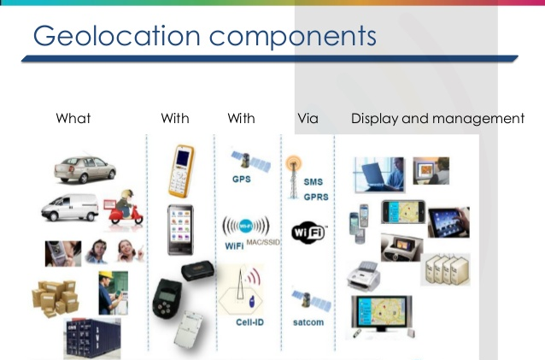
Figure 1 The Components of Geolocation (Source: Geolocation techniques by Hear and Know)
Figure 2.1: The Components of Geolocation

2.4.1. GEOLOCATION: A HISTORICAL PERSPECTIVE
Ground radio-navigation systems where the pioneers that brought about the first innovation in the area of geopositioning. The system, based on a radio signal sent by several transmitting stations proves to be precise at the local scale, but rapidly becomes imprecise at long distance due to the Earth’s roundness.
According to (“You are here”: a brief history of geolocation, 2019), In 1957, the date pinpointed as the start of space exploration, the Soviet government launched Sputnik 1, the first of a long series of artificial Earth satellites. The American engineers quickly realized that the Doppler effect detected on the satellite’s signals made it possible to deduce its orbital parameters and therefore its exact position. In 1964, the U.S. Army finalized the implementation of Transit, the first ever satellite positioning system in History capable of situating a receiver with a precision fluctuating between 200 and 1,000 m within a few hours, thanks to the signals and ephemerides of a handful of satellites put into orbit. A good start that paved the way for use by the general public. Until then almost exclusively reserved for military use, geolocation technology became more accessible in 1995 with the entry into service of GPS (Global Positioning System), an American development initiated as early as 1974, whose precision relies on the presence of a network of at least 24 satellites of the NAVSTAR system orbiting the Earth at an average distance of 20,000 Km from its surface. Radio waves sent from space at the speed of light enable the GPS receiver to quite easily deduce the distance of a satellite, thanks to the time of signal reception. Through triangulation, it thus becomes possible to work out the exact geographical position of a receiver with a precision of around thirty meters. By opening this GPS technology up to civilians in 1995, the American government facilitated the democratization of commercial geopositioning devices. Advances in miniaturization of GPS chips enabled the first model of geolocated mobile phone (the Benefon Esc!) to come about as early as 1999. The end of intentional degradation of the dedicated GPS signal as decided in May 2000 by the American government marked an important stage: notably facilitating the arrival on the market of onboard navigation devices combining GPS technology with “bird’s eye” view map interfaces. TomTom, with the TomTom GO in 2004, being the forerunner. The dominant position of the United States in the geolocation-by-satellite marketplace incited the rest of the world to develop their own techniques. Thus, Russia and China successively put into orbit GLONASS (24 fully operational satellites since 2011) and the Beidou 1 and 2 networks (since 2000). The European Union has also been developing Galileo since the early 2000s, which is already operational and will be fully deployed during the year 2020 with 24 satellites in service. Although these networks do not bring any particular innovations compared to the existing American technology, save that their recency ensures improved accuracy, they have considerably improved the quality of the data used today by most applications. Thus, the iPhone 4S was the first smartphone to announce its compatibility with the GLONASS network in 2011. By compiling GPS and GLONASS signals the device can guarantee the user better reliability of positioning data. In 2019, most devices also aggregate information transmitted by Galileo and Beidou. They are therefore based on an armada of American, Russian, Chinese, and European satellites, which facilitates signal quality improvement when transmission is imperfect.
2.4.2. BENEFITS OF GEOLOCATION
Geolocation has a broad variety of uses and methods. IP addresses of devices on the internet may be used to determine country, region, state, city, locality and more. As identified by (frankenfield, 2020) geolocation can be used to determine time zone and exact positioning coordinates, such as for tracking wildlife or cargo shipments he also noted that geolocation can help locate nearby store, ordered food online, or sought out the closest ATM. (frankenfield, 2020) further categorized the benefit of geolocation into three basic categories.
Payments: Financial institutions with mobile apps whose users have enabled location tracking can match the location of a customer’s phone with the location where the customer’s payment card is being used to detect possible payment card theft. If the two locations do not match, the fraud can be detected immediately and the card shut down. If the two locations do match, the customer can avoid experiencing any service disruption that might normally happen when the payment card provider detects unusual card activity.
Insurance claims processing: An insurance claims adjusting app can use geolocation technology to substantiate a policyholder’s location and minimize the number of fraudulent or exaggerated claims the insurer receives. A visual claims platform allows policyholders to work with their insurance agents using a web-based real-time communications platform to evaluate the extent of loss and determine a fair amount for the claim. Customers use their phone cameras to engage in a live video call with their insurance agents to assess damage. The agent can take screen shots, zoom in, or use the phone’s flashlight to get additional details and create records of the damage for the customer’s file. This technology creates an environment where more customers are satisfied with the claims payments they receive and prevents them from filing complaints with regulators, resulting in better outcomes for both insurance companies and their customers.
Banking: Bluetooth beacons, the same type of geolocation technology that is placed throughout stores to offer users who have downloaded the store’s app to receive targeted discounts while giving the store data about the consumer’s shopping behavior, are providing new forms of convenience to bank customers. Geolocation is allowing bank customers to access branch ATMs with their mobile phones instead of with their ATM cards after business hours, offering convenience. Beacon technology also improves service inside smart bank branches by notifying bank employees when a customer has been waiting in a teller line too long so the customer can be directed to another bank employee at a desk who can help them.

2.4.3. TECHNICAL ADVANTAGES OF GEOLOCATION
Some technical advantages that Geolocation offers are;
- Turn-by-turn directions update for smart navigation.
- Personalized communication.
- Geographical data analytics
- Asset tracking to prevent loss

CHAPTER THREE

METHODOLOGY

3.1 OVERVIEW
This chapter explains the methodology and approach involved in achieving the design and development of a web-based directory that makes nearby pharmacies easily accessible to the public. It gives more information on the architecture of the system, the state diagram of the system and also the various tools that will be used in accomplishing the results

3.2 EXISTING SYSTEM
Before now, they have been various web-based directory that enables customers in Oyo state get information about business. The need for this system will be pointed out as well as the challenges in the currently existing systems.
- BUSINESS LIST
Business List is a Nigerian business directory that enables businesses:
- Be visible online
- Obtain new customers and generate more traffic.
- Improve their social media shares.
- Get reviews and grow their business reputation online.
- Make company profile including contacts and description, products, photo gallery and your business location on the map visible to the public.

FEATURES OF BUSINESS LIST
- Business list provide listing services for jobs, businesses and more.
- Map location of businesses


Figure 3.2.1 Image showing how an interface of Business List
Source: Business List website
Figure 3.1: Image showing how an interface of Business List
HOW IT WORKS
To begin with, A business owner has to select a payment plan and register him/herself in order to be able to register his business and provide details like business name, email address, physical address, business location on the map, phone number, website and more. This information are what visitors will see when they visit the directory. Available products and services of individual businesses were also made available on the businesses’ pages
DRAWBACKS
The directory is general in scope as it lists business under various categories thereby requiring visitors to navigate to the pharmacies category and Oyo state location manually. Also, it was discovered that some businesses’ location where not available on the map. Although, this directory shows business locations on the map, it is not intelligent enough to map visitors to nearby pharmacies.
- FINELIB
Finelib is a Nigerian directory that provides online listing to businesses in Nigeria
FEATURE OF BUSINESS LIST
- Business list provide listing services for deals, events and businesses.

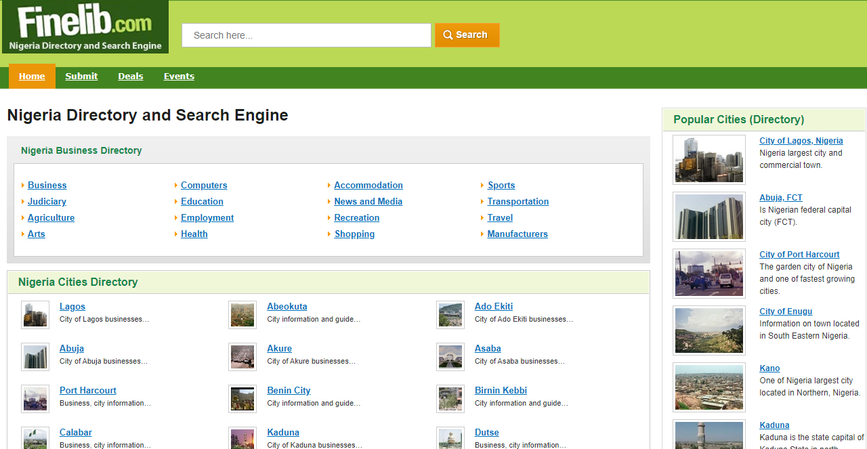
Figure 3.2.2 Image showing interface for Finelib
Figure 3.2: Image showing interface for Finelib

HOW IT WORKS
On visiting the website, it provides a list of categories and cities available. A visitor can navigate first to a desired city and further down to a business category or first to a business category then a city under that category. Available products and services of individual businesses were also made available on the businesses’ pages
DRAW BACKS
This directory requires manual navigation to desired listing by visitors and is not scope based. Also, it does not utilize any form of geolocation technique to make businesses easily accessible by the public.

- SKYSCANNER
Skyscanner is a travel company that provides hotel directories for hotels in destination in Oyo state and beyond alongside others. This helps their customers/potential customers round-off their entire trip with millions of rooms from all around Oyo state, from low-cost to luxury.
FEATURES OF SKYSCANNER
- Most popular destinations in Oyo State
- Directory of destinations in Oyo State

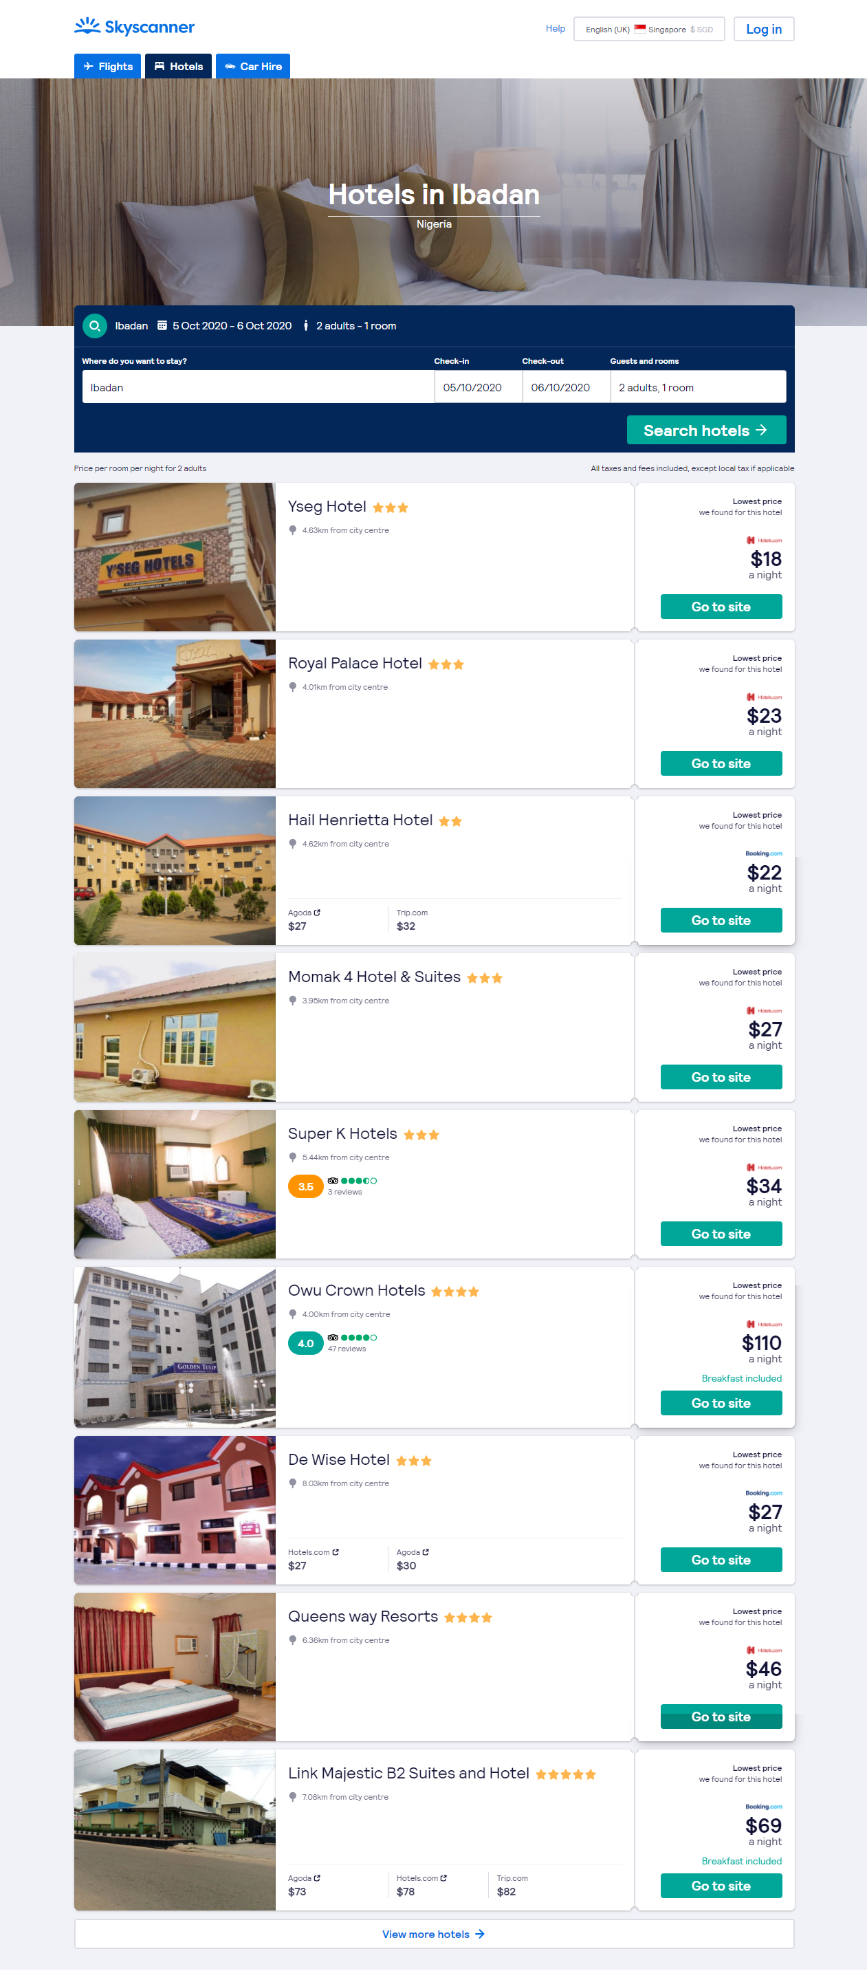
Figure 3.2.3 Image showing an interface of Skyscanner hotel directory
Source: Skyscanner website

Figure 3.3: Image showing an interface of Skyscanner hotel directory

HOW IT WORKS
On visiting the website, there are three navigation tabs and they include Flights, Hotels, and Car Hire.
The Hotels tab consists of a search panel with 3 additional filter option to get better results upon search.
DRAWBACKS
It is limited to hotels and totally depends on manual search by a user to provide available listings.

3.3 PROPOSED SYSTEM
The proposed system is a web directory that would be designed to help make accessing only pharmacies much easier by limiting the scope to a particular field, provide a medium for the public to quickly access nearby pharmacies in cases or urgency.
The system will be designed to provide the following benefits in the interest of the pharmacy;
- The system would enhance online visibility.
- The system would enable pharmacies connect with customers faster.
- The system would build up and strengthen the pharmacies reputation.
- The system would improve organic SEO.

3.3.1 FUNCTIONAL REQUIREMENTS OF THE PROPOSED SYSTEM
The following functional requirements would be achieved by the system to ensure its goals, operation and specific objective of the system for its users.
- Registration page: This page would enable pharmacy owners register their pharmacies in other to gain access to the application functions. Information such as pharmacy name, email address, phone number, website URL, description, map address, and password would be collected upon registration and would then be stored in the to enable them to access the application through login portal and to enable visitor get public information about the pharmacies.
- Database: This is a shared collection of data that are to meet the immediate need of visitors and authorized users. These data may be in form of text, numeric, or date. This is a very important feature needed for the web application as it would store data that can be retrieved when needed.
- Login: This enables registered users on the system to access and perform authorized operation on the application. Pharmacy owner would be required to provide login credentials supplied during registration for authentication.
- Locality Determiner: This enables the system to determine the location of a pharmacy and the current location of a visitor when he/she visits the application. This goes a long way to ensure that the public get accurate information of nearby pharmacies.

3.3.2 ELEMENTS OF THE PROPOSED SYSTEM
Below are the elements of the proposed system
- The Users: Admin, Pharmacies and visitors.
- Input: Data on pharmacies provided on registration and geographic coordinates determines by data.
- Geoprocesses: Location information determined at the backend, Google map embedded in the registration and pharmacy page.
- Storage: SQLite Relational database.
- Output: Maps, texts and images.

3.4 DEVELOPMENT TOOLS
- Visual Studio Code
Visual Studio Code is an editor for designing, coding, and developing websites, web pages, and web applications. It provides a means for a programmer create and modify programming language source code.
- PHP: it is a general-purpose scripting language that is especially suited to web development.
- Laravel: This is a full structured PHP framework, it highly secure, scalable and maintainable. Its MVC (Model View Controller) support makes development far clear and excellently documented
- SQLite: This is a software library that provides a relational database management system. It is highly suitable for development
- Apache Server: This is an open-source web server that delivers web content through the internet.

DESIGN OF THE PROPOSED SYSTEM

    - STRUCTURE CHART
HOMEPAGE
VIEW PHARMACIES
MAIN MENU

DELETE ITEMS

EDIT ITEMS

VIEW ITEMS

EDIT DETAILS

ADD ITEM

PHARMACY PAGE

LOGIN

ADMIN LOGIN
MANAGE LOCALITIES

EDIT LOCALITY
DELETE LOCALITY
UPDTAE LOCALITY
LOCALITIES

Figure 3.4 Structured chart for the proposed system

SYSTEM FLOWCHART
Start
edit Locality
Add Locality
DISPLAY ERROR MESSAGE
NO
LOGIN
Are details correct?
YES
IS ADMIN?
NO
DISPLAY PHARMACY PAGE
YES
Stop
EXIT?
YES
DISPLAY ADMIN DASHBOARD
Manage Locality?

YES
edit Locality
Add Locality
NO
NO
YES
YES
REGISTER
NO
Have an account?

DISPLAY HOMEPAGE

3.6 ADVANTAGE OF PROPOSED SYSTEM
- It saves people from the stress of manually selecting business categories.
- It eases accessibility of nearby pharmacy.
- Boosts online visibilities of pharmacies.
- Customers do not have to visit a pharmacy before knowing the available items.
- The interface is user friendly.

CHAPTER FOUR

SYSTEM IMPLEMENTATION AND TESTING

4.0 INTRODUCTION
System implementation refers to a stage in system life cycle whereby a new system is developed, installed and made ready for use. It is this stage that all details and key point in the requirement specification are practicalized. System implementation therefore, is a very essential stage in which its success determines to a great extent the success of the new system.
System design is concerned mainly with locating visitors and pharmacies and mapping visitors to nearby pharmacies in order to achieve necessary objectives. It addresses data input and output data, processing and interface.
This stage involves the design of web-based directory for pharmacies in Oyo state
using geolocation.

4.1 SYSTEM IMPLEMENTATION
The system will be implemented using software and hardware component.

4.2.1 SYSTEM DEVELOPMENT SOFTWARES
- VSCode.
- PHP/SQLite
- Laravel Server.
- Google map and Geocoding API
- Big Data Cloud Reverse Geocoding API

4.2.2 HARDWARE REQUIREMENTS
The following hardware specifications are recommended for efficient and effective functioning of the system.
- The required RAM size for the implementation of the system is 4GB.
- The required Hard disk size for the implementation of the system is 500GB.
- The required processor specification for the implantation of the system is Intel® Core™ i3-4030u CPU @ 1.90GHz.

4.3 CHOICE OF PROGRAMMING LANGUAGE
The pair of PHP and SQLite are preferred for web development and design for the following reasons:
- They’re free. It’s hard to beat free for cost-effectiveness. They’re Web oriented. Both were designed specifically for use on Web sites.
- They’re easy to use.
- They’re fast. Both were designed with speed as a major goal.
- They communicate well with one another. PHP has built-in features for communicating with MySQL.
- A wide base of support is available for both. Both have large user bases. Because they’re often used as a pair, they often have the same user base. Many people are available to help, including people on e-mail discussion lists who have experience using MySQL and PHP together.
- They’re customizable. Both are open source, thus allowing programmers to modify the PHP and MySQL software to fit their own specific environments.

4.4 INPUT DESIGN
The system utilizes four input tools and they are the keyboard, the scanner, the mouse and forms. Keyboard, scanner and mouse are referred to as hardware input devices while the form is referred to a software input tool and is specifically designed for sending data to be used by the database.

4.4.1 LOGIN FORM
The Login form enables the administrator and registered pharmacies to get authenticated in order to able to carry out tasks that required authorized access. The form is presented whenever the login link is visited or when an unauthenticated user tries to perform tasks that need authorized access. Users are required to confirm their email addresses and passwords stored in the database for the purpose of logging in.
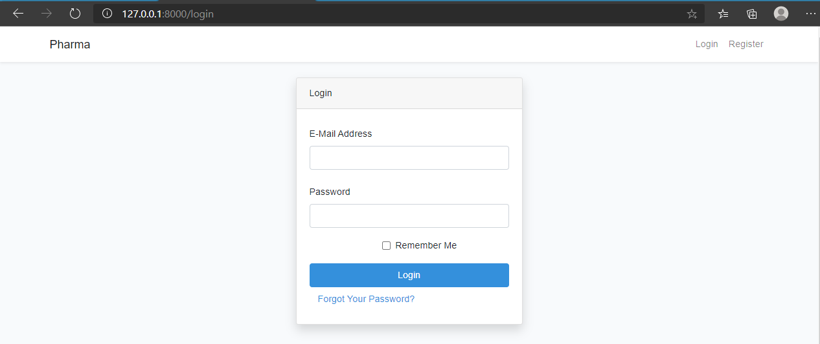
Figure 4.1 The Login form
Figure 4.1 Image showing the Login form

4.4.2 REGISTRATION FORM
The registration form allows unregistered pharmacies to provide necessary details required to sign up on the directory which includes their map addresses. When the register link on the main menu is visited by a visitor, the registration form is provided to such user. The registration form is shown in Fig 4.2
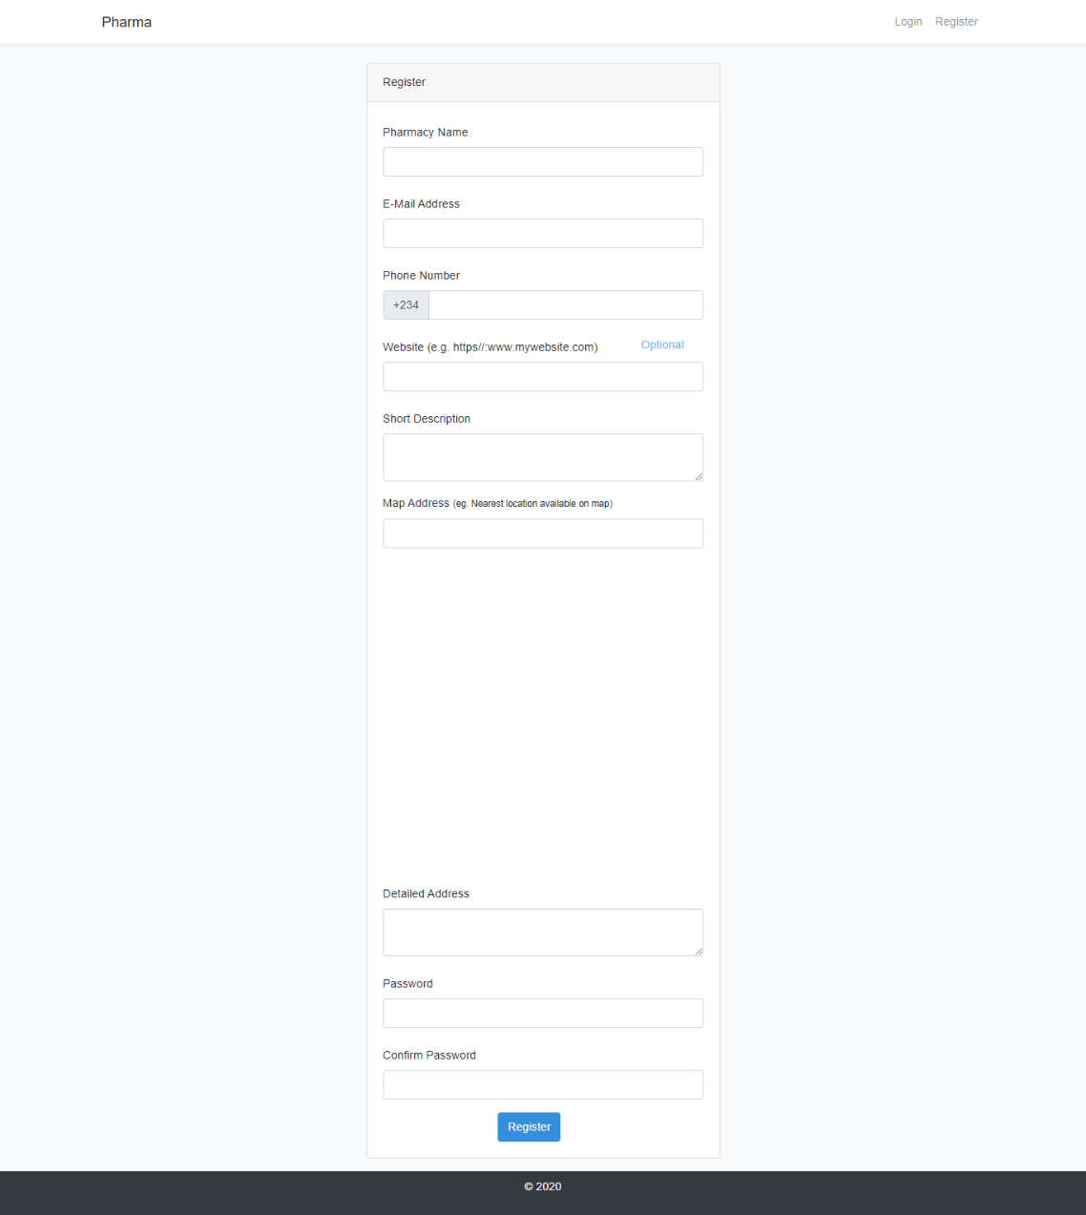
Figure 4.2 The Registration form
Figure 4.2 Image showing the Registration form
4.4.3 EDIT PHARMACY FORM
Authorized pharmacies can edit their information via the edit pharmacy form shown in fig 4.3

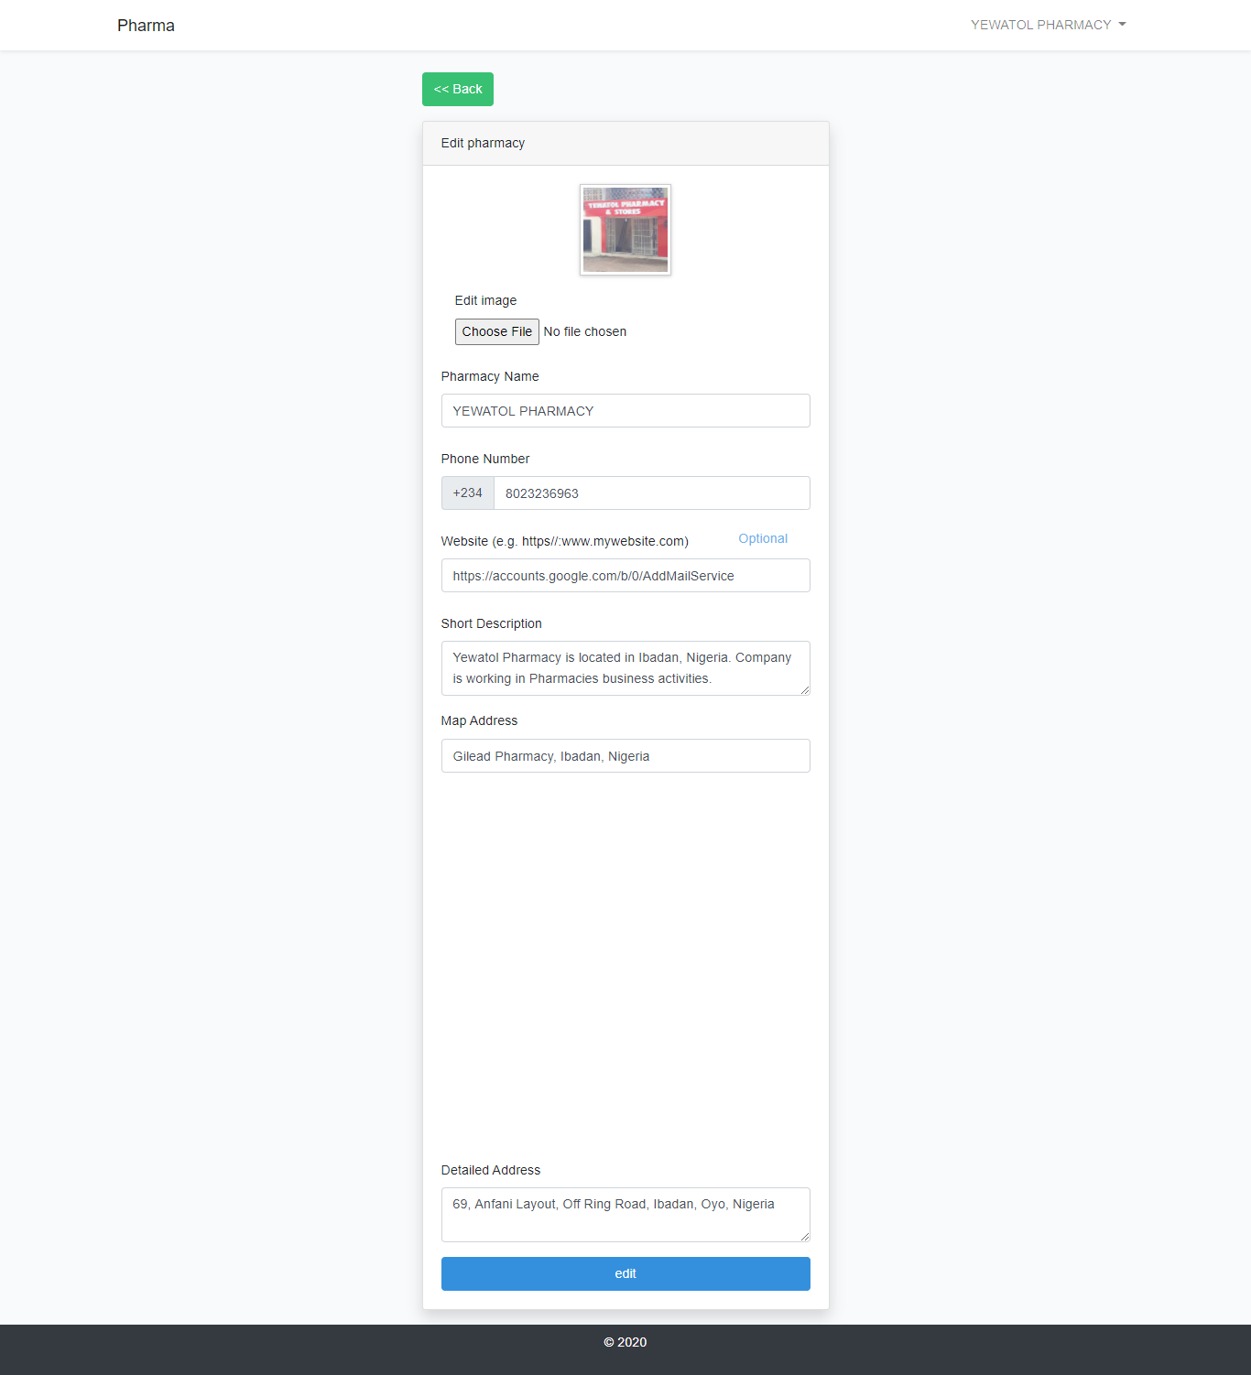
Figure 4.3 The Edit pharmacy form
Figure 4.3: Image showing the edit pharmacy form

4.4.4 ADD ITEMS FORM
Registered pharmacies can also add items using the add item form shown in fig 4.4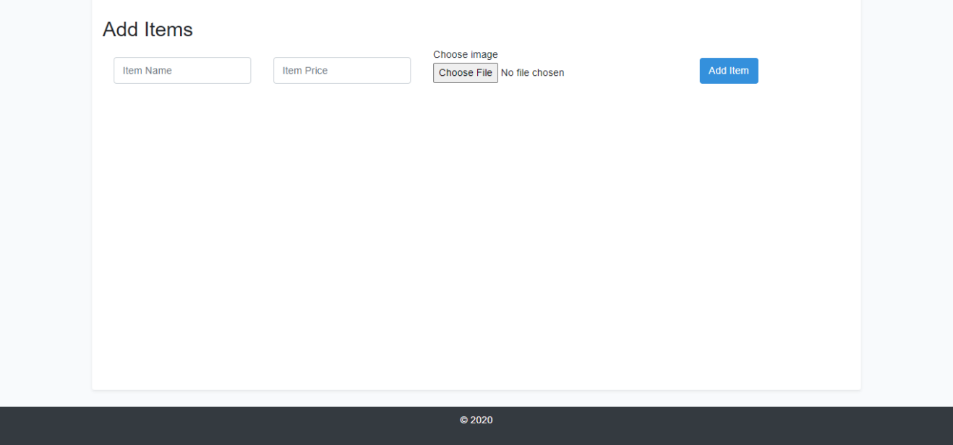
Figure 4.4 Add Items form
Figure 4.4: Image showing the add items form

4.4.4 ADD LOCALITY FORM
The add locality form enables the administrator to add localities otherwise known as Local Government Areas in the directory.
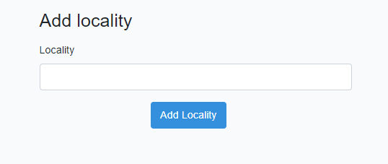
Figure 4.5 Add locality form
Figure 4.5: Image showing add locality form

4.4.4 EDIT LOCALITY FORM
The edit locality form enables the administrator to edit localities otherwise known as Local Government Areas in the directory.

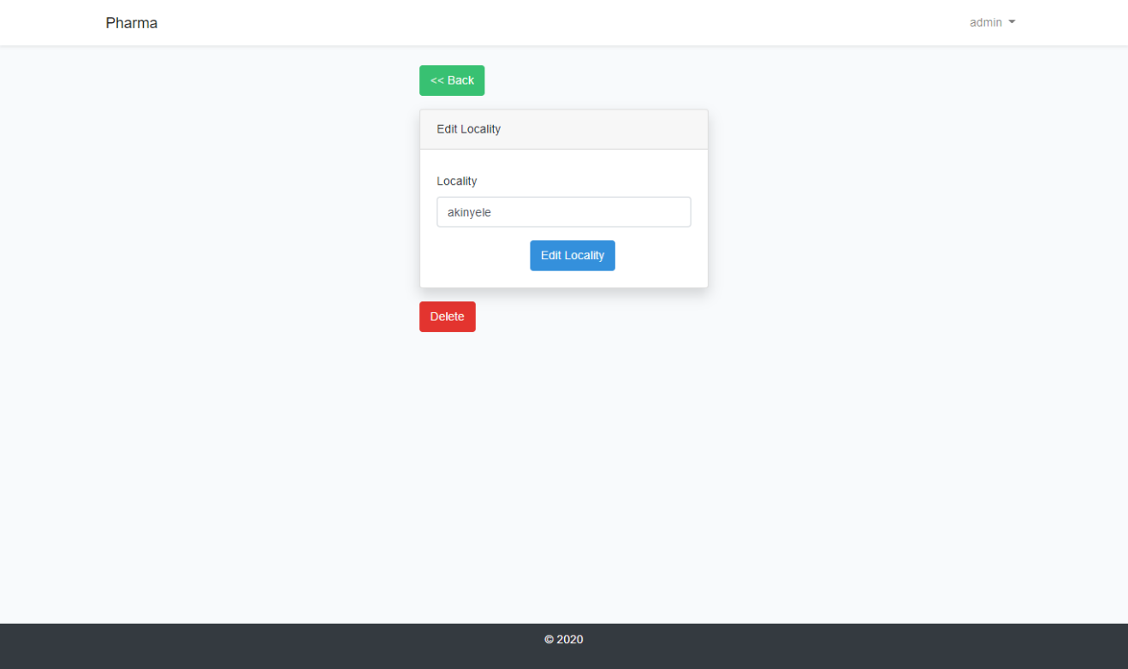
Figure 4.6 Edit locality form
Figure 4.6: Image showing edit locality form

4.5 OUTPUT DESIGN
The hardware devices for the output in this design is the visual display unit of computers while the software tools are graphical outputs and details tables.

4.5.1 THE HOMEPAGE
Whenever a visitor visits the directory, the homepage is the first page that will be presented to such individual. The directory demands for access to the visitor’s location via the browser, if the visitor grants access the directory provides such visitor with registered pharmacies in the same local government area as such visitor.
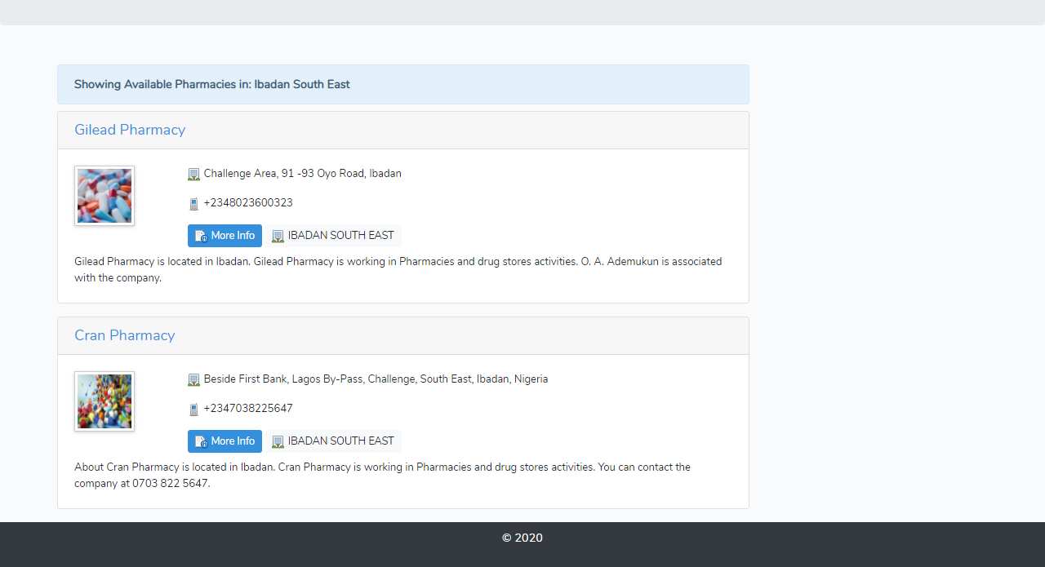
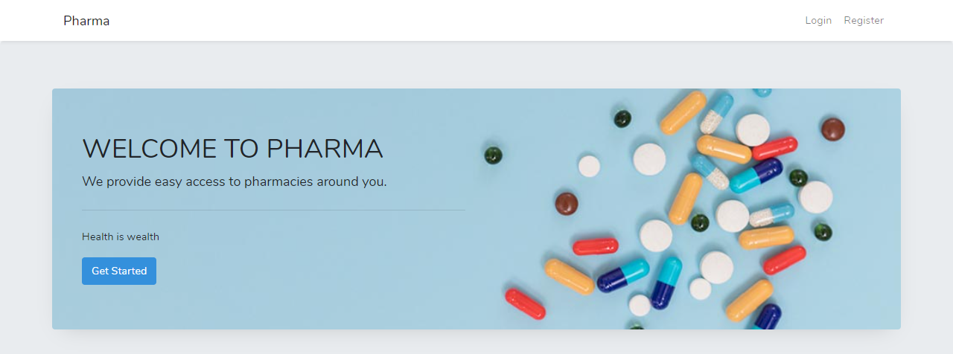Figure 4.7 The directory homepage
Figure 4.7: Image showing the directory homepage

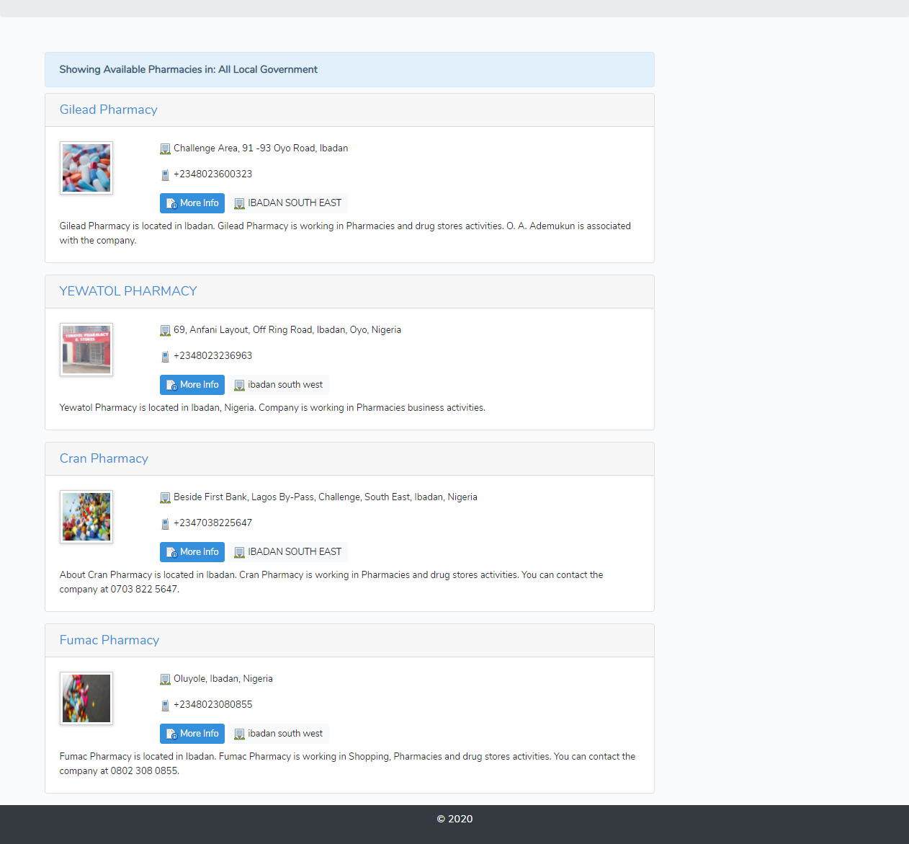
In a situation whereby a Visitor is not in Oyo state or the visitor’s location cannot be determined by the directory either due to the browser being denied location access or other unforeseen reasons, such visitor is provided with a list of all registered pharmacies

4.5.2 PHARMACY PAGE
When a pharmacy’s linked is visited on the home page, such visitor/user is provided with a page showing such pharmacy’s details all provided during registration. Figure 4.5 shows a pharmacy page with geographic interface and their details in a tabular format.
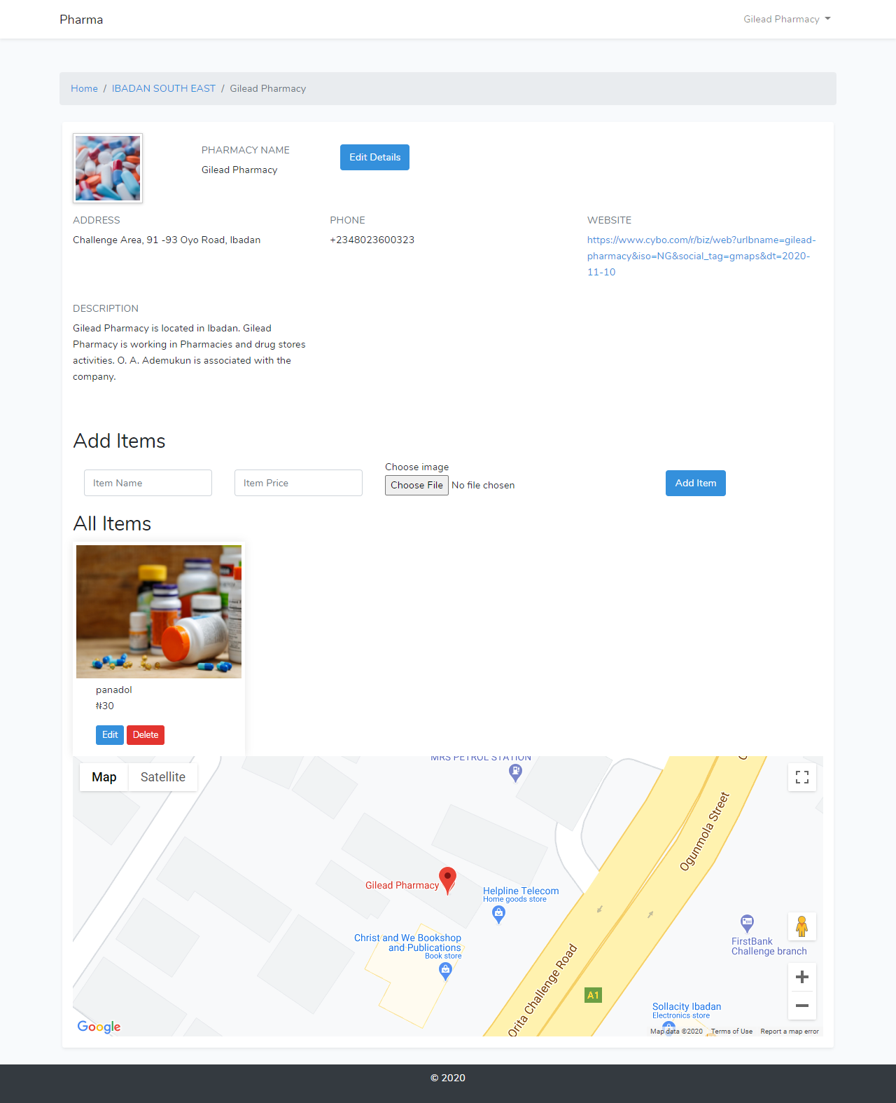
Figure 4.6 Pharmacy page with geographic interface.
Figure 4.8: Image showing pharmacy page with geographic interface

4.5.3 MAPS

4.5.3.1 REGISTRATION MAP
This map is right below the map address field in the registration, it shows the map location of addresses provided in the map address field.
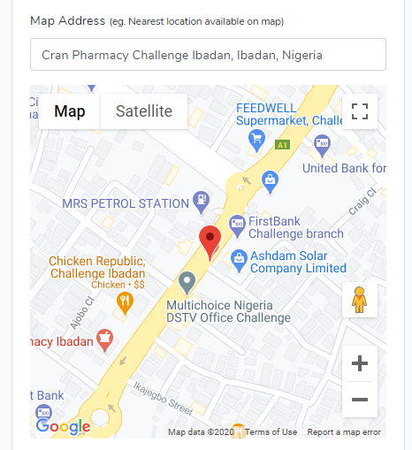
Figure 4.9: Image showing pharmacy registration map

4.5.3.1 PHARMACY PAGE MAP

The Coordinates retrieved from the map addresses by the pharmacy during registration are used to pinpoint such pharmacy on the map for visitors to easily locate
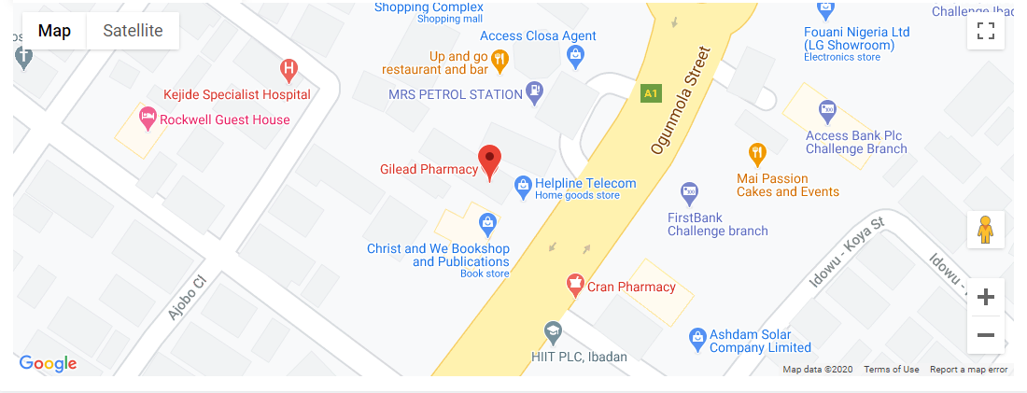
Figure 4.10: Image showing pharmacy page map

4.6 DATABASE DESIGN
The database management system used in the development of the Web Based Pharmacy Directory is SQLite. The database named Database contains Eight tables with only 4 being used by the directory, the remaining for are dedicated for SQLite and Laravel.
S/N | TABLE | CONTENT
i | Pharmacies | Pharmacy details, such as locality, phone number, address, website, image etc.
ii | Users | Contains name, email, password etc.
iii | Localities | Name, date etc.
iv | Items | Name, Price, Image etc.
Table 4.1 Database tables for the Directory

4.6.1 DATABASE SCHEMA
The schema for the database is below

Pharmacies:

S/N | ID | DATA TYPE
1 | Id | Integer
2 | user_id | Integer
3 | locality_id | Integer
4 | phone_number | varchar
5 | detailed_address | varchar
6 | Description | Text
7 | Image | varchar
8 | address_address | varchar
Table 4.2 Pharmacies table structure

Users:

S/N | ID | DATA TYPE
1 | Id | Integer
2 | name | varchar
3 | slug | varchar
4 | email | varchar
5 | email_verified_at | datetime
6 | password | Text
7 | remember_token | varchar
8 | created_at | datetime
9 | updated_at | datetime
Table 4.3 Users table structure

Localities:

S/N | ID | DATA TYPE
1 | id | Integer
2 | name | varchar
3 | slug | varchar
4 | created_at | datetime
5 | updated_at | datetime
Table 4.4 Localities table structure

Items:

S/N | ID | DATA TYPE
1 | id | Integer
2 | pharmacy_id | Integer
3 | name | varchar
4 | price | varchar
5 | image | varchar
6 | created_at | datetime
7 | updated_at | datetime
Table 4.5 Items table structure

The database file (database.sqlite) was in code editor while the he database tables were created using Laravel’s inbuilt migration system that allows tables to be created and dropped effectively and faster.

4.8 SYSTEM MAINTENANCE
Maintenance is a continuous process of making modifications and upgrading the application. This usually commences after the application has gone into use.

CHAPTER FIVE

SUMMARY, CONCLUSION AND RECOMMENDATIONS

SUMMARY
Businesses have been made easily accessible by the public with the aid of internet, Global Positioning Systems and proliferation of computing devices. One of the advantages of this connectivity and information flow is that it helps people easily locate nearby businesses. This reduces stress and it also saves time which is very crucial in cases of emergencies
The web-based application was developed to make nearby pharmacies easily accessible to the public and to increase the online presence of the pharmacies. The system was tested and found to be functional and the outputs produced by this system were encouraging. The application will hence reduce the stress of locating nearby pharmacies online unlike existing systems.

CONCLUSION
In the project, a web-based pharmacy directory was developed that offers a wide range of solutions to problem faced by people when trying to locate nearby pharmacies
In order to allow for future expansion, the system has been designed in such a way that will allow possible modification as it may deem necessary whenever the idea arises. This can be achieved easily due to the choice of MVC framework that facilitates easy scalability.

RECCOMMENDATION
It is recommended that the new system should be used with the necessary specifications of the system requirements and hosted on a dedicated server to prevent crashing cause by shared hosting.
It is recommended that the software be improved especially in areas of stock listing, if real-time goods update could be integrated it would make it easy for the public to get updated whenever a particular item is in or out of stock.

REFRENCES
“You are here”: a brief history of geolocation. (2019, 10 7). From Hello Future: https://hellofuture.orange.com/en/you-are-here-a-brief-history-of-geolocation/
Alling, T. (2012, 12 15). Why web directories are important for your site's success. From PHP Link Directory: https://www.phplinkdirectory.com/why-web-directories-are-important-for-your-web-sites-success/
Boswell, W. (2010, 2 25). What is a Web Directory. From About.com: http://websearch.about.com/od/enginesanddirectories/a/subdirectory.htm
frankenfield, j. (2020, 9 25). Geolocation. From investopedia: https://www.investopedia.com/terms/g/geolocation.asp#:~:text=Geolocation%20refers%20to%20the%20use,whereabouts%20of%20connected%20electronic%20devices.
geolocation. (2009, 10). From techtarget: https://searchmobilecomputing.techtarget.com/definition/geolocation
gravitate. (2020, 4 1). Geolocating Carmen Sandiego. From gravitatedesign: https://www.gravitatedesign.com/blog/what-is-geolocation/
Hill, D. (2020, 04 28). What is Geolocation? From securityboulevard: https://securityboulevard.com/2020/04/what-is-geolocation/
Marie. (2017, 10 4). The Importance of Business Directory Listings. From Simplio Web Studio: https://www.simpliowebstudio.com/why-business-directory-listings-are-important/
Sam. (2019, 9 21). How to Market Your Pharmacy. From Pharmacy Mentor: https://www.pharmacymentor.com/how-to-market-your-pharmacy-2
SendPulse. (2020, 01 03). From What is Geolocation?: https://sendpulse.ng/support/glossary/geolocation
Top 5 Benefits of Geolocation Technology. (2020). From CX App: http://info.thecxapp.com/blog/top-5-benefits-of-geolocation-technology
Turner, j. (2019, 9 15). What is the Importance of Online Directories? From The Search Engine Guys: https://www.thesearchengineguys.com/what-is-the-importance-of-online-directories
What is an Online Business Directory? (2020). From digitalshiftmedia: https://digitalshiftmedia.com/marketing-term/online-business-directory/

APPENDIX SOURCE CODE
Login Page
@extends('layouts.app')
@section('title')
<title>{{ config('app.name', 'Laravel') . "|| login" }}</title>
@endsection
@section('content')
<div class="container">
<div class="row justify-content-center">
<div class="col-md-4 mt-4">
<div class="card shadow rounded-sm">
<div class="card-header">{{ __('Login') }}</div>
<div class="card-body">
<form method="POST" action="{{ route('login') }}">
@csrf
<div class="form-group row">
<label for="email" class="col-md-12 col-form-label ">{{ __('E-Mail Address') }}</label>
<div class="col-md-12">
<input id="email" type="email" class="form-control @error('email') is-invalid @enderror" name="email" value="{{ old('email') }}" required autocomplete="email" autofocus>
@error('email')
<span class="invalid-feedback" role="alert">
<strong>{{ $message }}</strong>
</span>
@enderror
</div>
</div>
<div class="form-group row">
<label for="password" class="col-md-12 col-form-label ">{{ __('Password') }}</label>
<div class="col-md-12">
<input id="password" type="password" class="form-control @error('password') is-invalid @enderror" name="password" required autocomplete="current-password">
@error('password')
<span class="invalid-feedback" role="alert">
<strong>{{ $message }}</strong>
</span>
@enderror
</div>
</div>
<div class="form-group row">
<div class="col-md-6 offset-md-4">
<div class="form-check">
<input class="form-check-input" type="checkbox" name="remember" id="remember" {{ old('remember') ? 'checked' : '' }}>
<label class="form-check-label" for="remember">
{{ __('Remember Me') }}
</label>
</div>
</div>
</div>
<div class="form-group row mb-0">
<div class="col-md-12">
<button type="submit" class="btn btn-block btn-primary">
{{ __('Login') }}
</button>
@if (Route::has('password.request'))
<a class="btn btn-link" href="{{ route('password.request') }}">
{{ __('Forgot Your Password?') }}
</a>
@endif
</div>
</div>
</form>
</div>
</div>
</div>
</div>
</div>
@endsection

Login Controller
<?php
namespace App\Http\Controllers\Auth;
use App\Helpers;
use App\Http\Controllers\Controller;
use App\Providers\RouteServiceProvider;
use Illuminate\Foundation\Auth\AuthenticatesUsers;
class LoginController extends Controller
{
/*
|--------------------------------------------------------------------------
| Login Controller
|--------------------------------------------------------------------------
|
| This controller handles authenticating users for the application and
| redirecting them to your home screen. The controller uses a trait
| to conveniently provide its functionality to your applications.
|
*/
use AuthenticatesUsers;
//protected $redirectTo = RouteServiceProvider::HOME;
protected function redirectTo()
{
return Helpers::redirectByRole();
}
/**
* Create a new controller instance.
*
* @return void
*/
public function __construct()
{
$this->middleware('guest')->except('logout');

