DESIGN AND IMPLEMENTATION OF A COMPUTERIZED POS (POINT OF SALE) SYSTEM

BY

BANJO, OLUWAFEMI AKPOREFE
MATRICULATION NUMBER: 16010301006

SUBMITTED TO THE DEPARTMENT OF COMPUTER AND MATHEMATICAL SCIENCES,
MOUNTAIN TOP UNIVERSITY

IN PARTIAL FULFILLMENT OF THE REQUIREMENTS FOR THE AWARD OF THE DEGREE OF BACHELOR OF SCIENCE (B.Sc.) IN COMPUTER SCIENCE

CERTIFICATION
This is to certify that this project, THE DESIGN AND IMPLEMENTATION OF A COMPUTERIZED POS SYSTEM, prepared and submitted by BANJO OLUWAFEMI AKPOREFE, in partial fulfillment of the requirement of the degree of BACHELOR OF SCIENCE (computer sceince), is hereby accepted.

--------------------------------------------- (signature and date)
Dr. Oladeji F.
Supervisor

Accepted as partial fulfillment of the reqirement for the degree of BACHELOR OF SCIENCE (Computer Science)

---------------------------------------------- (signature and date)
Dr. Akinyemi, I.O.
Head of Department, Department Of Computer Science And Mathematics

------------------------------------------- (signature and date)
Prof. Akinwande, A.I.
Dean, College Of Basic And Applied Sciences

DEDICATION
I dedicate this work to Almighty God for the success of this program and the completion of this project. And to my parents that supported me through it all.

ACKNOWLEDGEMENT
My express thanks and gratitude goes to my parents without whose unwavering and uncontained support, I could not have made this career in Computer Science.
I particularly wish to honor Dr oladeji my project supervisor and my other lecturers who taught me from the beginning of this course to now and here. Without their knowledge, guidance, management and encouragement, I wouldn’t developed this project and I also thank my friends who directly or indirectly took interest to complete my project. God bless you all.

ABSTRACT
The global community especially the technologically advanced world is striving to attain what has been the global information age. It is an age that is envisaged to go beyond the use of computers as a mere tool for fast information processing, rather they will also become medium for processing and transferring such information from one location to another at equally fast rate. As a result, it’s appalling that sales in developing countries have not been able to benefit much from this revolutionized age of Information Technology especially in the area of a computerized Point Of Sales. A computerized point of sale system is a computer program which carries out all the functions of a manual system and electronic cash registers and much more. An electronic point of sale system gives you the ability to store client and supplier records, create quotations which can be later converted to invoices or cash sales, keep track and categorize your inventory in an easy way and generate reports at the click of a button! With today’s high performance computers and large storage devices one can easily run his/her business on an office computer (depending on the size of the business).

TABLE OF CONTENTS
TITLE PAGE
CERTIFICATION i
DEDICATION ii
ACKNOWLEDGEMENT iii
ABSTRACT iv

CHAPTER ONE
1.0 INTRODUCTION
1.1 BACKGROUND OF THE STUDY 1
1.2 STATEMENT OF THE PROBLEM 2
1.3 AIM/OBJECTIVES OF THE STUDY 2
1.3.1 AIM 2
1.3.2 OBJECTIVES 2
1.4 SIGNIFICANCE OF THE STUDY 3
1.5 LIMITATION OF STUDY 3
1.6 SCOPE OF STUDY 3
1.7 DEFINITION OF TERMS 3

CHAPTER TWO
2.0 LITERATURE REVIEW
2.1 OVERVIEW OF A COMPUTERIZED POS SYSTEM 5
2.2 FEATURES OF A POS SYSTEM 7
2.3 BENFITS OF A POS SYSTEM 8
2.4 EXISTING POS SYSTEMS IN THE MARKET 10
2.4.1 RETAIL MAN POINT OF SALES 10
2.4.2 QUICKBOOKS POS SOFTWARE 10
2.5 INVESTIGATION OF PROBLEMS 11

CHAPTER THREE
3.0 METHODOLOGY
3.1 INTRODUCTION 13
3.2 PRORGAM DESIGN 14
3.3 DATABASE DESIGN 17
3.3.1 DATABASE TABLES 18
3.3.2 DATABASE DIAGRAM 20
3.3.2 DATABASE VIEW 22
3.4 GRAPHICAL USER INTERFACE DESIGN 22
3.4.1 WPF 22
3.4.2 MARKUP 23
3.4.3 CODE-BEHIND 23
3.5 PROPOSED SYSTEM USERS 24
3.6 INPUT MEDIA 24
3.6.1 ERROR AVOIDANCE 25
3.6.2 ERROR DETECTION 25
3.6.3 DATA VALIDATION 25
3.6.4 ERROR MESSAGE DESIGN 25
3.7 USE CASE DIAGRAM 26
3.8 FLOWCHART OF THE PROPOSED SYSTEM 27

CHAPTER FOUR
4.0 SYSTEM IMPLEMENTATION AND TESTING
4.1 INTRODUCTION 28
4.2 SYSTEM REQUIREMENTS 28
4.3 SOFTWARE TESTING 29
4.4 SAMPLE IMPLEMENTATION 31

CHAPTER FIVE
5.0 SUMMARY, RECOMMENDATION AND CONCLUSION
5.1 SUMMARY 48
5.2 RECOMMENDATION 49
5.3 CONCLUSION 49
REFERENCES 50
APPENDIX (SOURCE CODE LISTING)

CHAPTER ONE
1.0 INTRODUCTION
1.1 BACKGROUND OF STUDY
One of the great recent advances in the world of information technology is the rapid development of communication which has brought world into a global village, we can send mails electronically (e-mail), search for information (WWW), buy goods online (e-commerce), withdraw transfer money (e-banking), schooling online (e-learning), this has affected the society positively to a great extent, as a result computerization of sales should not be exempted. Application of technology in sales has been adopted in developed countries for over two decades now, and this has been attributed to the desire of the governments of these countries to improve the efficiency of their goods and services, processes, accountability. Switching from a traditional cash register to a computerized POS system can be difficult – there are many factors to consider and some pitfalls to avoid. However, the return on investment and benefits to your business can really make it worth your time and effort. In the most basic sense, a POS system is a glorified cash register. The most basic POS system consists of a computer, a cash drawer, receipt printer, a monitor, and an input device such as a keyboard or scanner. However, in addition to being more efficient than cash registers, POS systems can create detailed reports that can help you make more informed business decisions. (“DESIGN AND IMPLEMENTATION OF A COMPUTERIZED POINT OF SALES SYSTEM - Project Topics,” n.d.)
In any modern supermarket or shops today, day-day transactions are run, with adequate reports and feedback on the status of the inventory and account. The point of sale of every supermarket handle daily transaction and processing, referencing the stock and taking into consideration the expiry date of products in the stock, from the point of sale, the account status of the general transaction exercise is ascertained. The daily transaction does not just take place without updating the stock to make sure that no product runs out of stock. The expiry data of every product is also tested on daily basis with the generated income of all these products report, which is submitted to the management’s decision making. (“DESIGN AND IMPLEMENTATION OF A COMPUTERISED TRANSACTION PROCESSING AND REPORTING SYSTEM FOR A MORDERN SUPERMARKET,” n.d.)
POS systems saves money, provide productivity gains, and can cut down the amount of time you spend away from the primary focus of your business. (“DESIGN AND IMPLEMENTATION OF A COMPUTERIZED POINT OF SALES SYSTEM - Project Topics,” )
1.2 STATEMENT OF THE PROBLEM
Sales is the fundamental tool in any business organization, the profit and loss of any business depends on detailed information on sales made to aid decision making and implementations, if accountability is not checked, then the business is sure to collapse, as a result in any retail, hospitality or food service business, there is a need for a system that gives feedback to the management to aid decision making, this is where point of sale systems come in handy.
The manual method of handling the transaction process and report of any modern shop makes the work very tedious and difficult. It wastes a lot of time and does not always produce very accurate and reliable reports. The system is also very expensive to maintain.
The use of manual method causes a lot of people to queue up by the cashier’s table waiting. Also the use of manual method delays management decision taking because the reports for the management’s decision making comes very late and are not accurate.

1.3 AIM/OBJECTIVES OF THE STUDY
1.3.1 AIM
The aim of this project is to design and implement a computerized point-of-sale system with the purpose of enhancing accountability within points of sales as well as improve growth, profit and customer service in a small retail business.
1.3.2 OBJECTIVES
The objectives of this project are as follows:
- Conduct a feasibility study and curate project related information from the target environment of the project.
- Create a user-friendly and easy-to-learn system that will generate sales receipt after purchase as well as other transaction reports on a daily, monthly, yearly and date interval selected.
- Include features in the program for additional functionality such as Customer Relationship Management (CRM). This system manages interactions with current and future customers at both retail and wholesale levels by creating individual customer accounts. This information is accessible at any time and is used for marketing campaigns, post-purchase email reminders, newsletters, etc. The CRM system is meant to better serve customers, increase customer willingness to pay, and retain customer loyalty.(Cote & McCarthy, 2015)
- The program will include an Inventory Management (IM) system to track inventory levels for every item on the sales floor according to its stock keeping unit. An IM system is highly recommended because consistent item tracking helps improve inventory decisions and reduce inventory costs. (Cote & McCarthy, 2015)
- A computer program has to be in place in considering information that can assist the management in decision making, an example of such information is a message on screen like “please order for more”, when the quantity on hand or in stock has reached a particular level which will be noted during updating.

1.4 SIGNIFICANCE OF THE STUDY
Moving from a manual checkout process/cash register machine to a Point of Sales system is very significant to any retail sales of business activities because of the return on investment and benefits to your business in the area of stocks processing, accountability and accurate data collation for effective management of the business.

1.5 LIMITATION OF THE STUDY
Most constraints experienced during the course of writing this project is that of low and inconsistent power supply and inadequate time for the gestation of the study and little/no internet access, though that did not stop me from writing and researching for detailed information. Another limitation that can be associated with this project is that the POS system at the initial stage costs more than the old cash register.

1.6 SCOPE OF STUDY
This project covers Crawford University as a case study, the design will cover the general point of sales section of small retail or hospitality businesses located in the institution.

1.7 DEFINITION OF TERMS
- Bar Code: information encoded into a rectangular bar shape, this information can be read by special device.
- Barcode Scanner: an electronic device that can read and output printed barcodes to a computer.
- Cash Register: is a mechanical or electronic device for registering and calculating transactions at a point of sale and as the name implies to store cash and relinquish change for customers after purchase.
- Inventory: the raw materials, work-in-process products and finished goods that are considered to be the portion of a business's assets that are ready or will be ready for sale.
- Inventory management system: Inventory management is the supervision of non-capitalized assets (inventory) and stock items. A component of supply chain management, inventory management supervises the flow of goods from manufacturers to warehouses and from these facilities to point of sale.
- Invoice: is a document that lists goods that have been supplied or services that have been done, and says how much money you owe for them.
- LCD (Liquid Crystal Display): technology used for display.
- Point of sale: is the time and place where a retail transaction is completed. The point of sale is often referred to as the point of service because it is not just a point of sale but also a point of return or customer order.
- POS terminal: an electronic device used to process card payments at retail locations. A POS terminal. A POS terminal generally does the following: Reads the information off a customer's credit or debit card. Checks whether the funds in a customer's bank account are sufficient.
- Receipt Printer: is an important part of a point of sale system. They are used in retail environments to print credit card slips and customer receipts.
- SKU (Stock Keeping Unit): used in inventory control and POS where each product is assigned a number.
- Warranty: A written guarantee of a manufacturer’s or retailer’s responsibility. A limited warranty provides specific conditions under which a manufacturer or retailer will repair or replace an item.
- Customer relationship management (CRM): is an approach to manage a company's interaction with current and potential customers. It uses data analysis about customers' history with a company to improve business relationships with customers, specifically focusing on customer retention and ultimately driving sales growth. (Bain & Company, 2015)

CHAPTER TWO
2.0 LITERATURE REVIEW
2.1 OVERVIEW OF A POS SYSTEM
The Point of Sale (POS) is simply the place where a retail transaction takes place--it's the hardware and software used to physically accept payments and record transactions. POS software automates some of the events around the point of sale (“POINT OF SALE SYSTEMS - WHAT ARE POINT OF SALE SYSTEMS” n.d.); Also known as the point of service or POS, the point of sale is the exact point in a transaction when goods or services are provided to the customer and payment is rendered for those products. While the specifics of a point of sale system will vary somewhat from one situation to another, the final outcome is always the same. (“Literature Review On Point Of Sales System,” 2013)
Point of sales (POS) software is a type of software that retail stores use to calculate their sales and operate the cash drawer; it is a computerized cash drawer. Point of sales add up the sales total and calculate the change. When a customer buy items from a retail store, the point of sales will minus or debit the amount of the items sold in the inventory system. At minimum, POS should be able to handle sales and manage your inventory database.(Wolf & Harmon, 2010)
Point of sales systems is mostly found in supermarkets. The point of sales system consists of the checkout counter, bar code scanner, and the cash register. Every time when an item is scanned, the system count the cost; till all the items selected by the customer are scanned, the system will calculate the total cost of all item that the customer would like to purchase. The customer will then pay that amount of money, using either credit card or cash. If the customer pays with cash, the point of sales system will allow the cashier to input the amount of money the customer paid and calculate the balance that should be returned to the customer. When the payment is done, Point of Sales system will generate a receipt and store a transaction log in the server or database.(“Literature Review On Point Of Sales System,” 2013)
Cloud POS can be accessed from a tablet or other device by service persons in the field or in a retail store, and sync with online purchases and accounts for better data collection and retention. In some cases, POS providers also provide integrated payment gateways for e-Commerce features and/or payment processing services. For small businesses, trends like mobile payments and mobile loyalty programs are especially relevant to product selection. For large businesses, the POS system will often be part of a larger retail management suite. (“POINT OF SALE SYSTEMS - WHAT ARE POINT OF SALE SYSTEMS”.)
The proposed system will be at least able to do the basic requirement of what a Point of Sales should have.
2.2 FEATURES OF A POS SYSTEM
There are many features in a Point of Sales system. The proposed system will highlight the existing and important features. One of them is easy-to-learn, by using a user-friendly and easy-to-learn system, the company will save up cost. (“Literature Review On Point Of Sales System,” 2013)
The second feature is easy-to-use. An easy-to-use point of sales system should require the minimum keystroke and minimum skill during daily sales. This will ensure customers do not have to wait too long until a receipt is printed. A complicated point of sales system will cause customers to wait while paying and a long queue when the cashier takes too long time to key in the data into the Point of Sales.(“Literature Review On Point Of Sales System,” 2013)
The third feature is automatic. Point of sales systems should be able to apply automatic discounts or preferred price levels to special customers. This will help ease the speed up the cashier's job when there is a promotion going on for instance.(“Literature Review On Point Of Sales System,” 2013)
The fourth feature is rewarding. Point of sales systems should be able to calculate the total sales by every individual staff to keep track their sales performance and commission. This will ensure that the staff can get their commission every month in their pay slip and it will motivate them to sell more items to earn more money.(“Literature Review On Point Of Sales System,” 2013)
The fifth feature is accommodating; some high selling items will be sold out very frequently. Customers may have to come back the next time the stock arrives, but when it is a hot selling product, it may be sold out before customers could come again and purchase it. Point of sales systems should be able to take sale orders so that, when the new stock arrives, it will be reserved for customers.(“Literature Review On Point Of Sales System,” 2013)
The sixth feature that this review would like to highlight is receipt. This is the most important feature is point of sales. Every sales must end up with a receipt after the sales is complete. Point of sales systems must be able to print receipts for customers to prove that they have bought the items from a store and it will be used for items that have warranty. The date of purchase will be printed on the receipt as well.(“Literature Review On Point Of Sales System,” 2013)
2.3 BENEFITS OF A POS SYSTEM
When updating from manual processes, the first system necessary is the POS system because it is the core for business analytics by providing management with access to comprehensive historic sales information. POS software helps to identify not only daily and weekly POS performance, but also inventory levels by SKU(Stock Keeping Unit) and location, order status, in-stock percentage (in-stock in a store as a percentage of shelf capacity), and warehouse and store out-of-stocks. Further research shows that a POS system streamlines the process of entering inventory into a computer upon completion of sales, thereby allowing for expedited inventory management for companies still doing this counting manually (Cote & McCarthy, 2015). POS data can be used to create expected sales forecasts based upon previous demand. This will impact purchase orders, which “should be determined by how much end-users are likely to demand, so POS data can be used to forecast what end-users will buy”(Brumbaugh, 2008). Forecasts are a very useful tool when considering how to price items and when to reorder additional units because they identify the frequency at which items are sold.
The flexibility and automation that a new point of sale system provides over manual processes is a key motivator for upgrading systems. A POS system is a means to collect and aggregate sales data automatically, which can then be used to produce a variety of sales reports including: daily reports with historical data, six week history reports, top selling categories, top margin categories, top margin customers, top margin items, customer rank by sales, top selling items, and sales by time of day (Cote & McCarthy, 2015). Specifically for a retail bread industry, a good system can show a manager which styles of bread are making the most money, which ones are stagnant, and which ones maintain the highest holding costs. This knowledge is crucial when dealing with perishable goods.
POS systems can also tackle issues relating to seasonality that all vendors must consider. It is difficult to sell particular products/fruits for example, during the start of the season comparative to others, which would sell quickly during that time. Conversely, that same product might outsell an annual greatly at the end of the season because its value is not subject to seasonal obsolescence. Often times, “many retailers do not (fully) consider seasonality in practice because of a lack of technical capabilities”(Ehrenthal, Honhon, & Van Woensel, 2014). However, “by accounting for non-stationary demand in inventory management, retailers can reduce inventory holding, handling, and stock-out cost substantially” (Ehrenthal, Honhon, & Van Woensel, 2014). Without the proper technology, there is a gap between a manager’s insight into trends and their actual patterns. A POS system tracks the sale of individual categories of plants immediately when they occur and manages every transaction completely. This provides management with a greatly enhanced ability to plan orders, plant placements, and adjust strategies for the seasonal nature of the industry.(Cote & McCarthy, 2015)
Buying a point-of-sale (POS) system may seem like a hassle and an unnecessary expense, but if you look closer, you’ll find clear gains. Other benefits of the system are:
- Accuracy: Scanning is more accurate than punching in numbers from a sticker, or expecting the cashier to remember what each item costs.(McCarthy, n.d.)
- Analysis: POS systems let you manage inventory, flag items for reorder, and analyse sales patterns. (McCarthy, n.d.)
A point-of-sale system is, at heart, a cash register — but because it’s based on a PC, it opens up a new world of data about your business.
A point-of-sale (POS) terminal can be networked to other terminals, and to a server in the back room or at another location. It can be expanded with handheld devices wirelessly linked to the main system. You can use it to can track a number of operations in useful ways and customize it as your needs change over time.
The main advantage of a computerized POS system over a cash box or a cash register is the sophisticated and detailed sales reports it provides. The software lets you analyse sales in different ways, such as by SKU (item sold), time periods, promotions, by store if you have more than one, or even by sales clerk. It will help your inventory manager buy in the right number of cartons of tissue paper with improved timing, and help your chef calculate how much cheese to order for the coming week, taking into account an upcoming holiday. It can also help reduce employee shrinkage.(McCarthy, n.d.)
But that’s only the start. Once your sales are computerized, you can plug that computer into a network, and the network into a back-office computer system that downloads results from all your registers, consolidating and monitoring the information in a variety of ways. If you bite the bullet and pay the costs, you can integrate all this into your accounting and inventory software systems.(McCarthy, n.d.)
2.4 EXISTING POS SYSTEMS IN THE MARKET
2.4.1 RETAIL MAN POINT OF SALES
Retail-Man POS is a retail management and POS solution for businesses of all sizes. Its capabilities include barcode scanning, sales and discounts management, reporting, and others. The software was designed and launched by EziSolution Systems headquartered in the United Kingdom. The software maintains an accurate customer information database with all the customer details for future reference. Other customer management capabilities of the software include email marketing, label printing, payment and purchase history, and salesperson history. Its POS services include barcode scanning, credit card processing, customer history, customizable GUI, layaways and quotes, multi-system integration, receipt printing, refunds and returns management, and sales commission management. (“Retail-Man POS Reviews - Why 4.8 Stars? (Jan 2018) | ITQlick.com,” 2018)
Retail-Man POS supports important peripheral devices such as barcode scanner, cash drawer, customer pole display, label printer, and others. It also offers retail accounting capabilities of accounts receivable and payable management, bank reconciliation, and purchase orders. Other capabilities include barcode generation, inventory classification, real-time inventory lookup, serial number assignment, and others. (“Retail-Man POS Reviews - Why 4.8 Stars? (Jan 2018) | ITQlick.com,” 2018)

2.4.2 QUICKBOOKS POS SOFTWARE
QuickBooks is an accounting software package developed and marketed by Intuit. QuickBooks products are geared mainly toward small and medium-sized businesses and offer on-premises accounting applications as well as cloud-based versions that accept business payments, manage and pay bills, and payroll functions.(Gene Marks, 2014)
QuickBooks POS software is a robust POS software that is used by major bookstores, supermarkets, eateries, boutiques & pharmacy stores all over the world.
The Features are;
- Inventory- Stock Item Setup, Easy Item Look up, Physical Inventory Count, Inventory Adjustment for Donations, Promotions & Damaged goods, Multiple units of measures, Easy change of item prices, Multiple price levels, Discount Pricing , Add Pictures to an item.
- Customer & sales – Sales, Receipts, Put a sale on hold, Accept a return or Exchange, Using Register cash for Expenses, Sales orders & work orders, Discount Pricing, Customer Loyalty,
- Purchasing & vendors- Purchasing & receiving, Purchase Order, Receiving Voucher, Purchase returns
- Daily activities- Create and modify reports, Find information, End of day reports, Back up your Data, Multi store exchange, Transfer merchandise between stores, Sales year over year, Department sales graph, Sales overtime, Best-selling items.(“POS Software Features And Prices - Business - Nigeria,” 2014)

2.5 INVESTIGATION OF PROBLEMS
This section is about to investigate existing problems in the Point of Sale software aforementioned as well as POS systems in general. The proposed system will seek to solve the problem to ease the task of employees as well as maximize profit.
Problems include:
- The initial cost of purchasing a current POS software may be too high for some small and developing businesses located within the target environment for example.
- There may be language/usage issues just like with any new system you incorporate into your business, there are going to be employees who will struggle to use it properly at first.
- Issues with the software like sales report for example in a currently used Point of Sales System of a company. When a receipt is being issued, the existing system cannot send a report to the Headquarters to inform them that a transaction is being made. To know the daily sales, Headquarters can only view it the next day because the report will have to be generated manually every night.
It means the Headquarters cannot view the sales report in real time each time a transactions is being made. The proposed system will solve this problem on the server software in the headquarters by implementing a page for authorized persons to view the transaction in real time and update every second.
Mistakes could be identified if the report could successfully be generated in the night. If there was an issue where the staff forgot to generate the report and the next day the report is lost or damaged; this will cause the company loses a report of a whole day and it might take a week to trace back what items have sold, pricing etc.
- The issue of steady power supply to keep the computer system running at all times. The use of UPSs, inverters/generators should help with this issue.
- Another problem found was the issue of the design of the documents used in the system where the user intends to edit the design (the address of the company for example) and there is no avenue made for that change or the existing system fails to implement the change.

CHAPTER THREE
3.0 METHODOLOGY
3.1 INTRODUCTION
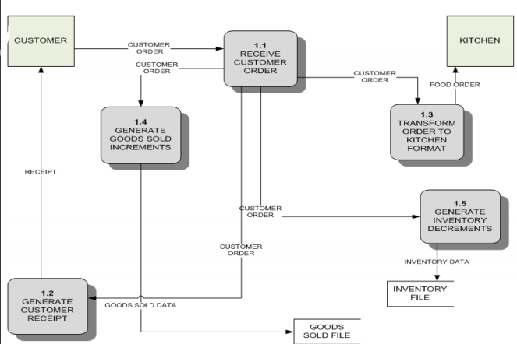
This chapter covers the ontological and methodological description of the design and implementation of the proposed Point of Sale system to help retail businesses increase efficiency and help eliminate waste in physical and human resources. The system will automate core business functions by tracking inventory, ordering supplies, managing labour, and generating financial reports. The POS system will comprise of a number of added functionalities (e.g. customer order history, a Yoruba language option and Customer Relationship Management (CRM)) that improve the user and customer experience and makes the system more robust. Figure 1 details the vision of how the POS system will allow them to receive and transform orders in a timely manner as well as track inventory and customer preferences represented as a data flow diagram (DFD).
Figure 1- POS System Context Diagram in a restaurant for example
After analysing the requirements of the task to be performed, the next step is to analyse the problem and understand its context. The first activity in this phase is studying the existing system and to understand the requirements and domain of the new system. Both activities are equally important, but the first activity serves as a basis of giving the functional specifications and then the successful design of the proposed system.
Understanding the properties and new system, that of the existing system and creative thinking are paramount as improper understanding can lead to diversion from the solution. The main purpose of this chapter is to give a general insight into the analysis and requirements of the system and to determine the operating characteristics of the system.

3.2 PROGRAM DESIGN
The proposed system will be designed and implemented using the object oriented development approach. This approach makes it easy to identify system components, locate and fix bugs quickly with very little effect on other components and allows reusability of program codes. In line with object oriented development, the Unified Modelling Language (UML) is used to design class models and use case diagrams for the main components to provide a blue print for implementation. The programming language for this project is C# using Visual Studio 2015. This language is both object oriented and event driven and makes it easy to design interactive user interfaces using the WPF (Windows Presentation Foundation) feature present in the Visual Studio software application. It is also proprietary to the windows platform which is the preferred choice of the target users. This guarantees that many of the libraries needed to run the system will be available on the user’s PC, making it cheaper to use the system. As an Information system, the point of sales system runs with a Microsoft SQL Server database at the back end to help collect, store, process and retrieve data for its users.
The model being followed is the agile SDLC (software development life cycle), which covers scrum methodology and scrum life cycle used in agile way of executing and maintaining projects. Scrum is a lightweight agile project management framework with broad applicability for managing and controlling iterative and incremental projects of all types. Unlike the waterfall software development life cycle, the distinctive feature of Scrum is the iterative process of developing. Development divides into several phases. Each of them results into a ready-to-use product. At the end of each step (called sprint in Scrum terminology) a ready product is delivered to a customer. Customer’s feedback helps reveal possible problems or change the initial plan, if needed.
To further explain with Scrum, the core roles involved into the process are as follows:
- Product owner – which in this case is the aim and objectives set initially which take care of the end user’s interests.
- Scrum master coordinates the whole process. His other task is to make sure that Scrum is used in a proper way. He also holds the Scrum meetings. Which in this case is the project supervisor.
- Scrum team. Develops the product. Its main tasks are programming, analysis, testing, etc.
Here are the main steps of development process that Scrum consists of.
Step 1. Product Backlog Creation
Product backlog is a list that consists of features that should be implemented during the development process. It’s ordered by priority and every item is called a User story. Every user story gets a unique ID. This list below shows how these stories can look like. These are actual product requirements that were implemented during the proposed system’s developing process:

ID | USER STORY
a-001 | Create a database as well as all the tables required by the proposed system.
a-002 | Create a log-in window with user authentication features (access code and passcode)
a-003 | Link the log-in window with the database table for users of the proposed system
Figure 2- User stories of the proposed system
The description of every user story should include the following required fields:
- Importance of a user story. It’s acceptable to use any number you want
- Initial estimate describes the overall capacity of work. It’s measured in story points
- How to demo. Describes the way of how the working product will be demonstrated
Besides these required fields, the optional ones can be added in case of need:
- Track is used to select all user stories of a certain type to change their priority. It can be used to increase the priority of user stories that relate to the Control panel, for example.
- Components make up a list of components that will be changed during the work. For example, an application’s modules, such as authentication or search.
- Requestor is a customer who’s interested in implementing some particular functionality.
- Bug tracking ID contains a list of detected bugs that relate to a proper user story.
After the product backlog creation is finished you can move to the next step – sprint planning.

Step 2. Sprint Planning and Sprint Backlog Creation
Firstly, the sprint’s duration was determined. A short sprint allows one to release the working version of a product more frequently. As a result, customer’s feedback will be received more often and all the possible bugs and errors will be revealed in time.
As an alternative, a longer sprint duration may be preferred. It will allow developers to work more thoroughly. The optimal sprint duration is defined as an average of these two options. As a rule, a sprint lasts about 2 weeks. What’s more important at this phase is the cooperation between stakeholders and team members. The product owner determines the importance of a proper user story, while the scrum team defines the appropriate labour costs.
After that, the most important user stories were selected from the product backlog. Then it was decided how the tasks at hand would be solved. The Sprint backlog was created next. It consists of user stories that will be completed during the current sprint. The amount of these stories depends on their duration in story points assigned to each story during evaluation stage.
Step 3. Working on the Sprint. Scrum Meetings
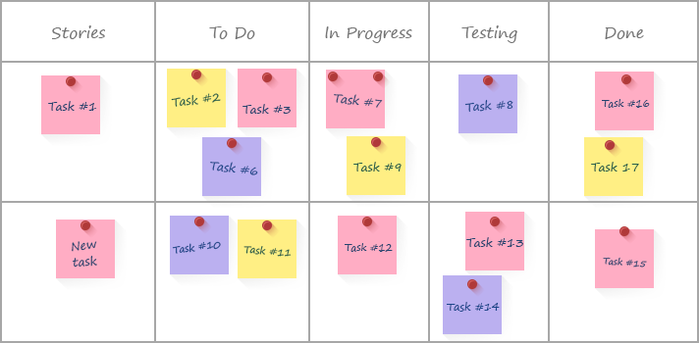
After actual user stories for the current phase were chosen, the system development process began. To track the current working process, a task board was used. These are usually big cards with the names of particular user stories and a bundle of little sticky notes with a description of single tasks which are needed for implementation of that story. These cards are arranged according to their importance. When work on a task has been started, the corresponding sticker is moved from the “To do” field to the “In progress” one. When work is completed, the sticker can be moved to the “Testing” field and after the task is successfully tested, the sticker goes to the “Done” field. An example of how the scrum task board can look like is shown at the start of the next page.
Figure 3
Other important scrum feature is everyday Scrum meetings. These meetings’ main goal is to get full and veracious information about the current project status. During these meetings every single team member should tell about the task that he has finished, which task he will choose next and what problems he faced during his work.

Moreover, a burn down chart is what the scrum team gets as a result of scrum meeting. It shows how many tasks remain uncompleted. This chart gives the ability to control the development process and should be updated after every meeting.
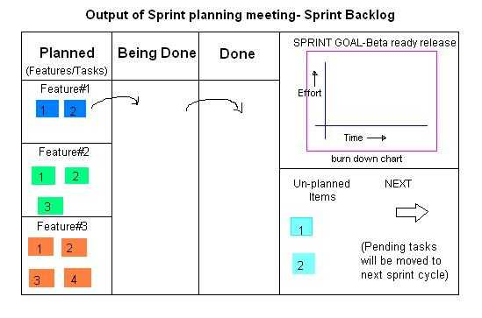
The X-axis represents the remaining days of work, while the Y-axis displays the overall amount of story points for the current stage. After a task that required a certain number of story points to complete is over, you can add a point on the diagram to indicate the current progress.
Figure 4
This chart helps draw conclusions about the current speed of work. Depending on these conclusions, the amount of user stories for the next sprint can be changed.
Day by day meetings help increase flexibility of the development process. They also allow understanding what changes should be made.
Definition of DONE: When some requirement from product backlog or sprint backlog is completed or DONE, the same need to be compared with acceptance criteria which is also called 'definition of DONE'. This definition of DONE varies with product to product and it has to be finalized or agreed upon at the start of the project between customer and product owner.

Step 4. Testing and Product Demonstration
Since the ideal result of every sprint is a working product, the full life-cycle testing process is very important. There are different ways to minimize costs of the testing period. For example, the overall amount of user stories can be decreased. As a result, the number of possible bugs was minimized. The other way was to include other parties into the development process.
The result of every sprint is product demonstration. A review was created and it demonstrated the results of the work. On this basis, the stakeholders took a decision about further project changes.
Step 5. Retrospective and Next Sprint Planning
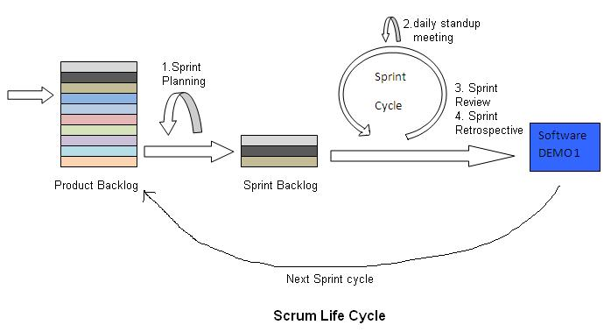
Retrospective’s main aim is to discuss the results and determine the ways how to improve development process on the next step. It was concluded what went well during the working process and what can be done better during the future iteration. When the ways of improvement were defined, concentration was placed on the next sprint planning. The steps 1 to 5 mentioned above are revisited again in the consecutive sprints. Hence the scrum life cycle is a continuous process.
Figure 5
3.3 DATABASE DESIGN
The database for the system was built with the SQL Server Management Studio software application. SQL Server Management Studio (SSMS) is an integrated environment for configuring, managing and administering all components with any SQL infrastructure. It provides a user interface and a group of tools with rich script editors that interact with SQL Server. Microsoft SQL Server Management Studio features include Object Explorer, which can view and manage all objects in a SQL Server instance; Template Explorer, which builds and manages files of text that can be reused to speed up query and script development; Solution Explorer, which builds the projects used to manage administration items, such as queries and scripts. SSMS components customize keyboard shortcuts and viewing property pages; connect to instances of the Database Engine and Analysis Services; visual design tools; and interactively build and debug queries and scripts.
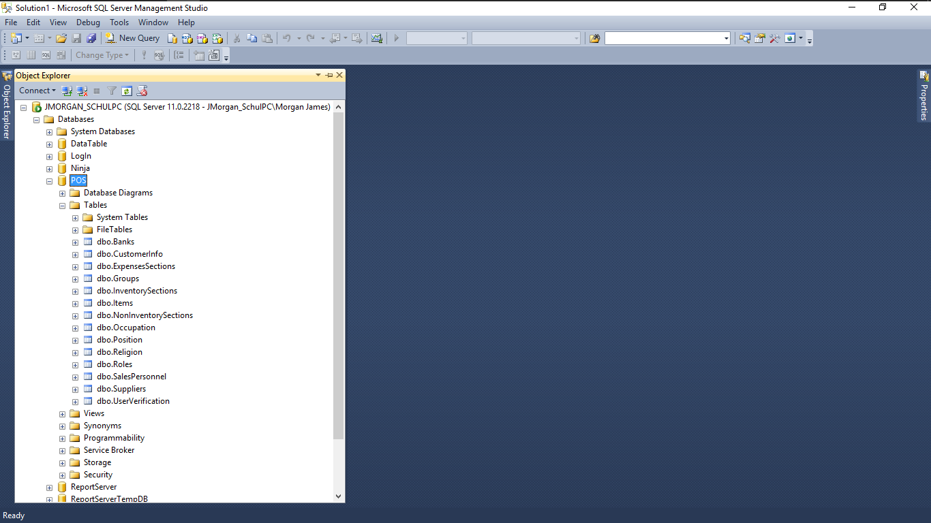
Figure 6 – The SQL Server Management Studio environment
The database was named “POS” as seen in the Object Explorer on the left hand side of the figure above. The database consists of multiple tables, views and a database diagram created for various groups of information required by the system.

3.3.1 DATABASE TABLES
This section highlights the tables in the database, note that dummy data has been used to populate the tables to help with the demonstration.
- Banks: this table holds information about banks used by customers and other components in the system.

Code | Name | Branch | Address | Account Officer | Phone Number
0101 | First Bank | Igbesa | Atan, Igbesa | Femi | 08027483302
Figure 7

- CustomerInfo: this table contains information of the customers entered into the system.
Code | Name |  | BirthDate |  | ReligionCode |  | JobCode | PositionCode
1000 | Tobe |  | 10/10/1998 |  | 001 |  | 001 | 001
OfficeAddress | OfficeNumber |  | HomeAddress |  | HomeNumber |  | Registration  Date | Discount
Somewhere | 07088476681 |  | Somewhere |  | 0816554651 |  | 10/01/2018 | 5%
ContactSalesperson |  | FormOfPayment |  | Balance
Johnson |  | Cash |  | 0.00
Figure 8

- ExpensesSection: this table contains details about the expenses related with the business using the system.
Code | Description
0301 | Salaries
0302 | Motor Running Expenses
0303 | Maintenance & Repairs
0304 | Rent & Rates
0305 | Others
Figure 9

- Groups: this table holds information for the category of items in the business’ stock/inventory.
Code | Description
01 | Inventory Items
02 | Non-Inventory Items
03 | Expenses

Figure 10

Code | Description
0101 | Books
0102 | Computers
0103 | Phones
- InventorySections: this table holds details for the category of assets intended to be sold in the business.

Figure 11

- Items: this table holds details of goods associated with the business. It can be an expense, inventory or non-inventory item.

SectionCode | ItemCode | Description | CostPrice | SellingPrice | WholeSalePrice
0101 | 0101-0001 | Oliver Twist | 50.00 | 50.00 | 50.00
WholeSaleQty | StockedItem | OpeningStock | UnitOfSales | MinimumStock | ReOrderQty
10 | YES | 10 | Pieces(PC) | 1 | 10
Figure 12

- NonInventorySections: this table holds details for the category of items that are purchased or sold but whose quantity is not tracked, hence not for sale.

Code | Description
0201 | Service Income
0202 | Sales Order
Figure 13
Code | Description
001 | Banker
002 | Civil Servant
003 | Lawyer
- Occupation: this table holds the information concerned with the customer’s current job at the moment of registration.
Figure 14

Code | Description
01 | CEO/Managing Director
02 | Assistant Manager
03 | Officer
- Positions: this table is used to hold the information regarding a customer’s position in their place of work.

Figure 15

- Religions: this table holds details about the different religions as per the customer.
Code | Name
1 | Christianity
2 | Islam
3 | Free Thinker

Figure 16

- Roles: this table holds details about the different user roles/groups in the system.
Code | Name
01 | Admin
02 | Cashier
Figure 17
- SalesPersonnel: this table holds information about the personnel of the business entered into the system.
Code | Name | RoleCode
1000 | Supervisor | 01
Figure 18
- Suppliers: this table holds information about the suppliers of goods associated with the business.
SuppliersCode | BusinessName | OfficeAddress | ContactPerson | Merchandise | PhoneNumber
1 | Crawford University | Faith City, Igbesa | Mary | Bread | 08026502305
Figure 19

- UserVerification: this table holds the access information required for logging into the system.
UserCode | PassCode
1000 | 0000000
Figure 20

3.3.2 DATABASE DIAGRAM
A database diagram shows entities (tables) in a database and relationships between tables within that database. A data model/diagram provides developers and users with a much better understanding of the database architecture. A database diagram is the skeleton structure that represents the logical view of the entire database. It defines how the data is organized and how the relations among them are associated. It formulates all the constraints that are to be applied on the data, the constraints being the primary and foreign keys. Primary keys and foreign keys are two types of constraints that can be used to enforce data integrity in SQL Server tables. These are important database objects.
A table typically has a column or combination of columns that contain values that uniquely identify each row in the table. This column, or columns, is called the primary key (PK) of the table and enforces the entity integrity of the table. Because primary key constraints guarantee unique data, they are frequently defined on an identity column. For example, in Figure 21, the columns that have a key beside them represent the primary keys of the respective tables.
A foreign key (FK) is a column or group of columns in a relational database table that provides a link between data in two tables. It acts as a cross-reference between tables because it references the primary key of another table, thereby establishing a link between them. The FOREIGN KEY constraint also prevents invalid data from being inserted into the foreign key column, because it has to be one of the values contained in the table it points to.
For example, see the CustomerInfo and Position tables in figure 21. The line with the key at one end shows the relationship between the tables which in this case is the Code in the Position table and the PositionCode in the CustomerInfo table. Thus exhibiting the foreign key relationship.

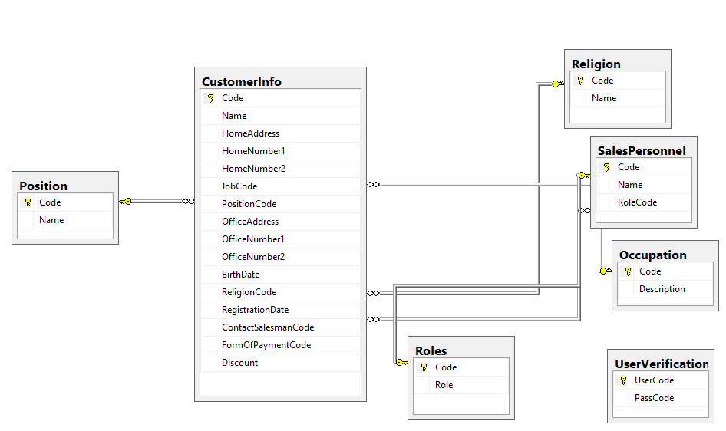
Figure 21
3.3.3 DATABASE VIEW
A view can be described as a virtual table which derived its data from one or more than one table columns. It is stored in the database. View can be created using tables of same database or different database. It is used to implement the security mechanism in the SQL Server. A view consists of rows and columns just like a table. The difference between a view and a table is that views are definitions built on top of other tables (or views), and do not hold data themselves. If data is changing in the underlying table, the same change is reflected in the view. A view can combine data from two or more table, using joins, and also just contain a subset of information.

Figure 22- Showing the design of the view
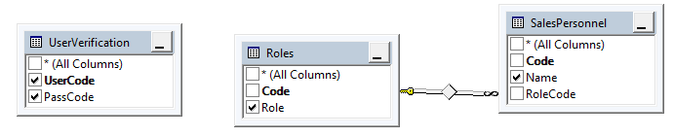
As seen above, the view combines three tables from the database (UserVerification, Roles and SalesPersonnel). The purpose of this View is to add a functionality into the system during login, which captures the name as well as role of the user whilst the user logs into the system.
UserCode | PassCode | Role | Name
1000 | 0000000 | Admin | Supervisor
Figure 23- showing the Output of the view

3.4 GRAPHICAL USER INTERFACE DESIGN
A graphical user interface (GUI) is a human-computer interface (i.e., a way for humans to interact with computers) that uses windows, icons and menus and which can be manipulated by a mouse (and often to a limited extent by a keyboard as well). The basic GUI elements in this system are check boxes, buttons, labels, textboxes, text blocks, grids, message boxes and so on. The GUI of the system was developed by the WPF (Windows Presentation Foundation) feature of Visual Studio.
3.4.1 WPF
Windows Presentation Foundation (WPF) and Extensible Application Markup Language (XAML) combine into a rich presentation system for building Windows desktop applications with visually stunning user experiences that incorporate UI, media, and complex business models.
Windows Presentation Foundation (WPF) lets you create desktop client applications for Windows with visually stunning user experiences. The core of WPF is a resolution-independent and vector-based rendering engine that is built to take advantage of modern graphics hardware. WPF extends the core with a comprehensive set of application-development features that include Extensible Application Markup Language (XAML), controls, data binding, layout, 2D and 3D graphics, animation, styles, templates, documents, media, text, and typography. WPF is included in the .NET Framework, so you can build applications that incorporate other elements of the .NET Framework class library.
WPF lets you develop an application using both mark-up and code-behind, an experience that ASP.NET developers should be familiar with. You generally use XAML mark-up to implement the appearance of an application while using managed programming languages (code-behind) to implement its behaviour. This separation of appearance and behaviour has the following benefits:
- Development and maintenance costs are reduced because appearance-specific mark-up is not tightly coupled with behaviour-specific code.
- Development is more efficient because designers can implement an application's appearance simultaneously with developers who are implementing the application's behaviour.
- Globalization and localization for WPF applications is simplified.
3.4.2 MARKUP
XAML is an XML-based mark-up language that is used to implement an application's appearance declaratively. It is typically used to create windows, dialog boxes, pages, and user controls, and to fill them with controls, shapes, and graphics.
3.4.3 CODE-BEHIND
The main behaviour of an application is to implement the functionality that responds to user interactions, including handling events (for example, clicking a menu, tool bar, or button) and calling business logic and data access logic in response. In WPF, this behaviour is implemented in code that is associated with mark-up. This type of code is known as code-behind.
3.5 PROPOSED SYSTEM USERS
The following are the proposed users of the system with a few of their functions within the system:
- Admin
- Add/Delete/Edit user groups (cahiers)
- Change system settings
- Manage system files
- Sales Manager
- Manage Customer information
- Change Prices
- Add/Delete Items
- Add/Delete groups/sections
- Make returns
- Make voids
- Cashier
- Add new customers
- Initialize and make sales
- Print reports

3.6 INPUT MEDIA
At this stage, choice has to be made about the input media. To conclude about the input media, consideration has to be given to;
- Type of input
- Flexibility of format
- Speed
- Accuracy
- Verification methods
- Rejection rates
- Ease of correction
- Storage and handling requirements
- Easy to use
Keeping in view the above description of the input types and input media, it can be said that most of the inputs are of the form of internal and interactive. As input data is to be the directly keyed in by the user, the keyboard can be considered to be the most suitable input device.

3.6.1 ERROR AVOIDANCE
At this stage, care is to be taken to ensure that input data remains accurate from the stage at which it is recorded up to the stage in which the data is accepted by the system. This can be achieved only by means of careful control each time the data is handled.

3.6.2 ERROR DETECTION
Even though every effort is made to avoid the occurrence of errors, still a small proportion of errors are always likely to occur, these types of errors can be discovered by using validations to checkmate the input data.

3.6.3 DATA VALIDATION
Procedures are designed to detect errors in the data at a lower level of detail. Data validations have been included in the system in almost every area where there is a possibility for the user to commit errors. The system will not accept invalid data. Whenever an invalid data is keyed in, the system immediately prompts the user and the user has to rekey the data and the system will accept the data only if it is correct. Validations have been included where necessary. The system is designed to be user-friendly one. In other words, the system will be designed to communicate with the user effectively. The system will be designed to have pop-up menus and message boxes.

3.6.4 ERROR MESSAGE DESIGN
The design of error messages is an important part of the user interface design. As the user is bound to commit one error or other while using the system. The system has been designed to be helpful by providing the user with information regarding the error committed. The application must be able to produce output at different modules for different inputs.

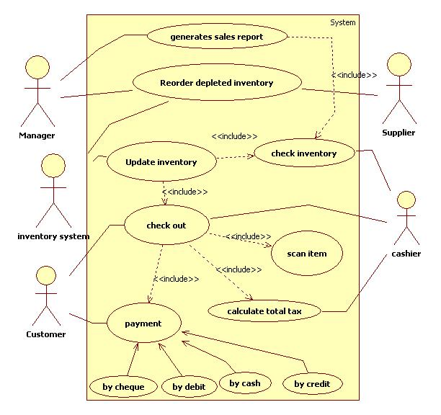
3.7 USE CASE DIAGRAM
Figure 24

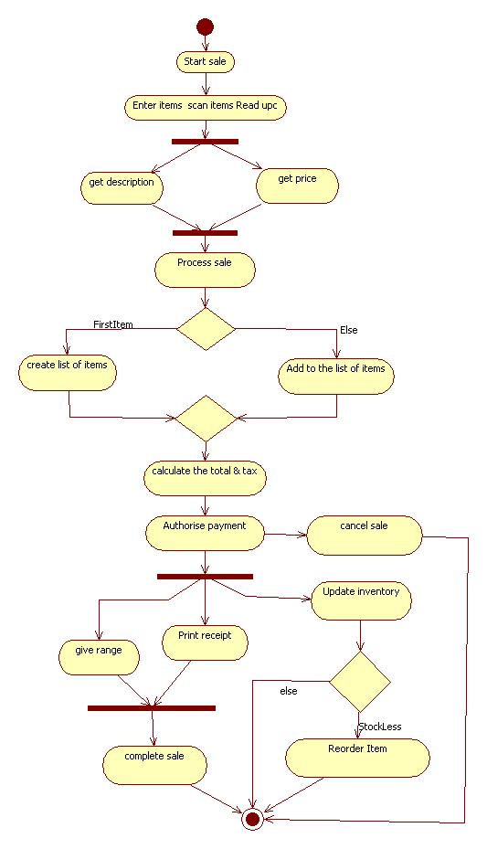
3.8 FLOWCHART OF THE PROPOSED SYSTEM
Figure 25

CHAPTER FOUR
4.0 SYSTEM IMPLEMENTATION AND TESTING
4.1 INTRODUCTION
It is the final step in the development cycle of the project before testing and maintenance. The system requirements would be also considered in this chapter, which concerns the co-ordination and control of the activities necessary to put the system into operation.
4.2 SYSTEM REQUIREMENTS
The requirements for running this point of sale system may not be well known to those in the target environment, furthermore it involves both software and hardware parameters.
The hardware requirements include:
- A PC (personal computer) with 2GB minimum, 4GB recommended RAM and 250GB disk space
- Mouse
- CPU: Pentium 4 or higher
- Keyboard
- Printer; the choice is then left for the user to select the appropriate printer for a print operation or a heavier-duty receipt printer depending on the budget.
- A 1500v uninterrupted power supply (UPS)
- Cash drawer
- Barcode Scanner
- Label Printer
The software requirements include:
- Windows 8.1 operating system or later
- Microsoft SQL Express Server 2008 or higher
- Microsoft Visual Studio 2015

4.3 SOFTWARE TESTING
Software testing is a critical element of software quality assurance and represents the ultimate review of specification, design and coding. In fact testing is one step in the software engineering process that could be viewed as destructive rather than constructive. A strategy for software testing integrates software test case design methods into a well-planned series of steps that result in the successful construction of software. Software testing is the process of evaluation a software item to detect differences between given input and expected output. Also, to assess the features of a software item. Software testing is a process that should be done during the development process. In other words software testing is a verification and validation process.
A strategy for testing may also be viewed in the context of the spiral. Unit testing begins at the vertex of the spiral and concentrates on each unit of the software as implemented in the source code. Since, the model used to build the system was the Agile Scrum model, testing was done after each sprint of development until all the components were built and the system was finally tested as a whole.
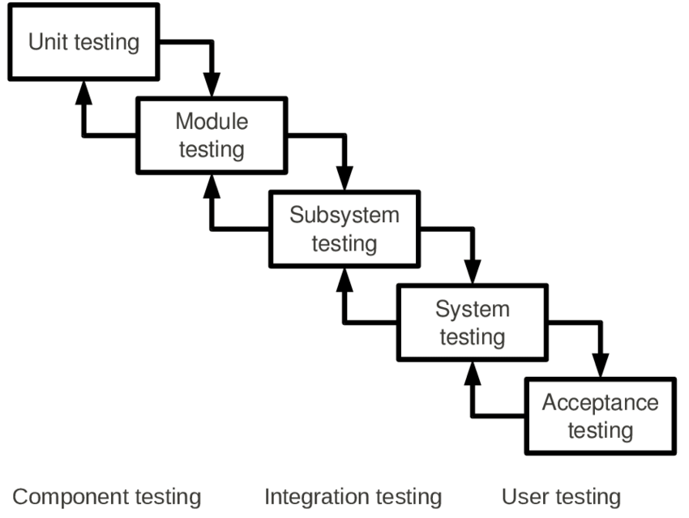
Figure 26
There are two basics of software testing: black box testing and white box testing.
Black box Testing
Black box testing is a testing technique that ignores the internal mechanism of the system and focuses on the output generated against any input and execution of the system. It is also called functional testing.
White box Testing
White box testing is a testing technique that takes into account the internal mechanism of a system. It is also called structural testing and glass box testing. To follow the concept of white box testing, each form was tested independently to verify that data flow is correct.
Black box testing is often used for validation and white box testing is often used for verification.
User Testing
Unit testing is the testing of an individual unit or group of related units. It falls under the class of white box testing. It is often done by the programmer to test that the unit he/she has implemented is producing expected output against given input.
Integration Testing
Integration testing is testing in which a group of components are combined to produce output. Also, the interaction between software and hardware is tested in integration testing if software and hardware components have any relation. It may fall under both white box testing and black box testing.
System Testing
System testing is the testing to ensure that by putting the software in different environments (e.g., Operating Systems) it still works. System testing is done with full system implementation and environment. It falls under the class of black box testing.
Acceptance Testing
Acceptance testing is often done by the customer to ensure that the delivered product meets the requirements and works as the customer expected. It falls under the class of black box testing.

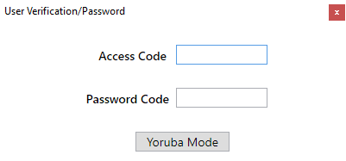
4.4 SAMPLE IMPLEMENTATION

Figure 27- Showing the log in window with a button to change the language
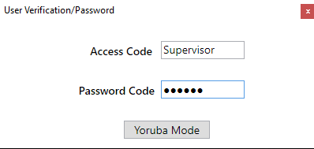
Figure 28 – Showing the form after the language button is used.
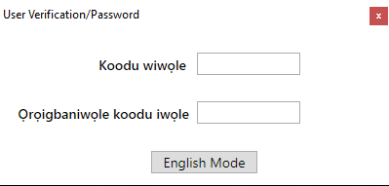
Figure 29 – The correct access code has been entered and it changes to the user’s name in the database.

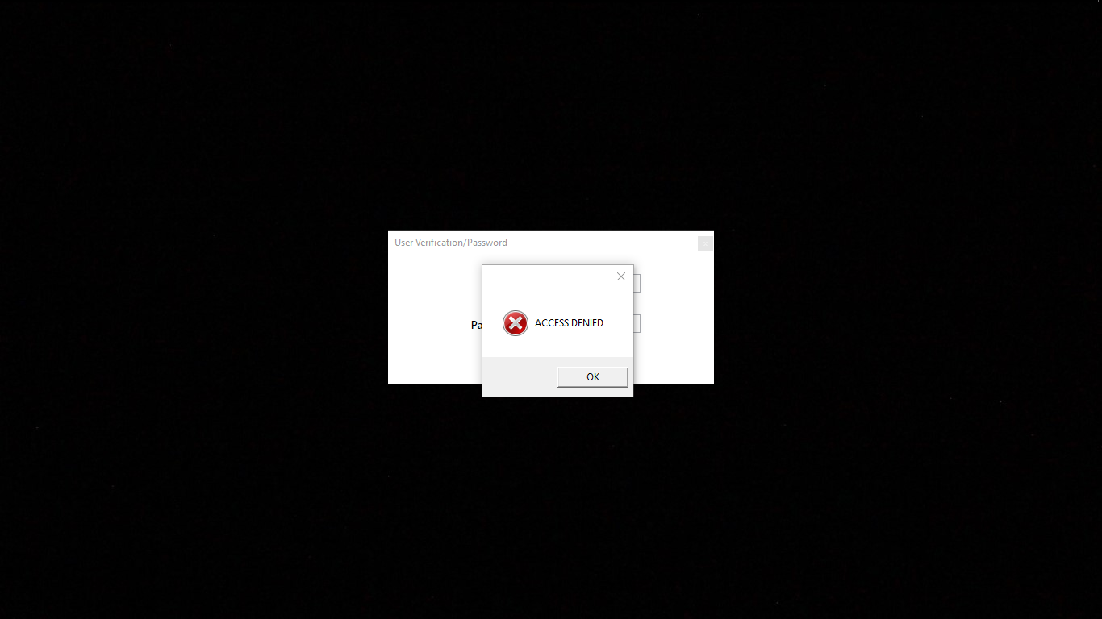

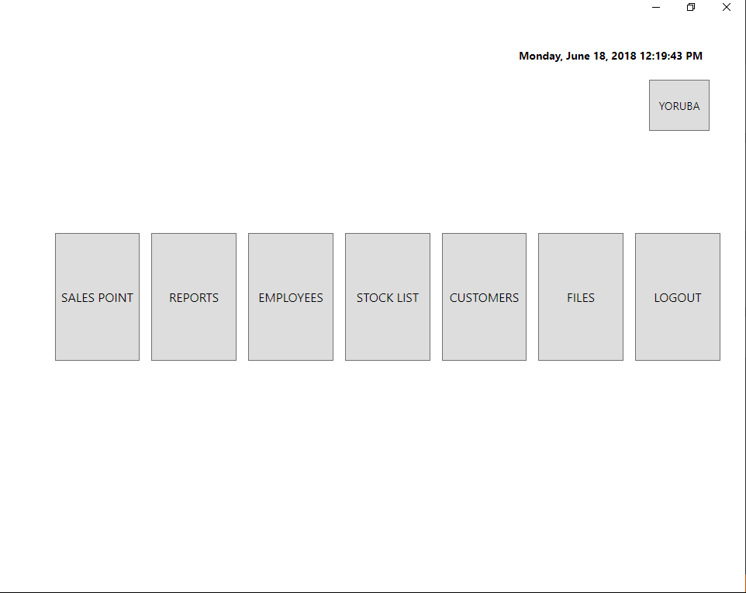
Figure 30- After invalid access information is used to login
Figure 31- The POS system’s dashboard after successful login
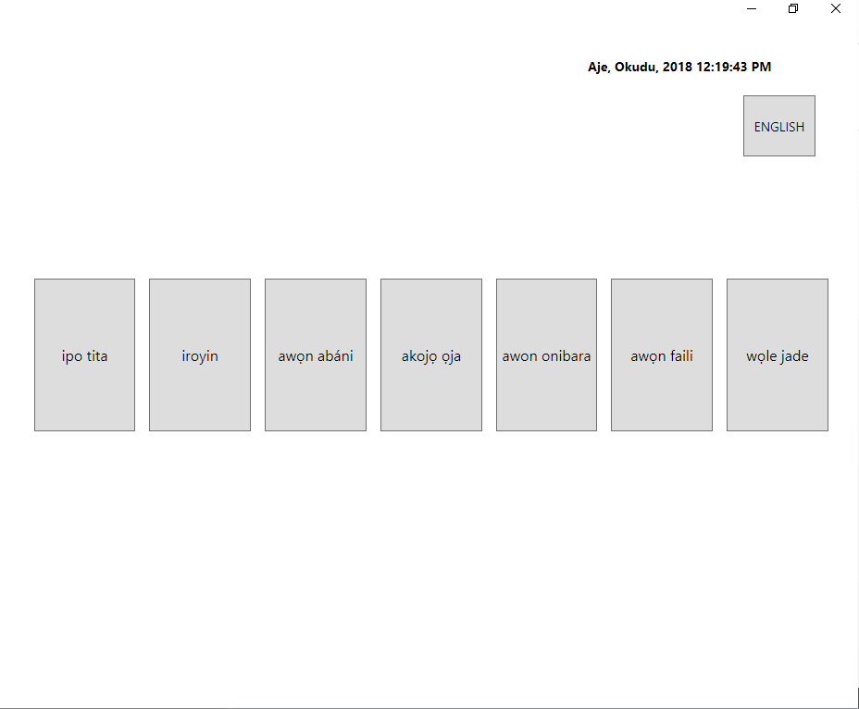
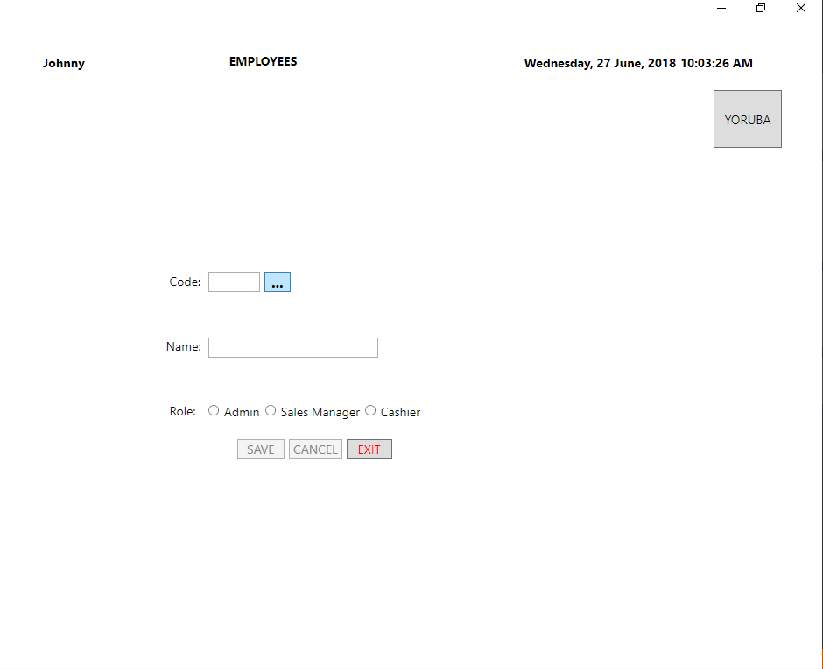
Figure 32- The dashboard in the Yoruba language mode

Figure 33- Employees page used to add and edit employees

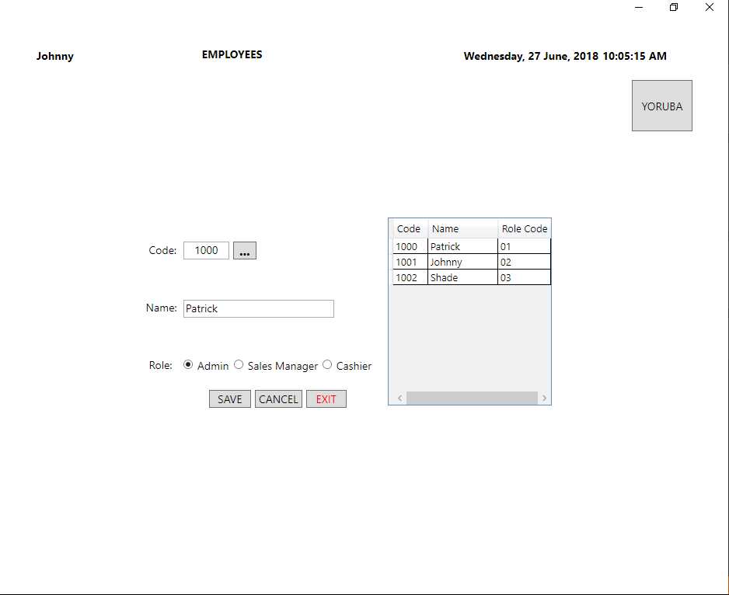
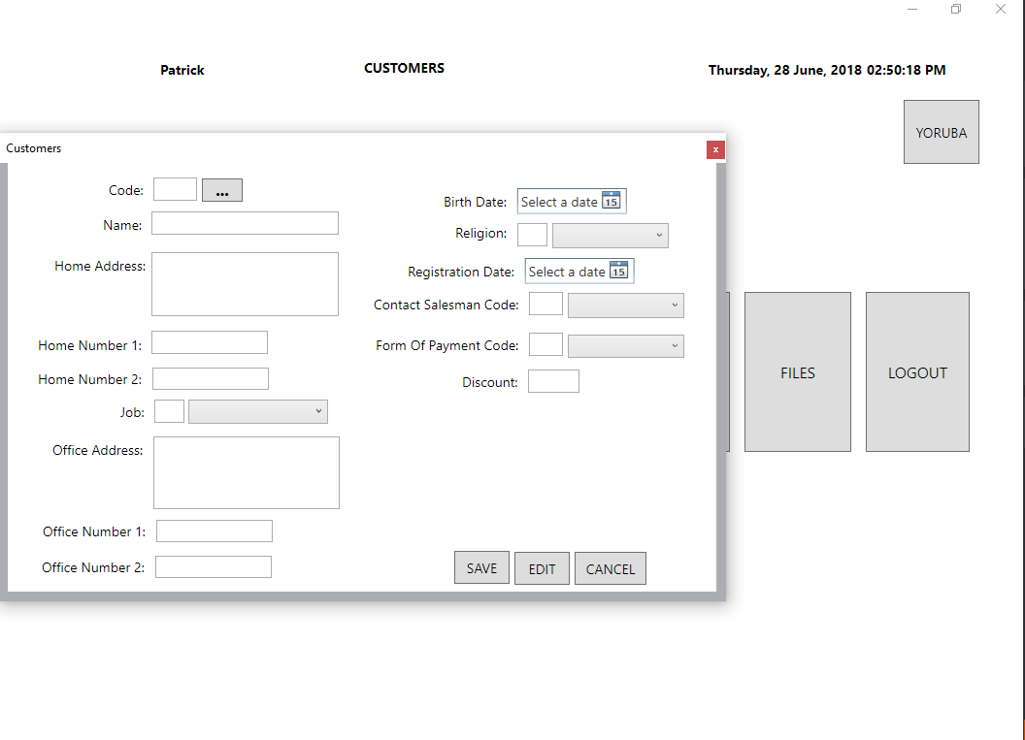
Figure 34

Figure 35

CHAPTER FIVE
5.0 SUMMARY, RECOMMENDATION AND CONCLUSION
5.1 SUMMARY
The system is committed to provide customers with the service, support and expertise they require to increase efficiency and profitability with a solution that provides an unmatched rapid return-on-investment.

5.2 RECOMMENDATION
Several areas were identified in which the project could be improved. One cause for concern is that the time allotted for project implementation was short indicating the need for a longer time horizon. Quite a number of components were not implemented in the project given the limited time period for implementation and testing. However it is noted that this is often the case in the real world as a project’s scope may be altered with little notice to the team and/or other factors may cause the project timeline to be lengthened due to hindrances to implementation and testing. So it is recommended that the Department make moves to provide a longer time period and other important resources for prospective final year students’ projects.

5.3 CONCLUSION
The success of any system is dependent on its usage. It is therefore hoped that the system will be put to use under optimum conditions that satisfy its requirements. Given the required maintenance, the system will help facilitate sales by tracking and storing relevant data needed for effective sales management
REFERENCES
- Agile Scrum Methodology | Scrum life cycle basics | scrum vs waterfall. (2012). Retrieved June 17, 2018, from http://www.rfwireless-world.com/Articles/agile_scrum_methodology.html
- Bain & Company. (2015). Management Tools - Customer Relationship Management. Retrieved April 17, 2018, from http://www.bain.com/publications/articles/management-tools-customer-relationship-management.aspx
- Brumbaugh, S. (2008). The Journal of business forecasting methods &amp; systems. The Journal of Business Forecasting (Vol. 29). Graceway Pub. Co. Retrieved from https://www.questia.com/library/journal/1P3-1644698421/the-abcs-of-point-of-sales-pos-data
- Cote, M., & McCarthy, T. (2015). The Power of Point of Sale Improving Growth, Profit, and Customer Service in a Retail Business. Nat Genet, 27(1), 5–6. https://doi.org/10.1038/83759
- DBMS Data Schemas. Retrieved June 18, 2018, from https://www.tutorialspoint.com/dbms/dbms_data_schemas.htm
- DESIGN AND IMPLEMENTATION OF A COMPUTERISED TRANSACTION PROCESSING AND REPORTING SYSTEM FOR A MORDERN SUPERMARKET. (n.d.). Retrieved April 17, 2018, from https://www.grossarchive.com/upload/1416897494.htm
- DESIGN AND IMPLEMENTATION OF A COMPUTERIZED POINT OF SALES SYSTEM - Project Topics. Retrieved April 17, 2018, from https://www.freeprojecttopics.com/projects/computer-science/design-implementation-computerized-point-sales-system/
- Dmitry Gurendo. (2015). Software Development Life Cycle (SDLC). Scrum Model Step by Step. Retrieved June 17, 2018, from https://xbsoftware.com/blog/software-development-life-cycle-sdlc-scrum-step-step/
- Ehrenthal, J. C. F., Honhon, D., & Van Woensel, T. (2014). Demand seasonality in retail inventory management. European Journal of Operational Research, 238(2), 527–539. https://doi.org/10.1016/j.ejor.2014.03.030
- Entity Relationship Diagram (ERD). Retrieved June 18, 2018, from http://www.datanamic.com/dezign/erdiagramtool.htmlGene Marks. (2014). Why Your Company May Dump QuickBooks This Year. Retrieved from https://www.forbes.com/sites/quickerbettertech/2014/01/06/why-your-company-may-dump-quickbooks-this-year/#74521e741923
- Gillum, A., & Rob, M. A. (2011). Issues in Information Systems IT PROJECT MANAGEMENT: CLASS PROJECT OF A POINT OF SALE (POS) SYSTEM IMPLEMENTATION IN A RESTAURANT, XII(2), 67–73.
- Laar, D. S., Konjaang, J. K., & Tankia, B. A. (2015). Design and Development of a Sales Management System for SMEs in Northern Ghana. International Journal of Innovative Research in Advanced Engineering, 2(5), 66–77.
- Mike McLaughlin. (2018). Agile Methodologies for Software Development. Retrieved June 17, 2018, from https://www.versionone.com/agile-101/agile-methodologies/
- SQL FOREIGN KEY Constraint. Retrieved June 18, 2018, from https://www.w3schools.com/sql/sql_foreignkey.asp
- Sularto, L., & Yunitasari, T. (2015). User Requirements Analysis for Restaurant POS and Accounting Application Using Quality Function Deployment. In Procedia - Social and Behavioral Sciences (Vol. 169, pp. 266–280). Elsevier B.V. https://doi.org/10.1016/j.sbspro.2015.01.310
- What is a Foreign Key? - Definition from Techopedia. Retrieved June 18, 2018, from https://www.techopedia.com/definition/7272/foreign-key
- Wolf, C., & Harmon, P. (2010). The State of Business Process Management 2010. Business.

