DESIGN AND IMPLEMENTATION OF A DIGITAL LIBRARY SYSTEM

BY

OYEDIRAN OLUFEMI SAMUEL
16010301002

BEING A PROJECT SUBMITTED IN THE DEPARTMENT OF COMPUTER SCIENCE AND MATHEMATICS, COLLEGE OF BASIC AND APPLIED SCIENCES, IN PARTIAL FULFILMENT OF THE REQUIREMENTS FOR THE AWARD OF DEGREE OF BACHELOR OF SCIENCE MOUNTAIN TOP UNIVERSITY KILOMETRE 12, LAGOSIBADAN EXPRESSWAY, IBAFO, PRAYER CITY, OGUN STATE NIGERIA

November, 2020

CERTIFICATION

This project titled, DESIGN AND IMPLEMENTATION OF A DIGITAL
LIBRARY SYSTEM), prepared and submitted by OYEDIRAN OLUFEMI SAMUEL of matriculation number 16010301002 in fulfilment of the requirements for the degree of BACHELOR OF SCIENCE (Computer Science) is hereby accepted.
_________________________ (Signature and Date)
Dr. (Mrs.) B.F. Oladejo
(Supervisor)
__________________________ (Signature and Date)
Dr. I.O. Akinyemi
(Head of Department)
Accepted as partial fulfilment of the requirements for the degree of BACHELOR OF

SCIENCE (Computer Science)
___________________________ (Signature and Date)
Prof. A. I. Akinwande
Dean, College of Basic and Applied Sciences
DEDICATION
This project work is dedicated to God Almighty.

ACKNOWLEDGEMENT
I sincerely want to acknowledge the presence of God Almighty with me throughout my four years degree program me in this wonderful university for his protection, provision, love and encouragement cannot be bought with money. For his mercy endureth forever (amen).
I sincerely appreciate my able supervisor Dr. (Mrs.) Oladejo for her assistance, advise and tolerance and also taking her time to supervise my project. May God reward you Ma.
I will like to acknowledge the Head of Department Computer Science and Mathematics Dr. I.O.
Akinyemi, and offer deep gratitude for the efforts, constant encouragement, guidance and support. I also appreciate all the members of staff of the Department of Computer Science: Dr. Alaba O. B., Dr. Oyetunji M.O., Dr. (Mrs.) Kasali F.A., Mr. Falana O.J., Dr. Idowu P.A., Dr. Okunoye O.B., Dr. (Mrs.) Oladeji F.A., Mr. Ebo I.O and others to mention but a few.
I sincerely want to appreciate my wonderful parents Pastor and Mrs. Abiodun Oyediran for their parental care, mentoring and finance. They are my source of motivation and encouragement. I thank God for keeping them alive to witness my graduation. I pray that the good lord will continue to grant them long life and prosperity.
I sincerely appreciate my friends and all Mountain Top University colleagues for their help and support during the period of working on this project. I say God bless you all.

TABLE OF Contents
CERTIFICATION ii
This project titled, DESIGN AND IMPLEMENTATION OF A DIGITAL ii
SCIENCE (Computer Science) ii
ACKNOWLEDGEMENT iv
LIST OF TABLES vii
LIST OF FIGURES viii
ABSTRACT 0
1.0 INTRODUCTION 0
1.1 BACKGROUND TO THE STUDY 2
1.2 STATEMENT OF THE PROBLEM 4
1.3 AIM AND OBJECTIVES OF THIS STUDY 4
1.5 JUSTIFICATION OF THE STUDY 5
1.6 PROPOSED METHODOLOGY 6
1.7 LIMITATION OF THE STUDY 6
1.8 DEFINITION OF RELATED TERMS 6
2.1 INTRODUCTION 8
2.2 Theoretical Framework 9
2.2.1 EARLY STAGE OF DIGITAL LIBRARY 9
2.2.2 DEVELOPING PERIOD 10
2.2.3 Architecture of Digital Library System 10
Figure 2.1 Shows the Architecture of Digital Library System 11
Figure 2.2 shows the Constituent Domains of digital library system 18
Figure 2.3 shows the resource domain of a digital library system 20
Figure 2.4 shows the content domain of the a digital library system 22
Figure 2.5 shows the user domain of a digital library system 24
Figure 2.6 shows the functionality domain of a digital library system 26
Figure 2.7 shows the policy domain of a digital library systems 28
Figure 2.8 shows the quality domain of a digital library system 30
Figure 2.9 shows the architecture domain of a digital library system 32
2.7 CHALLENGES OF DIGITAL LIBRARY IN NIGERIA 36
Waterfall Model 42
F. WEAKNESS IN THE PRESENT SYSTEM 60
G. METHODS OF DATA COLLECTION 60
H. DATABASE SYSTEMS 60
CHAPTER FOUR 61
4.1 SYSTEM IMPLEMENTATION 61
4.2 PROGRAM DESCRIPTION 61
4.2.1 Administration 61
4.2.2 Search 62
4.2.3 Archive 62
4.2.4 Logout 62
4.3 INPUT/OUTPUT DESIGN OF DATABASE 63
4.3.1 Database Files 63
A. Fig 2: Admin Login File 63
B. Fig 3: User Registration File 64
C. FIG 4: STAFF REGISTRATION FILE 65
D. FIG 5: UPLOADING FILE 66
4.3.2 Description of Database File 66
4.4. SYSTEM TESTING 67
4.5 SYSTEM IMPLEMENTATION 67
4.5 CHOICE OF PROGRAMMING LANGUAGE 68
4.6 USER GUIDE ON RUNNING THE SYSTEM 68
4.7 PROGRAM DOCUMENTATION 72
4.8 SYSTEM INSTALLATION 73
CHAPTER FIVE 75
5.1 SUMMARY, RECOMMENDATION AND CONCLUSION 75
5.2 SUMMARY 76
5.3 RECOMMENDATIONS 76
5.4 CONCLUSION 77
REFERENCES 78

LIST OF TABLES
Table Page
4.3.1: Admin database design 73
4.3.2: User registration database design 74
4.3.3: Reports database design 74
4.3.4: Uploading File 75
4.8.1: Sample of Input/output Database 82

LIST OF FIGURES
Figures Page
2.1: The Architecture Of A Digital Library System 11
2.2: Constituent Domains 22
2.3: Resource Domain 27
2.4: Content Domain 28
2.5: User Domain 30
2.6: Functionality Domain 39
2.7: Policy Domain 44
2.8: Quality Domain 46
2.9: Architecture Domain 48
3.1 Waterfall Model 51
3.2 Class Diagram 53
3.3 Use Case Diagram 56
3.4: Entity Relationship Diagram 57

3.5 Dfd, Activity Diagram 59

4.6.1: Login Page 70
4.6.2: Home Page 70
4.6.3: Add Student 70
4.6.4 Add Book 70
4.6.5 Book Issue Form 71
4.6.6 Book Return Form 71
4.6.7 Student Report Form 71
4.8.1. Diagram Of Input/Output Database 74

ABSTRACT
Libraries have been an important part of educational and information sector of any school. It is the intellectual nerve Centre of a school. The quality of a school is assessed by the quality of its library. The success of every library depends to a large degree on proper management.
Several libraries have experienced loss as a result of poor supervision and incapacitation in the processing of classified information for people in the library.
The goal of this research is therefore to establish a digital library infrastructure that will help guide and position the library to fulfill its ever-increasing demands.
During the implementation of this new method, the existing system has been analytically and objectively analyzed or surveyed, and in this manner we have defined strengths and deficiencies, and a new system has been developed for weakness.
The existing framework was evaluated using a common technique known worldwide for this purpose, called Organized System Analysis and Architecture Methodology (SSADM). The visual basic 6.0 programming language was used to code software modules built for the framework using certain computer-aided design tools.

x

CHAPTER ONE

1.0 INTRODUCTION
This project work was necessitated by the introduction of digital library as an alternative to traditional library which was widely in place for researchers over the years. It becomes imperative to look into how digital library is designed and implemented to ascertain whether it meet purpose of application to the library system as an alternative.
Digital Library is a definition of digitally collected content made available to users via digital devices and services, but without a single venue. It is, therefore, analogous to a library as a storehouse of information, but has a virtual existence in the digital spaces. It could also be define as,
A set of documents available through electronic means by the use of digital technologies that allow for the retrieval, archiving, preservation and dissemination of those document.
Another definition of digital library is that, A Digital Library (also referred to as a digital library) is a special library with a focussed set of digital items that can include text, visual content, audio, video material, housed as electronic forms of media (as opposed to paper, microform, or other media) along with means of arranging, preserving, and recovering the documents and media in the traditional library.
Digital libraries are often referred to as interactive libraries, virtual libraries and programs, wallless libraries or mixed libraries. In general, the phrase "digital libraries" is not well defined in the literature and there is a lack of consensus of what constitutes a digital library.
It can also be defined as, libraries that are organized collections of information resources and associated tools for creating, archiving, sharing, searching, and using Knowledge which can be viewed electronically. It could also be viewed as,
A collection of digital representations of information content, along with hardware, software, and personnel working under defined organizations to support the functions of a traditional library within a virtual context for a defined user community or communities. Another school of thought posits that a digital library or digital collection is an online database of digital objects that can include text, still images, audio, video, or other digital media formats.
The Digital Library System (DLS) expands and incorporates approaches to providing high-end information structures, programs and organizations in conventional libraries including in decentralized data systems. Here we will explore some of the parts or components of digital libraries and discuss several of the developments in this emerging field.
Building a comprehensive digital library system will assists client users to manage all phases of the information data life-cycle. Of particular importance is to simplify the authoring and creation process with the goal that wider population can participate by adding all types of multimedia content directly into digital libraries. Downstream access enables readers to benefit from this form of computer-based communication through space and time. Eventually, it is expected that information will be shared and that it will lead to another period of discovery, writing and use that is enabled by digital libraries.

1.1 BACKGROUND TO THE STUDY
In recent times, digital technologies enable us to digitalize and visualize informal materials on the internet. The advent of digital libraries in the 1990s and their massive growth in recent years have opened up broad horizons across a wide variety of topics relating to the architecture, deployment, development and assessment of digital libraries. The rapid growth of the internet in the 1990s, and the participation of the library and knowledge community, made the idea of digital libraries (DLs) a division of the library feasible, and research into digital libraries exploded in the mid-1990s, with the introduction of the Internet combined with the desire to keep information available and readily accessible. One of the major innovations that have driven the world to a quick pace of technological advancement is the computer. The machine is fundamentally an electronic information processor that is quickly transforming the way we collect, coordinate, recall, view, interpret, synthesize and apply information. The quality with which knowledge is produced and distributed influences the pace of development of a society and the fulfillment of its inhabitants. Today, society is powered by knowledge, and today, information is a universal necessity.
Computers can make large amount of information available to the world wide community with the aid of the internet. Like in other aspects of modern society, libraries are currently utilizing the Internet powerful communication framework to deploy its materials to the general public. The use of computers as machines has greatly aided businesses, institutions, government and individuals to carry out their activities easily. In this study, the internet will play a major role in Education and Research studies. Already in use in major educational institutions worldwide are libraries that are digital and mostly web-based. According to Yan and ZHA, (2014) The digital library is a distributed infrastructure capable of storing various electronic resources that can be efficiently and conveniently accessed by remote end-users through networks. Over the past few years, digital libraries have stepped away from a strong aspiration of realism and to be an extension to traditional libraries in the new knowledge culture, while the digital library is a repository of information that has connected resources offered to user groups using a range of technology. (Heradio, Fernandez-Amoros, Cabrerizo, & Herrera-Viedma, 2012).In the same vein, Lesk (2005) opined that it is a collection of information which is both digitized and organized that gives us the power we never had with traditional libraries. Khan and Bhatti (2015) asserted that today, university libraries worldwide are no longer simple stores of print material requiring people to be physically available to use information, but are spaces offering digital content that can be accessed anywhere that renders it accessible.
However, Chang-Ping, Yuan, & Wei-Wei (2014) argued that the roles of the digital library have changed dramatically as a result of rapid advances in internet technologies and evolving the behaviour of information consumers. Thus the digital library is not only a collection of documents in a well-organized electronic format, but also a forum for correspondence, learning and e-research by users. In reality, the digital library offers reliable and productive access to digital content or electronic information services (EIRs) to the academic community, such as faculty members and students, to help them explore issues, offer solutions to challenges, make decisions, and facilitate studying, teaching, study and much more. (Aramide& Bello, 2010).
.A web-based digital library system is a typical example of a web application. Web application has gradually started to replace standalone application for the sake of the advantages they provide. There have always being digital libraries long before the existence of the internet in the western world. Due to the numerous advantages measured up to web-based digital libraries they are commonly used mitigate technological drives among students today.
In addition, computers have influenced the ways in which individuals use information. It has changed the pace of work done, the method for achieving the work alongside the relationship among individuals conveying and utilizing the information. In any case, computers and libraries are not left out in the utilization of computer to carry out their day-to-day activities especially as it concerns the amount of information generated. Libraries have developed over the years which offered ascend to digital libraries.

1.2 STATEMENT OF THE PROBLEM
The following are inherent problems discovered after a cross examination of the use of digital libraries. these shortcomings are described below.
1. Members in the conventional library ought to go to the library physically, which is more likely to lead to bottlenecks in the library?
- Computer are not enough to accommodate large number of users
- The storage space is limited.
- The internet usage duration is restricted
- Inability for user to access the library resources 24/7.
- The library resources cannot be concurrently used. It is done in a queuing style.
- No enough trained professional personnel
- non availability of serene environment which makes library location unconducive

1.3 AIM AND OBJECTIVES OF THIS STUDY
The aim and objective of this study is to develop a Web base digital library that will create a system where study materials and books are available in digital format for easy accessibility to the students.
The objectives:
- Designing a digital library system which would help evacuate the problem faced in manual library.
- To create a comprehensive storage of large repository of data that can be accessed by authorized users.
- To organize and index digital objectives for different purpose which includes cataloging, finding aids and database.
- To create variety of access services for searching, browsing and discovering resources based on user preferences.
- To implement and test the system that can give remote request for library materials as personalized search based on user preferences by profile.
1.4 SCOPE OF THE STUDY
The scope of this project work is limited to Mountain Top University (MTU).

1.5 JUSTIFICATION OF THE STUDY
In implementing the objectives of this study, the advantages of a digital library over the traditional library are enormous. Users will be able to access library resource digitally without the inconveniences of users conveying books, journals, magazines etc. which could bring mileage of this library resource. Moreover, it will manage the cost users the opportunity to access digital books simultaneously without trusting that the book to be returned to the library. The proposed framework would have encryption and help track library resources by creating a robust database that would use library services. The system will also eliminate some of the routine manual work prevalent in a traditional library.
- A digital library provides facilities and services to support research, teaching, learning, and scholarly communication across disciplines. 2. It helps to compile, arrange and collect prints and digital material and to distribute it at the point of care and for potential use.
- This provides full access to knowledge.
- It acts as a portal for digital and electronic content.
- It provides a global perspective and integrates material from many sources in one place.

1.6 PROPOSED METHODOLOGY
This project work will outline the various method in all the stages of Analysis and configuration of the device for the realization of an effective digital library system. The necessary step-by-step description of how solutions to actualize stated objectives of the research work will be carried out. It outlines the various steps that were thoroughly adopted in achieving the objectives of the research along with the logic behind the adopted methods.

1.7 LIMITATION OF THE STUDY
The proposed framework would not take into account audio libraries. The site is not a stand-alone distribution system with its own user file and username Login and password. Also the time limits for this project work are short.

1.8 DEFINITION OF RELATED TERMS
Digital: Making reference or using signals or information defined by distinct values of a physical quantity.
Library: a building that houses an organized information resources (contents) inform of books periodicals, audio-visual, e-resources online and or offline etc. And trained personnel to manage, interpret audio dissemination the content for information, research, study and or recreations
Digital Library: Digital library is a definition of digitally collected content made available to users via digital devices and services, but without a single venue. It is thus similar to a library as a wealth of knowledge, but has a simulated life in digital spaces.
Digital Library Management System is the generic software system that supports the production and administration of Digital Library System and the integration of additional software offering more refined, specialized or advanced facilities.
Information: This is a collection of facts or data.

CHAPTER TWO
REVIEW OF RELEVANT LITERATURE

2.1 INTRODUCTION
This project work shall examine what other authors have said or writing about the design and implementation of digital library and other relevant literatures. Libraries have changed with the emergence of IT. They assumed the role of educator, teaching users to find, evaluate and use information both in the library and over electronic networks. Has the use of electronic libraries continue to sore user are expected to develop. With the growth of the World Wide Web, the issue of the digital library has become increasingly important. A number of scholars have made a series of contributions and discovery work focused on creating a digital library system and educational framework that will help push literacy and scholarly study to the grassroots.
Efforts have being made over the years at closing the digital divide (the gap between those with access to computer and the internet and those without it) yet access to the internet and electronic information resources is still very expensive on the African continent. Despite the costly nature of information and communication technology (ICT) infrastructures African institutions still expend a good part of their scarce resources to partake of the “goodies” that the internet technology provides. According to Fatoki O.C (2004) the digital library is an electronic information access system that offers the user a coherent view of an organized selected and managed body of information.
Digital Library is organized assortment of information, with its supported services and a place where the information is kept in digital format and can be retrieved over a network. It comprises of digital contents which are interconnected by establishing link, meta-data or simply query based relationship and software which may use basic pages in HTML or based on database management system. It can be interpreted as a single web page or huge collection mass digital information is not a digital library. Here, It is necessary to remember that digital libraries will not replace traditional libraries, but rather that electronic resources will be the future of traditional libraries. (Seadle, 2007).
Arms, W., (2000) views a digital library as “managed collection of information with associated services, where the information is stored in digital formats and reachable over the Internet.
Witten, I. and Bainbridge, D., (2003) define the digital library as “a focused collection of digital objects, including text, video, and audio with a methods for access and retrieval, and for choice, and preservation of the collection”. A digital library has the following characteristics, It is prearranged and managed collection of digital objects .It is available and obtainable over Internet or server. It is a universal information infrastructure. It supposed to offer service. This indicates that there is a difference between a digital collection and a digital library in that the last mentioned supposed to offer service to end users. Therefore, a digital library is considered a collection of information objects and a collection of services that should be provided by the digital library. “The definition of a digital library that came up in 1994 Digital Library Workshop emphasized that a full service digital library must complete all the necessary services of conventional libraries and also make the most of the known - well advantages of digital searching, storage, and retrieval.

2.2 Theoretical Framework

2.2.1 EARLY STAGE OF DIGITAL LIBRARY
In the early history of digital libraries, the library resource is not well known, but many important thinkers are related to the creation of the idea of the first digital library that was created by Project Gutenberg (PG). Project Gutenberg is a voluntary initiative to digitize and archive cultural works, to promote the production and dissemination of electronic books. (Har, Michael, 2004). Most of the items in PG collections are full text of public domain books. The project Gutenberg attempted to make these resources as free as conceivable in a structure that can be downloaded and used by any computer. However, the rise and advancement of digital libraries at this stage are driven by two main forces. First, digital technological development, especially in multimedia and networking, offered more-efficient and sometimes new ways in information processing and management. Secondly, individuals wanted to better share important information like library materials, scientific in educational and research materials.
Most early digital libraries were in various types of digital collection and information system. Personal information resources, work-group and organizational information collections and collaboration environment are a few models. Edward Fox in his book Digital Libraries Overview offered a recognized account of some early ventures in the field. According to his timeline, electronic project started as early as 1987 (Edward Fox, 1992). Libraries were likewise moving in this direction. Many libraries began replacing their catalog of cards with OPAC systems and began to store manuscripts and periodicals on CD-ROMs.
The Internet project was first conceived in 1989 and immediately grew at an accelerated pace after mid-1993. Users could search and set up a network node to use the details on the network. Some people named the advent of a true digital library. But the site is a library without a card catalog, and many search mechanisms or utilities were unrefined in the early stages.

2.2.2 DEVELOPING PERIOD
There is no obvious between the above era and this period. In many cases they co-exist. The rapid expansion of the internet and web activated here and there, the sudden advances in the research and development in digital libraries, and simultaneously proposes many questions to researchers. Since 1995, different kinds of conferences, workshops and forums on digital libraries were held and articles flooded discussing all kinds of questions from various perspective and digital libraries. Recently, Digital Libraries Initiatives Phase Two is proposed it aims to provide leadership in research critical to the growth of the next generation of digital libraries in order to advance the use and accessibility of globally distributed networked information services and to enable current and new communications to concentrate on creative applications. (Digital Libraries Initiative Phase Two, 1994). We believe digital libraries will continue developing with all these efforts.

2.2.3 Architecture of Digital Library System
The digital library infrastructure reflects the abundance and wealth of knowledge that offers unsophisticated consumers versatile access to rich and complicated information. The main components of the digital library system are seen in the table below.
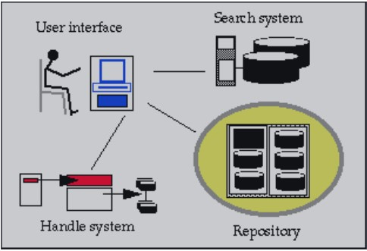

Figure 2.1 Shows the Architecture of Digital Library System

2.2.3 Dewey Decimal Classification System
In organizing library resources, classification systems are used to arrange and to locate reading materials systematically. The American librarian and librarian Melvil Dewey devised the Dewey Decimal method in 1873 and was first published in 1876. The Dewey Decimal Classification (DDC) system is published by the OCLC Online Computer Library Centre, Inc., and is continually being updated to keep pace with information. OCLC holds the copyright rights in the Dewey Decimal Classification and licensees the method for a number of purposes.

2.2.4 Web Applications
A Web-based application is referred to any program that is loaded from the Web every time it is running. Online-based programs also run in a web browser. However, Web-based software can often be client-based, where a small portion of the program is imported to the user's desktop, but execution is performed over the Internet on an external computer. Popular web apps now allow the capture, encoding, storing and transfer of confidential consumer data (e.g. contact details, credit card numbers, social security records, etc.) for immediate and repeated use. Apps such as web-mail, registration accounts, help and product request forms, shopping carts and content management systems, design new websites and provide companies with the means to connect with prospects and consumers. Web applications are, therefore, Computer programs that allow website users to send and retrieve data to/from a database over the Internet using their favorite web browser. The data is then displayed to the user inside their browser when the information is dynamically generated (in a particular format, e.g. in HTML using CSS) by the web application via a web server.

2.2.5. Web Browser
A browser is an application program that provides a way of interacting with all the information on the World Wide Web. It allows users to retrieve data and interact with content located on a web pages within a website. This content items, including images, videos and web pages, are linked using hyperlinks. In a technical context, a web browser is a client application that uses a web browser
HTTP (Hypertext Transfer Protocol) requests web servers around the Internet on behalf of the browser. Some popular web browsers of today are Google Chrome, Microsoft Internet Explorer, Safari, Mozilla Firefox, Opera etc.

2.3 The Systems Development Life Cycle (SDLC)
Buchanan (2006) is of the opinion that digital libraries is a set of logically related components (Software, hardware, processes, people, data, information etc.) Brought together to accomplish a predefined organizational goal which, in online systems, is achieved primarily through the processing of information. There is a general agreement that there is no standard method for designing a digital library. Guidelines published by International Federation of Library Associations IFLA for designing and building integrated library systems indicate that “even though there are many methodologies that address a project’s life cycle, the following four phases are generally accepted as standard: envisioning, planning, developing, and deploying or stabilizing”. From the library’s perspective, the scope of the project is not a methodology but rather a definitive statement as to what the digital library is intended to do –what services it will offer to its users and what functions it will perform. Buchanan (2006) states that the standard development life-cycle (SDLC) provides the common methodology and high-level operational guidelines within which software is developed and maintained.
According to Dennis (2000) The Systems Development Life Cycle (SDLC) is a method of learning how an information technology can meet customer needs, plan, build and distribute the system to customers. The SDLC typically consists of four fundamental phases or stages: planning, analysis, design, and implementation as a series of steps. Dennis (2000) went further to discuss the four fundamental phases and stages.
Planning phase- is considered a fundamental process of understanding why a digital library should be built and determining how it should be built. This process results in a vision document, which outlines the rational effort the project, the expected outcomes, the project’s feasibility, goals and constraints, opportunities and risks, and the structure of the project.
The analysis phase- Answers concerns about who will use the machine, what else the system will do, when and how it will be used. During this stage the researcher (developer) should investigate the current situation, identify improvement opportunities, and develop a concept for the new digital library (system). The next step is information gathering through interviews. The analysis of this information in conjunction with input from the data gathered led to the development of a concept for the new system. Interviews should have been conducted earlier in order to gather information related to existing ICT infrastructure, currently used IT applications, and information resources and services.
Design phase- Once the analysis was concluded the developer is then able to start designing the new system (digital library). The design phase or stage decides how the system will operate, in terms of the hardware, software, and available infrastructure. The first step in the design phase is to develop the design strategy, i.e. whether the system would be built by using commercial digital library software or would be developed using freely available digital library software. This led to the development of the basic architectural design for the system that described the hardware, software, and network infrastructure that would be used. The question as to which software package to use is to be driven by the present state of the organization funding. In case of financial constraints, freely available software can be used for developing the new system (digital library).
Implementation-The final phase in the (SDLC) is the implementation phase, during which the system is actually built. He states that this stage usually gets the most attention because, for most systems, it is the longest and most expensive part of the development process. The first step in implementation is system construction, during which the system is built and tested to ensure it performs as designed. After designing the proposed digital library, the prototype digital library, which has been designed should be tested to ensure that it performed as designed.

2.3.1 Design and Prototyping
This stage involved the design of an appropriate digital library system to assist in developing the services provided to end users. A quasi-experimental and system design approach could be used for this phase of the project. This phase which called (design and prototyping) focuses on developing the digital library which supposed to suit the needs and requirements of target users and to provide services that most frequently required by selected users. The design should aim at not only providing access to, or retrieval of, information, but rather to deliver electronic services to target users. At this stage, the developer should identify a number of collections–printed and/or digital– that are of importance to users, and a user-centered digital library system can be designed to meet user requirements and expectations. The first crucial step is to decide the objectives of designing the digital library. This step has to be considered early – before any further steps are taken. The broad objectives of designing a digital library system might be as per the following:
- Developing the standard of services presented to end users to enhance the level of research activities within the organization or the institution.
- The application and introduction of new ICT to enhance the existing quality of facilities and to address the issues facing the company or the organisation.
- Designing a low cost digital library that offers not only access to and retrieval of content, but also resources that are most often needed by users.

2.4 Digital Library Management System (DLMS)
Digital Library Management System is the generic software system that supports the production and administration of Digital Library System and the integration of additional software offering more refined, specialized or advanced facilities. The main concepts of characterizing the above systems, is to classify them in a number of domains, each of them representing a particular aspect of the Digital Library universe. These domains are:
(i) Organisation – this is the social structure that characterizes the planned Digital Library system. It is a super domain that consists of the other six domains that currently characterize the system;
(ii) Content – that is the material handled in the system;
(iii) Customer – reflects people communicating with the system;
(iv) Versatility – this reflects the services provided by the system;
(v) Regulation – that is the laws and conditions regulating the functioning of the whole scheme, including digital rights;
(vi) Functionality – there are elements of digital library services to be regarded from a quality point of view;
(vii) Design – which describes the elements of software and hardware) that make up the whole device concretely.
It also introduces the main roles that users may play within digital libraries, namely:
- Digital Library End-users: clients that the Digital Library infrastructure is built to support end-users and are categorized into Content Designers – 'producers' of Digital Library Content; Content Buyers – 'clients' of Digital Library Content; and Digital Libraries – 'curators' of Digital Library Content;
- Digital Library Managers: ‘the drivers’ of the Digital Library system, that is, the users needed to put the planned service in place. They are further divided into Digital Library
Designers – the users requested to characterize the Digital Library system before it is deployed; and Digital Library System Administrators – the users assigned to deploy the Digital Library System needed to implement the Digital Library Designers plan;
- Digital Library Software Developers: Implementer of the software parts needed to create the Digital Library system.
Digital Library (DL) It is a virtual entity that gathers, manages and retains digital content that is rich in time and provides its target user audiences with advanced features on that content, of specified quality and in compliance with rigorous coding policies. It is the last 'framework' currently viewed by end-users as a digital library. The Digital Library System (DLS) is a computing system that is implemented and operating and that implements DL installs.

2.4.1. Constituent Domains
The Domain System of the Digital Library, which contains all the elements required to reflect the three structures of the digital library world, is divided into two major classes: the Domain Organisation and the Complementary Domain. The Organisation Domain is based on the central principle of the Organization and is structured to reflect the key settings for characterizing the Digital Library environment, features that are unique to the digital library universe. It comprises the following sub-domains, in strict correspondence with the remaining core principles defined in the Digital Library Manifesto: Information Domain, User Domain, Functionality Domain, Regulation Domain, Consistency Domain, and Design Domain. Each of these domains focuses on a specific feature of the digital library universe. The Complementary Domain includes all other domains which, while not the objective of digital libraries and can be inherited from existing models, are still required to reflect the Digital Library system.
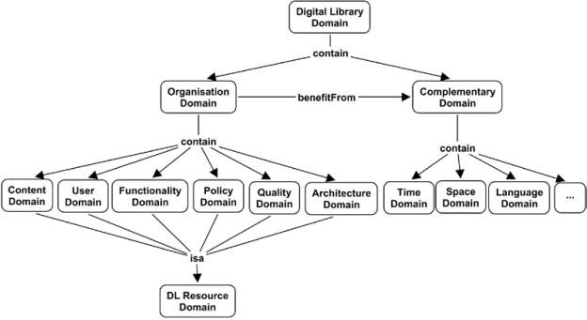

Figure 2.2 shows the Constituent Domains of digital library system

2.4.2. Resource Domain
This domain collects commonalities held by all individuals and partnerships that are handled in each "digital library." The most basic definition of the DL Resource Domain is Resource, which captures the characteristics of any digital library object. Knowledge Structures in all their types, Users, Features, Laws, Consistency Criteria and Architectural Elements are representations of the definition of Capital in the Digital Library universe. This instantiate the key principles of their respective domains, so each domain consists of resources, and the resources are the building blocks of all digital library domains. Both the various categories of resources share many of the features and ways in which they can be compared to other resources.
Each Resource is: (i) Identified by a Resource Identifier; (ii) arranged or laid out according to a Resource Format – Such a format may be derived from Ontology to ensure a coherent interpretation; it may be arbitrarily abstract and structured, since Resources may be made up of smaller Resources and may be connected to other Resources.
(<associated With>); (iii) characterized by various Quality Parameters, each capturing how the resource performs with respect to some attribute; (iv) regulated by Policies governing every aspect of its lifetime; (v) expressed by an Information Object (such as a Policy set down in a text or a flowchart); (vi) described by or commented on by an Information Object, especially by those dedicated to record Meta-data, Annotations, Context, or Provenance.
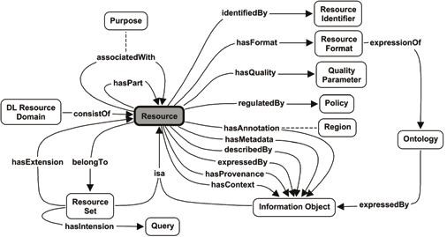

Figure 2.3 shows the resource domain of a digital library system

2.4.3 Content Domain
This domain represents all the entities managed by the Digital Library ‘systems’ to meet the information needs of their users. The most general concept in the Content Domain is Information Object. An Information Object represents any unit of information such as text documents, images, sound documents, multimedia documents and 3D objects, including games and virtual reality documents, as well as data sets and databases. Information Object also includes composite objects and Collections of Information Objects. As an Information Object is a Resource, it inherits all its features. Information Objects can acquire specializations depending on various aspects. All of them are expected to be captured by relying on relations between Information Objects.
One of these aspects is the level of abstraction at which they are specified. This leads to an abstract Information object by level of abstraction concept, which is a container or placeholder to be specialized using any of several models. For example, it can be useful to represent the IFLA FRBR model. Information objects can also be specialized by the predominant role they play in their relationship to other objects; the class Information object by relationship is the abstract conceptual container for the classes these objects give rise to, namely: (i) Primary Information Object, an Information Object that stands on its own, such as a book or a data set; (ii) Meta-data object, an
Information Object whose predominant purpose is to give information about a ‘target’ Resource (usually, but not always, a Primary Information Object); (iii) Annotation object, an Information Object whose predominant purpose is to annotate a ‘target’ Resource (or a Region of it).
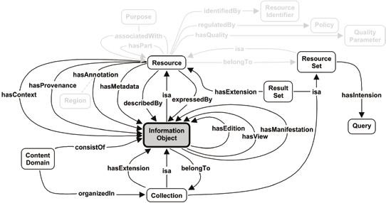

Figure 2.4 shows the content domain of the a digital library system

2.4.4 User Domain
This domain represents all the entities that interact with any Digital Library ‘system’, that is, humans and inanimate entities such as software programmes or physical instruments. Examples of inanimate entities include a subscription service offered by a university to its students, which provides access to the contents of an external or another Digital Library. Inclusion of hardware and software into the potential users of digital libraries marks a shift away from other Digital Library models and reflects a broader concept of ‘digital library’.
To capture these extended semantics, we use the concept of User as the dominant concept in this domain. Being a Resource, the User concept inherits all key characteristics of the former. A User Profile is used to model a User. Every User interacts with the Digital Library, Digital Library System or Digital Library Management System by performing certain Action(s). The User Profile is an Information Object that concerns Resources and essentially models a User by capturing a large variety of the User’s potential characteristics. It enables the User to interact with the ‘system’ as well as with other Users in a personalized, customized way.
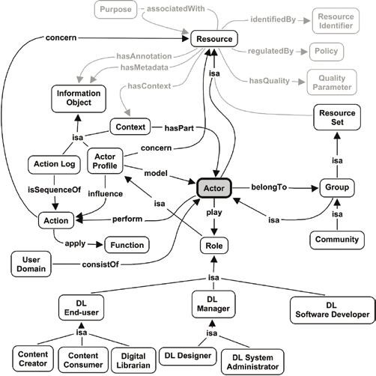

Figure 2.5 shows the user domain of a digital library system

2.4.5 Functionality Domain
This domain is one of the richest and most open-ended dimensions of the world of digital libraries, as it captures all the processing that can occur on Resources and actions that can be observed by Users in a Digital Library, Digital Library System or Digital Library Management System. The broad scope of the Function concept precludes enumerating and predicting all the different types and ‘flavours’ of Functions that may be included in a Digital Library, Digital Library System or Digital Library Management System. Each one may have its own set of Functions depending on its objectives or its intended Users. Therefore, the Function concept is specialized into five sub concepts that still represent quite general classes of activities. The first three types of Functions (Manage Resource, Access Resource, and Collaborate) accommodate activities related to the prime actions, which are performed by the digital library Users – namely End-user.
- Manage Resource includes all activities related to creating new Resources and making them available through the Digital Library, deleting old Resources from it, and updating existing ones. General management Functions that are applicable on all Resources include the creation, submission, withdrawal, update, preservation, validation and annotation. In addition to these general functions, other Functions result when dealing with specific kind of Resources, The second type of prime action expected to be performed by End-user deals with accessing the digital library offering.
- Access Resource encompasses all activities related to requesting, locating, retrieving, browsing, and representing Resources. The key characteristic of the Access Resource concept is that it represents Functions that do not modify the Digital Library (Digital Library System and Digital Library Management System as well) but identify Resources to be sensed by Users or possibly further exploited by other Functions
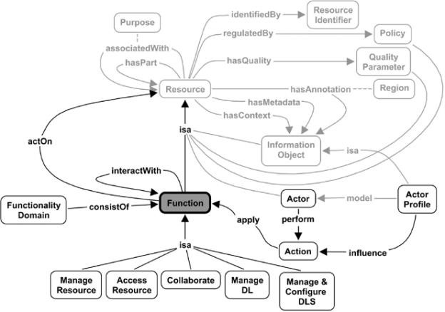

Figure 2.6 shows the functionality domain of a digital library system

2.4.6 Policy Domain
This domain represents the set of conditions, rules, terms or regulations governing the operation of any digital library ‘system’, that is, Digital Library, Digital Library System and Digital Library Management System. Policy at large governs the operation of any kind of ‘system’ including our society or the Institution or Organization that sets up the Digital Library. Policies are always addressed to defined Users. This domain is, by definition, very broad and dynamic. The representation provided by this model does not purport to be exhaustive, especially with respect to the myriad of specific rules each Institution would like to model and apply. The Policy domain captures the minimal set of relationships connecting it to the rest and presents the kind of rules that are considered as most critical in the Digital Library universe.
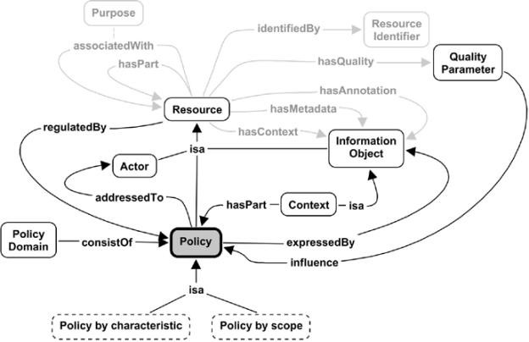

Figure 2.7 shows the policy domain of a digital library systems

2.4.7 Quality Domain
This domain represents features that make it possible to evaluate any digital library's system from a consistency point of view, with the intention of analyzing and reviewing it in relation to particular facets. Any digital library ‘system’ tenders a certain level of Quality to its Users that can be either implicitly agreed, that is, Users simply have an understanding of what Quality Parameters are guaranteed, or explicitly formulated, in that there is a Quality of Service (QoS) agreement. The Quality Domain is, by definition, very broad and dynamic, extensible with respect to the myriad of specific quality facets each Institution would like to model. It is important to note that this grouping is made from the perspective of the Resource under examination, that is, the main object under assessment. In any case, the User, understood as the active subject who expresses the assessment, is always taken into consideration and explicitly modelled, since he/she is an integral part of the definition of Quality Parameter. Therefore, the User Satisfaction parameter has been grouped under the Functionality Quality Parameter because it expresses how much a User (the subject who makes the assessment) is satisfied when he/she/it uses a given Function (the object of the assessment).
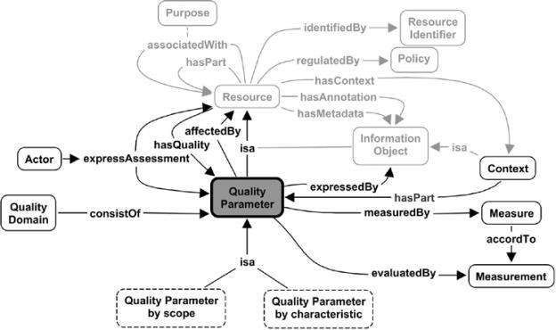

Figure 2.8 shows the quality domain of a digital library system

2.4.8 Architecture Domain
This domain includes concepts and relationships characterizing the two software systems playing an active role in the Digital Library universe, that is, Digital Library Systems and Digital Library Management Systems. The importance of this fundamental concept has been largely underestimated in the past. Having a clear architectural understanding of the software systems implementing the Digital Library universe offers guidelines on pragmatic set-up of a Digital Library as a whole. In particular, it offers insights into: (a) how to develop new systems, by maximizing sharing and reuse of valuable assets to minimize the development cost and time to market; and (b) how to improve current systems by promoting the adoption of suitable, recognizable, and widely accepted patterns to simplify interoperability issues. Architectural Components interact through a Framework Specification and are conformant to it. This framework prescribes the set of Interfaces to be implemented by the components and the protocols governing how components interact with each other. Architectural Components are classified into Software Architecture Components and System Architecture Components. These classes are used to describe the Software Architecture and the System Architecture of a software system respectively, where the former captures the organization of the programs a software system consists of, while the latter captures the organization of the processes and running units an operating software system consists of. Software Architecture Components are realized by Software Components. A Software Component, encapsulates the implementation of a portion of a software system and is regulated by particular Policies (Licenses).
Moreover, it is represented by an Information Object. Thus, the Resource representing the Software Component inherits the Information Object’s characterizing aspects, for example, it can be enriched through Meta-data and Annotations. Examples of Software Architecture Components are software packages implementing a specific Function, software artefact supporting the implementation of a specific Function, for example a Relational Database Management System (RDBMS). System Architecture Components are realized by Hosting Nodes and Running Components. A Hosting Node represents the (virtual) hardware environment hosting and running Software Components. A Running Component represents a running instance of a Software Component active on a Hosting Node. Example of System Architecture Components are servers that can host one or more of the Digital Library System processes or running units, an operational Web Service partaking to the System Architecture of a Digital Library System, a deployed Relational Database Management System (RDBMS).

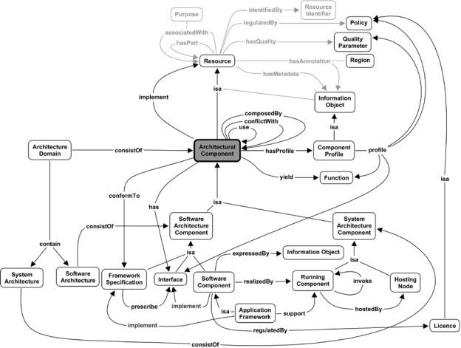

Figure 2.9 shows the architecture domain of a digital library system

2.5 Digital library based on user experience
This may be helpful to understand user’s opinion, attitude, satisfaction and service experiences with digital library which can be further considered for enhancing user’s satisfaction towards the use of digital library.
Ekere et al (2016) Research users' views of digital library equipment, tools and programs and find that users are very happy with them. Users are very informed and pleased with digital library services such as WWW, WIFI and search engines relative to online directories, portals, online abstracts, video CDs, CD-ROMs, and online indexes and abstracts.
Asad Khan (2016) Investigated consumers that affect the acceptance of the Digital Library by research students. Whereas the ease of use was greatly influenced by navigation, human variations and system characteristics. Usefulness is specifically influenced by the features of the system and the consistency of the system. Finally, it has been observed that the utility has the greatest impact on the digital library's decision to use it.
Edwards (1998) predicted the changes in the library system and information dissemination due to use of computers, application software’s, internet, networking etc. Due to this there is a significant change in the functions of libraries. Along with technology there is a need to deploy effective staff to process and disseminate the information for the benefits of users.
Hamedan Branch (2009) Focus that libraries and librarians intend to handle digital libraries due to transition, as well as to provide customers with conventional print-based services. The study highlighted the characteristics of digital libraries and the introduction of digital libraries from a conventional and perceived administrative and personnel viewpoint. Special workers with machine and programming efficiency are needed in the evolving world as per the opinion of the author.
Naga Raja Rao (2013) indicated in his communication that present new technologies are being used in library and information science and is the main reason in changing environment of libraries, but staff needed to manage the new digital libraries is to be flexible in adapting and adopting new skills and levels of awareness. Librarians have to adapt different skills to cope up with new technologies. This research displays the changing role of librarians in a higher education sector and it has adapted to a new social as well as changing educational agenda. The project basically covers the assumption that only its role has expanded due to changed formats of publishing documents. Technology alone cannot help in bringing out the required changes but also need efficient staff to manage the change. Attitudes, practices, and policies need to change if libraries in India are to truly benefit themselves and their community of users by the application of new technologies. LIS professionals have been playing a versatile role beyond their traditional job. They have to gather adequate knowledge of computer and communication technologies, networks and networking, operating systems, internet concepts, database management systems, along with adequate practical exposure to handle technological devices.

2.6 Pros and Cons
K. Nageswara Rao, and Babu (2001) highlighted the development in libraries from traditional to virtual which has brought drastic changes in the profession. The network technology and the internet using ICT has given the librarian a new dynamic role to perform as information scientist. The features of web, multimedia, collaborative multiprotocol, hypermedia oriented architecture made absolute revolution in information handling using different tools and technologies. Ultimately these avenues gave rise to digital library along with access to traditional library and staff pattern is different as compared to traditional library.
Liz Burke (2001) indicated that the virtual libraries and the digital libraries are the same but has a narrow difference in it. The future libraries can transform from traditional to digital and to the electronic and virtual movement. The librarians may require special skills having knowledge of web development, networking skills, hardware, and software interface and creating web pages to provide information in the changing environment to users.
Emmanuelle Bermès (2011) developed a digital library repository using OAIS model and indicated to accept the change and librarians and the supporting staff should have appropriate skills to develop knowledge bases to maintain the digital library more usable. The digital information available in multiple formats and to arrange the huge data is the main activity of the library acquiring technical skills.
Bas Savenije (2000) focused on ultimate changes of traditional libraries from book savvy users to online grasping information. Innovative changes are seen in traditional and academic libraries. The users demands of locating information on desk tops is been considered with the availability of electronic books and online information. To retrieve and disseminate the information and maintain storage, preservation of information is important fuser. This concept of providing information to the users gives rise to electronic media and expert staff to manage the information.
Lynne Brindley and Derek Law (1997) pointed that the digital library movement is initiated everywhere including developing countries. International organizations, govt. sectors, private organizations are using the digital resources and library tools for information retrieval and dissemination to manage funds and infrastructure appropriately. The digital library concepts are rapidly changing the traditional concepts. The ICT and electronic resources have been used in digital library and has changed the functioning of the libraries and role of librarians.
Ziming Liu (2006) has clearly stated that ICT and technologies, electronic resources and the implementation of digital libraries have made the tremendous impact on traditional libraries and its staff. Author in his survey which was conducted in Toronto listed the finding which indicates that young age people are more familiar with the electronic sources. The author said that the users are moving from traditional to digital libraries. The traditional and digital libraries have different roles where users demand is for both to satisfy their needs. The library has to play similar role in disseminating the information to users.
Subrata Sur (2007) has remarked Information Communication Technologies are being implemented in libraries to give traditional and digital information to the users. Librarian needs to redesign the infrastructure and skill to provide pinpointed information to the users in digital libraries and also highlights the professional skills required and technological facets required for the development of library staff to perform the future and current needs of the users.
Sharma (2007) listed skills required for the librarian to survive in the information commination era. The internet has made information easily available anywhere to the users through the search engines. Information can be accessed in electronic form by the users using electronic resources. Now in the digital era the librarians have to serves as e-specialist and provide information to the users. The traditional libraries providing digital information in the changing environment require technical skills like such as, operating systems, programming languages, networking, coding, etc. Digital library concept has change the working of the library environment.
Shiou – Luan Wang’s (2009) studied revealed the impact of ICT in university libraries to understand the users demand using ICT. The users require pinpointed information and guidance to use and refer the information generated and retrieved for the e-resources, the library staff has to computer savvy with IT knowledge to retrieve and disseminate the information to the required users. The users get satisfaction if the information is generated and disseminated properly to the users. The staff should have proper skills to retrieve and disseminate information to the users.
Yalan et al (2014) examined quality of digital library which define as the quality of information quality of system and overall service quality of digital library. The compression of user’s perceptions towards virtual communities and digital libraries have been done understand the actual nature of e quality perceived by the users. Based on the user’s perception study found that digital libraries provide better information, system and service quality than virtual communities.
Oladejo B. F. (2017) posited that the development of a system which could reduce the workload and time of analyzing book borrowing transactions with respect to books borrowed, books that are always on demand or most preferred books. The system could adapt to the borrowing trends and the changing demands and preferences of the library user or borrower recommend additional books.

2.7 CHALLENGES OF DIGITAL LIBRARY IN NIGERIA
The challenges and prospects of library in Nigeria especially the universities are enormous. Most university and college libraries in Nigeria are in a deplorable state due to insufficient financing. This manifests in university libraries having few current books, journals and other reading resources, staff shortages, deterioration of facilities, and inadequate equipment in the library buildings. Such circumstances are not conducive environment for learning. The project has the capacity of solving this problem. We are now in the period of information explosion, where there is the need for university libraries in Nigeria to use appropriate technology to access the real world information in other to enable universities carryout their traditional functions of teaching, research and public service effectively and efficiently.
Digital library is been introduced to the library system worldwide. The industrialized world is creating digital libraries because of the high value placed on the availability of information. The increasing acceptance of digital library might be due to the diverse information that they contain, the options for what they can include are virtually endless, as well as becoming boundless as technology advances.
Nigeria's university libraries are practically non-existent in both rural and urban marginal areas. Depending on where they exist, the orientation is narrow and book-based on outdated and insufficient collections of resources compromised by weak, redundant funding and inadequate collections (Atinmo, 2006). The functions of university libraries as sources of knowledge, invention and study, instruments for social advancement and means of communication have been truly disintegrated. It was proposed that digital libraries be set up for university libraries to respond effectively to the social cultural and developmental needs of library users in Nigeria.
With digital library, the quality of academic library collections will be reinforced up, staff and students will be able to access database for teaching and research. According to Okebukola (2002) the digital library would improve the quality of teaching, learning and research in higher institutions through the provision of current electronic books, journals and other library resources. Yau (2003) asserts that the digital library has an opportunity to address the pan city of teaching and exploration materials in the libraries of higher institution in Nigeria, as well as giving room for sharing of research outputs with the global community amongst the institutions and the local researchers.
However the introduction of a digital library means that libraries can spend more resources on computer hardware and software, licenses, educating librarians in emerging technologies, in particular in the field of text collection, testing, authentication and indexing of the materials to be digitized, as well as hiring online technology professionals to help and maintain them. The owner of copyright must be contacted and the rights acquired. Money is required to convert content into digital form and access services. A powerful server is required, assisted by specialized software and staff. The server would run during the day and new materials should be constantly added.
Building and sustaining a digital library system requires the proper technological infrastructure which includes telecommunication, servers, application platforms and software applications (Gbage, 2007).
The Web technology skills are needed to maintain web servers that host digitized materials and other digital resources hosted remotely as well as maintaining proxy access to restricted resources. Aschroff and Watts (2004) It has been reported that Nigeria has an extreme lack of automated library systems to deploy and operate infrastructure networks. The essence of electricity supply in Nigeria is a big concern. The digital library infrastructure cannot function in this situation because web servers hosting locally digitized material and proxy servers delivering authentication and remote access to subscribed electronic services need to be powered 24 hours a day.
Another challenge is the lack of purpose-built library buildings. Ifidon and Okoli (2002) observed that the first and second generation universities, those established between 1948 and 1970, and 1971 and 1979 respectively have completed their library buildings while the situation of the third generation universities i.e. those established between 1980 and 1983 is very bad. Also, difficulties are always encountered while downloading or printing. Everything is not available in digital format. There are restrictions, which vary from vendor to vendor, on how the product can be used.

2.8 Conclusion
Developing policy that positions information technology IT applications, and especially open source software (OSS), as part of a strategic plan for enhancing library services is a necessity. Many libraries especially in developing countries are suffering from being unable to deliver the required services to their users due to various barriers and obstacles. Drawing a policy that positions open source software as part of a strategic plan for improving library services is expected to assist in solving many problems, such as scarcity of electronic resources and absence of access to up-to-date information resources in addition to meeting the requirements and needs of the users.
Open source software (OSS), in conjunction with open access (OA) can also be beneficial to libraries in the long run. For instance, open source and open standards can help libraries provide patrons with easier access to OA materials and other resources, as open standards make it possible to create interoperable systems to access the literature in various OA journals seamlessly.

CHAPTER THREE
METHODOLOGY AND SYSTEM ANALYSIS

3.1 INTRODUCTION
This chapter deals with the methodology adopted for the study, design and development of the application. Methodology can be the analysis of the principles of methods, rules and postulates employed by a discipline. It refers to modus operandi that is a person’s technique of handling a task. This Research is referred as the search for knowledge or any systematic investigation to establish facts. This section will outline the various method to be used in all the stages of system analysis and design for the realization of an effective Digital Library System.

3.2 Project Development
The Applications Development Life Cycle (SDLC) is a process model used in the development of the project that represents the phases of the development of the information system from the original feasibility analysis to the maintenance of the completed application. Various SDLC methodologies have been developed to direct the processes involved, including the waterfall model (original SDLC method), rapid application development (RAD), joint application development (JAD), the fountain model and the spiral model.
Mostly, multiple models are merged into a form of composite approach. The second method of organized design is called concurrent growth, in which a general design for the entire system is created instead of being developed and executed in order, and is then separated into a set of different sub-projects that can be designed and implemented in parallel. When all the sub-projects have been finished, the components will be finally combined and the system will be shipped.
The primary advantage of this methodology is that it can reduce the schedule time required to deliver a system. The drawback of this approach lies in the fact that the sub-projects are not completely independent; design decisions made in one sub-project may affect another and the end of the project may require significant integrative efforts.
Rapid application development is the second type of systems development methodology. It emerged in the 1990s and Attempts to solve and address the weakness of the structured development methodologies. It includes the phased or staged development approach and the prototyping methodology. The phased methodology is a process whereby the application is delivered in stages, typically in order of functional priority. Standard design processes are followed until functional or technical specifications are complete for the application. Documentation is important, regardless of the type of model preferred or invented for any use and is typically carried out in parallel with the production process. Certain approaches perform best with particular types of programs, but in the final result, the most significant consideration for the performance of the project may be how closely a specific strategy has been implemented.

Waterfall Model


Operation

Analysis

Designing

Software
Development

Testing

Planning

Maintenance

Figure 3.1.Waterfall Model

3.3 Project Design
- Planning. The planning phase is considered a fundamental process of understanding why a digital library should be built and determining how it should be built. This process results in a vision document, which outlines the rational effort the project, the expected outcomes, the project’s feasibility, goals and constraints, opportunities and risks, and the structure of the project. In planning, the researchers conducted an interview to the client to gather some information about on how the librarian manage the books, borrowed books, returned books, all record of the student. It is remembered that the librarian writes manually the histories of all students who lent or returned the books. The student uses the form given to him by the librarian.
- Analysis. The research process asks questions about who will use the system, what the system will do, when and where it will be used. At this point, the researcher (developer) should examine the current scenario, find areas for change and design a framework for the new digital library (system). The next move is to collect details through interviews. The study of this information in combination with input from the data collected contributed to the implementation of a new system design. Interviews may have been done earlier to collect information on existing ICT infrastructure, commonly used IT applications, and information tools and services. The proposed digital library infrastructure is constructed solely from the point of view of users, without taking into account hardware restrictions (such as computers). In addition, the device architectures necessary to accomplish those designs are explained. After reviewing the conditions of the general plan, the project description is represented by the use of diagrams such that the creation and flow of data can be readily interpreted.
- Designing. The software design specifically targeted to librarian of the researchers used a user-friendly design to attract the user to use the new automated system. Here the system was designed purely from the users' viewpoint without considering the constraints of hardware (such as computers). In addition, system structures required to achieve such designs are clarified. After checking the requirement specifications included in the planning, the overview of the system represented by the use of diagrams so that the processed of data can be easily understood. Based on the representations, the division into sub-systems and input/output designing was performed. The entire project was divided into a number of modules on a functional basis, and each module was further divided into smaller units. The designing of the code, such as the determination of a coding system, was conducted. In addition, relationships between the data were analyzed.
- Software Development – Coding. In the development of the system, the researchers made used of Microsoft Visual Basic 6.0 for encoding source code of the system, in order to be accurate and fast acquisition of data/information.
- Testing. The researchers installed the new System. The researchers encountered problems while processing it for the first time but after several weeks the system has been successful and introduced it to the respondents.
- Operating. The researchers were responsible for conducting an operation test. The researchers conducted a test under the actual operation conditions, and verified that the system satisfies the required specifications. Because this test was intended to have a developed system accepted by the user, it was called an approval test or an acceptance test. The researchers conducted an operation test by running a program on a machine being used for actual operations.
- Maintenance. Researchers performed program maintenance to fix errors, maintain performance or other qualities. The general understanding of the researchers' maintenance is literally the repairing of detects. The Researcher Maintenance Management System helps the Segment Chiefs to schedule maintenance work on fixed assets, such as vehicles, machinery and property.

A. Structured Systems Analysis and Design Methodology (SSADM)
Structured Systems Analysis and Management Methodology (SSADM) is a series of principles for system analysis and application design. It uses a systematic analytical approach to the study and implementation of information systems. One of the key characteristics of SSADM is the intensive participation of consumers in the study of specifications. SSADM follows the waterfall life cycle model from the feasibility analysis to the physical design phase of development. One of the key characteristics of SSADM is the intensive participation of consumers in the study of specifications. Users are required to sign off each stage when they are finished to ensure that the criteria are fulfilled. Users are required to sign off each stage when they are finished to ensure that the criteria are fulfilled. Users are presented with simple, easy-to-understand documents consisting of different diagrammatic representations of the system. SSADM splits the construction project into stages, components, phases and activities. The data model is the first and foremost model built in SSADM. It is part of the set of specifications which consists of well-defined phases, steps and products.

B. Object-Oriented Analysis and Design Methodologies (OOADM)
Object-oriented research and design is a theoretical method for evaluating and developing programs, frameworks or DBMS applications by applying object-oriented programming, as well as using visual simulation in the software development process to analyze the task specifications, design a solution to the problem, and execute a solution in the programming language or database. The two most popular object-oriented methodologies are:
- Object Modeling Technique (OMT).
- United Modeling Language (UML)

Analytical Tools
The researchers presented the analytical tools used in the system which are class diagram, Entity Relationship Diagram, Use Case Diagram, DFD, activity diagram:

1. CLASS DIAGRAM
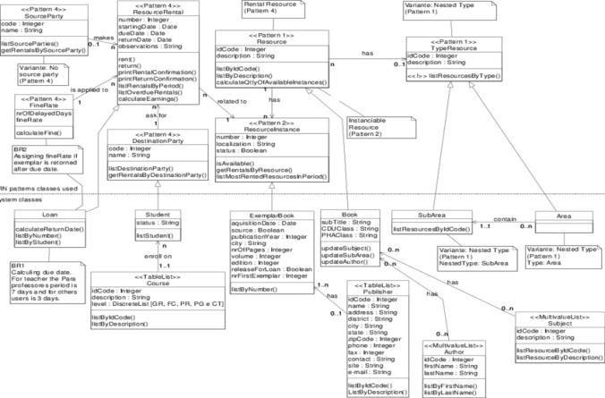
The figure 3.2 shows the class diagram for the system.

2. Use Case Diagram
The Figure 2 shows the use case diagram of the system. It has 4 actors: school librarian, vice chancellor, library user and system administrator; and 4 use cases: manage reading materials, manage user accounts, log in and manage reports. In the manage reading materials, the system permits the Librarian to add, update and view reading materials information. The library user are permitted to view and to reserve library reading materials. In the manage user accounts use case, the system lets the administrator to activate/deactivate them, and view user information. All of the actors except the library user in the system are permitted to change their password and view their own information. In the manage reports use case, the system allows the librarian to generate, update and view summary reports. The school principal is only allowed to view the generated summary reports.
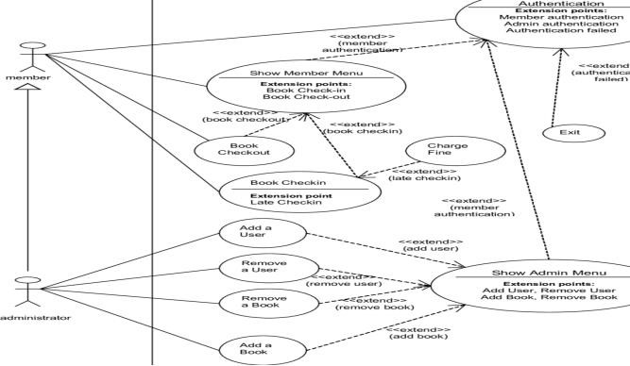
The Figure 3.3 shows the use case diagram of the system

3. Entity Relationship Diagram
The figure 3 shows the Entity Relationship Diagram for the system. The system will be implemented using HTML with server side scripting using PHP and MySQL for handling database queries. Each registered user has his/her own user information (User table). The school librarian can manage multiple library reading material (material table).The borrower’s usage of reading materials are keep track and stored (borrower record table). The borrower(s) can also suggest reading materials for acquisition, then the vice chancellor (user) will then approve the suggested acquisition list (acquisition list table).

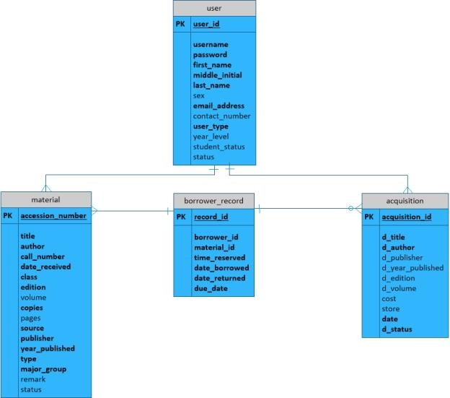
Figure 3.4. Shows the Entity Relationship Diagram of the Library Classification of the Library System.

4. DFD, activity diagram
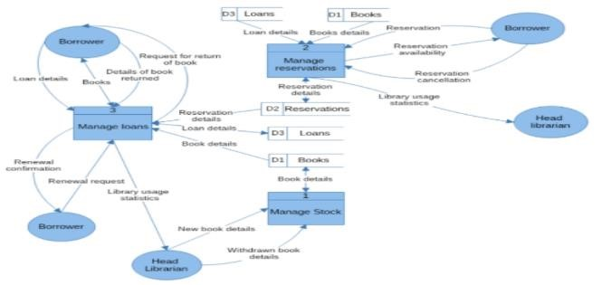
The figure 3.5 shows the DFD, activity diagram for the system

Activity Diagram

1. Input reading material
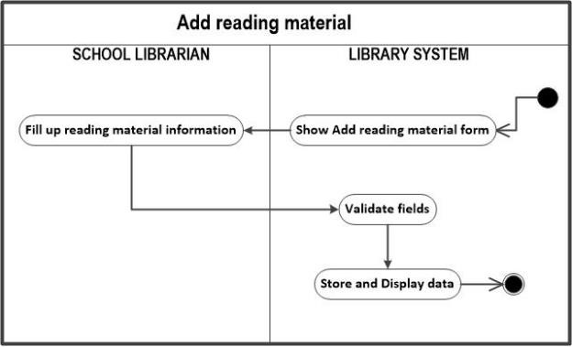
Figure 3.6: Activity Diagram: Adding newly acquired reading material into the library catalog

2. Search reading material
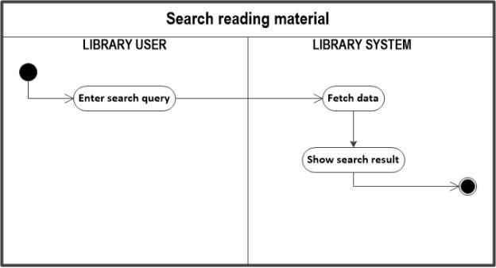
Figure 3.7: Activity Diagram: Search reading materials in the library catalog

3. Borrow reading material
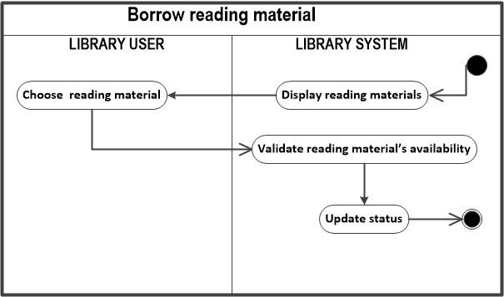
Figure 3.8: Activity Diagram: Borrowing of reading materials in the library

4. Reserve reading material
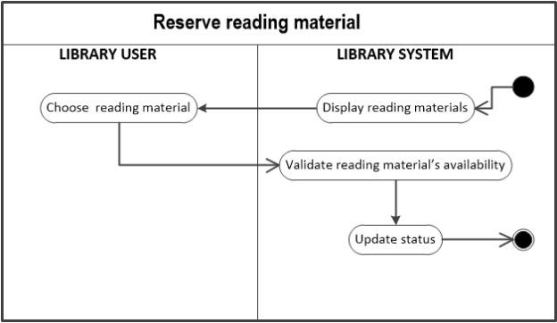
Figure 3.9: Activity Diagram: Reservation of reading materials in the library

5. Suggest reading material for acquisition
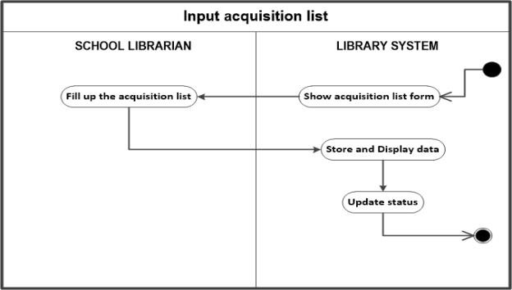
Figure 3.9: Activity Diagram: Suggesting reading materials for acquisition

6. View library users
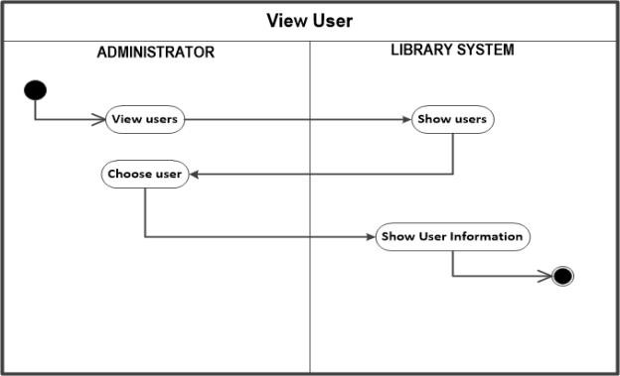
Figure 4.0: Activity Diagram: View library users

C. Prototyping
Software prototyping is the practice of developing samples for software systems, i.e. unfinished iterations of the software product being created. The goal of the prototype is to allow users of the app to test the design ideas of the developers for the design of the final product by actually testing them out rather than attempting to view and evaluate the design on the basis of the descriptions. Software prototyping offers an understanding of the features and possible threats or problems of the software. Prototyping can also be used by end-users to define and prove specifications that have not been considered and that can be a key factor in the business relationship between developers and their clients. The steps are encapsulated in the following outlines:
- Requirements specification, gathering and refinement: A prototyping model starts with requirement analysis. In this phase, the device specifications are described in depth. During the process, consumers of the system are interviewed to see what their perceptions of the system are.
- Quick design: The second phase is a preliminary design or a quick design. In this stage, a simple design of the system is created. It is not, however a complete design. It gives the customer a quick understanding of the framework. Fast concept helps to build the prototype.
- Build prototype: In this phase, an actual prototype is designed based on the information gathered from quick design. It is a small working model of the required system.
- Initial user evaluation of prototype: At this point, the proposed system is introduced to the client for initial assessment. It helps to explore the power and weakness of the operating model. Comments and feedback are gathered from the user and sent to the developer.
- Refine prototype: If the user is not pleased with the current version, you need to improve the prototype according to the input and recommendations of the user.
- Implement Product and Maintain: When the final system is developed on the basis of the final version, it is extensively tested and used for development. The machine undergoes scheduled maintenance to reduce downtime and avoid large-scale failures.

D. Expert System
An expert machine is a computer program programmed to replicate the problem-solving actions of a human being who is an expert in a narrow field or discipline. An expert system is a computer system that emulates the actions of human experts in a well-defined manner and strictly describes the area of expertise. It collects the information and heuristics that an expert uses in a particular mission. An overview of current technologies applied with an expert system that is developed for Database Management System, Decision Support System, and the other Intelligent Systems such as Neural Networks System, Genetic Algorithm. They are encapsulated in the following steps:
- Identify the problem and design the task
- Acquisition of knowledge and problem solving
- Design the system, knowledge rules, natural language interface, inferences engines and rule editors, heuristic search strategies forward and backward reasoning with rules.
- Build and test a prototype expert system
- Operate the expert system
- Maintain the expert system

E. Usability Engineering Methodologies
Usability can be defined as the capacity of a device to provide a condition for its users to perform tasks in a safe, effective and productive manner while enjoying experience. The object of use may be a software program, a website, a book, a tool, a method, or something a person may interact with. The beauty and consistency with which communications with a computer program or website (web usability) are built. Usability finds customer satisfaction and utility to be quality elements and strives to enhance user experience through iterative design. It refers to methods for improving ease-of-use during the design process
- Usability Inspection Method (UIM)
- Usability Test Method (UTM)

F. WEAKNESS IN THE PRESENT SYSTEM
The problems of the current system is in the very fact that it lacks an efficient and effective way of allowing students access to electronic resources. These are some of the weaknesses.
- Users that want to access electronic books must go to the library before they can be able to do so.
- There are no friendly user interface that can enable users to electronically search for resources using search terms like name of authors, title of books, ISBN etc.
- Increase in loans and acquisition due to lack of a suitable software that can make the use of digital library interesting.
- High cost of maintenance of CD-ROM to ensure they are workable.

G. METHODS OF DATA COLLECTION
During the course of this research, data was collected from relevant authorities through the following:
- Interview: This is a face-to-face discussion between the researcher and the respondent. It is indeed a direct communication involving the relation of facts and figures.
- Observation: This is the use of visual and visual aids like the eyes to study, compare, and analyze situations. I used these mediums during the course of this project work.

H. DATABASE SYSTEMS
Database systems developed because of the need to store large amount of data and retrieve book quickly and accurately. For example, a university library stores details about the books held and loans taken out by student. Not long ago, this knowledge on books and loans may have been kept in the box card index. Nowadays, just a few decades old, students are able to view their loans online to see if any books have lapsed. They can check to see if a book is available and reserve it. The library staff can quickly access statistics on overdue books, popular books which always leave the shelves.

CHAPTER FOUR

4.1 SYSTEM IMPLEMENTATION
This chapter shows the result of the objectives mentioned. It demonstrates the information of implementing the new system as it is designed, the process description. It also the way new system files are designed, their data flow diagram, the database structure of the entire parameters, or input variables to be used in the new system. To be able to effectively implement this system; Digital Library System (DLS), detailed and thorough study was carried out on the operations of the MTU library and an appropriate design of a Digital Library system for the MTU library was generated.

4.2 PROGRAM DESCRIPTION
The program is designed in such a way that it would not be difficult to implement. A description on how the program was designed will help the users to run the program effectively. Below is how the program was designed in module.

4.2.1 Administration
A dedicated staff takes care of the administration of the Digital Library System. These staffs are saddled with the responsibility of doing the following (sub modules):
- Student Registration.
- Uploading of Electronic Resources.
- Archiving of obsolete electronic books.
The administrators have their password which will enable them gain access to the operations to be carried out as mentioned above.

4.2.2 Search
This is one of the modules that will be made available to student. In this module student will be able to search for resources using the DLS. The search could either be carried out by:
- Title of book or
- Name of the author
- Year of publication

Before a student gains access to this electronic material, he or she needs to register with the MTU library. DLS immediately generates his unique identity username and password upon the completion of his/her registration process.

4.2.3 Archive
In this module, obsolete electronic resources are found here. The student also have access to the module because the student may want to read old books in electronic format he/she can go to the module and execute the search command using:
- Title of book or
- Name of the author
- Year of publication
Only the administrative staff can determine which electronic resource is obsolete. An administration staff may decide to recall an obsolete book into the current books available.

4.2.4 Logout
This module provides a way out of the DLS. After every transaction, the exit button is used to exit the DLS environment.

4.3 INPUT/OUTPUT DESIGN OF DATABASE
A sample of the input/output design of the database will be shown here. It is a show below.

4.3.1 Database Files
In the database design, the entities have different attributes, data types and relationships which are defined based on the user requirements. The entities in the database design are:
- Admin
- User
- Record

A. Fig 2: Admin Login File
File Name  User name  Password | Data Type  Var character  Var character | Width  30  30 | Description  Username  Password

B. Fig 3: User Registration File
File Name | Database | Width | Description
Surname  Other Names  Date of birth  Matric. No.  Year Admitted  Course of Study Department college/Faculty | NVAR Character  NVAR Character  Int  int  int  NVAR Character  NVAR Character | 20  30  12 | Surname  Other names  DOB

C. FIG 4: STAFF REGISTRATION FILE

File Name | Database | Width | Description
Surname  Other Names  Gender  DOB  Staff No.  Year Admitted  Course of Study Department college/Faculty | NVAR Character  NVAR Character  NVAR Character  Int int int  Int  NVAR Character  NVAR Character | 20  30  6  12  14  15  10  30  40 | Surname  Other Names  Gender  DOB  Staff No.  Year Admitted  Course of Study  Department  School/Faculty

D. FIG 5: UPLOADING FILE
File Name | Database | Width | Description
Title  Author  Subject  Publisher  Year of Pub  ISBN  Faculty/college  Department | NVAR Character  NVAR Character  NVAR Character  NVAR Character  int  int  NVAR Character NVAR Character | 100  50  70  40  10  20  50  35 | Title  Author  Subject  Publisher  Year of Pub  ISBN  Faculty/college  Department

4.3.2 Description of Database File
Admin Login: This allows an administrative personnel access to the system to carryout student registration, staff registration and also uploads of electronic resources. These duties are specifically meant for the admin staff.
User Registration File: This holds information about registered students that makes use of the Digital Library.
Staff Registration File: Contains records about registered staff who makes use of the Digital Library.
Uploading File: This is where the electronic resources are uploaded and stored in the database which would be made available to readers.

4.4. SYSTEM TESTING
Testing is the process of executing a system to find errors. Without testing, hidden errors will surface after sometime of use and perhaps irreversible damage has been done to valuable data. Testing does not only discover errors made during coding, but also errors in the previous phase. The goal therefore of testing is to discover the requirements, design and coding errors. System testing follows the logical conclusion that all parts of the system are tested and found to be working properly under all kinds of situations and then the system is achieving the goal of processing the data perfectly according to user rules and requirements.

4.5 SYSTEM IMPLEMENTATION
This system - Digital Library System contains an updateable database with fields, holding information that can be used to locate a resource in the Digital Library. The system was implemented using ASP.NET on Windows 7 operating system. When executed, it displays a splash screen which loads all other screen and then displays the home page screen on.
The home page screen contains four major module which are the Admin, Search, Archive, and logout while the Admin module contain Sub-module which are Student registration, Staff registration and Upload. Each of them will lead you to its database when clicked and manipulated.

4.5 CHOICE OF PROGRAMMING LANGUAGE
There are numbers of programming languages available that will permit a programmer to write instructions to control the Digital Library. In developing an application package, the development of database has given programmers better opportunity to manage database particularly in microcomputer whose capacity has been enhanced greatly. Database management system is a program that gives users access to a collection of information stored in the database.
Hence, in developing this package, I chose CSS and ASP.Net. The major reason is that it is efficient in managing information given to it. In collaboration with Microsoft Structured Query Language alongside MS-SQL are as follows:
- User friendliness capabilities.
- Multi file handling system.
- Flexibility.
- Data storage capability.

4.6 USER GUIDE ON RUNNING THE SYSTEM
The system was implemented and tested and separately during the design time and then the whole forms were connected. The system was compiled and tested
ADMIN PASSWORD: 12345

4.6.1 Login page
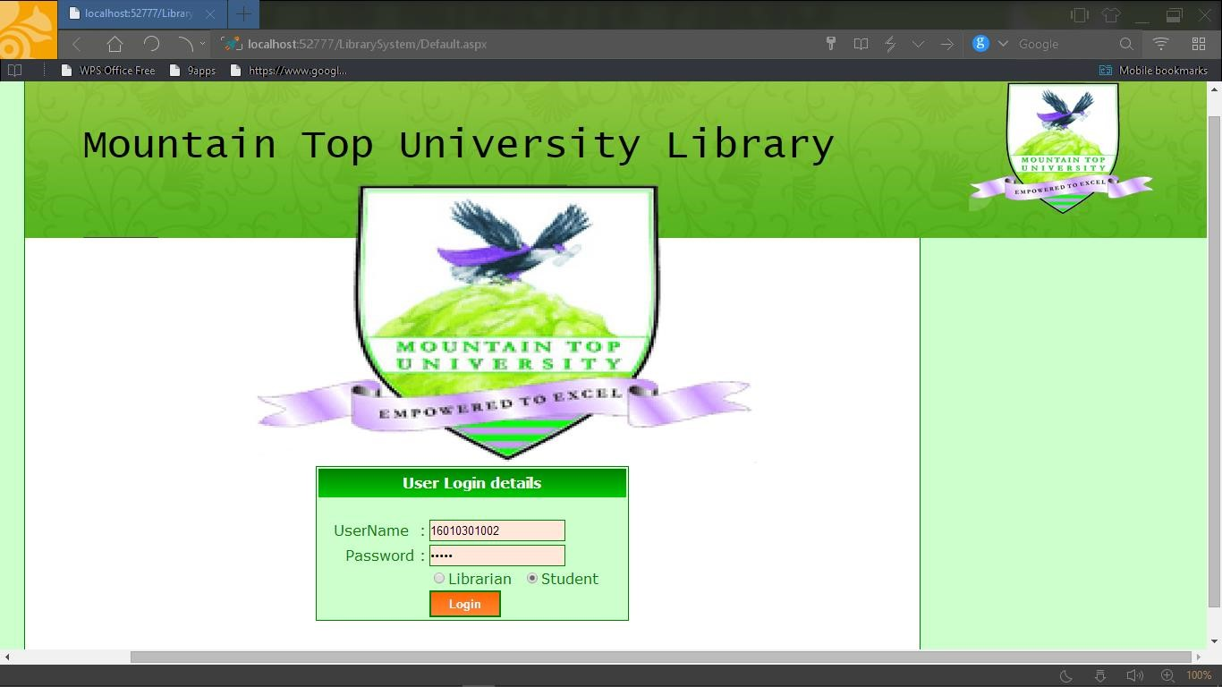
Fig 4.4 shows the login page
4.6.2 Home page
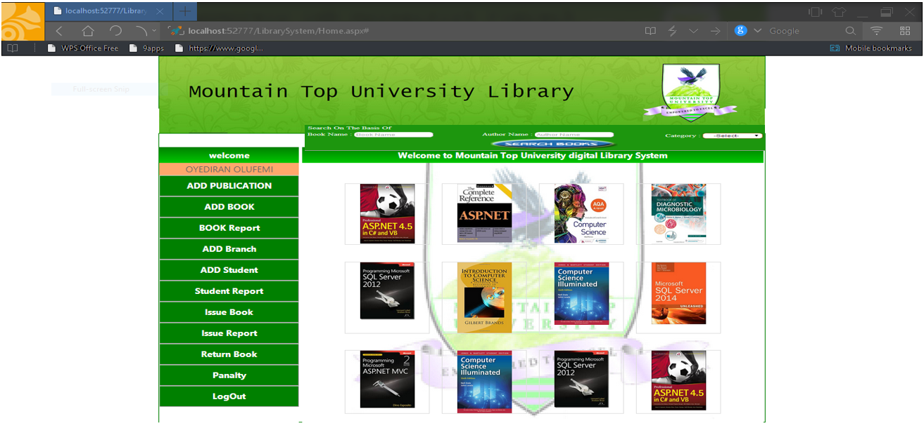
4.6.3 Add student
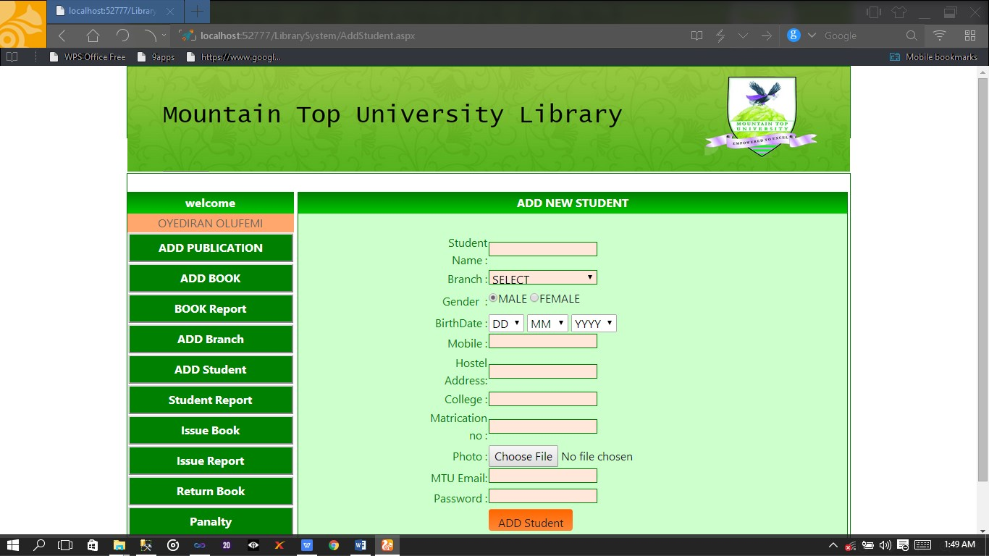
Fig 4.6.3 add student form
Fig 4.6.4 add book form
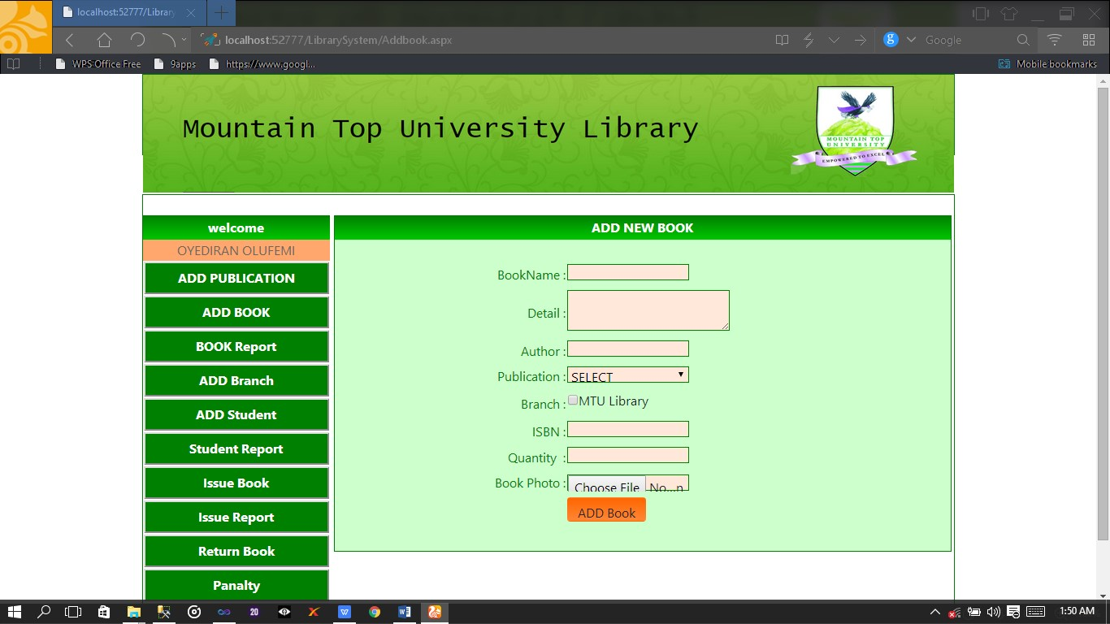
Fig 4.6.5 book issue form

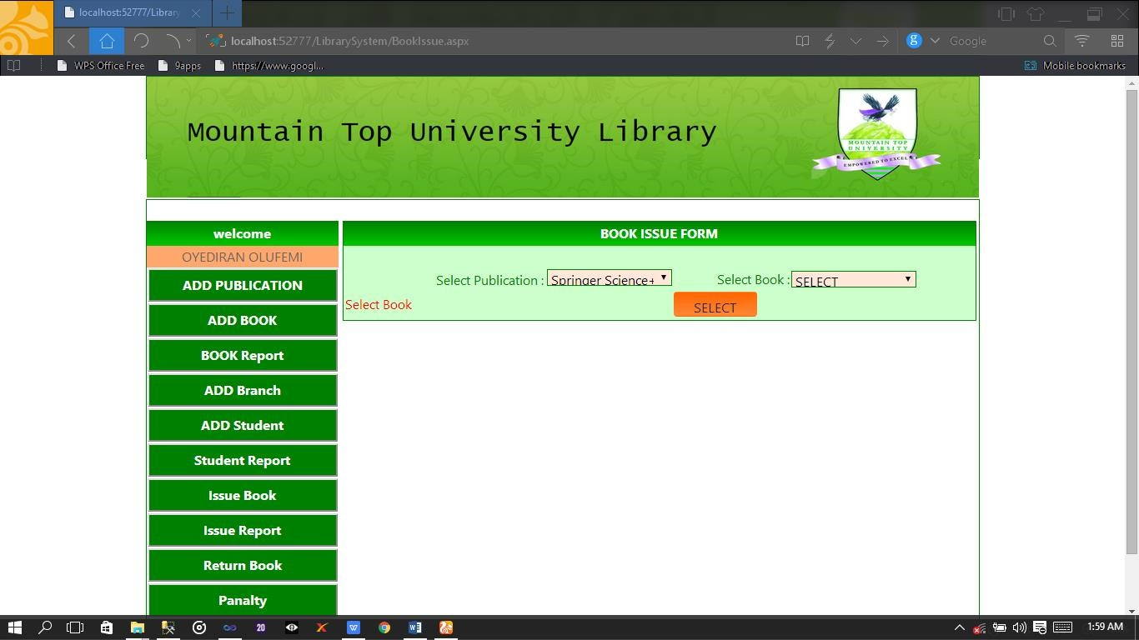
Fig 4.6.6 book return form
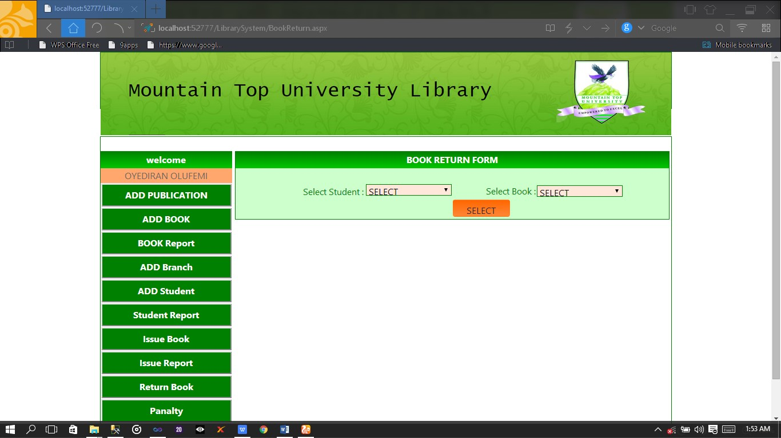
Fig 4.6.7 student report
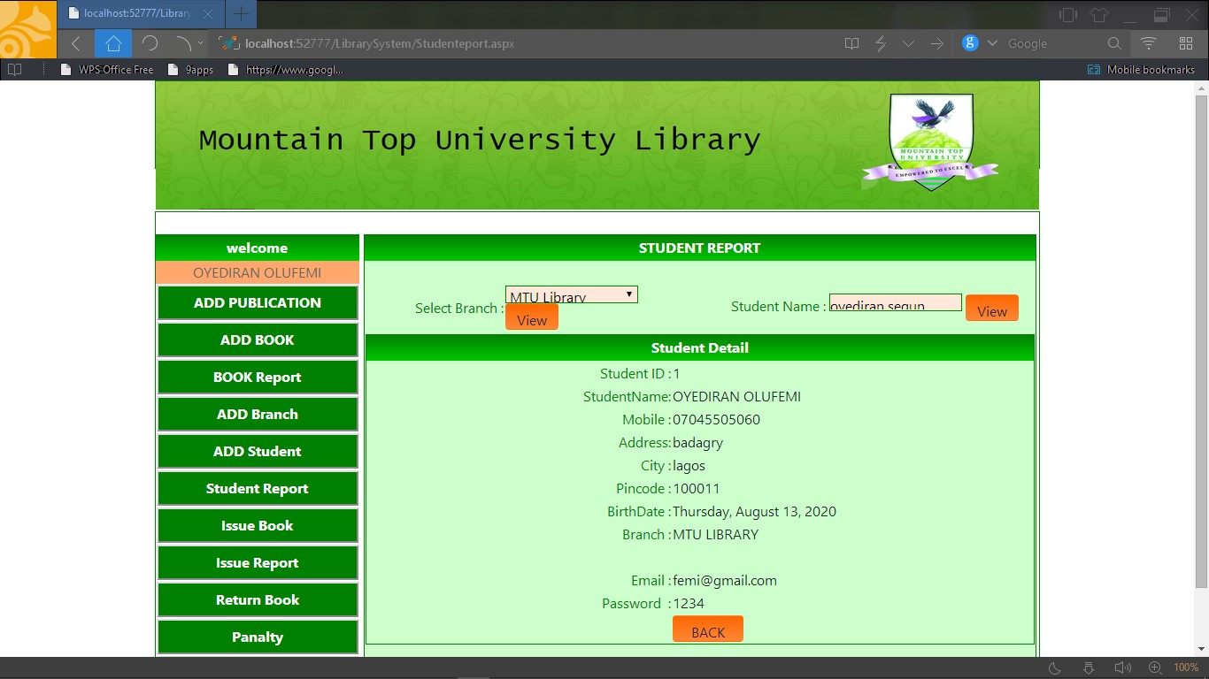

4.7 PROGRAM DOCUMENTATION
The program documentation involves statement of the sequence of the program, testing, running and output. Since proper documentation helps the programmer to be able to effect future maintenance on the system, it’s wise to document the work. This program-digital library system has been subjected to some tests and has proven effective. The test reveals bugs, which has been fixed. The process is quite a lengthy and expensive process but when carefully followed yields dramatic results. A careful and thoroughly designed Digital Library System in the design stage helps minimize error during the time of testing and running. It is a good practice to test each component of a program as it is produced as well as testing the complete program.

4.8 SYSTEM INSTALLATION
The program documented has been tested and it is password protected to prevent unauthorized usage. We now carryout change over from the old system to the new system by using a central computer that houses the database and from where a student or staff can access electronic materials. Digital Library System is web based. A trained personnel should be employed to handle the new system as well as maintain it during hardware installation, materials that are durable and efficient should be used.



TITILE

AUTHOR

SUBJECT

PUBLISHER

YEAR OF
PUBLICATION

ISBN

COLLEGE

DEPARTMENT

FIG 4.8.1: SAMPLE OF INPUT/OUTPUT DATABASE
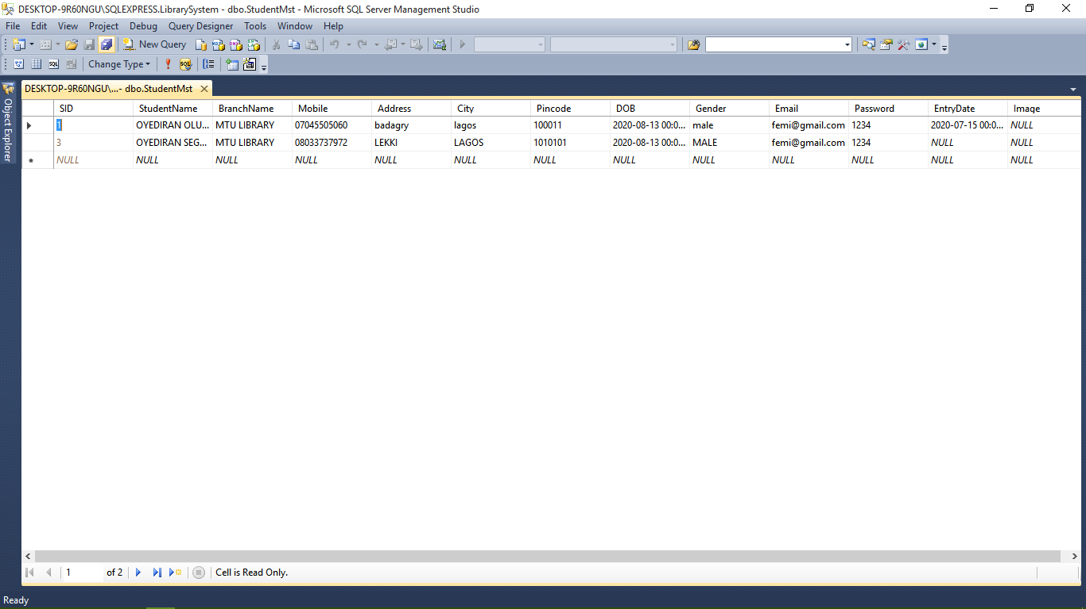

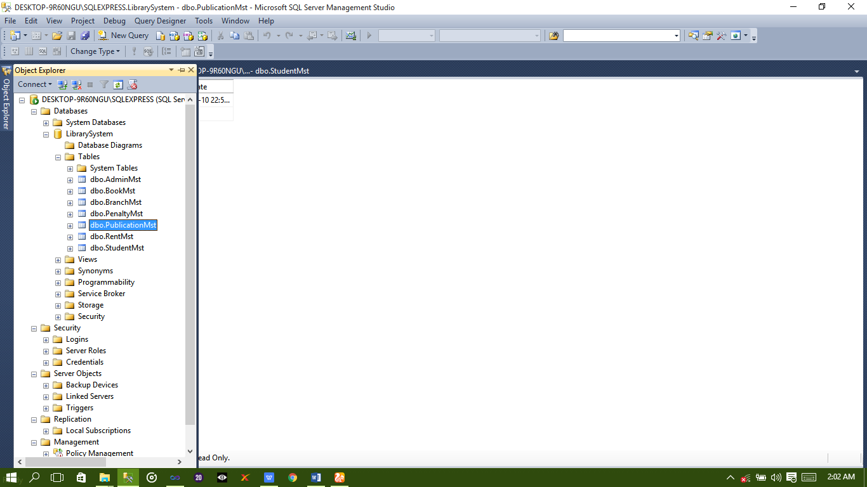

Fig 4.8.2 Diagram of input and output of database

CHAPTER FIVE

5.1 SUMMARY, RECOMMENDATION AND CONCLUSION
The field of Digital Libraries has always been poorly defined as “discipline” of amorphous border and crossroads, but also of atavistic resonance and unreasonable inspiration. “Digital Libraries” this oxymoronic phrase has attracted dreamers and engineers, visionaries and entrepreneur, a diversity of social Scientist, lawyer, scientist technicians and even critics. Some would argue, however that digital libraries have nothing to do with libraries as entities or the art of bibliography. Others would argue that the issue of the future of libraries as a social, cultural and community organization, along with similar concerns concerning the existence and treatment of what we have come to term "Intellectual Property" in our culture, is probably the most central issue within the Digital Libraries discipline, and that these issues are too important to be left to the librarian.

5.2 SUMMARY
The investigation and analysis of the present system was conducted and the problems associated with the old method of accessing electronic resources were discovered. The new system was designed and implemented. It took care of the problems identified during investigation. The implementation stage was successful and it was implemented using ASP.Net on Windows 7 Operating System. Some sample output hardcopies obtained will be attached as appendix.
The project was organized into five chapters namely:
Introduction which gives an overview of the project. Literature review which exposes the author to a lot of related sources and research carried-out by the people. Investigation and analysis which x-rays thoroughly the old system, hence noting the in capabilities. The design and implementation of the new system under which results were obtained. While the project ended with conclusion and recommendation with some references.

5.3 RECOMMENDATIONS
It is my recommendations to tertiary institutions especially the Mountain Top University to fully implement this system as this will not only boost the efficiency of our library services but will also have a good boost on the corporate image of the institution and the quality of books available to student, thus placing the institution in a leading position in Nigeria. Also, I recommend that the MTU library should ensure that books are made available in electronic format as it is in the hardcopies.

5.4 CONCLUSION
Libraries, the automated information management system and human computer interfaces are very important in this era of computers. Numerous study and functional efforts have exploded in digital libraries, and vast budgets for research and practice in digital libraries are being increased. The overall assessment of modern libraries would be linked to the transition of their content, as well as the evaluation of libraries throughout history. Digital Libraries allow for contact between individuals, human intelligence, organisations and technologies. The new digital library is shaping science, education, learning and living.
I am therefore looking forward to the day when the digital library will pass to the next level in Nigeria, where a conglomerate of technological services will be made accessible by the use of the Digital Library. A situation where digital resources will be made available in Nigeria through a global network where collections are created, stored at one library and made available to others through an agreement about the requirements for systems architecture, metadata, indexing and retrieval. The creation and implementation of universal standards would take much increased work and exploration.

REFERENCES
Clifford Lynch (2005). Where do we go from Here? The next decade for Digital Libraries, D-Lib Magazine. July/August 2003, Volume II, Number 7/8.
Fox, E. A. Envisioning a Computer Science Digital Library. Presented at Digital Libraries of the Future Panel, ACM Multimedia 93, Anaheim, C. A., 1993.
Harter, S., (1997). Scholarly Communication and the Digital Library: Problems and Issues.
Journal of Digital Information. http://jodi.ecs.soten.ac.uk
Levy, D. M. & Marshall, C. C., (1995). Going Digital: A Look at Assumptions Underlying Digital Libraries Communications of the ACM, 38(4), 77-84.
L.T Nowell and E. A. Fox: Envision: Information Visualization in a Digital Library; Demonstration. Seattle, WA: ACM SIGIR 95, July 10, 1995.
Robertsons, S. Jitan & Resse, K. (1997). Web Based Collaborative Library Research. Proceedings of the 2nd ACM International Conference on Digital Libraries 152 – 160.
Hamedan Branch. “Managing Digital Libraries in the Light of Staff and Users: An Approach” International Journal of information Science and Management, Vol.7, No 132, Iran.
Edwards Vilas,”. (1998) “Self-services: transforming the role of library staff.” Autumn 1998 SCONUL Newsletter, University of Sunderland.

Liz Burke. (2001) “The future role of librarians in the virtual library environment.” The Australian Library Journal, September.

K. Nageswara Rao, KH Babu. (2001) “Role of Librarian in Internet and World Wide Web
Environment.” Information Sciences, Vol. 4 No. 1.
Emmanuelle, Bermes et.all (2011) “The Human Face of Digital Preservation:
Organizational and Staff Challenges, and Initiatives.” Bibliothèque nationale de France International Journal of Digital Curation Issue 1, Volume 6.
Bas Savenije. (2000) “The future of the library: the crucial importance of
Accessibility.”Symponism. “IRIS e la Collaborazione al Servizio degli Studi Umanistici” Florence
Lynne Brindley, Derek Law. (1997) “Digital library developments – A realistic future.” IFLA INSPEL, Copenhaghen, p. 195 -203.
Sharifabadi, S. R. (2006). How Digital Libraries can Support E-Learning. The Electronic Library 24(3).
Dawson, A., 2007. Building a digital library in 80 days: the Glasgow experience. [online] available at: <http://cdlr.strath.ac.uk/pubs/dawsona/301.htm> [Accessed 24 January 2016].
Dennis, A. and Wixom, B., 2000. Systems analysis and design: an applied approach. New York:
John Wiley & Sons.
Digital library federation (DLF). 2008. Definition of digital libraries. [online] Available at:
<http://www.diglib.org/about/dldefinition.htm> [Accessed 21 January 2016].
Elaiess, R., 2009. General guidelines for designing bilingual low cost digital library services suitable for special library users in developing countries and the Arabic speaking world.
In: Proceedings of the world library and information congress: 75th IFLA general conference.
Milan, Italy 23-27 August 2009. [Online] Available at: <http://www.ifla.org/files/hq/papers/ifla75/175-elaiessen.pdf> [Accessed 28 October 2016]. [9] Jeng, H., 2006. Usability of the digital library: an evaluation module. Ph.D. New Jersey: State University of New Jersey.
Leiner, M. and Richard, S., 2006. A working definition of digital library. [online] Available at: <http://www.diglib.org/about/dldefinition.htm> [Accessed 16 January 2016]. [11] Witten, I. and Bainbridge, D., 2003. How to build a digital library. San Francisco: Morgan Kaufmann.
Arms, W.Y. (2000), Digital Libraries, MIT Press, Cambridge, MA.
Michael Seadle, Elke Greifeneder (2007) "Defining a digital library", Library Hi Tech, Vol. 25 Iss: 2, pp.169 – 173
Michael Seadle and Elke Greifeneder, (2007), “Defining a digital library” Library Hi Tech
Vol. 25 No. 2, 2007 pp. 169-173 Permanent link to this document: DOI
10.1108/07378830710754938
Ekere, Justina n. dr.; omekwu, charles obiora; and nwoha, chidinma m. (2016), "User’s perception of the facilities, resources and services of the MTN digital library at the university

Asad Khan Saima Qutab , (2016),"Understanding research students’ behavioural intention in the adoption of digital libraries A Pakistani perspective ", Library Review, Vol. 65 Iss 4/5 pp. 295
– 319 Permanent link to this document: http://dx.doi.org/10.1108/LR-06-2015-0070

Fox, Edward A. et. al. National Digital library of theses & dissertations: A scaleable
& sustainable approach to unlock university resources. D-lib magazine, Sept., 1996. < http://www.dlib.org/dlib/september96/theses/0970.html>.
Arms, Williums. Y. An architecture for information in digital libraries, D-Lib Magazine, Feb.
1997.

Bolanle F. Oladejo a recommender system for academic projects repositry International Journal of Scientific & Engineering Research Volume 8, Issue 6, June-2017 1586 ISSN 2229-5518 IJSER © 2017 http://www.ijser.org

Bertino, E., Casarosa, V., Crane, G., Croft, B., Del Bimbo, A., Fellner, D., Fiander, P., Fox, E., Fuhr, N., Ioannidis, Y., Koch, T., Larsen, R., Manson, P., Marchetti, P. G., Mylopoulos, J., Neuhold, E., Paolini, P., Papazoglou, M., Romary, L., Schek, H.-J., Smeaton, A., Thanos, C., Wactlar, H. (2001). Digital Libraries: Future Directions for a European Research Research Programme. San Cassiano. DELOS.
Borgman, C. (1999). What are digital libraries? Competing visions. Information Processing and Management, 35 (3), 227-243.
Borgman, C. (2010). Scholarship in the Digital Age: Information, Infrastructure, and the Internet.
The MIT Press.
Bush, V. (1945). As We May Think. Atlantic Monthly (176), 101-108. Candela, L., Athanasopoulos, G.; Castelli, D.; El Raheb, K.; Innocenti, P.; Ioannidis, Y.; Katifori, A.; Nika, A.; Vullo, G.; & Ross, S. (2011). The Digital Library Reference Model. DL.org Project Deliverable.
Candela, L., Castelli, D., & Pagano, P. (2011). History, Evolution and Impact of Digital Libraries. In I. Iglesias, T.-E. Synodinou, & S. Kapidakis, E-Publishing and Digital Libraries: Legal and Organizational Issues (pp. 1-30). IGI Global.
Fox, E. A., Akscyn, R. M., Furuta, R. K., & Leggett, J. J. (1995). Digital Libraries. Communications of the ACM, 38 (4), 23-28.
Fox, E., & Marchionini, G. (1998). Toward a Worldwide Digital Library. Communications of the ACM, 41 (4), 29- 32.
Griffin, S., Peters, C., & Thanos, C. (2005). Towards the new-generation digital libraries: recommendations of the NSF/EU-DELOS working groups. International Journal of Digital Libraries, 5 (4), 253-254.
Ioannidis, Y. (2005). Digital libraries at a crossroads. International Journal of Digital Libraries, 5 (4), 255-265.
Kuny, T., & Cleveland, G. (1996). The Digital Library: Myths and Challenges. Proceedings 62nd IFLA General Conference.
Lesk, M. (1999). Expanding Digital Library Research: Media, Genre, Place and Subjects. Proceedings of the International Symposium on Digital Libraries1999, ISDL’99, (pp. 51-57). Tsukuba, Ibaraki, Japan.
Licklider, J. (1965). Libraries of the Future. Cambridge: The MIT Press.
Subrata Sur. (2007) “Expert staff for digital resource management: an analytical view.” 5 th conventional planner, Guwahati University, December 7 – 8, INFLIBNET Centre, Ahmedabad, 2007.
Subrata Sur, Sujata Sur. (2007) “Expert staff for digital resource management staff for digital resource management: an analytical view “5th conventional planner, Guwahati University, December 7 – 8, INFLIBNET Centre, Ahmedabad.
Sharma P L. (2007) “Changing role of the librarians in the digital era and need of professional skills, efficiency and competency.” Library and Information science, DSpace/Manikin Repository.
Shiou – Luan Wang. (2009) “An examination of library use for improving services for IT
Impact” International conference on virtual environments, human interface measurements.” IEEE, Hong Kong, China.
Ziming Liu. (2006) “Print vs. electronic resources: A study of user perceptions, preferences and use.” Information Processing and Management, Vol.42 p. 583–592.

