DESIGN AND IMPLEMENTATION OF A GEOGRAPHICAL INFORMATION SYSTEM FOR TRACKING THE SPREAD OF CORONAVIRUS IN NIGERIA

ESOMOJUMI OLUWATOSIN.
16010301011

BEING A PROJECT SUBMITTED TO THE DEPARTMENT OF COMPUTER SCIENCE AND MATHEMATICS, COLLEGE OF BASIC AND APPLIED SCIENCES

IN PARTIAL FULLFILMENT OF THE REQUIREMENTS FOR THE AWARD OF BACHELOR IF SCIENCE (B.Sc.) DEGREE IN COMPUTER SCIENCE
MOUNTAIN TOP UNIVERSITY, IBAFO, OGUN STATE, NIGERIA

2020

CERTIFICATION

This is to certify that this project, DESIGN AND IMPLEMENTATION OF A GEOGRAPHICAL INFORMATION SYSTEM FOR TRACKING THE SPREAD OF CORONAVIRUS was carried out by me ESOMOJUMI OLUWATOSIN COLLINS with matric no. 16010301011 and duly supervised by Prof P.A Idowu.

_________________________ __________________
Prof.P.A Idowu Date
(Supervisor)

_________________________ __________________
Dr. I. O. Akinyemi Date
(Head of Department)

DEDICATION
This Project is dedicated to humanity.

ACKNOWLEDGEMENT
I owe my profound gratitude to the Almighty God who from the very beginning has given me strength, wisdom and courage, divine support and provision. I thank my Major Supervisor, Dr. Idowu P.A. for his encouragement and support. I deeply appreciate the fatherly advice and guidance of the Dean, College of Basic and Applied Sciences, Dr Akinwande A.I. My sincere appreciation goes to the Head of Department of Computer Science and Mathematics — Dr Akinyemi I.O., and to all other staff members of the Computer Science Department: Dr. (Mrs.) Kasali F.A., Dr. Balogun., Dr. and others to note.
I appreciate the continuous encouragement of my mentors. That's Pastor Olumide A. I am also grateful to my parents who for my success sacrificed money, time and other resources; and my siblings for their prayers. I would also like to thank all colleagues and friends of Mountain Top University for their prayers and encouragement. God bless everyone.

Table of Contents
CERTIFICATION 2
DEDICATION 3
ACKNOWLEDGEMENT 4
TABLE OF CONTENTS 5
ABSTRACT 6
CHAPTER ONE 7
  - Background To Study……………………………………………………………………………………..…………………….…….8
  - Statement of Problem………………………………………………………………………………………………………………..11
  - Aim and Objective of Study………………………………………………………………………………………………………..11
  - Research Methodology…………………………………………………………………………………………………………………………….11
  - Scope And Limitation Of Study………………………………………………….………………………………………………13
  - Justification Of Study………………………………………………………………………………………………………………..13
  - Arrangement of Thesis……………………………………………………………………………………………………………..13

CHAPTER TWO…………………………………………………………………………………………………………………………14
LITERATURE REVIEW…………………………………………………………………………………………………………………..14
2.1 Introduction………………………………………………………………………………………………………………………….14
2.2 Disease Surveillance And Reporting………………………………………………………………………………………17
2.2.1 The First Case In Nigeria…………………………………………………………………………………………………….21
2.2.2 International Health Regulation…………………………………………………………………………………………22
2.3 System Development Life Cycle Programming Improvement Life Cycle……………………………….24
2.3.1 Information Framework Advancement…………………………………………………………………………….26
2.3.2 Modelling Methods……………………………..…………………………………………………………………………..27
2.4 Geographic Information System………………………………………………………………………………………..32
2.4.2 Data Models……………………………………………………………………………………………………………………..33
2.5 Related Works……………………………………………………………………………………………………………………38

CHAPTER THREE………………………………………………………………………………………………………………………..40
3.1 Introduction…………………………………………………………………………………………………………………………40
3.2 Functional And Non Functional Requirement………………………………………………………………………41
3.2.1 Functional Requirement Analysis……………………………………………………………………………………..41
3.2.3 Hardware Prerequisites…………………………………………………………………………………………………43
3.3 System Analysis And Design…………………………………………………………………………………………….43
3.3.1 Use Case Graph……………………………………………………………………………………………………………..44
3.3.2 Class Diagram………………………………………………………………………………………………………………..46
3.4 System Development Tools Execution……………………………………………………………………………..47
3.4.1 Cascading Style Sheet……………………………………………………………………………………………………47
3.4.2 PHP……………………………………………………………………………………………………………………………….48
3.4.3 SQL……………………………………………………………………………………………………………………………….49
3.4.4 Google Map Api……………………………………………………………………………………………………………49

CHAPTER FOUR…………………………………………………………………………………………………………………….51
4.1 Introduction……………………………………………………………………………………………………………………51
4.2 Implementation Of The System Database For Covid 19 Cases…………………………………………51
4.3 Results Of The Implementation Of System Interface………………………………………………………. 62
4,4 Discussion Of Results……………………………………………………………………………………………………….76

CHAPTER FIVE………………………………………………………………………………………………………………………..77
5.1 Summary…………………………………………………………………………………………………………………………77
5.2 Conclusion………………………………………………………………………………………………………………………77
5.3 Recommendation……………………………………………………………………………………………………………78
REFERENCES………………………………………………………………………………………………………………………79-90

ABSTRACT
This project will help in getting information about the spread of coronavirus and how it spreads everyday by gathering data geographically and locally so as to be specific and accurate in tracking this deadly virus to prevent more spread.

A variety of associated risk factors will be reported and as a result, intervals that increased the risk will be given higher values, while intervals that reduced the risk of coronavirus will be given lower values using a web based information system using an hospital as a study case.

This study will identify the design and implementation for tracking the spread of coronavirus . Thus, this study conclude that the presence of GIS is needed to track this deadly virus and emanate a statistical result from the place, number of people who might have been infected with the virus.
Keywords: Coronavirus, GIS, ,Web-based information and Pandemic.

1.1 Background To Study

Coronavirus infection (COVID-19) is brought about by SARS-COV2 and speaks to the causative operator of a possibly deadly illness that is of extraordinary worldwide general wellbeing concern. In view of the enormous number of contaminated individuals that were presented to the wet creature advertise It is suggested in Wuhan City , China, that this is the origination of the deadly epidemic COVID-19.

Individual to-individual transmission of COVID-19 contamination prompted the segregation of patients that were in this manner directed an assortment of medicines. Broad measures to lessen individual to-individual transmission of COVID-19 have been executed to control the present episode. Uncommon consideration and endeavors to ensure or diminish transmission it needs to be applied in defenseless populaces including youngsters, medicinal services suppliers, and old individuals.

In this audit, we features the manifestations, the analysis of disease transmission, transmission, pathogenesis, phylogenetic investigation and future headings to control the increase of this lethal ailment. Covid-19 are a gathering of encompassed infections with non-segmented, single-abandoned, and positive-sense RNA genomes. Aside from tainting an assortment of financially significant vertebrates, (for example, pigs and chickens), six coronaviruses have been known to contaminate human has and cause respiratory sicknesses.

Among them, serious intense respiratory disorder and respiratory condition coronavirus are pathogens and exceptionally pathogenic coronaviruses that have brought about provincial and worldwide episodes Coronaviruses have an unmistakable Methylation patterns, is the name gotten from the external periphery, or -corona? of installed envelope protein. Individuals from the family Coronaviridae cause an expansive range of creature and human sicknesses.

Remarkably, replication of the RNA genome continues through the age of a settled arrangement of viral mRNA atoms. coronavirus (CoV) contamination makes respiratory ailments with mellow serious results. Over the most recent 15 years, we have seen the uprise of two zoonotic, exceptionally pathogenic HCoVs: extreme intense respiratory disorder coronavirus (SARS-CoV) and Middle East respiratory condition coronavirus (MERS-CoV).

Replication of HCoV is directed by a decent variety of crucial factors and instigates exceptional changes in cell structure and physiology A tale coronavirus, assigned as 2019-nCoV, developed in Wuhan, China, toward the finish of 2019. As of January 24, 2020, at any rate 830 cases had been analyzed in nine nations: China, Thailand, Japan, South Korea, Singapore, Nepal, Taiwan, and United States.

Twenty-six fatalities happened, mostly in patients who had fundamental disease. Albeit numerous subtleties of the uprise of this infection —, for example, its beginning and its potential to spread among people — stay unseen, an expanding number of incident seem to have come about transmission from human to human.

Given the extreme intense respiratory condition coronavirus (SARS-CoV) flare-up in 2002 and the Middle East respiratory disorder coronavirus (MERS-CoV) episode in 2012, 2019-nCoV is the third coronavirus to develop in the human populace in the precedence of two decades — a rise that has put worldwide general wellbeing foundations on high alarm.

China reacted rapidly by educating the World Health Organization (WHO) of the flare-up and sharing arrangement data with the universal network after revelation of the causative specialist. The WHO reacted quickly by planning diagnostics improvement; giving direction on persistent checking, example assortment, and treatment; and giving modern data on the flare-up.

A few nations in the area just as the United States are screening explorers from Wuhan for fever, planning to recognize 2019-nCoV cases before the infection spreads further. Updates from China, Thailand, Korea, and Japan demonstrate that the malady related with 2019-nCoV seems, by all accounts, to be moderately mellow as contrasted and SARS and MERS.

Coronaviruses make up an enormous group of viruses that can taint feathered creatures and vertebrates, including people, as indicated by world wellbeing association (WHO). These pathogens have been answerable for a few flare-ups the world over, including the extreme intense respiratory disorder (SARS) pandemic of 2002-2003 and the Middle East respiratory condition (MERS) episode in South Korea in 2015.

Most as of late, SARS-CoV-2, otherwise called COVID-19) set off a flare-up in China in December 2019, starting universal concern. While some coronaviruses have caused annihilating pestilences, others cause gentle to direct respiratory diseases, similar to the regular virus.

1.2 Statement of the Problem

Coronavirus (Covid-19) cases are on the increase among Nigerians affecting more adults thus posing a serious threat to nigerians In Nigeria, keeping track of incidence reports of Covid cases reported is not available which has led to the under-utilization of resources provided by the government and other NGOs to potential areas.

There is presently no information system which provided a central database for collecting and monitoring information related to Covid-19 reported at hospitals in a stable, trustworthy and timely manner, hence this study.

1.3 Aim and Objectives of the Study

The aim of this study is to develop an information system which can be used by hospital staffs and health workers for the storage and retrieval of information regarding reported Covid-19 at hospitals in order to improve decision making. The specific research objectives are to
- identify the requirements of the Covid-19 monioring system from system users;
- specify the design of the Covid19 monitoring system; and implement the system.

1.4 Research Methodology
In order to meet up to the aforementioned objectives the following methods were adopted
a. Following review of related works regarding the development of GIS systems, structured interview with medical experts was performed in order to identify the user and system requirements of the proposed system.

b. The system design was specified using the Unified Modelling Languages (UML) such as use-case for the user actions, sequence diagrams for timing of operation and class diagrams for the data model of the system.

c. The system will be implemented using a combination of Hypertext Mark-Up language (HTML) and Cascading Styling Sheets (CSS) for the web layout design, PHP for connecting data in and out of the database to the interface, JavaScript (JS) for Google Map functionality and Structured query language (SQL) for database implementation.

1.5 Scope and Limitations of the Study
This study is limited in scope to the development of a GIS system for the storage, retrieval and analysis of information for decision support for its users. This system will not be able to handle spatial analysis of location-based information which were presented using tables, charts and maps.

1.6 Justification of the Study
Advances in digital computing and communications have contributed immensely to the development of fast and reliable information system for the storage and retrieval of confidential information in a secured manner. Such technologies if put in place for managing the information captured about reported Covid-19 cases across Nigeria will enable hospital staff to properly analyze the trends of reported Covid-19 cases.

Spatial database technologies improve data analysis by providing a visual interpretation of analyzed data which enhances decision making almost instantaneously.

1.7 Arrangement of Thesis
This chapter presents the introductory section of the project. Chapter two presents the review of related works surrounding the body of knowledge of Covid-19, system development life cycle and mobile development practice.

Chapter three presents the specific materials and methods that were required for the design and development of the surveillance based system. Chapter four presents the results and discussion of the methods applied. Chapter five presents the summary, conclusions and recommendation of the study.

CHAPTER TWO
LITERATURE REVIEW
2.1 Introduction

Covid Diseases (COVID-19), a respiratory infection portrayed by fever, dry hack, and weakness, and infrequent gastrointestinal manifestations, had its underlying flare-up in Wuhan city, Hubei, China in late December 2019. Inside a month, the sickness has raised in China and further spread to different nations including Thailand, Japan, Republic of Korea, Vietnam, Germany, United States, and Singapore [15,28,31]. On the 30th January 2020, the WHO freely proclaimed COVID-19 as a sickness of global concern and later on eleventh March 2020 revealed it as a pandemic dependent on its disturbing degrees of spread and seriousness over the world.

As per the World Health Organization (WHO) COVID-19 circumstance report of 29th April 2020, there were 3,018,052 affirmed cases and 207,973 passings internationally. The infection has spread to in any event fifteen (15) nations in the Western Pacific Region with 146,720 affirmed cases and 6,037 passings; (53) countries in the European Region with 1,406,899 affirmed cases and 129,311 passings; ten (10) nations in the South-East Asia Region with 51,351 affirmed cases and 2,001 passings; (21) nations in Eastern Mediterranean Region with 176,928 affirmed cases and 7,304 passings; (35) districts in Region of the Americas with 1,213,088 affirmed cases and 62,404 passings; and (45) nations in African Region with 23,254 affirmed cases and 903 passings of which Nigeria had 1,337 affirmed cases and 40 passings . All things considered, this was the Nigerian circumstance report of 27th April 2020 .

In Wuhan , China, on December 31 , 2019, it was first posted to the WHO. Coronaviruses are named for the spikes that, resembling a crown or the corona of the sun, protrude from their surfaces. They can harm both animals and humans, and they can cause severe respiratory tract diseases.

(Parker-Pope) At least four kinds of coronaviruses, including the common cold, cause very fatal infections every year. At some point in their lives, most people get infected with one or more of these viruses (Metz). It is hard to accurately assess the lethality of a new virus. It appears to be less often fatal than the coronaviruses that caused SARS or MERS more than common flu. The fatality rate was over 2 percent, in one study.

Children are less likely to be infected with the new coronavirus, while middle-aged and older adults are disproportionately infected (Mandavilli). Compared to women, men are more likely to die from an infection, presumably because they produce poorer immune systems and have higher rates of tobacco use, type 2 diabetes, and elevated blood pressure than women, which could raise the risk of post-infection complications.

Experts suspect that the virus could have been first spread by an infected animal to humans at a market in Wuhan that sold live fish, animals and birds. Subsequently, the market was shut down and disinfected, rendering it virtually difficult to examine whatever animal may have become the actual root. As they have grown to coexist with many viruses, bats are considered a potential host, and they were found to be the starting point for SARS.

it is also possible that bats transmitted the virus to an intermediate animal, like pangolins, which are consumed as a delicacy in parts of China, and will have then passed on the virus to humans (Gorman). The outbreak grew thanks to human-to-human transmission. People infected with the virus produce tiny respiratory droplets after they breathe, talk, cough or sneeze, allowing the virus to travel through the air.

Most respiratory droplets fall to the bottom within some feet. folks that are in close contact with those infected, particularly members of the family and health care workers, may catch the virus this fashion. Scientists don’t understand how long the new coronavirus can continue to exist surfaces, and preliminary research suggests that hot and humid environments might not block the pathogen’s spread. Warm weather does tend to oppose influenza and milder coronaviruses.
Infected people is also able to expire coronavirus whether or not they need few obvious symptoms, a study in Germany has found. Still, a report by the globe Health Organization suggests that asymptomatic cases are rare. Symptoms of this infection include fever, cough and difficulty breathing or shortness of breath. The illness causes lung lesions and pneumonia.

But milder cases may resemble the flu or a nasty cold, making detection difficult. Patients may exhibit other symptoms, too, like gastrointestinal problems or diarrhea. Current estimates suggest that symptoms may appear in as few as two days or as long as 14 days after being exposed to the virus.
2.2 Disease Surveillance and Reporting

in Nigeria Nigeria is situated within the West African sub region. Administratively, the country is split into thirty six States and one Federal Capital Territory (FCT) Abuja.
There are 774 government Areas (LGAs) which is that the lowest administrative level. In 2000, the global Health Organization ranked Nigeria‘s total health system performance as 187th among 191 member states.

On the African continent, Nigeria is simply experiencing the direct effects of this pandemic, having recorded her patient in February 2020, with an increasing number of cases a day and a current case fatality ratio of 0.03 as at 13 April 2020.
Although the recorded cases could appear low, it's been forecast that Africa will have a number of the worst effects of this disease by the top of the pandemic.
Fig2.2 Shows the summary of COVID-19 Cases across different states in Nigeria as of 3 May 2020

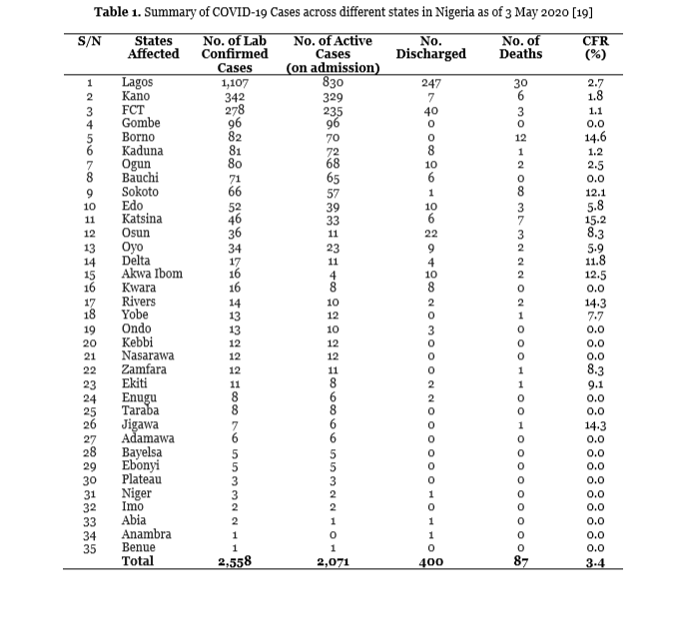

Generally, African countries have fragile health systems and this remains a source of concern, especially within the event of increased outbreaks. Nigeria's current national health systems cannot effectively answer the growing needs of already infected patients requiring admission into medical aid units for acute respiratory diseases and severe acute respiratory syndrome (SARS COV-2) pneumonia.

This has grim implications for Nigeria, especially as increased cases loom which will require critical care. Provision of quarantine or isolation facilities and availability of rapid diagnostic kits for fast and reliable testing and diagnosis of the disease also can be a challenge in Africa.

The Government of Nigeria is trying its best to prevent the spread of this pandemic and presently many countries in Nigeria are in total or partial lockdown. On 28 January (a month before the primary case of the virus emerged), the centralized had assured citizens of its readiness to strengthen surveillance at five international airports within the country to forestall the spread of the coronavirus.

The Nigeria Centre for Disease Control (NCDC) also announced that it had already founded a coronavirus group and was able to activate its incident system if any case emerged in Nigeria. the govt seems to possess mobilized quickly – on 31 January, following the developments of the pandemic in mainland China and other countries worldwide, the federal founded a Coronavirus Preparedness Group to mitigate the impact of the virus if it eventually spreads to the country.

On the identical day, the globe Health Organization (WHO) listed Nigeria among the 13 African countries identified as high-risk for the spread of the virus. When on 27 February Nigeria reported its first coronavirus case, Nigeria’s Minister of Health announced that those 60 people that had a contact with the index Italian patient were under isolation – 40 in Ogun State and 20 in Lagos State.

President Buhari has established a Presidential Task Force for the control of the virus within the country. The Nigerian government quickly announced the closure of all educational institutions. it's also postponed the 20th National Sports Festival that was billed to carry in Benin City and therefore the Nigeria Football Federation suspended all football activities for four weeks.

On 18 March, the national announced that travellers from 13 high-risk countries would now not be allowed to enter Nigeria until the Coronavirus pandemic was over. These are countries with over 1,000 cases domestically. the govt. also stopped issuance of visas from these countries. many nations have stepped up to produce emergency isolation and treatment centers.

The NCDC has been investing in epidemic-preparedness over the past few years and includes a well-established system of Public Health Emergency Operations Centers (PHEOCs) founded. It also puts out daily updates and issues public advisories. However, Nigeria is also grappling with a testing problem : As on 22 Mar, Nigeria’s Centre for Disease Control has only tested about 152 people, which has probably led to a large under-estimate of the matter.

The Federal Ministry of Health is functioning closely with States and also the Presidential Task Force on COVID-19 to review response activities, and initiate measures to shield the health and wellbeing of Nigerians. The Multi-Sectoral Emergency Operation Centre (EOC), led by NCDC, coordinates the national response activities. NCDC has also launched a WhatsApp Application: A free service founded to produce a central source of accurate, verified and current information on COVID-19 in Nigeria.
As the state scrambles to mobilise finances, its problems are mounting. Doctors in Abuja – Nigeria’s capital city – went on strike recently thanks to not having been paid their salaries for about two months. Nigeria has to act quickly to insure its frontline/healthcare workers.

2.2.1 The First Case In Nigeria
He was admitted at Reddington Hospital and was released the subsequent day after testing negative. Nigeria confirmed its first case in Lagos State on the 27th of February, an Italian citizen who works in Nigeria had returned on 25 February from Milan, Italy through the Murtala Muhammed International Airport, fell ill on 26 February and was transferred to Lagos State biosecurity facilities for isolation and testing.

The second case was confirmed on the 9th Of March, a Nigerian citizen in Ewekoro, Ogun State who had contact with the Italian citizen. On 13 March, Nigeria confirmed that the second case now not had the virus in his system and thus tested negative. On 17 March, Nigeria confirmed the third case in Lagos State, A 30-year-old Nigerian female citizen that returned on 13 March from the uk.

They also confirmed their first death, a 67-year-old Suleiman Achimugu, an engineer and former manager of Pipelines and products Marketing Company, who returned from uk with health conditions. On 24 March, there have been four new cases: one in Lagos State, one in Ogun State, one in Bauchi State and one within the FCT.
On 25 March, there have been seven new cases: three in Lagos State, one in Osun State, one in Rivers State and two within the FCT.

On 26 March, there have been 14 new cases: 12 in Lagos State, one in Bauchi State and one within the FCT. Nigeria announced that they were tracing 4,370 suspected cases of the virus. (Wikipedia,2020)

2.2.2 International health regulation (IHR)

The International Health Regulations (2005), (additionally alluded to as the IHR or the Guidelines) went into power on 15 June 2007. The Regulations are authoritative on each of the 46 WHO Member States in the African Region as all have concurred in 2005 to be limited by these Regulations. The IHR have a wide extension and the Regulations apply to - any crisis with worldwide repercussions for wellbeing, including flare-ups of rising and reappearing scourge inclined infections, episodes of food borne sickness, cataclysmic events, and compound or radio atomic functions, regardless of whether incidental or caused purposely. The IHR consider exercises learnt in past a long time in distinguishing and reacting to sickness flare-ups.

The International Health Regulations focused on ensuring worldwide wellbeing security while dodging superfluous obstruction with worldwide travel and exchange. IDSR gives a layout to the execution of IHR through the accompanying:
- A foundation and assets for observation, examination, affirmation, revealing and reaction;
- Experienced HR;
- Characterized usage measure (sharpening, appraisal, strategy, usage, checking and assessment);
- iv. Generic guides for assessment; Plan of action development; Technical guidelines; training materials; tools and Standard Operating Procedures that incorporate IHR components. Thus, IDSR is a framework with the possibility to guarantee a dependable gracefully of data to the public level so as to satisfy IHR prerequisites. The IHR give an occasion to deliver the danger to global general wellbeing security and exchange brought about by reappearing and developing transferable sicknesses including general wellbeing crises of global concern (PHEIC). They additionally give an incredible occasion to fortify reconnaissance and reaction frameworks, and to go about as a strong driver for IDSR execution.

Critically, Member States remembering Nigeria for the African Region suggested that IHR-2005 ought to be actualized with regards to IDSR. IHR is an official and lawful instrument. It calls for reinforcing of public limit with regards to observation and control, including locales, for example, purposes of passage (for example ports, air terminals and ground intersections); anticipation, alarm and reaction to worldwide general wellbeing crises; worldwide associations and global cooperation; and features rights, commitments, methods and observing of progress.

Through IDSR, Nigeria has been developing capacities for surveillance, laboratory confirmation, notification and response to outbreak.

2.3 System Development Life Cycle Programming improvement life cycle (SDLC)

This is a cycle followed for a product venture inside a product association. In writing, a large portion of the work characterized SDLC measures and inferred that it is a strategy for programming quality affirmation and an approach to guarantee that product improvement groups remain in the same spot.

In Tatar and Tomur (2013), SDLC was characterized as a reasonable model including a grouping of cycles followed to create data frameworks. It clarified that the product business follows the SDLC in light of the fact that it characterizes which assignment must be performed at each stage in the programming advancement measure and when completed adequately, the SDLC produces excellent programming that meets client desire and arrives at fulfillment inside time and quotes.

As expressed in Bhatnagar and Singh (2013), SDLC measure is an arrangement of exercises for framework creators and designers to follow for creating programming productively and on recommended time, for example, investigation, plan, execution, testing and upkeep. It further clarified that SDLC is an idea utilized in venture the board that depicts the stages engaged with a data framework advancement venture beginning from an underlying achievability studies to upkeep of the finished application, and accentuated that the essential targets of the SDLC are to guarantee the conveyance of high quality frameworks utilizing solid administration controls to amplify profitability.

In Sanni and Kaur (2014), SDLC was depicted as the philosophy by which the improvement of any product happens. It further clarified that before SDLC, cycle of building up the product was taken as casual exercises with no conventional standards what's more, principles which may prompt different issues, for example, delay being developed, cost invade and low programming quality.

The presentation of the SDLC gives the exact standard and the means for the improvement of the product. There are numerous SDLC models and procedures, for example, the cascade model, fast application advancement (RAD), joint application improvement (RAD), twisting model with every one of them comprising of arrangement of characterized steps or stages (Tatar and Tomur, 2013).

Nonetheless, Bhatnagar and Singh (2013) featured the most notable and generally utilized SDLC as the cascade, V-molded and advancement fast. Gandhi et al. (2014) 16 clarified that paying little heed to the decision of model, various sorts of dangers were related with every one of these SDLC stages. It proposed a model to help decide the effect of the danger on the task being grown, so that venture disappointments because of these dangers can be limited.

2.3.1 Information Framework Advancement
An Information framework comprises of information messages, message preparing and yield messages. It have additionally handling rules which control the execution of the Data framework. In the event that the handling rules are formalized we can have PC based Data frameworks.
Be that as it may, if the handling rules need a ton of individual information, judgment and Intuition, the data frameworks a manual. A deliberate Information framework will assist clients with using sound judgment and backing their activities (Anders, 2012). Data frameworks, as different items, are experiencing a daily existence cycle.

Such as Information Systems Development, Information Systems being used (Operation), Data Systems Maintenance Management and Information Systems Withdrawal. A data framework improvement is the way toward characterizing, planning, testing, and executing another product application or program (Farm Credit Association, 2007). The framework engineer utilizes various apparatuses, strategies, technique, strategy and theory to actualize the data framework improvement.

Demonstrating is a focal piece of the apparent multitude of exercises that lead up to the sending of great programming. It is utilized to impart the ideal structure and conduct of a framework. Likewise, models work to picture and control the framework's engineering and to better comprehend the framework we are building, regularly uncovering open doors for rearrangements, reuse and oversee chances (Booch et al., 1998). A Model gives the plans of a framework and help the clients picture the end result.

Distinctive displaying approaches for example, organized and object-situated, can be utilized in data framework improvement. The conventional perspective on programming advancement is alluded to as organized framework examination and configuration approach. This view drives designers to zero in on issues of control also, the deterioration of bigger calculations into more modest ones.

Such a methodology tends to yield fragile frameworks. As necessities change and the framework develops, frameworks worked with an algorithmic center end up being difficult to keep up. The item situated worldview is presently the most mainstream method of breaking down, planning and creating application frameworks, particularly huge ones.

In this worldview the components of a given circumstance is seen by decaying them into articles and item connections (Ramnath and Dathan, 2010). Frameworks created with the OO approach are more adaptable. These frameworks can be adjusted and improved effectively, by changing a few kinds of articles or by adding new sorts.

2.3.2 Modeling methods – Unified demonstrating language (UML)

Documentations empower to verbalize complex thoughts quickly and accurately. In ventures including numerous members, frequently of various specialized and social foundations, precision and lucidity are basic as the expense of miscommunication increments quickly.
In the OO world UML is the business standard language for indicating, envisioning, developing, and reporting the ancient rarities of programming frameworks (Laman, 2004). UML utilize diverse diagraming model to show the investigation and plan of a framework. There are nine antiques characterized in the UML demonstrating which essentially classified under two various perspectives on a framework model.

The static (or basic) see accentuates the static structure of the framework utilizing objects, properties, activities, and connections. These static parts are speaks to by, use case, class, bundle, segment, and organization graph (Padmanabhan, 2012).

- Use case graph

The utilization case graph is worried about the association between the framework and entertainers (objects outside the framework that associate straightforwardly with it). It presents an assortment of utilization cases and their relating outside entertainers. A utilization case is a nonexclusive depiction of a whole exchange including a few objects of the framework. Use cases are spoken to as ovals, and entertainers are portrayed as symbols associated with strong lines to the utilization cases they associate with.

utilization case outline is useful in picturing the unique situation of a framework and the limits of the framework's conduct. Each utilization cases in the utilization case graph can likewise be portrayed utilizing a story structure (Elkoutbi et al., 2012).

- Class graph

The class graph speaks to the static structure of the framework. It recognizes all the classes for a proposed framework and indicates for each class its credits, activities, also, connections to different classes. Connections incorporate legacy, affiliation, and conglomeration.

- Part chart

A part chart gives an actual perspective on the framework. Its motivation is to show the conditions that the product has on the other programming segments in the framework. It is worked as a component of design particular and created by engineers and developers.

d.Organization outline

The organization outline shows how a framework will be genuinely conveyed in the equipment climate. Its motivation is to show where the various segments of the framework will truly run and how they will speak with one another. It is used to recognize execution bottlenecks, and is created by planners, organizing architects, and framework engineers.

e. Bundle outline
Bundle outline shows how the different classes are gathered into bundles. Bundles are UML builds that empower you to coordinate model components into gatherings. It makes your UML outlines less complex and more obvious. Social charts essentially catch the dynamic part of the framework by indicating coordinated efforts among items and changes to the inner conditions of articles.

Dynamic viewpoint can be additionally depicted as the changing or moving pieces of a framework. These dynamic parts are spoken to by arrangement, joint effort, state diagram, and movement graph.

- Movement graph

Dynamic outlines are utilized to display the progression of an article as it moves from state to state at various focuses in the progression of control. It is basically a stream outline that underscore the movement that happens over the long run. Movement outlines can be utilized to model more elevated level business measure at the specialty unit level, or to show low-level inward class activities. It is less specialized in appearance, contrasted with arrangement charts, furthermore, business-disapproved of individuals will in general comprehend them all the more rapidly.

- Grouping outline

A grouping outline shows association among a bunch of articles in worldly request, which is useful for understanding planning issues.

It show a nitty gritty stream for a particular use case or even portion of a particular use case. An arrangement chart manages the succession of messages spilling out of one item to another. It is basically used to imagine the arrangement of brings in a framework to play out a particular usefulness.

- Joint effort outline

Joint effort outline is utilized to investigate the dynamic idea of the product. Coordinated effort charts show the message stream between objects in an article situated 20 application, and furthermore infer the essential affiliations (connections) between classes. The motivation behind coordinated effort graph is visualizing the organization of object and their interaction among each other.

2.4 Geographic Information System (GIS)

A geographic data framework (GIS) is an area based data framework displaying this present reality. It carefully catches, stores, oversees, investigates and presents area based datasets as alpha-mathematical or graphical yield (Lange, 2006). Relating objects to a geological situation inside a reference framework makes a topographical object. As a rule, we utilize geological directions, i.e., scope and longitude, to determine its situation on the outside of the earth. A GIS is a PC based framework to help in the assortment, support, stockpiling, investigation, yield, and appropriation of spatial information and data (Bolstad, 2007).

2.4.1 Geographic article

A geographic article is the principal unit of a GIS. It speaks to a one of a kind substance of the earth which is truly, mathematically or specifically restricted (Reinhardt et al., 2003). Norbert de Lange characterizes geological articles as follow: Geographical objects are spatial components which display mathematical, topological and worldly properties notwithstanding their semantic data (Lange, 2006). All things considered, geographic objects are a reflection of the real world. The created portrayal of this present reality is a computerized model with a characterized exactness. Topographical articles can be arranged into focuses, lines, and zones highlights, and strong figures (Imhof, 1975). For instance, point highlights can characterize outskirt stones or Points-of-Interest, line highlights can speak to water pipelines or streets, region highlights shows city zones or then again land-cover and strong figures speak to 3D structures or trees. This component based characterization characterizes one potential association of geographic information. Another methodology comprises in an article arranged model, i.e., general items can be determined into particular objects. A youngster object (e.g., a motorway) would acquire its credits from a base item (e.g., a street) (Lange, 2006). For overseeing, handling and imagining these articles we must make suitable structures, called information models.

2.4.2 Data models

An information model is the deliberation, portrayal and association of genuine world
components (Kappas, 2001). In that, the math, geography, semantic and relationship of genuine items must be preoccupied enough to produce a relating information model portrayal. This permits us to plan reality to information structures for computational and

representation purposes in a GIS. On a more significant level, we sort out geological articles utilizing two central standards: inside a layer or inside an article situated model. On a lower level, we separate between a raster-based and vector-based model.

- Topical layer idea

The topical layer idea starts from map making, where mapmakers made transparencies that could be overlaid on a light table. Subsequently, by joining various layers, they could make their ideal data thickness in a simple guide. This idea speaks to the default type of information association inside a GIS. It follows a top-down way to deal with make a topical arranging of all geographic info data. Each layer speaks to an unmistakable information topic comprising of an assortment of normal geographic components, e.g., a street organization, an advanced height model or metropolitan zones (Fig. 2.1). Topical layers have a few key favorable circumstances. To start with, they speak to a natural way to sort out and see information in a GIS. Second, blunders happening in a layer just have a nearby sway. At last, they are effective asset savvy, on the grounds that solitary mentioned layers are handled and envisioned.

- Vector, raster and half and half models

Vector information models speak to data as focuses, lines and polygons (Fig. 2.2). In a GIS, the OGC and ISO boards characterize these essential mathematical components as Simple Features (ISO, 2004). This model discretizes the math of genuine world components. All geographic components of the vector information model depend on point organizes, e.g., scope and longitude. The topological relationship is put away expressly, e.g., which focuses make a line or a region (Lange, 2006). Utilizing further ascribes, we characterize the topical relationship, e.g., regardless of whether a line is a street. Along these lines, the vector information model is likewise called the geo-social information model (Bartelme, 2005).
This model presents a few preferences (Buckey, 1997). Topographical information can
be spoken to with its initially caught goal. In a cartographic portrayal, the graphical yield is typically more tastefully satisfying. Additionally, straightforward mathematical components can for the most part be productively encoded into vector information, e.g., a street organization. Geography is effectively put away and empowers productive topological tasks, e.g., network examination. In any case, persistent information, e.g., temperature or rise information isn't viably

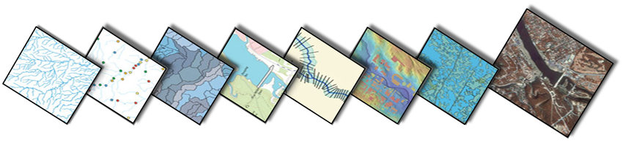

Thematic layers showing distinct images of geographical data
(Vaaraniemi, Mikael. (2014). Usability Oriented Visualization Techniques for 3D Navigation Map Display).

c. Field-based information model

The field-based model parcels the topic of the geographic information surface into
homogeneous zones (cells). The structure and size of these cells can be characterized uninhibitedly. In any case, overall, they should cover the whole information surface (Bartelme, 2005). Along these lines, every cell unequivocally stores geo-referred to topical data as appeared in Figure 2.3. A model for the field-based idea is the DEM, wherein every cell
speaks to the normal stature inside the covered info surface.

d. Raster information model

In GIS, the raster information model is utilized to speak to nonstop information over space. It
is a specialization of the field-based model. The info surface is isolated into similarly
measured territories, generally a quadratic cell, i.e., pixel. For instance, each cell stores the
encompassing temperature or the normal stature. The size of the cells characterizes the distinguishable information goal (Bartelme, 2005). The raster information model has a few points of interest (Buckey, 1997). In contrast with the vector model, the geographic directions are most certainly not unequivocally put away. In the event that the geographic area and stretch out of the whole lattice is characterized, the position of each pixel is verifiable in the design of the framework. Also, the subject (e.g., the temperature) is given verifiably and not unequivocally like in the vector model. Thus, information handling and investigation is generally very easy to perform. It is completely appropriate for consistent information. Notwithstanding, the cell size decides the goal for preparing and picturing the information. Subsequently, it is hard to enough speak to direct topographical components, i.e., basic highlights. Generally, putting away this information at a high exactness comes to the detriment of a high stockpiling cost.

With the ensuing quick extension and advancement of the Internet and the Internet (www), GIS expanded onto sites were getting always well known and accordingly various destinations have added GIS capacities on their sites (Zhuang, 1997).

Besides, Mobile-GIS are rising because of incorporating GIS, worldwide situating frameworks (GPS), remote interchanges and portable registering advances (Karimi, 2000). Giving this sort of usefulness to the overall population has started off the commencement and advancement of area based administrations (LBS) (Francica, 2000).

e.Area Based Service (LBS)

LBS are any help or application that broadens spatial data handling or on the other hand GIS abilities to end clients (in view of their geological area) by means of the Internet and additionally remote organizations (ESRI, 2001). Such administrations join versatile GIS innovation, simple to-utilize programs, versatile and remote gadgets, and remote and Web foundation with web workers to give data and administrations at whatever point furthermore, any place they are required.

2.5 Related Works

Santosa et al. (2018), took a shot at the improvement of a specialist framework for diagnosing Cataracts utilizing Fuzzy Logic Model. The examination distinguished factors that were identified with the determination of waterfalls at that point figured the fluffy rationale model utilizing three-sided enrollment capacities.

The model was reenacted utilizing the MATLAB programming and the aftereffects of the approval demonstrated that the finding master framework had a precision of 78% dependent on the evaluation of 50 example cases utilizing 81 principles. The study was restricted to the advancement of a specialist framework for diagnosing waterfalls. Gonzalez et al. (2016), played out an assessment of an electronic data framework for the checking of persistent sicknesses.

The point of the examination was to assess the subjective and quantitative consistency of the electronic record of sicknesses, for example, diabetes, heftiness, hypertension and dyslipidemia, rather than what was found in the clinical records through an approval framework. The investigation followed up on 3,293 infections recorded and contrasted them and the pathologies enlisted in the documents which were higher than the records (n = 4,188).

It was additionally discovered that there was an electronic sub register of infections recorded in clinical units with a differential in the quality guidelines of care. The outcomes uncovered that so as to expand the adequacy of electronic wellbeing data, an instrument of yearly or biennial survey by an orderly approval furthermore, in view of clinical records is required. The examination was restricted to the evaluation of an data framework. Martin-Gomez et al.

(2015), built up a GIS needed for overseeing provincial crisis assets. The examination introduced a technique for hazard investigation and evaluation to oversee regional information dependent on Geographical Information Systems from the perspectives of climatology, geology, calamity science, natural science, fire security and metropolitan administrations.

The outcomes were proposed to help nearby and commonplace government offices to: settle on asset portion choices; make elevated level arranging choices and raise public consciousness of catastrophes hazard, its causes, and approaches to oversee it. This investigation was restricted to the advancement of a GIS-based framework for overseeing crisis assets. Zhou et al.
(2014),The investigation zeroed in on distinguishing different CAD measure that mechanize the discovery of Covid-19.

CHAPTER THREE
RESEARCH METHODOLOGY

3.1 Introduction

This Chapter presents the cycle that was embraced so as to get together with the previously mentioned targets dependent on the procedure portrayed for this examination.
Following survey of related works with respect to the improvement of GIS frameworks, organized meeting with clinical specialists was acted so as to recognize the client also, framework prerequisites of the proposed framework. The framework configuration was indicated utilizing the Unified Modeling Languages (UML, for example, use-case for the client activities, grouping outlines for timing of activity and class charts for the information model of the framework.

The framework was executed utilizing a blend of Hypertext Mark-Up language (HTML) and Cascading Styling Sheets (CSS) for the web format plan, PHP for associating information all through the information base to the interface, JavaScript (JS) for Google Map usefulness and Structured question language (SQL) for information base usage.

3.2 Functional and Non-Functional Requirements of System
In order to develop a system that can be used for monitoring the location of various fire outbreaks, a set of requirements must be met by both users and systems which are generally classified as functional and non-functional requirements.

3.2.1 Functional requirements analysis
This involves the system functionality and behavioral analysis that how the system in view was able to perform the tasks required of it by the users. This involves the use of necessary unified modeling languages to analyze the system.

Hence, the functional requirements for the development of the system by users were as follows:
a. The system will only allow authorized users access to the system using usernames and passwords provided by system administrator;
b. New users and existing users must be able to change their default passwords to their preferred password;
c. The system must allow new hospital staffs to be created when required; d. Existing users must be able to provide information of new outbreaks upon reporting; e. Existing reported Covid-19 case records can be viewed by users using tables and charts; and f. System must provide a digital map showing the distribution of the location of outbreaks recorded by nurses.
3.2.2 Non-functional requirement analysis Non-functional requirements define the overall qualities or attributes of the system. Non-functional requirements place restrictions on the system being developed, the development process, and specify external constraints that the system must meet which include: a.

Openness: availability investigation is a sort of framework examination intended to decide if people with incapacities will have the option to utilize the framework in question, which could be programming, equipment, or some other sort of framework. Incapacities incorporates a wide scope of actual issues, including learning handicaps just as challenges with sight, hearing and development; b.

Honesty control: uprightness in term of information and organization security, is the confirmation that data must be gotten to by those approved to do as such. c. Security: in data innovation, security is the assurance of data resources using innovation, cycles, and preparing. This framework was constructed with the end goal that: the entrance authorizations for framework information may just be changed by the framework's information manager; all framework information must be supported up each 24 hours and the reinforcement duplicates put away in a protected area which isn't in the equivalent working as the framework. All outside correspondences between the framework's information worker and customers must be scrambled d.

Confirmation: is the way toward deciding if a person or thing is, indeed, who or what it is pronounced to be. e. Unwavering quality: is the capacity of a framework to play out its necessary capacities under expressed conditions for a particular timeframe. f. Privacy: is a bunch of decides or a guarantee that restricts the entrance or places limitations on particular sorts of data. g.

Reliability: the constancy of a processing framework is the capacity to convey administration that can reasonably be trusted by clients. h. Ease of use: ease of use is the straightforwardness with which a client can figure out how to work, get ready contributions for, and decipher the yields of the framework or segment. The convenience prerequisites include: very much organized client manuals, educational mistake messages, help offices; very much shaped graphical UIs.

3.2.3 Hardware prerequisites
For compelling and proficient execution of the venture, certain equipment prerequisite must be met which are as per the following: a web worker with significant sum of huge RAM and hard circle, a workstation with Ethernet card or remote card for web association, a remote switch or elective web access supplier (ISP) and Continuous force gracefully (UPS) or Inverter. 3.2.4

Software necessities For adaptable and viable utilization of the framework by means of the web, an organization working framework must be running on the organization worker, a windows working framework for the customer PC and a program on the customer PC to improve web association.

3.3 System Analysis and Design
So as to tackle a huge issue, it should be separated into a bunch of associating more modest issues whereby every one of these more modest issues can be decayed into significantly more modest issues, until after enough emphasess, we have an issue that can be fathomed all alone.

Every disintegration gives us a bunch of parts also, there is have to choose what those segments are and how they fit together in the action of framework plan. Framework investigation is the way toward social occasion and deciphering realities, diagnosing issues, and utilizing the data to prescribe enhancements to the framework. Framework configuration includes the investigation and arrangement of the fundamental equipment and programming parts to help an answer's design.

The plan stage changes the point by point necessities of the definition stage into a total, point by point particular of the framework. Probably the main exercises of this stage include;

a. Recognizable proof of all necessary information that will be required in keeping up a fire episodes data framework and playing out all the fundamental exercises that are needed by the client of the framework;

b. Portrayal and documentation of all connected substances that exist in the vector borne sickness data framework is performed;

c. Planning the parts of the framework: bound together displaying language (UML) graph that shows the relationship that exists between elements in the pediatric data system;the information base structures, inputs, yields, inward handling, manual methodology, framework interfaces, specialized climate, and in general framework engineering;

d. Directing walkthroughs of the plan to guarantee that it is programmable and in fact complete; and

e. Starting improvement of ways to deal with client backing and framework upkeep thereafter.

3.3.1 Use case graph

The utilization case graph was utilized to depict capacities gave by the framework that yields an obvious outcome for different entertainers that take an interest in the framework use, for example, the medical attendant and fire-administration men appended to fire administration stations.

The recognizable proof of entertainers and use cases brings about the meaning of the limit of the framework that is, in separating the assignments achieved by the framework and the errands achieved by its climate. The entertainers are outside the limit of the framework, though the utilization cases are inside the limit of the framework.

This will extend the progression of exercises and communication of the fire episodes data framework. Following is a portrayal of the ID of the framework clients close by the different exercises that can be performed by each. The utilization case chart appeared in Figure 3.1 shows a depiction of the entertainers close by their separate activites utilizing the proposed framework.

- Framework Administrator
is the super-client of the framework. He is answerable for making admittance to the framework by an approved client. The essential obligations of the framework manager are to: I. Make the profiles for recently enlisted emergency clinics dependent on their particular wards in the chose LGA; I.

Make the profiles for recently enlisted medical caretakers inside their particular clinics; ii. Deal with the profiles of enlisted emergency clinic staff; and iii. View data put away about clients made and vector-borne sickness cases announced. b. Medical attendants - is one of the essential clients of the framework whom are liable for announcing the vector-borne cases revealed close by their separate data needed for appropriately recognizing the announced Covid-19 cases dependent on number of individuals influenced, kind of infection revealed and area of report to notice a couple. Their essential duties are as per the following;

I. They are liable for detailing new Covid-19 case revealed;

ii. They can see data about revealed Covid-19 cases put away utilizing tables; and

iii. They won't have the option to see Covid19 cases cases put away as diagrams and guides.

- Specialist
is another essential client of the framework who is liable for utilizing the data of cases revealed by the attendants so as to make educated choices. The essential duties are as per the following:

I. They are needed to inquiry the framework for revealed Covid-19 cases based on various measures which incorporates individuals influenced, kind of area influenced, season of report to specify a couple of utilizing diagrams; and ii. They can see the aftereffects of the vector-borne cases announced utilizing maps.

3.3.2 Class Diagram

This chart was utilized to distinguish the different sorts of classes, objects and their separate examples close by their connections inside the setting of the proposed framework.

The framework has a primary class characterized as the clients of the framework who were all things considered 37 a framework head, a medical attendant or a specialist. Consequently, the client class is a speculation of the framework head, medical attendants and specialist classes while the clients whom were made for every job were the case of those class objects. Figure 3.2 shows a portrayal of the class chart that was indicated for this examination demonstrating the classes inside the framework.

Besides, every client were designated to a specific medical clinic with the end goal that a client can just have a place with just a single emergency clinic. Additionally, the distinctive revealed Covid-19 cases were made for the framework were situated at a specific ward in their individual nearby government territory. Accordingly, there can be at least Covid-19 cases that are revealed inside a specific ward.

Additionally, the classes named specialist profile and medical caretaker profile can be utilized to deal with the frameworks clients by making new clients, refreshing the data of existing clients and for eliminating non-existing clients from the framework. Likewise, the emergency clinic class can likewise be utilized by the attendants so as to have the option to deal with the revealed vector-borne cases to the emergency clinic.

3.4 System Development Tools Execution

instruments are apparatuses expected to do the advancement of the fire flare-ups data the board framework.

The instruments include: Cascading Style Sheet (CSS), Hypertext Pre-processor (PHP), Structured Query Language (SQL), and Google Guide API.

3.4.1 Cascading Style sheet
Falling Style Sheets (CSS) is the language used to tell PCs how plans should look on the Web. With CSS, subtleties can be indicated, (for example, widths, statures, colors, edges, cushioning, outskirts, foundations, and type styles).

CSS along with JavaScript is utilized by most sites to make outwardly captivating pages, client 38 Figure 3.2: Description of the Class Diagrams utilized for Data Modeling 39 interfaces for web applications and portable applications. The CSS sentence structure is comprised of three sections: a selector, a property and a worth: selector {property: value} for example p {color: blue} which demonstrates that the shade of all sections in that record where the CSS is utilized will be blue.

CSS spared a ton of work in the execution of the blood donation center data the board framework as it controlled the format of various website pages all at when where the outside templates are put away in CSS documents.

3.4.2 PHP
PHP is a scripting language planned explicitly for use on the web. It has highlights to help web engineers in programming the assignments expected to create dynamic web applications.

PHP is an incredible asset for making dynamic and intelligent web pages. PHP is an inserted scripting language when utilized in website pages. PHP is a broadly utilized open source universally useful scripting language that is particularly fit for the advancement of online spatial distributive fire episodes data the board framework.

PHP is a module found in Apache HTTP worker and its scripting motor can be incorporated with the web worker itself accordingly prompting quicker preparing, more productive memory distribution, and improved systems for upkeeps. Numerous unique sites require a backend information base. The information base can contain data that the website pages show to the client, or the reason for the information base may be to store data gave by the client.

3.4.3 SQL Organized Query Language (SQL)

Sql is a standard language for getting to and controlling information bases. Clients convey utilizing Structured Query Language (SQL), which is a standard coding languages comprehended by most information base administration frameworks. To make a solicitation that MySQL can comprehend, a SQL explanation is assembled and shipped off the MySQL worker.

A portion of the standard SQL orders are "Select", "Supplement", 40 "Update", "Erase", "Make", and "Drop". Instances of some normal social information base administration frameworks that utilization SQL are: Oracle, Sybase, Microsoft SQL Worker, Access, Ingres, and so on

3.4.4 Google map API

A geographic data framework is a coordinated assortment of PC equipment and programming, geographic and plain information, and work force and information intended to catch, store, control, update, dissect and show spatial information. The utilization of geographic data frameworks (GIS) as a significant innovation for map stockpiling, creation and dispersal has been completely perceived.

Google Map was dispatched by Google in 2005 to permit web designers to coordinate it into their web applications for free. Google Maps API permits the presentation of guides on the blood donation center administration data framework in this manner permitting clients to see the area of the closest blood save money with the mentioned blood sacks.

CHAPTER FOUR
RESULTS AND DISCUSSIONS

4.1 Introduction
This section presents the results and the discussion of this study which involved the design and development of a spatially enabled web-based system for monitoring reported Covid-19 cases at eye specialists’ hospitals. The chapter presents the implemented database of the system using the structured query language (SQL) alongside the system interface that was implemented using web-based development technologies such as the HTML, CSS and PHP for the development of the system interface and also connecting information between the system interface and the system interface.
4.2 Implementation of the System database for Covid 19 Cases
Figure 4.1
shows a description of the database that was implemented for this study in order to store and retrieve information required by the proposed system using SQL. As a results of this, a database was implemented called the wgis_covid19cases.sql which consisted of five (6) database tables which were required for managing the various types of information stored and manipulated by the system.
The results of the implemented Table called covidcases as shown in Figure 4.2 was used to manage information about the reported Covid-19 cases by a nurse from hospital. The table contains attributes, such as: the unique Id of each record, the patient details such as the name, gender, education, occupation, ethnicity and address, the state and LGA of the patient, the type cases reported, status of the patient.
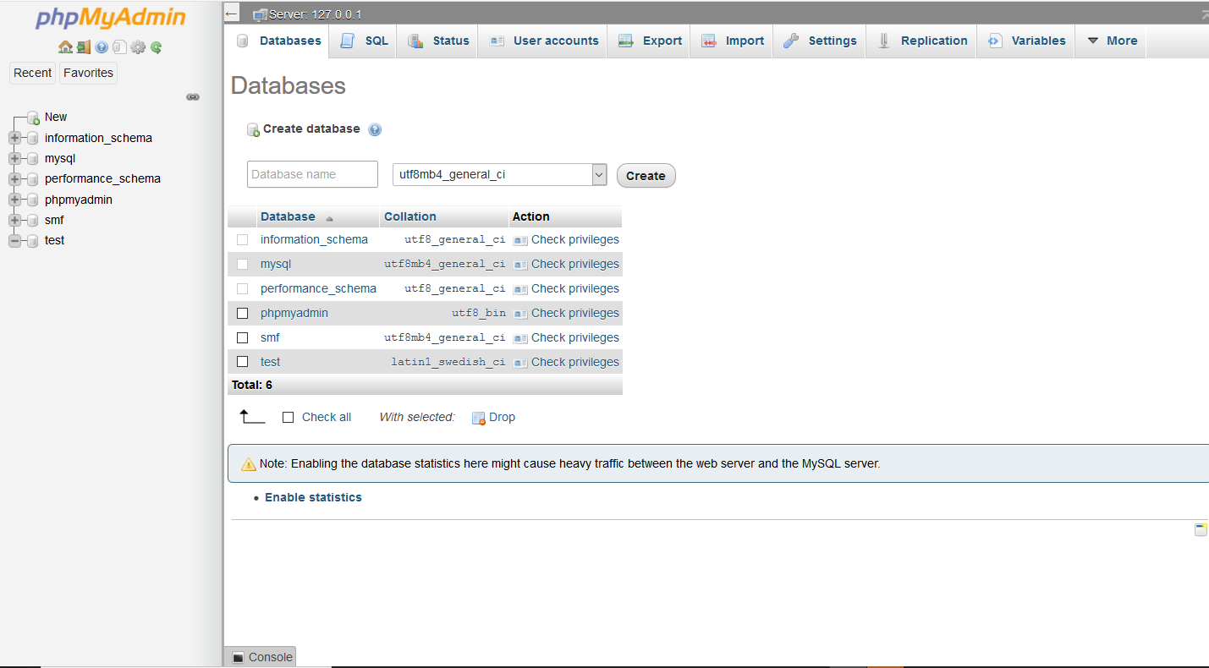

Figure 4.1: database wgis_covid19cases showing its Tables

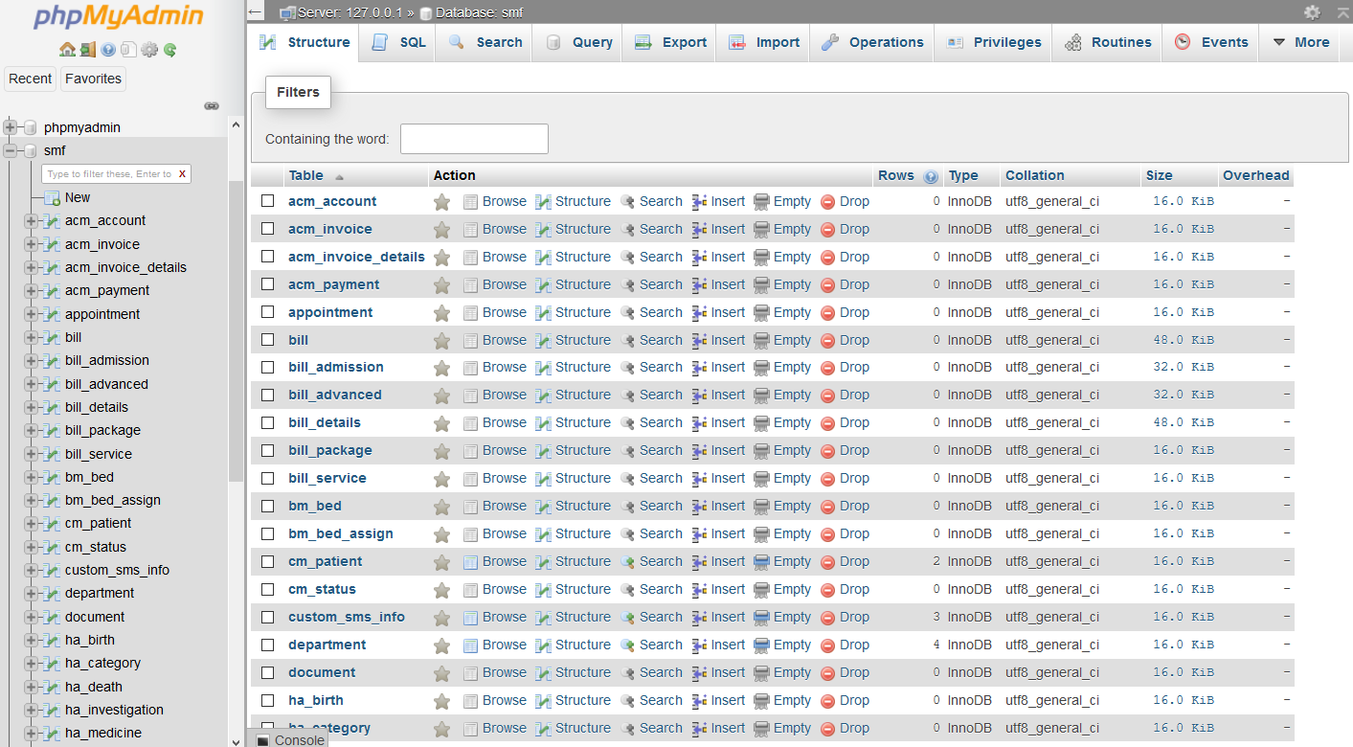

Figure 4.2: Table covid19cases showing its Respective records and Attributes

The results of the implemented Table called smf as shown in Figure 4.3 was
used to manage the information about the whole hospital.
The smf contains 43 tables which consist of the whole information about the hospital.

The results of the implemented Table called patient as shown in Figure 4.4
was used to manage information about the patient to which the hospitals they belonged to.
The results of the implemented Table called users as shown in Figure 4.6 was
used to manage information about the users whom were authorized to access the
system. The table contains 11 attributes, namely: the unique ID of each user record, the
type of user (nurse, admin or doctor), full names of users, gender, ethnicity, state of
origin of user, the hospital to which the user belonged, the type of the user, the data
information was reported alongside the username and password required by the user to
log into the system.

For each Table created in the database for storing and retrieving covid-19 cases
reported, the primary keys of were defined by the unique ID provided at the first column
for each respective table. Also, foreign keys were used to connect information from a

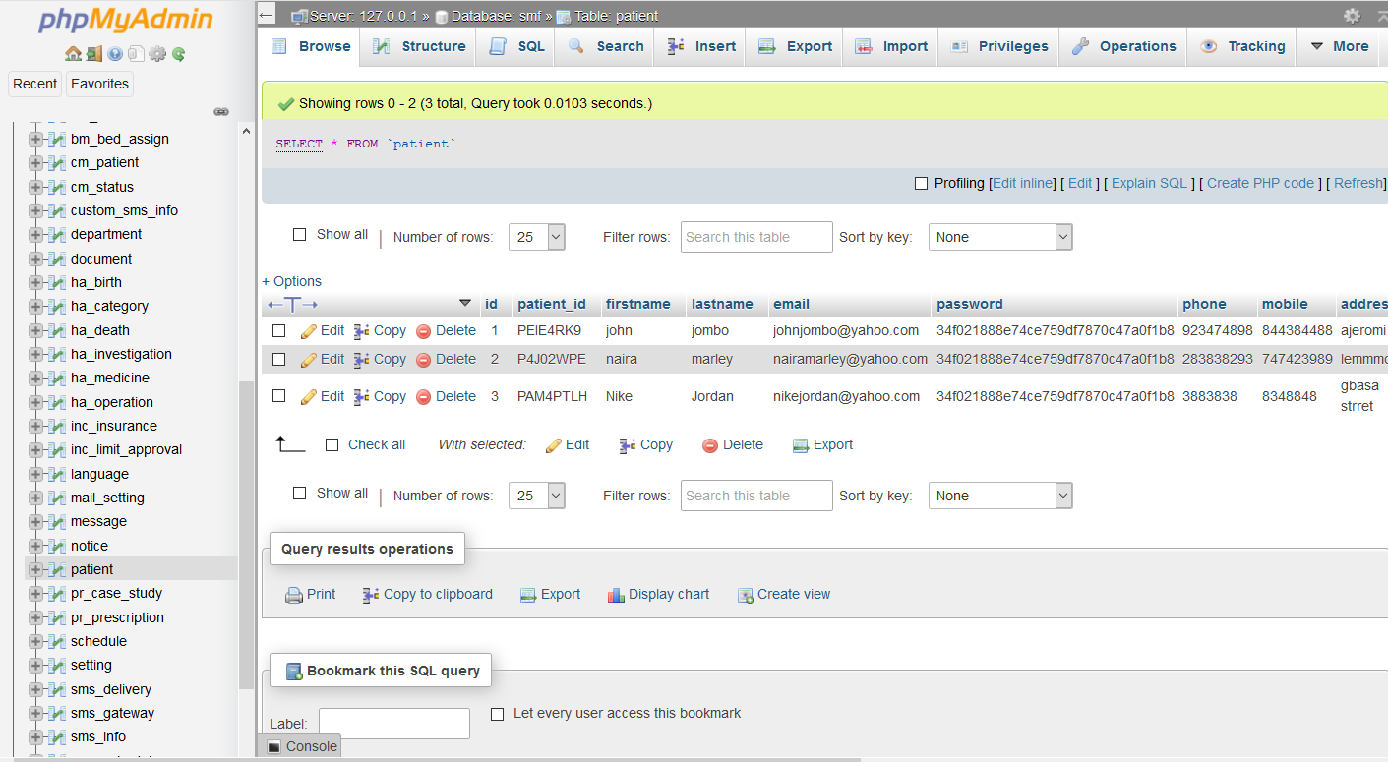

Figure 4.3: Table states showing its Respective Attributes and Records Of The Patient

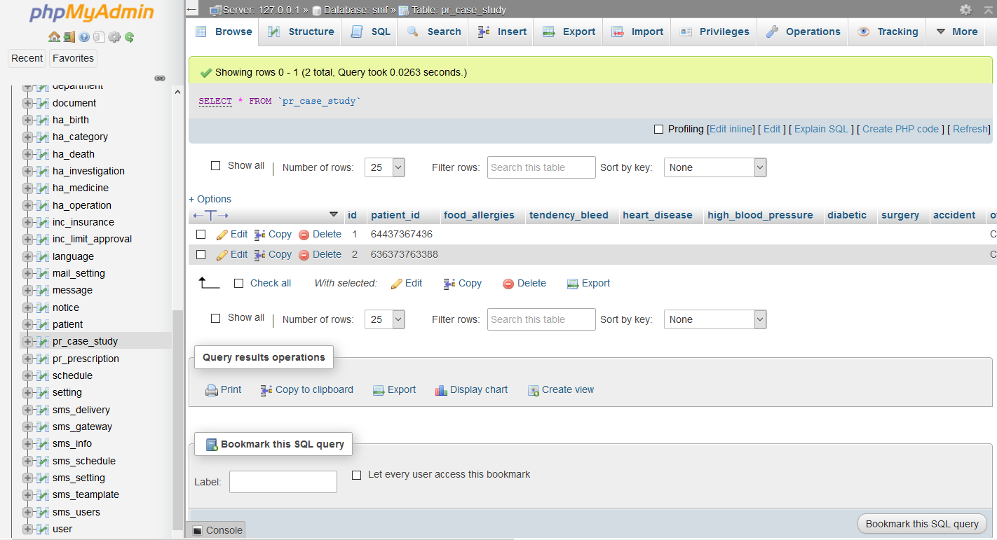

Figure 4.4: Table states showing its Respective Attributes and Records Of Patient Diagnosis of Covid-19

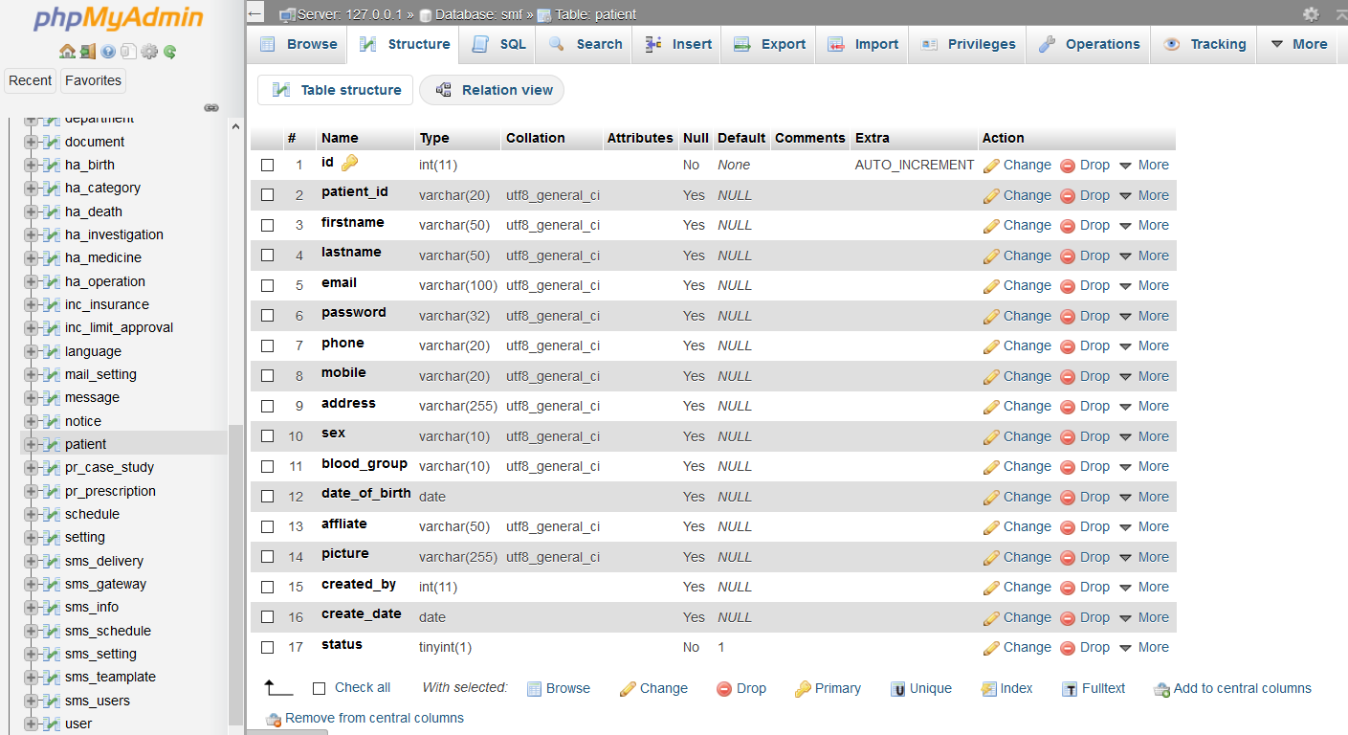

Figure 4.5: Table states showing its Respective Attributes and Records

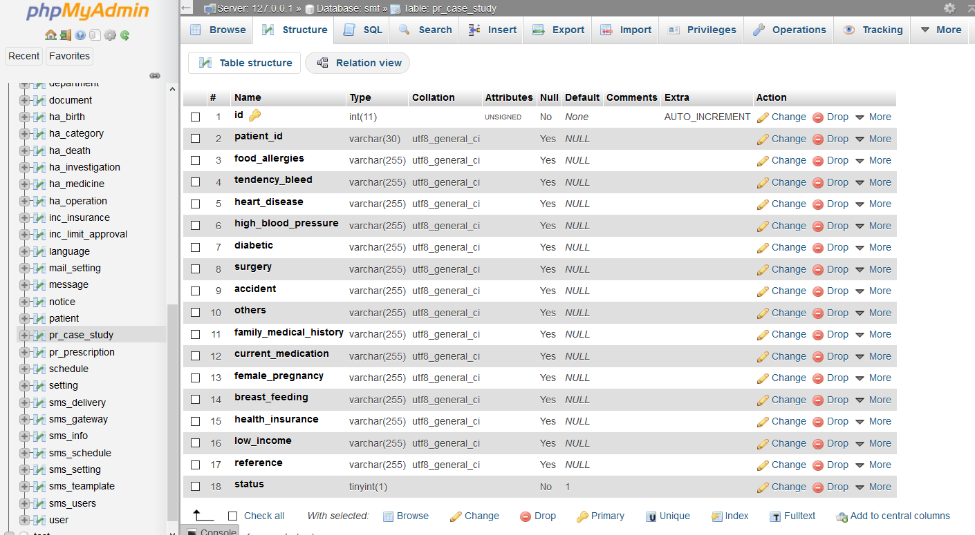

Figure 4.6: Table states showing its Respective Attributes and Records

Foreign Table onto a Referenced Table by describing the associated primary key of the
foreign Table as an attribute and a foreign Key of the referenced table.

4.3 Results of the Implementation of System Interface

Following the presentation of the results of the implementation of the system
database using SQL the results of the implementation of the system using web-based
technologies are presented. Figure 4.7 shows the system Login page also called the
Home Page open opening the system URL for user access. Users are required to provide
their username and passwords which is used by the system to determine the session
which is to be created following user access authentication by the system. Figure 4.8
shows the interface of the dashboard of the system administrator upon providing his
username and password to the system. The results of this interface showed the different
information stored on the system so far such as number of system users, number of infected and number of dead affected in the pandemic.

Figure 4.9 shows the results of the interface when an administrator is to create
a new user to the system which requires the user to provide the names of the users, gender, state of origin, agency name alongside the default username and
password provided by the administrator to the user. Figure 4.10 shows the results of the
interface required by the admin for managing the information of existing registered
users of the system. The far right panel can be used by the admin to either edit or delete the details of a user of interest.

Figure 4.11 shows the results of the interface required by the administrator for
viewing information about cases reported. Thus the interface shows the requirement of details such as the date of the reported cases, the data of occurrence of Covid-19 case, the hospital

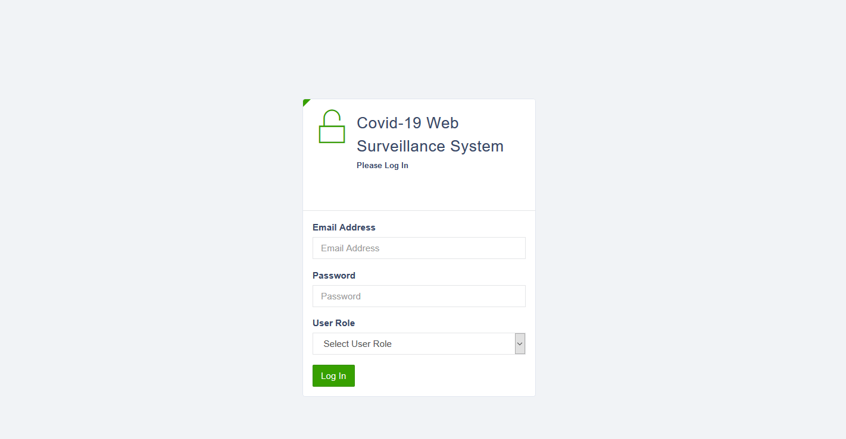

Figure 4.7: Screenshot of Login Page of Information System

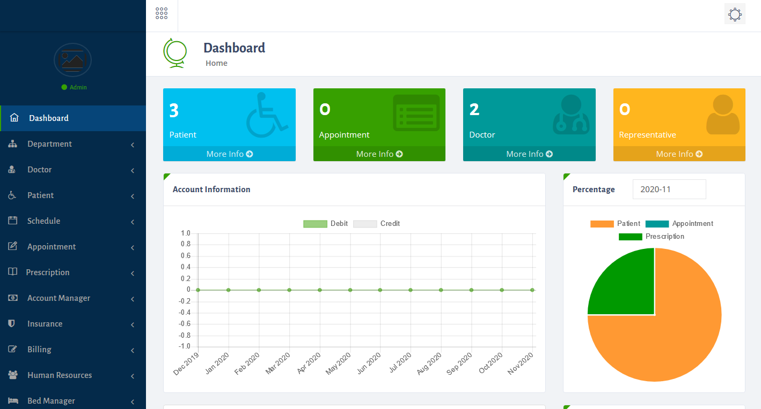

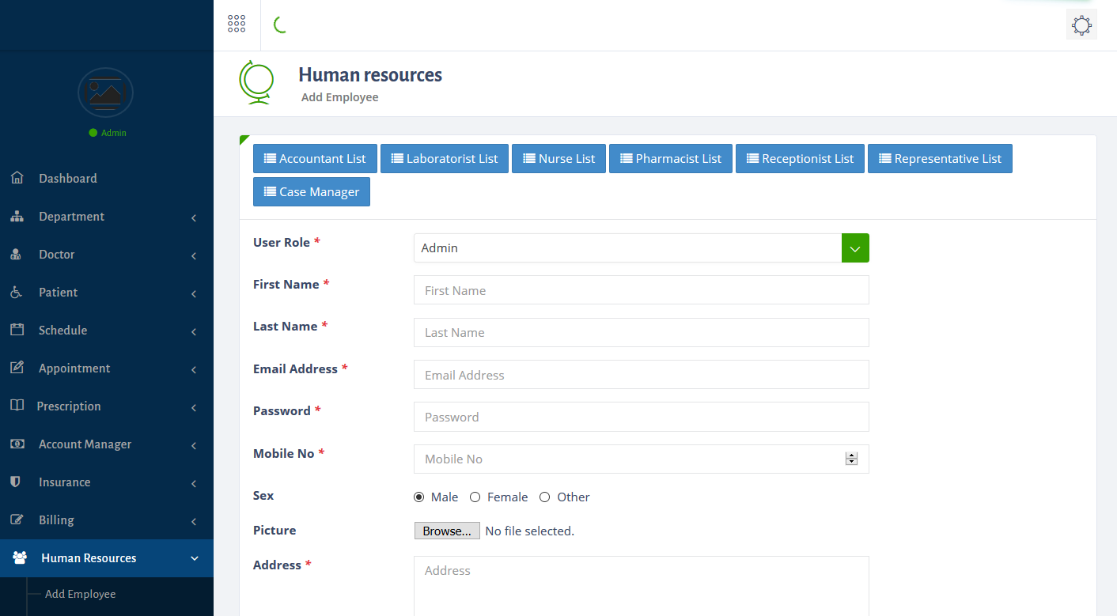

Figure 4.9: Screenshot of Admin Interface for Creating New Users Via Human Resources

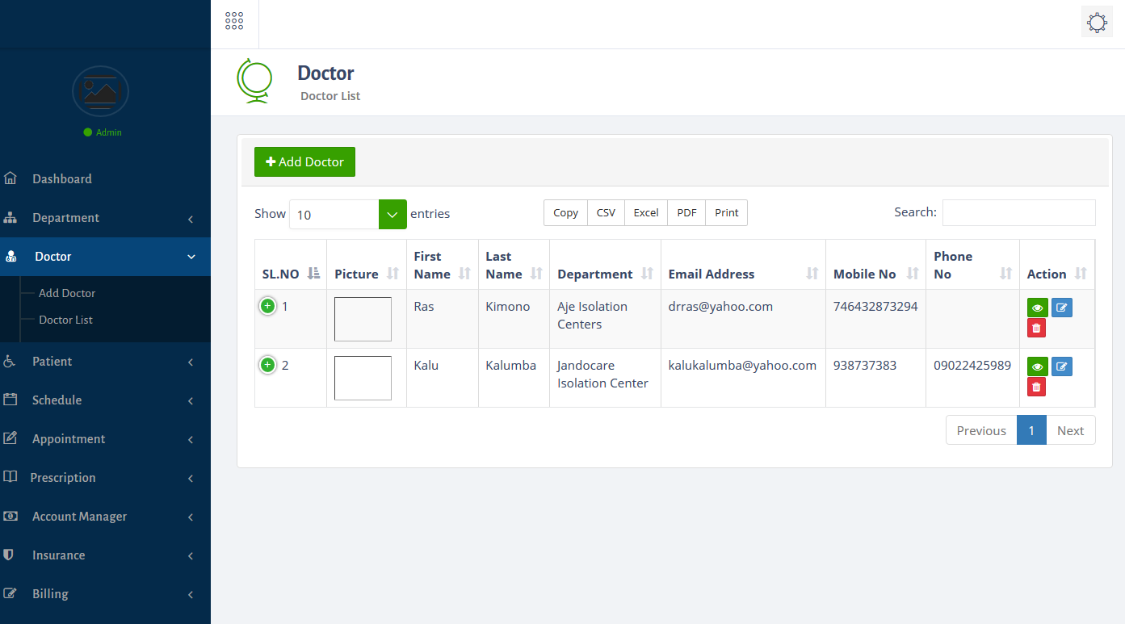

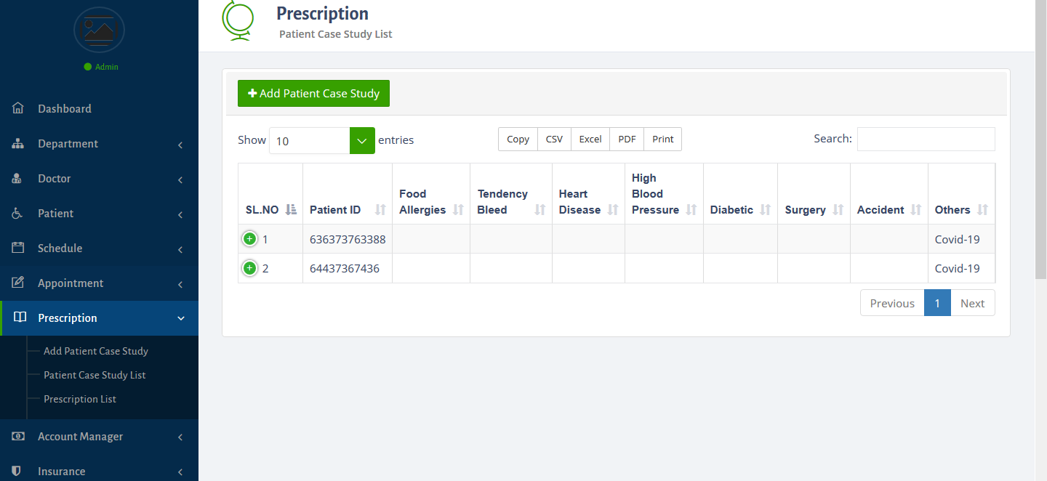

Figure 4.11: Screenshot Admin Interface for Viewing Covid-19 Cases
Reported

Figure 4.12 shows the results of the interface required by the admin belonging to a hospital in order to add information about a newly reported Covid-19 cases.

Figure 4.13 shows the results of the interface required by the case manager for viewing information about covid-19 cases reported. Thus the interface shows details about reported

Figure 4.14 shows a screenshot of the doctor’s interface for viewing information
about reported Covid-19 cases reported by nurses based on the location. Each Covid-19 case
which was reported to have occurred at a particular location where tagged with the
coordinates of that location. Therefore, as many covid-19 cases as were reported on the system by the nurses then as many number of markers that were shown in the system interface using the digital map provided by Google. For each location that was used to represent the reported covid-19 case, following a click by a mouse of that marker the details about the VBD case event reported was displayed on a text pop-up as shown in the interfaces shown in Figure 4.14.

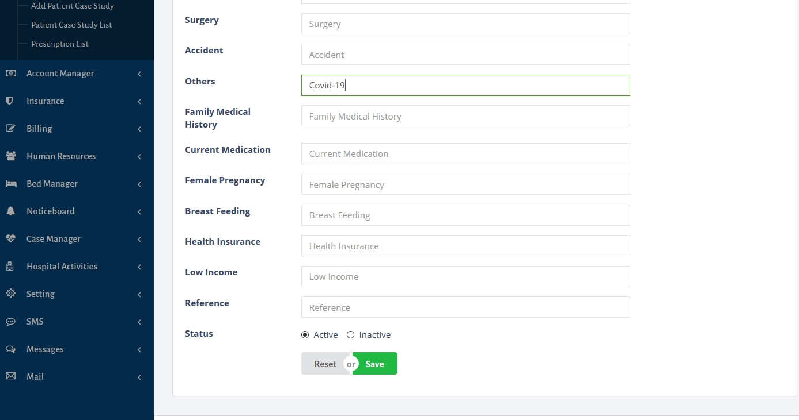

Figure 4.12: Admin Interface for adding new Covid-19 Case

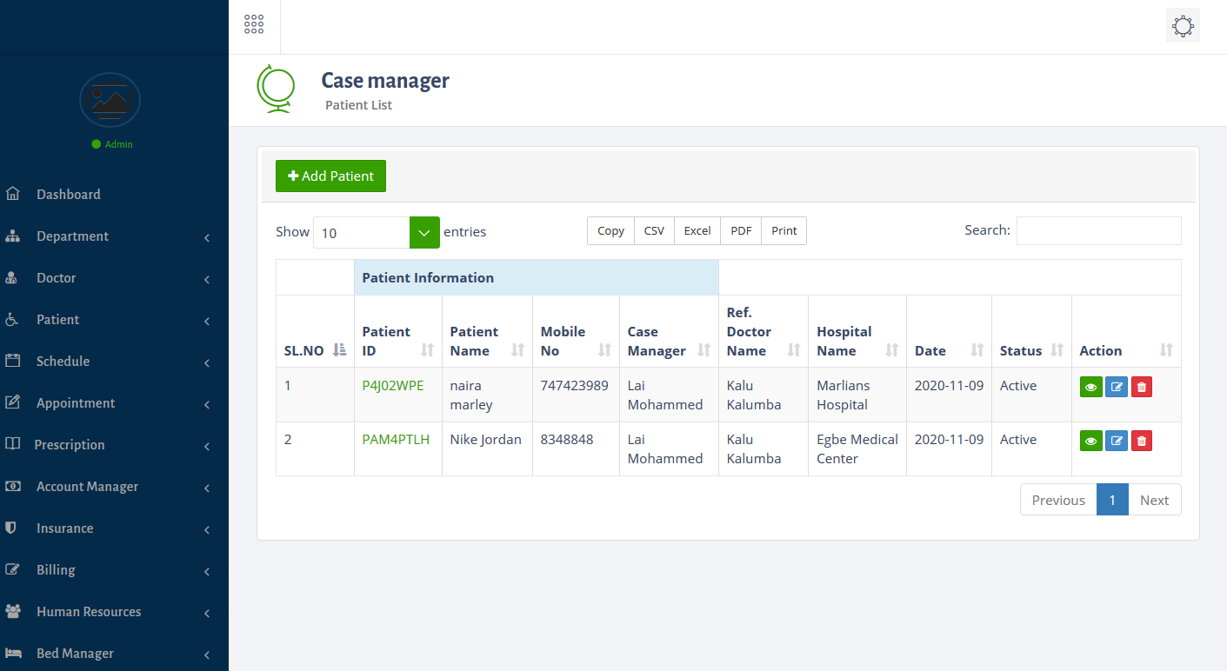

4.4 Discussion of the Results

The results of the study has been presented which showed the different
expectations of this study based on the objectives that were stated in the earlier chapters of this study.
The results of the identification of the user and system requirements allowed for the identification of the different users of the proposed system such as super user and the primary users of the system. The results showed that the super user was responsible for creating and managing the hospitals and the users belonging to their respective stations. Also, the results showed that the primary users can only access the system using their username and passwords provided by the system administrator of the system.

The results also showed that a primary user from a hospital has the responsibility
of creating new Covid-19 cases reported to have taken place at various locations. Also,
doctors belonging to hospitals can also make use of information stored about reported
outbreaks using structured Tables and alternatively as bar chart presentations which
shows the relationship between reported Covid-19 cases with various variables.

CHAPTER FIVE
SUMMARY AND CONCLUSION
5.1 Summary
This study developed a web-based spatially enabled system which monitors the
reported Covid-19 cases in Nigeria. The study identified the user and
system requirements that were required to be met by the system. The user and system
requirements were identified alongside the hardware and software requirements of the
system. The requirements of the system were also specified using unified modeling
languages using use-case diagrams for user requirements specification and class
diagrams for data modeling specification. The system was implemented using Web 2.0
technologies such as HTML, PHP and CSS for the web layout and data movement in
and out of web interface forms from and to system database. SQL was also used to
implement the system database for this study.

5.2 Conclusion
In conclusion, this study has designed and implemented a system for monitoring
the distribution of Covid19 cases reported by nurses from hospitals in Nigeria. The study
was able to identify the respective user and system requirements of the system and
appropriate designs were used to specify these requirements provided by the users using
use-case and class diagrams. The system database was implemented in order to suit the
mechanisms and inner workings of the proposed system. The system will provide a
means for which nurses will be able to provide details about reported so that doctors
can be able to view such information in the future in order to improve decision makings.
The study concluded that the users can be able to assess the system in order to make
necessary query about reported Covid-19 cases.

5.3 Recommendation
This study recommends that further work on this study can be focused on the
application of machine learning algorithms to the data stored about Covid19 so as to
understand unseen patterns which exist in the data about Covid-19 cases presented by the
nurses when reported. The deployment of the system at healthcare institutions across
Nigeria can also improve knowledge about the distribution of Covid-19 cases across
Nigeria.

REFERENCES AND CITATIONS
References

com, W. (2020, November 7). COVID-19 pandemic in Nigeria. Retrieved November 8, 2020, from Wikipedia website: https://en.wikipedia.org/wiki/COVID-19_pandemic_in_Nigeria
Gorman, J. (2020, June 1). U.S. and Chinese Scientists Trace Evolution of Coronaviruses in Bats. The New York Times. Retrieved from https://www.nytimes.com/2020/06/01/science/coronavirus-bats-wuhan.html
Mandavilli, A. (2020, February 5). Why the New Coronavirus (Mostly) Spares Children. The New York Times. Retrieved from https://www.nytimes.com/2020/02/05/health/coronavirus-children.html
Metz, C. (2020, April 30). How A.I. Steered Doctors Toward a Possible Coronavirus Treatment. The New York Times. Retrieved from https://www.nytimes.com/2020/04/30/technology/coronavirus-treatment-benevolentai-baricitinib.html
Parker-Pope, T. (2020, April 30). Why Days 5 to 10 Are So Important When You Have Coronavirus. The New York Times. Retrieved from https://www.nytimes.com/2020/04/30/well/live/coronavirus-days-5-through-10.html
Rosenthal, E. (2003, April 27). THE SARS EPIDEMIC: THE PATH; From China’s Provinces, a Crafty Germ Breaks Out (Published 2003). The New York Times. Retrieved from https://www.nytimes.com/2003/04/27/world/the-sars-epidemic-the-path-from-china-s-provinces-a-crafty-germ-breaks-out.html
Wight, A. (2020, March 24). What The US Could Learn From Nigeria’s Response To The COVID-19 Coronavirus Outbreak. Retrieved November 8, 2020, from Forbes website: https://www.forbes.com/sites/andrewwight/2020/03/24/what-the-us-could-learn-from-nigerias-response-to-covid-19/#22e30eb85637

Gonzalez-Alwarez, J.A., Ortiz-Solis, G., Ramirez-Cordero, H., Carrillo-Santoscoy,
J.P., Ocampo-Chavarria, A., Vejar-Aguirre, T., Jauregui-Ulloa, E. (2016).

Evaluation of an electronic Information System for the Monitoring of Chronic
Diseases. Mexican Journal of Cardiology 27(2): 77 – 86.

Idhoko, K.E. and Ojaiko, J.C. (2014). Integration of Geographical Information Systems
(GIS) and Spatial Data Mining Techniques in Fight against Boko Haram
Terrorist in Nigeria. International Journal of Science and research (IJSR)
6(14): 1932 – 1934.

Ivan N. & Godfrey O. O. (2016). A Secure Application for Information Sharing in
Organizations: A Case Study of Kabale District Local Government.
International Journal of Computer (IJC). ISSN 2307-4523 (Print & Online).
Volume 21, No 1, pp 64-77
Land, M.F. and Fernald, R.D. (1992). The Evolution of Eyes. Annual Review of
Neuroscience 15: 1 – 29.

Osheroff J.A., Pifer E.A., Teich J.M., Sittig D.F. and Jenders, R.A. Improving outcomes
with clinical decision support: an implementer’s guide. Chicago: Healthcare
Information and Management Systems Society; 2005.

Pearce, J. (2006). Neighbourhoods and health: A GIS approach to measuring
community resource accessibility. Journal of Epidemiology & Community
Health 60(5): 389 – 395.
Sanni, M. and Kaur, K. (2014). A Review of Open Source Software Development Life
Cycle Models. International Journal of Software Engineering and Its
Applications 8(3): 417 – 434.

Santosa, I., Romla, L. and Herawati, s. (2018). Expert System Diagnosis of Cataracts
Eyes Using Fuzzy Logic. Journal of Physics 953: 1 – 6.

Smiatek, G. (2005). SOAP Based web services in GIS/RDBMS Environment. Journal
of Environmental Modeling and Software 20: 775 – 782.

Tatar, E. and Tomur, E. (2013). A Secure Development Framework for SaaS
Applications in Cloud Computing. In 6th International Information Security &
Cryptology Conference held in Ankara Turkey: 338 – 342.
Zhou, Z., Rachir, S., Huiying, L., Xiangyu, C., Lixin, D., Damon, W.K.W., Chee, K.K
& Tien, Y.W. (2014). A Survey on Computer Aided Diagnosis for Vector-borne
Diseases. BMC Medical Informatics and Decision Making 14: 1 – 29.

Binder S., Sanderson L. M. The Role of the Epidemiologist in Natural Disasters. Annals of Emergency Medicine. 1987;16(9):1081–84. [PubMed]

Birkhead, G. S., and C. M. Maylahn. 2000. "State and Local Public Health Surveillance." In Principles and Practices of Public Health Surveillance, ed. S. M. Teutsch and R. E. Churchill, 270. New York: Oxford University Press.

Buehler J. W., Hopkins R. S., Overhage J. M., Sosin D. M., Tong V. Framework for Evaluating Public Health Surveillance Systems for Early Detection of Outbreaks: Recommendations from CDC Working Group. MMWR Recommendations and Reports. 2004;53(RR-5):1–11. [PubMed]

CDC (U.S. Centers for Disease Control Prevention). Surveillance of Health Status of Kampuchean Refugees—Khao I-Dang Holding Center, Thailand, December 1981–June 1983. Morbidity and Mortality Weekly Report. 1983;32(31):412–15. [PubMed]

———.2001Outbreak of Ebola Hemorrhagic Fever, Uganda, August 2000–January 2001 Morbidity and Mortality Weekly Report 50(5):73–77. [PubMed]

———.2003aEfficiency of Quarantine during an Epidemic of Severe Acute Respiratory Syndrome—Beijing, China, 2003 Morbidity and Mortality Weekly Report 52(43):1037–40. [PubMed]

———.2003bPrevalence of Selected Risk Factors for Chronic Disease—Jordan, 2002 Morbidity and Mortality Weekly Report 52(43):1042–44. [PubMed]

———. 2004a. Partnerships in Excellence: Charting the Future in Global Health. Atlanta: CDC, Epidemiology Program Office, Division of International Health.

———.2004bSyndromic Surveillance: Reports from a National Conference, 2003 Morbidity and Mortality Weekly Report 53Suppl.18–22. [PubMed]

Clavel-Arcas, C., R. Chacon, and A. Concha-Eastman. 2004. "Hospital Based Injury Surveillance Systems in Nicaragua and El Salvador, 2001–2002." Paper presented at the Seventh World Conference on Injury Prevention and Safety Promotion, Vienna, June 6–9.
Concha-Eastman, A., and A. Villveces. 2001. Guidelines for the Design, Implementation and Evaluation of Epidemiological Surveillance Systems on Violence and Injuries. Washington, DC: Pan American Health Organization.
Darby, Paul. 2003. "The Economic Impact of SARS." Publication 434-05, Conference Board of Canada, Ottawa.

Dean, A. D. 2000. "Computerizing Public Health Surveillance Systems." In Principles and Practices of Public Health Surveillance, ed. S. M. Teutsch and R. E. Churchill, 229–52. New York: Oxford University Press.

Effler P., Ching-Lee M., Bogard A., Ieong M. C., Nekomoto T., Jernigan D. Statewide System of Electronic Notifiable Disease Reporting from Clinical Laboratories: Comparing Automated Reporting with Conventional Methods. Journal of the American Medical Association. 1999;282:1845–50. [PubMed]

Elbasha E. H., Fitzsimmons T. D., Meltzer M. I. Costs and Benefits of a Subtype-Specific Surveillance System for Identifying Escherichia coli O157:H7 Outbreaks. Emerging Infectious Diseases. 2000;6(3):293–97. [PMC free article] [PubMed]
Fan, E. X. 2003. SARS: Economic Impacts and Implications. ERD Policy Brief Series Manila: Asian Development Bank.

Foege W. H., Hogan R. C., Newton L. H. Surveillance Projects for Selected Diseases. International Journal of Epidemiology. 1976;5(1):29–37. [PubMed]

Greenland, S. 2004. "Ecologic Inference Problems in the Analysis of Surveillance Data." In Monitoring the Health of Populations, ed. R. Brookmeyer and D. F. Stroup, 315–40. New York: Oxford University Press.

Herikstad H., Motarjemi Y., Tauxe R. V. Salmonella Surveillance: A Global Survey of Public Health Serotyping. Epidemiology and Infection. 2002;129(1):1–8. [PMC free article] [PubMed]

Heymann, D. L. 2004. Control of Communicable Diseases Manual. Washington, DC: American Public Health Association.

Heymann D. L., Rodier G. Global Surveillance, National Surveillance, and SARS. Emerging Infectious Diseases. 2004;10(2):173–75. [PMC free article] [PubMed]
Holder, Y., M. Peden, and E. Krug. 2001. Injury Surveillance Guidelines. Geneva: World Health Organization.

Holtzman, D. 2003. "Analysis and Interpretation of Data from the U.S. Behavioral Risk Factor Surveillance System (BRFSS)." In Global Behavioral Risk Factor Surveillance, ed. D. V. McQueen and P. Puska. New York: Kluwer Academic Press.

Kelly, A. E., A. C. Haddix, K. S. Scanlon, C. G. Helmick, and J. Mulinare. 1996. "Cost Effectiveness of Strategies to Prevent Neural Tube Defects." In Cost-Effectiveness in Health and Medicine, ed. M. R. Gold, J. E. Siegel, L. B. Russell, and M. C. Weinstein, 313–48. New York: Oxford University Press.
Kew O., Morris-Glasgow V., Landaverde M., Burns C., Shaw J., Garib Z. et al. Outbreak of Poliomyelitis in Hispaniola Associated with Circulating Type 1 Vaccine-Derived Poliovirus. Science. 2002;296(5566):356–59. [PubMed]

Lober W. B., Trigg L., Karras B. Information System Architectures for Syndromic Surveillance. Morbidity and Mortality Weekly Report. 2004;53(Suppl.):203–8. [PubMed]
Mack T. M. The Ghost of Pandemics Past. Lancet. 2005;365(9468):1370–72. [PMC free article] [PubMed]

McGeehin M. A., Qualters J. R., Niskar A. S. National Environmental Public Health Tracking Program: Bridging the Information Gap. Environmental Health Perspectives. 2004;112(14):1409–13. [PMC free article] [PubMed]

Meehan P. J., Rosenstein N. E., Gillen M., Meyer R. F., Kiefer M. J., Deitchman S. et al. Responding to Detection of Aerosolized Bacillus Anthracis by Autonomous Detection Systems in the Workplace. MMWR Recommendations and Reports. 2004;53(RR-7):1–12. [PubMed]

Meltzer M. I. Introduction to Health Economics for Physicians. Lancet. 2001;358(9286):993–98. [PubMed]

Murray C. J. L., and A. D. Lopez, eds. 1996. Global Burden of Disease and Injury Series, Volume I: The Global Burden of Disease—A Comprehensive Assessment of Mortality and Disability from Diseases, Injuries, and Risk Factors in 1990 and Projected to 2020. Cambridge, MA: Harvard University Press.

Narasimhan V., Brown H., Pablos-Mendez A., Adams O., Dussault G., Elzinga G. et al. Responding to the Global Human Resources Crisis. Lancet. 2004;363(9419):1469–72. [PubMed]
Noe R., Rocha J., Clavel-Arcas C., Aleman C., Gonzales M. E., Mock C. Occupational Injuries Identified by an Emergency Department Based Injury Surveillance System in Nicaragua. Injury Prevention. 2004;10(4):227–32. [PMC free article] [PubMed]
Nsubuga P., Eseko N., Tadesse W., Ndayimirije N., Stella C., McNabb S. Structure and Performance of Infectious Disease Surveillance and Response, United Republic of Tanzania, 1998. Bulletin of the World Health Organization. 2002;80(3):196–203. [PMC free article] [PubMed]

Nsubuga P., McDonnell S. M., Perkins B., Sutter R., Quick L., White M. E. et al. Polio Eradication Initiative in Africa: Influence on Other Infectious Disease Surveillance Development. BMC Public Health. 2002;2(1):27. [PMC free article] [PubMed]

Pappaioanou M., Malison M., Wilkins K., Otto B., Goodman R. A., Churchill R. E. et al. Strengthening Capacity in Developing Countries for Evidence-Based Public Health: The Data for Decision-Making Project. Social Science and Medicine. 2003;57(10):1925–37. [PubMed]

Peden, M., K. McGee, and G. Sharma. 2002. The Injury Chartbook: A Graphical Overview of the Global Burden of Injuries. Geneva: World Health Organization.
Peiris J. S., Yuen K. Y., Osterhaus A. D., Stohr K. The Severe Acute Respiratory Syndrome.
New England Journal of Medicine. 2003;349(25):2431–41. [PubMed]

Romaguera, R., R. R. German, and D. N. Klaucke. 2000. "Evaluating Public Health Surveillance." In Principles and Practices of Public Health Surveillance, ed. S. M. Teutsch and R. E. Churchill, 176–93. New York: Oxford University Press.

Sturm R. Increases in Clinically Severe Obesity in the United States, 1986–2000. Archives of Internal Medicine. 2003;163(18):2146–48. [PubMed]

Swaminathan B., Barrett T. J., Hunter S. B., Tauxe R. V. PulseNet: The Molecular Subtyping Network for Foodborne Bacterial Disease Surveillance, United States. Emerging Infectious Diseases. 2001;7(3):382–89. [PMC free article] [PubMed]

Thacker S. B., Berkelman R. L. Public Health Surveillance in the United States. Epidemiologic Reviews. 1988;10:164–90. [PubMed]
Thacker S.B., Berkelman R.L., Stroup D.F. The Science of Public Health Surveillance. Journal of Public Health Policy. 1989;10(2):187–203. [PubMed]

Thacker, S. B., and D. F. Stroup. 1998a. "Public Health Surveillance." In Applied Epidemiology: Theory to Practice, ed. R. C. Brownson and D. B. Petitti, 105–35. New York: Oxford University Press.

———. 1998b. "Public Health Surveillance and Health Services Research." In Epidemiology and Health Services, ed. H. K. Armenian and S. Shapiro, 61–82. New York: Oxford University Press.

Thacker S. B., Stroup D. F., Parrish R. G., Anderson H. A. Surveillance in Environmental Public Health: Issues, Systems, and Sources. American Journal of Public Health. 1996;86(5):633–38. [PMC free article] [PubMed]

Ungchusak K., Auewarakul P., Dowell S. F., Kitphati R., Auwanit W., Puthavathana P. et al. Probable Person-to-Person Transmission of Avian Influenza A (H5N1). New England Journal of Medicine. 2005;352(4):333–40. [PubMed]

USAID (U.S. Agency for International Development). 2005. "Infectious Disease and Response Strategy 2005." USAID, Washington, DC.
U.S. GAO (U.S. General Accounting Office). 2001. Challenges in Improving Infectious Disease Surveillance Systems. GAO-01-722. Washington, DC: U.S. General Accounting Office.

Vartiainen E., Sarti C., Tuomilehto J., Kuulasmaa K. Do Changes in Cardiovascular Risk Factors Explain Changes in Mortality from Stroke in Finland? British Medical Journal. 1995;310(6984):901–4. [PMC free article] [PubMed]

Wald N. J. Folic Acid and the Prevention of Neural-Tube Defects. New England Journal of Medicine. 2004;350(2):101–3. [PubMed]

White, M. E., and S. M. McDonnell. 2000. "Public Health Surveillance in Low and Middle Income Countries." In Principles and Practices of Public Health Surveillance, ed.

S. M. Teutsch and R. E. Churchill, 287–315. New York: Oxford University Press.
White M. E., McDonnell S. M., Werker D. H., Cardenas V. M., Thacker S. B. Partnerships in International Applied Epidemiology Training and Service, 1975–2001. American Journal of Epidemiology. 2001;154(11):993–99. [PubMed]

WHO (World Health Organization). 1993. "Epidemiological Surveillance of Communicable Disease at the District Level." WHO Regional Committee for Africa, 43rd session, AFR/RC43/18. WHO, Geneva.

. 1998. "Integrated Disease Surveillance: Regional Strategy for Communicable Diseases." WHO Regional Committee for Africa, 48th session. AFR/RC48/8. WHO, Geneva.

2003.Severe Acute Respiratory Syndrome (SARS) Weekly Epidemiological Record 78(12):81–83. [PubMed]

. 2003.. The SURF Report 1. Surveillance of Risk Factors Related to Noncommunicable Diseases: Current State of Global Data. Geneva: WHO.

WHO Report of an International Commission. Ebola Haemorrhagic Fever in Zaire, 1976. Bulletin of the World Health Organization. 1978;56(2):271–93. [PMC free article] [PubMed]

World Bank. 2001. World Development Report 2000–2001: Attacking Poverty. New York: Oxford University Press.
2004. World Development Indicators 2004. Washington, DC: World Bank. http://devdata​.worldbank​.org/hnpstats/query/default.html.

Zacher, M. 1999. Global Epidemiological Surveillance: Global Public Goods. New York: Oxford University Press.

