DESIGN AND IMPLEMENTATION OF A WEB-BASED HEALTHCARE MANAGEMENT RECORDS SYSTEM

OIBO JOY OPEYEMI

DESIGN AND IMPLEMENTATION OF A WEB-BASED HEALTHCARE MANAGEMENT RECORDS SYSTEM

OIBO, JOY OPEYEMI
16010301008

BEING A PROJECT SUBMITTED IN THE DEPARTMENT OF COMPUTER SCIENCE
AND MATHEMATICS, COLLEGE OF BASIC AND APPLIED SCIENCES
IN PARTIAL FUFILLMENT OF THE REQUIREMENTS FOR THE
AWARD OF DEGREE OF BACHELOR OF SCIENCE
MOUNTAIN TOP UNIVERSITY, IBAFO,
OGUN STATE, NIGERIA

2020

CERTIFICATION
This Project titled, DESIGN AND IMPLEMENTATION OF A WEB-BASED HEALTHCARE MANAGEMENT RECORDS SYSTEM, prepared and submitted by OIBO JOY OPEYEMI in partial fulfilment of the requirements for the degree of BACHELOR OF SCIENCE (Computer Science), is hereby accepted

(Signature and Date)
Dr. Omotunde A.
Supervisor

(Signature and Date)
Dr. Akinyemi I.O.
Head of Department

Accepted as partial fulfilment of the requirements for the degree of BACHELOR OF
SCIENCE (Computer Science)

(Signature and Date)
Dr. Akinyemi I.O.
Head of Department

DEDICATION
This Project is dedicated to God Almighty

ACKNOWLEDGMENT
I would like to acknowledge the almighty God for giving good retentive wisdom, knowledge and understanding. My sincere and profound gratitude to my supervisor Dr. Omotunde A. for His time, effort and guidance throughout the course of this project work with the aim to ensure that this project will be a success. I specially appreciate the Dean of College of Basic and Applied sciences in person of Professor Akinwande A.I and also to thank the H.O.D (Head of Department) of the department of Computer Science and Mathematics in person of Dr. Akinyemi I.O for his guidance during my stay at the university. I would like to thank all the lecturers of Department of Computer science and Mathematics Dr. Kasali F.A, Dr. Oyetunji M.O (Late), Dr. Oladejo B.F, for their advice and their words of encouragement. I want to thank my colleagues Olayinka Olusegun and Ademuyiwa Stephanie for their help, support and guidance during the duration of the project. I also want to thank all the non-academic staff of the Department of Computer Science and Mathematics for making my stay a worthwhile one.

I would like to thank my Father in person of Mr. Oibo P.I. for his financial support and words of encouragement, also I would like to thank my uncle in person of Mr. Alonge Toyin for his support towards me throughout my stay in this University, and also I would like to acknowledge my sisters for always being there for me and for always supporting me in all my project works, I pray that God will bless all of you abundantly and grant all your heart desires.

ABSTRACT
The 'Web-based healthcare management framework' is a platform designed to perform multiple operations in hospitals. Healthcare facilities have been developing increasingly in recent years. Therefore, the need for effective administration of healthcare is also growing, through which different procedures are required for the treatment of patients in these institutions, Mountain Top University is the case study here. This initiative highlights the creation and development of a web-based healthcare management records system aimed at providing a database that stores and handles data from the healthcare management records system, and also provides a forum for handling such data from patients and workers rather than using the physical process, which is often considered to be stressful and not as reliable as the electronic method.
By using an acceptable software development schedule, the approach used in this project work was completed. For the backend of this project, Java was used as the programming framework and for the database environment, Microsoft SQL. In addition, authentication requires the use of both username and password to allow the user to enter the portal of healthcare management.
The results of this project led to the creation of an application that can now automatically handle some hospital procedures without the need for any physical application or the use of biro and paper for application, and therefore keeps the data secure.
It was concluded that most healthcare providers would still find it stressful to run their institutions using the physical system rather than the automated method without adopting this requirement, and they would still struggle with record keeping, which will have to require providing huge files and a space to hold such documents.
Keywords: Management, Application, Web-based, Data, Database, Records, Administration, Healthcare

TABLE OF CONTENTS
Content Page
Title Page i
Certification ii
Dedication iii
Acknowledgment iv
Abstract v
Table of Contents vi
List of Tables ix
List of Figures x
CHAPTER ONE: INTRODUCTION
1.1 Background to the study
1.2 Statement of the problem
1.3 Aim and objectives
1.4 Scope of the study
1.5 Significance of the study
1.6 Definition of terms
1.7 Organization of subsequent chapters
CHAPTER TWO: LITERATURE REVIEW
2.0 Introduction
2.1 A brief history of healthcare in Nigeria
2.2 Healthcare & healthcare management
2.3 Systems
2.3.1 Management systems
2.3.2 Information systems
2.4 Healthcare management records systems
2.4.1 Origin of healthcare management records systems
2.5 Healthcare systems
2.5.1 Types of healthcare management records systems
2.5.2 Healthcare management records systems components or features
2.5.3 Advantages of healthcare management records systems
2.5.4 Steps for creating an information system for health management
2.6 The need for healthcare management records systems in Nigeria
2.7 The World Wide Web
2.7.1 Web-based applications or software
2.7.2 Online or web-based healthcare management records system
2.8 The future of frameworks for health information management
2.9 Review of related works
2.10 Summary of literature reviewed
CHAPTER THREE: METHODOLOGY
3.0 Introduction
3.1 Analysis and problem of the existing system
3.2 Analysis of the proposed system
3.2.1 Description of the Proposed System
3.2.2 Benefit of the Proposed System
3.3 Software development life cycle
3.4 System design and development
3.4.1 Requirement gathering
3.4.2 User requirements
3.4.3 Functional requirements
3.4.4 Non-Functional Requirements (NFRs)
3.5 Tools and diagrams such as data flow diagram, use case diagrams, etc.
3.5.1 Implemented system
3.5.2 UML class model diagram
3.5.3 Data flow diagram
3.5.4 Entity - relationship diagram
3.5.5 Use case diagram
3.6 Method of data collection
3.6.1 Interviews
3.6.2 Observations
3.6.3 Document Review

CHAPTER FOUR: SYSTEM DESIGN AND IMPLEMENTATION
4.0 Introduction
4.1 Objective of system design
4.2 System design
4.2.1 Logical design
4.2.2 Conceptual design
4.2.3 Physical design
4.3 System requirement and specification of models
4.3.1 Requirement and constraints for the software
4.3.2 Platform for hardware
4.3.3 Networking specifications
4.4 System development
4.4.1 HMS login module
CHAPTER FIVE: SUMMARY, CONCLUSIONS AND RECOMMENDATIONS
5.0 Introduction
5.1 Summary
5.2 Conclusions
5.3 Limitation of the study
5.4 Contribution to knowledge
5.5 Recommendation
REFERENCES
APPENDIX

LIST OF FIGURES
FIGURE PAGE
2.1 Schematic representation of a system 8
2.2 the components of an Information System 10
2.3 features of HMS 14
2.4 advantages of HMS 16
3.1 SDLC Phases 24
3.2 Waterfall Model 25
3.3 Class model diagram of a HMS 29
3.4 Zero Level DFD – Hospital Management System 30
3.5 First Level DFD – Hospital Management System 31
3.6 E – R Diagram for Hospital Management System 32
3.7 Use Case Diagram for an Administrator in Hospital Management System 33
4.1 image showing the Home page 39
4.2 showing the user registration 40
4.3 image showing the User login dashboard 41
4.4 showing the user profile interface 42
4.5 interface showing user groups under user management 43
4.6 interface showing users under user management 44
4.7 interface showing user activation page under user management 45
4.8 interface showing patient registration page under patient management 46
4.9 interface showing inpatients page 47
4.10 image showing ward management interface 48
4.11 image showing drug management interface 49
4.12 showing drug inventory 50

LIST OF TABLES

CHAPTER ONE
INTRODUCTION

1.1 BACKGROUND TO THE STUDY
A hospital is a health care facility that offers specialist staff and facilities for medical treatment. It is an institute undergoing constant development, for this reason, there have been issues regarding fast and easy hospital management, from managing healthcare quality improvement and compliance documentation, workflow and analytics, and task management solution with pre-surgical and surgical procedures, patient arrival and status etc. And so as the population increases, so does the workload.
Health is generally said to be wealth. Healthy people are vital to a country’s social and economic development. Therefore, the need for adequate medical care especially in the area of diagnosis and treatment of diseases is important, since there is a good relationship between the job output and health of the workers. Unfortunately, owing to a lack of standard technical know-how and manual treatment of most medical issues, sufficient medical care is absent in most developed nations (including Nigeria). It is also a known fact that the production of qualified medical doctors and other medical personnel and consultants is on the increase, but this is not enough to meet the health needs of the increasing population.
According to the Nigeria Health Blog (2019), the patient-to-doctor ratio is still high. Nigeria currently has a ratio of one doctor to six thousand patients (1:6000), as opposed to the one doctor to six hundred patients (1:600) norm of the World Health Organization (WHO). Besides enhancing the service provided to patients, computers have increased the accuracy, speed and efficiency of many of the administrative and technological activities historically involved in patient care. With advances in healthcare information processing, one can provide better means to process patient records and therefore speed up the treatment, which in turn reduces the overall cost.
This project proposes a Web based frame work for health care industries that organizes all activities performed in hospitals.

1.2 STATEMENT OF THE PROBLEM

Lack of immediate retrieval: -Most of the time, information is very difficult to find and retrieve e.g. - To find out about the patient’s history, the user has to undergo lengthy searches through various registers. This results in inconvenience and waste of time.
Preparation of accurate and prompt reports: - This becomes a difficult task as intelligence gathering is difficult, this is due to lack of information collation (ability to put information together and analyze them).
Lack of immediate information storage: - The information generated by various transactions takes time and efforts to store them

1.3 AIM AND OBJECTIVES
AIM
The aim of this project, is to design and implement a web-based health care records management system.
OBJECTIVES
This study is centered on the following objectives:
- To examine the current procedures employed with regards to patients admission, diagnosis and treatment.
- To improve on the already existing system by designing an efficient practical system aimed at an accurate, faster and reliable patient’s information system.

1.4 SCOPE OF STUDY
The proposed software product is a Health Care Management system. The system will be used in a clinic to get information from the patients and then store the data for future usages. A paper based system is the model currently in use. The intention of the system is to reduce time spent and increase the number of patients that can be treated accurately. The scope of this project will cover the implementation of a healthcare website. The website will involve authorized personnel. Though this system will allow client (staffs and students) who have not registered yet to register as an E-healthcare member. As long as they are members their records can be viewed.

1.5 SIGNIFICANCE OF THE STUDY
The creation of the Health Care Management System will bring about such benefits as the improvements in accuracy and reliability of information gotten, easy retrieval, update, and storage of patient records, as well as, easy operation of the new system.

1.6 DEFINITION OF TERMS
Hospital: Hospital, an institution designed, staffed and prepared for disease diagnosis; for the care of the ill, both medical and surgical.
Patient: Patient: Patient Medical Description. 1: A sick person is prepared to treat 500 people, especially when awaiting or under the care and treatment of a doctor or surgeon in the hospital.
2: a medical care customer (as a doctor or dentist) with a significant number of patients in a healthy practice.
Healthcare: The preservation or advancement of health by the prevention, diagnosis , treatment, rehabilitation, or cure of disease, sickness, injury, and other physical and mental impairments in persons is health care, health care, or healthcare.
Healthcare Management: The administration, management or supervision of healthcare services is also known as healthcare administration. This field relates to leadership, management, and administration of public health systems, health care systems, hospitals, and hospital networks in all the primary, secondary, and tertiary sectors.
Web-based: of, relating to or using the World Wide Web. (Dictionary.com)
Web-based Application or Software: Unlike computer-based software programs that are locally stored on the device's Operating System (OS), a web application (or web app) is an application software that operates on a web server. The user accesses web applications via a web browser with an active internet connection. These applications are programmed using a client-server model system, which provides services to the user ("client") through an off-site server hosted by a third party. Web-mail, online retail transactions, online banking, and online auctions are examples of commonly-used web applications.
Healthcare Information Systems: The health information system provides the basis for decision-making and has four main functions: generation, collection, review and synthesis of data and communication and usage. The health information system gathers data from and analyzes data from the health sector and other related industries and ensures their overall accuracy, validity and validity.
HTML - Hypertext Markup Language used for web page creation.
JavaScript- Programming language used to enhance dynamic web.
Server - Web Software that processes incoming network request over protocol e.g HTTP
Web browser - Application Software used to access the internet and information on the World Wide Web.

1.7 ORGANIZATION OF SUBSEQUENT CHAPTERS
This work was organized in the following ways:
Chapter One talks about the background to the study, the statement of the problem, aim and objectives, the scope of the study, limitations of the study, the significance of the study and the definition of terms.
Chapter 2 talks about the literature review of the project. It is an introduction to the Management System describing the components and activities of such a system, as well as the influence and any problems that exist. Also it presents the need to introduce the Healthcare management records systems in Hospitals.
Chapter 3 discusses the methodology.
Chapter 4 describes the system implementation and design, and
Chapter 5 presents the conclusion of this project.

CHAPTER TWO

REVIEW OF RELEVANT LITERATURES

2.0 INTRODUCTION
Healthcare management records system includes registration of patients, and also computerized billing in the pharmacy and labs, from assisting data entry to manipulating records, generating output in required form to transferring for further study, or to save it digitally for future use, by other doctors. The software offers a unique ID for each patient and automatically stores the information of each patient and employee in its database. It is possible to access the Healthcare management records system using a username and password. The data can be retrieved easily, and interface is user-friendly. The data is well secured for personal use and makes the processing of information very fast. It is efficient, versatile and simple to use, and it is designed and built to provide real advantages that are conceivable.
I researched the past, current and future issues in hospital management in this segment. The main sources of information were my fellow colleagues, who I asked some questions as pertaining to the topic, medical personnel and The internet was also very crucial as a source of information because of the vast amount of data found there and other trusted sources. The following review of literature is structured to enable readers gain a quick overview of the insights from the literature, as well as to gain a more detailed understanding of the evidence presented in the overview.
Methodology: I searched the internet for information relating to the issue to get the best information.

2.1 A BRIEF HISTORY OF HEALTHCARE IN NIGERIA
This is a health care timeline in Nigeria, concentrating on the modern health system.
Before 1472 Traditional medicine is the system of healthcare delivery in Nigeria. Traditional healing and medical practices include herbalists, divine healers, soothsayers, midwives, spiritualists, bone-setters, mental health therapists and surgeons. And today, these activities remain a viable part of the country's healthcare system.
1472 – 1880 In Nigeria, Western-style healthcare is implemented by physicians brought to their own well-being by explorers and merchants.
1880 – 1945 The foundation of hospitals erected largely by Christian missionaries gives form to the infrastructure base.
1945 – Present National Health Service Creation in Nigeria by National Development Plans from the First Colonial Development Plan in 1945 to the 2004-2008 Five Year Strategic Plan. Nigeria is also a developing country with significant health-care problems. The great barriers to improving the health and well-being of the Nigerian people are insecurity and large-scale corruption.

2.2 HEALTHCARE & HEALTHCARE MANAGEMENT
Healthcare is act of taking preventative or necessary medical procedures to improve a person's well-being. It is the maintenance or improvement of health. In allied health areas, treatment is provided by health practitioners.
The governance, leadership, management or control of healthcare systems, public health systems, hospitals, whole hospital networks or other medical services is healthcare management, also referred to as healthcare administration.

2.3 SYSTEMS
A system is a set of things or components working together as parts of a mechanism or an interconnecting network; a complex whole, organized for a common purpose.
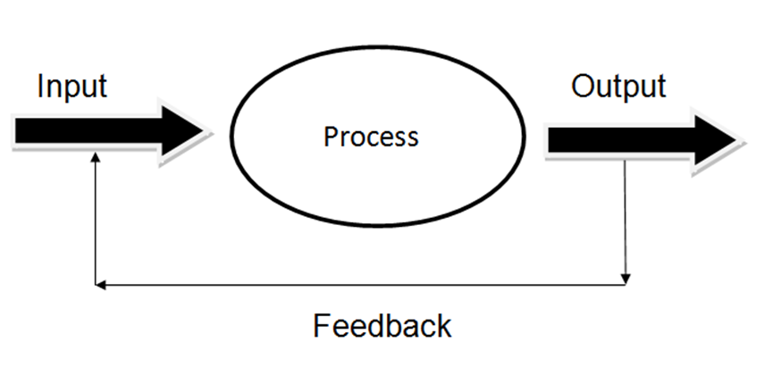
Figure 2.1 Schematic representation of a system

- Inputs are those elements which enter the system.
- For the transformation of inputs to outputs, processes are necessary.
- Products of the device are outputs. The elements of a system, consisting of entities that do not belong to the system , i.e. inputs, outputs and processes, are isolated from the environment but play an important role in the system's performance.
- Feedback is data pertaining to device performance. Continuous monitoring and feedback assessment to decide if the system is nearing completion of goals is part of the control.

2.3.1 MANAGEMENT SYSTEMS
A management system is a set of policies, processes and procedures used by an organization to manage the interrelated parts of its business and help it fulfil the tasks required for it to carry out its objectives. These objectives cover many areas of the organization's operations. Businesses operating in the 21st century face a number of challenges such as, competiveness, globalization, growth, speed of change and technology. But once there is a successful implementation of the management system it helps improve operational effectiveness, reduce costs, promote innovation and achieve continual improvement.

2.3.2 INFORMATION SYSTEMS
Computer technology is now crucial for the proper and efficient management of all forms of organization or business. The applications of computers, computing and communications covers all fields of human activity. The creation of appropriate systems to receive data at a time and turn them into information based on specific standards is therefore necessary.
A data system may be a set of interacting components that employment together to gather, process, and store and distribute information with the last word aim of making information needed and/or useful to the Agency/Enterprise to accomplish a purpose and deliver information, knowledge, and digital products. In a simpler way, a data system is that the one that takes data as input which it processes and returns the output as information. (Encyclopaedia Britannica, 2012)
Every company/organization has a data system, especially, consists of the subsequent main components (Lousa, 2010):
• People
• Procedures
• Software
• Data
• Material

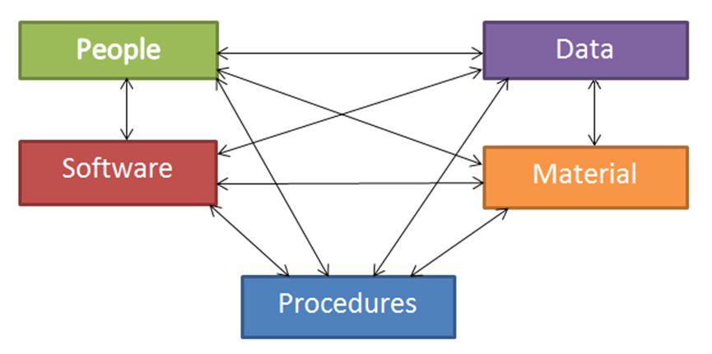
Figure 2.2 the components of an Information System
The system currently in place is a manual handling of patients and hospital records. The documents are shelved and then manually sorted out when needed by the nurses on duty. This of course puts a strain on the healthcare facility in the long run.

2.4 HEALTHCARE MANAGEMENT RECORDS SYSTEMS
Healthcare management records system is a computerized medical information system that collects, stores and displays patient information. They are a way of producing legible and structured patient data and of accessing individual patients ' clinical records. They are intended to complement existing (often paper based) medical records which are already familiar to medical practitioners.
The advantages of healthcare management records system can be summarized as optimizing the documentation of patient encounters, improving communication of information to physicians, improving access to patient medical information, optimizing billing, reduction of errors and forming a data repository for research, referencing and quality improvement, and reduction of paper.
The healthcare sector is an area of socio-economic interest to several countries, therefore a lot of effort is being put into the use of electronic health records. Still, there is evidence to suggest that the use of these systems have not been embraced as expected, and although there are some proposals to support their adoption, the support suggested is not by information and communication technology, which can provide automated support tools.

2.4.1 ORIGIN OF HEALTHCARE MANAGEMENT RECORDS SYSTEMS
The United States has a long history of health information management (HIM). Since 1928, when the American College of Surgeons (ACOS) tried to increase the standards of records being produced in clinical settings, the health information industry has officially been around. Thanks to the recent introduction of Electronic Health Records (EHR), HIM trends are still making headlines today. The HIM sector can trace its origins back to the 1920s, when healthcare practitioners realized that both providers and patients benefited from recording patient care. The specifics, complications and outcomes of patient care were identified by patient records. When healthcare providers realized that they were better able to treat patients with complete and accurate medical history, documentation became popular and much used throughout the nation. Health records were quickly described as vital to the protection and consistency of the experience of patients. By creating the American Association of Record Librarians, a specialist association that now operates under the name of the American Health Information Management Association (AHIMA), ACOS standardised these clinical records. "On paper, these early medical notes were kept, which explains the term" record librarians.

From the 1920s onwards, paper medical records were continually kept, but the advanced technologies of the '60s and' 70s brought the beginnings of a modern method. And with the coming of the information age, came the need for the exploration and development of computers and healthcare software application of medical records. The '80s created massive strides in the production of healthcare software. The advent of computerized registration meant patients were able to benefit from a more efficient electronic check-in process for the first time ever, and soon, computer healthcare applications began appearing on the market. However, these applications still faced limitations. Computer applications were being used within healthcare walls, but none of them could communicate with each other or be viewed by neighbouring departments. Healthcare was lacking an electronic record system that was communicative and cross-departmental. The new millennium, though, will change all that.

2.5 HEALTHCARE SYSTEMS
Healthcare management records system is a computerized medical information system that collects, stores and displays patient information. This system though is made up of different subsystems, depending on the hospital’s requirements. There are many different types of healthcare systems, including:
- Operational and tactical systems for easy classification of information: Use of tactical or operational health information systems is one of the most common methods of classifying the health information. Provisions for information systems dealing directly with that type of information are made at every level of this health information pyramid.
- Clinical and administrative structures: are structured to handle patient information at the administrative level. Another division of health information systems represents clinical and administrative health information systems. A clinical system that is not based on different types of administrative data is, however, practically impossible to create.
- Subject and task based systems: such as Electronic Medical Records (EMRs) or Electronic Health Records (EHRs); the subject-based health information system is related to any type of health care organization (patient or health care professionals), while basic activities (admissions / discharge system or operating theatre) are aligned with the task-based health information system.
- Financial systems: for tracking revenue and managing billing submissions, and helps in monitoring a patient’s usage of different departments.
These types of systems are also split up into various software solutions.

2.5.1 TYPES OF HEALTHCARE MANAGEMENT RECORDS SYSTEMS
Basic Health Information Subsystems
According to Winter (2001), the management system can be comprised of the varied combination of the following information subsystems, based on the requirements of the healthcare facility in question. They are:
- Administrative Budget Subsystem (A.B.S.): management personnel and payroll protocol, analytical and general accounting, asset management, treasury and hardware stores, supply management and procurement and payables management and available.
- Management of Patient System (M.P.S.): management of import and export patient, appointments and evening outpatient clinics, medical expenses, cost of medical procedures, pharmacy management and individual / general prescriptive medicines and medical supplies, reagents management, project management and maintenance of therapeutic diets based claims and management of feedstock.
- Medical Subsystem (M.S.): management and monitoring of inpatient and outpatient management of medical diagnoses and findings, patient records.
- Laboratory Information System (L.I.S.): management of laboratory tests and sampling applications consumables and reagents and management results.
- Nursing Subsystem (N.S.): nursing care administration, supply of medications and use of health materials, compliance with disease progression treatment and control, bed and special cases administration and transparency.
Others are: the Management Information System (M.I.S.) and the Picture Archiving and Communication Systems (P.A.C.S.).

2.5.2 HEALTHCARE MANAGEMENT RECORDS SYSTEMS COMPONENTS OR FEATURES
Depending on the context, software for medical facilities may differ in type and functionality. However, regardless of the needs, specifications, and approach to function of any particular hospital, there are certain universal features without which a hospital management program will be pretty much useless.
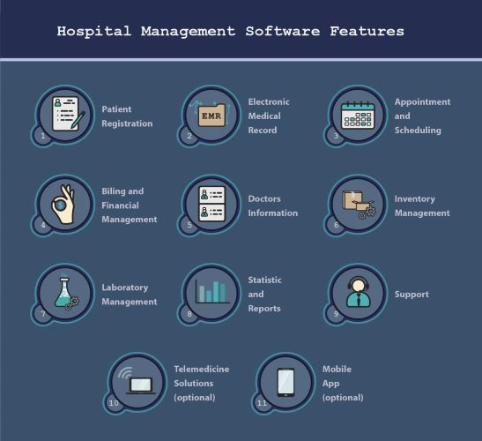
Figure 2.3 features of HMS

1. Patient Registration and EHR/EMRs
2. Appointment and Scheduling
3. Billing and Financial Management
4. Doctors Information
5. Inventory Management
6. Laboratory Management
7. Statistics and reports
8. Support
9. Telemedicine solution
10. Mobile App for Customers and Employees

    - ADVANTAGES OF HEALTHCARE MANAGEMENT RECORDS SYSTEMS
Some of the advantages of implementing a healthcare management records system include:
- Reduced workload and burn-out rates: Medical staff are likely to burn out, taking into account the specifics of their task. Time pressure, lack of control over work processes, role conflict, and poor relationships between groups and with leadership, and emotional intensity of clinical work can prove to be detrimental.
- Decreased Costs: A proper healthcare management records system can significantly decrease the administrative costs of a hospital’s processes by automating it. Management software can streamline workflow and even improve other aspects of medical facility management.
- Increased Customer Satisfaction: A patient can carry out and complete certain hospital procedure and processes using a computer or a mobile device, if a hospital has a software system. Moreover, it takes less time for all procedures to operate than in medical facilities that have not incorporated software solutions. As a consequence, it is a smooth and optimistic experience for patient engagement with a hospital.
- Clearer Strategic Development: With a decent hospital management system in place, it is much easier to see the full picture and have better control over the internal processes. As a result, the management has the necessary tools to make and implement strategic decisions to further the productivity and efficiency of the healthcare establishment.

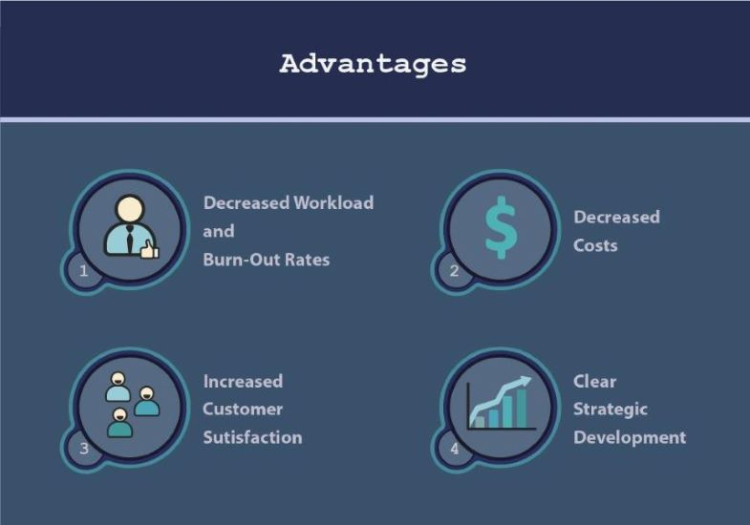
Figure 2.4 advantages of HMS

2.5.4 STEPS FOR CREATING AN INFORMATION SYSTEM FOR HEALTH MANAGEMENT
The Regional Office for the Western Pacific of the World Health Organization (WHO, 2004) [18] suggests the following measures when designing an information system for health management:
- Study the new framework
- Specifying the data criteria for the related units in the health system
- Evaluate the data flow that is most suitable and efficient
- Programming tools for data collection and reporting
- Establish procedures and processes for the processing of information
- Create and implement a training program for suppliers of data and users of data.
- Pre-test and, where possible, re-design of the data collection, data flow, data processing and data utilization framework.
- Track the device and test it
- Develop efficient mechanisms for data dissemination and feedback
- Assess the framework
According to (Chrisanthi and Cornford, 1998) [4], the method of creating an information system can be seen as a list of activities, beginning with the selection and implementation of a project for an information system and concluding with the maintenance of its optional components for a period of time before the system is phased out or replaced. They say, however, that this differs from one definition of the organisation to another. For their part, they recommend that the following measures for most organizations are typical:
- Recognition of an problem, pressure or opportunity
- Determination of general improvement criteria
- Feasibility study to evaluate alternative approaches
- Systems analysis to model detailed technical component specifications or organizational change requirements.
- Development of programs to work out how to satisfy the requirements
- Development or acquisition of, and configuration of, software and hardware
- Implementation of programs using organizational settings
- Services and maintenance
- If the device is no longer needed or used, phase it out.

2.6 THE NEED FOR HEALTHCARE MANAGEMENT RECORDS SYSTEMS IN NIGERIA
In Nigeria, healthcare provision is the simultaneous responsibility of the country's three levels of government. Private healthcare providers have a visible role to play in the delivery of health care. The federal government's role is mostly limited to coordinating the affairs of the university teaching hospitals, Federal Medical Centres (tertiary healthcare), while the state government’s priority is of general hospitals (secondary healthcare) and local government is on dispensaries (primary healthcare), which are regulated through the NPHCDA by the federal government.
With the constant influx and traffic of patients within, and moving between healthcare facilities, there is a need for healthcare management records systems in taking care of and managing both the hospitals and patients alike. The implementation and integration of healthcare management records systems is of paramount importance, if we want to stay abreast of the rising demand and changing trends in the Nigerian healthcare sector. Some of the problems faced by healthcare personnel are:
- The manual registration process leads to data redundancy and also gives an additional workload to the person who is in charge. This is because they still need to find the record of patients that have received treatment from the clinic before.
- From the research, by interviewing the medical staff, and also people who work under this organization; they feel that they are under-staffed and need more workers. This poses a problem in the University’s financial department as it is supposed to pay all the workers.
- Mishandling of the patients records and privacy, students private information can be easily accessed by anyone who can gain access to the manual records.
- There is no data backup. Once data about a patient is lost it cannot be easily recovered or be recovered at all.

2.7 THE WORLD WIDE WEB
The internet is a group of computers linked to each other around the world via a high-speed series of networks. The World Wide Web (www) consists of a vast assortment of files and documents that are stored on these computers and written in Hypertext Markup Language (HTML) that tells the browser, how to display the information. The computers that store files are called servers because they can serve request from many users at the same time. The users access HTML files and documents via applications called browsers (Academic Technology and Creative Services, 2010).

2.7.1 WEB-BASED APPLICATIONS OR SOFTWARE
You may access web applications through the Internet (or via the intranet). Web-based application adhere to or are governed by certain parameters. Such as:
- Maintenance: Software focused on the Web do not need to be installed more than once. Also they can be updated easily when new version of the application become available.
- Usage Scale: Desktop apps are limited to a physical location and thus have restrictions on usability. On the other hand, creating web apps makes it possible for users to access the application from any place using the Internet.
- Speed and Performance: Creation of Web applications relies heavily on Internet connectivity and speed. The absence of the Internet or its poor connectivity can cause web application performance problems.
- Bandwidth cost: As web apps are based on the internet, bandwidth consumption costs more than desktop applications do.
- A multi-tier architecture uses a web-based framework.
- For web applications, the user’s interaction with the software is through a compatible web browser.
- Multiple users can concurrently use a web application and offer superior performance as well.

2.7.2 ONLINE OR WEB-BASED HEALTHCARE MANAGEMENT RECORDS SYSTEM
Healthcare systems are built on the basis of Health Informatics, which is the intersection of clinical informatics and public health informatics. It is one of the areas that make up the interdisciplinary field known as biomedical computer science. The interdisciplinary study of the design, development, adoption and application of IT-based technologies in the delivery, management and planning of healthcare services is Health Informatics. Still, they must be built while taking into consideration, Health Information Privacy, which is an individual’s right to control the acquisition, uses, or disclosures of his or her identifiable health data. They can be a preferred option because of the increased chance for connectivity that they offer.

2.8 THE FUTURE OF FRAMEWORKS FOR HEALTH INFORMATION MANAGEMENT
Today's health information management industry is still focused on the first medical record librarians' founding objective: to lift and strengthen the standards of clinical documentation. The industry has come a long way from keeping health records in hard copies, but it has yet to understand the ultimate aim of completely functional EHR.
‘Geyfman (Brooks, 2015) noted that traditional organizations will have to understand not only how to collect data, but also to quickly and reliably process, analyse and deliver the data to those who need it, to any device.’ More important than the data itself is the ability to learn “actionable insights from the data,” Geyfman stressed (Brooks, 2015).

2.9 REVIEW OF RELATED WORKS
The review of literature brought contextual challenges and a short historical review of hospital management information systems to the fore. Information Platforms for Web-Based Healthcare Administration include strategic policy support systems and systems for clinical reporting. Laboratory Information Systems (LIS) and Radiology Information Systems (RIS) are some of the clinical support systems, others are pharmaceutical information systems and personal data processing systems with substantial added messaging capabilities between clinicians and personnel, and the ability to exchange data with other medical facilities (Keenan et al; 2006).

2.10 SUMMARY OF LITERATURE REVIEWED
Is a literature review relevant to the research topic; it would discuss an introduction to the chapter, an overview of the healthcare management records system and a brief history of HMS. The HMS types are also discussed. And a quick look at some of the literature on this paper.

CHAPTER THREE
METHODOLOGY

3.0 INTRODUCTION
A healthcare management records system is web application that is beneficial for hospitals and clinics. It helps the doctors as well as the patients keep track of a patient’s health history. The topic of System Analysis and Design deals primarily with the activities of software creation in this complex environment. Research requires a thorough study of the existing system, which contributes to a new system’s requirements. Analysis is a systematic examination of a system's different operations and their relationships inside and outside the system.
In this chapter, the data collection, the planning, the design, and the method used in implementing this system is analyzed in detail, which gives us a suitable result that leads to the final product.

3.1 ANALYSIS AND PROBLEM OF THE EXISTING SYSTEM
A proper analysis of the existing system (paper based) would enable the creation of new system that would perform better and more efficient.
The existing system leads to the innovation of automating the new system by which the clinic operates.
Features of the existing system as depicted in the above entails:
- Managing Queue: Queue management is a difficult problem of these hospitals due to the number of patients being attended to per time.
- Paper File System: the clinic makes use of paper file system to take records of the patients from registration to regular visits (all patient’s medical history with the clinic).
- Availability of facilities: Most times the clinic is only able to cater a lower number of patients.
- Service delivery: The number of patients attended to by the clinic is larger than the number of staffs on ground.

3.2 ANALYSIS OF THE PROPOSED SYSTEM
This is concerned with the co-ordination of activities, procedures, and software and equipment utilization in order to achieve the desired objectives. The analysis of the system entails: the description of the proposed system and the benefits derived from the proposed system.

3.2.1 DESCRIPTION OF THE PROPOSED SYSTEM
This website is designed basically for MTU clinic and is comprised mainly of;
- Registration page
- Logging application
- User management
- Ward management
- Drug inventory

3.2.2 BENEFIT OF THE PROPOSED SYSTEM
- It helps the clinic to keep track of patient records.
- It helps to deliver service to customers faster and better.
- It helps the clinic manage its patients.
- It helps patients get their desired medical attention as required.

3.3 SOFTWARE DEVELOPMENT LIFE CYCLE
The Software Development Life Cycle (SDLC) is a method used in the design, development and testing of high quality software by the software industry. The SDLC strives to deliver a high-quality software that meets or exceeds the requirements of consumers, achieves completion in time and estimates of costs.
7 Stages of the System Development Life Cycle:
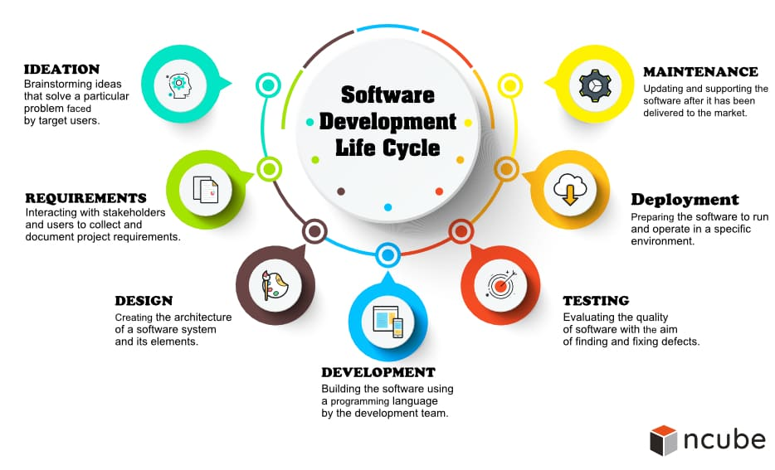
Figure 3.1: SDLC Phases

Waterfall Model
This is one of software engineering's most classical and oldest models. It is one of the oldest models that many companies often use for their initiatives in order to achieve their ultimate goal. (IEEE WESCON, Royce, W, 1970.)
It is a breakdown into linear sequential phases of project operations, where each step relies on the output of the previous one and corresponds to a task specialization. For some areas of engineering design, the strategy is common. It appears to be among the least iterative and versatile methods in software development, as progress flows in largely one direction ("downwards" like a waterfall) through the design, initiation, evaluation, design , construction, testing , deployment and maintenance phases. The figure below shows the waterfall model's progress flow (Royce, W, 1970, IEEE WESCON).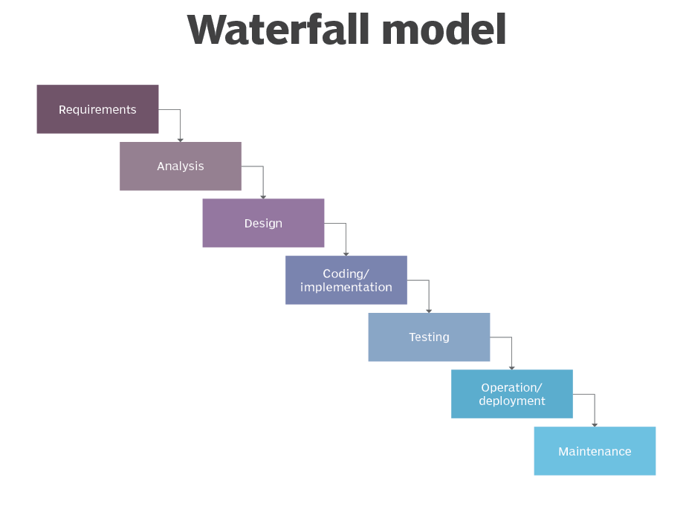
Figure 3.2: Waterfall Model

3.4 SYSTEM DESIGN AND DEVELOPMENT
System design is the method of specifying a system's elements, modules, interfaces, and data to meet defined specifications. System development, combined with the methods, procedures, models, and methodologies used to create them, is the mechanism of developing or altering programs.

3.4.1 REQUIREMENT GATHERING
The specifications of the system that is being used and the one that is to be created were extensively gathered through personal interview with the clinic staff and patients, through knowing their views about what is wrong with the current system, and what changes can be made to the new system that is about to be created.

3.4.2 USER REQUIREMENTS
It is very important to completely involve device users in such a way that the question of change management does not arise. Therefore, the stakeholders that would use the system were approached during the research and were asked what they expected of the proposed system and the results were the following:
- A framework that is simple to understand and use.
- A process that enhances the efficacy of data storage and retrieval.
- A system that is easily delivers outputs that are ready at the point of treatment, thereby reducing the waiting period and increasing the time to care for patients.
- A system which has an error validation feature, i.e. one that prompts the user when an odd, database-inconsistent command or data format entered into the system.
- A framework that offers attractive interfaces with simple system-wide navigation.
- A scheme that is easier, more versatile and easy.
- A system that stores information and generates reports in a timely and accurate way.
- A system that gives a unique id to each user.

3.4.3 FUNCTIONAL REQUIREMENTS
Functional specifications capture the system's expected actions. This action can be represented as activities, tasks or functions that must be performed by the system. It is also possible for the proposed system to:
1. Capture, store, and make available patient information at the moment of need.
2. Capture, store and produce user-friendly declarations of out-patient files for outpatient attendance records.
3. Indicate the number of records in a database to users with a real-time show.
4. Accurately and punctually produce reports.
5. Search and display descriptions of patient data for folder retrieval purposes.
6. New patients who enter the clinic will be recorded.

3.4.4 NON-FUNCTIONAL REQUIREMENTS (NFRS)
Non-Functional Specifications are conditions that define parameters, rather than particular behaviors, that can be used to determine the performance of a system. This is in contrast to functional specifications that define particular actions or functions. Systems must exhibit attributes of software quality, such as accuracy, efficiency, cost , safety and adaptability plus usability, i.e. Simple for the expected users to use. NFRs aid in meeting a system's functional specifications. The suggested scheme therefore works as follows:
- The program has high standards of efficiency and reliability.
- The device has interfaces that are user-friendly. This guarantees the simplicity with which it is possible to understand or use the software.
- Handles increasing volumes of work in a graceful way that can be quickly extended, i.e. the ease with which the system can be changed to accommodate a substantial increase in users, workload or transactions.
- Unauthorized access to a device with user authentication through a log-on system is prevented by the system.

3.5 TOOLS AND DIAGRAMS SUCH AS DATA FLOW DIAGRAM, USE CASE DIAGRAMS, ETC.

3.5.1 IMPLEMENTED SYSTEM
The system was developed using various programs;
Technology Implemented: CSS, JavaServer Faces (JSF), Bootstrap, Netbeans
Used Language: Java, Transact-Sql, JavaScript
Database: Microsoft SQL Server
Interface User: HTML, CSS, JavaScript
Online Browser: Chrome
Software: Web application
Operating System: Windows 10

HTML: HTML stands for Hyper Text Markup Language, HTML is the default Web page markup language, HTML element is the HTML page structure block, and HTML elements are represented by < > tags.
CSS: CSS stands for Cascading Style Sheets, with CSS defining how to display HTML elements. CSS is a stylesheet language that defines an HTML (or XML) document presentation. CSS specifies how items on video, on paper, or in other media must be made. It can monitor the layout of several web pages. External stylesheets are stored in CSS directories.
JAVASCRIPT: JavaScript, also abbreviated as JS, is an ECMAScript specification compliant programming language. JavaScript is high-level, assembled and multi-paradigm, mostly just-in-time. It has curly-bracket notation, dynamic typing, object-orientation depending on the prototype, and first-class functions.
JAVA: Java is a programming language based on the class and the object which is designed for as little dependency as possible in implementing it.
NETBEANS: NetBeans is an IDE for Java. NetBeans facilitates the creation of applications from a series of components of modular software called modules. NetBeans operates on Windows, MacOS, Solaris, and Linux.
MSSQL: Microsoft SQL Server is a framework developed by Microsoft for relational database administration. As a database server, it is a software product that can operate either on the same computer or on another computer through a network, with the primary purpose of storing and retrieving data as required by other software applications.

3.5.2 UML CLASS MODEL DIAGRAM
The class diagram is a static graphic representation. This reflects an application's static vision. The class diagram is not only used to visualize, explain and record various facets of a method, but also to create the software application's executable code.
The class diagram defines a class's characteristics and functions and also the system's restrictions. In the modeling of object-oriented structures, class diagrams are commonly used since they are the only UML diagrams which can be specifically mapped to object-oriented languages.
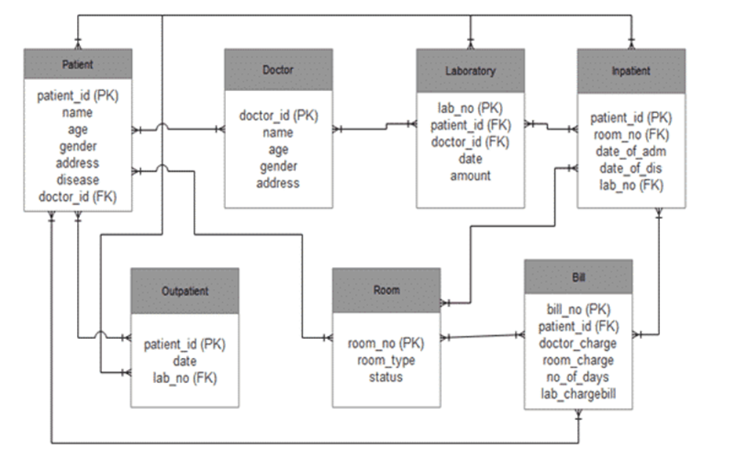
Figure 3.3: Class model diagram of a HMS

3.5.3 DATA FLOW DIAGRAM
Data flow diagrams (DFDs) are used to explain the flow of information in a system. They are independent of hardware and do not reflect decision points. They show the data as it moves between particular processes in a system. These diagrams help to illustrate how data in a graphical top-down fashion travels and transitions through the system. They also aid in creating a schematic description of the materials, procedures and interfaces of the device.
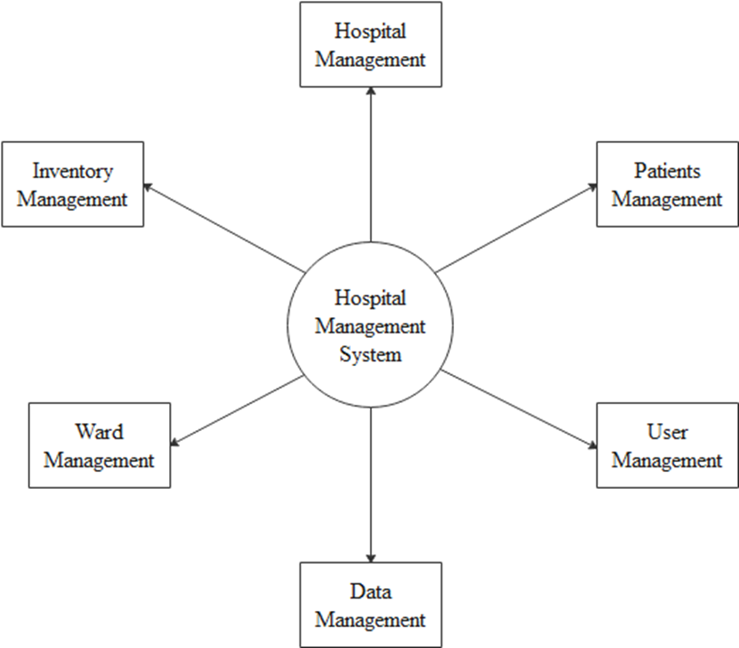
Figure 3.4: Zero Level DFD – Hospital Management System

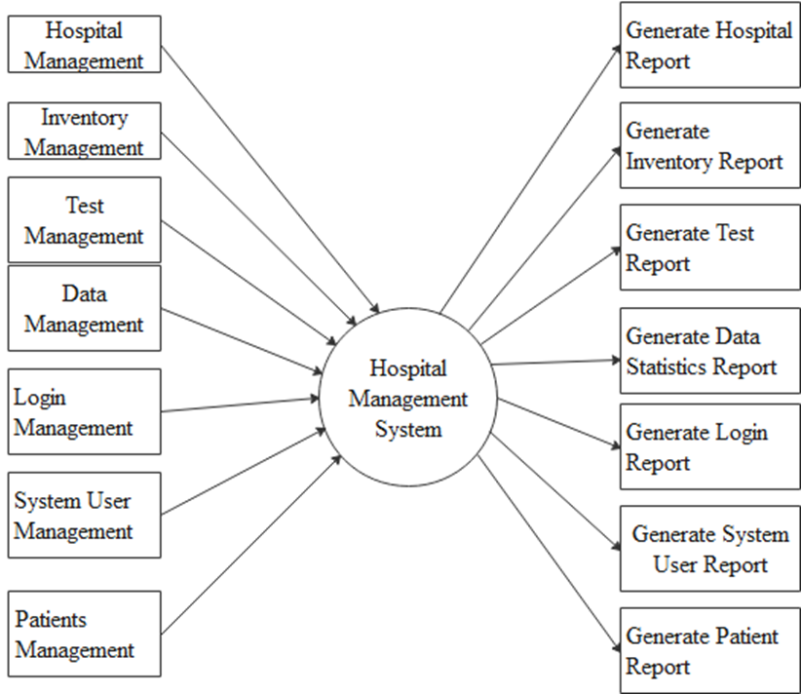
Figure 3.5: First Level DFD – Hospital Management System

3.5.4 ENTITY - RELATIONSHIP DIAGRAM
The ER diagram is a method for semantic data processing that is used to achieve the purpose of defining or representing data abstractly. The data defined abstractly is called a logical model. The conceptual model will lead to a schema. A schema means a fixed, permanent definition of the data structure.
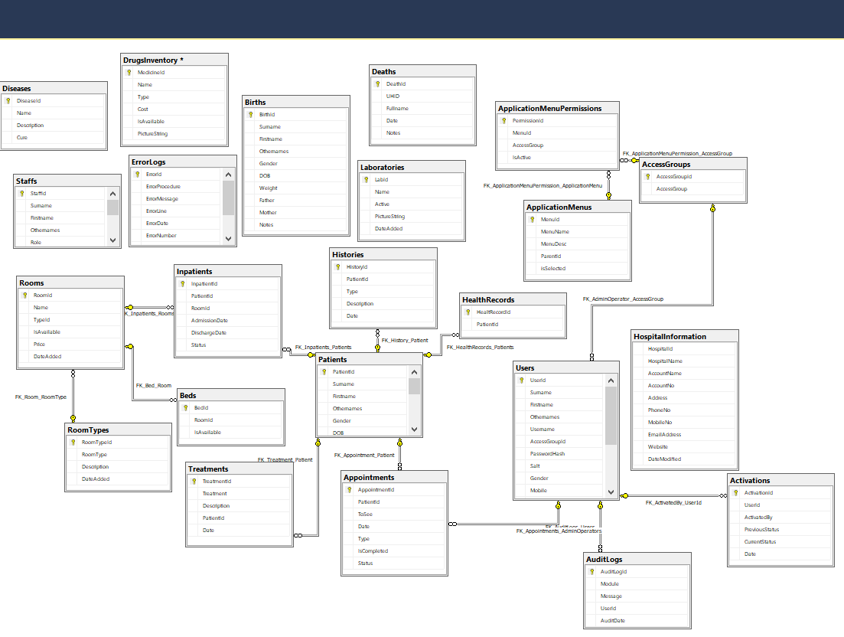

Figure 3.6: E – R Diagram for Hospital Management System

3.5.5 USE CASE DIAGRAM
Use cases explain the machine operations from an external user's viewpoint and in a form and language that they understand. A use case represents a particular device purpose which defines a series of operations and user experiences in an effort to achieve the objective. In order to properly grasp and record device specifications, the design of use cases has proven to be an outstanding strategy.
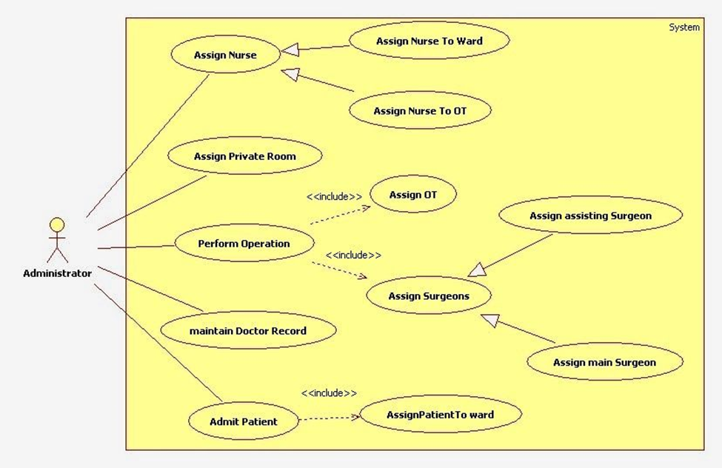
Figure 3.7: Use Case Diagram for an Administrator in Hospital Management System

3.6 METHOD OF DATA COLLECTION
The researcher analyzed the current structure in this chapter to define its vulnerable and powerful points. The data acquired from this study formed the basis for the new system's design. As seen below, a variety of steps, procedures and tools were employed:

3.6.1 INTERVIEWS
The researcher carried out face-to - face interviews with the holders of the stake. In order to fully understand their views, physicians, nurses, clinicians, reports and patients were interviewed. This technique has been selected because:
- It makes it possible to clarify questions
- Has a high response rate compared to written questionnaires
- It is acceptable for both literate and illiterate people to use
- Get the full scope and depth of data
- Develops customer relationships
- Can be flexible with customers

3.6.2 OBSERVATIONS
This method was used to collect accurate information, especially about procedures, about how the system actually operates. This involved the researcher regularly observing and recording in the hospital the activities and features of operations. Although the solution was time-consuming, it had a range of benefits, including:
- It provides more comprehensive and context-related data.
- It allows information about facts not mentioned in the interview to be collected.
- It enables checking of the accuracy of the answers to the questionnaires.
- Display operations of a program as they are currently occurring.
- Could adapt to events as they happen.

3.6.3 DOCUMENT REVIEW
This involved carrying out research and extensive reading of existing materials and documentation regarding patient’s information; requirements, design and implementation of management system resources such as libraries and the Internet were exploited.

CHAPTER FOUR

SYSTEM DESIGN AND IMPLEMENTATION
4.0 INTRODUCTION
This chapter discusses the implementation of this project, this chapter discusses the design and analysis of the system, it includes images from the application and the interfaces involved in the development of the application and also the methods used in the development, the whole object constructs a system that works together as a set of things. It is a set of interacting or interdependent parts of a mechanism or an interconnecting system component forming an integrated whole or a set of elements to other elements.

4.1 OBJECTIVE OF SYSTEM DESIGN
The healthcare management records system is a software application that would effectively provide assistance and support to clinical staff, giving them less stress and trouble in the allocation of facilities.

4.2 SYSTEM DESIGN
The design of the system is mainly the implementation of the application to be developed and this is split into three parts:
- Logical Design
- Conceptual Design
- The physical design

4.2.1 LOGICAL DESIGN
This model has been developed to show all the vital steps that the development of the system has taken. Use case tools, such as flow charts and data flow diagrams, were used in this step. In the development of the system, these models were vital and significant. This phase included the design of the graphical user interface, the input design in which the user inputs data, the output design showing the results of what a user would or would have entered, and the design of the database where information is stored for easy management. The technical blueprint from which the system was constructed was provided by these designs. In order to come up with input, output designs and the system view, a combination of layout tools were used. MicrosoftSQL was the database management system employed.

4.2.2 CONCEPTUAL DESIGN
In terms of a set of integrated ideas and concepts about what the system is expected to do, behave and look like, this was just a description of the proposed system, which would be readily understood by the users in the manner intended. This process was started by identifying several user-required entities and also identifying all the important relationships between the entities that exist. The outcome was the user interface model that was developed.

4.2.3 PHYSICAL DESIGN
This was the realization of logical design in physical terms. Forms, reports and tables were created and relationships between these tables were defined and security constraints were set. The expected schemas were translated into actual database structure during the physical period.

4.3 SYSTEM REQUIREMENT AND SPECIFICATION OF MODELS
Usually, it is expedient to develop it around the target users of the software when developing software. This software would be used by the clinical staff, so it is essential that to be able to use this system it requires minimal experience or know-how on their part. For the front end of the application, the system was implemented using HTML and CSS and the database end of Microsoft SQL was incorporated. It is noteworthy to state that the framework is expected to be used in a networked environment. We will discuss the various requirements of the system for this purpose.

4.3.1 REQUIREMENT AND CONSTRAINTS FOR THE SOFTWARE
Using Java, this system was designed. Java is a class-based, object-oriented programming language, which has the fewest dependencies possible for implementation. It is a general programming language designed to let application developers write once, run anywhere (WORA), which means that compiled Java code can run without the need for recompilation on all platforms that support Java.
A previous edition of Java might not be able to run the program effectively, although it would be possible for a more recent version of Java. Furthermore, using MSSQL (Microsoft Structured Query Language), the database end has been developed. This invariably means that Microsoft SQL Server Management Studio must be installed on the local machine. So it would run this software perfectly.

4.3.2 PLATFORM FOR HARDWARE
The hardware configuration section is an important task related to the software development. Insufficient random access memory can adversely affect the speed and efficiency of the whole system. To handle the entire activities, the process should be powerful. The hard disk should have enough file and application storage capacity.
- Processor: Intel(R) Core(TM) i5-8250U CPU @ 1.60GHz, 1800 Mhz, 4 Core(s), 8 Logical Processor(s)
- Size of cache: 512 KB
- RAM: 12.0 GB
- Network card: Any card can provide the required speed speed
- Connection to the network: Wi-Fi, Ethernet
- Printer: Inkjet/Laser Color printer provides at least 1000 Dpi
- Hard Disk: 1TB
- Monitor: Intel(R) UHD Graphics 620
- Mouse: ELAN Click pad

4.3.3 NETWORKING SPECIFICATIONS
As previously mentioned, the device is intended to be used in a networked environment. By default, at least one computer with the minimum requirements mentioned above is supposed to be in each of the departments of the hospital. Furthermore, all these networks are linked to a local area network (LAN) network.

4.4 SYSTEM DEVELOPMENT
In chapter three, the architecture of the system was addressed and earlier in this chapter, the system parameters and concept specifications were enumerated. We will now look at the system implementation process interacting with the system window by window or form-by-form.

4.4.1 HMS LOGIN MODULE
- Home Page
This is the project's welcome page, it is opened with the healthcare management records system URL, which will carry the User registration interface when you open this page.
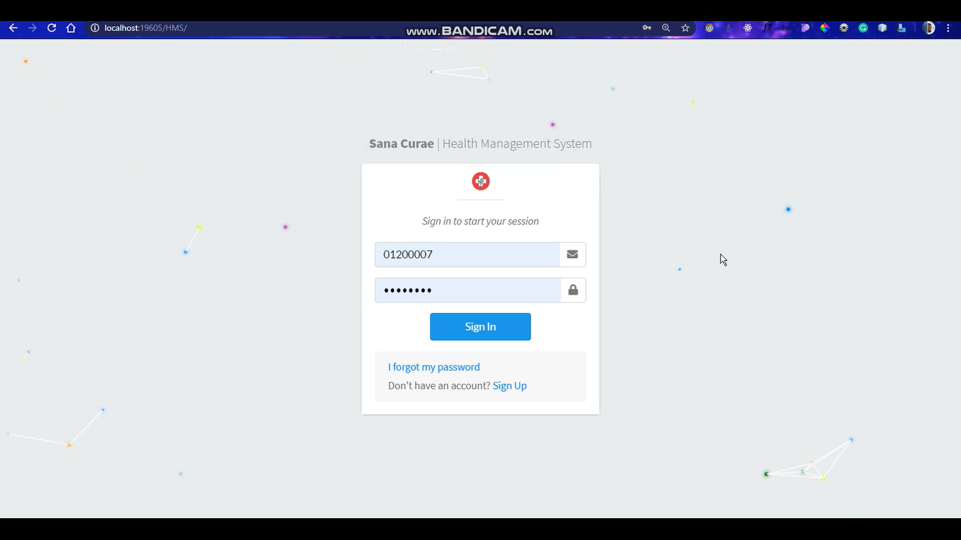
Figure 4.1 image showing the Home page

- User Registration
This page contains the first name , last name, other names, phone number , email, gender, user group before a person can log into the application interface, he / she has to establish an account, that is, he / she has to register.
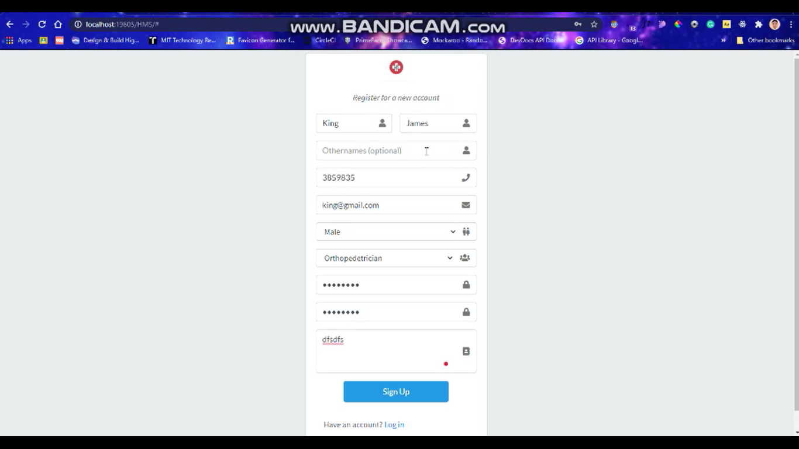
Figure 4.2 showing the user registration

- Dashboard
You can navigate this interface by clicking on the login button on the homepage and it takes you to the page where you see the dashboard, user management , patient management, ward management, medication management, and sign-out.

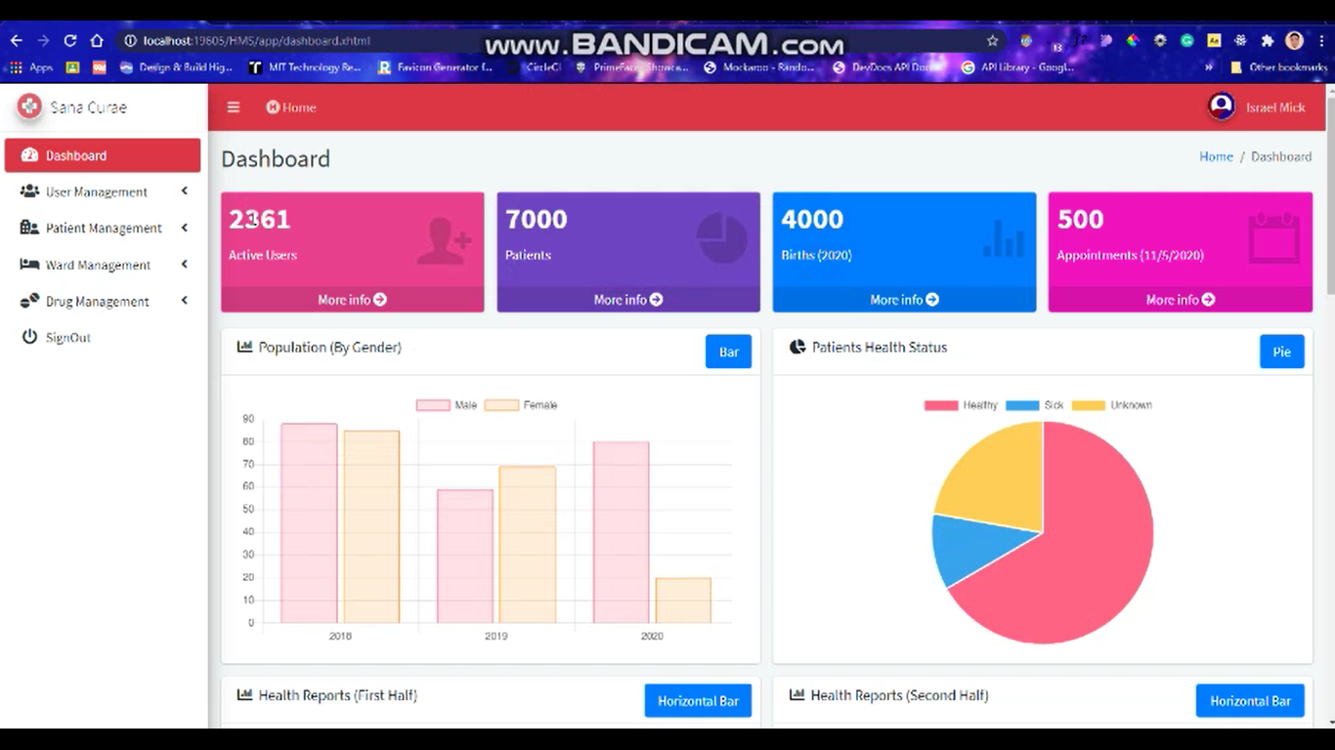
Figure 4.3 image showing the User login dashboard

- User Profile
You can navigate this interface by clicking on the profile button on the homepage and it takes you to the page where you see the profile, which includes the user’s basic information and the edit profile button.
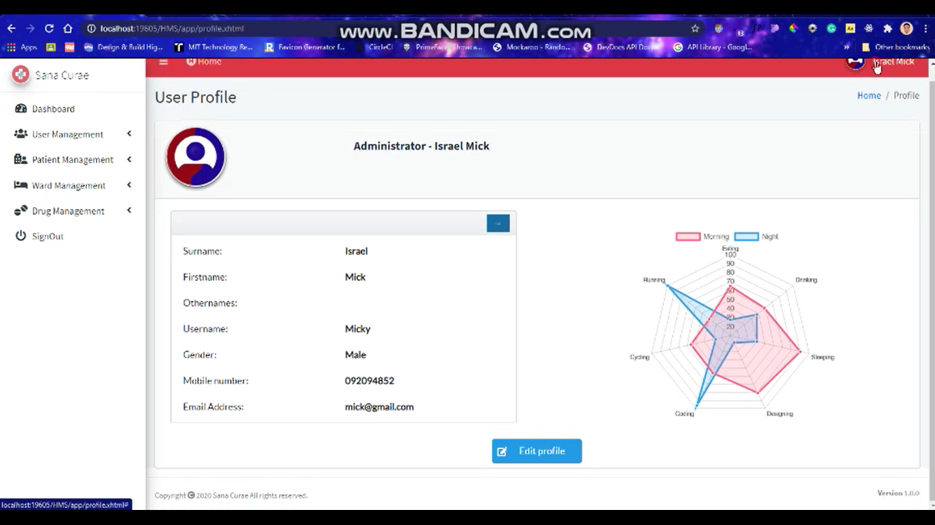
Figure 4.4 showing the user profile interface

- User Management
This is the part of the app, which consists of user groups, users, activate and deactivate users.

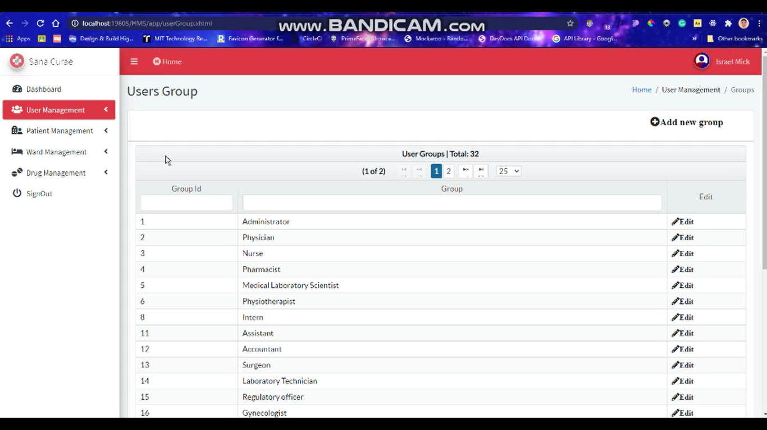
Figure 4.5 interface showing user groups under user management

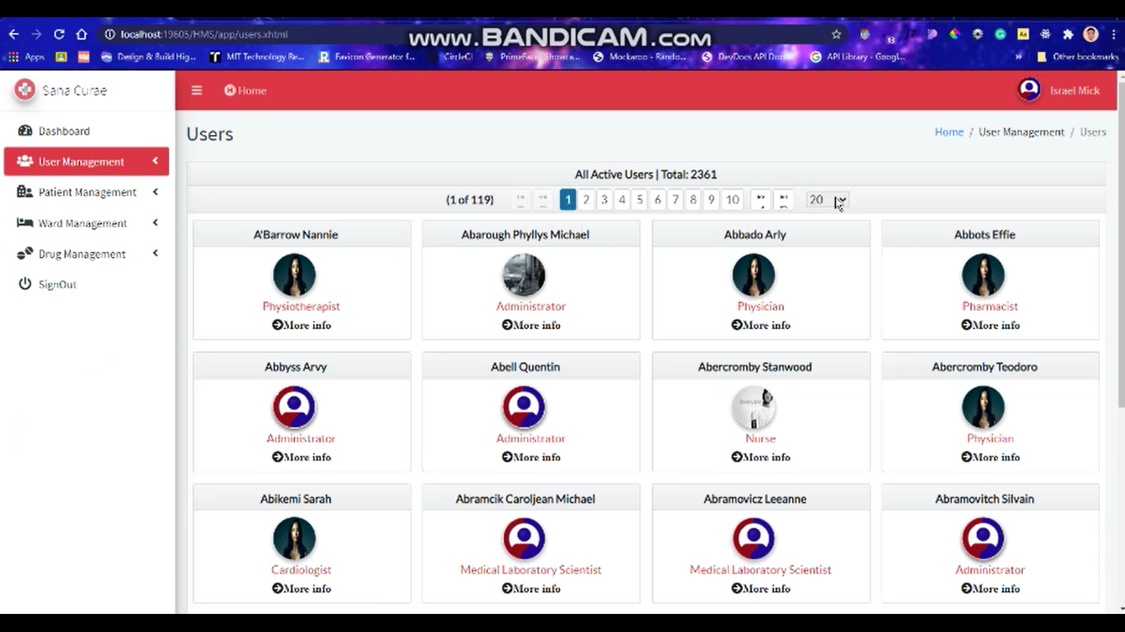
Figure 4.6 interface showing users under user management

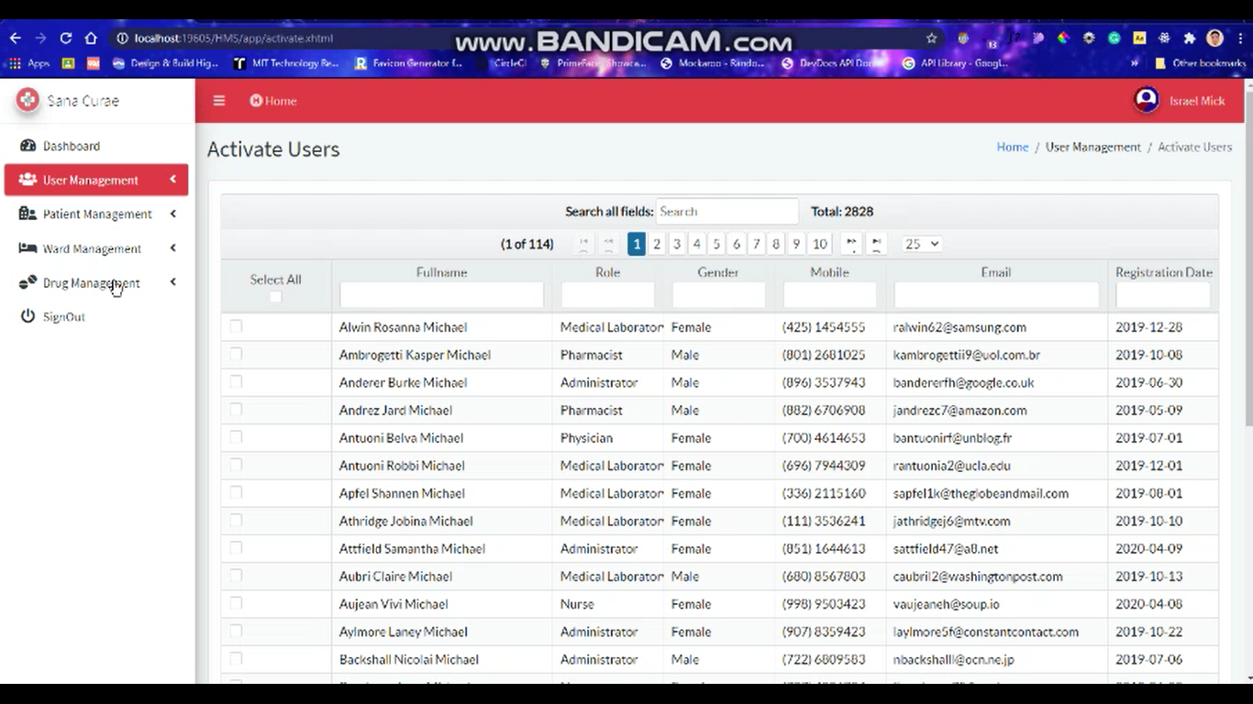
Figure 4.7 interface showing user activation page under user management

- Patient Management
This is the section includes the patient registration, inpatient and outpatient pages.
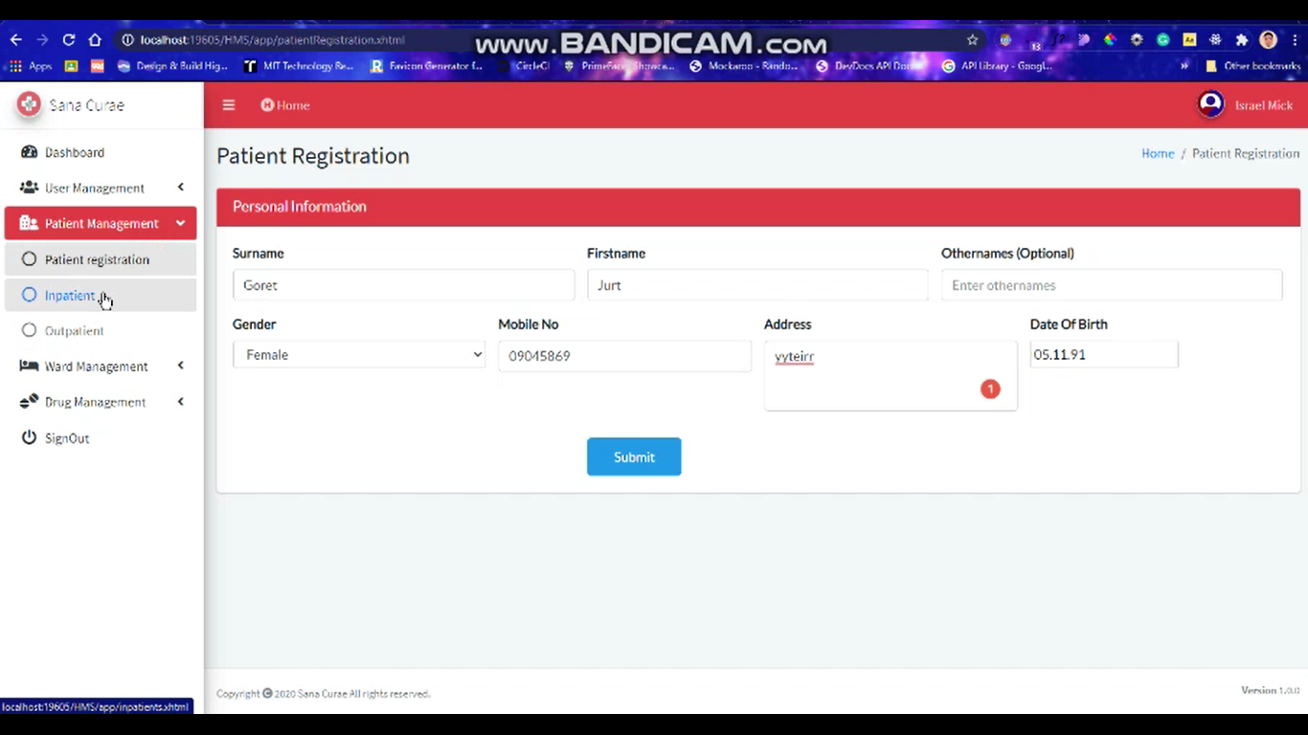
Figure 4.8 interface showing patient registration page under patient management

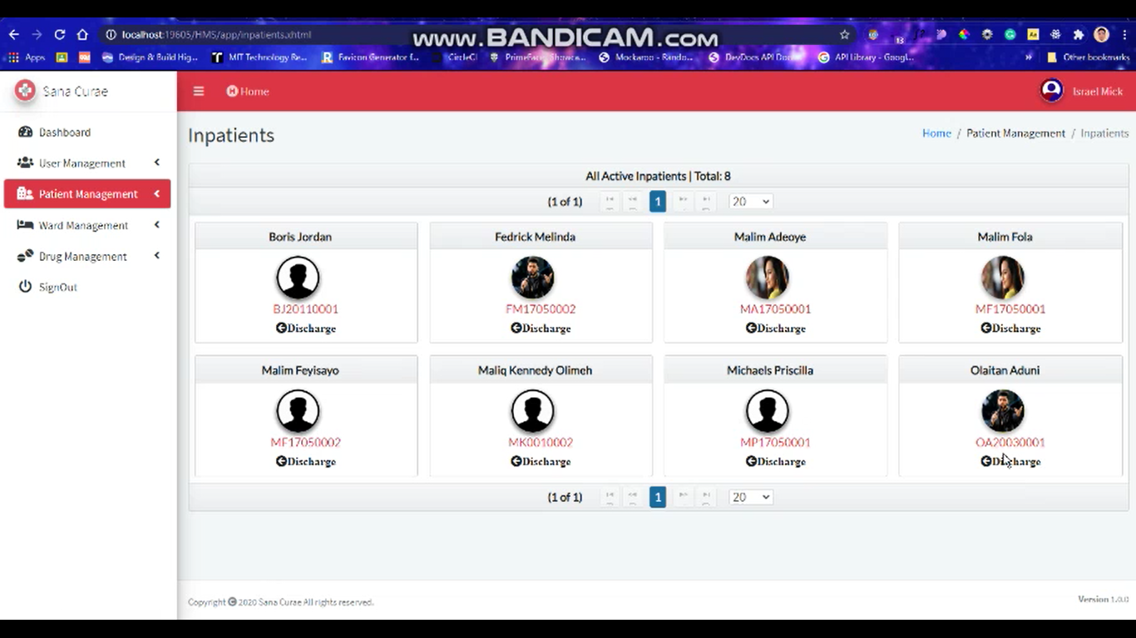
Figure 4.9 interface showing inpatients page

- Ward Management
This is the section comprises of the management of ward types, wards and beds.
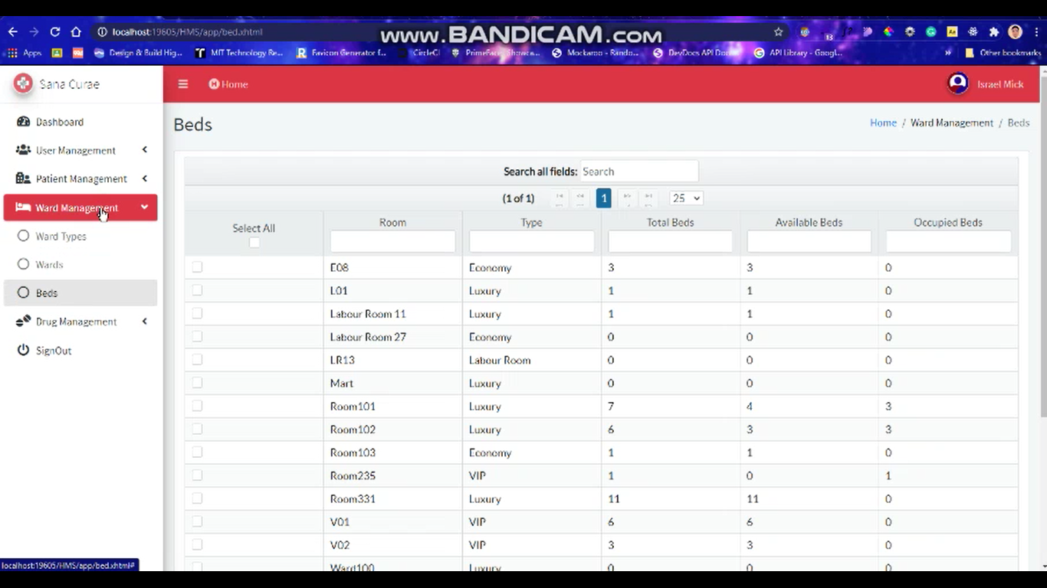
Figure 4.10 image showing ward management interface

- Drug Management
This is the section takes care of the drug inventory, all details related to the drugs used in the hospital are found here.
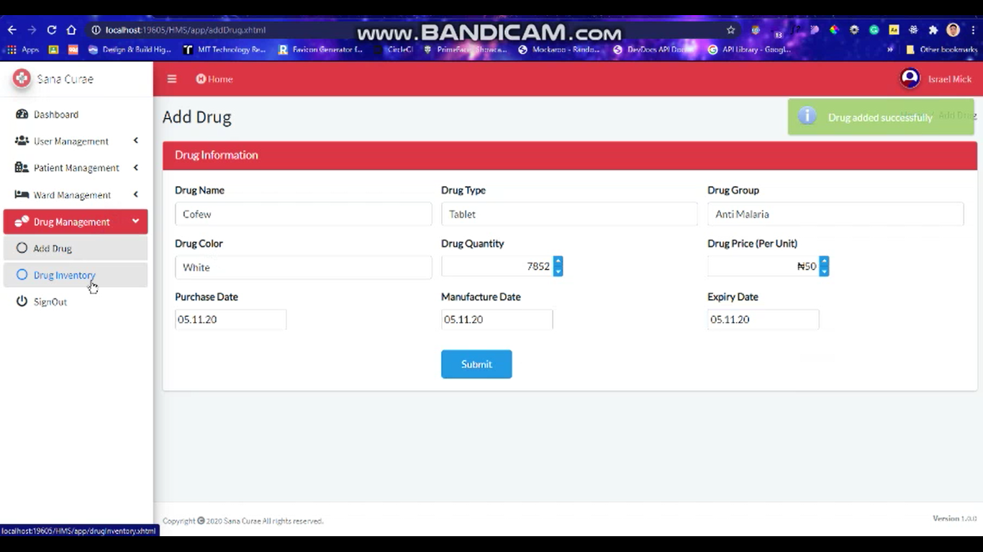
Figure 4.11 image showing drug management interface

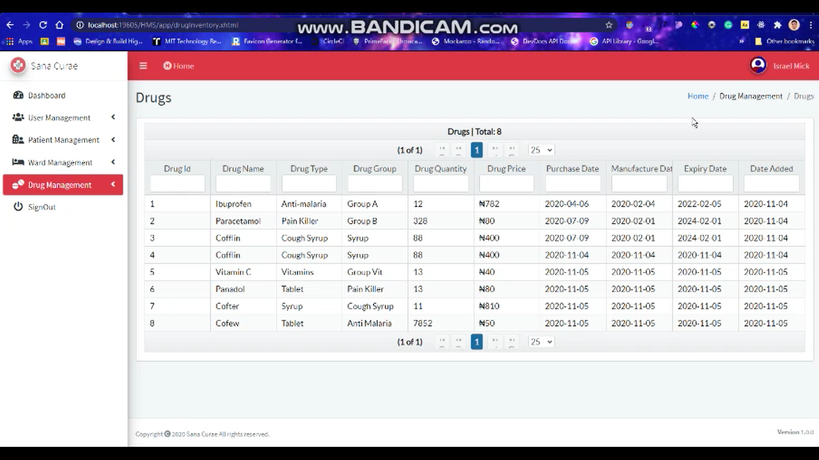
Figure 4.12 showing drug inventory

CHAPTER FIVE

SUMMARY, CONCLUSION AND RECOMMENDATIONS

5.0 INTRODUCTION
This chapter provides a description of what has been discussed so far, beginning with the project from Chapter 1 to Chapter 4, and also provides conclusions about the whole project, what was learned during the research work, and the outcomes of the research work so far.

5.1 SUMMARY
This project work, entitled "DESIGN AND IMPLEMENTATION OF WEB-BASED HEALTHCARE MANAGEMENT RECORDS SYSTEM" is built on the basis of the specification of user needs and the review of the actual system, identifying the issues with the current system leads to the new design of a computerized system that will be consistent with the current system, and is more user-friendly and more visual user-friendly.
This research project was carried out to allow the management of the Mountain Top University clinic to provide a broad and comprehensive database, to maintain all information relevant to the healthcare management records system, and to update information as it relates to file processing and database characteristics.
The designed framework enables:
1. Rooms to be automatically reserved and productive ward administration.
2. Ward allocation to be executed on a network system over the Internet.
3. It would minimize human error.
4. Without complications, a layman may use the framework.
5. The workers will be better conscious of the application's use.
6. The data and information of the patient is kept secure and strongly preserved.

Chapter one of this project clearly addresses the study's context, the problem statement, the aim and objectives, the nature of the study, the importance of the study, and the meaning of words. Chapter two speaks about the study of literature, the new scheme, etc. Chapter 3 addresses methods, the study and configuration of the structure, etc. Chapter four clearly addresses the system's introduction, and here we have chapter five that takes us to the conclusion, review and suggestion of this initiative.

5.2 CONCLUSION
Healthcare management records system is user-friendly computer-based framework for managing services in healthcare organizations. It is meant to simplify, take care of the total processing of records of resident patients. It is able to handle specifics of patients and staff, etc. The developed framework offers solutions to the challenges of manual hospital administration. The program ensures performance, cost-effectiveness and reliability, usability. It offers hospitals with the most scalable and adaptable standards-management framework solutions. In brief, the project was created using HTML, Java, JavaScript and Microsoft SQL in view of the user's prerequisite specifics and the current framework's analysis, with adaptability for future enhancement. The functionality of current programming requires a proper approach to the development of programming.
This HMS is meant for the management of numerous hospital operations. When the number of patients increases, so does the burden on hospital personnel that needs a healthcare management structure that can minimize human intervention to make life simpler and more technical for administration.

5.3 LIMITATIONS OF THE STUDY
This study is limited to elements within the sample frame owing to constraints of funds, time factor and personnel with which to carry out the research.
- Constraints affecting my system:
- Size-The Clinical Database System Size has a very large database that makes the system heavy, which increases the access time.
- Time -The time given for completing the project is only one semester, which is very short for such a large project to be completed.
- Expenses -The whole project completion process would cost some money to cover internet connectivity and the purchase of a domain to test the device.
- Only those who know about the Internet will benefit from the clinical management system, which means that computer illiterates will not be able to access it.
- No money was allocated for the project and this may to some extent limit the product scope.

ii. For this device to operate, a computer is necessary.
iii. This machine will not be used without electricity.
iv. This system will not be used without the Internet.
vi. This device would not be possible for a tech illiterate to use.

5.4 CONTRIBUTION TO KNOWLEDGE
By trying to take up new programming languages to address the issue of the HOSPITAL MANAGEMENT SYSTEM, this project has also taught me about updating the database and having to preserve and arrange archives in the management of the system for record keeping.

5.5 RECOMMENDATION FOR FURTHER STUDIES
I would like to suggest that other individuals and organizations conduct more analysis and look very well at this issue, as new issues emerge as the day goes on, so we need new solutions to fix these problems that are sure to arise, I would also recommend that people continue to use other approaches to solve this problem such that there would be alternate ways in which the problem can be solved.

REFERENCES
- Patient | Definition of Patient by Merriam-Webster
https://www.merriam-webster.com/dictionary/patient
- Web-based | Definition of Web-based at Dictionary.com
https://www.dictionary.com/browse/web-based
- Wikipedia contributors. (2020, June 6). Web application. In Wikipedia, the Free Encyclopedia. Retrieved 11:48, June 8, 2020, from
https://en.wikipedia.org/w/index.php?title=Web_application&oldid=961064404
- World Health Organization (2008). Health Metrics Network Framework and Standards for Country Health Information Systems,
EN_PDF_Toolkit_HSS_InformationSystems.pdf
https://www.who.int/healthinfo/statistics/toolkit_hss/EN_PDF_Toolkit_HSS_InformationSystems.pdf
- Britannica, E. (2012) Information System, [Online], Available: http://www.britannica.com/EBchecked/topic/287895/information-system [2012, May].
- Lousa, D. (2010) Integrated health information system. Bachelor thesis. University of Crete, [Online], Available:
http://nefeli.lib.teicrete.gr/browse/stef/epp/2010/LousaDimitra/attached-document-1275299485-805995-4166/Lousa2010.pdf [13 February 2012].
- Wikipedia contributors (2019, October). Timeline of healthcare in Nigeria. Wikipedia, the Free Encyclopedia. Retrieved: 24 June 2020 14:28 UTC, from
https://en.wikipedia.org/w/index.php?title=Timeline_of_healthcare_in_Nigeria&oldid=922012359

- Ajovi Scott-Emuakpor (2010) the evolution of health care systems in Nigeria: Which way forward in the twenty-first century
http://www.nigeriamedj.com/article.asp?issn=03001652;year=2010;volume=51;issue=2;spage=53;epage=65;aulast=Scott-Emuakpor [27-Nov-2010].
- BBC News (2019) Nigeria profile – Timeline
https://www.bbc.com/news/world-africa-13951696 [18 February 2019].
- Rais Akhtar; Health Care Patterns and Planning in Developing Countries, Greenwood Press, 1991. pp 264
- Ashley Brooks (2015). Health Information Management History: Past, Present & Future. Retrieved: June ‎8, ‎2020, ‏‎11:32:31 AM
https://www.rasmussen.edu/student-life/blogs/author-archives/ashley-brooks/
- Winter, A.F.A.E.B.O.J.B.B.B.A.G.S.G.A.H.A.H.W.H.R.H.A.J.H.K.I.P.O.-S.P.H.-U.T.A.W.A. (2001) 'Strategic information management plans: the basis for systematic information management in hospitals', International Journal of Medical Informatics, pp. 99–109.
- Aroosa Ashraf. Types of Hospital Information Systems. Retrieved: Tuesday, ‎July ‎21, ‎2020, ‏‎1:15:26 PM
https://resources.infosecinstitute.com/types-of-hospital-information-systems/
- Manasa, (2017). "Difference Between Client Server Application and Web Application." DifferenceBetween.net. October 5, 2017.
http://www.differencebetween.net/technology/software-technology/difference-between-client-server-application-and-web-application/
- UKEssays. (November 2018). Hospital Management system. Retrieved from https://www.ukessays.com/essays/management/hospital-management-system.php?vref=1
International Journal of Trend in Research and Development, Volume 2(6), ISSN: 2394-9333
www.ijtrd.com IJTRD | Nov - Dec 2015
Nigeria Health Blog, (September, 2019). Disturbing Doctor patient ratio in nigeria: It is 1 doctor to 6000 patients.
https://nimedhealth.com.ng/2019/09/14/disturbing-doctor-patient-ratio-in-nigeria-it-is-1-doctor-to-6000-patients/

APPENDIX
package com.hms.patient.entity;

import com.hms.db.DatabaseConnection;
import java.sql.CallableStatement;
import java.sql.Connection;
import java.sql.PreparedStatement;
import java.sql.ResultSet;
import java.sql.ResultSetMetaData;
import java.util.ArrayList;
import java.util.HashMap;
import java.util.List;
import java.util.Map;
import javax.faces.application.FacesMessage;
import javax.faces.context.FacesContext;

/**
*
* @author Olusegun
*/
public class InpatientEntity {

private String patientId, fullname, surname, firstname, othernames, gender, mobile,
address, responseMsg, dob, regDate, pictureString, errorMsg;
private int responseCode, errorCode;
private boolean isActive;

public String getPatientId() {
return patientId;
}

public void setPatientId(String patientId) {
this.patientId = patientId;
}

public String getFullname() {
return fullname;
}

public void setFullname(String fullname) {
this.fullname = fullname;
}

public String getSurname() {
return surname;
}

public void setSurname(String surname) {
this.surname = surname;
}

public String getFirstname() {
return firstname;
}

public void setFirstname(String firstname) {
this.firstname = firstname;
}

public String getOthernames() {
return othernames;
}

public void setOthernames(String othernames) {
this.othernames = othernames;
}

public String getGender() {
return gender;
}

public void setGender(String gender) {
this.gender = gender;
}

public String getMobile() {
return mobile;
}

public void setMobile(String mobile) {
this.mobile = mobile;
}

public String getAddress() {
return address;
}

public void setAddress(String address) {
this.address = address;
}

public String getResponseMsg() {
return responseMsg;
}

public void setResponseMsg(String responseMsg) {
this.responseMsg = responseMsg;
}

public String getDob() {
return dob;
}

public void setDob(String dob) {
this.dob = dob;
}

public String getRegDate() {
return regDate;
}

public void setRegDate(String regDate) {
this.regDate = regDate;
}

public int getResponseCode() {
return responseCode;
}

public void setResponseCode(int responseCode) {
this.responseCode = responseCode;
}

public boolean isIsActive() {
return isActive;
}

public void setIsActive(boolean isActive) {
this.isActive = isActive;
}

public String getPictureString() {
return pictureString;
}

public void setPictureString(String pictureString) {
this.pictureString = pictureString;
}

public String getErrorMsg() {
return errorMsg;
}

public void setErrorMsg(String errorMsg) {
this.errorMsg = errorMsg;
}

public int getErrorCode() {
return errorCode;
}

public void setErrorCode(int errorCode) {
this.errorCode = errorCode;
}

public List<InpatientEntity> fetchInpatientImage(String patientId) throws Exception {

List<InpatientEntity> patientImg = new ArrayList<>();
Connection conn = null;
CallableStatement cs = null;

try {
DatabaseConnection dbc = new DatabaseConnection();
conn = dbc.getConnection();
String sql = "{call [up_getPatientImage] (?)}";
cs = conn.prepareCall(sql);
cs.setString("patientId", patientId);

ResultSet rs = cs.executeQuery();
while (rs.next()) {
InpatientEntity ie = new InpatientEntity();
if (rs.getNString("PictureString") == null) {
ie.setPictureString("");
} else {
ie.setPictureString(rs.getNString("PictureString"));
}

if (rs.getString("Response") == null) {
ie.setResponseMsg("Operation failed, please try again.");
} else {
ie.setResponseMsg(rs.getString("Response"));
}

if (rs.getString("ResponseCode") == null) {
ie.setResponseCode(9000);
} else {
ie.setResponseCode(rs.getInt("ResponseCode"));
}

if (rs.getString("ErrorMsg") == null) {
ie.setErrorMsg("No error occured.");
} else {
ie.setErrorMsg(rs.getString("ErrorMsg"));
}

if (rs.getString("ErrorCode") == null) {
ie.setErrorCode(10000);
} else {
ie.setErrorCode(rs.getInt("ErrorCode"));
}

patientImg.add(ie);
}
} catch (Exception ex) {
InpatientEntity ie = new InpatientEntity();
System.out.println(ex.getMessage());
ie.setResponseMsg("Sorry, "
+ "we couldn't complete your request at the moment.");
ie.setResponseCode(9999);
} finally {
cs.close();
conn.close();
}
return patientImg;
}

public List<InpatientEntity> viewInpatients() throws Exception {
List<InpatientEntity> ops = new ArrayList<>();
Connection conn = null;
PreparedStatement pstmt = null;

try {
DatabaseConnection dbc = new DatabaseConnection();
conn = dbc.getConnection();

String sql = ("Select PatientId, Surname + ' ' + Firstname + ' ' + Othernames as Fullname,\n"
+ "Gender, DOB, Mobile, [Address]\n"
+ "FROM Patients\n"
+ "WHERE PatientId in (Select PatientId From Inpatients WHERE [Status] = 1);");

pstmt = conn.prepareStatement(sql);

ResultSet rs = pstmt.executeQuery();
while (rs.next()) {
InpatientEntity ipe = new InpatientEntity();
ipe.setPatientId(rs.getString("PatientId"));
ipe.setFullname(rs.getString("Fullname"));
ipe.setGender(rs.getString("Gender"));
ipe.setDob(rs.getString("DOB"));
ipe.setMobile(rs.getString("Mobile"));
ipe.setAddress(rs.getString("Address"));

ops.add(ipe);
}
} catch (Exception e) {
InpatientEntity ucl = new InpatientEntity();
System.out.println("Exception" + e.getMessage());
ucl.setResponseMsg("Sorry, "
+ "we couldn't complete your request at the moment.");
ucl.setResponseCode(9999);

} finally {
pstmt.close();
conn.close();
}
return ops;
}

public HashMap<String, String> dischargePatient(String patientId) throws Exception{
HashMap<String, String> map = new HashMap<>();

try {
DatabaseConnection dbo = new DatabaseConnection();
Connection conn = dbo.getConnection();
String sql = "{call [up_dischargePatient](?)}";

CallableStatement stmt = conn.prepareCall(sql);
stmt.setString("patientId", patientId);

boolean result = stmt.execute();

while (!result) {
result = stmt.getMoreResults();
}

ResultSet rs = stmt.getResultSet();
if (rs.next()) {
ResultSetMetaData rsmd = rs.getMetaData();
int colCount = rsmd.getColumnCount();

for (int i = 1; i < colCount + 1; i++) {
String colName = rsmd.getColumnName(i);
map.put(colName, rs.getString(colName));
}
}

if (rs != null) {
rs.close();
}
if (stmt != null) {
stmt.close();
}
if (conn != null) {
conn.close();
}
} catch (Exception ex) {
ex.printStackTrace();
map.put("Response",
"Sorry, we couldn't complete your request at the moment. "
+ "Please, try again.");
map.put("ResponseCode", "9900");
}
return map;
}
}

