DESIGN AND IMPLEMENTATION OF A WEB BASED PHARMACEUTICAL SYSTEM
(A CASE STUDY OF H-MEDIX PHARMACEUTICAL STORES)

BY

ADENIRAN ADENIYI HABEEB 15010301001

BEING A PROJECT SUBMITTED IN THE DEPARTMENT OF COMPUTER SCIENCE AND MATHEMATICS, COLLEGE OF BASIC AND APPLIED SCIENCES
IN FUFILLMENT OF THE REQUIREMENTS FOR THE AWARD OF DEGREE OF BACHELOR OF SCIENCE MOUNTAIN TOP UNIVERSITY, IBAFO, OGUN STATE, NIGERIA.
2020

CERTIFICATION
This Project titled, Web based pharmaceutical system, prepared and submitted by ADENIRAN ADENIYI HABEEB in partial fulfilment of the requirements for the degree of BACHELOR OF SCIENCE (Computer Science), is hereby accepted

(Signature and Date)
Prof. Ojesanmi O.A
Supervisor

Accepted as partial fulfilment of the requirements for the degree of Bachelor of Science (Computer Science)
(Signature and Date)
Dr. Akinyemi, I. O.
Head of Department, Department of Computer Science and Mathematics

(Signature and Date)
Prof. Akinwande, A. I.
Dean, College of Basic and Applied Sciences

DEDICATION

This project work is dedicated to God Almighty.

ACKNOWLEDGEMENT
All gratitude to God Almighty the giver of life, wisdom, knowledge and understanding, from the commencement of this project work to its completion to God be the glory.
My deepest appreciation goes to my supervisor Prof. Ojesanmi O.A for his keen advice, supervision and correction throughout my work, and for making out time out of his tight schedules to ensure the successful completion of this project work.
I will like to acknowledge the Head of Department Computer Science and Mathematics Dr. I.O. Akinyemi, and offer deep gratitude for his efforts, encouragement, chastisement, guidance and support. I appreciate all members of staff of the Department of Computer Science: Dr. (Mrs.) Kasali F.A., Mr. Falana O.J., Dr. Idowu P.A., Dr. Adamu O.B, Dr. Okunoye O.B, Dr. (Mrs.) Oladeji F.A., Dr Oladejo O.B, the secretary to the HOD, the software and hardware Lab technicians and the Departmental non-teaching members of staff, Mr. Ebo I.O., Oladokun T.R. and Amadi A.I.. I say God bless you richly.
I will not fail to appreciate Mr. Moju T., Mr. Osaghae O., and Mr. Gbemiga A., for their assistance, encouragement and selfless efforts God bless you deeply.
I heartily thank my parents Mr and Mrs Adeniran L.O, and my wonderful siblings, thank you all for your moral and financial support. I am grateful for all that you have done for me I say may God bless you richly.
I sincerely appreciate my friends, my coursemates, level mates, and all Mountain Top University colleagues, juniors and seniors who have in one way or the other inspired my work and for their support during the period of working on this project. I say God bless you all.

ABSTRACT
Web based Pharmacy management system is an online management system that is designed to improve accuracy and to enhance safety and efficiency in the pharmaceutical store, It is a computer based system which helps the Pharmacist to improve inventory management, cost, medical safety. It also involves manual entry upon arrival of new batches of drugs and upon drug movement out of the pharmacy for a certain period, e.g. every month, the pharmacist may want to generate report for the movement of drugs in and out of the pharmacy, getting information about the drugs e.g. expiry date, date purchased, number of drug type left, location of a drug in the pharmacy.
This project work will prompt the pharmacist about drugs that are close to expiry, preventing those drugs from being sold, preventing congestion in the pharmacy and also providing solution to the earlier stated problems.
Web based Pharmacy management system would be designed to help make the rigorous activities carried out in a pharmacy much easier by providing the statistics of drugs in stock, monitoring drug movement in the pharmacy and ensuring effective policing of the activities in the pharmacy.

Table of Content

Title Page

Front page ---------------------------------------------------------------------------------

Certification ------------------------------------------------------------------------------i

Dedication --------------------------------------------------------------------------------ii

Acknowledgement ---------------------------------------------------------------------iii

Abstrast ------------------------------------------------------------------------------------iv

Table of contents -------------------------------------------------------------------------v

List of figures ---------------------------------------------------------------------------viii

CHAPTER ONE

1.1 Introduction ---------------------------------------------------------------------------------1

1.2 Statement of problems ---------------------------------------------------------------------2

1.3 Aim and objectives -------------------------------------------------------------------------3

1.4 Significance of study (Justification) ------------------------------------------------------4

1.5 Scope and Limitations of study -------------------------------------------------------------4

1.6 Research Methodology ----------------------------------------------------------------------4

1.7 Definition of Terms --------------------------------------------------------------------------5

1.8 Chapter Layout -------------------------------------------------------------------------------5

CHAPTER TWO

2.1 Review of closely related works --------------------------------------------------------------------7

2.2 Content Management System ------------------------------------------------------------------------8

2.3 Pharmacy Inventory Management Systems -------------------------------------------------------9

2.4 Pharmacy practice in the past -----------------------------------------------------------------------9

2.5 The History of Pharmacy ----------------------------------------------------------------------------10

2.6 The Present day Pharmacy --------------------------------------------------------------------------13

2.7 The Future of Pharmacy -----------------------------------------------------------------------------14

2.8 The physical layout or appearance of tomorrow's pharmacies --------------------------------15

CHAPTER THREE
3.0 Introduction ---------------------------------------------------------------------------17
3.1 System analysis ------------------------------------------------------------------------17
3.2 analysis of existing system ------------------------------------------------------------18
3.3 Analysis of proposed system ----------------------------------------------------------18
3.4 Requirement Definition ---------------------------------------------------------------19
3.5 Method of information gathering ----------------------------------------------------19
3.6 System Design --------------------------------------------------------------------------20

3.7 System modelling ------------------------------------------------------------------------------20

3.8 System Flowchart -----------------------------------------------------------------------------22

3.9 Methodology -------------------------------------------------------------------------------------------24

CHAPTER FOUR: Result and discussion -------------------------------------------------------------25

4.0 SYSTEM DEVELOPMENT ----------------------------------------------------------------25

4.1 SOFTWARE IMPLEMENTATION -------------------------------------------------------25

4.2 System Testing and Debugging -------------------------------------------------------------26

4.3 DATABASE SPECIFICATION -----------------------------------------------------------26

4.4 SYSTEM MAINTENANCE ---------------------------------------------------------------27

4.5 HOME PAGE --------------------------------------------------------------------------------28

4.6 USER LOGIN PAGE ----------------------------------------------------------------------29

4.7 ADMIN PAGE ------------------------------------------------------------------------------30

4.8 PHARMACIST PAGE -----------------------------------------------------------------------31

4.9 MANAGER PAGE ----------------------------------------------------------------------------32

4.10 CASHIER PAGE ----------------------------------------------------------------------------33

CHAPTER FIVE

5.0 Summary ---------------------------------------------------------------------------------------34

5.1 Conclusion -----------------------------------------------------------------------------------------------34

5.2 Recommendation ---------------------------------------------------------------------------------------35

5.3 QR – Codes ----------------------------------------------------------------------------------------------36

5.4 References -----------------------------------------------------------------------------------------------37

APPENDIX --------------------------------------------------------------------------------------------------38

LIST OF FIGURES

Figures Page
Figure 3.1: System flowchart----------------------------------------------------------------------20
Figure 3.2: System Use Case Diagram-----------------------------------------------------------21
Figure 4.1: Home page------------------------------------------------------------------------------26
Figure 4.2: User login page-------------------------------------------------------------------------27
Figure 4.3: Admin page-----------------------------------------------------------------------------28
Figure 4.4: pharmacist page------------------------------------------------------------------------29
Figure 4.5: Manager page--------------------------------------------------------------------------30
Figure 4.6: cashier page----------------------------------------------------------------------------31

CHAPTER ONE

INTRODUCTION
Health-care delivery applications need a robust and secure medicine providing system. Stock-outs can have severe negating effects on patient care, especially in the chronic diseases (Kumar & Bano, 2017). Electronic Pharmacy System is a term used today to describe the application of information and communication technologies in the health sector.
Currently, there have been a significant growth implementing the pharmacy application and integrating it with data gotten from the existing systems; this could help to increase the accuracy and ease of the creation of medical needs and stock management. Besides, the number of stock-outs of medical supplies will decrease (Fung et al., 2013).
The Electronic Pharmacy System (EPS) is a web-based medication sales program that uses software and technology to accomplish its goals and carry out its work with greater precision.
In general, the increasing popularity of computers and gadgets has not delayed the birth of new revolutionary methods in the pharmaceutical management system in any way (Ferrández et al., 2017).
Computers have become an important part of the lives of many people these days because of the machines' flexibility and how much they can do with very little effort (Yousif et al., 2017). It has become possible to perform tasks in seconds that would have taken hours and even days in the past. In very little time, the advent of the Internet and other services such as search engines (Google being a prime example) have made it possible to search for the most distant stuff possible (Shepherd & Peterson, 2011).
The portability of computer systems has also helped to make data more portable than it was in the past.The Web-based pharmacy management system is an online management system developed to enhance accuracy and improve pharmaceutical store safety and productivity (Jabar, 2015). It is a computer-based system that helps improve inventory management, expense, and medical safety for the pharmacist. During the opening of stock and sales transactions, the device allows the customer to enter an output and expiry date for a specific product or drug (Goldberg et al , 2011). The system will also report the list of expired items after a given date before the product finally expires. It also requires manual entry for a certain period of time after the delivery of new batches of drugs and drug movement from the pharmacy, e.g. every month, the pharmacist will want to produce reports on the drug movement in and out of the pharmacy, collecting information on the drugs, e.g. expiry date, purchased date, number of drug type left, location of a drug in the pharmacy (Holm et al., 2015). The manual method in the pharmacy is currently being used. It allows the pharmacist to track each medication available in the pharmacy manually
This usually leads to mistakes as the pharmacist's workload increases (Mao et al., 2008). Due to the size and quality service of the pharmacy, the pharmacy has a very large customer base (Muallem et al., 2015). ). Many of these clients prefer to visit the pharmacy for services when they close off work. The number of customers patronizing the pharmacy is growing at this stage, rendering the pharmacists' workload even more tedious (Martin, 2011). This condition makes it impossible for the pharmacist to handle clients within a limited period. Meanwhile the pharmacist needs to ensure quality satisfaction in services to keep their customers.
The above factors contribute to delays in supplying consumers with services, thus slowing down sales and losing the chance of losing important customers in the end.

1.2 STATEMENT OF THE PROBLEM
In filing cabinets, pharmacy administration maintained paper records. It would be boring, dangerous and difficult to keep track of inventories of drugs in the shop, expiry date, quantity of drugs available depending on the categories and their functions, to operate a very large pharmacy with paper records.
To replenish the already dwindling stock, the pharmacist has to order medicines. Moreover, the ordering of drugs is carried out manually. As the pharmacist has to go through the stock, balance and make a rough calculation of the sum to be ordered based on figures, considerable time is allocated for writing the order. Since they expire, medications are not meant to be used. This project work would enable the pharmacist to address drugs that are near expiry, avoid the selling of those drugs, prevent congestion in the pharmacy, and provide a solution to the problems mentioned earlier.

1.3 Aim and Objectives
The aim of this research is to design a web based pharmacy management system for H-Medix pharmacy that will speed up the disbursement of medicines for patients through safety process. The following are the objectives:.
- To design a web based pharmaceutical system for H-Medix pharmacy.
- To design a databasefor H-Medix.
- To evaluate the developed system.

1.4 Significance of the Study
The enhancement of the web-based pharmaceutical system will be of significant benefit to H-Medix pharmacy. Data from the web-based pharmaceutical system will enhance both quick delivery of services and the issue of congestion within the pharmacy environment.
Since a web-based pharmacy system can have a more precise image of whether a certain prescription is available in the store or otherwise and, based on empirical evidence, correctional services will be in place. Similarly, the level of knowledge provided by the web-based pharmacy management system will help patients verify the availability of medications prescribed to them by their doctors and help the pharmacy management keep inventory of the shop.

1.5 Scope and Limitation
The scope of this research work is limited to the activities of H-Medix pharmaceutical store, which includes improving health outcomes, reduce hospital and long-term care admissions, enhance access and care in the Estate and surrounding communities and ensuring best use of resources. The use of an internet and computer based management system for improving the efficiency of a pharmacy is needed and it is an essential part of any modern continuously evolving society. The machine would not be able to manage the prescribing of medications, the contact between drugs and drugs. Contraindication and polypharmacy in a prescription would not be treated by the system;

1.6 RESEARCH METHODOLOGY
A description of how the web-based pharmacy management system will be developed is provided in the research method used for this project work.
Therefore, the method used in the design and collections of information from various sources are as follows:
- Studying the present system in detail and the organizational style.
- Knowing and understanding the input and output processes of the existing system.

1.7 DEFINITION OF TERMS
System: This is a complex collection of interrelated components that work together to achieve certain goals.
Drug interaction: is a situation in which, when both are administered together, a substance (usually another drug) affects the activity of a drug.
Polypharmacy: is the use by a patient of multiple medications, particularly when a patient is using too many forms of medication, i.e. when more medications are prescribed than clinically warranted.
Contraindication: is the condition or factor that serves as a reason to withhold a certain medical treatment.

1.8 CHAPTER LAYOUT
The chapter layout of this project is outlined in a sequential manner starting with Chapter one which consists of the Introduction, Background of the study, Statement of the problem, Aim and objectives, Significance of study, Research methodology, Scope, Limitation, and Definition of terms. Chapter 2 consists of introduction, Literature review of the project, an overview of pharmacy management in the past, at present and include the benefits of pharmacy management. Chapter three deals with the analysis of the existing system under which description of the current system will be analysed, problems of existing system, description of the proposed system and the advantages of the proposed system. Chapter 4 consists of system design, system implementation and system documentation under the system design, the system design will have input and output design. Chapter 5 will include summary, conclusion and recommendation. It consists of the summary of the project report, recommendation based on the research done on the project and conclusion.

CHAPTER TWO
LITERATURE REVIEW

2.1 REVIEW OF CLOSELY RELATED WORKS
The online pharmaceutical field is largely underdeveloped and untapped, looking at Sub-Saharan Africa in general. The nature of a pharmaceutical inventory system has not been completely captured by the systems available. In view of the above, the objective of this research work is to correct this problem by providing a forum for the ever-growing pharmaceutical industry in the country as well as in the region as a whole.
Several applications are equivalent to the pharmacy system based on the internet there are several applications that are equivalent to the pharmacy system based on the internet. Via the use of the internet, these apps work to promote the process of having a prescription product; e-pharmacies are split into several forms, like hospital pharmacies and health facilities or autonomous electronic pharmacy. In the Arab and Western world, for example, there are many similar applications for electronic pharmacy, but our emphasis was on electronic pharmacy in the Arab world, such as Dubai Electronic Pharmacy System, Adama Pharmacy, Fouda Pharmacy and Dowa Kuwait Online Pharmacy.
Adama Pharmacy, located in Saudi Arabia, created a new framework design in the field of customer service. It is, moreover, a pioneer in this field. So far, everybody commends the service offered at the high-class level. This includes many sections, including Mother & Baby, Skin Care, Hair Care, and others. Each section contains several products. This pharmacy is characterized by multiple sections and carrying a large number of products and medicines.

The instruction of how to use this website is straightforward by choosing the appropriate language to facilitate the selection of product or medication. Then, the patient can log in to the site and select the product from the offered list. Or the search tool could be used to find the product and calculate the price and enter the place of delivery and use the credit card number to pay (Adama pharmacy, 2016).
Fouda Pharmacy is the First Electronic Interactive Pharmacy in Egypt. This website requires the customer registration as the first step to enter a user name and Password. Then you can on the site choose a medical product that you want, after which the selected product is inserted into the customer data and the card number, and then sent to the address.
This pharmacy only sells herbal products and, like most e-pharmacies, does not include medical or nutritional products (Skin Care-hair Care-mother and baby products). It has a large number of categories and there are massive numbers of medicines in each category (Dowa Kuwait, 2016).
Dowa Kuwait Online Pharmacy is an automated service that provides prescription and healthcare products to consumers without having to go to the pharmacy.
It is the Middle East's first online, high-quality pharmacy operation. In addition to specialized distribution services, it supplies useful online healthcare knowledge. Simply place your order online via Dowa on this website, and it will be delivered to your doorstep wherever you are.
To register in this website, you need an e-mail and password. This web site contains online doctor, Special Offers, multiple Categories, Brands and Products. The method of selecting a similar product or drug to what happens on the Fouda pharmacy website (Dowa Kuwait, 2016).
2.3 CONTENT MANAGEMENT SYSTEMS
A Content Management System (CMS) is one that is used to manage information, be it web-based systems or information delivery systems.
These types of structures carefully handle data (Holm, Rudis & Wilson, 2015). Content management has been around for a while, but before the era of technologies such as the Internet, such as handheld computers, it finally did not become appropriate (Swanson et al, 2012).
The content stored in the system is generated in a native format that allows information to be easily retrieved. During the processing of information, most content management systems have different processes embedded in them. They also have usability features such as search boxes, user interaction, customization, all of which enhance the user experience (Rockley et al., 2003).
CMS are contained in frameworks that are used for online systems that involve trading of goods and services. One of such services can be seen in Amazon, which is an American company that deals with the sale of all kinds of goods from verified vendors.

2.4 PHARMACY INVENTORY MANAGEMENT SYSTEMS.
The management of inventory and taking stock of goods and services in different organizations have become so much easier with the growth of the computer system (Goldberg et al, 2011). These days, even phones and tablets have faster processing power than the early generation computers, which has made it easier to perform tasks.
Our economies has been referred to as the “learning economy”, because of the rate at which innovations come to light (Abbas, Alhasan, & Hamza, 2015). In China, a text messsage system was developed to help in general patient pharmaceutical care, and promote mobile systems (Mao et al., 2008). The management of inventory has taken various shapes and forms, one of which is called a Vendor-Managed Inventory (VMI) system.
The VMI gives a supplier full discretion to deliver goods and services, as long as the customer can fully optimize these goods and services. This method or level under the VMI system is called the Maximum Level. The other level in the system is called Order-up-to policy that allows the supplier to get the inventory of the customer to its maximum capacity at every delivery (Coelho & Laporte, 2015). Various computerized management systems have been useful in helping to save lives around the world.
The earthquake in Haiti in 2010 brought about a need for medicines for the injured, and aid for them. Due to the high influx of medicines into the country at the time, an inventory managemnt system was developed to help the cause. The hospitals in the country did not at the time have the means to provide medicines to the needy without losing track of what has been given to who, and what has not been given. In addition, the management systems that were proposed and later implemented helped in tackling shortage problems, thereby saving countless lives in the process. The Pharmacy Computerized Inventory Program (PCIP) had four processes that includes: needs assessment, the development of the PCIP, implementation of the PCIP, and outcomes and data analysis. The program proved to be a success and greatly reduced the turmoil going on in the land at the time of the earthquake (Holmet al., 2015).
Other parts of the world such as the Middle East have not been left out of the trend. A group of individuals in King Saud Bin Abdulaziz University for Health Sciences in Saudi Arabia came together to study and report findings on a pharmacy inventory management system in a hospital in Saudi Arabia.
Their software controlled and monitored existing stock levels, which allowed them to decide how much quantity of drugs to order in order to be at full capacity. The application was installed on all computers of the staff in the hospital which was used and information was directly updated to the database (Muallem et al., 2015). These various systems have allowed ease of work at the hospitals and pharmacies, and reduction of errors in drug related practices.

In addition, with the introduction of these practises, the prescription drug abuse trend has been curbed to a considerable extent. These days, applications make use of large databases and verification processes.

2.5 PHARMACY PRACTICE IN THE PAST
This gives an overview of events that have occurred in pharmacy practice through several ages both in the past and in present, and indicates possible events of the future.
2.1.1 The History of Pharmacy
As long as there have been societies, there have been specialists and physicians whose sole purpose was to prepare and administer medicinal treatments. The earliest healers engaged in what is now called Pharmacognosy, which is the study and application of plants and herbs for healing. Evidence that early man used pharmacognosy to treat illness is indisputable, with archaeological discoveries attesting to the fact pre-dating even the development of farming or animal husbandry. The beginnings of pharmacy are ancient.
When the first person expressed juice from a succulent leaf to apply to a wound, this art was being practiced. In the Greek legend, Asclepius, the god of the healing art, delegated to Hygeia the duty of compounding his remedies. She was his apothecary (or pharmacist). The physician-priests of Egypt were divided into two classes: those who visited the sick and those who remained in the temple and prepared remedies for the patients (Homan, 2008).
The pharmacy profession can be traced back at least as far as the Sumerian population, living in modern day Iraq from around 4000 BC; they used medicinal plants such as liquorice, mustard, myrrh, and opium. There were separate people who worked to prepare medicines, as a separate role from diagnosis and treatment, that was carried out by medics.

These precursors to pharmacists also combined their role with that of a priest. The Sumerians wrote the earliest surviving prescriptions from at least 2700 B.C. - so nearly 5000 years ago (Griggs, 1999). The Ancient Egyptians had specific preparers of medicine, known as Pastophor. Pharmacy was viewed as a high status branch of medicine, and again, like the Sumerians, these pharmacists were also priests who worked and practised in the temples (Anderson, 2005).
From surviving papyrus scrolls, notably the Ebers Papyrus which dates from 1500 BC, we know that the Egyptians made and used infusions, ointments, lozenges, suppositories, lotions, enemas, and pills. The Ebers Papyrus includes 875 prescriptions and 700 drugs. Meanwhile, in China in about the same era (2000 BC), a man called ShenNung wrote the first native herbal, which contained descriptions of 365 plant-based drugs (Anderson, 2005). Stalls and shops selling medicinal goods existed around 1900 B.C. in the town of Sippara on the Euphrates River.
However, the earliest recorded shop dealing with sales of medicines in London was opened in 1345. In ancient Greece and Rome and during the middle Ages in Europe, the art of healing recognized a separation between the duties of the physician and those of the herbalist, who supplied the physician with the raw materials from which to make medicines.
The Arabian influence in Europe during the 8th century had however brought about the practice of separate duties for the pharmacist and physician. A law enacted by the city council of Bruges in 1683, forbidding physicians to prepare medications for their patients, later reinforced the trend toward specialization. In America, Benjamin Franklin took a pivotal step in keeping the two professions separate when he appointed an apothecary to the Pennsylvania Hospital.
The development of the pharmaceutical industry since World War II led to the discovery and use of new and effective drug substances. It also changed the role of the pharmacist. The scope for extemporaneous compounding of medicines was much diminished and with it the need for the manipulative skills that were previously applied by the pharmacist to the preparation of pills, plasters, and potions (Rosenberg, 2008).
The pharmacist continues, however, to fulfil the prescriber's intentions by providing advice and information; by formulating, storing, and providing correct dosage forms; and by assuring the efficacy and quality of the dispensed or supplied medicinal product.

2.6 THE PRESENT DAY PHARMACY
The modern drugstore varies significantly from its ancient counterparts.
While the proprietors of pharmacies in the far distant past were often making numerous medical decisions - diagnosing and treating patients without the consultation of physicians - pharmacists in the modern drugstore are tasked instead with the responsibility of evaluating the appropriateness and managing the dispensation of pharmaceuticals prescribed to patients under a doctor's care. Among the most important of pharmacist jobs is assuring that the patient has not been prescribed two drugs that will have an adverse interaction. An in-depth study of pharmacology is required to make such evaluations and in all states, such positions are highly regulated and require testing before the issuance of a pharmacist's license. Far from being just a clerk behind a counter, pharmacists also play a role in disease management and evaluation of test results.
In hospitals, pharmacists are often in the role of interpreting chemical signatures in complex test results and advising physicians on treatment options as well as making doctors aware of new and possibly more effective drugs. Many people interested in a career as a pharmacist have found that in recent times it is a quite reliable profession in times of economic hardship. Earnings for professional pharmacists continue to rise while the industry for new and returning workers is quite robust.

2.7 THE FUTURE OF PHARMACY
Automation will assist with this, because anything that streamlines and automates the dispensing and distribution process will obviously free the pharmacist to fulfil more of a clinical role as well, “according to (James, 2016).
Simply put, tomorrow's pharmacists and pharmacies need to find ways to improve profit margins by lowering the cost of prescribing, adopting technology, and relying more on their clinical experience in patient counseling, immunizations, education, and other natural offshoots. Some experts predict that the future of pharmacy will embrace the clinical skills and care pharmacists have always been qualified to deliver. Technological options available to pharmacies today are as numerous as they are convenient. As the healthcare system becomes more digital, the most exciting thing is that pharmacists will have the potential to become more connected to patients and have more time for patient-centred activities.”
Pharmacies that do not step up to this challenge will lose the ability to handle important drugs, and this will mean loss of some of their most valuable prescriptions and patients.
“Several companies sell software and hardware that increase the efficiency of pharmacies by managing workflow. The pharmacist will play a significant role in making contributions to patient care, and these contributions will be documented using technology and transmitted using technology, and that care will be recorded in the EHR (electronic health records) in the future. Pharmacists will be integral team members as far as the care of patients is concerned.’’
Improved care and reduced errors will be the cornerstones of this relationship between pharmacists and automation.

2.7.2 The physical layout or appearance of tomorrow's pharmacies
The physical layout or appearance of tomorrow's pharmacies some experts say it depends on the individual pharmacy and the type of automation being implemented.
According to Bill G. Felkey, BA MS, professor of healthcare informatics in the department of pharmacy care system at Auburn University in Alabama predicted that many pharmacies across the country would choose to move the pharmacist to a more conspicuous forward location in their stores. With the pharmacist in front, however, you can put the technology behind closed doors or you can believe that patients will be fascinated to see how these robotics works. There will exist a mixed reception, depending upon where the pharmacy is and upon how well the patients receive the display of all these technologies. Muller said that dispensing machines have a definite impact on layout.
It has to be easily accessible to staff, but not located in an area that causes traffic and bottlenecks. Workflow also affects the logical placement of a dispensing machine. If the machine counts but does not label and vial, it needs to be located in the technician area and positioned so all techs have easy access. If the machine labels and vials, and only requires the final pharmacist check, it needs to be located between the pharmacists and technicians, depending on who is putting the prescription in the bag. Automation needs to fit into workflow, not just be a part of it. Christopher Thomsen, vice president, Kirby Lester Incorporation, business growth, agreed, adding that even in a case where a chain might have gone to a central-fill scheme, where, say, 20 to 30 percent of the volume is transported off-site, it still needs to decide how best to use automation to meet the remaining requirements for on-site dispensing.
Which is why, said Muller, you would not just add a machine into an existing layout; some thought and care must be given to properly reflow the behind-the-counter space to get the most from your investment. The bottom line is that everything needs to shift into an efficient flow that is more successful.

CHAPTER THREE

METHODOLOGY

3.0 INTRODUCTION
System is a collection of interrelated elements that work together to achieve a objective
System analysis is the systematic examination or detailed study of a system in order to identify problems of the system, and using the information gathered in the analysis stage to recommend improvements or solution to the system. System design is an abstract representation of a system component and their relationship and which describe the aggregated functionality and performance of the system.
System design is plan or blueprint for how to obtain answer to the questions being asked. The design specifies which of the various type of approach.

3.1 SYSTEM ANALYSIS
System analysis is the study, including computer systems analysis, of sets of interacting entities. Analysis of requirements or research into operations, operation research is closely related to this field. . It is also
"an explicit formal investigation carried out to help someone identify a better course of action and make a better decision than he might have otherwise made. System Analysis is a methodology that involves the use of systematic approaches to collect facts about an existing system in order to improve it or replace it with more efficient resources within the context system." In other words, System analysis is the process of investigating a system, identifying problems and using the information to recommend improvements to the system.

3.1.1 ANALYSIS OF EXISTING SYSTEM
We need to carefully highlight the problems of the existing system Before the researcher analyse the design of the proposed system, to avoid recurrence.
This analysis serves as a pointer on how to embark on building the proposed system that will help the Pharmacist provide optimal drug inventory management by monitoring the drug movement and state in the pharmacy. The problems of the current system should be outlined. Below are some of the problems associated with the existing system;
- Significant amount of time is allocated for writing the order as the pharmacist needs to go through the stock balance and make rough estimate for the amount to order based on Figures.
- The state of drugs in stock is manually checked.
- Mistake of selling expired drugs to customers.
- Too much workload on employees
- Filing cabinet in the pharmacy with paper record.

3.1.2 ANALYSIS OF PROPOSED SYSTEM
The proposed system would be designed to help make the rigorous activities carried out in a pharmacy much easier by providing the statistics of drugs in stock, monitoring drug movement in the pharmacy and ensuring effective policing of the activities in the pharmacy.
From the problems listed in the existing system, the implementation of the proposed system shall focus on;
- The system would enhance management services and improve productivity.
- The system would enhance User/System interface.
- The system would be cost effective.
- ·The system would improve information quality and accessibility.
- Pharmacists and patients having access to the proposed system at any time.
- Ensuring effective policing by providing statistics of the drugs in stock.

Generating report within a specified period.

3.2 REQUIREMENTS DEFINITION

Preliminary investigation plays an important role in developing a satisfactory requirement. Its' as a result of thorough investigation of how the current or the existing system works using the facts gathered at the preliminary investigation that leads to focusing on the possibility of replacing the existing system or improving upon the existing system. This task involves information gathering.

3.2.1 METHOD OF INFORMATION GATHERING
Collection of fact is the act of getting and gathering information from various sources in order to be able to compose the project. Data used for designing the system were gathered through several means. Method used in the design and collections of information from various sources are as follows:
  - Collecting and analysing existing materials on the project topic, written by different expert. Studying the present system in detail and the organizational style.

Knowing and understanding the input and output processes of the existing system.

Interviews: A qualitative form of interview was conducted in the pharmacy to know the equipment needed, and the mode of operation of the old system.

Primary data: This source has to do with the textbook contacted for the development of this project.

3.3 SYSTEM DESIGN
System design is the process of defining the architecture, components, modules, interfaces, and data for a system to satisfy specified requirements through system modelling. One could see it as the application of systems theory to produce development. The design of this system will be user friendly. It shall be designed in such a way that employees will be able to navigate easily through the information supplied on the system.
In other words, system design consists of design activities that produce system specifications satisfying the functional requirements that were developed in the system analysis process. System design specifies how the system will accomplish. System design is the structural implementation of the system analysis.

3.4 SYSTEM MODELLING
During the system requirements and design activity, systems may be modelled as a set of components and relationships between these components. These are normally illustrated graphically in a system architecture model that gives the reader an overview of the system organisation. System modelling helps to give more detailed system specifications that are in form of graphical representations that can describe problem to be solved or the system that is to be developed.

Because of the graphical representations used, models are often more understandable than detailed natural language description of the system requirements. Examples of such modelling tool is a System Flowchart.

3.5 SYSTEM FLOWCHART
System flowchart is a type of diagram that represents an algorithm or process, showing the steps as boxes of various kinds, and their order by connecting these with arrows. This diagrammatic representation can give a systematic solution to a given problem. Process operations are represented in these boxes, and arrows connecting them represent flow of control. Flowcharts are used in analysing, designing, documenting or managing a process or program in various fields. Different symbols are used in the flowchart to represent input, output, decision, connectors and process.(see fig. 3.1)

Staff Login
Patient Login
Admin Login
Stop
Exit
As Patient
As Staff
As Admin
Select Login
Start

yes

No

Yes

No
Yes

No

Figure 3.1: System flowchart.

Register Management
Register
Logins EPS
Reports
Sales
Complaint
Add patient

Supplier Management

Pharmacist
Medicine Management

Admin

Manager

Cashier

Exit

Figure 3.2: System Use Case Diagram

3.6 METHODOLOGY
The approach that is used in the design of the system is the Incremental Model of System Development Life Cycle where the product being designed is implemented and tested incrementally. It is relatively cheap and isused for small projects.
This methodology is most suitable for the project due to the project's future requirements which would require changes in the system (Muallem, 2015). This is further broken down in the use of:
1. JavaScript and Cascading Style Sheet tools for the web page components of the application
2. PHP as a server-side scripting language to compute records and information.
3. MySQL for database management to bring web application features to the system.

CHAPTER FOUR
IMPLEMENTATION AND DISCUSSION

4.1 SYSTEM DEVELOPMENT

This phase produces the actual code that will be delivered as the 'running system'. Individual modules developed in this phase are tested before being delivered to the next phase.

4.2 SOFTWARE IMPLEMENTATION
Software implementation occurs when the new or proposed software might have been realized after which the new software is tested and found to be working properly without errors. It is the installation of new software after all requirements are met based on user definition of quality.
The new system must have additional functionality before it can be considered to replace (if necessary) the old system. Such functionality includes; reliability of the software, performance of the software and security of the software.
4.2.1 CHOICE OF PROGRAMMING LANGUAGE
Choosing a programming language and the language of your experience depends on the scope of the application created.
The small applications are often created by using the same language; it is unusual to develop a large number of applications using the language. PHP started out as a small open source project that evolved as more and more people found out how useful it was. Rasmus Lerdorf unleashed the first version of PHP way back in 1994. PHP is a recursive acronym for "PHP: Hypertext Pre-processor".

PHP is a server side scripting language that is embedded in HTML. It is used to manage dynamic content, databases, session tracking, even build entire e-commerce sites. It is integrated with a number of popular databases, including MySQL, Oracle, Sybase, Informix, and Microsoft SQL Server.
PHP is pleasingly zippy in its execution, especially when compiled as an Apache module on the UNIX side. The MySQL server, once started, executes even very complex queries with huge result sets in record-setting time.
4.3 SYSTEM TESTING AND DEBUGGING
Software testing is an integral part of the development process. They need to ensure that the trial is to concentrate on the integration and application of the test to ensure that the quality system is the ability to work in an effective and Troubleshooting section of the program will not be compromised. The fixing of errors detected during the implementation of the program is debugging.
The system deals with real-life test system, to ascertain how much has been expected in carrying out the work. This was carried out in two phases.
Number one is to test the program logic test source code. Secondly, the details of the test and the test system should be given to specific conditions regarding how to do it, which. It collects data and inputting the output of the assessment is to see this product compared to the old system and whether it can replace the old system.
4.4 DATABASE SPECIFICATION
Detailed information is collected and stored in a database or data that is not present in a file at least twice. The data is consistent and controlled bridge construction. A good database for all users must be independent of the program and use it to create a common product. However, these systems used as a MySQL database application tool. . Only the database administrator (admin) is restricted to the database management system. It is the responsibility of the system builder / developer / programmer to manage the database and to upgrade the entire software.
4.5 SYSTEM MAINTENANCE
Maintenance is a continuous process of making modifications and upgrading the application. This usually commences after the application has gone into use. There are two different ways by which this application can be maintained. They include:
- Additive or Enhancement maintenance: Business processes are dynamic. As business processes change, applications that support these processes must evolve to reflect these changes. Thus, for this application to perform optimally and to meet changing user requirements, it must be modified continuously.
- Corrective maintenance: This is required in the event that an error occurred when the application is in use. Corrections must be made to changes discovered that can cause malfunctioning of the system. The proposed application is design to allow the user perform the basic operation (web-based pharmacy management system).

Therefore, the application comprises of different interface phases for the user. The interfaces are shown below:

4.5.1 HOME PAGE
This is the first page the user will see at the first visit of the site; it also contains some login links (i.e. login as admin, manager, pharmacist or cashier). The login allows users to logon and access different aspect of the application, depending on their privileges defined by the application. (See fig. 4.1)
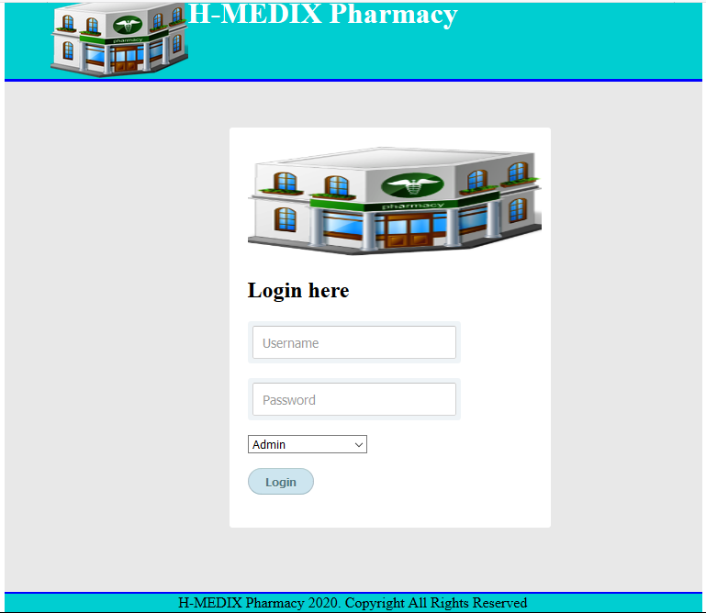
Figure 4.1: Home page

4.6 USER LOGIN PAGE
The login screen will not allow any person to enter into the main menu of the software without knowing the secret code, which is the user name or password provided by the authorized user of the software. (see fig 4.2)
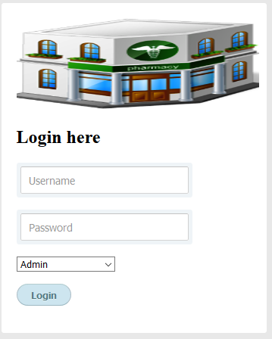
Figure 4.2: User login page

4.7 ADMIN PAGE
The Super admin used to manage the H-Medix pharmacy directly (see fig 4.3) in this page
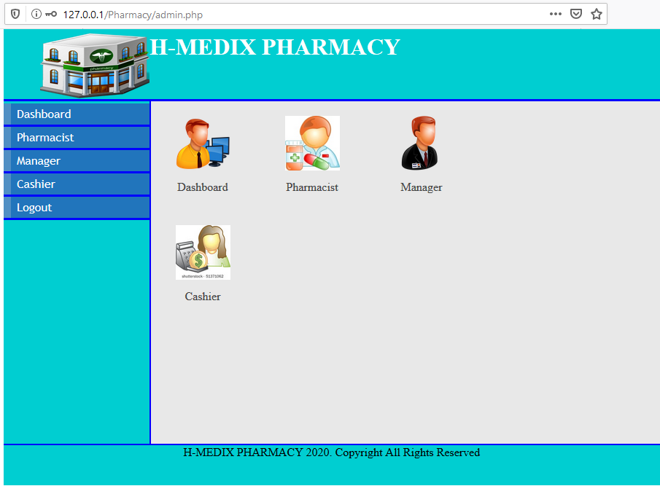
Figure 4.3: Admin page

4.8 PHARMACIST PAGE
The pharmacist used to manage the H-Medix pharmacy directly by prescribing drugs and at the same time checking stock of drugs left (see fig 4.4) in this page
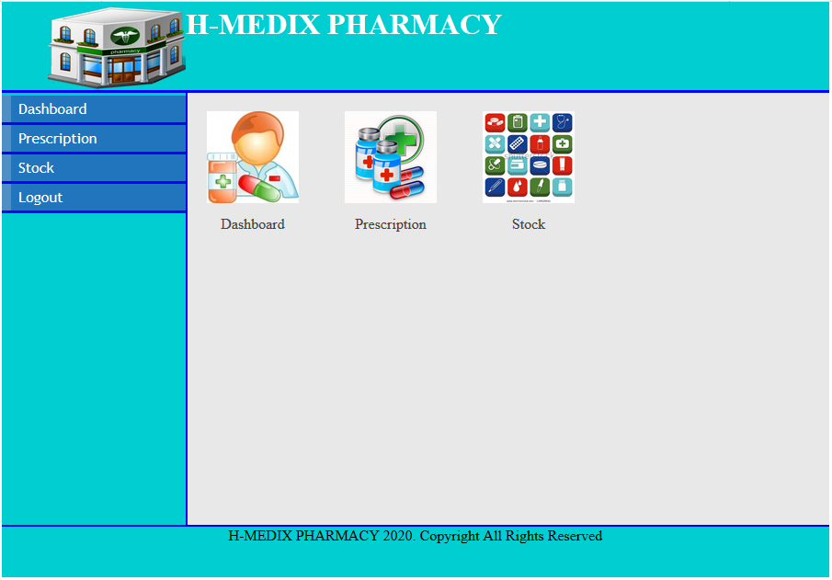
Figure 4.4: pharmacist page

4.9 MANAGER PAGE
This is the page in which the manager use to manage the H-Medix pharmacy directly by viewing prescription made by pharmacist, view users and invoice and also manage the stock of drugs left (see fig 4.5).
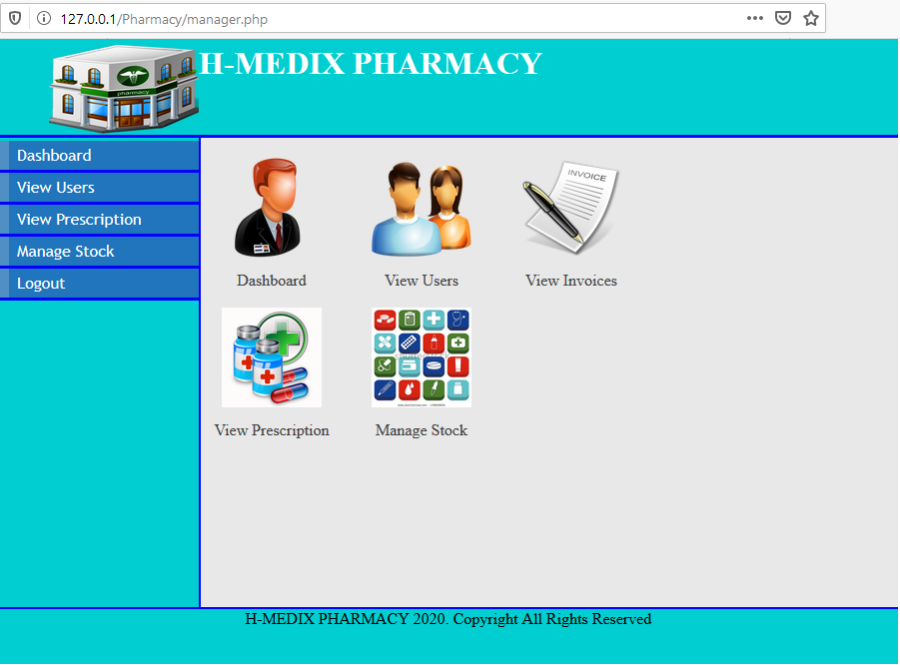
Figure 4.5: Manager page

4.10 CASHIER PAGE
The cashier used to perform his duty on H-Medix pharmacy directly by processing payment of the client/patient (see fig 4.6) in this page.

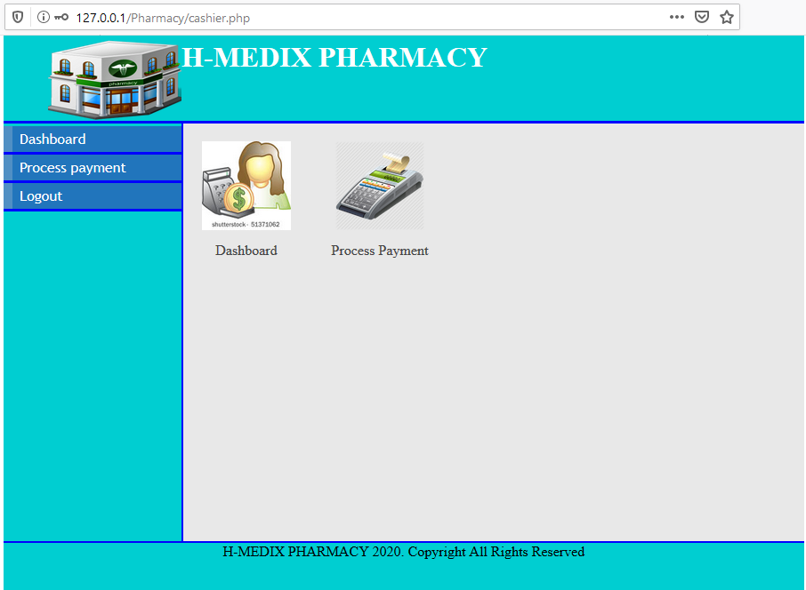
Figure 4.6: cashier page.

CHAPTER FIVE

5.1 SUMMARY
This work incorporates new modern technology for pharmacy management. The work has tried to portray the importance and useful nature of computer and its application in pharmacy management. The database is intended to properly store data that has been implemented using MYSQL and PHP as the server-side scripting language for computing the server’s features, as well as collecting the necessary data to be stored in the database. For easy management, PHP was used to build the application interface in a user-friendly way. The developed system contributes enormously to the computer services' active and general growth and eliminates the manual data processing approach that is associated with a lot of problems and vulnerable to manipulation by improving reliability and efficiency, as well as being quicker and much more than any manual counterpart.

5.2 CONCLUSION
This project focused on the application of technology to pharmacy management. Having extensively looked at the pharmacy management to understand present situation and identify areas that require improvement. Information availability, presentation, reliability and usability were selected as an entry point for technology application. It is on this premise that developing web-based pharmacy management system was decided on. To ensure the solution meets standard and suitably serves the proposed customers, the management was analysed and a requirement specification put forward. In developing the user requirement specification some assumptions were made based on the management analysis previously done. Hence further action was geared towards building the solution. The first of which was carrying out a research.
The assumptions made from the analysis required that they should be tested and validated. Also during research, it was discovered from the results that although a unanimously accessible information system would be viable for the pharmacy management, customers would be more inclined to use the solution if their information is secure and the system does not expose them to fraud. It was further discovered that regardless of the few but key challenges that might arise during development or in the future, they all come under the acceptable risk threshold. This allows the management a promise of return on investment, customer satisfaction and a good brand identity. Some of these are Usability, accuracy, flexibility, and security.

These requirements were then taken into consideration, and the portal was built using well-researched and standardized methodologies for development of the solution architecture, implementation plan and structure modelling and the final prototype. Finally, the framework for pharmacy management has been checked and rated by users. Also from an information technology standpoint, it was emphasised that the most effective solution to the pharmacy information provision need is the provision of a web-based pharmacy management system.

5.3 RECOMMENDATION
Also having looked at the technologies that are in existence in developed economies, and understanding the benefits as well as consequence involved in doing so. The following are the technologies that are presently not in use in pharmacy management and would be credible areas for further research: -
- Authenticity Verification: From the research it was discovered that the customers would very much like to ascertain the authenticity of prescribed drug sources.
- This creates an opportunity for further research as methods of calculating or estimating information source authenticity.
- QR-Codes: The adaptation of QR codes compared other technologies seems highly promising as user will not be requiring internet connectivity subscription separately from that which they already have via their mobile service provider.

- Hence, researching ways in which QR codes can successfully penetrate the pharmacy management will be a worthwhile venture especially with the growth of smart phone usage. In addition, to implement such technology it would require more supporting focuses on generating these codes, managing them to ensure that its introduction is not exploited for different purposes for which it was developed or even crime.
- Thus, posing high barriers to entry as such services would have to be imported as well as the human resource to manage it. It would also be a good area or research if ways of developing and managing this QR codes by indigenous companies.
- We will also develop and improve the design of the pharmacy to be new, attractive and consistent in colors and images, lines and satisfy customers.
- We will further promote more for the products in the pharmacy by doing advertisements in the internet, newspapers, television, by SMS and social networking media

REFERENCES
Fung, K. W., Kayaalp, M., Callaghan, F., & McDonald, C. J. (2013). Comparison of electronic pharmacy prescription records with manually collected medication histories in an emergency department. Annals of emergency medicine, 62(3), 205-211.
Ferrández, O., Urbina, O., Grau, S., Mateu‐de‐Antonio, J., Marin‐Casino, M., Portabella, J., & Salas, E. (2017). Computerized pharmacy surveillance and alert system for drug‐related problems. Journal of clinical pharmacy and therapeutics, 42(2), 201-208.
Ibtisam A. AL-Balushi, Jabar H. Yousif, Majid O. Al-Shezawi (2017). “Car Accident
Notification based on Mobile Cloud Computing”, International Journal of Computation and Applied Sciences (IJOCAAS). 2(2), Pp46-50, April, ISSN 2399-4509.
Jabar H Yousif (2015) “Classification of Mental Disorders Figures based on Soft Computing
Methods”. International Journal of Computer Applications 117(2):5-11, May.
Jabar H Yousif. (2013).” Natural Language Processing based Soft Computing Techniques”,
International Journal of Computer Applications 77(8):43-49, September. Published by Foundation of Computer Science, New York, USA. DOI: 10.5120/13418-1089.
Jabar H. Yousif, (2011). “Information technology development”, LAP
LAMBERT Academic Publishing, Germany ISBN 9783844316704.
Kumar, S., & Bano, S. (2017). Comparison and Analysis of Health Care Delivery Systems:
Pakistan versus Bangladesh. Journal of Hospital & Medical Management.
Majid O. Al-Shezawi, Jabar H. Yousif, Ibtisam A. AL-Balushi (2017). “Automatic Attendance Registration System based Mobile Cloud Computing”, International Journal of Computation and Applied Sciences (IJOCAAS). 2(3), Pp116-122, August, ISSN 2399-4509.
Shortliffe, E. H., & Blois, M. S. (2006). The computer meets medicine and biology: emergence of a discipline. Biomedical Informatics, 3-45.
Yousif, Jabar H., and Nebras N. Alattar (2017). "Cloud Management System based Air
Quality." International Journal of Computation and Applied Sciences (IJOCAAS). 2(2), pp145-152, Volume 3, Issue 1.

APPENDIX A
<?php
session_start();
include_once('connect_db.php');
if(isset($_SESSION['username'])){
$id=$_SESSION['admin_id'];
$user=$_SESSION['username'];
}else{
header("location:http://".$_SERVER['HTTP_HOST'].dirname($_SERVER['PHP_SELF'])."/index.php");
exit();
}
?>
<!DOCTYPE html>
<html>
<head>
<title><?php echo $user;?> - H-MEDIX PHARMACY</title>
<link rel="stylesheet" type="text/css" href="style/mystyle.css">
<link rel="stylesheet" href="style/style.css" type="text/css" media="screen" />
<link rel="stylesheet" type="text/css" href="style/dashboard_styles.css" media="screen" />
<script src="js/function.js" type="text/javascript"></script>
<style>
#left_column{
height: 470px;
}

</style>
</head>
<body>
<div id="content">
<div id="header">
<h1><a href="#"><img src="images/hd_logo.jpg"></a> H-MEDIX PHARMACY</h1></div>
<div id="left_column">
<div id="button">
<ul>
<li><a href="admin.php">Dashboard</a></li>
<li><a href="admin_pharmacist.php">Pharmacist</a></li>
<li><a href="admin_manager.php">Manager</a></li>
<li><a href="admin_cashier.php">Cashier</a></li>
<li><a href="logout.php">Logout</a></li>
</ul>
</div>
</div>
<div id="main">

<!-- Dashboard icons -->
<div class="grid_7">
<a href="admin.php" class="dashboard-module">
<img src="images/admin_icon.jpg" width="75" height="75" alt="edit" />
<span>Dashboard</span>
</a>
<a href="admin_pharmacist.php" class="dashboard-module">
<img src="images/pharmacist_icon.jpg" width="75" height="75" alt="edit" />
<span>Pharmacist</span>
</a>

<a href="admin_manager.php" class="dashboard-module">
<img src="images/manager_icon.png" width="75" height="75" alt="edit" />
<span>Manager</span>
</a>

<a href="admin_cashier.php" class="dashboard-module">
<img src="images/cashier_icon.jpg" width="75" height="75" alt="edit" />
<span>Cashier</span>
</a>
</div>
</div>
<div id="footer" align="Center"> H-MEDIX PHARMACY 2020. Copyright All Rights Reserved</div>
</div>
</body>
</html>

APPENDIX B
<?php
session_start();
include_once('connect_db.php');
if(isset($_SESSION['username'])){
$id=$_SESSION['admin_id'];
$username=$_SESSION['username'];
}else{
header("location:http://".$_SERVER['HTTP_HOST'].dirname($_SERVER['PHP_SELF'])."/index.php");
exit();
}
if(isset($_POST['submit'])){
$fname=$_POST['first_name'];
if (!preg_match("/^[a-zA-Z ]*$/",$fname))
{
$nameErr = "Only letters and white space allowed";
}
$lname=$_POST['last_name'];
$sid=$_POST['staff_id'];
$postal=$_POST['postal_address'];
$phone=$_POST['phone'];
$email=$_POST['email'];
$user=$_POST['username'];
$pas=$_POST['password'];
$sql1=mysql_query("SELECT * FROM cashier WHERE username='$user'")or die(mysql_error());
$result=mysql_fetch_array($sql1);
if($result>0){
$message="<font color=blue>sorry the username entered already exists</font>";
}else{
$sql=mysql_query("INSERT INTO cashier(first_name,last_name,staff_id,postal_address,phone,email,username,password,date)
VALUES('$fname','$lname','$sid','$postal','$phone','$email','$user','$pas',NOW())");
if($sql>0) {header("location:http://".$_SERVER['HTTP_HOST'].dirname($_SERVER['PHP_SELF'])."/admin_cashier.php");
}else{
$message1="<font color=red>Registration Failed, Try again</font>";
}
}}
?>
<!DOCTYPE html>
<html>
<head>
<title><?php echo $username;?> - H-MEDIX PHARMACY</title>
<link rel="stylesheet" type="text/css" href="style/mystyle.css">
<link rel="stylesheet" href="style/style.css" type="text/css" media="screen" />
<link rel="stylesheet" href="style/table.css" type="text/css" media="screen" />
<script src="js/function.js" type="text/javascript"></script>
<script src="js/validation_script.js" type="text/javascript"></script>
<!--<script>
function validateForm()
{

//for alphabet characters only
var str=document.form1.first_name.value;
var valid="abcdefghijklmnopqrstuvwxyz ABCDEFGHIJKLMNOPQRSTUVWXYZ";
//comparing user input with the characters one by one
for(i=0;i<str.length;i++)
{
//charAt(i) returns the position of character at specific index(i)
//indexOf returns the position of the first occurence of a specified value in a string. this method returns -1 if the value to search for never ocurs
if(valid.indexOf(str.charAt(i))==-1)
{
alert("First Name Cannot Contain Numerical Values");
document.form1.first_name.value="";
document.form1.first_name.focus();
return false;
}}

if(document.form1.first_name.value=="")
{
alert("Name Field is Empty");
return false;
}

//for alphabet characters only
var str=document.form1.last_name.value;
var valid="abcdefghijklmnopqrstuvwxyz ABCDEFGHIJKLMNOPQRSTUVWXYZ";
//comparing user input with the characters one by one
for(i=0;i<str.length;i++)
{
//charAt(i) returns the position of character at specific index(i)
//indexOf returns the position of the first occurence of a specified value in a string. this method returns -1 if the value to search for never ocurs
if(valid.indexOf(str.charAt(i))==-1)
{
alert("Last Name Cannot Contain Numerical Values");
document.form1.last_name.value="";
document.form1.last_name.focus();
return false;
}}

if(document.form1.last_name.value=="")
{
alert("Name Field is Empty");
return false;
}

}

</script>-->
<style>
<style>#left-column {height: 477px;}
#main {height: 477px;}</style>
</style>
</head>
<body>
<div id="content">
<div id="header">
<h1><a href="#"><img src="images/hd_logo.jpg"></a> H-MEDIX PHARMACY</h1></div>
<div id="left_column">
<div id="button">
<ul>
<li><a href="admin.php">Dashboard</a></li>
<li><a href="admin_pharmacist.php">Pharmacist</a></li>
<li><a href="admin_manager.php">Manager</a></li>
<li><a href="admin_cashier.php">Cashier</a></li>
<li><a href="logout.php">Logout</a></li>
</ul>
</div>
</div>
<div id="main">
<div id="tabbed_box" class="tabbed_box">
<h4>Manage Cashier</h4>
<hr/>
<div class="tabbed_area">

<ul class="tabs">
<li><a href="javascript:tabSwitch('tab_1', 'content_1');" id="tab_1" class="active">View User</a></li>
<li><a href="javascript:tabSwitch('tab_2', 'content_2');" id="tab_2">Add User</a></li>

</ul>

<div id="content_1" class="content">
<?php echo $message;
echo $message1;

/*
View
Displays all data from 'Cashier' table
*/

// connect to the database
include_once('connect_db.php');

// get results from database

$result = mysql_query("SELECT * FROM cashier")
or die(mysql_error());

// display data in table

echo "<table border='1' cellpadding='5' align='center'>";
echo "<tr> <th>ID</th><th>Firstname </th> <th>Lastname </th> <th>Username </th><th>Update </th><th>Delete</th></tr>";

// loop through results of database query, displaying them in the table
while($row = mysql_fetch_array( $result )) {

// echo out the contents of each row into a table
echo "<tr>";

echo '<td>' . $row['cashier_id'] . '</td>';
echo '<td>' . $row['first_name'] . '</td>';
echo '<td>' . $row['last_name'] . '</td>';
echo '<td>' . $row['username'] . '</td>';
?>
<td><a href="update_cashier.php?username=<?php echo $row['username']?>"><img src="images/update-icon.png" width="35" height="35" border="0" /></a></td>
<td><a href="delete_cashier.php?cashier_id=<?php echo $row['cashier_id']?>"><img src="images/delete-icon.jpg" width="35" height="35" border="0" /></a></td>
<?php
}
// close table>
echo "</table>";
?>
</div>
<div id="content_2" class="content">
<!--Cashier-->
<?php echo $message;
echo $message1;
?>
<form name="form1" onsubmit="return validateForm(validation_script.js);" action="admin_cashier.php" method="post" >
<table width="220" height="106" border="0" >
<tr><td align="center"><input name="first_name" type="text" style="width:170px" placeholder="First Name" required="required" id="first_name" /></td></tr>
<tr><td align="center"><input name="last_name" type="text" style="width:170px" placeholder="Last Name" required="required" id="last_name" /></td></tr>
<tr><td align="center"><input name="staff_id" type="text" style="width:170px" placeholder="Staff ID" required="required" id="staff_id"/></td></tr>
<tr><td align="center"><input name="postal_address" type="text" style="width:170px" placeholder="Address" required="required" id="postal_address" /></td></tr>
<tr><td align="center"><input name="phone" type="text" style="width:170px"placeholder="Phone" required="required" id="phone" /></td></tr>
<tr><td align="center"><input name="email" type="email" style="width:170px" placeholder="Email" required="required" id="email" /></td></tr>
<tr><td align="center"><input name="username" type="text" style="width:170px" placeholder="Username" required="required" id="username" /></td></tr>
<tr><td align="center"><input name="password" type="password" style="width:170px" placeholder="Password" required="required" id="password"/></td></tr>
<tr><td align="right"><input name="submit" type="submit" value="Submit"></td></tr>

</table>
</form>
</div>

</div>

</div>

</div>
<div id="footer" align="Center"> H-MEDIX PHARMACY 2020. Copyright All Rights Reserved</div>
</div>
</body>
</html>

APPENDIX C
<?php
session_start();
include_once('connect_db.php');
if(isset($_SESSION['username'])){
$id=$_SESSION['admin_id'];
$username=$_SESSION['username'];
}else{
header("location:http://".$_SERVER['HTTP_HOST'].dirname($_SERVER['PHP_SELF'])."/index.php");
exit();
}
if(isset($_POST['submit'])){
$fname=$_POST['first_name'];
$lname=$_POST['last_name'];
$sid=$_POST['staff_id'];
$postal=$_POST['postal_address'];
$phone=$_POST['phone'];
$email=$_POST['email'];
$user=$_POST['username'];
$pas=$_POST['password'];
$sql1=mysql_query("SELECT * FROM manager WHERE username='$user'")or die(mysql_error());
$result=mysql_fetch_array($sql1);
if($result>0){
$message="<font color=blue>sorry the username entered already exists</font>";
}else{
$sql=mysql_query("INSERT INTO manager(first_name,last_name,staff_id,postal_address,phone,email,username,password,date)
VALUES('$fname','$lname','$sid','$postal','$phone','$email','$user','$pas',NOW())");
if($sql>0) {header("location:http://".$_SERVER['HTTP_HOST'].dirname($_SERVER['PHP_SELF'])."/admin_manager.php");
}else{
$message1="<font color=red>Registration Failed, Try again</font>";
}
}}
?>
<!DOCTYPE html>
<html>
<head>
<title><?php echo $username;?> - H-MEDIX PHARMACY</title>
<link rel="stylesheet" type="text/css" href="style/mystyle.css">
<link rel="stylesheet" href="style/style.css" type="text/css" media="screen" />
<link rel="stylesheet" href="style/table.css" type="text/css" media="screen" />
<script src="js/function.js" type="text/javascript"></script>
<script>
function validateForm()
{

//for alphabet characters only
var str=document.form1.first_name.value;
var valid="abcdefghijklmnopqrstuvwxyz ABCDEFGHIJKLMNOPQRSTUVWXYZ";
//comparing user input with the characters one by one
for(i=0;i<str.length;i++)
{
//charAt(i) returns the position of character at specific index(i)
//indexOf returns the position of the first occurence of a specified value in a string. this method returns -1 if the value to search for never ocurs
if(valid.indexOf(str.charAt(i))==-1)
{
alert("First Name Cannot Contain Numerical Values");
document.form1.first_name.value="";
document.form1.first_name.focus();
return false;
}}

if(document.form1.first_name.value=="")
{
alert("Name Field is Empty");
return false;
}

//for alphabet characters only
var str=document.form1.last_name.value;
var valid="abcdefghijklmnopqrstuvwxyz ABCDEFGHIJKLMNOPQRSTUVWXYZ";
//comparing user input with the characters one by one
for(i=0;i<str.length;i++)
{
//charAt(i) returns the position of character at specific index(i)
//indexOf returns the position of the first occurence of a specified value in a string. this method returns -1 if the value to search for never ocurs
if(valid.indexOf(str.charAt(i))==-1)
{
alert("Last Name Cannot Contain Numerical Values");
document.form1.last_name.value="";
document.form1.last_name.focus();
return false;
}}

if(document.form1.last_name.value=="")
{
alert("Name Field is Empty");
return false;
}

}

</script>
<style>
<style>#left-column {height: 477px;}
#main {height: 477px;}</style>
</style>
</head>
<body>
<div id="content">
<div id="header">
<h1><a href="#"><img src="images/hd_logo.jpg"></a> H-MEDIX PHARMACY</h1></div>
<div id="left_column">
<div id="button">
<ul>
<li><a href="admin.php">Dashboard</a></li>
<li><a href="admin_pharmacist.php">Pharmacist</a></li>
<li><a href="admin_manager.php">Manager</a></li>
<li><a href="admin_cashier.php">Cashier</a></li>
<li><a href="logout.php">Logout</a></li>
</ul>
</div>
</div>
<div id="main">
<div id="tabbed_box" class="tabbed_box">
<h4>Manage Manager</h4>
<hr/>
<div class="tabbed_area">

<ul class="tabs">
<li><a href="javascript:tabSwitch('tab_1', 'content_1');" id="tab_1" class="active">View User</a></li>
<li><a href="javascript:tabSwitch('tab_2', 'content_2');" id="tab_2">Add User</a></li>

</ul>

<div id="content_1" class="content">
<?php echo $message;
echo $message1;

/*
View
Displays all data from 'Manager' table
*/

// connect to the database
include_once('connect_db.php');

// get results from database

$result = mysql_query("SELECT * FROM manager")
or die(mysql_error());

// display data in table

echo "<table border='1' cellpadding='5' align='center'>";
echo "<tr> <th>ID</th><th>Firstname </th> <th>Lastname </th> <th>Username </th><th>Update </th><th>Delete</th></tr>";

// loop through results of database query, displaying them in the table
while($row = mysql_fetch_array( $result )) {

// echo out the contents of each row into a table
echo "<tr>";

echo '<td>' . $row['manager_id'] . '</td>';
echo '<td>' . $row['first_name'] . '</td>';
echo '<td>' . $row['last_name'] . '</td>';
echo '<td>' . $row['username'] . '</td>';
?>
<td><a href="update_manager.php?username=<?php echo $row['username']?>"><img src="images/update-icon.png" width="35" height="35" border="0" /></a></td>
<td><a href="delete_manager.php?manager_id=<?php echo $row['manager_id']?>"><img src="images/delete-icon.jpg" width="35" height="35" border="0" /></a></td>
<?php
}
// close table>
echo "</table>";
?>
</div>
<div id="content_2" class="content">
<!--Cashier-->
<?php echo $message;
echo $message1;
?>
<form name="form1" onsubmit="return validateForm(this);" action="admin_manager.php" method="post" >
<table width="220" height="106" border="0" >
<tr><td align="center"><input name="first_name" type="text" style="width:170px" placeholder="First Name" required="required" id="first_name" /></td></tr>
<tr><td align="center"><input name="last_name" type="text" style="width:170px" placeholder="Last Name" required="required" id="last_name" /></td></tr>
<tr><td align="center"><input name="staff_id" type="text" style="width:170px" placeholder="Staff ID" required="required" id="staff_id"/></td></tr>
<tr><td align="center"><input name="postal_address" type="text" style="width:170px" placeholder="Address" required="required" id="postal_address" /></td></tr>
<tr><td align="center"><input name="phone" type="text" style="width:170px"placeholder="Phone" required="required" id="phone" /></td></tr>
<tr><td align="center"><input name="email" type="email" style="width:170px" placeholder="Email" required="required" id="email" /></td></tr>
<tr><td align="center"><input name="username" type="text" style="width:170px" placeholder="Username" required="required" id="username" /></td></tr>
<tr><td align="center"><input name="password" type="password" style="width:170px" placeholder="Password" required="required" id="password"/></td></tr>
<tr><td align="right"><input name="submit" type="submit" value="Submit"/></td></tr>
</table>
</form>
</div>

</div>

</div>

</div>
<div id="footer" align="Center"> H-MEDIX PHARMACY 2020. Copyright All Rights Reserved</div>
</div>
</body>
</html>

