DESIGN AND IMPLEMENTATION OF AN AIRLINE RESERVATION SYSTEM

BY

ANTHONY TEJIRI EMMANUEL
15010301025

SUPERVISED BY:
DR. O. O. OLANIYAN

BEING A PROJECT SUBMITTED IN THE DEPARTMENT OF COMPUTER SCIENCE, COLLEGE OF BASIC AND APPLIED SCIENCES, IN PARTIAL FULFILMENT OF THE REQUIREMENTS FOR THE AWARD OF DEGREE OF BACHELOR OF SCIENCE MOUNTAIN TOP UNIVERSITY IBAFO OGUN STATE NIGERIA

JUNE, 2019

CHAPTER ONE
INTRODUCTION
1.1 Background to the Study
In recent times, the world has experienced a huge boom in terms of technology, with innovation in every area making the human life more comfortable and our tasks easier, efficient and completed within a shorter period of time. This upsurge in terms of technology has also made immense impact in the Airline transport industry. The Airline industry has evolved into one of the most sophisticated and fascinating industries today. The invention of airplanes totally has revolutionised transport and more people use planes as it is the fastest means of transport. The movement of people to places previously considered unreachable by land or too distant, has not only connected people and cultures but has strengthened the economy of visited countries.
As we all know, to make a reservation for a seat on a plane, you need tickets. When air transport initially began, manual reservations were the only means of securing a place on the flight. The officials made use of paper tickets, pen-and-paper writing of customer and flight information. As more people continued to patronize the industry and the advent of the internet/globalization, online ticket booking systems were introduced and established. With the help of the internet, the way transactions take place has changed drastically which has been able to remove the barrier of time and location (Oyelade, Fatumo, Azeta & Ayo, 2009).
Tickets are the documents that confirm purchase and guarantee entry and a seat on an airplane for a chosen journey. All major airlines have adopted the use of ‘e-tickets’. An e-ticket contains the passenger information like name, date of travel, rules on changes and refunds, payment forms and validity of tickets. Online reservations have ensured that airlines create a fully mobile and social environment with the intelligent use of vast quantities of data to deliver real service and operational improvements (Pooja, 2015)
Reservation is a written record of an arrangement in which something such as a seat on an airplane is kept for a customer (Cambridge, 2019). Evolving from manual records and logs in the early 1930s, Airlines Reservations System (ARS) is the improved, computerized feature of airline reservations. ARS helps in systematic, efficient and effective organization of bookings, prices, schedules and customer data. Online airline reservation or e-ticket booking is a kind of user assistance where customers can book tickets for flight online. This is an easy method which saves a lot of time. Airline Reservation Systems were first introduced as relatively simple standalone systems to control flight schedules, maintain flight inventory, seat arrangements and aircraft loading (Pooja, 2015).
Pooja, (2015) stated that modern ARS comprises of a detailed and complete suite of packages that assists a variety of airline management tasks and customer needs from the reservation process to the entire flight completion. ARS has today evolved into Computer Reservations System (CRS). Computer reservation systems are classified as Passenger Service Systems (PSS) which handles a series of critical functions for the airline. When CRS is integrated with Global Distribution System (GDS), it can be used by multiple distribution channels such as travel agencies, who can then use it for hotel rentals, flight booking, car hires as well as activities and tours via a single system.
In this project, the system behind online ticket booking and reservation was explained and a working application was provided to give a sample online reservation for a passenger. To this end, sources like e-books, online articles, journals and websites had been consulted to gather relevant information about the project

1.2 Statement of the Problem
In the past years, ticket booking and reservation were performed manually and a lot of documentation was required. There were always lengthy queues at the organizations and there was an enormous chance of the officials cheating. Situations had also occurred where customers were unable to create cancellations in the current internet scheme after booking in a case where they are unable to move again. Another frequently occurring problem is the issue of people breaching security by accessing passengers’ login details which resulted in safety concerns. Therefore this project solved the identified problems with the stated objectives.

1.3 Aim and Objectives of the Study
The aim of this project is to automate the process of airline ticket reservation, booking and airline management which would minimize errors that resulted from manual system operations. The specific objectives are to:
- Develop a database for storing customer and flight information.
- Design an online interface for reservation and ticket booking.
- Implement the developed web based airline reservation system in which security measures are taken and reservation cancellation is possible.

1.4 Research Methodology
The design method taken is a waterfall model. The cascade model continues in a linear sequential way from one stage to the next. First, the specifications specification will be finished based on the assessment. Subsequently, a goal will be set at the end of the project.
When that was done, we proceeded to the development stage where we determined how the specified objectives and deliverables would be accomplished. This was accomplished by creating a design stage blueprint to get a reasonable concept of what is required of the scheme, what would be included in it, and what would not.

1.5 Scope of the Study
This project designs and implements the reservation system for airlines. Supported by a well-designed database, all accessible air aircraft data was incorporated together and can be readily obtained through a single point. A pleasant customer interface was supplied so that different combinations of search requirements can be obtained from the customer and the respective data base search statements are generated. The air ticket reservation system provides both customer and administrative interfaces with the latter used for administration purposes. The advanced scheme enables internet reservation; maintains client documents, provides an internet menu on flight plans, flight locations and their rates. It does not include catering for personnel wage calculations and other management problems. Also, this system is limited to local flights only. It is unable to support huge international flights for all countries.

1.6 Significance of the Study
This project is important in that it is of great benefit to the airline and the customers. It assists in decreasing the recursive job performed by the system administrator and other staff. It retains continuity between the distinct entry methods, i.e. by internet, at the data desk and across distinct physical places. It also assists in keeping client data in the event of an emergency, e.g. flight cancelation owing to poor weather and the occurrence of a crash in the worst situations. It also minimizes the number of empty seats on a plane and guarantees maximum usage of aircraft equipment.
1.7 Definition of Terms
Airline: This is an organization providing a regular public service of air transport on one or more routes.
Reservation: Reservation is a written record of an arrangement in which something such as a seat on an airplane is kept for a customer.
System: This is a set of things working together as parts of a mechanism or an interconnecting network; a complex whole.
Ticket: This is a piece of paper or e-document that gives the holder a certain right, especially to enter a place, travel by public transport, or participate in an event.
ARS: Airline Reservation System (ARS) is the improved, computerized feature of airline reservations. ARS helps in systematic, efficient and effective organization of bookings, prices, schedules and customer data. Airline reservation systems incorporate airline schedules, fare tariffs, passenger reservations and ticket records.
PSS: A passenger service system (PSS) is a series of critical systems used by airlines. The PSS usually comprises an airline reservations system, an airline inventory system and a departure control system (DCS). Generally the PSS is made up of modules that are used to manage different parts of the airline’s business.
CRS: A computer reservation system (CRS) is a computerized system used to store and retrieve information and conduct transactions related to air travel, hotels, car rental, or other activities. When CRS is integrated with Global Distribution System (GDS), it can be used by multiple distribution channels such as travel agencies, who can then use it for hotel rentals, flight booking, car hires as well as activities and tours via a single system.
GDS: A global distribution system (GDS) is a computerised network system owned or operated by a company that enables transactions between travel industry service providers, mainly airlines, hotels, car rental companies, and travel agencies.

1.8 Organization of Subsequent Chapters

CHAPTER TWO
LITERATURE REVIEW
2.0 Introduction
As far as worldwide competition is concerned, organisations around the globe make use of sophisticated science and technological functions to compete. In data and communication technology, the most prevalent case of technology can be seen. Various sectors use electronics and software and web advances to keep and track their company operations. The airline sector is the most frequently used system in the implementation of the informative systems. This section discusses the idea of reservation information system, their background, components, elements, situations, types and their applications in the real world in order to solve problems.
2.1 History of Airline Reservation System
Until the 1950s, airline reservations used manual systems at centralized booking centers, consisting of groups of individuals in a place with physical cards representing seats on aircraft. American Airlines was the first to set up an automatic reservation system. The use of a system to monitor data and enhance effectiveness was an extremely attractive goal in the sector and attracted the attention of other airlines worldwide. In the early 1950s, American Airlines sought a scheme that would enable real-time access to flight information in all its headquarters and incorporation and automation of its reservation and ticketing procedures (American Airlines C.R. Smith Museum, 2014).
American Airlines started to experiment with the first automated reservation system, the Electromechanical Reservisor, in 1946. It needed significant manual involvement and had an eight percent booking error level, which was the industry's lowest at the moment. In 1952, the airline launched a new system to obtain real-time access to inventory from across their network. The system, dubbed the Magnetronic Reservisor, seemed to be capable of storing up to 1,000 flights, which was a significant achievement at the time. However, it had some apparent flaws including requiring a team of officials, countless phone calls and significant effort to book even a single seat (Parker, 2016).
IBM, an American corporation, introduced the Semi-Automated Business Research Environment (Sabre) in 1964. Sabre was an early instance of a transaction handling scheme that had the capacity to modify seat inventory in real time (Scott's Cheap Flights, 2014).
The system could also work with only one assistant working to scan and update inventory, generate a booking, and print a ticket. Sabre, a coast-to-coast telecommunications network, was the United States ' biggest, private, online real-time information processing system Only the U.S. government had a greater operating system Sabre was an early instance of a system for transaction handling. It altered the content of the large databases containing airline and traveler data as a direct consequence of fully accessed data from data terminals (Pollack, 2016).
American Airlines invested more than $ 350 million in this venture in the early years, with $ 40 million spent on original growth. By contrast, during this time span, a fresh aircraft cost $ 4.5 million. The instant effect of the application of Sabre System was a decrease in the booking error rate to less than one percent, as well as a 30 percent savings on employee turnover. United Airlines joined the CRS industry in 1976 with the Apollo Reservation System after spending $ 250 million in system development. Other well-known traditional reservation systems were initially created by individual airline operators like Worldspan LP, Galileo International Inc., Which acquired Apollo in May 1997 and European rival Amadeus Global Travel Distribution (Pollack, 2016).
Sabre and Apollo started putting their computerized booking systems in travel organizations in 1976. Travel officers could print both tickets and boarding passes for their customers through the office automation provided by the systems Travel officers have been converted into an expansion of the airline sector, considerably streamlining the ticketing method (Pollack, 2016).
The airline industry's deregulation in the Airline Deregulation Act implied that airlines which had earlier worked under government-set tariffs ensuring airlines at least broke even, now wanted to enhance effectiveness to operate in a free economy. In this deregulated setting, the ARS and its successors have become essential to the transport sector (Winston & Morrison, 1995).
Other airlines later spent more in studies and development to introduce enhanced systems and airlines developed their own schemes through the mid-1960s and early 1970s. United Airlines created the Apollo Reservation System and soon after allowed travel officials to access it. The Apollo scheme was the basis for many further innovations that spread from US airlines to European airlines as well (Winston & Morrison 1995).

2.2 Conceptual Review
This sub-chapter breaks the concepts into bits and gives thorough explanation to them. It properly explains the concept of airline reservation system and all its related concepts.
2.2.1 Online Ticket Booking
As the web continues to acquire further ground in today's globe, online ticket reservation has become progressively famous Airline businesses strive to enhance their facilities to their customers and in order to do so; they need to build a completely portable and social atmosphere with the smart use of vast amounts of data to deliver actual service and operational improvements. As at the time of writing this project, an estimate of over 95 percent of airline businesses offer their customers mobile check-in.
2.2.2 E-commerce and Its Development
E-commerce can be described briefly as economic activities conducted electronically on the Internet, i.e. the purchase and sale of goods and services, or the transmission of funds or data via an electronic network, primarily Internet (Rouse, 2015).
Over the previous few years, e-commerce has grown steadily It has become a necessity for companies to give their customers the convenience of purchasing products and services from the comfort of their homes Different sets of guidelines on communication and interaction are used in e-commerce in the form of data transfer, email and shopping carts. E-commerce makes it easier to purchase products and services around the clock, which is feasible from any portion of the globe through an internet-connected device. It not only provides an easier manner to obtain goods and services, it also provides a broader range of products and excellent availability (Rouse, 2015).
E-commerce uses the electronic billing system for payments. Due to its simple and convenient equipment, minimal invoice documentation and minimal labour and administration expenses, the monetary paperless system has totally transformed the face of worldwide trade. The most common methods of payment online are credit cards, debit cards, bank transfers and other companies such as PayPal. Due to the rise in e-commerce and its simple, trouble-free e-payment system many companies, including the aviation sector, have risen steadily over the years (Ueland, 2013).
Online ticket reservation is one of many e-commerce characteristics. Now it is so simple to use air travel because booking and reservation are stress-free and it has led to enhanced patronage of the aviation sector.
2.3 Airline Industry
Airlines differ in size, from small domestic airlines to full-service international airlines with double decker aircraft. Airline services can be classified as intercontinental, domestic, regional or global, and may be operated as scheduled services or charters.
2.4 Airline Reservation System
Airline reservation systems (ARS) are features of the so-called passenger service systems (PSS), which are applications that support direct customer interaction. Airline reservation systems integrate airline schedules, fares, traveler reservations and ticket documents. Direct allocation of an airline operates within their own reservation system, as well as pushing out information to the GDS. The second form of immediate delivery channel is customers who create their own reservations using the web or mobile apps (Wardell, 1991).
Travel organizations and other indirect delivery channels access the same GDS as those accessed by airline reservation systems and all information is transferred through a uniform communication system that operates on two kinds of data transferred on SITA's High Level Network (HLN). These kinds of SMSs are called Type A[ generally EDIFACT format] for real-time interactive communication and Type B [TTY] for message type information and reservation. Message building requirements established by IATA and ICAO are international and extend to more than air transport. Since airline reservation systems are business critical applications and are functionally quite complicated, the operation The in-house airline reservation system is relatively costly (Wardell, 1991).
Before deregulation, airlines possessed their own reservation systems with travel officials subscribing to them. Today, the GDS is operated by autonomous businesses with significant customers being airlines and travel organizations (Winston & Morrison, 1995).
There are four significant GDS suppliers on the market: Amadeus, Travelport (which runs the Apollo, Worldspan and Galileo technologies), Sabre and Shares. There is one significant regional GDS, Abacus, serving the Asian industry and several regional competitors serving single nations, including Travelsky (China), Infini and Axess (both Japan) and Topas (South Korea). Of these, Infini is housed within the Sabre complex, Axess is heading into a division within the Worldspan complex and Topas organizations will migrate to Amadeus (Wardell, 1991).
Reservation systems can accommodate "ticket-less" airlines and "hybrid" airlines that use e-ticketing in addition to ticket-less to allow code shares and interlines.
In relation to these "uniform" GDS, some airlines have proprietary models that they use to operate their airline activities. A few instances are the OSS of Delta as well as Deltamatic systems and EDS SHARES. SITA Reservations continues as the biggest neutral multi-host airline reservation system with over 100 airlines presently handling inventories (Ross, 2013).
Today, many brands co-operate with the world airlines companies for user-friendly direct systems, increased productivity and efficiency. Some of the major ARS brands today are Abacus, Amadeus, Navitaire, Sabre and TravelSky (Ross 2013).

2.4.1 Amadeus
Amadeus CRS is the world's biggest GDS supplier in the travel and tourism sector, with an estimated business share of 37 percent in 2009 (Kollmeyer, 2010).
As of December 2010, over 90,000 travel organizations globally are using the Amadeus system and 58,000 airline marketing departments are using it as their inner distribution and reservation system. Amadeus provides access to bookable material from 435 airlines (including 60 low-cost carriers), 29 vehicle rental firms (comprising 36,000 vehicle rental sites), 51 cruise and boat operators, 280 hotel chains and 87,000 restaurants, 200 tour operators, 103 train operators and 116 travel insurance businesses (Amadeus, 2010).
2.5 Computer Reservation System
A computer reservation system or central reservation system (CRS) is a computerized scheme used to store and collect data and perform operations associated with air transport, hotels, restaurants, vehicle rental or other operations. Originally built and operated by airlines, CRSs were subsequently expanded to use travel organizations. Global distribution systems (GDS) book and sell tickets to various airlines. Most airlines have outsourced their CRSs to GDS businesses, which also allows consumers access through internet gateways. Modern GDS typically allows customers to book hotel rooms, rental vehicles, flight fares as well as other events and trips. They also provide access to train reservations and bus reservations in some markets although they are not always incorporated with the main system These are also used to transmit computerized data for hotel sector customers, make reservations, and ensure that the hotel is not overbooked (The Economist, 2012).
Major CRS include;
- AirCore
- AmeliaRES
- Avantik PSS
- Abacus
- Amadeus etc.

2.6 Reservation Information Systems
The airline reservation system was one of the earliest modifications to enhance airline sector effectiveness. Airline reservation system ultimately developed into a computer reservation system (CRS).
Significant activities of the airline booking scheme that book and sell tickets for various airlines are regarded as Global Distribution Systems (GDS). Airlines have liquidated most of their immediate assets from devoted GDS businesses that render their devices available to customers through Internet gateways. Modern Global Distribution Systems typically enable customers to book hotel rooms and rental vehicles as well as airline tickets (Wardell, 1991).
Global Distribution Systems (GDS) is a global electronic booking network used as a single point of entry for reserving airline reservations, hotel rooms, rental vehicles, and other travel associated products by travel officials, online booking systems, and big companies. Amadeus, Galileo, Sabre, and Worldspan are the world's leading storage technologies. They are owned and operated by major airlines, vehicle rental businesses and hotel organizations as joint ventures (Global, 2012).

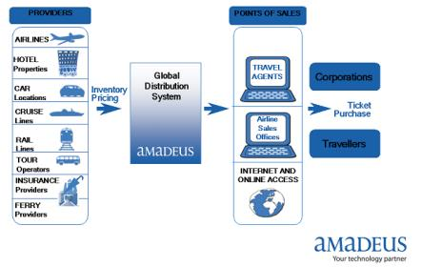
Figure 2.1: A global distribution system (Goran, Vladan & Marko, 2015).

2.7 Components of Reservation Information Systems
These are subsystems of information technology that render the Reservation Information System functional. They are consistent in design and the inability of one element may influence the functioning of the other element in the system They comprise of software resources, information, people and processes used in contemporary company enterprises.
2.7.1 Hardware
Hardware is used in data handling as personal physical instruments and equipment. In particular, it involves not only devices such as computers but also information media, i.e. all tangible items on which information is stored from paper plates to magnetic discs (O'Brien, 2001).
Others include keyboards, mouse, printers, scanners etc.
2.7.2 Software
Software involves all sets of guidelines for handling data and consists of distinct kinds of programs that allow the equipment to perform distinct functions. Software is further classified into system software and application software. The system software is concerned with maintaining the computer system functioning while Application software is general purpose or written for a particular assignment such as stock control. It can be written using a programming language or more general purpose piece of software such as database (Rochester, 1996).
2.7.3 Data
Rochester et al. (1996) describe data as all the raw and unprocessed facts that can be effectively used. Clearly, there can be no database system without information. The fundamental factor is based on the processing and data requirements of an organization. Data elements and relationships need to be precisely defined and the definitions need to be accurately recorded in the data dictionary.

2.7.4 People
These are needed for the implementation of all information systems according to O'Brien (2001). They include end-users and experts in the information system End-users are individuals using an information system. Specialists in the reservation information system assist in the growth and implementation of information system. These include system analysts, programmers, software operators, and others. People, are probably the component that most influences the achievement or failure of information systems

2.7.5 Procedures
These are a set of guidelines on how to combine the above components to process the data and produce the required output. They consist of the way to log in to the DBMS, making use of different forms and manipulations throughout the project.

2.7.6 Database
A database is a set of information arranged in such a manner that a software program can pick required parts of data quickly. You may think of a traditional database as an electronic filing system, organized by fields, records, and files. A field is a single piece of information; A record is a complete set of fields ; and a file is a collection of records. A telephone book, for instance, is similar to a file. It includes a list of records, each consisting of three fields: name, email and telephone number (Vangeal, 2018).
An alternative idea in the construction of databases is defined as hypertext. Any item, whether it is a piece of text a photo, or a movie, can be connected to any other item in a Hypertext database. Hypertext databases are especially helpful for arranging large quantities of heterogeneous data, but are not intended for numerical analysis (Vangeal, 2018).
Vangeal (2018) also says that the design of the database may be external, domestic or functional. The internal stage indicates how each end-user type understands the organization of its corresponding relevant information in the database. The internal level deals with efficiency, scalability, cost and other operational issues. The conceptual level totally unifies the distinct external views into a specified and entirely global perspective. It comprises of any generic information needed by end-users. The word database is used as shorthand for database management system. There are many distinct kinds of DBMSs, varying from tiny systems running on personal computers to enormous systems running on mainframes.
2.8 Types of Reservations in Reservation System
I. Guaranteed Reservation:
Payments must be made in guaranteed reservations even if the client fails to come, except where the airline's cancellation processes are implemented. This guarantees that the business will keep an item for the client until a given time after the planned deadline of the service (Businessdictionary, 2019). In exchange, the client must ensure his/her reservation of an item unless reservation is properly canceled. In order to guarantee a reservation, customers might opt for one of the following methods;
- Prepayment guaranteed reservation
- Credit card guaranteed reservation
- Advance deposit or partial payment
- Travel agent guaranteed reservation

II. Non-guaranteed Reservation:
This ensures that the business decides to keep an item for the customer until a stated reservation cancellation hour on that day. A reservation officer always makes sure that their clients are encouraged to ensure their reservations particularly in the high season (Businessdictionary, 2019).

2.9 Types of Information System
Information System is basically a combination of people, equipment, software, communication devices, network and data assets that process (storing, retrieving, transforming) data and information for a particular purpose. They include;
2.9.1 Transaction Processing System (TPS):
Transaction processing is a computational method that splits jobs into individual, indivisible operations called transactions. A transaction processing system (TPS) is a software program or combination of software / hardware that promotes transaction processing. TPSs are information systems that process data arising from company operations (IBM Corporation, 2012). An example is the payroll system etc.

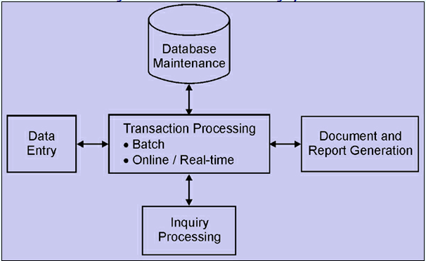
Figure 2.2: A Transaction Processing System (Expertsmind, 2003).

2.9.2 Management Information System (MIS):
A management information system (MIS) is a computerized archive of organized and programmed financial data in such a way that it produces periodic operation reports for every level of management in a company. Unique reports can usually be easily acquired from the system as well.
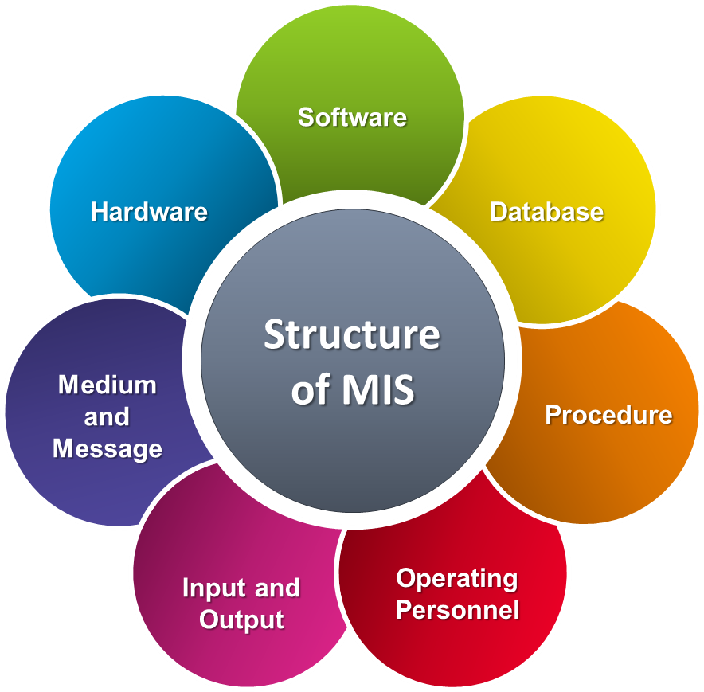
Figure 2.3: A Management Information System. (Toppr, n.d.).

2.9.3 Decision support systems (DSS):
A decision support system (DSS) is a computer program application that analyzes and provides company information so that consumers can make business choices easier. It is an "informative application" (to differentiate it from an "operational application" that gathers information during normal business operations). These are specifically intended to assist management make choices in circumstances where there is uncertainty about the potential outcomes of those choices. DSS includes instruments and methods to assist collect appropriate data and evaluate options and alternatives. DSS often involves the use of complex spreadsheets and databases to create "what-if" models (Finley, 2012).

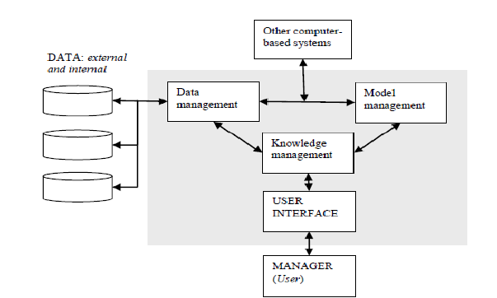
Figure 2.4: Showing Decision Support System (Giosvany, 2019).

2.9.4 Executive Support System (ESS)
This is aimed at assisting senior management in making strategic choices. It collects, analyzes and summarizes the main internal and external information used in the business. A nice way to think of an ESS is to picture the senior management team in an aircraft cockpit with the instrument panel showing them the status of all the key business operations. ESS typically includes a lot of data analysis and modeling tools such as "what-if" analysis to assist in strategic decision-making (Stair, 1996).
2.10 Application of Reservation Systems
Computer Reservation Systems (CRS) are used to manage airline seat inventory and seat reservation transactions. Initially built, owned and managed by airlines, the use of CRS as a distribution tool had been extended to travel agents. Over the years, CRS has developed into Global Distribution Systems (GDSs) hosting inventory of various airlines and other related services such as room reservations, ticket booking systems for football matches, train reservations for train seats and other reservation types (Nasim, 2010).
2.11 Benefits of Reservation Information Systems
- Convenience: The convenience is one benefit of booking a flight online. Being able to create all your travel plans on the internet implies you can do it at any moment of day or night at home and at your own leisure. On the go, customers can even create reservations on their smartphones or tablets. There is no need for long phone calls or travel agency visits, with just a few minutes and a mouse-click to finalize all your plans (Company, 1993).
- Changes and Cancelations: Customers can easily modify or cancel online reservations. Rather than calling the hotel or airline and waiting for a customer service representative to assist you through the process, booking online ensures you could do it wherever you have access to the Internet.
iii. Customer reviews: Making a reservation on the phone or at a travel agency does not allow you to check out what previous customers have thought of hotel chains or certain airlines. Another advantage of creating online reservations is being able to see these customer reviews (Company, 1993).

CHAPTER THREE
METHODOLOGY
3.0 Introduction
The methodology describes the tools, procedures, and techniques used to achieve the specific objectives of the airline reservation system for a sample airline (Greeniie Airline). This system employs the waterfall model as a method of developing the system. This system's design is based on the model below. It includes requirement determination, requirement analysis, system design, implementation, testing and validation.
3.1 User View Creation for Accessibility
Hyper Text Markup Language (HTML) was used to construct the customer view framework when creating the access for the two user views (Administrator and Customers). In this system, there's the admin and the user is the customer. Cascade Style Sheet (CSS) was used to create the styles in the web view pages. Javascript was used to add dynamics to user views, such as drop-down menus and adjusting things after page loads. The two user-design interfaces in the system for both the administrator and customers have distinct features.
3.1 Design and Development of Database for the System
The Structured Query Language (MySQL) is the database server used in this system. SQL is primarily used for accessing, editing and controlling databases. It is used as a system for managing databases. MySQL is a server that can be used to store big quantities of data in structured forms that can be accessed as a server-side scripting language through Hypertext Preprocessor (PHP) to allow communication between the front-end and back-end.
3.2 Design of Airline Reservation System
In the development of this system called Greeniie airline, flowchart, use case, sequence and activity diagrams were used depict the operations that take place and their interaction with each other. The flowchart showed a diagrammatic representation of an algorithm and the step-by-step approach to solving the problem of online reservation; the use case diagram showed the interaction of the user with the system and the relationship between the users involved. The sequence diagram showed object interactions arranged in time sequence and showed the objects and classes involved in the scenario and the sequence of messages exchanged between the objects needed to perform the system's functionality; while the activity diagrams showed workflows of step-by-step operations and actions including elements highlighting data flow between operations through one or more data stored. The class diagram of the system is also shown. Figures 3.1 to 3.5 show the diagrams.

Figure 3.1: Flowchart Diagram
No
Yes
No
Yes
No
Start
Register
Is registration valid?
Login
Is login valid?
Book Flight
Modify/Cancel flight?
Make Payment
Send Booking confirmations/ Print flight ticket
Stop

Figure 3.1: Flowchart diagram of airline reservation system
Figure 3.2 Use Case Diagrams
Figure 3.2.1 Administrator Use Case Diagram
The administrator is responsible for constantly updating and modifying system content.

Login/Logout

Add/delete/Modify/
customer Information

Add/delete/Modify/
Flight Information

Add/delete/Modify/
Schedule Information

View cancelled &
reserved tickets

Administrator

Figure 3.2.1 showing Administrator use case diagram

Figure 3.2.2: Customer (Registered user) Use Case Diagram
A person who accesses the system from the user point of view

Home page

Login & register

Book flight

Cancel Reservation

Contact Company

Customer or end user

Figure 3.2.2 showing Customer use case diagram

Figure 3.3: Sequence Diagram
Figure 3.3 Showing Sequence Diagram for Airline Reservation System

Figure 3.4: Activity Diagram
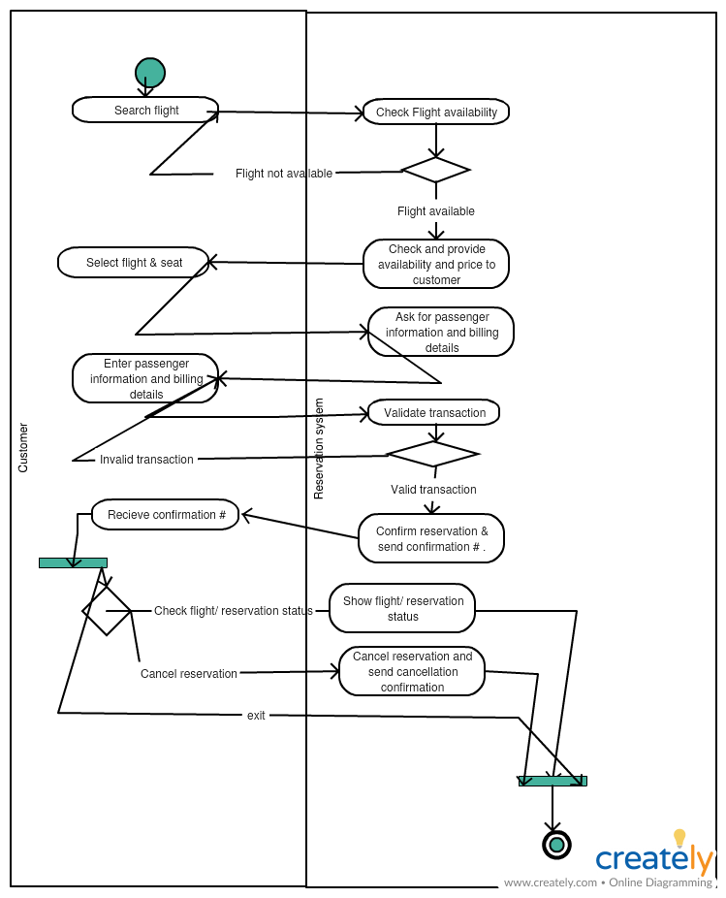
Figure 3.4 Showing Activity Diagram

Figure 3.5: Class Diagram
Figure 3.5 showing the Class Diagram

Figure 3.6: Waterfall Development Life Cycle
During the development of this project, water fall model which involved five (5) stages was used. The stages are: Requirement determination, Requirement analysis, System design, Implementation and Testing & Validation. Every stage had its mode of operation.

Figure 3.6 Showing a Waterfall Development Life Cycle

    - Requirement determination
During the requirement determination phase, system data was collected detailing how it should operate. This was a tasking part of system analysis The system requirements were collected and recorded for the system development. The main objective of this stage was to determine the system's functionality and the information was used to identify the user's requirement and system specification.

    - Requirement Analysis
During this stage, a detailed functional specification was given to specify the complete set of system capabilities to be implemented, along with process models showing the data to be managed and the procedures to be supported by the system.
3.6.3 System Implementation
MySQL was used for the database and Xampp Server to host web pages in this phase of the life cycle of software development. The actual system was acknowledged at this phase. The interface was designed using HyperText Markup Language (HTML) and JavaScript scripting language because they provide a user-friendly interface that is inexpensive and simple to learn. The database was designed in MySQL. based on Xampp Server software MySQL was used because it offers the database a high level of security and DML commands such as deleting, adding, or even editing. It also drastically reduces redundancy.

    - System Testing
The system was thoroughly tested in order to correct errors and to remove defects. The source code was tested to make sure that it produces the desired results when subjected to a set of predefined conditions. Three major types of testing on the system are;
- Unit testing
- System testing
- User Acceptance testing
Unit testing: Specific parts of the source code have been tested. I emphasized on the website- database connection to ensure that information sent by customers from the website, reaches the database of the system.
System testing: The entire software was also tested to guarantee that the system's functional requirements were efficiently and effectively integrated and achieved.
User Acceptance testing: The system under consideration was tested for user acceptance by constantly maintaining contact with the users of the system who are the customers and administrator. This was a significant factor in the success of the system's performance

CHAPTER FOUR
SYSTEM DESIGN AND ANALYSIS
4.0 Introduction
This section discusses the tools used to develop and implement the system. These include the context diagram, the level zero and one data flow diagram. These tools helped design the system and developed the system's primary idea and functionality in another to accomplish its specified task. This whole concept is a system, that is, a collection of components that work together as parts of a mechanism or interrelated system. As the development of information systems progressed to the design activities, the researcher studied ways in which the system would operate as it was meant to.

  - System Design Objectives
The Airline Reservation System (ARS) is a software solution to help an airline with flight reservation operations that include reserving, blocking, canceling and rescheduling tickets.
From the airlines ' point of view, the system offers the following;
1. The system should minimize the system administrator's repetitive work and booking agents ' job.
2. In the event of an emergency, the system should be able to retain customer information, e.g. flight cancelation owing to poor weather.
3. The system should minimize the number of empty seats on a flight and maximize the utilization of flight capacity.
4. The system should decrease the effort and frustration of customers in scheduling a trip, especially by reducing the search effort for the flight they need to take.
5. The system should make it easy for customers to verify ticket status or make adjustments to their flight.
4.2 System Design
This was divided into three namely;
- Logical
- Conceptual
- Physical design

    - Logical design
The logical model of the system was created in this case and shows all the important steps in the system growth. The researcher used case tools such as flow charts and data flow diagrams in this. These models were essential to the development of the system. This phase included the graphical user interface design, the input design in which the user enters information, the output design which shows the results of what a user has done, and the database design in which information is stored for simple management. These designs supplied the technical framework from which the system was developed. Layout tools like CASE tools were used to produce both input and output designs. Database design was based on the Relational data model and the database management system employed was MySQL.
4.2.2 Conceptual design
This was a description of the proposed system in terms of a set of integrated ideas and concepts about what it should do, behave, and look like, that will be understandable by the users in the manner intended. The process began with identifying the entities required by the users and identifying all the important relationships that exist between the entities. The result was the model of the user interface that has been developed.
    - Physical design
That was the physical achievement of the logical design. Tables, forms and reports have been established and links identified between these tables. Also, safety constraints have been established. The researcher converted the expected schemas into real database structures and had to map:
      - Entities to tables
      - Relationship to foreign key constraints
      - Attributes to columns primary unique identifiers to primary key constraints
      - Unique identifiers to unique key constraints
      - Attributes to columns.
The system has been developed on the following requirements;
4.3 Functional Requirements
The following requirements were captured for the intended use of the system.
4.3.1 User account
The registered user can book the flights directly and he may only register or see the flight information if he is a fresh customer. However, he must first register for the booking of the ticket.
4.3.2 Creation of new user account
If a new customer is available he must fill out the form containing fields like Name, Address, Contact no, Gender, E-mail, User ID and Password.
4.3.3 Checking Availability
The customer should enter the city of departure and arrival, date of travel, to verify the available flight.

4.3.4 Reservation of Flight
The system will request confirmation from the customer after the information has been provided. The seats are reserved after confirmation of the information.
4.3.5 Canceling / Rescheduling of Ticket
The client should provide information on the ticket number and the flight number to cancel the booking.
4.4 Non-functional requirements
The application was developed to meet these non-functional requirements.
4.4.1 Performance Requirements
The Airline Reservation System application should be able to respond to the queries submitted by the customer without much delay. When a user is searching for a flight from a specific location, it should not take long for the request to return the results. Naturally, the searches and other requests should be able to return the right results. It depends on the internet bandwidth and the hardware itself.
4.4.2 Quality Attributes
The system is very user friendly, interactive and easy to navigate.

4.4.3 Security Requirements
The confidential information is visible to a single authorized person. Customer information can be obtained only by the administrator.

4.5 Data Flow Diagrams
Figure 4.1: Context Diagram for Airline Reservation System

0

Airline
Reservation
System

Customer

Management

Schedule

Flight

Journey

Ticket

Customer info, Price
Inquiry,
Availability
Inquiry, Reservation
Request, Payment,

Price, Availability,
Confirmation, Ticket

Info, Flight Info

Management
Reports

Flight

Info

Journey
Details

Schedule
Info

Ticket
Info

Figure 4.1 showing the context diagram for the system

Figure 4.2: Level One Data Flow Diagram for Reservation Process

Confirmation Ticket

1.2

Determine
Price

1.1

Determine
Availability

1.1

Book
Reservation

1
.4

Pay for
Reservation

Financial
Institu
ti
on

Customer

D2 Customers

D1 Prices

D3
Flights

D4 Reservations

Price

Customer
Info, Price
Inquiry

Availability

Customer
Info
,
Availability
Inquiry

Available
Flights

Customer
Data

Customer
Data

Price Data

Price Data

Customer
Data

Customer
Details

Available
Flights

Booked
Flights

Reservation Request

Payment

Reservation
Details

Credit Inquiry,
Billing

Credit Verif
ication,
Payment

4.6 Database Design
Data types and attributes and their relationship were defined according to the user requirements. The design of the database also includes the creation of an appropriate system data model.

4.6.1 Entities
- Passenger (customer)
The person who is booking for purposes of travel
- Flight detail
The airplane to travel in
- Journey details
The details of the planned destination
- Ticket details
The details of the ticket
- Schedule details
Details of the journey schedule

4.6.2 Database Conceptual design
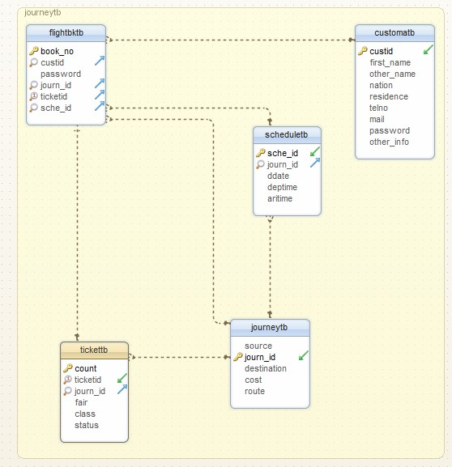

Figure 4.3 showing the data base logical design for an airline reservation system

4.6.3: Table Attribute Description (Physical Design)

Customers Table
Column Name | Data Type | Nullable | size
ID(PK) | Int | No | 1
Custid | Varchar2 | Yes | 25
Surname | Varchar2 | Yes | 25
Other_Name | Varchar2 | Yes | 100
Email Address | varchar2 | Yes | 50
Nationality | Varchar2 | Yes | 50
Residence | Varchar2 | Yes | 50
PhoneNo. | Int | Yes | 15
DOB | Varchar2 | Yes | 25
Table 1 showing passenger’s details
Flight Table
Column Name | Data Type | Nullable | size
ID (PK) | int | Yes
Source | Varchar2 | Yes | 25
Destination | Varchar2 | Yes | 25
Takeoff | Varchar2 | Yes | 10
Arrival | Varchar2 | Yes | 10
Price | Int | Yes
Day | Varchar2 | Yes | 15
Table 2 showing flight details/ Ticket table
Journey table
Column Name | Data Type | Nullable | Size
ID (PK) | int | No | 1
Custid | Varchar2 | Yes | 25
Email | Varchar2 | Yes | 25
Source | Currency | Yes | 25
Destination | Varchar2 | Yes | 25
Departure | Varchar2 | Yes | 20
Returndate | Varchar2 | Yes | 20
Day | Varchar2 | Yes | 25
Table 3 showing Journey details table
Journey Table
Column | Data Type | Nullable | Size
Id (PK) | int | Yes
Custid | Varchar2 | Yes | 25
Email | Varchar2 | Yes | 50
Password | Varchar2 | Yes | 100
Table 4 showing user details table

  - System implementation
The Airline Reservation system offers easy-to-use, interactive, responsive, graphical and telephonic interfaces. It provides;
i. As part of the administrator's working desktop environment, ARS offers an easy-to-use, intuitive Graphical User Interface (GUI).
ii. The ARS also provides an interactive graphic user interface on the World Wide Web for general customers.
Working Scenario
i. To continue with the reservation of tickets, the customer should register himself.
ii. During the registration process, the customer must enter all the information needed.
iii. After successful login, the username and password are used to register the customer formally to the web service.

4.7.1 Administrator Use Case Diagram
The administrator is the one whose responsibility is to regularly update and modify system content.

Login/Logout

Add/delete/Modify/
customer Information

Add/delete/Modify/
Flight Information

Add/delete/Modify/
Schedule Information

View cancelled &
reserved tickets

Administrator

Figure 4.4 showing Administrator use case diagram

Customer (Registered user) Use Case Diagram

Home page

Login & register

Book flight

Cancel Reservation

Contact Company

Customer or end user

Figure 4.5 showing Customer use case diagram

4.7.2 Hardware Platform
The requirements for implementation are based on system requirements. These are the requirements of hardware and software on which the system operates. The system supports all Pentium III and above users, operating systems, Linux, Windows NT, Mac, with RAM 512 MB, hard disk capacity of at least 10 GB and the processor speed of 550 MHZ.
    - Software Platform
In order to access the Web Server via TCP / IP, the client computer must have internet connectivity. The system should be installed in any Linux or Windows architecture-based server computer. The server must have a minimum of 10 GB RAM and 1 terabyte of storage at the processor speed of a minimum of 10 GHz.
    - System Execution Sequence
This is divided into two forms which is;
- User’s environment
- Administrator environment
User’s environment
- Welcome Page

CHAPTER FIVE
Summary, Conclusion and Recommendations

REFERENCES
Amadeus. (2010). Amadeus | About. Retrieved from https://amadeus.com/en/about
American Airlines ^ "Magnetronic Reservisor". American Airlines C.R. Smith Museum. Retrieved 3 August 2014.
Beal, V (2018). Database Retrieved March 4, 2019, from https://www.webopedia.com/TERM/D/database.html
Bourgeois, D. (2014). Information Systems Development. In Information Systems for Business and Beyond [PDF] (2nd ed., p. 104). Retrieved from https://bus206.pressbooks.com/chapter/chapter-10-information-systems-development/
Businessdictionary (2012) http://www.businessdictionary.com/definition/Global-DistributionSystem- GDS.html accessed on May 26, 2012
BusinessDictionary.com. Retrieved May 30, 2019, from BusinessDictionary.com website: http://www.businessdictionary.com/definition/guaranteed-reservation.html
BusinessDictionary.com. Retrieved May 30, 2019, from BusinessDictionary.com website: http://www.businessdictionary.com/definition/non-guaranteed-reservation.html
Cambridge. (2019). Reservation | meaning in the Cambridge English dictionary. In Cambridge Dictionary | English Dictionary, Translations & Thesaurus. Retrieved February 4, 2019, from https://dictionary.cambridge.org/dictionary/english/reservation
Company, D. P. (1993). Computer Reservation Systems: Action Needed to Better Monitor the CRS Industry and Eliminate CRS Biases. Collingdale, PA: DIANE Publishing.
Expertsmind. (2003). Transaction processing system [Image]. Retrieved from http://www.expertsmind.com/learning/transaction-processing-systems-assignment-help-7342872690.aspx
Finlay, P. N. (1994). Towards a Definition of Decision Support Systems. In Introducing decision support systems (2nd ed.). Hoboken, NJ: Blackwell Pub.
Goran, P. (2015). Global distribution system [Image]. Retrieved from https://www.researchgate.net/figure/Amadeus-GDS-Source-Website-Amadeus-Many-global-airline-companies-about-150-of-them-use_fig3_301202424/actions#reference
Giosvany Miranda, (2013) Context-aware Spatial Decision Support Systems (CA-SDSS): Articulating Decision Support Systems, Business Intelligence and Recommender Systems considering the geospatial component - Scientific Figure on ResearchGate. https://www.researchgate.net/figure/Schematic-of-components-for-a-decision-support-system-50_fig2_266642746 [accessed 25 May, 2019]
IBM Corporation, (2012)
Kollmeyer, B. (2010, March 23). Amadeus IT holding plans Spain IPO for 2010. Retrieved February 4, 2019, from https://www.marketwatch.com/story/amadeus-it-holding-plans-spain-ipo-for-2010-2010-03-23
Nasim Zaidi (2010), Civil Aviation requirements section 3 air transport series part one issue one, April, 2010.
Oyelade, O. J., Fatumo, S. A., Azeta, A. A., & Ayo, C. K. (2009). Development of a mobile airline reservation system. Journal of Computer Science & Its Application, 16(1), 58-59. Retrieved from http://eprints.covenantuniversity.edu.ng/2128/1/Development%20of%20a%20Mobile%20Airline%20Reservation%20System.pdf
Parker, D. (2016, August 16). Airline reservations systems: A brief history. Retrieved May 4, 2019, from https://airlinegeeks.com/2016/08/16/airline-reservations-systems-a-brief-history/
Pollack, T. (2016). Airline reservations. Retrieved from https://www.encyclopedia.com/computing/news-wires-white-papers-and-books/airline-reservations
Pooja, G. (2015). Online Airline Ticketing System Centria University Of Applied Sciences , Kokkola, Finland.
Rochester, J. B. (1996) Using Computers and Information: Tools for Knowledge Workers (1st ed.). Indianapolis, IN: Que Educational & Training.
Ross, G. 2013 Airline Reservation Systems History 101. Available: https://www.cbtravel.com/blog/2013/11/airline-reservation-systems-history-101/. Accessed: 17th September, 2015
Rouse, M. 2015 E-commerce (electronic commerce or EC) definition, Available: http://searchcio.techtarget.com/definition/e-commerce/. Accessed 10th February, 2019
Scott's Cheap Flights, (2014). "How Sabre Changed Airline Reservations". Scott's Cheap Flights. Retrieved March 25, 2019.
Stair, Ralph M. (1996) Principles of Information Systems and Managerial Approach, 2nd ed. Cincinnati, OH: Boyd & Fraser. [Accessed May, 19, 2012].
The Economist. (2012, August 25) The ineluctable middlemen Retrieved February 10, 2019, from https://www.economist.com/business/2012/08/25/the-ineluctable-middlemen
Toppr. (n.d.) Management information system [Image]. Retrieved from https://www.toppr.com/guides/accountancy/application-of-computers-in-accounting/management-information-systems-and-accounting-information-system/
Ueland, S. (2013) 11 alternative payment options. Retrieved February 4, 2019, from https://www.practicalecommerce.com/11-Alternative-PaymentOptions
Wardell, D. J. (1991) Airline Reservation System: A Report & Overview. Retrieved from https://www.academia.edu/487385/Airline_Reservation_Systems
Winston, C. & Morrison, S., (1995) The Evolution of the Airline Industry. Washington, DC: Brookings Institution Press, ISBN 081575843X. Cf. p. 61-62, Computer Reservation Systems

