DESIGN AND IMPLEMENTATION OF AN E-LEARNING SYSTEM
(A CASE STUDY OF MOUNTAIN TOP UNIVERSITY, IBAFO)
BY
DIBIE REJOICE CHIJINDU JOSEPH
SUBMITTED TO
THE DEPARTMENT OF COMPUTER SCIENCE AND MATHEMATICS,
COLLEGE OF BASIC AND APPLIED SCIENCE,
MOUNTAIN TOP UNIVERSITY, IBAFO, OGUN STATE.

IN
PARTIAL FULFILLMENT OF THE REQUIREMENTS FOR THE AWARD OF A BACHELOR’S DEGREE IN COMPUTER SCIENCE.

NOVEMBER 2020

CERTIFICATION
This is to certify that Dibie Rejoice Chijindu with matric number 16010301012, carried out this project work titled “Design and Implementation of Virtual Learning System”. As a partial fulfillment of the requirement for the award of Bachelor of Science (B.Sc.) in Computer Science.

_____________________ __________________
Dibie Rejoice Chijindu Date
Project Student

_____________________ ___________________
Dr. Oladejo Bolanle Date
Project Supervisor

_____________________ ___________________
Dr. Akinyemi I. Date
Head of Department

DEDICATION
This is dedicated to the almighty God for His love, care and mercies he relentlessly showered on me because I would be nothing without Him and I also dedicate this project to my parents Mr & Mrs Dibie and also to all Computer Science lecturers who have gone through a lot to put me on the right path.

ACKNOWLEDGEMENT
I wish to express my profound gratitude to the Almighty God for seeing me through this project and to those who contributed to the success of this project especially my parents Mr & Mrs Dibie, for their financial and unending moral support, prayer and words of encouragement which has kept me going all this while, may God bless you two.
An exceptional gratitude goes to my H.O.D, in the person of Dr. Akinyemi I. O., who has been the father-figure in this great department. I also want to acknowledge the tutelage of my supervisor in person of Dr. Oladejo Bolanle, who was always there for me in time of assistance and advice to make this project a successful one. I am really grateful to her because it was her advice that made me carry on with this project, which was a great decision.
I also want to say a big thank you to my eldest brother who helped financially through my ordeals in this great university.
A very special one goes to all Computer Science students for the togetherness, love, sacrifices. I love you all and you made my stay in MTU a fun-filled, pleasant, inspiring and educative one.
I will not forget you my good friends, well-wishers and loved ones, that in one way or another, contributed immensely to the success of this project, God bless you. Once again, I want to thank you all very much.

TABLE OF CONTENTS
CERTIFICATION ii
DEDICATION iii
ACKNOWLEDGEMENT iv
ABSTRACT vii
CHAPTER ONE 1
INTRODUCTION 1
1.1 Background to the Study 1
1.2 Statement of the Problem 2
1.3 Aim and Objectives of the Study 3
1.4 Research Methodology 4
1.5 Scope of the Study 4
1.6 Limitations of the Study 4
1.7 Contribution to Knowledge 5
1.8 Organization of the thesis 5
1.9 Definition of the Terms 6
CHAPTER TWO 9
LITERATURE REVIEW 9
2.1 Introduction 9
2.2 Historical Background of Virtual Learning System 9
2.3 Strategic Importance of E-Learning 14
2.4 Organizational Culture- An Important Consideration 16
2.5 Trainers in a Virtual Learning Era 18
2.5.1 Trainers’ Roles 19
2.5.2 Trainers’ Competencies 20
2.6 Learners’ Attitude Towards Using Technology 22
2.7 Online Interaction and Communication 23
2.8 Evaluation of E-Learning 24
2.9 Training Effectiveness in E-Learning 25
2.10 Feedback 27
2.11 Learning Environment 28
2.12 Global Issues in E-Learning 29
2.12.1 Learning and Teaching Styles 29
2.12.2 Social Issues in Global Virtual Learning 30
2.12.2a Differences in Educational Systems 30
2.12.2b Religious and Political Issues 30
2.12.2c Language Issues in Global E-Learning 31
2.13 Current Delivery Systems and Technologies 32
2.13.1 Texts and Graphics(HTML) 32
2.13.2 Multimedia 33
2.13.3 Collaborative Technologies 34
2.13.4 Blending 36
2.14 Future Delivery Systems and Technologies 38
2.14.1 DHTML Many e-learning systems are starting to use the delivery of a Dynamic HTML (DHTML) document. Without the need for browser plug-ins, DHTML allows for more immersive interactions-given the browser version is fairly recent. For distributing asynchronous content, DHTML is more frequently usedUsing a standard internet browser used to deliver innovations such as multimedia and even e-learning content environments, DHTML can build robust applications (Training & Development, 1999). 38
2.14.2 XML 38
2.14.3 VRML 39
2.14.4 Integrating Knowledge Management with E-Learning 39
2.14.5 Training and Learning Management Systems 40
2.14.6 Portals 40
2.14.7 Integrated Solutions 41
CHAPTER THREE 42
SYSTEM ANALYSIS AND METHODOLOGY 42
3.1 Introduction 42
3.2 Research Methods 43
3.3 Objective of The Existing System 44
3.4 Problem Identification 44
3.5 Description and Analysis of the Existing System 45
3.5.1 Proposed System 45
3.5.2 Features of The Proposed System 45
3.7 Development Tools for The System 49
3.7.1 Programming Languages Used 49
3.7.2 System Design 50
3.7.2 The software architecture for the web-based personalised e-learning system 51
3.7.3 Presentation Layer 52
3.7.4 Middleware 52
3.7.5 Data Layer 52
Figure 3.2: 3-Tier Client-Server Software Architecture of the web-based personalised e-learning system 54
3.7.6 Component Communication and Data Flow Model 55
4.5.1 Home Page 69
4.5.2 Tutor login 71
4.5.3 Tutor Registration 71
4.5.4 Student login 71
4.5.5 Student Registration 71
4.5.6 Pre-Test 72
4.5.7 Add Learning Materials 72
4.5.8 Edit Learning Material 77
APPENDIX 88
Source Code Listing 88
Home page 88

ABSTRACT
The demand to acquire knowledge or to learn has risen, thus, the present technology had gone a long way to provide means to learn, irrespective of the distance or the location of the e-learner and source of information. This is achieved through electronic sharing of information and virtual classroom. However, virtual classroom and text based e-learning is a system designed to help students gain access and acquire knowledge in any university of their choice. This method of learning will enhance face-to-face instruction, use of computer in classrooms and elicitation of information with the World Wide Web (WWW), enhanced distance education. Individual and group learning with both print and computer based materials. With all these, virtual classroom and text based e-learning knowledge is moving towards every student and staff of Mountain Top University (for instance) being an e-learner at least for part of their study, this could be through learning materials, e-mails contacting tutors or submitting assignment, the use of website for research or any one of the myriad e-learning applications. Thus, students or staff must not travel abroad to acquire knowledge. This project has some unique features such as a simplified way of which study materials can be distributed evenly among students, also allowing the teachers to give quizzes and also allows for easy communication between teachers and students. The outcome of this project is flexible and can easily be adapted to by almost every teacher and student.

CHAPTER ONE

INTRODUCTION

1.1 Background to the Study
Virtual learning is an e-learning system designed to help students at their university of choice gain access to and obtain information online. It may include: enhanced face-to - face teaching, enhanced distance education (on or off campus), computer-based materials for individual and community learning and fully online-based guidance. Because of this combination of virtual classroom and text-based virtual learning, information moves towards any student becoming an e-learner, whether via e-materials, e-mail to contact teachers/tutors or any of their many other e-learning platforms, at least for the duration of their study.
Online learning outcomes are accessible through a computer for learning and other supporting services, including computer-based training, computer-based instruction and technology. To deliver data and information, the e-learning framework uses text messages. Students or e-learners will receive lectures as if they were in the classroom, on their computer. This has gone a long way in encouraging e-learners to graduate from institutions.
The Internet has done so well, so to speak, in information technology and innovation as a worldwide computer connection, providing a massive network for information to be shared and circulated by millions of people across the world. Digital classrooms and e-learning based on text should not be an exception. Learners often face a lot of challenges in searching for basic information from the educational institutions of their choice, not because the person may not have the funds to obtain them, but because the risk of traveling to and from wherever the person may live at the institution may pose threats and challenges to the person concerned. Satellite computers were set up in order to minimize these dangers, but the issue of moving from one's location to that location in search of information was not solved. (Berge,1998).
In this regard, Mountain Top University competes with a number of institutions in this country, because of the afore mentioned problems, the number of student enrollment in the school is reduced. Therefore, Mountain Top University will have thousands of students with the "virtual classroom and text-based e-learning" framework in which it does not need to have accommodation or any structure for and yet economically benefit much ground, and students worldwide will suffer less from receiving a Mountain Top University certificate.
This is intended to require registration before anyone can participate. Information from the school staff and student database for students and lecturers would be used to register students and lecturers, so matric numbers and staff ID numbers would be given to fit their necessary details in order to gain access. This will help to increase the enrollment of students at the university. The system has very security-conscious software, except the supposed ones, that resides in the ever-helping. Having observed and seen. This advantage for students has been seen and witnessed on an unparalleled scale.
Indeed, my scholarly pursuit in Mountain Top University just got closer. This perhaps calls for implementation.

1.2 Statement of the Problem
In any institution you choose, regardless of the fact that the resources are there, it has never been easy for students to obtain basic and required education due to the problems students encounter and experience. Often they would accept not going to school at all, which causes a lot of problems. Moreover, it is very difficult for a student abroad or in a neighboring country to come to Mountain Top University for lectures every day, so it would be unlikely for employees of Mountain Top University to go abroad or a neighboring country where students may be placed to offer lectures every day.
Often, if the number of students increases, the reduction in the intake of students will be influenced in order to have sufficient structures where their lectures can be held.

Aim and Objectives of the Study
The aim of the research is to find potential solutions for students who are unable to gain the information they need because of their proximity to the institute. Again, to make it easier for students to receive all of the Mountain Top University certificates without being at the institute or with less difficulty. Notwithstanding the fact that there are other institutions offering the same courses as Mountain Top University, this will reduce their rivalry with them considerably. The problem structure is solved because the system is interactive, which means that there will be no physical interaction between students, their instructors and Mountain Top University.
As they say, "scientia st potential" which is “knowledge is power”. The objective of this study is to provide the students with all the necessary information for each subject that is carried out in this great institute. Again, to ensure that students follow the most current trend towards a learning climate across the globe. This will make Mountain Top University aware of developments in technology and benefit from making them want to provide the institution with other online provisions and computerization.

Research Methodology
A review of related literature and contemporary issues in e-Learning, learning theories and learning styles was carried out. Mathematical models and artifacts of the Unified Modeling Language (UML) were used to illustrate the logic and concept of the application. Then a web based personalized e-learning application was developed based on the three tier client – server architecture; using the following technologies:
- Macromedia Dreamweaver was used to develop the front-end, which comprises of web interfaces.
- PHP and Apache Web server were used for developing the back-end and coding of system logic.
- MySQL was used for the database development.
- Internet Explorer and Mozilla Firefox were browsers used for testing and debugging the application.

1.5 Scope of the Study
The project deals with the virtual files of the e-learning system that are transferable inside the network. It should be in the form of a text file (.txt), rich text files (.rtf) or hypertext mark-up language file (.html).

Limitations of the Study
The pace of technology is moving at a rapid pace and not everyone knows how to use any of the resources used for this method of education. This form of learning and measurement, particularly in relation to the cost of accessing the internet, is difficult for some people to afford.
Personally, I experienced a number of problems when carrying out this study work to be candid. For me, it wasn't easy to get information related to this study. The most significant thing I wanted was to get the courses Mountain Top University have altogether. The project job is a work job that needs time, resources and dedication. I had to deal with other activities while the process was going on because of the lack of money to meet all the resources and materials used.

1.7 Contribution to Knowledge
The virtual learning system will deliver digital content and provide a learner-oriented environment for the teachers and students. The virtual learning system will promote the construction of life-long learning opinions and learning society. Virtual learning also would provide ample opportunities of formal and informal learning. Therefore, with this system, learning is no more limited to the classroom setting.

1.8 Organization of the thesis
The thesis was organized in five chapters. Chapter one covers the background of the study, research motivation, research objectives, research methodology and contribution of the study to knowledge. In chapter two, some existing literatures on learning theories, learning styles definition and concepts, learning style models, trends in the use of computer in education, e-learning and personalized e-learning systems were reviewed. Chapter three presented and discussed the systems design considerations, mathematical model of the web-based personalized e-learning system, content development model, modeling and design of the new systems architecture and the database model of the system. Chapter four focused on the requirement, technology and implementation of the new system. Finally, chapter five presented the summary, conclusion, recommendations and further research.

Definition of the Terms
Computer: an electronic device for storing and processing data, typically in binary form, according to instructions given to it in a variable program.
Virtual Classroom: A virtual classroom is a digital learning environment that allows teachers and students to connect in online in real time.
E–learning: it is an acronym of Electronic Learning. It is an aspect of the virtual classroom that, through using text video, web or other IT resources, is concerned with exchanging information electronically.
File: this is a collection of related records.
VEL: This is the acronym of Virtual Electronic Learning
Program A series of logical instructions combined to perform a particular task and provide a solution to a given problem.
IT Tools: is any machine, technique etc. used in information technology.
Output: it is simply the result of the processed data by the computer.
Input: it is simply the data supplied to the computer for processing.
IT (Information Technology): Information technology is the use of computers to store, retrieve, transmit and manipulate data or information.
Data: facts and statistics collected together for reference or analysis and is used by the computer.
Information: data as processed, stored, or transmitted by a computer.
E-mail: messages distributed by electronic means from one computer user to one or more recipients via a network.
Storage Devices: a piece of computer equipment on which information can be stored.
Computer Network: It involves linking two or more computers using special protocols to exchange text, audio, messages or mail with data or information.
WWW (World Wide Web): all the resources and users on the Internet that are using the Hypertext Transfer Protocol (HTTP).
Website: a set of related web pages located under a single domain name, typically produced by a single person or organization.
Host Computer: a computer which stores a website or other data that can be accessed over the internet or which provides other services to a network.
Internet: a global computer network providing a variety of information and communication facilities, consisting of interconnected networks using standardized communication protocols.
E-learner: person who uses internet to obtain knowledge on the internet.
LAN (Local Area Network): A local area network is a computer network that interconnects computers within a limited area such as a residence, school, laboratory, university campus or office building.
Login: To link to the scale and make use of available information within a certain set of requirements given by the designer.
Logout: It closes one's access to the page that the individual was using.
Learning: process of acquiring knowledge

CHAPTER TWO

LITERATURE REVIEW

2.1 Introduction
The global economy and the way of life in organizations and the environment continue to be transformed by geopolitical, social and technological forces. Specifically, in institutions, these forces have and continue to revolutionize teaching and learning. The processes underlying design, production and delivery of training and education in the workplace, the rapid obsolescence of information and training, the need for just-in-time training delivery, and the need for cost-effective ways to meet learning needs of a globally dispersed workforce, have been redefined by technology.
Also, Urdan and Weggan related that the need for different learning models is due to ability differences and demographic modifications and need for versatile teaching and evolution of lifelong learning, but several words were attached to describe the creativity and reaction that has occurred. Some words include: distributed learning through e-learning, online learning, web-based learning, and distance learning.

2.2 Historical Background of Virtual Learning System
Computer-based training (CBT) was defined by Zahm (2000) as usually provided via CD-ROM or just as a web download and it is usually multimedia-based training.
Karon (2000) addressed the convenience aspect of well-designed computer-based training, stating that any well-designed computer-based training is more comfortable than conventional instructor-led training or workshops, whether it is network-based or distributed through the internet. Karon went on to say that self-paced CBT courses are accessible not only when the lectures are arranged or the teacher/lecturer is present, but whenever the students are ready to take them. Hall (1997) incorporated both Zahm (2000) and Karon (2000) concepts by highlighting computer-based training as an all-encompassing concept used to describe any computer delivered training, including CD-ROM and the World Wide Web. Hall further clarified that some individuals use the CBT term to refer only to old style, text-only training. Online training, like CBT, was categorized as an all-encompassing term which refers to all computer training across a network and the internet (Gotschall, 2000). Gotschall added that net-based training, could also be known as online training. Urdan and Weggen (2000) referred that online learning is just one aspect of e-learning and explains online, intranet and extranet learning. They added that on-line learning levels of complexity differ. It can apply to a sophisticated online learning program from a fundamental online learning program that involves text and graphics of the course, lessons, testing and record keeping, such as test scores and book markets. Complexity would involve animations, simulation, audio and video sequences, discussion groups of peers and exports, online tracking, connections to corporate intranet or web materials, and contact with records of corporate education. Schreiber and Berge (1998) agreed with Gotschall (2000) and stated that all technology-based learning, which is actually ready for immediate access, is online learning.
It would seem fair to say, given the wide meaning of online training, that web-based training is online training. Hall (1997) described web training as guidance provided over the internet or through the intranet of a business.
This preparation, according to Hall, is accessible by the use of a web browser, such as navigation. Hall and snider (2002) described e-learning as the method of learning on the internet and intranet through computers. However, distance learning was not included in the concept of e-learning and was defined as a learning process that meets three requirements as its own object: a geographic proximity divides contact between the teacher and the learner; communication is engaging, interactive and it goes both ways; and some form of technology is used to facilitate teaching and learning.
Learning is a lifelong practice that can be obtained anywhere, at any time, to satisfy a particular need or desire. Hall stated that their connections to data and analysis in real-time would become widely available. Thus, web training, online learning, e-learning, distributed learning, internet-based learning, given the advancement of the concepts, are all related (Hall & Snider,2000; Urdan & Weggen, 2000).
Technology-based learning is also close to e-learning and its associated terms.
(Urdan & Weggen, 2000). According to Urdan & Weggen, e-learning includes a broad variety of technologies and procedures, including computer-based learning, web-based learning, virtual classes, and interactive partnerships. They further customized their concept of content distribution through all electrical media, including the internet, intranet, satellite, television, audio/ video, interactive TV and CD-ROM, for the purposes of their research. However, they cautioned that e-learning is more broadly specified than distance learning, which would involve text-based learning and written correspondence courses. In their glossaries, Urdan & Weggan (2000), just like Hall & Snider (2000), have differentiated distance learning and e-learning, making e-learning comprehensive and synonymous with all computer-related software, resources and processes that are strategically associated with the value-added teaching and learning process.
The distinction between distance education and distance learning has been clarified by Berge (1998). Distance education has been seen as a structured distance learning process, with content, such as college courses, being broad in nature. While distance learning was seen as the development of experience and skills, all technology and other ways of distance learning were included. Perhaps this is why the word distance education is used by most academic institutions. These were the key principles of the analysis of five institutional concepts of distance education: traditionally, it meant correspondence education, teaching and learning scheduled, linking learners at a distance, designed to facilitate learner engagement, using audio, video and computer technologies as delivery modes, and as technology evolves and develops, delivery modes evolve.
Gotschall (2000) described distance learning as a transmission, typically through video presentations, of lectures to distance locations.
As described above, Hall and Snider (2000) defined distance learning with three criteria; they are: a geographic proximity distinguishes contact between the teacher and the learner, communication is two-way and engaging, and to promote the learning experience, technology and innovation is used. Willis (1994) identified in his concept of distance learning, that the development of experience and skills as another prerequisite for distance learning and endorsed the previous three criteria by claiming that distance learning occured by facilitated information and training, and included all technology and other modes of distance learning. Porter (1997) shared that training or education given to learners who are in a different place than the source or provider of instruction was distance learning. Porter went on to state that it is possible to change the technologies used in distance learning, the structure of a course or curriculum, and the level of oversight for distance learning courses to satisfy the needs or desires of a given audience.
Interestingly, e-learning was regarded by Urban and Weggan (2000) as a subset of distance learning, e-learning as a subset of e-learning and computer-based learning as a subset of online learning. Given the analysis of meanings of all these terms, "subset" does not seem to be the term best appropriate to describe the relationship between these terms and their forms. The concept illustrates a great depth of interdependence between them. Although a concept could be loosely described by one person, the all-encompassing power may be provided by another person. This implies that, given the all-encompassing method, e-learning may be the greater circle in which, given the purpose of its users, all other forms can overlap at various times and levels. Another reason for this option is that learning "just-in-time" is a big benefit of e-learning, but not distance learning. Distance learning means scheduled classes, or scheduled experiences. Not only does e-learning value planned learning, but it also recognizes the value of the learner's unplanned and self-directedness to optimize accidental learning to enhance efficiency.
According to NCSA’s e-learning group definition, E-learning is the development and use of information transmitted and facilitated mainly by electronic means. This method of learning currently relies on networks and computers, but as they are developed and implemented, it is likely to adapt to a system consisting of a range of platforms (e.g. wireless, satellite) and devices (e.g. cellular phones). E-learning can come in the form of lessons and also modules and smaller objects of learning. Synchronous or asynchronous access may be used in e-learning and can be geographically dispersed with differing time limits.

2.3 Strategic Importance of E-Learning
With the technological age, this definition of the learning organization has increased exponentially (Marsick & Watkins, 1993). McRea, Gay & Bacon (2000) reported that in the context of managing and growing the company, corporate learning and the corporate learning organization have now risen to a position of strategic prominence. The knowledge-based economy, the paradigm shift in the way education is perceived and provided, and huge knowledge gaps have been described by Urdan & Weggen (2000) as significant developments that have given rise to e-learning. They also reported that the second largest sector of the United states economy is the education industry, which is worth $772 billion. The rise in complexity and speed of the work environment caused by changes in technology are also significant problems that have bolstered the demand for e-learning. McCrea, Gay & Bacon (2000) described the transition from the industrial era to the knowledge age, advancement in technology, the ever reducing cycles of product growth, shortage of qualified workers, business resource planning and migration to the convergence of the value chain and the expanded company as a major contributor to the value chain of e-learning.
Coll, Lowy and Kalakota (1998) noted that the competitive market requires businesses to work together to build an E-Business Community (EBC), that is, an online platform for consumers, suppliers and value-added operations. The above developments have given birth to many market concerns that need to be resolved quickly if businesses are to maintain their competitive rating. They mentioned an E- business strategy must anchor on the following forces when evaluating an E-business community. Firstly, since wealth creation, connectivity, exchange and distribution, converse on popular digital networked platforms, the reinterpretation of value must be discussed. Industry borders blur, forcing suppliers to re-think the basis for the production of value. Secondly, the economics of digital information must be well known because it is usually inefficient and nearly impossible to hoard knowledge. Knowledge should be exchanged in the digital economy. Third, everywhere, information technology is driving transition. Thus, the speed and intensity of the information technology industry must be welcomed by every executive in every industry. Fourthly, employment, business systems, markets and even whole sectors face digital transformation or elimination. This implies that both tangible (quality and cost) and intangible benefits (information, power, and relationships) will be obtained by consumers while adding more value to society. Finally, the digital implosion drives desegregation and specialization which threatens the vertically or horizontally integrated firm's economic rationality. The time and financial cost of information and communication are minimized by digital knowledge. Coll, Lowy and Kalakota (1998) noted that it is economically viable for broad and diversified groups of individuals to have the data they need in real time to make safe decisions. Companies may raise wealth by adding value to product awareness through creativity, development, cost reduction, or customization at each point of their life cycle. The e-business powers discussed above set the tone for the relevance of e-learning strategies.
Hall and Karon (2000) capitalized on the intranet and internet access to classes, training can be self-paced, training is available at any time and location, training is less costly and travel time can be reduced or removed. Urdan and Weggen (2000) added that it is possible to maintain more content through customized learning because technology-based solutions create more space for individual variation in styles of learning. In addition, they highlighted increased student communication and efficiency as the online environment provides case studies, storytelling, demonstrations, role-playing, and stimulus, among other resources. Urdan & Weggen also remarked along this line that online training is less daunting than instructor-led courses. Online learning, they claim, is a risk-free environment that allows new ideas to be tried and errors made. Consequently, if training and growth prioritize separate tasks, off-site classroom focused on "just in case" learning, company misalignment is priorities and results, uncertain skill gaps, "one size fits all" mentality, and the training department is in the back office, the strategic value of the digital economy and digital learning is far from being accomplished by companies. Their culture of organization is in desperate need of improvement.

2.4 Organizational Culture- An Important Consideration
Kotter & Heskett (2002) clarified that it is useful to think of organizational structure as having two levels that vary in terms of exposure and resistance to change. Kotter & Heskett related at the deeper and less evident level that culture refers to ideals held by individuals in a group, and that appear to continue over time even though membership of the group changes. Culture at the more noticeable or visible level, illustrates an organization's behavioral habits or style that workers are immediately expected to follow by their fellow employees. Thus, notions of what is relevant in businesses vary; capital, technological advancement and employee well-being were defined by Kotter and Heskett as possible values that could underline organizations.
Nahavandi and Malekzadeh (1993), addressed conclusions arising from the success and failure of an organization to cope with the environment. These assumptions include the core concept and world view of an organization and form the manner in which the atmosphere and all other activities are interpreted and disrupted. Principles, corporate leadership, behaviour and assumptions, are the essence of the bond of the members of organizations. Nahavandi and Malekzadeh (1993) expressed that by agreeing on the organization's policy and physical environment, leaders control culture. Evidently, the E-learning strategic plan is followed by providing a careful understanding of the three layers of culture and this practical impact in the organization.
Harreld (1998) estimated that in 1997, the Meta Community reported that 32 of the 41 organizations surveyed, had calculated positive returns on their investment in intranets, and that two businesses were close to breaking through. The survey revealed that the word atmosphere was a significant inhibiting factor among the seven companies where intranets were not providing value. The study claimed that the corporate culture put a high priority on the Intranet 's existence is in direct contrast with its fundamental business. Harreld 1998 extended that it is pointless to impose new technology and innovative processes on a culture that is not willing to embrace them, knowledge management requires individuals to believe in some fairly countercultural ways, such as sharing their know-how with everyone else, making your errors public and spending lots of time exchanging information.
In their study of knowledge management, Khajanchi and Kanfer (2000) indicated that the most effective key to new initiatives and an organizational culture is to create an environment that facilitates knowledge sharing. Establishing such an environment would demand that culture and reward programs be carefully combined with business strategies.
Organizational culture plays a major role in the livelihoods, of either e-learning or information management. In this study, the strategic relevance, global concerns, and the production and assessment of e-learning reviews enhance the role of organizational culture in promoting and sustaining e-learning in organizations.

2.5 Trainers in a Virtual Learning Era
Technological progress is continuously and powerfully changing the way work is performed, requiring learning and training in the workplace to take place on a just-in-time, just-what-needed and just-where-it-is-needed basis (Bassi, Cheney & Van Buren, 1997). For collaborative instruction, e-learning is becoming the norm (Chute, Thompson & Hancock, 1999; Galagan, 2000). Although there is a lot of knowledge relevant to learners, minimal studies have examined the roles and abilities of necessary trainers in an e-learning environment (Abernathy, 1998).

2.5.1 Trainers’ Roles
Many scholars accept that technology can never eliminate trainers or educational designers, but technology brings with it more conditions for a diverse community of staff to work together and cooperate (Wagner & Reddy, 1999). In particular, trainers may need to take on new positions as the nature and climate of their work shifts. An analysis of the positions of the trainers is as follows.
Traditional trainer positions include instructional planner, creator of instruction, trainer, facilitator and supporter of materials. Trainers are also active in technology support, facility support, and distant-site facilitation in addition to the current positions (Chute, Sayers, Gardner 1999). The trainer can choose the technology and assist in installing the equipment when doing technology support. As a technology supporter, the trainer can also manage technology concerns with the facility supporter and distant-site facilitators. The trainer should ensure, as a facility sponsor, that distant sites are set up and operable. As distant-site facilitators, the teacher coordinates all distant-site setups and ensures that the equipment works, invites students to the classroom, and if there are issues, is available to students. Distant-site facilitators can also help with drills, distribute work, gather resources, and prescribe assessments to other trainers (Abernathy, 1998). In communicating with participants, it has also become important for trainers to use emerging technology. Furthermore, technology allowed learning to fundamentally alter the pivot of control from the trainer to the learner.

2.5.2 Trainers’ Competencies
Given the evolving nature of the positions of trainers, their competencies are important. Four areas of competency will be addressed. These are: comprehension of adult learners, teaching skills, personal skills (Weinstein, 2000), computer skills, business and strategic planning skills. It is essential that all trainers would have some knowledge of adult learning. Trainers are supposed to recognize, in particular, the following:
1. Adults want realistic understanding, not theory.
2. Adults have favoured forms of learning;
3. Adult learners are varied and distinctive;
4. Adult learners are driven and enthusiastic;
5. Adult learners already have a lot of understanding and knowledge; and
6. Adult learners need experience for problem-solving.

In relation to teaching skills, trainers must:
1. Establish the expertise and experience of experts;
2. Awareness of participants, working places;
3. Carefully arrange materials;
4. Keep concepts easy;
5. Establishing a suitable climate;
6. Use numerous teaching techniques;
7. Establish skills for questioning;
8. Improving capabilities in research;
9. Act on the capacity to write;
10. Easier to educate;
11. Develop skills in presentation and platforms;
12. Polish community abilities;
13. Feedback focus; and
14. Be an efficient assessor.
Personal competencies are inclusive but not exclusive to:
1. Love learning;
2. Show respect for learners;
3. Motivate learners;
4. Communicate effectively;
5. Work your network;
6. Take time for reflection; and
7. Be a good team player.
The abilities of computers should not go unmentioned. It is also expected that trainers should know about computers and be able to use them. Johnson, Palma- Rivas, Suriya and Downey (1999) clarified that teachers need to understand basic word processing and program presentation operations, different internet browsers and HTML editors. Johnson, Palma-Rivas, Suriya and Downey also illustrated that teachers must be able to transmit and store live audio and use message to communicate with students for concurrent activities. Trainers are required to dominate at least basic business and strategic planning knowledge and skills with e-learning being associated with the organizational, business and human resources strategies, and with e-learning becoming performance-oriented and enterprise-related.

2.6 Learners’ Attitude Towards Using Technology
The understanding of learners about the characteristics of educational delivery media and their desire to learn using these media has been shown to be key determinants in forecasting conventional classroom student motivation and performance (Coggins, 1998; Gee, 1990). As the major source of knowledge transmission to students in computer-mediated learning environments, these perceptions may also be equally relevant when integrating computer technologies. Few longitudinal studies have shown how learning styles and attitudes towards computer technology interact. According to Reiff and Powell (1992), their reflective observation topics had a hostile perception towards computers. They proposed that computer-assisted instruction would become an acceptable choice for students whose learning styles are concrete and experimentation-activity-oriented, although they may feel anxious and discouraged when reflective learners are adapted to this method of instruction. Similarly , a study by Enochs, Handley and Wollengerg (1984 ) found that computer-assisted instructions were best learned by students with more interest in objects or things (concrete experience) and less interest in working with individuals. Hackley (1997 ) examined teaching efficacy in distance learning facilitated by technology and found a positive relationship between the activities of students towards technology and their results in learning. Thus, it seems that understanding of technology and knowledge of how to use them are key outcomes of online learning.
Al-Kodmany et al's (1999) case study on the use of Asynchronous Learning Networks (ALNs) to educate people on two separate campuses found that the technologies used in the course were obstacles to learning without previous experience to the underlying technologies.

2.7 Online Interaction and Communication
A way of inspiring online learners is by offering different types of opportunities for communication and interaction. Davie and Wells (1998) observed that two factors promoting personal control are a sense of mastery and culture. Although a sense of mastery includes learning skills for electronic classroom involvement, a sense of community is the feeling of belonging to a supportive group and people working together to make sense, combat mutual alienation as distant learners, help and question each other, and learn to appreciate the contributions of themselves and others. Trainers are encouraged to improve engagement with students as facilitators because teachers who are conscious of their students as unique people are in a strategic position to foster a sense of mastery and community.
Synchronous and asynchronous learner-learner contact is another motivating possibility. Collaborative technologies are excellent tools for collaboration and interaction. In asking experts to rate forms of interactions, Soo and Bonk (1998) discovered that the most important type of interaction was asynchronous learner-learner interaction. However, Soo and Bonk have noted that technology tends to be the factor that makes and limits both the learning we want to impart in these online environments. Neal (1997) highlights the concern of Soo and Bonk by noting that multiple technologies have produced richer connectivity than any single technology. A different form of interaction was encouraged by each technology and various senses were used. Neal also added that, for various senses, each technology proved successful. Neal also added that each technology has proven efficient for the learning styles of different students.

2.8 Evaluation of E-Learning
"In recent years, for all organizational personnel roles, including human resources and training and growth functions, there has been a measurement revival." (1997: Hackett). Chief executives are particularly concerned with "the bottom line" effect of training (Philips, 1997). Education is no longer seen as merely an expense synonymous with doing business. Organizational leaders want to understand how training affects organizational efficiency and competitiveness. According to Holton (1995), the pleasure of being pressured to demonstrate that intervention and programs contribute to the organization's' bottom line' by developing human resources and training departments. Training practitioners must present proof that the costs associated with planning, implementing and providing a given training program will add value to the company in order to assess training value. Assessment is identified in many organizations as the most suitable tool for showing how value is added to training (Preskill, 1997).
Training has become an important component of competitive planning for many. More transparency is needed for this improved exposure, so organizations have increased efforts to assess and evaluate training performance (Philips, 1997). The assessment of training and growth programs and interventions are, among other things, the most important challenges facing training professionals today as a result of the forces listed above.

2.9 Training Effectiveness in E-Learning
The use of technology in learning and skills in today's academic and corporate settings is changing the way people learn. In the business world, technology training budgets increased 13 percent from 1998 to 1999, according to the 1999 Training Industry Survey. Although stand-up classroom teaching is still the traditional training delivery system, web-based training is gaining ground rapidly (Berstein and Auerbach, 1999). It is expected that the transition from conventional face-to - face classroom instruction to technology-based instruction will continue into the new century at an exponential rate.
Experts, journalists, and researchers have been inspired by the rapid growth and integration of e-learning systems to ask how best to measure the efficacy of such programs. The shift in the methods of training delivery comes at a time when the divisions of corporate training are increasingly responsible for showing how their activities add value to the company. (Hackett, 1997; Holton, 1995; Philips, 1997; Parsons, 1995).
Regardless of the method of implementation, companies are looking to educate practitioners to identify how the organization's training helps. Instruction provided by electronic media includes the use of assessment to assess its efficacy, like any other instructional method or procedure. E-learning systems are also subjected to the same metrics of quality as conventional training programs. Many concerns have surfaced about the efficacy of e-learning. One of the most commonly asked questions is, "How successful is it?" (Thompson, 1998; Chute, Thompson and Hancock, 1999; Edwards and Fritz, 1997). Systematic review of various sources and types of knowledge is needed to assess the overall efficacy of e-learning.
Thompson, Hancock (1999) has shown that distance learning is educationally successful, provides business value, and in many cases more cost-effective than other methods, according to Chute, both academic study and practical experience. For a good distance learning program, they propose ten main points:
- Determine criteria upfront.
- Look to distance learning as a way to revitalize and current training programs.
- Use methods for multilevel assessment.
- Keep the focus on what is learned, not on the technology that allows you understand
- Internally and externally market distance learning services.
- Use on-site collaboration.
- Obtain local field manager involvement.
- Make sure the instructors are well educated and trained.
- Plan programs explicitly for distance learning.
- Use reliable machinery.

2.10 Feedback
The quantity and quality of input given to the learner has an effect on the satisfaction of the learner. In particular, feedback is essential for e-learning courses to be implemented effectively. Methods of delivery of e-learning, such as web-based teaching, can provide obstacles to conventional classroom input. For example, learners do not simply raise a hand in a web-based course and ask for clarification about a point made by the teacher. Therefore, the nature and incorporation of feedback mechanisms influence the experience and level of satisfaction of the learners.
Distance learners do not receive the day-to-day guidance available in conventional classroom environments, according to Neal and Ingram (1999). Feedback from the teacher-student is important as it allows the instructor to assess the level of student satisfaction with a subject or a whole course. Other approaches to measure learner satisfaction need to be used because of the lack of conventional classroom input in e-learning environments. During and after the learning experience, learner feedback is necessary to assess satisfaction levels successfully. Due to the lack of face-to - face contact between teacher and student, e-learning courses require special efforts to gather information about the satisfaction of learners. E-learning courses, for example, do not allow the teacher to assess the degree of satisfaction of learners using conventional techniques such as facial expression or body language. Neal and Ingram 1999 indicated that once the conventional and course assessment forms are completed and reviewed, the issue of the effectiveness of what students have learned and their level of satisfaction with distance learning courses remains largely unanswered. In order to obtain student feedback on e-learning, special attention must be paid.

2.11 Learning Environment
Methodologies of technology-based learning include an emphasis on the world of the learners. The ease with which the learner can move through the learning environment determines both the amount of learning that occurs and the level of satisfaction of the learners with the course. It is less likely that a web-based course that is hard to navigate is satisfactory for users. Progress in technology-based learning programs is based on an orientation to the learner, not the teacher (Thomas, 2000). The move from conventional instructional design and development strategies is a strong emphasis on the learner and the learning environment. Norton and Wilburg (1998) thought that learner-based resources should be chosen on the basis of how they help learners learn. How well the tool facilitates the learning process is the most important thing. In a university environment, Smith (1998) identified many significant features of the distance learning program.
First, he established that in a typical face-to - face classroom setting, the interconnection between satellite sites by two-way audio / video systems does not offer the same form of interaction available to students. Owing to technical constraints, the reality of being in an off-site venue leads to the understanding of distance educational experiences. Secondly, the site where learners are situated leads to learners’ interpretation and comprehension of the distance learning situation. In distance learning contexts, this includes the extent of constructed truth.

2.12 Global Issues in E-Learning
With the rapid growth of information and communication technologies, the planet is becoming a global village (Nabil, Awerbuch, Slonim, Wegner & Yesha, 1997). This transition has more and more businesses looking for a truly global economy.

2.12.1 Learning and Teaching Styles
85 percent of global businesses are trying to create a corporate culture in all locations that is consistent with the objectives of the economy, according to DDI survey.
Similarly, for this to happen, they expect to institute a consistent training program across all international locations, but local culture and customs requirements will affect planning. Hierarchy, while individualism in individualistic culture is highly valued, is a cornerstone of social order and central to collectivist cultures. As a result, in a collectivist community, instructor-centered teaching and style is more appropriate, and in an individualistic society, the learner-centered style is more normal. In collectivist and individualist cultures, the position of instructors and students also differs. As a result of hierarchy, the teacher is seen in collectivist society as an authority. Individualistic cultures, on the other hand, treat people equally. Therefore, the different expectations and perceptions of the position of teachers and students in the classroom will cause discomfort. These are expressed in the participation of the class as well. Also sensitive is being humorous (Korpela, 1996; Lipman, 1991; McLellan, 1997). Being funny can be viewed as reckless in some cultures. In the culture of Japan, if the actions and activities of a trainer lack structure, trainees may regard the trainer as irresponsible. For instance, a responsive audience in Japan used in an approach is considered reliable by the amusing instructional style, also used in the United States input network.
Development Dimensions International has found that learners will respond differently to such classroom strategies as feedback and role-playing in different countries. Because of various learning styles and needs, it can also take longer to run workshops in some nations (Wellins & Rioux, 2000).

2.12.2 Social Issues in Global Virtual Learning
Some social problems, in addition to cultural issues, are closely linked to global e-learning. Here, I will discuss the educational systems, political and religious problems.

2.12.2a Differences in Educational Systems
Many countries have distinct systems of education. Some nations have shorter compulsory education years, although some countries provide more opportunities than others for higher education. The numerous educational systems provide a different pool of labor force for businesses to choose from. Young people have less chances of getting a college education in most developed countries, offering a limited pool of future workers to multinational businesses (Moore, 1994). As a result, a small demand for jobs forces businesses to fight for their workforce.

2.12.2b Religious and Political Issues
Both faith and politics are sensitive topics that should be taken into account by trainers and instructional designers who support global e-learning. Religion, history, economics, class structures and politics have a profound effect on how issues of life and work are viewed and programmed in Asia (Farmer, 1997). If the coaches on the training site are not cautious about these concerns, it can cause a lot of pain. For instance, the careless talk of an American trainer about the merger of China and Taiwan in a class attended by both Taiwanese and Mainland Chinese caused a full class silence (Kemper, 1998). It is also very important to pay attention to religious and political differences in the host nations.

2.12.2c Language Issues in Global E-Learning
Languages are a key topic in e-learning globally. Language, as well as culture itself, is a cultural instrument. Language contains not only its most apparent sense, but also the variations in use within a language that distinguishes one group from another. These variations were related to vocabulary level and preference, as well as to more subtle variations in the use of tone and language style (Aston & Dolden, 1994). The subtle signals of body language, facial expressions and what is not being said and what is going on in the room should be paid careful attention to (Poster, 1990; Pritchard, 1995).
English is the dominant language in the global e-learning arena, as it is in global e-commerce (Mason, 1998). This makes the adoption of training in non-English - speaking countries challenging. The obvious problem is how to translate English-language training materials in a foreign language into culturally aware, intellectually stimulating, knowledge-and-skill-transfer materials (Collins & Remmers, 1996). Trainees also have trouble interacting and engaging in a second language, English, in this situation. Some studies indicate that trainees should be able to discuss among themselves using their native language, while trainers should also try the native language or seek help from an interpreter.
In essence, global e-learning staff need to be:
- Aware of the respect and manage cultural differences
- Able to cope with social constraints and escape sensitive problems
- Aware of and learn the native language(s) or find good interpreters
- Able to take into account the technical infrastructure, and the cultural dimensions and consequences of a wide range of technologies.

2.13 Current Delivery Systems and Technologies
A training manager involved in the implementation of an e-learning solution within their company has many options available. Although specifics such as bandwidth, user interface, and interactivity may vary, the technologies used to provide e-learning instruction have started to converge around universal standards for technology and the distribution infrastructure known as the Internet. An examination of these different technology systems is given in this section.

2.13.1 Texts and Graphics(HTML)
Perhaps the most basic method of distribution used in e-learning is through static HTML pages. This medium is defined by Brandon Hall (1997) as consisting mostly of text-and-graphics web pages that use the World Wide Web 's basic capabilities. These courses tend to be mostly informative in nature and reflect much of the currently available e-learning courses. The cross-compatibility of the HTML language is one benefit of using intranet-based training and performance support. To access e-learning courses, all that is required is a web browser.
There are several various types of text and graphics-based courses, such as courses solely on email, bulletin board/online discussion boards, and static HTML web pages consisting of text and graphics. As an alternative to conventional face-to-face training, this delivery format is also used (Hall, 1997). Although these courses reflect the bare minimum in terms of using the web's resources, their instructional effects can be enhanced by designing interactivity into text and graphics courses. The use of multimedia is one common way in which this is done.

2.13.2 Multimedia
Multimedia training is a type of computer-based training that includes text, graphics , animation, audio (sound / music), and video using two or more media. In practice, multimedia uses as many resources to create a vibrant, engaging application delivered through the screen as is practicable. A standard software allows users during the course to monitor their progress and pace so that everyone can learn at their own level. In order to provide e-learning, multimedia languages such as Java and DHTML and plug-ins for authoring software such as Shockwave are being widely used. The result is that the ideology of multimedia is much larger than its reality at present. Experts expect, however, that this situation will change in the future as technological advances such as higher bandwidth and higher compression rates for audio and video transmission are introduced (Hall, www.brandon-hall.com). E-learning needs to move beyond simplistic interactivity such as 'Next' buttons to a more immersive form of interactivity that encourages perspective, expertise, and the ability to reapply information in multiple job contexts in order to be successful (Horn 2000). By building an infrastructure that facilitates collaborative learning, one way to help make this manageable is.

2.13.3 Collaborative Technologies
Instructors take on more of a facilitator role than a lecturer role in a collaborative paradigm, frequently mentoring virtual teams as they work through concerns and questions that contribute to the course's instructional goals. A map comparing web-based training (WBT) to interactive learning networks was compiled by Horn (2000):

WBT | Collaborative Learning Network
It has the advantage of being anytime, anyplace for individual learners. | It requires learners to complete assignments by specific deadlines, rather than simultaneously.
There's no collaboration among students. | Collaboration, voting, and outcomes are determined solely by students.
SME-centered; authority for learning is not transferred. | Learner-centered, learners understand that it is up to them to learn, not the teacher to teach.
The instructor (or subject matter expert) is the center of knowledge and learning. | The learner group connected via the Internet is the center of knowledge and learning.
Students are directed by an instructor or software to answer predetermined questions. | Learners are empowered by source knowledge to formulate and answer questions.
The authority figure is the subject matter expert and the associated content. | Authority transfers from the subject matter expert to the students.
Content is transmitted to students. | A transaction occurs between learners to determine content relevance and application.
Table 2.0: Comparison of WBT and Collaborative Learning Network
We have addressed collaborative environments so far that do not generally require complex logistics for time and place. Synchronous interaction can include another aspect of collaborative learning environments. Synchronous interaction is an increasingly common system of delivery used today in many environments of e-learning. Continuous, real-time exchange of information and learning at work is one of the appealing forces of synchronous interaction (Swider, 2000). Similar to conventional learning settings, other benefits include direct access to teachers and online mentors to ask questions and obtain answers. The downside is that it needs a fixed date and time, contradicting the promise of e-learning "anytime, anywhere" (Hall, 2000). Streamed media can be used at one time to transmit audio to several learners. It is seen as an essential feature of e-learning, regardless of the technology used to employ synchronous delivery. Anderson et al. (2000), working in the synchronous arena for IDC as a specialist company, recently recognized the value of synchronous delivery in a study on the future of e-learning; "While conventional brick-and - mortar classrooms will decline in revenue share for corporate education, live e-learning approaches must accelerate growth in technology delivered training." The authors add," IDC believes that this technology has great potential as a tool for successful learning, especially when combined with both conventional instructor-led training and other means of delivery”.

2.13.4 Blending
There is a growing trend to combine classroom approaches with e-learning. Instructional designers for e-learning courses find that mixing, or live e-learning, is often done to increase the consistency of the experience of learning. Blending refers to an online course of learning held at a given time. Instead of viewing e-learning from either web-based training or instructor-led training from a divisive spectrum, the different training alternatives now allow for more subtle choices. Decisions should be focused on the expense of putting together learners, which aspects of learning are better supported by classroom vs. self-instruction, and what is required to ensure the course is completed by individuals. Brandon Hall (1999) asks e-learning designers to take into account the following choices along the spectrum of blending:
- Online pre-test - Assess current skills.
- Online pre-work - Pre-work used to be hit or miss. Half the class wouldn’t bother with it, and it dragged them down. Now a mastery test can assure completion.
- Live classroom meeting - Tried and true, still the first choice of many learners.
- Self-paced online course - Likely to be the dominant form of instruction in the future, offering the flexibility of time- and place-independence.
- Online tutors - What happens when you are working online in a course and have a question? Will anybody ever see your exercises and provide feedback, grading and encouragement? This is the function of the online tutor, a role established by DigitalThink.com a couple of years ago. They claim it has helped them reach more than 85 per cent completion rates for their courses, a vast improvement over other online courses.
- Online performance support - Continue to provide users with simple, targeted tools to do their job better, faster, easier.
- Online post-test, - Easy [Kirkpatrick’s] Level II evaluation.
- Live online session. Need to give a booster session to assure the use of new skills, but don’t want to bring all the learners together in one physical location? How about a one-hour live online learning session?
- Discussion forum - The basic threaded discussion may emerge as the single most useful collaborative tool to link users with each other and with content experts.
A subtle advantage of blending is that it shifts away from the mindset of the "course" and toward the method of lifelong learning we hear so much about. Starting and ending points may be less clear-cut and can totally go away (Hall, 1999).

2.14 Future Delivery Systems and Technologies

2.14.1 DHTML
Many e-learning systems are starting to use the delivery of a Dynamic HTML (DHTML) document. Without the need for browser plug-ins, DHTML allows for more immersive interactions-given the browser version is fairly recent. For distributing asynchronous content, DHTML is more frequently usedUsing a standard internet browser used to deliver innovations such as multimedia and even e-learning content environments, DHTML can build robust applications (Training & Development, 1999).

2.14.2 XML
XML, short for Extensible Mark-up Language, makes it possible to identify learning material in detail, enabling e-learning content to be personalized based on the needs of a learner. This extensive labelling of the material of the web page often facilitates more specific searches. The technology is on the road to replacing HTML as the standard language for Web authoring and is already being used as a way of providing on-the-fly content customization by some e-learning providers (Barron, 2000a). In addition, the need for third-party browser plug-ins (i.e. Shockwave) would be removed if authoring-system vendors and courseware providers were to implement XML as a standard (Training and Development, 1999). By incorporating content and monitoring learner progress through many different providers, XML expands the benefits of inter-operability even further. Finally, the richer language of XML allows for more interactive content than HTML, which leads e-learners to have a more engaging experience and can ultimately make e-learning more commercially viable (Filipczak 1998). With the adoption of standards by the World Wide Web Consortium, XML is expected to radically change the Internet in general and e-learning in particular.

2.14.3 VRML
The Web's 3D language is the Virtual Reality Modeling Language (VRML). Its aim is to provide web pages with details in a three-dimensional format. Since objects are 3D in this setting, they can be seen, including close-ups, from any perspective. Simulations, such as in a production environment where one "moves" around the factory "operating" the equipment, provide applications for this in learning (1997, Hall). Present problems facing the broad acceptance of VRML in e-learning are the need to mount a client-side plug-in on the computer of the learner. The development of international standards for VRML, currently being developed by the Web3D Consortium, hopes to address this issue. (Barron, 2000)

2.14.4 Integrating Knowledge Management with E-Learning
Shouldn't training departments be interested in harnessing knowledge management if knowledge management is a perfect way to make learning happen? In a recent article on the evolving position that e-learning and knowledge management will play together in the future, Barron (2000c) raises this question. Traditionally, the two disciplines have occupied varying roles within an enterprise, usually with Information Management (KM) being a strategic collaborator with executive decision-makers. Internal training organizations have been poorly placed politically, typically the hosts of e-learning programs, but they have a reasonably strong reputation for coming under budget (Barron 2000c). Fortunately, the tools that both e-learning and knowledge management use will allow the two areas to converge. Collaborative forums used in e-learning allow learners to exchange knowledge, such as threaded discussion boards.

2.14.5 Training and Learning Management Systems
The architecture of an e-learning system is formed by Training Management Systems (TMS), also referred to as Learning Management Systems (LMS). TMS is a dynamic platform that facilitates user (learner) monitoring, performance assessment, content deployment, administrative features such as access to user records, and offers an environment for chat rooms, threaded conversations, and synchronous learning environments (McCrea et al. 2000; Domingo 1999). TMS will also interface with current business systems for enterprise resource planning. Features such as robust functionality, highly scalable, simple deployment, and deep content partnerships are included in the products of several leading TMS providers (McCrea et al . 2000). In order to satisfy the increasing number of e-learners, these features are particularly important when selecting a TMS.

2.14.6 Portals
On his website, http:/www.internetconnect.net/~bhall/portals/., Brandon Hall provides an explanation of learning portals. Websites that provide a combination of courses, collaboration and community are learning portals. Portals can also be seen as reflecting the e-learning system's end user interface from a particular viewpoint. As described above, the portal can act as an entry platform for the course content itself and for other features, such as training management systems and environments for authoring. It is important that the portal is well structured, easy to navigate and, if possible, customized for the learner (McCrea, Gay, and Bacon, 2000). Customized learning portals can provide users with many services, such as information and support related to work, growth plans, past and current classes, relevant news releases, announcement of upcoming seminars and activities, and access to learning groups (McCrea et al. 2000). In order to retain consumer loyalty, this customization of portals could prove to be extremely necessary in the future as the previously mentioned requirements that enable learners to access content from a variety of competing portals are implemented.

2.14.7 Integrated Solutions
In order to distinguish themselves from those in the industry competitively, many e-learning companies provide full turnkey solutions consisting of content and multimedia, an authoring environment and training management systems. "With the advancement of learning technologies now at a fever pitch, in the press releases of product developers, promises of a" complete training solution "have become a comical mantra (Barron 2000)." Many e-learning sites provide their resources as integrated solutions. We also looked at many of the elements and tools used to produce content for e-learning. Current technologies are giving way to newly evolving technologies, such as text and graphics, multimedia, collaborative applications, and synchronous delivery. The offering of courses, information, partnership, and community has emerged from commercial e-learning providers called portals. In order to provide a robust library of content, these providers collaborate with each other and other organizations. Finally, the convergence of all these variables into an integrated commercial solution marketed to organizations seeking to introduce a complete e-learning program is one emerging trend.

CHAPTER THREE

SYSTEM ANALYSIS AND METHODOLOGY

3.1 Introduction
E-learning is the technique of learning that takes advantage of modern information and communication technologies (ICT) to meet students' ongoing educational needs. Online-enabled learning "or" The use of network technologies is called eLearning to generate, encourage, distribute, and facilitate learning, anytime and anywhere. Web-based interactive learning platforms are gaining popularity with the advances in internet technology. These systems, being online, offer an opportunity to learn any course / subject at any time from any part of the world. In terms of time, money, paper, etc., it can be helpful in saving resources that will enhance the accessibility of course instructors as well as students. The role of e-learning has increased in light of the changing trends in ICT and the shortage of time. Once the contents of the course are digitized using a certain Content Management System (CMS) and made accessible on the internet, researchers, instructors and students can use them effectively. We will provide a clear understanding of all the processes involved in the design of the system in the following parts of these chapters. This will give us a good understanding of the characteristics provided by this interactive learning framework, including:
➢ Supporting better contact between workers and teachers, as well as between students.
➢ Providing regular and timely personalized attention, including computer-assisted evaluation and mental stimulation
➢ Promoting the economic reuse of costly capital of high quality.
➢ Promoting learners to take responsibility for learning.
➢ Creating an atmosphere that encourages an effective learning approach.

3.2 Research Methods
The following are various approaches used to acquire the necessary details in the process of sourcing information, including:
➢ Interviews
➢ The Internet
➢ Reference to published and unpublished material
Interview Method
Part of my research work 's success was focused on the availability and nature of data obtained from people around me. There have been regular visits to departmental heads during this research to ask about the manual system in use, how they would feel about it, and recommendations for what they want to add when creating a virtual system.
Internet
Part of my research work 's success was focused on the availability and nature of data obtained from people around me. There have been regular visits to departmental heads during this research to ask about the manual system in use, how they would feel about it, and recommendations for what they want to add when creating a virtual system.

Reference to Published and Unpublished Materials
I made several trips to the library to read and refer to both published and unpublished materials in order to complement the extensive knowledge I received from the internet.

3.3 Objective of The Existing System
The framework was designed to satisfy learners with a search for academic knowledge face-to - face. It includes the direct supervision of students and their procedures, the provision of classes and hostels and enables them to be easily managed by many important societies. Lastly, information acquisitions, personnel and the wellbeing of students are well taken care of to ensure operations proceed accordingly.

3.4 Problem Identification
There is a need to provide a good picture of the challenges of the current system in order to provide a clearer understanding of the changes in the newly developed system. The university's current framework has contributed to the discovery of the following issues:
a) There was an unavailability of lecture materials for staff and students, which posed a serious issue.
b) There was an insufficient number of employees needed to educate the students.
c) There were periods for lectures which weren’t compatible with all students.
d) Students who were not in school would skip their lessons, making it impossible for the class to catch up with them.
e) It proved difficult to get through to lecturers to inquire about problems related to the courses they took.

3.5 Description and Analysis of the Existing System
The current approach is a bit inconsistent and rather strenuous. It includes lecturers going to classes to give lectures and materials at a fixed specified lecture cycle that most of the time does not suit either the lecturer or the students, so sometimes the lecturers do not come to class, so during that period the class does not hold, which will then create a lackadaisical attitude towards that particular course in students. The lecturer will have to rush up the work on days where lectures are held to make up for the time lost in the previous classes and the student not being used to the rush may lose contact and interest in it. In order to estimate their degree of comprehension that would be achieved on paper, the student would later be accessed and often there would be reports of incomplete scripts that would lead to another phase fully exposing the current system's unaccountability.

3.5.1 Proposed System
The proposed learning platform will be built with a collection of interactive online services to provide learners with access to content, tools and resources to support instructional delivery and management, to add to the design objectives outlined above. They provide a large user base across the Intranet / Internet with access and services.

3.5.2 Features of The Proposed System
- Supports increased communications between staff and students, and among students.
- Providing frequent and timely individual feedback, for example through computer assisted assessment, and positive reinforcement.
- Supporting economic reuse of high quality expensive resources.
- Encourage students to take responsibility for their own learning.
- Creating an environment that promotes an active approach to learning.
    - Analysis of The Proposed System
We have faced several considerations and choices in developing a virtual learning environment, which consequently affect how students experience teaching, develop and process information. The new system is very automatic and online, which will save the university from the structure issue and the lack of accessibility of lecture materials.
  - Methodology
To identify the activities which will direct e-learning development projects, an instructional design model can be used. The waterfall model is the software model used principally for this project. This is an efficient and reliable model that has facilitated the use of complex information systems, including other subsystems. The ADDIE model development approach has been followed and the steps are explained below:
- Analysis: At the start of any development effort, this should be carried out to decide if
- training is required to fill a gap in professional knowledge and skills ;and
- virtual learning is the best solution to deliver the training.
ii) Design: The design stage encompasses the following activities:
- formulating a set of learning objectives required to achieve the general, high-level course objective;
- defining the order in which the objectives should be achieved(sequencing); and
- selecting instructional, media, evaluation and delivery strategies.
iii) Development: In this stage, the e-learning content is actually produced. The content can vary considerably, depending on the available resources. For example, e-learning content may consist of only simpler materials (i.e. those with little or no interactivity or multimedia, such as structured PDF documents) which can be combined with other materials (e.g. audio or video files), assignments and tests.
iv) Implementation: At this stage, the course is delivered to learners. The courseware is installed on a server and made accessible for learners.
v) Evaluation: An e-learning project can be evaluated for specific evaluation purposes. You may want to evaluate learners’ reactions, the achievement of learning objectives, the transfer of job-related knowledge and skills, and the impact of the project on the organization.
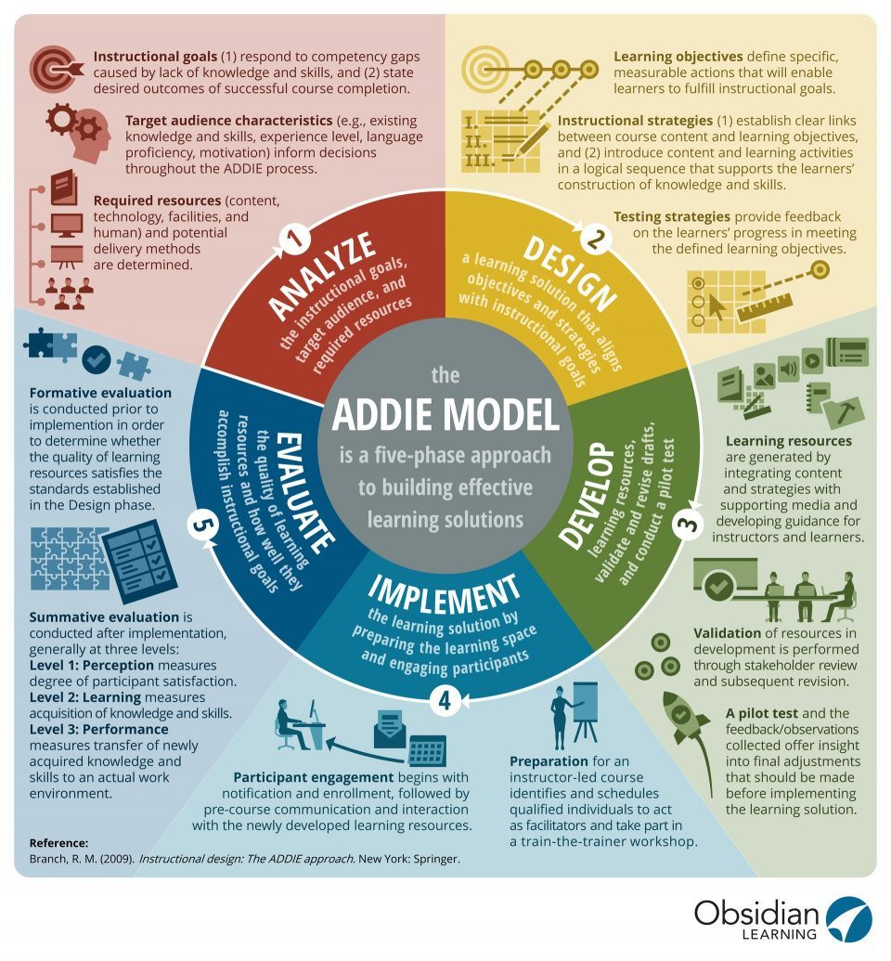
Fig. 3.1 ADDIE Model Explained

3.7 Development Tools for The System
MySQL
One of the standard query languages to communicate with databases is MySQL (pronounced My SEE Q EL). My SQL is a free and incredibly fast Open Source Database Server. MySQL is also cross-platform and, because of its flexible licensing requirements, ease of use and high performance, it has a high user base. In part, the wide range of other technologies such as PHP, Java and Perl helped promote its adoption.
WAMP Server (Windows, Apache, MySQL, PHP)
WampServer is a web development environment that is free for Windows. With Apache, PHP and the MySQL database, you can build web applications.

3.7.1 Programming Languages Used
Hypertext Pre-Processor(PHP): PHP is the web development language written by and for web developers. PHP stands for Hypertext Pre-Processor. It is an extremely versatile and very easy to understand, stable, server-side, open source scripting language. PHP is also cross-platform, which ensures that UNIX, Linux, Windows NT, and now MacOS (Why PHP, 2004) can run PHP scripts. PHP is described in (Linux. n.d.) as the official Apache HTTP server module, the market-leading free web server that runs approximately 67 percent of Apache, PHP and MySQL database applications on web servers.
Javascript: Javascript is a scripting language intended primarily for web pages to add interactivity and construct web applications. There is at least one Javascript interpreter built on virtually every personal computer in the world and in active use. The popularity of Javascript is due entirely to its position as the WWW scripting language.

HTML: HTML is short for Hypertext Markup Language. HTML is the language of authorship used to create electronic documents (called pages) displayed on the WWW. Each page contains a set of connections, called hyperlinks, to other sites. Using one version of HTML code or another, each web page you see on the Internet is written.

CSS: CSS is a plain text file format which is used on web pages to format content. CSS stands for Cascading Style Sheet, and web pages use it to help hold details in the right format for display. CSS files can help define a web page's font, size, color, spacing, border and position of HTML data, and can also be used to create a continuous look through multiple website pages.

SQL: Structured Query Language ( SQL) is a specialized language designed to update, delete, and request database information. For querying, adding, updating and changing data, SQL is used. SQL, which is an additional advantage for database managers, is supported by most relational databases since they are also expected to support databases across many different platforms.

3.7.2 System Design
The process of identifying the elements of a system, such as configuration, management, modules and components, the various interfaces of those components, and the data that passes through the system is system design. It is intended to meet a system 's unique needs and specifications by setting protocols and criteria for design activities.
System design means a structured approach to a system 's design. It can take a bottom-up or top-down approach, but either way, the process is systematic, taking into account all the system's related variables that need to be generated, from the design, to the hardware and software needed, right down to the data, and how it moves and transforms during its journey through the system. System design then overlaps with the architecture of systems analysis, systems engineering and systems.

3.7.2 The software architecture for the web-based personalised e-learning system
The personalised e-learning system architecture (Figure3.2) presents the main components which perform the functions of personalizing learning materials to meet individual learner’s learning requirements.
The architecture is based on a 3-tier client – server architecture which comprises of the presentation layer (user interface), the middleware (server and application services) and the data layer (databases). The database is separated from the client by the middleware. The middleware concept helps to improve scalability, load balancing transactional processing and interoperability issues by providing a means that allows for non-propriety/multi-platform adaptive personalised learning services.

3.7.3 Presentation Layer
The presentation layer which comprises of access portal and authentication, selection of learning object and pre-test perform the functions that allow learners to interact with the system by giving or obtaining information through their use.

3.7.4 Middleware
The middleware contains most of the application logic and translates learners’ requests into database queries and other actions and translate the query results to learning objects on learner mobile devices. The applications supported by this middleware are personalised learning program, user monitoring, learning object creation and update, knowledge route agent, learner profile creation and update and matching service. Learners access the application from various computers within an institution and its environs that have network coverage. Once a learner has been authenticated and pretested, he can access learning objects in a manner suitable to his/her learning style. The client application interfaces to the application layer using TCP/IP. The information from the database is presented in a compatible form to the browser by the use of HTML (Hyper-Text Mark-up language) Ikuomoregbe, Ehikioya and Ayo (2007).

3.7.5 Data Layer
The data layer is responsible for the storage, retrieval, maintenance and integrity of the data manipulated within the system. Though MySQL was used in this thesis for the implementation of the data layer, the architecture presented in fig 3.2, could allow other databases such as Microsoft SQL/SQL stored procedures, and oracle database to be implemented. Stored procedures are complex queries stored in a compiled form, inside the database, which can be executed by the database management system (DBMS) on the server side to enhance the robustness and reliability of the system, Lamberti,
Montrucchio, Sanna and Zunino (2003).

User Interface

Registration

and
Login

Selection of
learning
objects

Personalised
L
earning
S
ervices

Application
server

Web Browser

Apache web
server

Learner profile
creation &
update

Knowledge
route agent

Le
arning object
creation and
update

User
monitoring

Personalised
Learning
program

Matching
service

Learning
object
database

Learner
profile
database

Presentation layer

Middle ware

Data layer

User

Pre
-
Test

Figure 3.2: 3-Tier Client-Server Software Architecture of the web-based personalised e-learning system

3.7.6 Component Communication and Data Flow Model
The interaction between the system components and services are depicted in Figure 3.3.

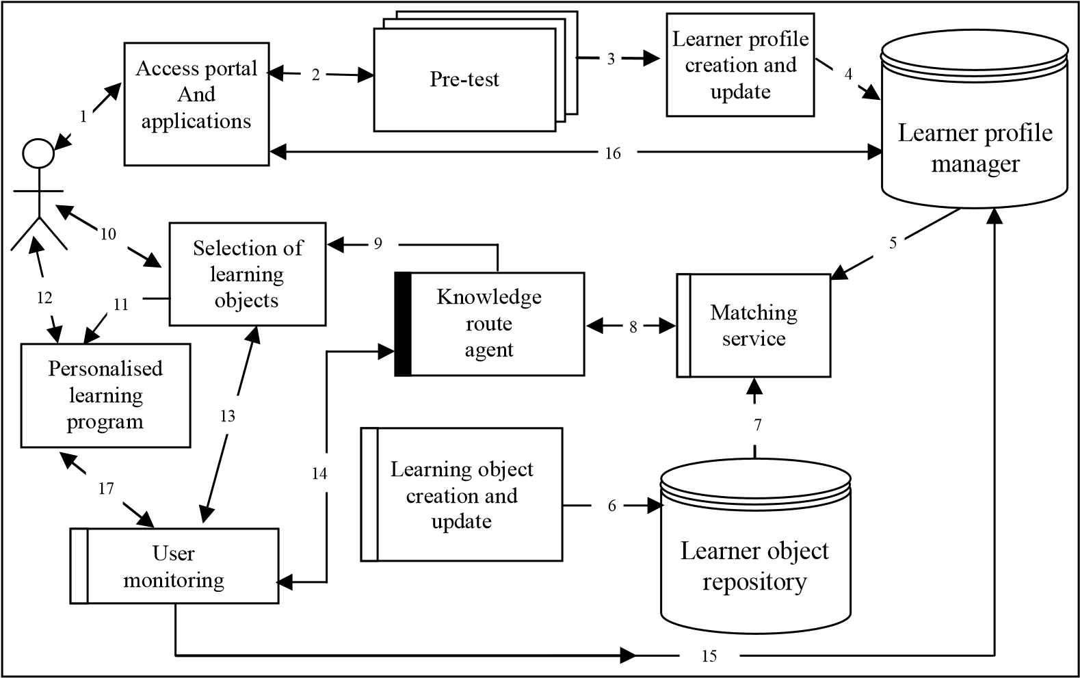

Figure 3.3: Component Communication and Data Flow Model of the web-based e-learning system – source Adewale (2007).

In Figure 3.3, both access portal and application, selection of learning objects and personalised learning program perform the functions that allow learners to interact with the system by giving or obtaining information through their use. The web-based personalised e-learning system builds a learner’s profile based on a combination of both their learning styles and prior-knowledge. Thirty-six questions were used to identify the individual learner’s learning style and to assess his prior knowledge for formulating parameters for the optimization algorithms in marching service. There are two main steps to carry out the analysis process. The first step involves a design of questionnaires by which the learner’s learning preference can be identified. In addition to having learners with strong activist, theorist, reflector, or pragmatist learning style; there is also the possibility of having learners with a mixture of learning style or learning preferences or possibility of learners developing their weaker learning styles. For instance, a number of learner features were required to provide feedback and to facilitate learner empowerment. This is possible through the decision that the learner should be allowed to re-compile the course based on any selected learning style. For example, after completing the learning style questionnaire the learner may be classified as an activist and is therefore presented with the activist course. However, this learner may be interested in developing his theorist skills and may wish to be presented with the theorist course. To facilitate this type of learner empowerment an option is included to allow the learner to re-compile the course based on a selected learning style.

After proper authentication via access portal and application, pre-test composes a pre-test which is used at the beginning of the learning process in order to identify the learners’ preferences. The pre-test consists of a set of questionnaires. The questionnaires are used for determining learners’ style via Equation (3.2). Results from the pre-test will indicate the type of learner and his level of prior-knowledge of the course. This information constitutes the basis of each learner’s profile which is stored in learner profile manager database and will be used subsequently by the matching service to provide personalised materials to each learner. On the other hand, if a learner’s preference is found in learner profile manager database after proper authentication and the learner is not willing to change his learning style, this preference will be extracted from learner profile manager database and will be used subsequently by the marching service to provide personalised learning materials for the learner.
The matching service retrieves a specific learner’s profile from learner profile manager database and carries out a mapping procedure. The results of this process will determine a selection of learning objects from the learning object repository and their sequencing for the personalised learning package. The knowledge route agent basically is a piece of software which receives the matching outcome from matching service and manages the current knowledge path of the learner. This architecture provides the software environment for learners to interact with their learning process and materials that allow them to engage learning with their learning experiences. All types of learners are supported according to their learning styles and prior knowledge.

These knowledge routes are presented according to different learners’ profiles. This set of information will be used by user monitoring for monitoring the learner’s participation against the learning outcomes. An adequate support to individual learner can be provided at the right time. Furthermore, this information can be used to generate learning patterns which will improve the instructional design on personalised learning materials.
Although, this system concentrates on mechanisms to provide greater personalization for the learner, a means is also provided to facilitate the development of a learner’s weaker learning style. Feedback pertaining to the learner’s learning style as determined through the learning style questionnaire is given to the learner. A learner, after receiving feedback showing strong tendencies towards the activist learning style, may wish the course to be re-compiled as if his preferred learning style is in fact theorist. Empowering the learner to carry out such an action provides him/her a mechanism to develop his/her weaker learning style and assists him in becoming a more versatile learner with a full range of learning capabilities rather than simply matching instruction to existing learning styles.

CHAPTER FOUR
SYSTEM DESIGN AND IMPLEMENTATION
4.1 Introduction
The initial aim was to provide online courses created by employees of Mountain Top University, leading to the offering of online degrees and eventually achieving the 'Virtual Learning' vision. The design, implementation and results / results of the proposed system are outlined in this chapter.

  - System Design
The aim of this project step is to create the design elements for the Virtual Learning system that can be used at Mountain Top University to improve the learning process. The proposed framework is called the Virtual Learning System for Mountain Top University. The proposed system is a web-based system of learning which provides:
- An efficient and easy learning system that students can interact with.
- A simple user interface that facilitates the interaction with the system.
- Administration tools that provide capabilities for implementing online courses.
- An efficient Student Management System that presents all the functions required by the student to fully implement the concept of Distance Learning System.
The system lifecycle goes through the following steps, according to the ADDIE Instructional Model: Planning, Research, Design, Implementation and Testing & Maintenance. During the entire project lifecycle, this model is followed.
To promote the achievement of these learning outcomes, the teaching methods and evaluation are planned. In particular, an approach to teaching and learning that examines theoretical principles in the sense of solving a real world problem has been integrated into the redesign of the curriculum.

4.3 System Modules
Student Sign-Up: This platform is intended for students who have already been enrolled by the administrator of the system. The system uses a authentication system where no one can just sign up to use the system. You must be registered with the administrator before you can sign up with your information.
Lecturers Sign-Up: This page is for lecturers who have been to the program before. The same protection applies to the lecturer where the administrator needs to add them to the framework, except that lecturers are able to pick their usernames, unlike students whose matriculation numbers are used.
Sign-in Page: Registered users can login to their account on this tab, whether they are a lecturer or a student. It essentially makes use of the authentication username (which is their respective matriculation number for students) and password format.

Admin Dashboard: This is the administrative tool used to handle all accounts, classes, courses, departments, and even user content.

Lecturers Platform: This is the forum from which lecturers monitor, communicate with, offer quizzes, and even tests, the content provided to the students, lectures or lecture materials.

Students Platform: This is the forum from which students receive lectures, take quizzes, engage and embark on self-paced learning with lecturers and peers.

4.4 Database Specification
Using the built data flow diagram, the database was designed using MySQL. The database provides information about the organizations involved in the various processes carried out within the system. It organizes and manages the data in order to achieve the result needed to help the relational database of systems where similar fields relate to different database tables of data.

Table 4.1 Teacher Table
COLUMN NAME | DATA TYPE | DESCRIPTION
teacher_id | integer | primary key of the table
username | varying characters | username of the user(lecturer)
password | varying characters | password of the user(lecturer)
firstname | varying characters | first name of the user(lecturer)
lastname | varying characters | last name of the user(lecturer)
department_id | integer | secondary key linking to the department the lecturer is in
location | varying characters | location of profile picture
about | varying characters | description of the lecturers’ achievements
teacher_status | varying characters | this shows if the lecturer has registered his/her account or not
teacher_stat | varying characters | this shows if the lecturer has been disabled or not

Table 4.2 Department
COLUMN NAME | DATA TYPE | DESCRIPTION
department_id | integer | primary key of the table
department_name | varying characters | Name of the department
dean | varying characters | Name of the Head of Department

Table 4.3 Student Table
COLUMN NAME | DATA TYPE | DESCRIPTION
student_id | integer | primary key of the table
firstname | varying characters | first name of the user(student)
lastname | varying characters | last name of the user(student)
class_id | integer | class a student belongs to
username | varying characters | username of the user(student)
password | varying characters | password of the user(student)
location | varying characters | location of profile picture
status | varying characters | this shows if the student has registered his/her account or not

Table 4.4 Activity Log
COLUMN NAME | DATA TYPE | DESCRIPTION
activity_log_id | integer | primary key of the table
username | varying characters | admin username that logged in
date | varying characters | date of login
action | varying characters | action performed when logged in

Table 4.5 Quiz Table
COLUMN NAME | DATA TYPE | DESCRIPTION
quiz_id | integer | primary key of the table
quiz_title | varying characters | title of the quiz
quiz_description | varying characters | description of the quiz
date_added | varying characters | date the quiz was added
teacher_id | integer | id of the teacher that added the quiz

Table 4.6 Quiz Question Table
COLUMN NAME | DATA TYPE | DESCRIPTION
quiz_question_id | integer | primary key of the table
quiz_id | integer | secondary key to the quiz table
question_text | varying characters | the main question and its options
question_type_id | integer | id of the question type e.g, “1” for objectives
points | integer | points awarded to each question
date_added | varying characters | date the quiz was added
answer | varying characters | secondary key linking to the answer table

Table 4.7 Answer Table
COLUMN NAME | DATA TYPE | DESCRIPTION
answer_id | integer | primary key of the table
quiz_question_id | integer | secondary key linking to quiz question table
answer_text | varying characters | answers to the questions
choices | varying characters | the correct answer given for a question

Table 4.8 Class Quiz Table
COLUMN NAME | DATA TYPE | DESCRIPTION
class_quiz_id | integer | primary key of the table
teacher_class_id | integer | secondary key to teacher class table
quiz_time | integer | time allocated for the quiz
quiz_id | integer | secondary key to quiz table

Table 4.9 Teacher Class Table
COLUMN NAME | DATA TYPE | DESCRIPTION
teacher_class_id | integer | primary key of the table
teacher_id | integer | secondary key to teacher table
class_id | integer | secondary key to the class table
subject_id | integer | secondary key to the subject table
thumbnails | varying characters | picture representation for the given class
school_year | varying characters | school year of the class

Table 4.10 Class Table
COLUMN NAME | DATA TYPE | DESCRIPTION
class_id | integer | primary key of the table
class_name | varying characters | name of the class consisting of the “level”

Table 4.11 Admin User Table
COLUMN NAME | DATA TYPE | DESCRIPTION
user_id | integer | primary key of the table
username | varying characters | username of the admin
password | varying characters | password of the admin
firstname | varying characters | First Name of the admin
lastname | varying characters | Last Name of the admin

4.5 System Implementation
This new system was thoroughly tested and the outcome was adapted to the planned performance. In the following opinions below, you will see that the processes are operating in tandem and that the institution's needs are met in sync with each other.
Below, some of the findings are displayed:

4.5.1 Home Page
The Home Page as shown in Figure 4.1 is a PHP form with no input field. It contains a brief description of the Personalized Web-based e-Learning System as well as some menu buttons that will take the system user to other parts of the system.

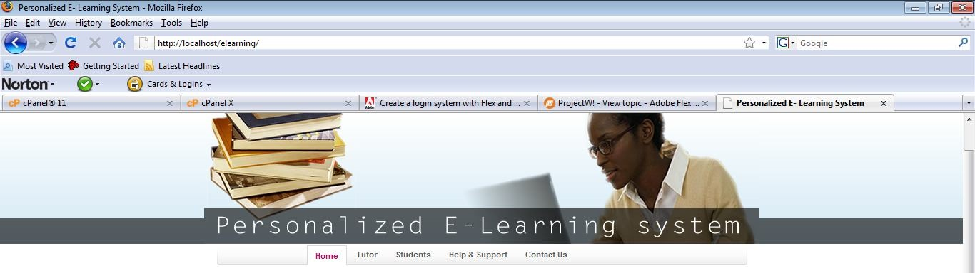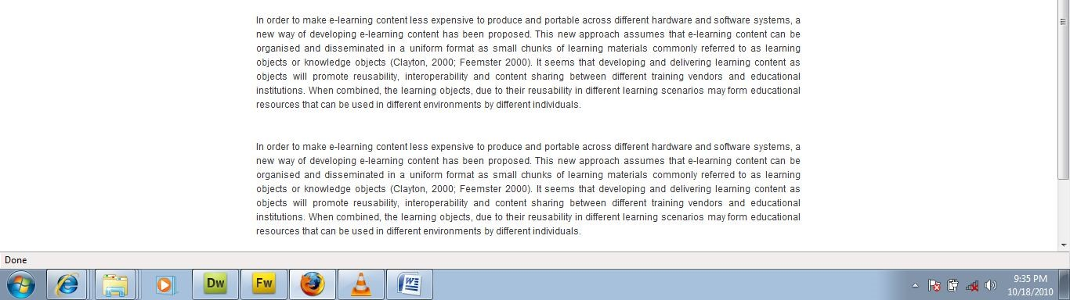

Figure 4.1 Home Page

4.5.2 Tutor login
The Tutor Login page as shown in Figure 4.2 is a form with two textboxes and a login button for input data. It collects the Tutor ID and password for registered tutors and allows them to login and create or edit learning content.

4.5.3 Tutor Registration
The Tutor Registration page as shown in Figure 4.3 is a form with textboxes and a register button for input data. It collects the tutor’s relevant particulars, it is used to assign Tutor ID and Password for new tutors who can now use their profile to login and create or edit learning content.

4.5.4 Student login
The Students Login page as shown in Figure 4.4 is a form with two textboxes and a login button for input data. It collects the Students ID and Password for registered students and allows them to login and view learning content.

4.5.5 Student Registration
The Student’s Registration page as shown in Figure 4.5 is a form with textboxes and a submit button for input data. It collects the student’s relevant particulars and is also used to assign student’s ID and Password for new students after which they will be directed to take the pre-test.

4.5.6 Pre-Test
The Pre-Test page as shown in Figure 4.6 is a form with thirty six questions and four radio buttons to each question that the students have to answer. The system uses their response to the questions to profile in order to determine their individual learning style. On clicking the submit button on this page, the system will generate and log the learner learning style and use it whenever the student logs in again to extract learning material for him/her.

4.5.7 Add Learning Materials
The Add Learning Material page as shown in Figure 4.7 is used by the tutor to create and add bits of learning contents to the system for access in a manner that suits the students’ learning styles.

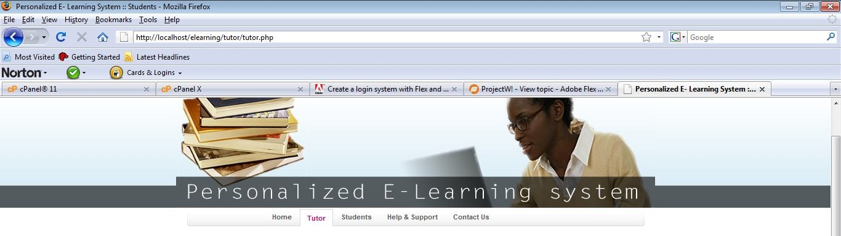

Figure 4.2 Tutor Login Page

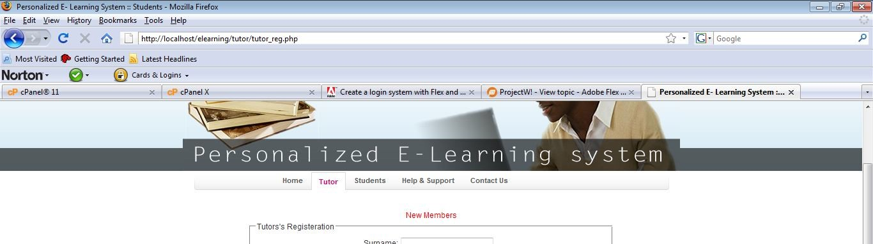

Figure 4.3 Tutor Registration Page

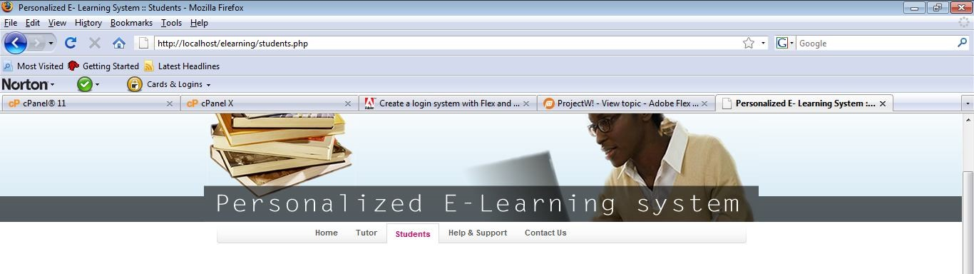
Figure 4.4 Students’ Login page

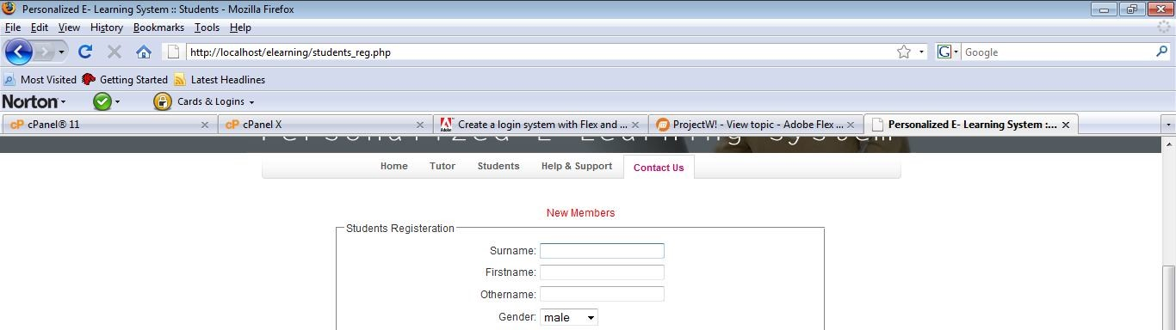

Figure 4.5 Students’ Registration Page

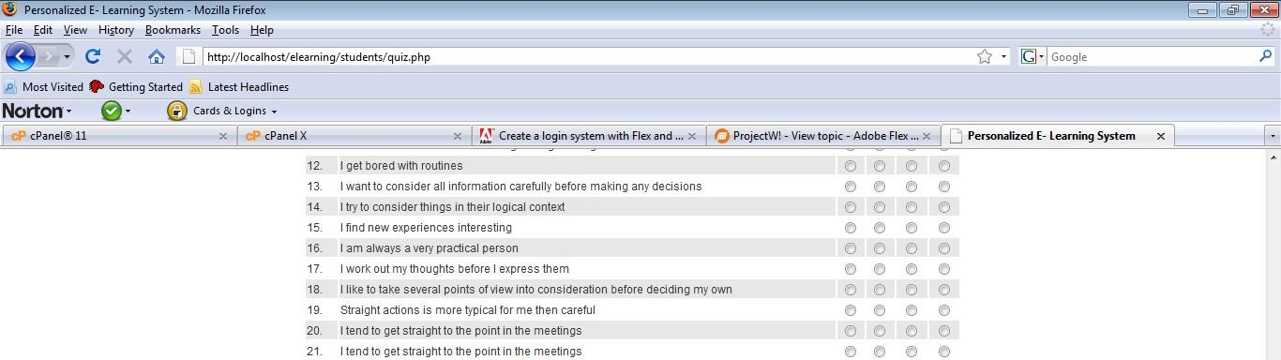

Figure 4.6 Pre-Test Page for Determining Students’ Learing Style.

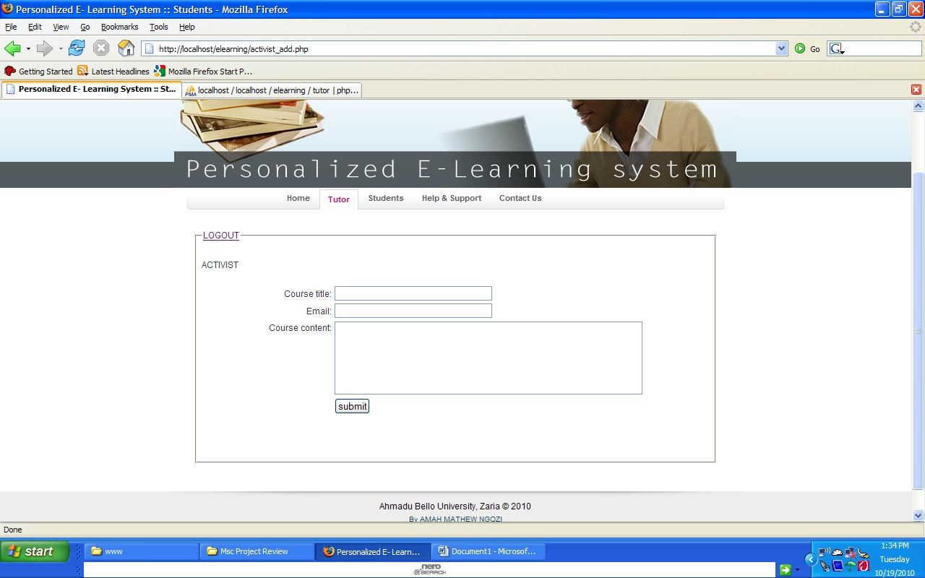

Figure 4.7 Add Learning Material Page


Figure 4.8 Edit Learning Material Page

4.5.8 Edit Learning Material
The Edit Learning Material page as shown in Figure 4.8 is used by the tutors only to alter and amend learning contents already in the system as the need arises.

4.6 System Requirements
The specifications of the framework for implementing the proposed system are:
Server-Side Requirement
Operational system: UNIX/Linux
Web Server: Apache
Programming language: PHP
Database: MySQL
Disk space on the server: 100MB

Client-Side Requirements
Hardware Specification: Compliant with any smartphone or personal computer
Operating System: Works smoothly on any computer that has a browser
Browser Support: Opens perfectly on any computer running scripts for PHP and Javascript.
Flash Player: Flash 16 or higher from Adobe.

CHAPTER FIVE
SUMMARY, CONCLUSION AND RECOMMENDATION
5.1 Summary
In today's education, traditional classrooms still play a man 's position because they are immersive spaces for every participant to connect with each other with rich methods, such as speech, language, gestures, etc. It is a natural idea for us to create a virtual classroom over networks that can provide teachers and students with live courses and lectures while closing the gap between distance participants. Easy, learner-oriented, promoting rich multimedia document formats should be a platform that offers live courses in which the teaching materials are prepared. For us, the purpose of this paper was to shed some light on issues relating to e-learning, education, ICTs and project management that were evident in the implementation of the Mountain Top University, Ibafo, e-learning project. Such crucial issues still require further study, particularly in developing countries where valuable resources are being invested in ICT-related projects, given that education is one of the most important areas that provide the country with its main resource, skilled human resources, especially for these countries, as it is in Nigeria.

5.2 Conclusion
To promote the learning process, this work proposed a framework for a simple, personalized, learner-oriented system. This system is composed of an e-learning web-based system through which the guest can freely navigate inside the system. If a particular course is to be taken by a student, he or she should be registered.
The project is progressing successfully and dramatically since it proposes the re-design of the curriculum in order to make it student-centered learning and to put the student in charge of learning control. A transition from a passive learning model to a constructivist model is defined by the re-design. The proposed framework facilitates constructive and collaborative learning and the development of a learning environment responsive to the needs of learners.
This project would allow students at Mountain Top University to access the lecturers' materials and also have a better way to communicate without moving around with the lecturers.

5.3 Recommendations
The virtual learning system will offer digital content and will provide teachers and students with a learner-oriented environment. The virtual learning system will provide the development of opportunities for life-long learning and a learning society. Digital learning will also provide formal and informal learning with ample opportunities. Therefore, with this method, learning is no longer restricted to the world of the classroom.

5.4 Limitations
Changing and also handling this transition was a major concern for such a project, where a variety of issues had to be re-considered as a result of problems encountered during the different phases of the project. For any project, management of transition is an evolving task, let alone a project being implemented in a volatile environment in which the human element plays a key role.
It must be acknowledged to us all that there is no research work carried out that does not encounter certain levels of difficulties, to illustrate the economic and time constraints surrounding students with a project job of this nature. This job on a project is no exception. Some variables that induced limitations to the work of the study are as follows.

Financial limitations: In undergoing a study like this, it is meant to be done on a larger scale and with enhanced features to the project platform but due to lack of funds, some functions and features couldn’t be put into place.
Time limitations: The period used in carrying out this study was short and conflicted with other activities (ie. school activities) and there was a global pandemic which changed our way of life.
Limited access to information/data: In the course of this research, there was a lot of limitations to the access of some information, data and documents that would have aided the success of the project.
Environmental limitations: This were constraints which occurred due to power and the location of the research and study location which had a higher level of reoccurring distractions.

5.5 Suggestions for further research
This project demonstrates that lecturers at Mountain Top University would have various levels of knowledge of technology, pedagogy, and content. In the pursuit to truly take Virtual Learning, one major challenge for Mountain Top University is to boost the existing bandwidth problems.
Against this context, it would be fitting to perform studies that concentrate on Mountain Top University's current technical infrastructure and identify problems that cause slow internet connections, as well as provide suggestions on how to solve these problems. It is also important to research the beliefs held by other people at Mountain Top University to enhance the use of virtual learning. For instance, it would be useful for Mountain Top University to examine the views of students about the idea of virtual learning, so teachers and other staff might become more aware of how students themselves understand that their studies will benefit from virtual learning.

REFERENCES
E-learner – Advantages and Disadvantages. Retrieved from http://www.dso.iastate.edu/asc/academic/elearner/advantage.html
10 reasons why eLearning is essential for students. Retrieved from https://murcha.wordpress.com/2011/01/05/why-elearning-is-essential-for-students/(2011, January 5).
Dictionary.com. Retrieved from dictionary.reference.com
What are contribution E-learning for School Education?. Retrieved from http://www.researchgate .net/post/What_are_contribution_E-learning_for_School_Education(2011, November 11)
Significance of eLearning. Retrieved from
http://www.elearningsofttech.com/pages/significance
What is World Wide Web (WWW)?. Retrieved from http://www.businessdictionary.com/definition/World-Wide-Web-WWW.html
Website Definition. Retrieved from http://searchsoa.techtarget.com/definition/Web-site
Abernathy, D.J. (1998). The WWW of distance learning: Who does what and where? Training and Development 52(9) p.29-30
Anderson, Cushing; Dankens, Anne-Sophie; Julian, Ellen H. (2000) “Worldwide and U.S. Corporate IT Education and Training Services: Forecast and Analysis, 1994-2004.” Report #W22154, May 2000. Available at http://www.idc.com.
Aston, M. & Dolden, B. (1994). Logical sans frontiers. Computer and Education, 22(1/2), 1-8.
Barron, Tom (2000a) “The future of digital learning.” E-learning May/June 2000 Vol.1, No.2,p. 46-47.
Barron, Tom (2000b) “Thinking Thin: The Race for Thin-Client Synchronous E-Learning.” http://www.learningcircuits.org/jun2000/barron.html June 2000.
Barron, Tom (2000c) “A Smarter Frankenstein: The Merging of E-Learning and Knowledge Management.” http://www.learningcircuits.org/aug2000/barron.html Aug 2000.
Bassi, L. Cheney, S. & Van Buren, M. (1997). Training industry trends 1997. Training and Development (51), p.46-47.
Berge, Z.L. (1998). Conceptual Frameworks in Distance Training and Education. In Schreiber, D.A., & Berge, Z.L. Distance training: How innovative organizations are using technology to maximize learning and meet business objectives. (pp. 19-36). San Francisco: Jossey-Bass.
Bernstein, D.S., & Auerbach, S. (1999). 1999 state of the industry report. Inside Technology Training, 12-16.
Boldley, J. H. (1994). Cultural anthropology: Tribes, states and global system. New York: Academic Press.
Chute, A. G, Sayers, P. K. & Gardner, R. P. (1999). Networked learning environments. http://www.lucent.com/cedl/networked-learning.html
Chute, A. G, Thompson, M. M., & Hancock, B W. (1999). The McGraw-Hill handbook of distance learning. New York: McGraw-Hill.
Coggins, C. C. (1988). Preferred learning styles and their impact on completion of external degree programs. The American Journal of Distance Education, 2(1), 25-37.
Collins, B, & Remmers, E. (1997). The World Wide Web in education: Issues related to cross-cultural communications and interaction. In B. Khan (Ed.). Web-based instruction (pp.85-92). Educational Technology Publications, Englewood Cliffs, NJ.
Davie, L. E., & Wells, R. (1998). Empowering the learner through computer-mediated communication. Alexandria, Va: U.S. Army Research Institute for the Behavioral and Social Sciences.
Davis, F. D., Bagozzi, R. P., & Warshaw, P. R. (1989). User acceptance of computer technology: A comparison of two theoretical models. Management Science, 35, 98-1003.
Driscoll, M. (1998). Web-based training: Using technology to design adult learning experiences. San Francisco: Jossey-Bass/Pfeiffer.
Domingo, Luis Santo (1999) “Choosing an e-learning management system.” December 15, 1999. http://www.intraware.com/ms/itwr/netinsights/1999/dec/991215_4.html
Edwards, C., & Fritz, J. H. (1997). Evaluation of three educational online delivery approaches. ED430516.
Enochs, J. R. (1984). The relationship of learning style, reading vocabulary, reading comprehension, and an aptitude for learning to achievement in the self-paced and computer-assisted instructional modes of the yeoman “A” school at the naval technical training centre. Paper presented at annual meeting of the mid-south Educational Research Association.
Filipczak, Bob (1998). “XML: meta-language for the Web?” Training, v. 35 no 5 (May ‘98) pp.113-114
Fishbein, M., Bandura, A., Triandis, H. C., Kanfer, F, H., Becker, M. H., & Middlesatdt, S. E. (1992). Factors influencing behaviour and behaviour change. Final Report on Theorists Workshop, University of Illinois, Department of Psychology.
Fiske, A. (1992). The four elementary forms of sociality: Framework for a unified theory of social relations. Psychological Review,99(689-723).
Galagan, P. (2000). Getting started with e-learning. Training and Development 54 (4), p. 62-64.
Gee, D. b. (1990). The impact of students’ preferred learning style variables in a distance education course: A case study. (ERIC Document Reproduction Service No. ED358 836).
Georgas, J. & Berry, J. W. (1995). An ecological taxonomy for cross-cultural psychology. Cross-Cultural Research, 29 (121-157).
Gotschall, M. (2000). E-learning strategies for executive education and corporate training. Fortune, 141 (10) S5 – S59.
Hackett, B. (1997). The value of training in the era of intellectual capital. The Conference Board, report 1199-97-RR.
Hall, B. (1997). Web-based training cookbook. New York: Wiley.
Hall, Brandon (1999). “Blending: How to Combine In-Person and Online Training.” Technology for Learning. September 1999, Vol. 5 no.9 pp,1-2.
Hall, Brandon (2000a) “Resource for enterprise-wide e-learning initiatives.” E-Learning Magazine, http://www.elearningmag.com/issues/may00/cover.html
McCrea, F., Gay, R. K., & Bacon, R. (2000), Riding the big waves: whitepaper on B2B e-learning industry. San Francisco: Thomas Weisel Partners LLC. McLellan, 1997
Mead, M. (1967). Cooperation and competition among primitive people. Boston: Beacon.
Moore, M. (1994). Is there a cultural problem in international distance education? In M.Thompson (Ed.). Proceedings of Conference of Internationalism in Distance Education. University Park: The Pennsylvania State University, The American Center for the Study of Distance Education, pp.188-192.
Nahavandi A., & Malekzadeh, A. R. (1993). Organizational culture in the management of mergers. Westport, Connecticut: Quorum Books.
Neal, L. (1997). Virtual classroom and communities. http://www.lucent.com/cedl/group97.html.

Neal, L., & Ingram, D. (1999). Asynchronous distance learning for corporate education: Experiences with lotus learningspace. [On-line].
Brogan P. (2000). Harnessing the power for online learning
Cann, A. J. (1999). Approaches to the evolution of online learning materials.

Walen, T. and Wright D. (1999). Methodology for cost benefit analysis of web based E- learning.

Walls. J. (1994). Global networking for local development.

Wang, X. C. (2000 July). Basic skills training vs. cultivation of creativity.

Wegner, S. (1998). Lost in translation?

Weinstein, M.B. (2000). Thirty-three worlds – class completeness training and development.

Willis, B. (1999). Distance education strategies and tools. Englewood cliffs, NJ: Educational publications.

Whyte, M.M. Karolick .D. and Hawley W.T. (1995). Cognitive style and feedback in computer learning style.

APPENDIX

Source Code Listing

Home page
<?php
if (!function_exists("GetSQLValueString")) { function GetSQLValueString($theValue, $theType, $theDefinedValue = "", $theNotDefinedValue = "") {
$theValue = get_magic_quotes_gpc() ? stripslashes($theValue) : $theValue;
$theValue = function_exists("mysql_real_escape_string") ? mysql_real_escape_string($theValue) : mysql_escape_string($theValue);
switch ($theType) { case "text": $theValue = ($theValue != "") ? "'" . $theValue . "'" : "NULL"; break; case "long": case "int":
$theValue = ($theValue != "") ? intval($theValue) : "NULL"; break; case "double":
$theValue = ($theValue != "") ? "'" . doubleval($theValue) . "'" : "NULL"; break; case "date":
$theValue = ($theValue != "") ? "'" . $theValue . "'" : "NULL"; break; case "defined":
$theValue = ($theValue != "") ? $theDefinedValue : $theNotDefinedValue; break;
}
return $theValue;
}
}
?>
<?php
// *** Validate request to login to this site.
if (!isset($_SESSION)) { session_start();
}
$loginFormAction = $_SERVER['PHP_SELF']; if (isset($_GET['accesscheck'])) {
$_SESSION['PrevUrl'] = $_GET['accesscheck'];
} if (isset($_POST['tutor_id'])) { $loginUsername=$_POST['tutor_id'];
$password=$_POST['password'];
$MM_fldUserAuthorization = "";
$MM_redirectLoginSuccess = "tutor_loginsuccess.php";
$MM_redirectLoginFailed = "tutor_loginfailure.php";
$MM_redirecttoReferrer = false;
mysql_select_db($database_connection, $connection);
$LoginRS__query=sprintf("SELECT tutor_id, password FROM tutor WHERE tutor_id=%s AND password=%s",
GetSQLValueString($loginUsername, "text"), GetSQLValueString($password, "text"));
$LoginRS = mysql_query($LoginRS__query, $connection) or die(mysql_error());
$loginFoundUser = mysql_num_rows($LoginRS);
if ($loginFoundUser) {
$loginStrGroup = "";
//declare two session variables and assign them
$_SESSION['MM_Username'] = $loginUsername; $_SESSION['MM_UserGroup'] = $loginStrGroup; if (isset($_SESSION['PrevUrl']) && false) {
$MM_redirectLoginSuccess = $_SESSION['PrevUrl'];
}
header("Location: " . $MM_redirectLoginSuccess );
} else { header("Location: ". $MM_redirectLoginFailed );
} }
?>
if (!function_exists("GetSQLValueString")) { function GetSQLValueString($theValue, $theType, $theDefinedValue = "", $theNotDefinedValue = "") {
$theValue = get_magic_quotes_gpc() ? stripslashes($theValue) : $theValue;
$theValue = function_exists("mysql_real_escape_string") ? mysql_real_escape_string($theValue) : mysql_escape_string($theValue);
switch ($theType) { case "text":$theValue = ($theValue != "") ? "'" . $theValue . "'" : "NULL";
break; case "long": case "int": $theValue = ($theValue != "") ? intval($theValue) : "NULL"; break; case "double":
$theValue = ($theValue != "") ? "'" . doubleval($theValue) . "'" : "NULL"; break; case "date":
$theValue = ($theValue != "") ? "'" . $theValue . "'" : "NULL"; break; case "defined":
$theValue = ($theValue != "") ? $theDefinedValue : $theNotDefinedValue; break;
}
return $theValue;
}
}
$editFormAction = $_SERVER['PHP_SELF']; if (isset($_SERVER['QUERY_STRING'])) {
$editFormAction .= "?" . htmlentities($_SERVER['QUERY_STRING']);
}
if ((isset($_POST["MM_insert"])) && ($_POST["MM_insert"] == "tutor_register")) {
$insertSQL = sprintf("INSERT INTO tutor (surname, firstname, othername, sex, email, mobile, rank,
tutor_id, password) VALUES (%s, %s, %s, %s, %s, %s, %s, %s, %s)",
GetSQLValueString($_POST['surname'], "text"),
GetSQLValueString($_POST['firstname'], "text"),
GetSQLValueString($_POST['others'], "text"),
GetSQLValueString($_POST['sex'], "text"),
GetSQLValueString($_POST['email'], "text"),
GetSQLValueString($_POST['mobile'], "text"),
GetSQLValueString($_POST['rank'], "text"),
GetSQLValueString($_POST['tutor_id'], "text"), GetSQLValueString($_POST['password'], "text")); mysql_select_db($database_connection, $connection);
$Result1 = mysql_query($insertSQL, $connection) or die(mysql_error());
$insertGoTo = "tutor_regsuccess.php";
if (isset($_SERVER['QUERY_STRING'])) {
$insertGoTo .= (strpos($insertGoTo, '?')) ? "&" : "?";
$insertGoTo .= $_SERVER['QUERY_STRING'];
}
header(sprintf("Location: %s", $insertGoTo)); }
?>

