DESIGN AND IMPLEMENTATION OF AN ONLINE SCHEDULING SYSTEM FOR NATIONAL IDENTITY NUMBER (NIN) ENROLLMENT EXERCISE IN NIGERIA

NWANERI, DAVID C.
16010301010

BEING A PROJECT SUBMITTED TO THE DEPARTMENT OF COMPUTER SCIENCE AND MATHEMATICS, COLLEGE OF BASIC AND APPLIED SCIENCES

IN PARTIAL FULFILLMENT OF THE REQUIREMENTS FOR THE AWARD OF BACHELOR OF SCIENCE (B.Sc.) DEGREE IN COMPUTER SCIENCE
MOUNTAIN TOP UNIVERSITY, IBAFO, OGUN STATE, NIGERIA

2020

CERTIFICATION
This is to certify that this project, DESIGN AND, IMPLEMENTATION OF AN ONLINE SCHEDULING SYSTEM FOR NATIONAL IDENTITY NUMBER (NIN) ENROLLMENT IN NIGERIA was carried out by me NWANERI DAVID CHISOM with matric no. 16010301010 and duly supervised by Mr Jeremiah Ademola Balogun.

_________________________ __________________
Mr. J.A. Balogun Date
(Supervisor)

_________________________ __________________
Dr. I. O. Akinyemi Date
(Head of Department)

DEDICATION
This project is dedicated to Humanity.

ACKNOWLEDGEMENT
I will like to acknowledge God for wisdom and understanding. I will like to acknowledge the effort of my supervisor Mr Jeremiah Ademola Balogun, for making time out of his schedule to attend to me. I will like to acknowledge the effort of all the staff of the Department of Computer Science and Mathematics for making my stay worthwhile.
Thank you all.

TABLE OF CONTENTS
CERTIFICATION ii
DEDICATION iii
ACKNOWLEDGEMENT iv
ABSTRACT viii
CHAPTER ONE 1
INTRODUCTION 1
1.1 Background to the Study 1
1.2 Statement of the Problem 3
1.3 Aim and Objectives of the Study 4
1.4 Research Methodology 4
1.5 Justification of the Study 5
1.6 Scope and Limitation of Study 5
1.7 Arrangement of Thesis 5
CHAPTER TWO 7
LITERATURE REVIEW 7
2.1 Introduction 7
2.2 Identity Management 7
2.2.1 Identity management information system 8
2.2.2 Identity Management in Nigeria 9
2.2.3 Problems facing identity management in Nigeria 10
2.3 Systems Development Life Cycle 10
2.3.1 Incremental model 11
2.3.2 Iterative model 12
2.3.3 Iterative and incremental model 13
2.4 Mobile Computing 13
2.5 Geographical Information Systems 14
2.6 Related Works 14
CHAPTER THREE 17
RESEARCH METHODOLOGY 17
3.1 Introduction 17
3.2 Functional and Non-Functional Requirements of System 17
3.2.1 Functional requirement analysis 17
3.2.2 Non-Functional requirement analysis 18
3.2.3 Hardware requirements 19
3.2.4 Software requirements 19
3.3 System Analysis and Design 20
3.3.1 Use Case Diagram 21
3.3.3 Class Diagram 24
3.4 Context Diagram 26
3.5 System Development Tools 28
3.5.1 Hypertext Markup Language (HTML) 28
3.5.2 Cascading Style Sheet 28
3.5.3 Mapbox 28
3.5.4 PostgreSQL 28
3.5.5 Django Framework 29
CHAPTER FOUR 30
RESULTS AND DISCUSSIONS 30
4.1 Introduction 30
4.2 Implementation of the system database for monitoring schedule records 30
4.3 Implementation of the mobile application for scheduling 31
4.4 Results of the Implementation of the System Interface 36
4.5 Discussion of Results 36
CHAPTER 5 38
SUMMARY AND CONCLUSION 38
5.1 Summary 38
5.2 Conclusion 38
5.3 Recommendation 39
REFERENCES 40

LIST OF FIGURES

Figure 3. 1 Showing Use-Case Diagram of user activities 23
Figure 3. 2 Showing the class diagram used for data modelling 25
Figure 3. 3 Showing the Context Diagram of the System 27

Figure 4. 1 Shows description of the database. 32
Figure 4. 2 Shows the Mapbox interface 33
Figure 4. 3 Shows another Mapbox Interface. 34
Figure 4. 4 Shows Scheduling form to make reservations. 35

ABSTRACT
This study aims to develop a scheduling system for the National Identity Number (NIN) enrolment exercise, which will be used by Nigerian citizens for scheduling NIN applicant slot for the enrolment exercise, thus reducing and possibly avoiding in the queue, needless waiting. The research objectives are to, elicit knowledge on the user and system requirements of the national ID card reservation information system; Furthermore, to specify the design of the system; and also, to implement a prototype system and test the system prototype.
In other to carry out the objectives of this project, several methods were adopted which are not limited to, the review of related works, the specified design of the scheduling system using the Unified Modeling Language (UML) and also, the implementation of a prototype system using the Java programming language.
The result of the study showed different expectations of the study based on the stated objectives. The scheduling system allowed the reservation for the primary user of the proposed system, which the applicant of the NIN. The result showed that the secondary user can view records of schedules made by applicants.
In conclusion, this study implemented the design of a scheduling system for the National Identity Number enrolment exercise. The study was able to identify the respective user and system requirements of the system and appropriate designs were used to specify these requirements provided by the users using use-case and class diagrams. The study also concluded that users can be able to make schedules through the scheduling system.

CHAPTER ONE

INTRODUCTION

1.1 Background to the Study
Identity is defined as “serving to establish whom the holder, owner, or wearer is by bearing their name and often other details such as a signature or photograph” (What is Identity?, 2020). An identity is a form of distinguishing one thing from the other. Identity, which can also be referred to as Personal Identity, “is the unique numerical identity of a person over time”; A person can be identified by culture, by religion, by trait, and other similar variables. (Personal Identity, 2020).
Identity management is a framework that verifies, identifies, and also handles authentication and authorization of individuals to have access to systems based on rights merited by the identities; (Rouse, 2020). The main purpose of an identity management system is to decide if a user should be given access to a system and also, put in place, the user’s level of access permission to a particular system. Identity Management System can be traced back as far as the 1500s. The use of an Identity Management System has created an information system that can be accessed to retrieve data to add information to the system.
An efficient national identity management system is critical to any economy's growth. It provides a nation with a universal identity infrastructure that allows access to and means of confirming the identity of people residing in a country. Thus in the absence of a robust national identity scheme, proper economic planning, sufficient intelligence collection and a working internal and external security infrastructure would be difficult to achieve. Thus in the absence of a robust national identity framework, proper economic planning, sufficient intelligence operations and a working internal and external security structure would be difficult to achieve (Isa & Oguntuase, 2019). Every country has an identity management system that keeps track of the number of citizens they have, the population of the country. In the United States, the identity of the citizens is managed by issuing out what they call a Social Security Number (SSN). In Nigeria, the Identity of the citizens is managed by issuing out what we call a National Identity Number (NIN). The body in charge of issuing this NIN in Nigeria is the National Identity Management Commission (NIMC).
Engaging in the National Identity Number (NIN) registration exercise in Nigeria comes with a lot of its challenges but this study attempts to tackle few constraints. One major challenge is the nerve-racking and unpleasant experience due to the delay, mostly caused by poor management and majorly overcrowded centres. Every NIN registration centre in Nigeria has a maximum number of people that they can attend to in a day, but a lot of people are ignorant of this and therefore flood many centres in the hopes of registering for their NIN, only to be disappointed, or best-case scenario, they end up waiting towards the end of the day before they are attended to. The few who manage not to get caught up in the waiting process are the rich or – in other words – people who can pay a token to the registration officers to fast track the process of getting their NIN; An average citizen who can’t afford to pay ends up in an unending queue.
The few who manage not to get caught up in the waiting process are the rich or – in other words – people who can pay a token to the registration officers to fast track the process of getting their NIN; An average citizen who can’t afford to pay ends up in an unending queue. With this system in place, one will not have to join an infinite waiting queue or worry about paying off a registration officer; The way the system works is simple and works thus: an individual who wants to register for the NIN sees the number of available less-occupied registration centres – through a scheduling system – and the maximum registration capacity of a centre; The individual can then pick a registration centre and reserve a sitting number in that centre. This will drastically change the whole ball game, introducing efficiency and eliminating wasted long waiting time.
This study offers to develop a Location-based Reservation System for citizens or individuals to determine the available centres and reserve a slot in a registration centre; every NIN registration centre in Nigeria has a maximum number of people that they can attend in a day, but a lot of people are ignorant of this and therefore flood many centres in the hopes of registering for their NIN, only to be disappointed, again. This study attempts to develop a geographical information system that will aid the scheduling of the national identity number enrollment exercise by Nigerian citizens thereby avoiding undue delay from enrolment centres. The National Identity Number enrollment exercise can be nerve-racking and unpleasant due to the delay, mostly caused by poor management.

1.2 Statement of the Problem
The long waiting time spent in the queue by Nigerians during the NIN registration exercise can be an exhaustive and discouraging experience. Various attempts made by officials to mitigate this experience include demanding bribe which has landed a deadly blow on the reputation and integrity of officials provided this responsibility (Olowogboyega, 2020).
As a result of this, many Nigerians are discouraged from participating in the National Identity Number enrolment exercise in enrolment centres across Nigeria. Presently, there is a proposed web-based information system that is used by the government in collecting identity-based information from Nigerians (Isa & Oguntuase, 2019), however, this system has not been active due to unforeseen challenges and lack of development planning. There is a need for the development of a geographical information system for end-users which can be used to schedule slots for the enrolment exercise among enrolment centres based on the location of the end-user, hence this study.

1.3 Aim and Objectives of the Study
This study aims to design and implement a location-based system which can be used by a Nigerian citizen for the scheduling of the National Identity Enrollment Exercise, thus avoiding unnecessary waiting in a queue, using any internet-enabled device.
The specific research objectives are to
- elicit knowledge on the user and system requirements of the scheduling system;
- specify the design of the system based on (i);
- implement a prototype system; and
- test the system prototype.

1.4 Research Methodology
In other to meet up the aforementioned objectives, the following method was adopted.
- A review of related works was conducted to identify the various information required for scheduling following which the users of the system and their respective roles were identified.
- The design of the scheduling information system was specified using Unified Modeling Language (UML) tools such as use-case diagrams for user tasks, sequence diagrams for system timings, class diagrams for the data model, and the system architecture.
- The prototype system was implemented using the Java Programming Language.
- The system was tested by users and evaluated based on user acceptance testing (UAT) parameters.

1.5 Justification of the Study
The purpose of this project is to help citizens of Nigeria get a NIN with ease, at no cost other than transportation to the centre and ease the stress of the registration officers at various centres. The extortion by public officials at the registration centres during the process of getting a NIN will be reduced. The introduction of a scheduling system for national identity number Enrollment exercise will encourage more people to partake in National Identity Number (NIN) registration.

1.6 Scope and Limitation of Study
Knowing that Enrollment for the NIN in Nigeria comes with other challenges, this project is aimed at developing a scheduling system to fast track the National Identity Number Enrollment and pick up process. The system is not in charge of enrolling citizens for the National Identity Number Enrollment exercise. The system does not handle government-related information but only creates a bridge for the end-users.

1.7 Arrangement of Thesis
This chapter presents the introductory aspect of the project. Chapter two presents the review of related works surrounding the body of knowledge of the reservation system. Chapter three presents the specific materials and methods that were required for the design and development of the scheduling system. Chapter four presents the results of the implementation of the database and the scheduling system prototype for making schedules. Chapter five presents the summary, conclusions, and recommendation of the study

CHAPTER TWO

LITERATURE REVIEW

2.1 Introduction
This chapter reviews the research literature that is relevant to reservation systems in different fields of study. The review helps to gain an overview of Reservation Systems in various industries and the foreground on which a conceptual model is built dependent on the part which is relevant to the project. This chapter reviews articles about reservation systems. This literature review deals with the topics that will help to understand various reservation systems in relevance to the Location-based Reservation System for the National Identity Enrollment exercise, with the sole goal of analyzing works that are related to this project and different ways previous studies achieved their goal.

2.2 Identity Management
Identity management is focused on authentication, It determines if a user should be given access to a particular system or network (Rouse, 2020). Identity management in a system happens when, like in the context of identity resolution systems, the system is preinstalled with personally identifiable information or when it retains all or part of the identity information of the individual from the references which it resolves in the case of identity capture systems. Systems that help identity management have a big benefit because they
can go beyond direct matching and linking records via correlation and affirmation (Identity Management, 2009).
A major importance of Identity is recognition. Identity gives one access to certain data or information, and this access is managed by what is called an Identity Management System. Various countries in the world have adopted the use of Identity management information systems to store information about the population of the country, this was first initiated in the year 1935. The Identity management system in the United States identifies her citizens with information known as Social Security Number (SSN); Every citizen of the country is expected to have an SSN to identify the individual.
The identity management system was used for the First Birth Certificates data which was recorded in church registers in England, compulsory registration of birth in the united states started in 1853 (History of Identity Management Infographic, 2020). In the year 1903 In the United States, people were issued driver’s licenses which was a requirement to drive a car. After the first world war, in 1920 there was a worldwide passport standard. Over the years Identity Management System has been adopted In various industries and sectors of the world, from The US Social Security Act which was signed in the year 1935 to the First Digital Identity and Passwords in 1960, which was introduced to keep files private; Identity systems evolved with the advancement in computing. (History of Identity Management Infographic, 2020).

2.2.1 Identity management information system
An identity management information system is a system that is used to verify identities and user information within its stored data. Information System is a collection of components’ that creates, stores, process, and distribute information or data (Bourgeois & Bourgeois, 2020). Enterprise Resource Planning (ERP), used to integrate the management of internal and external information in an enterprise, provides some examples of information systems; Geographic Information System (GIS), used to analyze geographic data; It is also known as Geolocation System. It refers to a system that uses location technologies such as GPS or IP addresses to identify and track the whereabouts of connected electronic devices (Frankenfield, 2020).

2.2.2 Identity Management in Nigeria
The identity management system in Nigeria regulates national identity issues in Nigeria with services that include enrollment and issuance of the National Identification Number (NIN), issuance of the National e-ID card, identity verification as well harmonization and authentication of data (National Identity Management Commission, 2020). The National Identity Management Commission (NIMC) organizes Identity Management in Nigeria to serve as the primary legal, administrative, supervisory and regulatory framework.
They manage the identity database in Nigeria (Ayamba & Ekanem, 2016). The NIMC issues a National Identity Number which is issued to Nigerians for the very purpose of Identification. The NIMC assigns a NIN upon effective enrollment, which is a collection of numbers, to an individual. Enrollment consists of documenting demographic data of a person and collecting all fingerprints. Portrait pictures and digital signatures, which are all used to cross-check existing data in the National Identity Database to confirm that there is no previous entry of the same data. The data is then processed with a special NIN that has been allocated to it until this step is completed. Furthermore, according to NIMC, it cannot be used by any other person once a NIN is given to a person, even if the previous person is dead. The NIN helps tie all records about a person in the database. (Ibrahim, 2016).

2.2.3 Problems facing identity management in Nigeria
Like all non-revenue generating agencies, NIMC struggles with obtaining timely funding to achieving its stated objectives. We are running a budget deficit on an ongoing basis, and the focus seems to be on capital-intensive real-sector infrastructure projects, whereas other projects, such as citizen recognition, are ignored and forced to compete with other projects intended to deliver basic services (Odagbami, 2020). Also, the process for the NIN enrollment exercise involves a physical location with an agent, a digital camera with a specific background, a desktop computer, a 4-4-2 fingerprint scanner, a printer, electrical power, and internet connection, to conduct an enrolment exercise.
Given that our population is expected to rise exponentially to 450 million people by 2050, NIMC needs more funds to fulfil its mandate successfully. It is estimated to cost between $400 million and $700 million to complete, based on World Bank estimates. Assuming that funding problems are resolved, we have to consider another aspect, changing government, post-election. Any new government, whether or not such reform is necessary or appropriate, attempts to change the social order. (Odagbami, 2020). This disrupts the execution of time-bound deliverables.

2.3 Systems Development Life Cycle
Software Development Life Cycle (SDLC) is a process used by the software industry to design, develop, and test high-quality software. SDLC strives to develop applications of high quality. According to Bhatnagar and Singh, (2013), the SDLC process is a set of activities to be undertaken by system designers and developers for the effective and time-limited production of software, such as research, design, implementation, testing and maintenance. It also clarifies that SDLC is a term used in project management that defines the phases involved in the implementation of an information system project, starting from initial feasibility studies to the maintenance of the completed application, and stressed that the primary objectives of the SDLC are to ensure that high-quality systems are produced using strong management controls to optimize productivity.
Half (2019), described SDLC as giving structure to the challenges of transitioning without forgetting a move from the beginning to the end of your project. It also mentioned the number of different SDLC methodologies used today to direct professionals through their project-based work, such as waterfall model, the rapid development of applications (RAD), joint development of applications (RAD), V-shaped model (verification and validation model), big bang model, agile model, iterative model, a spiral model with each of them consisting of series of defined steps or phases.
Gandhi et al., (2014) also explained that regardless of the choice of model, different types of risks were associated with each of these SDLC phases. It proposed a model to help determine the impact of the risk on the project being developed, so that project failures due to these risks can be minimized. The software development life cycle can be divided into different models; incremental phase, iterative phase, and a combination of both.

2.3.1 Incremental model
The incremental model of a software development life cycle is a traditional and highly sequential model that relies heavily on upward planning through documentation. Requirements for a software project are thoroughly defined upfront in this model. Because of this reason, the model is suitable for developing complex systems. Examples of this model are the waterfall model, Nolan’s stage model, B, and V-model. The Waterfall model encourages specification of requirements before design and also design before coding and reduces development and maintenance cost by generating documents that can be utilized in test and maintenance.
The incremental phase life cycle such as the V-model, Waterfall model is a good development process but it is not a suitable choice of methodology for this project due to the following disadvantages
- The next phase cannot be started without completing the previous stage and because of this, it is termed a rigid methodology.
- It usually takes a longer time to develop an application product using this methodology as compared to others. Considering the time frame of this frame of this project which is a matter of a few months.
- It lacks customer’s involvement after this requirement definition is completed and such not suitable for this project.

2.3.2 Iterative model
This process starts with a simple implementation of software requirements. In an iterative model, the model stages of development can start from any phase which means that the next phase can start even if the previous one is not yet completed. It can start without fully specified requirements. The model involves the end-user in the development stages of the product. Examples of iterative models include joint application development (JAD) prototyping and rapid application development (RAD).

2.3.3 Iterative and incremental model
This is a combination of iterative and incremental model. It is believed to be the fastest and latest model for developing software applications. It is lightweight and iterative, able to adapt to changes, ensure that the production of quality of application meets the need of the end-users. The model is divided into broad groups:
- Agile method e.g. Extreme programming and scrum.
- Spiral model e.g. Rational unified process (RUP)
The agile method is the most widely used in this group. According to (Pressman, 2010) extreme programming method functions on iterative development, recurrent discussion with the consumer, needing minor and regular publication, and the project is delivered just in time.

2.4 Mobile Computing
Mobile computing is a technology that enables data, voice and video to be transmitted through a computer or any other wireless device without connecting to a fixed physical connection (Mobile Computing - Brief Overview, 2020). In this instance, mobile communication refers to the infrastructure placed in place to ensure that smooth and efficient communication continues. These will include the required equipment, such as protocols, services, bandwidth and portals, to enable and support the services mentioned. At this point, the data format is also specified. This ensures that there is no collision with other existing systems that offer the same service. The use of mobile computing is adapted for the implementation of the location-based application.

2.5 Geographical Information Systems
The Geographical Information System (GIS) is a type of information system with a formulated structure that enables geographical data to be inspected and interpreted (Geographical Information System, 2020). The power of GIS is its ability to sync information about specified data by integrating geo-referenced data to show the original data and information derived in several ways. Geo-referenced data is widely defined as having physical dimensions and a spatial location, and according to such data, a geo-referenced document is indexed (Devlin & Blankenbeckler, 2011).

2.6 Related Works
(Hu & Gu, 2013), researched the development and Implementation of a Web-Based Online Hotel Reservation System. The purpose of the research is to analyze and design the hotel booking operation, and that achieves the functions of the register, login-in, reservation, customer management, and reservation management, etc., to improve the efficiency of hotel reservations. The system is developed with the B/S three-layer architecture. Its biggest advantage is that maintenance is simple, flexible, and easy to operate. The B/S framework simplifies the client, the user sends requests through the web browser, and the rest of the work can be handled by the webserver, such as requesting data, processing, sending results back, creating dynamic web pages. This structure not only frees the Client from the heavy burden and the requirement of constantly improving the performance but also frees the personnel of technical maintenance from heavy maintenance upgrade work. Lays in a three-layer structure are independent of each other; the change of any layer will not affect other layers’ functions.
GIG Mobility is an African technology-based transportation platform in Nigeria. The transport company's business model relies on the popularity of intelligent technology to fuel transportation operations from the ground up. GIGM operates an app that offers end users a lot of services but mainly allows people to book bus tickets and also, opt for pickup service online, and is available for IOS and Android platforms. The pickup service works by using a Geolocation-based system with the help of Google Maps; With the assistance of the google maps, one can select different pickup locations. With the integration of a location-based service into their operations, they can deliver to their customers and individuals who patronize them, fast and efficient service. Thus, they offer a transportation service that technology-empowered. (GIG Mobility, 2020).
(R, Temitayo, & G, 2017) did research on “design and implementation of an online booking system for a cinema house” to solve the problem of a long waiting queue to pay for placement to watch a movie in the cinema house. They tackled the issue by developing an online web-based booking system for cinema houses with aid of web technologies like HTML, CSS, and JavaScript for the frontend and MySQL database as the backend. The downside of this booking system is that the information was not in real-time and no system was put in place to let people know if spaces are still available which would have been a more suitable approach. It was stated in their research that As far as the subject matter is concerned, online booking systems can be developed for bus stations, airports, hotels, cinemas, and other centres that engage in the reservation.
(Chambers, Gallagher, Harte, & Mc Kinney, 2009) developed an automated Ticket Reservation System for Millennium Forum. The purpose of the development of this system was to incorporate features to aid the process for visually impaired users; The system was designed with the needs of visually impaired customers in mind. The application allowed customers to View show listings, Select shows, View show description, Check availability, and Reserve Tickets. In other to achieve the desired result the use of speech technologies was adopted into the system, also the use of CSLU ToolKit was adopted, the components include Audio Tools, Display Tools Speech Recognition, Speech Generation, Animated Faces.
The NIMC also proposed a solution to aid and support the National Identity Number enrollment exercise by developing an Online Pre-Enrolment Portal. They call it to do it yourself whenever and wherever you are in the process of enrolment. The process works by generating a 2D Barcode on a summary sheet when an applicant visits the Pre-enrolment Portal and fills the enrolment form. The pre-enrolment is an initial step in the enrolment process. To solve the constraints and challenges that come with the NIN enrolment exercise, the proposed project has failed to achieve the desired result, possible because of the complexity of this project and mainly because of the corruption that lies in the root of Nigeria. It is unknown if this project was ever functional but the link to the portal has never been active.

CHAPTER THREE

RESEARCH METHODOLOGY

3.1 Introduction
The methodology describes the tools, procedures, and techniques used to achieve the specific objectives of the geo-location-based reservation system. The design of the system was specified using the Unified Modelling Languages (UML) such as use-case for the user actions, sequence diagrams for the timing of the operation, and class diagrams for the data model of the system.

3.2 Functional and Non-Functional Requirements of System
To develop the geolocation-based system a set of requirements must be met by both users and systems, they are generally classified as functional requirements and non-functional requirements.

3.2.1 Functional requirement analysis
This is a description of the service that the system must offer. It describes the system and its components. It has to deal with the inputs to the software system, its behaviour, and outputs. It makes use of necessary unified modelling languages to analyze the system. Hence, the functional requirements for the development of the system by users were as follows:
- The system will allow users access to the system without user authentication, without the use of login information.
- Users only have to access a web link on their devices to access the system service.
- The system allows users to access the location of National Identity Centers in the country.
- The system allows enrolment officials to access records of daily reservations and schedules.
- The system provides a digital map to the users, showing locations of enrolment centres.

3.2.2 Non-Functional requirement analysis
This determines the device efficiency attribute. This indicates a set of criteria used to determine the specific functioning of a device. It enables the opportunity to place restrictions or limits on the system's architecture through the different agile backlogs. The external system constraint that the system should meet include
- Accessibility: it addresses discriminatory aspects related to equivalent user experience for people with different devices that run the Android Os; It means irrespective of the device, users will have the same experience.
- Usability: is about designing products to be efficient, satisfying, effective. It includes general aspects that provide a similar user experience for every user.
- Inclusion: It is about diversity and to the maximum degree possible, ensuring everyone's participation. This is often referred to in some regions as uniform design and design for all.
- Security: in terms of an information system, it is the process of implementing measures and systems designed to securely protect and safeguard information. This system was built such that: the access permissions for system data may only be changed by the system’s data administrator. All external communications between the system’s data server and clients must be encrypted.
- Non-Authenticated Integration: In computing, authentication involves recognition of the user’s identity. Non-authenticated integration does not require authentication.
- Reliability: Under specified conditions for a specific time, a system may perform its necessary functions.
- Integrity control: In terms of data and network protection, integrity is the guarantee that only those allowed to do so can access information.
- Confidentiality: The degree to which sensitive data is secured by the software system and only permitted access to the data is allowed.
- Dependability: A computer system's dependability is the ability to provide a service that users can justifiably trust.

3.2.3 Hardware requirements
For effective and efficient performance of the project, the minimum hardware requirement must be met which are as follows: a web server with a considerable amount of large RAM and hard disk, a workstation with Ethernet card or wireless card for internet connection, a wireless router or alternative internet service provider (ISP) and Uninterrupted power supply (UPS) or Inverter.

3.2.4 Software requirements
For flexible and effective use of the system via the internet, a network operating system must be running on the network server, any operating system for the admin computer, and a stable internet connection.

3.3 System Analysis and Design
System analysis is the method of collecting and analyzing information, diagnosing issues and using the data to suggest system upgrades. System design involves evaluating and configuring the necessary hardware and software components to support the architecture of a solution. The design stage transforms the detailed requirements of the definition stage into a complete, detailed specification of the system. Some of the most significant activities of this stage include:
- Pointing out the required data that will be needed in handling the National Identity Number scheduling system and performing all the necessary activities that are required by the user of the system;
- Characterization documentation of all related entities that exist in the scheduling system is performed;
- Designing the components of the system: unified modelling language (UML) diagram that shows the relationship that exists between entities in the scheduling system, the database structures, inputs, outputs, internal processing, manual procedures, system interfaces, technical environment, and overall system architecture;
- Carrying out walkthroughs of the design to ensure that it is programmable and technically complete;
- Beginning development of approaches for user support and system maintenance afterwards.

3.3.1 Use Case Diagram
The purpose of the use case diagram is to capture the dynamic aspect of a system. The diagrams are used to compile the specifications of a system, including internal and external variables. These specifications are often requirements for architecture. Therefore, use cases are planned and actors are identified when a system is examined to gather its features. The use case diagram was used to describe functions provided by the system that yields a visible result for various actors that participate in the system use, such as the enrolment official and the application user which is the core user of the system. The identification of actors and use cases contributes to the concept of the system boundary, which is to distinguish the tasks performed by the system and the tasks performed by its environment. A schematic of the use-case shown in Figure 3.1 shows a description of the actors alongside their respective activities using the proposed system.
- System Administrator: System admin is a person responsible for maintaining, configuring and securely operating computer systems; in particular, multi-user computers, such as servers. He or She is responsible for creating access to the system by an authorized user. The responsibilities are as follows:
- Evaluate the list of schedules for new applicants,
- Notify the enrolment officials on schedules made,
- Manage the profiles of schedules,
- View information about schedules made.
- Enrolment Official: is one of the users of the system who is responsible for verifying schedules made alongside their respective information. Their primary responsibilities are as follows;
- They responsible for verifying schedules, made;
- They can also view scheduling records.

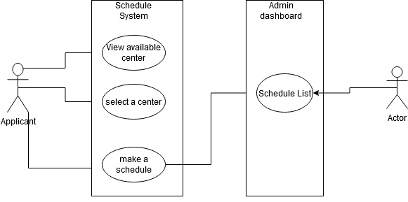
Figure 3. 1 Showing Use-Case Diagram of user activities

- Applicants: are the primary user of the system. They make schedules for the National Identity Enrolment exercise through the application. Their tasks are as follows:
- The applicants are the users of the application
- They are responsible for creating schedules for the enrolment exercise.
- They will not be able to view schedules made by other applicants
- They will be able to view a list of available centres for enrolment for that particular day.

3.3.2 Class Diagram
The class diagram defines a class's features and activities and also the restrictions placed on the system. In the diagram shown below in Fig 3.2, it was used to identify the various types of classes, objects, and their respective instances alongside their relationships within the context of the proposed system. The system has a main class called the System user. The system user is unique for each platform, applicants make use of the application to make reservations, while the enrolment officials make use of the web dashboard to view a list of the reservation or schedules. The System User is also a generalization class since it creates specific roles for each user, which are also the class objects.
Furthermore, each applicant (which is one of the system users) was allocated a particular slot number after a schedule has been made, by the applicants. The different schedule slots are stored and can only be viewed by the enrolment official or system admin if present. This also implies that the schedule records of several enrolment centres are dependent on the centre that the schedule was made to.
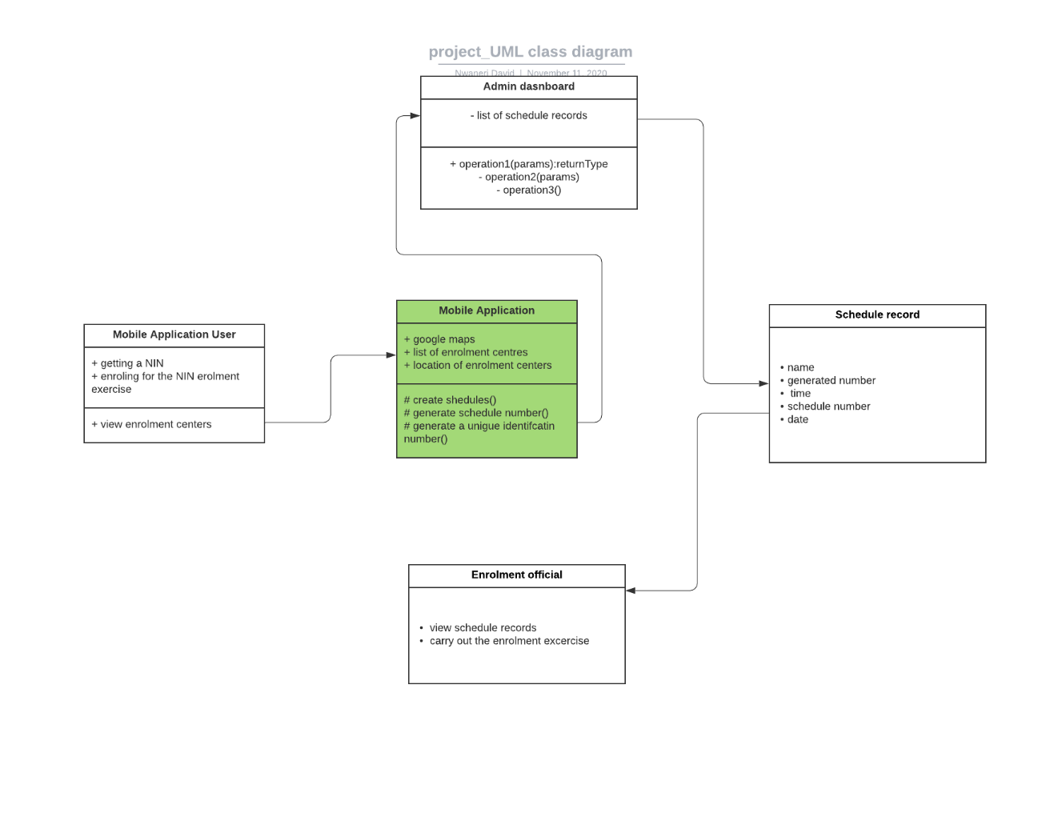
Figure 3. 2 Showing the class diagram used for data modelling

3.4 Context Diagram
Figure 3.2 shows the context diagram of the scheduling system, illustrating the overall system. It also defines the scope and boundary of the system to the external entity. This diagram also displays data and users' input and output flows, to and from the system and external entities.

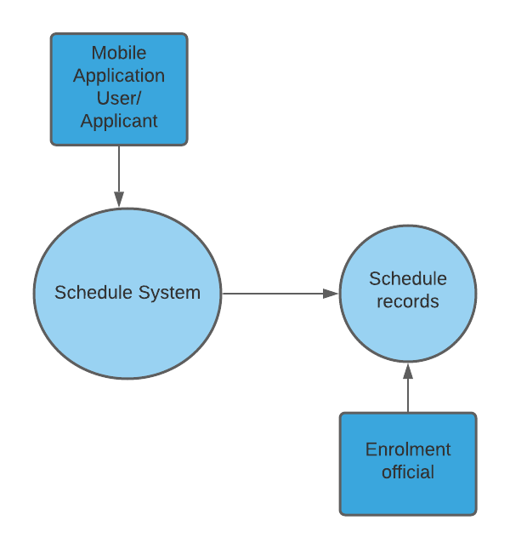
Figure 3. 3 Showing the Context Diagram of the System

3.5 System Development Tools
These are Implementation tools needed to carry out the development of the immunization information system. The tools include Cascading Style Sheet (CSS), Hypertext Pre-processor (Python, Django framework), PostgreSQL, and Mapbox Map API.

3.5.1 Hypertext Markup Language (HTML)
Hypertext Markup Language (HTML) is a simple document markup language intended for display in a web browser. It can be supported by technologies such as Cascading Style Sheets (CSS) and scripting languages such as JavaScript.

3.5.2 Cascading Style Sheet
Cascading Style Sheet (CSS) is the language of a style sheet used to characterize a text presentation written in a markup language such as HTML (Mozilla Developer Network, 2015). (Mozilla Developer Network, 2015). This is the World Wide Web's cornerstone technology, alongside HTML and JavaScript.

3.5.3 Mapbox
The Mapbox web services APIs allow one to programmatically access the Mapbox tools and services to use its APIs to retrieve account information, upload and modify resources, use the Mapbox core tools, and more. The Mapbox API as used in this project allows maps to be displayed on the scheduling system, enabling the specified users to access the different locations of the enrolment centres.

3.5.4 PostgreSQL
PostgreSQL is an advanced SQL version. It is used for a wide range of network, mobile, geospatial and computational applications as the main data store or data warehouse. It includes user-defined objects (e.g. translations, types of data, domains, functions, etc.), MVCC, database triggers and many more. It also includes a range of regular SQL commands including "Select", "Insert", "Update", "Delete", "Create", and "Drop".

3.5.5 Django Framework
Django Platform is a free-source web framework used to create quickly, pragmatically, cleanly, and stable websites. Its main purpose is to promote the establishment of complex websites powered by databases.

CHAPTER FOUR

RESULTS AND DISCUSSIONS

4.1 Introduction
This section presents the results and the discussion of this study which involved the design and development of a location-based application system for the NIN enrolment schedule. This chapter presents the implemented database of the system using PostgreSQL alongside the application interface that was implemented using web-based development technologies such as the HTML, CSS, JavaScript, Django for the development of the system interface and also connecting information between the user interface and the system interface.

4.2 Implementation of the system database for monitoring schedule records
Figure 4.1 shows a description of the database that was implemented for this study to store and retrieve the information required by the proposed system using Firebase. As a result of this, a database was implemented for managing the various information stored by the system.
The result of the implementation of the database was used to store information about various schedules that were made. The information stored in the database that is viewed by the admin is dependent on the enrolment centre that the schedule was made to. The table in the database consists of several attributes which include but is not limited to: Time of the schedule, generated unique ID, gender, name. The result of the implementation of the database is used to manage the scheduling records of the applicants.

4.3 Implementation of the Scheduling System
Figure 4.2 shows a snippet of the Mapbox feature on the web. Mapbox will be used to view available enrolment centres, the applicant can then click on one of these locations and make a schedule.
The result of the implementation of the web service allowed users to make schedules to available enrolment centres. The web service is operated mainly by the primary users of the scheduling system (the applicants), it manages data about the availability of enrolment centres. The application simply comprises of Mapbox interface, and on the maps interface are locations of various enrolment centres for which the user/applicant can schedule a sitting number.

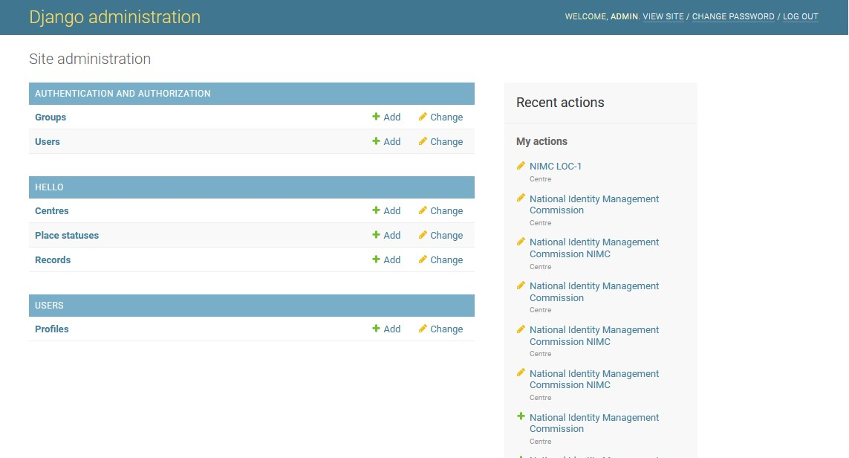
Figure 4. 1 Shows description of the database.

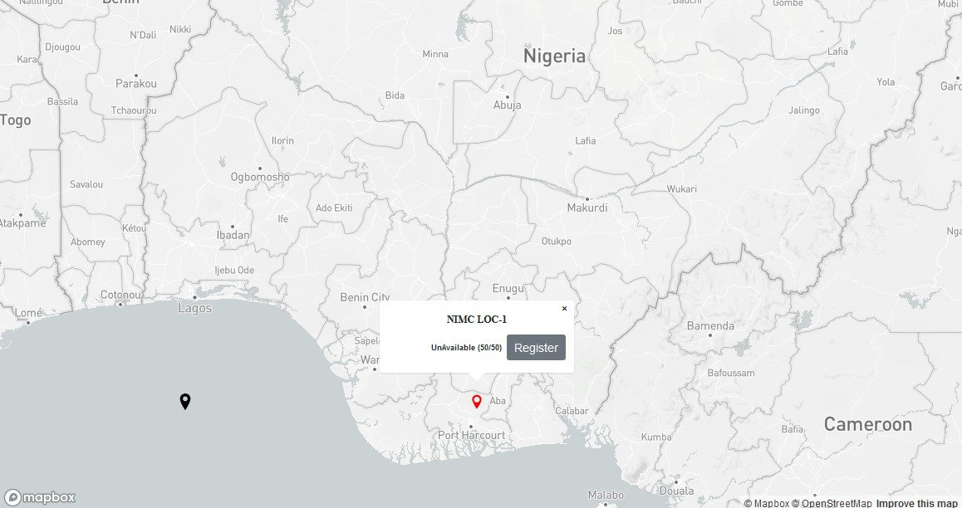
Figure 4. 2 Shows the Mapbox interface

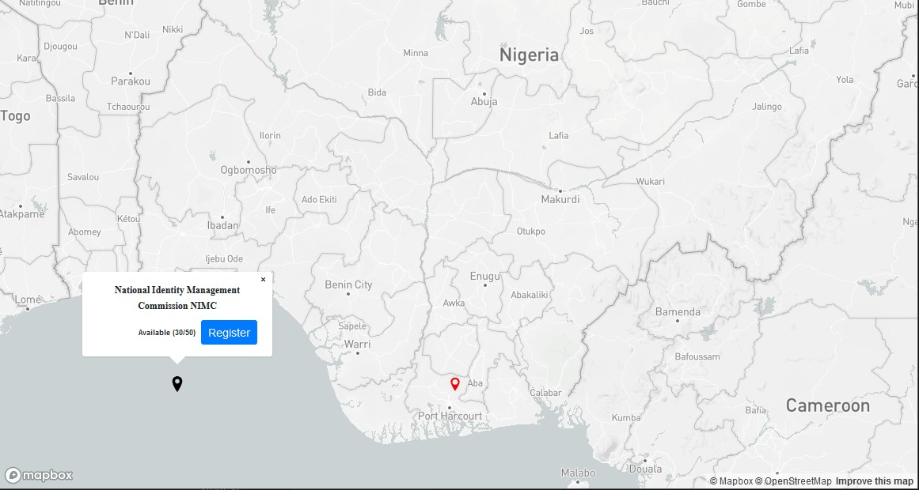
Figure 4. 3 Shows another Mapbox Interface.

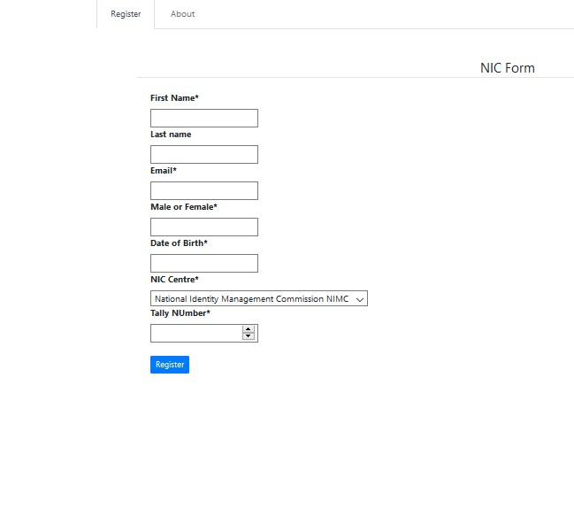
Figure 4. 4 Shows Scheduling form to make reservations.

4.4 Results of the Implementation of the System Interface
From the presentation of the results of the system database using PostgreSQL, the results of the implementation of the system using web technologies are presented. Figure 4.3 shows the Mapbox and an enrolment centre that shows availability for enrolment. Figure 4.2 shows that a centre is filled up and is unavailable. Figure 4.1 show the interface of the dashboard of the system administrator after providing a username and password for the system. The result of the information shows the different information stored on the system. Figure 4.4 shows the scheduling form through which applicants will make reservations for the enrolment exercise.

4.5 Discussion of Results
The result of the study showed the different expectations of this study based on objectives that were stated in the earlier chapters of this study. The results of the identification of the user and system requirements allowed for the identification of the different users of the proposed system such as secondary and the primary users of the system. The result shows that the secondary user was responsible for managing schedule records. Also, the results show showed that the primary users can access the system at any time and make a schedule or reservation at any enrolment centre.
The result of the specification of the design showed that the user requirements of the proposed system were identified following the use case diagram which was used to design the different interactions of the system users with the system alongside their respective feedback. The results of the data modelling of the proposed system showed that several classes were identified, some for identifying the enrolment centres, some for identifying the users, and some for identifying the schedule records; these designs were used to guide the process of the final implementation of the proposed system.
The results of the system showed that Firebase was used to implement a real-time database of this system. For each table in the database, several records were provided to the database. The results showed that the system was able to provide interfaces that were compliant with the system and user requirements that were identified in this study. The system implementation allowed users of various roles to perform their various duties using the system thus, removing the challenges and constraints attached to delay and time spent in getting a National Identity Number.

CHAPTER 5

SUMMARY AND CONCLUSION

5.1 Summary
This study developed a web-based system which enabled the scheduling of the National Identity Number enrolment exercise by applicants, and a web-based system which monitors scheduling records of applicants. The study identified the user and system requirements that were required to be met by the system. The user and system requirements were identified alongside the hardware and software requirements of the system. The requirements of the system were also specified using unified modelling languages using use-case diagrams for user requirements specification, and class diagrams for data modelling specification, system interaction display activity diagrams, system activity timing diagrams, and overall system background diagrams. The system was implemented using web technologies such as the Java programming language and Firebase for the real-time database.

5.2 Conclusion
In conclusion, this study has designed and implemented a system for the scheduling of the National Identity Number enrolment exercise in Nigeria. The study was able to identify the respective user and system requirements of the system and appropriate designs were used to specify these requirements provided by the users using use-case and class diagrams. The system database was implemented to suit the mechanisms and inner workings of the proposed system. The system also provided a means on how information about the schedules made will be seen in a comprehensive list, by the enrolment official. The study also concluded that users can be able to make schedules through the web system.

5.3 Recommendation
From this study, the following is recommended for the system:
  - Enrolment officials should receive training on how to use the system to gain an understanding of the functionality of the proposed system.
  - During future research of a scheduling system or research on the national identity number, other researchers can also use this report.
  - This system should be adopted by the body that maintains the Nigerian identity management system, NIMC.
  - In the event of a hardware or software malfunction, backups should be formed to prevent information loss.

REFERENCES
(2020, September 29). Retrieved from USC Libraries: https://libguides.usc.edu/writingguide/literaturereview
(2020). Retrieved from National Identity Management Commission: https://www.nimc.gov.ng/
Agbedo, O. (2019, November 9). National Identity Card: Another bumpy road to building a national database. Retrieved from TheGuardian: https://guardian.ng/saturday-magazine/national-identity-card-another-bumpy-road-to-building-national-database/
Android Studio. (2020, October 30). Retrieved from Wikipedia: https://en.wikipedia.org/wiki/Android_Studio
Ayamba, A. I., & Ekanem, O. (2016). National Identity Management in Nigeria: Policy Dimensions and Implementation. International Journal of Humanities & Social Science Studies (IJHSSS), 5.
Bourgeois, D., & Bourgeois, D. T. (2020). Information Systems for Business and Beyond. Retrieved from PRESSBOOKS: https://bus206.pressbooks.com/chapter/chapter-1/
Chambers, N., Gallagher, C., Harte, C., & Mc Kinney, C. (2009, April 30). Ticket Reservation System for the Millennium Forum BSc (Hons) Computing with Human Resource Management Intelligent MultiMedia Module: COM556M2. Retrieved from SEMANTICS SCHOLAR: https://www.semanticscholar.org/paper/Ticket-Reservation-System-for-the-Millennium-Forum-Mckevitt-Gallagher/357cde73dce65ef36d6f0be82bbc0d1b2ef96d0f
Development and Implementation of WEB-Based Online Hotel Reservation System. (2013, February). Retrieved from researchgate: https://www.researchgate.net/publication/266650526_Development_and_Implementation_of_WEB-Based_Online_Hotel_Reservation_System
Devlin, F. S., & Blankenbeckler. (2011, August). The Role of Geographic Information Systems In Management Information Systems. Retrieved from ReasearchGate: https://www.researchgate.net/publication/297892344_The_Role_Of_Geographic_Information_Systems_In_Management_Information_Systems
Firebase. (2014). Retrieved from Firebase: https://firebase.google.com/
Firebase. (2020, November 5). Retrieved from Wikipedia: https://en.wikipedia.org/wiki/Firebase
Flutter (Software). (2020, September 19). Retrieved from Wikipedia: https://en.wikipedia.org/wiki/Flutter_(software)
Frankenfield, J. (2020, September 25). Geolocation. Retrieved from Investopedia: https://www.investopedia.com/terms/g/geolocation.asp
Gabriel, S. (2020, August 17). NIMC and Identity Management Crisis in Nigeria. Retrieved from Fnancialwatchngr.com: https://www.financialwatchngr.com/2020/08/17/nimc-and-identity-management-crisis-in-nigeria/
Geographical Information System. (2020, September 16). Retrieved from Wikipedia: https://en.wikipedia.org/wiki/Geographic_information_system
GIG Mobility. (2020, August 31). Retrieved from Wikipedia: https://en.wikipedia.org/wiki/GIG_Mobility
GIG Mobility. (2020, August 31). Retrieved from Wikipedia: https://en.wikipedia.org/wiki/GIG_Mobility
Google Maps. (2020, November 4). Retrieved from Wikipedia: https://en.wikipedia.org/wiki/Google_Maps
History of Identity Management Infographic. (2020). Retrieved from IdRamp: https://idramp.com/history-of-identity-management-infographic/
Hu, P., & Gu, D. (2013, February). Development and Implementation of WEB-Based Online Hotel Reservation System. Retrieved from ReasearchGate: https://www.researchgate.net/publication/266650526_Development_and_Implementation_of_WEB-Based_Online_Hotel_Reservation_System
Ibrahim, I. A. (2016, January). The Importance of Identity Management Systems in Developing Countries. Retrieved from ResearchGate: https://www.researchgate.net/publication/332802561_The_Importance_of_Identity_Management_Systems_in_Developing_Countries
Identity Management. (2009). Retrieved from ScienceDirect: https://www.sciencedirect.com/topics/computer-science/identity-management
Isa, A., & Oguntuase, O. (2019, July 2019). National identity management in Nigeria: Matters arising. Retrieved from LEXOLOGY: https://www.lexology.com/library/detail.aspx?g=1318495f-7eeb-439e-a83e-d1329c604f2e
Mircrosoft. (2020). APA, MLA, Chicago – automatically format bibliographies. Retrieved from Microsoft support: https://support.microsoft.com/en-us/office/apa-mla-chicago-%E2%80%93-automatically-format-bibliographies-405c207c-7070-42fa-91e7-eaf064b14dbb
Mobile Computing. (n.d.). Retrieved from BrainKart: https://www.brainkart.com/article/Mobile-Computing_9872/
Mobile Computing - Brief Overview. (2020). Retrieved from tutorialspoint: https://www.tutorialspoint.com/mobile_computing/mobile_computing_overview.htm
Odagbami, G. (2020, August 16). NIMC, identity management crisis in Nigeria and the way forward. Retrieved from BusinessDay: https://businessday.ng/opinion/article/nimc-identity-management-crisis-in-nigeria-and-the-way-forward/
Olowogboyega, O. (2020, August 20). Getting a National ID card takes up to 4 years in Nigeria: going digital will not solve the problem. Retrieved from Techcabal: https://techcabal.com/2020/08/20/national-id-card/
Personal Identity. (2020, September 19). Retrieved from Wikipedia: https://en.wikipedia.org/wiki/Personal_identity
Personal mobile computing. (2013, December 17). Retrieved from Slideshare: https://www.slideshare.net/cegonsoft1999/presentation-mobile-computing
Purves, R. S., Alisstaire, E., & Xin, F. (2010, October). Automatically generating keywords for georeferenced images. Retrieved from ResearchGate: https://www.researchgate.net/publication/228732124_Automatically_generating_keywords_for_georeferenced_images
R, A., Temitayo, B., & G, I. (2017). Design and implementation of an online booking system for a cinema house. Retrieved from SEMANTIC SCHOLAR: https://www.semanticscholar.org/paper/Design-and-implementation-of-an-online-booking-for-Akinyede-Balogun/78981074931a6e2a9b4afb19b6045b152330c50e
Rafael, C. (2013, July 08). SECRET REVEALED: DISCOVER WHAT YOUR PROJECT SUPERVISOR IS LOOKING FOR IN YOUR PROJECT WORK AND HOW YOUR PROJECT IS GRADED . Retrieved from researchclue: https://nairaproject.com/blog/how-to-write-a-project-part1.html
Rouse, M. (2020). identity management (ID management). Retrieved from TechTarget: https://searchsecurity.techtarget.com/definition/identity-management-ID-management
Rozlia, V. R., & Negrusa, A. (2014, December). Online Hotel Booking Systems in Romania. Retrieved from ResearchGate: https://www.researchgate.net/publication/275541264_Online_Hotel_Booking_Systems_in_Romania
SAMPLE PROJECT JUSTIFICATION- Ashford Writing Center. (2020). 1-2.
Schiller, J., & Voisard, A. (2004). Location-Based Service. Elsevier.
What is Identity? (2020). Retrieved from Google: https://www.google.com/search?client=firefox-b-d&q=what+is+identity
What is mobile computing? (2019, April 3). Retrieved from Brainly: https://brainly.in/question/9155227

