DEVELOPMENT OF A FUZZY LOGIC-BASED PREDICTIVE MODEL FOR THE RISK OF LASSA FEVER

OJOMO ABIOLA
15010301028

BEING SUBMITTED TO THE DEPARTMENT OF COMPUTER SCIENCE AND MATHEMATICS, COLLEGE OF BASIC AND APPLIED SCIENCES

IN PARTIAL FULFILLMENT FOR THE AWARD OF BACHELOR OF SCIENCE (B.Sc.) DEGREE IN COMPUTER SCIENCE
MOUNTAIN TOP UNIVERSITY, IBAFO, OGUN STATE, NIGERIA

2020

CERTIFICATION
This Project titled, DEVELOPMENT OF A FUZZY LOGIC-BASED PREDICTIVE MODEL FOR THE RISK OF LASSA FEVER, prepared and submitted by OJOMO ABIOLA OLUWAJUBE in partial fulfilment of the requirements of the degree of BACHELOR OF SCIENCE (Computer Science), is hereby accepted

__________________________ (Signature and Date)
PROF. P.A. IDOWU.
Supervisor

__________________________ (Signature and Date)
DR. I. O. AKINYEMI
Head of Department

Accepted as partial fulfilment of the requirements for the degree of BACHELOR OF SCIENCE (Computer Science)

__________________________ (Signature and Date)
Prof. A. I. AKINWANDE

Dean, College of Basic and Applied Sciences

DEDICATION
I dedicate this project to God almighty for it has been with his guidance I was able to carry out this project successfully.
I also dedicate this project to my parents and siblings for their immense support and encouragement.

ACKNOWLEDGMENT
I am forever grateful to my parents, Mr. and Mrs. Ojomo, for the love and support shown to me throughout my stay at Mountain Top University.
I would also like to extend my appreciation to my supervisor PROF. P.A. Idowu, for his advice, contributions and suggestions to ensure the completion of this project. I count it a special privilege to have him supervise my project.
To all my wonderful lecturers, members of staff in the Department of Computer Science and the college at large, you all have been the best during my four years in this institution, may God continually bless you in all your endeavours.
Special thanks to all my friends. I am grateful for the time spent and, expertise shared to ensure this project is completed. I love you. God bless you all.
Above all, I want to express my sincere gratitude to Almighty God, the giver of life and my source of help, for everything.

TABLE OF CONTENTS

CERTIFICATION ii
DEDICATION iii
ACKNOWLEDGMENT iv
ABSTRACT viii
LIST OF TABLES x
LIST OF FIGURES xi
CHAPTER ONE 1
INTRODUCTION 1
1.1 Background to the Study 1
1.2 Statement of the Problem 2
1.3 Aim and Objectives of the Study 2
1.4 Research methodology 3
1.5 justificaion of the Study 4
1.6 scope and limitation of study 4
1.7 arrangement of thesis 4
CHAPTER TWO LITERATURE REVIEW 5
2.1 lassa fever 5
2.1.1 risk factors of lassa fever 6
2.1.2 clinical screening and intervention for lassa fever 6
2.2 predictive modeling 7
2.2.1 types of predictive models 8
2.1.2 developing a predictive model 9
2.3 fuzzy logic modeling 10
2.3.1 concept of fuzzy logic 11
2.3.2 fuzzy sets and membership functions 12
2.3.3 fuzzy inference system 13
CHAPTER THREE RESEARCH METHODOLOGY 17
3.1 Introduction 17
3.2 method of the identification of the associated risk factor 17
3.2.1 description of identified risk factors 18
3.2.2 identification of crisp and linguistic values of associated variables 19
3.3 method of fuzzy logic model formulation for risk of lassa fever 23
3.3.1 fuzzification of the risk of lassa fever 24
3.3.2 fuzzy inference system design 24
3.4 simulation environment used 25
CHAPTER FOUR RESULT AND DISCUSSION 26
4.1 Introduction 26
4.2 fuzzy model for risk of lassa fever 28
4.2.1 results of variables using the membership function editor 28
CHAPTER FIVE SUMMARY AND CONCLUSION 39
5.1 summary 39
5.2 conclusions 39
5.3 recommendation 40
REFERENCES 41
APPENDICES 43

LIST OF FIGURES

ABSTRACT
A fuzzy logic-based system has been applied to a number of medical cases, particularly in the area of diagnostic system development, and has been discovered to produce precise results.
This paper introduces a fuzzy logic-based method used to simulate a prediction model for the prediction of lassa fever among individuals.
The results of variable fuzzification and defuzzification, inference engine description and model testing were presented and showed that the model based on fuzzy logic would be very useful in predicting the probability of lassa fever among individuals.
keywords: fuzzy logic, prediction model, lassa fever.

CHAPTER ONE

INTRODUCTION
1.1 Background to the study
Lassa fever is a 2 to 21-day acute viral hemorrhagic disease that occurs most commonly in West Africa. The disease was identified when two missionary nurses died in Nigeria in 1969 (LeCompte, Fichet-Calvet & Daffis, 2006). Presently, in Sub Sahara Africa, the viral hemorrhagic disease is still a threat. The virus is transmitted to humans by contact with contaminated foods or other domestic good contaminated with rodent urine or faeces. A national newspaper "Punch" recently announced on February 19, 2018 that three out of seven confirmed cases of Lassa fever have passed away in Delta State since the disease outbreak was announced in the state on January 26, 2018.
In addition, twenty four persons were held under surveillance. Information and Communications Technology (ICT) can be influential in health care services support. It helps in increasing the quality of service and reducing the cost, as the cost of health care is a growing problem (Shekelle, Morton & keeler, 2006). It will offer new avenues for the access and use of health information by medical professionals and their patients. ICT has the potential to increase health care quality, performance and safety and allows health care providers to capture, store, retrieve and transmit information by electronic means. The use of ICT in health could boost the quality of health care as stated by many researchers who supported the belief.
Predictive research has become increasingly common in medical science, with the goal of predicting future events or outcomes based on trends within a collection of variables. Accurate predictive models can inform patients and physicians about the future course of an illness or the risk of developing illness and thereby help guide decisions on screening and/or treatment (Waijee et al, 2013). Fuzzy logic is a fundamental principle for integrating organized human intelligence into workable algorithms that make up fuzzy models, one of the soft computing devices. Fuzzy logic provides a practicable way to understand and manually influence the mapping behaviour of functions. Fuzzy logic generally, uses simple rules to describe the system of interest and this makes it easy to implement.

1.2 statement of the problem
Every year, about 100,000 to 300,000 infections occur with approximately 5,000 deaths occurs in west, almost a third occurring during the intra-partum period
Lassa fever is an encephalitis virus that is common in western Africa. In Nigeria there is no hospital with the capacity to conduct treatment of Lassa fever virus. (Barbara, et al. 1998) argues that the detection and treatment of patients depends solely on non-specific clinical criteria. 43 years after the reporting of the 1st case of Lassa fever, Nigeria is still dealing with the hairless tailed bush rats that caused the outbreak. More than 5,000 people die per year from the disease (THISDAY 2012).

1.3 aim and objectives of the study
The aim of the study is to determine the risk of Lassa fever among adults and children based on information collected about factors associated with the risk using fuzzy logic modelling.
The specific research objectives are to
1 elicit knowledge on the factors that are associated with the risk of Lassa fever
2 formulate the fuzzy logic model based on the factors identified in (1);
3 simulate the model; and
4 validate the model.

1.4 research methodology
In order to meet up with the aforementioned objectives, the method adopted with this study are presented as follows.
a. Following the review of literature surrounding Lassa fever information about factors that are associated with risk of Lassa fever were elicited from medical expert from a private hospital in Nigeria.
b. The fuzzy logic model was formulated by the process of using triangular membership function to fuzzify the associated risk factors (variables) as inputs and risk of Lassa fever as output variable.
c. The inference engine of the fuzzy logic was formulated by interpreting the association between the risk factors (as antecedents) and the risk of Lassa fever (as consequents) using If-Then rules.
d. The fuzzy logic model was simulated using the fuzzy logic toolbox available in the MATLAB R2015a Software
e. The model was validated using sample dataset based on accuracy, true positive rate, false alarm rate and precision.

1.5 justification of the study
The Nigerian health sector has set ambitious goals for delivering vital health services to all citizens; it is very important to improve the quality of decisions concerning care choices in order to minimize mortality rates for diseases in Nigeria. Predictive models for the classification of Lassa fever among West Africans can allow physicians to make use of the risk factors assessed from patients to determine the risk of Lassa fever, thereby improving the delivery of quality healthcare.
1.6 scope and limitations of the study
This research is limited to the use of non-invasive risk factors to predict Lassa fever risk among western Africans.
The study is limited to the use of information observed from individual infected with lassa fever.
1.7 arrangement of thesis
The very first chapter of the study including the analysis introduction, was created. Chapter 2 offers a literature review comprising of the identification of risk factors of lassa fever, which described Fuzzy logic modelling along with predictive modelling. Chapter 3 is actually a summary of the research techniques to be implemented in this specific study to be able to accomplish the study's objectives. The results as well as discussions of the solutions used in this specific evaluation come with in chapter 4. The analysis overview, conclusion & suggestions are talked about in chapter 5.

CHAPTER TWO

LITERATURE REVIEW
2.1 Lassa fever

Lassa fever is defined by World Health Organization (CDC) as an acute viral haemorrhagic illness caused by Lassa virus, a member of the arenavirus family of viruses. An estimated 100,000 to 300,000 infections of Lassa fever occur annually, with approximately 5,000 deaths. Lassa fever is known to be endemic in Benin, Ghana, Guinea, Liberia, Mali, Sierra Leone, and Nigeria, but probably exists in other West African countries as well. The overall case-fatality rate is 1%. Observed case-fatality rate among patients hospitalized with severe cases of Lassa fever is 15%. Lassa fever death rate can be reduced through early supportive care with rehydration and symptomatic treatment improves survival.
Lassa fever is endemic in Nigeria and the annual peak of human cases is usually observed during the dry season (December – April) following the wet season (May – June) reproductive cycle of the Mastomys rats.
In view of the fact that 90-95% of human infections are due to indirect exposure (through food or household products contaminated with urine and feces of infected rats) or direct contact with infected Mastomys rats, the very high density and high circulation of Lassa fever virus in young non-immune rat population during the wet season create a potential for further human infection, thus, the number of infections is expected to continue to rise until the end of the dry season.
Although Nigeria is an endemic country of Lassa fever and has developed capability to manage Lassa fever outbreaks, the current overall risk is considered moderate at the national level.
On a sub-national basis, capacities remain suboptimal. In this outbreak, fifteen confirmed cases were reported among healthcare workers and emphasizes the urgent need to strengthen IPC measures. In addition, the country 's capacity to detect and respond to Lassa fever outbreaks (surveillance, laboratory, case management, coordination and IPC measures) needs to be improved.
The overall regional and global risk is considered to be low due to minimal number of suspected cross-border transmission from Nigeria to neighbouring countries.

2.1.1 Risk factors of Lassa fever
Lifestyle factors contribute significantly to Lassa fever rates; for example, occupational exposure in healthcare settings, exposure to infected individuals, exposure to rodents (mastomys rat) or contaminated household items or food. Those at risk are those who live or visit areas with a large population of rodent infected with the virus or are exposed to infected humans, disease and lifestyle also affects Lassa fever rate, and may be bewildering factors in any study trying to focus on one risk factor.
To look at the rate of Lassa fever in individual populations, it is important to Determine more detailed risk factors and incidences.

2.1.2 Clinical screening and intervention for lassa fever
Human disease progresses within 3 weeks of Lassa virus infection. Lassa fever's initial symptoms are non-specific and can include fatigue, malaise, headache, sore throat, myalgia, cough, chest pain, nausea, vomiting, and diarrhea. In most cases, symptoms are mild; however, in approximately 20 percent of cases, severe disease complicated by abnormal bleeding, generalized edema, respiratory distress, hypotension, proteinuria, transaminitis, deafness, encephalopathy and/or hypotension develop. Although Lassa fever 's overall fatality rate is low, it is 15 to 20 per cent among hospitalized patients. Increased mortality rates were recorded during outbreaks and among pregnant women, particularly in the third trimester of pregnancy.
The only real prevention of transmission of the Lassa virus from its host to humans can be prevented by avoiding contact with Mastomys rodents, especially in the geographic regions where outbreaks occur.
Treatment with ribavirin reduces the risk of fatality to less than 5% if initiated in patients within the first 6 days of disease, but the beneficial effect on fatality decreases if ribavirin is started later in the course of disease. Despite the public health importance of Lassa fever, little is known about the genetic diversity or relationships of Lassa viruses found in various parts of West Africa.

2.2 Predictive Modeling
Predictive research aims to predict future events or outcomes within a collection of variables based on trends, and has become increasingly common in medical science (Agbelusi, 2014; Idowu et al., 2015). Precise predictive models can warn patients and clinicians about the potential course of a disease or the risk of developing a disease and thus help direct screening and/or treatment decisions (Waijeeet al, 2013a). Traditional explanatory research and predictive research present several important differences. Explanatory analysis usually uses statistical techniques that use previous theoretical models to test the causal hypothesis. In comparison, quantitative analysis, without preconceived theoretical assumptions, applies statistical methods and/or machine learning techniques to forecast future outcomes (e.g. predicting the probability of hospital readmission) (Breiman, 1984).
Although predictive models may be used to provide insight into the casualty of outcome pathophysiology, casualty is neither a primary goal nor a variable inclusion requirement (Moons et al., 2009). Non-causal predictive factors may be surrogates for other disease drivers, with tumor markers as cancer predictors. The most common example, is progression or recurrence. Sadly, a misunderstanding of the methodological discrepancies between explanatory and predictive research has contributed to a broad variance in the methodological standard of prediction research (Hemingway et al., 2009).

2.2.1 Types of predictive models
Previously, machine learning was used to predict behavioral outcomes in industry, such as predicting product customer preferences based on previous history of purchases. There are a range of different strategies for designing predictive algorithms, using a variety of predictive analytical tools / software, and literature has defined them in detail (Waijee et al., 2010; Siegel et al., 2011). Some examples include neural networks, supporting vector machines, decision trees, naive Bayes etc. For example, decision trees use techniques such as classification and regression trees, boosting and random trees to predict different outcomes.
Machine learning algorithms such as random-forest approaches have several advantages over traditional explanatory statistical modeling, such as the lack of a predefined hypothesis, which makes it less likely to overlook unexpected hypothesis (Liaw et al., 2002).
If there are many possible predictors available and when there are interactions amongst predictors common in engineering, biological and social causative processes, approaching a predictive problem without a clear causal hypothesis can be very successful.
Predictive models using algorithms for learning a machine can Consequently, facilitate the recognition of significant variables that may otherwise not be identified initially (Waijee et al., 2010). In fact, the machine learning literature contains many examples of the discovery of unexpected predictor variables (Singal et al., 2013).

2.1.2 Developing a predictive model
The first step in designing a predictive model is to pick appropriate candidate predictor variables for potential inclusion in the model by using the conventional regression analysis; however, there is no agreement on the best approach to do so (Royston et al., September 2009).
With all candidates a backward-elimination approach begins Variables, hypothesis tests are applied sequentially to determine which variables should be removed from the final model, whereas all candidates are included in the full model approach Variables to prevent unintended selection bias and overfitting. Significant predictor variables previously identified will normally be included in the final model irrespective of their statistical significance but generally the number of variables included is limited by the sample size of the dataset (Greenland, 1989). Inadequate selection of variables in this situation is a major and widespread cause of poor model results. Computer selection of variables is less of a concern Learning technique are often not based solely on predefined hypotheses (Ibrahim et al., 2012). There are several other important questions concerning the data Management when designing a predictive model, such as resolving data gaps and variable transformation (Kaambwa et al., 2012; Waijee et al., 2013).

2.3 Fuzzy Logic Modeling

The Fuzzy Logic theory (FL) was formulated by his fuzzy sets (Zadeh, 1965) as a response to the Aristotle Logic (bi-valued logic) approach. In one of Aristotle 's famous laws of thought, the Law of the Excluded Middle states that every proposition must either be False or True has the above (Salmani and Akbari, 2008). Lukasiewicz proposed a three-valued logic in the 1920's as a systematic alternative to the bi-valued Aristotle logic. The terms of his method are real, false and probable. This approach later led to a four-valued logic that eventually gave birth to the valued logic of infinity. Eventually Zadeh introduced the formal or mathematical Expression of an infinite-valued logic by its Fuzzy Sets and defined a fuzzy set as an object class with a continuum of membership grades.
The collection is characterized by a membership function that assigns a membership grade ranging from zero to one for every entity. To such sets are applied the theories of convexity, relationships, union, intersection, and complement, and so on (Zadeh, 1965). Fuzzy logic is a type of multi-valued logic in which variable truth values can be any real number between 0 and 1. By comparison, in Boolean logic, only integer values 0 or 1. can be the truth values of variables. Fuzzy logic Used to deal with the concept of partial truth, where the value of truth can vary between true and completely false (Novak et al., 1999). In addition, when using linguistic variables that are understood to be ambiguous, specific (membership) functions that manage certain degrees (Ahlawat et al., 2014).

2.3.1 concept of fuzzy logic
Fuzzy logic is a basic principle for integrating organized human knowledge into workable algorithms which are fuzzy models, one of the soft computing devices. This important method has been implemented to tackle the issue of imprecision and ambiguity in order to improve tractability, robustness and low-cost solutions to real-world problems (Sharareh and Xiao-Jun 2009). Fuzzy offers a realistic way to understand the mapping actions of functions and to manipulate them manually. Muddled logic, In general, basic rules are used to define the structure of interest and this makes implementation easy. In some science modeling applications and engineering systems over the past decade, Fuzzy systems have supplanted traditional technologies (Cheng, 2004). Therefore, Fuzzy logic has the capacity to articulate the complexity of human reasoning and to convert expert knowledge into numerical computable results. A questionable scheme consists of a series of laws for Fuzzy If-Then.
Fuzzy logic started with a Fuzzy Set definition. A Fuzzy set is a set with a clearly defined boundary but without a crisp. It may contain only partially-membered elements (MathWorks, 2007). There is a need to know what a classical set is all about in order to understand Fuzzy set. A classic set is a container that includes or excludes any given element altogether. In a classic set theory; if x is a set element A then μA(x)=1 but ifx is not set element A then μA(x)=0. In fuzzy logic, a matter of degree is the truth of any argument. Any statement could be flippant. The key benefit that fuzzy logic provides is the opportunity to answer a yes-no question with either a not-quite-yes or not-quite-no response.

2.3.2 Fuzzy Sets and Membership Functions
Fuzzy set is an extension of a classical (crisp) set, which deals with wholly inclusion and exclusion of any given element (MathWorks, 2011). Fuzzy sets can be used to represent simple linguistic concepts like yes-maybe-no, true-don’t know-false, cold-warm-hot, low-medium-high and so on. At the same time, a given element can belong to more than one Fuzzy group. The Fuzzy sets theory is a theory of graded definitions and the elasticity of membership. All fuzzy sets include membership functions (Zadeh, 1965). A Membership Function (MF) is a curve that determines how to map each point in the input space to a membership value (or membership degree) between 0 and 1. The input space is also called discourse universe (MathWorks, 2011).
In recent years a variety of membership functions have been introduced, including triangular, trapezoidal and bell-shaped membership functions. It is defined as a graph which defines how each point is mapped to the membership value in the input space[0 1]. The input value is often referred to as the set (u) of the universe of discourse, which contains all possible elements of concern in each application. The only condition a membership function really has to fulfill is that it will range from 0 to 1. The function itself can be an arbitrary curve whose form we can define in terms of simplicity, ease, speed and efficiency as a function that fits us.
The toolbox on MATLAB fuzzy logic (MathWorks, 2011) contains 11 types of built-in membership functions. In addition, these functions are constructed from several basic functions, namely: linear piece-wise functions, the Gaussian distribution function, Sigmoid curve and polynomial curves quadratic and cubic. Use straight lines they form the simplest membership functions. Of these the simplest is the triangular membership function, which is a three-point set that forms a triangle.

2.3.3 Fuzzy Inference System
Fuzzy inference is the method of formulating the mathematical model using fuzzy logic theory based on a mapping of an input set to an output value. The mapping Provides the basis from which decisions can be made, or detect trends. The fuzzy inference method requires logical processes, such as using the If-Then rules and membership functions. The Fuzzy Inference System (FIS) is a system built on rules; Used as an instrument for reflecting various types of problem awareness. FIS is also used to model interactions and relationships between variables that exit (Alayon et al., 2007, SenGupta and Singhal, 2015). FIS takes all the fuzzy rules in the rule base into account, and knows how to turn a set of inputs into corresponding outputs. There are four sub processes involved in FIS, namely: Fuzzification, Rule production, Composition or aggregation and Defuzzification.
- Fuzzification -Fuzzification is the first method to view a questionable logic scheme. The first step in controller modeling is data fragmentation (fuzzification) into input that can be accepted via Fuzzy logic. The fuzzification transforms a degree of membership for each unit of input data. It is achieved by making some membership function invoked. In the fuzzification process, each input data is mapped with membership function conditions to decide the degree of fitness for which each input corresponds to the fuzzified output. For example, the triangular membership function required the discourse universe declaration to be an interval [a b c] where a and c correspond to the triangle base, and b Matches the point where the triangle apex is located. Figure 2.1 shows the formulation of 3 triangular membership functions for a variable using labels: No, Yes and Probably with their intervals described as: [0 0.15 0.30], [0.31 0.50 0.70] respectively, and [0.71 0.85 1.00].
- Rule Production- The real value of each rule is calculated at this phase, and then applied to the corresponding part of each rule. The controller's rule-based method uses the values of the input variables to formulate potential output outcomes for each formulated rule output. As a result, the results of the production of rule Process rules are set using IF-THEN declarations. For instance, given a two-input-one output model, a rule line can be defined as equation (2.2).
𝐼𝐹 (𝑖𝑛𝑝𝑢𝑡1 = 𝑣𝑎𝑙𝑢𝑒) 𝐴𝑁𝐷 (𝑖𝑛𝑝𝑢𝑡2 = 𝑣𝑎𝑙𝑢𝑒) 𝑇𝐻𝐸𝑁 (𝑜𝑢𝑡𝑝𝑢𝑡 = 𝑣𝑎𝑙𝑢𝑒) (2.2)
- Aggregation- Each formulated Fuzzy rule produces a number representing the output truth value for that rule. Using the aggregation method all output for each rule must be merged into a single output fuzzified value. In order to achieve aggregation, two methods are widely used: the minimum and the methods of operation of the product. The minimum output is used in most applications as an aggregated output for all of the output generated by the formulated laws.
- Defuzzification- The resulting set is limited to one crisp number by Defuzzified. It includes transforming the aggregated single fuzzy output set into one crisp value. The interval the defuzzified value belongs to is used to evaluate the class the output is identified with. There are several defuzzification approaches, such as centroid, center of numbers, mean of maxima and left-right maxima. For most cases, however, centroid defuzzification approach is commonly used, and was used in the analysis.

2.4 RELATED WORKS
After a study of relevant works on the body of information surrounding the idea of Lassa fever and applied their respective methods. Within the following paragraphs a variety of works which have been checked because of their importance to this study are discussed.
Aroyehun et al. (2017), applied fuzzy logic to the prediction of the likelihood of water-related diseases. Awareness was obtained from a Medical Centre specialist, Osogbo, Osun State, Nigeria was used to develop the rule-base and used MATLAB software to simulate the predictive model. Also presented were the results of the fuzzification and defuzzification of variables, inference engine specification and model testing, which showed that the fuzzy logic-based model is very useful in predicting the probability of water-related disease (malaria) in South West Nigeria. The research was restricted to predicting water-related illnesses.
Khormehr and Maihami (2016), applied the fuzzy logic of developing a predictive model for the risk of stillborn birth. The study described many invasive and non-invasive parameters that were correlated with mortality risk. Until the model was formulated using fuzzy membership functions the cuckoo search algorithm was applied to the reduction of variables. The study results showed that after validation the predictive model displayed an accuracy of 95 per cent. The research was limited to using both invasive and non-invasive risk factors to determine the possibility of stillborn childbirth.
Idowu et al. (2018) applied Fuzzy logic to environmental disease determination in Nigeria. The predictive model was developed using Fuzzy logic MATLAB Fuzzy Toolbox logic. In Nigeria, data were collected from five different states. The result revealed that there are cases of environmental-related diseases in places where drinking water is not available and in locations where adequate toilet facilities are missing. There are always cases of cholera in areas where there are no toilet facilities, or where bucket and bush are used as toilets. In these areas that lack adequate water and toilet facilities there are always reported cases of cholera and during the raining season cholera outbreaks are common occurrences. The point stated above are a good reasons environmental health tracking system with predictive features should be considered in a country with high risk of health issues, so that environmental officers would be able to manage, track and easily monitor areas which are prone to these health issues. The research was limited to ambient disease prediction.
Idowu et al. (2015), applied Fuzzy Logic Theory to the development of a Sickle Aneamia Disease (SCD) survival model among pediatrics in Nigeria; The study identified three (3) factors that were linked to the severity of pediatric survival of SCD. The research followed the application of triangular membership functions to the Formulation of the survival rating model based on the determined variables. The study results showed that the IF-THEN rules had been used. The outcome of the extent of SCD survival was easily determined from pediatrics, developed and supported by the experts. The study was limited to developing a model for the survival of patients with SCD classification. The study was limited to developing a model for the survival of patients with SCD classification.

CHAPTER THREE
RESEARCH METHODOLOGY

3.1 Introduction
This section talks about different approaches used in this study in order to predict the likelihood of Lassa fever based on identified associated risk factors in individuals. Identification of different risk factors that are associated with the risk of Lassa fever which is endemic in Nigeria. Also presented were the membership functions used to formulate the Fuzzy logic model foreach risk factor defined alongside the Lassa fever performance goal risk. Following the rules-base of the derived inference engine.
In addition, for each risk factor evaluated, crisp values were suggested as a way of quantifying a user 's reaction to each risk factor. As a result, higher values were given at intervals which increased the risk whereas lower values were given at intervals which decreased the risk of Lassa fever. Hence, each crisp interval was assigned a linguistic value that was used as a nominal tag for which it was necessary to formulate each fuzzy membership function based on the values of the crisp interval.
A variety of risk factors were reported following the analysis of relevant works, so that some were age-related, lifestyle-related, dietary-related etc.

3.2 Method of the Identification of Associated Risk factors
A number of associated risk factors were identified for the purpose of developing classification model for the risk of Lassa fever. A number of associated risk factors were identified during the process of reviewing related works over the internet. Each defined risk factor was found to have a relative relation to the Lassa fever risk as some risk factors increased the associated risk and others decreased the associated risk of Lassa fever.
3.2.1 Description of identified risk factors
a. risk of lassa fever
According to this study which involved the development of a classification model for the risk of lassa fever using fuzzy logic, the target variable falls under a number of classes related to exposure to a patient with Lassa fever, Based on the level and degree of contact by an individual with a confirmed patient carrying the disease. The target variable is divided into 2 classes namely: High Risk and Low Risk. Therefore, Individuals at greatest risk of Lassa virus infection are those in contact with confirmed patient
b. socio economic status
This is defined as a measure of ones combined economic and social status and tends to be positively associated with better health which makes it one of the most important risk factors an considering status in health care settings, lower class would likely result to higher risk of lassa fever than higher class since people of higher social status would likely get better health care and abstain from poor surroundings and also be educated about the infection
c. socio demographic
Demographic, a statistic characterizing human populations is also a risk factor of lassa fever.
d. age of patient
Age of patients is one of the important risk factors as it was determined that the older the patient, then the lower the risk of lassa fever.
Therefore, older individuals have great knowledge on promoting good “community hygiene” to discourage rodents from entering homes.
e. place of delivery
The place of delivery can also affect the risk of still of lassa fever since most individuals with greater risk. The location of delivery was classified as hospitals, medical clinic as well as home delivery. The danger of stillbirth is actually greater among females that provide at the house as the risk of still birth is actually lowest among females that give births at hospitals (e.g. tertiary and private).
f symptoms
symptoms observed before coming to the hospital are classified into three level, namely level one, level two and level three.
e level of education
To the framework of the International Standard Classification of Education (ISCED), amounts of training are actually a purchased set of categories, meant to group informative programmes in relation to gradations of learning experiences as well as the expertise, abilities & competencies which each programme is actually created to impart.

3.2.2 Identification of crisp and linguistic values of associated variables
Following the identification of the all the risk factors that are associated with the risk of lassa fever, linguistic values and linguistic variables were being identified.
Three values where available for each of the crisp value, identified by various risk factors 0, 1, and 2
Table 3.1: identification of Crisp and Linguistic Values of Risk Factors
Risk factor | Linguistic variable | Crisp value
Age of patient | Low  Medium  high | 0  1  2
Socio economic status | Low class  Medium class  High class | 0  1  2
Level of education | Low class  Medium class  High class | 0  1  2
Risk of lassa fever | Low risk  High risk | 0  1
Level of symptoms | Level one  Level two  Level three | 0  1  2
Place of delivery | Hospitals  Medical clinic  Home | 0  1  2

Because of the importance of two or perhaps one even though the importance with probably the lowest risk of still birth was provided a value of zero. As shown in table 3.2, each danger factor was discretized into two or perhaps three parts such
that the values of zero as well as one or perhaps zero, one as well as two had been allocated to each linguistic adjustable defined.
As a consequence of this the risk factors have been classified as follows. The age of the individual was split in boosting order of danger of still birth as below forty years and above forty years of age hence was provided two linguistic variables; the age of the individual was split in boosting order of danger as under forty years and above Forty years hence was provided two linguistic variables; the socio-economic status was divided
In increasing order of possibility as lower class, top class and also middle class hence was given
Three linguistic variables; the story of smoking was split in boosting order of danger as
yes, previous, and no hence was provided three linguistic variables; the story of smoking was
divided and increasing order of danger as no, earlier and yes; the location of shipping was
divided in boosting order of danger as hospitals, medical clinic as well as home delivery hence was provided three linguistic variables.
The method of delivery was split in boosting order of threat as vaginal and
caesarean section (CS) hence was provided two linguistic variables; the labour initiation was
divided in increasing threat as induced and spontaneous hence was given two linguistic
variables; the gestation age of the female was split in boosting order of danger as
above thirty six weeks and under thirty six weeks hence was provided two linguistic variables; the history
of still birth was split in boosting order of threat as none and of course hence was provided two linguistic variables. Watching the identification of the variables which were suggested for
this particular study, the club membership feature which was used to formulate the fuzzy logic design was driven.

3.3 Method of fuzzy logic model formulation for risk of lassa fever
While developing a classification model for the risk of lassa fever using fuzzy logic theory the provided values was fuzzified using a triangular membership function, (trimf). The triangular membership function required the provision of 3 parameter with each carrying its own value which correspond to an interval a ≤ b ≤ c such that the values are numeric. This membership function has 3 parameters, which consist of the left-hand base, the central apex and the right-hand base of the triangle.
The interval of this parameter was used to define the crisp interval within which each crisp value required for calling each linguistic variable was assigned. Since only 2 or 3 variables were defined for each risk factors then there would be 2 or 3 triangular membership functions that would be formulated. The expression used compute membership values for each input value in x.
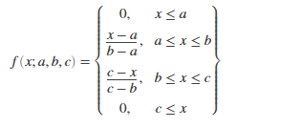
Using 2 or 3 triangular membership functions, the labels of the identified risk factors were formulated using the crisp intervals of (-0.5, 0.5), (0.5, 1.5) and (1.5, 2.5) to model each variable such that 0, 1 and 2 became the center b of each interval as shown in Table 3.2.
Crisp value | Interval | A | B | C
0 | (-0.5, 0.5) | -0.5 | 0 | 0.5
1 | (0.5, 0.5) | 0.5 | 1 | 1.5
2 | (1.5, 2.5) | 1.5 | 2 | 2.5

3.3.1 Fuzzification of the risk of lassa fever
After the risk factors for lassa fever were identified and fuzzified, the target variable used to describe the risk of stillbirth in male patients had to be formulated. The triangular membership function was used to formulate the fuzzy logic model for the target variable by assigning crisp values of 0, 1 and 2 to the target class labels, namely: no risk, low risk and high risk using the intervals [-0.5 0 0.5], [0.5 1 1.5], and [1.5 2 2.5] respectively.
The triangular membership functions were used to formulate the fuzzy logic model required to describe the 3 labels of the target class used in the description of lassa fever risk using identified crisp values as showed in table

3.3.2 Fuzzy inference system design
After the fuzzy logic model has been formulated using triangular Membership functions the fuzzy inference engine was introduced to model the risk factors and the risk of lassa fever due to its flexibility for control strategy implementation. Using the risk factors that were identified for assessing the risk of lassa fever the process of is used following the fuzzification process.
Targe class | Interval | A | B | C
No risk | (-0.5, 0.5) | 0.5 | 0 | 0.5
Low risk | (0.5, 1.5) | 0.5 | 1 | 1.5
High risk | (1.5, 2.5) | 1.5 | 2 | 2.5

Inference rule generation usually follows the fuzzification process. A typical rule that can be inferred is as follows:
IF (Risk Of Lassa Fever= “No”) AND (Socio Economic Status = “No”) AND (Socio demographic factors= “No”) AND (Age of patient= “No”) AND (level of education= “No”) AND (Symptons= “No”) THEN (Risk of lassa fever = “No Risk”)

3.4 simulation environment used
This model was simulated using the MATLAB. MATLAB integrates visualization, computation and programming in any easy to use environment where problems and solutions are expressed in familiar mathematical notation. Toolboxes are also comprehensive collections of MATLAB functions; the MATLAB toolboxes was used to formulate the model. The tool box is essential in the simulation of the model because it provides MATLAB functions, graphical tools and a Simulink block for designing, analysing and simulating systems based on fuzzy logic.
With respect to the study GUI tools also contribute by observing fuzzy inference system in the toolbox.
- Fuzzy Inference System (FIS) editor shows the input and output variables for the proposed model and the fuzzy logic inference engine
- The Membership Function Editor is a tool that allows you to view and edit all membership functions for the entire fuzzy inference scheme along with all input and output variables.
- Rule editor handles the correctness of the different rules that defined the behaviour of the system using a statement which combines risk factors reported for the risk of still-birth labels. The statement used with the rule editor is IF-THEN.
- Rule viewer helps to interpret the entire fuzzy inference process at once. It works by showing which rules are active, or how result is being influenced by individual membership function shapes.
- Surface viewer is used to display the dependency The Surface Viewer is used on either one or two of the inputs to show the dependency of one of the outputs.
Essential for plotting a surface map.
CHAPTER FOUR
RESULTS AND DISCUSSIONS
4.1 Introduction
This section presents the results of formulating triangular membership functions, based on the crisp intervals specified for each linguistic variable described in this report. Therefore, since the same crisp interval was used, 3 triangular membership functions with centres 0, 1 and 2 were used to define the labels of each risk factor.
The allocation of values has also been based on the increasing effect of defined risk labels.
$$Crisp/.-label_0\left(x;-0.5, 0, 0.5\right)= \left\{\begin{aligned}0;x≤-0.5 \\ \frac{x+0.5}{0.5} ;-0.5<x≤0 \\ \frac{0.5-x}{0.5};0<x≤0.5 \\ 0;x>0.5\end{aligned}\right.$$
$$Crisp-label_1\left(x;0.5, 1, 1.5\right)= \left\{\begin{aligned}0;x≤0.5 \\ \frac{x-0.5}{0.5} ;0.5<x≤1 \\ \frac{1.5-x}{0.5};1<x≤1.5 \\ 0;x>1.5\end{aligned}\right.$$
$$Crisp-label_1\left(x;1.5, 2, 2.5\right)= \left\{\begin{aligned}0;x≤1.5 \\ \frac{x-1.5}{0.5} ;1.5<x≤2 \\ \frac{2.5-x}{0.5};2<x≤2.5 \\ 0;x>2.5\end{aligned}\right.$$

The linguistic variables for the risk factors of lassa fever was formulated using the 4 triangular membership functions indicated in the equations (4.1a) to (4.1d).
$$Crisp-no\left(x;-0.5, 0, 0.5\right)= \left\{\begin{aligned}0;x≤-0.5 \\ \frac{x+0.5}{0.5} ;-0.5<x≤0 \\ \frac{0.5-x}{0.5};0<x≤0.5 \\ 0;x>0.5\end{aligned}\right. (4.1a)$$
$$Crisp-low\left(x;0.5, 1, 1.5\right)= \left\{\begin{aligned}0;x≤0.5 \\ \frac{x-0.5}{0.5} ;0.5<x≤1 \\ \frac{1.5-x}{0.5};1<x≤1.5 \\ 0;x>1.5\end{aligned}\right. (4.1b )$$
$$Crisp-high\left(x;1.5, 2, 2.5\right)= \left\{\begin{aligned}0;x≤1.5 \\ \frac{x-1.5}{0.5} ;1.5<x≤2 \\ \frac{2.5-x}{0.5};2<x≤2.5 \\ 0;x>2.5\end{aligned}\right. (4.1c)$$

4.2 Fuzzy model for risk of lassa fever
The results of the simulation of the membership functions and the rules of inference used to generate the final file are presented in the following sections of the Fuzzy Logic based predictive model for the risk of lassa fever.
The results of the recreation of the membership functions and the standards of deduction used to produce the last record are introduced in the accompanying areas of the Fuzzy Logic based predictive model for the risk of lassa fever.

4.2.1 Results of variables using the membership function editor
Therefore, the results of the simulation of the model for age of patient is shown in Figure 4.2 such that the interval [-0.5, 0.5] with centre 0 was used to model none, [0.5, 1.5] with centre 1 was used to model fair while [1.5 2.5] with centre 2 was used to model present. The results of the simulation of the model for socio economic status is shown in Figure 4.3 such that the interval [-0.5, 0.5] with centre 0 was used to model none, [0.5, 1.5] with centre 1 was used to model fair while [1.5 2.5] with centre 2 was used to model present.
The results of the simulation of the model for level of education is shown in Figure 4.4 such that the interval [-0.5, 0.5] with centre 0 was used to model none, [0.5, 1.5] with centre 1 was used to model fair while [1.5 2.5] with centre 2 was used to model present. The results of the simulation of the model for risk of lassa fever is shown in Figure 4.5 such that the interval [-0.5, 0.5] with centre 0 was used to model none, [0.5, 1.5] with centre 1 was used to model fair while [1.5 2.5] with centre 2 was used to model present.
The results of the simulation of the model for the presence of symptoms is shown in Figure 4.6 such that the interval [-0.5, 0.5] with centre 0 was used to model none, [0.5, 1.5] with centre 1 was used to model fair while [1.5 2.5] with centre 2 was used to model present.
The results of the simulation of the model for place of delivery is shown in Figure 4.7 such that the interval [-0.5, 0.5] with centre 0 was used to model none, [0.5, 1.5] with centre 1 was used to model low risk, [1.5, 2.5] with centre 2 was used to model moderate risk while [2.5, 3.5] with centre 3 was used to model high risk.
The screenshot of the final source code is shown in Figure 4.8 with A. Fis extension which was built from the simulation. Appendix II provides a detailed explanation of the various components of the .fis file, including the system components that describe the number of Mamdani input, output, model type, followed by the section of variables that define the name and alongside their types with their respective crisp value interval for each linguistic variable.

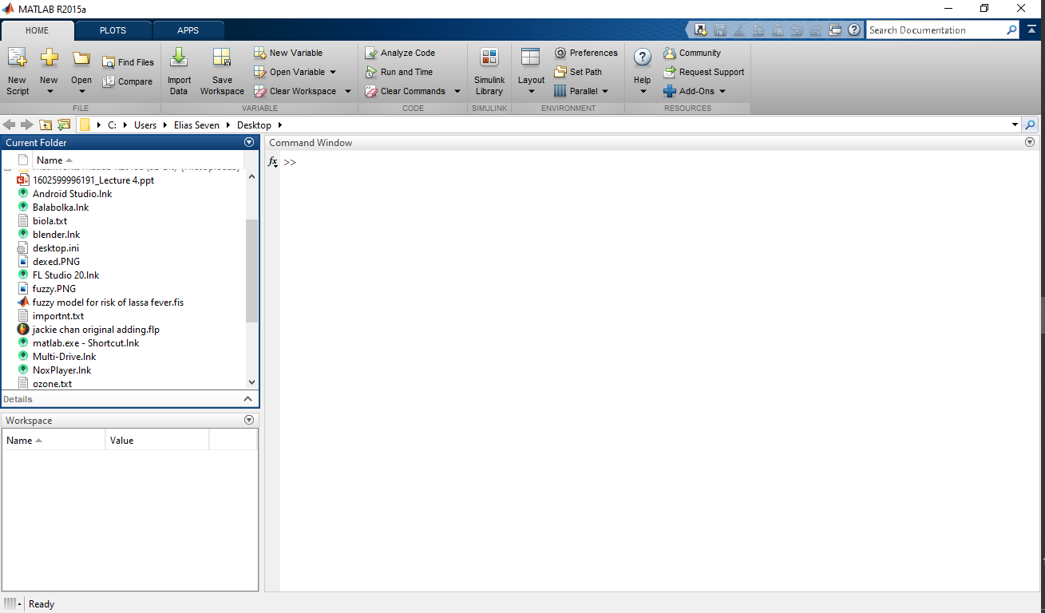
Fig 4.1: workplace of MATLAB for fuzzification lassa fever risk

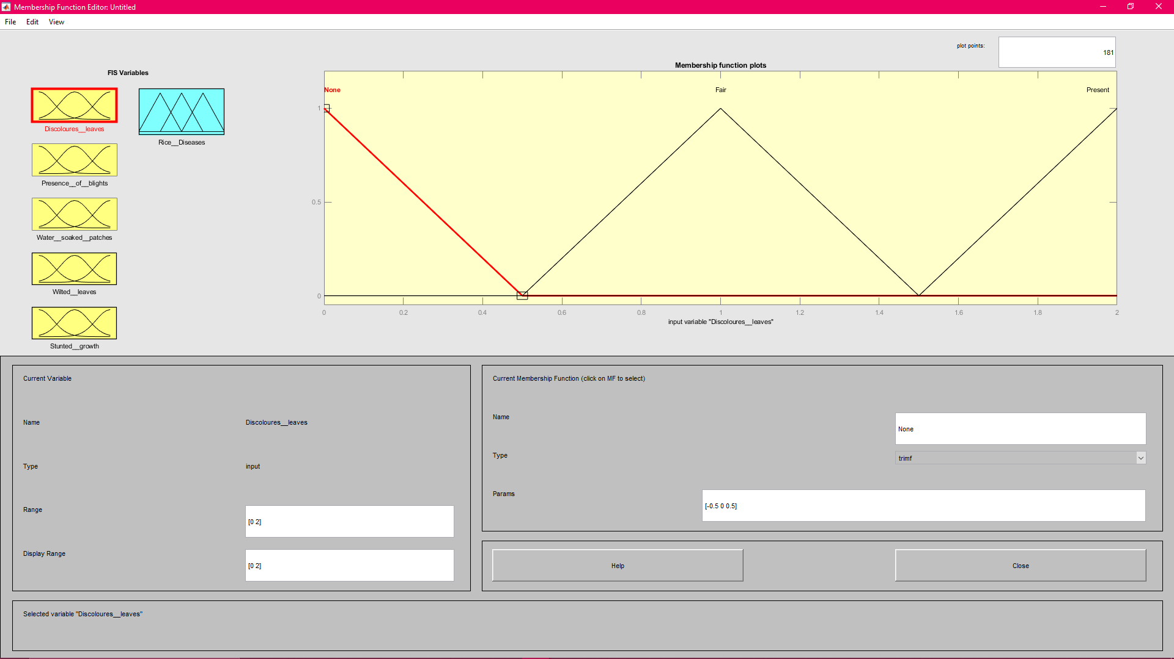

Figure 4.2 fuzzification of age of patient

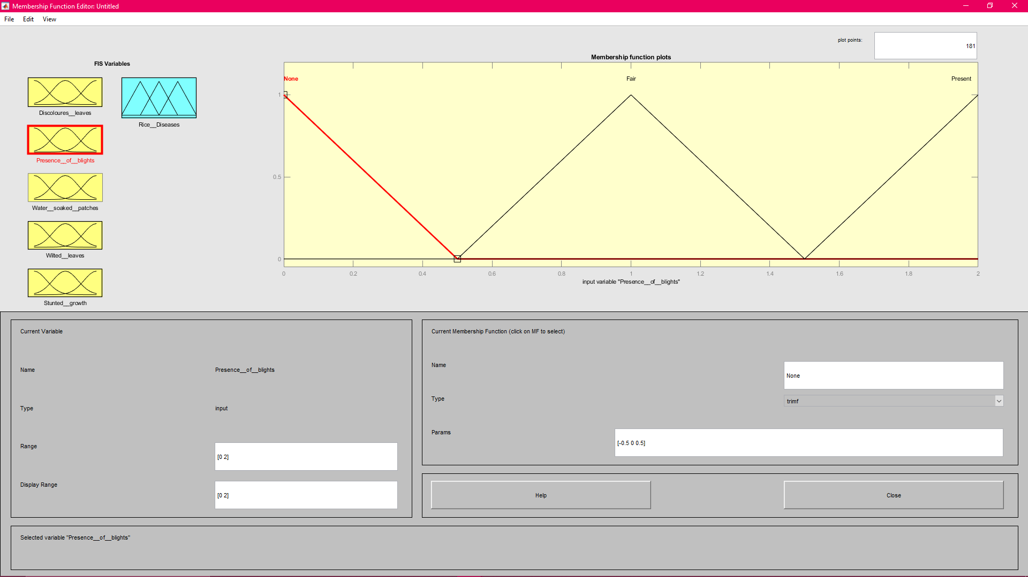

Figure 4.3: Fuzzification of the socio-economic status

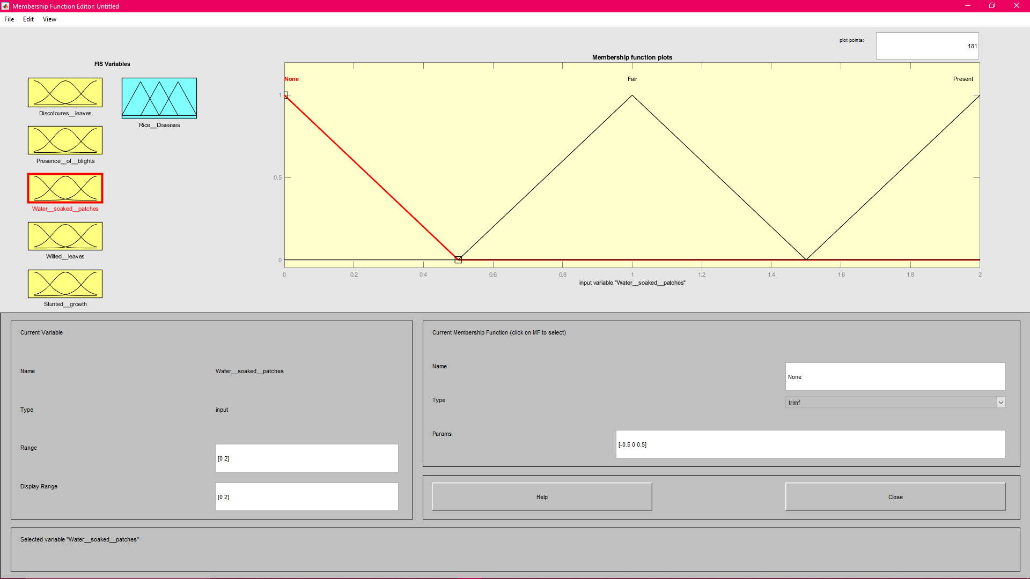

Figure 4.4: Fuzzification of the level of education

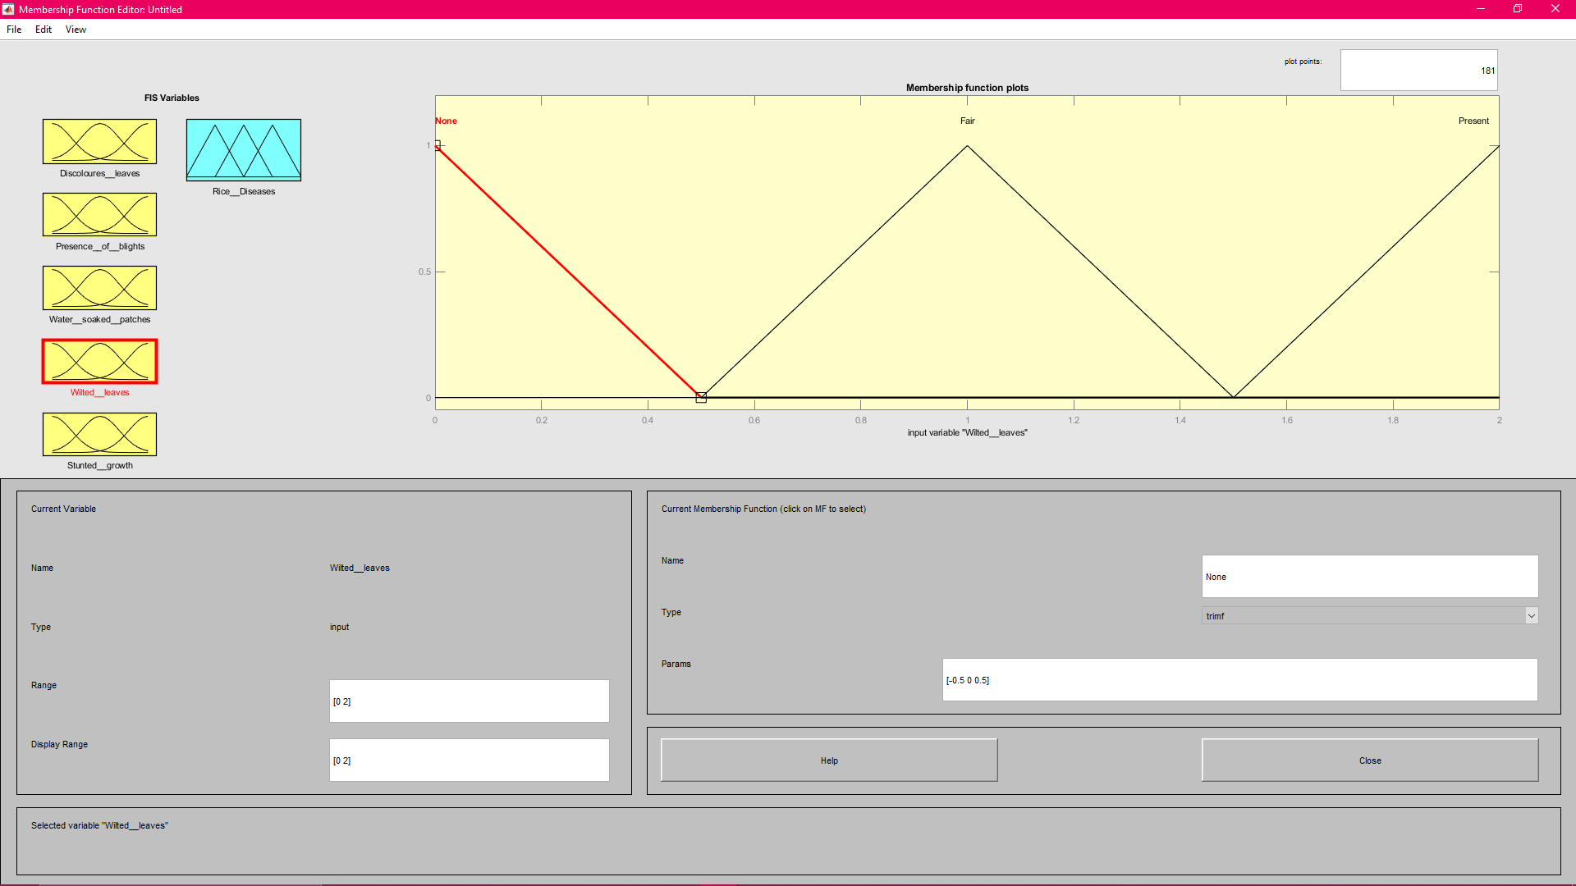

Figure 4.5: Fuzzification of the risk of lassa fever

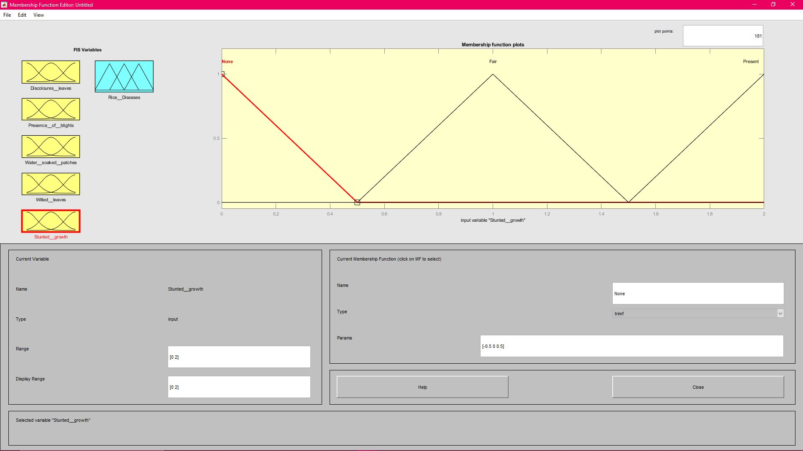

Figure 4.6: Fuzzification of the presence of stunted growth

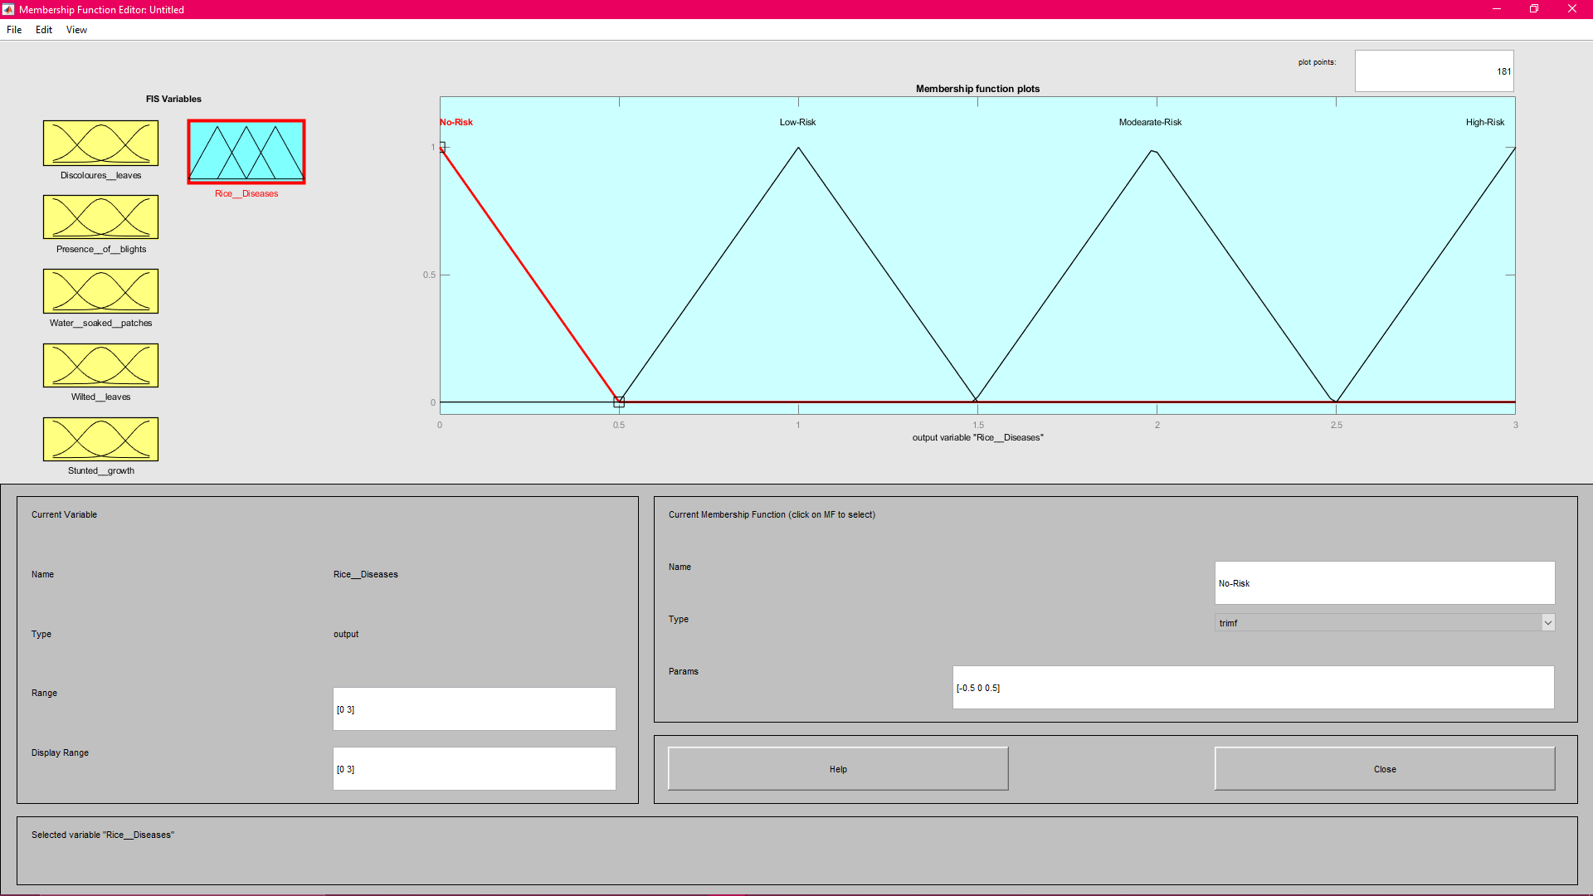

Figure 4.7: Fuzzification of the classification of Rice Plant Diseases

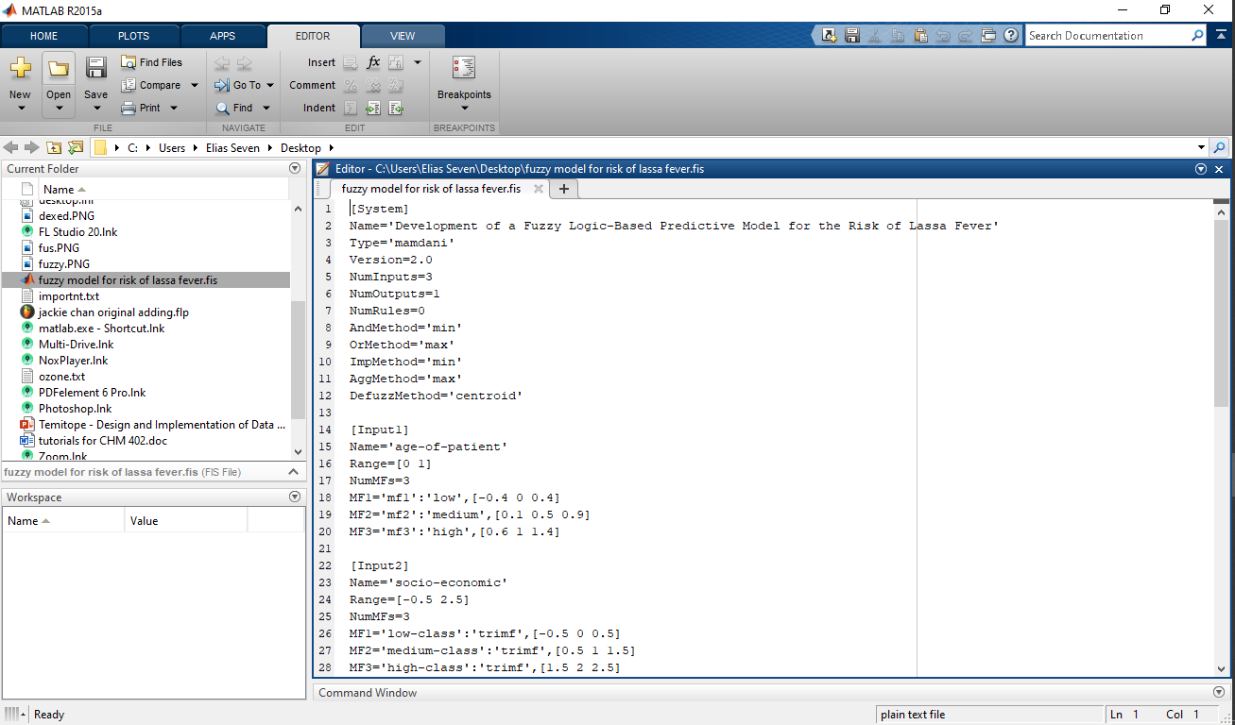

Figure 4.8: Source Code of fis File of Fuzzy Model for risk of lassa fever

CHAPTER 5
SUMMARY AND CONCLUSION
5.1 Summary
As it was proposed in chapter one, the main focus of the study was to develop a model Fuzzy Logic-Based Predictive Model for the Risk of Lassa Fever with the objectives of designing the model and implementing the model on MATLAB.
The model was simulated using a fuzzy logic toolbox available in the MATLAB software. The study identifies means via which cost effective measures which could be put in place into the prediction of the risk of lassa fever based on the information about risk factors. The classification model for the risk of still birth using rules was achieved by fuzzy based model simulation. This study identified 7 risk factors for determining the risk of lassa fever and were formulated using triangular membership functions.
In carrying out the study, most of the information was gathered from journals, books and past research papers related to the subject.

5.2 Conclusions
The study concluded that based on the variables that were identified in the dataset collected for this study, the study also concluded that the 9 related factors identified were risk of lassa fever, socio economic status, socio demographic status, age of patient, place of delivery, symptoms and level of education.
2and 3 triangular membership functions were appropriate for the formulation of the linguistic variables of the factors while the target risk was formulated using 3 triangular membership functions for the linguistic variables no risk, low risk and high risk
5.3 Recommendations
The study suggests that extra initiatives be put spot into the identification of extra non-invasive threat factors necessary for the first detection of Still birth among females that are expectant. Additionally, information regarding risk factors associated with Still birth must be collected so that data mining and machine learning algorithms may be used for the improvement of unbiased predictive versions which don't rely on pro rules elicited from specialists which might be restricted by bias.

References
Dunstan, S.C. and Chuma, E. (2017). Cassava Cultivation in Sub-Saharan Africa. In Achieving Sustainable Cultivation of Cassava. Volume 1. Burleigh Dodds Science Publishing Limited. http://dx.doi.org/10.19103/AS.2016.0014.06
Harvey, C.A., Rakotobe, Z.L., Rao, N.S., Dave, R., Razafimahatratra, H., Rabarijohn, R.H., Rajaofara, H. and MacKinnon, J.L.. (2014). Extreme vulnerability of smallholder farmers to agricultural risks and climate change in Madagascar. Philosophical Transactions of The Royal Society B, 369, 1-12 http://dx.doi.org/10.1098/rstb.2013.0089
Kaur, R, Din., S. & Panru P.S. (2013). Expert System to Detect and Diagnose the Leaf Disease of Cereal. International Journal of Current Engineering and Technology, 3(4): 1-12.
Nweke, Felix I. and Haggblade, S. (2010). The cassava transformation in West and Southern Sub-Saharan Africa. In Successes in Sub-Saharan Africa Agriculture: Lessons for the Future. Edited by Steven Haggblade and Peter B. R. Hazell Editors. Johns Hopkins, Baltimore, 29 – 70.
Owomugisha, G., Melchert, F., Mwebaze, E., Quinn, J.A. and Biehl, M. (2018). Machine Learning for Diagnosis in Plants using Spectral Data. In International Conference on Artificial Intelligence, 1-15.
Omoregbee, F.E. and Banmeke, T.O. (2017). Information Needs of Cassava Farmers in Delta State of Nigeria. Tanzanian Journal of Agricultural Sciences 12(2), 20 – 25.
Parsa, S., Kondo, Takumasa and Winotai, A. (2012). The Cassava Mealy bug (Phenacoccus manihoti) in Asia: First Records, Potential Distribution, and an Identification Key. PLoS ONE 7(10), 1-11.
Ramcharan, A., Baranowski, K., McCloskey, P., Ahmed, B., Legg, J. and Hughes, D.P. (2017). Deep Learning for Image-Based Cassava Disease Detection. Frontiers in Plant Science, 8, 1-7. doi: 10.3389/fpls.2017.01852
Sharareh, R.N. and Xiao-Jun, Z. (2009). Fuzzy Logic Approach to Predict the Outcome of Tuberculosis Treatment Course Destination. In Proceedings of the World Congress on Engineering and Computer Science Volume 2. October 20-22, San Francisco, USA.

APPENDIX I
Inference Rules for the Risk of lassa fever
Rule | Age of patient | Socio economic status | Level of education | Risk of lassa fever | Level of symptoms | Place of delivery | Risk of lassa fever
1 | None | None | None | None | None | None | None
2 | High | High class | Upper class | None | None | Low Risk | Low Risk
3 | None | High class | Upper class | None | Present | Low Risk | Low Risk
4 | None | High class | Upper class | Present | None | Low Risk | Low Risk
5 | None | High class | Upper class | None | None | Low Risk | Low Risk
6 | None | Medium class | Upper class | None | None | Low Risk | Low Risk
7 | Present | Medium class | Upper class | None | None | Low Risk | Low Risk
8 | None | Present | Upper class | None | None | Low Risk | Low Risk
9 | None | None | Present | None | None | Low Risk | Low Risk
10 | None | None | None | Present | None | Low Risk | Low Risk
11 | None | None | None | None | Present | Low Risk | Low Risk
12 | None | None | None | Present | Present | Moderate Risk | Moderate Risk
13 | Present | None | None | None | None | Low Risk | Low Risk
14 | None | Present | None | None | None | Low Risk | Low Risk
15 | None | None | Present | None | None | Low Risk | Low Risk
16 | None | None | None | Present | None | Low Risk | Low Risk
17 | None | Fair | None | None | Present | Low Risk | Low Risk
18 | None | Fair | Present | None | None | Moderate Risk | Moderate Risk
19 | None | None | Present | None | None | Low Risk | Low Risk
20 | None | Fair | None | Present | None | Low Risk | Low Risk
21 | None | None | None | None | Present | Low Risk | Low Risk
22 | Present | Fair | None | None | Present | Moderate Risk | Moderate Risk
23 | None | None | Present | Present | None | Moderate Risk | Moderate Risk
24 | Present | Fair | None | None | None | Moderate Risk | Moderate Risk
25 | None | Fair | None | Present | None | Low Risk | Low Risk
26 | None | None | None | None | Present | Low Risk | Low Risk
27 | Present | Fair | None | None | None | Low Risk | Low Risk
28 | None | Fair | None | None | None | Low Risk | Low Risk
29 | None | Fair | Present | None | None | Low Risk | Low Risk
30 | None | None | None | Present | Present | Moderate Risk | Moderate Risk
31 | None | Fair | None | None | Present | Low Risk | Low Risk
32 | Present | None | None | None | None | Low Risk | Low Risk
33 | None | Fair | None | None | Present | Low Risk | Low Risk
34 | None | Fair | Present | None | None | Moderate Risk | Moderate Risk
35 | Present | Fair | None | None | Present | Moderate Risk | Moderate Risk
36 | None | None | Present | Present | None | Moderate Risk | Moderate Risk
37 | Present | Fair | None | None | None | Low Risk | Low Risk
38 | None | Fair | None | None | None | Low Risk | Low Risk
39 | None | Fair | Present | None | None | Low Risk | Low Risk
40 | Present | Fair | None | None | None | Moderate Risk | Moderate Risk
41 | None | None | None | Present | Present | Moderate Risk | Moderate Risk
42 | Present | Present | Present | None | None | Moderate Risk | Moderate Risk
43 | None | None | Present | None | None | Low Risk | Low Risk
44 | Present | None | None | Present | Present | Moderate Risk | Moderate Risk
45 | Present | Present | Present | None | None | Moderate Risk | Moderate Risk
46 | None | None | Present | Present | Present | Moderate Risk | Moderate Risk
47 | Present | Present | None | None | Present | Moderate Risk | Moderate Risk
48 | None | Present | Present | Present | None | Moderate Risk | Moderate Risk
49 | None | None | None | Present | None | Low Risk | Low Risk
50 | None | None | None | None | Present | Low Risk | Low Risk
51 | Present | None | None | None | None | Low Risk | Low Risk
52 | None | Present | None | None | None | Low Risk | Low Risk
53 | None | None | Present | None | None | Low Risk | Low Risk
54 | Present | None | None | Present | Present | Moderate Risk | Moderate Risk
55 | None | None | None | Present | None | Low Risk | Low Risk
56 | None | None | None | None | Present | Low Risk | Low Risk
57 | Present | None | None | None | None | Low Risk | Low Risk
58 | Present | Present | Present | None | None | Moderate Risk | Moderate Risk
59 | None | None | Present | Present | Present | Moderate Risk | Moderate Risk
60 | Present | Present | None | None | Present | Moderate Risk | Moderate Risk
61 | None | Present | None | None | None | Low Risk | Low Risk
62 | None | None | Present | None | None | Low Risk | Low Risk
63 | None | None | None | Present | None | Low Risk | Low Risk
64 | None | Present | Present | Present | None | Moderate Risk | Moderate Risk
65 | Present | None | Fair | Present | Present | Moderate Risk | Moderate Risk
66 | Present | Present | None | None | None | Moderate Risk | Moderate Risk
67 | None | None | Fair | None | Present | Low Risk | Low Risk
68 | None | None | None | Present | Present | Moderate Risk | Moderate Risk
69 | Present | Present | Fair | None | Present | Moderate Risk | Moderate Risk
70 | None | Present | None | Present | None | Moderate Risk | Moderate Risk
71 | Present | None | Fair | Present | Present | Moderate Risk | Moderate Risk
72 | Present | Present | None | None | None | Moderate Risk | Moderate Risk
73 | Present | None | Fair | None | None | Low Risk | Low Risk
74 | None | Present | None | None | None | Low Risk | Low Risk
75 | None | None | Fair | None | None | Low Risk | Low Risk
76 | None | None | None | Present | Present | Moderate Risk | Moderate Risk
77 | Present | Present | Fair | None | Present | Moderate Risk | Moderate Risk
78 | None | Present | None | Present | None | Moderate Risk | Moderate Risk
79 | None | None | Fair | Present | None | Low Risk | Low Risk
80 | Present | None | None | Present | Present | Moderate Risk | Moderate Risk
81 | Present | Present | Fair | None | None | Moderate Risk | Moderate Risk
82 | None | None | None | Present | Present | Moderate Risk | Moderate Risk
83 | Present | Present | Fair | None | Present | Moderate Risk | Moderate Risk
84 | None | Present | None | Present | None | Moderate Risk | Moderate Risk
85 | None | None | Fair | None | Present | Low Risk | Low Risk
86 | Present | None | None | Present | Present | Moderate Risk | Moderate Risk
87 | Present | Present | Fair | None | None | Moderate Risk | Moderate Risk
88 | None | None | Fair | Present | Present | Moderate Risk | Moderate Risk
89 | Present | Present | None | None | None | Moderate Risk | Moderate Risk
90 | None | None | None | Present | Present | Moderate Risk | Moderate Risk
91 | None | Present | Present | None | None | Moderate Risk | Moderate Risk
92 | Present | None | None | None | Present | Moderate Risk | Moderate Risk
93 | None | None | Present | Present | None | Moderate Risk | Moderate Risk
94 | Present | Present | None | None | None | Moderate Risk | Moderate Risk
95 | None | None | None | Present | Present | Moderate Risk | Moderate Risk
96 | Present | Present | Present | None | Present | High Risk | High Risk
97 | Present | None | None | None | None | Low Risk | Low Risk
98 | None | Present | None | None | None | Low Risk | Low Risk
99 | None | None | Present | None | None | Low Risk | Low Risk
100 | None | None | None | Present | None | Low Risk | Low Risk
101 | None | None | None | None | Present | Low Risk | Low Risk
102 | None | Present | Present | None | None | Moderate Risk | Moderate Risk
103 | Present | None | None | None | None | Low Risk | Low Risk
104 | None | Present | None | None | None | Low Risk | Low Risk
105 | None | None | Present | None | None | Low Risk | Low Risk
106 | Present | None | None | None | Present | Moderate Risk | Moderate Risk
107 | None | None | Present | Present | None | Moderate Risk | Moderate Risk
108 | Present | Present | None | None | None | Moderate Risk | Moderate Risk
109 | None | None | None | Present | None | Low Risk | Low Risk
110 | None | None | None | None | Present | Low Risk | Low Risk
111 | Present | None | None | None | None | Low Risk | Low Risk
112 | None | None | None | Present | Present | Moderate Risk | Moderate Risk
113 | None | Present | Present | Fair | None | Moderate Risk | Moderate Risk
114 | Present | None | None | None | Present | Moderate Risk | Moderate Risk
115 | None | Present | None | Fair | None | Low Risk | Low Risk
116 | None | None | Present | Fair | None | Moderate Risk | Moderate Risk
117 | Present | Present | None | Fair | None | Moderate Risk | Moderate Risk
118 | None | None | None | Fair | Present | Moderate Risk | Moderate Risk
119 | None | Present | Present | Fair | None | Moderate Risk | Moderate Risk
120 | Present | None | None | None | Present | Moderate Risk | Moderate Risk
121 | None | None | Present | Fair | None | Low Risk | Low Risk
122 | None | None | None | Fair | None | Low Risk | Low Risk
123 | None | None | None | Fair | Present | Low Risk | Low Risk
124 | None | None | Present | Fair | None | Moderate Risk | Moderate Risk
125 | Present | Present | None | Fair | None | Moderate Risk | Moderate Risk
126 | None | None | None | Fair | Present | Moderate Risk | Moderate Risk
127 | Present | None | None | Fair | None | Low Risk | Low Risk
128 | None | Present | Present | None | None | Moderate Risk | Moderate Risk
129 | Present | None | None | Fair | Present | Moderate Risk | Moderate Risk
130 | None | None | Present | Fair | None | Moderate Risk | Moderate Risk
131 | Present | Present | None | Fair | None | Moderate Risk | Moderate Risk
132 | None | None | None | Fair | Present | Moderate Risk | Moderate Risk
133 | None | Present | None | Fair | None | Low Risk | Low Risk
134 | None | Present | Present | None | None | Moderate Risk | Moderate Risk
135 | Present | None | None | Fair | Present | Moderate Risk | Moderate Risk
136 | None | None | Present | Fair | None | Moderate Risk | Moderate Risk
137 | Present | Present | None | None | Present | Moderate Risk | Moderate Risk
138 | None | Present | Present | Present | None | Moderate Risk | Moderate Risk
139 | Present | None | None | Present | Present | Moderate Risk | Moderate Risk
140 | Present | Present | Present | None | None | Moderate Risk | Moderate Risk
141 | None | None | Present | Present | Present | Moderate Risk | Moderate Risk
142 | Present | Present | None | None | Present | Moderate Risk | Moderate Risk
143 | None | Present | Present | Present | None | Moderate Risk | Moderate Risk
144 | Present | Present | Present | Present | Present | High Risk | High Risk
145 | None | None | Present | None | None | Low Risk | Low Risk
146 | None | None | None | Present | None | Low Risk | Low Risk
147 | None | None | None | None | Present | Low Risk | Low Risk
148 | Present | None | None | Present | Present | Moderate Risk | Moderate Risk
149 | Present | Present | Present | None | None | Moderate Risk | Moderate Risk
150 | None | None | Present | Present | Present | Moderate Risk | Moderate Risk
151 | Present | None | None | None | None | Low Risk | Low Risk
152 | Present | Present | None | None | Present | Moderate Risk | Moderate Risk
153 | None | Present | Present | Present | None | Moderate Risk | Moderate Risk
154 | Present | None | None | Present | Present | Moderate Risk | Moderate Risk
155 | Present | Present | Present | None | None | Moderate Risk | Moderate Risk
156 | None | None | Present | Present | Present | Moderate Risk | Moderate Risk
157 | None | Present | None | None | None | Low Risk | Low Risk
158 | Present | Present | None | None | Present | Moderate Risk | Moderate Risk
159 | None | Present | Present | Present | None | Moderate Risk | Moderate Risk
160 | Present | None | None | Present | Present | Moderate Risk | Moderate Risk
161 | Present | Present | Present | None | Fair | Moderate Risk | Moderate Risk
162 | None | None | Present | Present | None | Moderate Risk | Moderate Risk
163 | Present | Present | None | None | Fair | Moderate Risk | Moderate Risk
164 | None | Present | Present | Present | None | Moderate Risk | Moderate Risk
165 | Present | None | None | Present | Fair | Moderate Risk | Moderate Risk
166 | Present | Present | Present | None | None | Moderate Risk | Moderate Risk
167 | None | None | Present | Present | Fair | Moderate Risk | Moderate Risk
168 | Present | Present | Present | Present | None | High Risk | High Risk
169 | None | None | Present | None | Fair | Low Risk | Low Risk
170 | Present | Present | None | None | None | Moderate Risk | Moderate Risk
171 | None | Present | Present | Present | Fair | Moderate Risk | Moderate Risk
172 | Present | None | None | Present | None | Moderate Risk | Moderate Risk
173 | Present | Present | Present | None | Fair | Moderate Risk | Moderate Risk
174 | None | None | Present | Present | None | Moderate Risk | Moderate Risk
175 | Present | Present | None | None | Fair | Moderate Risk | Moderate Risk
176 | None | Present | Present | Present | None | Moderate Risk | Moderate Risk
177 | Present | None | None | Present | Fair | Moderate Risk | Moderate Risk
178 | Present | Present | Present | None | None | Moderate Risk | Moderate Risk
179 | None | None | Present | Present | Fair | Moderate Risk | Moderate Risk
180 | Present | Present | Present | Present | None | High Risk | High Risk
181 | Present | Present | None | None | Fair | Moderate Risk | Moderate Risk
182 | None | Present | Present | Present | None | Moderate Risk | Moderate Risk
183 | Present | None | None | Present | Fair | Moderate Risk | Moderate Risk
184 | Present | Present | Present | None | Fair | Moderate Risk | Moderate Risk
185 | None | None | None | Present | Present | Moderate Risk | Moderate Risk
186 | Present | Present | Present | None | Present | High Risk | High Risk
187 | None | Present | Present | None | None | Moderate Risk | Moderate Risk
188 | Present | None | None | None | Present | Moderate Risk | Moderate Risk
189 | None | None | Present | Present | None | Moderate Risk | Moderate Risk
190 | Present | Present | Present | Present | Present | High Risk | High Risk
191 | Present | Present | None | Present | Present | High Risk | High Risk
192 | Present | Present | Present | Present | Present | High Risk | High Risk
193 | None | None | None | Present | None | Low Risk | Low Risk
194 | None | None | None | None | Present | Low Risk | Low Risk
195 | Present | None | None | None | None | Low Risk | Low Risk
196 | Present | Present | None | None | None | Moderate Risk | Moderate Risk
197 | None | None | None | Present | Present | Moderate Risk | Moderate Risk
198 | None | Present | Present | None | None | Moderate Risk | Moderate Risk
199 | None | Present | None | None | None | Low Risk | Low Risk
200 | Present | None | None | None | Present | Moderate Risk | Moderate Risk
201 | None | None | Present | Present | None | Moderate Risk | Moderate Risk
202 | Present | Present | None | None | None | Moderate Risk | Moderate Risk
203 | None | None | None | Present | Present | Moderate Risk | Moderate Risk
204 | None | Present | Present | None | None | Moderate Risk | Moderate Risk
205 | None | None | Present | None | None | Low Risk | Low Risk
206 | Present | None | None | None | Present | Moderate Risk | Moderate Risk
207 | Present | None | None | None | Present | Moderate Risk | Moderate Risk
208 | None | None | Present | Present | None | Moderate Risk | Moderate Risk
209 | Fair | Present | None | None | None | Moderate Risk | Moderate Risk
210 | None | None | None | Present | Present | Moderate Risk | Moderate Risk
211 | Fair | Present | Present | None | None | Moderate Risk | Moderate Risk
212 | Fair | None | None | None | Present | Moderate Risk | Moderate Risk
213 | Fair | None | Present | Present | None | Moderate Risk | Moderate Risk
214 | Fair | Present | None | None | None | Moderate Risk | Moderate Risk
215 | Fair | None | None | Present | Present | Moderate Risk | Moderate Risk
216 | Fair | None | Present | Present | Present | High Risk | High Risk
217 | Fair | None | None | Present | None | Low Risk | Low Risk
218 | None | Present | Present | None | None | Moderate Risk | Moderate Risk
219 | Fair | None | None | None | Present | Moderate Risk | Moderate Risk
220 | None | None | Present | Present | None | Moderate Risk | Moderate Risk
221 | Fair | Present | None | None | None | Moderate Risk | Moderate Risk
222 | Fair | None | None | Present | Present | Moderate Risk | Moderate Risk
223 | None | Present | Present | None | None | Moderate Risk | Moderate Risk
224 | Fair | None | None | None | Present | Moderate Risk | Moderate Risk
225 | None | None | Present | Present | None | Moderate Risk | Moderate Risk
226 | Fair | Present | None | None | None | Moderate Risk | Moderate Risk
227 | None | None | None | Present | Present | Moderate Risk | Moderate Risk
228 | Fair | Present | Present | Present | Present | High Risk | High Risk
229 | None | Present | Present | None | None | Moderate Risk | Moderate Risk
230 | Fair | None | None | None | Present | Moderate Risk | Moderate Risk
231 | None | None | Present | Present | None | Moderate Risk | Moderate Risk
232 | Fair | Present | None | None | None | Moderate Risk | Moderate Risk
233 | None | None | Present | Present | Present | Moderate Risk | Moderate Risk
234 | None | Present | Present | Present | Present | High Risk | High Risk
235 | Present | Present | None | None | Present | Moderate Risk | Moderate Risk
236 | None | Present | Present | Present | None | Moderate Risk | Moderate Risk
237 | Present | None | None | Present | Present | Moderate Risk | Moderate Risk
238 | Present | Present | Present | Present | Present | High Risk | High Risk
239 | Present | Present | Present | Present | None | High Risk | High Risk
240 | Present | Present | Present | None | Present | High Risk | High Risk
241 | None | None | None | None | Present | Low Risk | Low Risk
242 | Present | Present | Present | None | None | Moderate Risk | Moderate Risk
243 | None | Present | Present | Present | Present | Moderate Risk | Moderate Risk

