DEVELOPMENT OF A GEOGRAPHICAL INFORMATION SYSTEM FOR TRACKING THE IMMUNIZATION OF PEDIATRICS ACROSS NIGERIA

OVBIJE ONLYGOD
16010301004

BEING SUBMITTED TO THE DEPARTMENT OF COMPUTER SCIENCE AND MATHEMATICS, COLLEGE OF BASIC AND APPLIED SCIENCES

IN PARTIAL FULFILLMENT FOR THE AWARD OF BACHELOR OF SCIENCE (B.Sc.) DEGREE IN COMPUTER SCIENCE
MOUNTAIN TOP UNIVERSITY, IBAFO, OGUN STATE, NIGERIA

2020

CERTIFICATION
This is to certify that this project, DEVELOPMENT OF A GEOGRAPHICAL INFORMATION SYSTEM FOR TRACKING THE IMMUNIZATION OF PEDIATRICS ACROSS NIGERIA was carried out by me OVBIJE ONLYGOD
with matric no. 16010301004 and duly supervised by Dr. Peter Adebayo Idowu.

_________________________ __________________
Dr. P.A Idowu Date
(Supervisor)

_________________________ __________________
Dr. I. O. Akinyemi Date
(Head of Department)

DEDICATION
This Project is dedicated to God Almighty.

ACKNOWLEDGEMENT
I owe my profound gratitude to God Almighty who gave the strength, wisdom and courage, divine help and provision to me from the beginning to the completion of this work. I express gratitude to my major supervisor, Dr Peter Adebayo Idowu and Mr Jeremiah Ademola Balogun. for their guidance and support in ensuring the successful completion of this research. I sincerely appreciate the Dean, College of Basic and Applied Sciences, Dr. Akinwande A.I., for his fatherly advice, guidance and teachings. My heart-felt gratitude goes to the Head of Department, Computer Science and Mathematics – Dr. Akinyemi I.O., and all other members of staff of the department of Computer Science.

TABLE OF CONTENTS
CERTIFICATION i
DEDICATION ii
ACKNOWLEDGEMENT iii
ABSTRACT ix
CHAPTER ONE 1
INTRODUCTION 1
1.1 Background to the Study 1
1.2 Statement of the Problem 3
1.3 Aim and Objectives of the Study 3
1.4 Research Methodology 4
1.5 Scope of the Study 4
1.6 Signifance of the Study 5
1.7 Justification of the Study 5
1.8 Arrangement of Thesis 5
CHAPTER TWO 6
LITERATURE REVIEW 6
2.1 History of Immunization 6
2.1.1 Types of Immunization 7
2..2 Vaccination 8
2..2.1 Types of Vaccination 8
2.3 Vaccination of Pediatrics 10
2.3.1 Vaccination Schedules for Pediatrics 10
2.3.2 Compulsory Immunization 12
2.3.3 Non-Compulsory Immunization 12
2.3.4 Recommended vaccines for pediatrics 12
2.4 Immunization Information System (IIS) 15
2.5 Immunization Tracking Systems in Nigeria 15
2.6 System Development Life Cycle 16
2.6.1 Information System Development 17
2.6.2 Modeling techniques 17
2.6.3 Geographic Information Systems (GIS) 19
2.7.4 Geographic object 20
2.7.5 Data models 20
.7.5 Location-based service 23
2.8 Related Works 25
CHAPTER THREE 27
RESEARCH METHODOLOGY 27
3.1 Introduction 27
3.2 Functional and Non-Functional Requirements of System 27
3.2.1 Functional requirement analysis 27
3.2.2 Non-Functional requirement analysis 28
3.2.3 Hardware requirements 29
3.2.4 Software requirements 30
3.2.5 Method of Software Development 30
3.3 System Analysis and Design 30
3.3.1 Use Case Diagram 32
3.3.2 Sequence Diagram 35
3.3.3 Activity Diagram 35
3.3.4 Class Diagram 35
3.3.5 Context Diagram 40
3.4 System Development Tools 40
3.4.1 Hypertext Markup Language (HTML) 40
3.4.2 Cascading Style Sheets (CSS 42
3.4.3 Django Framework 42
3.4.4 PostgreSQL 42
3.4.5 Mapbox 42
CHAPTER FOUR 43
RESULTS AND DISCUSSIONS 43
4.1 Introduction 43
4.2 Implementation of the system database for monitoring immunization data 43
4.3 Results of Implementation of the system interface 52
4.4 Discussion of Results 69
CHAPTER 5 71
SUMMARY AND CONCLUSION 71
5.1 Summary 71
5.2 Conclusion 71
5.3 Recommendation 72
REFERENCES 73
APPENDIX 75
LIST OF FIGURES
2.1 Vaccination Schedule for Children (NPHCDA) 13
2.2 Thematic Layers organize the geographical data into distinct themes 21
2.3 Vector data models 22
2.3 Field based data models 24
3.2 Extreme Programming (XP) diagram 31
3.2 Use Case Diagram of Users activities 33
3.3 Sequence Diagram for System Administrator Activity timing 36
3.4 Sequence diagram Health worker and Public Health Official 37
3.5 Showing the Activity Diagram of the System 38
3.6 Showing the Class Diagram used for Data Modeling 39
3.7 Showing the Context Diagram of the System 40
4.1 Showing the description of the database 44
4.2 Showing the State table of the database 45
4.3 Showing the Coordinates table of the database 47
4.4 Showing the Users table of the database 48
4.5 Showing the Records table of the database 49
4.6 Showing the Schedule table of the database 50
4.7 Showing the Recommended Schedule table of the database 51
4.8 Screenshot of Homepage and Login users based on their roles 53
4.9 Screenshot of System Administrator Dashboard 54
4.10 Screenshot of Admin to add users 56
4.11 Screenshot of Admin to manage users 57
4.12 Screenshot of Admin creating and viewing recommended schedules 58
4.13 Screenshot of Admin viewing all records 59
4.14 Screenshot of Health worker dashboard and creating records 60
4.15 Screenshot of Health worker viewing a child’s record 61
4.16 Screenshot of Health worker creating and viewing a child’s schedule 63
4.17 Screenshot of Health worker viewing recommended schedules 64
4.18 Screenshot of Health worker viewing records in their health centre 65
4.19 Screenshot of Public worker viewing all records from health centres 66
4.20 Screenshot of Public worker viewing complied immunization using Charts 67
4.21 Screenshot of Public worker viewing complied immunization using Map 68

LIST OF TABLES
2.1 Vaccination Schedules for Children and Adolescents 14

ABSTRACT
The Nigerian Pediatric Association (PAN) has been successfully implementing a national immunization program since 1968. The program has increased immunization coverage from the beginning, but data on immunization coverage are collected and aggregated from local health centers in paper-based reports with deficiencies that, in turn, contribute to inadequate decision-making in the immunization sector. GIS and related spatial analysis approaches offer a range of tools for explaining and interpreting the evolving spatial organization of health care, analyzing its relationship to health outcomes, and exploring how the delivery of health care can be enhanced. This study presents a system that has been developed to provide spatial information on the distribution of pediatric immunization data across Nigeria. This system has been developed using Hyper Text Markup Language (HTML) and Cascading Styling Sheets (CSS) for page designs. After the design, the system was implemented and tested using the Django server, which acts as a local server for hosting web applications without the use of internet connectivity. Mapbox was been used as a mapping service application to ensure that geographical locations are displayed with the support of Mapbox API. The results of the system tests showed that the system handled the data properly; the coverage of the data stored showed the reliability of the system in data storage and retrieval. The simple interface design proved to be user-friendly for all users that handled the system. The system tackled the issue of a poor health care system for monitoring and evaluating pediatric immunization records. The map display also improves the easy-to- read and easy-to- understand environment for any authorized user to make decisions on immunization coverage. In conclusion, the system has the capacity to monitor and also spatially query the immunization of pediatrics across Nigeria. The system also will go a long way towards resolving the issue of immunization coverage in Nigeria to increase the country's global immunization rate. Also, it will be used by public health authorities to monitor pediatric immunization across Nigeria.

CHAPTER ONE
INTRODUCTION
1.1 Background to the Study
Immunization is the method by which a person is immunized against an infectious disease by the administration of a vaccine (Kristina, 2019). A vaccine can be seen as what initiates the immunization process. In this study, pediatrics, are referred to as infants, children and adolescents. Pediatric immunization is one of the most critical aspects of any health sector in the world and is enforced right from the birth of a child to the required age when all immunization schedules established by the government's vaccination policy have been completed.
Immunization of children in Nigeria started in 1967 and was initiated by an organization called the Pediatric Association of Nigeria (PAN), a non-governmental and non-political association of physicians focusing on childcare (PANConf, 2020). This then contributed to other initiatives such as the Expanded Immunization Programme (EPI) in 1979, later called the National Immunization Program (NPI) in 1996, the World Health Assembly Resolution (WHAR), the United Nations General Assembly Special Session (UNGASS) and many others working together to improve the health of Nigerian children by eradicating all six killers such as polio, measles, diphtheria, whooping cough, tuberculosis, and yellow fever (Ophoriet al., 2014).
With the assistance of these programmes and the improvements with mobile technology, children living in urban and even rural areas will be able to be delivered immunization services whether or not it's fixed (that is, done at the health centre) or mobile (done at the children's individual homes). However, data on immunization coverage from many Nigerian states was obtained and aggregated from community health centers in regular, paper-based reports with deficiencies. In addition, coverage estimates are inconsistent at sub-national levels, resulting in confusion about the size of the target population used by the denominator in coverage calculations (Nguyen et al., 2017).
The development of a Geographic Information System to monitor pediatric immunization in Nigeria can be used to address this problem. This system is an electronic system that easily stores and maintains immunization records for children from multiple health centres, manages vaccine inventories, and helps interpret immunization schedules. With this kind of system, immunization data from every health centre in the country can be monitored and hence enhanced decision-making. Currently in Nigeria, most of the existing and known health systems are based on the Geographical Information System (GIS) and this has helped in a variety of ways, such as improving decision-making by government officials, improving communications during the crisis, improving resource distribution and monitoring the spread of infectious disease. (Fiorenz, 2012).
According to Idhoko and Ojaiko (2013), GIS can be seen as a system capable of gathering, storing, analyzing and presenting geographically referenced information that works by linking information from different sources. Ontological developments and technical advancement have increased the general public's exposure to GIS ability and have also inspired researchers to pursue more effective GIS techniques (Pearce et al., 2006). The recent invention of web services, 3-dimensional (3D) visualization tools (e.g. Google Earth, World Wind) and Maps Application Programming Interface (API) has definitely led to the ever-increasing attention paid to the development and implementation of distributed GIS over the Internet (Butler, 2006).

Integrating GIS will allow the general public health authorities to monitor and follow up on immunization of pediatrics around the country in order to enhance the choices that impact control strategies.
1.2 Statement of the Problem
Tracking immunization is one of the milestone facing the Health Sector in Nigeria today, over 5 million children are not registered at birth and about 4.3 million still miss vaccination each year (UNICEF, 2018), even with the improvement in technology, the use of paper-based system for storing immunization records is still employed at health care centres, this has led to loss of records, and since the records are not being tracked, it has proven quite difficult to get the accurate compilation of vaccinated and non-vaccinated children in the country.
1.3 Aim and Objectives
The aim of this study is to develop an information system for public health officials, for the analysis of information stored by health workers regarding immunization of pediatrics in their health centres, in order to improve decision making.
The specific research objectives are to
- identify the requirements of the immunization tracking system based on system users.
- specify the design of the system based on (i).
- design the database required for storing and retrieving information; and
- implement a prototype system based on the design in (i) and (ii).

\
1.4 Research Methodology
In order to meet up with the aforementioned objectives of this study, the following methods will be adopted;
- Related works on the development of Geographic Information System (GIS).
- Structured interview with health experts in the immunization unit was done to obtain the user and system requirements.
- Due to the iterative and short-term nature of the system, extreme programming was employed in the development of the system.
- Graphical representation of the system was done with various Unified Modeling Language (UML) diagrams.
- Collection of information about coordinates of the various location of health centres.
- Adoption of the Mapbox API for integrating the mapping functions in to the system.
- The system was implemented using the combination of Hypertext Mark-Up language (HTML), Cascading Styling Sheets (CSS) and Bootstrap for the web user interface.
- For the server-side, Django framework was used to connect the web interface to the database. JavaScript (JS) for Mapbox functionality and PostgreSQL for database implementation.

1.5 Scope of the Study
This study is limited to the development of a GIS system for the storage, retrieval and analysis of immunization information of pediatrics for decision support for health centres within Ogun State.
1.6 Significance of the Study
This project will help in the analysis of immunization data, when needed for decision making. It helps in ensuring health workers administer vaccines to pediatrics using the recommended immunization schedules provided by the government. It also helps in the in easy retrieval of children immunization history by parents if needed. And most importantly, it helps in the analysis of the immunization coverage from several health centres in a state.
1.7 Justification of the Study
The improvement in technology around the world, cannot be overemphasized, comparing the results of immunization of pediatrics in the Nigeria to other countries, it’s way lower based on poorly effective means used of achieve it, systems that have been built for this purpose, still are inadequate to justify or map out the accurate information of children immunization in Nigeria. With the help of this project this information can be gotten and be used to make Nigeria as a whole a better country.
1.8 Arrangement of Thesis
This chapter presents the introductory aspect of the project. Chapter two presents the review of related works surrounding the body of knowledge of immunization tracking system. Chapter three presents the specific materials and methods that were required for the design and development of the immunization information system. Chapter four presents the results of the implementation of the database and frontend interface of the prototype for tracking immunization data. Chapter five presents the summary, conclusions and recommendation of the study.

CHAPTER TWO
LITERATURE REVIEW
2.1 History of Immunization
Immunization is the mechanism by which a person's system is improved against an infectious disease. Immunizations are also claimed to be less dangerous and safer than risking a milder form of disease as a result of being evidence against a particular disease (Vaxins, 2016). Before the advent of vaccines, individuals could only become evidence of commsunicable disease by contracting and surviving the disease. During this process, smallpox (variola) was prevented by inoculation, which created a milder effect than natural disease.
The first direct importance of smallpox inoculation was the Chinese author Wan Quan (1499-1582) in his Douzhenxinfa published in 1549 (Needham, 1999). Powdered smallpox scabs were blown up the noses of a healthy patient in China. Patients will then develop a light case of the disease and have been immune to it since then. The technique had a death rate of 0.5-2.0 percent, but that was considerable, but the disease itself had a death rate of 20-30 percent. Two reports on the Chinese practice of inoculation were obtained by the Royal Society in London in 1700; one by Dr. Martin Lister, who received a report from an East Indies employee stationed in China, and another by Clopton Havers (Silverstein, 2009).
In accordance with Voltaire (1742), the Turks derived their use of inoculation from the neighboring Circassia. Voltaire did not speculate about where the Circassians derived their technique, although he claimed that the Chinese had studied it for the last hundred years (Voltaire,1742). Stern and Markel wrote in 2005 about Jenner, a rustic doctor living in Berkeley (Gloucestershire), who had the world's first vaccine in 1796 (Heinemann, 1981). In his writings, Jenner 's discovery came from taking the pus of a cowpox lesion on the milkmaid 's hand and inoculating it on an eight-year - old boy, James Phipps. Then, six weeks later, he variolated at two places on Phipps' arm with smallpox, but the boy was unaffected by it in the same way as subsequent exposures. (Marchel, 2005).
Although Jenner proposed cowpox (smallpox) inoculation, which could be a much safer method. This practice, known as vaccination, eventually replaced smallpox inoculation, now referred to as variolation to say apart from vaccination. Until the 1880s, vaccine or vaccination was limited to smallpox, but Louis Pasteur developed immunization methods for chicken cholera and anthrax in animals and human rabies, indicating that the terms vaccine and vaccination should be expanded to cover up new procedures. This, however, creates uncertainty if care is not taken to determine which vaccine is used, e.g. measles or influenza vaccine.
2.1.1 Types of Immunization
Immunization can be accomplished in an active or passive manner: vaccination is an active form of immunization (FDA, 2019). When a person comes into contact with a microbe as an example, the system will eventually produce antibodies and other antimicrobial defenses. Subsequently, the immune response to this microbe can be very effective; this is often the case in many childhood infections that someone contracts only once, and is immune again, this normal phenomenon is assumed to be successful immunization, while pre-synthesized elements of the system are passed to the person so that the body does not have to generate these elements.
Antibodies are also used for passive immunization at present. Physiologically, passive immunization happens when antibodies are passed during pregnancy from the mother to the fetus. This form of immunization starts to work very quickly, but is short-lived because the antibodies are naturally broken down. Antibodies may be developed in animals called serum therapy, but there is a high risk of anaphylactic shock. Antibodies, called serum therapy, can be produced in animals, but there is a high risk of anaphylactic shock due to immunity to the animal serum itself. Humanized antibodies developed by cell culture in vitro are therefore used instead.
2.2 Vaccination
Vaccination is the use of a vaccine to help the immune system establish disease defense. In a weakened, live or dead state, vaccines contain microorganisms or viruses or proteins or toxins from the body. They help avoid illness from an infectious disease by stimulating the body's adaptive immunity. Herd immunity occurs when a sufficiently significant percentage of a population has been vaccinated. Vaccination efficacy has been extensively studied and confirmed. (Fiore et al., 2009), (Liesegang, 2009), (Chang et al., 2009). Vaccination is the most effective way to avoid infectious diseases; widespread immunity due to vaccination is primarily responsible for the global eradication of smallpox and the disappearance of diseases such as polio and tetanus from much of the globe (CDC, 2011).
Immunization and vaccination of children are two of the most significant strategies in public health and represent a cost-effective approach to minimize both morbidity and mortality associated with infectious diseases. It ensures that infants, right from the day of birth, are given the necessary vaccines at specific scheduled times, while others are kept healthy and free from many types of infections and diseases.
    - Types of vaccination
There are many different types of vaccines available. Each type is designed to teach your immune system how to control those types of germs and the severe diseases they cause, which are the four main types of vaccines recommended by Health and Human Services (HHS, 2019).
- Live-attenuated vaccines: These vaccines contain a live virus weakened during processing to prevent a vaccinated person from causing the actual disease. Live vaccines are used to protect against: measles, mumps, rubella (MMR combination vaccine), rotavirus, smallpox, chickenpox and yellow fever.
- Inactivated vaccines: These vaccines contain a virus that has been killed so as not to cause disease, but the body still recognizes it and stimulates production of antibodies against the virus. They can be given to individuals with weakened immune systems. Inactivated vaccines are used to protect against Hepatitis A, flu (shot only), polio (shot only) and rabies
- Subunit, recombinant, polysaccharide, and conjugate vaccines: In certain cases, no complete virus or bacteria are necessary to react immune to disease prevention; only essential sections, a portion or a "subunit" of the disease-causing bacteria or virus are needed to provide protection. These vaccines are used to prevent Hib disease against hepatitis B, human papillomavirus ( HPV) and the DTaP vaccines against whopping cough. Pneumococcal disease and meningococcal disease shingles.
- Toxoid vaccines: Certain bacteria are caused by the secretion of poison (a toxin) in humans. Scientists find that weakening the toxins does not cause disease, so that they are "detoxified." These are also used to protect against the HPV disease.

2.3 Vaccination of Pediatrics
The vaccination of pediatrics is very necessary and should be done at of when due. In Nigeria, there are lots of agencies that has contributed to the immunization growth form both far and ends of the country. Some of them include WHO, UNICEF, CDC, NPHCDA, NPI, and many others. Due to the aid of these organizations, vaccinations can be access in in any region of the world. This has saved the lives of so many children from deadly diseases such as measles, smallpox, yellow fever to name a few (Vaxins, 2010).
Vaccination schedule is a collection of vaccines, including the timing of all doses that may be recommended or compulsory depending on the country of residence. Multiple dose or doses are needed for optimum efficacy for several vaccines, either to produce adequate initial immune response or to improve time-long response. Tetanus vaccine boosters, for instance, are commonly prescribed every 10 years (Mayo, 2006).
The prescribed vaccination schedules have increased quickly over the past two decades and become complicated with the development of several new vaccines (Vaxins, 2010). According to The Scheme of Complete Basic Immunization for Toddlers Based on the Nature of Organization by Sendy, (2018), the types of immunization schedule are presented in the following paragraphs.
2.3.1 Compulsory Immunization
This is a government regulated immunization process, which is performed to protect one and his environment from such infectious diseases, according to one's own needs. Compulsory immunization requires routine, advanced and specific immunization.
- Routine Immunization: tasks of immunization that are carried out regularly as planned. The following explains it is more.
- Hepatitis B: It's prescribed on the birth, 10 and 16 weeks. It's a major global health problem which threatens your liver condition. It may cause chronic liver disease and even potential death.
- Whooping Cough: This vaccine is usually prescribed on the 6, 10, 14 weeks. It's the disease of the respiratory tract. It's caused by bacteria which lives in the throat, mouth, and nose. It's very dangerous for infants.
- Polio: The vaccination age should be six, eight, and sixteen weeks. Children under 5 years old are mostly affected. A paralysis occurs in one of two hundred infections. Approximately 5% of kids die as their muscles become immobilized.
- Measles: It is extremely infectious and remains the leading worldwide cause of death among young children. The usual vaccination age is nine months.
- Tuberculosis: It's usually prescribed for vaccination at birth. The disease is airborne and very lethal. It can be spread to many organs and cause serious illness. An untreated person can infect up to 15 people a year.
- Tetanus Toxoid: The normal vaccination age may be six months, and one year for mothers during their pregnancy. Muscle spasms are characteristic of tetanus. If the disease progresses, titanic seizure can cause death.
- Yellow Fever: It is recommended on the ninth month. Yellow fewer are not specially treated, although it is strongly recommended for people living in Africa. In Nigeria, vaccine preventable account is 22 per cent for this disease.
- Advanced Immunization: This is repeating immunization in order to maintaining the immune level or prolonging the protection period. This immunization is given to children (under 3 years old toddlers), elementary school age children, and women in fertile age.
- DT vaccination is given for creating simultaneously immune system to prevent diphtheria and tetanus for children. The side effects are limp and rash at injection area, also seldom occurrences of fever symptoms.
- TD vaccination is administrated as continuous immunization program after DT vaccination. This immunization is given since the children are 7 years old. The reactions from this immunization are occur if the children have severe reaction in previous vaccination.
- Specific Immunization: It is specific in the sense, that it examines the testing of vaccine-preventable disorders in the workplace and then addresses specific problems related to hepatitis B, chicken pox, TB, measles, rubella, diphtheria, polio, mumps and hepatitis A (David Baxter, 2007)
    - Non-Compulsory Immunization
This immunization schedule type is not regulated by the government. It is taken accordingly to one's needs to protect the society around him or her from certain contagious diseases.
2.3.4 Recommended vaccines for pediatrics
There are a number of immunizations plans for pediatricians. The correct order should therefore be well handled in the form of a schedule of immunizations. Nigeria uses the routine form of immunization schedule., Figure 2.1 indicates the immunization schedule recommended by the Nigerian Federal Ministry of Health to be given free of charge. Table 2.1 provides a view of vaccines for children and adolescents approved by the World Health Organization (WHO) (Ibenegbu, 2018).

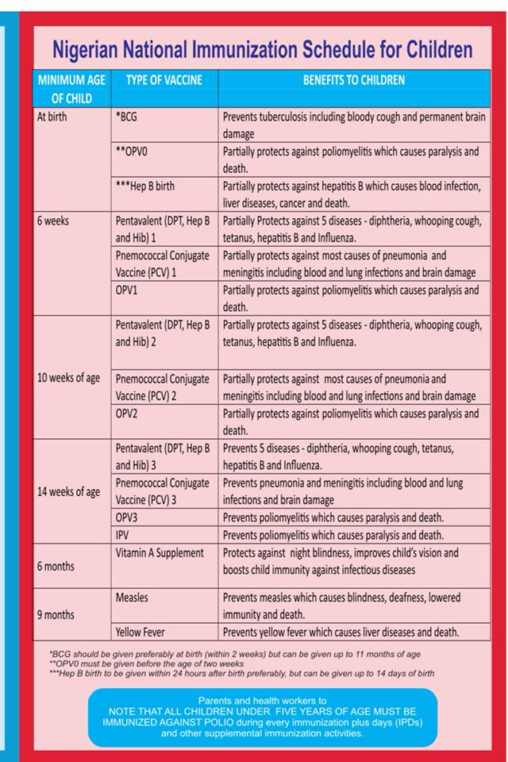
Figure 2.1 Vaccination Schedule for Children (NPHCDA)

Table 2.1 Vaccination Schedules for Children and Adolescents
AGE | DISEASE | VACCINE
At Birth | Hepatitis B | HBV 1,
At Birth | Polio | OPV0
At Birth | Tuberculosis | BCG
6 weeks | Polio | OPV 1
6 weeks | DPT, HIB, Hepatitis B | Penravalent 1
6 weeks | Rotavirus | Rotanix 1
6 weeks | Pneunomia and Ottis Media | Synoflorix 1 or Prevner  13
10 weeks | DPT, HIB, Hepatitis B | Pentavalent
10 weeks | Rotavirus | Rotarix 2
10 weeks | Pneunomia and Ottis | Synoflorix 2 or Prevner 13
14 weeks | DPT, HIB Heptasis B | Pentavalent 3
14 weeks | Pneunomia and Ottis | Synoflorix 2 or Prevner 13
6 months | Vitamin A | Vitamin A
9 months | Measles, Yellow Fever | Measles, Yellow Fever
12-24 months | Meningtis and Septiaemia | Nimenrix
12-24 months | Vitamin A | Vitamin A
12-24 months | Polio | OPV booster
15 -18 months | Measles, Mumps, Rubella | Measles, Mumps, Rubella
24 months | Typhoid Fever | Typherix

2.4 Immunization Information System (IIS)
Immunization Information System (IIS) is an information system that gathers vaccine data on all citizens in a geographical area; an information record or immunization information System (IIS) is a data system. Significant resources for improving and sustaining a high immunization coverage by re-assembling children and adults from various providers with vaccine records, foreshadowing potential expenses past due, due and subsequent to the provision of support for the generation for each person of vaccine records for records of vaccination and for formal vaccination evaluation.
One of the domestic health targets is to raise to 95% the number of children under the age of 6 enrolled in the fully operational IIS (CDC 2019) population. A fully functioning IIS requires 95% or more registration of children under the age of 6 with 2 or more experiences of vaccine administered under the Immunization Practices Advisory Committee (ACIP, 2011). The IIS is not a novel idea. Many individual health plans and practices offer their patients immunizations. The records are also based on computerized information systems, such as billing, developed for other purposes. The creation of completely computerized patient medical records is also on the rise. Although an IIS contains all vaccines provided by participating healthcare providers, only populations are concerned. IIS will provide information on the vaccinations provided by all providers to all children and to all adults (CDC 2019).

2.5 Immunization Tracking Systems in Nigeria
In Nigeria, a GPS (Global Positioning System) and locational services have not been introduced to help track vaccination records and timelines for health centers, but currently a Vaccine Tracking System (VTS) project has been developed. It is one of the tracking systems developed in 2012 in support of the Nigerian government and partner agencies' efforts in the elimination and certification of polioviruses. It uses data obtained during vaccination campaigns plus days (IPD) to detect missing or partially covered vaccination settlements in high risks.

2.6 System Development Life Cycle
The System Development Life Cycle (SDLC) is the mechanism used by the software sector for software design, development and testing. The SDLC is committed to creating quality software, which meets or surpasses customer requirements and achieves its delivery in a timely manner and costs. It is a structure that describes tasks performed at any level of the creation of software.
SDLC processes is an array of activities for system designers and developers to adopt effectively and on time for developing software, such as analytics, design, implementation, testing and maintenance, according to Bhatnagar and Singh (2013). It also describes that SDLC is a term that is used to characterize the phases involved in the creation of an information system, from the initial feasibility studies to the maintenance of the completed application, and emphasizes that the key goals of the SDLC is the guarantee of high-quality systems with strong controls to optimize productivity.
According to Half (2019), the SDLC explains the challenges of transformation from start to finish without forgetting a move. It also lists the numerous SDLC methodologies employed today to direct professionals through their project based work, such as waterfall model, fast application development (RAD), popular application development (RAD), the V-shaped model (verification and validation model).

Gandhi and his crew also clarified that different types of risks that were associated with each of these SDLC stages, regardless of model preference. It proposed a model to help assess the effect of the risk on the project under construction, with the goal to mitigate the project failures resulting from these risks (Gandhi et al., 2014).
2.6.1 Information System Development
Is a structured socio-technical and organizational structure for gathering, sorting and disseminating information (Piccoli et al., 2018). This consists of input messages, encoding of messages and output messages. It also has guidelines for processing that govern the implementation of the information system. However, the information systems have a manual if the procedures require a great deal of personal experience, evaluation and intuition. A purposeful knowledge system can assist and support consumers in making good decisions (Anders 2012). Each particular information system supports operations, administration and decision-making (Bulgacs and Simon, 2013). Creation of an information system is the process by which a new software app (farm credit association, 2007) is described, developed, tested and implemented.
According to Nyawaya (2008), stated some emerging examples of information system development such as geographic information systems, land information systems, disaster information systems and many more. He also listed out the stages in development of the system which include problem recognition and specification, information gathering, requirements specification for the new system, system design, system construction, system implementation review and maintenance.
    - Modeling techniques
Software engineering modeling is an essential component of any operation that can lead to successful software implementation. The optimal configuration and behavior of a system is communicated. Moreover, models are created in order to imagine and monitor the design of the system and better understand the system we are creating, which also demonstrate potential for simplification, reuse and risk management (Booch et al . 1998). A model provides the system designs and helps users view the final product.The modeling techniques include the notation of business processes (bpmn), UML diagrams, flowchart techniques, data flow charts, roles operation charts and an integrated feature model description. UML is a general-purpose modeling language, built for a standard way of representing the design of the device (Addison-Wesley 2005) for software engineering.
Within the Object Oriented (OO) Environment, UML is the industry standard language in which software systems artefacts are specified, visualized, designed and recorded (Laman, 2004). For the study and design of a system, UML uses a different diagramming model.In the UML modeling there are nine objects, primarily classified in two different views of a device model. The static view (or structural) emphasizes the system's static structure using objects, attributes, operations and connections. These static components are shown in case, class, set, component and implementation diagrams (Padmanabhan, 2012).
  - Use Case Diagram
It describes of the interaction between a user and a system, indicating the user 's relationship with the various use cases affecting the user. It may consist of various systems users and the various use cases and is often followed by other diagrams. Either circles or ellipses are depicted in the case of use. A use case diagram is useful for showing the system context and the drawbacks of the behavior of the system. The use case diagram can also define each case of use with a narrative form (Elkoutbiet al ., 2012).

  - Class Diagram
It is made of static structures that display system structure, classes, attributes of system operations (or methods), and interrelations between objects. Diagram is a type of system structure. It is the key element in object-orientated modulization. It is used to model the structure of the application generally and to convert the models into software code in detail (Sparks, 2011).
- Component Diagram
A Component diagram allows verification that the appropriate device functionality is reasonable. These diagrams are often used as a collaboration method between the creator and device stakeholders.
- Deployment Diagram
The deployment diagram in the UML models the physical deployment of objects to nodes (Wayback Machine, 2011). It shows how the system will be physically deployed in the hardware world. Its aim is to demonstrate where the various components of the system will be physically operating and how they will interact with each other.

2.7 Geographic Information Systems (GIS)
The GIS is a conceptualized structure which enables spatial and geographic information to be collected and analyzed. GIS applications (or GIS applications) are computer-based tools that enable users to construct interactive queries (user-created queries), analyze spatial information output, alter map data, and visually share the results of these queries (Clarke, K.C., 1986) (Maliene V et al., 2011). To assist in the collection, management, storage, analysis , development and dissemination of spatial data and information, GIS can also be used as a computer-based system (Bolstad, 2007).

2.7.1 Geographic object
It is a geographical entity. It's a special world entity which is constrained in terms of biology, geometry or theme (Reinhardt et al., 2003). Norbert de Lange describes geographical objects as follows: spatial elements describing geometric, topological, and temporal properties, in addition to semantical information (Lange, 2006) are geographical objects.
2.7.2 Data models
A data model is an abstract model that organizes and standardizes relationships between data elements and properties of reality entities. For example, a data pattern can imply that the data element for a car consists of a number of other color-size, car owner elements (Stan, 2016). This helps one to map data structures in a GIS for computational and visualization purposes. It also helps the organization, using two fundamentals, a layer or an object-orientated model, of geographical objects at a high level.
        - Thematic layer concept
A Thematic Layer lets you roll up metrics grouped and colored by regional boundaries (e.g. record count, numbers, percent values, other numeric fields). While the themed layers are similar to heat maps, they specifically differentiate concentrations by regional borders rather than by just hot spots.
        - Vector, raster and hybrid models
Is the form of points, lines, or polygons, the data models reflect data details (Figure 2.3), these basic geometrical factors are described as Simple Features..

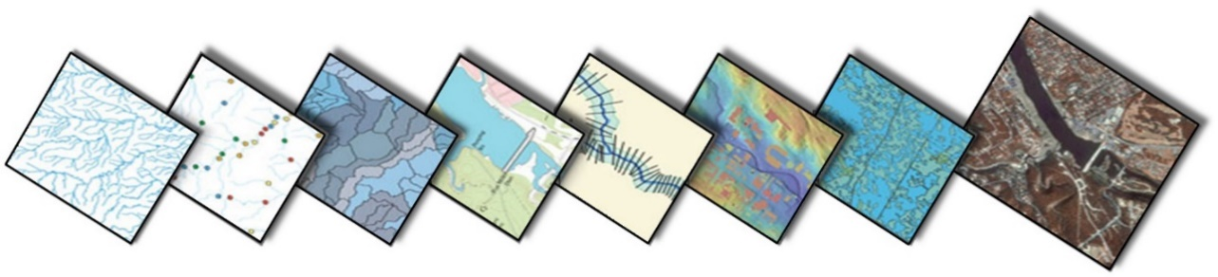
Figure 2.2 Thematic Layers organize the geographical data into distinct themes. In this image Points-of-Interest, orthoimages, elevation data and water bodies represent distinct layers.
(Source: Mikael Vaaraniemi, 2014)

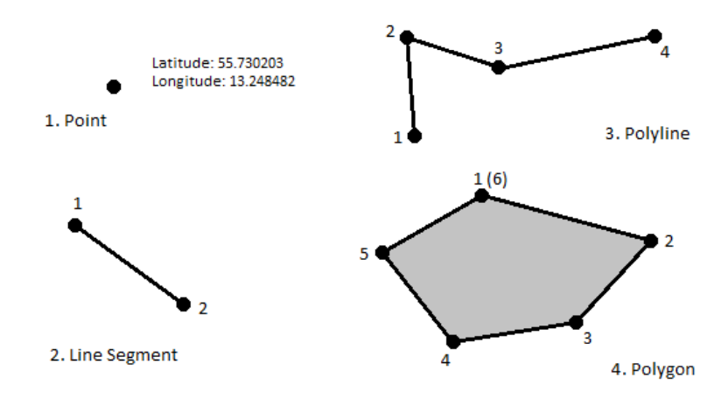
Figure 2.3: Vector data models (Source: Bartelme, 2005)

model. Both geographic elements are centered on point coordinates, e.g. latitude and longitude, in the vector data model. The topological relationship, for example, which points build a line or an field, is specifically stored (Lange, 2006). We describe the thematic relationship using further attributes, e.g., if a line is a path. Therefore, the geo-relational data model is also known as the vector data model (Bartelme, 2005).
        - Field-based data model
The field-based model partitions the theme of the geographic input surface into homogeneous areas (cells). The form and size of these cells can be defined freely. However, as a whole, they should cover the entire input surface (Bartelme, 2005). Therefore, each cell explicitly stores georeferenced thematic in- formation (Figure 2.4). An example for the field-based concept is the DEM, wherein each cell represents the average height inside the covered input surface.
- Raster Data Model:
In GIS, to display continuous data over space, the raster data model is used. It is a field-based model specialization. The input surface is divided into areas of equal size, usually a quadratic cell, that is, a pixel. Every cell, for instance, stores the ambient temperature or the average height. The cell size determines the perceivable resolution of data (Bartelme, 2005).
2.8 Location-based service:
A location service is a general term which refers to software services providing users with services or information that use geographic information and data (Schiller et al., 2004). LBS may be used in various contexts, for example in fitness or indoor object search (Guo et al ., 2008). Job and life in a personal capacity (2008), entertainment (Zhang et al., 2011).

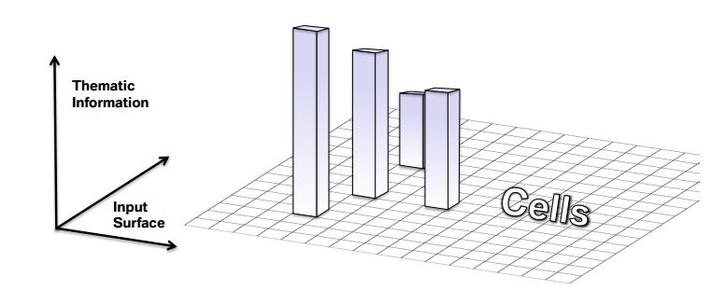
Figure 2.4: Field based data model showing partitions of the input space
(Source: Mikael Vaaraniemi, 2014)

2.9 Related Works
Sedghi, (2000) worked on the design and assessment of the distributed health care vaccine record system model (prototype). This study was aimed at developing a reliable data model based on Canadian health resources, such as the Canadian Public Health Department, the Canadian Immunization Guide and the National Data Standards Survey. The project used an online vaccine tracking model which was then introduced and validated by a number of health professionals using the expertise of the Canadian Immunization Guide and related data elements widely used in different jurisdictions. The findings illustrate how the information system for immunization is planned and implemented. The limitations of this study are that no charts or maps were used to indicate where the vaccine was administered.
Michelle Paradis et al., (2017), worked on Immunization and Technology Research among Newcomers: A Vaccine Monitoring Application Evaluation Survey. The aim of the study was to inform how the current mobile immunization monitoring program, CANImmunize, could be adapted to address the specific needs of newcomers in Canada. The findings of the study show that mobile devices can be a valuable tool to help newcomer families remain on board with provincial and territorial immunization schedules. The limitations of this research include a limited sample size and a single center study design, both of which could restrict the generalizability of results, and did not aim to determine the degree of coverage of vaccines in newcomers to Canada.
Victoria et al., (2014) focused on research using Geographic Information Systems to monitor the success of the Polio Vaccination Team in northern Nigeria. The main objective of the study or project was to introduce the Global Positioning System (GPS) Receivers and GIS to monitor polio vaccination in the region. The project included the supervision of 12 vaccination teams assigned to GPS receivers during additional immunization events, in addition to collecting reliable information based on certain variables, such as time tracked for all receivers, range and mean time tracked for single receivers. The findings of the analysis were that the program was able to track areas overlooked by the vaccination teams with the aid of satellite and GIS imagery.
Nguyen et al., (2017), worked on a digital immunization registry to demonstrate the effect of mHealth (Mobile Health) on improving system and immunization coverage in Vietnam for children under one year of age. In order to increase immunization coverage and timeliness of vaccination, the study focused on the core function of the system that provides SMS reminders, thus improving the consistency and efficacy of immunization programs. The result shows that the use of a digital immunization register and SMS immunization reminders will increase immunization coverage and vaccination timeliness and boost the efficiency and effectiveness of the immunization program, as the ImmReg (Immunization Registration) system is widely embraced and valued by health staff, health leaders and customers. The research was restricted to the use of SMS notifications and registration of immunizations and based only on children in Vietnam under the age of five.

CHAPTER THREE
RESEARCH METHODOLOGY
3.1 Introduction
The methodology describes the tools, procedures, and techniques used to achieve the specific objectives of the GIS immunization system. The design of the system was specified using the Unified Modelling Languages (UML) such as use-case for the user actions, sequence diagrams for timing of operation and class diagrams for the data model of the system. The system was implemented using a combination of Hypertext Mark-Up language (HTML) and Cascading Styling Sheets (CSS) for the web layout design, PYTHON for connecting data in and out of the database to the interface, JavaScript (JS) for Mapbox Map functionality and PostgreSQL for database implementation.
3.2 Functional and Non-Functional Requirements of System
To develop the GIS based system a set of requirements must be met by both users and systems, they are generally classified as functional requirements and non-functional requirements.
    - Functional Requirement analysis
This is a description of the service that the system must offer. It describes the system and its components. It has to deal the inputs to the software system, its behavior, and outputs. It makes use of necessary unified modeling languages to analyze the system. Hence, the functional requirements for the development of the system by users were as follows:
- The system will only allow users access to the system using usernames and passwords provided by the system administrator.
- New users and existing users must be able to change their default passwords to
their preferred password.
- The system should allow specified users to access the Immunization Record system in order to create, read, update and delete records
- The system should allow health centre’s staffs to view their records.
- The system must provide a digital map only to specified users, showing the distribution of the location of the health centres were the immunization was done.
    - Non-Functional Requirement analysis
This defines the quality attribute of the system. It represents a set of standards used to judge the specific operation of a system. It allows the ability to impose constraints or restrictions on the design of the system across the various agile backlogs. The external system constraint the system should meet include.
        - Accessibility: it addresses discriminatory aspects related to equivalent user experience for people with disabilities. In terms of web accessibility, it means that people with disabilities can equally perceive, understand, navigate, and interact with websites and tools
        - Usability: is about designing products to be effective, efficient, and satisfying. Usability includes user experience design. This may include general aspects that impact everyone and do not disproportionally impact people with disabilities
        - Inclusion: is about diversity, and ensuring involvement of everyone to the greatest extent possible. In some regions this is also referred to as universal design and design for all.
        - Security: in terms of information technology, it is the process of implementing measures and systems designed to securely protect and safeguard information. This system was built such that: the access permissions for system data may only be changed by the system’s data administrator; all system data must be backed up every 24 hours and the backup copies stored in a secure location which is not in the same building as the system. All external communications between the system’s data server and clients must be encrypted.
        - Authentication: In computing, authentication is the process of verifying the identity of a person or device. It is used to determine whether someone or something is in fact, who or what it is declared to be.
        - Reliability: It is the ability of a system to perform its required functions under stated conditions for a specific period of time.
        - Integrity control: integrity in term of data and network security, is the assurance that information can only be accessed by those authorized to do so.
        - Confidentiality: is the degree to which the software system protects sensitive data and allows only authorized access to the data.
        - Dependability: the dependability of a computing system is the ability to deliver service that can justifiably be trusted by users.
3.2.3 Hardware Requirements
For effective and efficient performance of the project, certain hardware requirement must be met which are as follows: a web server with considerable amount of large RAM and hard disk, a workstation with Ethernet card or wireless card for internet connection, a wireless router or alternative internet service provider (ISP) and Uninterrupted power supply (UPS) or Inverter.
3.2.4 Software Requirements
For flexible and effective use of the system via the internet, a network operating system must be running on the network server, a windows operating system for the client computer and a browser on the client computer to enhance internet connection.
3.2.5 Method of Software Development
Extreme programming (XP) is probably the best known and commonly used agile approaches. It was thought that Beck coined this name in 2002, when the method was formulated by pushing recognized good practice, such as iterative development, to extreme level in extreme programming, every contributor to the project is an integral part of the whole team. The team form around a business representative called the Customer, who sits with the team and works with them daily. Mostly extreme programming is idea for software environments that is dynamically changing based the customer requirement. extreme programming is set up for small group of programmers between 1 and 12 which enable easy testability of system requirements. According to (Well, 2013), the main goal of is to deliver software that is needed when it is needed. Due to this reason and the aforementioned above extreme programming was the preferred choice for developing the Immunization Tracking Systems for pediatrics.

3.3 System Analysis and Design
System analysis is the process of gathering and interpreting facts, diagnosing problems, and using the information to recommend improvements to the system. System design involves the analysis and configuration of the necessary hardware and software components to support a solution’s architecture. The design stage transforms

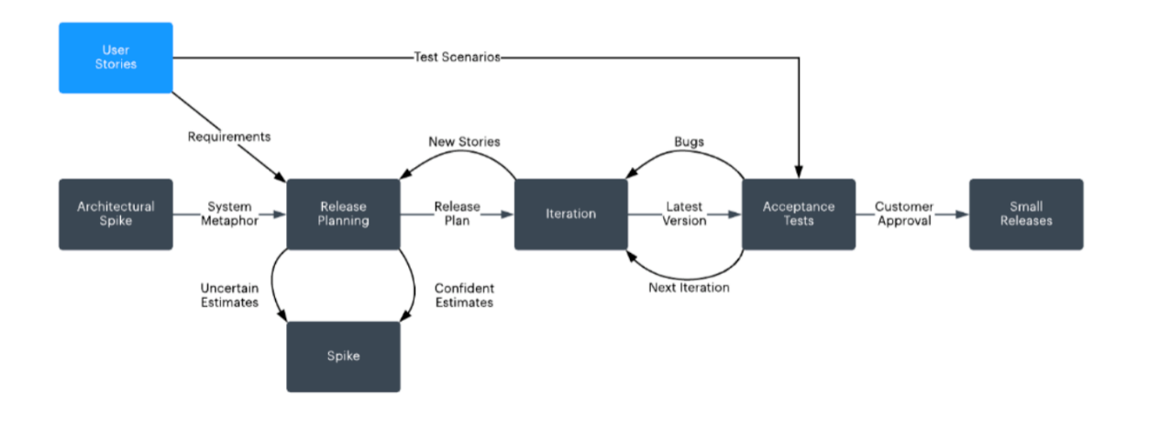
Figure 3.1 Extreme Programming (XP) Methodology
(Source: Lucidchart Content Team. (2020))

the detailed requirements of the definition stage into a complete, detailed specification of the system. Some of the most significant activities of this stage include:
- Pointing out the all required data that will be needed in handling the immunization record system and performing all the necessary activities that are required by the user of the system;
- Characterization and documentation of all related entities that exist in the immunization information system is performed.
- Designing the components of the system: unified modelling language (UML) diagram that shows the relationship that exists between entities in the immunization record system, the database structures, inputs, outputs, internal processing, manual procedures, system interfaces, technical environment, and overall system architecture;
- Carrying out walkthroughs of the design to ensure that it is programmable and technically complete and;
- Beginning development of approaches to user support and system maintenance afterwards.
3.3.1 Use Case diagram
The use case diagram was used to describe functions provided by the system that yields a visible result for various actors that participate in the system use, such as the health worker and public health worker which are core users of the system. The identification of actors and use cases results in the definition of the boundary of the system that is, in differentiating the tasks accomplished by the system and the tasks accomplished by its environment. The use-case diagram in Figure 3.2 shows the description of the actors alongside their respective activities using the proposed system.

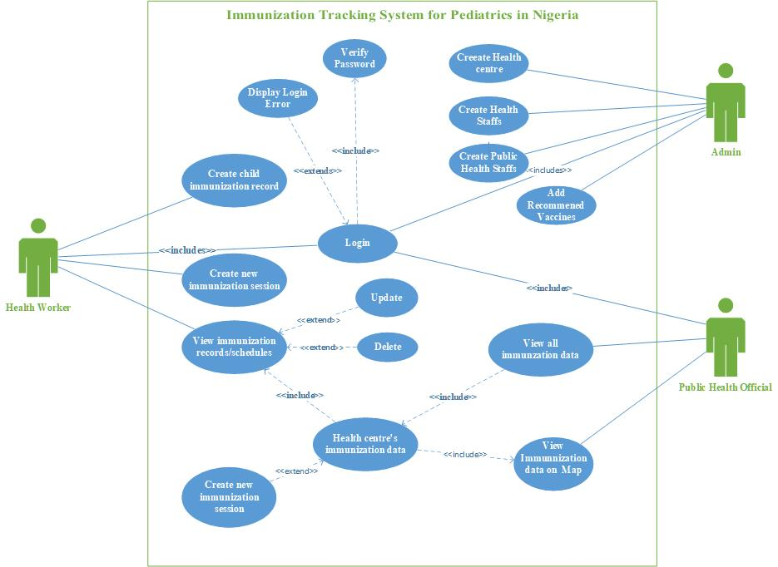

Figure 3.2 Showing the Use Case Diagram of Users activities

- System Administrator: is a person who is responsible for the upkeep, configuration, and reliable operation of computer systems; especially multi-user computers, such as servers. He or She is responsible for creating access to the system by an authorized user. The responsibilities are as follows:
  - Create the profiles for newly registered health centres based on their respective locations in the selected LGA;
  - Create the profiles for newly registered health workers within their respective health centres;
  - Manage the profiles of registered health centre’s staff and;
  - View information stored about the immunization records of each health centres.

- Health Worker: is one of the primary users of the system whom are responsible for recording each child’s immunization schedule alongside their respective information required for properly identifying the existing immunization records, based on the type of disease immunized for, type of vaccine given and location to mention a few. Their primary responsibilities are as follows;
  - They are responsible for creating and handling immunization records of children immunized;
  - They can view the immunization records analysis stored using tables and;
  - They will not be able to view the immunization records stored as charts and maps.

- Public Health Official: is another primary user of the system who is responsible for using the information of the immunization records recorded by the health workers from various health centre in order to make informed decisions. Their primary responsibilities are as follows:
  - They are required to query the system for view the number of children immunization records from each health centre based on specific criteria’s which includes the number of children immunization records, number of vaccines given, number of disease types immunized for, number of completed immunization schedules, details of vaccine given and many more.
  - They can also view the details of the immunization records gotten from various health centres using maps.
3.3.2 Sequence Diagram
The sequence diagram shown in Figure 3.3 and Figure 3.4 shows the interactions of the respective actors (users) with the objects and their time sequence of activity. It also displays the artifacts and classes involved in each scenario and the sequence of messages exchanged between objects required to execute the system functionality.
3.3.3 Activity Diagram
Activity diagrams as displayed in Fig 3.5shows the workflow of step-by- step procedures and behavior of user’s interaction with the system including elements highlighting data flow between operations by one or more stored data.
3.3.4 Class Diagram
Class diagram describes the attributes and operations of a class and also the constraints imposed on the system. In the diagram shown below in Fig 3.6, it was used to identify the various types of classes, objects and their respective instances

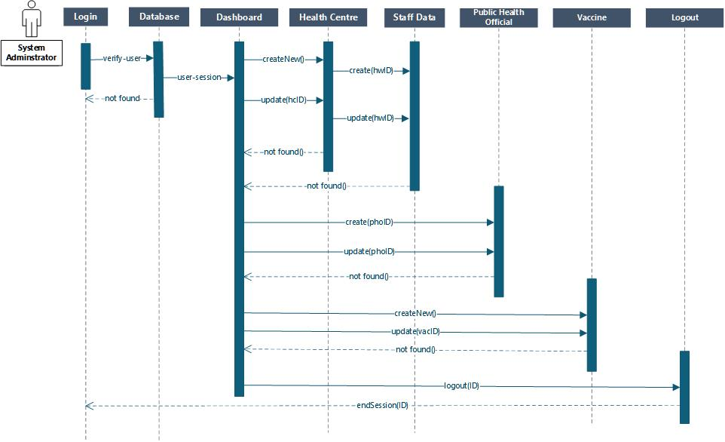
Figure 3.3: Sequence Diagram for System Administrator Activity timing

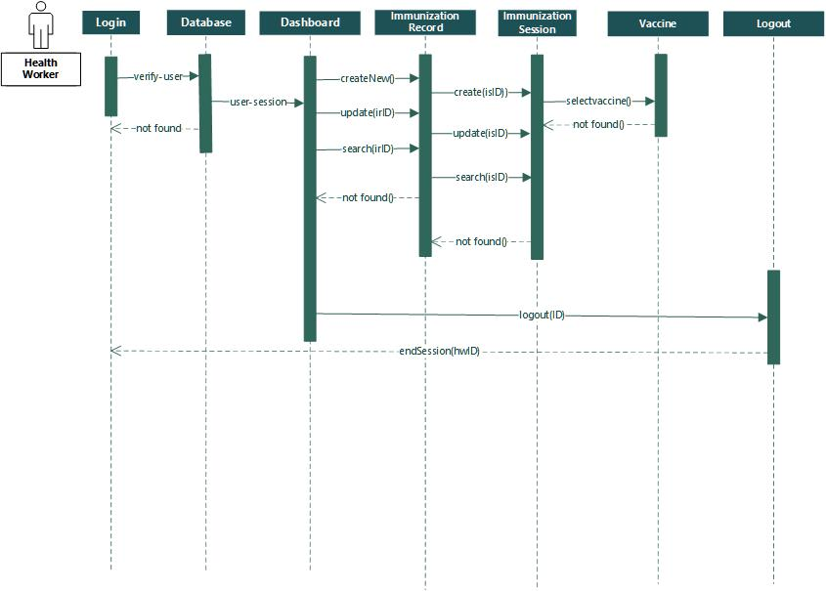

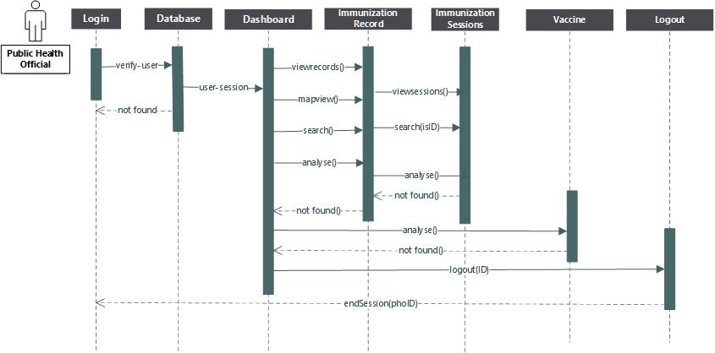
Figure 3.4: Sequence Diagrams showing Activity timing for the Health worker and Public health official

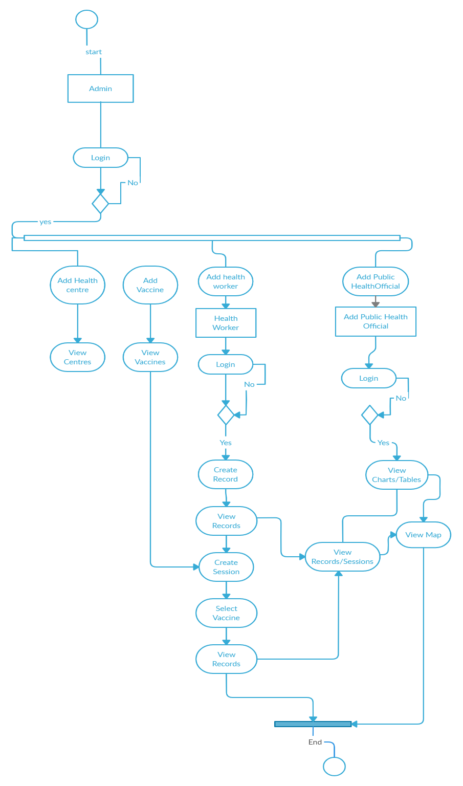
Figure 3.5: Showing the Activity Diagram of the System
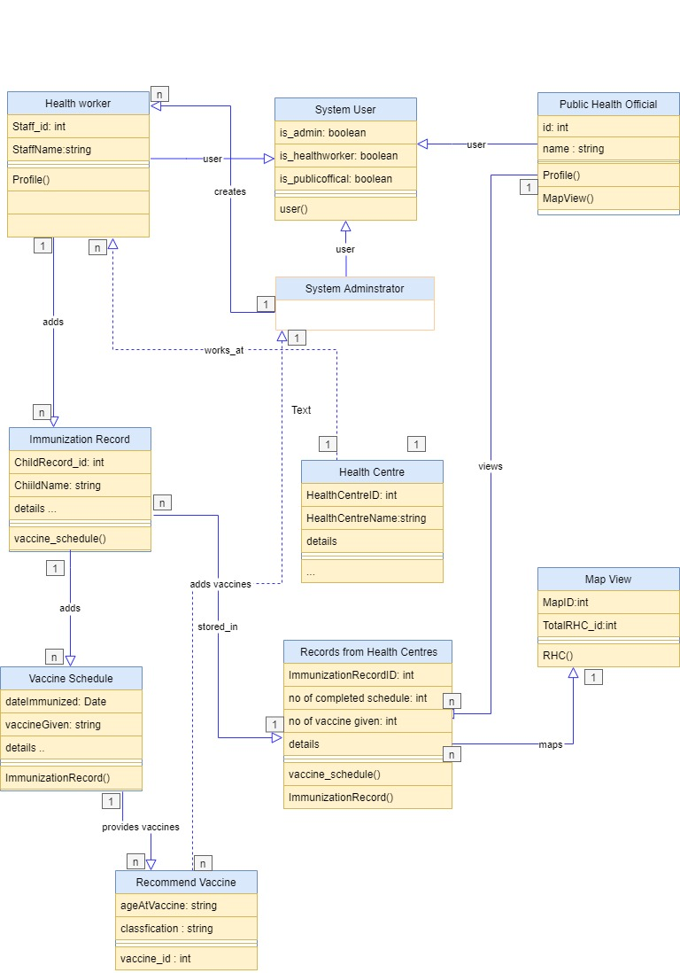

Figure 3.6: Showing the Class Diagram used for Data Modeling

alongside their relationships within the context of the proposed system. The system has a main class called System User, which identifies whether a user is a system administrator, health worker or a public health official. The System User class is also a generalization class, since it creates specific roles for each user (which are class objects). Furthermore, the different immunization records created in the system are stored based on their respective health centre, local government area. This implies that the immunization records of several health centres can be identified easily without any errors. And also, the public health officials are able to access the records and schedules of all heath centres and also view their locations on the map using the MapView class. Lastly all users can be able to view their profiles and change their passwords with the help of the profile class.
3.3.5 Context Diagram
Figure 3.7 shows the context diagram of the immunization tracking system, showing a data flow diagram illustrating the overall system. It also defines the scope and boundary of the system to the external entity. This diagram also displays data input and output flows to and from the system and external entities.
3.4 System Development Tools
These are Implementation tools needed to carry out the development of the immunization information system. The tools include: Cascading Style Sheet (CSS), Hypertext Pre-processor (Python, Django framework), PostgreSQL, and Mapbox Map API.

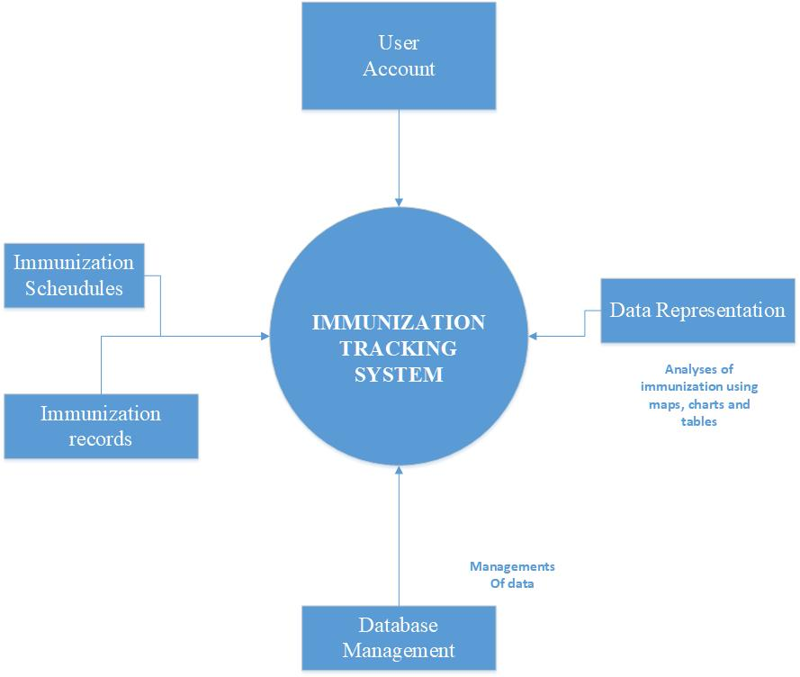
Figure 3.7: Showing the Context Diagram of the System

3.4.1 Hypertext Markup Language (HTML)
Hypertext Markup Language (HTML) is a basic markup language for documents intended to be viewed in a web browser. It can be supported by technologies such as Cascading Style Sheets (CSS) and scripting languages such as JavaScript.
3.4.2 Cascading Style Sheets (CSS)
CSS is a style sheet language used to describe the presentation of a document written in a markup language such as HTML (Mozilla Developer Network, 2015). This is the cornerstone technology of the World Wide Web, alongside HTML and JavaScript.
3.4.3 Django Framework
Django Platform is a free-source web framework used to create quickly, pragmatically, cleanly, cleanly and stable websites. Its main purpose is to promote the establishment of complex websites powered by databases.
3.4.4 PostgreSQL
PostgreSQL is an advanced SQL version. It is used for a wide range of network, mobile, geospatial and computational applications as the main data store or data warehouse. It includes user-define objects (e.g. translations, types of data, domains, functions, etc.), MVCC, database triggers and many more. It also includes a range of regular SQL commands including "Select", "Insert", "Update", "Delete", "Create", and "Drop".
3.4.5 Mapbox
The Mapbox web services APIs allow one to programmatically access the Mapbox tools in order to use its APIs to retrieve account information, upload and modify resources. The Mapbox Api as used in this project to allows the map to be displayed on the immunization information system, enabling the specified users to access the different locations of the health centers and their respective immunization data files.
CHAPTER FOUR
RESULTS AND DISCUSSIONS
4.1 Introduction
This section presents the results and the discussion of the study which involved the design and development of a spatially enabled web-based system for monitoring the immunization data of pediatrics from different health centres. This chapter presents the implemented database of the system using an advanced structured query language (PostgreSQL) alongside the system interface that was implemented using web-based development technologies such as the HTML, CSS, JS, Python and Django for the development of the system interface and also connecting information between the user interface and the system interface.

4.2 Implementation of the system database for monitoring immunization data
Figure 4.1 shows a description of the database that was implemented for this study in order to store and retrieve information required by the proposed system using PostgreSQL. As a result of this, a database was implemented called trackimmunize.sql which consisted of seven (7) database tables which were required for managing the various types of information stored and manipulated by the system. The results of the implemented Table called States as shown in Figure 4.2 was used to manage the information about the states to which the agencies may belong. The table contains 2 attributes which consisted of the unique ID of the state and the name of the state. The results of the implemented Table called locals as shown in Figure 4.4 was used to manage information about the LGA to which the health centre belonged to. The table contains 3 attributes which consisted of the unique ID of each LGA, the stateID of the state to which the LGA belong to and the name of the LGA.

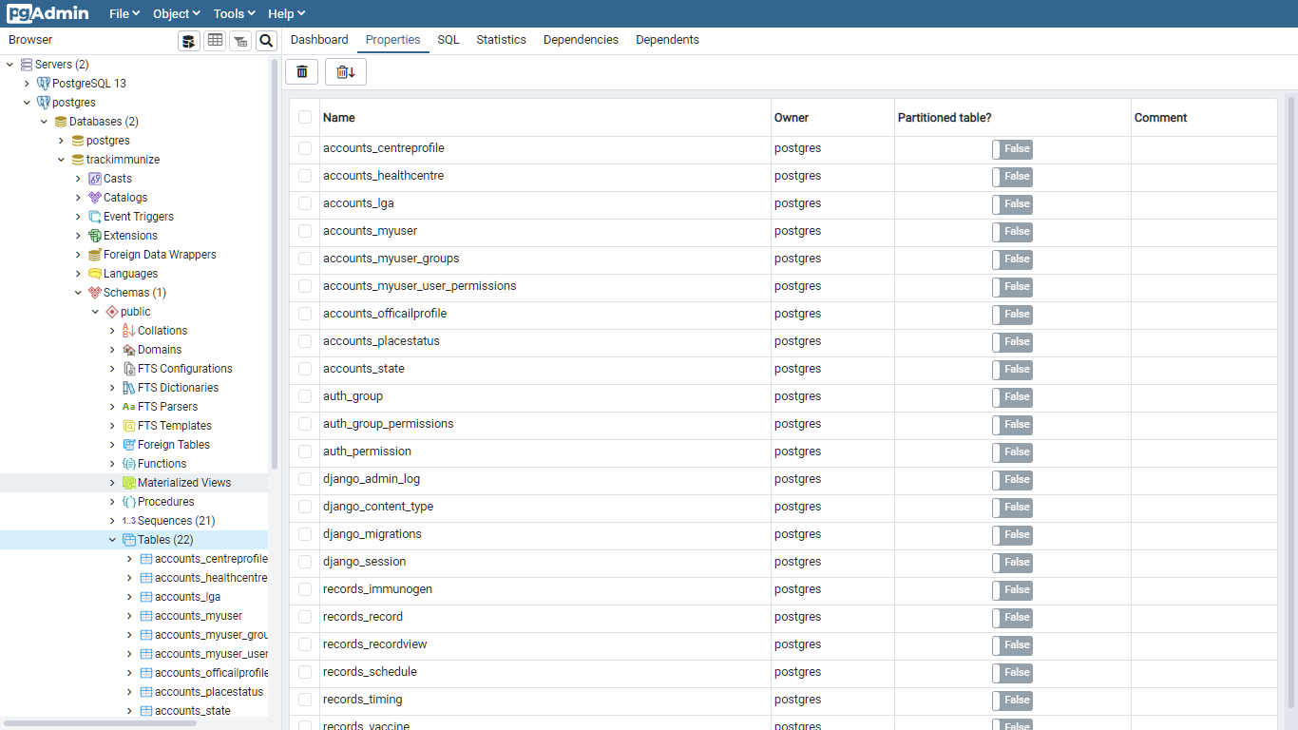
Figure 4.1: Screenshot showing the description of the database

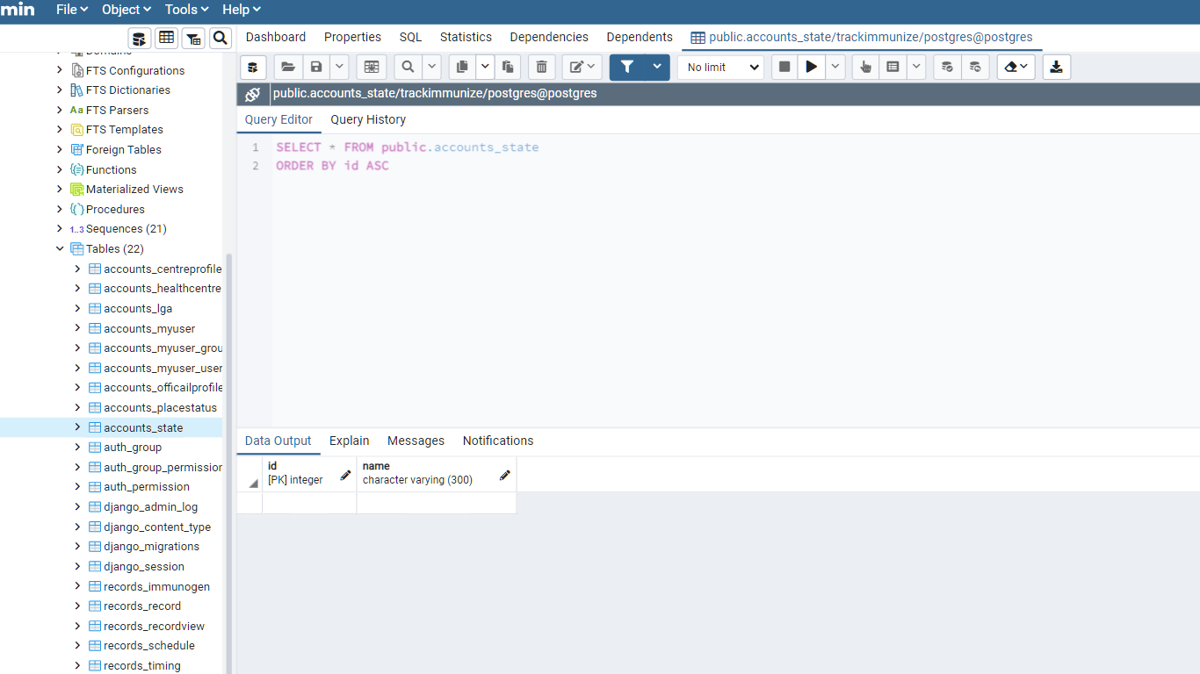
Figure 4.2: Showing the State table of the database

The results of the implemented Table called coordinates as shown in Figure 4.3 was used to store information about the LGA which are located within their respective states. For this study, the LGAs that were located within Ogun State were considered. The Table contained 5 attributes which consisted of the unique ID of each coordinate, the unique ID of the state, unique ID of the LGA, the latitude and longitude of the LGAs. The results of the implemented Table called MyUser as shown in Figure 4.4 was used to manage information about the users whom were authorized to access the system. The table contains 10 attributes, namely: the unique ID of each user record, the type of user (nurse, admin or doctor), full names of users, gender, ethnicity, state of origin of user, the health centre to which the user belonged to, the type of the user, the data information was reported alongside the username and password required by the user to log into the system.
The results of the implemented Table called Record as shown in Figure 4.5 was used to manage information about the immunization of pediatrics by health worker from several health centres in the state. The table contains attributes, such as: the uniqueId of each record, the record details such as the child’s name, gender, parent’s name, date-of-birth, ethnicity and address, the state, the LGA, and the health centre LGA. The results of the implemented Table called Vaccine as shown in Figure 4.6 was used to manage information about the recommended immunization schedules handled by the authorized users in the system. The table contains 5 attributes, namely: the unique ID of vaccine, classification, vaccine-name, timing (age at vaccine) and description. The results of the implemented Table called Schedule as shown in Figure 4.7 was used to manage information immunization schedules done by authorized users in the system.

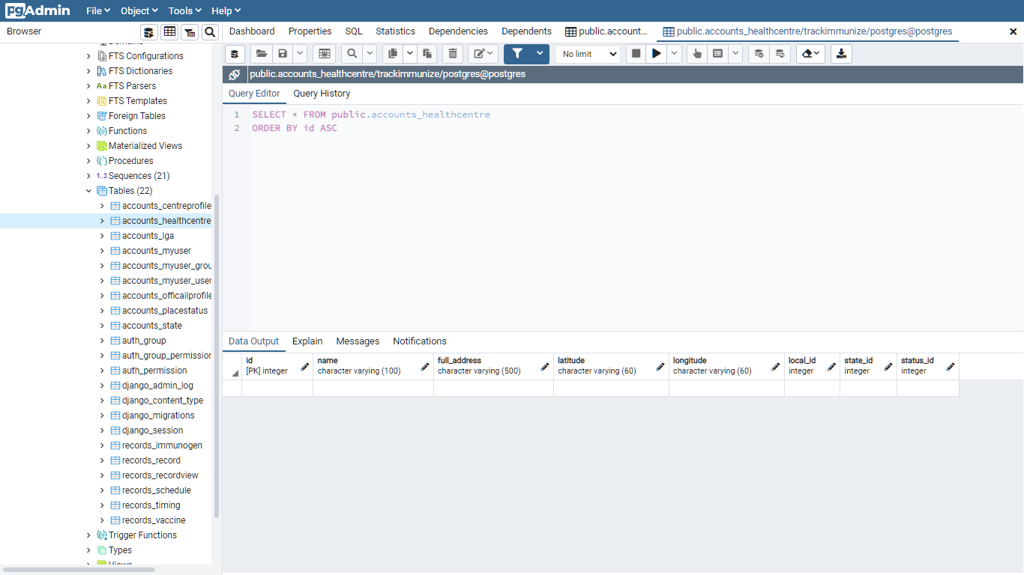
Figure 4.3: Showing the Coordinates table of the database

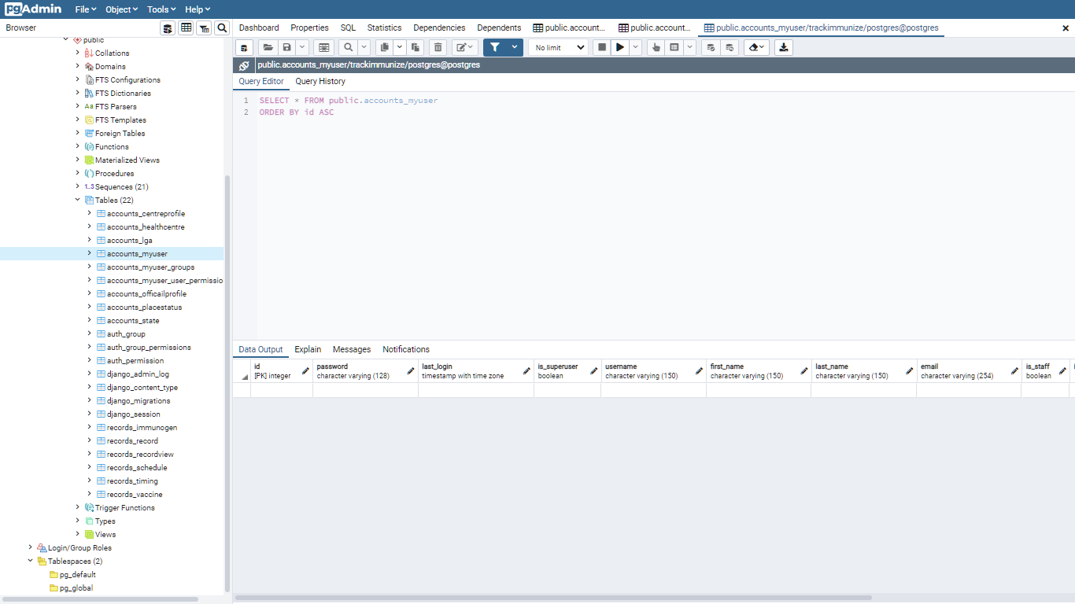
Figure 4.4: Showing the Users table of the database

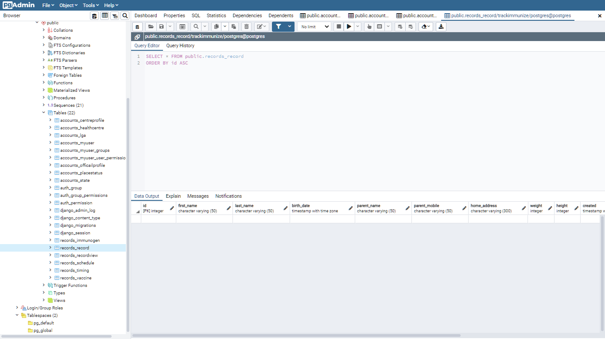
Figure 4.5: Showing the Records table of the database

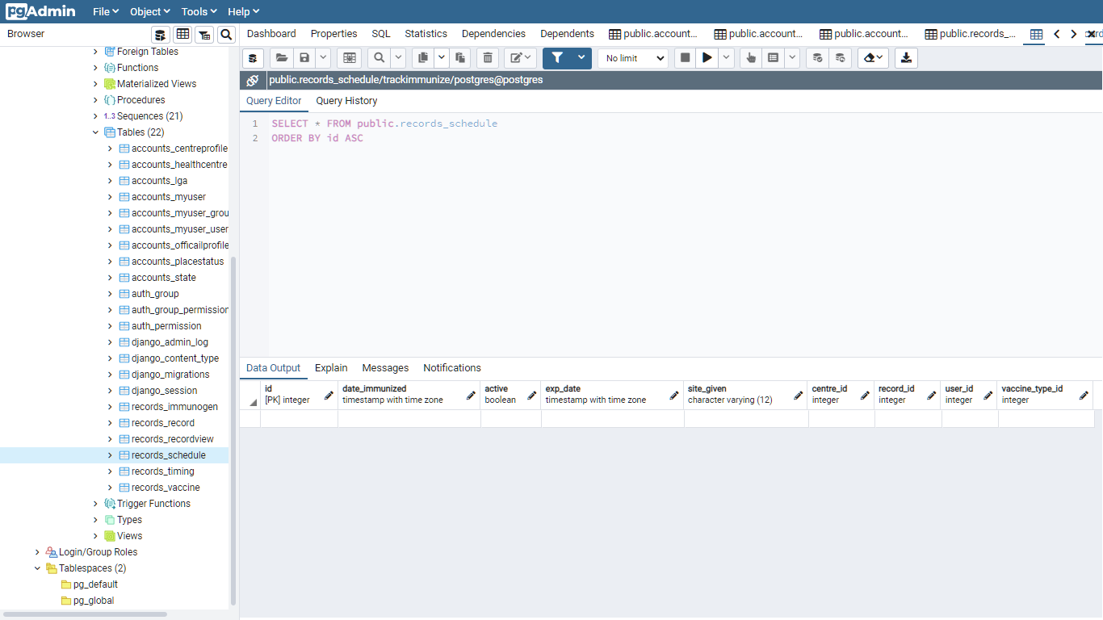
Figure 4.6: Showing the Schedule table of the database

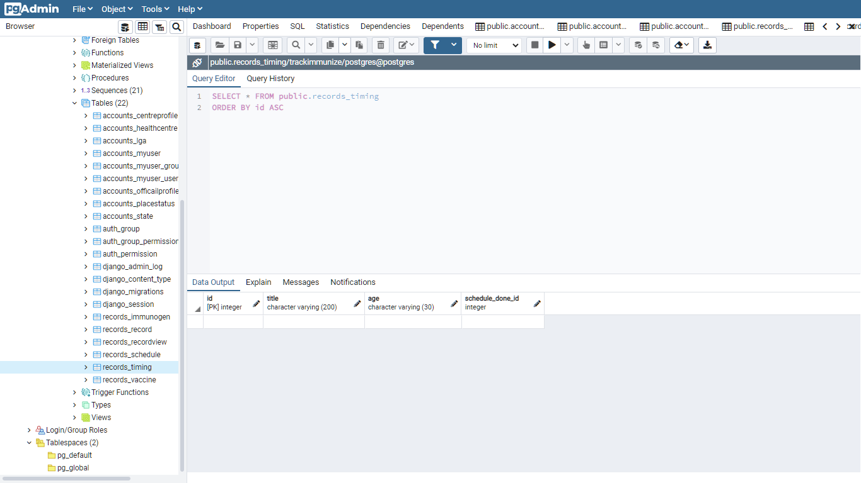
Figure 4.7: Showing the Recommended Schedule table of the database.

For each Table created in the database for storing and retrieving the immunization data of pediatrics, the primary keys of were defined by the unique ID provided at the first column for each respective table. Also, foreign keys were used to connect information from a Foreign Table onto a Referenced Table by describing the associated primary key of the foreign Table as an attribute and a foreign Key of the referenced table.
4.2 Results of the Implementation of System Interface
From the presentation of the results of the implementation of the system database using PostgreSQL, the results of the implementation of the system using web-based technologies are presented. Figure 4.8 shows the system Homepage and Login screen. The login page, here users are required to provide their username and passwords which is used by the system to determine the session which to be created following the user access authentications by the system. Figure 4.9 shows the interface of the dashboard of the system administrator after providing his username and password for the system. The result of this interface shows the different information stored on the system so far such as the number of system users, health centres, records and schedules





Figure 4.8: Screenshot of Homepage and Login page

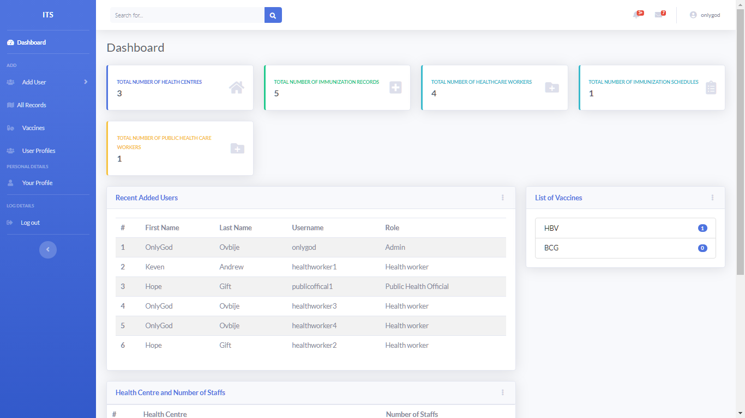
Figure 4.9: Screenshot of System Administrator Dashboard

Figure 4.10 shows the results of the interface when an administrator is to create add a new health worker and public official to the system, requiring the user to provide the names of the user, gender state of origin, health centre name alongside the default username and password provided by the administrator to the user. Figure 4.11 shows the results of the interface required panel by the admin for managing the information of the existing registered users of the system. Figure 4.12 shows the results of the interface required by the administrator for adding and viewing the recommended immunization schedules for all health centres.
Figure 4.13 shows the results of the interface required by the administrator for viewing the all records and their respective schedules from health centres. It also shows the data to be viewed on the map by the public health official which include the number of staffs, number of records, number of schedules, state, LGA, for each health centre.
Figure 4.14 shows the results of the dashboard and the interface required by the health worker belonging to a health centre to add a new immunization record for a child. The health worker is required to provide details such as the child’s first name, last name, date of birth, parents or guardian names, parents or guardian mobile number, home address, the child’s height and weight. Figure 4.15 shows the result for the interface required by the health worker for viewing a child’s immunization record. It shows the details about date created, child’s full name, weight, height, and birth date and list of schedules taken.

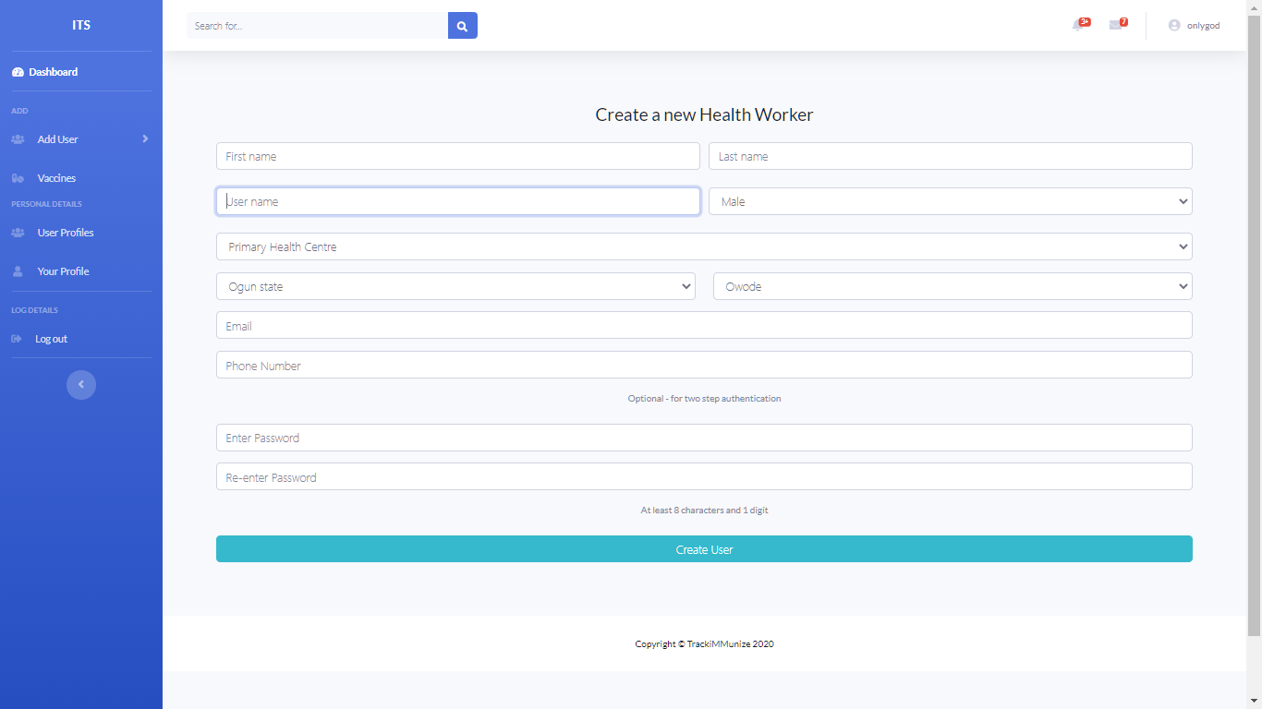

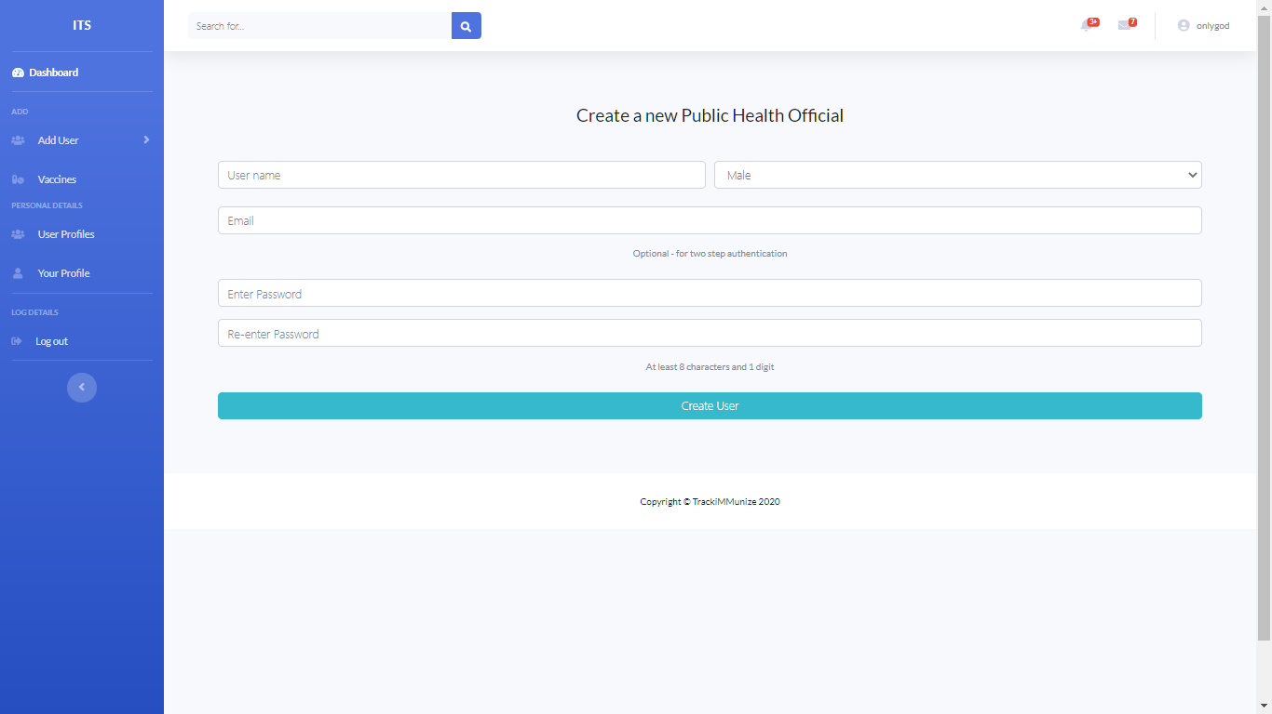

Figure 4.10: Screenshot of Admin to add users

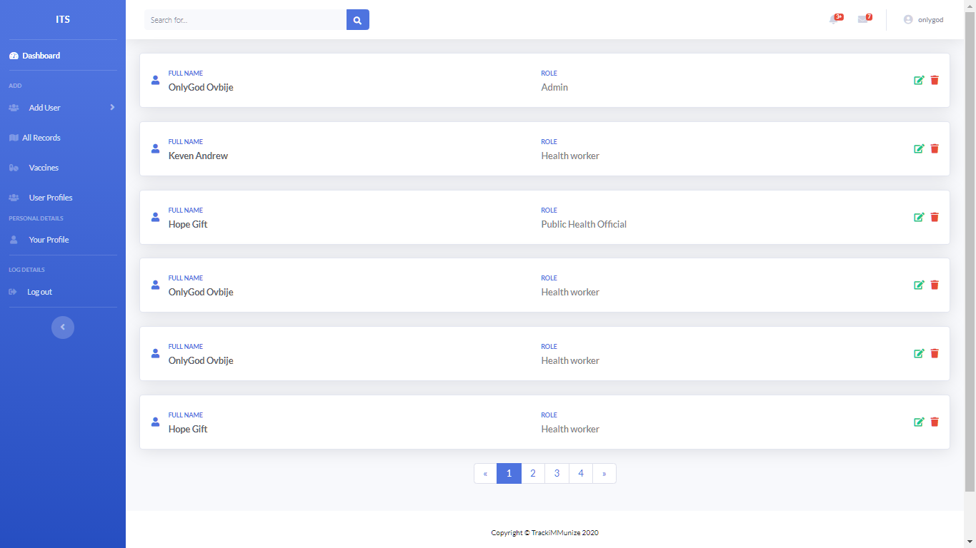
Figure 4.11: Screenshot of Admin to manage users

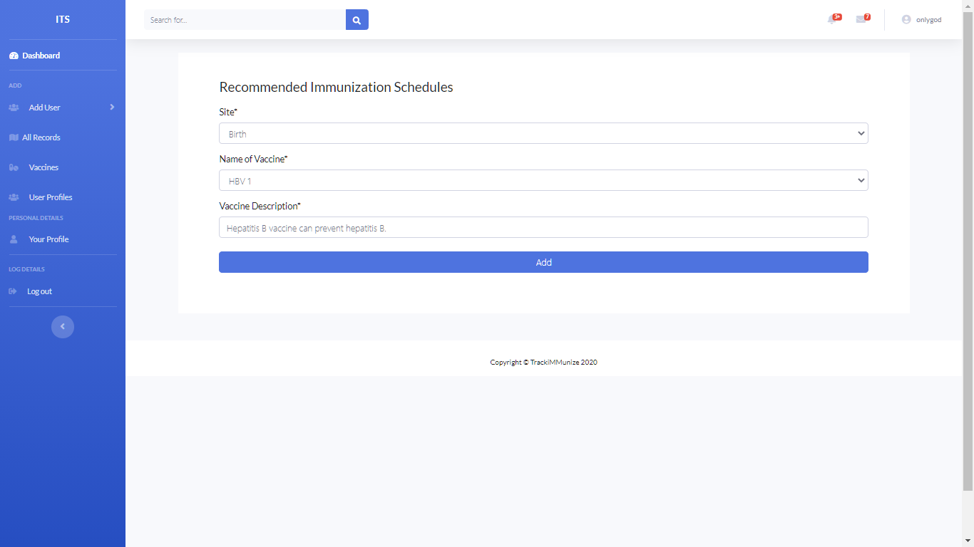
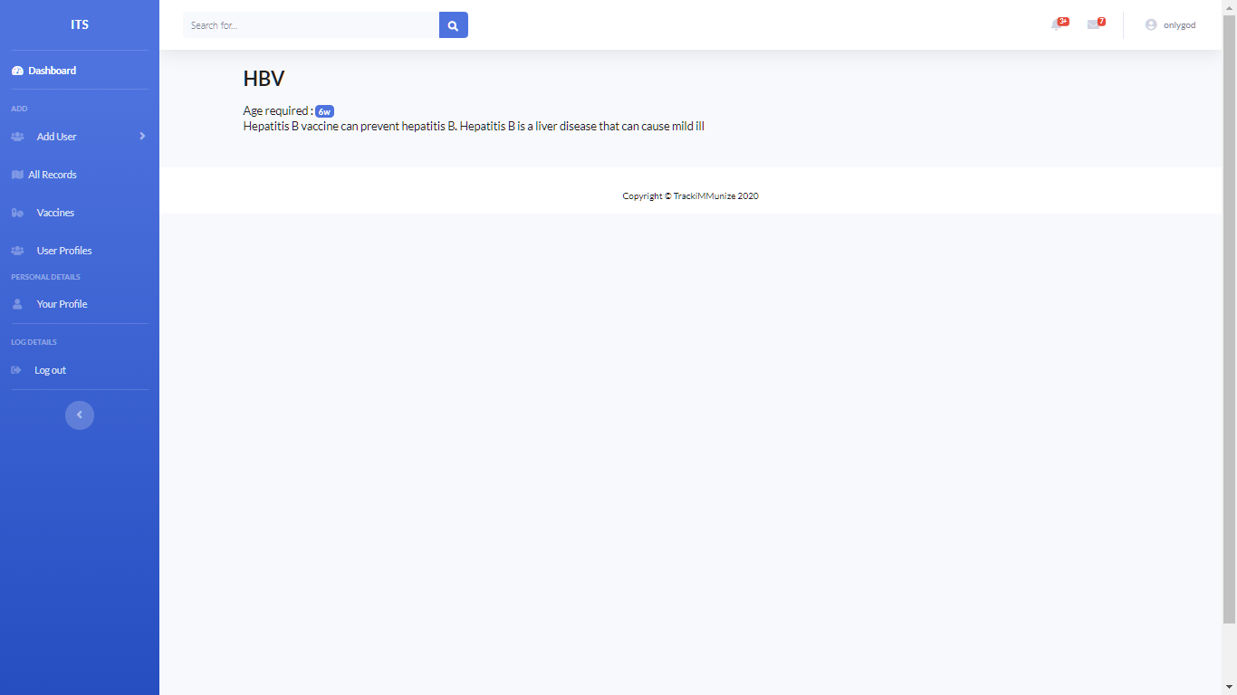
Figure 4.12: Screenshot of Admin creating and viewing recommended schedules

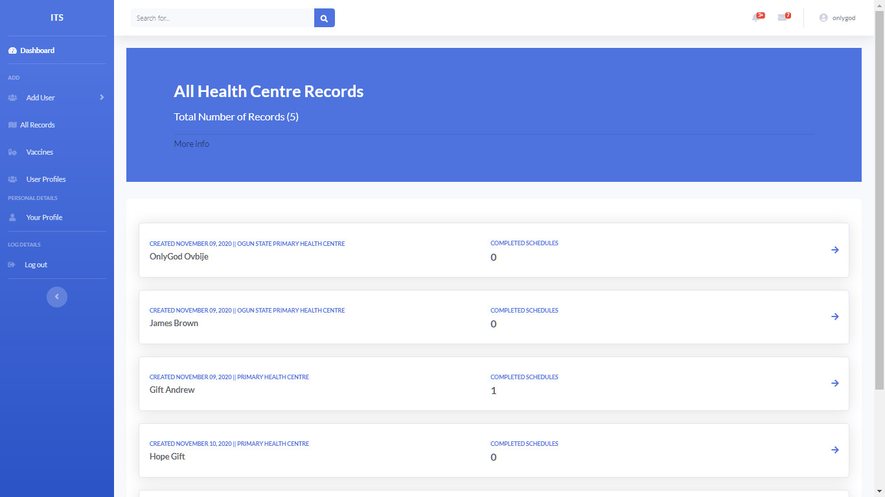

Figure 4.13: Screenshot of Admin viewing all records.

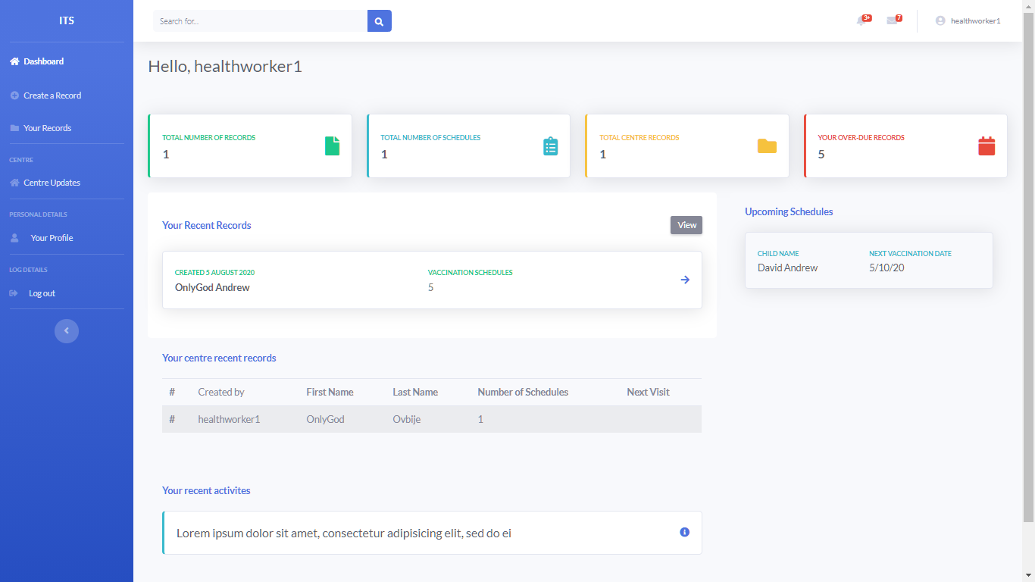

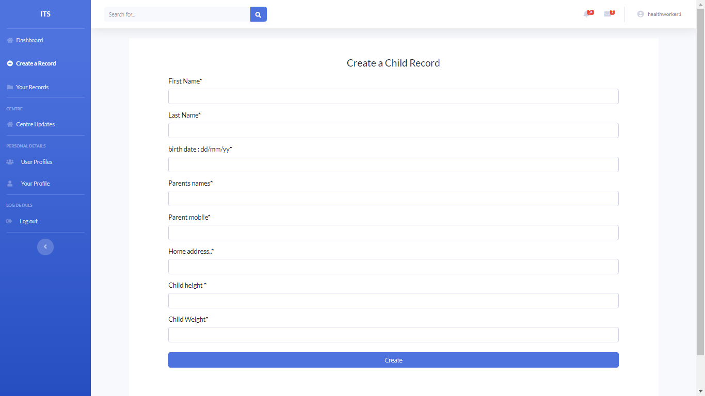

Figure 4.14: Screenshot of Health worker dashboard and creating records

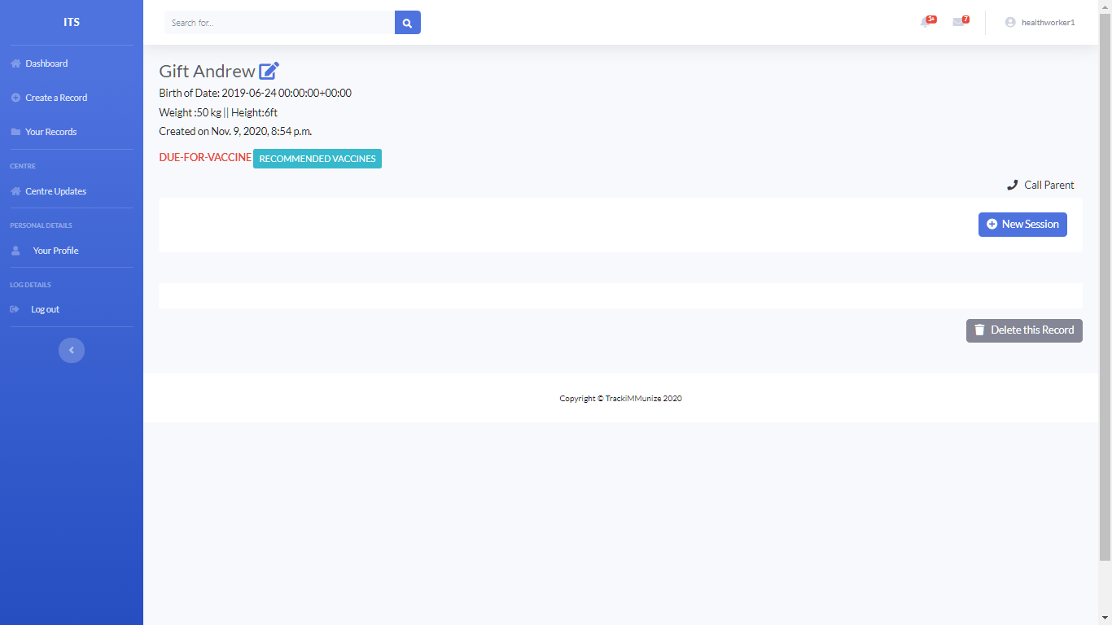
Figure 4.15: Screenshot of Health worker viewing a child’s record

Figure 4.16 shows the results of the interface required by the health worker belonging to a health centre to add a new immunization session for a child and also view the results. The health worker is provided details such as the vaccine-type, vaccine-expiration-date, date-given and site-given
Figure 4.17 shows the results of the interface required for a health worker belonging to a health centre to view all recommended immunization schedules for a particular child record in their health centre. Figure 4.18 shows the results of the interface required for a health worker belonging to a health centre to view all immunization records in their health centre and create immunization schedules for any if needed.
Figure 4.19 shows the interface required by a public health official for viewing list and
the compiled results for the all immunization records and schedules from several
health centres. Thus, the interface shows details such as the list health centres, number
of staffs, records and schedules respectively, just as it is observed by the administrator. Figure 4.20 shows the results of the interface requires by a public health official for viewing information about the current complied immunization data using bar and pie charts display. Thus, the interface shows various charts presented to the health official for observing the relationship between the details observed. Such variations include, age of children records in several health centres, the gender of the children and total vaccination coverage. Figure 4.21 shows the interface required by a public health official for viewing the map and the compiled results for the all immunization records and schedules from several health centres. Thus, the interface shows details such as the location of health centres in the state, number of health workers, records and schedules respectively.

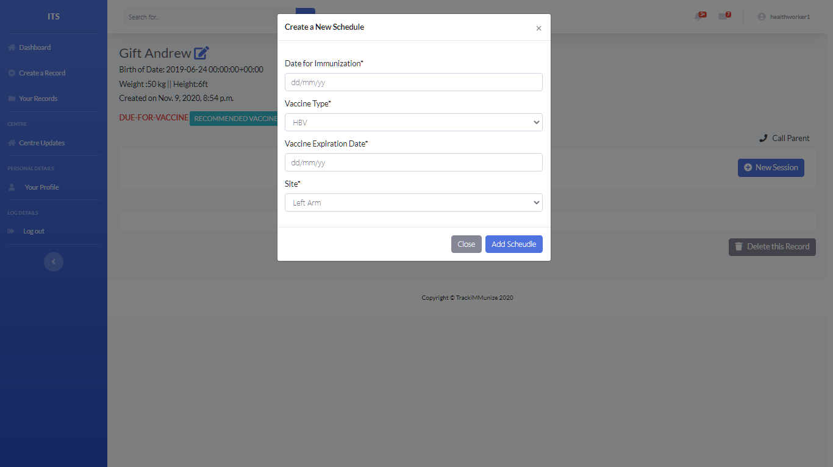

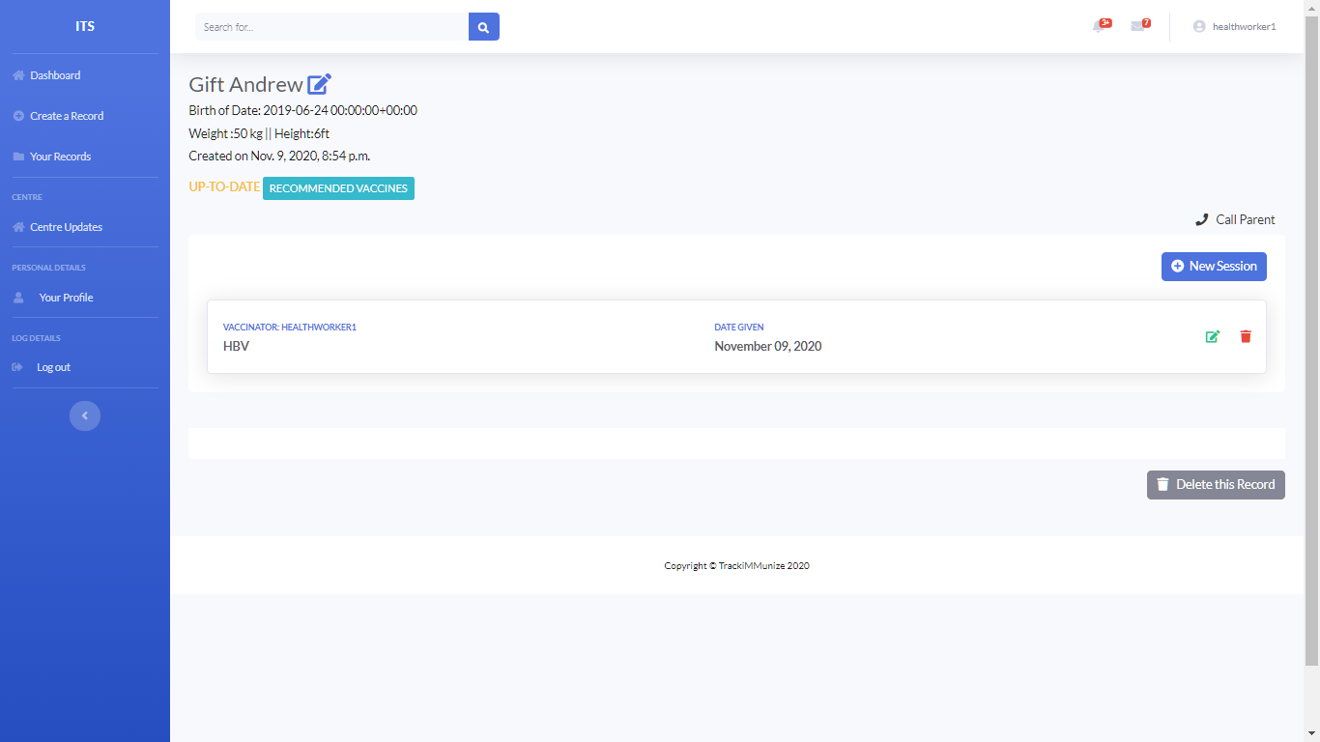
Figure 4.16: Screenshot of Health worker creating and viewing a child’s schedule

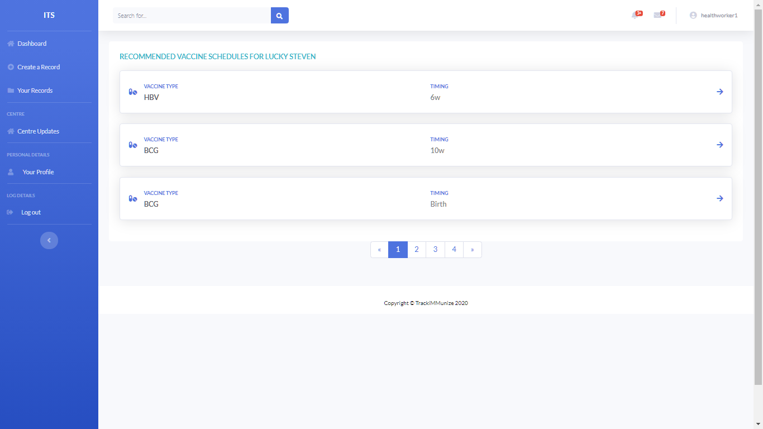

Figure 4.17: Screenshot of Health worker viewing a child’s recommended schedules

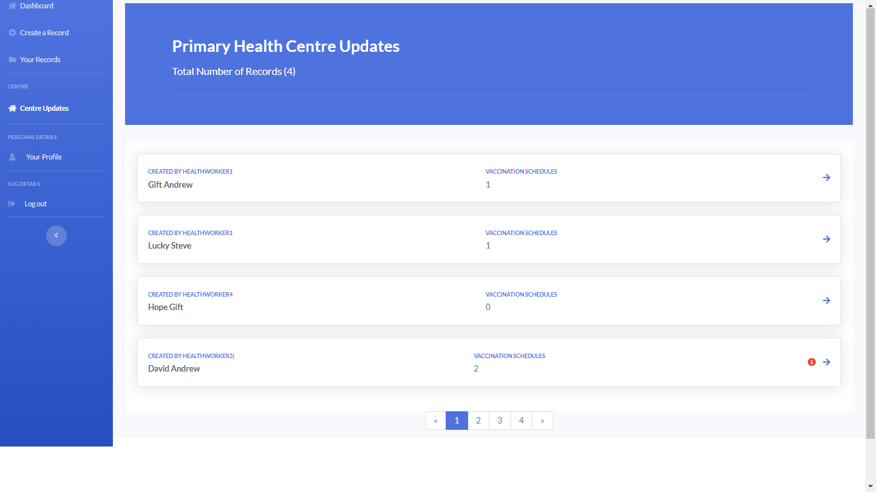
Figure 4.18: Screenshot of Health worker viewing records in their health centre

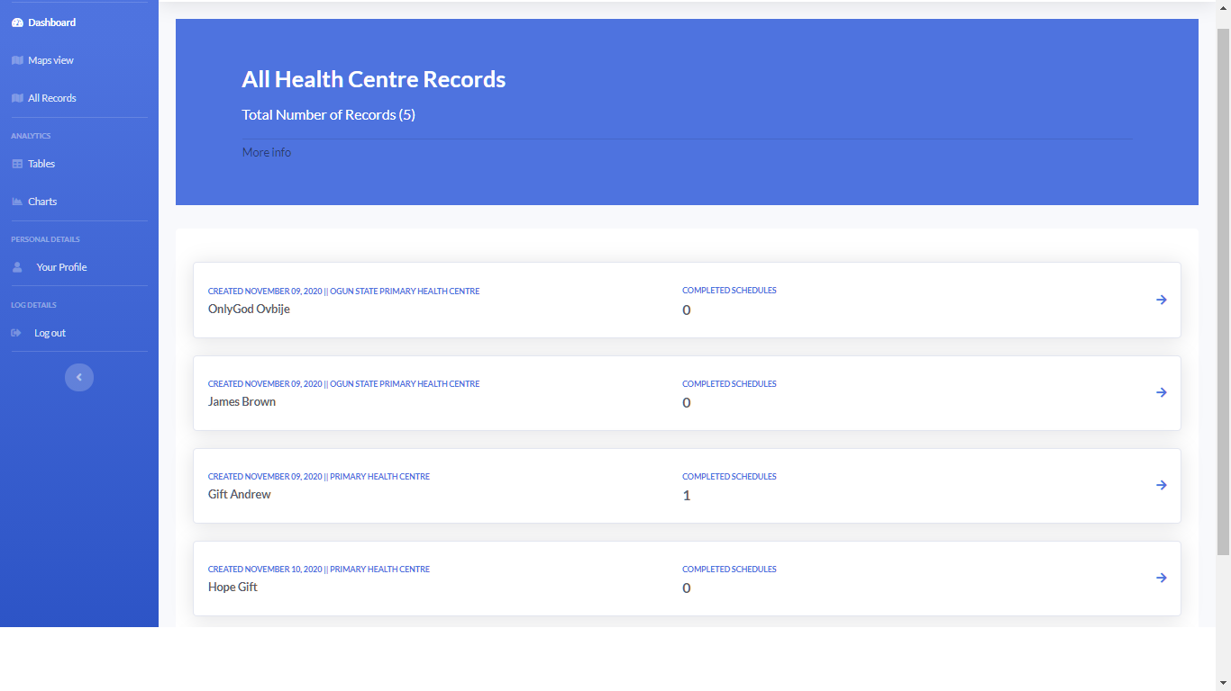
Figure 4.19: Screenshot of Public worker viewing all records from health centres

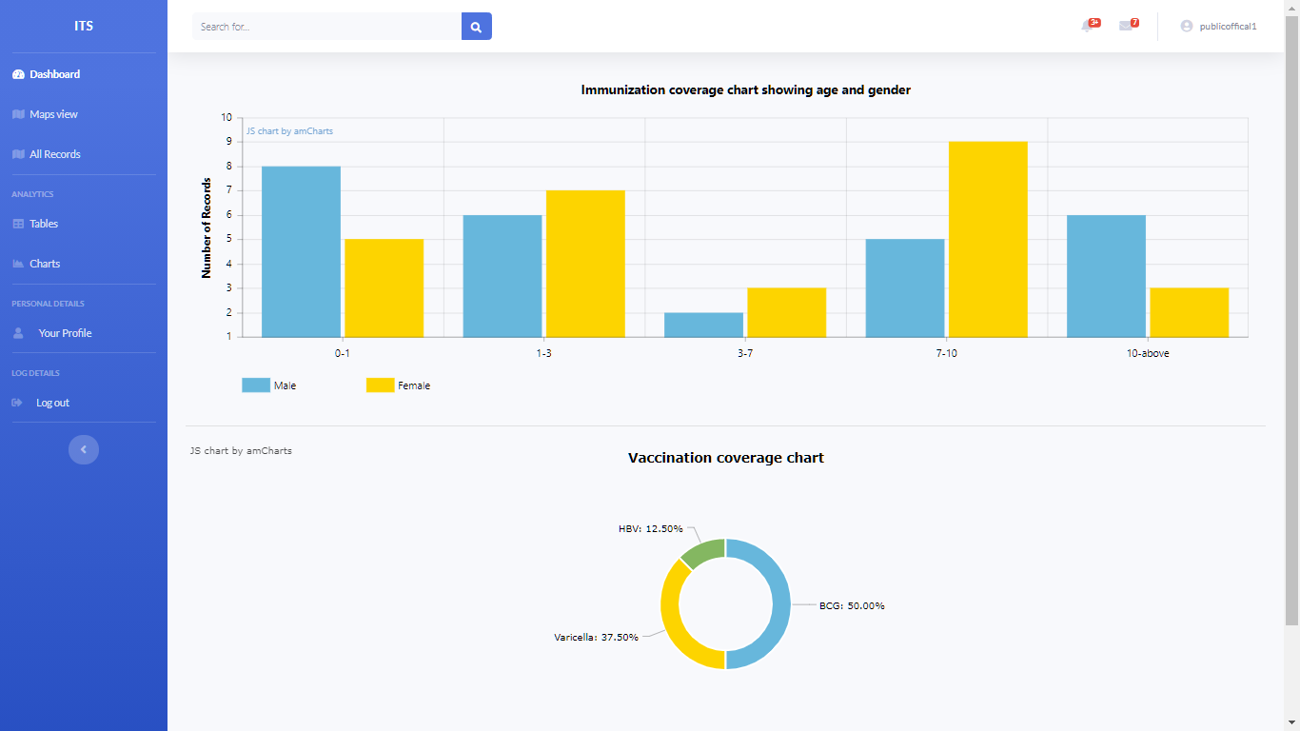
Figure 4.20: Screenshot of Public worker viewing complied immunization using Charts

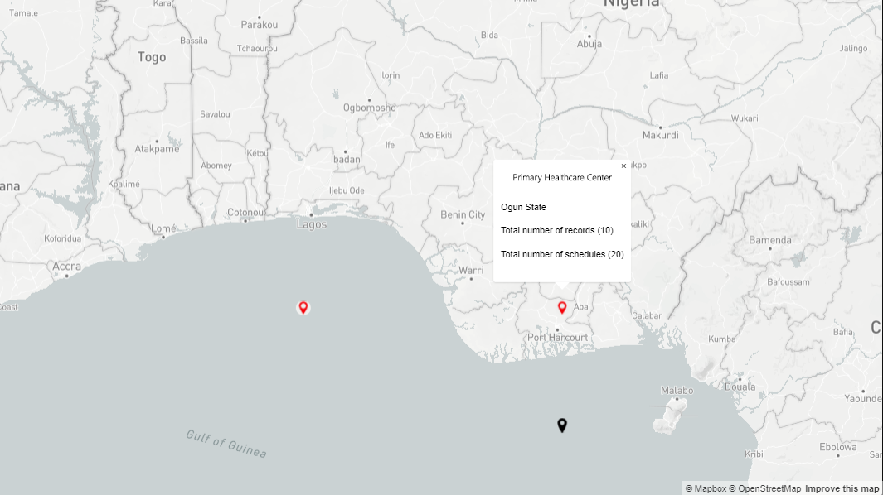
Figure 4.21: Screenshot of Public worker viewing complied immunization using Map

4.4 Discussion of Results
The result of the study has been presented which showed the different expectations of this study based on the objectives that were stated in the earlier chapters of this study. The results of the identification of the user and system requirements allowed for the identification of the different users of the proposed system such as superuser and the primary users of the system. The results showed that the superuser was responsible for creating and managing the users based on their respective roles. Also, the results showed that the primary users can only access the system using their username and passwords provided by the system administrator of the system.
The results also showed that the specified users from a health centre has the responsibility of creating new immunization records, new schedules for pediatrics and
are also responsible for ensuring that each child’s record is always up-to-date after every immunization session. On the other hand, the health officials representing a particular community or state can also make use of the information stored about the immunization data using structured tables and charts. They can also be able to view information about the immunization data of pediatrics on a digital map thereby facilitating a spatial distribution of the data over the map based on their locations.
The results of the specification of the design showed that the user requirements of the proposed system were clearly identified following the use case diagram which was used to design the different interactions of the system users with the system alongside their respective feedback. The results of the data modeling of the proposed system showed that a number of classes were identified, some for identifying the health centres, some for identifying the users and some for identifying the immunization data of pediatrics from various known locations within the state, these designs were used to guide the process of the final implementation of the proposed system for monitoring the spatial distribution of the immunization data of pediatrics across state.
The results of the system implementation showed that the advanced structured query language (PostgreSQL) was used to implement the database of this system by providing 7 tables which in turn had their respective attributes. For each Table in the database a number of records were provided to the database. Also, the system database information regarding location were restricted only to the LGAs located in Ogun State. The results of the system interface using HTML, Django and CSS, showed that the system was able to provide interfaces that were compliant with the system and user requirements that were identified in this study. The system implementation allowed users of various roles to perform their various duties using the system thus, removing the challenges attached to delay and time spent for health centres in administering immunization to pediatrics and analyzing or reporting immunization data in their various communities as long as the coordinates of the location is known.

CHAPTER 5
SUMMARY AND CONCLUSION
5.1 Summary
This study established a web-based, spatially-enabled system that tracks pediatric immunization in Nigeria. The study defined the user and system specifications that had to be met by the system. In addition to the hardware and software requirements of the system, the user and system requirements were defined. System specifications were also defined using unified modeling languages, user specification use-case diagrams for user requirements, data modeling specification class diagrams, system interaction display activity diagrams, system activity timing diagrams, and overall system background diagrams. The system was implemented using Web 2.0 technologies such as HTML, Python, Django and CSS for web layout and data movements in and out of web interface types from and to system databases. PostgreSQL was also been introduced for the system database for this analysis.
5.2 Conclusion
In conclusion, this study was carried out in order to create and design a monitoring system for the immunization and vaccination of pediatrics registered by health care workers from their respective health centers. This study was able to tackle the issue of a poor health care system for monitoring and evaluating pediatric immunization records. Also, this study was able to define the respective users and system specifications of the system and suitable designs were used to determine these requirements provided by the users using use-case, sequence, activity, class and context diagrams. In addition, the system database was in place to suit the processes and inner workings of the new system, and also provided a way for the public health official to view the information stored by health workers in a more detailed manner.. Lastly, this study ensured that the system has the capacity to monitor and also spatially query the immunization of pediatrics in Nigeria.

5.3 Recommendation
From this study the following is recommended the following about the system
as follows:
- Health workers and Health public officials should receive training on how to use the system to gain an understanding of the functionality of the system as a whole.
- The system upgrade is necessary as the requirements of the user change from time to time. Therefore, as user demands can slightly alter over time, making the system sufficiently flexible is very helpful.
- During future research of an immunization tracking system, other scientists can also use this project report, especially the digital map system.
- The system should be made available to all health centres in other to increase the number of immunization data stored.
- In the event of a hardware or software malfunction, backups should be formed often to prevent data loss.

REFERENCES

Chang Y, B. N. (2009). Evaluating the impact of human papillomavirus vaccines. Vaccine.
Domingo, N. B. (1997). The Triumph over the Most Terrible of the Ministers of Deaths. Annals of Internal Medicine, 635-642.
Fiore AE, B. C. (2009). Seasonal influenza vaccines. Current Topics in Microbiology and Immunology, 43-82.
IS, A., OJ, M., AA, A., & AT, O. (2004). Disease notification among physicians in a Nigerian Tertiary Health Institution. Niger Med Pract, 45-111.
J, N. (1999). Science and Civilization in China. Biology and Biological Technology, 134.
Jenner, D. B. (2001). The Riddle of Vaccinia Virus and Its Origin (London:Heinemann Educational Books. Vaccination: Jenner’s Legacy, 20-50.
Jenner, E. (1798). Inquiry into the Causes and Effects of the Variolae Vaccine . 45.
K.E, I., & and Ojaiko, J. (1932 – 1934). Integration of Geographical Information Systems. International Journal of Science and research, 6-14.
Lucidchart Content Team. (2020). What Is Extreme Programming? An Overview of XP Rules and Values. Retrieved from Lucidchart : https://www.lucidchart.com/blog/what-is-extreme-programming
Nga, N. T., Huong , M., Sang Dinh Dao , Hieu Trung Tran, & Tu Xuan. (2017). Digital Immunization Registry. Enhancing the Immunization System and Improving Immunization Coverage for Children under One Year Old in Vietnam, 20-30.
Ophori, M. Y. (2014). Current Trends of Immunization in Nigeria: Prospect and Challenges. In Tropical Medicine and HealthIn Tropical Medicine and Health, 67-75.
Ostrovskiy, S. (2017, February 4). Three ways to pass data from Model to Controller. Retrieved from Medium Corporation: http://www.meduim.com
PANConf. (2020, January 20). Paediatric Association of Nigeria. Retrieved from JNCI: https://blog.jnciltd.com/media/events/pediatric-association-of-nigeria-panconf-2018
Pearce, J. (2006). Neighbourhoods and health: A GIS approach to measuring community. Journal of Epidemiology & Community, 389 – 395.
Sendy Ayu, M. U. (2018). The Introduction of immunization for children.
Seth, B. (2017, November 13). Immunization Needs a Technology Boost. Retrieved from Nature: https://www.nature.com/articles/d41586-017-05923-8
Silverstein, A. M. (2009). A History of Immunology. Academic Press, 293.
Smiatek, G. (2005). SOAP Based web services in GIS/RDBMS Environment. Journal of Environmental Modeling and Software, 775 – 782.
TJ, L. (2009). Varicella zoster virus vaccines. Canadian Journal of Ophthalmology, 44.
Vaxins. (2016). Top Vaccination For Your Child. 50.

APPENDIX
Source Code
MODELS
Users/models.py
from django.db import models
from django.db import models
from django.contrib.auth.models import AbstractUser

class MyUser(AbstractUser):
is_doctor = models.BooleanField(default=False)
is_hw = models.BooleanField(default=False)
is_pho = models.BooleanField(default=False)

GENDER_CHOICES = (
('M', 'Male'),
('F', 'Female')
)

class CentreProfile(models.Model):
user = models.OneToOneField(MyUser, on_delete=models.CASCADE)
gender = models.CharField(max_length=60, choices=GENDER_CHOICES)
email = models.CharField(max_length=100)
health_centre_in = models.ForeignKey('HealthCentre', on_delete=models.CASCADE, related_name='centre', blank=True, null=True)
phone_number = models.CharField(max_length=20)

def __str__(self):
return self.user.username

class OfficailProfile(models.Model):
user = models.OneToOneField(MyUser, on_delete=models.CASCADE)
gender = models.CharField(max_length=60, choices=GENDER_CHOICES)
email = models.CharField(max_length=100)

def __str__(self):
return self.user.username

# adding health centre tables
class HealthCentre(models.Model):
name = models.CharField(max_length=100, blank=True, null=True)
full_address = models.CharField(max_length=500)
def __str__(self):
return self.name

class State(models.Model):
name = models.CharField(max_length=300, blank=True, null=True)

def __str__(self):
return self.name

class Lga(models.Model):
state = models.ForeignKey('State', on_delete=models.CASCADE)
local = models.CharField(max_length=300, blank=True, null=True)

def __str__(self):
return self.local

class Coordinate(models.Model):
latitude = models.CharField(max_length=60)
longitude = models.CharField(max_length=60)
state = models.ForeignKey('State', on_delete=models.CASCADE)
local = models.ForeignKey('Lga', on_delete=models.CASCADE)

def __str__(self):
return self.latitude + " ," + self.longitude

Records/models.py
# records
from django.db import models
from django.urls import reverse
from django.utils import timezone
from accounts.models import MyUser, HealthCentre
from django.contrib.auth import get_user_model

User = get_user_model()

class RecordView(models.Model):
user = models.ForeignKey(MyUser, on_delete=models.CASCADE)
record = models.ForeignKey('Record', on_delete=models.CASCADE)

def __str__(self):
return self.user.username
class Vaccine(models.Model):
timing = models.CharField(max_length=12, choices=TIME)
imu_id = models.CharField(max_length=10, blank=True, null=True)
description = models.CharField(max_length=100)

def __str__(self):
return self.imu_id

def get_absolute_url(self):
return reverse('detail-vaccine', kwargs={
'pk': self.pk
})

@property
def usage(self):
return self.schedule_set.count()

class Schedule(models.Model):
user = models.ForeignKey(MyUser, on_delete=models.CASCADE)
centre = models.ForeignKey(HealthCentre, on_delete=models.CASCADE, related_name='sch_centres', blank=True, null=True)
record = models.ForeignKey('Record', related_name='schedules', on_delete=models.CASCADE)
date_immunized = models.DateTimeField(default=timezone.now)
vaccine_type = models.ForeignKey('Vaccine', related_name='vaccines', on_delete=models.CASCADE)
next_date = models.DateTimeField(default=timezone.now)
active = models.BooleanField(default=True)

def __str__(self):
return self.vaccine_type.name

def get_update_url(self):
return reverse('schedule-update', kwargs={
'pk': self.pk
})

class Record(models.Model):
creator = models.ForeignKey(MyUser, related_name='user', on_delete=models.CASCADE)
centre = models.ForeignKey(HealthCentre, on_delete=models.CASCADE, related_name='rec_centres', blank=True, null=True)
first_name = models.CharField(max_length=50, blank=True, null=True)
last_name = models.CharField(max_length=50, blank=True, null=True)
birth_date = models.CharField(max_length=50, blank=True, null=True)
parent_name = models.CharField(max_length=50, blank=True, null=True)
parent_mobile = models.CharField(max_length=50, blank=True, null=True)
home_address = models.CharField(max_length=300, blank=True, null=True)
weight = models.IntegerField(blank=True, null=True)
height = models.IntegerField(blank=True, null=True)
created = models.DateTimeField(default=timezone.now)

def __str__(self):
return self.first_name + " " + self.last_name

@property
def usage(self):
return self.schedule_set.count()

def get_absolute_url(self):
return reverse('record-detail', kwargs={
'pk': self.pk
})

def get_update_url(self):
return reverse('record-update', kwargs={
'pk': self.pk
})

def get_delete_url(self):
return reverse('record-delete', kwargs={
'pk': self.pk
})

