




COLLEGE OF HUMANITIES, MANAGEMENT AND SOCIAL SCIENCES

Mountain Top University
Kilometre 12, Lagos-Ibadan Expressway, MFM Prayer City, Ogun State.
PHONE: (+234)8053457707, (+234)7039395024, (+234) 8039505596
EMAIL: support@mtu.edu.ng
Website: www.mtu.edu.ng.

Published By: Mountain Top University


COURSE GUIDE

COURSE TITLE: Introduction to Economics 1
COURSE CODE: ECO 101
LECTURER(S): Ademola O. YOUNG (Ph.D)

COURSE OBJECTIVES
GENERAL INTORDUCTION AND COURSE OBJECTIVES
This course provides an introduction to microeconomic analysis relevant for understanding the Nigeria economy. The behaviour of individual consumers and producers, the determination of market prices for commodities and resources, and the role of government policy in the functioning of the market system are the main topics covered. The objectives of this course are for students to understand the need for people to make choices and together work towards overcoming the universal problem of scarcity; appreciate the relevance of economics in a changing world; and develop the capacity to apply critical reasoning to economic issues.

COURSE CONTENTS
Lecture One: The Nature, Scope and Methods of Economics 6
Lecture Two: Basic Concepts of Economics 17
Lecture Three: Basic Economic Problems 20
Lecture Four: Economic System 24
Lecture Five Production Possibility Frontier 29
Lecture Six Methodology of Economics 37
Lecture Seven Theory of Production 48
Lecture Eight The Price System 61

LECTURE ONE
THE NATURE, SCOPE AND METHODS OF ECONOMICS
1.0 Introduction
In this lecture, we shall consider brief historical background of economics, various definition of economics, discuss the two main branches of economics and the significance of economics.
Objectives
At the end of this lecture, students should be able to:
- explain in what economics is all about;
- distinguish between microeconomics and macroeconomics; and
- explain the roles of economics in societal growth and development; and
- explain the relationship between economics and other social sciences.
Pre-Test
- Define economics.
- What do you understand by economics as a science and social science?
- What is the relevance of the study of economics to you?
CONTENT
  - Historical Background
Economics as a course and as a subject is as old as man. That is, it can be traced from the days of the first man, but unknown to him; he never knew he was practicing economics. As the society grew larger, the subject gained recognition in ancient Greek world. The first known name for economics was political economy which was given by Greek philosophers like Plato, Aristotle and the host of others. But they were myopic in their views, as there is a distinct difference between politics and economy. It was the likes of Adam Smith, Alfred Marshal, J.S. Mill, David Ricardo and a host of others who gave academic popularity to the subject. The nomenclature “economics” has its origination from the Greek word “okionomia”, which means “household management” or “management of household affairs”. And Alfred Marshal was the first economist to use the name Economics in his write up published in 1890.
Thus, the nature and scope of economics are related to: what is economics about? Is it a study of wealth, human behaviour, or of scarce resources? The scope of economics is very wide. It includes the subject matter of economics, whether economics is a science or an art and whether it is a positive or normative science. As regards the nature of economics, however, a study of the definition of economics will throw light on it.
  - What Economics is All About?
Economics is highly controversial in definition because exponents defined purely from the perspective of their understanding for the subject. Thus, for the purpose of comprehension, we shall classify definitions of economics into four:
- Wealth definition
- Welfare definition
- Scarcity definition
- Development definition
1.2.1 Wealth definition
The classical economists beginning with Adam Smith defined Economics as the science of wealth. According to these economists economics is related to and concerned with wealth. In particular: Adam smith in 1776, in his book titled Wealth of Nations defined economics as an inquiry into nature and causes of wealth of nations, whereby, it proposes to enrich both the people and the sovereign. (Adam Smith was a classical economist and the father of Economics because of his outstanding contributions to the subject. Adam Smith was a Scottish but an English scholar). Jean Baptist Say (A renowned France Economist) defined economics as “the study of the laws which govern wealth”. J. S. Mill defined economics as “the practical science of the production and distribution of wealth”.
Excessive emphasis on wealth enables the businessmen and industrialists to amass wealth by any means, whether fair or foul. Social reformers like Thomas, Carlyle, John Ruskin, Charles Dickens and William Morris reacted sharply to the wealth concept of Economics. They branded Economics as a “dismal science”, science of the devil “gospel of Mammon” and “science of bread and butter” etc. Wealth concept of Economics was bitterly criticized, because it assumes wealth as an end of human activities. So, the critics believe that if it is accepted in life, there will be no place for love, affection, sympathy and patriotism. Absence of these values will make our real life a hell. In line with the controversies trailing the definition of Economics as science of wealth, the welfare dimension was introduced.
1.2.2 Welfare definition
The neo-classical school led by Alfred Marshall which gave economics a respectable place among social sciences laid emphasis on man and human welfare. It studies and emphasizes wealth as a means of satisfying human wants, not as an end of human activities. According to Marshall, ‘‘Economics is the study of mankind in the ordinary business of life. Thus it is on the one side a study of wealth and on the other, and more important side a part of the study of man.’’ The important features of this welfare concept are as follows:
- Economics is the science of human welfare.
- Economics is the study of mankind in the ordinary business of life.
- Economics is a social science.
- Economics is the study of only economic activities.
Welfare concept was also criticized by the pioneers of ‘Scarcity Concept’. According to these economists, it will be an injustice to the subject, if it is restricted to ordinary business of life, concerned with economic activities and related to human welfare only. So, economics was redefined in terms of scarcity as scarcity forms the main issue in Economics.
1.2.3 Scarcity definition
Lionel Robbins in his book "Nature and Significance of Economics" published in 1932 not only revealed the logical inconsistences and inadequacies of the earlier definitions but also formulated his own definition of economics. Rather than the consideration of wealth and welfare as the main targets of economics, Lionel Robbins showed that the allocation of scarce means among alternative ends should be an ideal concern of economics. So, Robbins defined “Economics as the science which studies human behaviour as a relationship between ends and scarce means which have alternative uses”. Though, Robinson’s definition has its defects but it has universal acceptance because of its elaborate undertones such as:
- Economics as a science: Economics is not a science subject per se but the study is scientific in nature. Science means a body of knowledge acquired in a systematic way and can be verified through observation and experimentation. It is a body of generalizations, principles, theories, or laws which traces out a causal relationship between cause and effect. For any discipline to be a science it must be a systematized body of knowledge, have its own laws or theories, which can be tested by observation and experimentation, and can make predictions and in addition be self-corrective.
- Ends: it refers to the unlimited human wants. Man is a bunch of greedy element that will never stop to demand even unto death. Man’s wants are limitless or infinite or endless or insatiable.
- Scarce means: it refers to limited resources at the disposal of man. Man is faced with scare resources. Resources in Economics are money, time and factors of production (Land, Labour, capital and entrepreneur) – they are also known as economics resources.
- Alternative uses: as result of limited resources, man is compelled to using a commodity to serve for as many purposes as possible.
Limitations of Robbin’s definition
- Artificial relation between ends and scarce means.
- Failure to analyse the problem of unemployment of resources.
- Neglect the problems of growth and stability which are the corner stones of present day economics.
- It does not offer solutions to problems of Less Developed countries.
- Economics concerned with individual behaviour rather than social behaviour.
- Robbin’s conception of economics is essentially micro. It is concerned with individual behaviour, of economizing ends with limited means at his disposal. But economics is not concerned with individualistic ends and means alone. Economic problems are related to social behaviour rather than individual behaviour. Robbin’s definition thus steeped in classical tradition and fails to emphasize the macro-economic character of economics.
Based on the deficiencies in the Robbins’ definition of economics, Paul Samuelson introduced development concept which is tagged “growth-oriented definition”.
1.2.4 Development definition
Scarcity concept explains the presence of economic problems. It is concerned only with the positive aspect of the subject. Modern economists feel that economist should also suggest how the scarce means should be further increased to satisfy more wants and attain good living. Professor Paul Samuelson presented the growth-oriented definition of Economics. According to him, ‘‘Economics is the study of how man and society choose, with or without the use of money to employ scarce productive resources, which could have alternative uses, to produce various commodities over time and distribute them for consumption now and in the future among various people and groups of society. The important features of this concept may be summarized as follows:
- Problem of choice making arises due to unlimited wants and scarce means. We have to decide which wants are to be satisfied and which of them are to be deferred.
- Wants have tendency to increase in the modern dynamic economic system, so the available resources should be judiciously used. Best possible efforts should also be made to increase the resources, so that increasing wants can be satisfied.
- Economics is not concerned with the identification of economic problems but it should also suggest ways and means to solve the problems of unemployment, production, inflation etc.
- Economists should also suggest how the resources of the economy should be distributed among various individuals and groups.
- Economists should also point out the plus and minus points of different economic systems.
1.3 Significance/Advantages of Economics
Economics has both theoretical and practical significance to all and sundry. Economics, these days, touches every one whether he is an employee, a businessman, a tailor, an advocate, a labourer, a banker or a house-wife. The discussions on the significance of economics is subdivided into both theoretical and practical

1.3.1 Theoretical Advantages of Economics
- Increases in knowledge. The study of Economics helps us to understand the concepts of national income, employment, consumption, savings, capital formation, investment, price mechanism, demand and supply etc. It also enables us to understand the fiscal, monetary and industrial policy of the government.
- Developing analytical attitude. Economics as a science creates and develops logical thinking towards various economic problems. The study of Economics makes us capable of analyzing various data regarding economic events.
1.3.2 Practical Advantages of Economics
- Significance for the consumers: Every consumer has limited means to satisfy his unlimited wants. Economics is significant for the consumers in the sense that it tells them, how to make the best possible use of the funds available with them among different heads.
- Significance for producers: Production is the effective combination of land, labour, capital and enterprise as factors of production. Producers attain the knowledge of producing maximum quantity of goods at minimum cost. Economics helps the producers in determining the remuneration of various factors of production, i.e., wages to workers, rent to land, interest to capital and profit to entrepreneur. It also helps the producers in the fixation of the price of their commodity.
- Significance for workers. The study of Economics enables workers to understand their significance in the production process. They are also in a position to understand the concept of wages. They discuss labour problems with the management, and save themselves from being exploited.
- Significance for politicians. A good politician must have the knowledge of various economic problems, such as unemployment, rising prices, vicious circle of poverty and economic development of various sectors and regions. It is a tragedy that our politicians misuse the statistics to prove their point of view and not present the real situations.
- Significance for academicians. Economics as a science develops scientific outlook. Economic theories explain the concept of consumption, production, investment and distribution. They also tell about the various economic problems, their causes, effects and their possible solutions.
- Significance for administrators. Fiscal and monetary policies are formulated by the administrators, so they must know the theories of taxation and finance. It will enable them to understand the sources of public revenue and debt.
- Effective man-power planning. Developing economies suffer from over-population and underutilization of resources. Unemployment is their chronic disease. Economics will help in making effective plans for making the best possible use of all the adult people.
- Helpful in fixing price. Economic theories regarding value and equilibrium tell the producers to raise their output up to a limit, where marginal cost equals marginal revenue. It also helps the manufacturers to fix up price under different situations.
- Solving distribution problems. Production as we know is the result of the combination of factors of production, such as land, labour, capital and enterprise. Land is paid rent, labour is paid wages and salaries, interest is paid on capital and the enterprise gets profit. It is very difficult to fix the reasonable remuneration payable to each factor of production. Theory of distribution in Economics suggests that every factor should be paid according to its marginal productivity.
  - Branches of Economics
There are two main branches of economics. These are microeconomics and macroeconomics. These underline the two basic approaches to the study and analysis of all economic phenomena. While microeconomics relates to the study of individual economic units; macroeconomics is concerned with the study of the economy as a whole. Ragar Frisch was the first to use terms “micro” and “macro” in economics in 1933. Each of these is discussed in more details below.
1.4.1 Microeconomics
Microeconomics is the microscopic study of the economy in which the economic actions of individual and small groups of individuals are studied. The basic economics units are the consumer or the household, the firm, individual prices and wages, individual industries and particular. Microeconomics is the study of
- how resources are allocated to the production of particular goods and services
- how the goods and services are distributed among the people; and
- how efficiently they are distributed.
The centre of microeconomics is the determination of resources allocation and basic theory is that of the determination of relative prices through demand and supply. In view of this, price determination and allocation of resources are studied under three different stages
- the equilibrium of individual consumers and producers
- the equilibrium of a single market and
- the simultaneous equilibrium of all markets
The individual consumers and producers cannot influence the prices of goods and services they buy and sell. Given the prices, the consumer buys the units of the goods and services that maximize his/her satisfaction (utility). The producers on the other hand attempts to maximize his/her profits, given the input price. The interaction of both the consumers and producers in the market determine the prices and quantities that are bought and sold. Meanwhile, relaxing some of the assumptions of perfectly competitive market, this analysis can be extended to monopoly, oligopoly and monopolistic competition markets. Finally in microeconomics, the interdependence exists among different markets, so microeconomics goes further to examine the simultaneous determination of prices. While the first two stages is referred to as partial equilibrium analysis; the last stage is referred as general equilibrium analysis.
Importance of Microeconomics
Microeconomics has both theoretical and practical importance which makes it an acceptable approach to the study of economics. Few of them are discussed as follows:
- It helps to understand the working of a free-enterprise economy, where such decision as to what to produce, how to produce and for whom to produce are taken by producers and consumers without any extraneous force.
- It provides tools for economic policies. Microeconomics provides the analytical tools for evaluating the economic policies of the state.
- It helps the business executive in the attainment of maximum productivity with existing resources. It also helps to know the consumer demand and calculation of costs of production.
- It assists in the efficient employment of resources. It deals with the economizing of scarce resources without sacrificing efficiency.
- It helps in the field of international trade to explain gains from trade, balance of payment and determination of the foreign exchange rate.
- It helps in examining the condition for economic welfare
- It can be used the basis for prediction. Microeconomics allows us to make some conditional prediction about the aftermath of a decision making.
- It helps to understand the problem of taxation. For instance, microeconomic analysis studies the distribution of incidence of a commodity tax between sellers and consumers.
1.4.2 Macroeconomics
Macroeconomics is the study of aggregates covering the whole economy. It examines the aggregate behaviour of the whole economy. The aggregates cover by macroeconomics include national income, total employment, total saving, aggregate demand, aggregate supply and general price level. In other words, macroeconomics is aggregative economics which examines the interrelations among the various aggregates, their determination and causes of fluctuations in them. Macroeconomics is also known as theory of income and employment. It has the broad objectives of analyzing the causes of unemployment, the causes of inflation, the causes of sluggish growth of income and employment. The main objectives of macroeconomics are full employment, price stability, economic growth and favourable balance of payments.
Importance of Macroeconomics
The significance of macroeconomics cannot be overemphasized; it is an approach economic study and analysis which affects the life and interest of people everywhere
- It helps to understand the working of the economy.
- It assists in formulating appropriate economic policies that guide the economy along certain desired lines.
1.4.3 Distinction between Microeconomics and Macroeconomics
Microeconomics may be distinguished from macroeconomics on the basis of definition, objectives, their bases, government interference, methods of analysis, their assumptions and time dimension.
- Definition: Microeconomics is the study of economic actions of individuals and small groups of individuals. It includes particular household, particular firms, particular industries, particular commodities and particular prices. On the other hand, macroeconomics is not the study of individuals but the study of aggregate behaviour of the economy as a whole. This involves national income, employment, and general price level e. t. c.
- Objectives: the objective of microeconomics on the demand side is to maximize utility whereas on the supply side is to maximize profits at the minimum cost. On the other hand, the main objectives of macroeconomics are full employment, price stability, economic growth and favourable balance of payments.
- Basis: the basis of microeconomics is the price mechanism which operates with the help of demand and supply forces. These forces help to determine the equilibrium price in the market. On the other hand, the bases of macroeconomics are the national income, output, employment and general price level which are determined by aggregate demand and supply.
- Government interference: In microeconomic analysis, government interference in economic activities is totally ignored and downplayed. It is the invincible hands of demand and supply that regulate economic activities. Meanwhile, in macroeconomic analysis, government plays major role and represent the heartbeat of the process.
- Methods of analysis: Microeconomics adopts majorly the partial equilibrium analysis which helps to explain the equilibrium condition of an individual, a firm, an industry and a factor. On the other hand, macroeconomics is based on the general equilibrium analysis which is an extensive study of a number of economic variables, their interrelations and interdependences for understanding of the economic system as a whole.
- Assumptions: microeconomics is based on assumptions with the rational behaviour of individuals. As such, the phrase “ceteris paribus” is used to explain the various laws. On the other hand, the assumptions of macroeconomics are based on such variables as the aggregate volume of the output of an economy, with the extent to which its resources are employed, with the size of the national income and with the general price level.
- Time dimension: In microeconomics, the studies of equilibrium conditions are analyzed at a particular point in time. It does not explain the time element. Hence, microeconomics is considered as a static analysis. On the other hand, macroeconomics is based on time-lags, rates of change, and past and expected values of the variables. Thus, macroeconomics is concerned with dynamic analysis.
- Method of reasoning: Macroeconomic theories are based upon deductive method of reasoning while microeconomic theories are formulated according to inductive method of reasoning.
1.5 The Scope of Economics
The scope of economics is very wide. In particular, there has been a great controversy in the economic literature as regards whether economics is a science or an art or both and if it is a science whether it is a positive science or a normative science or both. It is necessary to discuss these in turn for proper understanding.
1.5.1 Economics as a Science
A science is a systematized body of knowledge ascertainable by observation and experimentation. It is body of generalizations, principles, theories, or laws which traces a causal relationship between cause and effect. For any discipline to be a science the following characteristics must be evident
- It must be a systematized body of knowledge.
- It must have its own laws and theories which establish a relation between cause and effect.
- All its laws must have universal validity.
- All the laws are tested and based on experiments.
- It can make future predictions.
- It has a scale of measurement.
On the basis of all the characteristics itemized above, economics can be considered as one of the subjects of science like physics, chemistry etc. According to economists such as Prof. Robbins, Prof Jordon, Prof. Robertson, ‘economics’ has also several characteristics similar to other science subjects. Let us take it one after the other.
- Economics is a systematized body of knowledge in which economic facts are studied and analyzed in a systematic manner. All the theories and laws in economics are related to both microeconomics and macroeconomics, which are studied and analyzed in a systematic manner.
- Economics like other sciences also deals with the relationship between cause and effect. Just like other sciences, a definite result is expected to follow from a particular cause in economics. For example the law of demand states that demand is a negative function of price, i.e., change in price is cause but change in supply is effect.
- Economics is also a science because its laws possess universal validity. Economics laws such as law of demand, law of diminishing marginal utility, law of diminishing returns, e. t. c., are generally accepted which make economics has attributes of science.
- Economic laws and theories can be tested and be subjected to experiments which can be scientifically analyzed through observation and facts gathered. For instance, one can gather fact and figure to examine the authenticity of the law of demand in Nigeria.
- Economics has its own methodology with which predictions and forecasts can be made about the future market condition with the help of various statistical and non-statistical tools. Just like other scientists, economists often project into the future to forecast the probable effect of economic actions.
- Economics has a scale of measurement. According to Prof. Marshall, ‘money’ is used as the measuring rod in economics. However, according to Prof. A.K. Sen, Human Development Index (HDI) is used to measure economic development of a country.
1.5.2 Classification of Economics as a Science
Economics a science can be classified into two. These are positive or normative science.
Positive Sciences: It deals with the actual happenings. It presents the real picture of facts without any comments and suggestions. Positive economics focuses on facts and avoids value judgments. It tries to establish scientific statements about economic behaviour without sentiments. Positive economics deals with what the economy is actually like. In summary, positive economic science is concerned with some peculiar keywords such as “what is “, “what was” and “what will be”. Economics as a positive science explains what actually happens and not what ought to happen.
Positive issues/Examples of Positive Statements in Economics
- India is an over-populated country.
- Prices in Nigerian economy are constantly rising.
- Nigeria is operating mixed economic system.
- Indian economy is developing economy.
- There is inequality of income in Nigeria.
Economics as a normative science: Economics is a normative science of what “what ought to be” or “what ought to have been” or “what should be”. It is concerned with the evaluation of economic events from the ethical point of view. So, it gives room to value judgment which makes distinction between good and bad or between desirable and undesirable. Economics is also normative science, because it suggests ways and measures to be adopted for economic betterment of the people. For instance, Alfred Marshall introduced welfare into economics is an example of normative. Normative statements cannot be subjected to verification as true or false. This is because it is not objective but highly subjective.
Normative issues/Examples of Normative Statements in Economics
- Inflation rate should be double digit.
- The rich should pay more taxes.
- There should not be multi-national companies in consumer goods industries in our country.
- Private sector should be encouraged for accelerating the pace of industrialization in Nigeria.
1.5.3 Economics as an Art
According to Т.К. Mehta, ‘Knowledge is science, action is art.’ According to Pigou, Marshall and many others, economics is also considered as an art. In other words, art is the practical application of knowledge for achieving particular goals. Science gives principles for any discipline while art puts these principles into practical uses. Therefore, considering the activities in economics, it can be regarded as an art also, because it gives guidance to the solutions of all the economic problems. So, since economics as a discipline embrace the knowledge of both science and art. Thus, economics should be treated both as a science and as an art.
Post-Test
- Is economics a science? Discuss
- Distinguish between microeconomics and macroeconomics.
- What is the relevance of the study of economics to the problems of your country?
Bibliography
- Lipsey, R. G., & Chrystal, K. A. (1999). Principles of economics. Oxford University Press. Ninth Edition

- Begg, D., FISCHER, S., & DORNBUSCH, R. (1994). Economics, England. Sixth Edition

- Jhingan, M. L. (2004). Microeconomic Theory, Grinda Publication Ltd. Fifth Revised and Enlarged Edition

- Adebayo, A. (1998). Economics: A Simplified Approach. African International Publishing. Volume 1, Second Edition

LECTURE TWO
BASIC CONCEPTS OF ECONOMICS
2.0 Introduction
This lecture focuses on basic economics concepts. In economics, we make use of certain concepts or terms. Their knowledge is essential before we start the study of the principles of economics. There is a lot of difference in the meaning of these terms as used in ordinary life and in economics. To make the study of economics clear, it is useful to understand these basic concepts or terms. It is not possible to explain all concepts in this topic because they are numerous. However, we shall discuss them at appropriate places in different section of this course. Basically, we will discuss six of these concepts of economics according to their positions. This is because they are fundamental principles upon which economics stands
Objectives
At the end of this lecture, students should be able to:
- List and define the basic economic terms used most often in the discussions of economic analysis
- Explain the of opportunity cost to the three tiers of an economy
Pre-Test
- Define opportunity cost.
- Explain the various type of costs known to you.
CONTENT
2.1 Basic Concepts
- Wants: Wants are human desires or needs of man. They are the origin of economic problems. In economics, wants are limitless or endless or unlimited or infinite. This is why man is a bunch of insatiable entity. Wants can be materials and immaterial. Wants are material when they are necessary or essential or cannot be done without by man. There are basically three wants that are material – food, clothing and shelter. On the other hand, wants are immaterial when they are important but are not necessary or essential. Wants are the root cause of studying economics.
- Resources: These refer to the means with which human wants can be satisfied. It includes productive resources like land, labour, capital and the entrepreneur. It also includes time and money.
- Scarcity: To a layman, scarcity means when resources or goods and services are not seen at all in the market. But to the economist, scarcity means when resources like money, time and factors of production are not available in sufficient quantities to meet people’s demand for them. Alternatively, scarcity is when goods and services are not sufficient to meet their demand due to limited resources. Simply, scarcity means limited in supply. Scarcity leads or results in choice.
- Choice: Choice is defined as the act of selecting among alternative desires or needs as a result of limited resources. Every rational consumer makes a choice of wants to satisfy first and the ones to postpone. The axiom that beggars have no choice is erroneous (wrong). Rather, beggars are not choosers because beggars are human and they are rational beings. Every choice is made effective with the use of scale of preference.
- Scale of Preference: It is a concept of economics that is necessitated by choice. Scale of preference is defined as the listing or arrangements or ranking of human wants (goods and services) in order of importance or priority. Scale of preference could be consistent and inconsistent. It is consistent when a consumer prefers only one item to other items on his table of wants. For example Mr. Papa has three needs; book, bicycle and a wristwatch. If he prefers book to others, he has a consistent scale of preference. On the other hand, scale of preference is inconsistent when the consumer cannot give a clear cut of his needs. That is when a consumer prefers too many things (needs) over others at a time. For example, Mrs Ogbeche prefers books to mirror at the same time prefers mirror to make up and also prefers make up to books. She is indecisive and greedy and above all she has an inconsistent scale of preference.
- Opportunity Cost: It is the foundation that guides economics and the activities of household, firms and government. Every decision taken by a consumer or firm or government has its opportunity cost. Opportunity cost is also known as forgone alternative or real cost. The following statements depict opportunity cost:
- You cannot have your cake and eat it (to have the advantages of something without its disadvantages or to have both things that are available).
- The opportunity gain of a thing is the opportunity loss of the other.
- You cannot serve two masters at a time, if you did, one master will be suffering at the expense of the other.
Opportunity cost (OC) is defined as the sacrifice which one makes in order to enable other things or items take place. It is the cost which one ought to have spent on a commodity but was later forgone so as to enable the consumption of other items to take place. For example, Mr. Okoli has two items to buy: a book and a biro, if he bought the book, his OC is the biro that is left unbought. In another example, if he has N100 and he intends to buy two items each costing N100: book and biro, if he bought the book his OC is biro. On the other hand, the N100 spent on book is the money cost. Money cost is defined as the price or the monetary value or the amount spent on an item or commodity. In another example, Mrs Ajasco, has three needs: bread, tea and butter; if she bought bread, her OC is tea and not tea and butter. In essence, OC is the next best forgone alternative.
2.2 Significance/ Importance of Opportunity Cost
Opportunity Cost is significant to the three tiers of economy: individuals (household), firms and government.
Individuals: Opportunity Cost enables them to take to take better decision on their priority needs, the ones to solve first and the one to take up the sacrifice or forgo.
Firms: Opportunity Cost enables them to take up the production of goods and services that have the least cost of production but can yield maximum profit level.
Government: Opportunity Cost enables government not to embark on white elephant projects (projects with large cost but of little importance).

Post-Test
- Discuss the view that scarcity is the fundamental problem of all societies.
- Differentiate between the following:
Money cost and real cost
Accounting cost and Economic cost
- Explain the following concepts: scarcity, choice, and opportunity cost. To what extent do these concepts fit into the definition of economics
Bibliography
- Lipsey, R. G., & Chrystal, K. A. (1999). Principles of economics. Oxford University Press. Ninth Edition

- Begg, D., FISCHER, S., & DORNBUSCH, R. (1994). Economics, England. Sixth Edition

- Jhingan, M. L. (2004). Microeconomic Theory, Grinda Publication Ltd. Fifth Revised and Enlarged Edition

- Adebayo, A. (1998). Economics: A Simplified Approach. African International Publishing. Volume 1, Second Edition

LECTURE THREE
BASIC ECONOMIC PROBLEMS
3.0 Introduction
Within the limits of available resources and technology, a society whether capitalist, socialist or mixed, developed or underdeveloped, faces five basic problems. What and how much to produce, for whom to produce, how much of resources to use and economic growth. This lecture, thus, focuses on five economic problems.
Objectives
At the end of this lecture, students should be able to:
1. Know what the fundamental economic problems are
2. Explain the roles of economics in societal growth and development
Pre-Test
1. Explain the meaning and nature of economic problems .
2. Mention atleast three basic economic priblems known to you.
3.1 Meaning and nature of economic problems
There is no single individual or country in the whole world that can satisfy all his wants. This shows that wants are unlimited and means (resources) are limited. Thus, this scarcity of means in relation to wants brings forth before us the problem that how much resources should be used in satisfying different wants. In this way, one has to choose certain set of wants from among unlimited wants, which are to be satisfied by his limited resources. In Economics, this very problem of choice making is called economic problem. Explaining it Prof. Friedmen has also said that whenever limited resources are used to satisfy different ends, economic problem arises. According to Prof. Eric Roll, ‘‘the economic problem is essentially a problem arising from the necessity of choice; choice of the manner in which limited resources with the alternative uses are disposed of. It is the problem of husbandry of resources’’. In brief, the problem of choice making arising out of limited means and unlimited wants is called economic problem.
3.2 Why do Economic Problems Arise?
The basic economic problem arises because resources are scarce, but human wants are unlimited. Economic problems arise due to following facts of economic life:
- Unlimited wants: Human wants are unlimited. As we satisfy one want, many more new wants come up. Besides this, one cannot satisfy even one particular want for all times to come. As we fulfil a particular want at a particular time, after a certain time it crops up again. This is why, it is said that wants are not only unlimited but they are recurring in nature also. Similarly, with the development of education, knowledge, scientific advancement and economic growth wants go on increasing.
- Different priorities: All wants are not equally important. Some are more important and some are less important. So, a man can satisfy his different wants in order of his priorities.
- Limited means: If means would have also been unlimited to satisfy unlimited wants, there would have been no economic problem. The reality of the life is different i.e., the existing supply of resources is inadequate in relation to the known desires of individuals. This gives rise to the problem of scarcity which is the basis of all economic problems.
- Means having alternative uses: Means are not only limited but they can also be used for different alternative uses. For example, wood may be used for fuel, furniture, house construction and many other uses.
In summary, it is necessary to make efforts to make adjustments between limited means having alternative uses and unlimited wants having different priorities. This gives rise to the problem of choice. It means that we have to choose, which wants should be satisfied and in what quantity. In a nutshell, we can say that multiplicity of wants and scarcity of means are the two foundation stones of Economics. This is why, it is said that scarcity is the mother of all economic problems.
3.3 Basic or Central Problems of Economy
Human wants are unlimited but resources to meet these wants are limited and scarce. These resources can also be put to alternative uses. Satisfaction of unlimited wants with limited means creates problem of choice making. In every economy, economic resources are limited, whereas demands are unlimited. This is why, every economy has to face and solve the following basic problems:
- Allocation of resources: Since the resources are limited in relation to the unlimited wants of human. The available resources of the society may be used to produce various commodities for different groups and in different manners. Any individual, organization or nation has to make three fundamental types of choices about how to allocate the scarce resources available to it. It has to decide on the following:
- What to produce? (Types and amount of commodities to be produced)
The resources such as land, labour, capital, machines, tools, equipment and natural means are limited. Every demand of every individual in the economy cannot be satisfied, so the society has to decide what commodities are to be produced and to what extent. Goods produced in an economy can be classified as consumer goods and producer goods. It is fundamental to every economic system that if we produce one commodity, it will mean that we are neglecting the production of the other commodity. In free enterprise economies, most decisions concerning the allocation of resources are made through the price system.
- How to produce? (Problem of the selection of the technique of production-choice between labour-intensive and capital-intensive techniques)
After the decision regarding what to produce has been settled, the next problem arises as to what techniques should be adopted to produce commodity. Goods can be produced with either a labour-intensive or capital-intensive system of production. The economy has to decide about the technique of production on the basis of the cost of labour and capital. The questions related to factor intensity in production are answered under the “Theory of production”.
- For whom to produce? (Problem of distribution of income)
This has to do with how goods and services produced are shared among individuals and groups in the economy. The individuals may belong to economically weaker sections or rich class of people. Actually this is a problem of distribution. Answers to such questions on for whom to produce are found under the “Theory of Distribution”.
- Fuller Utilization/Employment of Resources (Efficient use)
Having realized that the means and resources are limited and scarce, ensuring proper utilization of them is essential. So they can be properly used. There should not be the wastage of these resources. The problem with the economy is how to use its available resources i.e., land, labour, capital and other resources, so that maximum production with minimum efforts and wastages be made possible. Economic development will suffer, if certain resources remain idle. Since 1930’s after the great world depression we have started thinking of fuller utilization of limited resources. It has been accepted that the under-utilization or unemployment of resources is a waste, so the economy must ensure that the available resources are efficiently and effectively utilized. Problems regarding fuller utilization of resources and efficiency are studied under “Welfare Economics”.
- Economic Growth
Is the economy’s capacity to produce goods and services growing from year to year or is it remaining static? These questions have to do with economic growth. They are questions that have attracted the attention of economists for several years and are problems studied under the “Theory of Economic Growth”

Economic System and Resources Allocation under Different System
Post-Test
1. Economics is the study of how society decides what, how and for whom to produce. Explain this statement.
2. Discuss the five basic economic decisions facing all economies. Identify who made these decisions and how in capitalist, socialist and mixed economic

Bibliography
- Lipsey, R. G., & Chrystal, K. A. (1999). Principles of economics. Oxford University Press. Ninth Edition

- Begg, D., FISCHER, S., & DORNBUSCH, R. (1994). Economics, England. Sixth Edition

- Jhingan, M. L. (2004). Microeconomic Theory, Grinda Publication Ltd. Fifth Revised and Enlarged Edition

- Adebayo, A. (1998). Economics: A Simplified Approach. African International Publishing. Volume 1, Second Edition

LECTURE FOUR
ECONOMIC SYSTEMS
4.0 Introduction
This lecture identifies and discusses the characteristics of three main types of economic system: capitalism, socialism and mixed economy.

At the end of this lecture, students should be able to:
1. explain in details the distinguishing features of various economic system;
2. know some basic facts about the Nigerian economy and, on that basis, identify which of the three economic system it can be best classified
Pre-Test
1. Define economic system
2. What is the difference between capitalist and socialist economy?

CONTENT
4.1 Economic System
Economic system is the mode of production and distribution of goods and service within which economic activity takes place. In a broader sense, it refers to the way different economic elements (individual workers and managers, productive organizations such as factories or firms, and government agencies) are linked together to form an organic whole. The term also refers to how the different economic elements will solve the central problems of an economy: what, how, and for whom to produce. Having discussed what economic system is, we now explain different economic system we have.
4.1.1 Centrally Planned Economy (Socialism)
Centrally planned economy (also known as Command economy or socialism) is an economic system in which the means of production are owned and regulated by the state. So, command economy is one where all economic decisions are made by the government. The government decides what to produce, how it is to be produced and how it is to be allocated to consumers. This involves a great deal of planning. Planned economies tend to be run by governments who, in theory at least, want to see greater economic equality among consumers. By state planning, goods and services can be produced to satisfy the needs of all the citizens of a country, not just those who have the money to pay for goods.
Socialism is more in theory than reality. Rather we assume places or countries where government participation in business is more pronounced or noticed. Socialism is practiced by second world countries like former Soviet Union (Russia), Poland, Romania, Hungary, China etc. However China is a perfect example of a country that practices socialism. State (government) owns all means of production. Individuals are not permitted to own any property. Government + government planners make choices about What, How and For whom to produce.
- What to produce is answered by government planners, they make assumptions about consumers` needs and the mix of goods and services
- How to produce is answered by the government planners according the input-output analysis.
- For whom to produce – for consumers through state outlets. Prices can’t change without state instructions. (Restrictions)
Roles of government
1. Government makes the most economic decisions with those on top of the hierarchy giving economic commands to those further down the ladder.
2. Government plans, organizes and coordinates the whole production process in most industries.
3. Government is the employer of most workers and tells them how to do their jobs.
Advantages:
- There is more equal distribution of wealth and income.
- Production is for need rather than profit.
- Long-term plans can be made taking into account a range of future needs such as population changes and the environment.
Disadvantages:
- Vast bureaucracies employing – supervisors, coordinators
- People are poorly motivated
- Planners often get things wrong – shortages of surpluses of some goods
- Poor standard of living
4.1.2 Market Economy (Capitalism):
Capitalism is also a political and economic ideology which has its origination from America (USA). It is the direct opposite of Socialism. Capitalism is also known as Laissez Faire Economy or Free market or Capitalist State. This is an economic system in which each individual in his capacity as a consumer, producer and resources owner is engaged in economic activity with a large measure of economic freedom. All factors of production are privately owned and managed by individuals. It is also called free-market economy and is the system where decisions are made through the market (price) mechanism. The forces of demand and supply, without any government interference, determine how resources are allocated. What to produce is decided upon by the level of profitability for a particular product. How production should be organized is equally determined by what is most profitable. Firms are encouraged through the market mechanism to adopt the most efficient methods of production. For whom production should take place, production is allocated to those who can afford to pay. Consumers with no money cannot afford to buy anything.
One unique feature of capitalism is price mechanism. Price mechanism is also known as price system. It is defined as the allocation of scare resources through the determination of market forces or the invisible hand (demand and supply). Capitalism causes social imbalance because it encourages private acquisition of wealth, so the few get richer and the many poor get poorer. Capitalism is gradually becoming a global trend. Even Nigerian is gradually becoming a capitalist state (partially with the presence of privatization). However, USA is a perfect example of countries that practices capitalism. Others are Britain, Germany, France, Canada etc.
Private firms or individuals own means of production. They make choices about: what to produce, how to produce, and for whom to produce.
- What to produce is answered by consumers according their demand for goods & services
- How to produce is answered by the businessmen. They will choose the production method, which reduces their costs to reach the higher profit.
- For whom to produce – firms produce goods & services which consumers are willing and able to buy.
Roles of government
1. To pass laws to protect businessmen & consumers
2. To issue money
3. To provide certain services – police
4. To prevent firms from dominating the market and to restrict the power of trade unions
5. Repair and maintain state properties
Advantages:
- Goods and services go where they are most in demand and free market responds quickly to people’s wants plus wide variety of goods and services.
- No need for an overriding authority to determine allocation of goods and services.
- Producers and consumers are free to make changes to suit their aims.
- Competition and the opportunity to make large profits, greater efficiency, innovation
Disadvantages:
- It mis-allocates resources (to those with more income)
- It creates inequality of incomes
- It is not competent in providing certain services
- It leads to inefficiency (market imperfection)
- It can encourage the consumption of harmful goods - drugs
There are no pure free market economies or pure command economies. Because of: command economies are impossible to regulate all markets; while free market economies can’t provide public goods (defence) and can’t provide merit goods in sufficient quantity.
4.1.3 Mixed Economy:
It is the last of the three economic systems. It has elements of socialism and capitalism embodied in one. Most economists also call it WELFARE economy. It is an economic system where what, how and for whom to produce, means of production and distribution are jointly determined by government and individuals as well as firms. In essence, this is an economic system where the price mechanism and economic planning are used side by side. So, virtually all the features of both capitalist and socialist economies are present in mixed economic system. It is a mixture of a pure free-enterprise market economy and a pure command economy. The ownership of means of production and distribution are collectively owned and managed by both private and public enterprises. Some resources are allocated via the market mechanism and some via the state. Countries such as Nigeria, India, e. t. c. practice mixed economy. Decisions as touching what to produce? How to produce? And for whom to produce? Are taken by both the state and private enterprises.
In a nutshell, the private sectors (firms and individuals) and the public sector (government and its agencies) determine what how and for whom to produce. Nigeria and a host of other African and third world countries practice mixed economy; besides, all Western European countries.
Public Sector – is responsible for the supply of public goods & services and merit goods. These goods are provided free when used and are paid by taxes e.g. roads, healthcare, street lighting. The central or local government makes decisions regarding resource allocation in the public sector. In public sector, the state owns a significant proportion of production factors.
Private Sector – firms in response to the demand or consumers’ needs and wants make production decisions. In the private sector individuals are allowed to own the factor of production. Businesses are set up in this system by individuals to supply a wide variety of goods and services. Competition exists between these firms.
The Role of Government in a Market (Mixed) Economy
There are various opinions of various economic thoughts about the role of government interventions. Governments are generally argued to have four main macroeconomic goals:
- to maintain full employment
- to ensure price stability
- to achieve high level of economic growth
- to keep exports and imports in balance
Post-Test
1. Outline the distinguishing features of:
i. a capitalist economic system
ii. a socialist economy
iii. a mixed economy
2. The Nigerian economy provides us with a good example of mixed economy. Explain and discuss this statement.
Bibliography
- Lipsey, R. G., & Chrystal, K. A. (1999). Principles of economics. Oxford University Press. Ninth Edition

- Begg, D., FISCHER, S., & DORNBUSCH, R. (1994). Economics, England. Sixth Edition

- Jhingan, M. L. (2004). Microeconomic Theory, Grinda Publication Ltd. Fifth Revised and Enlarged Edition

- Adebayo, A. (1998). Economics: A Simplified Approach. African International Publishing. Volume 1, Second Edition

LECTURE FIVE
PRODUCTION POSSIBILITY FRONTIER (CURVE)
5.0 Introduction
This lecture focuses on production possibility curve or frontier, an analytical tool which is used to illustrate and explain the problem of choice in economics. It can also be referred to as “product transformation curve” or “production possibility boundary”. Specifically, it is defined as a graphical representation that shows the various combinations of amounts of two commodities that an economy can produce per unit of time using its existing resources to full extent and in the most efficient way. Likewise,
Objectives
At the end of this lecture, students should be able to:
1. draw, understand and explain the uses of production possibility curve
2. derive and interpret the slope of production possibility curve.
Pre-Test
1. Define production possibility curve
2. What is the difference between full employment, unemployment and economic growth?
3. What do you understand by the phrase ‘economic activity’?

CONTENT
5.1 Production Possibility Frontier (Curve)
Production Possibilities Frontier (PPF) refers to graphical illustration of the various maximum combinations of goods and services that an economy can produce efficiently using its available resources and technology within a given period of time. It explains the boundary between the goods and services that can be produced from those that cannot.
5.1.1 The Basic Assumptions of Production Possibility Frontier
The production possibility curve is based on the following key assumptions
- Only two goods are produced in different proportions in the economy
- The supplies of resources are fixed. The same limited resources can be re-allocated for the production of the two goods within limits.
- The same resources can be used to produce either or both of the two goods and can be shifted freely between them.
- The production techniques are given and constant.
- Full employment of resources. The economy’s resources are fully employed and technically efficient
- The time period is short
Note: These assumptions are to allow the use of simple graphical analysis. Note that these assumptions are realistic for the short run but not for the long run.
5.1.2 The Roles of Production Possibility Frontier
The PPF is a fundamental tool in the hand of economists to perform some critical roles in an attempt to illustrate the concepts such as scarcity, allocation of resources, choice and opportunity cost, efficiency and economic growth. The roles are as follows:
- It explains, with a model, the concepts of marginal cost and marginal benefit,
- It explains the concept of efficiency (both in production and allocation),
- It explains how to expand production by accumulating capital (resources) and improving technology with a view to break the existing limits.
- It also helps in explaining economic problem of allocating resources (making choices) in a situation of scarcity.
The example of production possibility frontier or curve is presented in Figure 1 below.
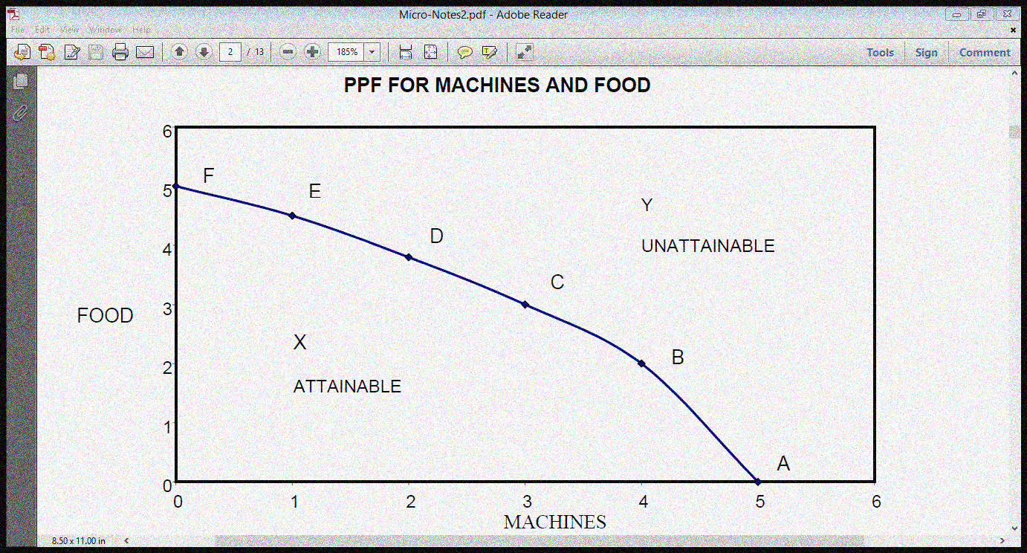
Figure 1: Example of Production Possibility Frontier for Food and Machine
The PPF curve divides production space into 3 distinct areas which are as follows:
- Points on the PPF curve (points like A, B, C, D, E, and F),
- Points on the inside of the curve (points like X); and
- Points outside the curve (points like Y)
- Points either on or inside the frontier are ATTAINABLE with the current level of resources and technology
- Points outside the frontier are unattainable with the economy's current level of resources and technology. We need more than the available resources and technology to reach there.
- Because scarcity forces the society to give up one choice for another, the slope of the PPF will always be negative, reflecting the concept of trade off.
- Point A shows that all resources are devoted to produce machines and no resources are available to produce food.
- Point F shows that all resources are devoted to produce food and no resources are available to produce machine.
- Points (A, B, C, D, E and F) on the PPF represent the maximum production (output) we can get when all resources are fully employed.
5.1.3 The Roles of Production Possibility Frontier
A. Full Employment and Unemployment
The PPF can be used to analyze and explain employment situation in production processes.
- From the assumptions stated earlier, all resources must be fully employed in order for the economy to be operating on the PPF.
- If all available resources are not used (i.e., unemployment of some of the resources), country ends up inside its PPF, producing less output than they could have produced.
- A reduction in unemployment moves the economy’s point of production closer to the PPF. When the society is closer to the PPF that means it is closer to full employment.
B. Efficiency and Inefficiency
All of the choices on PPF are efficient although they are not equally desirable.
- Efficiency means
- Producing the maximum output from the available resources used in production.
- The use of the least-cost methods to produce specific quantity of output.
- Using the fewest resources to produce specific quantity of a good or a service
- Using factors of production in the most productive way.
All points on the PPF are efficient points. We achieve production efficiency if we cannot produce more of one good without producing less of some other good.
- With inefficient production, we end up on the inside of the PPF
- Inefficiency is a result of some unemployed (unused) resources or misallocation (waste, under-use) of the resources, or both. Misallocation means assigning resources not to their best use.
- Point X in the graph above means that the country's resources are not being used efficiently. At such a point it is possible to produce more of one good without producing less of the other good.
C. Tradeoff
Operating on the PPF shows that one good has to be sacrificed in order to have more of the other
- Every choice along the PPF involves a tradeoff. Changes in production from one point on the PPF to another involve a tradeoff. Some of one good must be forgone (given up) to gain more of the other good.
- On this PPF, we must give up some machines to get more food or give up some food to get more food. Thus, PPF has a negative slope. Thus, a country that must decrease production of one good in order to increase the production of another must be producing on its PPF
- There is no tradeoff when production points are inside the PPF because it is possible to get more both goods without producing less of some other goods and services.
- All tradeoffs along the PPF involve a cost – an opportunity cost.
D. Opportunity Cost
The opportunity cost of any action or choice made is the highest value of the alternative forgone. The concept of opportunity cost could be made more precise using the PPF. All points (A, B, C, D, E and F) on the PPF involve opportunity cost; this is because to produce more of Food, you need to produce less of Machine. The opportunity cost is calculated as follows:
$Opportunity cost of producing one more unit= \frac{quantities of the good youmust give up}{quantities of the good you will get}$
$$Opportunity cost of producing one more unit of machines= \frac{∆Food}{∆Machine}$$
$$Opportunity cost of producing one more unit of food= \frac{∆Machine}{∆Food}$$
The slope of PPF depends on the concept of this opportunity. The slope of the production–possibility frontier (PPF) at any given point is called the marginal rate of transformation (MRT). The slope defines the rate at which production of one good can be redirected (by reallocation of productive resources) into production of the other. It is also called the (marginal) "opportunity cost" of a commodity, that is, it is the opportunity cost of Food in terms of Machine. It measures how much of Food is given up for one more unit of Machine or vice versa. The slope of PPF relies on the opportunity cost of one good in term of another. This opportunity cost by nature can be increasing, decreasing or constant; it all depends on the shape of the PPF.
- If the PPF is concave to origin (see Figure 1 for example); the opportunity cost will be increasing.
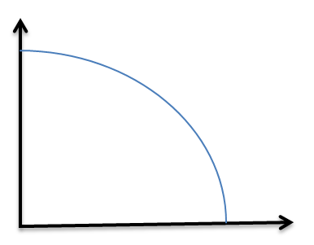
- If the PPF is convex to origin; the opportunity cost will be decreasing.

- If the PPF is a straight line, the opportunity cost will be constant as production of different goods is changing.

Production Efficiency and Allocative Efficiency
- All points (A, B, C, D, E and F) on the PPF represent production efficiency. Production efficiency occurs when we cannot produce more of one good without giving up some of the other good. But which point on the PPF gives the society the best allocation of resources on both goods (i.e., which point has allocative efficiency)?
- To determine the optimal (efficient) quantities of each good the society should produce, we should compare marginal costs and marginal benefits. Allocative efficiency exists when marginal benefit is equal to marginal cost.
- It is of great importance to know that both Production efficiency and Allocative efficiency are attained only when where marginal benefit of producing the two goods is equal to the marginal cost of producing them.
5.2 Economic Growth
All output combinations outside the PPF are unattainable with the available resources and technology. At these combinations, we could get more goods and services than what we are currently capable of producing. To attain these combinations, the two key factors are
- Capital accumulation is the growth of capital resources, which includes human capital (increasing or improving the quality of resources)
- Technological change (Improvement) is the development of new goods and of better ways of producing goods and services.
Any of these changes will shift PPF outward to reach new points that is unattainable before the changes. The new PPF would represent the new efficient allocation of resources and the country now has more of its goods and services. This is what is called economic growth (or an increase in production capacity).However, it to be noted that this economic growth can be balanced or unbalanced.
Balanced and Imbalanced Growth
If the capital accumulation and /or the advancement in the technology result in an increase in the production in all sectors (that is the production of both Food and Machine as example) there will be a balanced outward shift of the PPF (balanced economic growth).

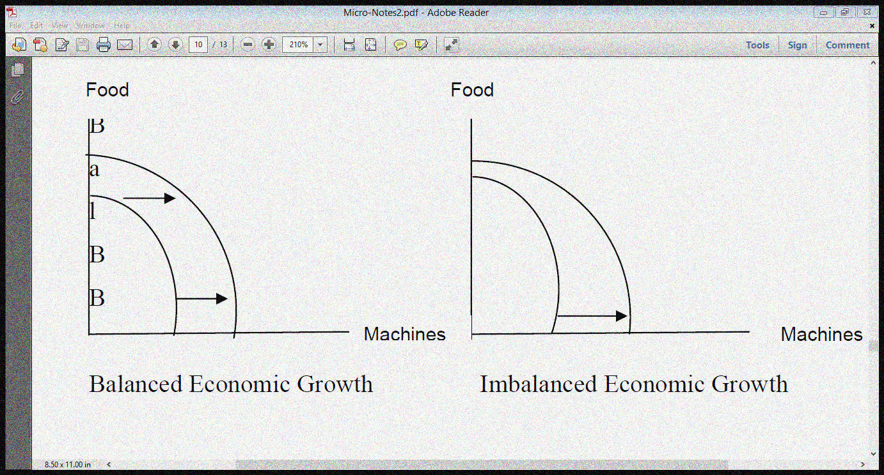

But if there is an increase in the resources and/or new advancement in the technology that lead to a development of only one sector or one good the growth would be imbalanced. For example if a new technology discovered that makes machine production more efficient and more productive the PPF outward shift will affect only machine sector and will not affect the food sector, at least in the short run.
Inward Shift
When the PPF shifts outward, we know the economy is growing. Alternatively, when the PPF shifts inward, it indicates that the economy is shrinking as a result of a decline in its most efficient allocation of resources and optimal production capability. A shrinking economy could be a result of war or natural disaster that results in a decrease in production or a deficiency in technology which might move the PPF inward and to the left.
An Important Hint on Production Possibility Curve
It is very important to know that only points on or within a production possibility curve are actually possible to achieve in the short run but the point outside the PPC is only achievable in the long-run. In the long run, if technology improves or if the supply of factors of production increases, the economy's capacity to produce both goods increases; if this potential is realized, economic growth occurs. That increase is shown by a shift of the production-possibility frontier to the right.
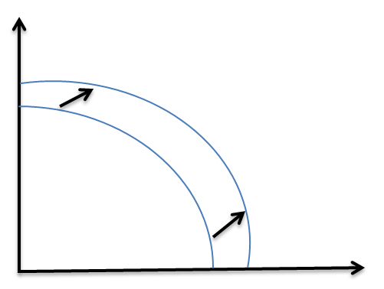
Post-Test
The following table shows the production possibilities in an hypothetical economy
Employment in War Equipment | Output of War Equipment | Employment in Agriculture | Outlay of Agricultural Process
4 | 30 | 0 | 0
3 | 27 | 1 | 14
2 | 22 | 2 | 22
1 | 15 | 3 | 29
0 | 0 | 4 | 35
You are required to:
- i. plot the graph of the economy’s PPF using suitable scales
ii. indicate the points on your graph that show inefficient organization of production
iii. explain why the points outside the frontiers are unattainable.
iv. use the PPF plotted in a (i) to explain the concept of opportunity
- i. Determine the opportunity cost of increasing agricultural proceeds from 14 to 22
ii. Determine the opportunity cost of increasing war equipment from 0 to 15 units

Bibliography
- Lipsey, R. G., & Chrystal, K. A. (1999). Principles of economics. Oxford University Press. Ninth Edition

- Begg, D., FISCHER, S., & DORNBUSCH, R. (1994). Economics, England. Sixth Edition

- Jhingan, M. L. (2004). Microeconomic Theory, Grinda Publication Ltd. Fifth Revised and Enlarged Edition

- Adebayo, A. (1998). Economics: A Simplified Approach. African International Publishing. Volume 1, Second Edition

LECTURE SIX
METHODOLOGY OF ECONOMICS
6.0 Introduction
By methodology of economics it is meant the way in which economists go about the study of their subject. That is, how they seek to gain knowledge of economic actions of man so as to be able to forecast possible course of future events.
Objectives
At the end of this lecture, students should be able to:
1. Define and interpret the mathematical concepts of variables, functions, e.t.c
2. Construct simple graphs and know their uses in economics
Pre-Test
1. What is a variable?
2. Mention four types of variable known to you
CONTENT
6.1 Methodology of Economics
6.1.2 Scientific Method
In their investigation of economic problems and economic relationships, economists often adopt scientific method. In this method, problems are identified and defined in a concise manner, relevant information relating to the problems are collected, organized and analyzed. Basically, there are two methods of reasoning in theoretical economics. They are the deductive and inductive methods.
6.1.3 The deductive method
Deduction means reasoning from or inference from the general to particular or from the universal to the individual. The deductive method derives new conclusion from fundamental assumptions or from truth established by other methods. It involves the process of reasoning from certain laws or principles which are assumed to be true to the analysis of facts. It is also known as a priori method. It is an established fact that ‘‘Man is rational’’ so he will try to purchase lesser quantity of a particular commodity when it is costlier. Masood, who is also a man will behave in the same way and purchase lesser quantity of goods. This method assumes that the behaviour of the general public will also be the behaviour of individual person. Similarly, the hypothesis that firms always maximize profits, rest upon the observation that some firms do behave in this way. This premise is based on a priori knowledge which will continue to be accepted so long as conclusion deduced from it are consistent with the facts. Macroeconomic theories are based upon deductive method. Deductive method is used to propound theory regarding the economy. Studies of national income, employment, price level and international trade is made on the basis of deductive method.
6.1.3 The inductive method
Induction is a process of reasoning from a part to the whole, from particulars to generals or from individual to the universal. It is an ascending process in which facts are collected, arranged and the general conclusions are drawn. For example, if we find that Ruth purchases more garments when its price falls. We observed that Dolapo does the same thing. Damilola and Benita also behave in the same way. Finally, we can generalize their behaviour and an economic theory that customers have tendency to buy more of a commodity when its price falls is formed. Economic laws of consumers’ behaviour, such as laws of diminishing utility, consumers’ surplus and diminishing returns have been developed on the basis of inductive method. Similarly, theories of rent, wages and interest, Engel’s law of Family Expenditure, Malthusian theory of population have been derived from inductive reasoning. This method is also known as historical method, concrete method, analytical method and realistic method. This is due to the fact that this method starts investigation of particular facts, historical events, and tries to generalize the findings of the observation for the whole economy. Micro economic theories are formulated according to inductive method.
6.3 Basic Distinction between a hypothesis and an economic theory
A hypothesis is a statement that can be tested. It is a proposal, a guess used to understand and/or predict something. We all make observation of events around us and from this observation some generalized statement emerged. For instance, we usually observe that when the price of a commodity rises, we buy less of it. We could then conclude that if the price of a commodity goes up then the quantity demanded falls. This sort of “if” “then” statement is called a hypothesis. If we test the above hypothesis in the real world situation and it is discovered that it is indeed true for various commodities, various people at different point in time, then it is elevated to the position of a theory. That is, a theory is a hypothesis that has been confirmed valid after undergoing some tests in the real world.
A theory is a general principle or body of principles that has been developed to explain a wide variety of phenomena. A theory is a well-substantiated explanation of some aspect of the natural world; an organized system of acceptable knowledge that applies in variety of circumstances to explain a specific set of phenomena. It consists of definitions, assumptions (have to be consistent with one another) and hypotheses (“if … then” statements, that is predictions). It is important to note that there is a basic distinction between the correctness of theory and the validity of a theory. A theory is correct if and only if it is logically consistent. That is if . On the other hand a theory is valid only when it is applicable. This implies that a theory may be correct but inapplicable; such a theory is not valid. (Validity of a theory and Stages of a theory are to be taught in ECO 201).
6.4 Economic Models versus Econometric Models
Three main types of languages are often used in expressing economic law. These are: verbal statement, graphical statement, mathematical statement/model (a combination of both functional relations and algebraic statement), also known as Economic Model. We can distinguish these languages by using the Law of Demand, Law of Supply, and Keynesian Consumption Theory.
6.4.1 Verbal statement
- The higher the price, the lower the quantity demanded, ceteris paribus. This statement implies the existence of an inverse relationship between price and quantity demanded. The use of words is often the easiest way of representation for simple analysis.
- The higher the price, the higher the quantity supplied, ceteris paribus. Unlike demand, this statement depicts the existence of a direct relationship between price and quantity supplied.
- The fundamental psychological law…is that men (women) are disposed, as a rule and on average, to increase their consumption as their income increases, but not as much as their as the increase in income.
6.4.2 Graphical statement
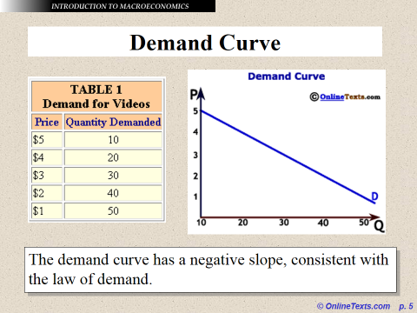

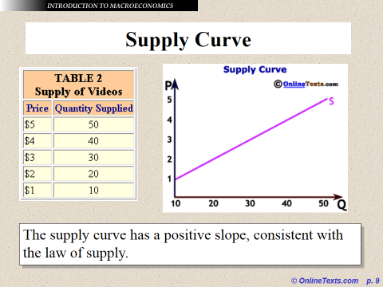

    - Mathematical Statement:
a. Functional statement
Ceteris paribus
Ceteris paribus
Where Quantity demanded of the commodity,
Quantity supplied of the commodity,
Price of the commodity,
Consumption,
Disposable Income (Income minus tax, i.e.)
- Algebraic statement

6.4.4 Economic model
A model is a simplified representation of an actual phenomenon, such as an actual system or process. The actual phenomenon is represented by the model in order to explain it, to predict it, and to control it, goals corresponding to the three purposes of econometrics, namely structural analysis, forecasting, and policy evaluation. Sometimes the actual system is called the real-world system in order to emphasize the distinction between it and the model system that represents it. Modeling, that is, the art of model building, is an integral part of most sciences, whether physical or social, because the real-world systems under consideration typically are enormously complex. In essence, economic model is an abstraction from reality. This is done by relating a number of variables to one another in a certain way such that the equation gives a meaningful mathematical interpretation in a set of analytical assumptions on which the model is based. A good example of this model is the national income model, while others are demand function, supply function, production function, consumption function etc.
6.5 Econometric Model
An econometric model is a combination of an economic model with an error term to produce a complete representation of the true data generating process. An econometric model specifies the statistical relationship that is believed to hold between the various economic quantities pertaining to a particular economic phenomenon under study. A simple example of an econometric model is one that assumes that monthly spending by consumers is linearly dependent on consumers' income in the previous month. Then the model will consist of the equation
where C is consumption, is disposable income, and is an error term measuring the extent to which the model cannot fully explain consumption. In other words, an error term is a random variable that represents all portion of the data generating process that are not captured by the economic model.
6.6 Variables
A variable is any well-defined item that can take on various specific values at any given point. For instance, the price of commodity, the quantity demanded of a commodity, consumption, income, gross domestic product, per capita income, e.t.c. In economics we distinguish between:
- Flow Variable:
A flow is a quantity which is measured with reference to a period of time. Thus, flows are defined with reference to a specific period (length of time), e.g., hours, days, weeks, months or years. It has time dimension. National income is a flow. It describes and measures flow of goods and services which become available to a country during a year. Similarly, all other economic variables which have time dimension, i.e., whose magnitude can be measured over a period of time are called flow variables. For instance, income of a person is a flow which is earned during a week or a month or any other period. Likewise, investment (i.e., addition to the stock of capital) is a flow as it pertains to a period of time.
Other examples of flows are: expenditure, savings, depreciation, interest, exports, imports, change in inventories (not mere inventories), change in money supply, lending, borrowing, rent, profit, etc. because magnitude (size) of all these are measured over a period of time.
- Stock Variables
A stock is a quantity which is measurable at a particular point of time, e.g., 4 p.m., 1st January, Monday, 2010, etc. Capital is a stock variable. On a particular date (say, 1st April, 2011), a country owns and commands stock of machines, buildings, accessories, raw materials, etc. It is stock of capital. Like a balance-sheet, a stock has a reference to a particular date on which it shows stock position. Clearly, a stock has no time dimension (length of time) as against a flow which has time dimension. A flow shows change during a period of time whereas a stock indicates the quantity of a variable at a point of time. Thus, wealth is a stock since it can be measured at a point of time, but income is a flow because it can be measured over a period of time. Examples of stocks are: wealth, foreign debts, loan, inventories (not change in inventories), opening stock, money supply (amount of money), population, etc.
The distinction between flows and stocks can be easily understood by comparing the actions of Still Camera (which records position at a point of time) with that of Video Camera (which records position during a period of time).
- Dependent variable: This is a variable whose value is determined by that of one or more other variables in a function. In essence, it is a variable (often denoted by y) whose value depends on that of another.
- Independent variable: An independent variable, a term used in math and statistics, is a variable you can manipulate, but it's not dependent on the changes in other variables.
Dependent Variable | Independent Variable
Explained variable | Explanatory variable
Predictand | Predictor
Regressand | Regressor
Response | Stimulus
Endogenous | Exogenous
Outcome | Covariate
Controlled variable | Control variable

Note: Parameters: Parameters are unknown constants.

6.7 Basic Tools of Economic Analysis: Tables, Graphs, Mathematical and Statistical Principles
The economist requires mathematical and statistical tools in economic analysis. Mathematical tools help the economist to discover the implications of his theories which will enable him to make predictions. Statistical tools are used by the economist when testing his theories against the real world observations.
6.7.1 Table
A table is an orderly arranged list of information, facts or data, usually set out in rows and columns, and which attempts to summarize a large mass of data by presenting it in a condensed form, thereby making data more comprehensive.
Uses of Tables
- It helps to present the original data in an orderly or systematic manner.
- Tabulation helps to summarise the data. And since the data is in a more condensed form, it becomes more readily comprehensible.
- By reducing and simplifying a large mass of data, a table brings out the important features in the data or shows a distinct pattern of relationship between variables in the data.
- A table eases comparison between different classes of data and makes further analysis of data possible.
- A table makes it possible for required figures to be easily located.
Features of a good Table
Tables differ in details, but they have some common characteristics.
- A good table must have neat layout and it must be easy to comprehend.
- A table has a general explanatory title or heading. This briefly states what the table is about
- There is a column title (caption). This shows the type of items classified along the columns.
- There is a row title (stub). This shows the type of items classified along the row.
- There is usually an indication of the unit in which the data have been presented. Most often, this is stated at the top right-hand corner. If the numbers are large, the units could be stated in hundreds, thousands, millions, e.t.c.
- Sometimes there is a note at the bottom of the table to indicate the source of information contained in the table.
- There could be an explanatory footnote on the data presented or classified. The meaning of all symbols used in the table is explained.
Example: Below is a table which shows the annual average output of some major food crops in Nigeria.

Table 1: Average annual output of major food crops in Nigeria (million metric tons)
CROPS | YEARS/OUTPUT
CROPS | 1960-1962 | 1963-1965 | 1966-1968 | 1969-1971 | 1960-1971  (Average)
Sorghum | 3.919 | 4.172 | 3.126 | 4.041 | 3.830
Millet | 2576 | 2.64 | 2.273 | 2.957 | 2587
Rice | 0.182 | 0.215 | 0.312 | 0.297 | 0.252
Maize | 0.435 | 1.148 | 1.095 | 1.425 | 1.181
Cowpea | 12.867 | 0.622 | 0.593 | 0.903 | 0.638
Yam | 7.212 | 14.818 | 11.649 | 11.997 | 12.833
Cassava | 7.989 | 7.982 | 8.588 | 6.175 | 7.489

Source: a. Agric Development in Nigeria (Federal Ministry of Agric and Rural Development)
b. Rural Economic Survey of Nigeria (Federal Ministry of Statistics, Lagos).
6.7.2 Charts and Graphs
Data which have been collected and tabulated could be put in form of diagrams (Charts and Graphs) to aid further comprehension by making an impression on the eye. People are able to comprehend spatial relationships much more and clearly than numerical relationships presented in tables. Charts are of various types:
- Pie Chart: A pie chart is a circle which is divided into sectors by radial lines. The circle represents the total mass of data under consideration, while the various sectors show the relative sizes or proportions of the different variables or values of components of the data.
- Bar Chart: Bar chart helps to show changes in the figures or size of variables in a simple manner. They are easier to construct and show data more accurately than pictograms. They are of various types.
- Simple bar chart: This is used when data involves more than one category.
- Component bar chart: This is used when data involves more than one category. Simple bars are divided into sections (components), and each component corresponds in size to the magnitude of the item it represents.
- Multiple bar chart: This is a variation of the component bar chart which also used to show data comprising two or more categories. This helps to aid comparison and comprehension of data. In a multiple bar chart, the component values are drawn as separate bars adjoining to each other.
- Histogram: A histogram is the graph of a frequency distribution. Generally, a histogram is presented as a set of rectangular bars having their bases as their intervals between the class boundaries and their areas proportional to the frequencies of the classes. No bars are left in the bars as is done in bar charts. The values of the variables are scaled along the X-axis while frequencies are scaled along the Y-axis. (Will be elaborated in Part 2)
- Frequency Polygon: If successive mid-points of the rectangular bars in the histogram are connected by straight lines, the resulting graph is called a frequency polygon. (Will be elaborated in Part 2)
- Pictograms: Pictograms are charts in which pictures or drawings of objects are used in such a way as to show the magnitude of the variables or to convey other information. They are especially useful to the ordinary person who appreciates pictures more readily than bar charts or other diagrams.
- Frequency distribution: (to be taught in part 2)
6.7.3 Measures of Central Tendency: The measures of central tendency, also measures of location, is the statistical information that gives the middle or centre or average of a set of data. They are all regarded as forms of averages. They are:
- The Arithmetic Mean
- The Geometric Mean
- The Harmonic Mean
- The Quadratic Mean
- The Median
- The Mode
Note: will be elaborated in part 2
6.7.4 Measures of Dispersion: The measures of dispersion, also known as the measure of variability, refers to the degree of spread of numerical value in a distribution. It measures the variation that occurs in a given set of data. Examples include:
- The Range
- The Quartile
- Mean deviation
- Variance
- Standard deviation
Post-Test
1. Discuss the three types of language for expressing economic laws.
2. Distinguish between: economic model and econometric model, exogenous and endogenous variables
3. What do you understand by pie chart?
4. The population of five towns in a country X in 2015 is as follows:
TOWN | POPULATION IN THOUSANDS
A | 50
B | 100
C | 25
D | 12.5
E | 12.5
Represent this information in a pie chart.
HINTS:
- Calculate the total population.
- Find the appropriate angle which represent each population size for the five towns (note that the total angle in a circle is ) using the following formula:
Population of town x 360
Total population size 1

4. Use the table in question 3 above to draw a simple bar chart.
5. A farmer produces maize and yam. The respective values of the crops produced for a period of six years are shown in the table below. By using an appropriate scale for the value of crops, illustrate the data in a component bar chart.
YEAR | MAIZE | YAM | TOTAL
2000 | 10 | 20 | 30
2001 | 15 | 25 | 40
2002 | 10 | 30 | 40
2003 | 10 | 25 | 35
2004 | 20 | 25 | 45
2005 | 25 | 30 | 55

- The value three brands of drinks sold by Mama Put Limited for five months is presented in table below:
 | SALES
 | VIJU MILK | COCA COLA | ZOBO
JANUARY | 50 | 48 | 30
FEBRUARY | 40 | 50 | 40
MARCH | 45 | 35 | 50
APRIL | 48 | 50 | 60
MAY | 60 | 40 | 30

By choosing an appropriate scale, depict the data in a multiple bar chart.
Bibliography
- Lipsey, R. G., & Chrystal, K. A. (1999). Principles of economics. Oxford University Press. Ninth Edition

- Begg, D., FISCHER, S., & DORNBUSCH, R. (1994). Economics, England. Sixth Edition

- Jhingan, M. L. (2004). Microeconomic Theory, Grinda Publication Ltd. Fifth Revised and Enlarged Edition

- Adebayo, A. (1998). Economics: A Simplified Approach. African International Publishing. Volume 1, Second Edition

LECTURE SEVEN
THEORY OF PRODUCTION
6.0 Introduction
This lecture focuses on production theory. We will identify and discuss attributes of factors of production. We will examine how production is carried out and also consider the relationship between input of factors and output of goods and services under different technological constraint
Objectives
At the end of this lecture, students should be able to:
1. Define the term production, production function, explain the main types of production and the concepts of production; and
2. explain the law of diminishing returns and its practical applications
Pre-Test
1. What is production?
2. Mention the various factors of production known to you.
CONTENT
6.1 Definition
Production is erroneously defined as the transformation of raw materials into finished goods that can create satisfaction. Rather, production is defined as the creation of goods and services that can satisfy human wants. This is why some believe that production is the creation of utility, utility means power of satisfaction derived from the consumption of a good or services. Production is technically defined as the use of inputs in order to produce desire output that can create satisfaction.
Production can be direct and indirect, it is direct when the goods and services are meant for self-consumption or not meant for sale. Production here is subsistence e.g. the services of the teacher to his children. On the other hand, production is indirect, when the goods and services produced are meant for commercial purposes i.e. they are meant for sale e.g. the activities of a big time farmer in Ogun or the service of a teacher to his students.
6.2 Types of Production
It is also known as stages of production. They are those various stages which production must undergo before production is said to complete.
- Primary Production: It is the first stage of production that involves extraction or bring out of raw materials from available natural and technological resources. The primary production is purely engaged in agriculture. It has the highest labour force in the whole of West Africa. Examples of primary production activities are farming, mining, forestry, fishing, animal husbandry, quarry etc.
- Secondary Production: It is the intermediate stage of production which involved in transformation of raw materials produced in the primary production stage into finished or semi-finished good. A good is finished when it has completed its production stages and can be consumed to create satisfaction. E.g. biro, already made clothes etc. A good is semi-finished when it half processed or has not completed its production stages e.g. textile materials, cement, flour, etc. The manufacturing industry and the construction industry are found under the secondary production.
- Tertiary Production: It is the third and last stage of production. It is this stage that helps to complete production. Production is said to be completed when goods and services produced reached hands of final consumers. The tertiary production involves distribution and exchange of goods and services. This is done through trade and its auxiliaries such as wholesalers, retailers, advertisers, bankers, communicators, insurances, personnel, transporters and ware house owners. People like teachers, doctors, entertainers, barber and a host of others who rendered services are all found under the tertiary production.
Note: The three stages are interrelated because no stage can do without other.
6.3 Factors of Production
They are those indispensable variables without which production cannot take place. The classical economics advocated for three factor of production, headed by “Adam Smith”. According to this school of thought, there are three factors of production: land, labour and capital. But neo-classical economists advocated for four factors of production: land, labour, capital and entrepreneur. This school of thought was headed by “Alfred Marshall”. Today, we assume four factors of production. The memory guide is “CELL”. Where
C = Capital
E = Entrepreneur
L = Labour
L = Land
Land – It is a factor of production which to layman means ordinary soil. But to the economists, land is the natural resource bestowed on planet earth by nature. Simply, land is commonly defined as the free gift of nature resources. Example are air, land, sea, ocean, lake, island, mountain, cloud, sun and moon light, spit, forest etc.
Characteristics or features of land
1) It is a factor of production.
2) It is a free gifts of nature.
3) It has no cost of production.
4) It has a reward known as rent or rate.
5) It geographical immobile.
6) It is fixed in supply.
7) It varies in value and in location
8) It suffers diminishing returns.
9) It is destroyable by man e.g. the ozone layer has been destroyed by man because of the rockets sent into the space.
Labour
It is an indispensable factors of production which involves two human factors: mental and physical. Labour is defined as the contribution of man physically and mentally towards the growth of production. Labour can be productive and unproductive. It is productive when a reward is attached either in cash or kind after completion e.g. civil servant’s salaries for their services. On the other hand labour is unproductive when no reward is attached after competition e.g. charitable helps, the former monthly environmental sanitation.
Features or characteristic of labour
- It is a factors of production
- It is involved mental and physical efforts i.e. it is human.
- It is divisible – division of labour.
- It can be found in qualities e.g. skilled or unskilled.
- It is rewarded in the form of wages or salaries.
- Labour is temporal, a time comes in life when a man can no longer work.
- Labour cannot be stored but can be transferred.
- Labour can be mechanized.
- Labour can increase or reduce in quantity.
- It is a function of population.
- Labour can improve over time.
- Labour can only improve with consistent practice.
- Labour is mobile.
Types of Labour
There are three types of labour:
- Skilled Labour: it is the labour that requires formal training or education before knowledge can be acquired e.g. teachers, doctors etc.
- Unskilled Labour: It is that labour that does not require formal education before knowledge can be acquired e.g. cleaners, maids, conductors etc. This types of labour has the highest degree of mobility.
- Semi-skilled Labour: Labour is neither skilled nor unskilled i.e. the worker acquires little knowledge of education before taking up apprenticeship scheme on any profession e.g. printers, photographers, fashion designers etc.
Importance of Labour
Without labour production cannot take place.
Capital
This can be defined as a stock of wealth created by man to be used mainly in the production of final goods and services. Therefore, capital includes plant, machines, industrial buildings which are called physical capital. It also includes intermediate or semi-finished goods such as raw cotton used for textiles, crude oil for petrol, motor spare parts, and so on. The term financial capital or liquid capital is used specifically to refer to money which is either contributed by the business owners or obtained as loan from banks or other sources. The financial capital earmarked for the purpose of paying wages and buying other inputs, as well as the semi-finished goods are sometimes referred to as the circulating capital. The social capital are the infrastructures like roads, hospitals, schools, and railway that are indirectly connected with production. The reward for capital is known as interest.
Entrepreneurship
The entrepreneur hires and organizes the other factors of production. He decides what goods to produce, how to produce, an in what quantity. He bears the risk of production. He earns profit for effective management of resources or suffers a loss for laxity and inefficiency. On the basis of the aforementioned functions of an entrepreneur, there is controversy as to its inclusion in the list of factors of production. There are two lines of argument against considering entrepreneurship as a factor production: one that its functions fit into that of a sole trader. Two, that in large organizations those functions are performed by the management team headed by a managing director. Hence, it is argued that entrepreneurship should be considered as a specialized type of labour.
6.4 Techniques of production (Factor Intensity)
Two Types: Labour Intensive and Capital Intensive
Labour intensive: More of labour and relatively little capital are engaged in production process. Conversely, under capital intensive more of capital and relatively little labour are employed.
Illustration

 | Labour | Capital | Techniques of production (Factor Intensity)
Method | (Unit) | (Unit) | Techniques of production (Factor Intensity)
A | 300 | 10 | Labour intensive
B | 20 | 50 | Capital intensive

6.5 Production function
In simple words, production function refers to the functional relationship between the quantity of a good produced (output) and factors of production (inputs). The production function is purely a technical relation which connects factor inputs and output. Production function can equally be defined the relation between a firm’s physical production (output) and the material factors of production (inputs). It shows the flow of inputs resulting into a flow of output during some time.
Mathematically, such a basic relationship between inputs and outputs may be expressed as:
Q = f (L, K, N)
Where Q = Quantity of output
L = Labour
K = Capital
N = Land
Hence, the level of output (Q), depends on the quantities of different inputs (L, K, N) available to the firm. In the simplest case, where there are only two inputs, labour (L) and capital (K) and one output (Q), the production function becomes.
Q =f (L, K)
In essence, the production function is a technical or engineering relation between input and output. As long as the natural laws of technology remain unchanged, the production function remains unchanged.” The relationship between inputs and outputs is summarized in what is called the production function. This is a technological relation showing for a given state of technological knowledge how much can be produced with given amounts of inputs. Thus, from the above definitions, we can conclude that production function shows for a given state of technological knowledge, the relation between physical quantities of inputs and outputs achieved per period of time.

Features of Production Function:
Following are the main features of production function:

1. Substitutability:
The factors of production or inputs are substitutes of one another which make it possible to vary the total output by changing the quantity of one or a few inputs, while the quantities of all other inputs are held constant. It is the substitutability of the factors of production that gives rise to the laws of variable proportions.

2. Complementarity:
The factors of production are also complementary to one another, that is, the two or more inputs are to be used together as nothing will be produced if the quantity of either of the inputs used in the production process is zero. The principles of returns to scale is another manifestation of complementarity of inputs as it reveals that the quantity of all inputs are to be increased simultaneously in order to attain a higher scale of total output.

3. Specificity:
It reveals that the inputs are specific to the production of a particular product. Machines and equipment’s, specialized workers and raw materials are a few examples of the specificity of factors of production. The specificity may not be complete as factors may be used for production of other commodities too. This reveals that in the production process none of the factors can be ignored and in some cases ignorance to even slightest extent is not possible if the factors are perfectly specific. Production involves time; hence, the way the inputs are combined is determined to a large extent by the time period under consideration.
The greater the time period, the greater the freedom the producer has to vary the quantities of various inputs used in the production process. In the production function, variation in total output by varying the quantities of all inputs is possible only in the long run whereas the variation in total output by varying the quantity of single input may be possible even in the short run.
Types of production function (NB: will be elaborated in part 2 )
i. Linear production function and ii Non-Linear production function
i. Linear production function: Here the power of a variable is raised to one
ii. Non-Linear production function: They are of several types
- Cobb-Douglas production function e.g. in its most standard form for production of a single good with two factors, the function is
where:
- Y = total production (the real value of all goods produced in a year)
- L = labor input (the total number of person-hours worked in a year)
- K = capital input (the real value of all machinery, equipment, and buildings)
- A = total factor productivity
- α and β are the output elasticities of capital and labor, respectively. These values are constants determined by available technology.
- Leontief (Input-Output) production function: In economics, the Leontief production function or fixed proportions production function is a production function that implies the factors of production will be used in fixed (technologically pre-determined) proportions, as there is no substitutability between factors. It was named after Wassily Leontief and represents a limiting case of the constant elasticity of substitution production function. The function is of the form
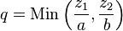
where q is the quantity of output produced, z₁ and z₂ are the utilised quantities of input 1 and input 2 respectively, and a and b are technologically determined constants.
- Constant Elasticity of Substitution (CES) production function
- Activity analysis production function
6.6 Basic distinction between short-run and long-run period
Short run” and “long run” are two types of time-based parameters or conceptual time periods that are often used in many disciplines and applications. The most prominent application of a short run and a long run is in the study of economics. The meaning of both “short run” and “long run” are relative. A short run can be any period of time ranging from a couple of weeks to months or even a year. On the other hand, a long run can also be in the same period of time depending on the company and the set parameters.
In economics, a short run characterizes the time when one factor of production is fixed and another factor is variable. In other words, it is a period of time over which the input of some factors cannot vary. Such a fixed factor may be land, equipment or building. In this situation, the factors haven’t fully adjusted to the operations schedule and economic situations. Taking labour as a variable factor, the short run production function can be written as
On the other hand, long run is a period during which all factors of production can vary. In the long run, firms are able to adjust all costs, whereas in the short run firms are only able to influence prices through adjustments made to production levels. The long run production function can be written as
6.7 Basic concepts of production
In order to describe how total output changes as more and more of the variable inputs are applied to a given quantities of the fixed inputs, we introduce three concepts of products: Total Product, Average Product and Marginal Product in this section. In addition, we also introduce and explain of law of diminishing returns.
- Total Product (TP) is the sum total of output produced by all the units of a variable factor along with some constant amount of the fixed factors used in the process of production.
- Average Product (AP) is the output per unit of the variable factor.
Where = Average Product of Labour
= Total Product of Labour
= of Units of Labour employed
- Marginal Product (MP) is the change in TP when one more unit of the variable factor is used (fixed factor remaining constant).
6.8 Law of variable proportion / Law of diminishing returns
This states that if increasing quantity of a variable factor (say labour) is used in conjunction with a fixed factor (say land) total output at first increases at an increasing rate but later increases at a decreasing rate since diminishing returns has set in. This implies that both the MP and the TP of the variable factor will eventually diminish. Another name for law of variable production is law of diminishing returns.
Table 8.1 Total Product, Marginal Product, and Average Product of Labor with Fixed Capital
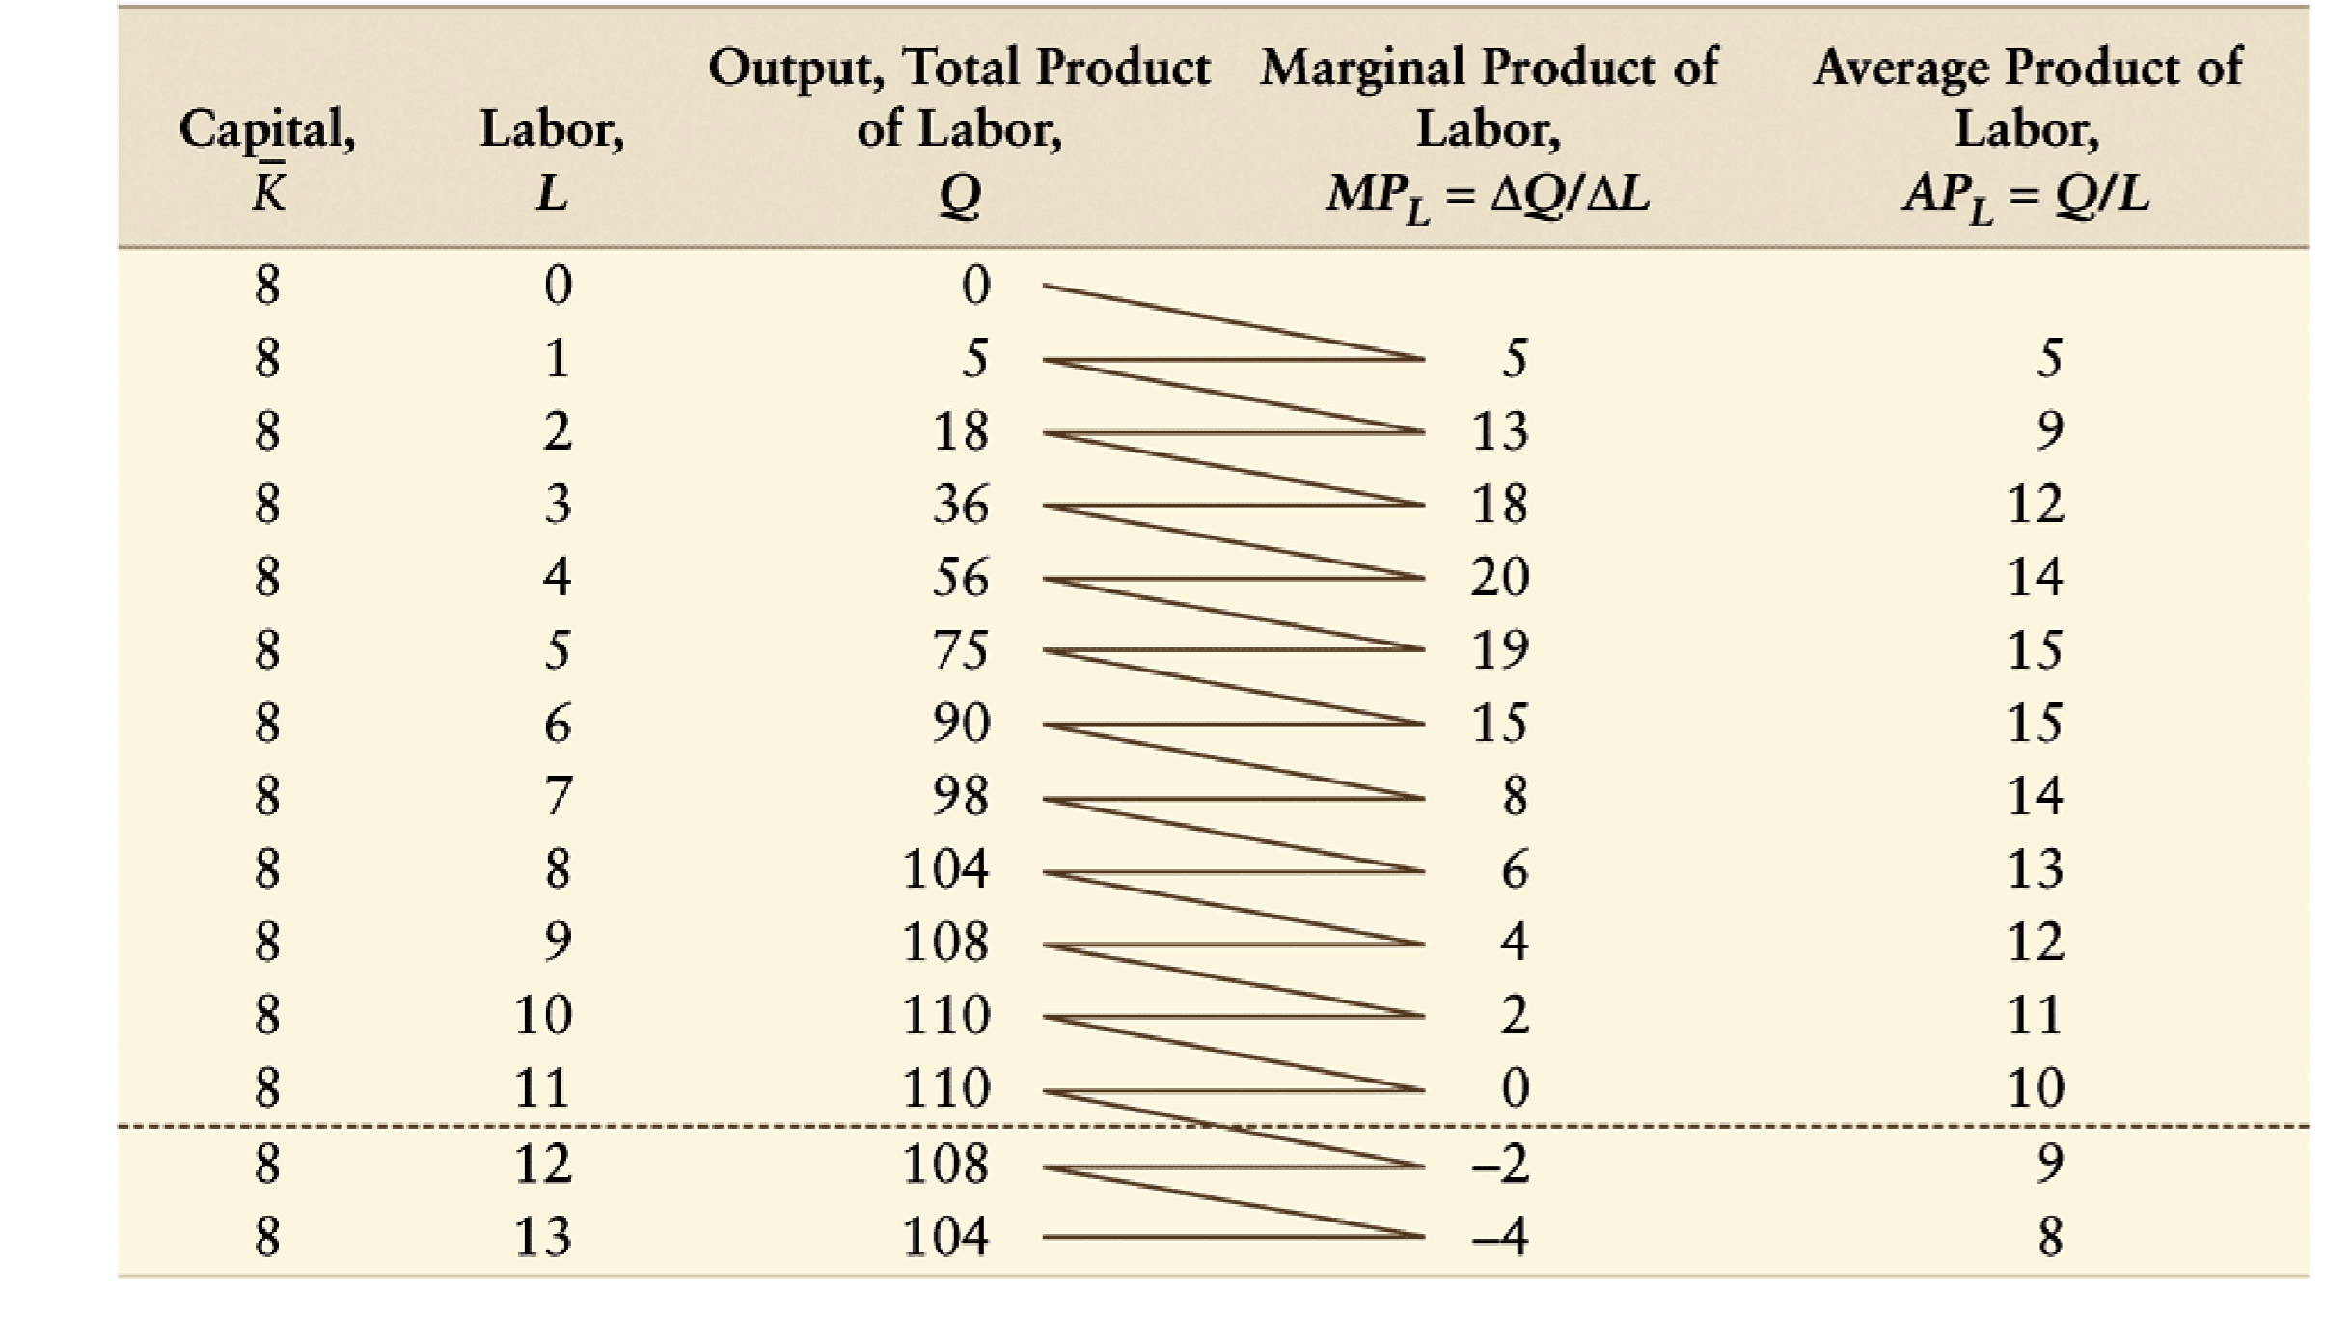
Total, Average & Marginal Products Curves
Observations
- when TP reaches maximum, MP equals zero
- where AP is maximum, we have point of extensive MP
- where TP reaches maximum or MP equals zero we have point of intensive MP
- at AP is maximum MP equals AP
- the MP cure is at maximum at the point of inflexion of the TP curve
Relations between AP and MP
- when AP is increasing, MP is also increasing but everywhere above AP
- when AP is falling, MP is also falling but everywhere below AP
- when AP is at maximum, MP=AP
6.9 Law of returns to scale
In the long run all factors of production are variable. No factor is fixed. Accordingly, the scale of production can be changed by changing the quantity of all factors of production. The term returns to scale refers to the changes in output as all factors change by the same proportion. It relates to the behaviour of total output as all inputs are varied and is a long run concept.
Returns to scale are of the following three types:
1. Increasing Returns to scale.
2. Constant Returns to Scale
3. Diminishing Returns to Scale
Suppose, initially production function is as follows:
P = f (L, K)
Now, if both the factors of production i.e., labour and capital are increased in same proportion i.e., x, product function will be rewritten as.
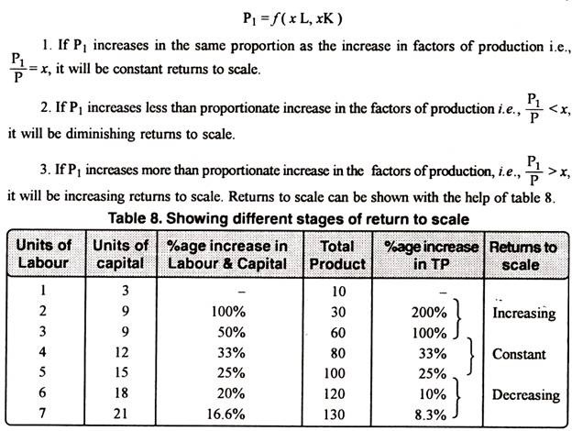
The above stated table explains the following three stages of returns to scale:

1. Increasing Returns to Scale:
Increasing returns to scale or diminishing cost refers to a situation when all factors of production are increased, output increases at a higher rate. It means if all inputs are doubled, output will also increase at the faster rate than double. Hence, it is said to be increasing returns to scale. This increase is due to many reasons like division external economies of scale. Increasing returns to scale can be illustrated with the help of a diagram 8.

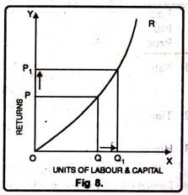
In figure 8, OX axis represents increase in labour and capital while OY axis shows increase in output. When labour and capital increases from Q to Q₁, output also increases from P to P₁ which is higher than the factors of production i.e. labour and capital.

2. Diminishing Returns to Scale:
Diminishing returns or increasing costs refer to that production situation, where if all the factors of production are increased in a given proportion, output increases in a smaller proportion. It means, if inputs are doubled, output will be less than doubled. If 20 percent increase in labour and capital is followed by 10 percent increase in output, then it is an instance of diminishing returns to scale. The main cause of the operation of diminishing returns to scale is that internal and external economies are less than internal and external diseconomies. It is clear from diagram 9.
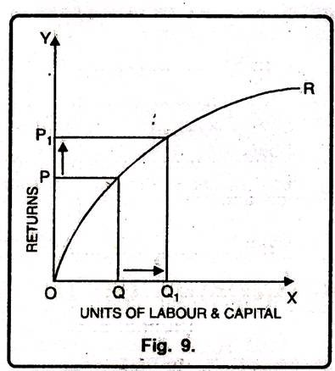
In this diagram 9, diminishing returns to scale has been shown. On OX axis, labour and capital are given while on OY axis, output. When factors of production increase from Q to Q₁ (more quantity) but as a result increase in output, i.e. P to P₁ is less. We see that increase in factors of production is more and increase in production is comparatively less, thus diminishing returns to scale apply.

3. Constant Returns to Scale:
Constant returns to scale or constant cost refers to the production situation in which output increases exactly in the same proportion in which factors of production are increased. In simple terms, if factors of production are doubled output will also be doubled.
In this case internal and external economies are exactly equal to internal and external diseconomies. This situation arises when after reaching a certain level of production, economies of scale are balanced by diseconomies of scale. This is known as homogeneous production function. Cobb-Douglas linear homogenous production function is a good example of this kind. This is shown in diagram 10. In figure 10, we see that increase in factors of production i.e. labour and capital are equal to the proportion of output increase. Therefore, the result is constant returns to scale.

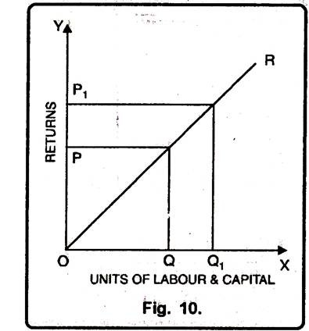

Post-Test
1. Explain the term production in economics. Outline the factors that are likely to affect the volume of production in an economy.
2. Briefly explain the relationship between total, average and marginal products using relevant diagrams
3. Explain the terms: short run and long run as used in economics
Bibliography
- Lipsey, R. G., & Chrystal, K. A. (1999). Principles of economics. Oxford University Press. Ninth Edition

- Begg, D., FISCHER, S., & DORNBUSCH, R. (1994). Economics, England. Sixth Edition

- Jhingan, M. L. (2004). Microeconomic Theory, Grinda Publication Ltd. Fifth Revised and Enlarged Edition

- Adebayo, A. (1998). Economics: A Simplified Approach. African International Publishing. Volume 1, Second Edition

LECTURE EIGHT
THE PRICE SYSTEM
8.0 Introduction
Price is the monetary value of a commodity. It is the amount of money one exchanges for a commodity. The price system or price mechanism is the process by which the monetary value of a commodity, service or factor of production is determined by the interplay of the forces of demand and supply. This is what Adam Smith called “the invisible hand”. Price system is one of the ways of allocating scarce resources among alternative uses. The uses of price theory are many but the greatest is the understanding of the operation of the private enterprise economy. Prices are normally determined by the interaction of the forces of demand and supply. The price system relates majorly to a capitalist economy in which means of production are owned privately by individuals. The price system is also applicable to the private sector of a mixed economic system.
Objectives
At the end of this lecture, students should be able to:
1. explain the concepts of demand and supply
2. know the factors influencing demand and supply
3. demonstrate how the price system can be used to promote the goals of the society
4. define and explain the concepts of elasticity of demand and supply
5. outline the determinant of elasticity of demand and supply
Pre-Test
1. Define the terms: demand and supply.
2. Explain the difference between the demand and supply schedule
CONTENT
8.1 The Price System
There are two basic things emphasized in price theory; one is demand and the other one is supply. The supply-and-demand here is a model for understanding the determination of the price of quantity of a good, service or factor of production sold in any economic transactions. The explanation works by looking at two different groups – buyers (demand side) and sellers (supply side) – and how they interact. Having explained what the price theory is all about, we discuss the concept of demand before analyzing supply.
8.2 What is Demand?
The main issue in economics is to explain and predict what actually happens in economic transactions (that is, between the buyer (what is demanded) and the seller (what is supplied)). For example, it is possible that a person might want to own several things such as cars, building houses, buying textbooks and so on. But if the person does not have sufficient money to actualize his desires (want), then such a fellow does not demand those things. So, to an economists demand for a commodity or service does not mean a desire that cannot be fulfilled, rather, it means a desire which can effectively be backed by ability to pay. In line with this explanation, demand is defined below.
Demand for a commodity is the quantity of that commodity which consumers are willing and able to purchase at each alternative prices during some specified period of time. Concisely, demand can be defined as the willingness and ability to pay a sum of money for some amount of a particular good or service over a period of time. It is very obvious that there are some unique features that must be present in the definition of demand and they are as follows:
- Willingness and ability to pay
- Demand is a flow concept; this means that reference must be made to a specific time period – a day, a week, a month and so on.

8.2.1 The Law of Demand
In real life situation, people are expected to demand for more of goods or services when the prices of goods or services decrease. This explains or expresses the inverse or negative relationship between price and demand. The relationship is the main issue emphasized by the law of demand. The law of demand refers to the direction in which quantity demanded changes with a change in price. The law of demand is expressed as follows:
“The lower (higher) the price, the greater (lower) will be the quantity demanded, given that all other conditions that influence demand remain unchanged (Ceteris paribus)”. In summary, this can be presented as thus:
$$↑P → Q_{d}↓$$
This is the First Law of demand and supply. However, for this law to hold, it depends on the validity of certain assumptions.
The Assumptions of Law of Demand
- There is no change in the tastes, preferences and habit of the consumer
- The income of the consumer remains constant
- There should not be any change in the price of related goods or services
- There should be no future expectations of change in price
- There should be no change in weather and population
The Rationale for the Law of Demand
The inverse/negative relationship between price and quantity demanded of a particular commodity can be explained as the consequence of some major factors, which are listed and explained as follows:
- The law of demand is based on the law of diminishing marginal utility. According to the law of diminishing utility marginal utility, when a consumer buys more of a commodity, marginal utility of that commodity continues to decline. This shows that the consumer will buy more units of that commodity only when its price falls. When less units of a commodity are available, utility will be high and the consumer will be prepared to pay more for the commodity. This shows that the demand will be more at a lower price and it will be less at a higher price. That is why there is an inverse/negative relationship price and quantity demand.
- Income effect: When the price of a commodity falls, the real income of the consumer increases because the consumer has to spend less in order to buy the same quantity. On the other hand, with the rise in the price of the commodity, the real income of the consumer falls. This is called income effect. Under the influence of this effect, with the fall in the price of the commodity the consumer buys more of it and also spends a portion of the increased income in buying other commodities
- Substitution effect: This explains the fact that as the price of a commodity increases, consumers will buy less of it and more of other substitute commodities. With the fall in the price of a commodity while the prices of its substitutes remaining the same; consumers will buy more of this commodity rather than the substitutes. As a result, its demand will increase. On the contrary, with the rise in the price of the commodity, its demand will fall, given the prices of the substitutes.
- Price effect: Every commodity has certain consumers but when its price falls, new consumers start consuming it, as a result demand increases. On the other hand, with the increase in the price of the product, many consumers will either reduce or stop consuming and the demand will be reduced. Hence, due to the price effect when consumers consume more or less of the commodity, the relationship between price and quantity demanded tends to be negative.

Demand Schedule and Demand Curve
Demand schedule and demand curve are two techniques for describing the demand-price relationship while holding constant other determinants of demand. So, the focus of both demand schedule and curve is on the demand and price.
Demand Schedule: It is a table showing a list of prices and quantities demanded of a commodity. At each price, the corresponding quantity is the amount of the commodity that would be bought and sold at that price. A simple example of demand schedule is presented below.

Table 1: Demand Schedule
Price per sachet of pure water(₦) | Quantity Demanded (per day)
10 | 10 units
9 | 20 units
8 | 30 units
7 | 40 units
6 | 50 units
It is observable from the typical example of demand schedule above that the lower the price the higher is the quantity demanded, and vice versa. This inverse/negative relationship re-affirms the principle of the law of demand emphasized earlier. When the information from the demand schedule above is presented in a graphical illustration then we have we called Demand Curve.
Demand Curve: It is a graphical illustration of the demand schedule. Specifically, a demand Curve is a graphical representation of the relationship between price and quantity demanded (ceteris paribus). It is a curve or line, each point of which is a pair of price and quantity demanded. Each point shows the amount of the good buyers would choose to buy at that price. The conventional practice is to show prices per unit on the vertical axis and quantities demanded in a given period of time on the horizontal axis.

P (Prices)
D

D
Q_{d} (Quantity demanded)
Figure 2: Demand Curve

The demand curve slopes downward from the left to the right.
It is imperative to know that both the demand schedule and the demand curve are drawn under the assumption of ceteris paribus, which means all other factors that determine demand aside from price are held constant.
8.2.2 Individual Demand and Market Demand
Individual demand refers to the quantities of a commodity which a single consumer would be willing and able to purchase at the various possible prices. On the other hand, the market demand is the sum of the various quantities that would be purchased by all the consumers of the product at each alternative price.
So, a market demand schedule shows the quantity of the good that would be purchased at each price. It is essentially identical with individual demand in Table 1 except that the figures under the quantity column are much greater or higher, being the sum of all the individual demands in the market. A hypothetical market demand schedule is shown in Table 2 below.

Table 2: A hypothetical market demand schedule
Price per sachet of pure water(₦) | Quantity Demanded (per day)
10 | 1,000 units
9 | 2,000 units
8 | 3,000 units
7 | 4,000 units
6 | 5,000 units

Geometrically, the market demand schedule has the same negative slope (that is the rate at which quantity demanded change as a result of change in price) with the individual demand schedule. However, the slope may differ in absolute terms, being the sum of various varying slopes.
8.2.3 Demand Equation
The relationship between price and demand may be presented in form of mathematical equation that will perfectly relate to the information on demand schedule and demand curve. Thus, the relationship between price and demand may be written in an equation form as follows:
$$Q_{D}=a-bP……………………………………………………………………………………(1)$$
Where
$"Q_{D}"$ is the quantity demanded;
$"P"$ is the price
$"a"$ represents “shift parameter” and it is a measure of the quantity demanded when the commodity in question does not command any price. This shift parameter changes when any of the independent variables of the demand function, except price changes. Thus, it means an increase in population or an increase in income will rise the value of $"a"$.
$"b"$ is the slope of demand curve and it shows the rate at which quantity demanded changes as a result of a unit change in price.
The minus $"-"$ in front of the slope ($"b"$) represents the inverse/negative relationship between price and quantity demanded.
From the market demand schedule in Table 2 above, the demand equation is
$$Q_{D}=11,000-1000P………………………………………………………………………….(2)$$
The demand equation in equation (2) can be generated using the formula below:
$$\frac{Q_{D}^{*}-q}{P^{*}-p}=b………………………………………………………………………………………………… (3)$$
Where$"b"$ is the earlier defined slope and it is calculated as follows:
$$b= \frac{q_{2}- q_{1}}{p_{2}- p_{1}}$$
Based on the information from the demand schedule in Table 2; the slope is calculated below
$b= \frac{2000-1000}{9-10}$
$$b=\frac{1000}{-1}$$
$b= -1000………………………………………………………………………………………….(4)$.
Since the value of the slope is ascertained, we substitute it into equation (3) above.
$$\frac{Q_{D}^{*}-q}{P^{*}-p}= -1000……………………………………………………………………………………….…\left(5\right)$$
$$\frac{Q_{D}^{*}-2000}{P^{*}-9}= -1000…………………………………………………………………………(6)$$
$$Q_{D}^{*}-20000= -1000\left(P^{*}-9\right)…………………………………………………………….(7)$$
$$Q_{D}^{*}-20000= -1000P^{*}+9000 …………………………………………………………(8)$$
$$Q_{D}^{*}=9000+2000-1000P^{*}…………………………………………………………………..(9)$$
$$Q_{D}^{*}=11,000-1000P^{*}…………………………………………………………………………(10)$$
The equation (10) above is a typical example of demand equation derived from the demand schedule in Table 2.
From the demand equation, it is possible to derive the equation for price (P) also. From equation (1) above
$$Q_{D}=a-bP$$
Make $P$, the subject of the formula
$$bP=a- Q_{D}……………………………………………………………………………………(11)$$
$$P= \frac{a- Q_{D}}{b}……………………………………………………………………………………(12)$$
$$P= \left(\frac{a}{b}\right)- \left(\frac{1}{b}\right)Q_{D}……………………………………………………………………………(13)$$
This is the Inverse Demand equation, which is simply the demand equation where P is the function of Q $[P=f\left(Q_{D}\right)]$
Where $\left(\frac{a}{b}\right)$ is a choke price. The Choke Price is the price at which consumers of a product will not desire any of the good. In another words, it is a price at which quantity demanded of a good is equal to zero. At any price below the choke price, consumers will demand some quantity of the good. However, at any price equal to or above the choke price, consumer will not express any demand for the good. It is evident from equation (13) that we can derive our choke price from our demand equation in equation (10)
$$Q_{D}^{*}=11,000-1000P^{*}$$
$$1000P=11,000- Q_{D}…………………………………………………………………………..(14)$$
$$P= \frac{11,000- Q_{D}}{1000}…………………………………………………………………………………(15)$$
$$P= \left(\frac{11,000}{1000}\right)- \left(\frac{1}{1000}\right)Q_{D}……………………………………………………………………(16)$$
$$P=11-0.001 Q_{D}……………………………………………………………………………….(17)$$
Since our choke price in equation (13) is $\left(\frac{a}{b}\right)$, which is the same thing as 11 in equation (17) above. This shows that any price equal to or above ₦11, the quantity demanded for the product will drop to zero.

8.2.6 Determinants of Demand (Factors Influencing Demand)
There are factors that influence the demand for a commodity. These factors are as follows:
- Commodity’s own price: The price of a commodity has great impact on the quantity demanded of it. This is explained by the law of demand. For a normal good, the higher the price, the lower the quantity demanded.
- Price of related or other commodities: Two related goods may either be substitutes or complements. Two goods are described as substitute goods or competing goods if they satisfy similar needs or desires. Malta Gold and Maltina, Coffee and Tea, Butter and Margarine, and so on. If the price of Malta Gold falls the demand for Malta Gold rises, this brings a fall in demand for Maltina. On the other hand, two goods are described as complementary goods if they are used together. That is one is not useful without the other. Examples are Stove and Kerosine, pen and ink, car and petrol, e. t. c. If the price of ink rises, the demand for ink will fall and this will also make the demand for pen to fall. Thirdly, goods can be unrelated. If the two goods are unrelated, say refrigerator and bicycle. A change in the price of one will have no effect on the quantity demanded of the other.
- Consumer’s income: A change in the income of consumer generally affects their demands for goods and services. For instance, a rise in the consumer’s income raises the demand for a commodity, and a fall in his/her income reduces the demand for it.
- Consumer’s taste or preference: A change in taste of the consumer in favour of a good will cause the demand for the good to increase at its current while a change in taste against will have exactly the opposite effect. A good example is the case of the black and white television versus colour Television.
- Consumer’s expectation about future price of a commodity: Consumer’s expectations of higher future prices may prompt him to buy more at the current price to beat the anticipated price rises. Conversely, expectations of falling prices will tend to decrease the current demand for products.
- Number of consumers: An increase in the number of consumers in a market brought about, perhaps, population growth, will cause an increase in demand, vice versa.
It is of great importance to emphasize it that all factors explained above can be categorized into two. One, factor that can cause change in quantity demanded; two, factors that can cause change in demand. It is a change in price that leads to a change in the quantity demanded whereas a change in any other factor causes a change in demand.
5.2.7Changes in the Quantity Demanded Versus Changes in Demand
The conventional way adopted by economists to separate the influence of commodity’s own price analytically from the influence of other factors on demand is changes in the quantity demanded and change in demand.
Change in the quantity demanded is the movement along the demand curve as a result of change in price of a commodity. This concept is used to explain a movement from one point on the demand curve to another point on the same demand curve. Change in the quantity demanded occurs only due to change in prices which results in movement from one point to another on a fixed demand curve. It is also called extension and contraction. This is demonstrated graphically in the Figure 2. If the initial price is $P_{1}$, the quantity demanded is $Q_{1}$. Supposing the price now rises to $P_{2}$, this will cause the quantity demanded to fall to $Q_{2}$. This is an example of upward movement along the same demand curve and it is known as contraction in demand. On the other hand, if price falls from $P_{1}$ to $P_{3}$, the quantity demanded will also increase from $Q_{1}$ to $Q_{3}$. This represents a downward movement along the same demand curve and it is known as extension in demand.
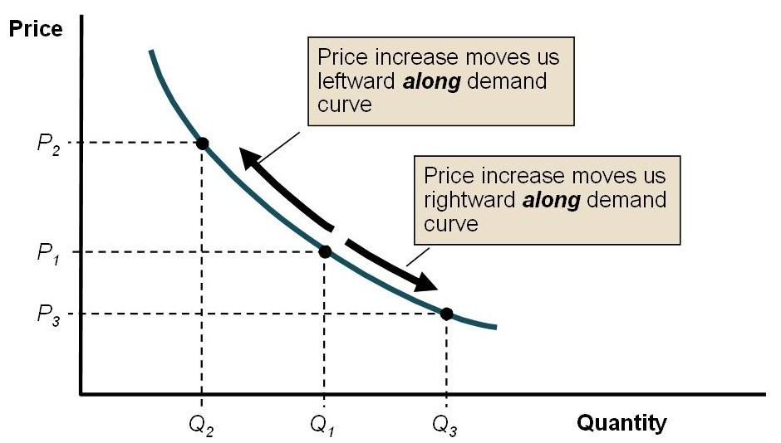
Figure 3: Change in quantity demanded

Change in demand is a shift in the entire demand curve. A change in demand for a commodity occurs as a result of changes in other factors aside from own price of the commodity. Change in other factors such as price of other commodities (complements or substitutes), income of the consumers, number of consumers, tastes or preference, change in population e. t. c. are responsible for change in demand and they are capable of changing the shift parameter in equation (1).

Price

$D_{3}$ $D_{1}$ $D_{2}$

Quantity

$$Q_{2}$$
$$Q_{1}{}_{}$$
$$Q_{3}$$
$$\overline{P}$$

Figure 4: Change in demand

An increase in demand is caused by other demand influencing factors apart from own price. The factors that cause increase in demand are as follows: (1) an increase in the consumer’s income; (2) an increase in the price of a close substitute or a fall in the price of a complement; (3) a change in consumer’s taste in favour of the good or the consumer’s increased preference for the product; (4) consumer’s expectation of higher future prices; and (5) an increase in the number of consumers of the product. Figure 3 above can be used to explain the increase in demand. An increase in any of the demand influencing factors apart from own price will cause demand to increase from $Q_{1}$ to $Q_{2}$, that is from $D_{1}$ (demand curve 1) to $D_{2}$ (demand curve 2). This is an example of outward (rightward) shift of demand curve. However, any decrease in any of the factors will cause the demand curve to shift leftward (inward), from $Q_{1}$ to $Q_{3}$, that is from $D_{1}$ (demand curve 1) to $D_{3}$ (demand curve 3).

CLASSIFICATIONS OF GOODS AND THE EXCEPTIONS TO THE LAW OF DEMAND
Goods can be classified in economics based on whether they obey the law of demand or not. The goods that obey the law of demand are called normal goods while those goods that do not follow the law of demand are generally called abnormal goods. It is not in all cases demand curve slopes downward to the right. In some few cases it has a positive slope whereby the relationship between price and quantity demanded is positive instead of being inverse/negative. This is called exceptional demand curve. An example of exceptional demand curve is presented in Figure 4 below

D
Price

Quantity

Figure 4: An Exceptional Demand Curve
Before we discuss other types of goods, it is necessary to define what a normal good is. Normal goods are any goods for which demand increases when income increases, and falls when income increases. Aside from normal goods which give a downward sloping demand curve, the following are the examples of cases where one may obtain exceptional demand curves.
- Inferior goods. These are goods for which demand increases as price rises, and demand decreases as price fall. This is what Alfred Marshal called the Giffen Paradox which makes demand curve to have a positive slope. It is sometimes referred to as Giffen goods (named after the economist Sir Robert Giffen). The is phenomenon is particularly common in less developed countries where the living standard of the majority of people is low; consumer are so poor that most of their income is spent on commodities necessary for subsistence. The example is that of demand for cheap basic foodstuffs which increases when their prices rise because the low income earners will always reduce their purchases of the relatively more expensive ones.
- Veblen Goods (Goods of ostentations). These are goods for which demand increase as the prices increase, because of its exclusive nature as a symbol of affluence. Some goods are categorized as a symbol of affluence. The typical examples are luxuries like expensive cars and jewelry, diamond, exclusive creations in clothing and lace materials. The demands for these goods are usually greater at high prices than at low prices. In economics, goods of ostentations are referred to as Veblen goods (named after the economist Thorsten Veblen).
- Fear of future rise in price. Demand for a commodity may increase when price rises if there is a shortage in anticipation of emergency or war. The activities of speculators may give rise to the positive relationship between price and quantity demanded of a commodity, which produce exception to the downward sloping demand curve.
- Consumer’s ignorance. Consumers may buy more at a higher price under the influence of the “ignorance effect”, where a commodity may be mistaken for some other commodity, due to deceptive packing, label, etc. Due to ignorance of the true identity or quality of a product cause by deceitful branding, packaging, advertising and sales promotional strategies; consumers may buy more when price rises.
Having critically examined the demand side which talks about the consumers or buyers, the next is to consider the supply side which emphasizes producers or sellers’ side of the market.
Supply
There are two sides to a market; namely, the demand and supply sides. Demand side refers to buyer’s side while the supply side appraises the producer’s or seller’s side. Supply should not be misconstrued for the entire quantity produced by a producer or the quantity that a producer wishes to produce. In order to have clear understanding of this, there is a need for us to differentiate between “stock” and “supply”. Firstly, what is supply?
The supply is the quantity of a commodity that producers are able and willing to offer for sale at each alternative price during a specified period of time.
Just like demand that we analyzed earlier, supply is also a flow concept; it is not properly defined if reference is not made to specific period of time. Stock, on the other hand, is the quantity of output which a seller has with him and has not yet brought for sale; whereas supply is the quantity of output brought from existing stock for sale at a certain price in the market.
The Law of Supply
The law of supply is a statement about the relationship between the quantities of a commodity that the producer or the supplier would offer for sale per unit of time each of the alternative prices at which that commodity might be sold. The law of supply also depends on the assumption of ceteris paribus and it is sometimes referred to as The Second Law of Supply and Demand. It states that
“The higher the price, the greater will be the quantity supplied, given that all other conditions that influence supply remain unchanged”. In summary, this can be presented as thus:
$$P↑ → Q↑$$
The law of supply suggests the positive or direct relationship that exists between quantity supplied and price
Supply Schedule
Individual supply schedule is a table that shows the list of the quantity of a product that a producer would offer for sale at each of the various alternative prices. Similarly, market supply schedule would be derived by adding the supply schedules of each of the several suppliers to a market. An example of supply schedule is presented as follows:
Price per sachet of pure water (₦) | Quantity Supplied (per day)
10 | 5000
9 | 4000
8 | 3000
7 | 2000
6 | 1000
Table 2: Supply Schedule
It is observable from the typical example of supply schedule above that the higher the price the higher is the quantity supplied, and vice versa. This direct/positive relationship re-affirms the principle of the law of supply emphasized earlier. When the information from the supplied schedule above is presented in a graphical illustration then we have we called Supply Curve.
Supply Curve
It is a graphical illustration of the supply schedule. Specifically, a supply Curve is a graphical representation of the relationship between price and quantity supplied (ceteris paribus). It is a curve or line, each point of which is a pair of price and quantity supplied. Each point shows the amount of the good producers or sellers would choose to offer for sale at that price. The conventional practice is to show prices per unit on the vertical axis and quantities supplied in a given period of time on the horizontal axis.
P (Price)
$Q_{s}($Quantity) Supplied
Supply Curve
Figure 5: An Example of Supply Curve

Important Notes on Supply Schedule and Curve
It is imperative to know that both the supply schedule and the supply curve are drawn under the assumption of ceteris paribus, which means all other factors that determine supply aside from price are held constant.
Supply Equation
The relationship between price and supply may be presented in form of mathematical equation that will perfectly relate to the information on supply schedule and supply curve. Thus, the relationship between price and supply may be written in an equation form as follows:
$$Q_{s}= -c+dP……………………………………………………………………………………(17)$$
Where
$Q_{s}$ and $P$ are the quantity supplied and price respectively,
$-c$ is the shift parameter. The negative sign that this shift parameter carries indicates that there is a minimum price a commodity must command before any quantity can be supplied. Below the minimum price, supplier will rather buy the commodity from another source (if available) than supply it in the market. Any price above the minimum price, the output will increase with price.
“$d$” is the slope that explains how quantity supplied respond to any change in price.
“$+$” in front of the slope $("\text{d }\text{"})$ explains the positive relationship between supply and price.
For the supply schedule in Table 3 above, the supply equation is
$$Q_{s}= -5000+1000P……………………………………………………………………………(18)$$

How to Derive Supply Equation from Supply Schedule
From the market supply schedule in Table 3 above, the supply equation presented in equation (18) can be generated using the formula below:
$$\frac{Q_{s}^{*}-q}{P^{*}-P}=d…………………………………………………………………………………………(19)$$
Where “d ” is the slope as earlier defined and it is calculated as follows:
$$d= \frac{q_{2}- q_{1}}{p_{2}- p_{1}}$$
Based on the information from the supply schedule in Table 3, the slope of the supply curve is calculated below
$$d= \frac{4000 - 5000}{9-10}= \frac{- 1000}{-1}=1000$$
Since the value of the slope is known, we substitute it into equation (19) above
$$\frac{Q_{s}^{*}-q}{P^{*}-P}=1000………………………………………………………………………………….(20)$$
$$\frac{Q_{s}^{*}-5000}{P^{*}-10}=1000……………………………………………………………………………….(21)$$
$$Q_{S}^{*}-5000= 1000\left(P^{*}-10\right)…………………………………………………………………..(22)$$
$$Q_{S}^{*}-5000= 1000P^{*}-10000 ……………………………………………………..………..(23)$$
$$Q_{S}^{*}=-10000+5000+1000P^{*}……………………………………………………….….….(24)$$
$$Q_{S}^{*}=-5,000+1000P^{*}……………………………………………………………….………….(25)$$
As noted earlier the minimum price at which the supplier will supply can be derived from the supply equation in equation (25). The minimum price the commodity must command is above ₦5. If it is ₦5, then quantity supplied will be zero. For us have a precise method of calculating the minimum price at which supplier supplies. We can use the formula presented below.
From equation (17) above,
$$Q_{s}= -c+dP$$
Make P (price) the subject of the formula
$$-dP= -c- Q_{s}$$
Divide both sides by $–d$
$$\frac{-dP}{-d}= \left(\frac{-c}{-d}\right)-\left(\frac{1}{-d}\right)Q_{s}$$
$$P= \left(\frac{c}{d}\right)+ \left(\frac{1}{d}\right)Q_{s}…………………………………………………………………………….(26)$$
For us to know the minimum price, we must know the price at which quantity supplied $(Q_{s})$ will be zero. So, let us assume that $Q_{s}$ is equal to zero
$$P= \left(\frac{c}{d}\right)+ \left(\frac{1}{d}\right)(0)……………………………………………………………………………….(27)$$
$$P= \left(\frac{c}{d}\right)…………………….……………………………………………………………….….(27)$$
This shows that the price at which quantity supplied ($Q_{s})$ is zero is $\left(\frac{c}{d}\right)$. So, the minimum price at which supply can enter market is any price above $\left(\frac{c}{d}\right)$. Now, using the derived supply equation in equation (25), this is expressed as thus:
$$Q_{S}^{*}=-5,000+1000P^{*}$$
$$-1000P= -5000- Q_{s}$$
$$P=5+ \left(\frac{1}{1000}\right)Q_{s}…………………………………………………………………………….(28)$$
If the quantity supplied ($Q_{s}$) is zero, then the equation (28) becomes
$$P=5$$
This shows that the minimum price the commodity must command is above ₦5. If it is ₦5, then quantity supplied will be zero. Specifically, the minimum price above which any supply can enter the market is ₦5.
Factors Influencing Supply (Determinants of Supply)
The quantity supplied of a commodity does not depend on its price alone but on a number of factors such as the price of other commodities, the price of factors used in its production, the goals of producers and the state of technology. These factors can be written in the form of an equation known as supply function thus:
$S_{Q}=f(P_{Q}; P_{A}, P_{A}, …….; F_{A}, F_{B}, …….;G;T)$
Where S is the supply of commodity Q which is a function (f) of the price of commodity Q, $(P_{Q})$, itself; of prices of other commodities $P_{A}, P_{A}, etc.,$ of prices of factors of production $F_{A}, F_{B}, etc.,$ of the goals of producers G., and of the state of technology T. these points are discussed below.
- Price of the commodity. The higher the price of a commodity, the larger will be the quantity supplied, and vice versa.
- Price of other commodities. A supplier or producer will supply more of a product whose rises and less of that whose price remain constant. This justifies the profit-maximizing motive of every rational entrepreneur.
- Prices of factors of production. If the prices of factors of production (labour, capital etc.) that are used in production of a commodity increases, its cost of production and price will increase. As a result of this, its output will fall and the supply will be reduced. The reverse will be the case, in the case of a fall in the price of a factor.
- The goals of producers. A producer may decide to supply more of a product at the ruling market price if it has a goal of increasing the overall profit even at the cost of a reduced profit per unit of output. Alternatively, the motive of a producer might be to increase its market share. In this regard, the output expansion will be backed by massive advertising and sales promotions.
- The state of technology. If new and improved methods of production are used, they tend to increase the supply of commodity.
Just as we have it under theory of demand, the factors that influence supply can be categorized into two. One, factor can cause movement along a supply curve. Two, factors that cause the entire supply curve to shift from one position to another position; that is, from original supply curve to the new one.
Changes in the Quantity Supplied Versus Changes in Supply
Conventionally, to make a distinction between changes in the quantity supplied and changes in supply (just like the case of demand) is also to separate the influence of the price of the commodity itself from the influence of other supply determinants.
- Change in the Quantity Supplied. This refers to the movement from one point to another point on a stable supply curve. This is basically caused by a change in the price of the commodity itself. An example of this is presented graphically as follows:
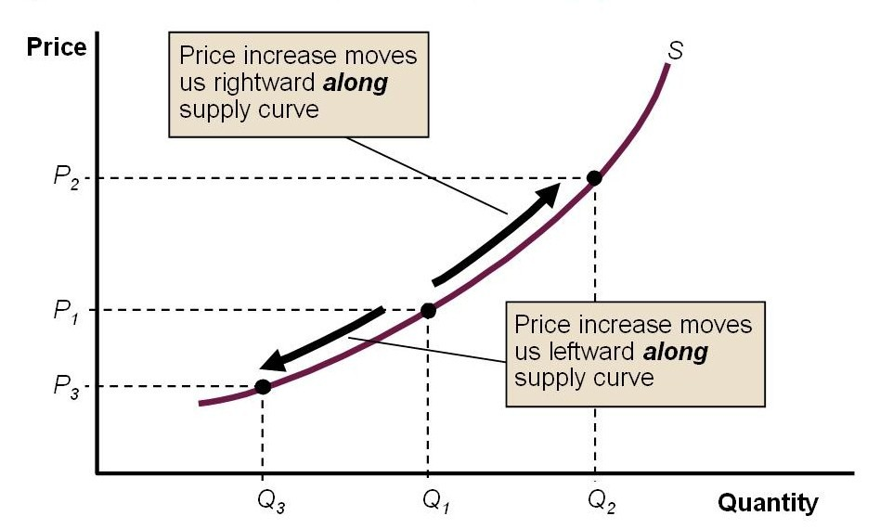
Figure 6: Changes in the Quantity Supplied
From Figure 5 above, an increase in price from $P_{1} to P_{2}$ causes an increase in the quantity supplied from $Q_{1} to Q_{2}$. This is an upward movement along a stable supply curve. On the other hand, a decrease in price from $P_{1} to P_{3}$ causes a decrease in the quantity supplied to also fall from $Q_{1} to Q_{2}$. This represents a downward movement along a stable supply curve.
- Changes in Supply. This refers to a total bodily shift in the supply curve at each and every price from one position to another. This is shift in supply curve that is caused by all other factors that can influence supply aside from commodity’s own price. An example of changes in supply is demonstrated graphically as follows:
Price (P)
Quantity (Q)
$$S_{3}$$
$$S_{1}$$
$$S_{3}$$
$$Q_{1}$$
$$Q_{2}$$
$$Q_{3}$$

Figure 7: Changes in Supply
Changes in supply are caused by factors such as price of other commodities; change in technology; changes in the price of factors of production, etc. If any of these factors cause an increase in supply, it will shift the supply curve from $S_{1} to S_{2}$ and the supply increase from $Q_{1} to Q_{2}$. However, if any of these factors cause a decrease in supply, it will shift the supply from $S_{1} to S_{3}$ and the supply fall from $Q_{1} to Q_{3}$.
EQUILIBRIUM
According to Alfred Marshall, the forces of demand and supply are likened to the “two blades of scissors” interact to determine the price of a product and the actual quantity traded on the market. At a particular price, the buyers are willing to buy a certain amount; the sellers are willing to sell exactly the same amount. The market is cleared, and then there is no surplus or shortage. That particular price is known as the equilibrium price or market price.
What is the Equilibrium Price or the Market Price?
It is the price at which the quantity demanded is equal to the quantity supplied.
Sometimes, it is referred to as the market clearing price because it is a price at which there is no excess supply (surplus) or excess demand (shortage). Note that an excess supply or surplus exists when the quantity supplied exceeds the quantity demanded. But when the quantity demanded exceeds quantity supplied, there exists an excess demand or shortage. Generally, at any price other than the equilibrium price, the market is said to be in disequilibrium and, such is called a disequilibrium price. A hypothetical example of market demand and supply schedule is presented in Table 4 below.
Table 3: Market Demand and Supply for Sachet of Pure Water.
Price (₦) | Quantity Demanded | Quantity Supplied | Surplus (+) or Shortage (-) | Pressure on Price
10 | 1000 | 5000 | +4000 | Downward
9 | 2000 | 4000 | +2000
8 | 3000 | 3000 | 0 | Equilibrium
7 | 4000 | 2000 | -2000
6 | 5000 | 1000 | -4000 | Upward

Figure 8: Graphical Illustration of Equilibrium Price and Quantity
Quantity (Q)
Price (₦)
S
D
Equilibrium
Excess Supply
Excess Demand
D
S
P

Mathematical Derivation of Equilibrium
Putting demand and supply equations together, we can find equilibrium where the supply and demand curves cross. The equilibrium consists of an equilibrium price P* and an equilibrium quantity Q*. It is important to note that the equilibrium must satisfy the market-clearing condition, which is $Q_{D} = Q_{S}.$
Recall the equations (1 and 17)
$$Q_{D}=a-bP →demand equation$$
$$Q_{S}= -c+dP →supply eqation$$
Since the market clearance (equilibrium) is always ensured at the point when quantity demanded is exactly equal to quantity supplied. Thus, this forms the starting point for our derivation
$$Q_{D}= Q_{S}……………………………………………………….. ………………………………………….(30)$$
$$a-bP=-c+dP$$
Collect like terms
$$\left(b+d\right)P=a+c$$
$$P^{*}= \frac{a+c}{b+d}…………………………………………………………………………………………………(31)$$
The equation (31) stands for equilibrium price. In order to derive our equilibrium quantity, we substitute equation (31) into either demand or supply equation. Choosing the demand equation
$$Q^{*}=a-\frac{b(a+c)}{b+d}$$
$$Q^{*}= \frac{a\left(b+d\right)-b(a+c)}{b+d}$$
$$Q^{*}= \frac{ab+ad-ab-bc}{b+d}$$
$$Q^{*}= \frac{ad-bc}{b+d}………………………………………………………………………………………………(32)$$
The equation (32) is the equilibrium quantity.
Aside from using the equations above, let us use the numerical values to bring home our point a bit in demand equation and supply equation of equations (10) and (25) that we derived earlier. We solve equations (10) and (25) simultaneously in order to get our equilibrium price and quantity.
$$Q_{D}=11,000-1000P$$
$$Q_{S}= -5000+1000P$$
Since the market attains equilibrium when quantity demanded is equal to quantity supplied, hence we set demand equation and supply equation to each other.
$$Q_{D}= Q_{S}$$
$$11,000-1000P= -5000+1000P$$
$$11,000+5000=1000P+1000P$$
$$16,000=2000P$$
$$P= \frac{16,000}{2,000}$$
$$P=8……………………………………………………………………………………………..(33)$$
This shows that the equilibrium price is ₦8.
In order to get the equilibrium quantity, we substitute 8 for P in either of demand or supply equation.
$$Q^{*}=11,000-1000P$$
$$Q^{*}=11,000-1000(8)$$
$$Q^{*}=3,000…………………………………………………………………………………………(34)$$
This simply shows that equilibrium quantity is 3000.
The market equilibrium may be either stable or unstable.
Stable and Unstable Equilibrium
Stable Equilibrium: An equilibrium is said to be stable if when the equilibrium price is displaced a little, the new price sets up economic forces which tend to restore it. In another way, an equilibrium is stable if any disturbance in the equilibrium situation is self-adjusting so that the old equilibrium position is restored. In summary, stable equilibrium is one where if there is any slight deviation from it, the forces acting will automatically ensure a restoration of the equilibrium. Figure 7 is an example of stable equilibrium.
Figure 9: An Example of Stable Equilibrium
Quantity (Q)
Price (₦)
S
D
Equilibrium
Excess Supply
Excess Demand
D
S
P

Unstable Equilibrium: Equilibrium is unstable when a small displacement of the equilibrium price sends the system away from it, never to be restored. So, an unstable equilibrium is one where there if there is any slight deviation from it, forces acting are such that will send the system further away from equilibrium. This is the case for all goods that invalidate the law of demand such as Giffen and Veblen goods.
Figure 10: An Example of Unstable of Equilibrium
D
S
$$P_{e}$$
$Q_{e}$
$$Q_{3}$$
$$Q_{4}$$
$$Q_{1}$$
$$Q_{2}$$
Price
Quantity

The Effect of Shifts in Demand and Supply Curves: A partial Equilibrium Analysis
A Partial Equilibrium Analysis also known as microeconomic analysis is the study of the equilibrium position of an individual, a firm, an industry or a group of industries viewed in isolation. It is carried out when we analyze the forces of demand and supply in any single market with a view to determining equilibrium position in complete isolation from all other markets. Let use diagrams and verbal explanation to illustrate different possibilities of partial equilibrium analysis that we have.
- Impact of Increase/Decrease in Demand on Equilibrium
Increase in Demand: An increase in demand will shift the demand curve from $D_{o}D_{o} to D_{1}D_{1}$ when supply curve is stable leads to a rise in equilibrium price from $P_{o} to P_{1}$ and a rise in equilibrium quantity from $Q_{o} to Q_{1}$. This simply shows that the case of decrease in demand will tend to produce fall in both equilibrium price from $P_{o} to P_{2}$ and equilibrium quantity from $Q_{o} to Q_{2}$.
- Impact of Increase/Decrease in Supply on Equilibrium
Increase in Supply: An increase in supply shift the supply curve from $SS to S_{1}S_{1}$ when the demand curve is the same will leads to a lower equilibrium price from $P to P_{1}$ and a rise in equilibrium quantity from $Q from Q_{1}$. A fall in supply shifts the supply curve from $SS to S_{2}S_{2}$ which leads to increase in equilibrium price ($P to P_{2}$) and a fall in equilibrium quantity from $Q to Q_{2}$.

General Equilibrium
General equilibrium is an extensive study of a number of economic variables, their interrelations and interdependence for understanding the working of the economic system as a whole. It brings together the cause and effects sequences of changes in prices and quantities of commodities and services in relation to the entire economy. An economy can be in general equilibrium only if all consumers, all firms, all industries and all factor-services are in equilibrium simultaneously and they are interlinked through commodity and factor prices. According to Stigler, “the theory of general equilibrium is the theory of interrelationship among all parts of the economy”.
Price Control
Government sometimes interferes in the market process of the forces of demand and supply by setting price either above the market price (equilibrium price) or below it in order to bring the prices under control. Concisely, price control is the situation whereby government interferes against the market forces of demand and supply to set prices either above or below the market prices. When prices are set below market price, it is called “maximum price or price ceiling”. On the other hand, when prices are set above the market price, it is labeled “minimum price or price floor”.
Price Ceiling or Maximum Price
Maximum price or Ceiling price is a highest price which sellers are allowed to charge for a good or service. When an economy is encountering the problem of inflation or during the war, one of the measures taken by government is to pass maximum price legislation. This involves fixing maximum price below the equilibrium or market price. Government does this to prevent price rising above a certain level. At a price lower than the equilibrium price, the quantity demanded is more than the quantity supplied which leads to shortage (excess demand) of the commodity. If the government does not put necessary apparatus in place to ensure that maximum price legislation is enforced, the problem of black-market which may result in higher price than the maximum price set by government. Example of maximum price is presented in the Figure below.
Figure 11: An Example of Ceiling Price or Maximum Price
Price (₦)
Quantity
S
Ceiling Price
$$P_{1}$$
Equilibrium
$$P_{e}$$
Shortage
$$Q_{e}$$
$$Q_{1}$$
$$Q_{2}$$
D

E

A price ceiling can be illustrated by the normal demand and supply curves in Figure 10 above; D and S are demand and supply curves respectively. They intersect at point E where $P_{e}$ is the equilibrium or market price and $Q_{e}$ is equilibrium quantity. If government regards the equilibrium price to be too high, it may fix a ceiling price at $P_{1}$. This action will result in a shortage (excess demand) of the good equal to $Q_{1}-Q_{2}$. In this situation, government may find it necessary to introduce rationing so that the limited goods may be allocated among all the buyers who want them.
Minimum Price or Price Floor
Price floor or minimum price is a least or minimum price buyers are legally required to pay for a good or service. Sometimes governments act against the forces of demand and supply by intervening to push prices up instead of down. Price floors have been widely legislated for agricultural products, such as wheat and milk, as a way to support the incomes of farmers. Another typical example of price floor is minimum wage which is often fixed above equilibrium price of the factor. Price floors are intended to help some people but usually generate predictable and undesirable side effects At a price higher than the equilibrium price, the quantity supplied is more than the quantity demanded which leads to surplus (excess supply) of the commodity.
Does a price floor always result in an unwanted surplus? The answer is No. If the price floor is binding: what happens to the unwanted surplus? The answer depends on government policy. In the case of agricultural price floors, governments may buy up unwanted surplus with a view to allowing the price floor to stand. In the case of minimum wage, when the government is not prepared to purchase the unwanted surplus, a price floor means that would-be sellers cannot find buyers. This is what happens when there is a price floor on the wage rate paid for an hour of labour, the minimum wage: when the minimum wage is above the equilibrium wage rate, some people who are willing to work but unable to find job may be ready to accept wage that is below the minimum wage. This may work against the price floor and render it ineffective. Figure 8.3 shows hypothetical supply and demand curves of price floor.
E
Price (₦)
Quantity
S
Price Floor
$$P_{1}$$
$$P_{e}$$
Surplus
$$Q_{e}$$
$$Q_{1}$$
$$Q_{2}$$
D
Equilibrium

Figure 12: An Example of Price Floor or Minimum Price
A price floor can be illustrated by the normal demand and supply curves in Figure 11 above; D and S are demand and supply curves respectively. They intersect at point E where $P_{e}$ is the equilibrium or market price and $Q_{e}$ is equilibrium quantity. If government regards the equilibrium price to be too low, it may fix a price floor at $P_{1}$. This action will result in a surplus (excess supply) of the good equal to $Q_{1}-Q_{2}$.
Consumer’s Surplus Versus Producer’s Surplus
The knowlegde of demand and supply is very useful in the explanation of consumer’s surplus and producer’s surplus. In welfare economics, the total benefit of both buyer and seller is explained with the concept of consumer and producer’s surplus. The two concepts are explained in turn below.
- Consumer’s Surplus is the difference between the total amount that consumers are willing and able to pay for a good or service and the total amount that they actually pay. Consumer’s surplus is derived whenever the price a consumer actually pays is less than what he is willing and able to pay. This represents net gain of consumer and it is a measure of the welfare that people gain from consuming goods and services. Consumer surplus is shown by the area under the demand curve and above the market or equilibrium price. The details on consumer’s surplus are presented in Figure 12 below. The total amount that consumer is willing and able to pay is the area under the demand curve. So, prices above equilibrium price are what the consumer is willing and able to pay On the other hand, what the consumer actually pays is the market price line. This shows that the price that consumer actually pays is the equilibrium price.
How to Calculate Consumer’s Surplus
Conventionally, there are two ways of calculating consumer’s surplus
- One is calculated from the graphical illustration (see Figure 12). Since the consumer’s surplus is the area under demand curve which is in form of triangle. The mathematical formula for calculating area of triangle is often used and it is specified as follows:
$$Consumer’s surplus= \frac{1}{2} \left(base*height\right)$$
From the information we have in Figure 12, the base is 6 while the height is 12.
$$consumer^{'}s surplus= \frac{1}{2} \left(6*12\right)$$
$$consumer^{'}s surplus=\frac{1}{2} \left(72\right)$$
$$consumer^{'}s surplus=36$$

- Consumer’s surplus can also be calculated from demand equation. The formula is
$$consumer^{'}s surplus= \int_{0}^{q}{(P)dq}-pq$$
Given the demand equation as follows $Q_{D}=10-P$. Calculate consumer’s surplus when price is ₦5. Since the direct demand equation is given, the first thing is to transform it into inverse demand function, which is
$$P=10-q$$
$$to get the value for q when price is ₦5$$
$$q=10-5=5$$
We substitute the information into formula as follows
$$Consumer^{'}s surplus= \int_{0}^{5}{(10-q)dq}-5(5)$$

$$Consumer^{'}s surplus= \left(10q-\frac{q^{2}}{2}\right)-25$$
$$Consumer^{'}s surplus=[10\left(5\right)-\frac{5^{2}}{2}]-5(5)$$
$$Consumer^{'}s surplus=[50-12.5]-5(5)$$

$$Consumer^{'}s surplus=[50-12.5]-5(5$$
$$Consumer^{'}s surplus=37.5-25$$
$$Consumer^{'}s surplus=12.5$$
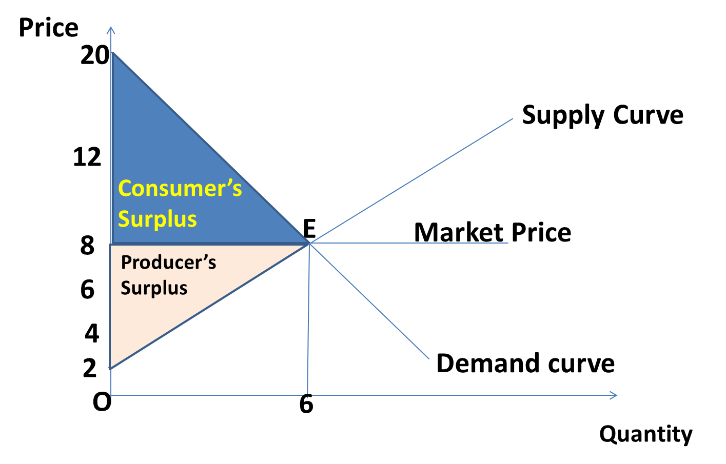
Figure 13: Consumer's Surplus and Producer’s Surplus
Producer’s Surplus
A producer’s surplus is defined as the difference between the minimum amount the producer would be willing to sell particluar units of his product and the amount the he actually sells the same units. Producers’ surplus is the area above the supply curve and below the market price line (see Figure 12). Just like the consumer’ surplus, there are two ways of calculating the producer’ surplus.
How to Calculate the Producer’ Surplus
- One is calculated from the graphical illustration (see Figure 12). Since the producer’ surplus is the area above supply curve but below the market or equilibrium price which is in form of triangle. the mathematical formula for calculating area of triangle is often used and it is specified as follows:
$$Producer’s surplus= \frac{1}{2} \left(base*height\right)$$

From the information supplied in Figure 12. The base of the triangle is 6 and height is also 6.
$$Producer’s surplus= \frac{1}{2} \left(6*6\right)$$
$$Producer’s surplus= \frac{1}{2} (36)$$
$$Producer’s surplus= 18$$
- Producer’ surplus can also be calculated from the supply equation at a particular price (P) and corresponding quantity (q). The formula is given as follows
$$Producer^{'}s surplus= pq- \int_{0}^{q}{(P)dq}$$

For instance, given the supply equation as $q_{s}= -5+10P$. Calculate the producer’s surplus when price (P) is ₦5. First find the inverse of the supply equation given.
$$10P= q_{s+}5$$
$$P= \frac{q_{s}}{10}-\frac{1}{2}$$
$$OR$$
$$P= 0.1q_{s}-0.5$$
Another information we need for this is the value of quantity supplied when price is ₦5
$$q_{s}= -5+10P$$
$$q_{s}= -5+10(5)$$
$$q_{s}= -5+50$$
$$q_{s}= 45$$
Having got all the pieces of information needed to be substitued into the formula
$$Producer^{'}s surplus= pq- \int_{0}^{q}{(P)dq}$$
$$Producer^{'}s surplus= 5(45)- \int_{0}^{45}{(0.1q-0.5)dq}$$
$$Producer^{'}s surplus= 5(45)- \int_{0}^{45}{(0.1q-0.5)dq}$$
$$Producer^{'}s surplus= 225-\left[\frac{0.1q^{2}}{2}-0.5q\right]$$
$$Producer^{'}s surplus= 225-\left[\frac{0.1{(45)}^{2}}{2}-0.5(45)\right]$$
$$Producer^{'}s surplus= 225-\left[101.25-22.5\right]$$
$$Producer^{'}s surplus= 146.25$$

Concept of Elasticity
Generally, elasticity refers to the degree of responsiveness or sensitivity of one variable to another. This expains the extent of how one variable responds or reacts as a result of change in another variable. Since the focus is still on the price system, we want to examine the price elasticity of demand before moving to elasticity of supply. The best way to see the degree of responsiveness of both demand and supply is simply to look at the slope of their curves. For instance a flatter demand curve represents a greater degree of responsiveness (for a supply or demand curve). Let us start with price elasticity of demand.
Price Elasticity of Demand
Price elasticity of demand is the degree of responsiveness of demand to change in price. Also, according to Professor Lipsey: “elasticity of demand may be defined as the ratio of the percentage change in demand to the percentage change in price.” Following the definition of Lipsey, the coefficient of price elasticity of demand is denoted by $E_{d}$ and it is defined as the ratio of percentage change in the quantity demanded to the percentage change in price. This is expressed as follows:
$$E_{d}= \frac{Percentage change in quantity demanded}{Percentage change in price}$$
If we use Δ (delta) to represent a change, $q$ for the quantity demanded and $p$ for price, the algebraic equation may be presented as thus:
$$E_{d}=- \frac{\frac{∆q}{q}}{\frac{∆p}{p}}= -\frac{∆q}{q} × \frac{p}{∆p}=- \frac{∆q}{∆p} × \frac{p}{q}$$
$$E_{d} =- \frac{∆q}{∆p} × \frac{p}{q}$$
The coefficient of price elasticity of demand always ranges between 0 and $∞$
It is to be noted that the coefficient $E_{d}$ of price elasticity of demand is always negative. This is as result of inverse/negative relationship that exists between price and demand. It is however necessary to know that this negative sign is often being ignored, this because it is as constant as anything. Although, price elasticity of demand is the most popular but we still have other ones such as income elasticity of demand and the cross elasticity of demand which will be discussed later.
Types of Price Elasticity of Demand
- Elastic Demand. Price elasticity of demand is said to elastic when a small change in price leads to a greater percentage change in quantity demanded. It is as follows $E_{d}>1$. If there is a 10% rise in price which leads to a 20% fall in quantity demanded, then $E_{d }= -\frac{20\%}{10\%}= \left|-2\right|$. In absolute terms, the price elasticity of demand is greater than 1

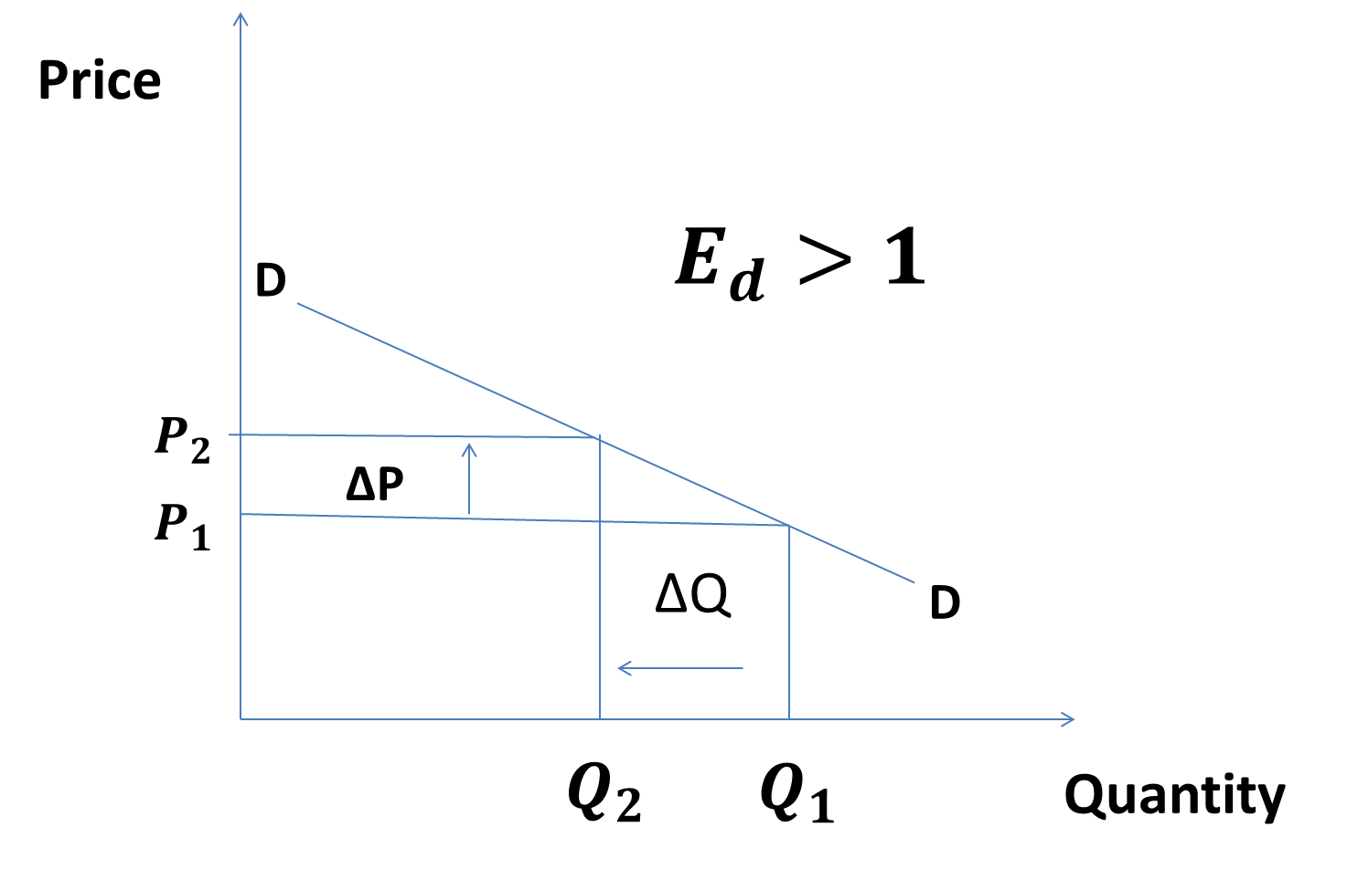
ΔQ > ΔP
Figure 14: An Example of Elastic Demand Curve
- Inelastic Demand. This is a situation whereby the quantities demanded respond less than proportionately to changes in price. Inelastic demand the coefficient is less than one and it is expressed as $E_{d} <1$. It is case where percentage change in price is greater than percentage change in quantity demanded. It is graphically presented as in diagram below
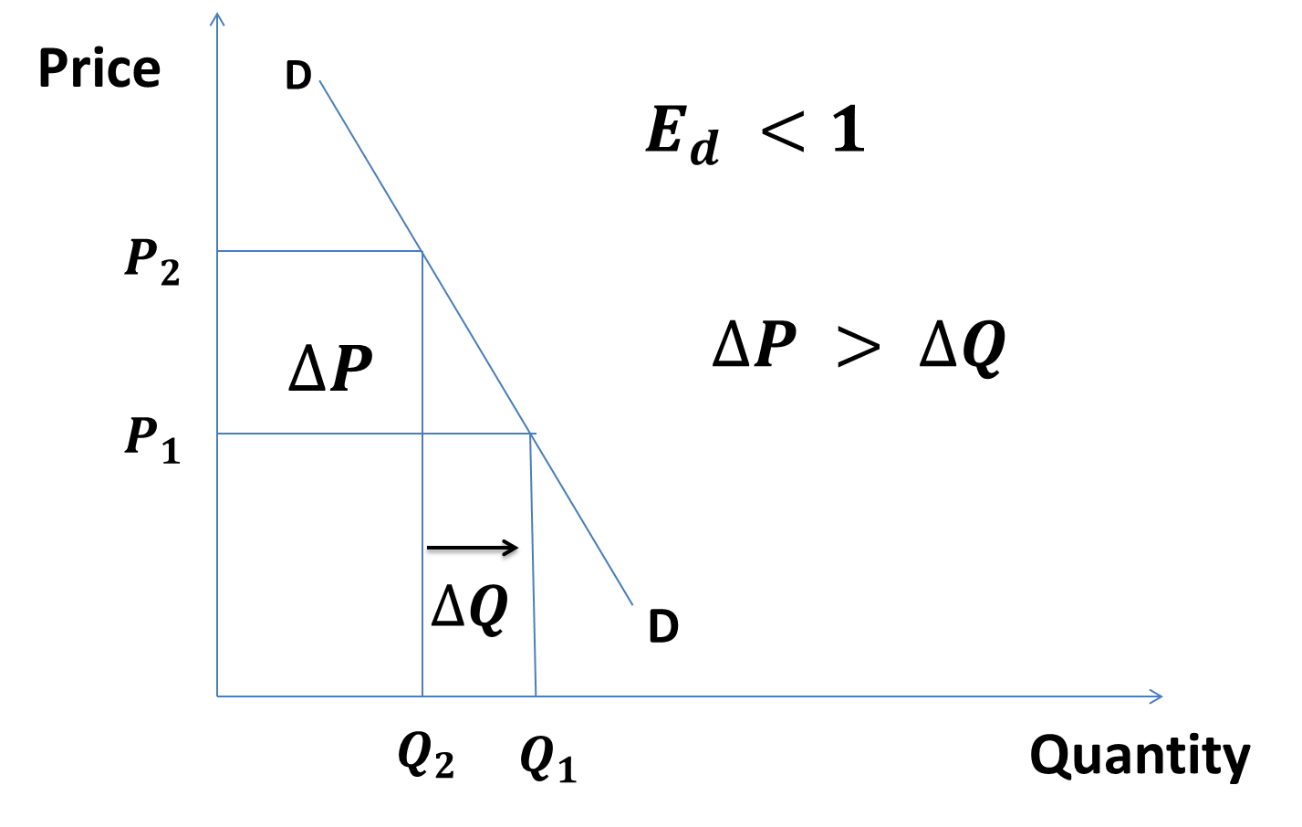
Figure 15: An Example of Inelastic Demand Curve
- Unit Elastic Demand. Price elastic demand is unity when the change in demand is exactly proportionate to the change in price. For example, a 20% change in price causes 20% change in demand. $E_{d} =\frac{20\%}{20\%}=1$. This is presented graphically in the diagram below.
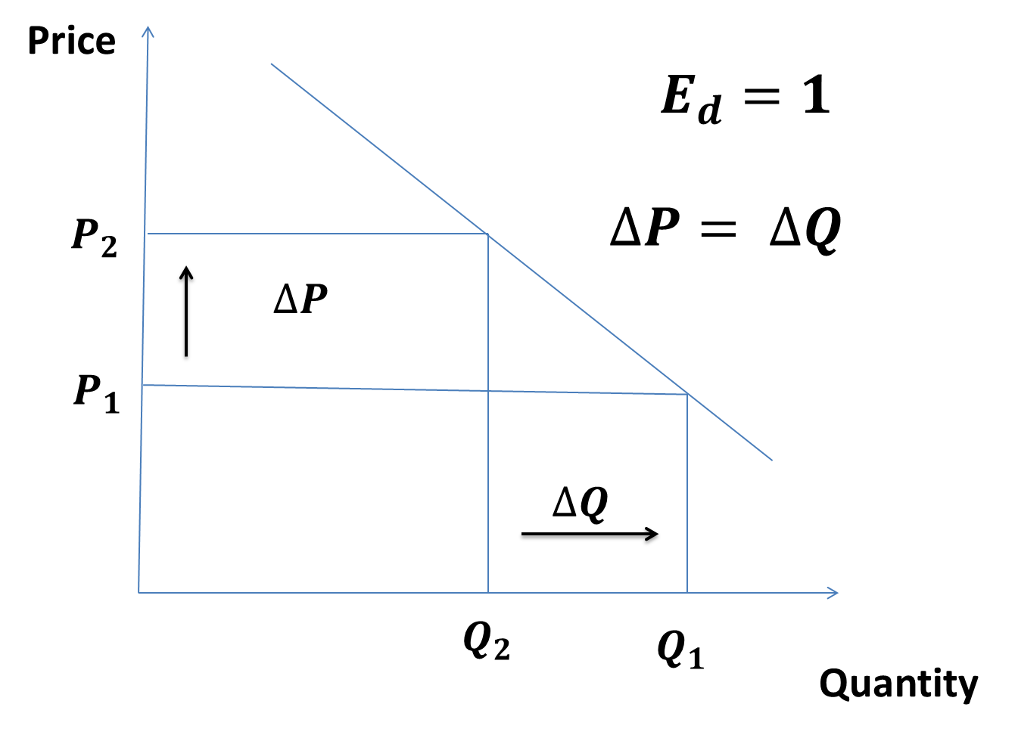
Figure 16: An Example of Unit Elastic Demand
- Perfectly Elastic Demand. Price elasticity of demand is perfectly or infinitely elastic if at a given price, consumers are ready to buy what they can obtain, and none at all at any other price. It is the case where price is constant but demand varies either by increasing or decreasing. An example of this is presented below.
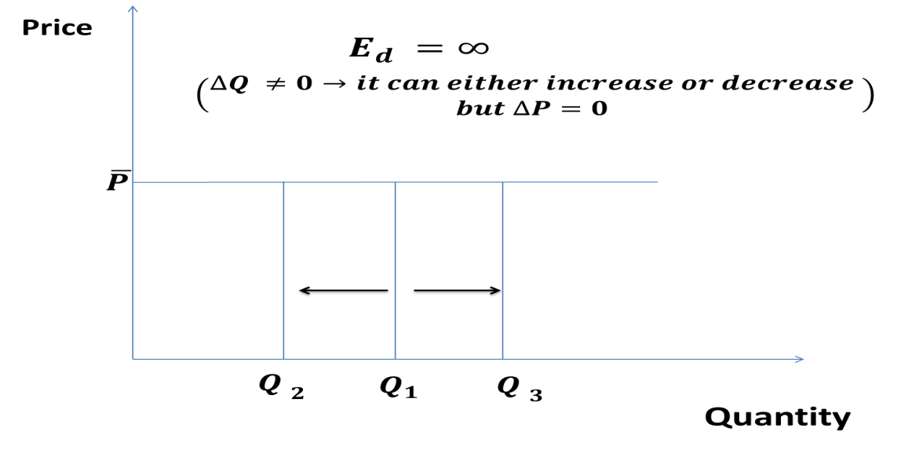
Figure 17: An Example of Perfectly Elastic Demand
- Perfectly Inelastic Demand. This is also known as zero elasticity. This is situation whereby quantity demand of a commodity remain the same irregardless whether price increases or decreases. The graphical illustration of this is presented below
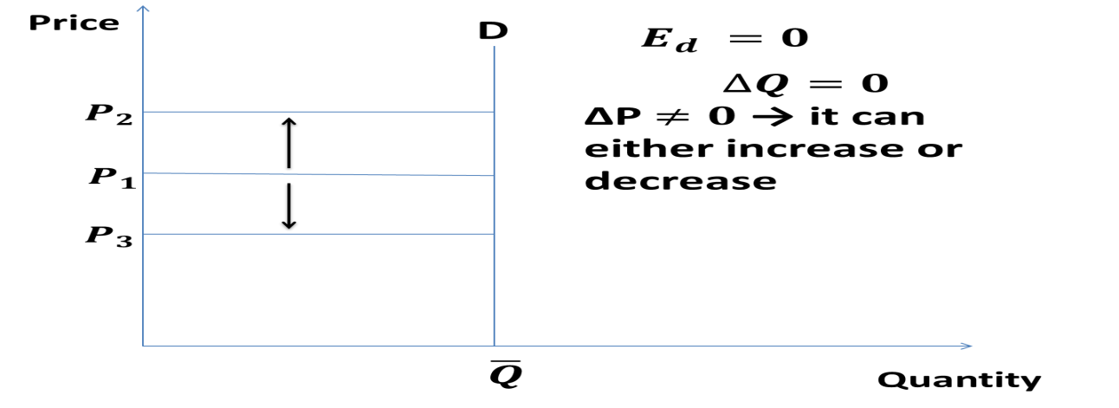
Figure 18: An Example of Perfectly Inelastic Demand
Methods of Measuring Price Elasticity of Demand
Broadly, there are two basic methods of measuring elasticity in economics. These are point elasticity of demand and arc elasticity of demand.
- Point elasticity of demand is an approach that measures the elasticity at a particular point on the demand curve.
The formula of point method elasticity is given as follows:
$$E_{d}=- \frac{∆Q}{∆P} × \frac{P}{Q}$$
Where P stands for the initial or original or old price; Q represents initial or original or old quantity demanded; $ΔQ =(Q_{2}- Q_{1})→difference between new quantity demand and old quantity$; $∆P=(P_{2}-P_{1}$)→ difference between new price and old price. Note that $(P_{1}=P and Q_{1}=Q)$.
Ideally, this is usually computed with the aid of calculus and it is a measure of the concept for continuous cases. This is defined as follows:
$$E_{d}=- \frac{dQ}{dP} × \frac{P}{Q}$$
It is to be noted that given a demand function such as $Q_{d}=a-bP$ , the slope of the demand curve is $\frac{dQ}{dP}$
- Arc elasticity of demand measures elasticity between two points on the same demand curve. In the word of Professor Baumol, “Arc elasticity is a measure of the average responsiveness to price change exhibited by a demand curve over some finite stretch of the curve.” This approach takes the average of the original and new quantities and price as bases. It can be calculated using what is called the The Midpoints Formula.
$$E_{d}= \frac{∆Q}{∆P} × \frac{P_{1}+ P_{2}}{Q_{1}+ Q_{2}}$$
Using the information on the demand schedule below to calculate both the point method and arc method of elasticity.

Point | Price (₦) | Quantity Demanded
A | 3 | 40
B | 4 | 20
C | 5 | 10
Table 4: Demand Schedule
Point Method of Measuring Elasticity
Calculate price elasticity of demand when price rises from ₦3 to ₦4 (that is moving from point A to B) using point elasticity method
$$E_{d}= \frac{ΔQ}{ΔP} × \frac{P}{Q} = \frac{(20-40)}{(4-3)} × \frac{3}{40}= -\frac{20}{1} × \frac{3}{40}=-\frac{60}{40} =\left|-1.5\right|$$
However, price elasticity of demand differs when when price falls from ₦4 to ₦3 (that is moving from point B to A) using the same point elasticity method
$$E_{d}= \frac{∆Q}{∆P} × \frac{P}{Q}= \frac{(40-20)}{(3-4)}× \frac{4}{20}= \frac{20}{-1} ×\frac{4}{20}= \frac{80}{-20}=\left|-4\right|$$
It is obseravble from the example given above that the point elasticity method of measuring elasticity at two points on a demand curve gives different elasticity coefficients because we used a different base in computing the percentage change in each case. In order to avoid this discrepancy, the arc method of measuring elasticity. The arc method is actually a response to improve on the weakness of point approach of elasticity.
Arc Method of Measuring Elasticity
Arc method is used based on the following formula, which is presented as follows:$$E_{d}= \frac{∆Q}{∆P} × \frac{P_{1}+ P_{2}}{Q_{1}+ Q_{2}}$$
On the basis of this formula, we can measure arc elasticity of demand when there is a movement either from point A to B or from B to A.
From A to B at point A, $p_{1}=3, q_{1}=40$ and at point B, $p_{2}=4, q_{2}=20$. substituting these values into the formula we get
$$E_{d}= \frac{(20-40)}{(4-3)} × \frac{(3+4)}{(40+20)}= \frac{-20}{1}×\frac{7}{60}=\frac{-140}{60}= \left|-2.33\right|$$
Also, from B to A at point B,$p_{1}=4, q_{1}=20$ and at point B, $p_{2}=3, q_{2}=40$. substituting these values into the formula we get
$$E_{d}= \frac{(40-20)}{(3-4)}×\frac{(4+3)}{(20+40)}= \frac{20}{-1} × \frac{7}{60}= \frac{140}{-60}= \left|-2.33\right|$$
Thus whether we move from point A to B or from B to A on the arc between A and B, the formula for arc elasticity of demand will give the same numerical value.
For the continuous case, the point elasticity is always calculated with the aid of calculus as $$E_{d}= \frac{dQ}{dP} × \frac{P}{Q}$$
Where $\frac{dQ}{dP}$ is the slope of demand curve
Given a linear demand equation derived from the demand schedule in Table 5 as $q_{d}=100-20p$. Calculate the elasticity when price equals 3.
When $p=3;the quantity demanded→q_{d}=100-20\left(3\right)=40$. This shows that$q=40.$
The next is to differentiate the demand equation with respect to price
$$q_{d}=100-20p$$
$$\frac{dq}{dp}= -20$$
We therefore substitute the pieces of information into the elasticity formula for continuous case
$$E_{d}= \frac{dQ}{dP} × \frac{P}{Q} \\ E_{d}= -20 × \frac{3}{40}= \frac{-60}{40}= \left|-1.5\right|$$
Elasticity Along the Demand Curve
The elasticity of demand varies along most demand curves. The elasticity of demand is different at every point along a downward-sloping linear demand curve; however, the elasticities are constant along horizontal, vertical, and log-linear demand curves. On the strictly downward-sloping linear demand curves-those that are neither vertical nor horizontal- the elasticity of demand is a more negative number the higher the price. Consequently, even the slope of the linear demand curve is constant, the elasticity varies along the curve.
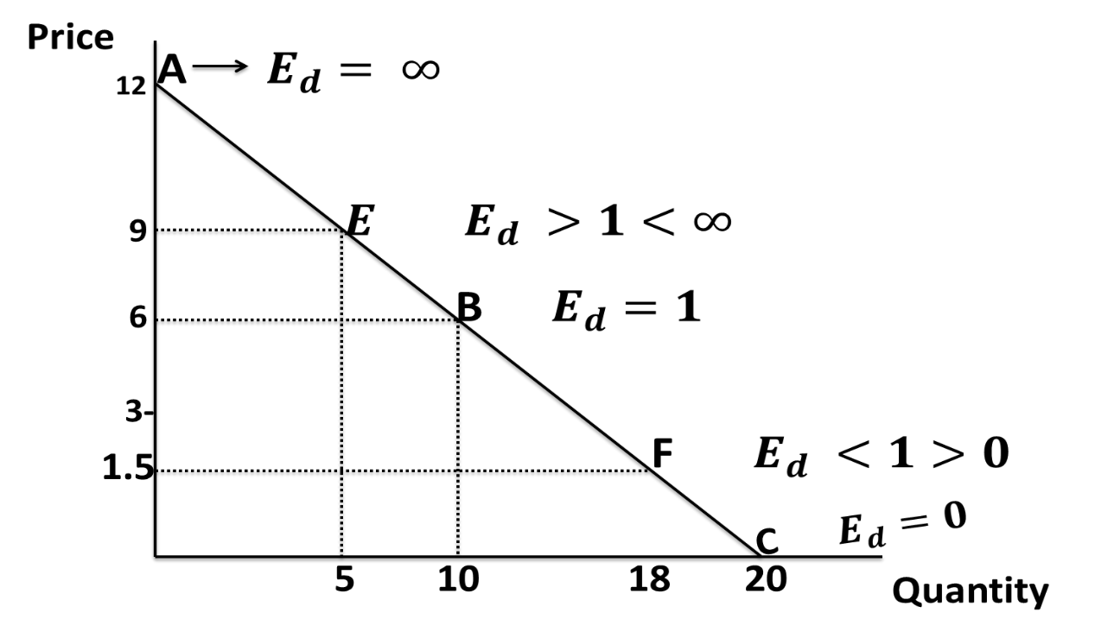
Figure 19: Elasticities along a Linear Demand Curve

The variability of elasticities along a linear demand curve indicates the slope of demand curve is not a good representation of elasticity. In fact, the slope of a demand curve is just a part of elasticity. The slope of demand curve $\left(\frac{∆P}{∆Q}\right)$, which is a reciprocal of the slope of demand equation $\left(\frac{∆Q}{∆P}\right)$, which is $- \frac{5}{3}.$
To show that elasticity actually vary along a linear demand curve, given the formula of elasticity as
$$E_{d}= \frac{∆Q}{∆P} × \frac{P}{Q}$$
Elasticity at point A is
$$\frac{5}{3}×\frac{12}{0}= ∞. This shows that the elasticity is infinity;that is, it is perfectly elastic.$$
Elasricity at point E is
$$\frac{5}{3}×\frac{9}{5}= 3. This shows that the elasticity is greater than one;that is, it is elastic.$$
Elasticity at point B is
$$\frac{5}{3}×\frac{6}{10}= 1. This shows that the elasticity is equal to one;that is, it is unitary.$$
Elasticity at F is
$$\frac{5}{3}×\frac{1.5}{18}= 0.14. This shows that the elasticity is less than one;that is, it is inelastic.$$
Elasticity at point C is
$$\frac{5}{3}×\frac{0}{20}= 0. This shows that the elasticity is equal to zero;that is, it perfectly inelastic.$$
In general, given a linear demand curve, elasticity coefficient at extremes (price and quantity axes respectively) are $∞ and 0.$ At any point between the upper extreme corner and the mid point, elasticity coefficient is greater than unitary; at the mid point, it is unitary; while at any point between the mid point and the lower extreme corner, it is less than unitary. These are illustrated in Figure
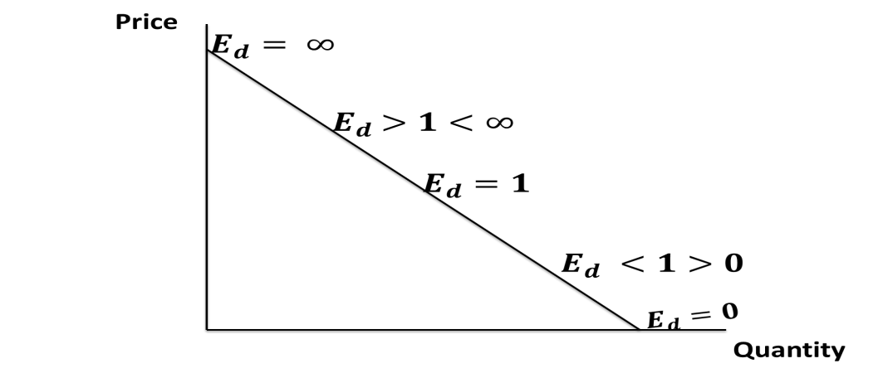
Figure 20: Variability of Elasticity along a Linear Demand Curve

Determinants of Elasticities of Demand
The price elasticity of demand is influenced by a number of factors which are discussed below.
- The availability of close subsitutes. Commodities that close substitutes tend to be elastic. This is because with change in the price of one commodity, the demand for its close is immediately affected. However, the demand for goods which have no subsitutes tend to inelastic.
- Nature of the commodity. Elasticity of demand for any commodity depends on the category to which it belongs i.e wether it is a necessity, comfort, or luxury. The demand for necessities of life like food salt, matches tends to be inelastic. This happens as demand does not change much with the rise or fall in their prices. On the contrary, the demand for goods that gives comforts such as milk, eggs, butter etc, is moderately elastic because with rise or fall in their prices, the demand for them decreases or increases. The demand for luxuries is more elastic because with a small change in their prices, there is a large change in their demand.
- The proportion of income spent. If the proportion of consumer’s income spent on a commoidty is small, the demand for the commodity tends to be price inelastic (such commodities are like salt, pen, pencil, needle etc.) but if the proportion of income spent on a commodity is large, then demand for the commodity will be price elastic.
- Habit. If people are habituated to the consumption of a particular commodity like tea, coffee or cigarettes of a particular brand, the demand for it will be inelastic.
- Varieties of uses. If the demand for a commodity that has many uses tends to be more elastic but if a commodity has only few uses , its demand is likely to be inelastic.
Income Elasticity of Demand
Aside from own price of a commodity, another determinant of demand is consumer’ income. For a normal good, demand tends to move in the same direction with income (ceteris paribus). In the same vein, income elasticity of demand provides a measure of sensitivity or responsiveness of demand to change in income. So, in the word of Lipsey, “The responsiveness of demand for a product to changes in income is termed income elasticity of demand”. The concept of income elasticity of demand expresses as a ratio of percentage change in the quantity demanded of a commodity to the percentage change in income. Thus its coefficient is often expressed as $E_{y}$. For a normal good, the coefficient is positive while the coefficient is negative for abnormal good or inferior good is negative.
$$E_{y}= \frac{Percentage change in the quantity demanded}{Percentage change in income}$$
$$E_{y}= \frac{{∆Q}/Q}{{∆Y}/Y}= \frac{∆Q}{Q} ×\frac{Y}{∆Y}= \frac{∆Q}{∆Y} ×\frac{Y}{Q}. This is for point method$$
For the arc method of measuring elasiticty
$$E_{y}= \frac{∆Q}{∆Y} × \frac{Y_{1}+ Y_{2}}{Q_{1}+Q_{2}}$$
The coefficient of income elasticity of demand, $E_{y}$, may be positive, neagtive or zero depending upon the nature of a commodity
- For a normal good, the coefficient is always positive. Moreover, normal goods are of two types: necessaries and luxuries
- For necessities, the income elasticity of demand is positive and it is less than one $(E_{y}<1).$ That is, it is inelastic.
- For luxuries, the income elasticity of demand is positive and it is greater than one ${(E}_{y}>1).$ This shows it is elastic.
- For abnormal goods, the income elasticity of demand is negative. That is, it is less than zero ${(E}_{y}<0).$
- The income elasticity of demand can be zero $(E_{y}=0)$. Income elasticity of demand is zero if with a change in income quantity demanded remains unchanged.

Cross Elasticity of Demand
Aside from own price and consumer’s income, another pertinent factor that can influence demand is the price of other related commodities. This explains how a change in price of a related good affect the demand of a particular good. So, the cross elasticity of demand is the relation between percentage change in the quantity demanded of a good to the percentage change in the price of a related good. In the word of Sloman, “ Cross elasticity of demand refers to the responsiveness of demand for one good to a change in the price of another.” The cross elasticity of demand is between two goods, say A and B. It expalins how demand for a commodity responds as a result of a change in the price of another related good. It is expressed as thus
$$E_{ab}= \frac{Percentage change in the quantity demanded of commodity A}{Percentage change in price of commodity B}$$
$$E_{ab}= \frac{{∆q_{a}}/{q_{a}}}{{∆p_{b}}/{p_{b}}}= \frac{{∆q}_{a}}{q_{a}} × \frac{p_{b}}{∆p_{a}}= \frac{∆q_{a}}{∆p_{b}}×\frac{p_{b}}{q_{a}} for point elasticity method$$
For the arc method of measuring cross elasticity of demand
$$E_{ab}= \frac{∆q_{a}}{∆p_{b}} × \frac{(p_{b1}-p_{b2})}{(q_{a1}+ q_{a2})}$$
The cross elasticity of demand can be positive, negative or zero depending on the nature of the relationship between commodities
- In the case of substitute goods, the cross elasticity is positive and elastic $E_{ab}>1$
- In the case of poor substitute, the cross elasticity is positive and the elasticity is equal to one ${(E}_{ab}=1)$.
- In the case of unrelated goods, the cross elasticity is equal to zero $\left(E_{ab}=0\right).$
- In the case of perfect substitutes, the cross elasticity is equal to infinity $(E_{ab}= ∞)$
Cross Elasticity of Complementary Goods
If two goods are complementary (jointly demanded), a rise in the price of one leads to a fall in the demand for the other. Since price and demand vary in the opposite direction, the cross elasticity of demand for complementary goods is negative.
The Price Elasticity of Supply
Just as we have it under demand, the concept of elasticity is also applicable to supply. The elasticity of supply is the degree of responsiveness of a change in supply to a change in price on the part of sellers. The coefficient of elasticity of supply is denoted by $E_{s}$ and is the ratio of percentage change in quantity supplied to the percentage change in commodity’s own price. The coefficient of elasticity of supply is positive as a result of the relationship between price and supply.
$$E_{s}= \frac{∆Q}{Q} ÷ \frac{∆P}{P}= \frac{∆Q}{∆P} × \frac{P}{Q} for point elasticity of supply.$$
For the arc method of measuring elasticity, the formula is the same as we have in under price elasticity of supply.
Types of Price Elasticity of Supply
The five types of elasticity of demand are exactly the same for price elasiticity of supply.
- Elastic Supply. It is a situation when a given change in price causes a more than proprotionate change in the amount supplied. An example of elastic supply is presented below in Figure 20.
- Inelastic Supply. It is a situation when a given change in price leads to a less than proportionate change in amount supplied (see Figure 21 for graphical illustration).
- Unit Elastic Supply. It is a situation when the change in the amount supplied is eactly equal to the proportionate change in price. The supply curve is a ${45}^{0}$ line (see Figure 22 for detail).
- Perfectly Elastic Supply. This is a situation when the sellers are willing to offer all the available quantity for sale at the prevailing price. If there is any fall in price, nothing will be supplied. Here the price is fixed but the quantity supplied varies (see Figure 23).
- Perfectly Inelastic Supply. This explains a situation when a change in price causes no change in supply whatsoever (ses the graphical illustration in Figure 24).
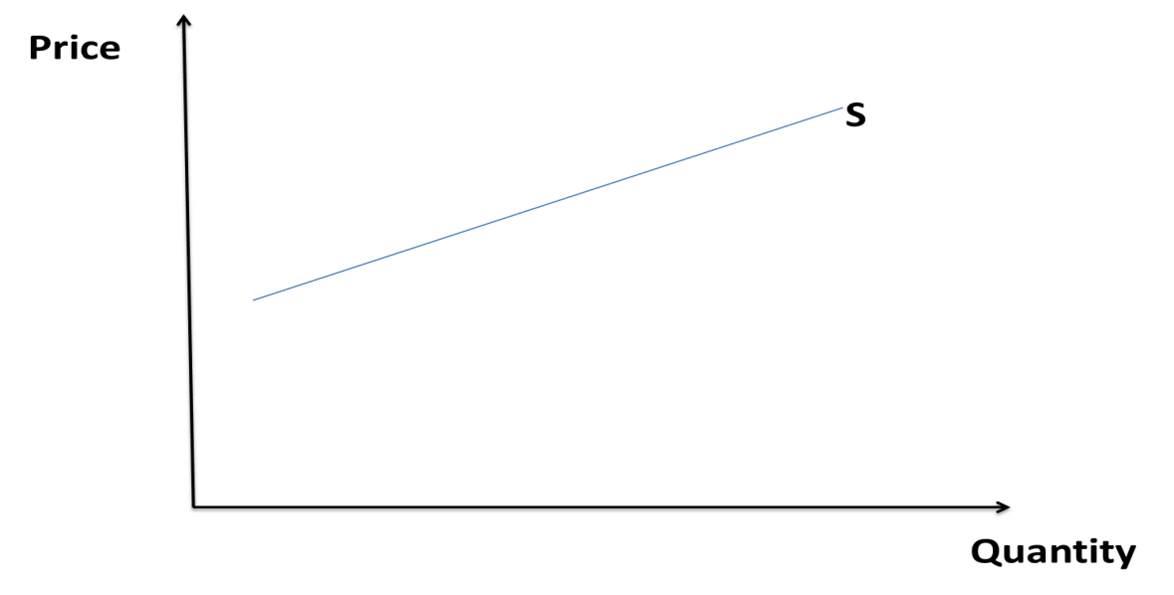
Figure 21: Elastic Supply

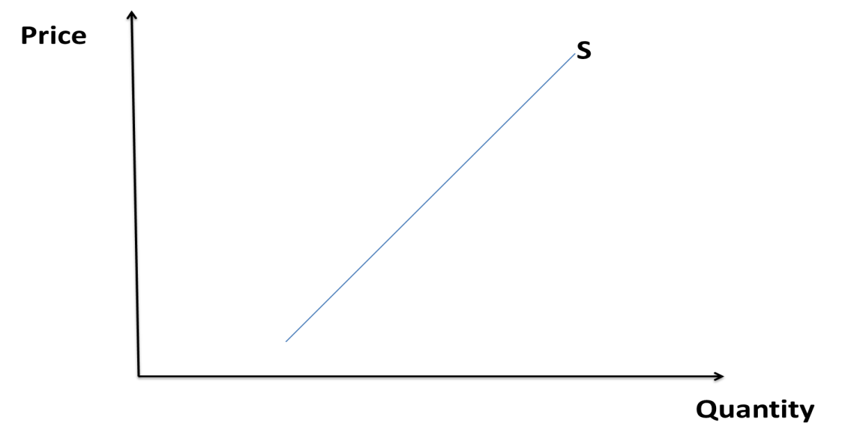
Figure 22: Inelastic Supply
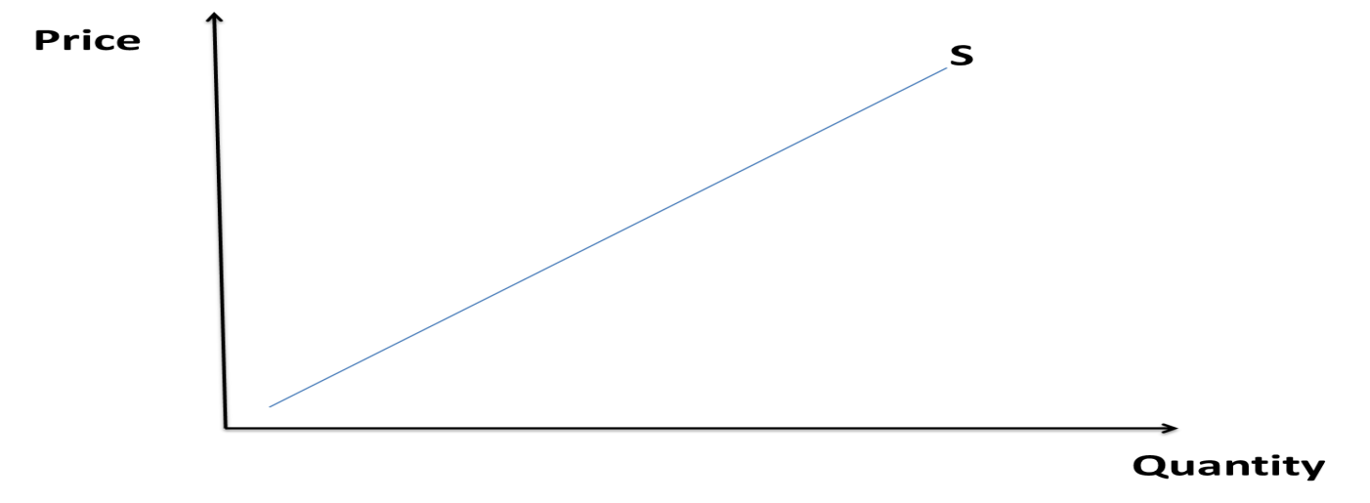
Figure 23: Unit Elastic Supply
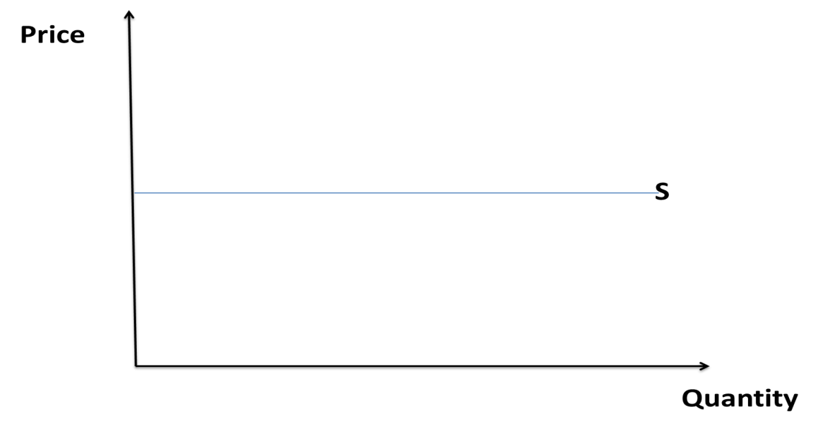
Figure 24: Perfectly Elastic Supply
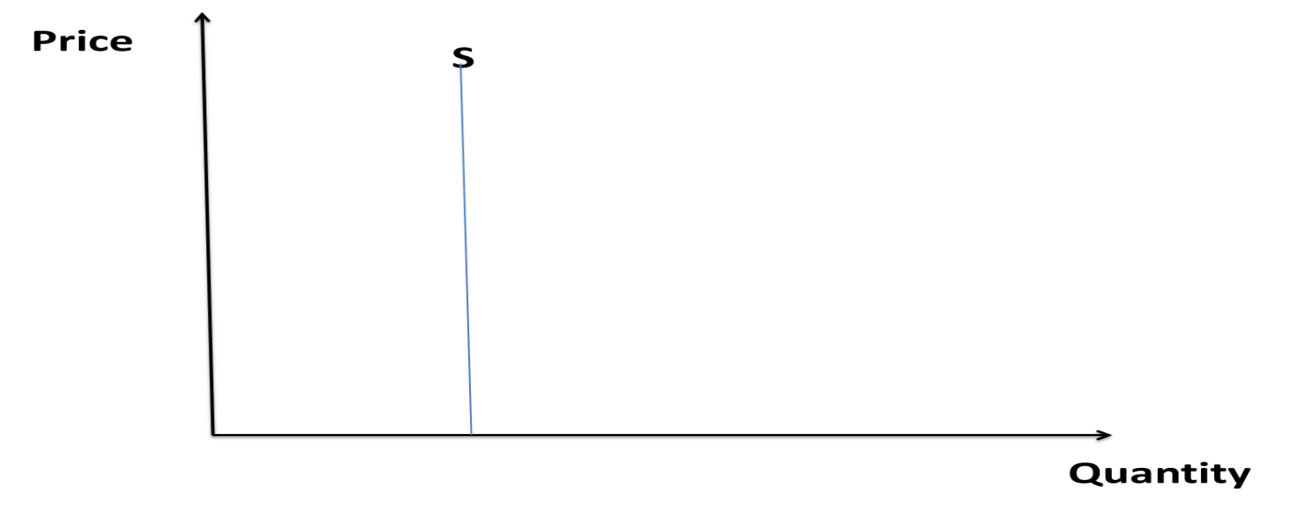
Figure 25: Perfectly Inelastic Supply
Factors influencing Elasticity of Supply
There are some important factors that influence the elasticity of supply. These are discussed below.
- Nature of the commodity. If a commodity is perishable, its supply is inelastic. This is because its supply cannot be raised or cut by a rise in its supply. On the other hand, the supply of durable goods is elastic because its supply can be changed with the change in its price.
- Time Element. The longer the time period, the more elastic will the supply of a commodity. The shorter the time period, the more inelastic will be the supply of a commodity. The supply of a commodity can be increased or decreased in the long-run than in the short-run.
- Producer’s Expectation. If the producers expect a rise in the price of a commodity in the future, they will cut down the present supply. As a result, the supply will be inelastic. On the other hand, if they expect the price to fall in the future, they will increase the present supply. Consequently, the supply will become elastic.
- Cost of production. If the per unit cost of production increases at a faster rate than the rise in price, the supply will be inelastic. On the other hand, if the per unit cost of production of a commodity increase very slowly in response to a price rise, the supply will be elastic.
Post-Test
Question 1
- The demand and supply for monthly gum memberships are given as:
$$Q_{D}=600-10P……………………………………………………………………………………1$$
$$Q_{S=}10P-300………………………………………………………………………………………2$$
If the current price for memberships is N50 per month, is the market in equilibrium? Would you expect the price to rise or fall? If so, by how much?
- Show in a diagram the effect on the demand curve, the supply curve, the equilibrium price, and the equilibrium quantity of each of the following events in the market for newspapers in your town.
Case 1: The salaries of journalists go up.
Case 2: There is a big news event in your town, which is reported in the newspaper
Question 2
- What is law of Law of demand? State and explain the assumptions underlying this law
- With the aid of diagram distinguish between
- movement along a demand curve and shift in the demand curve
- movement along a supply curve and shift in the supply curve
- Explain the conditions under which supply curve slopes backward and demand curve slopes upward.
Bibliography
- Lipsey, R. G., & Chrystal, K. A. (1999). Principles of economics. Oxford University Press. Ninth Edition

- Begg, D., FISCHER, S., & DORNBUSCH, R. (1994). Economics, England. Sixth Edition

- Jhingan, M. L. (2004). Microeconomic Theory, Grinda Publication Ltd. Fifth Revised and Enlarged Edition

- Adebayo, A. (1998). Economics: A Simplified Approach. African International Publishing. Volume 1, Second Edition

