




SCHOOL OF HUMANITIES, MANAGEMENT AND SOCIAL SCIENCES

Mountain Top University
Kilometer 12, Lagos-Ibadan Expressway, MFM Prayer City, Ogun State.
PHONE: (+234)8053457707, (+234)7039395024, (+234) 8039505596
EMAIL: support@mtu.edu.ng
Website: www.mtu.edu.ng.

Published By:
Mountain Top University


COURSE GUIDE

COURSE TITLE: Principles of Macroeconomics I
COURSE CODE: ECO 211
LECTURER: Clement Olalekan OLANIYI

COURSE OBJECTIVES
GENERAL INTORDUCTION AND COURSE OBJECTIVES
This course aims at explaining the general principles of macroeconomics, its objectives, and how the concept of macroeconomics emanates in terms of its origin and rudiments. It also exposes students to the theory of national income determination as touching its principles and model buildings as well as the basic components of national income. It equally introduces students to theories of consumption and investment. The course requires foundational knowledge in principle of economics and elementary mathematical economics.

COURSE CONTENTS
Lecture One: Introduction to Macroeconomics 6
Lecture Two: National Income and Theory of National Income
Determination 10
Lecture Three: Theory of National Income Determination

Lecture Four:

LECTURE ONE
INTRODUCTION TO MACROECONOMICS
1.0 Introduction
This lecture focuses on the basic concepts which provide background information that will be useful in the subsequent lectures. The starting point will be to discuss general macroeconomics, the brief history of macroeconomics and the objectives of macroeconomics. Also, the lecture is rounded up with a discussion on macroeconomic policy.
Objectives
At the end of this lecture, students should be able to:
- explain in details what macroeconomics connotes;
- discuss the brief history of macroeconomics;
- explain the objectives of macroeconomic; and
- explain the meaning of macroeconomic policy
Pre-Test
- Define macroeconomics
- Provide brief history of macroeconomics?
- What are the objectives of macroeconomics?
- What is macroeconomic Policy

CONTENT
1.1 Introduction to Macroeconomics
The word Macroeconomics is derived from Greek word ‘makro’, which means ‘big’ or ‘large’; and it describes and explains economic processes that concern aggregates. An aggregate is a multitude of economic subjects that share some common features. Macroeconomics is the study of the economy as a whole. Similarly, Macroeconomics is a branch of economics that studies how the aggregate economy behaves. In macroeconomics, a variety of economy-wide phenomena or issues is thoroughly examined such as, inflation, general price levels, rate of growth, national income, exchange rate, gross domestic product and changes in unemployment. The origin of macroeconomics as a separate branch of economics could be traced to the downturn or economic depression of 1930s.
1.2 Brief History of Modern Macroeconomics
Modern approach to the study of economics has two major branches. These are Microeconomics and Macroeconomics. The first economist to adopt the terms microeconomics and macroeconomics was a Norwegian economist named Ragnar Frisch in 1933. Compared to microeconomics, macroeconomics is a relatively new branch of economics. Until the Great Depression of 1930s, the scope of economic science was essentially limited to what we now called “microeconomics”. When the principles of economics adopted by the then economists (Classical economists) could not address the problems of economic downturns of 1930s, which resulted into a situation whereby goods and services produced by firms remained unsold and many workers became unemployed. The economic activities were abnormally at low ebb and the solutions were not forthcoming. This made the principles of microeconomics embraced by classical economists championed by Adam Smith and his followers to be questioned.
This led to the emergence of Macroeconomics as a separate branch of economics, when a renowned British Economist, John Maynard Keynes offered an explanation for the fallout from the Great Depression of 1930s. This actually came in 1936, the year in which John Maynard Keynes published his revolutionary book, ‘The General Theory of Employment, Interest and Money’. This book laid foundation for what we regard as Macroeconomics today. Although it should not be interpreted that the economists of the pre-Keynesian era did not give thought to the macroeconomic problems of the economy but it was not a formal way of studying economics then. Aside from this, inability of classical economics to provide solutions to the problem of Great Depression of 1930s heralded the failures of the market economy. This task was performed by J. M. Keynes in his book The General Theory of Employment, Interest and Money, which laid the solid foundation of modern macroeconomics. Having critically examined the origin of modern-day macroeconomics, it will be pertinent to examine the distinctions between microeconomics and macroeconomics.
1.3 Objectives of Macroeconomics
The study of macroeconomics, aggregate behaviour of the economy as a whole, is not for fun but it rather centres on the achievement of certain aims in order to drive an economy in a certain direction. The macroeconomic objectives vary from country to country and from time to time. The major macroeconomic objectives are outlined as follows:
- Economic growth
- High rate of employment
- Stabilization of prices, output and employment
- Equitable distribution of income
- Stabilizing balance of payment
- Exchange rate stability
In an attempt to achieve the macroeconomic objectives listed above, there are major policies often put in place to actualize them. This leads to the discussion on macroeconomic policy

1.4 Macroeconomic Policy
In order for the macroeconomic objectives itemized above to be achieved, there is a need to put appropriate policy actions in place. This policy is called macroeconomic policy.
Macroeconomic policy can be defined as a programme of actions undertaken to control, regulate and manipulate macroeconomic variables in order to achieve the macroeconomic goals of an economy. In another words, macroeconomic policy can be thought of as an attempt by the authorities to achieve particular target levels of certain major economic aggregates. There are many macroeconomic policies in economic literature but the two major macroeconomic policies are:
(a). Monetary policy
(b). Fiscal policy
Monetary policy is the policy actions of government over the control of money supply (the quantity of money available in an economy) through the activities of Central Bank in an economy. Governments through the monetary authorities (Central Bank) may decide to either increase or reduce the money supply depending on the predetermined objectives. The two major tools of monetary policy are:
- Money supply (the quantity of money available in an economy)
- Interest rate
Basically, there are there are two types of monetary policy and these are:
- Expansionary monetary policy
- Contractionary monetary policy
Expansionary monetary policy (also known as easy monetary policy) refers to policy actions of monetary authority to increases the money supply in order to lower unemployment, boost private-sector borrowing and consumer spending, and stimulate economic growth. It is used to boost the tempo of economic activities in an economy.
While contractionary monetary policy is the policy action of monetary authority to reduce the quantity of money in an economy and it is often done to control inflation.
On the other hand, Fiscal policy is the policy action of government concerning the use of the government finances to achieve the macroeconomic goals. In another words, fiscal policy is a policy under which government uses its expenditure and revenue programmes to produce desirable effects and avoid undesirable effects on the national income, production, and employment. In another way, fiscal policy can be defined as government actions to influence an economy through the use of taxation and spending. The main aims of any macroeconomic policy are to achieve predetermined macroeconomic objectives. The major tools of fiscal policy are:
- Government expenditure
- Taxation (government revenue)
Just like monetary policy, there are two types of fiscal policy and they are:
- Expansionary fiscal policy; and
- Contractionary fiscal policy.
Expansionary fiscal policy refers to government policy action to increase her expenditure or lowering taxes, or both. It is used to stimulate the economic activities. It is most often used during a recession, times of high unemployment or other low periods of the business cycle. On the other hand, contractionary fiscal policy refers to government policy action to reduce her expenditure or increasing taxes, or both. This is often done to control inflation in an economy as an instrument of stabilization.

In view of the macroeconomic goals and policies analyzed above, it becomes necessary for its analyses to have some means by which we can measure the current level of production, for this will allow us to compare actual output with potential output, present output with past output. Firstly, this will indicate to what extent resources are employed and unemployed; secondly, it will also reveal whether the rate of growth is acceptable or not. Such a measurement is usually referred to as the ‘national income’.
Post-Test
- Critically examine macroeconomic policy and its major types.
- Discuss how the contributions of John Maynard Keynes led to the emergence of modern macroeconomics
- Examine the origin of macroeconomics
- Study of macroeconomics is not without focus, discuss the major focuses of macroeconomics
Bibliography
-Mulhearn C., Vane H.R. (1999). The Objectives of Macroeconomic Policy. In: Economics.
Macmillan Foundations. Palgrave, London
-Branson, W. H. (1979). Macroeconomic theory and policy (No. 04; HB171. 5, B73 1979.).

LECTURE TWO
NATIONAL INCOME
INTRODUCTION
This lecture broadly focuses on the concept of national income and its components. Precisely, the definition of national, classification of transactions and ways of measuring national income are discussed. Also, the importance of national income, difficulties associated with national income calculation and items to be excluded from national income are thoroughly examined. The lecture is rounded up with the discussion on the basic components of national income.

Objective
At the end of this lecture, the students should be able to:
- understand the concept of national income
- identify the uses of national income and the problems associated with its measurement
- identify and explain various basic components of national income
Pre-Test
    - Define national income
    - Enumerate and explain various uses of national income and problem
    - Differentiate between real gross domestic product and nominal gross domestic product
    - Differentiate between gross national product and gross domestic product

  - What is National Income?
National income (National Product) is the total monetary value of all goods and services produced in an economy over a period of time. This is usually done on a yearly basis.
In an attempt to calculate national income in any economy, there are countless transactions that are being conducted. For the purposes of having a rational analysis of the way the economy is behaving, these numerous transactions have to be classified in some systematic manner in order to avoid confusions and errors in calculations. In view of this, it is necessary to distinguish between
- Those activities that relate to productive activities; and
- Other transactions, which are simply means of redistributing resources among the different members of the community.
These latter transactions are called transfer payments. This distinction between productive activities and all other transactions is absolutely central to the basic concepts of national income accounting. This is because any transactions that are not related to productive activities cannot be included in national income accounting. Although this distinction is the most important in deciding what transactions to be included in national product.
  - Three Ways of Measuring National Income
The process of national income calculation in a modern economy is an extremely complex process. In fact, it has been a herculean task, which is extremely complicated and gigantic. The economists have however devised a system of estimating national income. The basic approach is to measure the two kinds of flows that economic activities generate, namely product flows and money flows. The money flows can be looked upon from two angles: (i) money flows as factor payments, and (ii) money flow as payments for goods and services. Accordingly, there are three approaches to measuring national income. These are:
- Product Flow Approach (Output approach);
- Factor Income Approach (Income Approach); and
- Expenditure Approach
All the three approaches used for measuring National Income always give the same results for an economy.
  - The Importance of National Income
Although it is widely acknowledged that National Income account has some major problems as discussed earlier. Meanwhile, it has its peculiar usefulness to policy makers, planners, economists and politicians. The importance of national income includes the followings:
- It measures the overall economic performance of an economy
- It can be used to assess the sectorial performance of an economy
- It can be used to measure the standard of living of people
- It is useful for economic planning
- It is useful for international comparison

  - Difficulties Associated with National Income Calculation
There are so many difficulties in measuring national income of a country accurately. The difficulties involved in national income accounting are both conceptual and statistical in nature. Some of these difficulties involved in the measurement of national income are discussed below:
- Non-Monetary Transactions
- Problem of Double Counting
- The Underground Economy
- Petty Production
- Public Services
- Transfer Payments
- Capital Gains or Loss
- Price Changes
- Wages and Salaries paid in Kind
- Illiteracy and Ignorance
  - Economic Activities Excluded from National Income Accounts
There are so many activities in the economy that cannot enter into national income accounting. Few of them are these:
- Non-market product
- Self-services
- Housewife services
- Illegal activities. Such as prostitution, gambling, smuggling and bribery, etc.
- Capital gain or loss
- Intermediate goods
- Price changes. Etc

  - Basic Concepts of National Income
There are basic concepts that explain the details of national income with a view to picturing/showing the economy in totality. These concepts are parts of macroeconomic indicators/variables used in macroeconomics.
- Gross Domestic Product (GDP)
This is the total value of all goods and services produced within the territory of an economy by those living in that country irrespective of their nationality. This excludes the net income from abroad. GDP can be measured either at “factor cost” or at “market prices”. Just as noted earlier that national income is one of the most significant factors in measuring economic performance, and GDP is the most commonly used measure of a country's economic performance.
- Gross National Product (GNP)
This is the total value of all goods and services produced by the citizens of a country whether or not currently resident in that country. It simply means adding earnings from citizens living abroad ($Y_{n}$), and deducting earnings from foreigners staying in the country ($Y_{f}$). It can be expressed as follows:
$$GNP=GDP+ Y_{n}- Y_{f}$$
- Gross Domestic Product at Factor Costs
This is the total value of all goods and services produced in a country based on the costs of factors of production. The estimation excludes the excess of indirect taxes over subsidies. Usually indirect taxes are deducted whereas subsidies are added to arrive at GDP at factor cost. This can be expressed as thus:
$$GDP at factor cost=GDP-indirect taxes+subsidies$$
- Gross Domestic Product at Market Prices b
This is the market value of the total goods and services produced within the territory of a given country. It is calculated by adding indirect taxes and subtracting the subsidies.
$$GDP at market prices=GDP+indirect taxes-subsidies$$
- Nominal GDP, Real GDP and GDP Deflator
The prices by which GDP is measured matter a lot in macroeconomics. In order to picture this clearly, the terms such as nominal GDP, Real GDP and GDP Deflator are examined below
- Nominal GDP. Nominal GDP is the GDP measured at current market prices. The nominal GDP is the value of goods and services produced in a year and measured in terms of current price. A growing nominal GDP might reflect a rise in inflation as opposed to growth in the amount of goods and services produced in an economy. There is tendency of overestimation when GDP is measured based on the current market price because the effect of inflation is not adjusted for.
- Real GDP. Real GDP is the GDP measured at constant price or fixed price. It is a situation whereby the production of goods and services is valued at constant prices. To measure GDP in real terms, a base year is chosen when the general price level is normal, which it is neither too high nor too low. In summary, real GDP uses constant base-year prices to place a value on the economy’s production of goods and services. The real GDP adjusted for effect of inflation. GDP is to gauge how well the overall economy is performing. Because real GDP measures the economy’s production of goods and services, which reflects the economy’s ability to satisfy people’s needs and desires. Thus, real GDP is a better gauge of economic well-being than is nominal GDP. This is because real GDP takes care of the distortion of inflation on the economy and it gives clear and real picture of the economy.
- GDP Deflator. GDP Deflator is a measure of the level of prices in an economy. It is an economic measure of inflation, so it can be regarded as a rate of change in prices. In a nutshell, GDP Deflator is an index of price changes of goods and services included in GDP. It calculated as follows:
$$GDP Deflator= \frac{Nominal GDP}{Real GDP} ×100$$
- Growth Rate of GDP.
It is a measure of economic growth from one period to another expressed as a percentage and adjusted for inflation (i.e. it can be expressed in real or nominal terms, but the most acceptable is that of real terms). The real economic growth rate is a measure of the rate of change that a nation's gross domestic product (GDP) experiences from one year to another. It is calculated as follows:
$$Growth Rate of GDP= \frac{R{GDP}_{t}- {RGDP}_{t-1}}{{RGDP}_{t-1}} ×100$$
Where $R{GDP}_{t}$ is the real GDP of current year; $R{GDP}_{t-1}$ is the real GDP of the previous year.

- Net National Product (NNP).
This is the value of all goods and services produced by nationals of a country within a year after allowances has been made for the consumption of fixed capital (i.e depreciation) used in the production process.
$$NNP= GNP-Depreciation$$
- Net Domestic Product (NDP).
It is the gross domestic product (GDP) minus depreciation on a country's capital goods. Net domestic product accounts for capital that has been consumed over the year in the form of housing, vehicle, or machinery deterioration.
$$NDP= GDP-Depreciation$$
- Personal Income (PI).
This represents the total income received by households from all sources before personal income taxes are paid. Personal income can be calculated from GNP or GDP by deducting any retained company profit from total profits and adding transfer payments.
$$PI=GNP\left(or GDP\right)-retained company profits-company taxes+transfer payments$$
- Disposable Income.
This is the income from all sources which accrues to households and private non-profit institutions after deducting direct taxes and other current transfers paid to them.
$$DI=PI-direct taxes-current transfer payments$$
- Transfer Payment.
This represents the payment made by the business sector or the government for which no services are currently rendered by the individual who received them. The examples are retirement benefits, pension allowances, scholarship awards, bursary awards, food subsidies, etc.

Post-Test
- Practically discuss with valid points the usefulness of national income accounting in Nigeria
- Critically differentiate between real GDP and nominal GDP
- Explain the meaning of underground economy and its place in national income accounting

Bibliography
-Mulhearn C., Vane H.R. (1999). The Objectives of Macroeconomic Policy. In: Economics.
Macmillan Foundations. Palgrave, London
-Branson, W. H. (1979). Macroeconomic theory and policy (No. 04; HB171. 5, B73 1979.).

LECTURE THREE
THEORY OF NATIONAL INCOME DETERMINATION
INTRODUCTION
This lecture prepares students for the understanding of the theory of national income determination with Keynesian approach. The precise discussions are done on consumption and saving functions. Students are exposed to the concepts of marginal propensity to consume (MPC), marginal propensity to save (MPS), average propensity to consume (APC), average propensity to save (APC), e.t.c. The art of model buildings are extensively discussed as touching two-sector model, three-sector model, e.t.c. The meaning of multiplier effect and its implications in national income determination are well discussed

Objectives
At the end of this lecture, students should be able to:
- understand details on consumption and savings function
- explain the meanings of MPC, MPS, APC and APS
- have proper understanding of autonomous and induced consumption
- work with national income models (two-sector, three-sector, e.t.c)
Pre-Test
- Differentiate between autonomous consumption and induced consumption
- Explain every component of a consumption function
- Build structural models of national income
- Define multiplier
3.1 Consumption Function
Consumption function has a pivotal role in Keynes's General Theory of employment, interest and money. Keynes consumption function is a macroeconomic concept which shows the relation between aggregate consumption and aggregate income. Let us start with the basic understanding of circular flow of income.

C
Y = E
45⁰
Y
0

Figure 5: Income = Consumption Expenditures (Y = C)

Under the two-sector model of circular flow of national income, it is initially assumed that all income earned by the household is spent on consumer goods and services. This means that income (Y) is equal to expenditures on consumption (C), such that $Y = C$. This is usually represented by the 45⁰ line as in the following diagram below
However, for analytical purposes the 45⁰ line is merely used to determine the equilibrium of national income, which is where national income is exactly equal to consumption expenditures. In reality, we know that not all income is spent as a certain fraction is saved. This shows that income (Y) is often more than consumption expenditures (C). Meanwhile, it is important to stress it that consumption (C) level depends on the level of income (Y). In fact, John Maynard Keynes believes that current consumption expenditure is a highly dependable and stable function of current income. He puts it that "the amount of aggregate consumption mainly depends on the amount of aggregate income (both measured in terms of wage units)." He termed it a "fundamental psychological rule of any modern community that, when its real income is increased, it will not increase its consumption by an equal absolute amount," and stated somewhat less definitely that "as a rule, . . a greater proportion of income,. . is saved as real income increases."
This functional relationship between consumption and income is called the propensity to consume or consumption function. Symbolically, it is expressed as follows:
$$C=f(Y)$$
The functional consumption function above shows that consumption expenditure (C) is a positive function of income. This shows that consumption increases with increase in income. According to Keynes, the relationship between income and consumption is based on “fundamental psychological law” that “men are disposed, as a rule and on average, to increase their consumption as their income increases, but not as much as the increase in their income”. In line with the principle of Keynes, the relationship between income and consumption using the concept of marginal propensity to consume (MPC).
Marginal Propensity to Consume (MPC). MPC is the change in consumption as a result of change in income. The marginal propensity to consume can be symbolically expressed as $\frac{∆C}{∆Y}$. It can also be defined as the ratio of change in consumption due to change in income. In the opinion of Keynes, MPC decreases as the income increases. In plain words, it means that as income increases, people tend to consume a decreasing proportion of the marginal income. This kind of income-consumption relationship represents the Keynesian consumption function. The Keynesian theory of consumption produces a non-linear consumption function as shown below.

C
C =f(Y)
Y
0
Income
Consumption Expenditure

Figure 6: Non-Linear Consumption Function

The consumption function may be relevant for individual household’s consumption behaviour. At the aggregate level, however, the Keynesian economists have estimated and used linear consumption in reconstructing Keynes’s income theory. Based on this fact, let us look at the linear consumption function
The Linear Consumption Function
Although Keynes postulated non-linear consumption function, it is now a convention in the modern interpretation and analysis of Keynesian macroeconomics to use a linear consumption function of the following form.
$$C=a+bY$$
In the consumption function above, the components are explained as follows:
- C = aggregate consumption expenditure;
- Y = total national income.
- Intercept “a” is a positive constant. This “a” denotes the level of consumption at zero level of income. The consumption at zero level of income is called autonomous consumption. Autonomous consumption is the minimum level of consumption that would still exist even if a consumer had absolutely no income. It is usually financed out of past saving.
- “b” is a positive constant. Mathematically, it represents the slope of a straight line consumption function. The constant “b” is called marginal propensity to consume ($MPC= \frac{∆C}{∆Y}$). The MPC is less than 1 but greater than 0, that is, 0 < b < 1.
Given the consumption function, it can be shown that $b={∆C}/{∆Y}$.
a
C
$$C=a+bY$$
Y
C
0
- $“bY”$ is the induced consumption. This is the consumption level that varies with the income level.

Figure 7: The Linear Consumption Function
To show that $MPC =b= \frac{∆C}{∆Y}$
If $C=a+bY$
By definition of MPC, it is change in consumption as a result of change in income
$$C+∆C=a+b(Y+∆Y)$$
$$∆C=-C+a+bY+b∆Y$$
$recall that C=a+bY$, the term (-C) and $(a+bY)$ cancel out.
$$∆C=-\left(a+bY\right)+a+bY+b∆Y$$
$$∆C=b∆Y$$
$$b=\frac{∆C}{∆Y}$$
This shows that $MPC=b=\frac{∆C}{∆Y}$
Average Propensity to Consume (APC)
Related to the concept of marginal propensity to consume (MPC) is average propensity to consume (APC). APC is defined as the ratio of total consumption to total income. It explains the proportion of income that is spent on goods and services rather than on saving. It is defined as a ratio of total consumption to total income.
$$APC=\frac{C}{Y}$$
Given the consumption function, $C=a+bY$
$$APC= \frac{C}{Y}= \frac{a+bY}{Y}$$
$$APC= \frac{a}{Y}+\frac{bY}{Y}$$
$$APC= \frac{a}{Y}+b$$
Since MPC = b, the following generalizations can be made about the relationship between APC and MPC. From the equation above, it is evident that APC ≠ MPC. APC is greater than MPC, APC equals MPC plus some positive value $(a/Y)$. Just like MPC, as income (Y) increases, APC decreases.

3.2 Saving Function
Saving function is the counterpart of the consumption function. It is a function that explains the relationship between income (Y) and saving (S). Therefore, saving is also the function of income.
$$S=f(Y)$$
Since consumption and saving are counterpart of each other. It means that $Y=C+S$. Hence, saving can be defined as follows:
$$S=Y-C$$
Recall that $C=a+bY$, then it can be substitute for C in saving equation above.
$$S=Y-(a+bY)$$
$$S=Y-a-bY$$
$$S=-a+Y-bY$$
$$S=-a+\left(1-b\right)Y$$
This represents the saving equation. The term $(1-b)$ in function above gives what is known as marginal propensity to save (MPS). This MPS is defined as the change in saving as a result of change in income. This saving function is presented graphically in the Figure below.
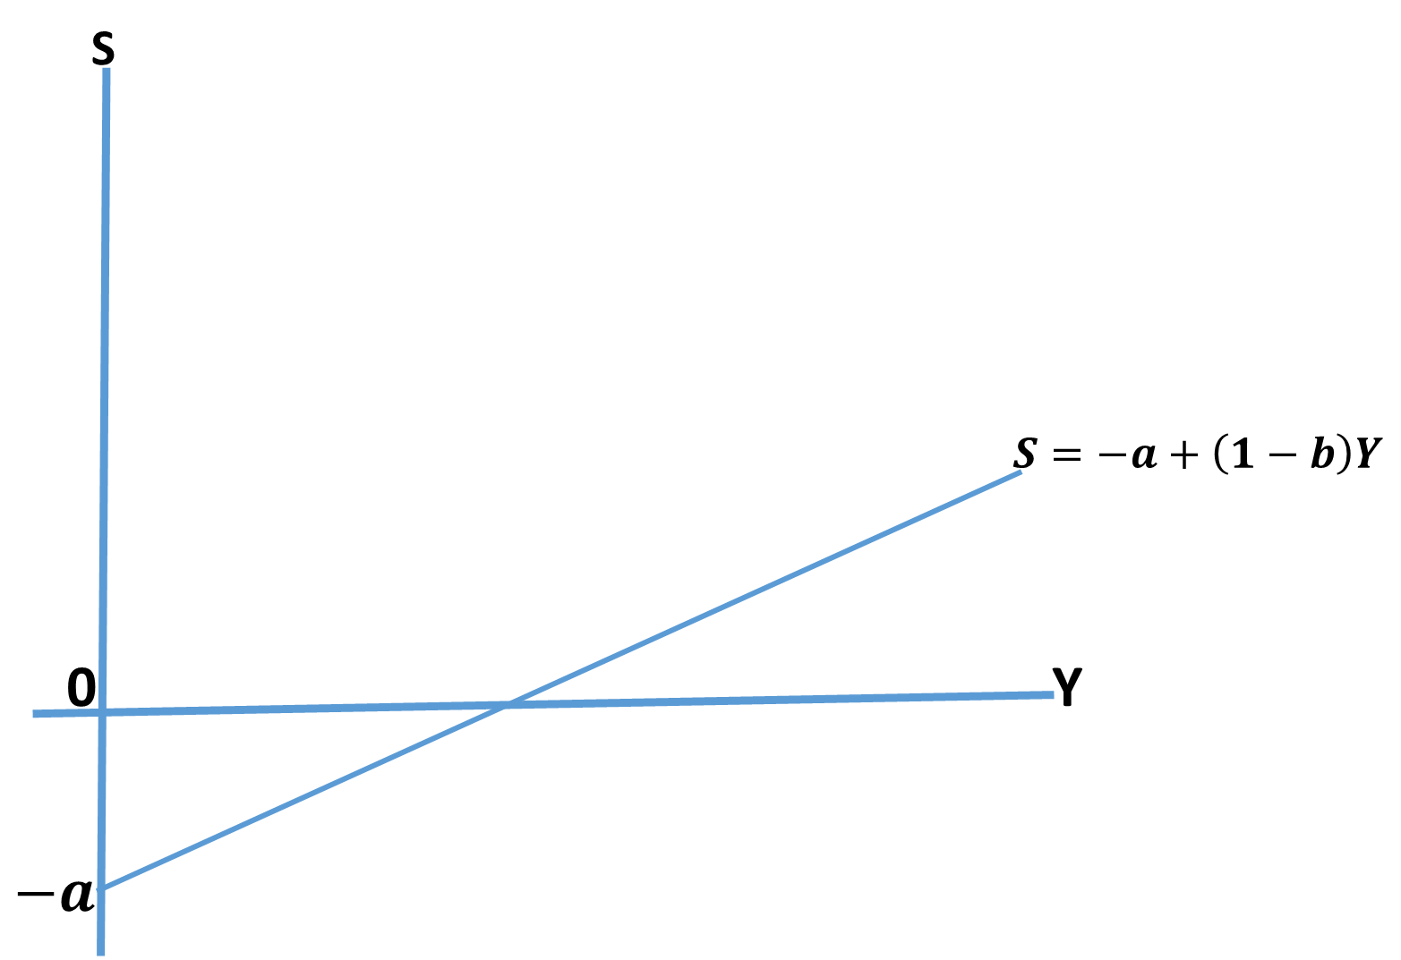
E
Figure 8: The Saving Function
Strict observation from the graphical illustration of saving function above reveals pieces of information which need clarifications.
- The point E represents equilibrium and it is the point at which saving is equal to zero and total income earned is spent on consumption
- To the right of this point, Y>C hence there are positive savings
- To the left of it, there are negative savings or dis-saving, that is running down of previous savings
Corresponding to the slope of the consumption function $b$, which is called MPC or marginal propensity to consume, is the slope of the savings curve $(1-b)$, which denotes the marginal propensity to save (MPS).
$$MPS=1-b= \frac{∆S}{∆Y}$$
The marginal propensity to save is also positive and its value lies between zero and one. It is of importance to note that the summation of MPC and MPS is always equal 1. This can be demonstrated as follows:
$$Y=C+S$$
Any change in income (Y) will affect both the consumption (C) and savings(S)
$$∆Y=∆C+∆S$$
Divide both sides by $∆Y$
$$\frac{∆Y}{∆Y}=\frac{∆C}{∆Y}+\frac{∆S}{∆Y}$$
Hence,
$$1=MPC+MPS$$
This result shows that $MPC =1-MPS$, always, $MPS = 1-MPC$. The same condition goes for average propensity to consume (APC) and average propensity to save (APS).
3.3 A Two-Sector Model of National Income
According to the Keynesian theory of income determination, the equilibrium of national income $(Y)$ is determined at a level where demand aggregate $(C + I)$ equals the aggregate supply of income $(C+S)$. That is, national income equilibrium is determined where:
$$Aggragate demand=Aggregate supply$$
$C+I=C+S$
Since at equilibrium, the injection equals withdrawal $(that is, I=S)$
It is to noted that Keynes focused on the aggregate demand side of the economy
$$Y=C+I$$
Where $C=a+bY$ and $I=I_{0}$. That is, investment $(I)$ is being autonomous.
Hence
$$Y=a+bY+I_{0}$$
$$Y-bY=a+I_{0}$$
$$Y\left(1-b\right)=a+I_{0}$$
$$Y= \frac{a+I_{0}}{1-b} OR \frac{1}{1-b}(a+I_{0})$$
This represents equilibrium level of national income for a two-sector economy. Having established equilibrium level of national income, it is of great importance to examine how change in any of the components of national income will affect the whole system. This will lead us to the concept we called Multiplier Effect.
The Multiplier
The multiplier effect is an economic term referring to how an increase (decrease) in one economic activity can cause an increase (decrease) throughout many other related economic activities. A multiplier is a factor of proportionality that measures how much an endogenous variable changes in response to a change in one or some exogenous variable. In national income determination, the concept of multiplier is very important as it explains and measures how an endogenous variables respond to any change in exogenous variable.
From the equation of national income equilibrium above, when we measure change in national income as a result of change in either consumption or investment.
Let us recall that the equilibrium level of income is given by
$$Y=C+\overline{I}……………………………………………………………………………….(1)$$
Recall that any change in the level of income will affect both the consumption (C) and the investment (I).
$$∆Y=∆C+∆\overline{I}…………………………………………………………………………(2)$$
Recall that $C=a+bY$ and also that any change in income (Y) will cause change in consumption. Remember that change in autonomous consumption “a” will zero. This is because it does not depend on income (Y).
$$∆C=∆a+b∆Y……………………………………………………………………..(3)$$
Change in autonomous consumption is zero ($∆a=0)$. This means that autonomous consumption$(a)$ does not depend on income.
$$∆C=b∆Y……………………………………………………………………………..(4)$$
Substitute equation (4) into equation (2)
$$∆Y=b∆Y+ ∆\overline{I}…………………………………………………………………….(5)$$
$$∆Y-b∆Y=∆\overline{I}………………………………………………………………….(6)$$
$$∆Y(1-b)=∆\overline{I}………………………………………………………………….(7)$$
$$∆Y= \frac{1}{1-b}∆\overline{I}………………………………………………………………..(8)$$
$$\frac{∆Y}{∆\overline{I}} = \frac{1}{1-b}……………………………………………………………………(9)$$
This is a simple income multiplier. Similar result can be obtained for a change in autonomous consumption. It is evident that the size of the multiplier depends on the magnitude of marginal propensity to consume $(MPC = b).$
Considering the equilibrium level of national income derived earlier, the effect of equilibrium income of any change in the level of exogenous variables, which in this case are autonomous consumption and investment expenditure. The multiplier effect can be determined by finding the derivative of income partially with respect to $“a” and \overline{I}$. Thus giving,
$$\frac{∂Y}{∂a}= \frac{1}{1-b}$$
Similarly
$$\frac{∂Y}{∂\overline{I}}= \frac{1}{1-b}$$
This is the simplest form of a national income multiplier which measures the rate at which national income changes as a result of changes in the one/two component(s) of aggregate demand: consumption and investment expenditures. The model analyzed above assumes a two-sector economy whereby there is no government activities. In order to move closer to realities, we now relax the assumption of no government activities.
3.4 A Three-Sector Model of National Income
A three-sector, closed economy model takes cognizance of government activities through the collection of taxes and government expenditures. Thus the model is re-specified as follows:
$$Y=C+I+G………………………………………………….\left(a\right)$$
$$C=a+bY_{d}…………………………………………………….(b)$$
$$Y_{d}=Y-T…………………………………………………….(c)$$
$$T=T_{0}+tY……………………………………………………(d)$$
$$I= I_{0}…………………………………………………………..(e)$$
$$G=G_{0}………………………………………………………….(f)$$
By substituting equations (b) to (f) in equation (a) and re-arranging the equilibrium income is given as
$$Y= \frac{a+I_{0}+G_{0}-bT_{0}}{1-b+bt}……………………………………………….(g)$$
This represents national income equilibrium for a three-sector economy model.
To derive national income multiplier for a three-sector economy model, we carry out partial differentiation of equation $(g)$ with respect to $a, I_{0}, and G_{0}$ in turns. This gives us the consumption; investment and government expenditures multipliers respectively which are identical as follows:
$$\frac{∂Y}{∂a}=\frac{∂Y}{∂I_{0}}=\frac{∂Y}{∂G_{0}}= \frac{1}{1-b+bt}$$
Also, partial differentiation of equation $(g)$ with respect to $T_{0}$
$$Y=\frac{-b}{1-b+bt}$$
It gives us the tax multiplier which is negative and less in absolute terms than the other multipliers. This shows taxes as leakages or withdrawals to the circular flow of income. The fact that tax multiplier is negative makes it to be recognized as a built-in stabilizer as it reduces the changes in income that are induced by exogenous changes in any component of aggregate demand.
The Concept of Balanced Budget Multiplier
The concept of balanced budget emphasizes a situation whereby government revenue (Taxes) is exactly equal to government expenditures. If tax is given as being only autonomous so that equation (d) is re-specified as
$$T=T_{0}………………………………………………………………(h)$$
Then the new equilibrium of national income will be
$$Y= \frac{a+I_{0}+G_{0}-bT_{0}}{1-b}……………………………………………….(i)$$
In order to derive balanced budget multiplier, suppose now we ask what happens to Y if we raise government expenditure $(G_{0})$ and tax revenues$(T_{0})$ by the same amount, holding $I_{0} and C_{0}$ fixed. Setting $∆G=∆T$ while $∆a=∆I_{0}=0$
$$∆Y=\frac{∆a+∆I_{0}+∆G_{0}-b∆T_{0}}{1-b}………………………………………..(j)$$
Recall that under balanced budget $∆G_{0}=∆T_{0}$
$$∆Y=\frac{∆G_{0}-b∆G_{0}}{1-b}……………………………………………(k)$$
$$∆Y=\frac{∆G_{0}(1-b)}{1-b}……………………………………………(l)$$
$$∆Y= \frac{(1-b)}{1-b} ∆G_{0}………………………………………..(m)$$
$$\frac{∆Y}{∆G_{0}}= \frac{(1-b)}{1-b}$$
$$\frac{∆Y}{∆G_{0}}=1$$
This shows that the balanced budget multiplier equals one. An equal increase in tax revenues and government expenditures with investment remaining unchanged will raise equilibrium income by the change in government expenditure i.e. without any multiplier effect.
3.5 A More Complex of National Income Model Building
Apart from substitution method, matrix method can also be used to determine the equilibrium level of national income. In line with the structural equations given as follows:
$$Y=C+I+G$$
$$C=α+ βY_{d} (Where Y_{d}=Y-T)$$
$$T=μ+δY$$
$$I=I_{0}$$
$$G=G_{0}$$
The endogenous variables in the structural equations given above are $Y, C and T which are national income \left(Y\right), Consumption expenditure \left(C\right) and Tax (T)$. Based on this, the equations can be derived as follows.
$$Y=C+I_{0}+G_{0}$$
$$Y-C=I_{0}+G_{0}………………………………………………(1)$$
$$C=α+βY_{d}$$
$$C=α+β(Y-T)$$
$$C=α+βY-βT$$
$$-βY+C+βT=α………………………………………………..(2)$$
$$T=μ+δY$$
$$-δY+T=μ………………………………………………(3)$$
The three equations can be combined together and solve simultaneously
$$Y - C=I_{0} + G_{0}$$
$$-βY + C+ βT= α$$
$$-δY + T= μ$$
From these three equations, the 3 by 3 matrix can be formed
$$\left(\begin{matrix}1 & -1 & 0 \\ -β & 1 & β \\ -δ & 0 & 1\end{matrix}\right)\left(\begin{matrix}Y \\ C \\ T\end{matrix}\right)=\left(\begin{matrix}I_{0}+G_{0} \\ α \\ μ\end{matrix}\right)$$
$$Y= \frac{\left|A_{1}\right|}{\left|A\right|}=\frac{\left|\begin{matrix}I_{0}+G_{0} & -1 & 0 \\ α & 1 & β \\ μ & 0 & 1\end{matrix}\right|}{\left|\begin{matrix}1 & -1 & 0 \\ -β & 1 & β \\ -δ & 0 & 1\end{matrix}\right|}$$
Let A be $\left(\begin{matrix}1 & -1 & 0 \\ -β & 1 & β \\ -δ & 0 & 1\end{matrix}\right)$ and the determinant of A as $\left|A\right|$
$$\left|A\right|=\left|\begin{matrix}1 & -1 & 0 \\ -β & 1 & β \\ -δ & 0 & 1\end{matrix}\right|$$
$$\left|A\right|=1\left(\left|\begin{matrix}1 & β \\ 0 & 1\end{matrix}\right| \right)-\left(-1\right)\left(\left|\begin{matrix}-β & β \\ -δ & 1\end{matrix}\right|\right)+0\left(\left|\begin{matrix}-β & 1 \\ -δ & 0\end{matrix}\right|\right)$$
$$\left|A\right|=1\left(1-0\right)+1\left(-β+δβ\right)+0(0+δ)$$
$$\left|A\right|=1\left(1\right)+1\left(-β+δβ\right)+0$$
$$\left|A\right|=1-β+βδ$$
Let the $A_{1}$ be $\left(\begin{matrix}I_{0}+G_{0} & -1 & 0 \\ α & 1 & β \\ μ & 0 & 1\end{matrix}\right)$ and the determinant of $A_{1}$as $\left|A_{1}\right|$
$$\left|A_{1}\right|=\left|\begin{matrix}I_{0}+G_{0} & -1 & 0 \\ α & 1 & β \\ μ & 0 & 1\end{matrix}\right|$$
$$\left|A_{1}\right|=(I_{0}+G_{0})\left(\left|\begin{matrix}1 & β \\ 0 & 1\end{matrix}\right|\right)-\left(-1\right)\left(\left|\begin{matrix}α & β \\ μ & 1\end{matrix}\right|\right)+0\left(\left|\begin{matrix}α & 1 \\ μ & 0\end{matrix}\right|\right)$$
$$\left|A_{1}\right|= \left(I_{0}+G_{0}\right)\left(1-0\right)+1\left(α-μβ\right)+0(0-μ)$$
$$\left|A_{1}\right|=1\left(I_{0}+G_{0}\right)+1\left(α-μβ\right)+0(-μ)$$
$$\left|A_{1}\right|=I_{0}+G_{0}+ α-μβ$$
Alternatively, it can be re-arranged as follows:
$$\left|A_{1}\right|={α+I}_{0}+G_{0}-μβ$$
This value is called total autonomous spending. The total spending of the economy that does not depend on income.
Hence,
$$\overline{Y}= \frac{\left|A_{1}\right|}{\left|A\right|}= \frac{{α+I}_{0}+G_{0}-βμ}{1-β+δβ}$$
$$\overline{Y}= \frac{α-βμ+ I_{0}+G_{0}}{1-β+βδ}$$
Based on the equilibrium level of national income established above, discuss the effect of an increase in government expenditure and the marginal tax rate on equilibrium of income.
The Effect of an Increase in Government Expenditure
$$\frac{∂Y}{∂G}= \frac{1}{1-β+βδ} >0$$
This shows that the effect of an increase in government expenditure is expansionary.
The Effect of an Increase in Marginal Tax Rate
Given the equilibrium level of national income (Y)
$$\overline{Y}= \frac{{α-βμ+I}_{0}+G_{0}}{1-β+βδ}$$
The marginal tax rate is $δ$.
Using the quotient rule
Let $U={α+I}_{0}+G_{0}-βμ$ and $V=1-β+βδ$; $\frac{∂U}{∂δ}=0; \frac{∂V}{∂δ}=β$
$$\frac{∂Y}{∂δ}= \frac{V∂U-U∂V}{V^{2}}$$
$$\frac{∂Y}{∂δ}= \frac{\left(1-β+βδ\right)\left(0\right)-({α+I}_{0}+G_{0}-μβ)(β)}{{(1-β+βδ)}^{2}}$$
$$\frac{∂Y}{∂δ}= \frac{-β({α+I}_{0}+G_{0}-βμ)}{{(1-β+βδ)}^{2}}$$
$$\frac{∂Y}{∂δ}= \frac{-β({α+I}_{0}+G_{0}-βμ)}{{(1-β+βδ)}^{2}}<0$$
$$\frac{∂Y}{∂δ}= <0$$
This means that an increase in marginal tax rate has a contractionary effect on the equilibrium level of national income. Theoretically, this simply implies that an increase in taxes has likelihood of reducing the purchasing power of people in the economy. This re-affirms the fact that tax constitutes a leakage/withdrawal to the circular flow of income.
Post-Test
- Consider a hypothetical economy where government plays her roles and all economic activities are done internally with no transaction with the rest of the world. Also, the tax structure of the economy has both autonomous and induced elements. Use appropriate models and notations within the context of matrix approach only to:
- determine the level of income at which aggregate demand and supply for the economy are equal;
- explain the effect of an increase in government expenditure on the economy; and
- give an account of how increase in marginal tax rate influences the economy.
- Suppose a model is given to represent the state of an economy as follows
$$Y=C+I+G$$
$$C= α+βY_{d}$$
$$\left(where Y_{d}=Y-T\right)$$
$$I= I_{o}$$
$$G=G_{o}$$
$$T=μ+δY$$
- Identify the endogenous variables in the model.
- Using a matrix approach only,
- determine the total autonomous spending
- find the equilibrium level of national income.
- Use both mathematical expression and verbal illustrations to discuss the effect of an increase in marginal tax rate on the economy.

Bibliography
-Mulhearn C., Vane H.R. (1999). The Objectives of Macroeconomic Policy. In:
Economics. Macmillan Foundations. Palgrave, London
-Branson, W. H. (1979). Macroeconomic theory and policy (No. 04; HB171. 5,
B73 1979.).
- Wainwright, K. (2005). Fundamental methods of mathematical economics.
McGraw-Hill.
- Chiang, A. C. (1984). Fundamental methods of mathematical economics

LECTURE FOUR
INTRODUCTION
This lecture explains in details the inherent controversies between Classical macroeconomics and Keynesian macroeconomics
Objectives
At the end of this lecture, students should be able to:
- understand the basic and fundamental postulates of Classical and Keynesian macroeconomics
- differentiate between Classical and Keynesian macroeconomica
Pre-Test
- Explain the basic postulates of classical macroeconomics
- Explain the fundamental postulates of Keynesian macroeconomics

Classical Versus Keynesian Macroeconomics
Macroeconomics is of relatively recent origin. The foundation of modern macroeconomics, as a separate branch of economics, was laid down by a British Economist, John Maynard Keynes (1883-1946) in his revolutionary book titled The General Theory of Employment, Interest and Money (1936). This should not be interpreted that the economists of the pre-Keynesian era had not given thought to the macroeconomic problems of the economy. Although not a formal approach of studying economics then, the use of macro approach can be traced to the writings of 16th century economists called ‘mercantilists’. The main aim of discourse here is to discuss the major points of divergence between Classical approach of macroeconomics and Keynesian views of macroeconomics.
The Classical Macroeconomics
The school of economic thought that dominated the economic world before the ‘Keynesian Revolution’ is called the ‘Classical school’. The classical economists had not developed any coherent macroeconomic theory or model. Their macroeconomic thoughts were in the forms of certain ‘postulates’ which are discussed shortly.
Postulates of Classical Macroeconomics
- The Say’s Law of Market: The foundation of classical macroeconomics is rooted in the Say’s law which states that ‘supply creates its own demand’ OR ‘supply calls forth its own demand’. The logic behind this law is that supply of goods itself generates sufficient income to generates a demand equal to the supply of goods. This is how supply creates its own demand. The significance of this simple law is that it is regarded as the core of ‘classical’ macroeconomic thought. The Say’s law is generally attributed to a French economist, Jean Baptiste Say (1767-1832). Say’s law is regarded as the ‘beginning of sound thinking in macroeconomics’ by an economist, Mark Blaug.
- There is always full employment: The classical economists postulated that all employable resources, labour and capital, of a country are always fully employed in the long-run. It is believed that if there is unemployment at any time, there is a tendency towards full employment, provided there is no external or government interference with the functioning of the economy. In the classical view, full employment does not mean that all resources are fully employed, there might be frictional and voluntary unemployment in the state of full employment.
- The economy is always in the state of equilibrium: The classical economists believed that an economy is always in the state of equilibrium. They believed that full employment of resources generates incomes, on the one hand, and goods and services, on the other hand. The value of goods and services is always equal to incomes. The income earners spend their entire income. This implies that the entire output of goods and services is sold out. There is no general overproduction and there is no general underproduction.
- Money does not matter: The classical economists treated money only as a medium of exchange. In their opinion, the role of money is only to facilitate the transactions. It does not play any significant role in determining the output and employment. They believed that the levels of output and employment are determined by the availability of real resources, that is labour and capital.
- No government interference in economic activities: One of the main pillars of classical macroeconomics is embedded in the principles of laissez-faire. A system of laissez-faire is one in which there is complete absence of government control or regulation of private, except to ensure free competition. The government has no role to play in economic activities than to maintain law and order and create enabling environment. The economic activities are to be regulated by the invisible hands of demand and supply, also known as price mechanism.
- Prices and Wages Flexibility: The classical theory proposes that all markets re-equilibrate (there is always equilibrium in the markets) because of adjustments in prices and wages which are flexible. For instance, if an excess in the labor force or products exist, the wage or price of these will adjust to absorb the excess.
The Keynesian Macroeconomics
The evolution of modern macroeconomics was championed by John Maynard Keynes. The Keynesian macroeconomics was built on the critique of classical principles of economics. He attacked the workability of classical doctrines of economics. The quest for solutions to problem of The Great Depression in 1930s provided ample opportunity for J. M. Keynes to criticize the classical principles because most of their theories failed to solve the economic problems then. The following bases are used to provide Keynes’ contributions against Classical economists.
- Keynes’ denial of Say’s law of market: As a result of the great depression of 1930s, J. M. Keynes faulted the say’s law upon which the principles of classical economics rests. He posited that supply does not always create its own demand. Keynes totally disagreed with this view and stressed the possibility of supply exceeding demand, causing disequilibrium in the economy and pointed out that there is no automatic self-adjustment in the economy.
- Unrealistic assumption of full employment conditions: Keynes considered the fundamental classical assumption of full employment equilibrium condition as unrealistic. He suggested that there is the possibility of equilibrium condition of underemployment as a normal phenomenon. Keynes regarded it as a rare phenomenon. Keynes in fact considered the underemployment condition of equilibrium to be more realistic.
- State of economic equilibrium is an occasional phenomenon: Say’s Law laid down that supply and demand would always be in equilibrium and the process of equilibrium was automatic and self-balancing. Keynes refuted this too. He pointed out that the structure of modern society rests on two principal classes — the rich and the poor — and there is unequal distribution of wealth between them. Keynes attached classicists’ posit of permanent state of equilibrium in an economy but said that equilibrium is a rare phenomenon. To him, the economy is often characterized by the state of disequilibrium.
- Prices and wages are sticky downward: Keynes objected to the classical formulation of employment theory, whereby unemployment will disappear if the workers accept sufficiently low wage rates (i.e., a voluntary cut in money wage). Keynes rejected the idea of wage flexibility as a means of promoting employment at a time of depression. He stressed it that policy of wage-cuts is no more acceptable in the modern time where labour unionisms are very strong.
- Keynes’ Attack on Laissez-faire Policy: J. M. Keynes seriously criticized pivotal philosophy of classical school which revolves around laissez-faire policy of capitalism. Keynes instead supported government interference in economic activities through appropriate policies in order to bail economy out of cyclical fluctuations.
- Undue Importance to the Long Period: Keynes was strongly against the classical principle of long-run equilibrium. Keynes, instead, attached greater importance to short-term equilibrium. To him, “in the long run, we are all dead.” So, it is no use to say that in the long run everything will be all right. Keynes was more concerned about immediate solutions to economic problems rather than emphasizing unrealistic long-run phenomenon.

Post-Test
- Economics is interesting when it comes to the inherent controversies between Keynesian macroeconomics and classical macroeconomics. In line with this argument,
- present and discuss in details five major principles of classical macroeconomics
- show how John Maynard Keynes attacked the doctrines of classical macroeconomics you discuss in question (2a)
- Provide a detailed and comprehensive inherent controversies between Keynesian and Classical macroeconomics

Bibliography
-Mulhearn C., Vane H.R. (1999). The Objectives of Macroeconomic Policy. In:
Economics. Macmillan Foundations. Palgrave, London
-Branson, W. H. (1979). Macroeconomic theory and policy (No. 04; HB171. 5,
B73 1979.).

LECTURE FIVE
INTRODUCTION
This lecture focuses on the basic theories of consumption. It exposes students to the basic principles and postulates of each theory of consumption.
Objectives
At the end of this lecture, students should be able to:
- know the various theories of consumption
- understand the basic postulates and assumptions of each theory of consumption
- differentiate one theory of consumption from another
- relate these theories to real life situations
Pre-Test
- Mention and explain the baseline theory of consumption
- Mention and explain consumption that discusses the three phases of life
- Differentiate between permanent consumption and transitory consumption
- Differentiate between permanent income and transitory income.
5.0 The Theories of Consumption
Economics has so many theories. The controversies around them make them interesting. Theories of consumption centres on the relationship between consumption and its determinants. The baseline theory of consumption is “Absolute Income Hypothesis” by John Maynard Keynes in his General Theory. Other consumption theories build on the postulates of the Keynes’ philosophies about the relationship between consumption and income, which is termed consumption function.
The following theories of consumption are to be examined:
- Absolute Income Hypothesis by John Maynard Keynes
- Relative Income Hypothesis by James Duesenberry
- Permanent Income Hypothesis by Milton Friedman
- Life Cycle Hypothesis by Brumberg Ando and Franco Modigliani
Each of these theories of consumption, its properties and criticism are discussed in turn
5.1 Absolute Income Hypothesis
The absolute-income theory of consumption is linked to the basic principle of Keynes’ theory of consumption. The basic proposition of the absolute-income theory of consumption also known as the Absolute Income Hypothesis is described along the Keynesian ‘Consumption Function’. The consumption function is simply the relationship between consumption and income, which was extensively discussed under the Keynesian theory of income determination.
The Proposition of the Theory
The Keynesian consumption theory is based on, what he calls, ‘a fundamental psychological law.’ In summary, the law states that “men are disposed, as a rule and on average, to increase their consumption as their income increases, but not by as much as the increase in their income.” That is, marginal propensity to consume $\left(\frac{ΔC}{ΔY}\right)$ is “positive and less than unity.” This law emerges “a priori from our knowledge of human nature and from the detailed facts of experience”. According to Keynes, households decide their current consumption expenditure on the basis of their current income. Based on this law, the absolute-income theory of consumption hypothesizes that current consumption expenditure depends on the current and absolute level of income.
Formally, the absolute income theory of consumption can be stated as current consumption is the function of the current income. That is,
$$C=f\left(Y\right)$$
Where, C is current consumption and Y is current income.
The Main Properties of the Keynesian consumption function
The major features of absolute income hypothesis are summarized as follows:
- The real consumption expenditure is a positive function of the real current disposable income. This relationship between consumption and income makes the absolute income hypothesis.
- The marginal propensity to consume (MPC) – the proportion of the marginal income consumed- ranges between zero and one. That is $0<MPC<1$
- The marginal propensity to consume (MPC) is less than the average propensity to consume (APC). That is, ${∆C}/{∆Y}< C/Y$.
- The MPC declines as income increases, that is, the proportion of marginal income consumed goes on decreasing.
*One of the properties of absolute-income hypothesis states that marginal propensity to consume (MPC) is less than average propensity to consume (APC). Demonstrate this in line with a linear consumption function.
Given
$$C=a+bY_{d}$$
By definition, the marginal propensity to come is the ratio of change in consumption to change in disposable income
$$MPC= \frac{dC}{dY_{d}}=b$$
Also, by definition the average propensity to consume is the ratio of consumption to disposable income
$$APC= \frac{C}{Y_{d}}= \frac{a+bY_{d}}{Y_{d}}$$
$$APC= \frac{a}{Y_{d}}+\frac{bY_{d}}{Y_{d}}$$
$$APC= \frac{a}{Y_{d}}+b$$
Since $MPC=b$, which is just a subset of $APC=\frac{a}{Y_{d}}+b$.
Hence, it indicates that $MPC<APC$
This shows that marginal propensity to consume (MPC) is less than average propensity to consume (APC) as suggested by J. M. Keynes in his absolute income hypothesis.
The Drawbacks of Absolute Income Hypothesis
Being the first theory of consumption in economics, John Maynard Keynes laid a foundation for all other theories of consumption. However, scholars have criticized the certain postulates of absolute income hypothesis. The few of them are as follows:
- It is more based on ‘introspection’ than on observed facts. One of the serious drawbacks of the Keynes’ absolute income hypothesis is that it is based more on Keynes’ own thought than observed facts.
- The early empirical studies have supported only first and the third properties while the second and fourth properties were not confirmed.
- The post War studies based on the US data cast serious doubt on the validity of the Keynesian consumption function. Simon Kuznets’ study of the disposable income and savings in the US during the period from 1869 to 1929 disclosed that MPC remained constant during the whole period and that MPC = APC. This contradicted the third property of Absolute Income Hypothesis which says MPC < APC. The implication is that Keynes’ consumption function is only applicable to pre-War data but fails to hold during the War.

5.2 The Relative Income Hypothesis
As a result of inherent weaknesses discovered in the Absolute Income Hypothesis of J. M. Keynes, economists made several attempts to resolve the contradiction. The first attempt was made by James Duesenberry in 1940s. In the process, he propounded what is called the Relative Income Hypothesis or the Relative-Income Theory of Consumption. This theory emphasizes it that what determines consumption is not only the absolute income as suggested by John Maynard Keynes but also the relative income which suggests that individuals or households try to imitate or copy the consumption levels of their neighbours or other families in a particular community. This is called demonstration effect.
- The relative income hypothesis links the consumption of a household with the income and expenditure level of the households of the comparable income groups
- It also stresses the imitative and competitive consumption behaviour of the households with regards to consumption
The relative income hypothesis is explained in two ways using the consumption behaviour of people as follows:
- Demonstration Effect in Consumption Behaviour
- Ratchet Effect in Consumption Behaviour
Demonstration Effect in Consumption Behaviour
The hypothesis states that households having a relatively lower income and living in the community of higher incomes tend to spend a higher proportion of their income on consumption than the households with higher incomes. Duesenberry calls it ‘demonstration effect.’ This phenomenon is also known as ‘keeping up with the Joneses’.
The relative-income theory of consumption states that the proportion of income consumed by a household depends on the level of its income in relation to the households with which it identifies itself, not on its absolute income. In other words, the level and pattern of the consumption of a household is determined by the consumption level and pattern of the household with which it lives or of those with whom it wishes to keep up.
Ratchet Effect in Consumption Behaviour
The relative income hypothesis deviates from the absolute income hypothesis on the question as to what happens to consumption level when household income decreases. While absolute income hypothesis holds that consumption decreases as income decreases, the relative income hypothesis holds that consumption does not decrease proportionally as income decreases as it was suggested by J. M. Keynes.
The ratchet effect arises due to households’ resistance against fall in consumption following a decrease in household income. Duesenberry argued that when absolute income increases, absolute consumption increases, but when absolute income decreases, the households do not allow their consumption to fall in proportion to the fall in their incomes. It is so because household get used to a certain standard of living in the long run and hence when their income falls, their consumption falls less than proportionately. When consumption does not fall in proportion to the fall in income, then APC rises and MPC falls. This is called ratchet effect in consumption behaviour.
The Assumptions of Relative Income Hypothesis
- The consumption behaviour of individuals is interdependent rather than independent.
- Consumption relations are not perfectly reversible over time.
- The percentage of income consumed by any individual does not depend on his absolute income but rather on his ‘percentile position in the income distribution,’ or his relative income.
Shortcomings of the Relative Income Hypothesis
Some economists have pointed out the following shortcomings in the relative income hypothesis. Though these shortcomings are not strong enough to pose serious challenges to the validity of the theory. The shortcomings are discussed as follows
- The relative income hypothesis states that an upward change in income and consumption is always proportional irrespective of whether change in income is small or large. The empirical evidence however suggests that exceptionally large and unexpected increases in incomes are often associated with less than proportionate increase in consumption.
- The relative income hypothesis states that consumption standards are irreversible. It is however argued that this proposition may hold in the short run but not in the long run. People cannot go on dissaving in the long run to maintain their standards at a level higher than sustainable under the condition of decreasing income.
- The relative income hypothesis states that income and consumption change always in the same direction. The empirical evidence has shown that income and consumption had changed in the opposite direction. For instance, during 1948-49 recession in the US, consumption expenditure was rising while disposable income was decreasing
Practice the following Questions
- In line with relative income hypothesis, explain what you understand by the following:
- Demonstration effect in consumption behaviour
- Ratchet effect in consumption behaviour
- Critically examine the points of divergence between absolute income hypothesis and relative income hypothesis
- Analyze and discuss the main assumptions of both absolute income hypothesis and relative income hypothesis
- Discuss extensively the shortcomings of the following theories of consumption
- Absolute income hypothesis
- Relative income hypothesis
- Using the tenet of permanent income hypothesis, demonstrate that marginal propensity to consume and average propensity to consume are the same.
5.3 The Permanent Income Hypothesis
Permanent income hypothesis is also known as Friedman’s theory of consumption. According to Milton Friedman in his permanent income hypothesis, it is permanent income, not the current income, which determines the level of current consumption expenditure. Permanent income is broadly defined as the means of all incomes anticipated in the long run. This permanent income is an approximation of incomes anticipated from all human and non-human wealth (or capital). It simply refers to as labour income plus capital incomes. If all material, financial and human sources of income are treated as wealth, the permanent income of the current year can be defined as
$$Y_{p}=rW$$
The permanent income is estimated using the following method
$$Y_{pt}= \sum_{i}^{n}{\frac{Y}{1+i}}$$
$i$ is the approximated rate of interest used to discount the stream of permanent income to the present value
Where $Y_{p}$ is the permanent disposable income with reference to the current year, W represents overall wealth and r is the rate of return. Apart from permanent income, the theory acknowledges the possibility of the households making transitory income. Transitory income is the unanticipated income or temporary/unstable income. Also, the households make once-in a-while purchase of the goods which they do not need for immediate consumption. The permanent income hypothesis assumes that there is no relationship between permanent income and transitory consumption.

Assumptions of Permanent Income Hypothesis
- It assumes that average propensity to consume is constant.
- It assumes that marginal propensity to consume from transitory income is equal to zero
- It assumes that both average propensity to consume and marginal propensity to consume are the same.
The Basic Propositions of Permanent Income Hypothesis
The basic propositions and assumptions of the permanent income hypothesis can be stated algebraically as follows
$C_{p}=kY_{p}$ Permanent consumption ($C_{p}$) equals k proportion of permanent income ($Y_{p}$)
It states that permanent or planned consumption is a certain proportion (k) of the permanent income.
$Y_{m}=Y_{p}+Y_{t}$ : Measured income ($Y_{m})$ equals permanent income ($Y_{p}$) plus transitory income ($Y_{t}$)
$C_{m}=C_{p}+C_{t}$ : Measured consumption ($Y_{m})$ equals permanent consumption ($Y_{p}$) plus transitory consumption ($Y_{t}$)
$R_{1}\left(Y_{t}, Y_{p}\right)=0$ Correlation coefficient ($R_{1}$) between $Y_{t}$ and $Y_{p}$ equals zero
$R_{2}\left(C_{t}, C_{p}\right)=0$ Correlation coefficient ($R_{2}$) between $C_{t}$ and $C_{p}$ equals zero
$R_{2}\left(Y_{t}, C_{t}\right)=0$ Correlation coefficient ($R_{3}$) between $Y_{t}$ and $C_{t}$ equals zero
The principles emphasized of Permanent income hypothesis itemized above are self-explanatory.
Criticism of the Hypothesis Has Centered On Two Main Assumptions:
- The claim that the average propensity to consume is constant has been questioned by some economists. They find out that average propensity to consume declines as permanent income increases. Also, from a theoretical standpoint, the average propensity to consume of low-income households should exceed that of high-income households.
- The assumption that marginal propensity to consume from transitory income equals to zero has also been opposed by some economists. Many economists have also objected to Friedman’s assumption of a marginal propensity to consume from transitory income equal to zero. Empirically, much evidence suggests that the marginal propensity to consume from transitory income is positive and not zero.

  - Life Cycle Hypothesis
The life cycle theory of consumption, popularly known as ‘life-cycle hypothesis’, was developed by Franco Modigliani and Brumberg Ando in the early 1960s. Just like permanent income hypothesis, the life cycle hypothesis too rejects the Keynes’ absolute income hypothesis that current consumption depends on the current income. The life cycle hypothesis postulates that the consumption in any period is not the function of current income of that period but of the whole lifetime expected income. The theory asserts that individual consumption in any period depends on his expected lifetime income.
Specifically, the life cycle hypothesis postulates that individual consumption expenditure behaviour in any time period depends on the followings
- The resources available to the individual,
- The rate of return on his capital,
- The age of the individual.
The resources available to an individual consist of his existing net wealth and present value of all his current and future labour incomes. According to the life-cycle hypothesis, a rational consumer plans consumption on the basis of all his resources and allocates his income to consumption over time so that he maximizes his total utility over his lifetime.
The Assumptions of the Life Cycle Hypothesis
- Individual consumption pattern depends on his expected lifetime income.
- Consumption expenditure is financed out of the lifetime income and accumulated wealth
- Individual plans his pattern of consumption expenditure based on expected income in their entire lifetime
- The consumption level of a typical individual is, more or less, constant over his lifetime.
- It assumes that lifetime consumption is equal to lifetime income.
- The theory assumes that consumer operates under conditions of certainty. This assumption says that the average individual would consume his entire lifetime income, leaving him at the end with zero level of savings.
This theory of consumption shows that the level of individual consumption is limited by his expectations of lifetime income. It is explained that an individual in his early years of life spends on consumption either through borrowing from others or spending the assets bequeathed from his parents.
An individual in his main working years of his lifetime consumes less than the income he earns and therefore makes net positive savings. The accumulated net positive savings are invested in assets. Through this system wealth is accumulated, from this which he consumes in the future years. In his lifetime after retirement, he again dis-saves from net positive savings of working years. In the old age of retirement, he consumes more than his income but is able to maintain or even slightly increase his consumption in the lifetime after retirement.
Life cycle hypothesis is explained using the graph below. It is assumed that a typical individual knows exactly at what age he will die. In the graph below, it is taken that the individual would die at the age of 75 years. That is, 75 years is his expected lifetime. It is further assumed in the life cycle theory that net savings in the entire lifetime is zero, that is, the savings done by the individual in his working years of his life is equal to the dis-savings made by him in his early years of life before he is able to earn income as well as the dis-savings which he makes after retirement.
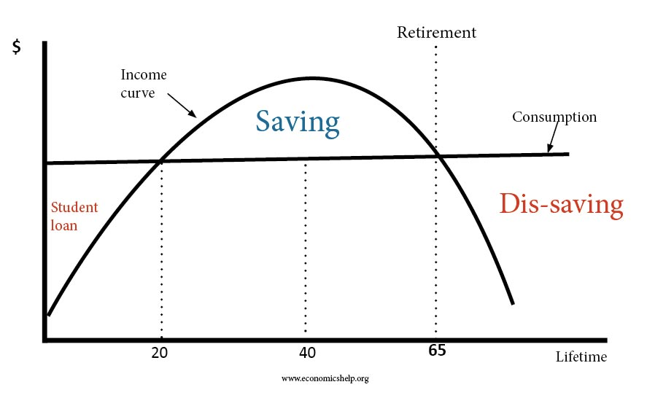
The life cycle hypothesis can be explained using the equation below
$$C=aW_{R}+cL_{L}$$
Where $W_{R}=real wealth$, $L_{L}=labour income$, $a=mpc of wealth income$, and $c=mpc of labour income$.

To explain the life-cycle hypothesis, late us assume an individual expects to live for N years with his age of retirement at R. he start working at the age of B, that is, his working life equals R-B years. The lifetime income can be expressed as follows
$$Life time income=Y_{L}(R-B)$$
Where, $Y_{L}=annual labour income$, and $R-B=number of working years$. Assuming $R-B=E_{L}$ to be the earning life. Then we may re-define lifetime income as follows
$$lifetime income=Y_{L}×E_{L}$$
According to the life-cycle hypothesis, an individual plans his lifetime consumption in such a way that his lifetime consumption equals his lifetime income. Given the individual’s expected life of N years and his planned constant (annual) consumption (C), the consumption hypothesis can be written as
$$C ×N=Y_{L}×E_{L}……………………………………………………………..(**)$$
The term $C×N$ represents the lifetime consumption. If $C×N is represented by C_{L}, which is lifetime consumption$. Then the lifetime consumption will now be expressed as thus
$$C_{L}=Y_{L}×E_{L}$$
To get the annual consumption, simply make C subject of the formula in equation (**) above. This can be done by dividing both sides of the equation (**) by N. With this, we get the annual consumption (C) as
$$C=\frac{E_{L}}{N} × Y_{L}$$
This shows that only a fraction of labour income is consumed annually and the rest is saved and accumulated
Since we know the annual income of the individual and have also set out how to determine annual consumption. The lifetime savings can be easily sorted out.
$$S=\left(Y_{L}×E_{L}\right)-(C_{L})$$
$$Where C_{L}=C ×N$$
We can also derive our annual savings $(S_{L})$ as follows. This will be annual labour income ($Y_{L}$) minus annual consumption (C)
$$S_{L}=Y_{L}- C$$

Practice Question
Given the life expectancy of a man to be 80 years. He started working at the age of 20 and retired at age of 60. If the annual income of this man is ₦225,000. Follow all the principles of life-cycle hypothesis determine his
- Lifetime income,
- Lifetime consumption, and
- Lifetime savings
The Drawbacks of the Life-Cycle Hypothesis
There are few criticisms that scholars have made against the life-cycle hypothesis of Modigliani and Ando. The theory has been criticized base on its strong assumptions
- The assumption that households and individuals have a definite and conscious vision about expected consumption and income may not be realistic.
- The theory does not give room for uncertainties in expected income and consumption
- The assumption that each individual or household has all the needed information to plan his lifetime consumption based on the expected lifetime income may not be realistic.
- The assumption that each individual/household maintains relatively constant consumption may not be realistic. The consumption behaviour of individuals varies over time.

Post-Test
- Given the life expectancy of a man to be 80 years. He started working at the age of 20 and retired at age of 60. If the annual income of this man is ₦225,000. Follow all the principles of life-cycle hypothesis determine his
- Lifetime income,
- Lifetime consumption, and
- Lifetime savings
- One of the properties of absolute-income hypothesis states that marginal propensity to consume (MPC) is less than average propensity to consume (APC). Demonstrate this in line with a linear consumption function
- In response to Keynes’ principle that APC is greater than MPC, the permanent income hypothesis by Milton Friedman asserts that both APC and MPC are the same. Justify the belief of Friedman using appropriate tool.
- (A). Present a concise proposition of absolute-income hypothesis
(B). Discuss the four major properties of absolute-income hypothesis

Bibliography
-Mulhearn C., Vane H.R. (1999). The Objectives of Macroeconomic Policy. In:
Economics. Macmillan Foundations. Palgrave, London
-Branson, W. H. (1979). Macroeconomic theory and policy (No. 04; HB171. 5,
B73 1979.).

LECTURE SIX
INTRODUCTION
This lecture focuses on the various concepts and theories of investment. It provides detailed information to assist students in the understanding of what investment is in economics.
Objectives
At the end of this lecture, students should be able to:
- understand the meaning of investment in economics
- differentiate between autonomous investment and induced investment
- explain different theories of consumption
- differentiate one theory of investment from the other.
Pre-Test
- Define investment
- Provide details on the induced and autonomous consumption
- Using appropriate tools to explain the classical theory of investment
6.0 INVESTMENT FUNCTION
Investment is one the most important part of aggregate demand and it plays a central in the determination of equilibrium income. Investment is a key component of aggregate demand. In a closed economy, aggregate demand is determined as the sum of the consumption expenditure of households, investment spending of business firms and government expenditure. $[Y=C+I+G]$. In economics, investment is simply the addition to existing stock of capital over time which make it a flow concept. The investment can be autonomous or induced.
6.1 Autonomous Versus Induced Investment
Autonomous Investment
When investment is independent of the level of income, it is usually defined autonomous. This type of investment does not respond to changes in income. Autonomous investment are often determined by external or exogenous factor. The graphical illustration of autonomous investment is presented below.
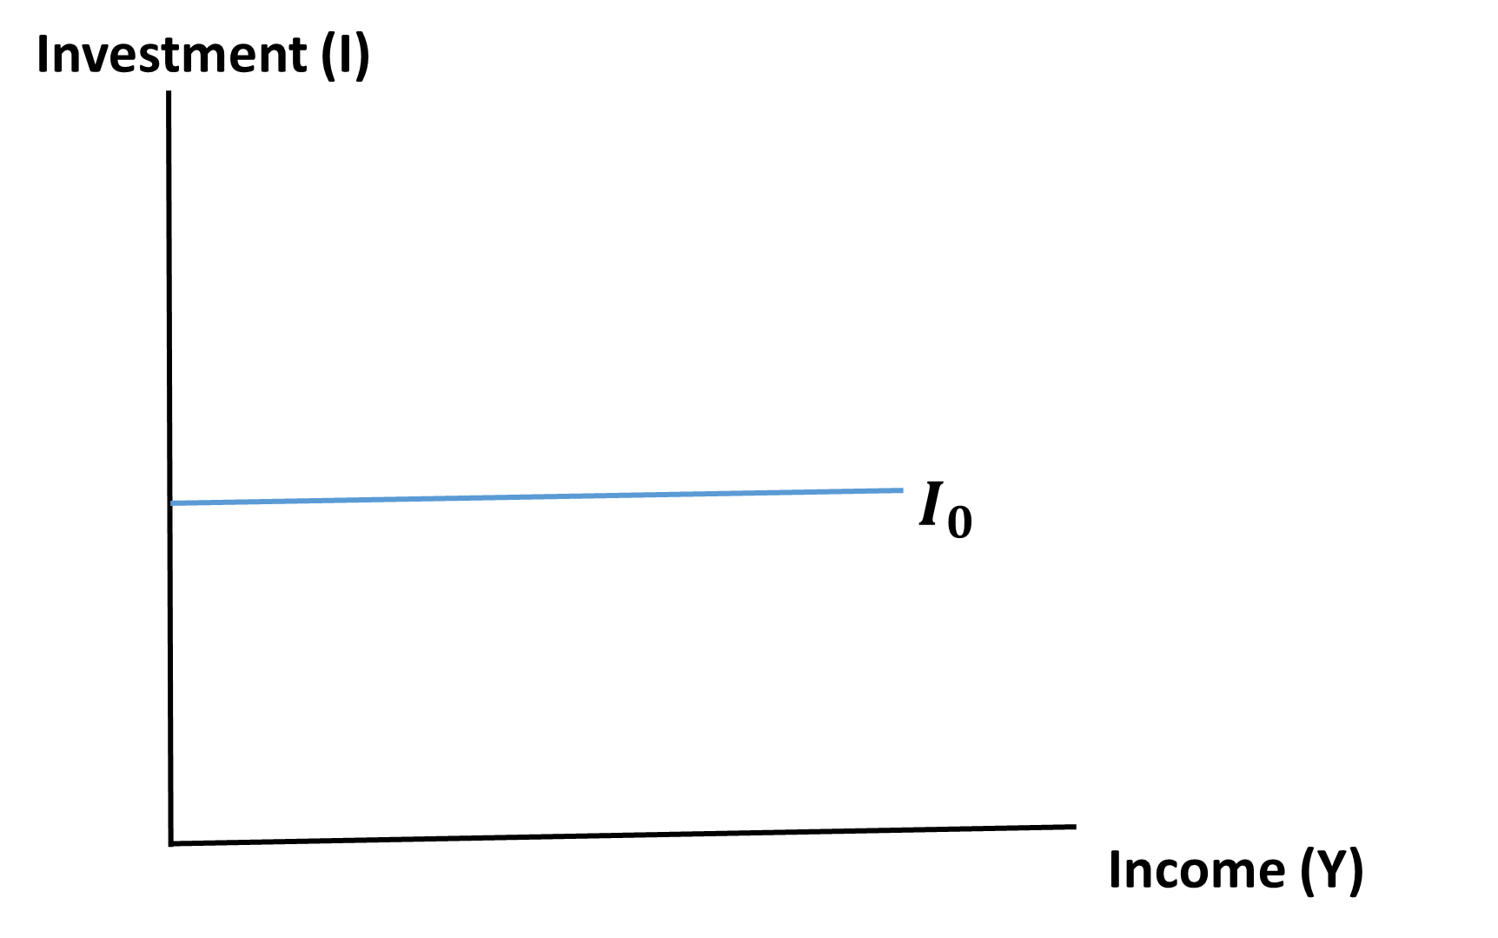
Induced Investment
This type of investment is basically influenced by income and interest rate. Investment is therefore income and interest elastic. Income is the most important determinant of induced investment followed by interest rate.
$$I=f\left(y, r\right)$$
$$f^{'}\left(y\right)>0$$
$$f^{'}\left(r\right)<0$$
Combining the two components of investment to give total investment, that is autonomous and induced investment
$$I= I_{o}+I(y, r)$$

6.2 THEORIES OF INVESTMENT
There are many theory of investment but this study is concerned itself with the following
- The classical theory of investment.
- The Keynesian theory of investment
- The Accelerator principle theory of Investment

6.2.1 The Classical theory of Investment
The classical economists argued that planned investment will always be equal to planned savings and that the equilibrating factor is the interest rate. The proposition of the classical is that if there is disequilibrium, the rate of interest will serve as a factor to equilibrate the investment and savings. According to the classical economists, both investment and saving are function of interest rate; that is, interest rate is a major determinant of savings and investment. While savings is an increasing function of interest rate, the investment is a decreasing function of interest rate.
$$S=f\left(r\right); f^{'}\left(r\right)>0$$
$$I=f\left(r\right); f^{'}\left(r\right)<0$$
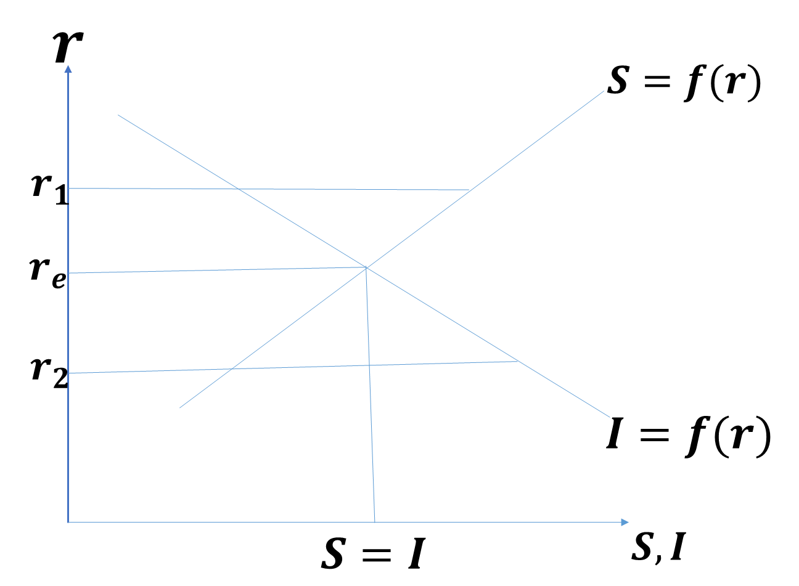
The equilibrium rate of interest is $r_{e}$. It is this interest rate that regulates both the rate of savings and investment. At higher interest rate, savings exceeds investment and competition will bring down interest rate as savers save more. When interest rate is low, investment will be high and this will increase interest rate. In other words, the equilibrium is self-adjusting. This was the bases of Keynesian attack on the classical doctrine.
6.2.1 The Keynesian Theory of Investment
John Maynard Keynes started his contribution to the theory of investment by attacking the main principle of classical school. The classical exclusion of income as a determinant of both investment and savings was criticized by Keynes. It was emphasized that income has great influence on savings and investment and that interest rate is not the only determinants of investment. Keynes further explained his theory of investment using the approaches called Marginal Efficiency of Capital (MEC) and Marginal Efficiency of Investment (MEI).
6.2.1.1 Marginal Efficiency of Capital
The marginal efficiency of capital (MEC) is the highest rate of return expected from an additional unit of a capital asset over its cost. MEC is equal to the rate of discount which would make the present value of the series of stream of income given by the returns expected from the capital assets during its life just equal to its supply price. Concisely, the MEC is the rate of interest that equates the present value of the streams of benefit with its initial cost outlay. Symbolically,
$C=\frac{R_{1}}{(1+i)}+\frac{R_{2}}{{(1+i)}^{2}}+………………+ \frac{R_{n}}{{(1+i)}^{n}}$
$Where C=cost of the capital asset; R_{1}, R_{2}, ………..,R_{n} are the prospective yields$ or the series of expected annual relations from the capital assets in the year 1, 2, ….., n. Also, $i is the rate of interest which makes the capital assets exactly equal to the present$
$value of the expected yield from it.$ MEC or the rate of discount which equates the two sides of the equation. The present value of a capital asset is inversely related to the rate of interest. The lower the rate of interest, the higher is the present value and vice versa.
6.2.1.2 Marginal Efficiency of Investment
Marginal Efficiency of Investment (MEI) is the expected rate of return on investment as additional units of investment are made under specified conditions and over a stated period of time. In the language of John Maynard Keynes, the comparisons are to be made between the expected rates of return (MEI) on any additional investment and the market rate of interest. The rate of return (MEI) is computed as the rate at which the expected stream of future earnings from an investment project must be discounted to make their present value equal to the cost of the project.
The Criteria for the Viability of Investment Projects
The different between expected rates of return from an investment project (MEI) and market rate of interest ($r)$ is the yardstick to be used as follows:
- Investment would be undertaken as long as the marginal efficiency of each additional investment exceeded the interest rate.
If $MEI>r$, the investment is very viable
- If the interest rate is higher, investment would be unprofitable because the cost of borrowing the necessary funds would exceed the returns on the investment.
$If MEI<r$, the investment is not viable
- If the marginal efficiency of investment (MEI) is equal to the market rate of interest; t he decision for the investment is indeterminate. It depends on the motive of embarking on investment. If the motive is to make profit, it would rather be abandoned. On the other hand, if the motive is to break even, it can be undertaken.
$If MEI=r$, the investment is indeterminate
Note: Discuss the major difference between classical theory of investment and Keynesian theory of investment
6.2.1.2 Differences between MEC and MEI
- The marginal efficiency of capital (MEC) is the highest rate of return expected from an additional unit of a capital asset over its cost while Marginal Efficiency of Investment (MEI) is the expected rate of return on investment as additional units of investment are made under specified conditions and over a stated period of time.
- The MEC is a stock concept while MEI is a flow concept
- The MEC determines the optimum capital stock in an economy at each level of interest rate while the MEI determines the net investment of the economy at each interest rate, given the capital stock.
- The MEC is based on a given supply price for capital, while MEI is based on induced changes in this price.
- MEC is the expected rate of returns on capital while MEI is the expected rate of return on investment.
6.3 The Accelerator Theory of Investment
The simple accelerator theory of investment explains net investment in term of increases in expected output. The theory states that a stable relationship exist between the stock of capital and output. Increase in output will put pressure on existing production capacity which necessitates an expansion of the capital stock and in turn necessitate a high rate of investment expenditure. It simply means that output affects production capacity which in turn affect capital stock and finally investment.

6.3.1 The Assumption of the Accelerator Theory of Investment
The accelerator principle is based upon the following assumptions
- It assumes a constant capital-output ratio
- It assumes that resources are easily available
- It assumes that there is no excess or idle capacity
- It assumes that the increased demand is permanent
- It assumes that an increase in output immediately leads to a rise in net investment

6.3.2 The proposition of the Theory
Given the assumptions stated above, the accelerator theory of investment can be explained as follows. The theory explain the relationship between output and capital as direct and positive. This is denoted by the ratio $(k)$ of capital $(K)$ to output $(Y)$ at time period $t$.
$$β= \frac{K_{t}}{Y_{t}}$$
$$K_{t}=βY_{t}$$
This explains that capital stock at time t is a positive function output at time t
The theory details that change in output demand from one period to another period will cause a corresponding change in capital stock
$${∆K}_{t}=β{∆Y}_{t}$$
This shows that the change in capital stock (${∆K}_{t}$) is a response to the change in output ($∆Y_{t}$)
$$where {∆K}_{t}= K_{t+1}-K_{t} and$$
$$∆Y_{t}= Y_{t+1}-Y_{t}$$
$$K_{t+1}-K_{t}=β(Y_{t+1}-Y_{t})$$
Change in capital stock over time is the same thing as net investment ($∆K=I$) in economics
$$I_{t}=β{∆Y}_{t}$$
In line with the above equation, the accelerator theory of investment states that the investment is a function of the change in the level of output.
The factor $β$ is the accelerator coefficient. The value of $β$ depends on the magnitude of capital-output ratio.
6.3.3 The Shortcomings of the Accelerator Principle
- The assumption of constant capital-output ratio is not realistic. The invention and improvement in technology and production techniques make the capital-output relationship dynamic
- The assumption of full capacity is not realistic. Idle capacity may exist in the production
- The assumption of availability of resources in accelerator theory may be inappropriate. The resources may become unavailable once there is a fall in employment.
- The theory does not take into account the possible time lag between when change in output is made and when investment is made by change in capital stock.

Post-Test
  - With the aid of appropriate measures such as clear expressions, mathematical notations and graphical illustrations, discuss in details the classical theory of investment.
  - Discuss the major flaw in the classical theory of investment
  - Clearly differentiate between marginal efficiency of capital and marginal efficiency of investment
  - Use all the necessary tools, differentiate between autonomous investment and induced investment
Bibliography
-Mulhearn C., Vane H.R. (1999). The Objectives of Macroeconomic Policy. In:
Economics. Macmillan Foundations. Palgrave, London
-Branson, W. H. (1979). Macroeconomic theory and policy (No. 04; HB171. 5,
B73 1979.).

