CHAPTER ONE
- INTRODUCTION
1.1 Background of the Study
As human populations and economies have increased, so has the demand for water on a global scale. Scarcity of water has a substantial impact on biodiversity in both aquatic and terrestrial ecosystems, as well as putting human food sources at jeopardy. Global population increase, climate change effects, and lifestyle changes are putting increasing pressure on our vital water supplies, leading to widespread moisture stress in many nations As a result, people are becoming more aware of the importance of water conservation. Because water has such a profound impact on public health and living situations, it is important for our lives. Water is also distributed unequally over the globe. Vital human activities such as feeding, breathing, circulation, waste, and reproduction all require water to function properly. Water is also a living space and one of the fundamental ingredients in the construction of the living environment. Pollution of water occurs when the natural composition of water resources (streams, groundwater, lake, sea, etc.) deteriorates due to human activities, natural occurrences and the substances in the natural composition of water resources (streams, groundwater, lake, sea, etc.) grow above the ideal concentration values. (Keles, et al., 2014). Water resources are essential for the survival of all living beings, as well as economic development and environmental protection. Environmental contamination has the greatest impact on this essential natural resource, making it the most vulnerable to pollution. Water is essential for all living things, and some of its main activities in the body are as follows: it is a biological solvent that allow the movement and dissolution of vitamins and mineral nutrients; it is essential for regulating temperature of the body; it serves to protect and cushions the organs as well as other organs; it is a physiological solvent that transports and dissolves vitamin D in the body; it is a physiological soluble that transfers and dissolve. In addition to all these, water has an important place in performing many vital activities such as circulation, excretion, and reproduction, (Akın M, Akın G. Suyun Önemi, et al 2007) 80-90% of our blood and 75% of our muscles are made up entirely of water. (Çepel N, Ergün C 2003) Water is an indispensable element of life and we feel uncomfortable when we are dehydrated even for a short time. When we lose really significant benefits, such as the water we have, we realize how valuable water is. People should be able to drink water that is safe to drink and has enough oxygen and minerals. It should also be clear. (G. Akn, Tiydem Yaynclk, 2008). When one liter of raw water pollutes eight liters of clean water, it becomes useless (Aksungur N, Firidin 2008). The extent to which the natural cycle of water supplies is under jeopardy is becoming clearer. The current global population of healthy and water-deprived individuals is predicted to be around 1.4 billion (Olakolu, 2009) It is clearly obvious how serious the matter is. Human activities are the primary source of pollution in groundwater and oceans, causing ecosystems to lose their natural balance. The most common pollutants found in water are acids and alkalis, detergents, household wastes and fertilizers, heat, various metals, nutrients, oils and dispersants, organic hazardous wastes, pathogens, and pesticides. (Göksu M. Ziya L 2015) Pollution of water don’t stay in the water; it also seeps into the soil, in which it is absorbed by plants, vegetables, and fruits via irrigation. These toxic wastes “Poor water quality, diseases produced by freshwater on living things, low agricultural productivity, biodiversity loss in aquatic ecosystems, death, and increased costs of drinking and electric water purification” are subsequently passed on to the animals who drink the contaminated water, compromising the food supply's long-term viability.( Keresteciolu 2002).
1.1.1 Importance of water
Water is a crucial natural resource for the ecosystem's functioning as well as human well-being. It is a useful component of life. Water is part of the most essential elements of human life, and the body cannot survive for more than a few days without it. As a consequence, we cannot neglect the value of ensuring that everyone has access to healthy drinking water. However, because of many corruption-related issues that pervade every aspect of the economy, improved access to clean water in Nigeria is slow. Nigeria is Africa's most populated country, with population of over 200 million people and a 2% annual growth rate. There has not been any improved access to sufficient water supply to accompany the rapidly increasing population. The gap between those who have clean water and those who do not has grown even wider. As reported by Olukanni et al 2006, its availability has a downside that is rising and duplicating itself while intensifying the battle for scarce water resources (Olukanni 2012). It's needed for human and animal consumption. It is needed for the rise of agricultural products that support life on Earth. Water is also used for a series of other uses, such as hydropower, navigation, and recreation. If water is harnessed and used properly, it can be a blessing and of great benefit to mankind. However, if the water is not properly regulated, it may become a curse, wreaking havoc and causing misery. Water quality management is an important part of water resources engineering, as contamination can jeopardize its utility (Arora, Gupta 2013). Water vapor in the form of clouds and mist, as well as seawater, sea ice, and freshwater, can all be found in the atmosphere in various forms. Water travels in an endless loop through the climate, picking up gases and elements as it goes, moving to the sea, to the land, and back to the atmosphere. The hydrologic/water cycle is the name for this cycle. The water cycle ensures that all available water on the planet moves through a continuous and renewable mechanism of condensation, evaporation, precipitation and transpiration. As part of the hydrologic cycle, groundwater is present. An aquifer is a subterranean region where groundwater can be found. Groundwater is derived from three main aquifer areas, which are located between 300 and 1,500 feet below the surface of the earth. The soil profile protects this groundwater from surface pollution (a layer of clay and fine-grained sediments). Some of the qualities of water as follows. Water is an excellent solvent, capable of dissolving a range of compounds. Water is readily available in all three states due to its boiling and freezing points (solid, liquid, and gaseous).
- The heat of the water is a bit high. This allows water to gently absorb and release heat, allowing it to regulate the temperature of its surroundings.
- Water can allow light to reach life forms submerged in it because of its transparency. This is necessary for the survival of plant life in the oceans, lakes, and rivers.
- Water has neither an acidic nor a basic pH. It is a neutral chemical with pH of 7.
1.1.2 Justification of the study
Water's importance to human life, whether for consumption or for household purposes, has made it a valuable business. The majority of raw water sources are contaminated in some way. As a result, it is critical to purify it, particularly for drinking purposes. Purification processes come in a variety of shapes and sizes, depending on the amount of capital available to set up the process. The sort of treatment technique to use is mostly determined by the quality of the raw water.
Mountain Top University established a water treatment plant for commercial purposes, taking into account the university's personnel as well as Prayer City and its environs. This is aimed at generating revenue for the university from within. Customer complaints about the products had occurred during the course of this venture's operations. This needed changes to the treatment procedure, which included filter media replacement in the cylinders of the filter beds. The prior stage involved the traditional loading of the cylinders, each with a different type of material but of varying grades. The current loading is a cylinder filled with a mixture of media to deal with raw water quality issues. This research will look into the effectiveness of this mixed media in meeting not just national or local criteria, but also international quality standards specified by the World Health Organization.
1.2 Statement of Problem
The low quality of treated water is caused by the inefficiency of filter beds in water treatment operations. Contaminants such as suspended particles are more likely to pass through the filter beds. Random laboratory testing by the Mountain Top University (MTU) water factory's quality control unit had shown that certain suspended pollutants might be present in the factory's treated water. The quality control parameters of the MTU water factory's water treatment process are investigated in this research. Parameters such as turbidity, colour, and particulate content of the treated water are measured and analysed more explicitly.

1.3 Aim of This Study

The aim of the project is to determine the effectiveness of the mixed filter beds of the MTU Water Treatment Plant, with respect to the quality of the treated water. This would help to put suspended particles in the beds’ inlet water in check, including the colour and turbidity of the water. The filter beds at the MTU Water Treatment Plant consists of an array of three filter bed cylinders.

1.3.1 Objectives of the Study
- To study the effectiveness of filter beds through the comparison of physicochemical analysis of raw and treated water samples.
- To establish the peak efficiency of the filters beds
- To determine the workable backwashing period considering the results of analysis from a week interval sampling.
- To package the treated water from the filter beds without treating further in Reverse Osmosis equipment.
1.4 Scope of the Study
This study covers the quality monitoring of the treatment process from the first Filter A to the last Filter bed C at the water Treatment plant of Mountain Top University.
1.5 Significance of the Study
To determine the magnitude of contaminants in the treated water of Mountain Top University from the outlet of the filter beds in order to elongate the life span of the Reverse Osmosis Membrane

CHAPTER TWO
2.0 LITERATURE REVIEW
2.1 Raw Water Classifications
Raw water is naturally occurring water that has not undergone treatment and still retains all its bacteria, minerals, particles, parasites and ions. Organic decomposition products, sand/clay particles, algae, bacteria, and viruses all exist in various concentrations in raw water, and the pH maybe out of limit. The most efficient therapeutic procedures are coagulation and flocculation. Our coagulants, polymers, and anticipants are all FDA approved and NSF certified. Because of the presence of pollutants, raw water is generally unfit for human consumption. In some developing nations, drinking and cooking with raw water is a big health concern. Without treatment, raw water can be used for farming, construction, and cleaning. Farmers use it to water their crops and provide it to their livestock to drink, keeping it in man-made lakes or reservoirs for long periods of time. In the construction business, raw water can be used to manufacture cement or to dampen untreated roadways to prevent dust from rising. Raw water can also be utilized for non-human consumption purposes such as flushing toilets and cleaning cars. Water that has been processed before usage, such as water supply, or water that is utilized in an industrial process, such as liquid waste, is known as raw water.
The following are the different types of water:
a) Groundwater
When it rains, some of the water flows off the surface and into rivers, while the rest enters the ground. It gently seeps through the soil particles and around or through the rocks. It accumulates in hollows when it comes into contact with a barrier, such as a solid sheet of subsurface rock, generating underground lakes known as aquifers. Some individuals extract this groundwater by drilling a borehole and pumping it to the surface. This water, in general, includes large amounts of compounds known as minerals.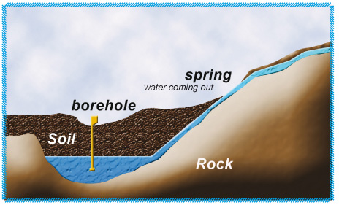
Figure 2.1 Groundwater
b) Natural Spring Water
Groundwater may “leak” to the surface as a spring or “puddle” to form a vlei in some situations. Streams and rivers are fed by springs. Spring water, in general, has a low mineral content other than tap or groundwater.
c) River Water
River water is a surface water source and a part of the water cycle. It can be used for a variety of reasons, including residential use, irrigation, industrial processing, and energy production. Drinking water must undergo treatment and generated with extra caution since it may include pollutants that endanger human health. The quality and quantity of water conveyed by the river is affected by a number of factors. For starters, river water is reliant on the watershed. This implies that when the seasons change, the river's water level fluctuates throughout the year. The numerous climate zones and, of course, the river catchment are intricately tied to the seasons. The impact of large catchments on river water levels is slower than that of small catchments (FAO 1992).
.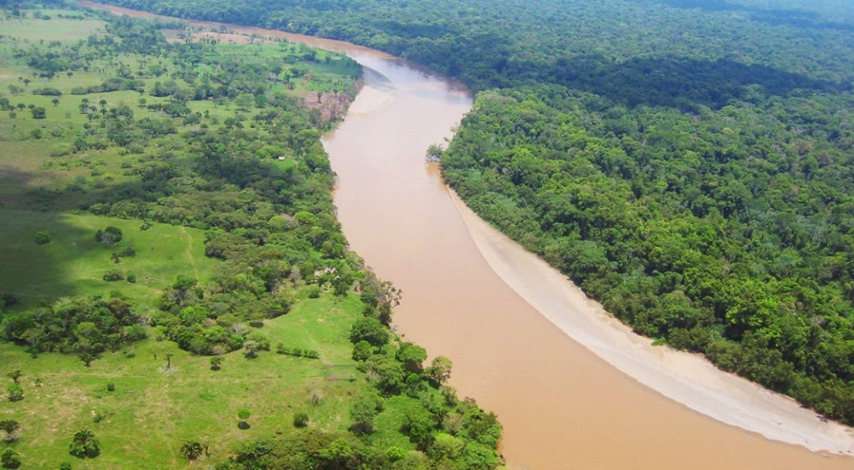
Figure 2.2 River water

d) Ocean Water
Ocean water contains large amounts of dissolved gases such as oxygen, carbon dioxide, and nitrogen. This gas exchange takes place at the ocean's surface, and the temperature and salinity of the water affect its solubility. (Chester et al., 2012). Ocean acidification happens when the amount of carbon dioxide in the atmosphere increases as a result of the use of fossil fuels, resulting in increasing levels in ocean water. (The United Nations Environment Programme, 2017). The ocean provides essential environmental services to humanity, such as climate control. It also provides a means of trade and transportation, as well as access to food and other resources. It is estimated that it is home to 230,000 species, but it could be far larger—possibly over two million. (Drogin, August 2008). The ocean, on the other hand, is confronted with a slew of environmental issues, including marine pollution, overfishing, ocean acidification, and other climate-related repercussions. The continental shelf and coastal waters, which are most influenced by human activities, are particularly vulnerable.
e) Lagoon
A lagoon is a small body of water separated from a larger body by a short landform such as reefs, coastal regions, border peninsulas, or isthmuses. Lagoons are categorized into two kinds: coastal lagoons and atoll lagoons. According to Davis, lagoon are also been found on mixed-sand and gravel beaches. Body of water designated as coastal lagoons and bodies of water classified as estuaries have some overlap. Lagoons are widespread along various coastlines across the world.
( Richard 1994). A deep body of water is located in the center of the ring. A lagoon is formed by the interaction of coral development and water. The creation of an atoll can take up to 300,000 years. Lagoons form along the shores that are gently sloping. They're shallower than atoll lagoons and usually have an island, reef, or sand bank separating them from the ocean. An entrance usually connects a coastal lagoon to the ocean. (Allaby Michael 1990)
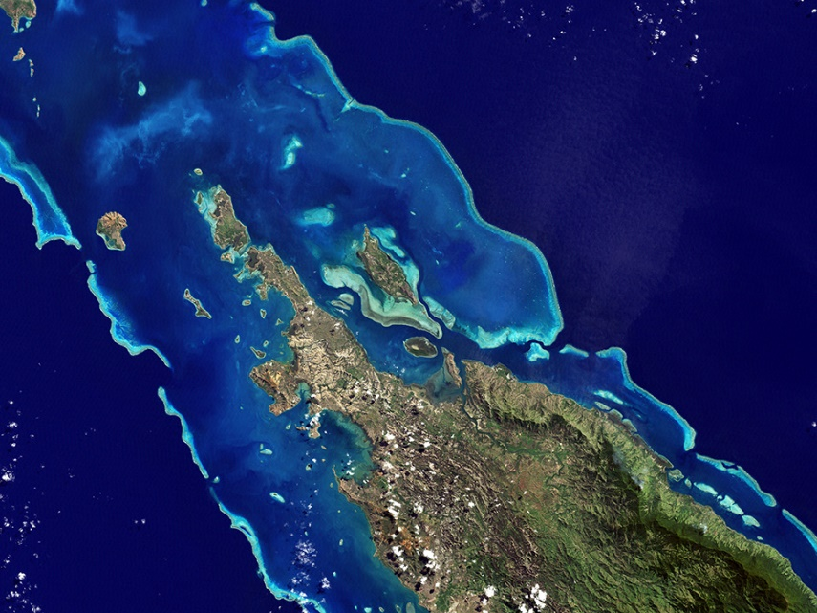
Figure 2.3 Lagoon water
f) Lake
A lake is just like a body of water that is surrounded by land and located in a basin, separate from any stream that feeds or drains the lake (Purcell, Adam 2008). Although lakes are not oceans, they are part of the Earth's water cycle, just like the much bigger oceans. On the other hand, are often coastal areas of the ocean. Although there are no official or scientific definitions, they are often larger and deeper than ponds, which are also on land (Williams et al 2004 ). Rivers or streams, on the other hand, are typically running in a channel on land. Rivers and streams feed and drain the majority of lakes. Natural lakes can be found in hilly places, rift zones, and areas where glaciers is still present. Other lakes can be found in endorheic basins or along the courses of mature rivers that have broadened into basins. Because of unstable drainage patterns left over from the previous Ice Age, there are many lakes in various places of the planet. Over geologic time spans, all lakes will gradually fill in with sediments or spill out of the basin in which they are contained.
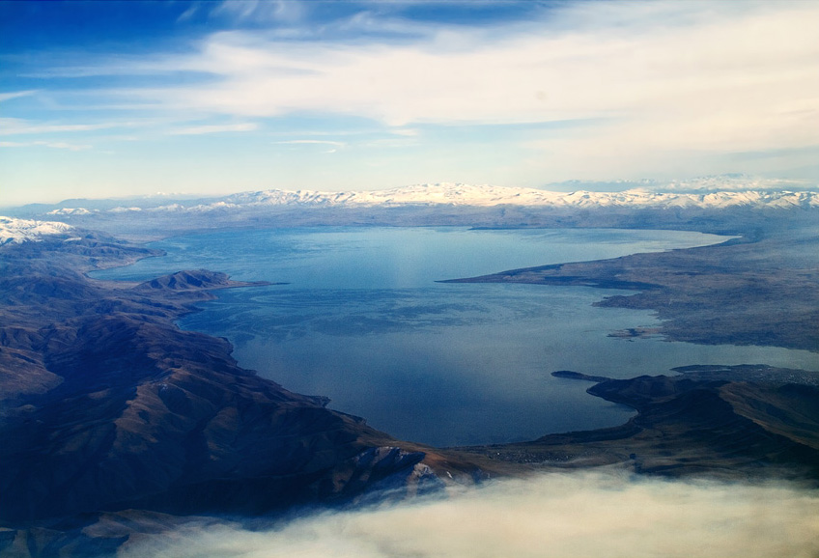
Figure 2.4 Lake water
2.2 Uses of Water
- Irrigation
Food is one of a person's most fundamental needs. Food is grown in diverse places of the world depending on climatic circumstances, but water is something that all crops require without exception. We all know how important water, sunlight, and soil nourishment are to a plant's growth. Farmers sow seeds each year and wait for rainfall to replenish their farms in order to have their crops ready for harvest.
- Cooking
Everything takes some amount of water in the preparation, whether it's your favorite curry or your favorite dessert. Water not only boils, killing all the bacteria in your food and making it nutritious, but it's also a crucial part of the dish's flavor.
- Washing And Cleaning
Water is required for cleaning and washing, whether it is your clothes, your home, or your body. Water is a fantastic cleaning and washing agent because of its unique qualities. Water also cleanses and breaks down the trash that humans produce in large quantities

- Drinking
Potable water is water that is suitable for drinking. All of our cells, organs, and tissues utilize water to help control our body's temperature and maintain other bodily activities. Because our bodies lose water through breathing, sweating, and digesting, it's critical to rehydrate by drinking water and consuming water-rich meals.
- Provides Home To Millions Of Creatures
Not only is water the soup from whence life arose, but the vast ocean and other bodies of water also support more life than land does! Mammals, fish, birds, insects, trees, plants, algae, krill, and a variety of other organisms either live in or are completely reliant on water for living. Even worms can be seen living on icebergs made entirely of water! And you'd be astonished at how vital each organism is to the eco-survival. System’s In the food chain, even a worm can have an impact on the life of a whale. Life would be deprived of its principal source of nutrition if it did not have access to water.
- Enables Transportation
Traveling by car necessitates the use of a road. A railroad track is required for train travel. You do this with the help of a plane. However, planes have limited room and fuel is prohibitively expensive. What if we needed to ship massive items across oceans? Ships are required for this, yet ships can only go on water! Ship transportation is largely used to move people and non-perishable commodities, sometimes known as cargo.
- Industrial Uses Of Water
For processing, chilling, and diluting products, many businesses require huge amounts of water. The paper business, the food industry, and the chemical industry are all examples of industries that use a lot of water. Water is also employed in the manufacturing of a number of commercially essential items as an industrial solvent. Water is used to spin turbines in almost all power facilities that generate energy. Heavy water, an essential type of water, is commonly employed as a neutron moderator in nuclear reactors.
- Other Important Uses Of Water
The temperature of the Earth's surface would be significantly lower if it weren't for the high specific heat of water. It would be difficult for life to survive as a result of this. During the day, the water in the Earth's seas absorbs heat from the sun and helps to maintain the temperature at night. Water is required for crop irrigation and is hence an essential component of agriculture. It is extensively used in cooking since it boils at a temperature of 100 degrees Celsius. Water is used in a variety of domestic chores, such as washing and cleaning. Water also acts as a means of goods transportation. Many items are delivered by ship between the continents of the Earth.
2.3 Importance of Water in Living Organisms
All vital minerals and vitamins are conveyed inside the bodies of living organisms through to the medium of liquid (owing to its ability to dissolve a wide range of substances). It's also important for enzymes to function properly in living creatures. If it weren't for the high specific heat of water, the temperature of the Earth's surface would be much lower. As a result, life would struggle to survive. The water in the Earth's seas absorbs sun's heat during the day helps to maintain a consistent temperature at night. Crop irrigation necessitates the use of water, making it a necessary component of agriculture. It is often used in cooking operations since it boils at a temperature of 100ºC. Water is used for a variety of household tasks, including washing and cleaning. Water transports cargo as well. Ships move a great deal of cargo between the continents of the Earth.
2.4 Water treatment in Mountain Top University
According to Mountain Top University. To allow aeration, the water from the bore hole is sieved before entering the pre-treated tank. Aeration is simply the process of circulating air through mixed water dissolved in a liquid. Water treatment refers to any process that improves the quality of water so that it can be used for a specific purpose. Drinking water, industrial water supply, irrigation, river flow maintenance, water leisure, and a range of other applications, including safely returning to the environment, could all be possible end uses. The process of eliminating or lowering the concentration of contaminants and undesired components in water so that it can be used for its intended purpose is known as water treatment. This technique is important for human health since it allows individuals to drink and irrigate at the same time

2.4.1 Stages of the Treatments
a) Aeration is the process of adding air to assist the aerobic microorganisms in the consumption of pollutants. Aeration is an important component of most biological treatment systems. A properly designed and operated aeration system will do two things:
- Adds air to the raw water thus increasing the dissolved oxygen (DO) levels
- Mixes the raw water
Aeration is a lengthy process of introducing air to mix with raw water in order to oxidize dissolved gases and heavy metals out of the water. It also serves as oxygen to enrich the water with oxygen. The aeration process can take up to 30 hours to complete.

4Fe(HCO₃)₂ + O₂ + 2H₂O → 4Fe(OH)₃ + 8CO₂ ……………………….equation 1

2Mn(HCO₃)₂ + O₂ + H₂O → 2Mn(OH)₄ + 4CO₂……………………...…equation 2

O₂ + 4H⁺ + 4e⁻ ⇌ 2H₂O …………………………………………….……equation 3

Fe²⁺ + ¼ O₂ + H⁺ ⇌ Fe³⁺ + ½ H₂O…………………………………………equation 4

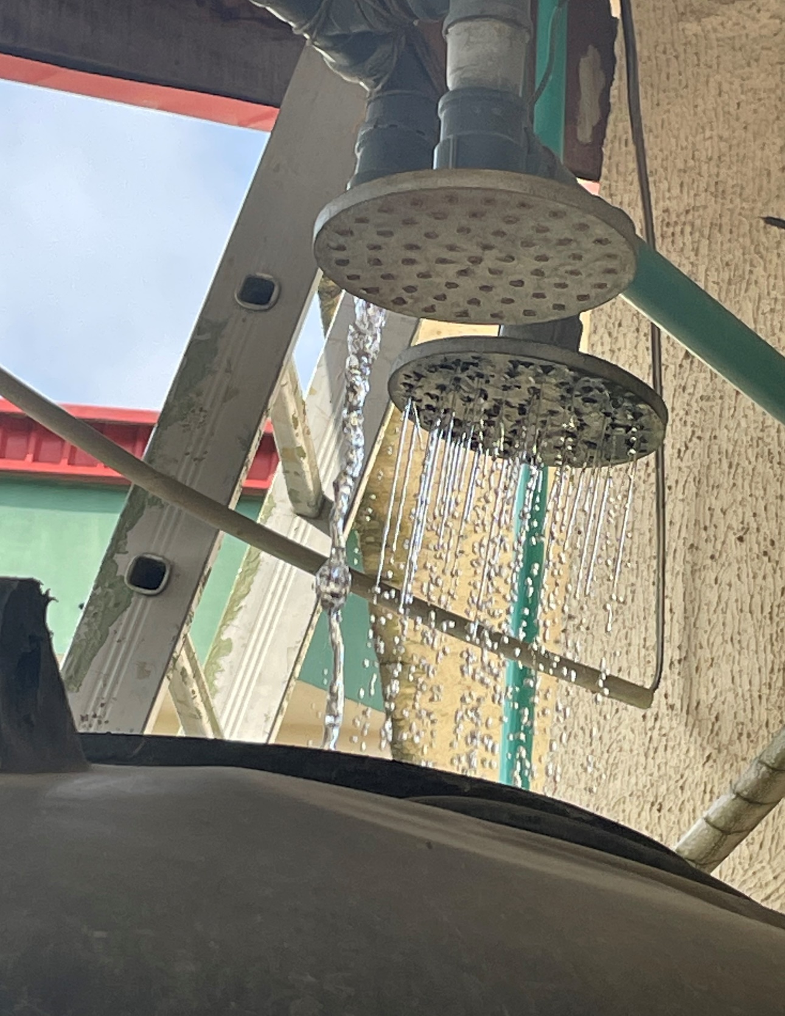 Figure 2.5 Showering of water for aeration.

b) Filtration
i) Sand Filter. This is done through the process of chemical feed. It helps to facilitate the flocculation or coagulation of any suspended solid. It's utilized to get rid of floating and sinkable particles, as well as suspended materials.
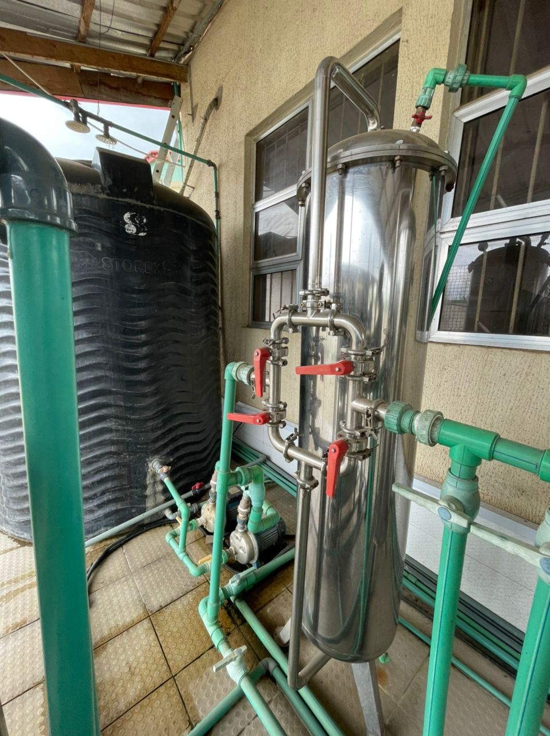
Figure 2.6 Sand Filter
ii) Carbon Filter. This is used to remove taste from the water through the process of a bed of activated carbon to remove contaminant. They are most effective at removing chlorine, particles such as sediment, volatile organic compounds (VOCs), taste and odour.
Pb + CaCl₂ + H₂O + C ⇌ PbC + HOCl + HCl……………….…………equation 5
Pb⁺ adsorbed on Carbon (activated) in the presence of CaCl₂

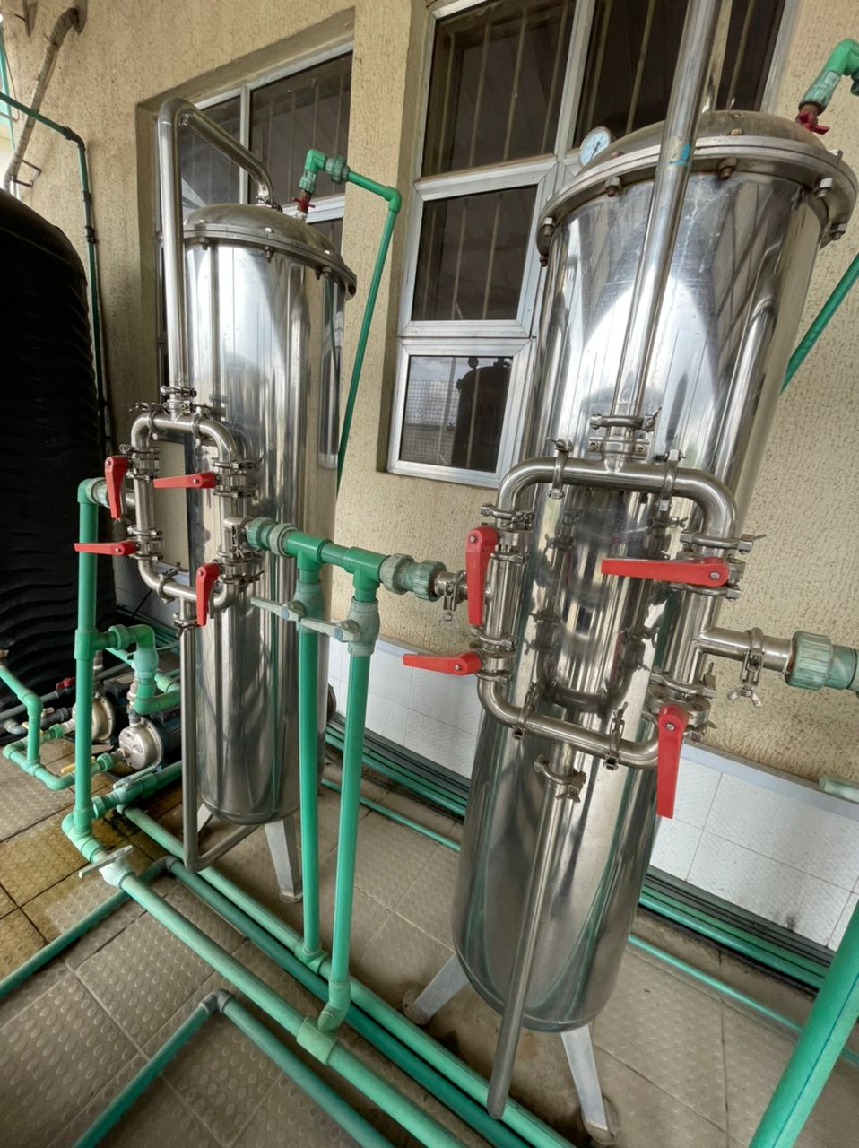
Figure 2.7 Carbon filter

iii) Resin Filter. This is use to remove the unwanted ion from the water and add the needful ion into the water. It also attracts the calcium and magnesium ions and replaces them with sodium ions which are less problematic for water through a bed of ion exchange.
Cat ion Exchanger for Treatment of Permanent Hardness
RCOOH (resin) + CaCl (hard water)→RCOO2Ca (Carboxylate) + H⁺ + Cl⁻ equation 6
Ionization RCOO⁻ H⁺ + Ca⁺ Cl⁻ →
RCOOH + MgSO₄ → RCOOMg + H⁺ + SO₄²⁻ ………………….……equation 7
CaSO₄ (hard water) + NaCl H+ (cat ion resin) → NaSO₄ + Cl- + H⁺ + SO₄²-equation 8

CaSO₄ (s) +Na₂CO₃ ⇌ CaCO₃ + Na₂SO₄ …………………….……...…..equation 9
Treatment of Temporary Hardness
CaCO₃ (s) + CO₂ (aq) + H₂O ⇌ Ca²⁺ (aq) + 2 HCO₃⁻ (aq)…………...…equation 10

Ca(HCO₃)₂ → CaCO₃ + H₂O CO₂…………………………………..…equation 11

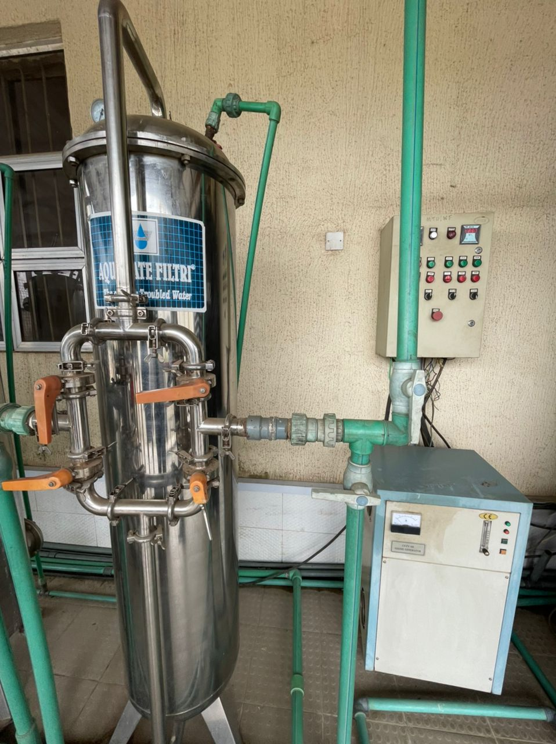
Figure 2.8 Resin filter

iv) Ozone Generator
Ozonation (also known as ozonisation) is a chemical water treatment procedure in which ozone is injected into the water. Ozone, a gas made composed of three oxygen atoms, is one of the most powerful oxidants (O3). Ozonation is a type of advanced oxidation that generates highly reactive oxygen species capable of destroying a wide range of chemical compounds as well as all microorganisms. Ozone water treatment has several applications since it is effective for disinfection as well as the breakdown of organic and inorganic contaminants. Ozone is formed using energy by exposing oxygen (O2) to high electric voltage or UV radiation. On-site production of the required amounts of ozone is possible, but it requires a lot of energy and is consequently costly. Ozone is added to the water for like 30 minutes because of its effectiveness in water purification.
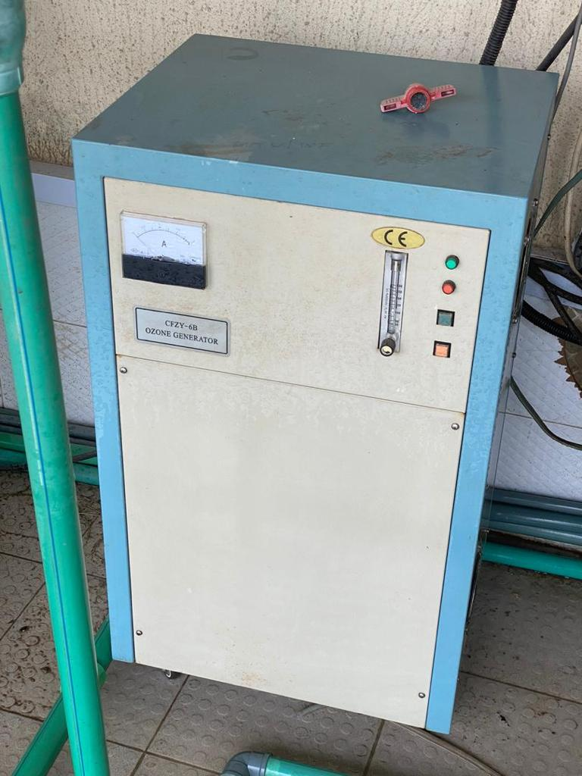
Figure 2.9 Ozone generator
The Benefit of Drinking Ozone Water
As compared to chlorination, ozone has a higher disinfection efficiency against bacteria and viruses. Furthermore, the oxidizing properties can lower iron, manganese, and sulphur levels, as well as minimize or remove taste and odour issues. Iron, manganese, and sulphur in the water are oxidized by ozone to form insoluble metal oxides or elemental sulphur. Post-filtration is used to eliminate the insoluble particles. Coagulation or chemical oxidation can be used to extract organic particles and chemicals. Ozone is unstable, and it can degrade in as little as a few seconds to as long as 30 minutes. The rate of degradation is determined by the chemistry, pH, and temperature of the water temperature.

v) Reverse Osmosis (Ro)
This is a water purification method that separates ions, undesirable compounds, and bigger particles from drinking water using a partly permeable membrane. Ro consist of membranes which are used to evacuate every dirt still inside the water also used to remove a wide variety of both aesthetic and health related contaminant. Reverse osmosis systems remove common chemical contaminants including sodium, chloride, copper, chromium, and lead, as well as lowering arsenic, fluoride, radium, sulphate, calcium, magnesium, potassium, nitrate, and phosphorus (metal ions, aqueous salts). The only method for removing the most dissolved solids (TDS) and salts from water, as well as improving chloride removal, is reverse osmosis. To generate high-quality water, reverse osmosis systems pressurize water and pass it through a semipermeable membrane. The finely pored filter collects all main pollutants while only allowing water molecules to flow through when high pressure is applied to the feed water. This water treatment system's permeate water has 90-95 percent fewer TDS and salt particles, making it one of the cleanest and best quality types of water available. Water from a reverse osmosis system has the lowest PPM values, as low as 10 PPM. For dealing with high chloride levels in saltwater, reverse osmosis would be the most effective method. For eliminating salts like chloride, reverse osmosis is the most effective way. The RO process works by pushing water across a membrane that prevents bigger ions like chloride from passing through while allowing water molecules to pass through. In homes, small reverse osmosis systems called point-of-use systems are often located near the kitchen sink. Despite the fact that reverse osmosis systems are cost-effective, previous systems could only generate a tiny amount of treated water per day. Recent advancements in membrane elements now allow systems to produce 100 gallon or more per day. 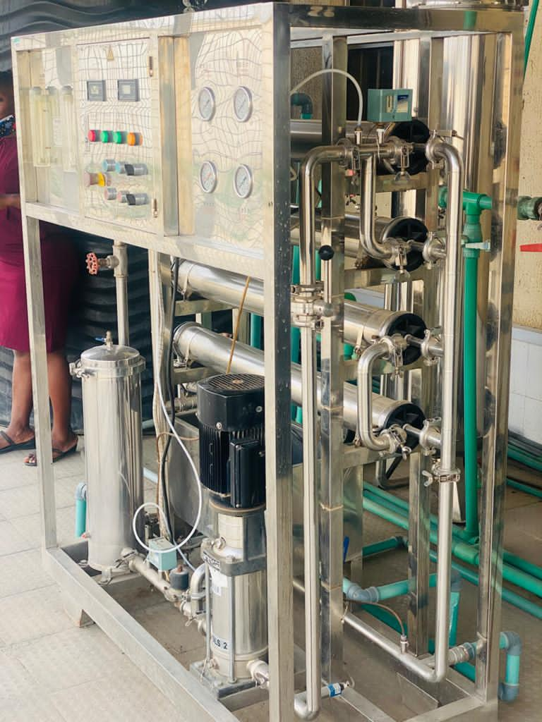 Figure 2.10 Reverse osmosis
2.5 Working Principle of Reverse Osmosis
Reverse osmosis works by increasing pressure on the salt side of the RO and forcing water through the semi-permeable RO membrane, leaving virtually all dissolved salts in the reject stream (about 95 percent to 99 percent). The amount of pressure required is determined by the salt concentration in the feed water. To counteract the osmotic pressure, more pressure is required as the feed water concentration rises.
Desalinated water that has been demineralized or deionized is known as permeate (or product) water. The reject (or concentrate) stream is the water that contains concentrated contaminants that did not pass through the RO membrane.
Water molecules pass through the semi-permeable membrane as feed water enters the RO membrane under stress (enough pressure to overcome osmolality), but salts and other contaminants are not allowed to cross and are expelled through the deny flow (also known as the concentrate or brine flow), which can be drained or fed back into feed water system in some situations. Permeate or product water is the water that goes through the RO membrane and is generally devoid of dissolved salts to the tune of 95 percent to 99 percent. It's critical to recognize that a RO system employs cross filtration rather than typical filtration, which accumulates contaminants within the filter media. In cross filtration, the liquid runs through or crosses the filter with extracting: purified water is flowing one way, contaminated water goes the other. Cross flow filtration eliminates contaminants by enabling water to whisk them away while maintaining sufficient agitation to keep the surface layer clean.
2.6 Contaminants Reverse Osmosis Will Remove from Water
Reverse osmosis can remove 99 percent or more of dissolved salts (ions), particles, colloids, organics, microorganisms, and progeny from feed water (although an RO system should not be relied upon to remove 100 percent of bacteria and viruses). Reverse osmosis (RO) does not ensure that all pollutants are entirely eliminated. During onsite water analysis, it's possible that a pollutant found in the feed water isn't present in the RO water. However, with each successive investigation, this finding may alter. When reading a membrane spec sheet, the most important thing to understand is that RO rejects a particular percentage of pollutants, which varies based on the contaminants and conditions. Furthermore, different membranes have distinct rejection properties. I've included a specification document for the Dow Filmtec® membrane at the bottom of this response; this is the product by which all other membranes are judged. From a technological standpoint, a RO membrane will reject any material with a molecular weight greater than 100. In general, RO membranes remove between 95 and 99 percent of inorganic particles. Calcium, Strontium, Copper, and compounds like Sodium Chloride are examples of this. At maximal efficacy, organic material such as bacteria and viruses are eliminated at a rate of 99.9%. The water generated may not always be devoid of bacteria and viruses. While the RO membrane removes chlorine compounds, it is hydrolysed and destroyed by chlorine. The rate of destruction is determined by the amount of chlorine in the water. It is recommended that a RO membrane be pre-treated with Activated Carbon to remove chlorine, a water softener to reduce hardness, which will foul the membrane, and sediment filtering to prevent the membrane from plugging. Dirt, hardness, algae, and mild are all removed by RO, but these should be filtered out to avoid premature membrane failure. One caveat on the removal of germs and viruses. Reverse osmosis systems remove typical chemical pollutants (metal ions, aqueous salts), such as sodium, chloride, copper, chromium, and lead, as well as reducing arsenic, fluoride, radium, sulfate, calcium, magnesium, potassium, nitrate, and phosphorus. It also helps in disinfection
- Disinfection
Ultraviolet Light
The most effective way for removing microorganisms from water is ultraviolet water purification. UV rays penetrate hazardous pathogens in your home's water and kill bacteria that cause illness by targeting their genetic core (DNA). This is a very effective way of removing their ability to reproduce. Ultraviolet light is a simple, effective, and environmentally friendly way to disinfect your water. UV systems kill 99.99% of hazardous microbes without adding chemicals or altering the flavour or odour of your water. Other filtration technologies, such as reverse osmosis or carbon block filters, are frequently used in conjunction with UV water purification. UV light is a natural process that does not cause toxic substances to be released into the water. Simply plug in the electricity and connect at the point of entrance. It's a disinfection process that's safe, effective, and ecologically friendly, and it's utilized in both residential and industrial settings all over the world.
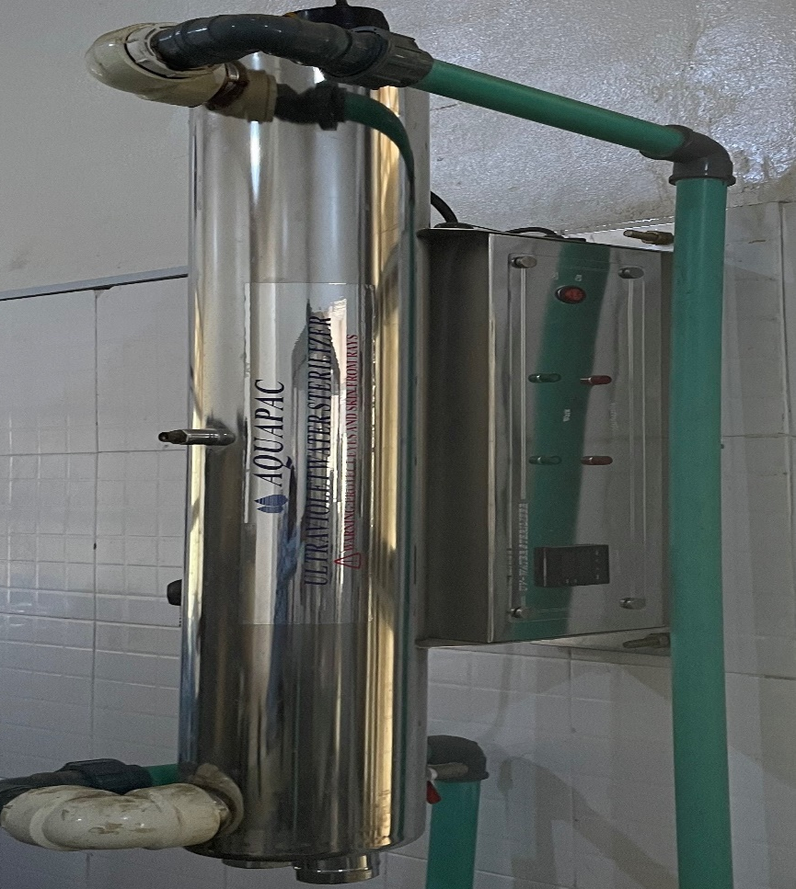
Figure 2.11 image showing the UV light
Advantages of Ultraviolet Purification
Chemical Free: UV purification does not use any chemicals, like as chlorine, and does not produce any toxic by-products.
Taste % Odour Free: UV has no chemical flavour or odour, therefore the water is tasteless and odourless.
Extremely Effective: By removing 99.99 percent of disease-causing bacteria, this is one of the most effective ways to kill disease-causing microbes.
Requires Very Little Energy: It uses about the same amount of energy as a 60 watt light bulb to run.
Easy to Maintain: It's a system that you can set and forget about; all you have to do is update the UV bulb once a year.

2.7 Quality Monitoring In Water Treatment
Water quality is of major importance to humanity, as it is directly related to human well-being. In line with Ranjana (2010), the standard of public health depends to a larger extent on the standard of groundwater. Although groundwater quality is believed to be quite sensible compared to surface water, its quality is that the sum of natural earth science of the setting and man actions withdrawal, land use amendment, and solid waste merchandising (Chapman, 1996). The water quality parameters reflect the level of water resource contamination and show whether water is safe for human consumption. Contaminated water is unacceptable because of health effects, poor style and aesthetic worth to shoppers (Suthra et al., 2008).

2.7.1 Physico-Chemical Parameters
The physico-chemical parameters used in monitoring quality of water are: pH, conductivity, total dissolved solids, total solids, suspended solids, calcium and manganese, magnesium, chlorides, iron are water's most important physico-chemical properties in terms of quality.
2.7.2 pH
The hydrogen ion (H+) measurement available in water is pH. Groundwater acidity is attributed to the presence in the soil of organic acids, as well as those of chemical origin introduced into the water (Chapman and Kimstach, 1996). Acid rain contains dissolved carbon dioxide (CO₂), nitrogen dioxide (NO₂) or sulphur dioxide (SO₂) which often yields elevated concentrations of hydrogen ions (H+) ions and carbonic acid (HCO) and may pose a serious threat to groundwater pH (Hamil and Bell, 1986). The rainwater pH is at about 5.7 (Krauskopf and Bird, 1994). Increased acidity is also due to the oxidation in region soils of reduced Sulphur compounds (Efe et al., 2005). Through affecting the chemical kinetics of essential constituents, the pH influences the solubility and toxicity of metals. Other acids such as HNO₃, HNO₂ and humic acid are formed as a result of organic matter decomposition, and when minerals such as pyrite (FeS₂) break down, sulphuric acid is produced. High pH levels make it less corrosive to water (Gustafsson, 2003). When found in groundwater, borates, phosphates, silicates and other bases also contribute to the alkalinity. This eliminates free divalent toxic metal ions such as Cd₂ +, Cu₂ +, Pb₂ +, Zn²⁺ or methyl-metal complexes, forming inorganic ligands (anions) with metals (cations). Metal complexes are not available biologically, and thus are not toxic. The carbon dioxide (CO₂) dissolves readily in water as shown in equation 1. The dissolved CO₂ (aq) leads to the formation of carbonic acid (H₂CO₃) with water molecules as shown by equation 2 and Carbonic acid is very unstable and dissociates easily into H+ and Bicarbonate ion (HCO₃⁻), as shown in equation 3. At pH 6.3, the CO₂ dissolved in water is equivalent to the bicarbonate ion (HCO₃-). Dissolved carbon dioxide dominates with a pH < 6.3. HCO₃₋ dissociates at higher pH base water to yield H+ and a Carbonate ion (CO₃²⁻) according to equation 4.
CO_{2 (G)} ↔ CO_{2 (aq)}…………………………………………..(1)
CO_{2 (aq)}+ H₂O ↔ H₂CO_{3(aq)}……….…………………............(2)
H₂CO₃ ↔ H⁺ + HCO₃⁻ (pH 6.3).…………………...…..…...(3)
HCO₃ ↔ H⁺ + CO₃²⁻(pH 10.3).…………………….….……(4)

2.7.3 Conductivity
Water conductivity is important because it tells you how much dissolved substances, chemicals, and minerals are present in the water. Higher concentrations of these impurities result in higher conductivity. Even trace amounts of dissolved salts and chemicals can increase water conductivity. Significant changes in the conductivity of water may indicate that a pollutant has entered the water if you are in charge of a water treatment facility. It's also possible that it's a sign of a sewage leak.

2.7.4 Total Dissolved Solids
Total Dissolved Solids (TDS) is the concentration of all the minerals dissolved in the water. Natural waters contain a number of different concentrations and proportions of both ionic and uncharged species that make up the Total Dissolved Solids (Agbaire and Oyibo 2008). TDS in groundwater is due to increased weathering of minerals from acids produced as degradation by-products. Thus, TDS is a geochemical parameter that closely links the conductivity of the bulk to microbial hydrocarbon degradation (Atekwanna et al., 2004). High TDS, over 1000 mg / L, is usually unacceptable or unpleasant to taste. TDS is a function of temperature and pH. More minerals dissolve at higher temperatures and lower pH in the groundwater. Ion TDS sources include hard water ions (Ca₂ +, Mg₂+, HCO₃- and CO₃²⁻), agricultural runoff fertilizer (NH₄ +, NO₃, PO₄³⁻, and SO₄²⁻), urban runoff/ salinity from tidal mixing, minerals or irrigation water (Na+, Cl- and K-) and acidic rainfall.
2.7.5 Total Solids
Total solids, TS, is a measure of all the suspended, colloidal, and dissolved solids in a sample of water. Solid particles like silt and plankton, as well as dissolved salts like sodium chloride, NaCl, are included. A buildup of total solids in rivers and streams is a regular occurrence. The National Water Quality Inventory1 of the Environmental Protection Agency found that siltation, one of the key contributors to total solids, is the most common contaminant in the streams and rivers they tested. The total solids in water can be influenced by a variety of circumstances. Soil erosion is a major factor. An increase in water flow or a reduction in stream-bank vegetation can hasten soil erosion and contribute to the accumulation of suspended particles like clay and silt. Natural rocks or minerals in the soil, like halite (NaCl) or limestone (CaCO3), can dissolve in water and add to total solids. Total solids can come from a variety of runoff sources. Fertilizers and suspended dirt particles are frequently found in agricultural runoff. Industrial wastes, effluent from water systems, and stormwater runoff from parking lots, roads, and rooftops are among the other sources. Bottom-dwelling aquatic species like catfish can add to total solids in the water by churning up silt that has accumulated at the stream's bottom. Organic materials suspended in the water, such as plankton or decomposing plant and animal waste, contributes to the total solids in a stream. The amount of total solids in water is frequently influenced by dissolved solids. In reality, the quantity of dissolved solids can be more than the mass of suspended particles in some cases. In freshwater samples, dissolved solids comprise soluble salts that produce ions such calcium, chloride, bicarbonate, nitrates, phosphates, and iron. The health of the stream and the species that dwell there can be harmed if total solids levels are too high or too low. The clarity of the water will be harmed by high levels of total solids. The amount of sunlight that can permeate the water is reduced, lowering the photosynthetic rate. Water with less clarity is also less appealing to the eye. While this isn't necessarily hazardous, it is unsuitable for many water usage. When the water is foggy, the sun will heat it up more quickly. This happens because the water's suspended particles absorb sunlight, which warms the surrounding water. This leads to a slew of other issues related with rising temperatures.
2.7.6 Suspended Solids
The collecting of samples is the initial stage in determining a suspended solids concentration. According to the ISO 6107-2 Standard (ISO, 2006), sampling is the "procedure of removing a portion of a body of water, intended to be representative, for the purpose of examining various characteristics." The ISO 5667-2 Standard (ISO, 1991) also defines different types of samples and stipulates that a point sample represents only the water at the sample collecting location. Although the "homogeneity of the process to be sampled is typically lacking," the D3370 Standard (2003) acknowledges that "samples gathered from a single point in a system are always recognized as being non-representative to some degree." "Whenever two phases with different densities are present, isokinetic sampling is necessary and is moreover recommended for corrosion product sample," according to this standard; in this case, isokinetic indicates that fluid velocity in the nozzle is equal to fluid velocity approaching the nozzle. Hunt and Wilson (1985) stated that sampling should ideally be isokinetic, citing Shelley and Berg (1976). (1982). Shelley (1976) focused on sand experiments and concluded that the ratio of sampling velocity to flow velocity had little effect for particles obeying Stokes' Law as well as organic particles with a specific gravity close to unity, even though significant errors could occur for larger or heavier particles. "Sampling efficiency" (defined as "the ratio of sampled particulate concentration to particulate concentration in the sampled stream") increased as particle size decreased, according to Winterstein and Stefan (1986). "A critical particle size exists below which errors could be negligible," they concluded. These authors, on the other hand, did not specify the particle size distribution: their suspended solids density was 2,650 kg.m-3. Rossi (1998) did a review of these aspects as well, albeit his research was mostly based on Shelley (1976) and Hunt and Wilson (1985) articles, which were based on trials with sands with a specific gravity of 2,650 kg.m-3. Berg (1982) reported similar findings for sands, stating that the density of municipal total suspended solids (TSS) ranged from 800 to 1,600 kg.m-3, with over 95 percent of particles smaller than 2 mm. Bertrand-Krajewski et al. (2000) proposed a sample velocity 10 times higher than the particle settling velocity, as well as a sampling height between 40 and 60 percent of the water level and away from the walls, and a sampling pipe internal diameter bigger than 12 mm. These criteria are similar to those in the ISO 5667-10 Standard (1992), which call for a flow velocity of at least 0.50 m.s-1, a sample height of at least 33% of the water level, and a sampling pipe internal diameter of at least 9 mm. These standards, when considered collectively, provide a strict testing guideline; additionally, it is useful to analyze the impact of their violation. Kafi-Benyahia et al. (2006) compared Bertrand-Krajewski et al. (2000)'s theoretical criteria with results obtained using automatic samplers, demonstrating that total suspended solids concentrations are homogeneous for catchments ranging from 41 to 2,581 ha and that good sampling representativeness can be achieved when pipes are clean.

2.7.7 Hardness
Hardness refers to the ability of water to form suds with soap. Hard water leaves a ring in the bathtub, forms soap curds in clothing, and builds up scale in boilers and kettles (Whitman et al., 1998). Hardness is divided into two: Calcium hardness Ca (HCO₃)² and noncarbonated hardness Mg (HCO₃)²The presence of salts such as Calcium Chloride (CaCl₂), Magnesium Sulphate (MgSO₄), and Magnesium Chloride (MgCl₂) causes non-hardness (APHA, 1998; Burton and Pitt, 2002; Chris 2012). Any hardness greater than the alkalinity represents noncarbonated hardness is measured as Calcium Carbonate mg/L. Hardness is classified as soft, moderately hard, hard and very hard (EPA, 1986). Areas with limestone formations have a higher hardness and alkalinity due to the dissolution of Bicarbonates and Carbonates. Calcium in groundwater is derived from Calcite, Aragonite, Dolomite, Anhydrite and Gypsum. In igneous and metamorphic rocks calcium is supplied by the feldspars, pyroxenes and amphiboles and the less common minerals such as Apatite and Wollaston (Chris, 2012). Water hardness is an important component of water because it has a bearing on the portability of water. Water can be classified based on its hardness. This helps to distinguish water for human consumption and other uses.

2.7.8 Chlorides
Chlorides (Cl-) is one of the major water anions, and is usually combined with calcium, magnesium, or sodium. Because nearly all chloride salts are highly water soluble, the chloride content ranges from 10 to 100 mg /L. Seawater contains more than 30,000mg/L of NaCl. Corrosion of piping systems is associated with chloride. As the water content of NaCl increases, the corrosion rate and the iron dissolved in the water from the piping increases. The proposed maximum chloride contaminant level (SMCL) is 250mg /L, due strictly to the intolerable salty taste contained in drinking water (USEPA, 1994).

2.7.9 Iron
Iron is not toxic, but it gives water an objectionable taste, and may leave brown stains on porcelain and in clothing. Due to reduced shape (Fe²⁺ and HS), water becomes reddish brown on exposure to air due to Ferric hydroxide and prolonged consumption of this water can lead to liver disease (Ranjana, 2010). Minerals contained within the underlying bedrock, soil and sand are the largest contributors of iron in groundwater, the most common being ferrous iron and borehole, calcareous, shale and coal, which often contain Iron rich mineral pyrite, and acidic rain also releases Iron into groundwater (BGS, 2003; Lenntech, 2008). Depth increases in Iron content (Dennis, 2002). An aquifer in which groundwater is in a strongly oxidized state and a near-neutral pH, Iron is most likely Fe³⁺ and is bound in solid phases (BGS, 2003). Moving from their oxidized form / giving up of electrons (Fe³⁺ and SO₂₋) to the reduced form (accepting electrons) at a given temperature requires a reduction in the redox potential (dissolved oxygen) or a reduction in pH. Methane formation occurs at nitrate to nitrogen gas, Fe³⁺ (insoluble) to Fe²⁺ (soluble), Sulphate to hydrogen sulphide and with very low redox potential (Drever, 1982). Using a water softener, potassium permanganate or green sand filters and aeration (addition of oxygen to water) both helps in Iron precipitation can be done in reducing iron treatment. Following evaporation and transpiration, salts may be concentrated in the groundwater.

2.8 Filtration Operation in Water Purification
Much work have been done on water filtration for purification purposes. Some of these works includes the following;
2.9 Alternative Filter and Filtration Process in Water Treatment, the Media Material
In a suitable treatment of water, filtration is a key component of the multi-barrier method to pathogen elimination. Where the suspended solid and other particulate matter present in water become more resistant to disinfection as a result of this. Alternative media, particularly glass media, has been shown to offer several advantages, including good filtration performance in eliminating residual particles and turbidity, minimal filtration configuration changes, and modest head loss growth. In addition, research in the use of alternate filter medium is encouraged. (Anna Cescon et al 2020).
2.10 Multistage Slow Sand Filtration as a Drinking Water Treatment for Small Communities
Slow sand filtration is a tried-and-true method for treating drinking water in small towns. The removal of turbidity, total coliforms and fecal coliforms under the range of influent turbidities (1 to > 100 NTU), water temperatures (2 TO 20^{O}C), and hydraulic loading rates (0.2 to 0.8)m/h) were checked. Furthermore, multistage filtration holds particular promise for small areas of northern climates that are needed to fulfil safe water regulations but rely on surface water sources with variable water quality and temperatures, based on its performance with challenging influent water quality and cold water conditions. (Shawn A. Cleary, 2005).
2.11 Development of a Water Purification Simplified Slow Sand Filter
Simplified slow sand filter was developed with granular carbon for water purification. The results of none filtered water and that of filtered water were compared. Turbidity, pH, Electrical conductivity, Calcium, Magnesium, Sodium, Potassium, Iron II, Colonies growing on nutrient agent at 37°C in 24 hours, and E-Coli for the filtered water were 0.91mg/l, 6.7, 26.8S/cm, 12.6mg/l, 16.0mg/l, 0.82mg/l, 0.31mg/l, 0.12mg/l, 12 and 8, respectively There was reduction of E-Coli present in the water by 69%. This can be employed in school laboratory. (Yusuf et al 2019).

2.12 Exploring Activated Carbon Filtration's Multifunctionality
In water treatment, activated carbon (GAC) is used to remove organic components and residual disinfectants. Raw materials such as nut shells, wood, coal, and petroleum are being used to make the majority of activated carbon. Adsorption and catalytic reduction are the two major ways activated charcoal may remove pollutants from water. Adsorption removes organics, whereas catalytic reduction removes residual disinfectants. Molecular weight, pH, Contaminant content, and Particle size are all factors that affect the quality of activated carbon.
Molecular weight. When the molecules are less soluble in water their molecular weight increases then activated carbon adsorbs more efficiently..
pH. At a lower pH, most organics become less soluble and more easily adsorbed. As the pH rises, so does the rate of elimination.
Contaminant concentration. The greater the pollutant concentration, the more activated carbon can remove it.
Particle size. 8*30 mesh (biggest), 12*40 mesh (most frequent), and 20*50 mesh activated carbon are the most prevalent sizes (finest). The finer mesh allows for greater contact and removal, but at the cost of increased pressure drop.
Flow rate. The lower the flow rate, the longer it takes for the pollutant to permeate into a pore and be adsorbed. A longer contact period with activated carbon nearly always improves adsorption. (Francis J. DeSilva 2000).
2.13 Design of a Water Purification Activated Carbon Filter Made in the Community from Agricultural Waste
This study describes the fundamental design and manufacturing of activated carbon filters for water purification in the Northern Region made from agricultural wastes (coconut and palm kernel shells). Depending on the kind of agricultural waste utilized in water filtration, the activated carbon (AC) generated had a concentration of 80 to 90 percent. There were adsorption and turbidity experiments performed. The results of the tests showed that AC with good physicochemical characteristics may be made locally from agricultural waste. The volume percentage of contaminant eliminated was likewise calculated to be 97.2%. The water flow velocity through the porous AC was measured at 1.62 m/s. A volumetric flow rate of 0.056 m 3 /s was also found. The findings are then examined in order to develop locally produced AC filters for water purification. (J. D. Obayemi 2014).

2.14 Activated Carbon's Performance in Water Filters
The aim of this research is to look at how activated carbon performs in a water filtration system. In water treatment, activated carbon is frequently used to remove pollutants from tap and well water. Before and after the water treatment, two types of water samples, tap water and well water, are examined. The pH, turbidity, total suspended solids, biochemical oxygen demand (BOD), and chemical oxygen demand (COD) tests were used to examine the water samples. According to the water analysis results, the GAC-A outperforms the GAC-B in terms of lowering turbidity, total suspended particles, BOD, and COD. The water's BOD and COD, on the other hand, were decreased by UV light. Polutants found in both tap and well water. (Siong, 2014).
2.15 Groundwater Iron Removal Experimentation
Because of the origin of the reservoir rocks and the character of the grounds that surround the aquifer layer, the ground waters that serve the city of Illizi are iron-rich. Due to the high rate of precipitation of ferric iron, of rust color, coming from the oxidation of ferrous iron in water, this water has a large turbidity. The presence of iron in groundwater causes a variety of problems, including deterioration of organoleptic quality and water color (brownish discoloration with a tendency to rust in the presence of iron), corrosion and filling of distribution and storage vessels, and a reduction in disinfection effectiveness due to oxidant consumption. This work was done on the defferrization pilots that were set up in the city of Illizi's neighborhoods. Our research focuses on two therapy units: - The first is based on a natural oxygenation process involving a series of cascades - Decantation –Filtration (TDF). The second device is based on an artificial oxygenation process using aerators, Decantation, and Filtration (ADF). The primary goal is to identify the characteristics of the pilots that will allow the units to be more effective in terms of iron removal. The total iron and the flow are the subjects of measurement and analysis. The taken water is measured and analyzed from the point of entry into the unit to the point of exit. The results reveal that both of the studied techniques are quite effective at drawing down the iron in water: - The first procedure (TDF) produces folding backs with a ppm range of 0.3 to 0.014. - The second procedure (ADF) produces folding backs with a ppm range of 0.39 to 0.026. (Samir kateb et al 2018).
2.16 Understanding Water Hardness
Water hardness is an important factor of water quality for fish cultureIt measures the concentration of divalent ions (salts having two positive charges) in water, such as calcium, magnesium, and/or iron. Water hardness is caused by a variety of divalent salts, but calcium and magnesium are the most common. Chemical titration is the classic method for determining hardness. The hardness of a water sample is measured in milligrams per liter (mg/l CaCO3), which is the same as parts per million (ppm). Calcium carbonate hardness is a broad phrase that refers to the overall amount of divalent salts present rather than a specific mineral. Calcium carbonate hardness is a broad phrase that refers to the overall amount of divalent salts in the water. It does not specify whether calcium, magnesium, or another divalent salt is the source of hardness. A combination of divalent salts can be used to create hardness. It is theoretically feasible to have calcium-free water with a high hardness. In fish culture water, calcium is the most significant divalent salt. (William A. Wurts 2015)
2.17 Review of Drinking Water Treatment Process Optimization
The optimization of the treatment process in the drinking water treatment process is a major topic. The process is made up of many different components, such as settling, coagulation, flocculation, Filtration, sedimentation, and disinfection and so on. The process optimization entails taking steps to reduce management and monitoring costs while also improving the quality of the water generated. The goal of this research is to offer water treatment operators with methods and practices that will allow them to make the most efficient use of their facility and, as a result, optimize the price per cubic meter of treated water. (Mohamed Farhaoui et al 2016).
2.18 Properties and Characterization of Ion Exchange Resins for Water Purification
In the case of major projects such as nuclear power plants, heavy water plants, and thermal power stations, the ion exchange method for water purification has practically become a universal technology. This is mostly due to the method's simplicity, the process's economics, and its capacity to create water of required purity. The ion exchange resins employed in these applications are organic polymer compounds which are generally stable under normal operating circumstances As a result, ion exchange resin testing is becoming increasingly significant. Plants include polymers such as dowex, Amberlite, and other Dow products, which are now used in India's nuclear power plants. Chemical Company of the United States and Roam and Hass of West Germany. These are nuclear-grade items that come with a long-term performance warranty (A.S. Gokhale, P.K et al 1987)
2.19 Water and wastewater treatment using ozone-based technologies
Ozone is a powerful oxidant that may be used to eliminate bacteria, inorganic ions, and organic contaminants from surface and ground water, as well as wastewater treatment. The earliest application of ozone is as a biocide in the treatment of drinking water. The integral ozone exposure necessary for a particular level of disinfection may be estimated using the microorganism's deactivation kinetic constant. Ozone oxidizes iron, manganese, and arsenic in water, converting them to an insoluble state that may then be filtered out. Both methods need ozone in molecular form, but only the indirect radical reactions that occur during ozonation may be used to remove organic contaminants that are resistant to conventional treatments. In water, ozone decomposes into the hydroxyl radical, the most powerful oxidant accessible in water treatment, especially when hydrogen peroxide is present. To adapt the ozone dosage to the desired degree of elimination of a specific pollutant or an aggregate measure of pollution, models for the ozonation process are necessary. Mineralization, or the removal of organic carbon from wastewater, has been achieved in both urban and household treatment plants. The findings demonstrate that the logarithmic reduction in TOC as a function of total ozone exposure generally divides into two zones, each with its own set of kinetic parameters. (Rodríguez et al 2018).
2.20 Water Treatment Plant Units: Step-by-Step Design and Calculations
Due to its critical significance in household and drinking purposes, this study offered the design procedures and calculations for each unit of the water treatment plant (WTP). By predicting water demand and creating the unit process, it also illustrated and developed the processes of the water processing units. The goal of this project was to assess the water demand for a specific neighbourhood and to make recommendations for the needed units of a WTP, design processes and calculations are required. The design of the WTP units was applied to Greater-Zab River water for the designated area in Erbil City, Iraq. At various times, the quality and quantity of water in the Greater-Zab River were statistically analyzed and exhibited. The units of the treatment operations were intake, coagulation, flocculation, sedimentation, and adsorption (optional), filtration, disinfection, storage, and pumping. According to the calculations and technical drawings of the units, the average flow and population used for the WTP layout were 60,000 m3/day and 200,000, respectively. In addition, some of the values had to be estimated as field measurements, which has been included into the algorithm. Each unit's WTP outline findings were tabulated. It's possible that the findings of this study can be applied to the development of other WTP units. A multitude of factors influenced the WTP unit's removal efficiency, including the WTP's age, maintenance, political and economic conditions, technical issues, and water requirements. (Shuokr Qarani Aziz 2019).
2.21 Modelling the Aluminium Sulphate Dose to Improve The Drinking Water Treatment Process
In water treatment procedures, determining the appropriate dosage of coagulant is a major challenge. Raw water quality and certain metrics are linked to coagulant dosage (Turbidity, pH, Temperature and Conductivity). The goal of this research is to give water treatment operators a tool that can forecast and, in certain cases, replace the manual technique (jar testing). The model is based on current process data from a water treatment plant in the centre of Morocco (Meknes). The turbidity, pH, and temperature factors are all part of this non linear model. When the aluminium doses observed are compared to the alum doses estimated by the expanded model, an unexpected result emerges. Modelling has been shown to minimize aluminium sulphate usage by more than 10%. As a result, the model may be used to calculate aluminium dosages in water treatment plants and expanded to include additional applications. Mohamed Farhaou et al 2016).

2.22 Water Purification Techniques Using Fibre Composites and Biodegradable Polymers: A Review
Water purification is primarily addressed for a sensitive reason: it is one of the most important sources of survival for all living things. Water may be found in various forms on the earth's surface, and lakes and rivers provide a significant volume of drinking water. All living things require water to survive, but humans require filtered water that is high in minerals and salts. The lack of germs and disease-causing microbes, dissolved metal ions, and heavy contaminants is referred to as pure water. Drinking water must be not only pure but also healthful in order to be fully functional. Healthy water contains nutrients such as minerals and salts that are necessary for the human body's organs to operate properly, such as the heart and kidneys, and for blood to circulate freely throughout the body. All of the technologies attempted to purify water, but it was not healthful. This has a significant impact on the life cycle before and after consuming just clean water for an extended length of time. Some water purification systems use hazardous polymers and terrible chemical compositions. Then-current methods for water purification and filtration were upgraded and incorporated into Nanotechnology and polymers. Reverse osmosis is the foundation for any purification process that employs semipermeable membranes with ultra, micro, and nano porous membranes to remove germs, microorganisms, minerals, and salts. If consumed over an extended period of time, this RO-processed water may cause sickness. To overcome the need to add minerals and salts to water, fiber composites and mineral cartridges were developed. All of these water purification approaches, as well as the use of fiber composites and polymer membranes, are discussed in this article, along with flaws that may do a lot of harm to humans. (Raviteja Chopparapu et al 2020).
2.23 Chloride Hardness in Drinking Water Estimation
The drinking water at the University of Education Vehari (UEV) was tested to see how hard it was. This project was completed in the UEV Chemistry Lab. Argentometric Titration or the Mohr Method of analysis were the chemical/analytical tests used to determine the hardness of the water. In this experiment, a water sample was correctly analysed in a chemical lab. The molarity of Chloride content was determined based on the data. The molarity of the resulting Chloride was 0.0133, indicating that the water was very hard. The water at the institution has been certified unsafe for drinking due to high levels of Chloride in the water. This level of chloride ions in a very tiny water sample is excessive. In typical circumstances, we drink 6-8 glasses of water each day, or 800-1000 mL (1 L). If we compute this value for 1 liter, it is extremely hazardous to human health. Chloride hardness produces a variety of difficulties, including evaporator scaling, washing, sink stains, and hair and skin sturdiness. Hard water is also claimed to induce a variety of therapeutic issues, including as urolithiasis, cardiovascular confusion, renal difficulties, and anencephaly. It is capable of causing the majority of gastrointestinal illnesses in people. As a result, the authors suggested that this water be used after it has been boiled, filtered, or chlorinated. (Fazal-ur-Rehman et al 2018).
2.24 A Carbonation Process with a Closed Pressure Reactor Removes Hardness From Water Samples
Hardness is one of the properties of various ground and natural water sources that is undesirable. Increased scaling on water pipes and boilers, atopic eczema, and strange-tasting drinking water are just a few of the issues that hard water may cause across the world. Dissolved minerals, mostly calcium and magnesium compounds, produce hardness in natural water. According to the Water Quality Association (WQA) and the United States Geological Survey (USGS), hard water is classed as 0–60 ppm soft, 61–120 ppm moderately hard, 121–180 ppm hard, and more than 180 ppm very hard water. A hardness level of 50 to 150 ppm CaCO3 is considered acceptable by most water utilities. The effects of a carbonation procedure on the elimination of hardness in various water samples were studied in this study. A wide range of hardness removal methods are currently available. Carbonation is a low-cost technique for removing Ca2+ and Mg2+ ions from hard water, and it is one of those traditional ways. The ethylene diamine tetra acetic acid (EDTA) technique was used to determine the hardness levels of 17 distinct water samples in this investigation. Ca2+ and Mg2+ ions were found in significant amounts in Seoul outdoor swimming pool water (140 ppm). A carbonation procedure using a closed pressure reactor for a 5 minute reaction period decreased the hardness of the various water samples by 40–85 percent. (Min Kyung Ahn et al 2018).
2.25 Chlorination of Water and Its Implications for Human Health
Climate conditions are essential to life on Earth, and their destruction or disruption as a result of direct or indirect human activity poses the biggest risk to human health. Environmental elements such as "air" and "water" play a direct role in human existence on the planet. Human activities have been found to pollute the air with harmful chemicals, resulting in significant health concerns such as damage to the immunological, respiratory, neurological, and reproductive systems, as well as other health issues such as cancer. Microorganisms and hazardous chemicals should not be present in water meant for human consumption. The influence and severe repercussions of chlorinated water on human health are poorly understood. Chlorination is a widely used and cost-effective method of sanitizing water. Hundreds of various by-products termed chlorination by-products, such as trihalomethanes and halo acetic acids (HAA's), are produced during disinfection. The effects of two HAAs, tri- and di-chloroacetic acid, on the progression of cancer, respiratory disorders, and neurological abnormalities are discussed in this article. (Mahendran Botlagunta1, 2014)
2.26 A New Look at the Impact of Iron and Manganese Release in Drinking Water Systems
In recent years, researchers have paid increasing attention to the problem of metal ions release, as a result of increased attention to the quality of drinking water and extensive study on the corrosion of water distribution systems. From the standpoint of occluded water, this article investigates metal ion discharge in drinking water systems. When just the influence of occluded water on metal ion release is examined, the concentration of iron and manganese ions in the bulk water increases with the quantity of chloride and sulphate ions. This finding is in line with prior research. As the pH rises, the concentration of iron and manganese ions in the bulk water does not decrease. At the same time, the presence of pipe scales poses a risk to the drinking water's quality. It has been discovered that as the number of pipe scales grows, so does the concentration of iron and manganese ions in the bulk water. A single component pipe scale cannot prevent manganese migration in occluded water because Fe3O4 has an adsorption effect on iron. (Huiyan Tong 2019).
2.27 Iron Content in Water Determination
To detect iron in water samples, a simple, effective, and safe technique was devised. The procedure uses a Spectro quant Iron Cell Test kit in which ascorbic acid is used to convert all iron ions to iron (II) ions. Iron (II) interacts with a triazine derivative to create a purple complex that may be measured photometrically in a thioglycolate buffered solution. With concentrations of 0.50, 1.0, 2.0, 3.0, and 4.0 ppm, a calibration curve of iron standards was created, yielding an R2 value of 0.9989 and the straight line equation y=0.4749x-0.046. Two sets of water samples were analysed for iron. Set I samples 1, 2, 3, 4, 5, and 6 were acidified with 0.1 percent HNO3 and the absorbance was measured in a UV-Visible Spectrometer at 565 nm. Set II samples 1, 2, 3, 4, 5, and 6 were acidified with 0.1 percent HNO3 and the absorbance was measured in a UV-Visible Spectrometer at 565 nm. Set I samples had values of 0.45, 0.13, 3.84, 5.64, 6.72, 5.78 ppm, whereas set II samples had amounts of 0.11, 0.11, 0.14, 0.12, and 0.11 ppm, respectively. The detection limit (LOD) is 0.10 ppm, while the quantification limit (LOQ) is 1.0 ppm. (Sreenivasareddy Annem 2014).
2.28 The Effects of Calcium and Magnesium in Groundwater and Drinking Water on the Health of Slovak Republic
The goal of this study is to look into the impact of groundwater/drinking water chemical composition on Slovak citizens' health. Primary data contains 20,339 groundwater chemical assessments (34 chemical elements and compounds) and health indicators (HI) for the Slovak population (HI). The researchers looked at life expectancy, possible years of lost life, relative/standardized mortality for cardiovascular and oncological conditions, as well as gastrointestinal and respiratory problems. The chemical and health data were presented as mean values for each of the 2883 Slovak municipalities. An artificial neural network (ANN) was used to analyse environmental and health data. The most relevant link between HI and groundwater chemical composition was discovered to be Ca + Mg (mmolL), as well as calcium and magnesium. For these, the following limit values were set Ca + Mg 2.9–6.1 mmolL1, Ca 78–155 mgL1, and Mg 28–54 mgL1 are the most important groundwater chemical characteristics. The health of the Slovak population is the best and their life expectancy is the longest at these concentration levels. In the United States, these limit levels are almost twice as high as they are in the United Kingdom. In relation to the current Slovak valid drinking water guideline values (Stanislav Rapant 2017).

CHAPTER THREE

3.0 MATERIALS AND METHOD
3.1 Materials Used For Sample Collections
The following materials were used for the experiment: Paper Tapes, Conical Flask, Dropper, and 75Cl PET bottles which was bought after blowing.

3.2 Collection of Samples
Samples were taken every week from 7th of March to 2nd of June 2021 at MTU water treatment plants.
The input and output samples from the filter beds were collected twice, before and after backwashing, and every Wednesday. The water collected from the filters were poured into the 75Cl PET bottles, leaving 2.5 cm of space for oxygen. The sample bottles were labelled according to each media filter for easy identification. The bottles were then carried to the laboratory in an insulated box to minimize external influence on the sample as temperatures or pressure.
3.3 Test Procedures For Analysis Of Samples
a) Filter Bed A (Sand Filter)
Dissolved Solids
This is an evaporation-based measurement of the total amount of dissolved materials. In boilers, high dissolved solids concentrations induce process interference and foaming.
Calculating total dissolved solids concentration:
Mg Dissolved Solids/L = (A-B) x 1000
mL sample
Where:
A = weight of dried residue + dish, mg
B = weight of dish, mg.

Apparatus
Heater, Orbit Shaker, Laboratory Oven, 100 Ml Beaker, Measuring Cylinder, Water Bath, and Analytical Balance
Procedure
I filtered the water sample through Whatman No 42 filter paper to obtain a clear sample. I took 100ml to an already weighed porcelain dish and evaporate to dryness in the water bath. I dried the residue for one hour at 103°C in the oven and after cooling, weigh the beaker again
Calculation of test result
TDS(mg/l) = W X 10^6
V
Where
W = Weigh in gram of residue obtained
V =Volume in ml of the sample taken

Total Solids
Total solids is the sum of dissolved and suspended solids gravimetrically determined.
Calculations:
- mg/L Total Solids (TS) = (W2-W₁)mg X1000
Vml
- mg/L Total Fixed Solids (TFS) = (W₃-W₂)mg
Vml
- mg/L Total Volatile Solids (TVS = TS mg/L-TFSmg/L
- mg/L Total Suspended Solids (TSS) =(W₅-W₄)mg
Vml
- Total Dissolved Solids(TDS) = TS mg/L- TSS mg/L
(sijo developer 2017)

Apparatus
Heater, Orbit Shaker, Electric Oven, 100 ml Beaker, Measuring Cylinder Water Bath, and Analytical Balance
Procedure
100ml of a well shaken sample was taken and transferred into completely on a sand bath, before taking it to the oven set at 103°C for drying for one hour. The beaker is cooled and re-weighed.
Calculation of test result
TDS(mg/l) = W X 10^6
V
Where
W = Weigh in gram of residue obtained
V =Volume in ml of the sample taken
Suspended Solids
Suspended solids is the difference between Total Solids and the Total Dissolved Solids and the unit is Mg/L.

Weight _{final} (g)- Weight_{initial}(g) x 1,000,000 =mgTSS/L
Sample Volume(mL) (Cole-Parme 2021)
b) Filter Bed A (Sand Filter)
Reagent and Equipment Used:
Iron Kit, Spectrophotometer, Beaker and Syringe.
Procedure
- I on the spectrophotometer.
- I selected programmed tests.
- I selected all tests [or another sequence containing 53 Iron phen] from testing menu
- I selected 53 Iron phen from menu.
- I Rinse the tube[0290] with sample water and I filled to 10ml with sample
- I inserted the tube into chamber, and I close lid and select blank.
- I remove the tube from spectro. I remove the cap and add 6 drops of *acid phenanthroline indicator [2776]. I capped and invert the tube 4 times to mix reagents. I waited for five-minute color development period.
- After five minutes, mix, I inserted tube into chamber, and close lid and select scan sample. I recorded the result as ppm ferrous iron.
- I removed tube from spectro. I used the 0.1g spoon [0699] to add one measure of *iron reducting reagent [2777]. I capped and invert 15-20 times to mix, and I waited 5 minutes for maximum color development.
- After 5 minutes, I insert tube into spectro. I close lid and select scan sample. I I recorded the result as ppm total iron.
- Then I press and hold off button to turn the spectrophotometer off or press exit to a previous menu or make another menu selection
- Total iron [ppm] – ferrous iron [ppm] = ferric iron [ppm]

C) Filter Bed C (Resin Filter)
Reagent and equipment used:
Iron kit, Calcium And Magnesium Kit Spectrophotometer, Beaker and Syringe.
Procedure
- I turned on the spectrophotometer.
- I selected programmed tests
- I selected all tests [or another sequence containing 13 Ca & Mg hard-udv] from testing menu
- I selected 13 Ca & Mg hard-udv from menu
- I rinsed a clean vial[0156] with sample water
- I used the syringe[1184] to add 3ml of sample to the vial
- I then inserted the tube into chamber, then close lid and select scan blank
- I removed vial from spectro.
- I used the syringe[1184] to add 3ml of sample to a calcium hardness UDV vial[4309]
- I Shake vigorously for 10 seconds
- I inserted the tube into chamber, then close lid and select scan sample. I recorded result
- I Pressed and hold off button to turn the spectrophotometer off or press exit button to exit to a previous menu or make another menu selection.

3.4 Physicochemical Parameters
Each filter bed was allowed to pour for a few seconds to flush out any externally contaminated water. The water from the filter beds was then collected in a 75cl bottle, and the physical parameters were determined immediately in the lab. The pH readings of the water samples were obtained using a pH meter after standardizing the pH meter with 4, 7, and 10 buffers. The Total dissolved solids (TDS) and total solids in the sand filter bed were measured using a TDS meter.

CHAPTER FOUR

4.0 RESULTS AND DISCUSSSIONS
The filter beds are mixtures of several media
Filter bed A contains Sand of different grades, Activated carbon, Akdolite and Pebbles/gravels loaded in that order of downwards the bed
Filter bed B contains the same as filter A but the quantity of Activated carbon was reduced to accommodate more of Akdolite
Filter bed C contains Sand of different grades, Resin and Pebbles/gravels of same space volume loaded in that order downwards the bed
Samples were taken on every Wednesday of the week from 17th of March to 2nd of June 2021
Dates of Sampling
Dates | Weeks
17/03 | 1
24/03 | 2
07/04 | 3
14/04 | 4
21/04 | 5
28/04 | 6
05/05 | 7
12/05 | 8
19/05 | 9
26/05 | 10
02/06 | 11
Table 4.1: showing the weeks of samples

