EFFECTS OF Carica papaya (Linn.) LEAF METHANOL EXTRACT ON FERTILITY OF MALE DIABETIC RATS

BY

ADEKUNLE ROTIMI .K.
15010102002

A RESEARCH PROJECT SUBMITTED IN FULFILMENT OF BACHELOR OF SCIENCE (B.Sc.) Hons DEGREE IN BIOCHEMISTRY

TO

THE DEPARTMENT OF BIOLOGICAL SCIENCES
COLLEGE OF BASIC AND APPLIED SCIENCES
MOUNTAIN TOP UNIVERSITY
MAKOGI-OBA,
OGUN STATE

JULY, 2019.

DECLARATION

I hereby declare that the project titled EFFECTS OF Carica papaya (Linn.) LEAF METHANOL EXTRACT ON FERTILITY OF MALE DIABETIC RATS submitted to BIOCHEMISTRY UNIT of the Department of BIOLOGICAL SCIENCES, COLLEGE OF BASIC AND APPLIED SCIENCES, MOUNTAIN TOP UNIVERSITY, Ogun State under the supervision of Mrs. AYODELE O.O is my research project report.

ii

CERTIFICATION

This is to certify that this research was carried out by Adekunle, Rotimi Kazeem with matriculation number; 15010102002 of Biochemistry in the Department of Biological Sciences, in partial fulfilment of the requirement for the award of Bachelor of Science (b.sc) degree in Biochemistry.

……………………………… ………………………….
ADEKUNLE ROTIMI .K. Date
Student

……………………………… ………………………….
Mrs. AYODELE O.O Date
Supervisor

……………………………... ………………………….
Dr. ADEIGA .A. Date
Head of Department

iii

DEDICATION

This project is dedicated to God almighty, the Alpha and the Omega. Also to my mother, Mrs P.G. Gomez-Adekunle, and my beloved sister Adekunle Adeola Omotoyosi.

iv

ACKNOWLEDGEMENTS

My appreciation goes to my project supervisor Mrs. Ayodele O.O. for always pushing me to do the best and not settle for less and for her patience. I also thank Dr. Adeiga A. my H.O.D, Prof. Akinwande I., the dean of the college of basic and applied sciences, Dr. Ajayi G.O., my level coordinator, and everyone in the school that contributed to the success of this research work. I also thank my project partners Dada Ifeoluwa and Ajayi Oluwatoye for their support, my lecturers, and all my course mates that have made the journey so far, a memorable and remarkable one!
I am sincerely grateful to my mother, Mrs. Patricia Gomez-Adekunle whose sacrifice and prayers are transforming me to the man I dreamed to be, my father, Mr. Taiwo Adekunle, for all his support and words of encouragement, my biological sister, Adeola Adekunle for always being there, my step-brothers and step-sister for showing me that life may not always be fair but there is always a fare to make it fair, my nephews and my nieces. My friends Nwachokor Wisdom, Sanusi Temitope, Okwara Uchechukwu, Elekwachi Kingsley, and Anazodo Esther.
I deeply appreciate friends that have stood by me through my academic pilgrimage in this university, friends like Obasemola Adeola, Muse Ifeoluwa, Adewunmi Moshood, Akorede Breakthrough, Adebayo Glory, Olajide Oluwafisayo, Ajayi Oluwatoye, Ajayi Precious, Amos Olufemi, Marcus Alero, Odu Elizabeth, Aiyeyun Elizabeth amongst many others, and my special appreciation goes to Olusanya Esther Tobi for being a remarkable support, for always understanding and putting up with my shenanigans.
I appreciate my mentors who are worth emulating Dr. D.K. Olukoya, Apostle Joshua Selman, Dr. A. Akinyugha, Pastor Abraham Tosin, Pastor Olumide Adesina,and Minister Ajayi Oluwatobiloba for always believing in me!
All majesty and glory be ascribed to the blessed trinity for the gift of life and for the grace given to me to complete this project.

vii

ABSTRACT

Diabetes mellitus is a prevalent metabolic disorder that leads to other microvascular and macrovascular complication, affecting both men and women. It has thus been discovered to have an adverse effect on the fertility of men as a result of diabetic induced oxidative stress (Omolaoye, et al., 2018), which damages the sperm cell. Carica papaya is usually used in folklore medicine to treat many conditions which include the use of papaya leaf juice in increasing platelet count, treating asthma and other complications (Ankit and Devendrasinh, 2017).
Diabetic male rats were treated with C. papaya extract for a duration of 14 days, glucose concentration was determined using the Randox glucose kit; 20µl of samples and standard were mixed with 200µl of working reagent and incubated at 37ºC for 10 minutes, the absorbance was read at 500nm against a blank that consisted only the working reagent. Concentration of plasma glucose was obtained by the calculation: (Absorbance of Sample/Absorbance of Standard) X Standard Concentration (103mg/dl). Seminal analysis was ran as recorded by Cheesbrough, 2005., for evaluation of morphology, motility and sperm count under the microscope.
Experiment carried out gave results of a significant decrease in plasma glucose levels in diabetic rats treated with C. papaya extracts as well as metformin drug. The seminal analysis parameters that were ran also showed a significant increase in the percentage of motile sperm cells in rats subjected to 200mg/kg body weight extract treatment in comparison to the diabetic rats with a percentage mean and standard deviation value of 73.10 $±$ 5.50.
The study has shown that C. papaya may be able to reduce to effect of diabetic induced oxidative stress on the sperm cells, and improving the fertility of male mammals, however, more research is required to investigate the activity of antioxidants and superoxide dismutase in the effect of C. papaya on male fertility.

Keywords: Diabetes Mellitus, C. papaya, plasma glucose, seminal analysis, fertility.

viii

TABLE OF CONTENTS
DECLARATION ii
CERTIFICATION iii
DEDICATION iv
ACKNOWLEDGEMENTS v
ABSTRACT vi
CHAPTER 1 1
INTRODUCTION 1
1.1 Background to the study 1
1.2 Statement of research problem 2
1.3 Justification of study 3
1.4 Aim and objectives of research 3
CHAPTER 2 4
LITERATURE REVIEW 4
2.1 Carica papaya 4
2.2 Diabetes 7
2.2.1 Types/classification 7
2.2.2 Glucose regulation 9
2.3 Oxidative stress 10
2.4 Diabetes and advanced glycation end products (ages) 12
2.5 Oxidative stress and male fertility 14
2.7 Seminal fluid 18
2.7.1 Semen Synthesis/ Spermatogenesis 19
2.7.2 Seminal analysis 19
2.8 Superoxide dismutase 22
2.9 STREPTOZOTOCIN (STZ) 22
2.10 ANTIDIABETIC DRUG (METFORMIN) 23
CHAPTER 3 24
METHODOLOGY 24
3.1 Materials and Reagents 24
3.1.1 Collection and preparation of plant materials 24
3.2 Filtration 24
3.3 Concentration 25
3.4 Assay methods 25
3.4.1 Phytochemical screening 25
3.4.1.1 Molisch’s Test for Carbohydrates 26
3.4.1.4 Alkaloid (Mayer’s Test) 26
3.4.1.5 Saponin (Froth Test) 26
3.4.1.6 Treponoids (Salkowski Test) 26
3.4.1.7 Protein (Ninhydrin Test) 27
3.4.1.8 Phenol (Ferric Chloride Test) 27
3.4.1.9 Polyphenol 27
3.4.1.10 Fat & Oil (Spot Test) 27
3.4.1.11 Flavonoids (Alkaline reagent Test) 27
3.5 Experimental animals 28
3.5.1 Sample collection 29
3.6 Determination of Plasma Glucose concentration 29
3.7 Seminal Analysis 29
3.7.1 Sperm Count 29
3.7.2 Sperm Morphology 30
3.8 Determination of superoxide dismutase activity 30
3.9 Waste disposal 31
3.10 Statistical Analysis 31
CHAPTER 4 32
RESULTS 32
4.1 Phytochemical components of C. papaya leaf methanol extract 32
4.2 Effect of C. papaya leaf methanol extract on the blood glucose of diabetic rats 33
4.3 Effect of C. papaya leaf methanol extract on tested fertility parameters of male diabetic rats. 34
4.3.1 Sperm Morphology 34
4.3.2 Sperm Motility 35
4.3.3 Sperm Count 35
4.4 Effect of C. papaya leaf methanol extract on the extent of superoxide dismutase levels in diabetic rats. 36
CHAPTER FIVE 38
DISCUSSION, CONCLUSION AND RECOMMENDATION 38
5.2 CONCLUSION: 40
5.3 RECOMMENDATION: 40
REFRENCES 41

CHAPTER 1

INTRODUCTION

Background to the study

Fertility is the ability to biologically produce offspring and it is preceded by the mating of two opposite sexes of a particular species or sometimes between two different species which involves the fusion of gametes. The process of reproduction and fertilization is made possible by the action of reproductive organs and cells from a male and a female during and after mating (Anwar and Anwar,. 2016).
The male reproductive gamete is the spermatozoa and that of the female is the egg (ovum). These join together to form a zygote. However, there are possibilities that the fusion of these cells (i.e. the spermatozoa and the egg) can be hindered from forming a zygote; this is referred to as Infertility.
Infertility could occur due to various reasons; for a female the causes of infertility ranges from low gonadotropins to anovulation, amongst others. For male, though hormonal fluctuations also may lead to infertility, but the efficiency of the reproductive cell (spermatozoa) is affected majorly by the morphological integrity of the cell (Anwar and Anwar., 2016). Often times, when there is a distortion or impairment in the morphological integrity of the sperm cells in the semen the efficiency of the cells to undergo zona binding (that leads to egg fertilization) is compromised. A major cause of the morphological damage is oxidative stress (Asmat et al., 2015). Oxidative stress is the resultant condition when there are more reactive oxygen species (free radicals) than the antioxidants present in the body, which may lead to lipid peroxidation. Spermatozoa membrane consists of polyunsaturated fatty acids (PUFAs) which are prone peroxidation and thus making the cells susceptible to oxidative damage (Moussa, 2008). This may result in distorted morphological change of the sperm cells, low motility, azoospermia or even death of the sperm cells.
Diabetes Mellitus is known to be a prevalent disease condition with range of complications that affects the structural and functional properties of biomolecules (Craig et al 2009; Kerner and Brückel J, 2014). Reports has indicated that male diabetic patients are prone to infertility (Kerner and Brückel J, 2014).
Carica papaya which belongs to the family Caricaceae is a known medicinal plant rich in antioxidants and phytochemicals which has the capability of preventing oxidative stress and inhibiting the actions of the reactive oxygen species (Parle et al., 2011). Papaya has been used in folklore and traditional medicine to treat different health complications such as fever, menstrual disorder, hypertension, asthma, as well as diabetes. Unripe papaya has been reported to affect women fertility (Parle et al., 2011). This study thus aims at exploring the antioxidant activity of papaya leaves and its ultimate effects on fertility of diabetic rats.

1.2 Statement of research problem
Diabetes mellitus is a prevalent metabolic disorder that leads to other microvascular and macrovascular complication, affecting both men and women. It has thus been discovered to have an adverse effect on the fertility of men as a result of diabetic induced oxidative stress, which damages the sperm cell. Therapeutic research has recently been on plants which may possess active compounds that can negate some of this complication. Since the effect of diabetic induced oxidative stress is ultimately cell damage, this research work is to explore the effect of antioxidant activity of C. papaya methanol extract on oxidative stress in diabetic male mammals in order to reduce the morphological damage on the spermatozoa. The degree of change in the morphological distortion and antioxidant level after experiment determines if papaya’s antioxidant content is capable or incapable of reversing or inhibiting the damage caused by oxidative stress on sperm cells of a diabetic male mammal.

1.3 Justification of study
Various study has established the fact that diabetes mellitus could consequently lead to infertility, by the action of oxidative stress and Advanced Glycation End products (AGEs) on the reproductive cells and even on DNA. This study will further reveal the antioxidant effect of C. papaya leaves and its effect on fertility of in diabetic and normal states.
Consequently, this study could prove impactful in the fight against infertility especially in diabetic patients.

1.4 Aim and objectives of research
This aim of this study is to investigate the effects of C. papaya leaf methanol extract on fertility of male diabetic rats. The specific objectives are to:
- Identify the phytochemicals present in methanol extract of C. papaya leaves.
- Determine the effect of C. papaya leaf methanol extract on blood glucose levels of diabetic and non-diabetic rats.
- Determine the effect of C. papaya leaf methanol extract on some fertility parameters of male diabetic rats.
- Determine the effect of C. papaya leaf methanol extract on the extent of superoxide dismutase levels in diabetic rat

CHAPTER 2

LITERATURE REVIEW

2.1 Carica papaya
The Carica Papaya plant is a fruit plant that is found in tropical geographic regions, it was first cultivated in Mexico, and is known for yielding the pawpaw as fruit. The plant belongs the family of Caricaceae and it is also known for its various benefits to contemporary health issues.
Papaya is a known medicinal plant with the stem, root, leafs, fruit and even the seed being tremendously beneficial to the body. The plants’ different sexes can easily be differentiated by the physiological properties of their leaves (Parle et al., 2011); a male papaya has smaller flowers borne on long stalks, while female papaya flowers are pear shaped when unopened and bisexual flowers are cylindrical, also the yielding of fruits can be used in differentiating the sexes, males yields no fruit this is because it only produces pollens, the female when pollinated produces a small fruit, while the hermaphrodite can self-pollinate hence produces fruit (Parle et al., 2011).
The plant C. Papaya has a great economical value and has a wide range of uses, especially because of part of it is useful, as the fruit is consumed and also used to produce juice and wine, the bark, the leaf, the stem and the root all have benefits that ranges from nutrition to medicinal (Ikeyi Adachukwu et al., 2013).
Scientific classification:
Domain – Flowering plant
Kingdom - Plantae
Subkingdom - Tracheobionta
Class - Magnoliopsida
Superdivision - Spermatophyta
Phyllum - Steptophyta
Order - Brassicales
Family - Caricaceae
Genus - Carica
Species - C. papaya (Parle et al., 2011).
Papaya is widely known for the presence of the proteolytic enzyme Papain that can be found in various parts of the plant, papain helps in the digestion of protein and improves digestion generally (Baur et al., 2008, Barger et al., 2009).
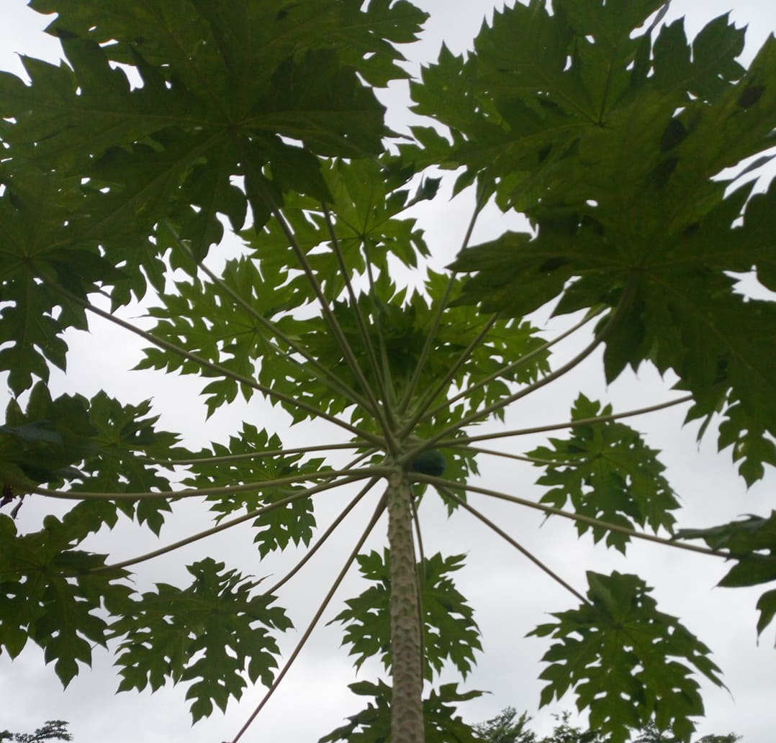
Figure 1 Carica Papaya Tree
Unripe papaya has been discovered to have an anti-fertility effect on pregnant rats while its consumption over time in a male can result in a long term azoospermia and this is because of the rich content of phytochemicals in papaya. Chloroform extract from papaya was reported to cause azoospermia in rats (Parle et al., 2011). Papaya contains flavonoids which have capability to inhibit the action of free radicals hence reduce oxidative stress. Papaya is usually used in folklore medicine to treat many conditions which include the use of papaya leaf juice in increasing platelet count, treatment of asthma, relieve of menstrual pain and nausea because of the richness in antioxidants contents (Ankit and Devendrasinh, 2017). C. Papaya is also very useful in the treatment of protozoal infections, bacterial infections, fungal infections, inflammation, hypertension, wounds, and tumors, also it is a known plant beneficial in scavenging of free radicals due to its richness in antioxidants (Ankit and Devendrasinh, 2017).
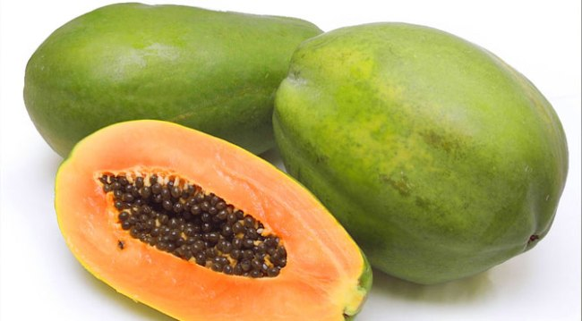
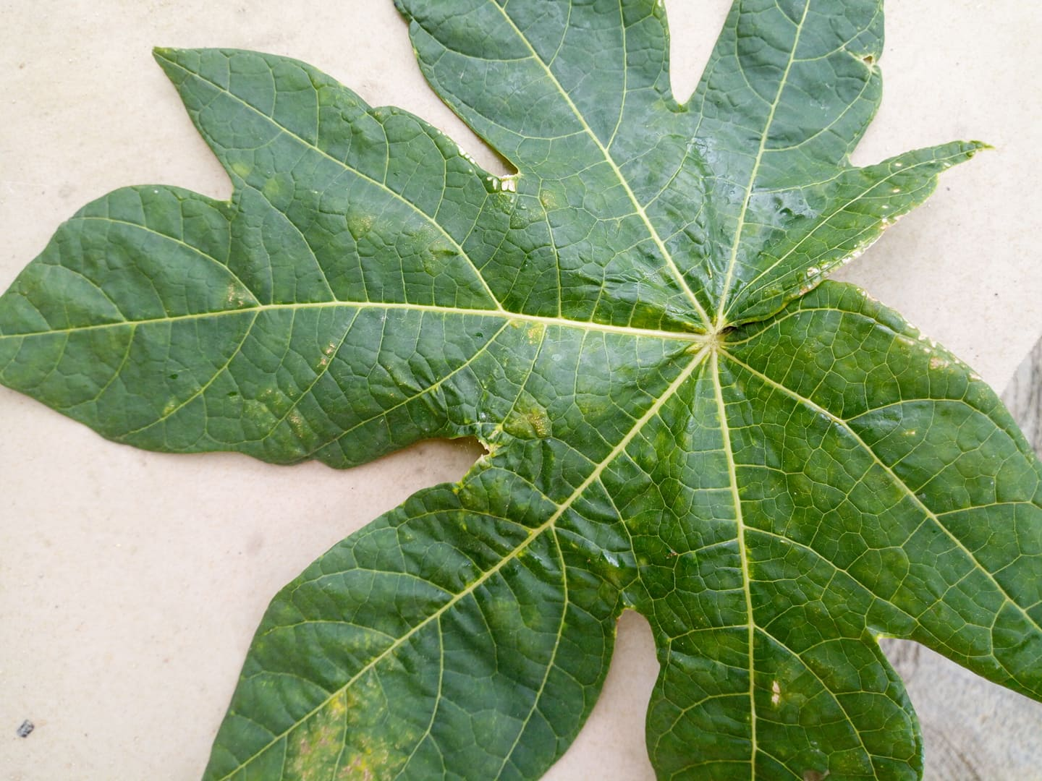

Figure 2 C. Papaya Leaf and fruit (greenmylife.in)

C. Papaya leaf has been recorded to contain various active metabolites and being a rich source of antioxidants and vitamins such as folic acid, vitamin C, vitamin B12, vitamin A etc., (Ankit and Devendrasinh, 2017), helping to increase the antioxidant activity within the blood because it’s effectiveness is similar to some standard antioxidants.

2.2 Diabetes
Diabetes Mellitus is a condition of impaired production of insulin to regulate the body’s absorption of sugars. Characterized by Hyperglycemia followed by other microvascular and macrovascular diseases, Diabetes is a globally threatening metabolic disorder (Craig et al 2009).

2.2.1 Types/classification
Type 1 Diabetes: This is as a type of diabetes that occurs when there is pancreatic β-cell destruction by the mediated T-cell (autoimmune) leading to absolute insulin deficiency, which is why latent autoimmune diabetes in adults (LADA) is classified as a type 1 diabetes. It is known to affect children and young adults and as such referred to as juvenile diabetes. It is characterized by fasting hyperglycemia and ketoacidosis, with children manifesting ketoacidosis as the first symptom and others hyperglycemia.

Type 2 Diabetes: This ranges from predominant insulin resistance with relative insulin deficiency to prevailing defective secretion with insulin resistance, and has a close relation with other metabolic disorders (Craig et al 2009). This form of diabetes is found in over 90-95% of patients with diabetes, it is mostly due to insulin resistance, and as such for these patients their diabetes is not insulin dependent (i.e. they need not take insulin) as their β-cells function well but slowly hyperglycemia builds and ketoacidosis occurs spontaneously. The probability of having this type of diabetes increases as one gets older. Sometimes obesity, and lack of physical activities promotes the risk of having this type of diabetes, women with prior gestational diabetes mellitus which occurs during the time of pregnancy also have tendencies of having this type of diabetes mellitus (Craig et al 2009).
Other types of diabetes include:
- Gestational Diabetes
- Drug induced
- Rare forms of auto-immune mediated diabetes
- Diseases of the exocrine pancreas
- Endocrinopathies
- Genetic defects of the β-cell function Genetic defects of insulin action
- Other genetic syndromes which can be associated with diabetes
- Infections
- Glucose tolerance impairments that first appear or are first diagnosed during pregnancy.
Diabetes Mellitus occur in all, or as a result of the above listed conditions and symptoms, even though sometimes this may vary based on the type of diabetes that is operational (Craig et al 2009)

2.2.2 Glucose regulation

In a healthy state, when there is excess glucose in the blood stream insulin is secreted from the pancreas to for regulation as it will be absorbed by the muscle where it can undergo glycolysis, and when there is shortage of blood glucose, glucagon is secreted to signal the liver to release stored glycogen as glucose through the glycogenolysis pathway (Lehininger., 2005), but in diabetic conditions the action insulin is impaired leading to excess accumulation in the blood.
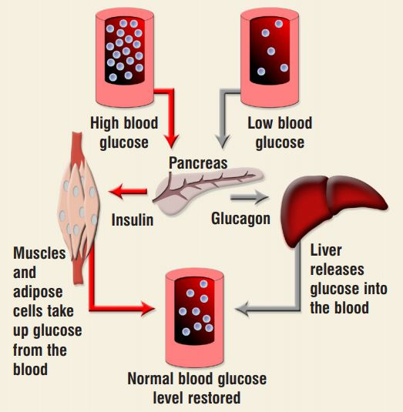
Fig. 3. Glucose regulation by the complementary activity of insulin and glucagon Source: James and McFadden, 2004

2.3 Oxidative stress
Oxygen (O₂), though the very gas that supports life, could also lead to necrosis and cell death when it generates reactive species due to oxidation. Oxygen is capable of producing reactive oxygen species (ROS) such as hydroxyl radical (•OH), superoxide radical (•O⁻₂), and hydrogen peroxide (H₂O₂) which are exogenous ROS. Cellular ROS include NADPH oxidase and hydroperoxyl HO•₂ (Somogyi et al., 2007).
Oxidative stress is defined as any disturbance in the balance of antioxidants and pro-oxidants in favor of pro-oxidants which could be as a result of different factors such as aging, inflammation, drug action and toxicity (Asmat et al., 2015). Oxidative stress results in the inefficiency of the functions of some body cells and also a damage in the structure of cells resulting into different diseased conditions, examples of such structural impairment and diseased conditions caused by oxidative stress are listed in Table 1.

Table 1: Organs affected and diseases caused by oxidative stress (Asmat et al., 2015)
Organs | Diseases
Lungs | Asthma, chronic bronchitis
Kidneys | Glomerulonephritis, chronic renal failure
Joints | Arthritis, rheumatism
Brain | Alzheimer’s disease, Parkinson’s disease, memory loss, and stroke
Eyes | Cataract, retinal diseases
Fetus | Preeclampsia, IU growth restriction
Heart vessels | Arteriosclerosis, hypertension, ischemia, cardiomyopathy, heart failure
Multiorgans | Cancer, diabetes, inflammation infection, aging

Oxidative stress occurs via two mechanisms. Firstly, due to the lowered level of antioxidants (which may be as a result of mutated antioxidant enzymes, toxins, or low intake of nutritional antioxidants). Secondly, oxidative stress occurs due to the increase in the number of free radicals such as ROS resulting from chronic inflammation (Somogyi et al., 2007).
Oxygen (O₂) possesses a property of free radicals as a result of its two unpaired electrons that have a parallel spin in separate antibonding orbitals that supports its stability and paramagnetic property, this however can be altered by a single electron exchange which converts O₂ to an oxidizing agent, and electron transfer to O₂ is catalyzed by the enzyme oxidase to produce energy or substrate oxidation. (Chikezie et al., 2015)
Reactive Oxygen species (ROS) could be free radicals or non-radical oxygen species. Hydroxyl •OH, Superoxide •O⁻_{2 ,} Nitric oxide NO• are examples of free radicals while Hydrogen peroxide (H₂O₂), Ozone (O₃), Lipid peroxide (LOOH) are examples of Non radical reactive oxygen (Somogyi et al., 2007). Reactive oxygen species can be produced either by stimulation of NADPH oxidases or by the mitochondrial respiratory chain. In the later ROS become unwanted byproducts of the metabolism, which is as a result of the oxidative stress, this then leads to overproduction of ROS that can cause alteration of proteins, and DNA also causing lipid peroxidation (Somogyi et al., 2007), and this consequently result in cell damage or cell injury.
Free radicals are classified as follows
- Reactive oxygen species (ROS).
- Reactive Nitrogen species (RNS)
- Reactive chlorine species
And each of these could result in oxidative stress by means of their high reactivity especially the ROS and RON which are more abundant in macromolecules and are involved in almost all the major metabolism in the system (Somogyi et al., 2007)

2.4 Diabetes and advanced glycation end products (ages)
In the diabetic condition, free radicals are produced during the process of autoxidation of glucose. Hyperglycemia which is what diabetes mellitus is characterized by, enhances the autoxidation of
Figure 4: Maillard Reaction Pathway (Singh et al., 2014).

glucose molecules which then releases reactive oxygen species (ROS) and increases level of advanced glycation end products (AGEs) leading to frequent occurrence of oxidative stress and also the synthesis of glycoxidation products, one of which is Glycated hemoglobin (HbA1c) (Chikezie et al., 2015). The reaction responsible for this is known as Milliard reaction having intermediates; a Schiff base and an

Amadori product and the AGE as the end point. The reaction pathway schematically goes like this:
HB + GLUCOSE SCHIFF BASE AMADORI PRODUCTS HbA1c AGEs
Without the action of a regulatory enzyme glycated hemoglobin (HbA1C) is formed in the reaction as glucose reacts with NH2 terminal amino acid (valine) of β-chain of the hemoglobin through a ketoamine linkage; that is, the N-terminal valine of the hemoglobin that is glycated (bonded to glucose). The glycation process continues as a result of hyperglycemia leading to continuous production of AGEs. AGEs interact with their receptors (RAGE), which a continuous activation of this receptors can lead to inflammation, and consequently, this inflammation is believed to be the source of pathogenicity of AGEs. Although RAGE can also be activated by some different ligands such as some fibrillary proteins, cytokines and also S100-calranulins (a calcium-binding protein predominantly expressed by neutrophils, macrophages and monocytes, used as a marker for inflammation), they interact to various other AGEs (Singh et al., 2014).
Figure 5 shows how the interaction between AGEs and RAGE lead to different diabetic complications some of which include nephropathy, retinopathy, neuropathy etc.

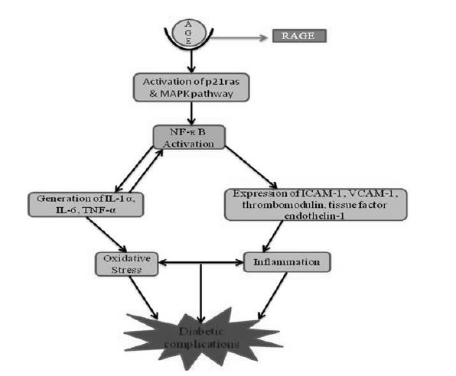
Figure 5: A flow of AGEs and RAGE interaction leading to diabetic complications (Asmat et al., 2015).

2.5 Oxidative stress and male fertility
Oxidative stress in diabetes involves the action of free radicals such as ROS and RNS, these free radicals are implicated in the release of spermatozoa from germinal epithelium which occurs because of the abnormally elevated levels of the retention ROS in the cytoplasm. These can readily react with other molecular species (oxidation) leading to both functional and structural changes, occurring as a result of spermiogenesis error (Amrit and Bilaspuri, 2010).
Also, it has been discovered that reactive nitrogen species like Nitric Oxide severely damage the effect on the ability of sperm cells for zona binding, and also the motility of the sperm. ROS have been discovered to be primarily produced by the dead sperm cells (spermatozoa) via a reaction that is catalyzed by amino acid oxidase, another great source of ROS is the leukocytes (white blood cells, especially neutrophils and macrophages) as well as immature sperm cells and this could lead to untimely sperm dysfunction due to excessive generation of ROS (Amrit and Bilaspuri, 2010).
Healthy and fertile males due to study have been postulated to have their sperm concentration and motility in-tact and not affected by level of ROS which is as a result of good antioxidant level in the system. ROS accumulation is affected by the insufficiency or lack of defense systems or mechanisms (internally) and also the exposure of the gametes to different techniques of manipulation in the environment that can result in oxidative stress (Amrit and Bilaspuri, 2010).
Abnormalities in spermatogenesis (which includes retention of cytoplasm) enhances oxidative stress as well as the imbalance between the scavenging antioxidants and the synthesized ROS resulting in infertility. Other factors that could lead to infertility in males include hormonal fluctuations e.g. testosterone. Lipid peroxidation has been reported to cause damage on the mammalian spermatozoa by disrupting the structural integrity of the tail which is the plasma membrane that consists of the poly unsaturated fatty acids (PUFAs) thereby leading to lower rate of motility, and the loss of ATP in the cell resulting to axonemal damage, and also promotion of structural impairment of the mid-piece of the sperm cells (Amrit and Bilaspori, 2007).
The sperm cell membrane consists of polyunsaturated fatty acids (PUFAs) and as earlier stated the production of ROS leads to an oxidative attack on the PUFAs and then results in the production of peroxides. The PUFAs are responsible for the flexibility, motility and fluidity of the sperm enabling it to go through fertilization, but the unsaturated nature of the fatty acids allows them to be reactive to free radicals and this reaction initiates lipid peroxidation (Amrit and Bilaspuri, 2010).

Lipid peroxidation has a modifying effect on the lipids (fatty acids) that are found in the plasma membrane of the sperm cell, affecting the structural integrity of the cell and the cell’s viability (Sinha and Gupta 2018). The oxidative attack is majorly on the PUFAs which are located in the plasma membrane of the spermatozoa hence leading to structural impairment of the tail of the sperm consequently resulting in the inability of the sperm cells to swim properly and damaging their motility.
The ROS involved in the oxidative attack changes the cellular homeostasis of gametes in a detrimental way, allowing a radical binding between the cell and macromolecules surrounding it, which then leads to the damage of the mitochondria, DNA through base oxidation, and also could lead to cell apoptosis (Sinha and Gupta, 2018).

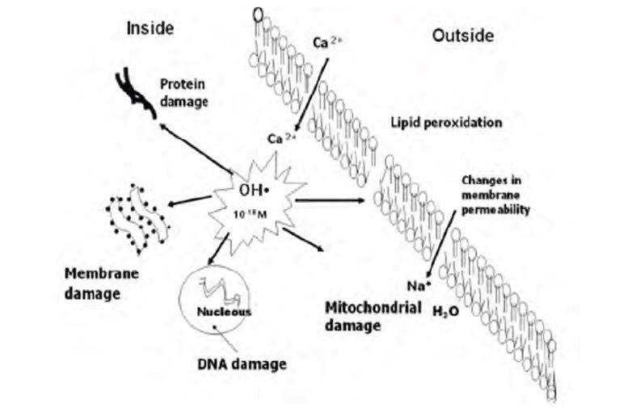
Figure: 6. Reactions of Lipid Peroxidation (Sinha and Gupta 2018).

2.6 Antioxidants
Any substance that is capable of inhibiting the oxidation of a substrate is referred to as antioxidant. Antioxidants can be classified into two based on their mechanism or actions (Somogyi et al., 2007). These classes include the breaking antioxidant and the preventive antioxidant. The major difference between these two is that preventive lowers the rate of initiation while breaking antioxidants interfere with the propagation. Catalase, peroxidase are examples of preventive antioxidants amongst others that can react with ROOH and chelators of metal ions such as ethylene diamine tetra acetate (EDTA), this class of antioxidants act by preventing the uncontrolled synthesis or production of free radicals and inhibiting their reactions with biomolecules an example is how superoxide dismutase (SOD) traps superoxide radicals in vivo. The site of action of these antioxidants is dependent on their nature with aqueous environments; for example, SOD acts in the aqueous phase, the hydrophilic intracellular antioxidants can be found in the cytosol, and are thus referred to as cytosolic antioxidants. They can also be found in the mitochondria and other nuclear compartments, while hydrophobic antioxidants are found within the membrane where they inhibit lipid peroxidation (Somogyi et al., 2007).
Lack of sufficient antioxidants to scavenge the ROS often leads to damages that could cumulatively result into damage of cells, macromolecules, and even the DNA. This could lead to any of the diseased conditions as seen in Table 1, but the presence of antioxidants, even in a minute quantity can inhibit the reaction between ROS or free radicals and biological substrates through a process known as redox homeostasis (Somogyi et al., 2007).
Some antioxidants are acquired from external sources and these are called exogenous antioxidants. These are usually obtained from diet, but it is nearly impossible to get enough of these exogenous antioxidants from modern diet, hence antioxidant supplement treatment is usually recommended, examples of these exogenous antioxidants include Vitamin A, C and E, but those naturally found in the system are called endogenous antioxidants examples are Glutathione, Superoxide dismutase, catalase etc. (Asmat et al., 2015).
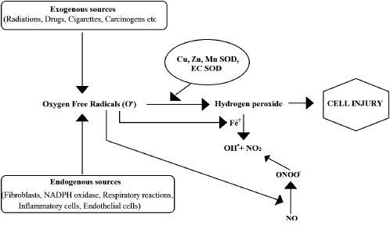

Figure: 7. Free radicals induced cell injury (Asmat et al., 2015).

2.7 Seminal fluid
The seminal fluid (semen) is a viscoid whitish body fluid that is produced through the process of spermatogenesis and released at the point of ejaculation in males through their reproductive organ. The semen contains the male gametes (sperm cells) needed for reproduction, which need to have the ability to bind with the female gamete for fertilization to take place. The semen contains millions of sperm cells out of which one fertilizes a single egg.

2.7.1 Semen Synthesis/ Spermatogenesis
Sperm is produced in the testes, and then transported to the epididymis to attain maturity and the ability to swim, they are then stored in the vas deferens till ejaculation. At ejaculation, the stored sperm are transported out of the vas deferens and are mixed with the prostatic fluid and the seminal fluid.

2.7.2 Seminal analysis
This is a complete investigation carried out upon the semen. This includes the check for rate of motility, viability, pH, morphology of cells etc. The structure of the mammalian spermatozzon can be basically divided into three sections, these sections include:
- Head
- Mid-piece
- Tail
The head contains the nucleus where the haploid 32 chromosomes are, while the tail is the agent of locomotion made up plasma membrane, while the mid piece houses the mitochondria.
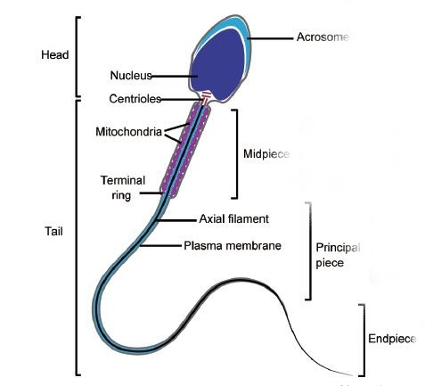
Figure 8: Structure of the mammalian sperm cell (G.L Ding et al., 2015)

2.7.2.1 The Hemocytometer
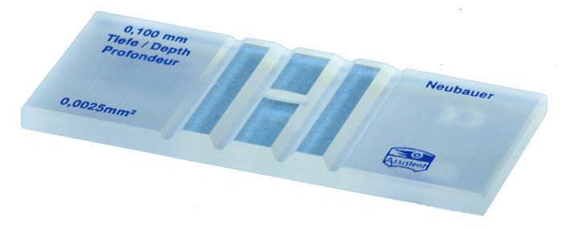
The hemocytometer otherwise known as the counting chamber is a glassware in the shape of the normal microscope glass slide with ruled chambers (4 of them) which has the area of 9mm² and depth of 0.1mm.

Figure 9: Neubaur Improved Counting Chamber (www.google.com)


Figure 10: Ruled squares of the counting chamber

This laboratory tool is usually used to count cells which is where the name counting chamber is coined. It has milled grooves that cuts the surface into two, it has 2 raised ridges that are beside two metallic plated chambers that are engraved with rulings for counting. The two ridges help in holding the cover glass placed on the hemocytometer and leaving a space of 0.1mm that allows the liquefied sample flow into the chamber to be counted under the microscope.
Under the microscope the chamber shows 9 large squares all of which measures 1mm² each, but the large squares at the 4 corners are what are used in counting cells. Each of the squares at the corners are further ruled into 16 squares having 0.25mm sides. Unlike the squares at the corners, the large square that is located at the center is ruled and divided into 25 squares and each of them is further divided into 16 squares.

2.8 Superoxide dismutase
Superoxide dismutase (SOD) is an enzyme that is acts in the catalytic conversion of superoxide into oxygen and hydrogen peroxide, it is the sole enzyme that is actively involved in the suppression of adrenaline autoxidation, and also controls both the level of Reactive Nitrogen Species and ROS level.
SOD is vital in the defense of antioxidants as an important signaling molecule that is capable of interacting with superoxide (which have been found to be involved pathological conditions) in order to control RNS and ROS levels, as well as regulating signals. Higher activity of SOD reduces the threat of lipid peroxidation (Wang et al., 2018.) The reaction of SOD makes it a good assay marker, the superoxide radical is produced from the reaction of xanthine oxidase which can lead to the production adenophrine from the oxidation of epinephrine which then increases the pH (Valerino and McCormack, 1971) and at the same times increases the concentration of epinephrine.

2.9 STREPTOZOTOCIN (STZ)
Streptozotocin is an antineoplastic agent which is toxic the pancreatic beta cells that are responsible for the secretion of insulin. It is often used in research to induce hyperglycemia.
STZ mechanism of action is by causing damage to the DNA and induces the activation of PARP which implicated in diabetes. It’s damaged to the beta cells is as a result of it being transported in the cell by proteins that normally transport glucose, and this is because of its similarity with glucose molecule (Szkudelski, 2008).
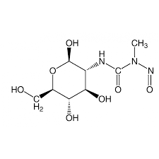

Figure 11: Molecular structure of STZ

2.10 ANTIDIABETIC DRUG (METFORMIN)
Metformin is a strong base with the pKa of 12.4 and exists as a protonated cation within normal physiological pH, it is easily transported across cell membranes (Mustafa, et al., 2015)
The drug possesses a great action mechanism that can drastically reduce hyperglycemia. The drug is capable of stimulating the secretion of insulin from the pancreas, by decreasing the output of glucose from the liver, it also increases the absorption of glucose by many tissues but reduces the absorption of glucose in the intestine (Klip and Leiter, 1990).
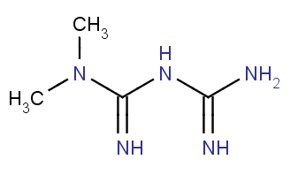

Figure 12: Molecular structure of metformin

CHAPTER 3

METHODOLOGY

3.1 Materials and Reagents
Volumetric flask, Weighing balance, Filter Paper, Funnel, Dropper, Test tubes, Test tube racks, Beaker, Fume Cupboard, Rotary Evaporator, Spatula, Water Bath, Nose mask, Eye googles, Hand gloves, Distilled Water, H₂SO₄, 1%HCL, 3.5%FeCl, Glacial Acetic Acid, Chloroform, Potassium Iodide, Mercuric chloride, Ammonium, Acetic Anhydride, 1% Potassium Ferricyanide, Potassium Hydroxide, 10%NaOH, Benedicts’ reagent, and α-Naphthol, Carbonate buffer.

3.1.1 Collection and preparation of plant materials
Male species of papaya leaf was plucked directly from trees at a local farm at Amofe Adetoye Street, Ayobo, Lagos, in January 2019. The leaves were washed with water to remove soil content and dust, after which they were dried in the hot air oven at 40ºC.
After drying to a crunchable state, the leaves were then pulverized using a laboratory blender. The powder was kept in a transparent glass jar and the refrigerated at 4ºC until use. Fine powder of the papaya leaves was soaked in 70% methanol, by dissolving 70g of the fine powder of papaya in 320 ml of methanol (8:1w/v) in a jar which was then tightly closed and intermittently shaken over the space of 3 days to allow a better interaction between the plant and the solvent. The process is referred to as maceration.

3.2 Filtration
The mixture of the methanol and plant was filtered using a sterile cotton over an empty beaker. The filtrate was then gathered into a beaker and the residues as well into another beaker. After filtration, the filtrate was allowed to settle, mixed and then filtered again, this was done twice to ensure that it was finely filtrated.

3.3 Concentration
The filtrate was then concentrated in a rotary evaporator machine at 45ºC. At the end of the concentration, the rotary evaporator had successfully separated the solvent from the crude extract, the crude extract was then collected in a beaker and evaporated to dryness in a hot air oven at 40ºC, after which it was weighed to get the percentage yield.

3.4 Assay methods

3.4.1 Phytochemical screening
The following were the phytochemicals that were tested for:
- Carbohydrates
- Alkaloids
- Saponin
- Treponoids
- Protein
- Phenols
- Polyphenols
- Fat & Oil
- Phytosterol
- Tannin
- Flavinoids
- Glycosides

3.4.1.1 Molisch’s Test for Carbohydrates
Extract (0.5g) was dissolved in 5ml of distilled water. 2ml of Molisch reagent was added, the mixture was then shaken properly. 2ml of concentrated H₂SO₄ was poured carefully along the side of the test tube.
3.4.1.2 Tests for Tannins
Extract (0.5g) was dissolved in 5ml of distilled water and 2 ml of 2% FeCl₃ solution was added.

3.4.1.3 Tests for Glycosides
Extract (0.5g) was dissolved in 5ml distilled water. 3ml of chloroform was added and the mixture was shaken. The chloroform layer was separated and 2ml of 10% ammonia solution was added.

3.4.1.4 Alkaloid (Mayer’s Test)
The leaf methanol extract 0.05 was dissolved in HCL and then filtered. Mayer’s reagent (potassium mercuric iodide) was then added to the filtrate.

3.4.1.5 Saponin (Froth Test)
0.05g of extract was diluted and dissolved in 20ml of distilled water. 1-2cm of foam above the solution after 15 minutes of shaking indicates the presence of Saponin.

3.4.1.6 Treponoids (Salkowski Test)
Chloroform (2 mL) was added to the extract and then filtered. 3 ml of H₂SO₄ was carefully added to the filtrates, and the mixture was then shaken and allowed to stand.

3.4.1.7 Protein (Ninhydrin Test)
2 ml of 0.2% Ninhydrin reagent was added to –g of the extract, after which the mixture was boiled for few minutes in a water bath.

3.4.1.8 Phenol (Ferric Chloride Test)
FeCl₃ (3-4 drops) solution was added to the solution of extract and distilled water. Appearance of bluish black color denotes a positive result for the presence of the phenol.

3.4.1.9 Polyphenol
Methanolic extract (1g) was dissolved in distilled water (5ml) and then heated in water bath for 30minutes. 1ml of FeCl₃ was then added to the mixture followed by potassium Ferricyanide.

3.4.1.10 Fat & Oil (Spot Test)
A small quantity of extract is pressed between 2 filter papers. Oil stains on the paper indicates the presence of fat and oil.

3.4.1.11 Flavonoids (Alkaline reagent Test)
Extract was treated with few drops of 10% NaOH solution. Formation of intense yellow color (which becomes colorless after the addition of dilute acid) this indicates the presence of flavinoids.
3.4.1.12 Test for anthraquinone
Extract (0.5g) was dissolved in 5ml of distilled water. 10ml of conc. H₂SO₄ was added and filtered. 5ml of chloroform was added to the filtrate and the chloroform layer was pipetted into another test tube. 1ml of ammonia was added.

3.4.1.13 Test for Phytosterol (Libermann-Burchard’s test)
Extract (0.5g) was dissolved in 5ml of distilled water. 2 drops of conc. H₂SO₄ was added slowly along the side of the test tube. Change in color (Violet-blue)

3.5 Experimental animals
Rats were weighed and placed in clean and dry animal cages for acclimatization for 1 week. Every morning upon entering the animal house, rats were exposed to light for 12 hours and darkness for another 12 hours daily, and they were given water and feed ad libitum.
A total number of 30 rats were segregated or divided into 5 groups with each group containing 6 rats and were all induced with streptozotocin (STZ) except the normal control group.
1st group – Normal Control
2nd group – Diabetic control
3rd group – Diabetic rats administered with 100mg/kg of leaf methanol extract
4th group – Diabetic rats administered with 200mg/kg of leaf methanol extract
5th group – Diabetic rats administered with 100mg/kg of standard dug (Metformin)
Administration was done orally, every 24 hr. for a period of 14 days (2 weeks). After 2 weeks (14 days) the rats were sacrificed using the anesthetic method, then dissected and epididymis was harvested, emulsified in normal saline and then examined immediately under the microscope for seminal analysis.

3.5.1 Sample collection
All the experimental animals were fasted for at least 12 hours after the period of administration of plant extract and metformin, blood samples were collected into the heparinized anticoagulant bottle via ocular puncture. The collected blood samples were centrifuged at 2500rpm for 15 minutes, the plasma was separated into a plane bottles and refrigerated at 4ºC
The rats were anaesthetized, and semen samples were collected from the epididymis into a clean plain tube.

3.6 Determination of Plasma Glucose concentration
Plasma glucose concentration was determined according to glucose oxidase method using Randox kit.
Tubes were labelled according to identity and group given to the experimental animals, alongside 1 tube for blank and another for standard. Standard reagent (20µl) was pipetted into a clean test tube, 200µl of working reagent was added, 20µl samples were pipetted into corresponding test tubes and 200µl of working reagent was added. All the tubes were incubated at 37ºC for 10 minutes and the absorbances were read at 500nm against a blank that consisted only the working reagent. Concentration of plasma glucose was obtained by the calculation:
(Absorbance of Sample/Absorbance of Standard) X Standard Concentration (103mg/dl)

3.7 Seminal Analysis

3.7.1 Sperm Count
A drop of liquefied semen was placed on the hemocytometer and covered with a cover glass. This process is what is regarded as charging the hemocytometer. The charged hemocytometer was then placed under the microscope and examined under the 10X objective lens. Sperm cells that were seen in 5 squares that are diagonal to one another in the large square that contained 25 smaller squares were counted. Total number of cells counted was then multiplied by a factor 50,000 (Cheesbrough, 2005).

3.7.2 Sperm Morphology
A thin smear of the sample was made on a clean, grease-free slide, and fixed in 95% Ethanol. It was allowed to air dry and then the slide was stained with sodium bicarbonate-formalin (semen analysis fluid) for 1 minute. The fluid was then washed away with equal volume of water, after which the slide was flooded with carbol-fuchsin for 5 minutes, and then rinsed with equal volume of water. The smear was counter stained using methylene blue for 2 minutes, then rinsed with water again and allowed to air dry. The stained smear was then examined under the 10X objective lens under the microscope by counting the number of sperm cells with good morphology in a total of 100 sperm cells that counted (Cheesbrough, 2005).

3.8 Determination of superoxide dismutase activity
Superoxide dismutase (SOD) activity was investigated according to the method of Misra and Fridovich (1972). 0.05M Carbonate buffer (pH 10.2) was prepared by dissolving Na₂CO₃.10H₂O (14.3 g) and 4.2 g of NaHCO₃ in 900 ml of distilled water. The pH was adjusted to 10.2 and the reagent was made up to 1 litre. Adrenaline (0.3 mM) was freshly at use prepared by dissolving 0.0137g of Adrenaline in 250 ml of distilled water.
1 in 10 dilution of plasma sample and distilled water was made by diluting the 1ml of the sample in 9 ml of distilled water. From the diluted sample 0.2 ml was siphoned and added to 2.5 ml of the 0.05M carbonate buffer (pH 10.2) that was prepared, 0.3 ml of the 0.3 mM adrenaline solution was added, and the mixture was quickly inverted about times to mix. A blank was prepared by the addition of 0.2 ml of water instead of the sample and the increase in the absorbance of sample was read against the blank at a wavelength of 480nm every 30 seconds for 2 minutes, 30 seconds.

3.9 Waste disposal
Experimental wastes were incinerated, and the rat carcasses were buried in designated location.

3.10 Statistical Analysis
All values are presented as mean ± standard deviation. Variation within a set of data was analyzed by one-way analysis of variance (ANOVA) using the Graph Pad Prism Software (GPPS 7.0). Values of p<0.05 were regarded as statistically significant

CHAPTER 4

RESULTS

4.1 Phytochemical components of C. papaya leaf methanol extract
Results shows the C. Papaya leaf methanol extract indicates the presence of some phytochemical compounds such as carbohydrates, phenol, saponins etc., which may point to the richness in few antioxidants.
Table 2: Qualitative phytochemical components identified in C. papaya leaves
PHYTOCHEMICAL TEST | OBSERVATION | RESULTS
ALKALOIDS | A yellow precipitate | ++
CARBOHYDRATES | Benedict’s Test: Mild formation of orange precipitation  Molisch’s Test: Mild formation of dark-purple coloration | +
GLYCOSIDES | Appearance of pink color | +
SAPONIN | Formation of 1-2cm of foam above the solution after shaking | ++
TEREPONOIDS | Golden yellow coloration | ++
POLYPHENOL | Green-Blue color observed | +
FLAVONOIDS | Intense yellow color which becomes colorless after the addition of diluted acid | ++
TANNINS | Blue-green coloration formed | ++
PROTEIN | Violet/blue pigmentation | ++
PHYTOSTEROL | Deep violet-Blue coloration | ++
ANTHRAQUINONE | Pink-red coloration was observed | +
FAT AND OIL | Oil stain observed | +
PHENOL | A bluish black coloration was formed | ++
+, positive

4.2 Effect of C. papaya leaf methanol extract on the blood glucose of diabetic rats
The result showed significant (P<0.05) increase in plasma glucose level of diabetic control rats against normal control group. There was significant decrease in plasma glucose levels in the groups that were administered 100mg/kg, 200mg/kg and metformin drug when compared to the diabetic control (Figure 10). The recorded glucose concentration in the diabetic treated group is almost the same with that of normal rats.

Figure 13: Plasma glucose levels of normal control and diabetic rats
Values are mean ± SE; n=4

4.3 Effect of C. papaya leaf methanol extract on tested fertility parameters of male diabetic rats.

The effect of C. papaya leaf methanol extract on sperm count, morphology, and motility are shown in figures 14 &15, and table 3.

4.3.1 Sperm Morphology

Result reveals that the percentage normal cells were reduced in diabetic control group compared to the normal control group, while the groups administered with 100mg/kg, 200mg/kg body weight of extract and metformin had significantly increased normal sperm cells compared to the diabetic control (Figure 14).

Figure 14: Spermatozoa morphology of normal, diabetic control, and diabetic treated rats.
Values are mean ± SD; n=4

4.3.2 Sperm Motility

The results of sperm motility (Table 3) showed that in diabetic control group, the percentage of motile cell was lower, while non-motile cells were higher compared to the normal control group. There was a significant increase in percentage of motile cells in rats given 200 mg/kg of C. Papaya methanol extract and metformin compared to the diabetic control rats.

Table 3: Sperm motility of normal control and diabetic rats
GROUPS | MOTILE CELLS (%) | NON-MOTILE CELLS (%) | SLUGGISH (%)
Normal control | 65.41 $±$ 4.40 | 11.95 $±$ 2.86 | 22.60 $±$ 0.71
Diabetic control | 30.30 $±$ 2.50 | 57.60 $±$ 4.90 | 12.10 $±$ 0.90
Diabetic + 100mg/kg | 23.81 $±$ 4.00 | 59.52 $±$ 10.50 | 16.67 $±$ 0.50
Diabetic + 200mg/kg | 73.10 $±$ 5.50 | 11.50 $±$ 0.50 | 15.40 $±$ 2.00
Diabetic + Metformin | 67.20 $±$ 14.2 | 18.60 $±$ 0.50 | 14.40 $±$ 2.10
Values are mean ± SD; n=4

4.3.3 Sperm Count

Diabetic group with 200mg/kg of plant extract alongside the Diabetic + metformin group show a slight increase in the sperm count examination (Figure 15).
Figure 15: Sperm counts of normal control and diabetic rats
Values are presented as mean ± standard deviation; n=4

Effect of C. papaya leaf methanol extract on the extent of superoxide dismutase levels in diabetic rats.
Result showed no significant difference (P>0.05) in the percentage inhibition of superoxide dismutase in normal control rats, diabetic control rats, diabetic rats treated with extracts and metformin (Figure 16).
Figure 16: SOD activities in normal control and diabetic rats
Values are presented as mean ± standard deviation; n=4

CHAPTER FIVE

DISCUSSION, CONCLUSION AND RECOMMENDATION

5.1 DISCUSSION

Diabetes Mellitus is known to be a prevalent disease condition with range of complications that affects the structural and functional properties of biomolecules (Craig et al 2009; Kerner and Brückel J, 2014). Reports has indicated that male diabetic patients are prone to infertility (Kerner and Brückel J, 2014).
Infertility could occur due to various reasons; for a female the causes of infertility ranges from low gonadotropins to anovulation, amongst others. For male, though hormonal fluctuations also may lead to infertility, but the efficiency of the reproductive cell (spermatozoa) is affected majorly by the morphological integrity of the cell (Anwar and Anwar., 2016).
Proper regulation of glucose in the body by the action of insulin and glucagon is what is impaired in diabetes, the result of this study showed that C. papaya maybe beneficial like metformin in the secretion of insulin and glucagon to regulate the blood glucose concentration as result showed a significant (P<0.05) decrease in plasma glucose levels in the groups that were administered 100mg/kg, 200mg/kg and metformin drug when compared to the diabetic control, similarly Juarez-Rojop et al., 2012 recorded that C. papaya has a hypoglycemic effect in diabetic rats, by increasing insulin production.

Contrary to Kusemiju et al., 2012., that reported that C. papaya bark extract decreased sperm quality due to release of ROS, the result of this study reveals that the percentage of normal cells in rats treated with 100mg/kg, 200mg/kg body weight of C. papaya methanol leaf extract and metformin significantly increased when compared to the diabetic control. Udeh and Nwaehujor, 2013, also recorded that 200mg/kg and 400mg/kg of extract reduced sperm count, which totally contradicts the findings of this study, however, physiological and therapeutic factor could be at work in this case, putting into the consideration the total amount of days rats were treated with the extract, the rats with increased levels of sperm count, motility and morphology were treated only for a duration of 14 days (2 weeks). This might have been possible by early production of antioxidants that inhibited further damage from being done to the cell. Results also showed significant increase in the percentage of motile sperm cells in diabetic rats treated with the extract this also contradicts findings that were reported by Parle et al., 2011., as well as the increase that this study recorded in the morphology of rats treated with the extract.
The presence of phenol and polyphenol suggests that C. papaya methanol extract is a good source of antioxidants required in scavenging ROS that leads to lipid peroxidation which ultimately leads to cell damage, similar findings were made by Ankit, and Devendrasinh., 2017. Cell damage occurs in sperm cells when the PUFAs that are integrated within the plasma membrane of the sperm cell are damaged, the morphology of the sperm cell reveals that the tail is made up of the PUFAs, and when damaged the motility of the cell is impaired, once this occurs the chances of fertilization is reduced, however this study has proven that C. Papaya is rich in antioxidants that can scavenge the ROS that leads the cell damage (Somogyi et al., 2007).

5.2 CONCLUSION:

This study suggests that C. papaya methanol leaf extract is a good plant that has hypoglycemic effect in diabetic rats, and may increase the sperm count, the percentage of sperm motility and morphology due to it being a good source of antioxidants that scavenges ROS and inhibit lipid peroxidation of the plasma membrane of the sperm cell.

5.3 RECOMMENDATION:

It is recommended that further studies be carried out on C. papaya extracts to discover the level of its effect in lipid peroxidation and its’ action on superoxide dismutase. Also more studies are required to investigate the effect of C. papaya leaf extract fractions at higher concentrations than 200mg/kg body weight to affirm if it may likely be beneficial as this study has shown or may have no effect as other studies have shown, so as to educate the society better on the use of the plant.

REFRENCES

Ahmadi, S., & Bashiri R., Ghadiri-Anari, A., and Nadjarzadeh, A., (2016). Antioxidant supplements and semen parameters: An evidence based review. International Journal of Reproductive Biomedicine. 14; 729-736.
Amrit K.B., and Bilaspuri G.S, (2011). Impacts of oxidative stress and antioxidants on semen functions. SAGE-Hindawi Access to Research Veterinary Medicine International. 2011; pp. 1-7.
Ankit N., and Devendrasinh J., (2017). Pharmacognostic study of Carica Papaya leaf extract as inhibitors of reactive oxygen species. International research journal of pharmacy 8(3); pp. 13-17.
Asmat U., Ismail K., and, Abad K., (2015). Diabetes mellitus and oxidative stress-A concise review. Saudi Pharmaceutical Journal 3(13); pp 1-7.
Barger G.O., Finar L., and Hormick C.A., (2009). Papaya Extract, Macmillan Publisher, New
York, p. 711.
Chikezie P.C., Ojiako O.A., and Ogbuji A.C., (2015). Oxidative stress in Diabetes Mellitus. International Journal of Biological Chemistry, 9(3); pp 92-109.
Craig M., Hattersley A., and Donaghue K., 2009, Pediatric Diabetes; Definition, epidemiology and classification of diabetes in children and adolescents. University of NSW, University of Sydney, The Children’s Hospital at Westmead, Australia; Institute of Biomedical and Clinical Sciences, Peninsula Medical School, Exeter, UK. pp 3-12.
Ding G.L., Liu Ye., Miao-E L., Jie-Xue P., Meng-Xi G., Jian-Zhong S., He-Feng H., (2015). The effects of diabetes on male fertility and epigenetic regulation during spermatogenesis. Asian Journal of Andrology, 17; pp 948-953.
Ikeyi A.P., Ogbonna A.O., Eze F.U., (2013). Phytochemical Analysis of Paw-Paw (Carica Papaya) Leaves. International Journal of Life Sciences Biotechnology and Pharmaceutical Research. 2(3); 347-351.
James and McFadden, (2004). Understanding the process behind the regulation of blood glucose. Diabetes Knowledge. 100(16); 56-58.
Juarez-Rojop, I.E., Diaz-Zagoya, J.C., Ble-Castillo, J..L., Miranda-Osorio P.H…Bermudez-Ocana, D.Y., (2012). Hypoglycemic effect of Carica papaya leaves in streptozotocin-induced diabetic rats. BMC Complementary & Alternative Medicine 12(236); pp 1-12
LEHNINGER, A. L., Nelson, D. L., & Cox, M. M. (2013). Lehninger principles of biochemistry. New York, W.H. Freeman., chp. , page 527-539.
Kaushal V.S., (2016). Biological Activities of Carica Papaya Linn: A short review. World Journal of Pharmacy and Pharmaceutical Sciences 5(12); pp 1622-1633.
Kerner, Wolfgang & Brückel, J. (2014). Definition, Classification and Diagnosis of Diabetes Mellitus. Diabetologie und Stoffwechsel. 122; 384-386.
Kusemiju T.O., Yama O.E., Okanlawon A.O., (2012). Effects of Carica papaya bark extract on oxidative stress parameters in testes of male albino rats. International Journal of Applied Research in Natural Products 4(4); pp. 1-6.
Layali I., Tahmasbpour E., Joulaei M., Gholam S., Jorsaraei A., and Farzanegi P., (2013). Total Antioxidant Capacity and Lipid Peroxidation in Semen of Patient with Hyperviscosity. Cell Journal 16 (4); pp 554-559.
Monica Cheesbrough (2005). Discrete Laboratory Practice in Tropical Countries Part 2, Cambridge Second Editions. Published by Press Syndicate of the University of Cambridge, chp. , page 130-132.
Omolaoye, T.S., du Plessis, S.S., (2018). Diabetes mellitus and male infertility. Asian Pac J Reprod 2018; 7(1): 6-14.
Parle, Milind, and Gurditta., (2011). Basketful benefits of papaya. International Research Journal of Pharmacy. 2; 6-12.
Raji Y., Salman T.M., and Akinsomisoye O.S, (2005). Reproductive Functions in Male Rats Treated With Methanolic Extract of Alstonia Boonei Stem Bark. African Journal of Biomedical Research, 8; pp 105-111.
Saba A.B., Oridupa O.A., Oyeyemi M.O., and Osanyigbe O.D., (2008). Spermatozoa morphology and characteristics of male wistar rats administered with ethanolic extract of Lagenaria Breviflora Roberts. African Journal of Biotechnology 8(7); pp 1170-1175.
Anwar S., and Anwar A., (2016). Infertility: A Review on Causes, Treatment and Management. Scient Open Access Journal: Women’s Health & Gynecology. 2016. pp 1-5
Singh V.P., Bali A., Singh N., Jaggi A.S., (2014). Advanced Glycation End Products and Diabetic Complications. Korean Journal of Physiological Pharmacology. 18; pp 1-14.
Sinha A., and Gupta S., (2018). Lipid Peroxidation and its Impact on Infertility. Scient Open Access Journal: Women’s Health and Gynecology 4(1); pp 1-10.
Somogyi A., Rosta K., Pusztai Peter., Tulassay Z., and Nagy G., (2007). Antioxidant measurements. Physiological measurement. 28; 41-55.
Udeh E.N., and Nwaehujor O.C., (2013). Anti-fertility effects of Carica papaya Linn: Methanol leaf extracts in male wistar rats. Journal of Pharmacology and Toxicology 8 (1); pp 35-41.

