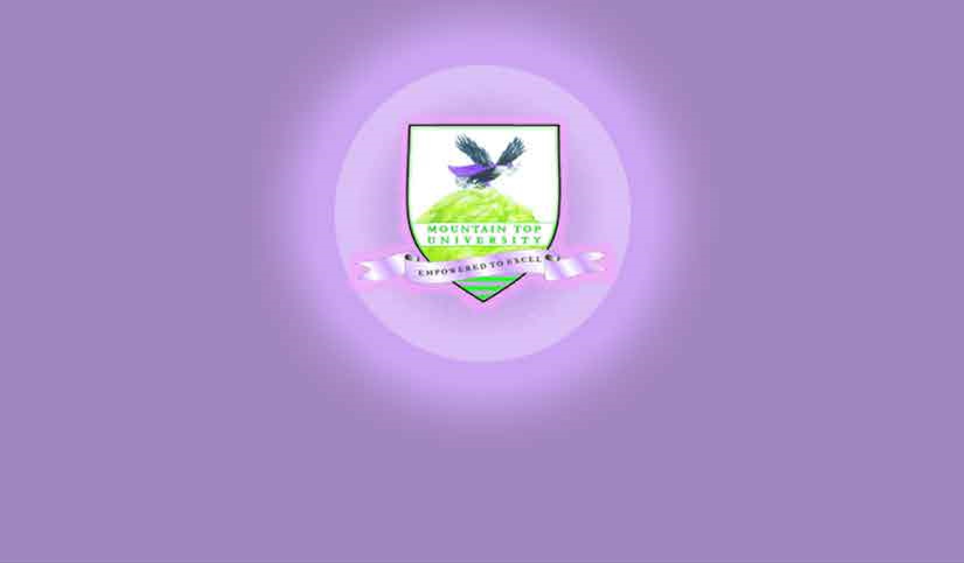

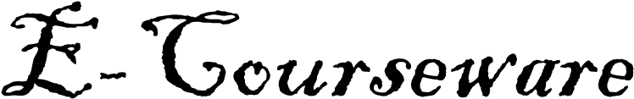


SCHOOL OF HUMANITIES, MANAGEMENT AND SOCIAL SCIENCES

Mountain Top University
Kilometre 12, Lagos-Ibadan Expressway, MFM Prayer City, Ogun State.
PHONE: (+234)8053457707, (+234)7039395024, (+234) 8039505596
EMAIL: support@mtu.edu.ng
Website: www.mtu.edu.ng.

Published By:
Mountain Top University

Course Title: Creative Writing I
Course Code: ENG107
Course Lecturer: Olatunbosun Taofeek

COURSE DESCRIPTION


INTORDUCTION
This course is an introduction to creative writing with the aim of developing skills and acquiring tools that are needed in the creative writing enterprise. The exploration commences from the three genres (poetry, drama and poetry) of literature to other sub-genres of writing such as critical essays, etc. The course also introduces students to the dynamics of sustained reflective writing in the creative craft in order to learn techniques, approaches and styles that are relevant to the creative writer. At the end of the course duration, the students are expected to have understood and be able to compose writings that are not beyond the short story level.

COURSE CONTENT

Lecture One: Introduction to Creative Writing: 7-9
a. Fictional Writing
b. Non-fiction Writing
Lecture Two: Introduction to Realism: 10
a. Plausibility
b. Verisimilitude
Lecture Three: Reading and Writing Poetry: 11
a. Poetic Craft
b. Poetic Tradition
Lecture Four: Reading and Writing Drama: 12
a. Dramatic craft
b. Dramatic tradition
Lecture Five: Reading and Writing Prose 13
a. Prose writing craft
b. Tradition in Prose writing
Works Cited 15

LECTURE ONE

Topic: Introduction to Creative Writing

What is Creative Writing?

Creative writing is an imaginary kind of writing that is not copied directly from any source other than the ordinary imagination of the writer. Although, it is arguable to state that there is any writing completely imaginary without a product of influence.

Objectives
- Ability to define/explain creativity;
- Ability to define/explain creative writing;
- Ability to define/explain non-fiction; and
- Ability to define/explain fiction.

Pre-Test
- What is creativity?
- What are the major differences between fictional and non-fictional writing?

Types of Writing

- Fictional writing: a writing expected to be purely imaginative. This is where we have the three genre of literature: drama, poetry and the novel. We have sub-genres under each genre—poetry (elegy, epic, ballad, etc.)

- Non-fictional writing: a writing that deals with existing script(s) but now converted to a new form of writing. Under this genre we have biography, memoir, historiography, etc.

Relevant Concepts

Creativity: This is the act of recreating something new which is different from what has been as a result of responding to individual sensibility due to deficiencies, problems or an interest in searching for solution or cure to the writer’s psychoses. In this study, the material created by the creator is our concern.
Text: This is the composed message(s) under critical study. Under this study the text is either the primary or secondary massages consulted during the cause of the research to aid our arguments. The primary texts are those texts that are considered at the operational level, basic, while the secondary ranges from post-textual, sub-textual to para-textual which are used to substantiate the arguments in the primary texts.
Author: This is the person who takes responsibility for his/her created message(s). Under this regard the person who gave existence to the text and whose name is attached to such document. It is from this concept we have authorship.
Authorial fallacy: This is a biographical fallacy. It is the mistake in judgement that a critic assumed that a text can be interpreted from the reflections of the author. This concept clearly disregards interpreting text from the lens of biography.
Intentional Fallacy: this is a mistake in criticism where the critic judges in error by using the author’s intentions, of which cannot be verified, to interpret, evaluate and analyse. This is what gave rise to authorial intent.
Authorial control: this is the power of the author in controlling what goes into print to represent him/her. This ranges from the content to the title of the work.
Pathetic fallacy: this is the “emotional falseness” that beclouds the judgment of a critic due to the fact that the critic shares sentiment for a know argument.
Historiography: this is the history surrounding the used materials in the cause of study such as our chosen texts and other secondary materials.
Close Reading: this is the kind of interpretation that pays attention to individual words, syntax and sentences without relating to the author.
Diary study is another aspect of biographic study that deals with the record of individuals or certain events that are kept as records.
Memoir: this is a French word meaning memory. It is the collection of memories that an individual writes about on events in the subject’s life.
Biography, this is nonfictional literature which handles the subject of life. In general, the form is considered to include autobiography, in which the subject recounts his or her own history.
LECTURE TWO

Topic: Introduction to Realism

Realism is the “relative” understanding of life and its scientific workability. Reality in literary context is the representation of the world in the text.

Objectives
- Ability to define/explain realism;
- Ability to define/explain plausibility;
- Ability to define/explain verisimilitude; and
- Ability to define/explain what realism is not.

Pre-Test
- What is realism?
2. What are the features of realism?
3. What is the difference between plausibility and verisimilitude?

- Any text without the atom of reality may not be a success. For any creative enterprise to be successful, there should be an embracement of realism.
- Realism is expound in two concepts: plausibility and verisimilitude.
- Plausibility: the ability of an event or better still a writing to be believable. Avoidance of doubt.
- Verisimilitude: relating to authenticity/honesty to details or possessing an element of truism. This is faithfulness to the human logic—mimesis.

LECTURE THREE

Topic: Reading and Writing Poetry

Poetry is a kind of writing written in elevated language and versified.

Objectives
1. Ability to define/explain poetry;
- Ability to list and explain features of poetry;
- Ability to define/explain types of poetry; and
- Ability to define/explain what poetry is not.

Pre-Test
- What is Poetry?
- What are the major features of poetry?

Poetry: an imaginative composition in an elevated language that can command attention.

Poetic Craft: to be a successful poet/poetess you need to have the mastery of imagery, allegory, rhyme, meter and diction.

Poetic Tradition/Form: to write successful poems you need to understand existing tradition and forms which are sonnet, lyric, ode, epic, ballad, elegy, myth, oral/spoken words, etc.

LECTURE FOUR

TOPIC: READING AND WRITING DRAMA

Drama is the inclusion of the script written for performance and the performance of the script in the theatre.

Objectives
- Ability to define/explain drama;
- Ability to define/explain theatre;
- Ability to define/explain types; and
- Ability to define/explain theatrical instruments.

Pre-Test
- What is theatre?
- What are the major types of theatre in the world?

Dramatic Craft: this can be better explore through theatrical elements:

- Literary elements: plot (initial incident, preliminary event, rising action, climax, falling action & denouement), theme, characters, dialogue, music, spectacle, audience, convention, exposition, conflict, suspense, language, style, soliloquy and monologue.

- Technical elements: Scenery, costumes, props, lights, sounds and makeup.

- Performance elements: acting, character motivation, character analysis, empathy, speaking, breath control, vocal expression, inflection, projection, speaking style, diction, nonverbal expressions (gesture and facial expression).

Dramatic Tradition: these aspects remain constant and do not change. All a playwright needs is how to handle them: stage, audience, script and acting. Furthermore, on this is the use of tragedy, comedy, farce and tragi-comedy. In dramatic construction.

LECTURE FIVE

TOPIC: READING AND WRITING PROSE

Objectives
- Ability to define/explain prose fiction;
- Ability to define/explain types of prose fiction;
- Ability to define/explain non-fiction; and
- Ability to define/explain fiction.

Pre-Test
- What is Prose fiction?
- What are the major differences between fictional and non-fictional writing?

Prose Writing Craft: basically, to be a successful prose writer the three points below are needed:

- How to create a story—plot, character, suspense and themes;

- How to tell a story— use of narrative techniques; and

- How to show a story— conception, brainstorming, materials and delineation.

Tradition/forms in Prose Writing: this can be divided into non-fictional prose and fictional prose.

Fictional prose: short story, novel or a novella.

Non-fictional: biographies, essays, letters, articles, editorials.

Works Cited

- Debono E. Serious Creativity. London: Ebury Publishing. 2015. Print.
- Adams, K. “The Sources of Innovation and Creativity”. A Paper Commissioned by the National Centre on Education and the Economy for the New Commission on Skills of the American Workforce. National Centre on Education and Economy. 2006. Online.
- Amabile, T. “How to Kill Creativity” in Harvard Business Review. Harvard: Harvard Press. Sept—Oct 1998. Print.
- Cuddon, J.A. A Dictionary of Literary Terms and Literary Theory (3rd ed.) Cambridge: Basil Blackwell Inc. 1993. Print.
- Lynn, S., Texts and Contexts: Writing About Literature With Critical Theory (2nd ed.) NY: Longman, 1998. Print.
- Mugo, M. “Exile & Creativity: A Prolonged Writer’s Block”, Olaniyan, T. & Quayson, A. (eds.) African Literature: An Anthology of Criticism and Theory. Oxford: Blackwell Publishing Ltd. 2007. p. 144-149.Print.
- Murfin, R. and Supryia M. The Bedford Glossary of Critically and Literary Terms. Boston: Bedford Books. 1997. Print.
- Biddle, A. & Toby F. Reading, Writing, and the Study of Literature. NY: Random House, 1989.Print.
- Abrams, M. H. A Glossary of Literary Terms (7th ed.). Fort Worth: Harcourt Brace College Publishers, 1999. 247-253. Print.
- Writer’s Choice: Grammar and Composition. USA: Macmillan/McGraw-Hill. 2009. Print.

