

ENGINEERING SITE INVESTIGATION OF SOIL COMPETENCE WITHIN MOUNTAIN TOP UNIVERSITY’S PERMANENT SITE AT MAKOGI-OBA, OGUN STATE, USING GEOPHYSICAL METHODS
By
AGBONJARU DAVID CHUKWUEBUKA
16010401004

A PROJECT SUBMITTED TO THE DEPARTMENT OF GEOSCIENCES, COLLEGE OF BASIC AND APPLIED SCIENCES, MOUNTAIN TOP UNIVERSITY, PRAYER CITY, OGUN STATE, NIGERIA

IN PARTIAL FULFILMENT OF THE REQUIREMENTS FOR THE AWARD OF BACHELOR OF SCIENCE (B. Sc.) DEGREE IN GEOPHYSICS

FEBRUARY, 2021

DECLARATION
I hereby declare that this project has been written by me and is a record of my own research work. It has not been presented in any previous application for a higher degree of this or any other University. All citations and sources of information are clearly acknowledged by means of reference.

___________________________
AGBONJARU, DAVID CHUKWUEBUKA

___________________________
Date

CERTIFICATION
This is to certify that the content of this project entitled “Engineering site Investigation of Soil Competence within Mountain Top University’s Permanent Site at Makogi-Oba, Ogun State, Using Geophysical Methods” was completed and submitted by AGBONJARU, DAVID CHUKWUEBUKA with matriculation number 16010401004, in partial fulfilment of the requirements for the award of BACHELOR OF SCIENCE (B.Sc.) DEGREE IN APPLIED GEOPHYSICS. The original research work was carried out by him under my supervision and is hereby accepted.

_____________________________________________
DR. O.B. BALOGUN
Supervisor

_____________________________________________
DR. O.B. BALOGUN
Head of Department

DEDICATION
I dedicate this thesis to God, the creator of the universe, and my family.

ACKNOWLEDGEMENTS
I am much grateful to the ALMIGHTY GOD for the grace and prolonged fortitude, in not only enabling me to complete this thesis but also for the successful completion of the degree. I would like to appreciate the university for providing the equipment used for the data acquisition. My profound gratitude goes to the Vice-Chancellor, Prof. E.A. Ayolabi, for his tremendous support and assistance. I will like to use this medium to appreciate the efforts of my Supervisor, Dr O.B. Balogun for without his consistent persuasion and patience in dealing with me, I wouldn’t be completing this research project. I also very especially grateful to the member of staffs of Geosciences Department Dr. J.A. Adeoye, Mr. M.O. Okunnubi, Mr. R.P. Akinwale, Mr. Dayo O. Ebun and Mr. A. O. Alao, right from the onset of the project, down to fieldwork, data processing and completion of the entire write-up.
My dearest family, I am ever-bound to your numerous supports and contribution towards my formal education, and also for your motivation. I want to thank my father, in the person of Mr. Sunday Agbonjaru for financing the project and playing a pivotal role during the fieldwork. My dear colleague, a friend, a brother, Omishakin Solomon, you surprised me and exceeded my expectations numerously. I remember what you said: “all things will fall into place subsequently”. I appreciate your effort in putting me through the various aspect from the fieldwork to processing software. I would also like to thank Mr. Emmanuel whose is currently doing his M.sc., Mr Segun, Uncle Maxwell and Mr. Akeem who made themselves readily available for the fieldwork. Onimisi ThankGod thanks for your advice.

TABLE OF CONTENTS
PAGE
Title Page i
Declaration ii
Certification iii
Dedication iv
Acknowledgements v
Table of Contents vi
List of Figures xi
List of Tables xiv
Abstract xv

CHAPTER ONE
INTRODUCTION
  - General Introduction 1
  - Study Area 2
    - Description of Study Area 2
    - Relief, Climate and Vegetation 2
      - Relief 2
      - Climate 2
      - Vegetation 5
    - Geology of the Study Area 5
1.2.3.1 Regional Geology of the Study Area 5
1.2.3.2 Local Geology of the Study Area 5
1.2.3.3 Hydrogeology of the Study Area 5
1.3 Problem Definition 7
1.4 Aims and Objective of the Study 7
1.5 Literature Review 8
1.6 Research Methodology 9
1.7 Limitation of the Study 10
1.8 Expected Contribution to Knowledge 11
CHAPTER TWO
BASIC THEORIES AND PRINCIPLES OF THE GEOPHYSICAL METHODS
2.1 The Geophysical Methods 12
2.2 The Electrical Resistivity Method 12
2.2.1 Definition and Units of Resistivity 13
2.2.2 Potential Distribution within the Earth 14

2.2.3 Apparent Resistivity due to a Point Current Source 17
2.2.4 The Multielectrode System Configuration 19
2.2.5 Limitations of Electrical Resistivity Method 19
2.2.6 Field Operational Problem 20
2.3 Seismic Refraction Method 21
2.3.1 Refraction at a Horizontal Interface 24
    - Limitations of Seismic Refraction Method 27
    - Field Operation 29
CHAPTER THREE
MATERIALS AND METHODS OF STUDY
3.1 Electrical Resistivity Instrumentation 30
3.2 2D Seismic Refraction Tomography and MASW Instrumentation 33
3.3 Data Processing 35
3.3.1 Electrical Resistivity Tomography (ERT) 35
3.3.2 Vertical Electrical Sounding (VES) 35
3.3.3 Seismic Refraction Tomography Data Processing 36
3.3.3.1 DC Offset Removal 37
3.3.3.2 Geometry Assignment and Editing 37
3.3.3.3 Frequency Filtering 37
3.3.3.4 Picking of the First Arrivals and Generating the Travel Time curves 38
3.3.3.5 Velocity modelling 38
3.3.4 MASW Method 39
3.4 Computation of Engineering Parameters from Seismic Compressional and 41
Shear Waves
CHAPTER FOUR
RESULTS AND DISCUSSION
4.1 The Vertical Electrical Sounding (VES) Results 41
4.2 The Geoelectric Sections 42
4.3 The 2D Electrical Resistivity Inverted sections 47
4.4 The 2D Seismic Refraction Tomography 53
4.5 The Multi-channel Analysis of Surface Wave (MASW) Result 58
4.6 Computed Bulk Density (ρ), Compressibility (β), Bulk Modulus (K), 62 Dynamic Shear Modulus (G) and Rock mass Quality (Q) from the Compressional
Wave Velocity (Vp) and Shear Wave Velocity (Vs).
CHAPTER FIVE: CONCLUSION AND RECOMMENDATION
5.1 Summary and Conclusion 64
5.2 Recommendation 64
REFERENCES 66
APPENDIX 69

LISTS OF FIGURES
Figures Pages

Figure 1.1: Location map of the study area 3
Figure 1.2: Elevation map of the study area 4
Figure 1.3: Geologic map of the Nigerian sector of the Dahomey basin 6
Figure 2.1: Radial current flow within a homogeneous earth 15
Figure 2.2: Radial current flow in a hemispheric earth 15
Figure 2.3: A four electrode system 18
Figure 2.4: Propagation of seismic waves 23
Figure 2.5: Reflected and refracted P- and S-wave rays generated at a boundary 25
Figure 2.6: Travel-time versus distance curves for the direct ray and reflected ray 26
Figure 3.1: Data acquisition map of the study area 31
Figure 3.2: Field setup for SuperSting R8 32
Figure 3.3: Field setup for Terraloc Pro Seismograph 34
Figure 4.1: VES type curves 43
Figure 4.2 (a): Geoelectric section connecting VES 1 and VES 2 45
Figure 4.2 (b): Geoelectric section connecting VES 3, VES 4 and VES 5 45
Figure 4.3 (c): Geoelectric section connecting VES 2 and VES 4 46
Figure 4.3 (d): Geoelectric section connecting VES 1 and VES 3 46
Figure 4.4(a): 2D electrical resistivity inverted section along Profile 1 48
Figure 4.4(b): 2D electrical resistivity inverted section along Profile 2 48
Figure 4.4(c): 2D electrical resistivity inverted section along Profile 3 49
Figure 4.4(d): 2D electrical resistivity inverted section along Profile 4 49
Figure 4.4(e): 2D electrical resistivity inverted section along Profile 5 50
Figure 4.4(f): 2D electrical resistivity inverted section along Profile 6 50
Figure 4.5(a): 2D seismic refraction tomogram along Profile 3 55
Figure 4.5(b): 2D seismic refraction tomogram along Profile 4 56
Figure 4.5(c): 2D seismic refraction tomogram along Profile 5 57
Figure 4.6(a): Shear wave velocity model along Profile 3 59
Figure 4.6(b): Shear wave velocity model along Profile 4 59
Figure 4.6(c): Shear wave velocity model along Profile 5 60

LISTS OF TABLES
Tables Pages
Table 2.1: Compressional wave velocities (Vp) in earth materials 28
Table 2.2: Shear waves velocity of soil types 28
Table 4.1: VES Interpretation Results 44
Table 4.2: Engineering Parameters Computed from the Vp and Vs of the Subsurface 63
Layers in the Study Area

ABSTRACT
Geophysical methods have been used to investigate the competence of the near surface soil at Mountain Top University’s permanent site in Makogi-Oba, via Ibafo, Lagos-Ibadan Expressway, Ogun State, Nigeria with a view to determining its suitability for construction purposes.
The method adopted include the 2D electrical resistivity tomography, 1D vertical electrical sounding, 2D seismic refraction tomography and the multichannel analysis of surface wave. The 2D ERT was first conducted and this was followed by the vertical electrical sounding at some selected points on the 2D ERT profiles. This was followed by the seismic refraction tomography survey before the multichannel analysis of surface waves was finally done.
The 2D electrical resistivity imaging delineated between three to four layers which were the clayey top soil, a sandy clay layer, a low resistivity clay and another sandy clay layer. Maximum depth probed was 49.7 m. The vertical electrical sounding delineated four geoelectric layers which were interpreted as clayey topsoil, a clay layer, sandy clay layer and a second clay layer. From the vertical electrical soundings, top soil resistivity and depth ranged from 12 to 51 ohms-m and 0.4 to 0.8 m respectively, second layer resistivity and depth ranged from 3 to 7 ohms-m and 1.5 to 5.2 m respectively, third layer resistivity and depth ranged from 13 to 163 ohms-m and 1.6 and 9.1 m respectively. The fourth layer resistivity varied between 3 to 46 ohms-m. The third layer is the most competent layer delineated and depth to this layer ranged between 2.2 and 5.6 m.
On the seismic survey models, only two distinct layers were delineated with the discrimination property being the degree of consolidation of the earth materials. Seismic compressional wave velocity, shear wave velocity, bulk density, compressibility, bulk modulus, shear modulus and rock-mass quality within the first layer ranged between 511 and 1500 m/s, 175 and 185 m/s, 1.474 and 1.929 gcm⁻³, 0.235 x 10⁻⁶ and 3.150 x 10⁻⁶ Pa, 0.318 x 10⁶ and 4.262 x 10⁶ Pa, 52,349 and 55362 Pa, and 0.001026 and 0.01 respectively.
Within the second layer, seismic compressional wave velocity, shear wave velocity, bulk density, compressibility, bulk modulus, shear modulus and rock-mass quality ranged between 1042 and 1750 m/s, 230 and 240 m/s, 1.761 and 2.005 gcm⁻³, 0.167 x 10⁻⁶ and 0.546 x 10⁻⁶ Pa, 1.832 x 10⁶ and 5.993 x 10⁶ Pa, 96519 and 110728 Pa, and 0.003484 and 0.01778 respectively.
The study identified the sandy clay layer as the most competent lithologic layer within the near subsurface sequence and concluded that the near surface strata in their present state are not competent to bear the load of heavy engineering construction. It was recommended that a pile foundation which could be anchored on the sandy clay layer be considered in case the site is to be developed. It should be noted however that before any construction of any sort should be done at this site, the mechanism to take care of flooding that occurs when the Ogun river dam is spilled out should be put in place.

CHAPTER ONE
INTRODUCTION
  - General Introduction
Mountain Top University is a developing institution of higher learning which has continued to grow rapidly since its inception. The growth has been rapid that its present campus is becoming congested and there is now the undeniable need for expansion.
In reaction to this, the University has procured a bigger expanse of land, known as the permanent site, where minor construction activity has commenced. However, before extensive construction activities can commence, it has become necessary that geophysical investigations which will be complementary to the suites of geotechnical investigation that have been done be carried out.
The role of geophysicist in engineering sites investigations cannot be overemphasised and it keeps evolving (Adewunmi and Olorunfemi, 2005). Geophysics offers a reliable, rapid and non-invasive approach to investigating the earth’s near-surface. It has also proved to be effective in assessing the condition of sub-grade soil (Momoh et.al., 2008). Unfortunately, it has not found general acceptance in civil engineering practices partly due to the fact it is an evolving practice and partly because conventional civil engineers feel threatened by it.
While geophysics has not been recommended solely as the means of investigating the soil for engineering practice, integrating it with geotechnical methods have the benefit of compensating for the deficiencies of geotechnics, one of which its failure to be able to detect sub-surface geologic structures which could be inimical to heavy engineering structures. It is therefore in an effort to have a comprehensive and holistic understanding of the nature and competence of near-surface soil within Mountain Top University permanent site that this project was conceived. We want to build structures that will be strong, durable and safe at the permanent site.
  - Study Area
1.2.1 Description of Study Area
The study area is the proposed university library at Mountain Top University’s permanent site in Makogi-Oba community, off Lagos-Ibadan Expressway, Ibafo area, Ogun state, Nigeria. With reference to the WGS’84 datum, the area falls between latitudes 06.7472701º N and 06.7501100º N; and longitudes 03.3811654º E and 03.3835190º E (Figure 1.1). Expressed in Universal Transverse Mercator (UTM) coordinates with reference to WGS’84 datum, the area is delimited by latitudes 745827 and 7456141 mN; and longitudes 542122 and 542382 mE. The area is a plain with elevation ranging between 6.4 and 11.6 m (Figure 1.2).
    - Relief, Climate and Vegetation
      - Relief
The area is a gently undulating lowland where many beels are present. Elevation ranges between 7.5 and 18.5 m. The major river draining the region is River Ogun.
      - Climate
The region experiences two climatic seasons which are the dry and wet seasons. The dry season spans from November to March, and the wet season from April to October (Adeleke and Leong, 1978). Available rainfall data shows that rain falls throughout the whole year but a noticeable sharp decrease is usually observed from November to March. Average rainfall is 1693 mm per year while average temperature is 27.0º C (Climate-data.org).

Figure 1.1: Location map of (a) the study area (b) Nigeria showing Ogun state (c) Ogun state showing Ibafo/Makogi-Oba. (Digitised after Google Maps, 2020)

Figure 1.2: Elevation Map of the Study Area (Obtained from SRTM (USGS, 2006))

      - Vegetation
Ibafo (Makogi-Oba) is a wetland region. The vegetation of Ibafo is very similar to the vegetation observed generally in Lagos state, Nigeria. Just as in Lagos state, the vegetation can be classified as a typical swamp forest consisting of freshwater regions/freshwater swamp forest (Lagos state government). In the flood plain regions, only grasses that are tolerant of heavy water are present.
    - Geology of the Study Area
1.2.3.1 Regional Geology of the Study Area
The study area falls within the western section of the Nigerian sector of the Dahomey basin. The basin was believed to have been formed in response to the separation of South America from Africa during the Mesozoic (de Klasz, 1978). The oldest sediments in the basin are non-fossiliferous, folded rocks of unknown thickness but pre-Albian (early Cretaceous) in age. The youngest strata are Pleistocene to Recent in Age. The strata deposited during the Cretaceous were assigned to the Abeokuta Group by Omatsola and Adegoke (1981) and subdivided into three formations which were the Ise Formation (oldest), Afowo Formation, and Araromi Formation (youngest). Overlying the Araromi Formation is the Ewekoro Formation which is also overlain in places where they occur by the Oshosun Formation.
1.2.3.2 Local Geology of the Study Area
The study area lies within the Recent Alluvium and Coastal Plain sands of the Nigerian sector of the Dahomey basin, southwestern Nigeria (Figure 1.3).
1.2.3.3 Hydrogeology of the Study Area
The research area is within the floodplain of the Ogun river, with a tributary of the river within the University. The area is prone to flooding.

Figure 1.3: Geologic Map of the Nigerian Sector of the Dahomey Basin (After Petters, 1982). Inset is the study area.

1.3 Problem Definition
Construction activities associated with large scale urbanization has been on the rise in Nigeria. A lot of these construction activities have involved the siting of large engineering structures which are expected to be strong, durable and safe for use. There has however been an increasing trend in the rates of failure of such engineering structures. Most of the times, the design of these structures is faultless but they still fail because comparably less attention is given to the study of soil competence and investigations about the presence of geologic structures which could be dangerous to such large engineering structures.
Therefore, to prevent the issue of failure of erected buildings and other engineering structures that will be sited, engineering site investigation of the soil competence and near-surface geological structures within Mountain Top University permanent site was done so that necessary precautions can be taken when construction commences in earnest.
1.4 Aim and Objective of the Study
The aim of the study is to determine the suitability of the near subsurface soil for construction of engineering structures using integrated geophysical and geotechnical methods.
The specific objectives are as follow:
- to evaluate the competence of the sub-surface layers at the near-surface using geophysical methods.
- to investigate the presence of near-surface geologic structures that could be inimical to engineering structures.
- to make recommendations on remediation modalities if potential threats to engineering structures were identified.
1.5 Literature Review
Geophysics is a science discipline that helps us discriminate and characterise earth materials based on their contrasting physical properties which may include electrical conductivity (or resistivity), magnetic susceptibility, rate of propagation of seismic waves, composition of natural radioactive materials etc., (Adewumi and Olorunfemi, 2005; Momoh et.al., 2008). These authors were also able to establish that relationship exist between competence of earth materials and their physical properties (Adewumi and Olorunfemi, 2005; Momoh et.al., 2008). Geophysics helps to reveal the presence of contrasting geophysical properties of earth material in situ in a minimally invasive and rapid manner, thereby providing accurate data from which competence of earth materials can be evaluated. In addition, the configuration of bedrock and presence of geologic structures (some of which could be inimical to engineering structures) and their prospective influence can be evaluated (Adepelumi and Olorunfemi, 2000; Momoh et.al., 2008; Akintorinwa and Adeusi, 2009; Ayolabi et al., 2012).
According to Adewumi and Olorunfemi (2005), geophysical studies of engineering sites before construction is highly relevant and can be used to derive qualitative information about the condition of the subsurface and competence of soil. Geophysical methods can be utilized independently or in mixes for engineering site analysis (Adewumi and Olorunfemi, 2005; Ayolabi et al, 2012). The utilizations of such geophysical method include evaluation of depth to bedrock and determining bedrock configuration, assessment of the competence of subgrade soils and mapping of underground geological structures (Akintorinwa and Adeusi, 2009; Adepelumi and Olorunfemi, 2000). Geophysics provide a rapid, non-invasive and cost-effective means of assessing the competence of soil for suitability for engineering construction purpose (Momoh et.al., 2008).
As a rapid means of rock identification and site selection in foundation design and construction of engineering structures, the direct current resistivity method is particularly effective (Adewumi and Olorunfemi, 2005). 2D and 3D Electrical Resistivity Tomography (ERT) are excellent for imaging bedrock topography and structures in areas of relatively thin overburden as in a typical basement complex terrain. They also give excellent result when applied in sedimentary basins and coastal areas for engineering site investigation (Ayolabi et al., 2012). The technique of vertical electrical sounding (VES) may be used to investigate the subsoil of a site in terms of the water table, the characteristics of the soil, the extent, the depth and distribution of each soil type, and even the consistency of the soil type in relation to engineering works (Adewumi and Olorunfemi, 2005; Ayolabi et al., 2012). Integration of geotechnical methods with geophysical methods to investigate engineering sites is often encouraged because geotechnical investigation results provide a typical benchmark against which the geophysical results can be evaluated especially in cases where doubt could arise due to lack of relevant priori information. In addition, both geophysical and geotechnical investigations are known to be complementary to one another (Adewumi and Olorunfemi, 2005).
Ayolabi et al. (2012) integrated 2D electrical resistivity tomography, cone penetrometer test (CPT) and standard penetration test (SPT) in order to pinpoint the proficient subsurface layer for the foundation of engineering structures. The result proved the method as very efficient in identifying competent and less competent earth materials. It also proved beyond doubt the importance of conducting thorough geophysical and geotechnical before erecting engineering structures.
1.6 Research Methodology
Existing literatures relevant to the study were first reviewed. This was followed by reconnaissance site visit and generation of the basemap for the study area. Field data acquisition plan was then designed. Geophysical methods adopted were the 2D electrical resistivity tomography (ERT), 1D vertical electrical sounding (VES) technique of the electrical resistivity method, 2D seismic refraction tomography and the multichannel analysis of surface wave (MASW).
The 2D ERT was first conducted, this was followed by the VES along selected points on the 2D ERT profiles. The VES has the capacity to better resolve adjacent beds that may have appeared merged on a 2D ERT inverted section. Following the VES survey, were the 2D seismic refraction tomography and the MASW surveys.
Though, the inherent disadvantage of seismic refraction tomography is that it does not resolve adjacent sedimentary layers optimally (in sedimentary terrains) compared to when it is being used to map basement – overburden boundary (in basement complex terrains), it still remains the only method that can give us elastic and acoustic parameters (e.g., bulk modulus, shear modulus, Poisson’s ratio and Lame’s constant) relating to soil competence. Subsurface (geologic) structures that could pose any form of threat to engineering structures are expected to be revealed on the ERT imaging sections and the VES geoelectric sections.
The 1D VES was expected to better resolve vertical beds with less superimposition, approximation or suppression of individual bed layers as could happen in seismic refraction and electrical resistivity tomography. While the best picture of the subsurface is better gotten from ERT imaging, layer thicknesses and their respective apparent resistivity values which could be used to infer the competence of each geologic layer are better gotten from 1D VES.
1.7 Limitation of the Study
Geotechnical (soil) test data such as lithologic logs, Standard Penetration Test, Cone Penetration Test and the Atterberg limit tests were not available to constrain the geophysical interpretation.
1.8 Expected Contribution to Knowledge
The research is expected to reveal to us the degree of competence of the soil at the near surface and to as well reveal the presence of any geologic structures that may be dangerous to the siting of any proposed engineering structure.
The research is also expected to give recommendations to remediate any unfavorable soil conditions based on the result of the investigation.

CHAPTER TWO
BASIC THEORIES AND PRINCIPLES OF THE GEOPHYSICAL METHODS USED
2.1 The Geophysical Methods
Geophysical methods are very versatile and have the ability to measure physical properties contrast such as electrical resistivity (or conductivity), magnetic susceptibility, density, acoustic impedance e.t.c. in earth materials and this has made them suitable for various studies such as mapping of geologic boundaries (or structures), determination of depth to bedrock (or competent earth material), evaluation of fluid saturation within the sub-surface as well as delineating various geologic layers that make up the lithological succession in a terrain. The principles of the geophysical methods used in this study are discussed in this section.
2.2 The Electrical Resistivity Method
This method employs the use of direct, artificially generated current, which is introduced into the ground and measures the resulting potential difference at the surface (Telford et al., 1990; Kearey et al., 2002). Deviation from the pattern of potential differences expected from homogenous ground provides information on the form and electrical properties of subsurface. The electrical resistance of the ground is determined by the introduction of electrical current (I) into the ground by means of electrodes called the current electrodes and measuring the corresponding potential difference generated via the potential electrodes also driven into the ground (Reynolds, 1997). Thus, the apparent resistivity of the ground is further calculated from the measured parameters: resistance and geometric factor of the electrode array used, using the relation:
$l_{a}$=$\frac{∆v}{I}$K 2.1
R=$\frac{∆v}{I}$ 2.2
$l_{a}$=RK
where k = Geometric Factor
2.2.1 Definition and Units of Resistivity
It is well known that the resistance R in ohms of a wire is directly proportional to the length L, and is inversely proportional to its cross-sectional area A that is:

$R$ $∝L/A$ 2.3
$R=lL/A$ 2.4
where ℓ, the constant of proportionality, it is known as the electrical resistivity or electrical specific resistance, a characteristics or electrical specific resistance, a characteristic of the material which is dependent of its shape or size. According to ohm’s law, the resistance is given by
$R=\frac{∆V}{I}$ 2.5
Where ΔV is the potential difference across the resistance and I is the electrical current through the resistance. Substituting equation 2.5 into equation 2.4 we have
$\frac{∆V}{I}$= 𝓁$\frac{L}{A}$ 2.6

Cross multiplying, we have
I𝓁L = $∆v$A 2.7
Making ℓ the subject of the formulae we get
𝓁 =$\frac{A}{L}$ $\frac{∆v}{I}$ 2.8

In a semi-infinite material the resistivity at every point must be defined. If the cross-sectional area and length of an element within the semi-infinite material are shrunk to infinitesimal size then the resistivity, ℓ, may be defined as follows,
$l=\frac{{}_{L⤍0}^{lim}{\frac{∆V}{L}}}{{}_{A⤍0}^{lim}{\frac{I}{A}}}$ 2.9

Recall; E = $\frac{V}{L}$ and J =$\frac{I}{A}$
𝓁 =$\frac{E}{J}$ 2.10
Where E is the electrical field and J is the current density.
J = $\frac{E}{l}$
But 𝜎 = $\frac{I}{l}$
Therefore, J = 𝜎E 2.11
Where 𝜎 is the conductivity of the material. The unit of resistivity is the ohm-meter (ῼ-m)

2.2.2 Potential Distribution within the Earth
According to Telford et al., (1990) and Reynolds (1997), the earth is assumed to be a homogenous body in which potential distribution at any point within it is the same (Figures 2.1 and 2.2).
Equipotential Surface

Ground Level

Figure 2.1: Radial Current Flow within a Homogeneous Earth (After Telford et al., 1990)

Figure 2.2: Radial Current Flow in a Hemispheric Earth (After Telford et al., 1990)

J = $\frac{I}{A}=\frac{I}{4∏r2}$ 2.12
Since area of a sphere = 4πr²
But J = 𝜎E
𝜎E = $\frac{I}{4πr^{2}}$ 2.13
`
- $\frac{σ∂v}{∂r}$= $\frac{I}{4πr^{2}}$
∂v =$\frac{I}{σ}\frac{I}{4πr^{2}}$∂r
∂v = 𝓁$\frac{I}{4πr^{2}}$ 2.14
On integrating both sides we have,
V = -𝓁∫$\frac{I}{4πr^{2}}$∂r
V = $\frac{lI}{4πr^{2}}$ 2.15

Equation 2.15 gives the electrical potential V at any point P caused by a point electrode emitting an electrical current (I) in an infinite homogenous and isotropic medium of resistivity ℓ. In contrast to equation 2.15 and general assumption, the earth is semi-infinite and in homogenous in practice. Thus, the current source is located at the surface of hemispherical earth (Figure 2.2).

J = $\frac{I}{A}$
But the cross-sectional area for a hemisphere is 2πr²

J =$\frac{I}{2πr^{2}}$
- $\frac{σ∂v}{∂r}$=$\frac{I}{2πr^{2}}$ 2.16

∂v = $\frac{∂I}{2πr^{2}}$∂r
∫∂v = - 𝓁∫$\frac{I}{2πr^{2}}$∂r
V = $\frac{lI}{2πr^{2}}$ 2.17

2.2.3 Apparent Resistivity due to a Point Current Source

In practice a potential difference rather than a potential is measured and four electrodes are mostly used. According to Telford et al., (1990), the resistivity equation for the four-electrode system is derived below (Figure 2.3).
Potential at M due to A is
${V_{M}}^{A}$ = $\frac{IL}{ 2πr_{1}}$ 2.18
Potential at M due to B is
${V_{M}}^{B}$ =$\frac{IL}{2πr_{2}}$ 2.19
Potential at N due to A is

A

B

M

N

O

Figure 2.3: A Four Electrode system (After Telford et al., 1990)

2.2.4 The Multielectrode System Configuration
The arrangement of electrodes in relation to each other is called the electrode configuration. Wenner, Schlumberger, dipole-dipole, gradient, pole-pole, pole-dipole and squared array are some of the array types that exist (Loke, 2002). Traditionally, all of these arrays make use a pair of current and potential electrodes, but technology has made it available that we can have numerous electrodes which are selected in pairs of current and potential electrode automatically. This is the concept of multielectrode system configuration. All the various array type used in traditional 2D electrical resistivity survey can also be engaged in the multielectrode system configuration.
2.2.5 Limitations of Electrical Resistivity Method
The interpretation of a multiplayer sounding curve generally is not unique (Kearey et al., 2002). This means that a given electrical sounding curve can correspond to a variety of subsurface distributions of layers’ thicknesses and resistivities. Furthermore, several other limitations are inherent in the conventional methods of electrical sounding (Telford et al., 1990; Kearey et al., 2002). They are:
- Equivalence: This occurs in multi-layer resistivity curve. The curve can correspond to a great number of different geoelectric models. There are different types of equivalence namely;
  - Equivalence of K-type curves
  - Equivalent of H-type curves. Approximate equivalence of sounding curves of sections with horizontal or vertical contacts, or both to sounding curves of section with horizontal boundaries only.
  - Approximate equivalence between two multiplayer sections.
  - Equivalence between isotropic and anisotropic media.
- Monotonic change in resistivity: When the resistivity of the subsurface layer increases and decreases monotonically, the sounding curve may resemble a curve of a simple two-layer earth model (principle of suppression), unless the thickness of the layers increases significantly with depth.
- Relative thickness of a layer: The detectability of a layer of given resistivity depends on its relative thickness which is defined as the ratio of the bed thickness to its depth of burial. The smaller the relative thickness of a given layer the smaller the chance of its detectability on a sounding curve.
2.2.6 Field Operational Problem
Field operational problems associated with electrical resistivity method are:
- Poor Electrode/Ground Contact: Electrical contact may be poor and hence conductivity reduced, if the ground is hard and dry, ambiguous reading can be generated, thus the ground has to be moisturized to improve the ground conductivity.
- Lateral inhomogeneity: Lateral inhomogeneity of the earth can disrupt the quality of data.
- Dip effect: If the dip is less than 10º, then its gently dipping interface, therefore the effect is considered insignificant. But when the dip is greater than 10º it gently affects the degree of accuracy of data generated.
Noise: These are unwanted signals generated by interference e.g., Telluric noise, Power lines, buried pipes e. t. c.

2.3 Seismic Refraction Method
Seismic waves are energy waves that pass through the layers of the earth, resulting from earthquakes, volcanic eruptions, magma movement, massive landslides, and large man-made explosions that emit acoustic energy at low frequency (Reynolds, 2011). Short-lived wave trains, known as pulses, which usually contain a broad range of frequencies, are produced by sources suitable for seismic surveying. The seismic pulse propagation speeds are determined by the elastic moduli and densities of the materials through which they move (Telford et al., 1990; Kearey et al., 2002; Reynolds, 2011).
There are two main types of seismic waves: those that pass through the bulk of a medium are known as body waves while those confined to the interfaces between media with contrasting elastic properties, particularly the ground surface, are called surface waves. The body waves can further be categorized into two namely:
- Primary waves (P waves): P waves is sometimes referred to as longitudinal and compressional waves. They are also called primary waves because they spread more quickly than the other wave kinds across the medium. In P-waves, material particles oscillate in the direction of wave distribution by compression and expansion, precisely like a sound wave, around fixed points. The velocity of P-waves can be determined by the mathematical expression.
$V_{p}= \sqrt{\frac{k+\frac{4μ}{3}}{ρ}}$ 2.20
where (K) Bulk modulus, (μ) Shear modulus, and (ρ) density (Kearey et al., 2002; Lowrie, 2007; Reynolds, 2011).
- Secondary waves (S waves): Often they're called shear and/or transverse waves because they travel more slowly than P-waves across the medium. In S-waves, particles comprising the medium are driven in the direction perpendicular to the direction in which the wave travels. The medium is deformed along spherical surfaces in this case, as the wave radially propagates. The velocity of S-waves can be determined by the expression:
V_{s} = $\sqrt{\frac{µ}{ρ}}$ 2.21
where (μ) Shear modulus, and (ρ) density (Telford et al., 1990; Kearey et al., 2002; Lowrie, 2007; Reynolds, 2011).
Seismic surface waves do not penetrate deep into subsurface media of which two forms exist, Rayleigh waves and Love waves. (Telford et al., 1990; Kearey et al., 2002; Lowrie, 2007; Reynolds, 2011).
- Rayleigh waves: They are called ground roll. They can be likened to waves on the water surface due to their ripple-like movement when travelling. Rayleigh waves will not be dispersive in a homogenous earth but in a double layer earth, when Rayleigh waves are 1 to 30 times the thickness of the top layer, they become dispersive. In general, longer wavelengths penetrate deeper and are more sensitive to deeper layers' elastic properties, while shorter wavelengths respond to the elastic properties of the shallow layers It is approximately 90 percent of the velocity of the S wave for a homogenous media, nevertheless they are much slower than body waves (Figure 2.4).
- Love waves: They are Horizontal polarized shear waves (SH waves) which exist only in the presence of a semi-infinite medium overlain by a finite upper layer of thickness.

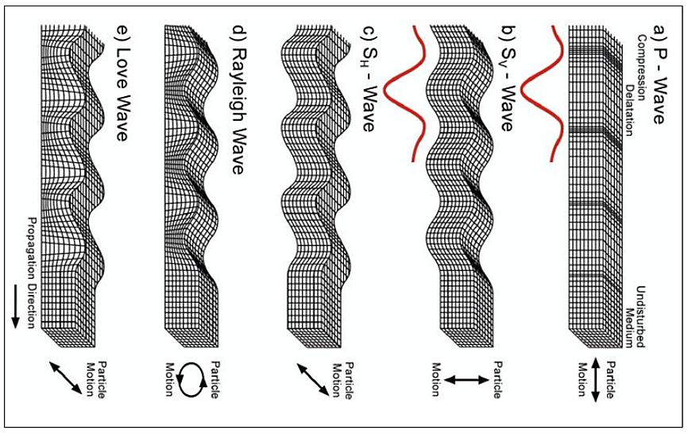

Figure 2.4: Propagation of seismic waves (After Lowrie, 2007)

Normally they go a little more rapidly than Rayleigh, around 90 percent of the S wave speed and also possess the highest amplitude (Figure 2.4).
Figure 2.5 depicts the propagation of waves in a medium. This is applicable also in seismic wave propagation through earth materials.
2.3.1 Refraction at a Horizontal Interface
The refraction method is illustrated for the case of the flat interface between two horizontal layers in (Figure 2.5). Let the depth to the interface be (d) and the seismic velocities of the upper and lower layers be (V₁) and (V₂) respectively (V₁<V₂). The direct ray from the shot point at (S) is recorded by a geophone (G) at distance (x) on the surface after time (x ⁄ V₁). The travel-time curve for the direct ray is a straight line through the origin with slope (m₁ = 1 ⁄ V₁). The hyperbolic t–x curve for the reflected ray intersects the time axis at the two-way vertical reflection “echo” time (t₀).
At great distances from the shot-point the reflection hyperbola is asymptotic to the straight line for the direct ray (Kearey et al., 2002; Lowrie, 2007; Reynolds, 2011).
The doubly refracted ray travels along the path (SC) with the velocity (V₁) of the upper layer, impinges with critical angle (i_{c}) on the interface at (C), passes along the segment (CD) with velocity (V₂) of the lower layer, and returns to the surface along (DG) with velocity (V₁). The segments (SC) and (DG) are equal, (CD = x – 2SA) and the travel-time for the path (SCDG) can be written:
$t = \frac{2Sc}{V_{1}} + \frac{CD}{V_{2}} = \frac{2d}{V_{1}cos i_{c}} + \frac{x - 2dtani_{c}}{V_{2}}$ 2.22
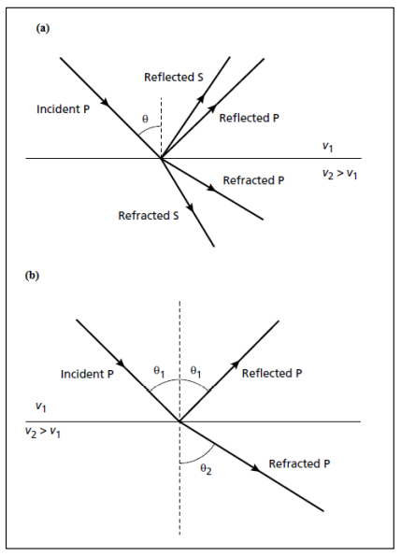
Figure 2.5: (a) Reflected and refracted P- and S-wave rays generated by a P-wave ray obliquely incident on an interface of acoustic impedance contrast, and (b) Reflected and refracted P-wave rays associated with a P-wave rays obliquely incident on an interface of acoustic impedance contrast (After Kearey et al., 2002).

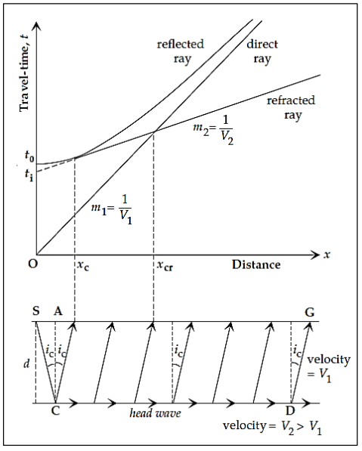

Figure 2.6: Travel-time versus distance curves for the direct ray and the reflected and refracted rays at a horizontal interface between two layers with seismic velocities V₁ and V₂ (After Kearey et al., 2002).
Rearranging terms and using Snell’s law (eq. 2.22), we get for the travel-time of the doubly refracted ray:
$t = \frac{x}{V_{2}} + \frac{2d}{V_{1}}cosi_{c}$ 2.23
The doubly refracted rays are only recorded at distances greater than the critical distance (x_{c}). The first arrival recorded at (x_{c}) can be regarded as both a doubly refracted ray and a reflection. The refraction t–x curve is found to intersect the time axis at the intercept time (t_{i}), given by:
$t_{i}= \frac{2d}{V_{i}}cosi_{c}=2d\frac{\sqrt{V_{2}^{2}- V_{1}^{2}}}{V_{1}∙ V_{2}}$ 2.24
Close to the shot-point the direct ray is the first to be recorded. However, the doubly refracted ray travels part of its path at the faster velocity of the lower layer, so that it eventually overtakes the direct ray and becomes the first arrival. The straight lines for the direct and doubly refracted rays cross each other at this distance, which is accordingly called the crossover distance, (x_{cr}):
$x_{cr}=2d ∙ \sqrt{\frac{V_{2}+ V_{1}}{V_{2}- V_{1}}}$ 2.25
Tables of seismic velocities of different earth materials given by Kearey et al., (2002) and McDowell et al., (2002) are presented in Tables 2.1 and 2.2
    - Limitations of Seismic Refraction Method
- The existence of certain beds or layers with insufficient velocity contrast or thickness cannot be detected by the refraction method. These layers called hidden layers or blind zones.
- Seismic refraction observations require relatively large source-receiver offsets (distances between the source and where the ground motion is recorded, the receiver).
Table 2.1: Compressional wave velocities (Vp) in earth materials (Kearey et al., 2002).
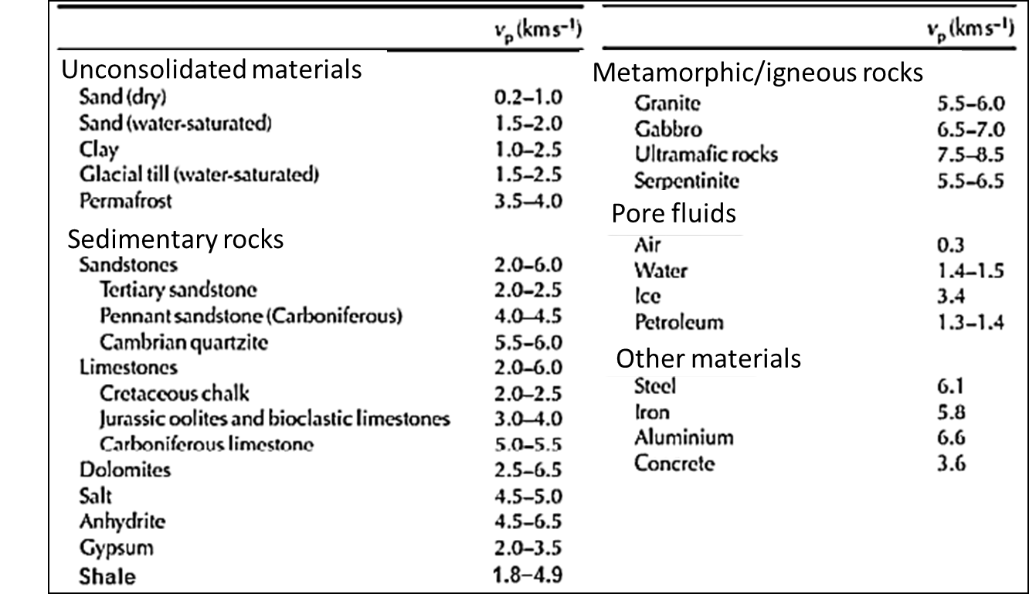

Table 2.2: Shear waves velocity of some earth materials (McDowell et al., 2002).
Materials | Vs (m/s)
Air | 0
Water | 0
Sands and clays | 100-500
Glacial till | 600 – 1300
Chalk | 600 – 1500
Strong limestone | 1500 – 3500
Weathered granite | 500 – 1500
Fresh granite | 1500 – 3000
Slate | 2500 – 3800

- Seismic refraction only works if the speed at which motions propagate through the Earth increases with depth.
- Seismic refraction observations are generally interpreted in terms of layers. These layers can have dip and topography.
- Seismic refraction observations only use the arrival time of the initial ground motion at different distances from the source (i.e., offsets).
2.3.3 Field Operation
A number of different of noises may contaminate our seismic measurements (Kearey et al., 2002). Since we control the source of the seismic energy, we can control some types of noise, but not all of it. Seismic noises could be either:
- Uncontrolled Ground Motion: Anything that causes the ground to move, other than your source, will generate noise. Such as; wind, traffic, people walking, moving animals, etc.
- Electronic Noise: Geophones transform the ground motion they detect into electrical signals. These signals are then conveyed down the cable, magnified and registered by the recording system. Therefore, anything that can cause electrical signal shifts generates noise in our recorded data. For example, loose connections between the geophones and the cable or cable and the recording system.
- Geological Noise: We can take into account any type of subsurface geological structure that we cannot easily interpret as a source of noise.

CHAPTER THREE
MATERIALS AND METHODS OF STUDY
This chapter provides a detailed description of the four geophysical techniques and methodology used for data acquisition and data processing. The methods were used because of their ability to delineate the extent of sub-soil variation in both laterally and vertically in depth based on sub-soil physical properties. The data acquisition map is shown in Figure 3.1.
3.1 Electrical Resistivity Instrumentation
The field materials used are:
- SuperSting R8 & R1 earth resistivity meter.
- Electrodes
- Cable
- Hammer
- Meter Rule
- Battery
- GPS
The electrical resistivity method employed the 2-D Electrical Resistivity Tomography and the Vertical Electrical Sounding (VES). The SuperSting R8 was used for the acquisition of the 2D electrical resistivity tomography data (Figure 3.2). The SuperSting R8 system consists of a resistivity/IP meter, 112 electrodes that are connected via cable, and an energy source (battery) that is used to power a resistivity/IP meter. Data was acquired for six traverses using the Dipole – Dipole array. The distance between each traverse is about 60 meters and has a spread length of 224 meters.

Figure 3.1: Data Acquisition Map of the Study Area

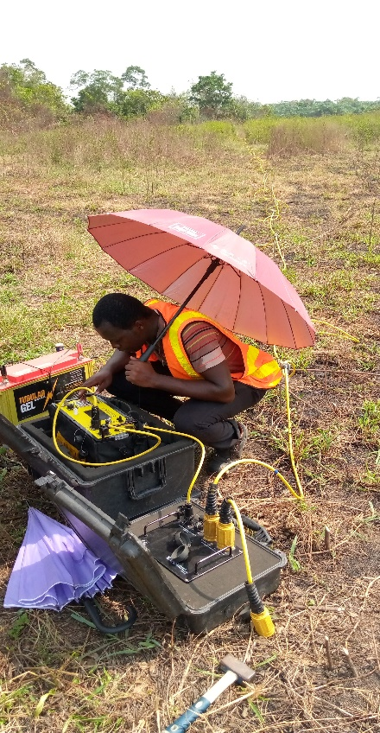

Figure 3.2: Field setup for SuperSting R8 Earth Resistivity Meter

The SuperSting R1 was applied for the acquisition of the Vertical Electrical Sounding (VES) data using Schlumberger array configuration. The resistance and the apparent resistivity of the soil at each point were recorded.
3.2 2D Seismic Refraction Tomography and MASW Instrumentation
The field materials used are:
- Terraloc Pro Seismograph.
- 48 geophones with a frequency of 4.5Hz.
- Geophone cables
- Shot cable and shot geophone
- Batteries.
- Global Positioning System (GPS).
- Measuring Tape
- Sledge Hammer weighing 5 kg.
- Base plate.
Forty-eight (48) geophones were mounted on the ground and connected to two seismic ground cables with a total of 48 outlets. These seismic geophone cables are used to send the electrical pulse from each geophone to the seismograph to record the seismic signals. The seismic source was generated by hitting a 5 kg sledge hammer on a rubber plate. During the survey, two offset shots and three split shots were fired.
Terraloc Pro seismograph was used during the data acquisition (Figure 3.3). The sampling rate used in the course of the survey is 100 μs and the window time length is 204.8 ms, the reason for the use of the Terraloc Pro seismograph is because of its wide range of sampling rates.

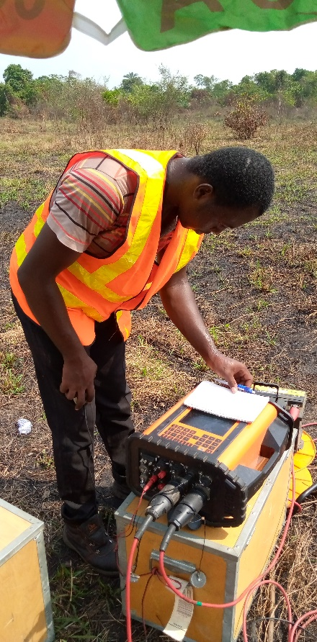

Figure 3.3: Field setup for ABEM Terraloc Pro Seismograph

After the equipment has been set up, the noise level was monitored on the seismograph. The lowest acceptable noise level was determined before shots were fired.
The only difference in the data acquisition procedure between the 2D seismic refraction tomography and 2D Multichannel Analysis of Surface Waves (MASW) is the way their data is being acquired, unlike the conventional 2D refraction tomography where the geophones are planted on the ground and the specified kind of shot type either two offset shot, three split shot, for this study two offset shot and three split shot. End-on shot is acquired only at the offset of the spread, preceding this is the removal of the first geophone from it initial position and positioning it at the end of the spread, making it the last geophone and moving the geophone cable towards the new last geophone, known to the first geophone this process is called roll along.
3.3 Data Processing
3.3.1 Electrical Resistivity Tomography (ERT)
For inversion of the 2-D resistivity data, Advance Geophysical Incorporated (AGI) EarthImager software was used. This software generates an apparent resistivity inverted section from the measured field data, by comparing the measured model with a computed theoretical model. A final inverted model of apparent resistivities, which is taken to be the sub-surface model, is then generated.
3.3.2 Vertical Electrical Sounding (VES)
The differences in the geoelectric characteristics were used to calibrate depth sounding curves for the number of layers represented by the four forms of auxiliary curves (H, K, A and Q) and also for profiles and maps involving appraising of pattern or likely anomalous signature capable of distinguishing target. The subjective interpretation of the depth sounding curves was conducted using partial curve matching technique (Bhattacharya and Patra, 1968). The VES data were drawn on a transparent surface in order to do this. The technique of partial curve matching included the use of standard two (2) master layer and four (4) auxiliary curves (H, K, A and Q). This approach selects the segment-by-segment curve from the position with shorter electrode distance to the position with longer distances to be balanced. In order to limit the interpretation of the computer employing iteration software, WINRESIST the results of VES curves obtained from a partial curve matching are now used. This sometimes decreases the depth estimated. The results of the software iteration illustrate the qualitative analysis to appreciate the resistivity, thickness and depth. The vertical electric sounding results (VES), obtained using the WINRESIST program, are shown as depth sounding curve. The apparent readings for resistivity against electrode separation on a log-log paper are plotted, which was matched with the curve. Based on the results of the interpreted VES data, geoelectric sections were developed. See in Appendix A
3.3.3 Seismic Refraction Tomography Data Processing
The speed of sounds through the surface varies depending on the structure of the material and its compaction. Seismic energy transmitted from the source on the surface is refracted at the limits between various media and returns to the surface in due course. Seismic refraction surveys use this phenomenon to characterize the soil structure by looking at the time required to convey energy through the subsurface (Reynolds, 2011).
The seismic refraction survey method uses seismic energy that returns to the surface after traveling through the ground along refracted ray pathways. Unlike the seismic reflection method, only a few processing steps will be used in the refracted method to improve data and significantly reduce noise.
3.3.3.1 DC Offset Removal
This process is the first stage of data the processing data once the data has been acquired by the seismograph. DC offset noise (also called DC bias, DC component, or DC coefficient) is a 0 Hz frequency component which distort the data. Being a low frequency noise, it is often eliminated using a Butterworth high-pass filter. In this research, the software used for this processing is the “Reflex2DQuick” software.
3.3.3.2 Geometry Assignment and Editing
The geometry of the field is written to the data (trace headers) in order to associate each trace with its respective shot, offset, channel, and common midpoint (CMP). This is done by providing the longitude, latitude, and elevation of each shot point and geophone using the GPS. After DC offset removal and geometry assignment, we can modify the seismic data to mute the wrong traces (noise channels, poorly planted geophones etc.) or rectify the polarity problems.
3.3.3.3 Frequency Filtering
Frequency filters differentiate between selected waveform input frequency components and noise. Frequency filters are used when the signal and noise components of the waveform have different frequency qualities and can therefore be separated on this basis (Oz Yilmaz, 2001). The main types of filtering are:
- high-pass filter: also referred to as a low-cut filter, is a filter that transmits high-frequency signals but attenuates signals with frequencies below the cut-off frequency.
- a low-pass filter: also referred to as a high-cut filter, is a filter that transmits low-frequency signals but attenuates signals with frequencies higher than the cut-off frequency.
- band-pass filter: is a filter that passes signals only in a definite frequency band while attenuating all signals outside this band.
3.3.3.4 Picking of the First Arrivals and Generating the Travel Time curves
When performing a refraction survey, the time of arrival of the first wave is the only information extracted from the recorded seismograms that is used. It may be difficult picking the first arrivals at remote geophones where the signal-to-noise ratio is low. Some of the later peaks and troughs in the same wave train are likely to be stronger, and sometimes it is possible to work back from them to estimate the position of the first break. Picking the first arrivals was done using a software called “SeisImager” that is aided by a tool called “Pickwin”.
The data extracted from the refraction survey consists of sets of first-arrival times measured at geophones at different distances from the source position. Since these are graphed against vertical time axes and horizontal distance axes (a diagram called travel time curve or time-distance curve), the slope of any line is equal to the reciprocal of a velocity, i.e., steep slopes correlate to slow velocities, while the gentle slope correlates to high velocities.
3.3.3.5 Velocity modelling
The interpretation of the seismic refraction data is based on the modeling and inversion of the acquired seismic velocity. The velocities are determined by the travel time plot for each seismic line. By simulating the paths taken through the subsurface by seismic energy or 'ray tracing,' the thickness and extension of each layer in the model can be adjusted in an iterative manner until a solution is reached. This produces a cross-section velocity model of the subsurface. Borehole records can further calibrate the data to provide subsurface layer levels across the survey line.
There are many techniques used for seismic refraction inversion, one of which is known as the Tomographic Method that is used during this research. The tomographic method involves the production of an initial velocity model, and then iteratively tracing the rays through all of the model, comparing the calculated travel times with the measured travel times, improving the model and repeating the process until the difference between the calculated and the measured time is reduced.
The initial velocity model is developed utilizing time-term technique, which is the Least-Squares linear approach, to determine the best discrete-layer solution for the data. The tomographic method provides more realistic profiles where there are gradational vertical changes in velocity (e.g. soil gradation into saprolite and then rock gradation) or lateral changes in velocity (e.g., fracture zones, vertical contacts, or solution cavities in rock).
The inversion was done using SeisImager, which again is facilitated by a tool called Plotrefa. The horizontal axis represents the long-profile distance in meter, while the vertical axis represents the elevation in meter. Color contours are a tomographic model where the subsurface is regarded as a layer of discrete blocks and the best-fit velocity value for each block is calculated.
3.3.4 MASW Method
The Multichannel Surface Wave Analysis (MASW) method is a geophysical method for generating the shear-wave velocity (Vs) profile (i.e., Vs versus depth) by analyzing Rayleigh-type surface waves on a multichannel record to evaluate the elastic characteristic (stiffness) of the ground. (Taipodia and Dey, 2012).
MASW first of all measures the seismic surface waves actually generated from the seismic sources, analyzes the velocity distribution of those surface waves, and finally derive the shear wave velocity (Vs) variations below the surveyed area which are most important in the understanding of the propagation velocity trend of the surface waves. The shear wave velocity is linked to the stiffness of the medium through which the waves travel. Surface wave surveying is therefore a useful tool for determining variation in ground stiffness with depth. Comparison to standard seismic survey methods, such as cross-hole and downhole, the MASW is cost-effective and saves time (Reynolds, 2011; Taipodia and Dey, 2012).
Regarding the way surface waves are produced, there are two main types of waves. (Taipodia and Dey, 2012):
- passive MASW: Where surface waves are formed by natural sources extraneous to the survey, such as traffic and tidal movements.
- active MASW: Where surface waves are created by a source of impact, such as a sledge hammer or a weight drop.
The active MASW method was used in this study, where the seismic source was a sledge hammer, and 48-geophones, which were arranged in a linear array and connected to a multi-channel seismograph, acquiring data concurrently in all geophones. The entire MASW procedure consists of three steps:
1. Collecting multi-channel field records.
2. Extract the dispersion curves.
3. Invert this dispersion curve to obtain a Vs (Shear wave velocity) profile.
The 2D Vs model was developed by incorporating a range of 1D Vs models together. This technique was used at three traverses along lines 3, 4 and 5 respectively. In order to produce a 2D Vs profile, a new acquisition was made with vertical low-frequency geophones (e.g., 4.5 Hz) that are sensitive to surface waves. The source used was a sledge hammer and the geophone interval was 2 m for 48 geophones. The overall length of the profile is 143 m. However, during the survey, 48 offset points were acquired where the range of the shot point range was between 1 and 2 m.

3.4 Computation of Engineering Parameters from Seismic Compressional and Shear Waves
Bulk Density (ρ), Compressibility (β), Bulk Modulus (K), Dynamic Shear Modulus (G) and Rock mass Quality (Q) were derived from the Compressional Wave Velocity (Vp) and Shear Wave Velocity (Vs). Presented below are the equations that relate these quantities with seismic velocities.
Bulk Density (ρ): According to Gardner et al., (1974), bulk density of earth materials is given as
$ρ=a{V_{p}}^{0.25}$ 3.1
where ρ is bulk density (g/cc), $V_{p}$ is compressional seismic wave velocity (m/s) and a is a constant which is = 0.31
Shear modulus (G) is given as
$V_{s}=\sqrt{\frac{G}{ρ}}$ 3.2
where $V_{s}$ is shear wave velocity (m/s), G is Shear Modulus (Pa) and ρ is bulk density (g/cc)
Bulk modulus (K) is given as:
$V_{p}=\sqrt{\frac{K+\frac{4}{3}G}{ρ}}$ 3.3
Compressibility (β) is given as
$β=ρ{(V_{p}^{2}- \frac{4}{3}V_{s}^{2})}^{-1}$ 3.4
where ρ is bulk density (g/cc), $V_{p}$ compressional seismic wave velocity (m/s) and $V_{s}$ is shear wave velocity (m/s).
Rock-mass Quality (Q) is given as
$Log \left(Q\right)= V_{p}-3.5 km/s$ 3.5
CHAPTER FOUR
RESULTS AND DISCUSSION
4.1 The Vertical Electrical Sounding (VES) Results
Presented in this section are the VES sounding curves (Figure 4.1). For all the points investigated, the VES curve type obtained is the “HK” type curve. This indicated that four (4) geoelectric layers were delineated. The geoelectric layers delineated were interpreted to correspond in their order of succession from the ground surface to a silty clay/clayey topsoil, a low resistivity clay layer, a sandy clay layer and the fourth geoelectric layer of low resistivity suspected to be clay.
Topsoil resistivities and thickness varied from 12 to 51 ohms-m and 0.4 to 0.8 m respectively. The second layer which was interpreted as low resistivity clay has resistivities and thicknesses ranging from 3 to 7 ohms-m and 1.5 to 5.2 m respectively. The third layer which was interpreted as sandy clay has resistivities and thicknesses varying between 13 and 163 ohms-m, and 1.6 and 9.1 m respectively. The resistivity of the fourth geoelectric layer (which is also a low resistivity clay) varied between 3 to 46 ohms-m. The depth to the fourth layer ranged from 5.7 to 14.6 m. The summary of the geoelectric parameters were presented in Table 4.1.
4.2 The Geoelectric Sections
Geoelectric sections were generated for the purpose of layer and layer thickness correlation across proximal VES points. Based on the distribution of the VES points (Figure 3.1), VES 1 and VES 2; VES 3, VES 4 and VES 5; VES 1 and VES 3; as well as VES 2 and VES 4 were used to generate the geoelectric sections presented in Figures 4.2 (a), (b), (c) and (d) respectively. From the geoelectric sections, it can be inferred that:
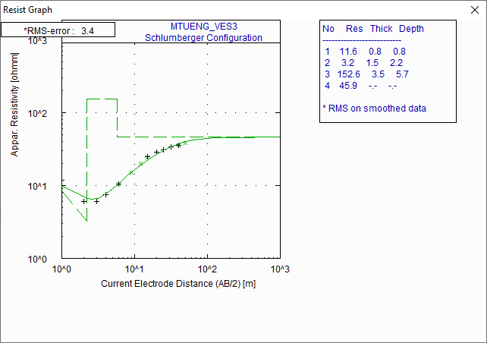
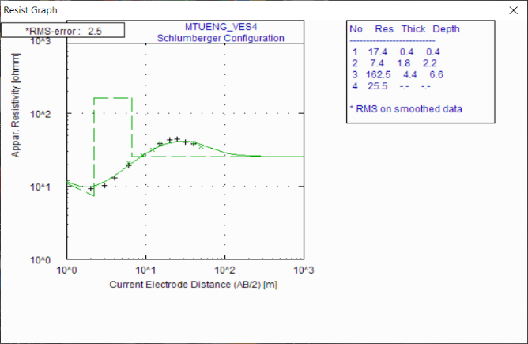
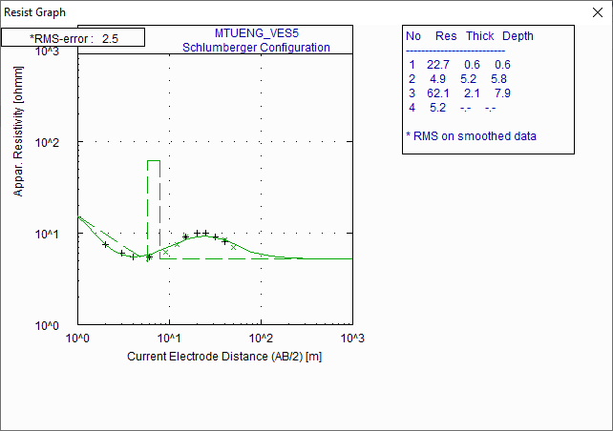
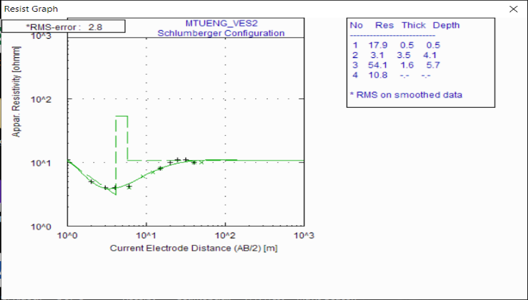
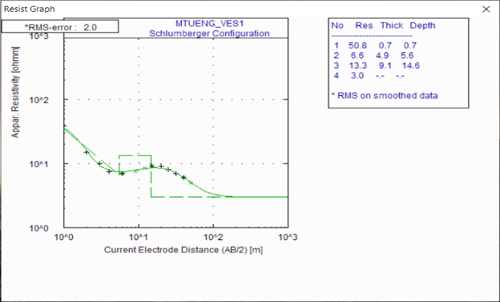

Figure 4.1: VES curves for VES 1 (top left), VES 2 (top right), VES 3 (centre), VES 4 (bottom left) and VES 5 (bottom right).

Table 4.1: VES Interpretation Results
VES No | Coordinates |  | Layer No | Resistivity (Ωm) | Thickness (m) | Depth (m) | Lithology | VES Type Curve
VES No | Easting | Northing
1 | 542201 mE | 745927 mN | 1 | 51 | 0.7 | 0.7 | Topsoil | HK
1 | 542201 mE | 745927 mN | 2 | 7 | 4.9 | 5.6 | Clay | HK
1 | 542201 mE | 745927 mN | 3 | 13 | 9.1 | 14.7 | Sandy Clay | HK
1 | 542201 mE | 745927 mN | 4 | 3 | - | - |  | HK
2 | 542186 mE | 745988 mN | 1 | 18 | 0.5 | 0.5 | Topsoil | HK
2 | 542186 mE | 745988 mN | 2 | 3 | 3.5 | 4.0 | Clay | HK
2 | 542186 mE | 745988 mN | 3 | 54 | 1.6 | 5.6 | Sandy Clay | HK
2 | 542186 mE | 745988 mN | 4 | 11 | - | - |  | HK
3 | 542322 mE | 745996 mN | 1 | 12 | 0.8 | 0.8 | Topsoil | HK
3 | 542322 mE | 745996 mN | 2 | 3 | 1.5 | 2.3 | Clay | HK
3 | 542322 mE | 745996 mN | 3 | 153 | 3.5 | 5.8 | Sandy Clay | HK
3 | 542322 mE | 745996 mN | 4 | 46 | - | - |  | HK
4 | 542302 mE | 746032 mN | 1 | 17 | 0.4 | 0.4 | Topsoil | HK
4 | 542302 mE | 746032 mN | 2 | 7 | 1.8 | 2.2 | Clay | HK
4 | 542302 mE | 746032 mN | 3 | 163 | 4.4 | 6.6 | Sandy Clay | HK
4 | 542302 mE | 746032 mN | 4 | 26 | - | - |  | HK
5 | 542311 mE | 746080 mN | 1 | 23 | 0.6 | 0.6 | Topsoil | HK
5 | 542311 mE | 746080 mN | 2 | 5 | 5.2 | 5.8 | Clay | HK
5 | 542311 mE | 746080 mN | 3 | 62 | 2.1 | 7.9 | Sandy Clay | HK
5 | 542311 mE | 746080 mN | 4 | 5 | - | - |  | HK

Figure 4.2 (a): Geoelectric Section connecting VES 1 and VES 2

Figure 4.2 (b): Geoelectric Section connecting VES 3, VES 4 and VES 5

Figure 4.3 (c): Geoelectric Section connecting VES 2 and VES 4.

Figure 4.3 (d): Geoelectric Section connecting VES 1 and VES 3.
- the sandy clay layer which is the relatively more competent layer thins northward for most part of the study area (Figures 4.2 (a), (b) and (c)) except in a portion of the western part where this layer is relatively thinner in the southern region (Figure 4.2 (d)).
- depth to the sandy clay layer ranges from 2.2 to 5.8 m. This invariably means that to a good approximation the upper 2.2 to 5.8 m of earth material in the study area are constituted of incompetent clayey material.
4.3 The 2D Electrical Resistivity Inverted sections
Six (6) 2D electrical resistivity inverted sections of the subsurface were generated along Traverses 1, 2, 3, 4, 5 and 6. The relative positions of the traverses to one another is shown in Figure 3.1. Generally, between three (3) to four (4) geoelectric layers were delineated across all the sections. These layers are a low resistivity top soil, a relatively high resistivity layer, another low resistivity layer and another relatively higher resistivity layer (figures 4.4 (a), (b), (c), (d), (e) and (f)).
4.3.1 Traverse 1 (Figure 4.4 (a))
This is the southernmost traverse. It trends in the ENE-WSW direction (Figure 3.1). The top soil resistivity and thickness varied between 2 and 22 ohms-m, and about 1.5 to 6.2 m respectively while the resistivity and thickness of the second layer (having relatively high resistivity) varied between 29 to 135 ohms-m, and about 6 to 12 m respectively. The third layer which is another low resistivity layer has resistivity ranging from 2 to 29 ohms-m and thickness ranging from about 25 m (at the eastern end) to over 30 m at the western end. The fourth layer was only delineated at the eastern region of the traverse. It has a relatively higher resistivity (between 17 and 29 ohms-m) than the overlying layer. The end of this layer was not imaged by the inverted section. The total
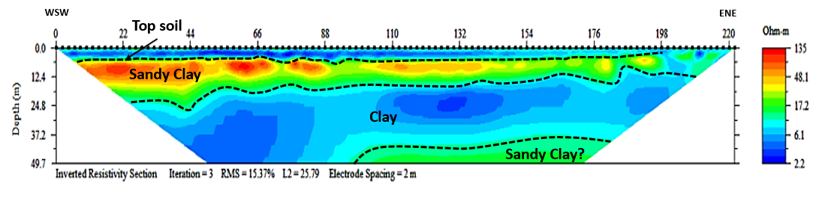
ENE

Figure 4.4(a): 2D Electrical Resistivity Inverted section along Profile 1
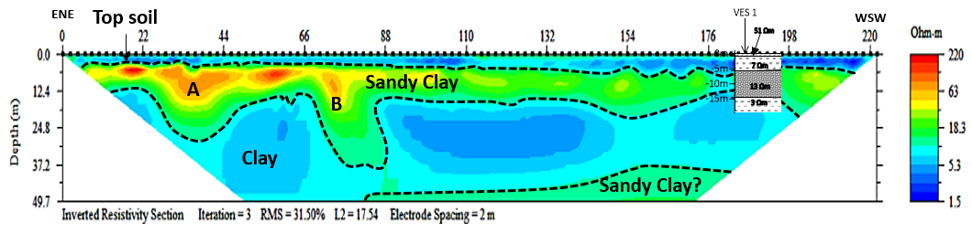

Figure 4.4(b): 2D Electrical Resistivity Inverted section along Profile 2
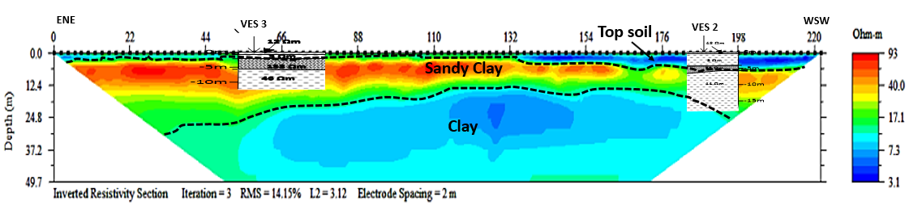
Figure 4.4(c): 2D Electrical Resistivity Inverted section along Profile 3
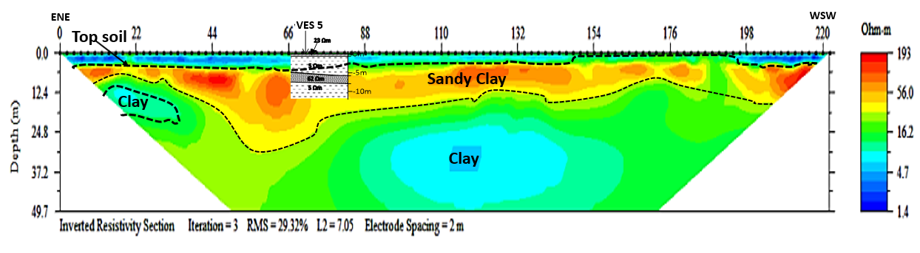
Figure 4.4(d): 2D Electrical Resistivity Inverted section along Profile 4

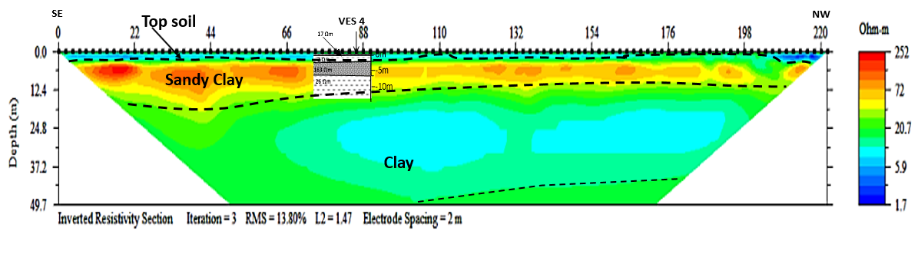
Figure 4.4(e): 2D Electrical Resistivity Inverted section along Profile 5
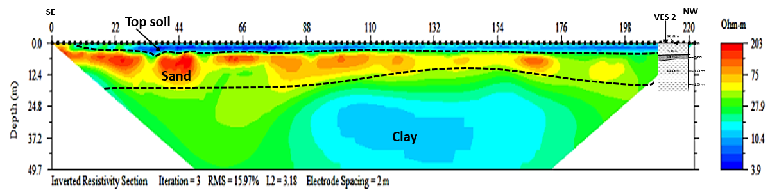
Figure 4.4(f): 2D Electrical Resistivity Inverted section along Profile 6

depth imaged by the 2D inverted section is 49.7 m. The third layer, which is likely clayey, is the thickest layer delineated in the inverted section.
4.3.2 Traverse 2 (Figure 4.4 (b))
This is also an ENE-WSW trending profile. The top soil resistivity is between 2 and 25 ohms-m and the thickness is roughly 5 m along the whole profile. The second layer has a relatively higher resistivity than the topsoil. The resistivity varied between 34 to 220 ohms-m, and thickness between 6 and 30 m. This layer, interpreted as sandy clay, is thickest at the regions labelled “A” and “B” which seems to be a river channel filled-up with the sandy clay deposit. The third layer is a low resistivity layer of clay whose thickness ranged from about 10 m to over 30 m around the eastern (ENE) end.
A fourth layer having a relatively higher resistivity than the overlying layer was observed at the western end of the traverse. The total depth imaged by the 2D inverted section is 49.7 m. VES 1 is located at 186 m from the start of the profile (figure 4.4(b)). The topsoil and the underlying clay layer from the VES were merged as the topsoil on the 2D inverted section. The thickness of the sandy clay layer as given by VES 1 (i.e. 9 m) was about the same on the 2D inverted section as well.
4.3.3 Traverse 3 (Figure 4.4 (c))
This is another ENE-WSW trending profile. The top soil resistivity is between 3 and 32 ohms-m and the thickness varied between 1 and 6 m along the whole profile. The second layer has a relatively higher resistivity than the topsoil. The resistivity varied between 32 and 92 ohms-m, and thickness between 6 and 15 m. The third layer is a low resistivity layer of clay. The total depth imaged by the 2D inverted section is 49.7 m. VES points 2 and 3 are located at 198 m and 60 m from the start of the profile respectively (figure 4.4(c)).
4.3.4 Traverse 4 (Figure 4.4 (d))
The profile trends in the ENE-WSW direction. The top soil resistivity is between 1 and 12 ohms-m and the thickness varied between 0.5 and 4.5 m along the whole profile. The second layer has a relatively higher resistivity than the topsoil. The resistivity varied between 30 and 193 ohms-m, and thickness between 6 and 20 m. The third layer is a low resistivity layer of clay. The total depth imaged by the 2D inverted section is 49.7 m.
VES point 5 is located at 71 m from the start of the profile (figure 4.4(d)). Topsoil and the first clay layer delineated by VES 5 were merged together as topsoil on the 2D inverted section. The sandy clay layer which is just 2.1 m thick on the VES was found to be over 20 m on 2D inverted section. Immediately underlying the 2.1 m thick layer of sandy clay on the VES is a low resistivity clay layer (Table 4.1). This suggests that though, the sandy clay was very thick (over 20 m) on the 2D inverted section, the whole sandy clay layer on the 2D inverted section could in reality be intercalation of sandy clay and thin clay beds which merged together on the 2D to give an impression of a very thick sandy clay layer.
4.3.5 Traverse 5 (Figure 4.4 (e))
This is a NW-SE trending profile. The top soil resistivity is between 2 and 15 ohms-m and the thickness varied between 0.5 and 3 m along the whole profile. As in other profiles, the second layer has a relatively higher resistivity than the topsoil. The resistivity varied between 39 and 252 ohms-m, and thickness between 3 and 15 m. The third layer is a low resistivity layer of clay. The total depth imaged by the 2D inverted section is 49.7 m. VES point 4 is located at 86 m from the start of the profile (figure 4.4(e)). Topsoil and the first clay layer delineated by VES 4 were merged together as topsoil on the 2D inverted section. The sandy clay layer which is just 4.4 m thick on the VES was found to be over 10 m on 2D inverted section. Along this traverse too, it is predicted that there is likelihood that the whole sandy clay layer on the 2D inverted section could in reality be intercalation of sandy clay and thin clay beds which merged together on the 2D to give an impression of a very thick sandy clay layer.
4.3.6 Traverse 6 (Figure 4.4 (f))
This is also a NW-SE trending profile. The top soil resistivity is between 4 and 20 ohms-m and the thickness varied between 0 and 3 m along the whole profile. As in other profiles, the second layer has a relatively higher resistivity than the topsoil. The resistivity varied between 40 and 203 ohms-m, and thickness between 6 and 18 m. The third layer is a low resistivity layer of clay. The total depth imaged by the 2D inverted section is 49.7 m. VES point 2 is located at 212 m from the start of the profile (figure 4.4(f)). Topsoil and the first clay layer delineated by VES 2 merged together as topsoil on the 2D inverted section. The sandy clay layer which is just 1.6 m thick on the VES was found to be over 10 m on 2D inverted section. Along this traverse the likelihood of the whole sandy clay layer on the 2D inverted section being in reality intercalation of sandy clay and thin clay beds which merged together on the 2D to give an impression of a very thick sandy clay layer is suspected.
4.4 The 2D Seismic Refraction Tomography
2D seismic refraction tomography was conducted on traverses 3, 4 and 5 with the start of line coinciding with that of 2D electrical resistivity imaging (Figure 3.1). Being just about 140 m long, the 2D seismic tomography lines were shorter than the 2D electrical resistivity imaging lines. The 2D seismic tomography images are shown in figures 4.5 (a), (b) and (c).
4.4.1 Traverse 3 (Figures 4.5 (a))
This profile trends in the ENE-WSW direction. Two layers were delineated on the 2D seismic image. Depth to the second layer varied between 5 and 10 m along the profile (figure 4.5(a)). VES point 3 is located at exactly 60 m from the start of the profile. When the VES section at VES point 3 was correlated with the seismic refraction tomogram, it was discovered that all the layers delineated by the VES were merged together as the first layer of the seismic tomogram. The primary wave velocity (V_{p}) varied between 511 to 1042 ms⁻¹, and 1042 and 1200 ms⁻¹ for the first and second layers respectively. The seismic tomogram also suggested that the interface between the last layer delineated by the VES and the layer immediately underlying it could be coincident with the interface between the first and second layer of the seismic tomogram at that point (VES 3 point).
4.4.2 Traverse 4 (Figures 4.5 (b))
This profile also trends in the ENE-WSW direction. Two layers were delineated on the 2D seismic image. Depth to the second layer varied between 1 and 5 m along the profile (figure 4.5(b)). VES point 5 is located at exactly 71 m from the start of the profile. When the VES section at VES point 5 was correlated with the seismic refraction tomogram, it was discovered that the first two layers delineated by the VES were merged together as the first layer of the seismic tomogram while the last two layers were also merged together and correspond to the second layer on the seismic tomogram. The primary wave velocity (V_{p}) varied between 515 to 1099 ms⁻¹, and 1099 and 1200 ms⁻¹ for the first and second layers respectively. Being less consolidated based on the range of

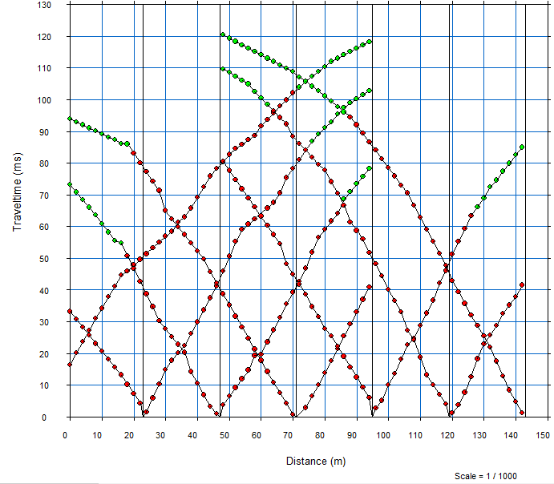
WSW

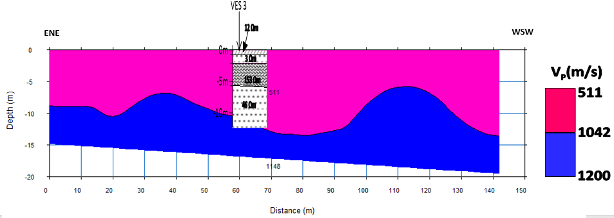

Figure 4.5(a): 2D Seismic Refraction Tomogram along Profile 3

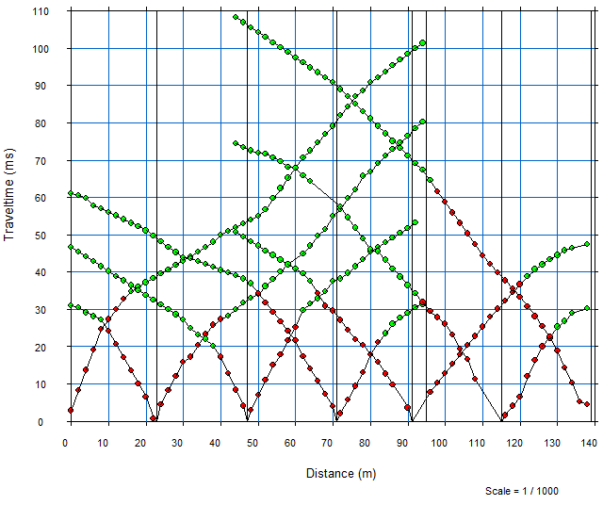

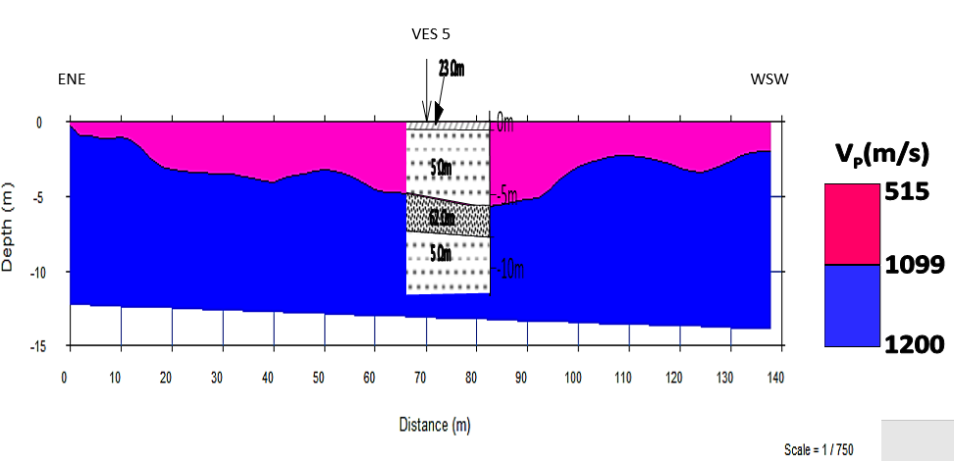

Figure 4.5(b): 2D Seismic Refraction Tomogram along Profile 4

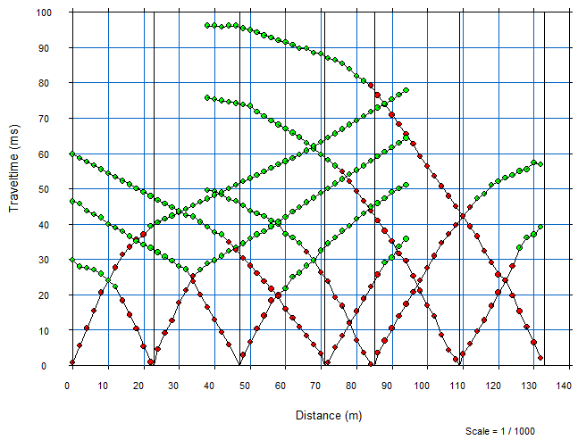

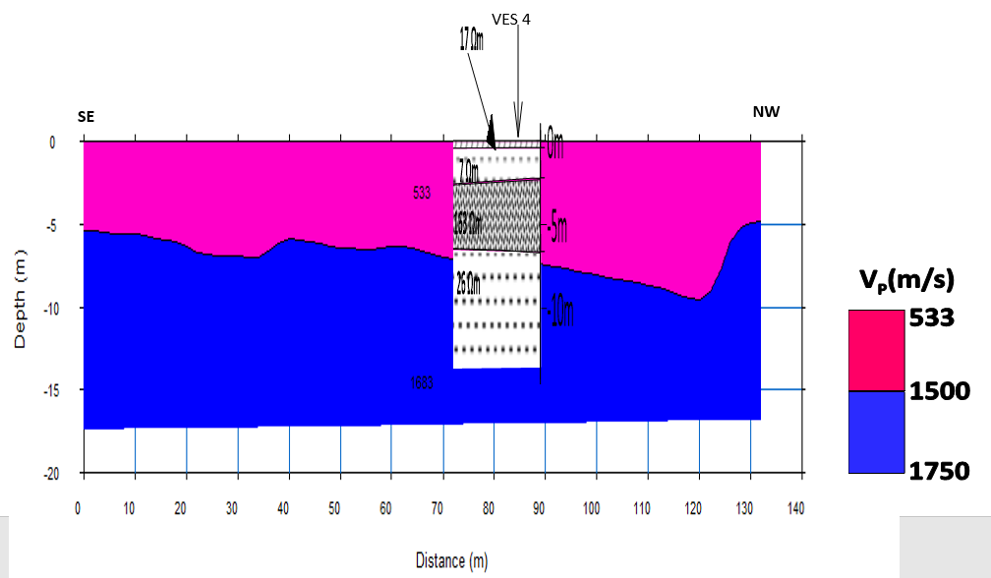

Figure 4.5(c): 2D Seismic Refraction Tomogram along Profile 5
velocity of propagation of the primary seismic wave (V_{p}), the first layer is more likely to be constituted of less consolidated sediments that may have been transported with flood current, the study area being part of the flood plain where overflown dam water are discharged.
4.4.3 Traverse 5 (Figures 4.5 (c))
This profile trends in the NW-SE direction. Two layers were delineated on the 2D seismic image. Depth to the second layer varied between 5.5 and 9.5 m along the profile (figure 4.5(c)). VES point 4 is located at 86 m from the start of the profile. When the VES section at VES point 4 was correlated with the seismic refraction tomogram, it was discovered that the first three layers delineated by the VES were merged together as the first layer of the seismic tomogram while the last layer corresponded with the second layer on the seismic tomogram. The primary wave velocity (V_{p}) varied between 533 to 1500 ms⁻¹, and 1500 and 1750 ms⁻¹ for the first and second layers respectively. The degree of consolidation of earth material is likely to have played the most significant role in discriminating the layers on the seismic tomogram.
4.5 The Multi-channel Analysis of Surface Wave (MASW) Result
Multi-channel analysis of surface wave data was acquired along the profiles on which 2D seismic refraction tomography data were acquired (Figures 4.6 (a), (b) and (c)). This method makes use of surface waves (i.e. Rayleigh waves) to delineate lithologies and to give an estimate of the shear wave velocity (Vs). From this method, two geologic layers were delineated along all the three profiles and their shear wave velocities were estimated.

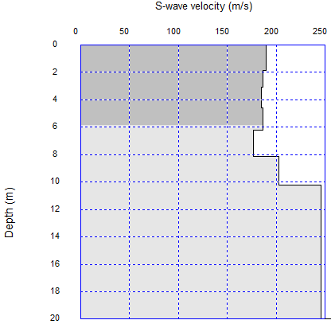

Figure 4.6(a): Shear Wave Velocity Model along Profile 3
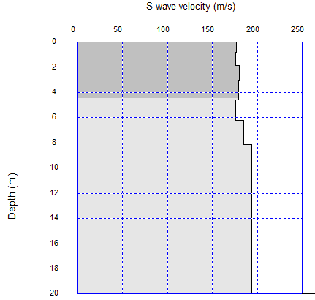

Figure 4.6(b): Shear Wave Velocity Model along Profile 4

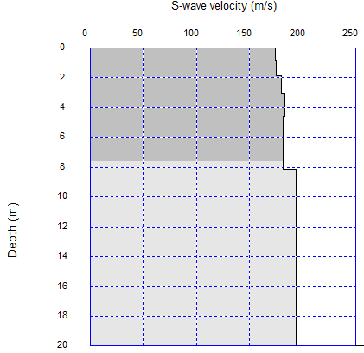

Figure 4.6(c): Shear Wave Velocity Model along Profile 5

4.5.1 Traverse 3 (Figures 4.6 (a))
This profile trends in the ENE-WSW direction. Of the two layers delineated, the first layer has an average Vs of 185 ms⁻¹ while the second layer has an average Vs of 230 ms⁻¹ (Figure 4.6 (a)). Average thickness of the first layer is about 5.9 m. This is consistent with the thickness of the first three geoelectric layers of VES 3 (i.e 5.8 m) which is 60 m from the start of the profile on the assumption that the first three layers on the VES was merged together as the first layer of the inverted S-wave model.
4.5.2 Traverse 4 (Figures 4.6 (b))
This profile also trends in the ENE-WSW direction. Of the two layers delineated, the first layer has an average Vs of 175 ms⁻¹ while the second layer has an average Vs of 240 ms⁻¹ (Figure 4.6 (b)). Average thickness of the first layer is about 4.4 m on this profile.
4.5.3 Traverse 5 (Figures 4.6 (c))
This is a NW-SE trending profile. Of the two layers delineated, the first layer has an average Vs of 175 ms⁻¹ while the second layer has an average Vs of 235 ms⁻¹ (Figure 4.6 (a)). Average thickness of the first layer is about 7.6 m. VES 5 is located at 86 m from the start of this profile. When compared with VES 5 results, the first layer (delineated on the MASW S-wave model) is thought of as consisting of the first three geoelectric layers of VES 5. These three layers have a combined thickness of 6.6 m.

4.6 Computed Bulk Density (ρ), Compressibility (β), Bulk Modulus (K), Dynamic Shear Modulus (G) and Rock mass Quality (Q) from the Compressional Wave Velocity (Vp) and Shear Wave Velocity (Vs).
Presented in Table 4.2 are the engineering parameters derived from the compressional wave and the shear wave velocities of earth materials in the study area. These parameters include the bulk density (ρ), the compressibility (β), inverse of the compressibility which is usually referred to as the bulk modulus (K), Dynamic Shear Modulus (G) and the Rock Mass Quality (Q). All the computed engineering parameters which are very low indicated that the soil highly incompetent for engineering structures.

Table 4.2: Engineering Parameters Computed from the Vp and Vs of the Subsurface Layers in the Study Area
 | Profile 3 | Profile 4 | Profile 5
V_{p} Layer 1 (m/s) | 511 – 1042 | 515 - 1099 | 533 – 1500
V_{p} Layer 2 (m/s) | 1042 – 1200 | 1099 -1200 | 1500 – 1750
V_{s} Layer 1 (m/s) | 185 | 175 | 175
V_{s} Layer 2 (m/s) | 230 | 240 | 235
ρ Layer 1 (g/cc) | 1.474 - 1.761 | 1.477 - 1.785 | 1.490 - 1.929
ρ Layer 2 g/cc) | 1.761 - 1.825 | 1.785 - 1.825 | 1.929 - 2.005
β Layer 1 (x 10⁻⁶Pa) | 0.546 - 3.150 | 0.480 - 3.018 | 0.235 - 2.760
β Layer 2 (x 10⁻⁶Pa) | 0.400 - 0.546 | 0.402 - 0.480 | 0.167 – 0.235
K Layer 1 (x 10⁶Pa) | 0.318 – 1.832 | 0.331 – 2.083 | 0.362 – 4.262
K Layer 2 (x 10⁶Pa) | 1.832 – 2.499 | 2.083 – 2.487 | 4.262- 5.993
G_{av} Layer 1 (Pa) | 55362 | 49944 | 52349
G_{av} Layer 2 (Pa) | 96519 | 105094 | 110728
Rock-mass Quality (Q) Layer 1 | 0.001026 - 0.003483 | 0.001035 – 0.003972 | 0.001079 – 0.01
Rock-mass Quality (Q) Layer 2 | 0.003483 – 0.005012 | 0.003972 – 0.005012 | 0.01 – 0.01778

CHAPTER FIVE
5.1 Summary and Conclusion
Geophysical methods have been used to investigate the competence of the near surface soil at Mountain Top University’s permanent site in Makogi-Oba, via Ibafo, Lagos-Ibadan Expressway, Ogun State, Nigeria with a view to determining its suitability for construction purposes.
From the study, it was found out that the area is underlain by a lithologic sequence of clayey topsoil, low resistivity clay layer, relatively high resistivity sandy clay layer, and another low resistivity clay layer. On the 2D ERT inverted sections, the upper first two lithologic layers were merged together as a clayey topsoil which was underlain by a relatively high resistivity sandy clay which in turn was underlain by a thick column of low resistivity clay layer. The sandy clay layer is the most competent of the lithologic sequence delineated. The seismic refraction tomography and MASW delineated two layers which were likely discriminated based on their relative degree of consolidation.
The sandy clay layer, which is the most competent lithologic sequence has apparent electrical resistivity values ranging from 13 to 163 ohms-m, and thickness ranging from 1.6 to 9.1 m from 1D VES models. The thickness obtained for this layer on the 2D ERT inverted sections is about 6m on the average though there is possibility of thickness overestimation due to merging of adjacent layers. The depth to this layer ranged from 2.2 to 5.8 m using the 1D VES layer. The topsoil in the study area is generally not suitable for engineering or construction purpose.
5.2 Recommendation
From the results of the geophysical investigations, a pile foundation is recommended for buildings or construction works that would be undertaken in this area. The pile should be anchored on the sandy clay layer. The depth to this layer is between 2.2 to 5.8 m. More VES data can be acquired so that a more representative isopach map and map of the depth to this sandy clay layer can be generated.
It should be noted however that before any construction of any sort should be done at this site, the mechanism to take care of flooding that occurs when the Ogun river dam is spilled out should be put in place. Water marks on shipping containers found within the site indicated that the flood level could reach close to 2 m. Owing to this fact, construction is discouraged until probably the area is sand-filled to about 2.5 m higher, and river channels dredged so that flood can have free channels to pass when the dam is spilled.

REFERENCES
Adeleke, B.O. and Leong, G. C. (1978). Certificate Physical and Human Geography, West African Ed. Oxford University Press, Nigeria, Ibadan. pp. 32
Adepelumi, A.A. and Olorunfemi, M.O. (2000). “Engineering Geological and Geophysical Investigation of the reclaimed Lekki Peninsula, Lagos, SW, Nigeria”. Bulletin of Engineering Geology and the Environment, 58: 125-132.
Adewunmi, I. and Olorunfemi, M.O. (2005). “Using Geoinformatics in Construction Management”. Journal of Applied Sciences, 5 (4): 761-767.
Akintorinwa, O.J. and Adeusi, F.A. (2009). “Integration of Geophysical and Geotechnical Investigation for a Proposed Lecture Room Complex at the Federal University of Technology, Akure, SW, Nigeria”. Ozean Journal of Applied Sciences 2(3): 105-118.
Ayolabi, E.O., Folorunso, A. F. and Jegede, O.E. (2012). “An application of 2D Electrical Resistivity Tomography in Geotechnical Investigations of Foundation defects: a case study”. Journal of Geology and Mining Research, 3(12): 142-151.
Bhattacharya, P.K. and Patra, H.P. (1968). “Direct Current Electric Sounding (Methods in Geochemistry and Geophysics, 9.)”. Elsevier Publishing Co., Amsterdam, London, New York, 106(2), 135 p.
de Klasz, I. and Jan Du Chene, R. (1978). “Presence of Albian-Cenomanian in South-western Nigeria and Its Paleogeographic Implications”. Compte Rendu de la Société de Physique et d'Histoire Naturelle de Genève, 13, 10-15.

Elawadi, E., El-Qady, G, Nigm, A., Shaaban, F. and Ushijima, K. (2006). Integrated Geophysical Survey for Site Investigation at a New Dwelling Area, Egypt. Journal of Environmental and Engineering Geophysics, 11(4): 249-259.
Gardner, G.H.F., Gardner, L.W., and Gregory, A.R. (1974). “Formation velocity and density—the diagnostic basics for stratigraphic traps.” Geophysics 39:770–780, pp.
Google Maps (2020). Mountain Top University Permanent Site, Makogi-Oba, Ogun State, Nigeria, 1:1500. Google Maps Online. Accessed 21 November, 2020.
Kearey, P., Brooks, M., and Hill, I. (2002). “An introduction to geophysical exploration (3rd ed.)”. Blackwell Publishing, Malden, U.S.A. 281 p.
Loke, M.H. (2002). “Electrical imaging surveys for environmental and engineering studies: A practical guide to 2-D and 3-D surveys”. 127 p.
Lowrie, W. (2007). Seismic wave propagation. In: Lowrie W. (2nd Ed.). Fundamentals of Geophysics. Cambridge University Press, 171-192, pp.
Momoh, L.O., Akintorinwa, O., and Olorunfemi, M.O. (2008). “Geophysical Investigation of Highway Failure – A Case study from the Basement Complex Terrain of Southwestern Nigeria”. Journal of Applied Sciences, 4(6): 637-648.
McDowell, P.W., Barker, R.D., and Butcher A.P. (2002). “Geophysics in engineering investigations”. London: Construction Industry Research and Information Association, CIRIA C562
Omatsola, M.E. and Adegoke, O.S. (1981). “Tectonic Evolution and Cretaceous Stratigraphy of the Dahomey Basin. Journal of Mining and Geology, 18: 130-137.
Petters, S.W (1982). Central West African Cretaceous – Tertiary benthic foraminifera and stratigraphy: Paleontographical Abseiling v. 179, 1-104.
Reynolds, J.M. (1997). “An Introduction to Applied and Environmental Geophysics”. Chichester: John Wiley and Sons Ltd. pp. 769
Reynolds, J.M. (2011). “Electrical resistivity sounding and tomography”. Technical Summary. Reynolds International. 2, pp. 2
USGS (2006) Shuttle radar topography mission, 1 Arc second scene, filled-finished-B, global land cover facility. Maryland: University of Maryland, College Park.
Taipodia, J., and Dey, A. (2012). “A review of Active and Passive MASW Techniques”. Engineering Geophysics for Civil Engineering and Geo-Hazards, National Workshop CBRI, Roorkee pp. 1-13
Telford, W.M., L.P. Geldart, R.E. Sheriff, and D.A. Keys, (1990). “Applied Geophysics”. Cambridge University Press. 744p.
Oz Yilmaz, (2001). “Seismic data analysis”. Processing, Inversion, and Interpretation of Seismic Data. Society of Exploration Geophysicists, 1, 41-46, pp.
Internet Resources
https://www.en.climate-data.org/africa/nigeria/lagos/lagos-552/ Retrieved on 31st November, 2020
https://www.lagosstate.gov.ng/about-lagos/ Retrieved on 31st November, 2020

APPENDIX
Resistivity (VES) Data Sheets
Date: 13th January 2021 Observer: Geosciences Department
Electrode Array: Schlumberger Instrument: AGI Supersting R1
Site Location: MTU Permanent Site Geographic Coordinates:
Station Location: VES 1 Northing: 745927.00 m N
Easting: 542201.00 m E
Electrode Position | AB/2 | MN/2 | Pi (AB/2 Squad.) | K | R | Rho
1 | 1 | 0.25 | 3.141592654 | 6.283185307 | 6.080 | 38.20
2 | 2 | 0.25 | 12.56637061 | 25.13274123 | 0.597 | 15.00
3 | 3 | 0.25 | 28.27433388 | 56.54866776 | 0.177 | 10.00
4 | 4 | 0.25 | 50.26548246 | 100.5309649 | 0.075 | 7.50
5 | 6 | 0.25 | 113.0973355 | 226.1946711 | 0.031 | 7.00
6 | 6 | 0.50 | 113.0973355 | 113.0973355 | 0.062 | 7.00
7 | 9 | 0.50 | 254.4690049 | 254.4690049 | 0.295 | 75.00
8 | 12 | 0.50 | 452.3893421 | 452.3893421 | 0.019 | 8.50
9 | 15 | 0.50 | 706.8583471 | 706.8583471 | 0.013 | 9.00
10 | 15 | 1.00 | 706.8583471 | 353.4291735 | 0.025 | 9.00
11 | 20 | 1.00 | 1256.637061 | 628.3185307 | 0.014 | 9.00
12 | 25 | 1.00 | 1963.495408 | 981.7477042 | 0.008 | 8.00
13 | 32 | 1.00 | 3216.990877 | 1608.495439 | 0.004 | 7.00
14 | 40 | 1.00 | 5026.548246 | 2513.274123 | 0.002 | 6.00
15 | 40 | 2.50 | 5026.548246 | 1005.309649 | 0.006 | 6.00
16 | 50 | 2.50 | 7853.981634 | 1570.796327 | 0.003 | 5.00

Station Location: VES 2 Geographic Coordinates:
Northing: 745988 m N
Easting: 542186 m E
Electrode Position | AB/2 | MN/2 | Pi (AB/2 Squad.) | K | R | Rho
1 | 1 | 0.25 | 3.141593 | 6.283185 | 1.751 | 11.00
2 | 2 | 0.25 | 12.56637 | 25.13274 | 0.199 | 5.00
3 | 3 | 0.25 | 28.27433 | 56.54867 | 0.071 | 4.00
4 | 4 | 0.25 | 50.26548 | 100.531 | 0.040 | 4.00
5 | 6 | 0.25 | 113.0973 | 226.1947 | 0.019 | 4.20
6 | 6 | 0.5 | 113.0973 | 113.0973 | 0.035 | 4.00
7 | 9 | 0.5 | 254.469 | 254.469 | 0.024 | 6.00
8 | 12 | 0.5 | 452.3893 | 452.3893 | 0.015 | 7.00
9 | 15 | 0.5 | 706.8583 | 706.8583 | 0.011 | 8.00
10 | 15 | 1 | 706.8583 | 353.4292 | 0.023 | 8.00
11 | 20 | 1 | 1256.637 | 628.3185 | 0.016 | 10.00
12 | 25 | 1 | 1963.495 | 981.7477 | 0.011 | 11.00
13 | 32 | 1 | 3216.991 | 1608.495 | 0.007 | 11.00
14 | 40 | 1 | 5026.548 | 2513.274 | 0.004 | 10.00
15 | 40 | 2.5 | 5026.548 | 1005.31 | 0.010 | 10.00

Station Location: VES 3 Geographic Coordinates:
Northing: 745996 m N
Easting: 542322 m E
Electrode Position | AB/2 | MN/2 | Pi (AB/2 Squad.) | K | R | Rho
1 | 1 | 0.25 | 3.141593 | 6.283185 | 1.862 | 11.70
2 | 2 | 0.25 | 12.56637 | 25.13274 | 2.626 | 66.00
3 | 3 | 0.25 | 28.27433 | 56.54867 | 0.133 | 7.50
4 | 4 | 0.25 | 50.26548 | 100.531 | 0.104 | 10.50
5 | 6 | 0.25 | 113.0973 | 226.1947 | 0.044 | 10.00
6 | 6 | 0.5 | 113.0973 | 113.0973 | 0.133 | 15.00
7 | 9 | 0.5 | 254.469 | 254.469 | 0.079 | 20.00
8 | 12 | 0.5 | 452.3893 | 452.3893 | 0.053 | 24.00
9 | 15 | 0.5 | 706.8583 | 706.8583 | 0.035 | 25.00
10 | 15 | 1 | 706.8583 | 353.4292 | 0.081 | 28.50
11 | 20 | 1 | 1256.637 | 628.3185 | 0.049 | 31.00
12 | 25 | 1 | 1963.495 | 981.7477 | 0.035 | 34.00
13 | 32 | 1 | 3216.991 | 1608.495 | 0.022 | 36.00
14 | 40 | 1 | 5026.548 | 2513.274 | 0.014 | 36.00
15 | 40 | 2.5 | 5026.548 | 1005.31 | 0.038 | 38.00

Station Location: VES 4 Geographic Coordinates:
Northing: 746032.00 m N
Easting: 542302.00 m E
Electrode Position | AB/2 | MN/2 | Pi (AB/2 Squad.) | K | R | Rho
1 | 1 | 0.25 | 3.141593 | 6.283185 | 1.926 | 12.10
2 | 2 | 0.25 | 12.56637 | 25.13274 | 0.374 | 9.40
3 | 3 | 0.25 | 28.27433 | 56.54867 | 0.182 | 10.30
4 | 4 | 0.25 | 50.26548 | 100.531 | 0.129 | 13.00
5 | 6 | 0.25 | 113.0973 | 226.1947 | 0.084 | 19.00
6 | 6 | 0.5 | 113.0973 | 113.0973 | 0.018 | 2.00
7 | 9 | 0.5 | 254.469 | 254.469 | 0.104 | 26.50
8 | 12 | 0.5 | 452.3893 | 452.3893 | 0.071 | 32.00
9 | 15 | 0.5 | 706.8583 | 706.8583 | 0.052 | 37.00
10 | 15 | 1 | 706.8583 | 353.4292 | 0.108 | 38.00
11 | 20 | 1 | 1256.637 | 628.3185 | 0.068 | 43.00
12 | 25 | 1 | 1963.495 | 981.7477 | 0.045 | 44.00
13 | 32 | 1 | 3216.991 | 1608.495 | 0.025 | 40.00
14 | 40 | 1 | 5026.548 | 2513.274 | 0.015 | 38.00
15 | 40 | 2.5 | 5026.548 | 1005.31 | 0.039 | 39.00
16 | 50 | 2.5 | 7853.982 | 1570.796 | 0.022 | 34.90

Station Location: VES 5 Geographic Coordinates:
Northing: 746080 m N
Easting: 542186 m E
Electrode Position | AB/2 | MN/2 | Pi (AB/2 Squad.) | K | R | Rho
1 | 1 | 0.25 | 3.141592654 | 6.283185 | 2.387 | 15.00
2 | 2 | 0.25 | 12.56637061 | 25.13274 | 0.298 | 7.50
3 | 3 | 0.25 | 28.27433388 | 56.54867 | 0.106 | 6.00
4 | 4 | 0.25 | 50.26548246 | 100.531 | 0.055 | 5.50
5 | 6 | 0.25 | 113.0973355 | 226.1947 | 0.024 | 5.50
6 | 6 | 0.5 | 113.0973355 | 113.0973 | 0.049 | 5.50
7 | 9 | 0.5 | 254.4690049 | 254.469 | 0.024 | 6.20
8 | 12 | 0.5 | 452.3893421 | 452.3893 | 0.017 | 7.50
9 | 15 | 0.5 | 706.8583471 | 706.8583 | 0.013 | 9.00
10 | 15 | 1 | 706.8583471 | 353.4292 | 0.025 | 9.00
11 | 20 | 1 | 1256.637061 | 628.3185 | 0.016 | 10.00
12 | 25 | 1 | 1963.495408 | 981.7477 | 0.010 | 10.00
13 | 32 | 1 | 3216.990877 | 1608.495 | 0.006 | 9.00
14 | 40 | 1 | 5026.548246 | 2513.274 | 0.003 | 8.00
15 | 40 | 2.5 | 5026.548246 | 1005.31 | 0.008 | 8.50
16 | 50 | 2.5 | 7853.981634 | 1570.796 | 0.004 | 7.00

