ENUMERATION AND MOLECULAR CHARACTERISATON OF PATHOGENIC ESCHERICHIA COLI AND SALMONELLA SPP IN SUYA.

BY

ADEDIGBA, TOLULOPE ADEWALE
MATRIC. NUMBER: 16010101005

A PROJECT SUBMITTED IN PARTIAL FUFILMENT OF THE
REQUIREMENT FOR A BACHELOR OF SCIENCE DEGREE (B.Sc. Hons.) IN THE
DEPARTMENT OF MICROBIOLOGY AT THE COLLEGE OF BASIC AND APPLIED SCIENCES, MOUNTAIN TOP UNIVERSITY,
MOWE, IBAFO, OGUN STATE.

FEBRUARY, 2021

CERTIFICATION
This is to certify that this project was carried out by ADEDIGBA, TOLULOPE ADEWALE with matriculation number 16010101005 of the department of microbiology, college of basic and applied sciences in Mountain Top University under the supervision of DR O.E. FAYEMI

_____________________ _____________________
DR O.E. FAYEMI DATE
PROJECT SUPERVISOR

DEDICATION
I dedicate this project to God Almighty for giving me life, good health and all I needed to make this work a success and secondly to my dear irreplaceable parents, Mr and Mrs Adedigba for their guidance, understanding and sacrifice. I also dedicate this work to my course mates and friends for their support in the course of my four-year study of microbiology in Mountain Top University. May the Almighty God bless you all! Amen.

ACKNOWLEDGEMENT
My utmost acknowledgement goes to God Almighty, for His divine love and protection and for seeing me through the completion of this project.
I am very grateful to the Head of Department, Microbiology, Late Dr. A.A. Adeiga and all my lovely lecturers for their counsel, guidance and contributions towards the completion of my project.
My sincere gratitude goes to my supervisor, Dr. O.E. FAYEMI whose detailed guidance and encouragement went a long way in helping me complete this write-up and for his mentorship, patience, and assistance throughout the duration of my seminar. May God bless you sir, Amen.
My appreciation also goes to Dr. G.B. Akanni and Mr Tosin Ogunbiyi for their efforts in guiding me through the completion of my project and members of staff (teaching and non-teaching) at the Department of Biological sciences of Mountain Top University. The theoretical and practical knowledge that they have imparted me is invaluable and highly appreciated. May God reward you all.
I highly appreciate my mother, Mrs Dayo Motunrayo , for her attentiveness, unending love, moral and spiritual support and I also appreciate my lovely siblings Sir Abraham Adedigba, Miss Adedigba Mercy, I also appreciate the university chaplain Pastor Olumide Adesina for his fatherly love and spiritual support, also my friends who in directly or indirectly contributed towards the completion of this project, Moyin, Moses, Esther, Bose, Oyindha and Tolu for their encouragement help, support and prayers, My colleagues: Bimpe, Olaide, Aima, stella and Pricilla and my Course-mates who rendered great supports and how they made this journey worthwhile and memorable.
May God in His infinite mercies continue to bless you all, Amen!

LISTS OF FIGURES
Figure 1: Typical diagram of Escherichia coli (Castro-Sowinski 2016) - 7 -
Figure 2 Escherichia coli species and its sub species classification. (Wakeham, (2013) - 9 -
Figure 3: Structure of Salmonella typhi; source: (Hessel et al., 1999) - 16 -
Figure 4 Prevalent serovars of salmonella; source: (Keith et al., 2017) - 18 -
Figure 5: Chart of microbial analysis showing the counts of coliforms and pathogenic E. coli (STEC) in Suya sample collected from Magboro market, Ogun State. - 37 -
Figure 6: Chart of microbial analysis showing the counts of yeasts and mold in Suya sample collected from Magboro market, Ogun State. - 38 -
Figure 7: Microbial count in Suya from Magboro market, Ogun State. - 39 -
Figure 8: suspected colonies of salmonella species Xylose Lysine Deoxycholate agar (XLD agar - 40 -

LIST OF TABLES
Table 1: Factors Determining The Virulence And Salmonella Genus Bacteria - 21 -
Table 2 Pcr Reaction Components Used For 16s Rrna Amplification - 30 -
Table 3: Multilex Pcr Protocol - 30 -
Table 4: Procedure For Thermalcycler - 30 -
Table 5 Morphological Characteristics Of Bacterial Isolates On Eosin Methylene Blue, Xylose Lysine Deoxycholate And Sorbitol-Macconkey Agar - 33 -
Table 6. Morphological Characteristics Of Bacterial Isolates On Potato Dextrose Agar - 34 -
Table 7:Morphological Characteristics Of Bacterial Isolates On Nutrient Agar - 34 -

TABLE OF CONTENTS
CERTIFICATION i
DEDICATION ii
ACKNOWLEDGEMENT iii
LISTS OF FIGURES iv
LIST OF TABLES v
ABSTRACT viii
CHAPTER ONE - 1 -
1.0 INTRODUCTION - 1 -
CHAPTER TWO - 4 -
2.0 LITERATUE REVIEW - 4 -
2.1 FOOD BORNE DISEASES - 4 -
2.2 IMPLICATION OF MEAT IN FOOD BORNE DISEASES - 6 -
2.3 ESCHERICHIA COLI - 6 -
2.3.1 PATHOTYPES OF E.COLI - 9 -
2.3.1.1 ENTEROPATHOGENIC E. COLI (EPEC) - 10 -
2.3.1.2 ENTEROTOXIGENIC E. COLI - 10 -
2.3.1.3 ENTEROHEMORRHAGIC E. COLI (EHEC) - 11 -
2.3.1.4 ENTEROINVASIVE E. COLI (EIEC) - 11 -
2.3.1.5 DIFFUSELY ADHERENT E. COLI (DAEC) - 11 -
2.3.1.6 ENTEROAGGREGATIVE E. COLI (EAEC) - 12 -
2.3.1.7 MECHANISMS OF PATHOGENISIS IN PATHOGENIC E. COLI SEROVARS - 12 -
2.3.2 BACKGROUND OF SALMONELLA - 14 -
2.3.2.1 EPIDEMIOLOGY OF SALMONELLA - 16 -
2.3.2.2 SEROVARS OF SALMONELLA - 17 -
2.3.2.3TRANSMISSSION OF SALMONELLA - 19 -
2.3.2.4 PATHOGENICITY OF SALMONELLA - 20 -
2.3.3PREVENTIONS AND CONTROL OF ENTEROPATHOGENS - 24 -
CHAPTER THREE - 25 -
3.0 Materials and Methods - 25 -
3.1 Description of Study Area - 25 -
3.2 Collection of Samples - 25 -
3.3 Materials and Equipment Used - 25 -
3.4 Media Used - 25 -
3.4.1 Peptone Water - 25 -
3.4.2 SORBITOL-MACCONKEY AGAR (SMAC) - 26 -
3.4.3 MACCONKEY AGAR - 26 -
3.4.4 NUTRIENT AGAR - 26 -
3.4.5 EOSIN METHYLENE BLUE (EMB AGAR) - 27 -
3.4.6 POTATO DEXTROSE AGAR (PDA) - 27 -
3.4.7 XYLOSE LYSINE DEOXYCHOLATE AGAR (XLD AGAR) - 27 -
3.4.8 SELENITE F BROTH - 28 -
3.5 Sample Preparation - 28 -
3.6 ISOLATION OF E.COLI, COLIFORMS AND TOTAL VIABLE COUNT - 28 -
3.6.1 ISOLATION OF YEAST AND MOULD - 29 -
3.6.2 ISOLATION OF SALMONELLA SPP. - 29 -
3.7 PRESERVATION OF ISOLATES - 30 -
3.8 MOLECULAR CHARACTERIZATION OF ISOLATES - 30 -
3.8.1 DNA Extraction - 30 -
3.8.2 PCR Protocol - 30 -
3.8.3 AGAROSE GEL ELECTROPHORESIS - 32 -
CHAPTER FOUR - 33 -
4.0 RESULT AND DISCUSSION - 33 -
CHAPTER FIVE - 40 -
5.0. CONCLUSIONS AND RECOMMENDATIONS - 40 -
5.1. CONCLUSIONS - 40 -
5.2 RECOMMENDTIONS - 40 -
CHAPTER SIX - 41 -
REFRENCES - 41 -

ABSTRACT
There is an increased health concern that street vended meat might be more significant as a vehicle for the transmission of human enteric pathogens like Escherichia coli and Salmonella spp. Consumption of meat products without proper processing potentially exposes consumer to foodborne diseases and infections. Escherichia coli cause serious food poisoning in their hosts. This study focused on detection and enumeration of pathogenic E. coli and Salmonella in suya, using selective agar media and molecular characterization. The highest counts of pathogenic E. coli in suya bought by the roadside and market place were 3.6 Log10 CFU/g and 3.4 Log10 CFU/g, respectively. Salmonella was also detected in 25g of suya samples. Selective media used confirmed the presence of these pathogens. This study, established the presence of presumptive Shiga toxigenic E. coli and Salmonella in suya sold within Magboro, Ogun State. In addition, the study also demonstrated that suya may be a vehicle for the transmission of Salmonella and pathogenic E. coli. Therefore, meat products such as suya should be properly handled during processing to prevent cross-contamination with pathogenic bacteria.

CHAPTER ONE

1.0 INTRODUCTION
Street vended foods are described as ready-to-eat foods (RTE) and drinks prepared, provided and sold by traders and street vendors, especially in streets and public places (Hanashiro et al., 2005). Street foods are not only valued for their distinctive tastes, enjoyment and the role they play in societies' cultural and social heritage, they have also become significant and necessary for maintaining the population's nutritional status. (Rane, S 2011).
Street vended foods are often hawked and sold on the sidewalks, schools, fuel stations, parking garages, roads, marketplaces and wherever people gather. (FAO/WHO, 2005). It has been reported that street vendors sell 81 million meals each year. (Graffham et al., 2005). This food constitutes the primary source of food for many low and middle-income consumers outside their home (FAO, 2009). While there is no data on the number of meals sold in Nigeria, there are expectations that the number is also high since a study has shown that food sales are a profitable sector. (Dipeolu et al., 2007).
Up to 2 million people every year, most of whom are infants, die from diseases caused by the ingestion of food and water contaminants (FAO, 2014). In many countries, regulating and maintaining the protection of street food is a major challenge, given that this food is much less costly and is often prepared/sold on the streets by local food vendors. (WHO/FAO, 2010). Also, these kinds of foods are perceived to be a major public health risk due to lack of basic infrastructure and services, difﬁculty in controlling the large numbers of street food vending operations because of their diversity, mobility and temporary nature (Ghosh M et al., 2007, Sousa CP 2008). Ensuring the safety of street-vended foods in many countries is a big challenge considering the fact that these foods are less expensive and are. Due to the unsafe or unsanitary food handling by mobile food vendors, the safety of street food is of great concern to the public health agencies, (Burt et al., 2003, WHO 2010).
Due to the lack of basic infrastructural facilities, difficulty in managing the large number of street food sales operations due to their diversity, accessibility and irregular nature, street foods are considered to be a significant public health risk. (Adesetan et al 2013). For many low and medium-income consumers outside their homes, this food is the main food source. (FAO, 2009). Ready to eat food (RTE) especially those which are made out of meat/poultry and plates of mixed greens, arranged and additionally sold by sellers in roads have been perceived as possible vehicles of microbial foodborne microscopic organisms (for example Salmonella, Listeria monocytogenes, enteropathogenic Escherichia coli) (Cardinale et al., 2005, Cho et al., 2011, WHO 2010, El-Shenawy et al., 2011).
Despite the natural advantages of the deal and utilization of road distributed food, the security of road food can be influenced by a few variables, for example, the nature of the crude materials, planning conditions, taking care of and capacity conditions, just as the activity of organizations in areas that don't meet all sanitation prerequisites (Aluko et al., 2014; Choudhury et al., 2011, Muyanja et al., 2011). Thus, road sanitation has stayed a significant general health concern worldwide, and all more critically in Nigeria were the guideline of this basic area is practically non-existent or deficient, making road nourishments a risky wellspring of sustenance (Oyeyi and Lum-nwi 2008, Wada Kura et al., 2009). As indicated by a report, Nigeria's food supply chain is developing more perplexing and the broad rate of food borne diseases (FBDs) now present a critical danger to general wellbeing and the economy (Rondon and Nzeka, 2011). While most foodborne diseases (FBDs) are inconsistent and may happen as segregated cases, a foodborne disease outbreak is characterized as the event of at any rate two instances of comparative sickness, coming about because of the utilization of basic food (CDC, 2005). It has been appeared through observation and the study of disease transmission considers that most FBDs are brought about by microbial microorganisms particularly microscopic organisms (Mead et al., 1999). In most parts of the world, the occurrence of foodborne diseases is more often associated with Salmonella enteritidis serotype (SE), Vibrio cholera, Escherichia coli serotype 0157:H7, Listeria monocytogenes and food-borne trematodes (Mensah et al., 2002; Wawa et al., 2009, Tambekar et al., 2011, Annan-Prah et al., 2011). Although Staphylococcus aureus isn't under observation as causative organism for FBD in the USA, an examination uncovered that it is likewise a significant causative organism (Ajayi and Oluwoye 2015). Poultry, red meat, deserts and egg are known as a significant vehicle for Salmonella outbreaks, it can likewise transfer the other microbe like E. coli and Campylobacter species (Akbar and Anal 2011). The red meat and poultry are bound to get sullied with microorganism during handling because of its short-lived nature (Canadian Pediatric Society, 2008). Street foods are sold outdoors, often near garbage collection sites and these have been reported as important sources of food pathogens (Jay et al., 2005). Food contaminated with pathogens often times smell, look and taste normal, plus the foodborne pathogen and their associated toxins can withstand common cooking techniques (Sandel et al., 2003). There is zero tolerance for E. coli O157:H7 in ready to eat (RTE) food and it monitoring is of significant concern in such food (keeratipibul et al., 2009).
There are over 250 identified diseases transmitted by food and water, according to the Centre for Disease Control (CDC) (CDC 2005). Foodborne diseases encompass a wide range of diseases and are a growing global public health issue; they are also a major cause of worldwide downward economic growth (White et al., 1997, Opsteegh and van der Giessen, 2011). In both industrialised and developing countries, the global burden of FBD and its impact on development and trade is currently unknown (Majowicz et al., 2010).

CHAPTER TWO

2.0 LITERATUE REVIEW

2.1 FOOD BORNE DISEASES
Food-borne illness continues to be an important global source of human disease (Jacob et al., 2010). Globally, foodborne diseases have caused significant morbidity and mortality (Abdul-Mutalib et al., 2012). The World Health Organization (WHO) estimates that 18% of children under 5 years of age in different countries die globally from diarrhoea (Bryce et al., 2005).
As defined by the World Health Organization (WHO), foodborne diseases are any infectious or toxic nature caused by the ingestion of infected food or water, ranging from mild, self-limiting gastrointestinal upsets to life-threatening conditions (Adams and Moss, 2008). Developing nations, however, tend to bear the greater portion of the foodborne disease burden (Kaferstein, 2003). Consumption of these roadside foods has been reported, considering the economic and nutritional benefits of street foods, to significantly increase the likelihood of foodborne diseases as street foods are readily contaminated from various sources. Street foods have numerous advantages, apart from the dangers of contamination and diseases, which include being sources of foods that are readily available and accessible by numerous people in the population (Feglo and Sakyi, 2012). Storing raw meat over ready-to-eat foods can lead to cross-contamination. As developed by the World Health Organization (WHO 2007). Food-borne diseases are rising widely, perhaps due to the increasing complexity of the food supply chain and the evolving lives of people around the world. Both of these developments are responsible for changing the trend of drug susceptibility and the emergence of new pathogens that were previously considered less significant (Robert 1997, Ravel et al., 2009). Salmonella enteritidis serotype (SE), Vibrio cholera, Escherichia coli serotype 0157:H7, Listeria monocytogenes and food-borne trematodes are more generally linked with incidences of food-borne disease in most parts of the world (Mensah et al., 2002; Wawa et al., 2009, Tambekar et al., 2011, Annan-Prah et al., 2011). Furthermore, pathogen such as S. aureus is capable of producing preformed toxins that cause foodborne intoxication (Loir et al., 2003). Depending on the causative agent involved, common symptoms of FBD can usually begin within several minutes to several days after food intake, and symptoms may include one of the following: nausea, stomach pain, vomiting, diarrhoea, gastroenteritis, fever, headache, or tiredness. Although these symptoms in healthy people are self-limiting, they can be extreme in infants, elderly, pregnant and immuno-compromised individuals (Bhunia, 2008). The incidence of pathogenic E. coli is suggestive of faecal contamination in food and other Enterobacteriacae such as Enterococcus faecalis (Gelsomino et al., 2002) and indicates inadequate hygiene during preparation, handling and storage, absence of reheating and improper vending temperatures (Umoh and Odoba, 1999; Tambekar et al., 2011).). Although a few studies have documented the presence of E.coli 057:H7, Listeria spp and other varieties of microorganisms in certain refined dairy products sold in some places of Uganda (Wawa et al., 2009; Mugampoza et al., 2011), few studies have been led to survey the prevalance and levels of E. coli and Salmonella spp, and, the And the variables that increase vulnerability street-sold foods to microbial contamination.

2.2 IMPLICATION OF MEAT IN FOOD BORNE DISEASES
Meat is the flesh or other edible components of animals used for food usually domesticated cattle, pigs, or sheep, containing not only muscles and fat, but also tendons and ligaments. The word meat refers to the flesh of mammals eaten as food. Raw meat refers to uncooked animal muscle tissue used for food (Duffy et al., 2006). Due to the consumption of uncooked meat and raw milk, enterohaemorrhagic strains of E. coli are mainly involved in food-borne diseases (sousa 2005). Several cases of prevalent foodborne diseases globally are linked with meat and meat products and foodborne outbreaks (EFSA, 2012; OMS, 2015). The development of a wide range of microorganisms, including Escherichia coli, can be facilitated by meat as a nutrient-rich substrate. E. coli has been given considerable attention due to mortality and morbidity rates involved with outbreaks and serious cases of human (Paton and Paton, 1998).
Meat gets infected with Salmonella spp. most commonly during the manufacturing process, as a result of reckless handling or poor grooming, bacteria that are prevalent in animal intestines may be transmitted to meat (Yeh et al 2017). A good habitat for the development of pathogenic Salmonella spp. is fresh meat. Because of the high nutritional content, pH of 5.5–6.5, and high-water activity (aw = 0.98–0.99) (Mani-Lòpez et al., 2012

2.3 ESCHERICHIA COLI
Escherichia coli is a prevalent non-pathogenic flora of the human intestine with the exception of anaerobic bacteria, and it aids in vitamins production, and competes with and inhibits pathogenic bacterial growth (Feng, 2013). Escherichia coli was first isolated from the faeces of a boy, initially named "Bacterium coli commune," in 1885 by the Austrian paediatrician Theodor Escherich (Escherich, 1885). It is a Gram-negative, facultative anaerobe, non-sporulating rod within the family Enterobacteriaceae. (Tharannum et al., 2009). It has the capacity to ferment various sugars, but a characteristic of the species is lactose fermentation (with acid and gas production) (Feng, 2013). Ordinarily as a human, our gut is naturally colonized by E. coli, since it is a natural commensal and a resident of humans and other warm-blooded animals' gastrointestinal tracts, is also a prominent causative microorganism of childhood diarrhoea. (Adams and Moss, 2008).
However, by obtaining virulence factors that have helped them to adapt to new niches, some strains have evolved the potential to trigger diseases in the gastrointestinal, urinary, or central nervous system. (Farrokh et al., 2013). Some of the virulence factors mediated by E.coli in establishing infection in the host is shown in Fig 1.

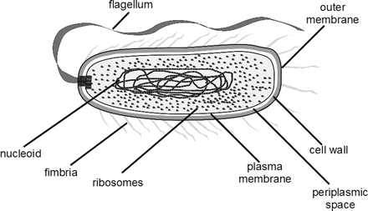

Figure 1: Typical diagram of Escherichia coli (Castro-Sowinski 2016)
Escherichia coli, the widely recognized natural intestinal tract flora of humans and animals, is not usually considered a pathogen of concern to its group( Bélanger, et al., 2011), but one unique group named Shiga toxin producing Escherichia coli (STEC) has been reported the most potential pathogen and can cause bloody diarrhoea and even death in some cases (Brooks et al., 2005) This STEC group is now prevalent worldwide, particularly serogroup O157: H7 which is the most prevalent strain responsible for the majority of infections caused by this group of E. coli (Leclerc et al., 2002). Known diseases caused by E. coli includes diarrhoea, acute diarrhoea, haemorrhagic colitis, urinary tract infections, and septicaemia (Levine, 1987; Nataro and Kaper, 1998). Escherichia coli is one of the faecal contamination markers of bacteria, suggesting the presence of coliform and other enteric bacteria that may contaminate food products. Its presence in food indicates the presence of other pathogen like E. coli O157:H7, Salmonella, Enterococcus, and several more (keeratipibul et al., 2009). In most cases, cattle are associated with Escherichia coli and considered as an essential reservoir of human pathogenic E. coli strains. Beef is the essential vehicle for this pathogen in Canada. 41% of food borne infections are estimated to be associated with ground beef (Greig and Ravel, 2009). The organism can spread commonly with the aid of beef, poultry meat, water, swimming in contaminated water and contact with cattle (Marcus, 2008). It has recently been studied that chicken sold on the markets may be unsafe for young women and may cause infection of the urinary tract, according to McGill University researcher (2010). E. coli present in these foods can cause common urinary tract Infections.
The E. coli species Based on the Kauffman classification system, is splited into serogroups and serotypes based on its 219 antigenic composition. (somatic or O antigens 220 for serogroups and flagellar or H antigens for serotypes) (Feng, 2013). There are 174 E. coli O and 53 E. coli H antigens that have been stated (Croxen et al., 2013). Most E. coli strains are commensal in the intestine, but a subset harbour virulence factors known as E. coli pathotypes, or pathogenic, diarrheagenic, or enterovirulent E. coli. These include enteropathogenic E. coli (EPEC), Shiga toxin producing E. coli (STEC), enteroinvasive E. coli (EIEC), enteroaggregative E. coli (EAEC), diffusely adherent E. coli (DAEC), and enterotoxigenic E. coli (ETEC), and also a new pathotype, adherent invasive E. coli (AIEC) (Croxen et al., 2013). Enterohemorrhagic E. coli (EHEC) is a subset of pathogenic STEC strains (Feng, 2013). The presence of the gene encoding Shiga toxins (stx 1 or stx 2), generally acquired 230 via a lambdoid bacteriophage, categorizes the strain as Shiga toxin-producing E. coli (STEC) or verocytotoxin-producing Escherichia coli (VTEC, Croxen et al., 2013). Shiga toxin-producing E. coli (STEC), including O157 and many non-O157 serogroups, are significant causes of foodborne illness. Although several outbreaks have been attributed to O157:H77 throughout the world About 400 serotypes of STEC are known to be involved in the disease. (Karmali et al., 2010)

2.3.1 PATHOTYPES OF E.COLI
Figure 2 Escherichia coli species and its sub species classification. (Wakeham, (2013)
The figure above highlights the overview of various pathogenic E. coli and other serotypes.

2.3.1.1 ENTEROPATHOGENIC E. COLI (EPEC)
Enteropathogenic E. coli was the first pathotype of E. coli to be identified (Bekal et al., 2003) The term enteropathogenic E. coli (EPEC) was stated by (Neteret al, 1955) to designate certain serotypes of E. coli that were associated with outbreaks of infantile diarrhoea. In 1987. Enteropathogenic E. coli (EPEC) targets the intestinal epithelium and produce a typical attaching and effacing (A/E) lesion (Moon et al., 1983).
Enteropathogenic E. coli (EPEC) is also known to be a potential foodborne pathogen, though surveillance for this diarrheagenic E. coli type is generally poor (Okeke 2009) Although the true link with food vehicles is uncertain, chicken and beef continue to be identified as common sources with occasional infections with this kind. Both enteroaggregative E. coli (EAggEC) and enterotoxigenic E. coli (ETEC) can also be associated with foodborne outbreaks albeit infrequently. The pathogenesis of EPEC involves intimin protein (encoded by eae gene) that causes attachment and effacing lesions (Hicks et al., 1998) and a plasmid-encoded protein referred to as EPEC adherence factor (EAF) that enables localized adherence of bacteria to intestinal cells (Tobe et al., 1999).

2.3.1.2 ENTEROTOXIGENIC E. COLI
Enterotoxigenic E. coli (ETEC) cause diarrhea without fever and it is distinctive from other Escherichia coli pathotypes through their production of enterotoxins. ETEC produces heat-labile (LT) and/or heat-stable (ST) enterotoxins (Nataro and Kaper, 1998). An ETEC strain is capable of expressing only an LT, only an ST, or both, and it may produce one or numerous colonization factors (CFs). Structurally and functionally, LT toxins are similar to cholera enterotoxin and are further divided into LT I (associated with humans and animals) and LT II(associated primarily with animals) (Spangler, 1992). There are many variants of ST, including ST1a and STb (Nataro and Kaper, 1998).

2.3.1.3 ENTEROHEMORRHAGIC E. COLI (EHEC)
Enterohaemorrhagic E. coli (EHEC) is characterized by verotoxin or Shiga toxin (Stx) production. The possession and expression of Stx strongly correlates with bloody diarrhoea and haemolytic uremic syndrome (Scheiring et al., 2008). EHEC has been linked with haemorrhagic colitis (HC) and haemolytic uremic syndrome (HUS) (Karmali, 2004). EHEC strains also hosts the locus for enterocyte effacement (LEE). Although more than 200 serotypes of E. coli can produce Stx, most of these serotypes do not harbour LEE. This has led to the use of Shiga toxin producing E. coli (STEC) or verotoxin producing E. coli (VTEC) as general terms for any Escherichia coli strain that produces Stx. EHEC, however, is used to denote only the subset of Stx positive strains that also contain LEE (Kaper et al., 2004).

2.3.1.4 ENTEROINVASIVE E. COLI (EIEC)
Enteroinvasive E. coli (EIEC) strongly resemble Shigella in their pathogenic mechanisms and the kind of clinical illness they develop. EIEC penetrates and multiplies inside the colon's epithelial cells, causing significant cell death. Dysentery-like diarrhoea with fever is a clinical manifestation. (Nataro and Kaper, 1998). Much of EIEC pathogenesis is the result of the multiple effects of its plasmid-borne type III secretion system secreting multiple proteins such as IpaA, IpaB, IpaC and IpgD (Sansonetti et al., 2000). The IpAH gene encoding the invasive plasmid antigen H is located on both the chromosome and the invasion plasmid (Dutta et al., 2001).

2.3.1.5 DIFFUSELY ADHERENT E. COLI (DAEC)
Diffusely adherent E. coli (DAEC) are types of EPEC that contain a characteristic, diffuse pattern of adherence to HEp-2 cell monolayers (Bilge et al., 1989). On the basis of this, two subclasses of DAEC strains have been proposed: diffusely adhering enteropathogenic E. coli (DA-EPEC) harbouring an LEE island (Beinke et al., 1998) and those DAECs expressing adhesins (draA-E and draP) of the Afa/Dr family (Nowicki et al., 2001; Berger et al., 2004).
DAEC is a heterogenous group that generates a diffuse adherence pattern on HeLa and HEp-2 cells and has been associated with the watery diarrhea that can become persistent in young children in both developing and developed countries as well as recurring urinary tract infections (Croxen and Finlay 2010, Servin 2005). The consequences of this persistence are unknown, but several observations have suggested a potential role in the development of chronic inflammatory intestinal disease (Servin A 2005). Phenotypic detection of DEAC is based on the mannose-resistant diffuse adhesion of these strains to cultured epithelial HEp-2 or HeLa cells (Nataro and Kaper 1998, Nataro et al., 1987, Bouzari et al., 1994).

2.3.1.6 ENTEROAGGREGATIVE E. COLI (EAEC)
This pathotypes is the most recently identified diarrheagenic E. coli and is the second most common cause of traveller’s diarrhoea after ETEC in both developed and developing countries (Sarantuya et al 2004). Enteroaggregative E. coli are commonly being recognized as a cause of endemic and epidemic diarrhoea worldwide and recently, it has been documented to cause acute diarrheal illness in new-borns and children in industrialized countries (Pawlowski et al., 2009). This organism has also been associated with persistent diarrhoea. Diarrhoea caused by EAEC is often watery, but it can be accompanied by mucus or blood (Croxen and Finlay 2010

2.3.1.7 MECHANISMS OF PATHOGENISIS IN PATHOGENIC E. COLI SEROVARS
The distinctive histopathology induced by enteropathogenic E. coli is termed attaching and effacing (A/E) lesions and is induced by the intimate adhesion of bacteria to the intestinal epithelial cells and effacement of enterocyte microvilli (Chen and Frankel 2005). Eae is one of the genes used for molecular diagnosis of EPEC at present. However, several aspects of the pathogenesis of these bacteria have not yet been completely unraveled and may include factors other than those directly responsible for A/E lesions as well as more specialized intestinal cells (Cravioto et al., 1979, Nataro et al., 1998, Jafari et al., 2012). Enterotoxigenic strains attach to intestinal epithelial cells using a heterogenous group of protein surface structures termed colonization factors (CFs) which can be fimbrial, non-fimbrial or fibrillar (Croxen MA, Finlay BB. 2010). The more recent nomenclature refers to these framework or structures as coli surface (CS) antigen, but some of the old names still persist such as colonization factor antigen I (CFA/I). Following the initial attachment and colonization, ETEC strains cause diarrhoea by producing heat-labile (LT) and/or heat-stable (ST) enterotoxins, that are plasmid-encoded (Johnson and Nolan 2009). ETEC bacteria produces the small STs as a 72-amino acids preprotoxin which is processed into an 18-19 amino acid active toxin called STa and a 42 amino acid toxin referred to as STb. STa is produced by both human and animal strains, whereas STb is mainly detected in strains of veterinary origins (Nagy and Fekete 2005).
Shiga toxin family with related structure and similar biological activity comprises of Stx1 which is highly comparable to the toxin of Shigella dysenteriae differing in a single amino acid and Stx2 with less than 60% amino acid homology to Stx1 (Beddoe et al., 2010, Caprioli et al., 2005). Shiga toxins is analogous to the heat-labile enterotoxin of ETEC belonging to the AB5 family of the toxins and consist of a pentameric ring-shaped B subunit that is non-covalently attached to the A subunit. Globotriaosylceramides (Gb3s) interact with the B subunit on the surface of human intestinal mucosa and kidney epithelial cells, resulting in toxin internalization. where the A subunit is activated causing cell lysis (Croxen and Finlay. 2010). The characteristic attaching and effacing lesions (A/E) are triggered by this intimate attachment, but the initial adhesion of EHEC to colonocytes is not well established. (Croxen and Finlay BB. 2010, Johnson and Nolan 2009, Viazis and Diez-Gonzalez 2011, Caprioli et al., 2005). The ability of STEC to produce A/E lesions is sufficient to cause non-bloody diarrhoea but Shiga toxin is essential for the development of bloody diarrhoea, HC, and HUC (Savarino et al., 1994). Another toxin found in many STEC/EHEC isolates is the enteroaggregative heat-stable enterotoxin1 (EAST1) and usually two copies of the astA gene is present in the chromosome (Nataro and Kaper 1998, Viazis and Diez-Gonzalez 2011). The significance of this carriage in the pathogenesis of EHEC is unclear, but it has been suggested that some of the non-bloody diarrhoea in person infected with these strains might be due to the production of this toxin (Nataro and Kaper 1998, Xicohtencatl-Cortes et al., 2009)
The lack of adequate animal models and the heterogeneity of virulence factors have contributed to a lack of information on the transmission, pathogenicity and epidemiology of the enteroaggregative E. coli. However, the main characteristics of EAEC pathogenesis are colonization of intestinal mucosa, the development of mucoid biofilms and the elaboration of various enterotoxins, cytotoxins and mucosal inflammation. (Huang et al., 2006 Weintraub 2007, Boisen et al., 2009, Croxen and Finlay 2010). Intestinal mucosa colonization by the EAEC occurs through aggregative adherence fimbriae (AAF) encoded by a 55-65 MDa plasmid named pAA. (Scaletsky IC 1984, Czeczulin et al., 1997). Though two other adherence factors (AAF/III and AAF/IV) as well as a non-fimbrial adhesin have been identified, some strains that do not contain any of these recognized fimbriae have been found despite showing an AA phenotype that is predictive of the adhesins that are not yet characterized. (Monteiro-Neto et al., 2003, Boisen 2008, Aslani et al., 2011), EAEC adhesion to intestinal tissue is mediated by antigenically heterogeneous adhesins, similar to ETEC strains, and multiple carriage of AAFs by the EAEC strain has been unusual. (Bouzari et al., 2005, Nataro et al., 1994

2.3.2 BACKGROUND OF SALMONELLA
Salmonella is present naturally in the ecosystem and in cats, dogs, amphibians, reptiles, and rodents, including both domestic and wild animals. It is usually found in poultry entrails, where the health of the bird may be endangered in some cases. (McMullin, 2004, Park et al., 2017). Salmonella is gram negative (G-ve) bacterial pathogen with a wide variety of hosts and belongs to Enterobacteriaceae family (Raghunathan et al., 2009). Bacteria belonging to the Salmonella genus were named after doctor of veterinary medicine Daniel Elmer Salmon, who along with his assistant, Mr. Theobald Smith, in the process of searching for causes of cholera prevalent in hogs, isolated in 1885 a new species of bacteria—Bacillus cholerasuis, renamed to Salmonella enterica serovar Cholerasuis (Fàbrega, and Vila, 2013, Li et al., 2013). Salmonella is comprised of two species Salmonella enterica which is further divided into 6 subspecies and Salmonella bongori. The body antigenic classification is based on somatic ―O‖, flagellar ―H‖, and capsular ―K‖ antigens. Salmonella typhi and paratyphoid are serotype, It is mainly responsible for inducing enteric fever in humans. It is able to grow from 7 oC to 37 oC (Lake et al., 2002). There are approximately 2500 different Salmonella serotypes present in various sources, such as food, animals and the environment. Typhimurium, Newport, Javiana, Enteritidis and Heidelberg are commonly found in kids. Reptile and Salmonella interactions are now well-known and dangerous for toddlers who have close contact with reptiles in their homes. (Marcus, 2008). The Salmonella genus is a member of the family of Enterobacteriaceae and includes Gram-negative, flagellated, non-sporulating and facultative bacteria that grow well between 35 and 37 °C. (Ricke et al., 2013). Salmonella ingestion can lead to Salmonellosis.
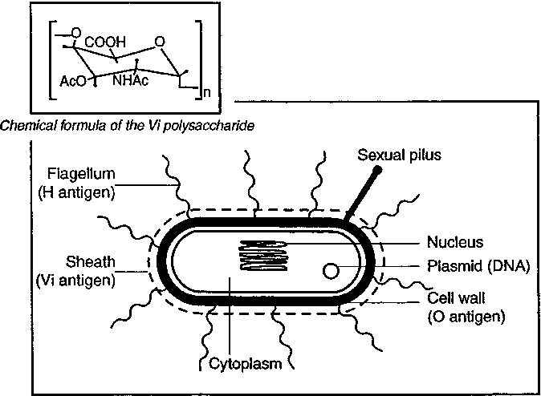
Figure 3: Structure of Salmonella typhi; source: (Hessel et al., 1999)

2.3.2.1 EPIDEMIOLOGY OF SALMONELLA
Salmonellosis and other illnesses are caused by this bacterium. Salmonellosis is one of the world's most common foodborne diseases, accounting for about 93.8 million foodborne diseases and 155,000 deaths worldwide each year. (Eng et al., 2015). U.S. statistics account for more than a million people with Salmonellosis per year and poultry was the pathogenic vehicle in nearly 20 percent of these cases. (Hoffmann et al., 2015).
Almost 95% of human salmonellosis is reported to be associated with the ingestion of contaminated products of animal origin, such as meat, poultry, eggs, milk, seafood, and fresh produce. (Foley and Lynne, 2008). Uncooked or inadequate cooking of meat leads to the pathogen being transferred by food. Salmonella can be obtained from uncooked chicken near bones, (Canadian Paediatric Society, 2008). Food is an important infection route for salmonella including those that are resistant. (European Food safety Authority 2006). Salmonella enterica Enteritidis or S. enterica other than Enteritidis or Typhimurium has been associated with a variety of food vehicles varies from area to area (Gordon et al., 2008). Majority of the zoonotic pathogens are transmitted by animal-based food origin (Dhama et al., 2013). Meat industries especially poultry meat is becoming common as vital source of meat in various countries, broiler chicken is one of the main types (Gerbens-Leenes et al., 2013). Broiler chicken carcasses and meat become infected with Salmonella during its slaughtering processing and even during sale on the outlets (Shafini et al 2017). In several regions, Salmonella is the primary cause of foodborne infection associated with egg and poultry contamination. (WHO / FAO. 2001). (Panisello 2000) has reported the correlation of outbreaks of Salmonella species with food of animal origin and its improper cooking, storage and cross-contamination from infected instruments to food or food to food often contributes to promoting outbreaks of Salmonella (Panisello et al., 2000). Poultry and meat are known to be an effective primary Salmonella pathogen vehicle for the human population, and caused pandemic by Salmonella agona and Salmonella hadar in 1970s and 1980s associated to poultry (Sumner et al., 2004).

2.3.2.2 SEROVARS OF SALMONELLA
There are 2 major species of Salmonella: S. enterica and Salmonella bongori. S. bongori comprises 22 serotypes that are mainly linked with cold-blooded animals, and human infections are not common (Lamas, et al 2018). S. enterica is divided into 6 subspecies (enterica, salamae, arizonae, diarizonae, houtenae, and indica) because of the variations in biochemical characteristics (Grimont and Weill, 2007). The subspecies enterica is responsible for more than 99% of human salmonellosis, and it includes 1,531 serotypes among which are Salmonella typhimurium and Salmonella enteritidis (Lamas et al, 2018). Humans are the only reservoir of typhoid Salmonella, caused by Salmonella Typhi and Salmonella Paratyphi (Eng et al., 2015). The figure below highlights the serovars of salmonella;

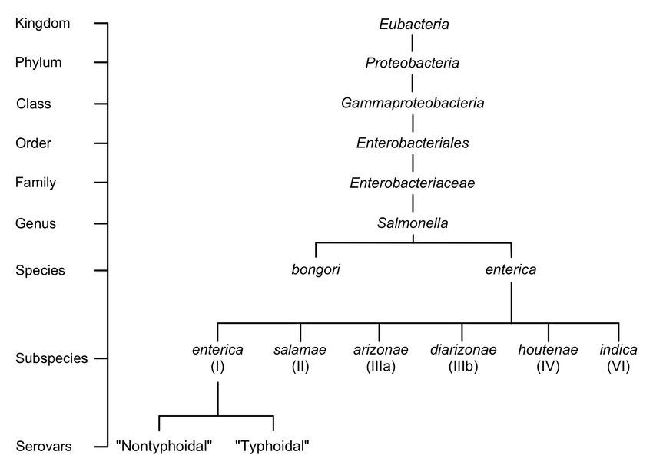
Figure 4 Prevalent serovars of salmonella; source: (Mackenzie et al., 2017)

The rest of Salmonella serovars are known as non-typhoidal, where the animals are the major reservoir (Eng et al, 2015). S. enterica, subsp. Enterica serotypes are predominantly associated with warm-blooded animals, while the other non-enterica subspecies are more closely associated with cold-blooded animals, although some exceptions have been reported. (Lamas et al., 2018). The occurrence of non-typhoid diseases caused by Salmonella varies between countries.; For example, 690 cases per 100,000 population are estimated to be caused in Europe, while in Israel, non-typhoid Salmonella infection is estimated to be about 100 cases per 100,000 annually. (Eng et al., 2015). Salmonella typhimurium is the world's most prevalent serovar and is linked to foodborne outbreaks in developed and high-income countries. (Mohammed, 2017). Although there are variations in the most frequently isolated serovars among regions, the differences are not significant between countries within the same region (Hendriksen et al., 2011).

2.3.2.3TRANSMISSSION OF SALMONELLA
Non-typhoidal Salmonella infection can be transmitted to humans through the ingestion of food or water contaminated by waste from infected animals, through direct contact with infected animals or through the intake of food from infected animals. (Eng et al., 2015). This bacterium has been isolated from a wide variety of species: poultry, ovine, swine, fish and seafood and their food products, as well as from other cold-blooded animals. (Nguyen et al., 2016; Flockhart et al., 2017, Zajac et al., 2013). The food sources most widely reported as responsible for outbreaks of salmonellosis are typically poultry, meat products, and eggs. (Sanchez et al., 2002). Salmonella thyphimurium has been associated mainly with the ingestion of undercooked meat or ground beef and milk products, and especially raw eggs (Heredia and García 2018.)
Salmonella asymptomatically colonizes the intestines of poultry, especially chicken and turkeys. As a result of bacteria being spread horizontally or vertically at the stage of primary production, (Antunes et al., 2016, Dunkley et al., 2009). The horizontal pathway of infection includes contaminated feed and water, as well as bedding, soil, air, and farm personnel (Nidaullah, et al., 2017, Singh, et al., 2013). The vertical pathway includes direct infection of offspring by its flock (Sivaramalingam et al., 2013, Nidaullah et al., 2017). Salmonella may be present in as much as 65% of individuals in a flock. Depending on the geographical position and the period of the year, serotypes colonizing the poultry gastrointestinal system differ and some of them are repeatable. (e.g., S. Enteritidis, S. Typhimurium) (Nidaullah et al., 2017, Barua et al., 2013, Saravanan et al., 2015). In contrast to unregulated intestinal transmission and colonization, Salmonella may also be transmitted to the liver, spleen, and ovaries. (Dunkley et al., 2009) Serotypes of S. Gallinarum and S. Pullorum are pathogenic to poultry, but not to humans. However, they cause significant losses in the poultry industry (Andino, and Hanning 2015). Many strains isolated from poultry show resistance to selected antibiotics and are responsible for food poisoning in humans. Much attention is also paid to eggs and poultry meat as sources of Salmonella bacteria. (Saravanan et al., 2015). Infected birds are the primary source of Salmonella spp. and infection in the production environment. At any point of the production line, bacteria may be introduced and cause the finished product to be contaminated. (Nidaullah et al., 2017, Kallapura et al., 2014). In addition, eggs can also be environmentally contaminated, and pathogenic bacteria can not only be found on the surface of an egg shell, but also penetrate the inside of the egg shell. (Whiley et al., 2017).
Acquisition of the invasive plasmid (pINV) encoding the ability to invade host tissues (Silva et al., 1980, Hale et al., 1983, Harris et al., 1982, Parsot 2005 ) is probably the single most important event that has probably given rise to the evolution of both Shigella and EIEC from non-pathogenic E. coli In addition to the genes of pINV many chromosomal genes which are not specific to Shigella spp. and are carried on the chromosome are required for pathogenesis (Sansonetti, PJ 1992).

2.3.2.4 PATHOGENICITY OF SALMONELLA
The United States is estimated to have more than a million cases of salmonellosis a year. Nearly 20,000 need hospitalization and there are around 400 cases of death due to Salmonella infection. (Anderson et al., 2016, Jiang et al 2015)s. Pathogenic Salmonella virulence is associated with both chromosomal and plasmid genes. (Chaudhary et al., 2015). There are large gene cassettes in the bacterial chromosome, called pathogenicity islands (SPIs), that code nearly 60 genes responsible for specific interactions with the host organism. (Chaudhary et al., 2015, Lahiri et al., 2010). The infection process of Salmonella spp begins after microbes are ingested. The bacteria invade the small intestine through the stomach. The pathogenicity of Salmonella spp. depends on the serotype and the host’s immunity, and its virulence is determined by the factors presented in Table 1 (Figueiredo et al., 2015, Ingram 2017).
Three forms of salmonellosis are caused by pathogenic bacteria that belong to the genus Salmonella. in humans: non-invasive and nontyphoid, invasive and nontyphoid, and typhoid fever caused by the serotype S. typhi, as well as paratyphoid fever caused by two serotypes S. paratyphi A, B, and C (Kurtz et al., 2017, Snider et al., 2014). Serotypes that cause typhoid fever are transmitted between individuals without animal vector mediation. (McSorley 2014). Food or water may be associated with infection, and the presence of such bacteria is closely linked to poor hygiene. Spread is affected by overpopulation in areas with poor sanitary conditions. (Kanj et al., 2015). It's difficult to state the exact number of cases of typhoid fever. The global occurrence is thought to reach as high as 21 million a year with over 200,000 fatal cases. (Kurtz et al., 2017, Pham and McSorley 2015). In Africa, Southeast and Central Asia, the highest number of cases of typhoid fever has been reported. (Andino et al., 2015, Shukla et al., 2014). Clinical manifestations include headache, fever, diarrhea or constipation, stomach ache, and loss of appetite., but other possible symptoms are: respiratory problems, lethal neurological changes, perforation of the intestine, and hepatic and splenic injury (Fàbrega and Vila 2013, Antillón et al., 2017 ). Pathogens enter the organism via water or food contaminated with faecal microbiota. The environment is therefore an important vector for the spreading of Salmonella spp. (Andino and Hanning 2015, Kurtz. et al 2017, Wiedemann et al 2015).

 | DESCRIPTION | REFERENCES
Adherence to host’s cells | Adherence modulated by:  -Fimbriae (protoplasmic outgrowths) – proteins interacting with the host’s receptors on the tips  -Adhesins (proteins ) : BapA, SiiE, Shd A, MisL and Sad A  - Flagellae (up to 10 randomly distributed over the cell surface) – mobility of the cell may indirectly facilitate adhesion | Foley et al., 2013 Wiedemann et al., 2015, Figueiredo et al., 2015
Invasion and replication inside host cell’s | - after binding the pathogen to host’s cells;  - transmission of effectors to the cytosol of the infected cell. Effectors stimulate the cell’s signalling system through the type III secretion.  - secretion system coding genes are localised on SPIs;  - effector proteins responsible for invasion and replication of Salmonella spp. influence also the survival and stimulated production of proinflammatory cytokines (development of infection). | Bierschenk et al., 2017, Lahiri et al., 2010, Ramos-Morales et al., 2012, Sun et al., 2016
Polysaccharide coating | - the superficial part of the membrane bilayer of Gram-negative bacteria is composed almost entirely of lipopolysaccharides (LPS);  - Lipid A—the lipid part of the external lipopolysaccharide layer, causes various immunological responses of the host organism (e.g., activation of the complex of toll-like receptors 4-MD2-CD14, which leads to expression of proinflammatory molecules or adhesion proteins). | Chessa et al., 2014, Kawasaki et al., 2012, Nobre et al., 2015, Van Asten et al .,2005.
Production of toxins | - endotoxins (lipid A);  - exotoxins (cytotoxins and enterotoxins). | Giannella, (Medical Microbiology chap 21) Kawasaki et al 2012, , Nobre ., et al 2015, Van Asten et al., 2005.

Table 1: factors determining the virulence and salmonella genus bacteria

2.3.3PREVENTIONS AND CONTROL OF ENTEROPATHOGENS
Prevention of enteropathogens is not easy; it is possible to prevent and monitor animal habouring enteric bacteria. It is recognized that certain simple steps are effective in reducing the risk of infection. ( Dhama et al., 2013; DuPont, 2007; EFSA, 2013; Sofos, 2008); and it is imperative that the following measures are applied in farms and processing plants in order to reduce contamination with Salmonella.
- Reducing the burden of infection on farms by increasing hygiene and separating sick and healthy animals.
- Avoid the cross-contamination.
- Take precautionary measures to check for pathogen spread in the farm and processing environments.
- Judicious use of antibiotics for treating animal diseases.
- Application of sublethal multiple hurdles in the food processing and preservation.
- Proper cooking of the food products.
- Avoid the consumption of raw or undercooked animal products

CHAPTER THREE

3.0 Materials and Methods

3.1 Description of Study Area
The study site was Ofada Makoloki market which is located in Obafemi-Owode Local government area in Ogun State and is one of the many towns around the state that share a close proximity with the ever-bustling Lagos. Magboro, a name that is said to mean ‘spreading out’, has definitely grown in population compared to over a decade ago. A town once occupied by only the natives is now an urban settlement with a population estimated to be over a million inhabitants and still growing. In the market at Magboro, everything needed is mostly sold in these markets because the market is situated closely to Lagos-Ibadan expressway (Link between Ibadan, capital of Oyo state and Lagos) which is a compulsory route for travelers by road.

3.2 Collection of Samples
Samples of suya were bought, meat suya gotten from animals like goat, sheep, cow etc. and gizzard suya gotten from poultry, at random from different street vendors at popular spots in Magboro market. The suya meat samples were to the laboratory aseptically for identification and microbial analysis.

3.3 Materials and Equipment Used
Materials used: Petri-dishes, beakers, conical flasks, hockey stick, measuring cylinder, Eppendorf tubes, micro pipette (with their tips), test tubes (with their racks), spatula, filter paper, inoculating loop, wash bottles.
Equipment used: Autoclave, incubator, weighing balance, thermal cycler, centrifuge, stomacher blender, distiller, Lamina air flow cabinet, Magnetic stirrer water bath (set at 50°C and 100°C), Bunsen burner.

3.4 Media Used

3.4.1 Peptone Water
Peptone water is a microbial growth medium composed of peptic digest of animal tissue and sodium chloride. The pH of the medium is 7.2±0.2 at 25 °C and is rich in tryptophan. Peptone water is also a nonselective broth medium which can be used as a primary enrichment medium for the growth of bacteria.

Preparation
1. The dehydrated medium was dissolved in the appropriate volume of distilled water to make up 0.1% and 1% peptone water based on manufacturer’s instruction’s instructions in a conical flask and mixed thoroughly.
2. The mixture was heated for a while to dissolve the powder completely and was then sterilized by autoclaving at 121°C for 15mins.
3. 9ml of the 0.1% was then dispensed into various test tubes for serial dilution.
4. 225ml of the 1% was then dispensed into conical flask.

3.4.2 SORBITOL-MACCONKEY AGAR (SMAC)
Sorbitol MacConkey agar is a selective and differential media used for detecting sorbitol non-fermenting Escherichia coli O157: H7.
Preparation
- 50g of the medium was suspended in 1000ml distilled water and mixed thoroughly.
- The mixture was heated with frequent agitation to completely dissolve the powder and autoclaved at 121^{O}C for 15minutes.
- The agar was allowed to cool to 45^{O}C and poured aseptically into sterile petri dishes and left to solidify.

3.4.3 MACCONKEY AGAR
MacConkey Agar is used for gram-negative enteric bacteria isolation and lactose fermentation differentiation from non-lactose fermenting bacteria and lactose fermenting bacteria.
Preparation
- 48.5g of the medium was suspended in 1000ml distilled water and mixed thoroughly.
- The mixture was heated with frequent agitation to completely dissolve the powder and autoclaved at 121^{O}C for 15minutes.
- The agar was allowed to cool to 45^{O}C and poured aseptically into sterile petri dishes and left to solidify.

3.4.4 NUTRIENT AGAR
Nutrient agar is a general-purpose nutrient medium used for cultivation of microbes supporting growth of a ride range of non-fastidious organisms.
Preparation
- 28g of the medium was suspended in 1000ml distilled water and mixed thoroughly.
- The mixture was heated with frequent agitation to completely dissolve the powder and autoclaved at 121^{O}C for 15minutes.
- The agar was allowed to cool to 45^{O}C and poured aseptically into sterile petri dishes and left to solidify.

3.4.5 EOSIN METHYLENE BLUE (EMB AGAR)
Eosin methylene blue agar is a differential medium used to isolate coliforms. It provides a color indicator distinguishing between organisms that ferment lactose (e.g., E. coli) and those that do not (e.g., Salmonella, Shigella).
Preparation
- 36g of the medium was suspended in 1000ml distilled water and mixed thoroughly.
- The mixture was heated with frequent agitation to completely dissolve the powder and autoclaved at 121^{O}C for 15minutes.
- The agar was allowed to cool to 45^{O}C and poured aseptically into sterile petri dishes and left to solidify.

3.4.6 POTATO DEXTROSE AGAR (PDA)
Potato dextrose agar is a general purpose medium for yeasts and molds that can be supplemented with acid or antibiotics like Chloramphenicol, Tartaric Acid and Chlortetracycline can be added as selective agents and to inhibit bacterial growth.
Preparation
- 39g of the medium was suspended in 1000ml distilled water and mixed thoroughly.
- The mixture was heated with frequent agitation to completely dissolve the powder and autoclaved at 121^{O}C for 15minutes.
- The agar was allowed to cool to 45^{O}C and poured aseptically into sterile petri dishes and left to solidify.

3.4.7 XYLOSE LYSINE DEOXYCHOLATE AGAR (XLD AGAR)
Xylose Lysine Deoxycholate Agar is a selective growth medium used for the isolation of Salmonella and Shigella spp. From clinical and food samples.
Preparation
- 57g of the medium was suspended in 1000ml distilled water and mixed thoroughly.
- The mixture was heated with frequent agitation to completely dissolve the powder.
- It was transferred to the water bath at 50^{O}C. it is not to be autoclaved as instructed by the manufacturer.
- The agar was allowed to cool to 45^{O}C and poured ascetically into sterile petri dishes and left to solidify.

3.4.8 SELENITE F BROTH
Selenite F Broth is the medium used for the selective enrichment of Salmonella spp from both clinical and food samples. It is a buffered Lactose Peptone Broth to which Sodium Biselenite is added as the selective agent.
Preparation
1. 19g dehydrated media of selenite F was dissolved in 750 ml distilled water in a sterile conical flask. (Part A)
2. 4g of sodium biselenite was dissolved in 250ml distilled water in another conical flask. (PartB).
3. PART A and PART B was mixed together and heated to dissolve the medium completely. Distribute in sterile test tubes
4. It was then sterilized in a water bath or free-flowing steam for 10mins. It is not to be autoclaved as instructed by the manufacturer.

3.5 Sample Preparation
Twenty-five (25 g) of each suya samples was weighed into a sterile stomacher bag containing 225 ml of 1% buffered sterile peptone water and blended in a stomacher machine set at 180 rpm (revolution per minute) for 4 minutes to form a homogenate of the food sample and was incubated at 37^{O}C for 24hours. The resultant homogenate was diluted serially up to 10⁻⁴.

3.6 ISOLATION OF E.COLI, COLIFORMS AND TOTAL VIABLE COUNT
Twenty-five gram (25 g) of each suya samples was weighed into a sterile stomacher bag containing 225 ml of 1% buffered sterile peptone water. The mixture was diluted serially up to 10^{-4.} From the appropriate dilutions, 0.1 ml was plated in duplicate onto SMAC Agar, EMB Agar, MAC Agar an Nutrient Agar for the isolation of enteropathogenic E.coli, coliforms and for the Total viable count the using the spread plate technique. The plates were incubated at 35^{O}C- 37^{O}C for 18- 24 hours.

3.6.1 ISOLATION OF YEAST AND MOULD
Twenty-five gram (25g) of the samples were added to 225ml of 1% buffered peptone water obtaining the initial dilution of 10⁻¹. Further 10-fold dilutions up to 10⁻⁴ were prepared in peptone water. Aliquots (0.1 ml) of each dilution was plated on PDA and spread out using a glass spreader. The plates were inverted and kept at 25^{O}C for 2 days. Yeast appear as creamy and white colonies while Mould appear as filamentous colonies.
NOTE: PDA was modified with 25mg of chloramphenicol to inhibit the growth of bacteria.

3.6.2 ISOLATION OF SALMONELLA SPP.
Primary enrichment
Twenty-five gram (25g) of the samples was aseptically added to 225ml peptone water which was subjected to 3 different dilution factors starting with the original 10¹-10⁴ using serial dilution method.
Secondary Enrichment
One ml (1ml) from the pre-enrichment broth was inoculated into 9ml of Selenite F Broth contained in test tubes and was incubated at 37^{O}C for 24hours to allow selective enrichment for Salmonella spp. This enrichment was peculiar to Salmonella alone. After incubation, the test tubes were vortexed and a loopful of the incubated selenite F broth was streaked unto Xylose lysine deoxycholate agar. The plates were inverted and incubated at 37^{O}C for 24hours. The plates were examined for typical Salmonella colonies.
Sub Culturing
The plates were checked after the required duration for the growth a sub-culturing needs to be done. Sub culturing was done to purify the isolated bacterial colonies from a mixed culture to a new and single culture, the bacterial isolates transferred or sub-cultured were those were differentiated on the basis of their colony morphology, shape, color, elevation and other physical characteristics.
Presumptive colonies obtained after incubation were sub- cultured unto fresh nutrient agar plates using the streaking method procedure by taking a loopful of preferred isolate using the inoculating loop (the inoculating loop is heated using the Bunsen burner and allowed to cool for like 5 seconds before taking the loop from the original mixed culture and streaked onto the new petri-dish). The plates were inverted and incubated at 37^{O}C for 18- 24 hours.

3.7 PRESERVATION OF ISOLATES
A loopful of each isolate was inoculated into a sterile Eppendorf tube containing 1ml of brain heart infusion and 500ul of 20 % sterile glycerol as cryoprotectant and it was stored in a -4⁰c freezer.

3.8 MOLECULAR CHARACTERIZATION OF ISOLATES

3.8.1 DNA Extraction
Boiling method
Each isolate was streaked out on nutrient agar and incubated overnight at 37⁰C. The loopful actively dividing cells were emulsified in 500ml double distilled water until it was turbid, it was centrifuged at 14,000 RPM for 5 minutes and the supernatant was decanted, 1ml of sterile water was added to the Eppendorf tube, vortexed and centrifuged again at 10,000RPM for 2 minutes the process was repeated twice, 200ul of sterile water was pipetted into the Eppendorf tube, vortexed and centrifuged at 14,000RPM for 5 minutes and then it was placed in the heating block to boil for 10-20 minutes, it was then placed in the fridge for a while, the content of the Eppendorf tube was then vortexed and centrifuged finally at 14,000RPM for 5 minutes, a new set of Eppendorf tubes were labelled and the supernatant containing the extracted DNA was then transferred into the new Eppendorf tubes and they were placed in racks and stored in the freezer for further use.

3.8.2 PCR Protocol
16S rRNA amplification
Partial 16S rRNA gene amplification using forward primer fD1 (5´-AGA GTT TGATCC TGG CTC AG-3´) and reverse primer rD1 (5´-AAG GAG GTG ATC CAG CCG CA-3´) (Weisburg et al., 1991). The components of the PCR and constituent mixes were summarized in Table 3 below. The PCR was carried with initial denaturation at 95°C for 5 min; 35 cycles of 95°C for 2 min; 42°C for 30 s and 72°C for 4 min; and a final elongation step at 72°C for 10 min. The PCR products were confirmed by electrophoresis and visualized under UV light with a Gel
Doc system (Cleaver Scientific Ltd,Warwickshire, United Kingdom)

Table 2: PCR REACTION COMPONENTS USED FOR 16S RRNA AMPLIFICATION
No. | Component | 1 rxn
1 | Mastermix | 5ul
2 | fD1 | 0.4ul
3 | rD1 | 0.4ul
4 | DNA | 2ul
5 | dH₂O | 2.2ul
6 | Total | 10ul

Table 3: MULTILEX PCR PROTOCOL
No | Component | 1 rxn
1 | Master mix | 7.5ul
2 | STX1F | 0.186ul
3 | STX1R | 0.186ul
4 | STX2F | 0.186ul
5 | STX2R | 0.186ul
6 | EAEF | 0.186ul
7 | EAER | 0.186ul
8 | DNA | 2ul
9 | dH₂O | 4.36ul

Table 4: PROCEDURE FOR THERMALCYCLER
Analysis | Step | Temperature | Time
1x | Initial denaturation | 95⁰c | 5 min
35x | Denaturation | 95⁰c | 2 min
 | Annealing | 42⁰c | 30 sec
 | Polymerization | 72⁰c | 4 min
1x | Final polymerization | 72⁰c | 10 min
1x | Hold | 4⁰c | ∞
Cycler

3.8.3 AGAROSE GEL ELECTROPHORESIS
The agarose was prepared using dry agarose powder, 1g of the agarose powder was then dissolved in 50ml of TAE buffer the mixture was then boiled until a clear solution was gotten 3ul of ethidium bromide was added to the mixture using a micropipette it is swirled and left to cool but not solidify, the content of the flask is then transferred into the gel cast with the combs in place, after, it is left to solidify and the gel is gently removed and put in an electrophoresis tank containing TAE buffer. 4ul of the PCR products are then pipetted into each well that was formed after removing the comb. The tank is connected to the power pack and left to run till it gets to one-third of the gel and then it is turned off and the gel is viewed under the UV transilluminator.
PRECAUTIONS
• Aseptic techniques were observed at every stage of work.
• Personal protective technique was also observed, such as wearing of covered shoe, nose cover, gloves, lab coat, etc.
• Ensured that the inoculating loop cooled before picking the organism when sub-culturing in order not to kill organism of interest.
• Ensured that the petri-dish was incubated inverted.
• Ensured proper timing, most especially during autoclaving.

CHAPTER FOUR

4.0 RESULT AND DISCUSSION
The purpose of this study is to establish the prevalence of common food-poisoning pathogens in selected street-vended meat. The result findings were summarized in the tables below in Table 5, 6 and 7 which shows the Morphological characteristics of samples cultured on Eosin methylene blue, Xylose lysine deoxycholate and Sorbitol-MacConkey Agar, Nutrient Agar and Potato dextrose Agar. However, Salmonella was not detected in the food samples which was cultured on XLD agar. While figure shows the results of Escherichia coli, Yeast and mould and Total viable count grown on Eosin methylene blue, Xylose lysine deoxycholate, Sorbitol-MacConkey Agar, Potato dextrose Agar and Nutrient Agar.
This study shows the presence of Yeast and mould and pathogenic E. coli found in street vended suya. The presence of the of these microorganisms can be as a result of unhygienic work place, lack of proper hygiene of the vendors, use of unhygienic equipment for food preparation etc. Their presence in ready-to-eat food renders it unfit and unsafe for consumption by humans. There is need for monitoring of this nutrition products by educating processors and consumers on good sanitary practices during processing displaying and sale of the products and the possible danger of contaminated products.

Samples | Isolate ID | Color | Shape | Size | Elevation | Appearance | Texture | Opacity | Margin
Meat suya | S1 EMB | Green metallic sheen | Circular | Moderate  Large | Raised | Shiny | Smooth | Opaque | Entire
 | S1 SMAC | Pink  White | Circular | Puntiform  Moderate | Raised | Shiny | Smooth | Opaque | Entire
 | S1 XLD | Yellow | Circular | Large | Raised | Shiny | Smooth | Opaque | Entire
Gizzard suya | S2 EMB | Green metallic sheen | Circular | Small  Moderate | Raised | Shiny | Smooth | Opaque | Entire
 | S2 SMAC | Pink  White | Circular | Small | Raised  Flat | Shiny | Smooth | Opaque | Entire
 | S1 XLD | Yellow | Circular | Large | Raised | Shiny | Smooth | Opaque | Entire
Table 5 Morphological characteristics of bacterial isolates on Eosin methylene blue, Xylose lysine deoxycholate and Sorbitol-MacConkey Agar

Table 6. Morphological characteristics of bacterial isolates on Potato dextrose agar

Sample | Isolate ID | Colour | Shape | Size | Elevation | Appearance | Texture | Opacity | Margin
Meat suya | S1 PDA 1 | White  Creamy | Circular  Irregular  Filamentous | Small  Moderate  Large | Raised | Shiny | Smooth | Opaque | Entire
 | S1 PDA 2 | White  Creamy | Circular  Irregular  Filamentous | Puntiform  Moderate  Large | Raised  Flat | Shiny | Smooth | Opaque | Entire
Gizzard suya | S2 PDA 1 | Green metallic sheen | Circular  Filamentous | Small  Moderate  Large | Raised | Shiny | Smooth | Opaque | Entire
 | S2 PDA 2 | Pink  White | Circular  Irregular  Filamentous | Small  Moderate | Raised | Shiny | Smooth | Opaque | Entire

Sample | Isolate ID | Colour | Shape | Size | Elevation | Appearance | Texture | Opacity | Margin
Meat suya | S1 NA | White | Circular | Small  Moderate  Large | Raised | Shiny | Smooth | Opaque | Entire
Gizzard suya | S2 NA | White | Circular | Small  Moderate  Large | Raised | Shiny | Smooth | Opaque | Entire
Table 7:Morphological characteristics of bacterial isolates on Nutrient Agar

The results of Escherichia coli, Yeast and mould and Total viable count grown on Eosin methylene blue, Xylose lysine deoxycholate, Sorbitol-MacConkey Agar, Potato dextrose Agar and Nutrient Agar.
The results of Escherichia coli, Yeast and mould and Total viable count grown on Eosin methylene blue, Xylose lysine deoxycholate, Sorbitol-MacConkey Agar, Potato dextrose Agar and nutrient agar.

Figure 5: Chart of microbial analysis showing the counts of coliforms and pathogenic E. coli (STEC) in Suya sample collected from Magboro market, Ogun State.

According to SANS 2011, the microbiological specification for coliforms, E. coli and Salmonella should be <2, <1 and 0/25g respectively. Salmonella was absent in 25g of the suya sample examined. This places the sample on an acceptable but not satisfactory range as E. coli was identified in the sample. The incidence of foodborne pathogens in suya are of growing concern since it is widely consumed by among people.
Keys:
S1: Sample 1 (Meat Suya)
S2: Sample 2 (Gizzard Suya).

Figure 6: Chart of microbial analysis showing the counts of yeasts and mold in Suya sample collected from Magboro market, Ogun State.

Keys:
S1: Sample 1 (Meat Suya)
S2: Sample 2 (Gizzard Suya).
The microbiological specification for Yeasts and Moulds in dried meat products should be < 3 cfu/g (SANS, 2011). Some species of Aspergillus are known to produce powerful mycotoxins which are harmful to man (Zain 2011), thus their occurrence in suya is undesirable. The presence of moulds could have come from contaminated spices used and wrapping with contaminated wrap before serving (Shamsudeen and Oyeyi, 2008).

.

Figure 7: Microbial count in Suya from Magboro market, Ogun State.
Keys:
S1: Sample 1 (Meat Suya)
S2: Sample 2 (Gizzard Suya).

The Total viable count (TVC) in dried meat products should be less than 6 log cfu/g (SANS, 2011). The TVC for S1 was moderately higher than the microbial specification with a count of 6.2 log10 cfu/g. Although S2 has a count of 5.9 log10 cfu/g, it should not be considered safe as the microbial load present is likely to cause illness to consumers.

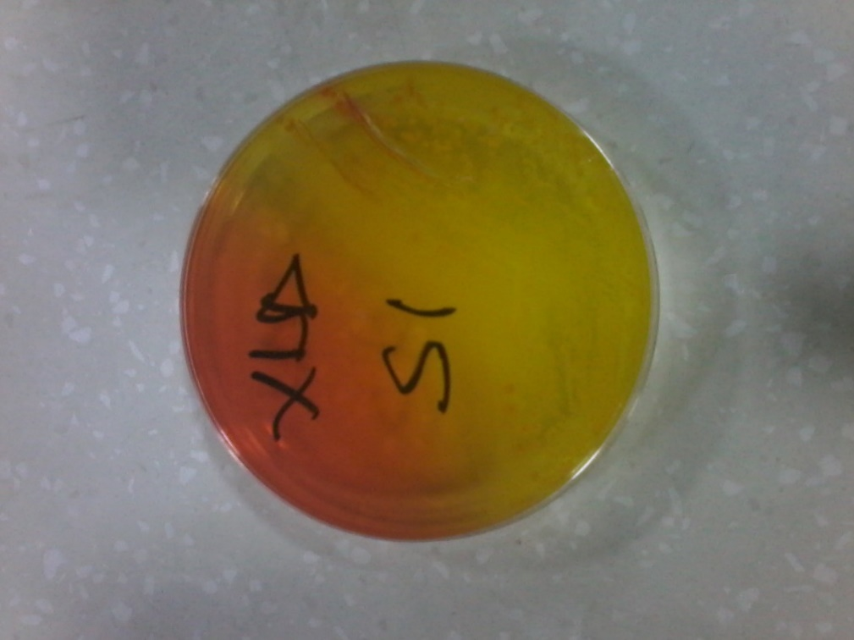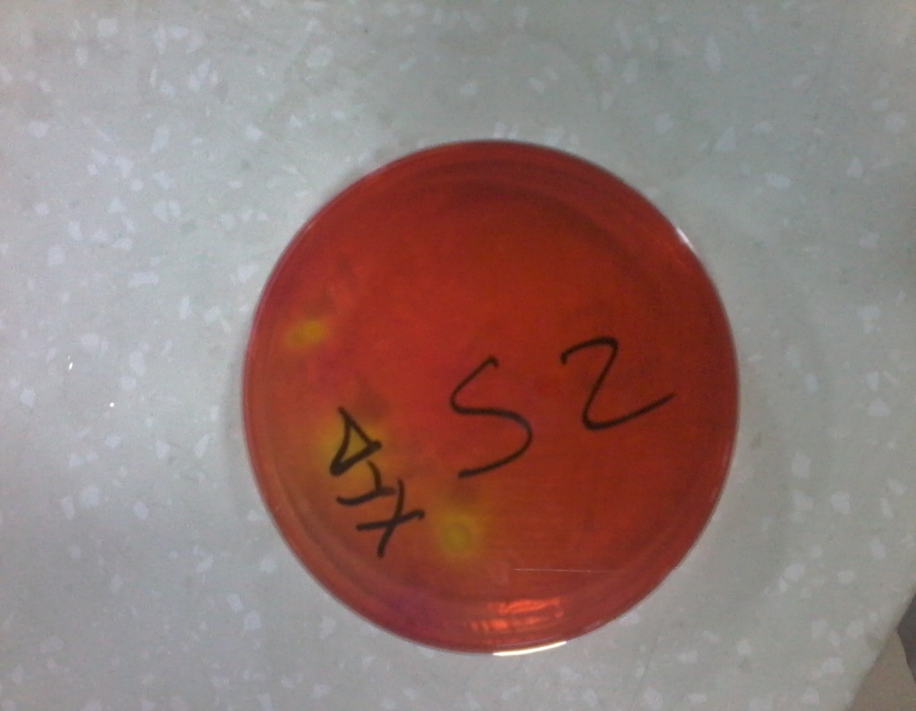
Figure 8: suspected colonies of salmonella species Xylose Lysine Deoxycholate agar (XLD agar

CHAPTER FIVE

5.0. CONCLUSIONS AND RECOMMENDATIONS

5.1. CONCLUSIONS
In conclusion, Salmonella, E. coli, yeast and mould are important food borne pathogens responsible for most foodborne diseases. This research has helped established the hazard associated with gizzard and beef suya sold around magboro market and the risk associated with the consumption of such products as a result of the products not conforming to microbiological standard and unfit for consumption. There is need to mitigate continuous meat contamination and monitor safety of this products by educating processors and consumers on good sanitary practices during processing displaying and sale of the products and the possible danger of contaminated products and enforcing rules to checkmate GMP in preparing street vended food.

5.2 RECOMMENDTIONS
Good hygiene practices should be ensured amongst street vended food retailers to ensure minimal contamination and reduced risk of contaminating food. Government should organize food safety education for the food processor in the inform sector help address the high level of ignorance amongst road side food vendors. There should be an active food safety surveillance system that can enforce good food safety practices across the food process of meat production transporting, processing and sale (from the abattoir to road side sellers) and ensuring full compliance across all stages in meat processing.

