

COLLEGE OF BASIC AND APPLIED SCIENCES

DEPARTMENT OF GEOSCIENCES

Mountain Top University
Kilometre 12, Lagos-Ibadan Expressway, MFM Prayer City, Ogun State.
PHONE: (+234)8053457707, (+234)7039395024, (+234) 8039505596
EMAIL: support@mtu.edu.ng
Website: www.mtu.edu.ng.

Published By: Mountain Top University

COURSE GUIDE

COURSE TITLE: Geological Map Interpretation and Field Mapping

COURSE CODE: GLY 203

LECTURER: AKINMOSIN, A (PhD)

COURSE CONTENT

Interpretation and simple geological maps.
- Introduction
- Types of map
- Topographic and geological maps
- Uses of Geological map
- Scale and types
- Conventional signs and symbols
- Section drawing
- Types
- Horizontal beds
- Inclined beds
- Vertical beds
- Map completion
- Writing of geological history

Field techniques.

- Introduction
- Practical – recording of geological features and base maps.
- Mapping of rock outcrops and rock structures
- Drawing of geological map and cross section
- Writing of geological report

COURSE OBJECTIVES
GENERAL INTORDUCTION AND COURSE OBJECTIVES
Map interpretation and field techniques are the hallmarks of a well-trained geoscientist. Consequently, this course is aimed at introducing the students to basic principles of generating simple geological map of an area as well as interpreting already published maps of different areas. The course essentially a practical course which is expected to form bedrock on which other geological field exercise is based. Objectives of the course among other things are:
- Identification of basic features of topographical map
- Location of oneself on topo map with use of landmarks and other equipment like GPS, compass clinometer etc.
- Identification and mapping of rock outcrops/exposures and associated structures
- Generation of simple geological map of mapped area
- Interpretation of geological map

COURSE CONTENT PAGE

Introduction
Lecture 1: Types of map and uses
Lecture 2: Scale, Conventional signs and symbols

Section drawing
Lecture 3:- Horizontal beds
Lecture 4: - Inclined beds
Lecture 5: - Vertical beds
Lecture 6: - Folded beds
Lecture 7: - Faulted beds
Lecture 8: - Completion of outcrop
Lecture 9: Writing of geological history

Field techniques.
Lecture 10: Preparatory Briefing- what are expected to be seen on the field
Lecture 11: (While on the field):
- Practical – recording of geological features and base maps.
- Mapping of rock outcrops and rock structures
- Drawing of geological map and cross section
- Writing of geological report

LECTURE ONE
1.0: Types of map and uses of Geological map
Introduction: this lecture is aimed at introducing the students to different types of map being used in geosciences or related disciplines.
Expectations: at the end of the lecture, students are expected to among other things to be able to:

- Describe what a map is.
- Able to identify various types of map
- Identify peculiar features of each type of maps
- Differentiate geological map from topographical map
1.1: What is a Map?
Definition
- Topographical map: map of an area bearing essentially features such as: relief, drainage system, vegetation, road network, rail network, worship places, landmark points etc., (see Fig. 1).
- Geological map: an offshoot of topographical map which shows essentially rock distribution and rock boundary of a place, (see Fig. 2).
In both cases, they represent a larger portion of the earth system that has been compressed with the use of scale.
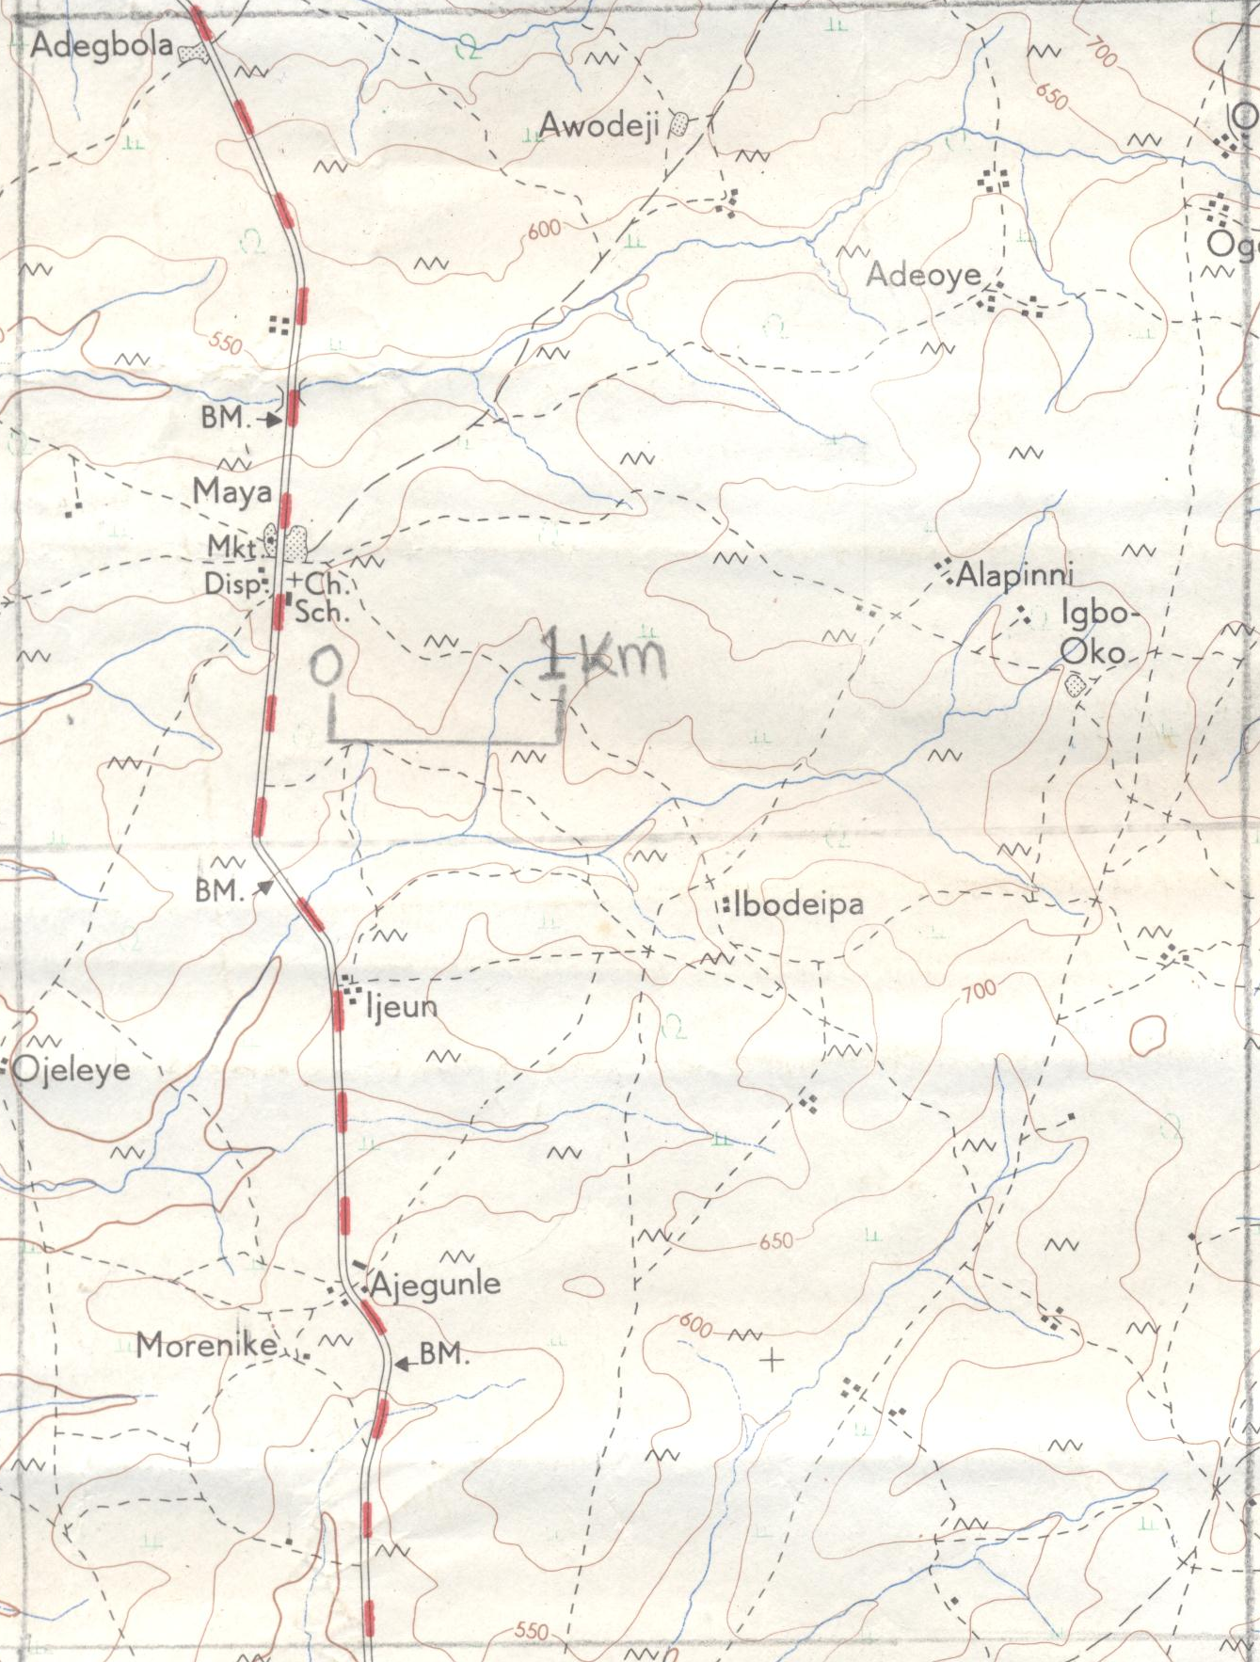
Fig. 1: Sample of Topographical map
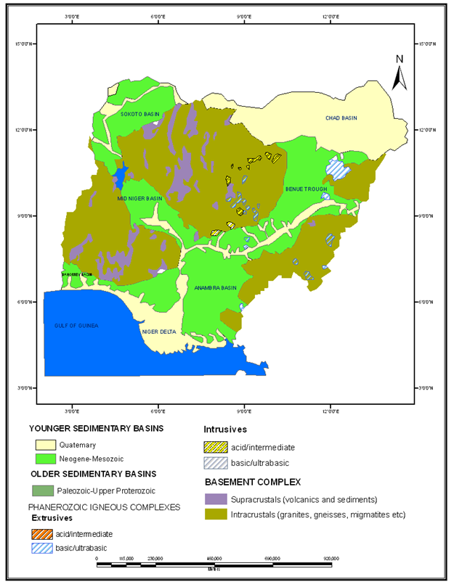
Sample of Geological map of Nigeria, showing distribution of Basement Complex rocks and Sedimentary Basins (Oyawoye, 1972).

USES OF MAPS.
The various maps earlier mentioned above have the following uses:

(i) Bring out at a glance various geographical elements;

(ii) Bring out the relationships amongst geographical elements;

(iii) For investigation and exploration of resources;

(iv) For planning, optimal utilization and develop­ment of resources;

(v) For seeing many dimensions of a region at one time, thus helping in regional planning.

LECTURE 2. SCALE, CONVENTIONAL SIGNS AND SYMBOLS.
Introduction: the lecture is aimed at introducing students to basic map features that will aid them in mapping reading and interpretation.
Objectives:
- To understand various types of scale and how they can be used appropriately
- To be able to identify various signs and symbols on a map and how they can be applied.
Scale:
The scale indicates the proportion which, a distance between two points on a map bears to the distance between the corresponding points on the actual ground. For instance, if an actual distance of 5 miles is represented on the map by a distance of 1 inch, the scale is 1″—5 miles.

Selection of a scale primarily depends on (1) the size of area to be mapped (2) the extent of details to be shown, (3) the size of the paper.

Representation of a Scale:

There are three ways in which the scale is depicted on the map.

1. By such a statement as “3 inches to the mile” or “1/3 mile to the inch”.

2. By graphic scale in which a straight line is di­vided into a number of equal parts and is marked to show what these divisions represent on actual ground.

3. By a Representative Fraction. This expresses the proportion of the scale by a fraction in which the numerator is one and the denominator also in the same unit of length. For example, if the Repre­sentative Fraction is stated to be 1/100,000 or 1: 100,000, this means that one unit on the map represents 100,000 of the same unit on ground.

Map Signs and Symbols
Since a map is a reduced representation of the real world, map symbols are used to represent real objects. Without symbols, we wouldn't have maps.
Both shapes and colors can be used for symbols on maps. A small circle may mean a point of interest, with a brown circle meaning recreation, red circle meaning services, and green circle meaning rest stop. Colors may cover larger areas of a map, such as green representing forested land and blue representing waterways.
To ensure that a person can correctly read a map, a Map Legend is a key to all the symbols used on a map. It is like a dictionary so you can understand the meaning of what the map represents.
Here are some common symbols:

TOPOGRAPHIC CONTOURS
(land elevation)
Index  number written on line | 
Intermediate  between Index lines | 
Supplementary  added to flat areas to show measurements | 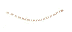
Depression  such as volcano top or crater  (little dashes are called hachures) | 
Cut; Fill  roadway leveling terrain | 

VEGETATION
Woodland  trees at least 6feet tall | 
Scrub  low brush | 
Orchard  planted vegetation | 
Vineyard  cultivated vines | 
Mangrove  dense, tropical trees | 

SURFACE FEATURES
Levee | 
Sand or mud area, dunes or shifting sand | 
Intricate surface area | 
Gravel beach or glacial moraine | 
Tailings pond | 

MINES AND CAVES
Quarry or open pit mine | 
Gravel, sand, clay, or borrow pit | 
Mine tunnel or cave entrance | 
Prospect; mine shaft | 
Mine dump | 
Mine tailings | 

GLACIERS AND PERMANENT SNOWFIELDS
Limit  blue denotes coverage | 
Form lines  Show shape, not elevation | 

BUILDINGS AND RELATED FEATURES
Building | 
School; church | 
Built-up Area | 
Racetrack | 
Airport | 
Landing strip
Well (other than water); windmill | 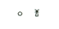
Tanks | 
Covered reservoir | 
Gaging station | 
Landmark object (feature as labeled) | 
Campground; picnic area | 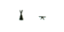
Cemetery: small; large | 

ROADS AND RELATED FEATURES
Primary highway | 
Secondary highway | 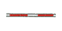
Light duty road | 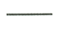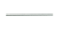
Unimproved road | 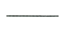
Trail | 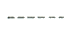
Dual highway | 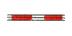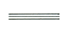
Dual highway with median strip | 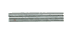
Road under construction | 
Underpass; overpass | 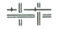
Bridge | 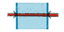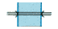
Drawbridge | 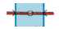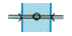
Tunnel | 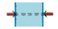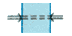

RAILROADS AND RELATED FEATURES
Standard gauge single track; station | 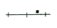
Standard gauge multiple track | 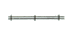
Abandoned | 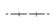
Under construction | 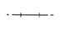
Narrow gauge single track | 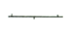
Narrow gauge multiple track | 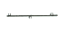
Railroad in street | 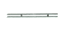
Juxtaposition | 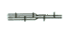
Roundhouse and turntable | 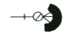

TRANSMISSION LINES AND PIPELINES
Power transmission line: pole; tower | 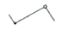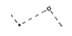
Telephone line | 
Aboveground oil or gas pipeline | 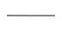
Underground oil or gas pipeline | 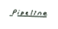

BOUNDARIES
National | 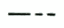
State or territorial | 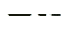
County | 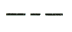
Civil township | 
Incorporated city | 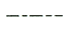
Park, reservation, or monument | 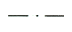
Small Park | 

LAND SURVEY SYSTEMS
U.S. Public Land Survey System
Township or range line | 
Section Line | 
Found section corner; found closing corner | 
Witness corner; meander corner | 
Other land surveys
Township or range line | 
Section line | 
Land grant or mining claim; monument | 
Fence line | 

CONTROL DATA AND MONUMENTS
Horizontal control
Third order or better, permanent mark | 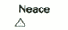
With third order or better elevation | 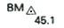
Check spot elevation | 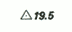
Coincident with section corner | 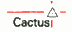
Unmonumented* | 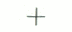
Vertical control
Third order or better, with tablet | 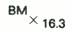
Third order or better, recoverable mark | 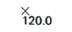
Bench mark found at section corner | 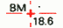
Spot elevation | 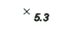
Boundary monument
With tablet | 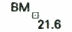
Without tablet | 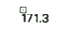
With number and elevation | 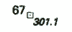
U.S. mineral or location monument | 

RIVERS, LAKES, AND CANALS
Intermittent stream | 
Intermittent river | 
Disappearing stream | 
Perennial stream | 
Perennial river | 
Small falls; small rapids | 
Large falls; large rapids | 
Masonry dam | 
Dam with rock | 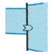
Dam carrying road | 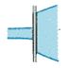
Perennial lake; Intermittent lake or pond | 
Dry lake | 
Narrow wash | 
Wide wash | 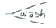
Canal, flume, or aquaduct with lock | 
Elevated aquaduct, flume or conduit | 
Aquaduct tunnel | 
Well or spring; spring or seep | 

SUBMERGED AREAS AND BOGS
Marsh or swamp | 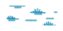
Submerged marsh or swamp | 
Wooded marsh or swamp | 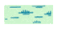
Submerged wooded marsh or swamp | 
Rice field | 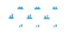
Land subject to inundation | 

MARINE SHORELINE
Approximate mean high water | 
Indefinite or unsurveyed | 

BATHYMETRIC FEATURES
(water depth)
Area exposed at mean low tide; sounding datum | 
Channel | 
Offshore oil or gas: well; platform | 
Sunken rock | 

BATHYMETRIC CONTOURS
Index | 
Intermediate | 
Supplementary | 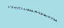
Source: http://www.compassdude.com/map-symbols.php

LECTURE 3: SECTION DRAWING.
Introduction: the hallmark of any geological map interpretation is the ability of a student being able to draw geological cross section and make vivid geological history of the mapped area. This aspect of the course is therefore intends to train students on the basic techniques required to do so.
Section drawing is an aspect of map interpretation which involves unveiling the relationship of rock units to one another within the subsurface or at the surface when exposed. In other word, it shows the arrangement of rock units at the subsurface or at the when exposed.
Cross section drawing for rocks covers both crystalline and sedimentary rocks. However at this level, attention will be focused on sedimentary rocks. At higher levels, students will be introduced to advanced map interpretation under which crystalline rocks will be treated.
In order to carry out section drawing of any geological mapped area, the first approach is to draw the topographical profile of the place. The procedure involved is enumerated in our working manual pages 16 and 20.

Objectives: after these lectures, students are expected to have among other things being able to:
o Draw and describe the geology of an area with horizontally laid beds
o Draw and described the geology of an area with deformed beds.

Horizontal Beds.
When sediments are deposited, they become compacted over time as a result of overburden. As time passes by, and with more sedimentary supplies, more of such layers (depending on the type of sediments deposited) are formed. They are several stratigraphical principles that guide deposition of sediments. Such is the principle of superposition. It states that “in an undisturbed setting, the lowermost bed is other than the overlain ones” in Figure 5a of our working manual, the bedding plane between the limestone and shale is horizontal. It is the same height above the sea level which tallies with the definition of a contour. They are therefore horizontal.
The steps involved in section drawing of horizontal layers are enumerated in our working manual page 37. Students are to follow as the lecturer demonstrate this in the class.

LECTURE 4: DEFORMED BEDS.
Introduction: When horizontally laid beds are subjected to earth movement or tectonism, such beds are bound to be deformed. Deformation of such could be in form of inclination/tilting, faulting, or folding.

Inclined and Vertical Layers-
In inclined beds just as it is applicable to other deformed beds, the bedding plane between the rock units there won’t be horizontal. Their heights above the sea level won’t tally with the definition of a contour. They are therefore not horizontal.
To draw the cross section of such inclined or vertical layers will require special expertise other than the one required for horizontally laid beds.
The procedures involved here are enumerated in our working manual page 40. Students are to follow as the lecturer demonstrates the procedures in the classroom.

LECTURES 5 & 6: FOLDED AND FAULTED BEDS.
As mentioned in the previous lectures, when horizontal beds are deformed, there tends to be discordance in the relationship between the contour lines and bedding planes. For folded or faulted beds, it will require more expertise over inclined and vertical beds in order to draw their cross sections.
Details of the procedures required are enumerated on pages 69 and 81 of our working manual. Students are to follow as the lecturer demonstrates these in the classroom.

LECTURE 7: COMPLETION OUTCROP.
Introduction: One of the commonest problems usually encountered in mapping deals with completion of boundaries of rock formations from partial outcrops. Application of structure contours or strike lines is of the opinion that these rock units have the same values of strike and dip.
The techniques required to carry out completion of outcrop of formation boundaries on the map where partial information are given are enumerated on pages 89 and 90 of our working manual. Students are to follow as the lecturer demonstrates these procedures in the classroom.

FIELD TECHNIQUES.
LECTURE 8: PREPARATORY LECTURE
Introduction: Understanding of earth systems and our environment over a geological period is dependent on both experiences gained from field work exercise and reliable data and appropriate samples that are collected in the field.
Objectives: the main goal of field work is to acquire the basic and fundamental geological field skill of mapping. The course emphases basic skills that is requisite for good field mapping.
This preparatory lecture is geared towards briefing the students on the under listed before departure to the field.
- General over view of what the course is all about.
- Safety measures to be taking while on the field.
- Rules guiding field mapping.

LECTURE 9: MAPPING TECHNIQUES ON THE FIELD.
This lecture involves practical demonstration of what students are suppose to do while in the field. This demonstration includes the following:
- How to locate yourself in the field.
- How to make essential field observations and taking measurements:
- Use of compass to navigate
- Use of clinometer to measure strike and dip
- Recording of observations correctly on a base map
- Recognition of main classes of rocks- igneous, metamorphic and sedimentary
- Recognition of main geological structures- folds, faults, unconformity etc.
- How to keep accurate field records:
- Keeping map and field note books up to date
- Making appropriate field diagrams drawn to scale
- Construction of geological logs/profiles through sedimentary sequence
- How to generate and draw appropriate geological map
- How to draw geological cross section of the generated geological map
- How to write appropriate geological field report

Essentially, a good geological report should have following sub-headings:
- Abstract
- Introduction
- Lithological units
- Structures
- Geological history
- Conclusions
- References.

RECOMMENED TEXTBOOKS
- Geological maps and their interpretation by E.A. Fayose, ISBN: 978-978-916-521-8. Published by Lighthouse Publishers LTD.
- Geological Maps: Their Solution and Interpretation by T. Bolton, ISBN: 0 521 36158 3. Published by Cambridge University Press.
- Geological field techniques by Angela L. Coe, ISBN-13: 978—1444330625. Published by Wiley Blackwell.

