GSM BASED FIRE ALARM SYSTEM USING ARDUINO UNO

BY

ADEMUYIWA, STEPHANIE ADEDUNNI
16010301016

BEING A PROJECT SUBMITTED IN THE DEPARTMENT OF COMPUTER SCIENCE AND MATHEMATICS,
COLLEGE OF BASIC AND APPLIED SCIENCES,
IN PARTIAL FULFILMENT OF THE REQUIREMENTS
FOR THE AWARD OF DEGREE OF BACHELOR OF SCIENCE MOLUNTAIN TOP UNIVERSITY
IBAFO, OGUN STATE
NIGERIA

CERTIFICATION
This Project titled, GSM BASED FIRE ALARM SYSTEM USING ARDUINO UNO, prepared and submitted by ADEMUYIWA, STEPHANIE ADEDUNNI in partial fulfillment of the requirements for the degree of BACHELOR OF SCIENCE (Computer Science), is hereby accepted

(Signature and Date)
Dr. Oladeji F.
Supervisor

Accepted as partial fulfillment of the requirements for the degree of BACHELOR OF SCIENCE (Computer Science)

(Signature and Date)
Dr. Akinyemi, I. O.
Head of Department, Department of Computer Science and Mathematics

(Signature and Date)
Prof. Akinwande, A. I.
Dean, College of Basic and Applied Sciences

DEDICATION
This Project is dedicated to God Almighty

ACKNOWLEGEMENT
I would like to acknowledge the almighty God for giving me retentive wisdom, knowledge and understanding. My sincere and profound gratitude to my supervisor Dr. Oladeji F. for her time, advise, effort and guidance throughout the course of this project work with the aim to ensure that this project will be a success.
I specially appreciate the Dean of College of Basic and Applied sciences in person of Professor Akinwande A.I and to thank the H.O.D (Head of Department) of the department of Computer Science and Mathematics in person of Dr. Akinyemi I.O for his guidance during my stay at the university. I would like to thank all the lecturers of Department of Computer science and Mathematics Dr. Oyetunji M.O (Late), Dr. Kasali F.A, Dr. Oladejo B.F, for their advice and their words of encouragement. I want to thank my colleagues Oibo Joy Opeyemi, Benjamin Ahkigbe and Olusegun Olayinka for their help, support and guidance during the duration of the project. I also want to thank all the non-academic staff of the Department of Computer Science and Mathematics for making my stay a worthwhile one.
I would like to thank my parents in person Mr and Mrs Ademuyiwa for their financial support, encouragement and prayers, and I will want to thank my sister in person Mrs Ruth A. for her financial support and care, towards me throughout my stay in Mountain Top University. I pray that God will answer all their prayers.

Table of Content
Title Page i
Certification ii
Dedication iii
Acknowledgement iv
Table of Content v
List of Figure viii
List of Table ix
Abstract x
Abbreviations/ Acronyms xi
Chapter One: Introduction 1
- Background Information 1
- Statement Of Problem 2
- Aim And Objectives 3
- Scope Of Study 3
- Significance Of The Study 3
- Definition Of Terms 3
Chapter Two: Literature of Review 5
- Introduction 5
- History Of Internet Of Things 5
- Application Of IoT 5
- IoT Component 7
- Related Works(Fire Alarm Using Internet Of Things) 17
- Conceptual Model 22
Chapter Three: Methodology 24
- Description Of The System 24
- System Analysis 24
- System Design 25
- Hardware Component Unit 31
- Methodology 37
- Method Of Data Collection 37
Chapter Four: System Implementation 39
- System Implementation 39
- System Requirement 39
- System Development 40
- Testing 44
Chapter Five: Summary, Conclusion, Recommendation 48
- Summary 48
- Limitation 48
- Conclusion 48
- Contribution 48
- Recommendation 49
Reference 50
Appendix 51
- Code Of The Mq135 51
- Code Of Lm35 52
- Bills Of Material 54
- Connection Of All The Sensors 55
- Connection Of The GSM Module To Arduino 56
- Connection Of Both Sensors And GSM Module To The Arduino57
- Serial Monitor Reading Of The LM35 58
- Serial Monitor Reading Of MQ135 59
- Serial Monitor Reading of Flame Sensor 60
- Serial Monitor Reading Of The Fire System 61

List of Figures
- Arduino Uno 9
- Flame Sensor 10
- GSM-Based SIM900 11
- Jumper Wire 12
- Bread Board 13
- Buzzer 14
- MQ135 Smoke Sensor 15
- Led Light 16
- Conceptual Model 23
- Context Diagram 26
- Flow Diagram 27
- Sequence Diagram 28
- Block Diagram 29
- Use Case Diagram 30
- Labelled Diagram of Arduino Uno 31
- SIM900 Interfacing with Arduino 33
- Flame Sensor Interfacing with the Arduino Uno 34
- LM35 Interfacing with the Arduino 35
- MQ-135 Interfacing with the Arduino 36
- Diagram of the Methology 38

List of Table
Table 2.1 Related Works (Fire Alarm Using Internet Of Things) 17
Table 4.1 Functionality Testing of the MQ135 45
Table 4.2 Performance Testing 47

ABSTRACT
Untimely response, constrained navigation due to poor urban planning and traffic jams, highly flammable construction materials, insufficient capacity by the fire department and lack of access to automated fire detection systems by residents due to purchasing costs are among the factors that affect fire-fighting services in our environment. The fallout of a fire flare-up could extremely intense prompting far and wide loss of property and loss of lives. Residential areas contain numerous flammable materials such as clothing, books, wooden cabinets, beddings and plastics while also housing sources of ignition that include cooking gas and electronic devices thus are prone to severe fire accidents. Fire episodes have a commencement time of around 3 to 5 minutes, which is the ideal chance to identify it and put it out after which it may gain out of power. This suggests that ideal distinguishing proof of a potential fire episode is pivotal to overseeing it. At present, most private foundations just as business premises are not fitted with fire detection systems owing to lack of awareness, high purchasing costs and inefficiency of the devices given the high false alarm rates which have a cost attached to them such as the unnecessary deployment of fire-fighting personnel. The fire detection devices are highly susceptible to false alarms because reliance on one sensor that reads only one percept from the environment for instance smoke or heat. Notwithstanding, the progression of the Internet-of-Things has prompted the improvement of 'brilliant' advances where different sensors can be fused into objects like fire locators furthermore empowering them to carry out programmed tasks, and communicate wirelessly with other objects. This research aimed at proposing a prototype of a GSM based fire alarm system using Arduino approach. Rapid prototyping methodology was applied in this research for development of the prototype. Data was collected by experimentation. MQ135 smoke sensor, LM35 temperature sensor, Flame sensor and an Arduino microcontroller, a GSM shield was used in this prototype. In the event of a fire outbreak, the device will be able to send an SMS alert and call to the homeowner as well as the firefighting department.
Abbreviations/ Acronyms
IoT - Internet-of-Things
CO2 - Carbon dioxide
PPM - Parts Per Million
AC - Alternating Current
DC - Direct Current
MQTT - Message Queue Telemetry Transport
SMS - Short Messaging Service
USB - Universal Standard Bus

CHAPTER ONE
INTRODUCTION
1.1 BACKGROUND INFORMATION
The world has experienced a tremendous explosion of IoT (Internet of Things) based object and things in recent times, making communication between objects and humans easier through
connectivity of physical object at anytime, anyplace, thereby using any service or network. The object or things are made intelligent, programmable, and capable to interact with humans. Objects such as smart phones, internet television, vehicles, doors, water sprinklers e.t.c (Obanda, 2017) (Prof. madhu, Vaishnavi, Dushyanth, Tushar , & Sohan, 2019)
According to (Obanda, 2017) the IoT has become a reality in this our present days where the microcontrollers which have communication and data transfer capabilities through procedure such as the Wi-Fi, GSM and Bluetooth along with other object such as sensors. The IoT is capable of controlling and automating most of the house appliances such as the different electrical gadget, thermostat, windows, and doors e.t.c. This capabilities makes solving of problem areas of the world possible like accidental fire outbreaks. (Neha & Yogita, 2017)
Fire outbreaks has become a recurrent, destructive, regular occurrence and most influential disaster when compared to other disaster. The most know causes are electrical appliances, cooking appliances, gas leakage, and lab appliances e.t.c which has led to loss of life, properties and so on. Due to the effect of this fire disaster a Fire detector or fire alarm has been created using an IoT device called the microcontroller and other devices (Mahzan, Enazai, & Noh, 2018).
According to (Obanda, 2017) the evolution of the Internet of things (IoT) has brought along low cost hardware particularly micro controllers such as the Arduino Uno, transmitters, receivers and sensors for instance the smoke and temperature sensors that are able to be customized and programmed to detect accidental fire outbreaks. This research aims at harnessing these capabilities and using them to combat the challenges facing fire detection.

1.2 STATEMENT OF THE PROBLEM
The most prevalent threat faced by all properties is fire. No properties around the world are exempted from fire, which often causes loss of life and properties especially if the fire spreads to neighboring homes, offices e.t.c. The properties and the occupants will be at risk if plans developed for fire threat is not implemented (Agazi, Bahta, Mekonen, & Solomon , 2010).
The problems are;
- False alarm: - there are some nuisances fire alarm system that gives false information/alarm which have being faced by the fire alarm professionals especially smoke detector and another problem. This to ignorance to fire alarm even though it is true.
- The case when there is nobody in the building: - There is the possibility that the fire could have burnt a lot of valuables before the neigbours close to the area of fire outbreak would detect that there is a fire outbreak.
- Deep sleeper: - There are instances where some residents within a building are sound sleepers, thereby not able to detect when there is a fire outbreak, even when the fire alarm is sounding. As such notification via emails to other members of such locations can automatically become beneficial.
The problems above can be solved by using a GSM based fire alarm system using Arduino. (Obanda, 2017)
1.3 AIM AND OBJECTIVES
The aim of the project is to develop an IOT Based system that is capable of providing reliable alarms and alerts in the case of fire outbreaks in residential or commercial buildings.
Objectives
The following are the objectives of the study;
- To perform a literature review on the existing techniques usually applied in the detection of fire within residential and commercial based buildings, alongside the typical challenges common to them.
- To build an IOT based prototype that would be able to send message to the occupier, when there is a fire outbreak at any time irrespective of their location.
- To test the built prototype using multiple sensors for sensing fire based triggers.

1.4 SCOPE OF STUDY
This study focuses on the development of an IOT fire alarm system using a GSM based devices as well as the famous Arduino Uno device.
1.5 SIGNIFICANCE OF THE STUDY
The creation of a GSM based fire alarm system using Arduino Uno microcontroller is to complement the audio alarm systems by going the extra mile of sending GSM based notifications to the residents of the building where the prototype would be housed.
1.6 DEFINITIONS OF TERMS
- Temperature sensors(LM35) – Takes the temperature reading of the room
- Flame sensor – Detects a fire
- LED light – Shows if there is a fire outbreak or not. Red led light will represent that there is a fire outbreak while the Green led light represents there is not fire outbreak.
- GSM module SIM900 – Enable the microcontroller to connect to a GSM network
- Microcontroller circuit – processes and handles the sensor. The microcontroller used is the Arduino Uno
- MQ-135 – detects smoke, gas, and any other harmful gases
- Buzzer – To sound an alarm in case of fire.

CHAPTER TWO
2.1 INTRODUCTION
Home automation or Smart Homes can be said to be the introduction of technology within the home environment to provide convenience, comfort, security and energy efficiency to its occupants. Adding intelligence to home environment can provide increased quality of life. With the introduction of the Internet of Things (IoT), the research and implementation of home automation are getting more popular. Presently many researches have done that provide many home automation facilities with the proliferation of IOT.

2.2 HISTORY OF INTERNET OF THINGS
In 1965 Laurence G Roberts and Thomas Merrill connect two early super-computers in Massachusetts and California, creating the world‘s first wide-area network (WAN).
In 1969 ARPANET sends its first message, bringing online the world's first operational packet switching network using TCP/IP, forming the backbone of how today‘s Internet work.
In 1973 First patent issued for a passive RFID tag to Italian inventor Mario Cardullo.
In 1982 the principal Internet-associated machine was a Coke candy machine manipulated by Computer Science graduate understudies at Carnegie Mellon University to reveal to them whether the machine was supplied with cold soda.
In 1990 John Romkey creates the first Internet-controlled ‗device‘, a toaster that could be turned on and off over the Internet. In 1991 Mark Weiser publishes ―The Computer in the 21st Century in Scientific American.
In 1999 ―Internet of Things coined as term by British tech pioneer Kevin Ashton (now at Belkin, behind WeMo), the title of a presentation given to P&G (Procter & Gamble) about supply chain innovation.
In 2007 the number of connected devices exceeds the human population of the planet for the first time.
In 2013 inaugural M2M & Internet of Things Global Summit held in Washington, DC.
In 2014 Google acquires NEST labs "which is a company that designs and manufactures sensor driven, Wi-Fi-enabled, self-learning, programmable thermostats and smoke detectors" for $3.2 Billion, signaling the IoT‘s movement into the mainstream consumer spotlight, primarily via smart home products.
2.3 APPLICATION OF IOT
According to (Keyur, Sunil, & PG, 2016) the IoT is diverse which has different applications such as;
- Internet of smart living
- Internet of smart agriculture
- Internet of smart health
- Internet of smart cities
- Internet of smart industry
- Internet of smart enivornment
- Internet of smart energy
As related to the topic I will dwell more on the internet of smart living
The internet of smart living deals on home automation where the
- Smart Home Appliances: Fridges with LCD screen determining what's inside, food that is going to lapse, fixings you have to purchase and with all the data accessible on a Smartphone application. Clothes washers permitting you to screen the clothing distantly, and. Kitchen ranges with interface to a Smartphone application permitting distantly customizable temperature control and observing the broiler's self-cleaning highlight.
- Remote Control Appliances: Switching on and off remotely appliances to avoid accidents and save energy.
- Safety Monitoring: home alarm systems, and cameras makes people feel safe in their daily life at home.
- Weather: Showcases outside climate conditions, for example, dampness, temperature, pressure, wind speed, and downpour levels with capacity to communicate information over significant distances.
- Intrusion Detection Systems: Detection of window and door openings and violations to prevent intruders.
- Energy and Water Use: Energy and water supply consumption monitoring to obtain advice on how to save cost and resources, & many more.
2.4 IOT COMPONENT
The devices used to makeup this project using iot devices
- ARDUINO UNO:
Arduino UNO in figure 2.1 has been used as an interfacing medium for the hardware and software.
- FLAME DETECTOR
it is used to detect a fire outbreak through the flames, and the flame sensor consist of IR receiver, capacitor, resistor, potentiometer, and comparator LM393 is an integrated circuit in figure 2.2.
- GSM MODULE
The acronym GSM is presently understood to mean Global System for Mobile Communications. We chose the SIM 900 because that our county Nigeria support the SIM 900 2G network. It requires a SIM (Subscriber Identity Module) card just like mobile phones to activate communication with the network in figure 2.3.
- JUMPER CABLE
it is an eletrical wire with connector or pin at each end (or sometimes with them – simply “tinned”)in figure 2.4, which is used to interconnect the components of breadboard or other prototype or test circuit, internally or with other equipment or component without soldering. There are different types of jumper cable namely:
- female-to-female jumper cable:- this is the jumper cable that has connector at both end
- female-to-male jumper cable:- this is the jumper cable that has connector at one end and pin at another end.
- male-to-male jumper cable:- this is the jumper cable that has pin at both end.
- BREAD BOARD
It is a construction base for prototyping of electronics in figure 2.5
- BUZZER
The buzzer in figure 2.6 being used in this project is a 5-12 V buzzer and has got enough alarm sound to be used in a fire alarm system
- MQ-135
It is used to detects smoke, gas, and any harmful gases in figure 2.7. It composed by micro AL2O3 ceramic tube, Tin Dioxide (SnO2) sensitive layer, measuring electrode and heater are fixed into a crust made by plastic and stainless steel net.

- LED LIGHT
The diagram in figure 2.8 shows if there is a fire outbreak or not. Red led light will represent that there is a fire outbreak while the Green led light represents there is not fire outbreak

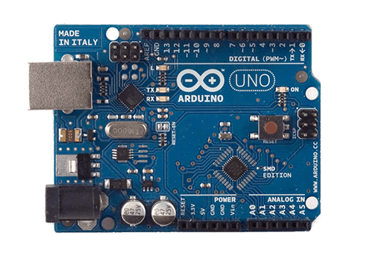

FIGURE 2.1: ARDUINO UNO

.

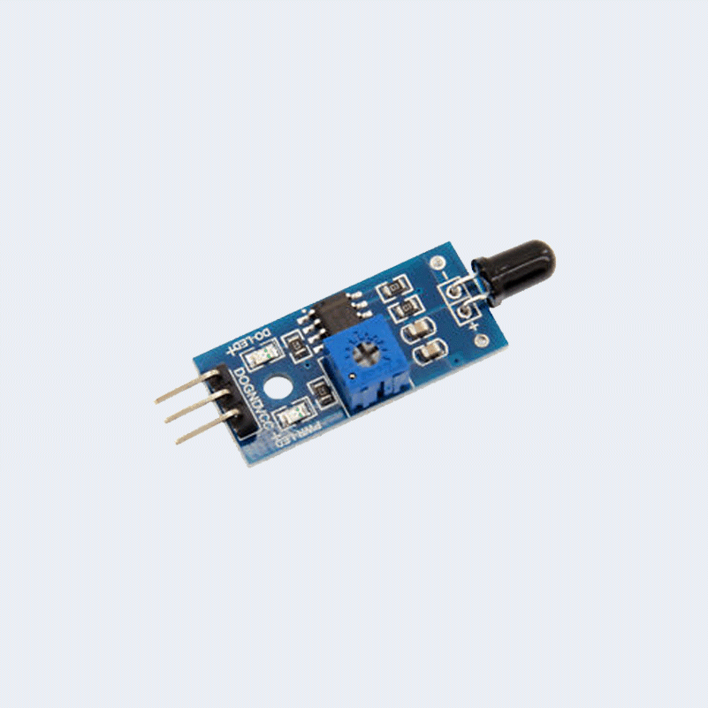
FIGURE 2.2: FLAME SENSOR

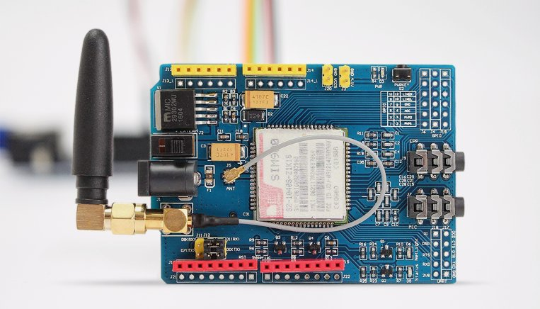
FIGURE 2.3: GSM MODULE SIM900

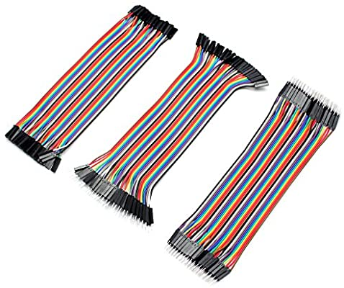

FIGURE 2.4: JUMPER WIRE

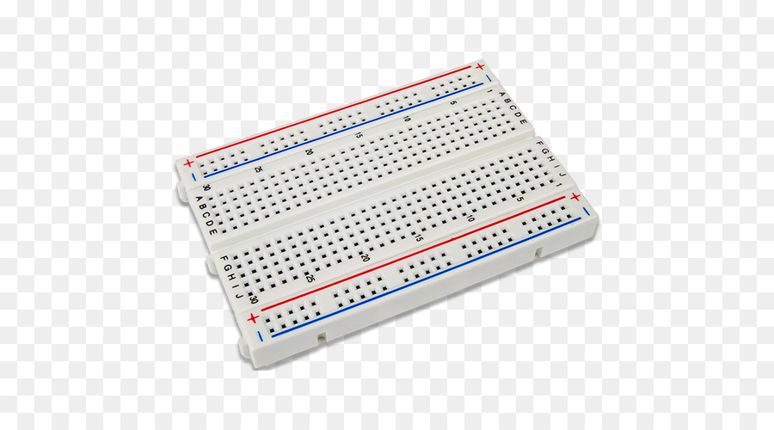

FIGURE 2.5: BREAD BOARD

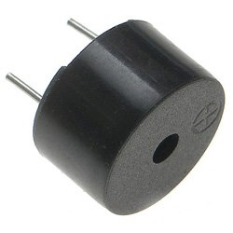

FIGURE 2.6: BUZZER

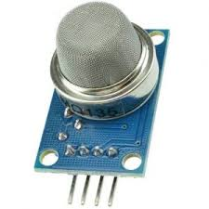

FIGURE 2.7: MQ-135 SMOKE SENSOR

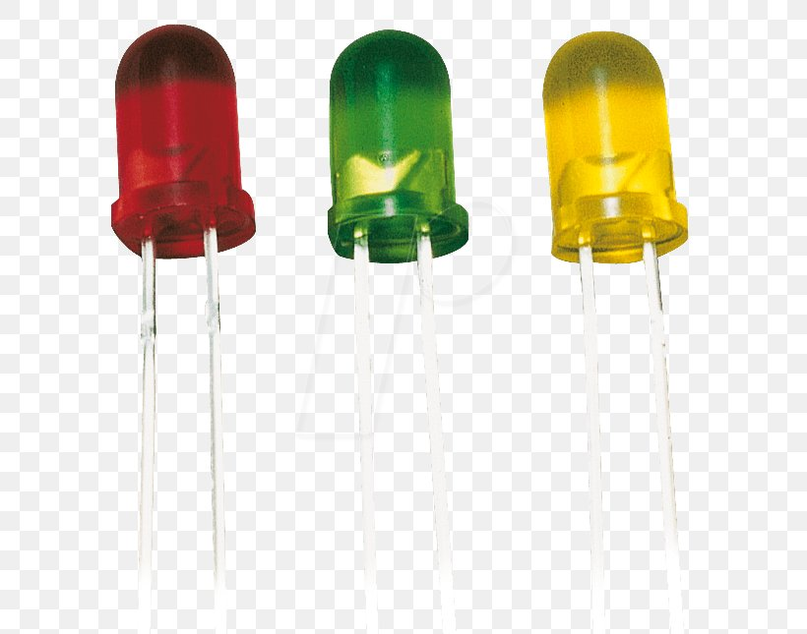

FIGURE 2.8: LED LIGHT

2.5 RELATED WORKS (FIRE ALARM USING INTERNET OF THINGS)
S/N | Reference, author, year | Approach and Methodology | Conclusion
1 | Vijayalakshmi & muruganamd, 2017 | This paper talks about the plan idea and development of putting out fires using the IoT model.  The system minimizes the disaster, death and losses caused by fire. It uses the sensor detects the fire condition and transfers the data to the system.  The fire brigade and building owners do the interactions with the system reading the data sent from the sensors  The users can communicate with the system through various approaches to monitor and control the environment and get more information about it.  They made used of fuzzy logic algorithm that analyzes and synthesizes multi-sensors or multi sources of data under certain criteria to complete data processing for decision making and task estimating. | The IoT technology approach improves the fire-fighting safety management work from traditional fire fighting to modern fire fighting.  The algorithm used analyzes the data for smart decisions making.  The system is still human dependent as the data is sent to the system and the user makes the final decision.
 | Imteaj et al. 2017 | This system detects fire and can provide the location of where the fire incident occurs.  They made use of 360-relay motor with a camera so that it can snap the image in whatever angle the fire is detected.  The system will immediately send a message along with the image of where the system detected the fire along with the arduino’s location to an admin.  Am admin has to confirm or deny the arrangement and if the admin confirm that there is really a fire outbreak, then the system will immediately raise an alarm and an automatic message will be sent to the nearby fire brigade.  They made use of two different types of microcontrollers, the Raspberry pi 3 and the Arduino Mega 2560 rev3. The code written Arduino would have a specific IP address for each Arduino to identify the each of them. | The system reduces the rate of raising a false alarm, as a picture of the location would be sent as well, which makes it very effective, but the delay in waiting for the admin to check the image and verify it, giving the system the go-ahead to contact fire brigade can increase the spread of the fire and the damage done to the location.
It of | Tiwari et al., 2017 | They deployed various sensors to different locations to identify a fire using temperature and smoke sensors.  Fire is detected through monitoring the significant increase in temperature and the detection of carbon dioxide and carbon monoxide present in the atmosphere.  It is done using IoT through GSM network. | The temperature of the premises where the sensors are installed can be known at any time before reaching the critical limit set by the user.  There were many bugs in the software as well as connection errors in the hardware, which came along with the development of the application and which was solved individually.
 | Artim, 2018 | They made use of smoke sensor and flame detectors.  The smoke detector identifies a fire while it is still in its early stage and provides early detection for emergency personnel to respond and control the developing fire before severe damage occurs.  They additionally utilized flame sensors to speak to the third significant sort of programmed identification strategy, and impersonate the human feeling of sight.  They are observable pathway gadgets that work on either an infrared, bright or blend guideline.  The system sends notification providing data about the area of alarm. It also cuts of the source of electricity. | The system detects the fire at an early stage.  The system can’t predict or prevent a fire using a smoke sensor or flame sensor until the fire actually occurs.
 | Sowah, 2016 | In a research publication published on the IEEE depository alongside two  other researchers outlined an attempt to use a multi-sensor approach to fire detection. They affirm that the need to produce a more reliable fire detection system devoid of false alarms has led to the adoption of multi-sensor approaches. Unlike fire detection approaches relying solely on smoke,  this approach relies on the detection of more than one fire signature.
2.6 CONCEPTUAL MODEL
Figure 2.9 below describes how the GSM based fire alarm system using Arduino works. An apartment is fitted with the GSM based fire alarm system using Arduino that is built using an Arduino Uno micro controller, GSM module, led light, MQ-135 sensor, flame sensor, temperature sensor, buzzer. The temperature sensor is used by the prototype to detect the hotness and coldness of an environment. High intensity of heat are a potential cause of fire and the detection of the flame is added to increase the accuracy of fire detection e.g. if a flame is detected and immediately after temperatures are high then possibly a fire outbreak has occurred. Thresholds are set on all the sensors such that when these thresholds match the current state in the room, a positive identification of a fire is made. An SMS alert is sent to the owner of the home as well as the fire department.



ARDUINO UNO
LED LIGHT
BUZZER

GSM MODULE
MQ-135
SENSOR
TEMPERATURE SENSOR
FLAME SENSOR
SMS Alert+ location
SMS Alert

FIGURE 2.9: CONCEPTUAL MODEL

CHAPTER THREE
METHODOLOGY
3.1 DESCRIPTION OF THE SYSTEM
The new system is a GSM application that is to monitor smart IoT devices i.e. (sensors) to know if it is above the normal readings. The system would monitor the temperature of the room, the type of air, and if there is a flame to send notification of any fire outbreak by sounding the buzzer and sending messages to the client.
The new system also send/call the client and the fire fighters if there is any fire outbreak.

3.2 SYSTEM ANALYSIS
A system analysis is part of the System Development Life Cycle (SDLC) in which you determine what the users would like in the system
REQUIREMENT SPECIFICATIONS
The requirement needed in the system development in this device is divided into two. Namely,
- Functional requirement
- Non-functional requirement

    - Functional requirements
Functional requirements explain what has to be done by the prototype by identifying the necessary task, action or activity that must be accomplished. They include:
- The prototype should read analog temperature data from the environment.
- The prototype should send a text alert and sound the buzzer during a flame outbreak.
- The prototype should the sound buzzer and sends a text notification to relevant parties if a fire accident occurs.
    - Non-functional requirement
Non-functional requirement includes important behavioral properties that the system must have, such as usability and performance.
Flexibility
- The system should not break down if an update is pushed to the system in the future
Performance
- The system sensor must detect a fire quickly and transit the data without delay
- The system to be available 24hours a day
Operational
- The system should be able to send and receive data to the supplied endpoint.
- The system should be able to work on any device (mobile device)
- The system should be able to call the end user.

3.3 SYSTEM DESIGN
This process entails the definition of the components, modules, interface, architecture, and data for the system to achieve the specified requirements.

3.3.1 The Context Diagram
The use of context diagram is to establish the boundaries and context of the system to be modelled of the things that are outside and inside the system which is being modelled, and it identifies the flow of information between the external entities with the system in figure 3.1.

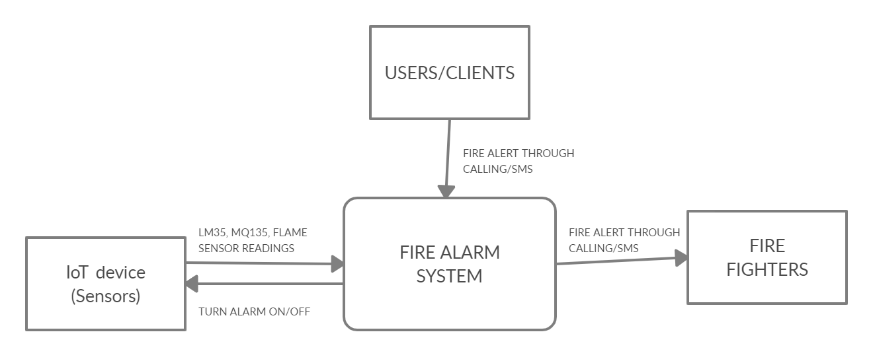
FIGURE 3.1: CONTEXT DIAGRAM

    - The Flow Diagram
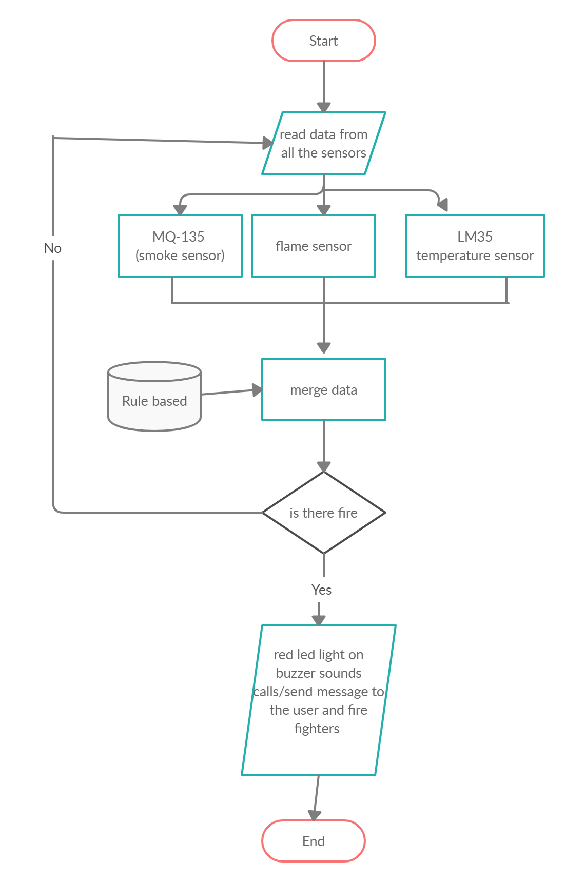

FIGURE 3.2: FLOW CHART
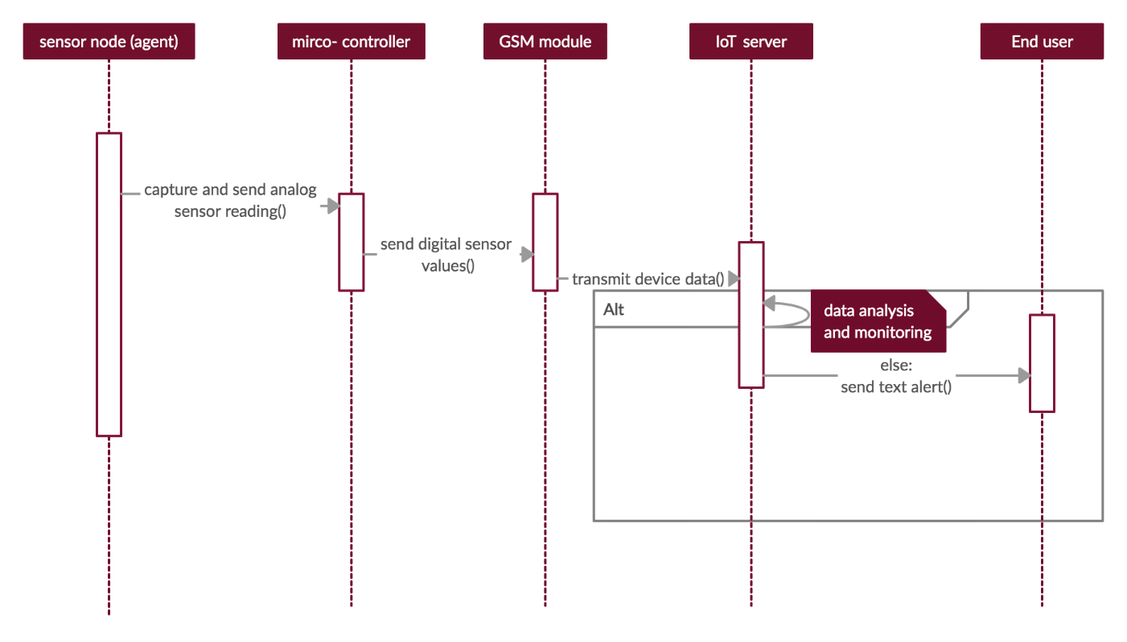
3.3.3 SEQUENCE DIAGRAM
FIGURE 3.3: SEQUENCE DIAGRAM

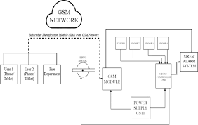
3.3.4 BLOCK DIAGRAM

FIGURE 3.4: BLOCK DIAGRAM

    - USE CASE DIAGRAM
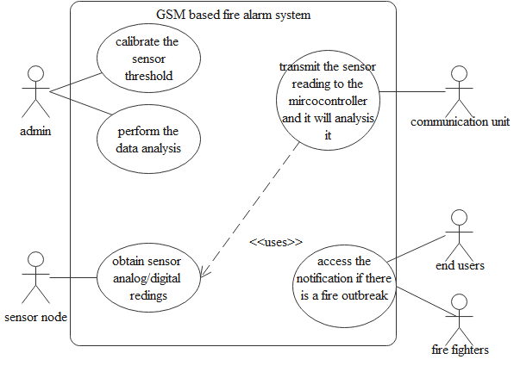

FIGURE 3.5: USE CASE DIAGRAM (Obanda, 2017)

3.4 HARDWARE COMPONENT UNIT
- 3.4.1 Arduino UNO Board
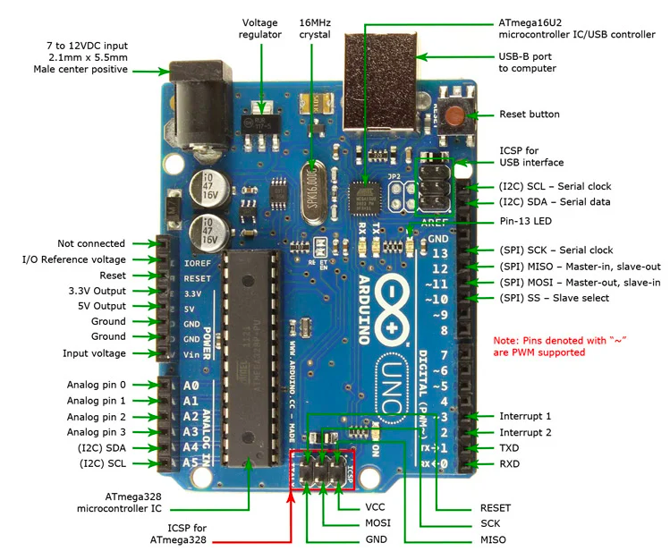

FIGURE 3.6: LABELLED DIAGRAM OF ARDUINO UNO (Tonutti,2015)

    - GSM Module SIM900
The UART protocol is used by the SIM900 GSM/GPRS shield to communicate with an Arduino. It is supported by a chip of 1200bps to 115200bps baud rate with Auto-Baud detection. The (RX, TS) of the shield is connected to the Software Serial (D8, D7) of the Arduino by the help of jumpers’ wire in figure 3.7 .
    - Flame Sensor
Flame sensor is connected to the Arduino Uno by connecting the VCC, GND, and DO of the flame sensor to 5V, GND and PIN3 of the Arduino Uno respectively with the help of the jumper wires in figure 3.8.
    - Temperature Sensor (LM35)
The pin A0, OUT, GND of the LM35 is connected to 5V, A1, GND of the Arduino Uno with the help of the jumper wires in figure 3.9
    - Smoke Sensor (MQ-135)
The pin A0, GND, VCC of the MQ-135 is connected to the A0, GND, 5V of the Arduino Uno with the help of jumper wires in figure 3.10.

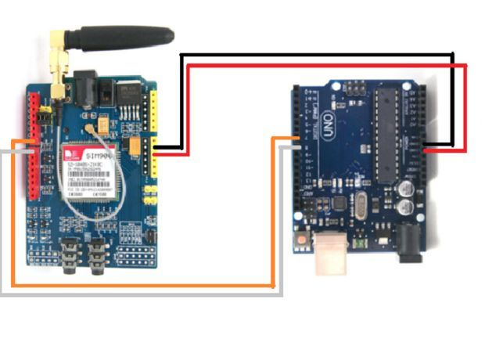

FIGURE 3.7: SIM900 INTERFACING WITH ARDUINO

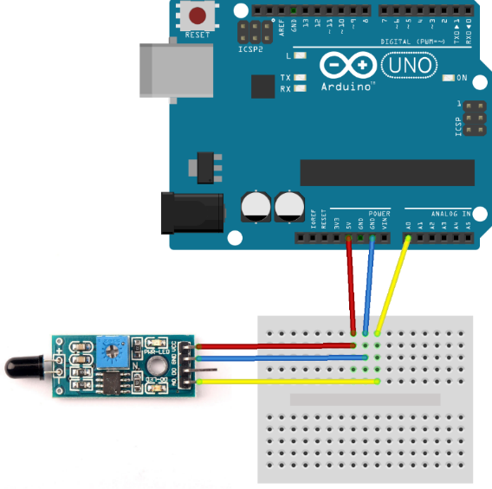

FIGURE 3.8: FLAME SENSOR INTEFACING WITH THE ARDUINO UNO

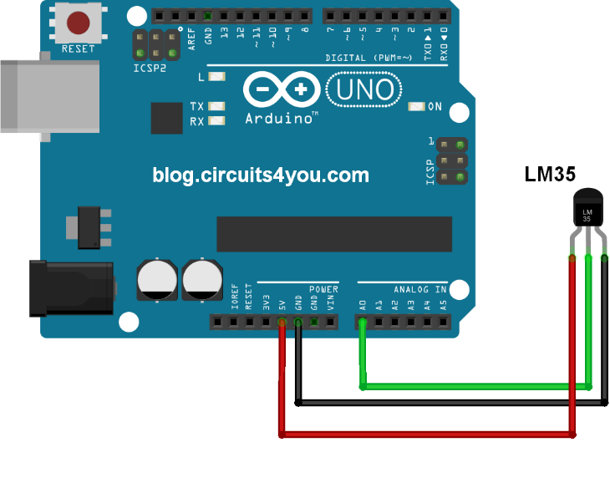

FIGURE 3.9: LM35 INTERFACING WITH THE ARDUINO

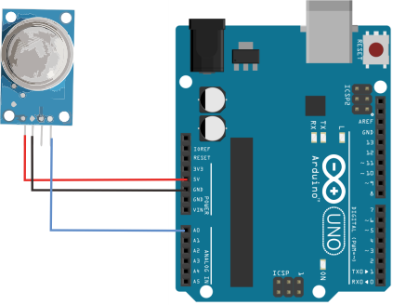

FIGURE 3.10: MQ-135 INTERFACING WITH THE ARDUINO UNO

3.5 METHOLOGY
Rapid prototyping was used as the development methodology for this research that is know as rapid application development (RAD) model in figure 3.11. RAD was adopted because of its two key advantages that include saving cost and time and also allows easier incorporation of changes to the prototype. (Obanda, 2017)
3.6 METHOD OF DATA COLLECTION
Research data is data that can be collected, created, or observed, for purpose of analysis to produce genuine research results. Therefore, the accuracy of research is highly dependent on the quality of data used. This research employed primary data. Primary data can be defined as genuine research that is obtained directly from the source which includes information collected from questionnaires, experiments, survey, measurement and focus groups. The primary data used in this research was collected through an experiment. The experiment involved using an LM35 temperature sensor that recorded daily temperature readings for one week in a house, including the MQ-135 and flame sensor. The readings were recorded after every six hours and aggregated on a daily basis. The data gotten was later used to get the threshold for each of the sensor used. The results are discussed in Chapter 4 of this research.

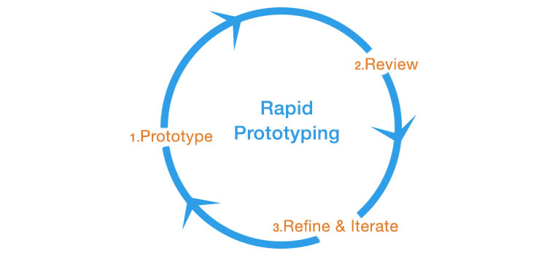

FIGURE 3.11: DIAGRAM OF THE METHOLOGY (Obanda, 2017)

CHAPTER FOUR
SYSTEM IMPLEMENTATION
4.1 SYSTEM IMPLEMENTATION
In this chapter, the effectiveness of the method described in the previous chapter for the GSM based fire alarm system using Arduino Uno is evaluated.
The implementation stage involves the code-and-fix method of development.
4.1.1 Language Description
The programming language used for the implementation of this project is the processing. Processing is a flexible graphical library and integrated development environment (IDE) that is built for the new media art, electronic arts, and visual design communities. Arduino IDE is a special software running on your system that allows you to write program in Arduino language (i.e. sketches) for different Arduino boards. The Arduino programing is based on processing, which is similar to the C language. After the Arduino language is written in the Arduino IDE, it should be uploaded on the Arduino board for execution
4.1.2 Program Description
The system just has a part with is the hardware
4.1.2.1 Hardware
The sensors and the Arduino board was programmed writing processing code in the Arduino IDE. All the sensors were arranged on the breadboard connecting the analog and digital input/output pins to the microcontroller (Arduino Uno board).
4.2 SYSTEM REQUIREMENTS
4.2.1 User Interface Requirement
- Use of any communication device
- Don’t use a phone that is on airplane
4.2.2 Hardware Requirements
- An uninterrupted power supply
- Your SIM card must be active at all time
4.3 SYSTEM DEVELOPMENT
4.3.1 Users
Firefighter and owner: They receive notification in case of a fire with the last temperature, smoke and flame readings and it calls them.
4.3.2 HARDWARE
The Arduino Uno microcontroller receives the instruction sent from the Arduino IDE, reads data from the digital and analog pin then analyse the data by comparing it to the data threshold. If the data goes above the threshold it alerts the client and firefighters then sound the buzzer.

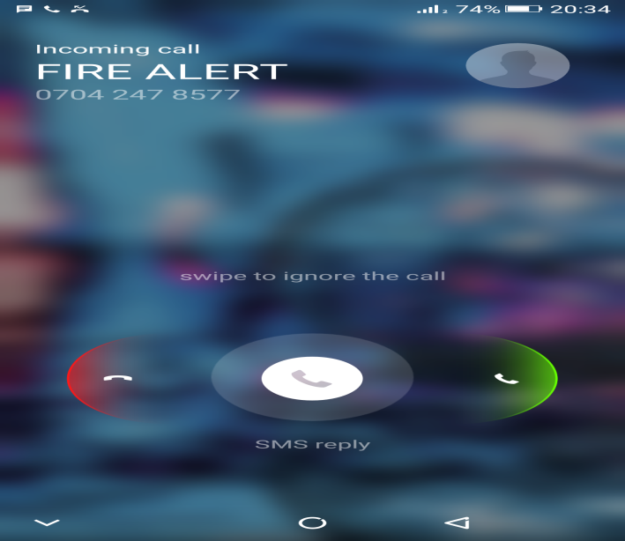

FIGURE 4.1 NOTIFICATION BY CALLING

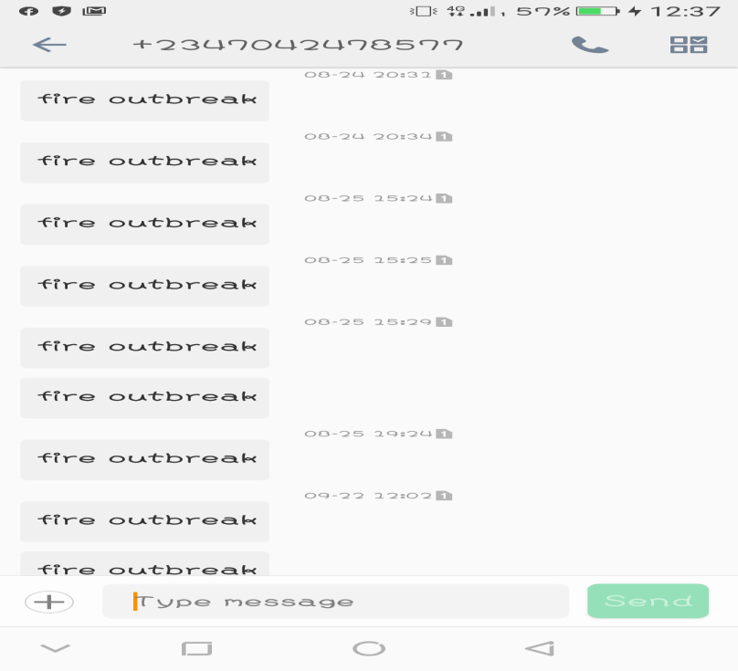

FIGURE 4.2 NOTIFICATION BY MESSAGING

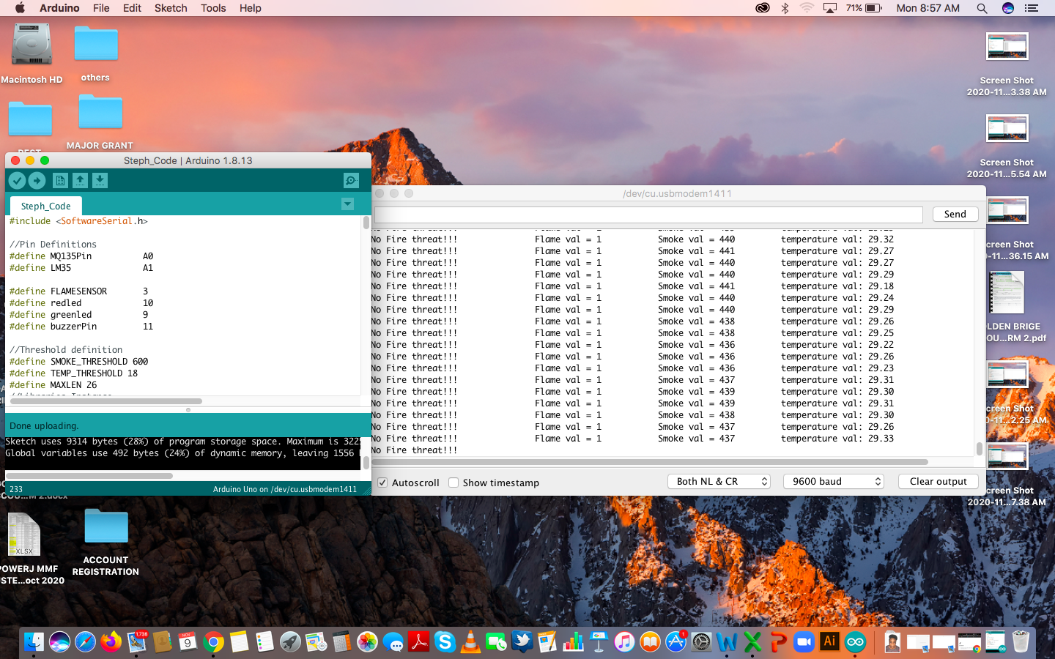

FIGURE 4.3 RESULT FROM ARDUINO IDE

4.4 TESTING
In this stage, each sensor is tested separately. The tests conducted to ensure the preciseness of each sensor before integrating into the main prototype. The final prototype system was tested to ensure that it is precise in the detection of fire to ensure the absence of false alarms.
4.4.1 MQ135 sensor testing
The MQ135 sensor in the prototype, functionality was tested. The combustible gas and smoke was produced using a cigarette lighter and paper. As illustrated table 4.1 are the test results;
Three tests were arrived out on the MQ125 sensor. All the three tests were passed representing 100% percent functionality.

Table 4.1: Functionality Testing of the MQ135
Test Name: MQ135 sensor
Type of Test: Functionality.
Sensor Threshold: 600ppm
MQ135 sensor in ppm  (Parts-per-million) | Action | remark
0ppm | No Text Alert Sent | This is the expected action.
400ppm | No Text Alert Sent | This is the expected action.
601ppm | Text Alert Sent | This is the expected action.

4.4.4 Performance Testing
To evaluate the warning service (Text Alert) based on a speed metric, performance testing was carried out. Once a fire was detected, it was necessary for the prototype to send timely text SMSs to the related parties. This test was carried out using a stopwatch to analyze and document the amount of time taken between the detection of the fire and the alert’s arrival on a cell phone. Three experiments were carried out and the findings are as shown table 4.3

Alert Name | Time before text arrived
Alert 1 | 40 seconds
Alert 2 | 55 seconds
Alert 3 | 70 seconds
Average Time (In Seconds) | 55 seconds
Table 4.2 Performance Testing

The average time before the end-user got the text message was about 55 sends

CHAPTER FIVE
SUMMARY, CONCLUSION AND RECOMMENDATION
5.1 SUMMARY
To summarize, there are keys functionalities/techniques that were implemented to ensure the prototype was used to achieve its main objectives, which was to reduce false alarm rates, and its sub-objectives, which were affordability and making fire detectors “smart”. They are as follows:
- Using MQ135, Temperature, and Flame as parameters to detect fire.
- Including a potential cause of fire (Cooking gas) into the system.
- Combining both rate of rise in the temperature unit and a fixed temperature threshold as techniques to detect changes in room temperature.
- Combining both rate of rise in the smoke/gas unit and a fixed MQ135 threshold as technical to detect changes if it is greater than the threshold.
- Using GSM instead of Wi-Fi for sending text notifications.
5.2 LIMITATION
- No record keeping is being done in the system which deprives us from any type of analysis which can be beneficial for the betterment of the existing system
- Due to the absence of GPS the project the client or firefighters will not be able to see the location of the place, but I was able to program the address into the system.
The design and construction of a GSM Based fire alarm system using Arduino was successfully carried out and tested effectively. I believe that this project will reduce the false alarm of fire outbreak in homes, lab and the problems stated in chapter 1 of this project write up. Safer environment are ensured due to this project.
5.4 CONTRIBUTION
The reduction rate of false alarm and provision of warnings on time in case of any fire outbreak has been substantially solved by the provision of the GSM-based fire alarm system using Arduino. Through the function of the project, it has contributed to the use of the Internet of things (IoT) and developed the fire alarm system.
5.5 RECOMMEDATION
The recommendation based on the project result is as follows:
- The use of rechargeable batteries as a power source can be enable for the device to be extended
- The use of GPS can be used in order to give accurate location the end user(i.e. client and firefighters)

REFERENCES
Agazi, w., Bahta, G., Mekonen, A., & Solomon , B. (2010). GSM Based Fire and Smoke Detection and Prevention System (Thesis). Adigrat University . Retrieved January 15, 2020
Amirul, A. R., & Rahimi, B. (2020, January). Advanced gas leakage, fire and power supply failure. Indonesian Journal of Electrical Engineering and Computer Science, 17, 222~227. doi:10.11591
Keyur, K. P., Sunil, M. P., & PG, S. (2016, May). Internet of Things-IOT: Definition, Characteristics, Architecture, Enabling Technologies, Application & Future challenges. Research Gate, 6(5), 6122-6131. doi:10.4010/2016.1482
Mahzan, N. N., Enazai, N. I., & Noh, K. S. (2018). Design of an Arduino-based home fire alarm system with GSM module. Journal of Physics, 1-8. doi:10.1088/1742-6596/1019/012079
Mid, I. M., Md, A. b.-A.-R., Md, N. I., & Md, R. H. (2016). An Intelligent Fire Detection and Mitigation System Safe from Fire (SFF). International Journal Computer Application, 133(6), 1-7. Retrieved January 15, 2020
Neha, M., & Yogita, B. (2017, March). Literature Review on Home Automation System. International Journal of Advanced Research in Computer and Communication Engineering, 6(3). doi:10.17148/IJARCCE.2017.63173
Obanda, Z. S. (2017). Multi-sensor fire detection system using an Arduino Uno mircocontroller (Thesis). Retrieved January 15, 2020, from http://su-plus.strathmore.edu/handle/11071/5686
Prof. madhu, B. R., Vaishnavi, K. R., Dushyanth, N. G., Tushar , J., & Sohan, C. (2019, May-June). IoT Based Home Automation System over Cloud. International Journal of Trend in Scientific Research, 3(4), 966-968. doi:IJTSRD24005
Trung, L. (2019). Fire detection and alarm system(Thesis). 1-60. Retrieved january 15, 2020
Tonutti, Michele. (2015). The Companion Crutch - Design and Development of a Wireless Instrumented Crutch. 10.13140/RG.2.2.20813.33763.
APPENDIX A
CODE OF THE MQ135
#define MQ135Pin A0
void setup()
{
pinMode(MQ135Pin, INPUT);
Serial.begin(9600);
}
void loop()
{
int val = 0;
for (int i = 0; i< 100; i++)
{
val = analogRead(MQ135Pin);
}
val = val-50;
Serial.println(val);
delay(1000);
}

APPENDIX B
CODE FOR LM35
#define LM35 A1

void setup()
{
// put your setup code here, to run once:
pinMode(LM35, INPUT);
Serial.begin(9600);
}

void loop()
{
float val = 0;

for(int i = 0; i < 100; i++)
{
val += analogRead(LM35);
delay(2); //FOR ADC STABILITY
}
val = val/100;
float temperature = val * (5./10.);
Serial.print("val: ");
Serial.print(val);
Serial.print("\ttemperture: ");
Serial.println(temperature);

delay(1000);
// put your main code here, to run repeatedly:

}

APPENDIX C: BILL OF MATERIALS
Hardware name | Technical Specification | Descriptions
SIM900 GSM module | - Operating temperature: 30oc to +80oc  - Supply voltage: 3.5V – 4.5V | The frequency of operation of the module is 850/900/1800/1900MHz and can be used for communication orally (provided a microphone and portable speaker is connected to it) and for SMSs.
Arduino Uno | - Operating voltage: 5V  - Input voltage: 7-12V  - Digital I/O pins: 14 | A microcontroller that is cheap and easy to progam.it is used in this project because of its compatibility with most sensors
buzzer | - Operating voltage: 3- 24V  - Rate voltage: 12V DC | Standard Piezzo buzzer.
Jumper cables | Red. Blue. Black, and yellow colour codes | The use of female-female, male-female, male-male
MQ135 | - Operating Voltage is +5V  - Detect/Measure NH3, NOx, alcohol, Benzene, smoke, CO2, etc | Fast response and High sensitivity
Bread board | The smaller version | It serves as a connection to all the sensor
Led light | Green and red color code | The green light serves as safe  The red light serves as danger

APPENDIX D: CONNECTING OF ALL THE SENSORS

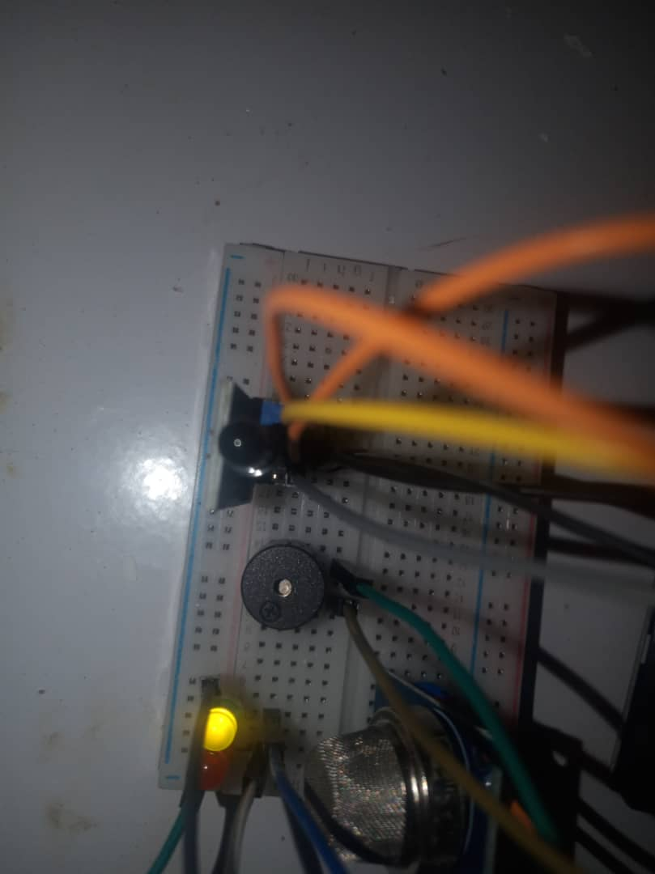

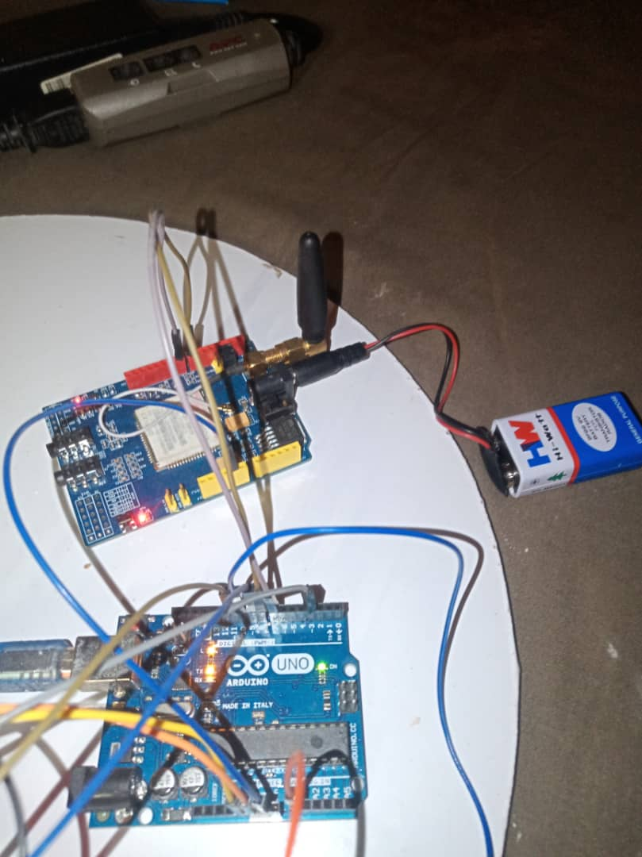
APPENDIX E: CONNECTING THE GSM MODULE TO THE ARDUINO

APPENDIX F: CONNECTING BOTH THE SENSORS AND GSM MODULE TO THE ARDUINO
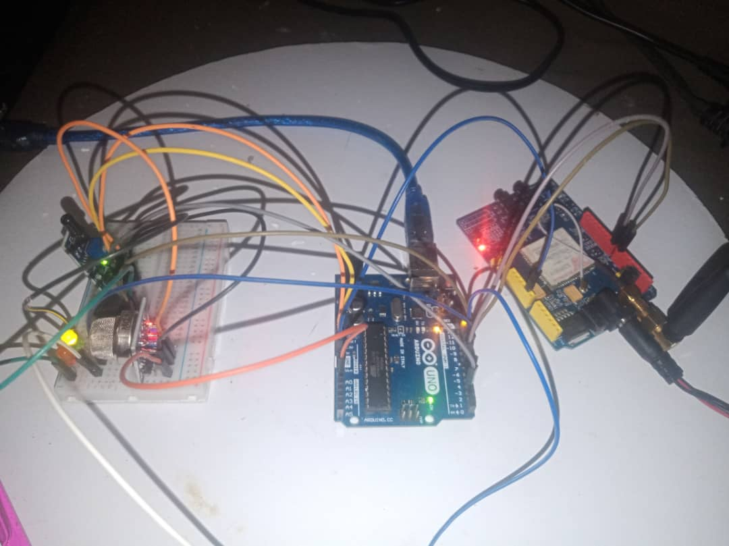

APPENDIX G: SERIAL MONITOR READING OF THE LM35
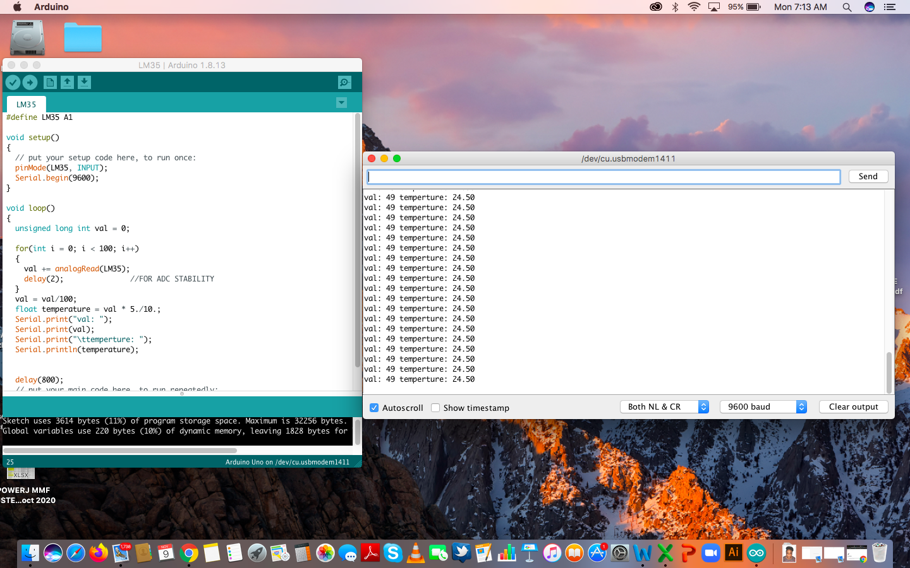

APPENDIX H: SERIAL MONITOR READING OF THE MQ135
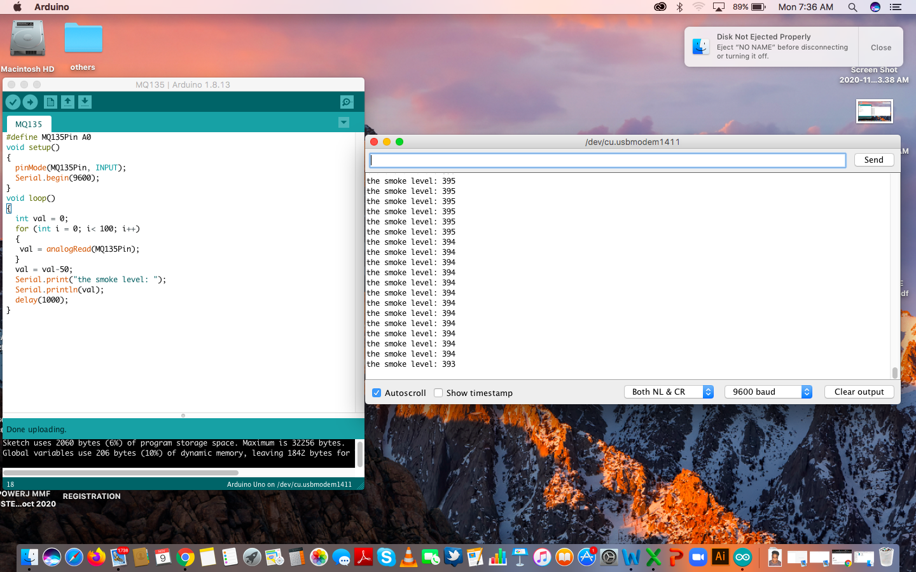

APPENDIX I: SERIAL MONITOR READING OF THE FLAME SENSOR
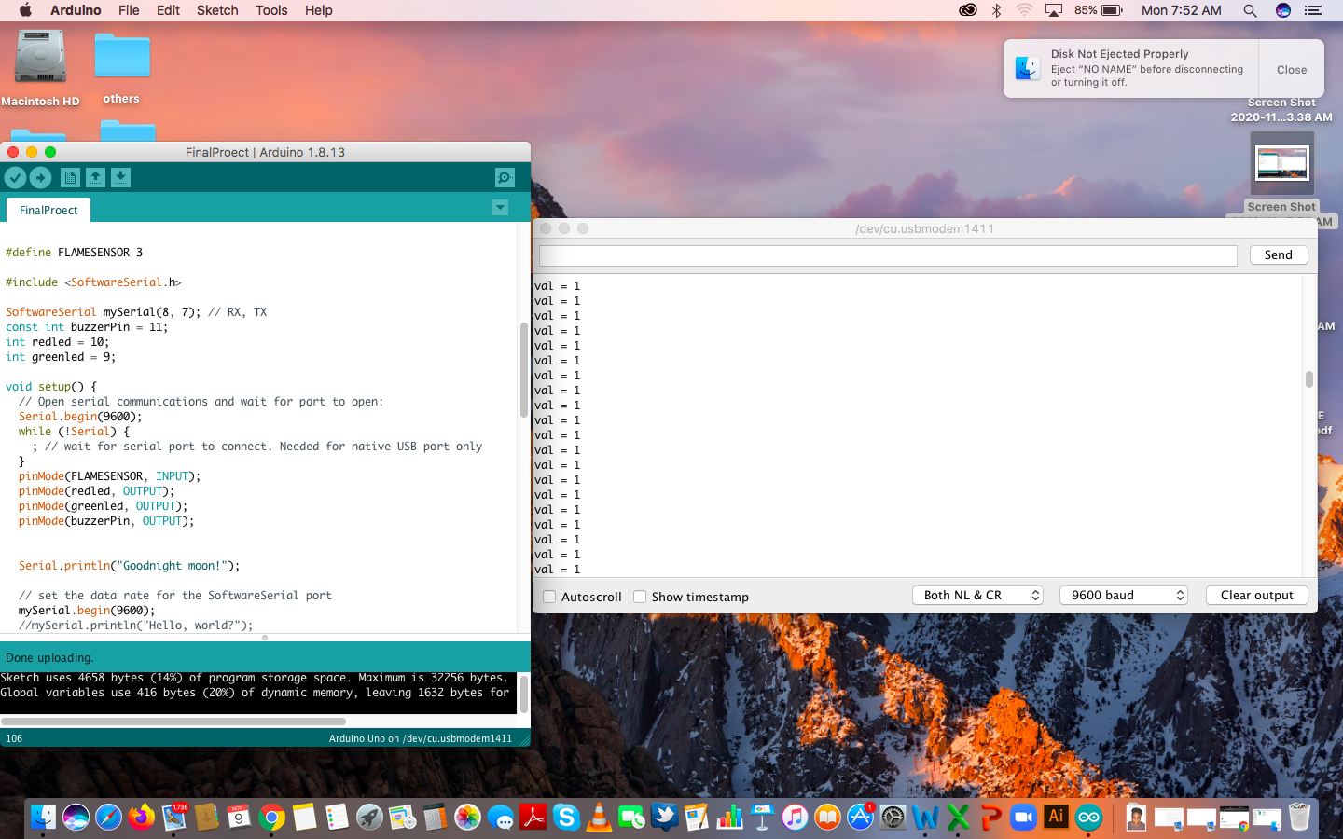

APPENDIX J: SERIAL MONITOR READING OF ALL THE SENSOR

