IMPACT OF THE MANUFACTURING SECTOR ON ECONOMIC GROWTH IN NIGERIA

(1981- 2020)

By

IDEHEN Martha Precious

MATRIC NO: 17020301006

BEING A PROJECT SUBMITTED TO THE DEPARTMENT OF ECONOMICS, COLLEGE OF HUMANITIES MANAGEMENT AND SOCIAL SCIENCES, MOUNTAIN TOP UNIVERSITY.

IN PARTIAL FULFILMENT OF THE REQUIREMENTS FOR THE AWARD OF BACHELOR OF SCIENCE DEGREE (BSC) IN ECONOMICS.

AUGUST, 2021.

CERTIFICATION
This is to certify that this work was carried out by Idehen, Martha Precious (17020301006) at the Department of Economics Mountain Top University, Ogun State Nigeria under my supervision.

Name of Supervisor: Dr. Babasanya, A.O.
Signature & Date -------------------------------------

Name of H.O.D: Dr. Ologundudu Mojeed M
Signature & Date -------------------------------------

DEDICATION
This research is dedicated to The Almighty God who alone has made it possible for me to get to complete this project and get to this point in life. All glory belongs to him alone.

ACKNOWLEDGMENTS
My sincere appreciation goes to my wonderful parents Arch. and Mrs Idehen for their unfailing guidance, love and support and to me, they’ve always been there for me through every phase I passed through, thank you very much for your prayers also, and also to my siblings for being there for me, supporting me and listening to me, I appreciate you all sincerely.
I also want to deeply appreciate my project supervisor, Dr. Babasanya, Adeyemi for his huge support, guidance and advice towards the successful completion of this project. I also appreciate my H.O.D, Dr.. Ologundudu, Mojeed .M. and my lecturers Dr Obafemi Ademola Young and Mr Oluyomi, Olatunji Oluwatosin for assisting and pushing me through various ways to ensure I successfully complete this work. My sincere thanks also goes to Dr. Maku, Olukayode, Dr Clement, Olaniyi, Dr Ojapinwa, Taiwo and Dr Adelowokan for their sincere support and teaching me most of the things I know regarding my field of study.
I want to deeply thank the university chaplain Pastor Olumide, Adesina for his spiritual guidance, prayers, fatherly concern and advices to me.
Also, I will like to express my thanks to my wonderful friends for always encouraging me and course mates who have contributed to my work in one way or another.

TABLE OF CONTENTS
CONTENTS PAGES
TITLE PAGE i CERTIFICATION ii DEDICATION iii ACKNOWLEDGEMENTS iv TABLE OF CONTENTS v LIST OF TABLES ix ABSTRACT x
CHAPTER ONE: INTRODUCTION
  - Background to the Study 1
  - Statement of the Problem 3
  - Research Questions 6
  - Research Objectives 6
  - Research Hypothesis 6
  - Significance of the Study 6
  - Scope of the Study 7
CHAPTER TWO: LITERATURE REVIEW
2.1 Conceptual Review 8
2.1.1 Concept of Industrialisation 8
2.1.2 Concept of Manufacturing 8
2.1.3 Concept of Economic Growth 9
2.1.4 An Overview of the Manufacturing Sector and Economic Growth in Nigeria 10
2.1.4.1 An Overview of Policies Set in Place to Boost Nigeria’s Manufacturing Sector 11
2.1.4.2 The Import Substitution Industrialization Strategy 11
2.1.4.3 The Nigerian Indigenization Policy 12
2.1.4.4 The Nigerian Enterprise Promotion Act 12
2.1.4.5 Structural Adjustment Programme 12
2.1.4.6 Trade and Financial Liberalization Policy 13
2.1.4.7 Bank of Industry 13
2.1.4.8 Small and Medium Industries Equity Investment Scheme 13
2.1.4.9 National Economic Empowerment and Development Strategy 14
2.1.4.10 National Integrated Industrial Development 14
2.1.4.11 Industrial Park Development Strategy 14
2.2 Theoretical Review 15
2.2.1 Theories of Economic Growth 15
2.2.1.1 Classical Growth Theory 15
2.2.1.2 Neo-Classical Growth Theory 16
2.2.1.3 The Endogenous Growth Model 17
2.2.1.4 Nicholas Kaldor’s Growth Model 18
2.3 Empirical Review 19
2.4 Summary of Literature Review 24
2.5 Gaps in the Literature 24
CHAPTER THREE: METHODOLOGY
3.1 Theoretical Framework 25
3.2 Sources of Data 25
3.3 Model Specification 28
3.4 Estimation Technique 29
3.4.1 Unit Root Test 30
3.4.2 Lag Length 30
3.4.3 Co-Integration Analysis 30
3.4.4 Short-Run and Long-Run Estimates 31
CHAPTER FOUR: PRESENTATION AND INTERPRETATION OF RESULTS
4.1 Unit Root Test Results and Interpretation 33
4.1.2 Lag Length Order Selection Criteria Results 37
4.1.3 Co-Integration Test 40
4.2 Empirical Results on the Relationship between Manufacturing Capacity Utilization and Economic Growth in Nigeria 43
4.2.1 Long-Run Effect of the Relationship between Manufacturing Capacity Utilization and Economic Growth in Nigeria 43
4.2.2 Short-Run Effect of the Relationship between Manufacturing Capacity Utilization and Economic Growth in Nigeria 46
4.3 Empirical Results on the Impact of Manufacturing Sector Output and Economic Growth in Nigeria 48
4.3.1 Long-Run Effect of the Impact of Manufacturing Sector Output and Economic Growth in Nigeria 48
4.3.2 Short-Run Effect of the Impact of Manufacturing Sector Output and Economic Growth in Nigeria 51
4.4 Summary of Discussion of Results 53
CHAPTER FIVE: SUMMARY, CONCLUSIONS AND RECOMMENDATIONS
5.1 Summary of the Findings 54
5.2 Conclusion 55
5.3 Recommendations 56 References 57

LIST OF TABLES
Table 3.1 Sources of Data 26
Table 4.1 Result of the Augmented Dickey Fuller Test 35 Table 4.2 Result of the Phillip Perron Test 36 Table 4.3 Lag Length Selection Criteria for Objective One 38 Table 4.4 Lag Length Selection Criteria for Objective Two 39 Table 4.5 Co-Integration Test Result for Objective One 41 Table 4.6 Co-Integration Test Result for Objective Two 42 Table 4.7 Estimated Long-Run Test Result for Objective One 45 Table 4.8 Estimated Short -Run Test Result for Objective Two 47 Table 4.9 Estimated Long -Run Results for Objective One 50 Table 4.10 Estimated Short Run Results for Objective Two 52

ABSTRACT
This study examined the Impact of Manufacturing Sector on Economic Growth in Nigeria. In line with the objectives of the study, secondary data were obtained from Central Bank Statistical Bulletin and World Bank Indicator covering the period of 1981 to 2020. The data was based on manufacturing capacity utilization, manufacturing sector output, inflation, exchange rate, technology, money supply, government expenditure and real interest rate. The study employed the Autoregressive Distributed Lag (ARDL), it employed the Augmented Dickey-Fuller (ADF), Phillip-Perron (PP) test the lag order of the ARDL models using VAR order selection criteria, the cointegration test and tested for long-run and short-run relationship. The results of the data showed that there exists a positive relationship between the manufacturing sector and economic in Nigeria. The results showed that manufacturing capacity utilization, manufacturing sector output, and real interest rate has a positive relationship with economic growth, while inflation, exchange rate, technology, government expenditure and money supply has a negative relationship with economic growth in the long run in Nigeria. Thus, the study recommends that the government should work on improving the infrastructural facilities in the country to aid investment and also encourage entrepreneurs. Also the central bank can make interest rate more assessable to investors to encourage investment in the manufacturing sector.
Keywords: Manufacturing sector, manufacturing capacity utilization, ARDL, Economic Growth.

CHAPTER ONE
INTRODUCTION
1.1 Background to the Study.
Manufacturing has long been seen as the primary driver of economic growth and development in advanced and more contemporary sectors, as it has never been recorded that any country in the world has achieved economic growth by engaging in agriculture without having a strong standing industrial sector to act as a back bone as both agriculture and industrialization are both integral parts of every economy that wants to achieve structural change and development. The significance of the manufacturing sector can never be over emphasised as it brings about economic transformation.
The significance of the manufacturing sector in bringing about economic transformation cannot be overstated. In reality, the industrial sector creates an outlet for increased productivity through import substitution and export expansion, resulting in increased foreign exchange earning capacity, job creation and increased per capita income, all of which boosts unique consumption arrangements (Beckerman, 2007). It is worth noting that manufacturing is an important component under the industrial sector and can be used interchangeably with industry, Industrialization alternatively acts as an enormous tool for creating wealth, generating employment and accelerating growth and development in the economy (Afolabi and Laseinde, 2019).
Industrial development is concerned with the use of modern machineries, and technology in the creation of goods and services, and the reduction of human suffering and advancement of societal welfare (Bennett and Anyanwu, 2015). As a result, manufacturing has to do with the application of advanced technologies to boost productivity and the development of managerial and entrepreneurial abilities in the respective countries.
Manufacturing is the process of turning raw materials into completed goods in huge quantities, and it necessitates the use of various production tools as well as labour, capital and supplies (Adofu, 2015). It is worth noting that a strong manufacturing sector is a precondition for industrialization, only few countries in the world therefore have been able to grow their manufacturing sector and achieve industrialization.
In Nigeria, despite being endowed with natural resources, the manufacturing sector performance has been so unimpressive and this has contributed to the negative growth of output, pumped up the unemployment rate, caused a widespread problem of poverty, low standard of living, and has also increased the crime rate in the country.
Nigeria has widely implemented a number of techniques targeted at enhancing manufacturing sector productivity in order to bring about economic development and progress. For instance, during the First National Development Plan, which ran from 1962 to 1968, Nigeria adopted the import substitution industrialization strategy, which aimed to reduce the size of finished goods imported by producing locally and exporting some of the locally produced consumer goods, thereby encouraging foreign exchange savings. The country’s import substitution policy was consolidated during the Second National Development Plan period (1970-1974), which coincided with the oil boom, during this period the manufacturing activities depended highly on imported materials because the technological base of the economy was extremely weak.
However, in the early 1980’s the collapse of the world oil market reduced oil export earnings, making the industrial sector, which was heavily reliant on imports, unsustainable because it could no longer afford the massive import bills. Various policies were implemented to fix the aforementioned situation, including the restrictive monetary policy and stringent exchange control measures of 1984, as well as the stabilization measures of 1982, all of which failed. As a result, in1986, the Structural Adjustment Programme was implemented (CBN, 2003). SAP was implemented primarily to reduce the economy’s reliance on crude oil which was the primary source of foreign revenue, by encouraging non-oil exports, manufactured goods in particular.
Despite all the economic policies set up and all the hard work of the government to kick-start and sustain rapid industrial growth in Nigeria, the non-oil sector notably the manufacturing sector still remains stunted in growth. For over seven decades the contribution of the manufacturing sector to GDP over the years has fluctuated and declined greatly which does not speak well of Nigeria’s industrialization. Nigeria’s industrial sector has been characterized by excessive production cost, high imports of industrial inputs, low GDP, poor forward-backward linkages with other sectors in economy and low employment generation (Obioma and Ozughalu, 2005). The development of some of the Asian Tigers countries who were once on the same level of development with Nigeria in 1960’s and 1970’s can be attributed to the level of output yielded from the industrial sector. Instead of increasing, Nigeria’s manufacturing sector contribution has declined and keeps declining greatly. Nigeria’s manufacturing sector in the past ten years has not exceeded 5% (CBN, 2012), by implication, Nigeria is a poorly developed country with a low rate of industrial growth and development.
  - Statement of the Problem.
At independence, the British colonial masters left Nigeria a very weak and insignificant manufacturing sector, our industrial sector was then highly dominated by European companies, examples are John Holt and the likes. They were deeply involved in trade and commerce and also engaged in the marketing of goods imported from their home country to Nigeria. There was no attempt to reinvest financial resources generated within the country for development purposes neither was there any concrete attempt made to develop indigenous entrepreneurship (Banjoko and Bagshaw, 2012). The colonial economic policy, which was based on ensuring that the colonies are constant providers of fundamental raw resources for manufacturing industries and international importers of manufactured goods, did not include an industrial sector. One of the most fundamental flaws of the colonial administration was the failure to build a steady foundation for the development of an industrial sector in Nigeria. Nigeria’s inability to improve on her manufacturing sector and head on to industrialization despite being naturally endowed with various resources can be traced to the policy inconsistencies and distractions. Economic growth is substantially low and manufacturing sector is extremely weak and thus cannot give in any good contribution to increase output. Many multinational industries have been forced to give up and move to neighbouring countries due to terrorism, meanwhile most small scale enterprises have been forced to close down and staff layoffs are now popular in medium and large scale companies.
Manufacturing contribution in 1960 was a mere 4.8%, it experienced an increase to 7.2% in 1970 and also increased to 7.4% in 1975. It experienced a decline to 5.4% in 1980, it then sky rocketed to a 10.7% in 1985, in 1990, the manufacturing sector contributed 8.1%, but by 1992, it declined to 7.95%. It fell from 6.2% in 2000 to 3.4% in 2001, it climbed to 4.16% which is lower than it was in 1960. Although there was a large increase in manufacturing production index between the period of 1970 and 2000, it fluctuated at times, the increase can be attributed to substantial expenditures in the manufacturing sector from oil production earnings (Bennet, Anyanwu and Kalu, 2015). Although, during the recent years an upward and downward trend has been observed from the manufacturing sector output, as of 2015 the percentage of manufacturing to GDP was 9.43%, it fell to 8.68%, since that period, there has been a rise in the manufacturing output growth and the percentage spiked to 11.52% in 2019.
A country is said to have achieved industrialization when one-fourth of the GDP is contributed by its manufacturing sector, and at least one tenth of its total population is employed in the industrial sector of the economy. The manufacturing sector is expected to be dominant to the GDP, particularly in Nigeria (Ayodele and Falokun, 2003).
The manufacturing sector in Nigeria does not account for at least a quarter of the country’s GDP. As a result, she is dealing with capacity underutilization which is posing a huge threat to the country’s growth and development (Adewale, 2002).
As of today, the manufacturing sector in Nigeria has not made any significant contributions to the country’s economy neither has it brought about employment opportunities, there exists a downward trend in the revenue and job creation in the manufacturing sector. Other sectors being neglected in the economy has also denied the manufacturing sector the source of their raw materials leading to the importation of materials into the country which has led to low level of industrialization.
The Nigerian manufacturing sector faces a lot of constraints starting from the various unstable government policies set during the oil boom with the aim of fast tracking industrialization, although this policies had their advantages but the benefits were not felt as the government kept changing policies before they could be effected thus, leading to Nigeria experiencing few advantages and more of the adverse effects of these policies. Some of this policies among many include the First National Development Plan which aimed at starting up industrialization across the country, import substitution as an industrialization strategy, export promotion strategy and foreign private investment as industrialization strategies and reform policies like indigenization policy, SAP all of which have not brought dynamic change to the economy (Ekpo, 2014).
It is therefore necessary to evaluate the contribution of the Nigerian manufacturing sector to Nigeria’s economic growth, to examine the various determinants and constraints behind the manufacturing sector performance and also how the country can be pushed to industrialization.
  - Research Questions
The following questions are to be answered by this research study
- What is the relationship between manufacturing capacity utilization and economic growth in Nigeria?
- What is the impact of manufacturing sector output on economic growth in Nigeria?
  - Objectives Of The Study
The broad objective of this study is to evaluate and examine the impact of the manufacturing sector on economic growth in Nigeria. The other specific objectives are to;
- assess the relationship between manufacturing capacity utilization and economic growth in Nigeria.
- examine the impact of manufacturing sector output on the economic growth in Nigeria.
  - Research Hypothesis
In order to test for validation or rejection, the following hypothesis shall be carried out
H₀₁: There is no relationship between manufacturing capacity utilization and economic growth in Nigeria.
H₀₂: The manufacturing sector output has no impact on Nigeria’s economic growth.
  - Significance of the Study
The importance of this study cannot be overstated as the manufacturing sector is a very vital and important sector in the economy, currently the level of productivity in the manufacturing sector is extremely low, such has been the case from the start and will not change if certain measures are not taken. Hence, the importance of this study. This study will dig and expose the level of manufacturing industry productivity and how they contribute to the growth of the economy. It will also bring to light the problems faced by the manufacturing sector, how such problems have affected the sector, how such problems could be reduced and how to aid the sector yield positive effects on the economy.
This research tries to review other empirical studies on similar topics and strengthen current works on the problems facing the manufacturing sector. When this research is concluded, the results will be helpful to economic policy makers, showing them that a strong manufacturing sector is essential for industrialization and the findings will also be useful to other researchers who want to carry out further research on the manufacturing sector.
  - Scope of the Study
This study covers a period of 40 years, that is, 1981-2020. This study will be based on the empirical findings on the manufacturing sector and its impact on economic growth within this specified period. This research makes use of secondary data and is limited to the data made available in Nigeria during the stated period. The specified period was used due to the fact that data was easily assecible during this period of time.

CHAPTER TWO
LITERATURE REVIEW
This chapter discusses the conceptual, theoretical and empirical issues which are related to the manufacturing sector and how it affects economic growth. This chapter is divided into three main sections, the conceptual review, theoretical review and empirical review of literatures. The term industrialization will be used interchangeably with the term manufacturing as the manufacturing sector is a subsector of the industrial sector.
2.1 Conceptual Review
2.1.1 Concept of Industrialisation
Industrialization be described as the transformation of a predominantly agrarian economy to one based on goods production. This is a process where individual manual labour is replaced by mechanical mass production, and there is usually an efficient division of labour in such an economy, in addition to a rise in the overall revenue and people’s standard of living.
Industrialization as defined by Wikipedia, involves the extensive re-organization of an economy for the main purpose of manufacturing. It focuses on sustainable development, technological progress and direct investment in more advanced technologies.
2.1.2 Concept of Manufacturing.
The manufacturing sector can be broadly seen as a combination of industries involved in the conversion of raw materials into consumer goods. The manufacturing sector provides a means of producing goods and services and also providing good jobs for the citizens of a country. The manufacturing sector was in fact described as the power house of the economy (Kayode, 2000).
According to the oxford learner’s dictionary, manufacturing can be defined as the business or industry that entails the mass production of goods in factories. Manufacturing also refers to a significant transformation of goods and services.
According to (Adofu, et al, 2015), manufacturing has to do with production of goods through the use of diverse instruments of production. It entails the creation of commodities for personal use or for sale, it requires the use of equipment’s, labour, tools, organic and inorganic materials in order to convert raw materials to completed products in huge quantities.
Manufacturing sector can be seen as the key sector in an economy that highly encourages and motivates conversion of raw materials into completed goods.
2.1.3 Concept of Economic Growth.
On the other hand, economic growth is among the main macroeconomic goals of every nation and it is used to check how healthy the economy is. Usually, it is measured by using the GDP which is the gross domestic product. GDP can thus be described as the sum total monetary value of the goods and services produced in a country over a given or specified period of time.
Economic growth can be defined as an increase of an economy’s ability to produce overtime the products and services required to better the lives of her people (Anyanwu, 1995).
Economic growth has been defined as a steady process by which the productive capacity of a given economy is increased overtime in order increase the level of national income overtime (Todaro, 1977). Speedy growth of the economy has always been a major fixation of economists around the world, especially in developing countries still driving towards development.

2.1.4 An Overview of the Manufacturing Sector and Economic Growth in Nigeria
Prior to the period of Nigeria’s independence, only few manufacturing industries existed, Nigeria depended solely on the importation of cheap commodities and no production of capital goods.
The periods after independence consisted of a surge of industrial activities. Manufacturing in Nigeria started properly from 1955-1960 against the predominance of wholesale trade and the extractive industry (Schatzl, 1973). It must be noted that the industrialization was never part of the plan set in motion by the colonial masters. In 1972, the Nigerian Enterprises Promotion decrees was placed, thereby limiting foreign ownership shares in different industries, this shifted the manufacturing sector from foreign ownership to indigenous ownership in the late 1970s.
Due to Nigeria’s over dependence on oil from 1980 to 2000, the level of production from the manufacturing sector dropped significantly, this can be attributed to the negative impact of the collapse of oil prices in the international oil market. Therefore, due to this global crisis, Nigeria’s foreign earning faced a decline which forced the government to place tariffs and import duties on the importation of certain commodities, since most of the raw materials used for manufacturing were imported, manufacturers found it hard to obtain raw materials, spare parts and other components needed for production as a result of this a lot of industries had to close up due to the decline In capital utilization. The average capitalization as at 1975-1981 was at 70% but due to this global oil crisis which took place in 1983 it plummeted to 9.7% and dropped to 43.0% as at 1984,this event marked the start of the retrogression from which the manufacturing sector is yet to recover from till date.
As at 1986, although this was the period at which SAP was introduced, the manufacturing output growth dropped to about 2.6%. From the period of 1993 to 1998, the manufacturing sector output growth was negative (Adoyi, 2016). The manufacturing sector output has since been stunted and as at 2009 the manufacturing sector output was said to be at 4.1% according to the Manufacturers Association of Nigeria.
The manufacturing sector output growth of recent has been fluctuating at different rates, the manufacturing sector output as at 2016 was at a 23.48% decline from its initial percentage in 2015, as at 2017 it was at a 6.48 decline and it faced an increase to 16.67 in 2018 and a drastic increase to 34.73 in 2019 (world bank,2021).
2.1.4.1 An Overview of Policies Set in Place to Boost Nigeria’s Manufacturing Sector
Since the political independence in 1960, a substantial number of policies have been put in place in order to increase the productivity of the manufacturing sector and other industrial sector’s in the economy. Among this policies we have:
2.1.4.2 The Import Substitution Industrialization Strategy (ISI): which was under Nigeria’s First National Development Plan in 1962 can be seen as the local production of manufactured goods for domestic markets (Ekpo, 2014). According to Wikipedia, it is a trade and economic policy that advocates for the substitution of locally produced items for imported commodities. Although placing import substitution strategies may not always yield positive effects, some countries had adopted it and came out successful, Nigeria therefore decided to adopt it. This strategy which was adopted in 1960 and existed till the1970’s. By adopting this policy, Nigeria sought to reduce her dependence on foreign markets through the production of basic necessary goods and also ease the burden on the exchange rate, certain measures which was said to be necessary for this strategies to work include high tariffs on imports of consumer goods, quota and outright prohibition on importation of specific consumer goods and low tariffs on the importation of capital and intermediate goods were set in place (Bankole, 2004). From 1960 through the 1970’s a lot of inducements were granted to the private sector to reduce their cost of production. These inducements include income tax reliefs, tax holidays, industrial estates were also built and let out to industrialists at subsidized rates, thereby relieving them of a bit of the burdens of capital expenditure on kick-starting their businesses (Okuneye, 2019).
2.1.4.3 The Nigerian Indigenization Policy (1972): This was the next policy which the government set in place and this was due to the inability of the import substitution policy to achieve the aims and objectives which it was meant to achieve, the indigenization policy of 1972 was aimed at providing various opportunities for indigenous businessmen, giving total control and ownership to Nigerian indigenes the enterprises that were either fully or partially owned by foreigners and also to encourage foreign investors to move to areas of the economy were large investments were needed more (Oyedele, 2009).
2.1.4.4 The Nigerian Enterprise Promotion Act (1977): This policy gave opportunities to local entrepreneurs and also gave either total or partial control of ownership to Nigerian businessmen, although this policy did not really favour the country because we lacked the technical know-how and skills on how to go about the improvement of the manufacturing sector. During this period was when Nigeria experienced the oil boom which brought about abundance and prosperity to the country, there was a lot of foreign earnings from the boom and this led to her increase in the consumption of imported goods.
2.1.4.5 Structural Adjustment Programme 1986 (SAP): SAP as it is widely known and called was another policy which was set in place to correct the ineffectiveness of all the other policies which were earlier placed to aid industrialization, this policy aimed at promoting investments , increasing the efficiency of the country’s industrial sector, to encourage non-oil exports and also provide the bases for improving the private sector as well as privatizing and commercializing the economy towards promotion of industrial efficiency. Remarkably, SAP had some positive effect on the industrial sector, for example, capital utilization as at 1986 was a mere 30% but by mid-1987, it rose to 36.7% at 1990, it rose to 40.3% and to 42.0% at 1991. This increase could be attributed based on the fact that manufacturers could now easily access foreign exchange and could import inputs (Obi, 2009).
Given the positive contribution SAP had brought to Nigeria, it also left some negative marks on the country, it could be argued that SAP worsened the difficult situation Nigeria had already forged into. For example, the high interest rate and liberalization of the foreign exchange regime during this period led to inflation and decrease in consumer purchasing, it causes industries to either let go of staffs or short down completely.
2.1.4.6 Trade and Financial Liberalization Policy (1989): This was the next policy set after the structural adjustment programme and it was set to encourage competition and effectiveness in the financial sector. The aims of this policy was to encourage competition among local firms and between import-competing firms in order to promote efficiency, to reduce the levels of trade barriers, and to determine the exchange rate and also deregulate interest rate in order to bring about efficiency (Adeoye, 2004).
2.1.4.7 Bank of Industry 2000 (BOI): The bank of industry was established during the reign of President Olusegun Obasanjo this institution was introduced to fast track industrial development in the country. The bank of industry is a combination of Nigerian Bank for Commerce and Industry, Industrial and Insurance Brokers, Nigeria Industrial Development Bank and Leasing Company of Nigeria. This institutions provided loans, equity finances and technical help to industrial enterprises with the aim of generating employment in the country, promotion of indigenous entrepreneurship and also to make an impact in terms of long term loans (Okuneye, 2019).
2.1.4.8 Small and Medium Industries Equity Investment scheme 2000 (SMIEIS): This policy was introduced in the year 2000 and apart from trying to correct the failures of the preceding industrial policies, it was also meant to increase per capita income, GDP and also bring about structural changes in businesses through growth and increased GDP. The guidelines that coordinated the scheme was that 60% of the SMIEIS funds was to go to the real sector, 305 to services and 10% was to go to micro enterprises through NGO’s.
2.1.4.9 National Economic Empowerment and Development Strategy 2004 (NEEDS): In 2004 the federal government introduced the National Economic Empowerment and Development Strategy to further improve on the industrial sector, under this strategy, the government tried to concentrate more on the private sector, the private sector was identified as the investors and engine of growth. Meanwhile, the government were identified as the regulators and facilitators of the private sector. The objectives of this strategy as stated in the NEEDS documents are to enhance the establishment of efficient small and medium sized enterprises to aid economic advancement, to promote a healthy environment for private sector leadership, to facilitate an internationally healthy competitive industrial sector.
2.1.4.10 National Integrated Industrial Development 2007(NIID): This policy comprised mainly of four integrated programmes which are: Industrial Governance and Public Private Sector Partnership. The second programme was Strengthening Industry’s Institutional Support Base, this targeted at growing SME’S by using common facilities. The third programme was Environmental and Energy, which tried to address the problems of low power generation and utilization through rural renewable energy, and the last programme was the Rural Private Sector Agro-industrial Development. The cluster concept which was conceived by the NIID policy was only feasible on paper because the operational facilities such as adequate power and water supply, sustainable transport network and the likes were in shortage.
2.1.4.11 Industrial Park Development Strategy 2009(IPDS): This cluster concept strategy aimed at creating industrial parks and special economic zones to promote non-oil growth, as a medium term strategy, this was only feasible in paper due to the number of challenges faced in Nigeria. One of the challenges includes lack of basic infrastructures in areas were industrial parks are located which could lead to a lot of delay in operational activities in such parks which in turn can delay industrial development.
All this policies put together were all set to achieve a similar objective which was industrial development, although Nigeria recorded a number of positive effects from these policies, these policies failed because the government kept bringing new policies to suffocate the growth which the preceding policies were already breeding. We can therefore say that all this policies brought about the gradual death of the Nigerian manufacturing sector.
2.2 Theoretical Review
2.2.1 Theories of Economic Growth as Related to Industrialization
There are series of competing theories that cover the study of economic growth and development, each theories have its own strong points and weakness with different ideologies involved. This section explains alternative theories of economic growth that are related to industrialization, and these theories are explained below.
2.2.1.1 Classical Growth Theory
The classical growth theory can be seen as a theory of economic growth which consists of the works of different economists, but the two most important theorists include Adam Smith and David Ricardo.
The classical growth theory was developed during the industrial revolution mostly by British economists. This theory views capital accumulation, division of labour and, the reinvestment of profits derived from specialization, and also the need for comparative advantage as the main drivers towards economic growth.
Adam Smith who was the leading theorist of the classical growth theory, wrote in his 1776 work, "An Inquiry into the Nature and Causes of the Wealth of Nations," that when division of labour transitioned into specialization of tasks, it drove the economy faster into an industrialized, capitalist economy. As the industrial revolution reached its pinnacle, he argued that the availability of increasingly specialized tools would lead to higher specialization among workers, resulting in increased productivity. But capital accumulation was a major criteria for all this to occur, he explained this process through the term “invisible hand”, he explained that these will push capitalists to participate in the investment process, productivity gains, and they would also reinvest by pursuing their own personal interests which will benefit the nation indirectly.
Although, the principles of Adam Smith and the other classical thinkers are admirable, there are numerous flaws that render these theory non applicable. The fact that their ideas were largely constrained to the condition that the economy must operate under an active agrarian economy to back the industrial sector was the first loophole, these theorists underestimated the power of technology, and how it would go a far way in affecting both the agricultural sector and industrial sector together( Harris, 2007).
2.2.1.2 The Neo-classical Theory
After the classical growth theory failure, the neo-classical growth theory came into light, the main theorists in this area were Robert Solow and Trevor Swan who introduced the model of long-run economic growth in 1956 as listed by the National Bureau of Economic Research. They attributed a stable rate of economic growth to the combination of three key forces which are capital, labour and technology.
The neoclassical growth model popularly known as the Solow-Swan model was first introduced in 1956 by Robert Solow and Trevor Swan. At first the model considered exogenous population increase to set the growth rate but later on in 1957, Robert Solow added technology change into the model. According to them, while an economy is limited in terms of labour and capital, the contribution technology adds to growth is unlimited.
The major assumptions of this model is that capital is subjected to diminishing returns in a closed economy. Another assumption is that, assuming non-zero rates of labour growth, in the short run, the growth rate slows as diminishing returns take effect and the economy unites into a steady-state rate of growth.
The Solow-Swan model basically highlights issues such as constant returns to scale, diminishing marginal productivity of capital, sustainability between capital and labour and also exogenously determined technical progress. The model stated that for the economy to experience growth in the long-run, technological progress must be dominant in such an economy although, technology is an exogenous variable to such an economy (Sola, 2013).
Although, the neoclassical growth theory acknowledges labour, capital and technology as factors which drive economic growth, technology here is still yet to be explored. As a result of this oversight as well as lack of consistent practical evidence, other alternative models have been set up to correct this.
2.2.1.3 The Endogenous Growth Model
The endogenous growth model also called the AK-model was developed as an alternative to the Solow-Swan neoclassical growth model’s omissions on the basis of endogenous factore, it explains an economy’s long-run growth rtae. It explains the long-run growth rate of an economy on the basis of endogenous factors. The endogenous growth theory have been established by Arrow, Romer and Lucas amongst others.
The key assumptions of the endogenous growth theories is that, there are many firms in a market, and knowledge or technological progress is a non-rival good. It also emphasises rising returns to scale for all elements and maintaining constant returns to at least one factor, and that technological progress is founded on creation of new ideas.
The model states that economic growth depends primarily on endogenous forces rather than exogenous forces as stated by the neo classicalists, it also attributes economic growth to investment in human capital, innovation and knowledge.
Romer (1986) stated that capital accumulation is necessary for technological progress to take place, because technology depends on capital. The more a country increases its capital stock especially in the area of human capital, the more they are likely to have and use new technologies. He claimed that countries who had stock of human capital experienced increased growth rate of goods leading to faster growth.
Lucas (1988) from his own point of view stated that human capital had a role to play in the process of economic growth. He articulated that human capital led to an increase in labour productivity. Human and physical capital is necessary for revamping the economy. Also Barro(1990) added that an efficient government is needed concerning the matter of public spending and investment which are likewise required for private investments. This therefore implies that good governance is necessary for economic advancement.
2.2.1.4 Nicholas Kaldor’s Growth Model
This theory was founded by Nicholas Kaldor in 1957, his theory of growth analysed how the manufacturing sector and economic growth are linked, during the post war period, he concluded that for growth to occur a link between manufacturing growth and economic performance was required. Kaldor’s approach was divided into three laws of growth.
The first law stated that GDP growth is related positively to the growth of the manufacturing sector. The second law is that the manufacturing productivity is positively connected to manufacturing sector expansion, the reasoning is that manufacturing has a rising returns to scale which can either be static or dynamic in nature. The third law asserts that the non-manufacturing sector productivity of is related positively to the advancement of the manufacturing sector, the reasoning here is that the non-manufacturing sector has declining returns to scale.
There are three assumptions of the Kaldor growth theory as cited by Thirlwall (2003), the first assumption is that when the ability of he growing returns sector to absorb labour from the diminishing returns sector decreases, the GDP growth rate will decrease. The second is that demand comes from the agricultural sector during the early statges of industrialization, but export demand is more likely to drive the process later on. Finally export growth and output growth can create a virtuous circle but this depends heavily on trade barriers.
2.3 Empirical Review
There has been a lot of discussions about how the manufacturing sector is related to economic growth and due to this, diverse literatures have been written on the relationship between the manufacturing sector and economic growth.
Afolabi and Laseinde (2019) examined the performance of the manufacturing sector and economic growth in Nigeria by checking the factors that affect the manufacturing sector performance. Based on the results found, manufacturing, agriculture and services are related positively with real GDP and population, while gross capital formation is negatively related to the real GDP. They also suggest that the government should increase their efforts in promoting socio-economic infrastructural frameworks in Nigeria so as to create a more favourable environment for external and domestic institutional interactions.
Okuneye (2019) in his study on industrial sector performance and economic growth in Nigeria discussed that there was a relationship between inflation rate, industrial sector output and economic growth. While interest rate lacks a significant effect on the economic growth, economic growth is positively influenced by the inflation rate. He hammered on the need for the government to put in place policies that will stimulate private-sector driven industrialization in Nigeria, the government should also review the high interest rate policies placed on loan accessibility so as to encourage investment which will in turn increase economic growth.
Chukwuedo and Ifere (2017) assessed the manufacturing subsector and economic growth in Nigeria, the study investigated the how manufacturing output and economic growth and development are related from 1981 to 2013. The study established that, in order for the manufacturing sector output to have a significant influence on economic growth, certain policies must operate within the economy such as availability of capital, quality institutions which protect property rights. The study also established the fact that there’s a need to improve resource allocation for development in order to promote innovations such as technology to increase the engagement of the manufacturing sector within the country.
Danladi, Akomolafe, Babalola and Oladipupo (2015) in their literature examined globalization and the manufacturing sector and supports the claim that if a country leaves her economy open and interacts with other country’s it raises its general level of production and thus the manufacturing sector output. The study goes further to recommend that the government should promote continuous openness of its economy in a way which is beneficial and install proper measures to spike up the confidence of investors who want to invest in the sector.
Nyor and Chinge (2014) after examining the impacts of industrial policies on the manufacturing sector established that the Nigerian manufacturing has not been able to have a proper head start due to the various industrial policies which the government used to burden the industrial sector, thereby crippling it. This work seeks to measure the impact of industrial policies on the manufacturing sector and how they can help to boost economic growth and development.
Sola, Obamuyi, Adekunjo and Ogunleye (2013) in this study examined the manufacturing sector performance for sustainable development in Nigeria from 1980 to 2008, the results showed that investment, capacity utilization and imports were major determinants of manufacturing sector performance for the period in which the study was carried out. They established that in order to improve the poor performance of the manufacturing sector, the government should make provisions of incentives for firms to become more export oriented.
Inakwu (2013) studied the impact of manufacturing sector on economic growth in Nigeria between the period of 1980 to 2008, this study assessed the effect of manufacturing output, investment, government expenditure and money supply on the log of real GDP, the results from the study show that there was a significant relationship between manufacturing and economic growth with the period in which the study was carried out.
Muhammed (2019) in his study surveyed the development of the manufacturing sector in Nigeria from the pre independence period, this article demonstrated that international capital started and gradually became the drive towards industrialization in Nigeria. It also asses the structure of the manufacturing sector and the consequences of the development of the manufacturing sector. It also examines the purpose of investment in the manufacturing sector which was to utilize the human and material resources of the country in order to produce for profit.
Banjoko and Bagshaw (2012) in their study on the performance of the Nigerian manufacturing sector: a 52 year analysis of growth and retrogression from the period of 1960 to 2012, they examined the performance of the manufacturing sector since the period of independence by using measures such as the manufacturing sector percentage contribution to GDP, the index of manufactured products, manufacturing value added and percentage of capacity utilization. After carrying out their investigations, they found that the Nigerian manufacturing sector has always underperformed despite the many diverse policies undertaken by the Nigerian government. The paper then concludes by making recommendations for achieving a strong manufacturing sector.
Joseph, Ochinyabo and Abubakar (2014) examined the effect of interest rate on manufacturing sector performance in Nigeria and tried to determine the role interest rate plays on the performance of the Nigerian manufacturing sector from the period of 1986 to 2012. The results of this study showed that inflation, lending interest rate and supply of electricity are the major factors which influence the level of the manufacturing sector performance. They recommended that industrial policies placed should be made consistent to enhance the growth of the manufacturing sector, the government should provide the basic infrastructural facilities to help the manufacturing sector, and that the Central Bank of Nigeria also have a role to play which is to ensure that funds are available at a low cost to the manufacturing sector.
Odior (2013) empirically investigated the impact of macroeconomic factors on the manufacturing productivity in Nigeria for the period of 1975 to 2011 and he deduced from his findings that giving loans and advances to the manufacturing sector and FDI can easily boost up the level of manufacturing productivity in Nigeria. He goes further to offer recommendations on how to guarantee output growth in both the short and long run.
Okon and Osesie (2017), while doing a study on hazards of manufacturing sector and economic growth in Nigeria examined the impact the manufacturing sector has on economic growth in Nigeria from the period of 1981 to 2015. Based on the results, they concluded that manufacturing output has a positive relationship with economic growth in Nigeria. They went further to discuss the major hazards faced in the manufacturing sector and how it can be controlled.
Umofia (2018), assessed the performance of the Nigerian manufacturing sector for the period of 1960 to 2010 which is a time frame of 50 years. To measure this, performance indices such as average manufacturing capacity utilization and manufacturing real sector GDP were used. The findings was that the Nigerian manufacturing sector has not fared and performed adequately given all the policies that it has been force fed since independence. The study recommends the increase of capacity utilization to help boost manufacturing locally and exports likewise.
Osifo and Omoruyi (2016), examined the impact of macroeconomic variables on manufacturing sector output in Nigeria from the period of 1980 to 2014. The study made use of the OLS analysis for estimation, ECM to examine the short run effect of the variables, unit root test for the stationary variables and co-integration analysis for the long run equilibrium relationship. The results from this study showed that money supply positively impacted the manufacturing sector, exchange rate had a negative impact on manufacturing, while capital utilization and unemployment were not significant determinants of the manufacturing sector output. The study further recommended that the nation increase the strength of her manufacturing sector, employment of youths should be increased and the government should put in place macroeconomic policies which will stimulate growth in the manufacturing sector.
Adoyi (2016), in his study assessed the impact of manufacturing sector on the GDP of Nigeria covering the period of 1989 to 2014. His study employed the use of OLS model for estimation. His study showed that the manufacturing sector of Nigeria, investment and money supply are all positively linked. He further recommended that the Nigerian government should ensure its economy is not closed in a beneficial way, the rate of investment and money supply should be made steady so as to encourage people to get involved in manufacturing activities.
  - Summary of Literature Review
From the start of the literature review, it is quite obvious that there is an agreement among various authors on the definition of concepts used in this study. The theoretical aspect also opened us up to different theoretical underpinnings talking about how the manufacturing sector can enhance growth.
After making empirical enquiries from various literatures, it was discovered that various authors came up with similar answers concerning how the manufacturing sector has been advancing and performing since independence. The empirical reviews also examined the factors that affect the manufacturing sector and also addressed ways in which the government can help to revamp the manufacturing sector effectively.
2.5 Gaps in the Literature
By assessing the various related literatures to this study, it was discovered that a lot of emphasis have been made on the impact of industrialisation on economic growth, the impact of globalisation on economic growth, the challenges faced by the manufacturing sector and industrial policies and how they affect the manufacturing sector with little or no reference to the actual connection between the manufacturing sector and economic growth. Study shows that most of the related literatures that discuss the relationship between the manufacturing sector and economic growth have not been able to capture the recent development in this country.
Therefore, this study aims to bring up-to-date the impact of the manufacturing sector on economic growth in Nigeria in respect to the recent coronavirus pandemic which led to a global shut down of all economies. The study also includes other control variables like technology, which to the best of my knowledge has not been seen in any study which tries to investigate the impact of the manufacturing sector on economic growth in Nigeria.

CHAPTER THREE
RESEARCH METHODOLOGY
This chapter specifies the methodology used in carrying out this research. It covers the theoretical framework, sources of data, model specification and estimation technique.
- Theoretical Framework
To set up the model specification, this study follows the Kaldor’s growth model as propagated by Kaldor (1957), and the law implies that, the growth of GDP and the growth of the manufacturing sector have a positive connection. That is the faster the growth of the industrial sector, the faster the growth of GDP. The productivity of the manufacturing sector and the growth of the manufacturing sector are both related in a positive manner, this can also be identified as Verdoorn’s law. This law argues that there is an increasing return to scale in manufacturing. There is a positive relationship between the productivity of the non-manufacturing sectors and the growth of the manufacturing sector. This law argues that the non-industrial sector has a diminishing return to scale.
- Sources of Data
The basis of data to be used in this study is the secondary data. This data will be sourced from the Central Bank of Nigeria’s statistical bulletin (CBN,2020),World Development Indicators (WDI,2020). The specific source for the variables to be used in this study are shown as follows;

Table 3.1: Sources of Data
SYMBOL | VARIABLE | DESCRIPTION | SOURCES OF DATA
RGDP | Real Gross Domestic Product | Real GDP can be seen as an inflation adjusted measure which reflects the quantity of goods and services produced in an economy for a given year. | CBN Statistical Bulletin(2020), WDI(2020)
MOT | Manufacturing Sector Output | This refers to the percentage of output that is being produced by the manufacturing sector in an economy in a particular period of time. | WDI (2020)
MCU | Manufacturing Capacity Utilization | This refers to the manufacturing and production capabilities being utilized by a country. It shows the relationship between output produced with the available resources and potential output that can be produced if capacity was fully used. | CBN Statistical Bulletin(2020)
M₂ | Money Supply | This can be described as the total stock of money which is circulating in an economy. | CBN Statistical Bulletin(2-20)
GOVEXP | Government Expenditure | This term refers to the amount spent by the government on purchasing goods and providing services such as education and social protection among others. | CBN Statistical Bulletin(2020)
TECH | Technology | This term as related to manufacturing, refers to a number of modern methods of science, production, and engineering that helps in industrial production and other manufacturing processes. | WDI(2020)
INF | Inflation | Inflation can be seen as a decline in the purchasing power of a particular currency over time, it also refers to a persistent rise in the prices of goods and services. | WDI(2020)
EXR | Exchange Rate | This can be defined as the value of one country’s currency to that of another country or economic zone. | WDI(2020)
RINR | Real Interest Rate | Real interest rate is seen as an interest rate which has been adjusted to account for inflationary effects | WDI(2020)
Source: Author’s Computation
3.3 Model Specification
In order to achieve the broad objective, a model reflecting the effect the manufacturing sector has on economic growth has been set up, RGDP can be seen as the dependent variable, while manufacturing sector output, manufacturing capacity utilization, money supply, government expenditure, exchange rate, inflation, technology and real interest rate are the independent variable. The model can be written as:
RGDP = f (MOT, MCU, M₂, GOVEXP, INF, EXC, TECH, RINR)
Where RGDP = Real Gross Domestic Product
MOT = Manufacturing Sector Output
MCU = Manufacturing Capacity Utilization
M₂ = Money Supply
GOVEXP = Government Expenditure
INF = Inflation
EXC = Exchange Rate
TECH = Technology
RINR = Real Interest Rate
The above function can be represented in a linear econometric format using certain parameters as thus:
RGDP = β₀ + β₁Mcu + β₂Mot +β₃M₂ + β₄Govexp + β₅Inf + β₆Exc +β₇Tech +β₈Rinr +μ (3.1)
Where β₀, β₁, β_{2,} β₃, β₄, β₅, β_{6,} β₇ and β₈ are the parameters and the μ is the error term.
It is therefore expected that β₀, β₁, β₂, β₄, β_{6,} β₈ > 0 respectively, and that β₃, β₅ < 0 respectively.
In order for the first objective to be attained, a model has been set up reflecting the effect of manufacturing Capacity Utilization on economic growth. The model is written as follows:
RGDP=f (MCU) (3.2)
The above function can be represented in a linear econometric format using certain parameters as thus:
RGDP = β₀ + β₁Mcu + β₂Inf + β₃Exc + β₄Tech + μ (3.3)
In order for the second objective to be attained, a model has been set up reflecting the impact of manufacturing sector output on economic growth. The model is written as follows:
RGDP=f (MOT) (3.4)
The above function can be represented in a linear econometric format using certain parameters as thus:
RGDP = β₀ + β₁Mot + β₂Govexp + β₃M₂ + β₄Rinr +μ (3.5)
3.4 Estimation Technique
This study will apply the use of time series data to analyze the manufacturing sector and other macro-economic variables data. The Auto-Regressive Distributed Lag (ARDL) approach is the estimation technique which will be used to carry out the regression analysis of this research, it will be used to analyse if the manufacturing sector has a short-run and long-run effect on economic growth in Nigeria. ARDL requires estimating the conditional error correction version of the ARDL model for the require variables under estimation. The following techniques must be followed to analyse the model specification below:

    - Unit Root Test
To carry out any policy analysis with the results from this study, it is crucial to differentiate between correlations that is developed from sheer trends and one related to primary causal relationship. In order to arrive at this, all the data of the variables used in this study are put through the unit root test to determine if they are stationary. According to (Gugarati,2007) stationary refers to a situation where the mean and variance of the time series data are the same no matter how they are measured, they do not vary with time. This test will help in good forecasting. The Augmented Dickey Fuller and Phillips-Perron test are adopted to check if the data is stationary at level.
    - Lag Length
The lag length determination is very vital in the specification of ARDL models. To choose the appropriate lag length, following the literature, the information criteria such as Akaike Information Criteria (AIC), Hannan-Quinn Information Criteria (HQ), the Log Likelihood (LL), the Schwarz Information Criteria (SIC), and the Final Prediction Error (FPE) will be considered.
    - Co-Integration Analysis
The co-integration analysis is used to examine the long-run relationship among two variables that are not integrated of the order of zero. Co-integration analysis refers to a group of variables that move together, although on their own they may not be stationary, after concluding if they are stationary, it is necessary to determine if a long run relationship exists between the variables.

    - Short-run and Long-run Estimates
This provides unbiased estimates of the long-run model and valid T-statistic even in situations where the regressors are endogenous. Inder (1993) and Pesaran (1997) have shown the inclusion of dynamics may correct the biasness of the endogenous regressor.
In relation to the above advantages, the ARDL form of equation for objective one is specified as follows:
$$∆β_{0}RGDP+ \sum_{i=1}^{a}{a_{1}}∆ln{RGDP}_{t-i}+\sum_{i=0}^{b}{a_{2}}∆ln{MCU}_{t-1}+\sum_{i=0}^{c}{a_{3}}∆ln{INF}_{t-i}+\sum_{i-0}^{d}{a_{4}∆ln{EXC}_{t-i}+\sum_{i=0}^{e}{a_{5}∆ln{TECH}_{t-1}+}}+β_{1}ln{RGDP}_{t-1}+β_{2}ln{MCU}_{t-1}+β_{3}ln{INF}_{t-1}+β_{4}ln{EXC}_{t-1}+β_{5}ln{TECH}_{t-1}+µ_{t}$$ (3.5)
Where Δ represents the first difference operator, $β_{0}$ is the drift component and $μ_{t}$ is the white noise residual. $β_{2 }$Represents the long-run coefficient to be estimated when $a_{1}$ represents the short-run coefficients in the respective variables in the model.
The ARDL form of the objective two is specified below:
$$∆β_{0}RGDP=\sum_{i=1}^{a}{a_{1}}∆ln{RGDP}_{t-i}+\sum_{i=0}^{b}{a_{2}}∆ln{MOT}_{t-1}+\sum_{i=0}^{c}{a_{3}}∆ln{GOVEXP}_{t-i}+\sum_{i-0}^{d}{a_{4}∆ln{M2}_{t-i}+\sum_{i=0}^{e}{a_{5}∆ln{RINR}_{t-1}+}}+β_{1}ln{RGDP}_{t-1}+β_{2}ln{MOT}_{t-1}+β_{3}ln{GOVEXP}_{t-1}+β_{4}ln{M2}_{t-1}+β_{5}ln{RINR}_{t-1}+µ_{t}$$ (3.6)
Where Δ represents the first difference operator, $β_{0}$ is the drift component and $μ_{t}$ is the white noise residual. $β_{2 }$Represents the long-run coefficient to be estimated when $a_{1}$ represents the short-run coefficients in the respective variables in the model.

CHAPTER FOUR
PRESENTATION AND INTERPRETATION OF RESULTS
The analysis of this chapter is divided into six sections. Section 4.2 presents the results of the unit root test. Section 4.3 shows the lag length of the objectives 1 and 2 stated in chapter 1. While Section 4.4 depicts the test for co-integration among the variables using the bound test approach, Section 4.5 evaluates the long and short run relationship of the variables in each objective. Section 4.6 contains the conclusion and presents the summary of the findings.
4.1 Unit Root Test (Stationary Test) Results
The study applied the unit root test techniques to examine the time series of the related variables using both Augmented Dickey-Fuller (ADF) test and the Phillips- Perron (PP) test. Testing for unit root in a research is important for two main reasons. On the one hand, testing for unit root is important in order to avoid the outcome of I(2) variables. If I(2) variables appear as a result in a model, the computed F-statistics provided by Pesaran et al. (2001) will be rendered invalid since they are proven on the presumption that the variables are I(0) or I(1). The choice of these two test statistics is prompted by the fact that both tests are able to control higher-order autocorrelation. Both tests statistics were done for two alternative specifications at 5% level of significance.
In table 4.1, the first panel shows the ADF test for intercept only, and it shows that Rgdp which is a proxy for economic growth and inf are stationary at level I(0) while all the other variables ( mcu, tech, mot, govexp, m₂, exc) are stationary at the first difference I(1). Rinr is stationary at both at level I(0) and first difference I(1).
The second panel shows the ADF test for trend and intercept, it shows that only rgdp and mcu are stationary at level I(0), while ( rgdp, inf, tech, mot, govexp, m₂ and exc) are stationary at first difference I(1). Also, Rinr is stationary both at level I(0) and first difference I(1).
The table 4.2 shows the PP test, the first panel shows the PP test for intercept only, it shows that only rgdp is stationary at level I(0), while all the other variables (mcu, inf, tech, mot, govexp, m₂ and exc) are stationary at first difference I(1). Rinr is stationary at both at level I(0) and first difference I(1).
The second panel shows the PP test for trend and intercept, it shows that rgdp and mcu are stationary at level I(0), while (rgdp, inf, tech, mot, govexp, m₂ and exc) are stationary at first difference I(1). Also, Rinr is stationary both at level I(0) and first difference I(1).

Table 4.1: Result of the Augmented Dickey-Fuller (ADF) Test
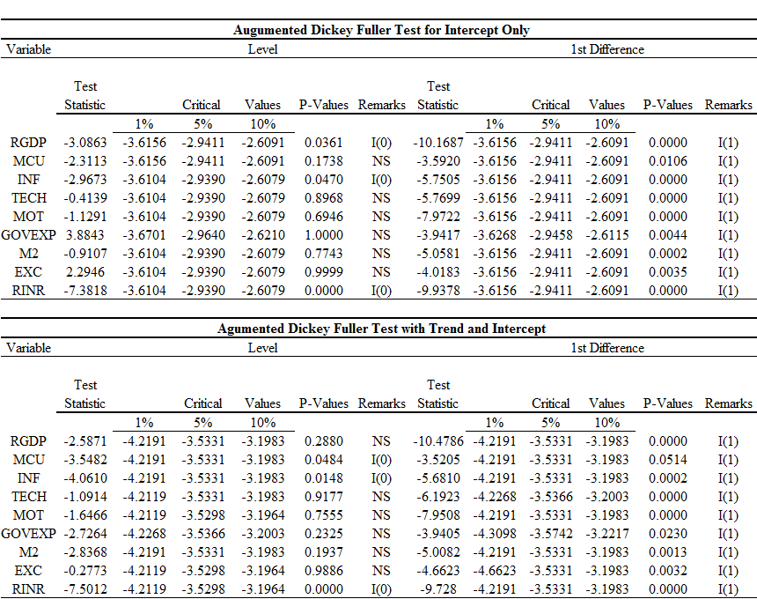
Source: Author’s computation from E-view 10

Table 4.2: Result of the Phillips-Perron (PP) Test
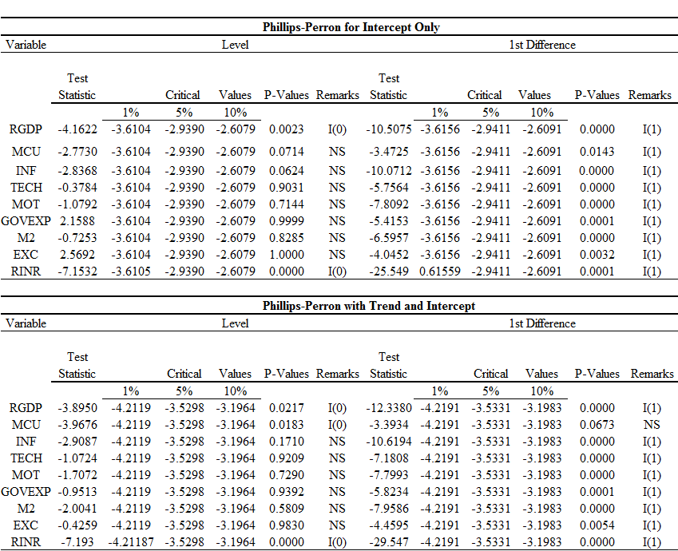
Source: Author’s computation from E-view 10

4.1.1 Lag Length Order Selection Criteria Results
After the stationary test has been carried out and the stationary conditions have been met, by evaluating the specified ARDL models in search of probable existence of long-run relationship among the variables using the ARDL co-integration technique. This is because unlike other methods of estimating co-integrating relationships, the ARDL co-integration technique does not involve symmetry of lag lengths; each of the variables can have a different number of lag terms. However, it is required to determine the appropriate lag length in order to avoid the issue of misspecification and loss of the degrees of freedom before this test is run. Following the literature, lag order selection criteria ascribed to Hannan-Quinn information criteria (HIC), the Log Likelihood (LL), the Schwarz information criteria (SIC), Final Prediction Error (FPE) criteria and the Akaike information criteria (AIC) were considered. The results are presented in table 4.3.

Table 4.3: Lag Length Order Selection Criteria for Objective 1
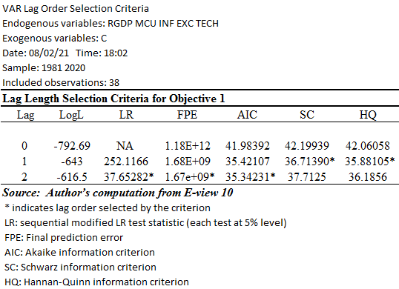

Table 4.4: Lag Length Order Selection Criteria for Objective 2
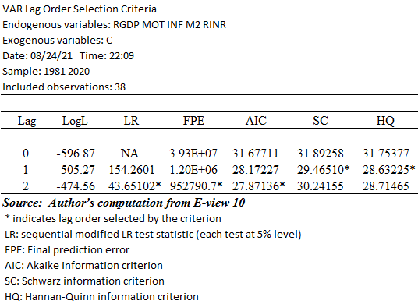

4.1.2 Co-integration Test
After verifying the stationarity of all the variables involved in the unit root test and the lag order selection criteria tests have been carried out, a co-integration test is thereafter carried out in order to find the long run convergence of the time series. As explained in the literature, there are various procedures of conducting co-integration analysis among time-series variables. The most used methods are: the residual-based approach suggested by Engle and Granger (1987) and the most likeable approach suggested by Johansen and Julius (1990) and Johansen (1992). This study uses the recently developed econometric technique of bound testing approach to co-integration in analyzing the data. The advantages of this technique is that it allows a mixture of I(0) and I(1) variables as regressor with the implication that the order of integration of variables may not essentially be the identical.
This study tests for co-integration relationship amongst the variables involved, it made use of the F-Statistics in order to establish the relationship. The results obtained from the bound test is shown in the table 4.4 below. It can be observed that from the table below for objective 1 at 5% level of significance, since the F-Statistics (6.90289) is greater than the lower bound value (2.56), the null hypothesis is rejected and since the F-Statistics (6.90289) is larger than the upper bound (3.49), it denotes the existence of a long-term relationship amongst the variables. Also, for objective 2 at 5% level of significance, since the F-Statistics (4.36088) is greater than the lower bound value (2.56), the null hypothesis is rejected and since the F-Statistics (4.36088) is greater than the upper bound (3.49), it signifies there is a long-run relationship among the variables.

Table 4.5: Co-integration Test Results for Objective 1
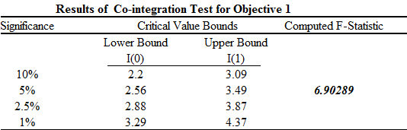 Source: Authors computation from E-view 10

Table 4.6: Co-integration Test Results for Objective 2
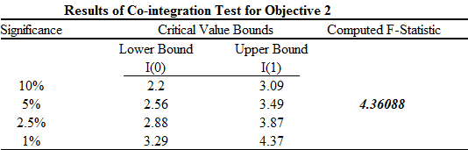
Source: Authors computation from E-view 10

4.2 Empirical Results on the Relationship between Manufacturing Capacity Utilization and Economic Growth in Nigeria.
4.2.1 Long-Run Effect of the Relationship between Manufacturing Capacity Utilization and Economic Growth in Nigeria.
The result of the long-run test carried out for objective one is presented below in Table 4.7 below and it shows that manufacturing capacity utoilization and economic growth have a positive and statistically significant relationship. This indicates that utilizing Nigeria’s manufacturing capability has a positive impact on the country’s economic progress. It can be seen that manufacturing capacity utilization has a statistical long-run relationshipwhich is shown by the t-statistic and prob. Value. The coefficient of MCU is positive (0.749295) which is statistically significant with the probability value (0.001) which is less than 0.05 (5%) level of significance and greater than the t statistic (3.677643). Also, the result shows that inflation has a negative but statistically significant relationship with economic growth as shown by the coefficient (-0.077547) and the prob. Value (0.0481) which is less than 0.05 and the t statistic (-2.069936). Furthermore, Exchange rate is negatively related to economic growth as shown by the coefficient (-0.079775), it is also statistically significant as shown by the prob. Value (0.0118) which is less than 0.05 and the t- statistic (-2.702267). This means that holding all other things constant in the long run a 1% change in EXC will result in a -0.079775 change in economic growth.
Additionally, the coefficient of Technology (-0.002547) shows that technology has a negative relationship with economic growth and is statistically insignificant as shown by the prob. Value (0.8987) which is greater than 0.05 and the t-statistic (-0.482451). This result does not agree with my apriori expectation and this could be as a result of lack of investment in technology, lack of available expertise in this area and also lack of maintenance. The R², adjusted R², F-statistic, and the Durbin-Watson statistic for this model is presented in Panel B in Table 4.7, R² the explanatory power of the model is high (0.734779). Therefore, the proportion of variation in economic growth which is measured by the proxy real GDP that is jointly explained by manufacturing capacity utilization, inflation, exchange rate and technology is about 73%. Furthermore, the Adjusted R² that is the proportion of variation in economic growth measured by the proxy real GDP that is jointly explained by the explanatory variables after the effect of insignificant repressor has been removed is about 63%. Moreover, the F-statistic is used to measure the overall significance of the estimated model, the F-statistic is significant at 7.48019 at prob. Value 0.000014. This implies that the rate of increase in manufacturing capacity utilization, inflation, exchange rate and technology are not significant determinants of economic growth in Nigeria. The Durbin-Watson statistic was used to test for autocorrelation of the residuals in the model and the first order autocorrelation in particular shows the absence of autocorrelation at 2.545741.

Table 4.7: Estimated Long-Run Test Result for Objective One
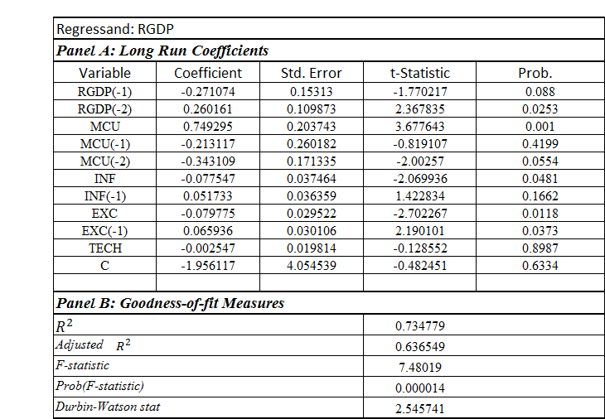 Source: Authors computation from E-view 10

4.2.2 Short-Run Effect of the Relationship between Manufacturing Capacity Utilization and Economic Growth in Nigeria.
In order to determine the relationship between manufacturing capacity utilization and economic growth in the short-run, assess the short-run adjustment mechanism to equilibrium as well as the speed of adjustment, the short-run dynamics of the equilibrium were obtained directly as the estimated coefficients of the variables at level and first difference in the ARDL model (2,2,1,1,0), the results are shown below in table 4.8. From the table below, it can be noted that the coefficient of the error correction term for the estimated equation is negative (-0.770055) but statistically significant as the prob. Value = 0.0043 and the t-statistic = -3.1438. Therefore, the speed of adjustment implied by the coefficient of the ECT suggests that the deviation from the short-run to long-run is corrected by -0.7700 units each year. This signifies that there is a steady long-run relationship among RGDP, manufacturing capacity utilization, inflation, exchange rate and technology. The table 4.8 shows that a unit increase in manufacturing capacity utilization will cause a -0.154165 decrease in RGDP, all other things being equal. A 1% increase in inflation will lead to a 0.080988 increase in the RGDP, all other things being equal. There exists a negative but statistically insignificant relationship between exchange rate and RGDP as a 1% increase in exchange rate will cause a -0.012602 decrease in RGDP. Also, a 1% increase in technology will lead to a 0.000106 increase in RGDP.

Table 4.8: Estimated Short-Run Test Result for Objective One
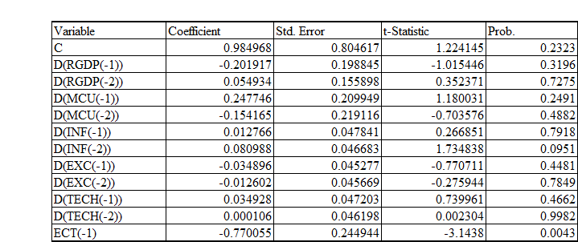
Source: Authors computation from E-view 10

4.3 Empirical Results on the Impact between Manufacturing Sector Output and Economic Growth in Nigeria
4.3.1 Long-Run Effect of the Impact of Manufacturing Sector Output on Economic Growth
The result of the long-run effect of the objective 2 is presented in table 4.9 below, and it shows that the long-run equilibrium between manufacturing sector output and economic growth is positive but statistically insignificant as shown by the coefficient (0.466923), and as seen in the prob. Value (0.3025) which is greater than 0.05 which is 5% level of significance and the t-statistic is (-2.246597). Furthermore, it can be seen that a negative relationship exsists between government expenditure and economic growth as shown in the coefficient (-0.00553), it is also statistically insignificant as shown in the prob. Value (0.0789) which is greater than 0.05 and the t-statistic (-1.835232). Also, the result shows that there’s a negative relationship between money supply and economic growth, this is shown by the coefficient (-1.123552), the negative relationship between money supply and economic growth is statistically significant as shown in the prob. Value (0.008) which is greater than 0.05 and the t-statistic (-3.84023).
In addition, there exists a positive relationship between real interest rate and economic growth as seen in its coefficient (0.25166). The relationship is also statistically significant as seen in the prob. Value (0.0012) which is less than 0.05 and the t-statistic (3.669042), this implies that a 1% change in real interest rate will cause a 0.25166 change in rgdp. The R², Adjusted R², F-statistic, probability value and Durbin-Watson statistic are shown in panel B in table 4.9 below. R² the explanatory power of the model is high (0.549114). Hence, the proportion of variation in economic growth measured by the proxy real GDP that is jointly explained by manufacturing sector output, government expenditure, money supply and real interest rate is about 54%. Also, the Adjusted R² that is the proportion of variation in economic growth measured as the proxy real GDP that is jointly explained by the explanatory variables after the effect of the insignificant repressor has been removed is about 42%. Additionally, the F-statistic which is used to measure the overall significance of the estimated model is significant at 4.414734 with a prob. Value 0.001399. This implies that the rate of increase in manufacturing sector output, government expenditure, money supply and real interest rate are insignificant determinants of economic growth in Nigeria. The Durbin-Watson statistic was used to check for autocorrelation of the residuals in the model, the first order autocorrelation in particular indicates the absence of autocorrelation at 1.769607.

Table 4.9: Estimated Long-Run Test Result for Objective Two
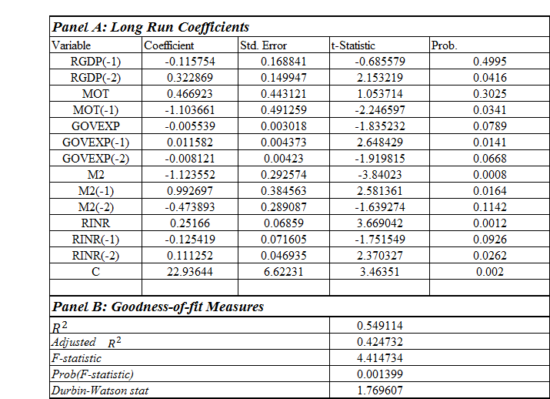Source: Authors computation from E-view 10

4.2.4 Short-Run Effect of the Impact of Manufacturing Sector Output on Economic Growth in Nigeria.
In order to determine the impact of manufacturing sector output and economic growth in the short-run, assess the short-run adjustment mechanism as well as the speed of adjustment, the short-run dynamics of the equilibrium relationship were obtained directly as the estimated coefficients of the variables at level and first difference in the ARDL model (2, 1, 2, 2 ,2). The results of the short-run estimate test is shown in table 4.10 below. The table shows that the coefficient of the error correction term for the estimated equation is both negative (-0.965091) and statistically significant as the prob. Value = 0.0003 and the t-statistic = -4.135448. Therefore, the speed of adjustment implied by the coefficient of the ECT suggests that the deviation from the short-run to the long-run is corrected by -0.965091 percent per year. This signifies that there is a steady long-run relationship among RGDP, manufacturing sector output, government expenditure, money supply and real interest rate. This shows that a 1% percent increase in manufacturing sector output will lead to a 0.875384 increase in RGDP, all other things being equal. Also, a unit increase in government expenditure will lead to a -0.005745 decrease in RGDP, all other things being equal. The relationship between money supply and real GDP is negative but statistically significant, this shows that a 1% percent increase in money supply will lead to a -0.001338 decrease in RGDP. Additionally, a 1% increase in real interest rate leads to a -0.965091 decrease in RGDP.

Table 4.10: Estimated Short-Run Test Result for Objective Two
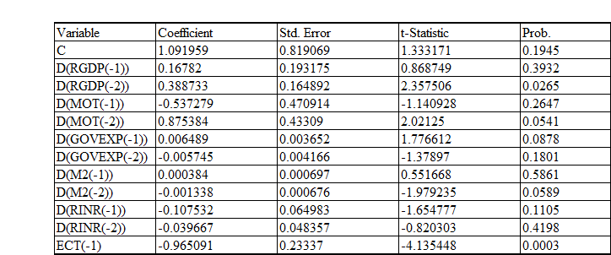 Source: Authors computation from E-view 10

4.4 Summary of Discussion of Results
This section of the research addressed the results of the estimation in line with research objectives. This study consists of two specific objectives in its empirical work which are to assess the relationship between manufacturing capacity utilization and economic growth, and also to examine the impact of manufacturing sector output on economic growth. The analysis on the relationship between manufacturing capacity utilization and economic growth showed that in the long-run there is a positive and statistically significant relationship between manufacturing capacity utilization and economic growth in Nigeria, and in the short-run there is a negative and statistically insignificant relationship between manufacturing capacity utilization and economic growth in Nigeria. There exists a positive but statistically insignificant relationship between manufacturing sector output and economic growth in Nigeria in both the long-run and the short-run. The findings above implies that in the long-run manufacturing capacity utilization is a significant determinant of economic growth, while it is an insignificant determinant of economic growth in the short-run, and manufacturing sector output is not a significant determinant of economic growth in the long-run but is a significant determinant of economic growth in the short-run in Nigeria.

CHAPTER FIVE
SUMMARY, CONCLUSIONS AND RECCOMENDATIONS
This chapter presents the summary of the findings. It brings into light policy conclusions and recommendations, contribution to knowledge and limitations of the study will be discussed in this chapter.
5.1 Summary of the Findings
The broad objective of this study was to assess the impact of the manufacturing of the manufacturing sector on economic growth from 1981 to 2020. Specifically, the relationship between manufacturing capacity utilization and economic growth as well as the impact of manufacturing sector output on economic growth. The study also examined other determinants that affect economic growth like: inflation, exchange rate, technology, government expenditure, money supply and real exchange rate. In order to accomplish the above listed objectives, the required background to the study was laid, the problems were acknowledged and justified.
The study made use of the econometric technique of analysis. In order to accomplish the specific goals it used the Auto Regressive Distributed Lag Model (ARDL). To determine the time series of the variables, the unit root test was conducted using the Augmented Dickey Fuller (ADF) test and the Phillip Perron (PP) test. The unit root test was carried out before the ARDL test was carried out. The ADF showed that for intercept only at level, Rgdp and inflation are stationary at level I(0) while all the other variables ( manufacturing capacity utilization, technology, manufacturing sector output, government expenditure, money supply, exchange rate) are stationary at the first difference I(1). Real interest rate is stationary at both at level I(0) and first difference I(1). The ADF for trend and pattern showed that only rgdp and manufacturing capacity utilization are stationary at level I(0), while ( rgdp, inflation, technology, manufacturing sector output, government expenditure, money supply and exchange rate) are stationary at first difference I(1). Also, Real interest rate is stationary both at level I(0) and first difference I(1).
The PP test for intercept only showed that only rgdp is stationary at level I(0), while all the other variables (manufacturing capacity utilization, inflation, technology, manufacturing sector output, government expenditure, money supply, exchange rate) are stationary at first difference I(1). Real interest rate is stationary at both at level I(0) and first difference I(1).
The PP test for trend and intercept, shows that rgdp and manufacturing capacity utilization are stationary at level I(0), while (rgdp, inflation, technology, manufacturing sector output, government expenditure, money supply, exchange rate) are stationary at first difference I(1). Also, Real interest rate is stationary both at level I(0) and first difference I(1).
The study went ahead to predict the lag length order using the VAR lag length order selection criteria which picked lag 2 for the two ARDL models. The Cointegration relationship between the variables was the determined in each ARDL model using the bound test approach, which implies that a long-run relationship exists among variables. The study then proceeded to investigate the long-run and short-run connection using ARDL. Based on the above tests carried out it was discovered that manufacturing capacity utilization, manufacturing sector output, inflation money supply and real interest rate all conform with the apriori expectations of the study.
5.2 Conclusion
Economic growth in Nigeria can be accelerated by increasing the input of the manufacturing sector. The link between the manufacturing sector and economic growth cannot be overstated, and this has raised serious concerns about the country’s growth and development. As a result, this study comes to a conclusion that manufacturing capacity utilization has a significant positive long-term impact on Nigeria’s economic growth. Although, manufacturing sector output has a long-run positive link with nigeria’s economic growth, it is not significant, and the real interest rate has a positive and large impact on Nigeria’s economic growth. In addition, the study finds that inflation, the exchange rate, technology, government spending and money supply all have an adverse impact on Nigeria’s economic growth.
5.3 Recommendation
It is obvious that this country’s government has deeply neglected the sector and for the economy to grow and for the country to be industrialized, the government must take certain steps and policies to bring the sector back to life.
In Nigeria, it is obvious we experience a high level of capacity underutilization, and the level of output from the manufacturing sector is extremely low. To remedy this, the government concentrate on the inadequate infrastructural development in the country, the government should make available infrastructural facilities such as good roads and networks to ensure the flawless and smooth transportation of raw inputs and finished goods, proper telecommunication services, and also try to revamp the energy sector, this area has served as a serious block road to development in the manufacturing sector as a lot of companies in Nigeria have production cost because they have to power generators to function properly, his has chased various investors away to neighboring countries. Stable power supply is needed for manufacturing to run properly and smoothly.
The manufacturing sector can also improve through upgrading of technology to more modern technology, bringing in improved machineries to save time, cost and energy and other innovative ways of doing things that would yield productive output in the economy.
The central bank can also make interest rate more accessible to investors and entrepreneurs who wish to embark of investment in order to enhance expansion and development of the economy. The exchange rate can also be moderated in order to enhance more investments in the country, thereby ensuring stable economic growth.

REFERENCES
Adeoye, BW 2005 industrial development in Nigeria in the context of globalization. Nigerian Institute of Social and Economic Research (NISER), Ibadan.

Adewale, J.O (2002). Industrial development, electricity crisis and economic performance in Nigeria. European Journal of Economics. Finance and Administrative Sciences. 2010;18:1450-2887.

Adofu, I., Taiga, U., & Tijani, Y., (2015) "Manufacturing sector and economic growth in
Nigeria” (1990-2013). pp. 1-6.

Adoyi, Andrew .A. (2016). “Impact of Manufacturing Sector on Gross Domestic Product in Nigeria”. A Research Project, Modibbo Adama University of Technology, Yola, Adamawa State, Nigeria
.
Afolabi.A. and Laseinde O.T. (2012). “Manufacturing Sector Performance and Economic Growth in Nigeria”, Journal of Physics: Conference Series.

Anyanwu, B.K, Kalu, U. N & Alexanda O.U. (2015). The Effect of Industrial Development on Economic Growth (An Empirical Evidence in Nigeria 1973-2013), European Journal of Business and Social Sciences, 4(02), 127-140.

Anyanwu, J.C. (1995). Modern macroeconomics: Theory and application in Nigeria. Joanee educational publisher’s ltd, Onitsha, Anambra state.

Ayodele, A.I & Falokun, G. (2003). The Nigerian Economy: Structure and Pattern of Development, JODAD Publishers.

Banjoko,S. A., Iwuji, I. I., Bagshaw, K. (2012).“The Performance of the Nigerian Manufacturing Sector: A 52-Year Analysis of Growth and Retrogression (1960-2012). Journal of Asian Business Strategy, 2(8), pp. 177-191.

bankole, A. S. (2005). Nigreia’s Industrialization Strategy under Multilateral Trade Agreements. In: The Challenges of Industrialization: A Pathway to Nigeria becoming a Highly Industrialized Country in the Year 2015. Nigerian Economic Society, Ibadan, pp.147-178.

Barro, R., 1990. Government spending in a simple model of endogenous growth. Journal of Political Economy 98: 103-125.

Beckermann, W. (2007) ‘Economists, Scientists and Environmental Catastrophe, Oxford Economic Papers, 24(1). 237-244.

Bennett, K.O & Anyanwu, U.N (2015) the Effect of Industrial Development on Economic Growth (AN empirical Evidence in Nigeria 1973-2013), European Journal of Business and Social Sciences, 4(02), 127-140.

B.W. Adeoye. (2005). “Industrial development in Nigeria in the context of globalization”. A paper submitted for presentation at the 45th Annual Conference of the Nigerian Economic Society (NES).

CBN, (2003). Contemporary economic policy issues in Nigeria. Abuja, Nigeria: CBN Publication.

Central Bank of Nigeria. (2012). Central Bank of Nigeria Statistical Bulletin, Vol. 23.

Central Bank of Nigeria (2020). Central Bank of Nigeria Statistical Bulletin.

Chukwuedo .S. Oburota and Ifere .E. Okoi (2017). “Manufacturing Sub-Sector and Economic Growth in Nigeria”. British Journal of Economics, Management and Trade. 17(3): 19.

Danladi J.D. Akomolafe K.J. Babalola .O. Oladipupo A.R. (2015). “Globalization and the Nigerian Manufacturing Sector”. Journal of Law, Policy and Globalization. 41.

Earnest, Simeon Odior (2013). “Macroeconomic Variables and the Productivity of the Manufacturing Sector in Nigeria: A Static Analysis Approach”. Journal of Emerging Issues in Economics, Finance and Banking (JEIEFEB). 1(5).

Ekpo, U. N (2014). “Nigeria Industrial Policies and Industrial Sector Performance: Analytical Exploration”, IOSR Journal of Economics and Finance (IOSR-JEF). 3(4), 01-11.

Emmanuel, Okokondem Okon, and Saliu, Wisdom (2017). “Hazards of Manufacturing Sector and Economic Growth in Nigeria”. International Journal of Social Sciences, Humanities and Education (IJSSHE). 1(1).

Gujarati, D.N. (2007). Basic Econometric. (4th Edition)

Inakwu, U.A. (2013). An assessment of the impact of manufacturing sector on economic growth in Nigeria: A research project. Caritas University, Amorji-Nike, Enugu, Nigeria.
Joseph .O. Ochinyabo .S. and Abubakar .S. (2014). “The Effect of Interest Rate on the Manufacturing Sector Performance in Nigeria”. The Benue Journal of Social Sciences, 2(1). Pp. 112-129.

Kaldor, N. (1970), the case for regional policies. Scottish Journal of Political Economy XVII, pp. 337-348.

Kayode, O.A. (2000). Contemporary Economic Policy Issues, CBN Publication 2000.

Lucas, R.E. Jr. (1988), on the mechanics of economic development. Journal of Monetary Economics, Vol. 22, pp. 3-42.

MAN, Manufacturers Association of Nigeria

Muhammed .M. (2019). “The Emergence of Manufacturing Industries in Nigeria (1955-1978). Journal of Advances in Social Sciences and Humanities. 5(6), 807-823.
Nyor, Gabriel A and Chinge, A. Dodo (2014). “The Impacts of Industrial Policies on the Manufacturing Sector in Nigeria: An Assessment”, Research on Humanities and Social Sciences, 4(21), 111-120.

Obi, Iwuagwu (2009). “Nigeria and the Challenge of Industrial Development: The New Cluster Strategy. African Economic History. 37(1): 151-180.

Obioma, E. C. and Ozugahalu, U. M. (2005). Industrialization and Economic Development: A Review of Major Conceptual and Theoritical Issues. In: The Challenges of Industrialization: A Pathway to Nigeria becoming a Highly Industrialized Country in the Year 2015, Nigerian Economic Society, Ibandan, pp.63-97.

Okuneye B.A. (2019). “Industrial Sector Performance and Economic Growth in Nigeria”. Fountain University Osogbo Journal of Management (FUOJM). 4(1), 15-30.

Osagie .O. and Aigbovo .O. (2016). Macroecomic Variables and Manufacturing Sector Output in Nigeria. University of Benin, Nigeria.

Oyedele, OF 2009 industrial policies and incentives in Nigeria overtime 1960 till date paper presented at teacher’s education class, university of Ibadan, Nigeria, unpublished paper.

Pesaran, .H. Smith .R.J. Shin .Y. (2001). “Bound Testing Approaches to the Analysis of Level Relationship”. Journal of Applied Econometrics, 16(3):289-326.

Romer, P. (1986). ‘Endogenous Technological Change.’ Journal of Political Economy 98(2) 71-102.

Sola, O. et al (2013). Manufacturing performance in Nigeria: Implication for Sustainable Development. Asian Economic Review, 3(9), 1195-1213.

Schätzl, L. (1973). Industrialization in Nigeria: A spatial analysis (Vol. 81).

Thirlwall, A.P. (1993). Economic growth and the balance of payment constraints. Palgrave MacMillan publishers, December 15 1993.

Todaro, P.M. (1977). Economic development in the third world: An introduction to problems and policies in a global perspective. Longman, London 1977.
Umofia, Nsikan (2018). “Trend Analysis of the Performance of Nigeria’s Manufacturing Sector (1960-2010). International Journal of Arts and Humanities (IJAH), Ethiopia. 7(4) no 27: 109-116.

World Bank (2021), World Development Indicators. Online database.

