IMPLEMENTATION OF NETWORK SECURITY FOR ACADEMIC INSTITUTIONS USING PENTBOX HONEYPOT.
ONI DANIEL OLUWATOBI
MATRIC NUMBER: 16010301020

BEING A PROJECT SUBMITTED IN THE DEPARTMENT OF COMPUTER SCIENCE
AND MATHEMATICS, COLLEGE OF BASIC AND APPLIED SCIENCES
IN PARTIAL FUFILLMENT OF THE REQUIREMENTS FOR THE
AWARD OF DEGREE OF BACHELOR OF SCIENCE
MOUNTAIN TOP UNIVERSITY, IBAFO,
OGUN STATE, NIGERIA

2020.

Certification
This is to certify that this project, DESIGN AND IMPLEMENTATION OF NETWORK SECURITY (INTRUSION DETECTION) FOR ACADEMIC INSTITUTIONS USING PENTBOX was prepared and submitted by Oni Daniel Oluwatobi (Matriculation Number: 16010301020) and duly supervised by Dr F. A. Kasali.

__________________________ (Signature and Date)
DR. F. A. KASALI
Supervisor

__________________________ (Signature and Date)
DR. I. O. AKINYEMI
Head of Department

Accepted as partial fulfilment of the requirements for the degree of BACHELOR OF SCIENCE
(Computer Science)

__________________________ (Signature and Date)
Prof. A. I. AKINWANDE
Dean, College of Basic and Applied Sciences

Dedication
I dedicate this project work to my late dad; Pastor Olukunle Oni.

Acknowledgement
The success and final outcome of this project goes to the Almighty God for wisdom and understanding. I specially appreciate my Supervisor Dr. Funmilayo Kasali who took keen interest in my project work and guided me all along, and never relented to attend to me anytime I came to her for assistance. I would like to acknowledge the Head of Department Computer Science and Mathematics Dr. I. O. Akinyemi, and owe him my deepest gratitude for the efforts, constant encouragement, guidance and support of all the academic and non-academic staff of the Department of Computer Science and Mathematics. For the teachings that have brought out positive values in me and making my stay a worthwhile one.
I extend my gratitude to Mountain Top University for setting greater heights for me and bestowing me, with the power of excellence. I say God bless you richly. I heartily would like to thank my parents, Mr & Mrs Oni and sibling, thank you all for your moral and financial support. I am grateful for all the investments into my education and future. I would not forget to include all the students in the Department of Computer Science and Mathematics, for making my stay a worthwhile one, I say God bless you all richly.

ABSTRACT
As organizations go online, a number of advantages are realized and as a result academic institutions have not been left behind in this move. However most of the techniques organizations have used to guard against unauthorized system access have been found lacking and as a result many disastrous unauthorized access has been reported. This is declined by the way that applications used to break into frameworks are currently effortlessly gotten to in certain shops and the Web. Indeed, even a portion of the vindictive programming are spreading over organization to make more dangers by clients. What number of clients know about that their PC might be utilized as zombie PCs to target other casualty frameworks? As innovation is developing quickly, more up to date assaults are showing up. Security is a central issue to get over every one of these issues.
In this postulation, we will make a genuine situation, utilizing honeypots. Honeypot is an all-round planned framework that draws in programmers into it. By drawing the programmer into the framework, it is conceivable to screen the cycles that are begun and running on the framework by programmer. At the end of the day, honeypot is a snare machine which appears as though a genuine framework to draw in the aggressor. The point of the honeypot is breaking down, getting, watching and following programmer's practices to make safer frameworks. Honeypot is extraordinary approach to improve network security chairmen's information and figure out how to get data from a casualty framework utilizing measurable devices. Honeypot is likewise helpful for future dangers to monitor new innovation assaults.

TABLE OF CONTENTS

CERTIFICATION | ii
DEDICATION  ACKNOWLEDGEMENT  ABSTRACT | iii
TABLE OF CONTENT | vi
LIST OF FIGURES  CHAPTER ONE: INTRODUCTION | viii
1.1 Background to the study | 1
1.2 Statement of the Problem | 2
1.3 Aim and Objectives of the Study | 2
1.4 Scope of the Study | 2
1.5 Significance of the Study | 3
1.6 Definition of Terms | 3
CHAPTER TWO: LITETATURE REVIEW | 5
2.0 Introduction | 5
2.1 Conceptual Review | 6
2.1.1 Overview of Network Monitoring | 6
2.2 Theoretical Review | 8
2.2.1 Honeypot Technology | 8
2.2.2 Honeypot Work Principle | 8
2.2.3 Classification of Honeypot | 10
2.2.4 Advantages and Disadvantages of Honeypot | 12
2.3 Survey of Related Works  CHAPTER THREE: METHODOLOGY | 13
Introduction | 15
3.1 Flow chart of Honeypot system | 15
3.1.1 Firewall | 16
3.1.2 Intrusion Detection System | 17
3.2 Kali Linux | 18

3.3 Pentbox 1.8 Framework | 18
3.4 Method for Data Collection | 19
3.5 Procedure for Data Analysis  CHAPTER FOUR: IMPLEMENTATION AND RESULT | 19
4.1 System Requirement | 20
4.2 Configuration of Honeypot (Pentbox) | 21
4.3 Configuring Wireshark | 24
4.4 Finding the Ip Address of the Domain Using Deep Information Gathering Tool | 24
4.5 Starting Nmap/Zenmap Gui. | 25
4.6 Result and Conclusion | 30

CHAPTER FIVE: SUMMARY, CONCLUSION AND RECOMMENDATIONS
5.0 Summary 34
5.1 Contribution to Knowledge 34
5.2 Limitations 34
5.3 Recommendation for Further Study 35
5.4 Conclusion 35
References 48
Appendix 51

List of Figures

Figure page
2.1 Architecture of Network Monitoring (Edmund, 2000) 7
2.2 Honeypot Work Principle 9
3.1 Flow Chart of Honeypot Technology
3.1.1 Firewall 17
3.1.2 Intrusion Detection System 17
4.1 Opening Pentbox Directory 21
4.2 Pentbox Tools 22
4.3 Configuring the Honeypot 22
4.4 Configuring the Honeypot 23
4.5 Honeypot Activated 23
4.6 Screen Shot of Real Time Capture of TCP Packets Using Wireshark 24
Screen Shot of Finding the Domain IP Address 25
4.8 Screen Shot of Zenmap Intense Scan 26
4.9 Screen Shot of Zenmap Intense Scan Output 27
4.10 Screen Shot of Result for Ports/Hosts Scan 28
4,11 Screen Shot of Topology Scan 29
4.12 Screen Shot of Host Details 30
4.13 Screen Shot of Honeypot Showing the Information About Every Connection That Is
Detected. 31
4.14 Screen Shot of Honeypot Showing the Information About Every Connection That Is Detected. 32

CHAPTER ONE
- INTRODUCTION
1.1 Background to the Study
Security has become a big challenge for many organizations especially when it comes to protecting important information from unwanted attackers. In the process of safeguarding web data, firewalls, encryption, authentication and Virtual Private Networks are all traditional ways of securing network. More so, the use of Intrusion detection/ prevention systems is the current trend when it comes to network security (Mohit, Tiwari, Bharti & Kishan, 2017).
Effective network security is largely dependent on understanding the internet's current and emerging threats. To protect information systems and their users, precise. concise, high quality data and malicious operations is of vital significance (Yegneswaran, Bartòrd, and Paxson 2005). Discovering vulnerabilities such as Heartbleed. shellshock, and Poodle and their extensive prevalence across a number of operating systems attracts government attention to safety of the system. As noted with Heartbleed, attackers were much quicker than suppliers could generate and roll out patches in exploiting the vulnerabilities. Relying solely on traditional defense lines like Intrusion Detection Systems and dynamic firewalls alone does not provide a holistic coverage on the detection of novel and emerging patterns of assaults.
(Schneier, 2000) "Security is a process, not a product." This popular quote is well echoed by the phenomenon that although there are a big range of safety instruments available today (whether as business or open-source alternatives), none of these instruments can address all of an organization's safety objectives on a one-handed basis. As a result, safety experts are looking for more sophisticated instruments that are efficient in recovering from safety gaps and detecting them. In order to observe the activities of a hacker, the methodology chosen is to mislead them, by giving them some emulated set of activities on a system which appears to be authentic. Their activities are then logged and monitored to acquire insight into the plan of action of the black-hat community. In honeypots, this idea is adopted- system whose value lies in being tested, attacked or compromised. Honeypots give insights on the attacker's actions and motivation and are able to spot zero-day attacks. The field of honeypot research comprises of two principle columns: a) the advancement of the honeypot programming and its skillful sending: b) Exploring the log data procured in an organized manner.
Honeypots have recently gained a great deal of attention from the research community because of their use in Capturing and logging questionable networking practices that can be used to obtain concrete data about hackers conduct and operations. In addition to its use as a research instrument, it was also implemented as a research instrument in academic organizations. For instance, the Georgia Institute of Technology's Honeynet Project has been used in network security courses to educate learners how to use instruments like ethereal and tcp dump to examine the traffic of attacks. (Honeynet Project,h.n.).

1.2 Statement of the Problem
In other for academic institutions to keep up with their counterparts especially in the area of information and communication technology, most of them have embraced the numerous benefits that using the internet and other digital media has to offer. Most of the information they put online are critical but since this information run through a network, they are prone to various forms of vulnerability such as unwarranted access. There is a growing need for such threats to be minimized or totally eliminated. Due to network traffic, packets which are received are likely contain virus which could at times appear as signature rules and as a result corrupt the entire Honeypot IDS infrastructure. Since most institutions do not really give network security the priority that it deserves during budgeting, they remain prone to some of these threats and if left unchecked could result into loss of resources. Deploying only a single intrusion prevention technique such as a firewall may not always be effective. Hence, the focus of this work is to develop a Honeypot IDS for improved network security.
1.3 Aim and Objectives of the Study
The main objective of this research is to develop a Honeypot IDS for improved network security. The specific objectives are to:
1. design a framework which can be used to monitor network traffic
2. implement the designed framework.
1.5 Scope of the Study
This project focused on monitoring Mountain Top University network traffic which was analyzed against some set of rules. This also covers the development of network for use at a university (MTU) to secure and provide extra safety for information and other valuable resources. The requirement includes designing a honeypot on the real network thereby preventing unauthorized access to the real network and giving the network administrator enough time to study the attacker's aim, purpose and objectives of attacking the network, with this knowledge the network administrator properly safeguard the valuable information and documents and sourcing for more methods to deny these attackers access to the real network.
1.5 Significance of the Study
security is currently a trending issue for different network types. The main reason behind the advent of honeypot is that firewalls and access control on their own do not provide an adequate defense against attack. Aside the fact that this work will provide a way for improving network security and also help new users understand the concept of honeypot IDS.
1.6 Definition of Terms
- Attacks: An attack on system safety that stems from a smart threat; that is, a smart act that is a deliberate effort (particularly in the context of a method or technique) to avoid safety facilities and violate a system's security strategy.
- Denial of Service (DOS) Attacks: Denial of Service is an assault whereby the frameworks getting an excessive number of solicitations can't restore correspondence with the requestors. At that point the framework devours assets sitting tight for the finish of the handshake.
- Firewall: A firewall is a typical defense mechanism for border control or perimeter.
- Heartbleed: In the famous OpenSSL cryptographic software library, it is a severe vulnerability. This weakness makes it possible to steal the data protected by the SSL / TLS encryption used to safeguard the Internet under ordinary circumstances.
- IP Spoofing: Spoofing implies having the computer's address mirror the address of a trusted computer so that other computers can be accessed. The intruder's identity is concealed by distinct means, making it hard to detect and prevent.
- Network Security: Network security relates to all hardware and software functions, features, operating processes, accountability measures, access controls, administrative and management policies needed to provide an appropriate level of hardware, software and safety of data.
- Packet Filtering: A firewall operates tightly with a TCP / IP protocol and works with an algorithm to divide information obtained from network apps or more Obviously from protocol services (Telnet, SMTP, DNS, SMNP, NFS, etc) into information packets.
- shellshock is a segment of the security bug family, otherwise called Slam entryway. The first was delivered on 24 September 2014 in the ordinarily utilized UNIX slam shell. Numerous Web confronting administrations, for example, a few organizations on web workers, use Slam to handle certain solicitations, empowering an aggressor to make weak Slam renditions actualize self-assertive orders.
- Intrusion: An intrusion refers to any unwarranted access or malicious utilization of information resources.
- Intruder: An intruder is any person that get access to information through fraudulent methods.
- Pentbox: Pentbox is security and Interruption recognition unit that contain the different devices that will truly support moral programmer/infiltration analyzer to play out their occupation without any problem. It customized in Ruby and arranged to GNU/Linux frameworks, yet viable with Windows, MacOS and each framework where Ruby works. It is open source and free accessible.
- Malicious: Malicious is anything that causes harm for other people
- TCP: Transmission Control Protocol is a standard that describes how to set up and keep a network discussion with which application programs can exchange data. TCP works with IP, which defines how computers send packets of data to each other.
- UDP: User Datagram Protocol is part of the Internet Protocol suite that is used for network programs on a variety of PCs and is an unconnected protocol that ends brief message called datagrams.
- Network traffic: It is the quantity of information moving across a network at a specified moment.
- Packets: A TCP / IP network packet includes several parts of information, including the data it carries, the IP addresses of the source location needed for service quality and packet processing.

CHAPTER TWO
LITERATURE REVIEW
2.0 Introduction
This review introduces a review of network security, overview of network monitoring, honeypot technology, honeypot work principle, classification of honeypots, advantages and disadvantages of honeypot and survey of related works. Late investigations have demonstrated that the absence of security of data has made genuine harms to associations, government, and academic institutions and has become a huge concern in this age (Almutairi (2016); Michal, Eva and Zuzana, 2017). In the course of recent years, the web has advanced and individuals have been confronting difficulties of network security. This is a major issue for some associations and establishments who need to shield their useful and private information from threats inside or outside the association. Ongoing examinations have additionally demonstrated that human and association factors likewise sway on network security. Network professionals confronted difficulties to oversee security and they use extraordinary devices like firewall, antivirus, Intrusion Prevention System (IPS), Honeypots among others.
Among every one of these devices, Honeypot assumes a significant job to distinguish the malicious activities quickly and reinforce response for real time assault and attack. Be that as it may, regularly Honeypot users find it hard to utilize Honeypot and unfit to exploit every one of its functionalities. So as to improve the convenience of Honeypot a few difficulties which affect security must be comprehended. It has raised the likelihood that vindictive users increase illicit access to associations to take private data they are keen on or demolish it by infusing applications called malware. Those applications are made to enable vindictive users to control organizations' computers remotely. The past strategies which have been utilized to secure data/Information have now been debilitated, which has prompted interest for better techniques to improve and prevent access to unapproved data from attackers. In this way, a Honeypot is required for the detection of all undesirable and suspicious traffic that can’t be recognized by devices that have been conveyed commonly. For example, Firewall usually do not have terminals that are directly connected so that the application for network management can not readily track their status. Network monitoring methods are thus created to allow apps for network management to verify the status of their network devices. As network devices are increasingly being used to construct larger networks, network monitoring methods are being extended to monitor networks as a whole.
(Edmund, 2000) outlined three major basic goals for network monitoring: which are; Performance monitoring, account monitoring and fault monitoring.
Performance Monitoring deals with network performance measurement. Performance surveillance has three significant problems. First, data on performance surveillance is generally used to schedule future network development and to identify current network utilization issues. Second, the performance surveillance timeframe must be sufficiently long to create a model of network conduct. Third, it's essential to choose what to evaluate. In a network, there are too many measurable items. Fault monitoring deals with the measurement of network issues. Account monitoring is about how the network is used by users. Network administrators are constantly striving to keep their networks running smoothly. If a network were to be down even for a short time, productivity would decline within a company, and the ability to provide essential services would be compromised in the case of public service departments. Administrators need to monitor traffic movement and efficiency across the network to be proactive rather than reactive and check that safety breaches do not happen within the network.
Active network monitoring adds option to modify the data on the line. Passive network monitoring exists in several forms. Simple surveillance can be simple as the quantity of information monitored and generated is low for manual evaluation. Monitoring all kinds of details about the network and its traffic carries a comparable obstacle; data is collected about faults and attackers, but there is so much data that it gets lost in the ocean. Figure 2.1 shows the general architecture of network monitoring.
2.2 Conceptual Review
2.2.1 A Brief Review of Network Security
Network security refers to any activities designed to protecting your network. It comprises of techniques and procedures that are deployed to safeguard networks against inner and external threats. Network security includes all activities that organisations, businesses and institutions undertake to safeguard the value, continuous usability of assets and the integrity and continuity of operations. Effective network security targets a range of threats and prevents them from entering or spreading on your network (Amanpreet &Monika, 2014).
Network attacks have been discovered to be as varied as the system that they attempt to penetrate. Attacks are known to be either deliberate or unintentional and technically skilled intruders have b een interested in targeting the protocols used for secure communication between network devices. (Suliamon, 2014). The easiest ways computers have been protected and secure from attacks such as installing virus protection, using strong passwords, using firewall to enhance settings, and software has proved to be insufficient and not capable of preventing unauthorized users from having access to information.
The primary objective of network security is to provide adequate controls at all phases along the perimeter that allows access to the network and can only enable passage of traffic if an authorization has been issued, whilst noting the level of risk that goes with it. Network security has just one goal; Protect whatever is connected to a network from intruders.
2.2.2 Overview of Network Monitoring
Network monitoring is the function of network management to collect data. Applications for network monitoring are developed to retrieve information for network management applications. The aim of network monitoring is to collect helpful data from different components of the network so that the data gathered can be used to manage and control the network. Most network devices are situated in distant places. When a network failure happens, surveillance officials need to identify, isolate, and correct network malfunctions and potentially retrieve the failure. Commonly, Administrators should be warned by officials to solve issues within a minute. With the stable network, the tasks of the administrator continue to be constantly monitored if there is a danger from either inside or outside the network. They also need to verify the network performance frequently if the network devices are overloaded. In order to create a network plan for short-term and long-term future improvements, data about network utilization can be used before a failure due to overload. These systems do not normally have directly linked terminals so that the request for network management can not readily track their status. Network surveillance methods are created to enable network management applications to check the status of their network devices (Edmund, 2000, p. 2).

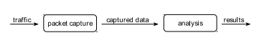

Fig 2.1: Architecture of network monitoring (Edmund, 2000)

2.3 Theoretical Review
2.3.1 HONEYPOT TECHNOLOGY
Honeypots are digital frameworks and cycles set up to seem operational to gather data on danger conduct and vectors. Genuine or recreated frameworks and cycles are designed to show up as though they are genuine frameworks, frequently with weaknesses. A considerable lot of the recently depicted sensors are embedded inside and around honeypots to gather information on danger practices. Honeypots have been utilized for everything from single workers to organizations of workers, through customer cycles and documents or data. Honeypots are a typical method and instrument for blue pencilling uncontrolled dangers (Thomas W. Edgar & David O. Manz, 2017).

A honeypot is a fake PC framework that seems alluring to an aggressor. While the aggressor is assaulting the honeypot under the feeling that it is a beneficial framework to control, they can be seen by security staff who would then be able to endeavour to trap and control the assault. Honeypots are broadly utilized in organization security. In the cloud setting, a honeypot virtual machine can be conveyed, which would screen any dubious endeavour to break into the virtual machine. Honeypots can be conveyed both by the cloud specialist co-op just as cloud clients (Dinkar Sitaram & Geetha Manjunath, 2012).

Honeypots are a fairly dubious apparatus in the stockpile of those we can use to improve our organization security. A honeypot can distinguish, screen, and once in a while mess with the exercises of an aggressor. Honeypots are designed to purposely show weaknesses or materials that would make the framework appealing to an aggressor. This may be a purposefully weak help, an obsolete and unpatched working framework, an organization share named "highly confidential UFO reports," or other comparative things that may fill in as lure for an aggressor.

A fascinating aspect regarding honeypots is that the weaknesses or information that is forgotten about to lure the aggressor is altogether bogus. Actually, honeypots are arranged to show these things so we can get the assailants and screen what they are doing on the framework without their insight. This may be done with an end goal to give an early admonition framework to a partnership, as a technique for exploring what strategies aggressors are utilizing, or as a purposeful objective to screen the exercises of malware in nature.

We can likewise extend honeypots into bigger structures by setting up a few such frameworks in an organization, regularly alluded to as a honeynet. Honeynets can permit us to set up different honeypots with shifting arrangements and weaknesses, for the most part with a type of brought together instrumentation for checking all the honeypots on the organization. Honeynets can be especially helpful for huge scope checking of malware action, as we can copy a wide range of working frameworks and weaknesses for our objective frameworks to show. These frameworks can be utilized inside to an organization to recognize insider dangers just as the dangers that got inside (Jason Andress, 2014).

Honeypots are utilized to recognize and trap assailants by introducing weak frameworks that give off an impression of being a creation framework, however indeed they are a fake framework that is separated from the creation climate. Honeypots can be utilized to distinguish aggressors since they can be arranged to caution when they are being assaulted or have been effectively undermined. They can likewise be utilized to trap assailants by giving them bogus data that is additionally set to trigger cautions when gotten to. Service organizations should set up honeypots all through their association and especially in their edge and keen framework conditions. Thusly, they will have the option to comprehend their present dangers just as the sort of tests aggressors are utilizing to discover shortcomings in their foundation. At long last, they can utilize honeypots to order countermeasures against assailants before they breakout of the honeypot and into the creation climate (Tony Flick & Justin Morehouse, 2011).

2.2.2 Honeypot Work Principle
A honeypot works by means of fooling attackers into believing it is a device. So attackers assault the system without understanding that they're being discovered completely. Honeypot seems like a sincerely host provided critical provider, so it has more enchantment to the hacker. Through its enchantment to hackers and being attacked, the related records of the attackers consisting of the IP address, motives of the attackers getting into the machine and assault conduct of the attacker might be collected. That's accomplished typically through the Implementation of the heritage software program. (Li, Zhang, 2009) Which video display units and statistics the network communication information among the attackers and honeypot host, and uses some analytical tools to interpret and analyze these facts. Facts capture is a difficult section to any honeypot that has the capability to seize everything the attacker is doing. it is able to additionally capture the packets and packet payloads worried inside attack. This records are crucial in analyzing the attackers activities.

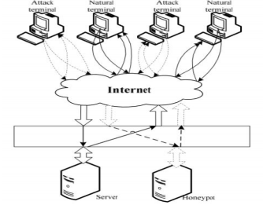

Fig. 2.2 HoneyPot Work Principle (International Journal of Advance Engineering and Research Development (IJAERD), 2017).

Honeypot system comprises of normally three modules which are induced, deceive and analysis. The induced module is used to draw attackers to attack the Honeypot system. Honeypot system comprises of normally three modules which are induced, deceive and analysis. The induced module is used to draw attackers to attack the Honeypot system.
CLASSIFICATION OF HONEYPOT: consistent with the layout, deployment of honeypot can be segregated into two (2) sections; production and research honeypots.
• Production Honeypot: A creation honeypot is one utilized inside a business venture's environmental factors to shield the partnership and help alleviate threat (Karthik, Samudrala, and Yang, 2004). Creation honeypots copy the creation organization of the undertaking. Assailants connect with them to show the weaknesses of the creation organization. revealing these shortcomings and alarming managers of attacks can give early alert of assaults and help diminish the odds of Interruption (Gubbels, Kecia, 2002). It is found miles inside the creation network with various creation workers like a firewall to improve their security. Creation honeypot empowers to decrease the risks of interruption and transfer esteems to the safety efforts of a business. Creation honeypot calls for less usefulness than an examination honeypot. They're simpler to constillct and set up. Despite the fact that they find attack styles, they don't convey a lot of information about the aggressors than research honeypots. You could gain from which framework assailants are coming from and what adventures are being delivered, yet perhaps not who they might be, the way they might be readied, or what gear they might be the use of (Mokube, Iyatiti and Michele Adams, 2007).

Examination honeypots are genuine running frameworks and administrations that assailants can have Connection with. By and large, it is intended to get understanding about the blackhat network. They contain higher danger, gather sizeable insights and Virtuoso on new assault systems and techniques. So it manages the cost of a more noteworthy precise picture of the kinds of assaults. It is utilized to query the dangers organizations face and assists with outfitting better wellbeing towards these dangers. Exploration Honeypot is additional complex to send and keep up. They are utilized mostly by methods for examination, military, or government oganizations. Examination honeypots add very great expense to investigate by methods for introducing a stage to find out about digital dangers. Assailants can be watched moving and recorded advance through advance as they assault and bargain the framework. This insight gathering is one of the most interesting and exciting qualities of honeypots. (Spitzner, Spear, 2001) As per the Honeypot with Various Aggressor Collaboration Level, we may likewise separate honeypots into three most significant classes: low-connection, medium association, and high-communication.
Interaction Honeypot
• low interaction honeypot: frameworks at this point don't gracefully gatecrashers with the genuine working gadget for distant login (Koch, Robert, Mario Golling, and Gabi Dreo, 2013). They are utilized for mimicking the particular trademark or administration which is running in the current framework, aggressors can exclusively have movement In this controlled reach. A low-connection honeypot presents one of a kind simple contributions that can be completed via checking an interesting port (R. Berthier et. al, 2008). Low communication honeypots copy network benefits on preconfigured port, for example, FTP, SQL, Web, SSH, and so forth
• Medium-cooperation Honeypots: medium interaction honeypot flexibly the assailant with a higher dream of a working framework in light of the fact that there is more for the aggressor to have collaboration with. More mind boggling attacks can subsequently be logged and examined (Mokube, Iyatiti, and Michele Adams, 2007). They can catch additional Data, and have improved disguise than low Intuitive honeypots.

• High interaction honeypots are designed with genuine working framework and award a real working framework for aggressors. They are a convoluted arrangement and contain the organization of real working frameworks and applications (Chawda, Kartik, and Ankit, 2014). High intuitive honeypot grants assailants running all the guidelines in the genuine working framework. so there are inordinate probabilities for gathering gigantic measures of data, as everything activities can be logged and investigated. Any mistake in the framework may also allow a programmer to control the full Working framework, attack different frameworks, or catch messages in the application framework (E. Cooke et al, 2004) High-intuitive honeypots are more useful to hold onto the significant purposes of weaknesses or endeavors obscure to the rest of the world. These honeypots are quality on account of multi Day assaults.

2.2.4 Advantages and Disadvantages of Honeypot
Advantages
- Honeypot creates confusion for attackers by giving them bogus data,
- It can provide forensic evidence in a court of law that is admissible. As long as it is deployed correctly and is not advertised, it can be used as legal evidence.
- You can use honeypots to intrude assaults. Knowing that a system is set up to capture and log all activities may scare away would be intruders.
- The properly designed and configured Honey Pot will collect data such as the IP address, the attackers ' motives entering the attacker's system and attack behaviour.
- Honeypots distract intruders from the scheme of manufacturing, making them harmlessly use all their attempts.
- Honeypots don't cost much. Some basic versions can be downloaded free of charge.
- Honeypots can detect insider attacks by offering precious insider pattern data.

Disadvantages
- Honeypots can only monitor interacting activity with it. They've got a tight viewing field. They see only what activity is aimed at them.
- Honeypots are also at danger as attackers may misuse honeypot to damage other systems. (Spitzner, Lance, 2003)
- Fingerprinting is another disadvantage of honeypots. Fingerprinting is when an attacker can identify a honeypot's true identity because it has certain features or behaviors that are expected. (Spitzner, Lance, 2003)
- Another disadvantage is that honeypots must be maintained like any other networking equipment and services. Building a honeypot needs you to have at least an entire system devoted to it, and for some corporations this may be a costly resource.

2.3 Survey of related works

Honeypot plays a great role in the area of network security. Honeypots have developed in a variety of ways to deal numerous fresh safety threats on the Internet today not only against safety defenders but also novice users. types of honeypots are being introduced to cope with the recent changes in network security, they are acting against the new activities.
(Pokalidis et al, 2006) proposed a honeypot called ' 'Argos". It automates the surveillance, detection and generation of signatures for intrusion detection of fresh unidentified malware. It IS intended to slow the spread of new, and therefore unknown, malware such as worms, viruses, and bug designs. When Argos detects vulnerable data, assembly codes, called "shellcode," are also dynamically inserted into the process to extract detailed information about the process so that the process is slowed down or trapped in an infinite loop to minimize its excesses.

(Alosefer & Rana, 2010) proposed "Honeyware". To detect malicious web servers, it is a low-client-side honeypot interaction. Alosefer tested Honeyware in advance against 94 URLs in which 84 were malicious and 10 were benign. Honeyware identified 83 URLs that were malicious. Since Honeyware is a low honeypot interaction, the data it collects must be processed by a time-consuming external processing engine.

(Adachi & Oyama, 2009) proposed "BitSaucer". It is a hybrid honeypot, i.e. providing the facility for both low interactions to attain fewer resource demands and elevated honeypot interaction to emulate complete answers.
(Zhuge et al, 2007) proposed a new honeypot called "HoneyBow" to automatically detect and capture malware, such as viruses and worms, without needing manually researching honeypots output information from human security professionals. HoneyBow detects file changes by comparing their original MDS hash after deliberately malware to change their files. The process that produced the modification is recorded as malware when any m0dification is identified and its MmFetcher element restores the original copy of the documents. Another element MmWatcher, monitors system calls that create and modify files, triggering detection of intrusion. Finally, to detect Silspect operations of malware, MmHunter monitors code being performed as a debugger.
(Anagnostakis et al, 2005) proposed "Shadow Honeypots". They are true apps for the manufacturing network, but they contain integrated honeypot codes. They are centred in high-interaction honeypot on the trade-off issue as false Positive and false negative. All incoming requests to a server running the honeypot shadow will be performed as if they were performed by a server operating the manufacturing. If a request is determined to be innocent by the shadow honeypot, it will forward the application to the manufacturing server.
LaBreais another type of honeypot intended to slow or prevent assaults by acting as a sticky honeypot for detecting and trapping worms and other malicious codes. It can run on both Windows and UNIX.
(Vinu V. Das, 2009) proposed a solution to mitigate denial of service attacks by hiding production servers behind an access gateway, called "Active Server (AS)". Each AS authenticates its customers and a path is launched between the client and a server once a client is authenticated. If an AS does not authenticate a client, the client will be trapped there as a honeypot. The client can be authenticated by any AS if a client has access to various ASes. Honeypots trap attackers, preventing, reducing and delaying the DOS attack effects.
(Niels Provos, 2004) suggested an open source honeypot with low contact called "Honeyd." It is a strong honeypot and can be operated on systems such as UNIX and Windows. It can monitor unused IPs, simulate TCP / IP stacklevel operating systems, simulate thousands of virtual hosts simultaneously, and monitor all ports depending on UDP and TCP.
(Nazario, 2009) suggested "PhoneyC" a fresh form of honeypot. It expands in two directions current honeypots. ^{T}he first is to activate honeypots, meaning honeypots on the client side. The second is the dynamic parser of web content to interpret binary dynamic content, particularly client-side scripts such as JavaScript, VB Script, and even Active-X controls. By integrating the two extensions to web applications, active honeypots on the client side become web "clawers" that visit a large number of web servers to detect malicious web servers automatically. As a Consequence, many malicious script / control operations were detected during tests by PhoneyC.
(Rowe et al. , 2007) suggested the "Fake Honeypot" concept. The objective of fake honeypot is to repel attackers by deliberately revealing themselves to attackers from a manufacturing network. It looks like a true honeypot, but it does not execute any true characteristic typical honeypots. A mathematical model was implemented to maximize the Impact of fake honeypots, using certain parameters such as the likelihood of a scheme being a honeypot.

CHAPTER THREE
METHODOLOGY
3.0 Introduction
This chapter talks about the methods used to carry out the honeypot system. It also shows the tools used and design methods used to implement the design, this method will also be used for data collection and data analysis. With the improvement to Information and technology and security, the process by which hackers attack servers and systems has changed drastically.
The honeypot system, which has been developed to monitor threat prone ports on a server or system, works on the premise that when any unwanted access is detected in the Mountain Top University network, the system sends the data to the server, and the server will check if it is a malicious data or not using the packet sniffer. If the data sent is malicious, such packet will be discarded and if not the data will be sent to the destination system.
This model was Introduced using an open source software called Pentbox; a Security Suite that packages network and system-oriented safety and stability testing instruments. Nmap, brief for Network Mapper, a free open-source tool for scanning vulnerability and discovering network. Wireshark is a free and open source protocol analyzer that allows users to browse information traffic on a computer and in a network with little or no hitch.

Flow Chart of Honeypot System
The study will start by designing a framework of a Honeypot which would use an open source software called Pentbox. The framework explains the flow of packets in and out of a protected network. Figure 3.1 shows the framework of honeypot's activities in an institution:

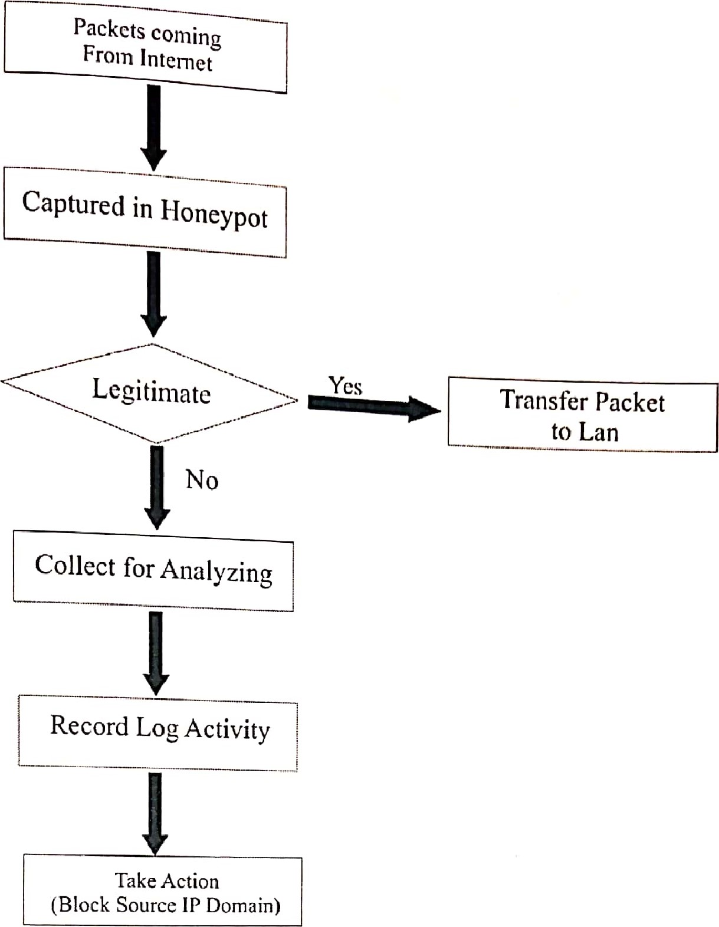
Fig 3.1 Flow chart of honeypot technology ((IJAERD), 2017).

Honeypot actually cannot prevent cyber-attacks against the network but helps in identifying and detecting them when used with other defense oriented tools such as firewall and Intrusion detection System (IDS).

3.1.1 Firewall
Firewall defines a single chock point that keeps unauthorized users out of the protected network, prohibits the entry or exit of potentially vulnerable services, and provides protection against various types of IP spoofing and routing attacks. Single choke point simplifies safety management by consolidating safety capacities on a single system or System set. The firewall is immune to penetration itself.

3.1.2 Intrusion Detection System (IDS)
Intrusion is defined as the act of unwanted attackers or hackers to have access to confidential information of the users. IDS has been defined and explained by many authors, articles, journals and published books. These are few definitions which have been given by some authors:
Niemela (2011) defined IDS as a software or hardware that controls environmental intrusions and anomalies is set to be guarded. The IDS is a safety surveillance instrument, comparable to a firewall that attempts to identify and potentially stop malicious activity.
An Intrusion Detection System (IDS) is a security system that tracks computer systems and network traffic and analyzes that traffic for possible malicious assaults from outside the organization and also for system misuse or assaults from inside the organization.
IDS is described as a device or software application that tracks network or system operations and finds out if any malicious activity happens (Mohit et. al, 2017).
The National Institute of Standards and technology (as cited in Shaik, Nageswara & Chandulal, 2015) classifies Intrusion Detection as the process of monitoring events happening in a computer system or network and evaluating them for indications of intrusion are described as efforts to compromise the confidentiality, integrity, accessibility or bypass the safety mechanism of a computer or network. Intrusion Detection is the disclosure of attacks made on IT systems with the intention of breaching the confidentiality, integrity or availability of all or part of the system (Darren, 2009).
Intrusion detection systems will detect an intrusion or intrusion attempt by examining features which include Network traffic, CPU and Input / Output (I/O) utilization and File activity or user location for signs of attacks.

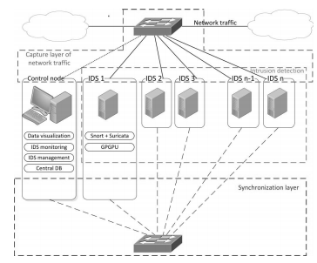
Fig 3.1.2.: Model of several IDS and one control node (Michal et al., 2017)

3.2 Kali Linux
Kali Linux is a sophisticated penetration testing and security auditing platform based on Debian. Kali includes several hundred instruments for multiple information security functions, such as Penetration Testing, Security Research, Computer Forensics, and Reverse Engineering. Offensive Security, a major information security training firm, develops, finances and maintains Kali Linux.
On March 13, 2013, Kali Linux was published as a full, top-to-bottom BackTrack Linux reconstruction that fully adheres to Debian development norms. This open-source software contains some of the tools that will be used for this work which include;
- Wireshark
- Pentbox
- Nmap/Zenmap
- DIGT

3.3 PENTBOX 1.8 FRAMEWORK
According to www.seurity-database.com, Pentbox is a framework that consists of security and stability testing oriented tools that are commonly used in networking. It is developed in ruby and oriented to GNU/Linux systems, but is compatible with every system where Ruby works. Tools in pentbox 1.8
- Cryptography tools
- Base64 Encoder & Decoder
- Multi-Digest (MD5, SHAI, SHA256, SHA384, SHA512, RIPEMD-160)
- Hash Password Cracker (MD5, SHAI, SHA256, SHA384, SHA512, RIPEMD-160)
- Secure Password Generator
Il Network tools
- Net Dos Tester
- TCP port scanner Honeypot
- Fuzzer
- DNS and host gathering
- MAC address geolocation (samy.pl)
Ill . Web
- HTTP directory brute force
- HTTP common files brute force

3.4 Method for Data Collection
The pentbox, which has a module for data capture, deals with the collection and recording of the Honeypot operations. It deceives the intruder by detecting all exercise within the honeypot and the data entering and leaving the honeypot, without being known to the attackers. Attacker does not know that in a fake system he is working. collected information is stored in the database. Captures particular quantities of Information through traffic reduction. Captures the attacker's activity on honeypot itself. Captures the attacker's activity even if it is in encrypted form.
3.5 Procedure for Data Analysis
Wireshark is a tool (also known as a network sniffer) for network or protocol and data analysis. It is used to analyze the structure of various network protocols and is capable of demonstrating encapsulation. The analyzer operates on Unix, Linux and Microsoft Windows operating systems, and employs the GTK+ widget toolkit and pcap for packet capturing,
Wireshark shares many characteristics with tcpdump. The difference is that it supports a graphical user interface (GUI) and has information filtering features. In addition, Wireshark permits the user to see all the traffic being passed over the network.
Features of Wireshark includes;
- Data is evaluated either from the network link wire or from information files that already have data packets captured.
- Supports live information reading and analysis for a broad spectrum of networks (including Ethernet, IEEE 802.11, PPP and loopback).
• Users can browse captured data networks with the assistance of GUI or other variants.
- Users can use command line switches to edit and convert the captured documents to the editcap application.
- The filter screen is used to filter and organize the display of information. The creation of plug-ins can scrutinize new protocol-captured traffic is also capable of tracking Internet Voice (VolP) calls. Rough USB traffic can also be captured when using Linux.

CHAPTER FOUR
RESULT DISCUSSION AND SYSTEM IMPLEMENTATION
This chapter shows the method that have been used for the implementation and showing the result of the objectives mentioned. This chapter presents an overview of the Honeypot System, which was used to ensure the detection, prevention of the confidentiality of the information against unwanted access and intrusion in the network.
System requirements
The system requirement is divided into two parts the Software and the hardware.
Software Requirements; as the software on the market is witnessing geometric progression, a major element in a system is the compatible software part. The company and one user should accept selected software as well as be liable for the scheme. Operating System: Kali Linux.
Hardware Requirements; Hardware Requirements Hardware configuration section is a significant software development job that inadequate random access memory can adversely influence the velocity and effectiveness of the whole system. To manage all the activities, the method should be strong. The hard disk should have sufficient capacity to store the file and application.
Processor: | Core i3, Core i5, Core i7 and above
Processor speed: | 2.9GHz onwards
RAM: | 8GB (Minimum)
Hard disk: | 500GB
Monitor Display: | LED
Mouse: | Touchpad with multi-touch gesture support, USB or PS/2

4.2 HONEYPOT CONFIGURATION
In this phase, Kali Linux Operating System is installed on a virtual box to set up the server. After this was done, the command prompt terminal of Linux is opened, so as to start the pentbox-1.8 framework. The set-up of this Pentbox honeypot would be accessible, if the command prompt terminal is given administrative authority. The following are steps taken;
Step1. cd pentbox-l.8
Step2. ls
Step3. ./pentbox.rb
Stepl. cd pentbox-l.8

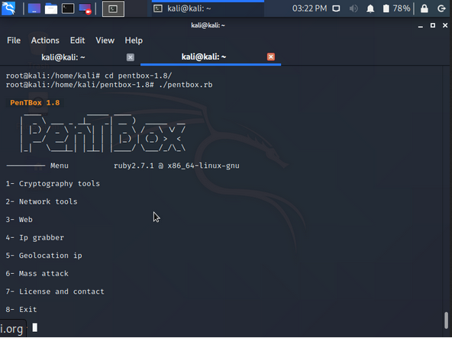
Fig. 4.1 Opening Pentbox Directory on Kali-Linux OS.

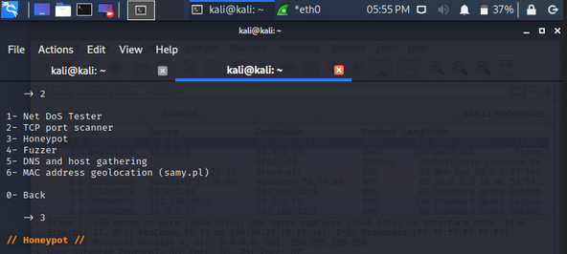
FIG. 4.2 Various Pentbox IDS tools

Step 5: <SELECT OPTION 3> Honeypot.

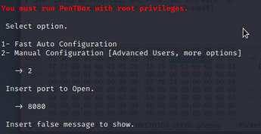
Fig. 4.3 Configuring the honeypot.

STEP 6: SELECT OPTION 2 <manual configuration>

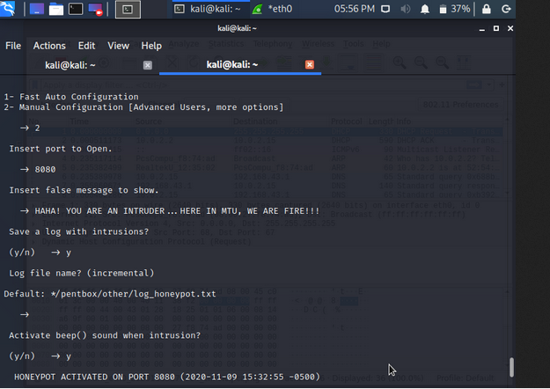
Fig.4.4 Configuring the Honeypot contd.

STEP 7: INSERT PORT TO OPEN
STEP 8: INSERT FALSE MESSAGE TO SHOW
STEP 9: LOG FILES SAVING
STEP 10: ACTIVATE BEEP ( ) FOR INTRUSION ATTEMPTS

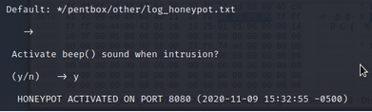
fig. 4.5 Honeypot Activated on Port 8080

This port 8080 is the port (both TCP and UDP) in which the computer sends and receives data from a web server based on a Web client. It is to send and receive IML pages or network information.

  - Configuring Wireshark
Click the Linux Logo > then select all applications> search for wireshark > Run Wireshark. After doing this, then click on the network interface that will be used to capture the data. This will be the eth0 (Ethernet). On the honeypot, we use Wireshark to monitor traffics in a network.

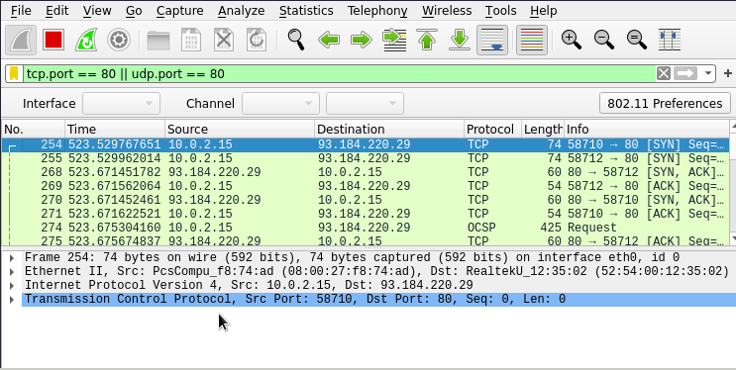
Fig. 4.6 snapshot of packets using Wireshark in real time.

Finding the IP Address of the Domain Using Deep Information Gathering Tool
To view the ip address of the www.mtu.edu.ng page, the Dmitry (Deep-magic Information Gathertng Tool) a UNIX/(GNU)Linux Command Line Application coded in C. Dmitry has the capacity to collect as much data about a host as possible. Base feature is capable of gathering possible subdomains, email addresses, uptime data, tep port Scanning, who is searches, and more by typing the following command on kali Linux terminal.
Dmitry—l www.mtu.edu.ng.

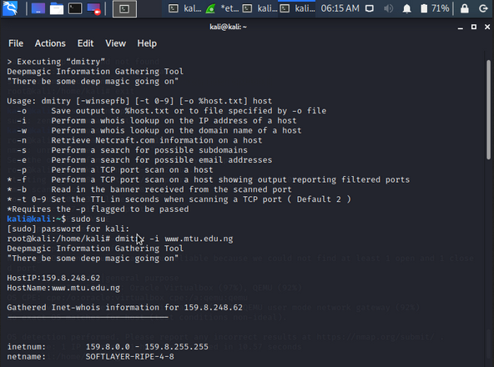

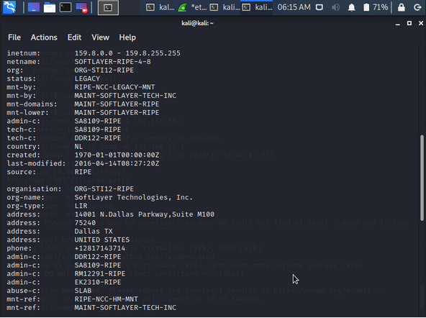
Fig. 4.7.1 Screenshot of how domain IP address was found

  - STARTING NMAP/ZENMAP GRAPHICAL USER INTERFACE
Enter 111 the target for your scan. Choose your target which is the Mountain Top University domain
(www.mtu.edu.ng), or the IP address (159.8.248.62), then select intense SCAN.
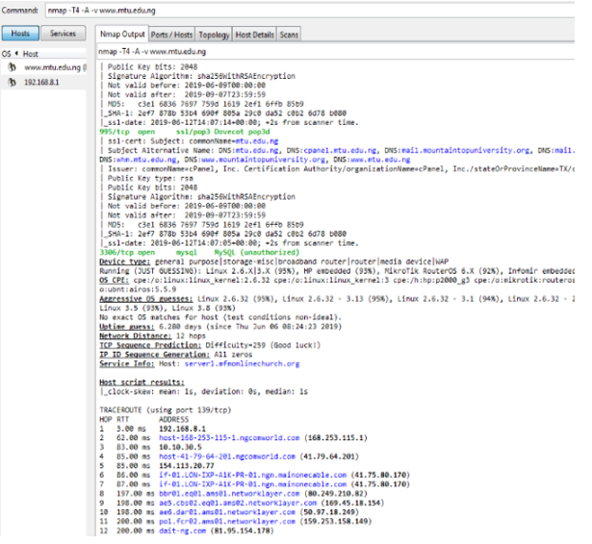

Fig. 4.8. N-map Intense scan output for www.mtu.edu.ng.

STEP 11: is to show the results of the ports (open and closed) scanned and their services also inclusive.

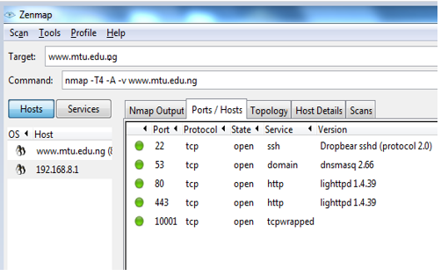
Fig 4.10. Scan results of ports and host.

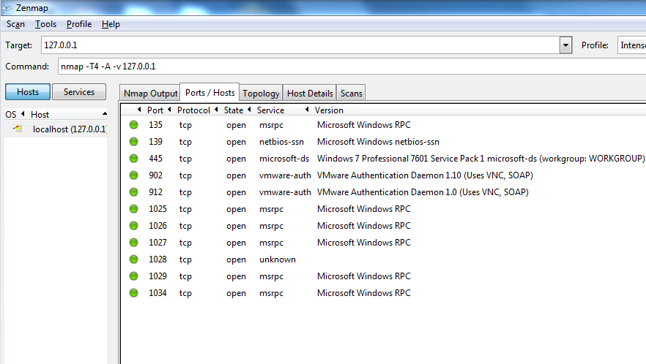

Fig. 4.11 Ports scan

STEP 12: Click on topology to view the network map. It shows how many addresses data passes through before reaching its target.
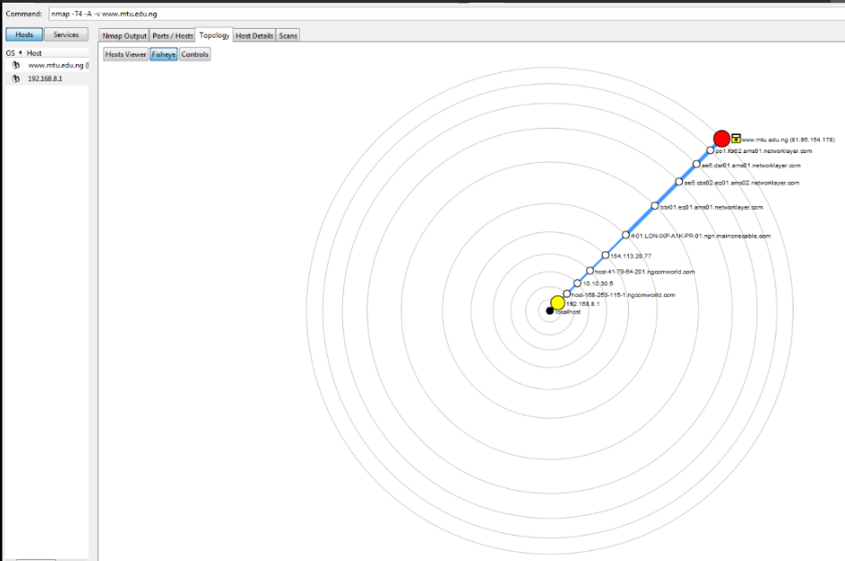
Fig. 4.11 Snapshot of network topology real time scan

Fig 4.12. shows the host details. It shows a summary of the scan such as the number of ports scanned, IP address, security accuracy, open ports, closed ports, operating system and others.

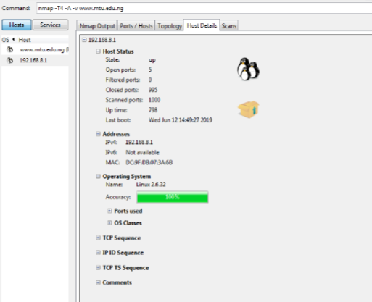
Fig. 4.12 Snapshot of Host details

4.6 Result and Conclusion
After all these processes have been met, pentbox will capture and record every connection made on the network. Honeypots would report if there are any attacks on the connections that has been received by it and as widely known, honeypot reports only malicious traffics on the network.

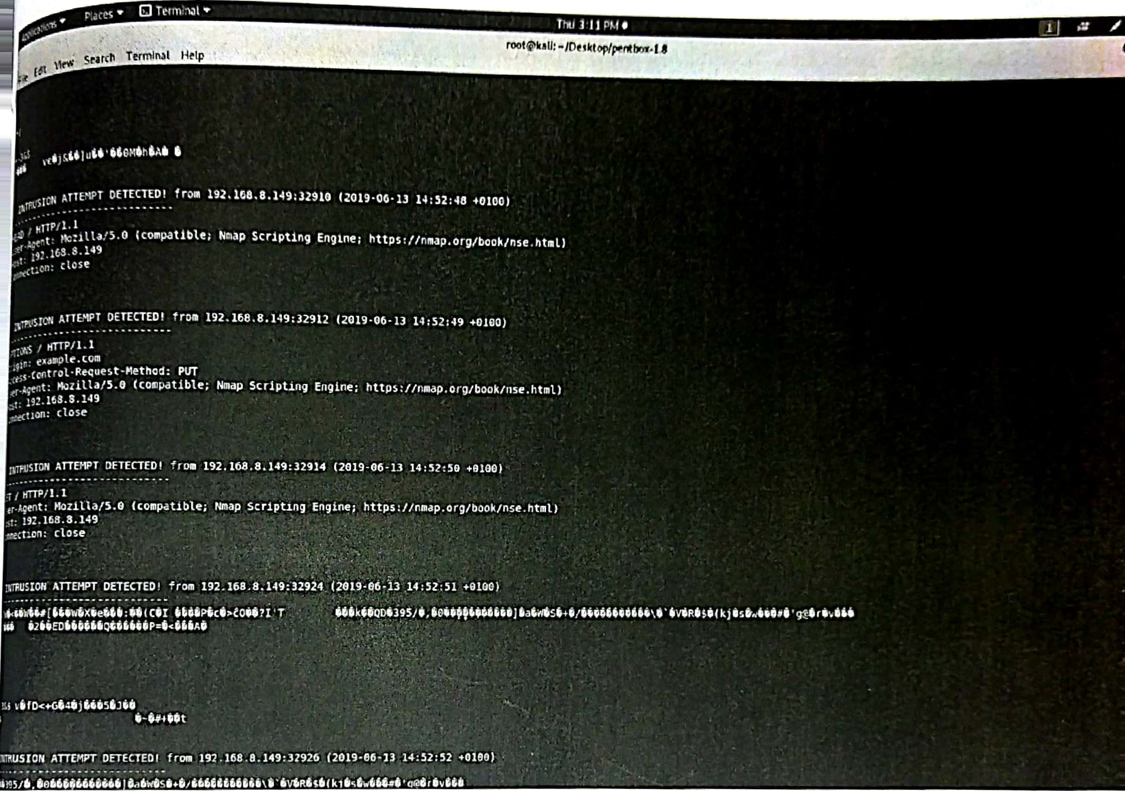
Fig 4.13 Snapshot of Honeypot showing information on detected connections

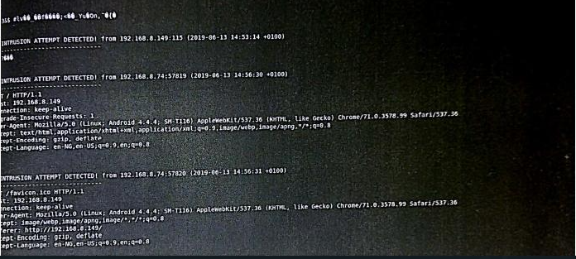
Fig 4.14. Snap-shot of Honeypot showing information on detected connections

Information recorded by honeypot
INTRUSION ATTEMPT DETECTED! From
192.168.8:32419 (2020-06-13 12:16:03 +0100)
GET/HTTP/1.1
Host: 192.168.8.149
Connection: keep-alive
Upgrade-Insecure-Requests: 1
User-Agent: Mozilla/5.0 (Linux; Android 4.4.4; SM-T116)
AppleWebKit/537.36 (KHTML, like Gecko)
Chrome/71.0.3578.99 Safari/537.36
Accept:
Text/html,application/xhtml+xml,application/xml;q=0.9,image/webp,image/apng,*;q=0.8
Accept-Encoding: gzip, deflate
Accept-Language: en-NG, en-US; q=0.9, en;q=0.8
After knowing which IPS are trying to attack, we can do prevention by blocking the IP or applying our tools as required. As you can see, we now know where the attacker came from, what exploit method was used and the time the exploit was attempted. Honeypots can be used in securing the network of Mountain Top University. Honeypots acts as an early alarming tools to secure the organization technologies and private data. Still IDS technology is not such powerful to protect global information infrastructure completely. In this work we have reviewed a basic honeypot. Hence we can safely conclude that different types of honeypots can be used to detect different types of attack signatures and rules can be defined to filter the traffic based on the gathered information.

CHAPTER FIVE
SUMMARY, RECOMMENDATION AND CONCLUSION

5.1 Summary
Network safety zone has made the greatest strides in latest years because no one expects their system to be assaulted by intruders. Honeypot technology is a significant and helpful component of a general network security approach if safety experts and scientists are to understand their opponents and ensure that network security keeps pace with the fast modifications in network assaults. No other mechanism is similar in a honeypot's effectiveness if the main objective is to collect data.
This work describes fresh methods of enhancing network security policies with honey-pot, but we must also remember the reality that if an intruder knows about or bypasses such a scheme, the entire mechanism is irrelevant, so create a honeypot in such a manner that the intruder certainly believes it is the initial server of manufacturing. Strong control mechanism is needed because if the intruder is effective in managing the honeypot scheme, it won’t be considered for attacking usage by the intruder.

5.2 Recommendation
In the future, attempts can be produced to add some more algorithms and methods such as connection tracking, protocol analysis, and pattern detection in stream content etc. depending on which security administrator can conduct the assessment and retrieve the signature even more accurately. To create Honeypot more flexible, some more parameters such as enabling adverse input interpretation like Port! 445 that can also be attached to all ports except 445. There also requires to be a quantitative comparison between the current technique and the suggested approach

5.3 Conclusion
Honeypot is a network security option, but a useful instrument complements other safety systems to create an additional active network security protection scheme. Working with IDS and firewall, Honeypot offers fresh ways to prevent, detect and respond to assaults. Because of its capacity to trap attackers into a decoy scheme, Honeypot can function as a useful deception instrument for item system avoidance. Honeypot, supplemented by IDS, decreases false positives and false negatives. Routing monitoring of intelligence offers flexible response to assaults. Different types of honeypots share prevalent information control and information capture techniques. Experts focus on the two to make the deployment of honeypot easier and harder to detect, From the developments in honeypot studies and manufacturing now days, I expect the inclusion, virtualization and delivery characteristics of the potential honeypot. Integrated honeypot encapsulates in a single unit of all the species. Virtual honeypot produces in one computer, a big amount of honeypot structures. Distributed honeypot includes various honeypot systems in a real network to provide strong communication between the assaults and system. They all create potential honeypot that will be less cost effective and one that it’s application can be simplified.
Network security is not a route that many learners take, but when we talk about computing, we see it as one of the most significant subjects. This work has trained me a lot about the society of black hat and white hat. It also gave an understanding of how the forensic jobs are enormous and complicated. Every day new threats are found and keeping up to date is the best way to remain safe. Most assaults will have no impact on the scheme by doing this easy job. Nowadays, the issue is that individuals using an operating system's pirated version contribute to botnets. They don't sustain critical changes in their scheme and are more vulnerable to automated assaults. The detection of a honeypot scheme is not difficult these days, most of the work should be directed towards the continuous creation and application of this wonderful technology.

Limitations
- Inability to access to live servers
- Scarcity of previous works
- Lack of constant both wired and wireless networks
- Time Constraints

REFERENCES
Adachi Y., and Oyama Y., (2009) Malware Analysis System using Process-Level Virtualization: Proceedings of IEEE Symposium on Computers and Communications, pp. 550-556.
Alosefer, Y., and Rana, O. , (2010) Honeyware – Web based Low Interaction Client Honeypot: Proceedings of the International Conference on Software Testing, Verification, and Validation Workshops, pp. 410-417.
AnagnostakiS, K.G., et al, (2005) Detecting Targeted Attacks Using Shadow Honeypots: Proceedings of the Conference on USENIX Security Symposium, pp. 9-23.
Artail H., et al, (2006) A hybrid honeypot framework for improving intrusion detection systems in protecting organizational networks. Vol. 25 Pages 274-288
Berthier, R., et al (2008) An Empirical Analysis on the Comparison of Network Attack Datasets: 11th IEEE High Assurance Systems Engineering Symposium. (HASE 2008), pp. 39-48.
Chawda, Kartik, and Ankit D. (2014) Dynamic & hybrid honeypot model for scalable network monitoring: Information Communication and Embedded Systems (ICICES), International Conference on IEEE
Cooke, E. , et al (2004) Understanding Distributed Black hole Placement: Proceedings ofthe 2004 ACM workshop on Rapid malcode, ACM. New York. pp. 54-64.
Das, Vs, (2009) Honeypot Scheme for Distributed Denial of Service: Proceedings of the International Conference on Advanced Computer Control, pp. 497-501.
Gubbels, Kecia, (2002). Hands in the Honeypot. GIAC Security Essentials Certification
Honeynet Project, http://www.honeynet.org. Accessed on 17/2/19. 13:24 http://labrea.sourceforge.net/labreainfo.html. Accessed:22/02/19, 14:18
spitzner, L., (2001). The value of honeypots.
Yegneswaran, V., et al (2005) Using honey nets for internet situational awareness: Proceedings of the Fourth
Workshop on Hot Topics in Networks (HotNets IV). Citeseer, pp. 17—22
Y.K Jain and S. Singh (2011) Honeypot based Secure Network System ln IJCSE. Vol 3. No.2 Feb 2011.
Jakub S., Ibrahim G. and Vaclav P. (2015). Network Monitoring Approaches: An Overview. International Journal of Advances in Computer Networks and Its Security– IJCNS. 5(2) [ISSN :2250-3757]

Mohit T., Raj K., Akash B., & Jai. K. (2017). Intrusion Detection System. International Journal of Technical Research and Applications, 5(2), 38-44.

Jian, B., et al. (2010) Research on network security of defense based on Honeypot: International Conference on Computer Application and System modelling (ICCASM 2010). Vol. 10. IEEE.
Karthik, S., et al. (2004) Design of Network Security Projects Using Iloneypots: Journal of Computing Sciences in colleges.
Koch, R., et al. (2013) Attracting sophisticated attacks to secure systems: A New Moneypot Architecture: Communications and Network Security (CNS) on IEEE.
Mokube, et al. (2007) Honeypots: concepts, approaches, and challenges. Proceedings ofthe 45th annual southeast regional conferences. ACM.
Nazario, J., (2009) PhoneyC: A Virtual Client Honeypot: Proceedings of USENIX Workshop on Large-Scale and Emergent Threats, pp. 1-8.
Portokalidis, G., et al(2006) Argos: an Emulatorfor Fingerprinting Zero-Day Attacks. ACM SIGOPS Operating Systems Review, Vol. 40, No. 4, pp. 15-27.
Provos, N., (2004) A virtual honeypotframework: Proceedings of the 13th conference on USENIX Security Symposium, Vol. 13, SSYM^{t}04, Berkeley, CA, USA.
Rowe, N., et al (2007) Defending Cyberspace with Fake Honeypots. Journal of Computers, Vol. 2, No. 2, pp. 2536.
Schneier, B, (2000) Secrets and Lies: Digital Security in a Networked World. John Wiley & Sons.
Spitzner, L, (2003)Honeypots: tracking hackers. Vol. l. Reading: Addison-Wesley.
Spitzner, L, (2003) The Honeynet Project: Trapping the hackers. pp. 15-23.1EEE Security
& Privacy 99.2.

APPENDIX
Command lines
- Set up of Pentbox Honeypot Configuration
# cd pentbox-1.8/
# ./pentbox.rb
// Honeypot //
SELECT Honeypot
Select Manual Configuration
Insert port to Open
8080
Activate beep() sound when intrusion?
(y/n) input n
“HONEYPOT ACTIVATED ON PORT 8080 (2020-11-09 15:32:55 -0500)

- ACTIVATION OF DMITRY ON WWW.MTU.EDU.NG
$ sudo su
[sudo] password for Kali:
root@kali:/home/kali# Dmitry –I www.mtu.edu.ng
Deepmagic Information Gathering Tool
HOST IP: 159.8.248.62
HOST NAME: www.mtu.edu.ng
Gathered Inet-who is information for 159.8.248.62

Inetnum: 159.8.0.0 – 159.8.255.255
Netname: SOFTPLAYER-RIPE-4-8

- INFORMATION RECORDED BY HONEYPOT
INTRUSION ATTEMPT DETECTED! From
192.168.8:32419 (2020-06-13 12:16:03 +0100)
GET/HTTP/1.1
Host: 192.168.8.149
Connection: keep-alive
Upgrade-Insecure-Requests: 1
User-Agent: Mozilla/5.0 (Linux; Android 4.4.4; SM-T116)
AppleWebKit/537.36 (KHTML, like Gecko)
Chrome/71.0.3578.99 Safari/537.36
Accept:
Text/html,application/xhtml+xml,application/xml;q=0.9,image/webp,image/apng,*;q=0.8
Accept-Encoding: gzip, deflate
Accept-Language: en-NG, en-US; q=0.9, en;q=0.8

