INVESTIGATING MOUNTAIN TOP UNIVERSITY BOREHOLE WATER FOR ITS QUALITY AND HEALTH IMPLICATIONS ON STUDENTS

BY

ARIRIGUZOH VICTORIA-GRACE ONYEKACHI
(16010101001)

A project submitted to the Department of Biological Sciences, College of Basic Sciences, Mountain Top University, Ibafo, in partial fulfilment of the requirements for the award of Bachelor of Science (B.Sc.) (HONS) degree in Microbiology
NOVEMBER, 2020

CERTIFICATION
This is to certify that this project was carried out by ARIRIGUZOH, VICTORIA-GRACE O. with matriculation number 16010101001 of the Programme Microbiology in the Department of Biological Sciences, College of Basic and Applied Sciences in Mountain Top University under the supervision of DR A. A. ADEIGA and DR. O. E. FAYEMI.

----------------------------- |  | -------------------- |  |  | -------------
STUDENT’S NAME |  | SIGNATURE |  |  | DATE
------------------------------ |  | ---------------------- |  |  | -------------
SUPERVISOR’S NAME |  | SIGNATURE |  |  | DATE

DEDICATION
I dedicate this work to my precious mother Dr Stella Aririguzoh for her unwavering support and love for me.

ACKNOWLEDGMENTS
My utmost acknowledgement goes to God the Almighty Father, for His divine love and protection and for seeing me through the completion of this project.
I am highly grateful to my late former supervisor Dr Adesina Adeiga who was supervising this work before his untimely demise. His guidance patience and mentorship was immeasurable throughout the duration of this project. I also appreciate the intervention and supervision of Dr. O.E. Fayemi when my supervisor passed on.
My appreciation also goes out to all the staff of the Department of Biological Sciences - both academic and non-academic - for their help and guidance throughout my stay in Mountain Top University. In particular, I would like to acknowledge Dr Francis Ibadin, Dr Moses Abiala, Dr Gabriel Akanni, Mr. Tosin Ogunbiyi, Mr Opeyemi Ojo, Mr Gabriel Abah and Mr Taiwo Emmanuel.
I am incalculably indebted to my dear mother, Dr Stella Aririguzoh, for her unwavering support and love. I am most grateful to the various members of Chaplaincy, especially Pastor Olumide Adesina, Dr Ademola Young and Pastor Olumide Tanimowo. I also want to acknowledge certain people that helped with this work Mrs Esther Amusan who diligently went through this work, Professor Humphrey Adebayo and Professor Emeka Iweala. I also appreciate my wonderful colleagues: Davies Priscilla, Oyakhire Aimalohi, Keku Tosin, Akuwudike Ifeoma, Muttallab Mariam, Akinte Moyosoreoluwa, Ajao Daniel, Titus Martins, Obasemola Adeola, Chelsea Nicholas and Uche Emeka.

TABLE OF CONTENTS PAGE
TITLE PAGE … ... … … … … … … i
CERTIFICATION … ... … … … … … … ii
DEDICATION ... … … … … … … iii
ACKNOWLEDGEMENTS ... … … … … … … iv
TABLE OF CONTENTS ... … … … … … … v
ABSTRACT ... … … … … … … vii

CHAPTER ONE: INTRODUCTION
1.1 Introduction … … … … 1
1.1 Background to the Study … … … … … 1
1.2 Statement of the Problem … … … … … 3
1.3 Justification of Study … … … … 4
1.4 Research Objectives … … … … … … 4
1.5 Research Questions … … … … 5
1.6 Significance of the Study … … … … 5
1.7 Scope of the Study … … … … 6
1.8 Limitation of Study … … … … 6
1.9 Operational Definition of Terms … … … … 6

CHAPTER TWO: LITERATURE REVIEW
2.1 Uses of Water … … … … … … … 8
2.2. Sources of Water … … … … … … … 9
2.3 Water and Contamination … … … … … 10
2.4 Water and Health … … … … … … 12
2.4.1 Allergies … … … … … … … 12
2.4.2 Allergic Contact Dermatitis … … … 13
2.5 Immune Response … … … … … … 14
2.5.1 The Function of IgE in Allergic Inflammation … 15
2.6 Water Treatment … … … … … … 19

CHAPTER THREE: MATERIALS AND METHODS
3.1 Materials … … … … … … … … 22
3.2 Sample Collection Procedure … … … … … 22
3.3 Physico-Chemical Analysis of Samples … … … 22
3.4 Chemical Tests for Metal Detection ... ... ... … 23
3.5 Microbiological Tests … … … … … 24
3.6 Immunological Tests … … … … ... … 24

CHAPTER FOUR: RESULTS AND DISCUSSION
4.1 Physico-Chemical Analysis… … … ... … 28
4.2 Microbiological Results… … … ... … … 28
4.3 Chemical Tests Results … … … ... … … 30
4.4 Immune Response … … … ... … … 31
4.5 Data from Female Student Respondents … ... … 31
4.5.1 Cross Tabulations ... … ... … 41
4.6 Answering The Research Questions … … ... … 46
4.7 Discussion … … ... ... … 47

CHAPTER FIVE: CONCLUSIONS AND RECOMMENDATIONS
5.1 Conclusions … … … ... ... … … 49
5.2 Recommendations … … ... ... … … 49
5.3 References … … … … ... ... … … 51
APPENDIX 1 The Histograms ... ... ... ... ... … 57
APPENDIX 2 Cross Tabulations ... ... ...... ... … 65

ABSTRACT
Many female students of Mountain Top University have complained about itching and rashes developing on their bodies after bathing with water from the university’s boreholes. The data for the work was generated in two ways: the laboratory analysis and a survey among the female students to pinpoint the effect of the water on their skins. The water samples were collected from the different borehole sources in the female hostels and subjected to Physico-chemical, microbiological, chemical and immunological tests. The water samples were analysed for the presence of heavy metals (Pb, Cr, Mn, Fe, Zn). The average temperature was 27°C. From the results analysed the turbidity was 0.15ms/cm, the pH was mainly acidic (4.4 – 5.5) and the conductivity 0.007µScm⁻¹. The total dissolved solids were between 0.22 and 0.23mg/L. After undergoing Atomic Emission Spectrophotometry, the metallic content of the water showed that Lead (<0.012), Chromium (<0.005), Manganese (0.133, 0.295 and 0.250), Iron (0.062, 0.235. and 0.068) and Zinc (0.242, 0.027 and 0.221) were detected. All the heavy metals detected in the water samples, except Manganese, met the acceptable standard set by the World Health Organization. The enumeration of total viable counts indicates the microbial contamination of the borehole water samples. The immunological tests also point towards an increase in immune cells most especially basophil, eosinophil and neutrophil. The responses to the research instrument also indicate an adverse reaction by female students to the water. The boreholes within the university community contain heavy metals and microbial contaminants. It is therefore recommended that the university undertake proper treatment of the water coming from the boreholes in the female hostels.

CHAPTER ONE
INTRODUCTION

1.1 BACKGROUND TO THE STUDY
Water is an essential element needed for the survival of living things since the evolution of life forms (Bhattacharya et al., 2018). Water is an inorganic transparent, tasteless, odourless and almost colourless chemical material that is the primary component of the earth's hydrosphere. It is a fluid in most living organisms. Even though it does not have calories or organic nutrients, it is essential to all known life forms. The chemical formula is H₂O, indicating that each of the molecules contains one oxygen and two hydrogen atoms connected by covalent bonds. Water is present in three different states on earth: liquid, gas and solid. The state of water depends on its temperature. Water flows on our planet as a liquid in streams, rivers and oceans. It is solid as ice in the North and South Poles and is gas (vapour) in the atmosphere. Water is also found in plants and animals. All living things need water to survive. People can go without food for weeks, but they can only survive without water for a few days. Water supports all forms of plant and animal life (Lozan et al., 2007).
Water can be used for direct and indirect reasons. Direct uses include bathing, drinking and cooking. Examples of indirect uses of water include, for example, the processing of wood to make paper and in the production of steel used in the making of cars. The bulk of the world's water is used for agriculture, industry and electricity (Centers for Disease Control and Prevention, 2020). The most common water uses include:
- Drinking and Household Needs
- Recreation
- Industry and Commerce
- Agriculture
- Thermoelectricity/Energy

Sources of Water
According to Vanloon and Duffy (2005), water is generally obtained from two principal natural sources: surface or ground sources. Surface water typically refers to water that falls to the ground as rain or hail but also includes freshwater lakes, rivers and streams. Groundwater is water that is extracted from the ground. McMurry and Fay (2004) and Mendie (2005) include borehole and well water as groundwater. Most inhabitants get their water from streams and lakes in rural areas while most urbanized cities rely on water distribution systems and drilled boreholes for their water needs.
The Australian Government's Department of Health (2010) sees anything which contaminates water as a contaminant or pollutant. Water has peculiar chemical properties arising from two factors: its polarity and hydrogen bonds. It can dissolve, absorb, adsorb different compounds (WHO, 2007). In other words, water on its own is not clean as it acquires contaminants from its immediate environment. Other activities contributing to water pollution include natural biology, human and animal actions (Mendie, 2005). Some people may be infected with various types of diseases from contacting water. According to the Australian Government Department of Health (2010), it is possible to be infected with bacteria, virus and parasites from drinking contaminated water
A borehole is a narrow passage bored in the ground, either vertically or horizontally. A borehole may be drilled for different reasons, including drawing of water; other liquids (such as petroleum); gases (such as natural gas); part of a geotechnical investigation; environmental site assessment etc. A borehole is a cost-effective way of getting water for various uses. However, it can be prone to contamination if it is not dug deep enough due to capillarity seepage (Al-Turki, 1995). Contamination is contingent on the chemistry of the soil and the environment. If the borehole is drilled in an area which is possibly receiving industrial fall out like lead dust, this can be washed down into the soil after a torrential downpour of rainfall. The water from the borehole is thereby polluted (Al-Turki, 1995).
In most parts of the urbanized world, proper water treatment methods usually kill the germs that cause many waterborne diseases. However, water treatment and hygiene standards in rural communities are generally inadequate. This may explain why many waterborne diseases still occur in these areas.
The host rock decides the chemical makeup of natural groundwater. A large number of the salts, metals and organic chemicals found in groundwater are necessary for human wellness. However, if the concentration of these useful substances is high, they can make the water taste bad. Importantly, they can cause harm to human beings drinking it. Micro living things such as protozoa, e.g. Cryptosporidium, bacteria and viruses may also be seen in groundwater. Many of these microbes transmit waterborne infectious diseases such as gastroenteritis and cholera
(Ramírez-Castillo et al., 2015). Conductivity, pH and turbidity measurements are used to determine the physical qualities of water. These qualities affect the taste, odour and appearance of water. Today, the rising level of water pollution and water use have created urgent needs to maintain good water quality that can be used in different applications (Bhattacharya et al., 2018).
The quality of water used by a person can affect his health, both immediately and even in the future. For example, a high magnesium concentration may result in an upset stomach for some days. Similarly, exposure to high levels of nitrates will reduce the amount of oxygen in the blood and cause methemoglobinemia which is particularly dangerous to pregnant women and their developing babies; babies under six months of age and the elderly (Ward et al., 2018).

1.2 STATEMENT OF PROBLEM
Mountain Top University is a residential campus located at Ibafo. All students live in the hostels. At present the school has nine hostels:

Table 1.1 Student halls of residence

NO | NAME OF HOSTEL | OCCUPANTS
1 | Daniel 1 | Male
2 | Daniel 2 | Male
3 | Guest House A | Male
4 | Guest House B | Male
5 | Zion House | Male
6 | Regional House. | Male
7 | Elizabeth New Hall | Female
8 | Elizabeth 2 | Female
9 | Elizabeth 3 | Female

Each hostel has a borehole, except for Elizabeth New Hall that has two. This means that students have access to ten boreholes. Water is pumped from these boreholes to the student rooms for the residents' use, including washing their bodies. Apart from Elizabeth Hall 3, all the other student rooms are en-suite. However, residents in Elizabeth Hall 3 have their bathrooms located outside their rooms and at the end of their wings of the halls.
There are about x number of females in the female hostel using borehole water provided by the school. A third of these students have complained of itching and developing rashes on their skin while using the borehole water. They were diagnosed to have an allergy when they presented at the health centre, and it was attributed to the borehole water they use to bathe. Since they have no choice of another water source, they have continued to use the borehole water. No factor has been attributed to this skin reaction. Thus the attention of this school was drawn to the situation. It is hoped that this study's outcome will help control the situation and bring about a solution to the problem.

1.3 JUSTIFICATION OF THE STUDY
The reason for conducting the research is to identify factors causing the adverse skin condition experienced by the students. In the course of the investigation, the following steps will be taken:
- Conducting laboratory investigation for the microbial content that may cause the condition.
- Carrying out chemical investigation for the mineral content in the borehole water to identify metals could cause the skin reaction.
- Using the animal experiment to verify the immune cells that could be provoking the reaction.
In the microbial Investigation, water samples from the borehole were taken to investigate the bacterial, parasitic, or fungal content by culturing the water samples and doing the microscopic investigation to identify the organisms that may cause the skin reaction.
The chemical investigation involves assessing the mineral contents of the borehole water to determine the metals that are above the acceptable levels specified by the World Health Organization. Excessive metals in the water are injurious to health and actually may be causing the skin reactions been complained about by the students.

1.4 RESEARCH OBJECTIVES
General Objective or Aim
The primary aim is to establish the cause of allergic body reactions from students to MTU borehole water.
Specific Objectives:
- To determine the quality of the borehole water.
- To determine the microbial content of the borehole water that may be of health risk.
- To evaluate the mineral content of the borehole water that may be causing allergic reactions to the students' skins.
- To assess the demography of the student population to be studied.
- To establish in the animal experiment, any immune reaction through the changes in immune cells of mice inoculated with the borehole water.
- To determine the IgE level raised in the serum of the mice used.

1.5 RESEARCH QUESTIONS
The following are the research questions for this study:
- What is the quality of the borehole water used by students of Mountain Top University, Ibafo?
- What are the microbial contents of the Mountain Top University borehole water that can put the health of the students to risk?
- What are the mineral contents of the Mountain Top University borehole water that may cause allergic reactions on the skins of the students?

1.6 SIGNIFICANCE OF STUDY
The study's significance is investigating the causative factors of the skin condition arising from female students' use of borehole water. The result of the investigation of the cause of allergy experienced by the female students will lead to steps of specific action to the solution. The result of the study will elucidate the factors responsible for the allergy.
This study will show the cause of the body reaction of the students to the water. This will demand a solution to the elimination of the cause of allergy in the borehole water.
First are the students who have been having health-related issues arising from the experience of body rash. If the sources of the contamination are identified and handled effectively, their body reactions will stop. Their parents too would have more peace if they know why their children have been experiencing allergic reactions while in school.
Secondly, the university itself stands to benefit from this research project greatly. The school management would identify the problems the water from the boreholes are causing and then make desirable changes to improve the overall water delivery system.
Thirdly, the Ogun State Water Board and other research organisations would also be able to use the results from this study to be better informed about the water quality in the Ibafo area and add the same to their database.
Last but not least, future researchers will also be able to draw inspiration from this study in their research. The published text of this project would provide a guiding document to microbiologists interested in borehole studies.

1.6 SCOPE OF THE STUDY
The Scope of study for this research project is limited to Mountain Top University students' residential hostels, and the boreholes present sunk in the hostels. Therefore, this study does not extend to other universities within or outside Nigeria. It used specific water testing procedures including, but not limited, to microbiological assessment, physiochemical tests and white blood cell tests.

1.7 LIMITATION OF THE STUDY
There are certain limitations to the study, including but not limited to the high cost. Not all parameters could be checked for a broader and more accurate description of the borehole water characteristics. A more precise test would have involved the use of ELISA test kits for cytokines evoked by immune cells. Unfortunately, these could not be used due to the cost of the reagents. The study does not go beyond Mountain Top University environment.
Due to Covid-19 restrictions on movements, not all students were on campus to complete the questionnaire, especially the 200 Level students. The unexpected closure of the university resulted in some tests not being carried out. The gender of the sample population are all females; perhaps male students could have had more varied answers.

1.9 OPERATIONAL DEFINITION OF TERMS
The terms below are contextually defined as they are used in this study:
- Immunoglobulin E (IgE): These are antibodies produced by the immune system during an allergic reaction.
- A xenobiotic is a biochemical substance found within an organism that is not naturally produced or expected to be present within the organism.

CHAPTER TWO
LITERATURE REVIEW

2.1 USES OF WATER
Water is important. It can be used in food production, sanitation, transportation, power generation, leisure and more. Solley et al., 1998 categorized water uses into the following broad categories:
- Commercial water use includes freshwater for motels, hotels, restaurants, office buildings, civilian and military institutions and other money-making facilities
- Domestic use is part of the water used in different homes every day. It includes water for everyday household purposes, such as those used for drinking, food preparation, bathing, washing clothes and dishes, flushing toilets and watering lawns and gardens. Domestic water use is probably the most important daily use of water for most people.
- Industrial water use is a valuable resource to the nation's industries for such purposes as processing, cleaning, transportation, dilution and cooling in manufacturing facilities. Major water-using sectors include steel, chemical, paper and petroleum refining. The industries may often re-use the same water and for more than one purpose.
- Irrigation water use is water applied to wet farms, orchards, pasture and horticultural crops. Water is also used in chemical applications, crop cooling, harvesting, and salts' leaching from crop root zones. Non-commercial agricultural uses of water activities include self-supplied water to moisten public and private golf courses, parks and nurseries.
- Livestock water includes freshwater used for stock animals, pets, feeding lots, dairies, fish farms and other non-farm needs. Water is also needed in the production processes of red meat, poultry, milk, wool.
- Mining water use includes water for the removal of naturally occurring minerals. They may be solids, such as coal and ores; liquids, such as crude oil; and gases, such as natural gas. This category includes quarrying, milling (such as crushing, screening, washing and flotation) and other operations that are part of mining.
- Public Supply water use refers to water reserved by public and private water suppliers, such as municipal waterworks and delivered to consumers for domestic, commercial and industrial purposes.
- Thermoelectric Power water use is the quantity of water used in the generation of thermal electricity. The energy produced by the water turns the turbines to generate electricity. Other sources of heat may be from fossil fuels, nuclear fission, or geothermal. Fossil fuel power plants typically re-use water.

2.2 SOURCES OF WATER
In some developing countries, including Nigeria, the majority of people live in rural areas. The rivers, streams, wells and more recently, boreholes serve as their primary water sources for drinking and domestic uses (Ibe and Okplenye, 2005). Nevertheless, the last few years have made it evident that the steady increase in demands for freshwater and its scarcity is a threat to human society's sustainable development (Mekonnen and Hoekstra, 2016).
Groundwater is generally considered safe drinking water because it has a low microbial load and little need for treatment before drinking. However, groundwater resources are commonly vulnerable to pollution, which may degrade their quality (Palamuleni and Akoth, 2015). Protection of groundwater is a big challenge to society since water quality on human health attracts keen interest. Therefore, assessing groundwater quality and developing strategies to protect aquifers from contamination is necessary to properly plan and design water resources (Akinbile and Yusoff, 2011).
Human actions can result in groundwater pollution. Harmful materials from junkyards, landfills, septic tanks, agricultural practices, uncontrolled surface spillage and acid rain can seep deep into the soil and penetrate the groundwater aquifers. In case the aquifers are porous, the damaging substances can travel extended distances polluting the groundwater on the way. It is important to note all possible causes of pollution when picking out the best spot to drill a borehole (Harvey, 2004). The natural decontamination of polluted waters in itself is never fast, while heavily contaminated water may criss-cross long distances before a significant degree of refinement is achieved (Halder and Islam, 2015).
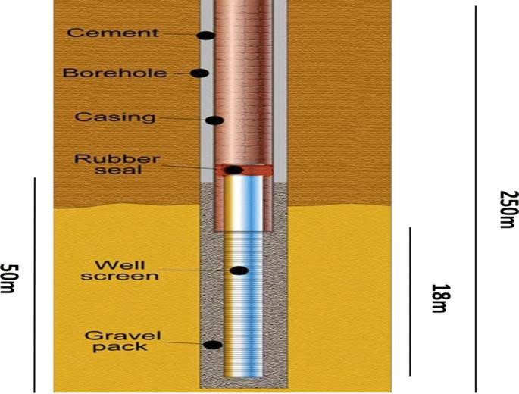

Figure 2.1. Sectional Picture of a Borehole
Source: Akinlalu & Afolabi (2018)

There are several underlying causes of borehole problems. These include improper well design and construction; biofouling, borehole stability, aquifer, incomplete well development and corrosion (Alberta Ministry of Agriculture and Forestry, 2020). A typical treatment given to borehole water is Membrane Filtration Treatment. A membrane is a thin film of a semi-permeable material that separates elements when a driving force is applied across the membrane. Membrane processes are used to remove bacteria, other microorganisms, particulates and natural organic material, which can impart colour, tastes and odours to water and react with disinfectants to form disinfection by-products (Ghernaout, 2018).

2.3 WATER AND CONTAMINATION
Groundwater is generally less susceptible to contamination and pollution when compared to surface water bodies (Zenan et al., 2002). Groundwater pollution occurs widely from diverse sources such as poor used water disposal, industrial pollution, agricultural practices, atmosphere fallout, clearing of vegetation, over-abstraction of groundwater and excavation below the water table (Tredoux et al., 2007). These affect water quality and threaten human health, economic development, and social prosperity (Milovanovic, 2007).
Contamination of water bodies is a growing environmental concern. In the case of underground waters like boreholes, this may arise even from the construction process of the borehole, drilling fluids, chemical casings and other materials which may find their way into the well to pollute the water (Angulo et al., 1997).
A well that is dug but not covered during the borehole construction stage can also be a direct route for contaminants to move from the surface of the ground to the aquifer thereby creating a good chance for chemical casing and bacteriological pollution to occur (Braunstein, 2007). Even supposing, there is no source of anthropogenic contamination. In that case, there is the potential for naturally occurring levels of metals and other chemicals that can be harmful to human health to enter (Getso et al., 2018).
Water contaminants can be classified into three broad groups:
- Inorganic
- Organic
- Biological.
As municipal, industrial and agricultural waste enter the water, biological and chemical contaminants, including heavy metals also enter water resources (Shanbehzadeh et al., 2014).
Inorganic Contaminants: Many aquatic environments face metal concentrations that exceed water quality criteria designed to protect the environment, animals and humans. The problems are exacerbated because metals tend to be transported with sediments, are persistent in the background, and bioaccumulate in the food chain (Ravindra et al., 2014). Heavy metals are one of the most common contaminants found in wastewater. These metals pose a harmful hazard to human beings and animals, even at low concentration (Ravindra et al., 2014). There are many non-living materials such as copper, chromium, lead, fluoride, arsenic, mercury, manganese, zinc, etc. that can foul a source of water. People can get drinking water from industrial procedures, plumbing systems, as well as natural sources (U.S. Environmental Protection Agency 2006; Nriagu 1988). Sources of inorganic contaminants may be anthropogenic or geographical. The breaking down of fluoride-bearing substances (like fluorspar, ralstonite, fluorite, fluorapatite, and others) on the ground can cause higher fluoride points in groundwater (Sharma and Bhattacharya, 2017). The over exploitation of groundwater also increases the problem of fluoride concentration in the water.
Organic Contaminants: The primary anthropogenic causing contamination resulting from humankind's activities are pesticides, domestic waste, and industrial wastes. The pollution caused by natural materials can lead to health challenges like hormonal disorders, malignant cells, and nervous system disorder (Ram et al., 1990; Harvey et al., 1984). Trihalomethanes (THMs) are made at the point when the chlorine in treated drinking water joins with normally happening natural matter. Pesticides are fabricated to interface with different compound chemical processes in the pest’s body chemistry. Tragically, in doing this, all pesticides influence the digestion of non-focused on living life forms. Pesticides normally weaken the liver and the sensory system (Sharma and Bhattacharya, 2017). Additionally, Volatile Organic Chemicals (VOCs) like solvents and organic chemicals such as styrene, benzene, toluene, trichloroethylene (TCE), adhesives, vinyl chloride, gasoline additives and fuel additives can contaminate the water (Wehrmann et al., 1996).
Biological Contaminants: Impureness of water is produced by the existence of living organisms like protozoan, bacteria, algae, and viruses. These can cause definite water problems (Daschner et al., 1996; Ashbolt, 2004). Algae are usually relatively copious and hinge on nutrients present in the water, for example, Phosphorous. The nutrients usually come from domestic run-off or industrial contamination. The surplus algae growth not only impacts on the taste and odour of water; it also blocks the filters and produces unwanted growth of slime on the carriers. Some protozoans such as Giardia and Cryptosporidium are frequently found in rivers, lakes and streams fouled with animal faeces or received wastewater from sewage treatment plants (Sharma and Bhattacharya, 2017). All of these may lead to health issues.
Bad water causes complications to health because it leads to waterborne diseases. Waterborne diseases may be warded off by taking steps even at the households’ levels, such as boiling water before drinking the same. However, supplying safe water for everyone is a challenging assignment (Sharma and Bhattacharya, 2017).

2.4 WATER AND HEALTH
Some algae such as blue-green algae (Aphanizomenon, Anabaena, and Microcystis) are capable of releasing toxins which can damage the nervous system (neurotoxins) liver (hepatotoxins), and skin (Hitzfeld et al., 2000; Rao et al., 2002). Volatile Organic Compounds (VOC's) can cause chronic health problems like malignant cells, central nervous system disorders, birth defects, liver and kidney impairment, and reproductive disorders (Brown et al., 1984).
2.4.1 ALLERGIES
An allergy can be defined as a hyper-sensitivity caused by contact to a specific antigen (allergen) resulting in considerable increases in reactivity to that antigen on subsequent exposure, sometimes resulting in harmful immunologic consequences (McConnell, 2007). An allergen is a type of antigen that stimulates or provokes an abnormally vigorous immune response which the immune system fights as a perceived threat that would otherwise be harmless to the body.
There are various types of allergens, such as:
- Animal products: Pet dander, dust and cockroaches
- Drugs: Penicillin and sulpha drugs are common triggers
- Foods: Wheat, nuts, milk, shellfish and egg
- Insect stings: Bees, wasps and mosquitoes
- Mould: Airborne spores from mould can trigger a reaction
- Plants: Pollens from grass, weeds and trees, resins for example from poison ivy and poison oak
- Other allergens: Latex (found in latex gloves and condoms) and metals (nickel and copper)
The underlying mechanism of an allergic reaction includes immunoglobulin E antibodies (IgE) which joins an allergen and then to a receptor on mast cells or basophils where it activates the release of inflammatory chemicals such as histamine (NIAID, 2015). The immunoglobulin E antibodies are parts of the body's immune system.

2.4.2 ALLERGIC CONTACT DERMATITIS
Contact dermatitis is an inflammatory skin condition induced by exposure to an environmental agent. It is one of the most common skin diseases with significant socio-economic impact (Uter et al., 1998). The skin is the outermost layer of the physical body and the first to encounter any chemical or bodily element from the environment. According to the pathophysiological mechanisms involved, two main types of contact dermatitis can be differentiated: irritant contact dermatitis and allergic contact dermatitis (ACD). Irritant contact dermatitis is due to the pro-inflammatory and toxic effects of xenobiotics. They can activate innate skin immunity. Allergic contact dermatitis (ACD) requires the activation of antigen-specific acquired resistance leading to the development of effector T cells which mediate the skin inflammation (Saint-Mezard et al., 2004).
There are some risk factors or genetic predisposition to contact dermatitis. Some people are more prone to develop allergies to contaminated water, while others with the same exposure do not. But there are many systems at play that determine whether or not any person develops the allergy or an irritant reaction. These include how well the skin acts as a barrier, how the body produces an inflammatory response and how prone it is to develop allergies (Daniel, 2020).

2.5 IMMUNE RESPONSE
The human immune system must defend the physical body itself by keeping or even killing microorganisms that invade the body. Some organisms such as bacteria, viruses and fungi cause sicknesses. The immune system comprises of an intricate and vital network of cells and organs that protect the body from infection. It responds to bacteria and viruses in a very complicated way. In essence, it recognizes unique molecules (antigens) a foreign substance in the body that triggers the production of antibodies (a type of protein) and special white blood cells called lymphocytes that mark the antigens for destruction. During the primary immune response to the first encounter with a specific pathogen, some lymphocytes, also known as memory cells, develop with the capabilities to confer long-last immunity to that pathogen, usually for life. These memory cells recognize antigens on the pathogens they have come across before, prompting the immune system to respond faster and more effectively than during the first exposure (WHO, 2020). Mast cells are widely recognized as critical effector cells in allergic disorders and other immunoglobulin E–associated acquired immune responses (Galli et al., 2005). After activation, mast cells may immediately extrude granule-associated mediators and generate lipid-derived substances that induce immediate allergic inflammation (Metcalfe et al., 1997).
The synthesis of chemokines and cytokines may also follow mast cell activation. Cytokine and chemokine secretion, which occurs hours later, may contribute to chronic inflammation. The biological functions of mast cells appear to include a role in innate immunity; involvement in host defence mechanisms against parasitic infestations; immunomodulation of the immune system; tissue repair and angiogenesis (Metcalfe et al., 1997).
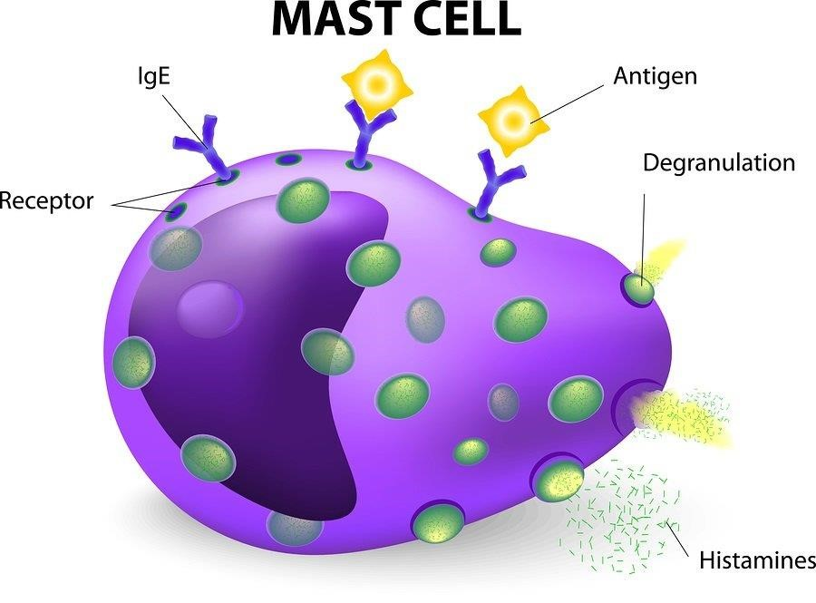
Figure 2.2: Picture of a Mast Cell Source: thehollandclinic.com

2.5.1 THE FUNCTION OF IgE IN ALLERGIC INFLAMMATION

Sensitization
The immune response in allergy starts with sensitization. For example, when food allergens are eaten, the antigen-presenting cells in the epithelium lining internalize, work on and then express these allergens on their cell surfaces. The allergens are then presented to other cells involved in the immune response, particularly T-lymphocytes. Through a series of direct cell interactions, B-lymphocytes are transformed into antibody secretory or plasma cells. During the allergic reaction, the plasma cell produces IgE-antibodies, which, like antibodies of other immunoglobulin isotopes, can bind a specific allergen through its Fab portion. Different allergens arouse the production of corresponding allergen-specific IgE antibodies. Once formed and released into circulation, IgE binds, through its Fc portion, to high-affinity receptors on mast cells, leaving its allergen-specific receptor site available for future interaction with the allergen. Other cells known to show high-affinity receptors for IgE include basophils, Langerhans cells and activated monocytes (Roald and Victor, 2004). Production of allergen-specific IgE antibodies completes the immune response known as sensitization (WAO, 2015).

Re-exposure to allergen
The allergen's binding to IgE triggers the immune system to start a more aggressive and swift memory reaction on a re-exposure. The cross-linking of many mast cell/basophil-bound IgE antibodies by allergen starts the process of intracellular signalling (Galli and Tsai, 2012). This leads to the degranulation of cells and the discharge of mediators of inflammation (WAO, 2015). Mast cells try to sustain a fixed number of unoccupied high-affinity IgE receptors on their cell surface. IgE antibodies bind to these receptor sites, waiting for their specific allergen to be encountered. To keep the number of unoccupied IgE receptor sites constant the mast cell regulates IgE receptor expression, probably in response to circulating IgE levels (WOA, 2015).

Early and late phase reactions
The immune system's reaction to allergen exposure can be separated into two stages. The first stage is the instant hypersensitivity or early phase reaction. It occurs within 15 minutes of exposure to the allergen. The second or late-phase reaction occurs 4-6 hours after the disappearance of first phase symptoms. This stage can last for a few days or weeks. During the early phase reaction, chemical mediators are released by the mast cells. These include histamine, prostaglandins, leukotriene's and thromboxane, and they produce local tissue responses characteristic of an allergic reaction (Abdulkhaleq et al., 2018). For example, in the respiratory tract, these include sneezing, oedema and mucus secretion, with vasodilatation in the nose, leading to nasal blockage. The Broncho-constriction in the lungs leads to wheezing. The late phase reaction in the lung includes cellular infiltration, fibrin deposition and tissue destruction resulting from the sustained allergic response leading to increased bronchial reaction, oedema and further inflammatory cell recruitment. These observations tend to suggest that IgE is instrumental in the immune system's response to allergens because of its ability to trigger mast cell mediator release, causing both the early and late phase reactions (WAO, 2015).
Allergen - - - → IgE – antibody - - - → Mast cell/Basophil - - - → Mediators - - - →
Inflammation - - - → Symptoms and signs of disease - - - → Treatment
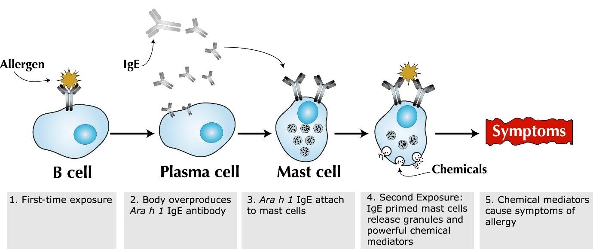

Figure 2.3: Immune response during an allergic response
Source: American Academy of Allergy Asthma and Immunology (2020), Histamine
Toxicity

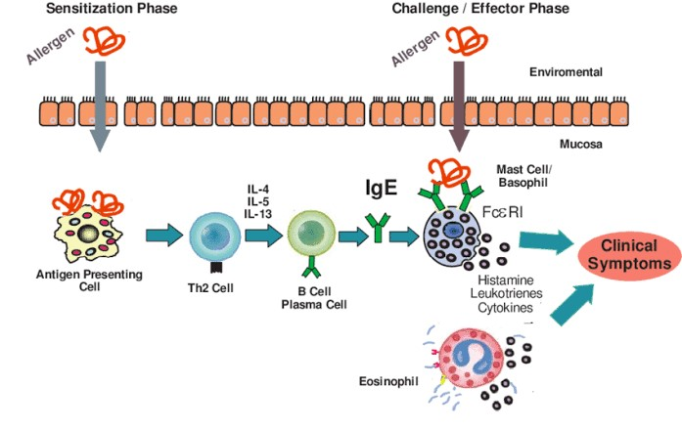

Figure 2.4: Immune response to an allergen
Source: Ronald van Ree et al. (2014)

However, Saint-Mezard et al. (2014) reported that the two necessary steps involved in a contact sensitivity reaction are sensitization (also known as induction phase) and elicitation (also known as challenge stage) phases.

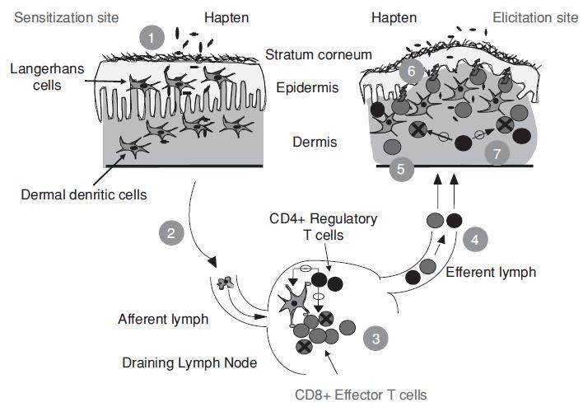

Figure 2.5: Immune response to an allergic dermatitis Source: Saint-Mezard et al., (2004)

Persons with allergic contact dermatitis may have persistent or worsening dermatitis, especially if the materials they are allergic to are not identified or if they practice improper skincare. The longer a person has had severe dermatitis, the lengthier, it is assumed that dermatitis will heal once the cause is identified (Thomas et al., 2019).
Immunoglobulin E has a molecular structure similar to that of other classes, having two specific antigen-binding sites attached to a constant (Fc) region. IgE in serum has no known biological relevance and exerts its effect only when bound to blood basophils or tissue mast cells. Mediators released from these cells are responsible for the immediate hypersensitivity reactions (Kemeny et al., 1985).
The mechanisms regulating IgE synthesis differs from those of the other classes. Serum levels are generally low in healthy individuals (Value). Levels rise in childhood to reach adult levels by the age of 15 to 20 years. Because IgE levels are usually low, a specific IgE response to an allergen will often cause a significant rise in total IgE (Kemeny et al., 1985).

2.6 WATER TREATMENT
Water treatment refers to the various methods and processes used to purify water and make it safe for human consumption. The need for science-based solutions for pure water provisioning results in several water treatment methods to counter the problem. The suitable technology for water treatment is based on:
- raw water characteristics (i.e., the nature and extent of contamination),
- infrastructure (i.e., power, availability of chemicals),
- affordability/cost as well as acceptability.
Some of the conventional water purification methods are sedimentation or settling, boiling/distillation, chemical treatment (precipitation/coagulation/adsorbents), disinfection and filtration. Some of these are explained below:
Distillation: Is the process of separating the components or substances from a liquid mixture by using selective boiling and condensation. In this separation method, the water's mixed ingredients are separated by boiling the water to the point of vaporization and condensing it back to liquid form in a separate container. It is based on the differences in boiling points of the individual parts (Sharma and Bhattacharya, 2017).
Thus, the distillation procedure depends on the vapour pressure properties of liquid mixtures. The basic principle defined as the input of heat energy elevates vapour pressure. When the vapour pressure reaches its surrounding pressure, the liquid mixture boils, and distillation occurs because of the variances of volatility in the mixture. This procedure results in a separation between water and inorganic substances, such as calcium, magnesium, lead, and pathogenic bacteria.
However, organics with boiling points lower than 100°C cannot be removed efficiently and can become concentrated in the final product water. Distilled water purification machinery was initially established for industrial use. However, it came eventually for home use. As this process is not very effective in removing organic chemicals, a carbon filter system must be further added to make the water safe for consumption. The carbon filters entail systematic changing as they can quickly become breeding grounds for the growth of bacteria.
Even though distilled water is safe, it is not healthy as it contains no nutrient minerals, which are needed for drinking water (Kozisek, 1980). It lacks minerals and ions, e.g. calcium that plays critical roles in biological functions such as in nervous system homeostasis, which is typically found in potable water (Azoulay et al., 2001).
Reverse Osmosis: Is a form of water treatment that removes contaminants from unfiltered water, or feedwater, through the application of pressure to force it through a semi-permeable membrane. The water flows from the more concentrated side (i.e. the side with more contaminants) of the Reverse Osmosis (R.O.) membrane to the less concentrated side (i.e. the side with fewer pollutants) to provide hygienic drinking water. The freshwater produced through this process is called the permeate. The concentrated water left over after this process is called the wastewater or brine.
According to Greenlee et al., 2009 reverse osmosis is best suited to address the two issues for which it was initially designed:
- Desalinating brackish water or seawater and
- Reducing particular chemical contaminants
It is typically used for home water treatment to remove chemical toxins (Pawlak et al., 2006), dyes (Nataraj et al., 2009), organic contaminants (Bhattacharya et al., 2008), pesticides (Bhattacharya, 2006), salts (Bhattacharya and Ghosh, 2004), and microbes (Park and Hu, 2010).
A reverse osmosis (R.O.) system removes sediments and chlorine from the water with a pre-filter before it forces water through a semi-permeable membrane to remove dissolved solids. After water exits the R.O. membrane, it passes through a post-filter to refine the drinking water before it enters a dedicated faucet. Reverse osmosis systems have various stages depending on their number of pre-filters and post-filters.
Most water filtration experts agree that four filtration stages are more or less required for reverse osmosis filters. These four stages include the sediment pre-filter, a carbon block pre-filter, a reverse osmosis membrane and a carbon-block post filter.
- Pre-filters have the role of removing larger contaminants, silt, rust, sand, chlorine and other organic chemicals, chlorine by-products, finer pollutants and other contaminants that may damage or clog the R.O. membrane.
- Because the R.O. membrane is vulnerable to the damaging effects of chlorine, a carbon block pre-filter is necessary to maintain the integrity of the membrane.
- Reverse osmosis membrane, which is the heart of an R.O. system, is responsible for carrying out the reverse osmosis filtration.
- The post-carbon block filter is the last stage and acts as a final polish for water by removing any pollutants missed in the previous steps.
- Optional stages in R.O. systems are re-mineralizer filters or alkaline filters, which add healthy minerals to water that may have been lost because of the R.O. filtration process.
Alkaline filters also reduce the acidity of water.
Limitations:
- The sanitized water gotten after reverse osmosis treatment is bereft of useful minerals,
- A membrane may come to be clogged after prolonged use and hence, requires periodical replacement of the membrane.

CHAPTER THREE

MATERIALS AND METHODS

This study is a descriptive/experimental design in a cross-sectional student population to determine the effect of borehole water use. This chapter shows how the primary data are generated for this study. Two types of data are used:
- The primary data is principally generated to answer the research questions. The information is not previously in existence but freshly created for the primary purpose of addressing. They are data from laboratory work
- The secondary data is already published. They are needed to support the study, for example, the journal articles and other papers used in the literature review

3.1 Materials
The materials used are 15 ml McCarthy bottles, 50 ml sterile plastic bottles, Acetone-alcohol, Capillary tubes, Conductivity Meter, Cotton wool, Crystal Violet, Deionized water, Dropper, Ethanol, Concentrated HNO_{3,} Incubator, Labelling markers, Leishman Stain, Microscopic Slides, Nutrient Agar, Petri dishes, pH buffers, Spectrophotometer, Syringes, TDS meter, Thermometer, Turbidimeter, Portable Water Monitoring System and Water.

3.2 Sample Collection Procedures

Water Sample Collection
Water samples were collected from the three boreholes in the female students' residential areas into sterile 15 ml McCarthy bottles and labelled appropriately as Elizabeth New Hall Wing A, Elizabeth New Hall Wing B and Elizabeth 2 and 3. The valve was allowed to run for a minute after which the 15 ml McCarthy bottles were carefully uncapped and filled with water.

3.3 Physico-Chemical Analysis of Samples
The water samples from each source (borehole) were examined in terms of physical and chemical properties such as colour, temperature, pH, conductivity, concentration, total dissolved solids and turbidity. The colour was checked visually.

pH Determination
The water samples' pH was done using the probe of a portable water quality monitoring system by inserting the probe into a beaker containing the water samples and left for 1-2 minutes before readings were taken.

Temperature
The water samples' temperature was determined using the probe of a portable water quality monitoring system by inserting the probe into a beaker containing the water samples and left for 1-2 minutes before readings were taken.

Turbidity
Turbidity was done using a turbidimeter, where the water samples were placed in a sample compartment, and the result was read.

Conductivity
The conductivity of samples was measured using a conductivity meter by inserting the probe into a beaker that contained deionized water, then the water samples, and the readings were taken.

Total Dissolved Solids
The samples' conductivity was measured using a TDS meter by inserting the probe into a beaker that contained deionized water, then the water samples, and the readings were taken.

3.4 Chemical Tests for Metal Detection
This test was done on the borehole water samples to check for certain metals that could indicate gross contamination and unsafety of water when present in water. The test for metals was done using Flame Atomic Emission Spectrophotometry.
The samples were first digested before being passed through the spectrophotometer. The procedure for Digestion is given as follows;
- 50 ml of truly shaken H₂O were digested with 5 ml of concentrated HNO₃ on a hot plate till the solution was reduced to less than 20 ml by volume.
- The solution was made to 100 ml by the addition of deionized water.
- The solution was transferred to previously washed acid bottles.
- The reagent blank was prepared by digesting 50 ml of deionized water with 5 ml of concentrated HNO₃ till the solution was reduced to less than 20 ml by volume.
- The solution was made to 100 ml by the addition of deionized water.
- The solution was run through the spectrophotometer

Table 3.1 Instrumental operating conditions for the determination of heavy metal
in water samples using Flame Atomic Emission Spectrophotometry

Metal | Flame | Wavelength  (nm) | Lamp Current (mA)
Lead (Pb) | Air acetylene | 217.0 | 6
Chromium (Cr) | Air acetylene | 357.9 | 2
Manganese (Mn) | Air acetylene | 279.5 | 12
Iron (Fe) | Air acetylene | 248.3 | 15
Zinc (Zn) | Air acetylene | 213.9 | 10

Source: Bahru, T., Hussen, A. & Rao, V. (2019).

3.5.1 Microbiological Tests
The microbiological examination of the borehole water emphasizes the assessment of the hygienic quality of supply.
The Nutrient Agar was prepared following the manufacturer’s instructions and autoclaved. Once cool, the water samples were cultured using the spread plate method and kept in the incubator.

3.6 IMMUNOLOGICAL TESTS

Inoculation of Albino Mice
The albino mice epidermis was inoculated with the borehole water with the aid of a syringe. This was done once a week for four weeks. It was after this that the process of bleeding to check the immune cells provoked was started.

Blood Sample Collection
This was done to check the immune cells provoked. The blood samples (1 ml) were got from the orbital sinus of the albino mice. This procedure is used with recovery in experimental circumstances, and this method is also called periorbital, posterior-orbital and orbital venous plexus bleeding.
Requirements include Swiss albino mice, anaesthetic agent, cotton, capillary tube and blood sample collection tubes.
- The blood sample was collected under general anaesthesia.
- Topical ophthalmic anaesthetics agent was applied to the eye before bleeding.
- The animal was scuffed with the thumb and forefinger of the non-dominant hand, and the skin around the eye was pulled taut.
- A capillary tube was inserted into the eye's medial canthus (at a 30-degree angle to the nose).
- A slight thumb pressure was adequate to rupture the flesh and enter the plexus/sinus.
- Once the plexus/sinus was punctured, blood passed into the capillary tube.
- Once the required volume of blood was collected from plexus, the capillary tube was gently removed to be cleaned with a sterile cotton swab.
- The bleeding was stopped by applying gentle finger pressure.
- After thirty minutes of the blood collection, the animal was checked for post-operative and periorbital lesions.

Blood Smear
- A clean glass slide was placed on a flat surface, and a drop of blood was added on it.
- Another clean slide, held at an angle of about 45 degrees was used to touch the blood with one end of the glass slide, to allow the blood to run along the edge of this slide by capillary action. It was then pushed carefully along the first slide's length to produce a thin smear of blood.
- These were allowed to air dry, labelled appropriately and placed in the slide transport containers.
Staining
Staining is a method used to enhance contrast in samples, generally at the microscopic level. For this study, Leishman stain was used.
Leishman stain is generally used when there is a need to study a blood smear for blood cells, differential leucocyte count, type of anaemia, toxic granules and platelet count. It is also used to single out nuclear and cytoplasmic morphology of the blood's various cells like platelets, red blood cells (RBCs), white blood cells (WBCs), and the parasites. Leishman stain is the most dependable stain for peripheral blood film examination (Mondal et al., 2017)
Leishman staining rationale
Leishman Stain is a neutral stain for blood smears. It consists of a mixture of Eosin (an acidic stain) and Methylene blue (a basic stain) in Methyl alcohol and is usually diluted and buffered during the staining procedure. It stains the different components of blood in a range of shades between red and blue. As it is a type of Romanowsky stain, it contains both the acidic and basic dyes with an affinity for the blood cells' basic and acidic components. The acidic dye, Eosin, variably stains the basic parts of the cells, i.e. the cytoplasm, granules etc. and the basic dye, Methylene blue stains the Acidic components, especially the Nucleus of the cell. The stain must be diluted for use with Phosphate buffer to pH 6.8 or 7.2, depending on the specific technique used. The pH 6.8 is preferred when the morphology of blood cells is to be examined, and pH 7.2 is right for parasitic studies.

Leishman Staining Procedure
- A thin blood smear was prepared and allowed to air dry.
- Six drops of the Leishman stain were added to the microscopic slide.
- After 2 minutes, double the amount of distilled water was added and the content mixed by swirling.
- The slides were incubated for 10 minutes at 37°C.
- The slides were rinsed thoroughly with distilled water.
- The slides were left to air-dry in a tilted position.
- The slides were observed under the oil immersion objective lens of the microscope.
The colour of Granules by Leishman Stain were Basophil (purple-black), eosinophil (red-orange), and neutrophil (Purple).

CHAPTER FOUR

4.0 RESULTS AND DISCUSSION

This study aims to determine the quality of MTU borehole water and the health implications of students. This chapter shows the data generated from the surveys and laboratory tests.
The result findings are summarized in the tables below.
4.1 PHYSICO-CHEMICAL ANALYSIS

Table 4.1 Physico-Chemical parameters of borehole water within the university hostels
Hall of  Residence | pH | Temperature  (°C) | Conductivity  (µScm⁻¹) | TDS  (mg/L) | Turbidity  (ms/ cm)
Elizabeth New  Hall Wing A | 4.4 | 27.2 | 0.007 | 0.22 | 0.15
Elizabeth New  Hall Wing B | 5.5 | 27.1 | 0.007 | 0.23 | 0.15
Elizabeth Halls  2 and 3 | 4.6 | 27.0 | 0.007 | 0.23 | 0.15

From this table, we can observe that the water samples got from the hostels are mainly acidic in pH value. They had normal room temperature as well. The Total Dissolved Solids (TDS) content does not give room for concern.

4.2 MICROBIOLOGICAL RESULTS
Table 4.2: The Total viable counts on nutrient agar.
Hall of Residence | Microbial counts | Cfu/ml
Elizabeth New Hall Wing A | 78 | 780
Elizabeth New Hall Wing B | 60 | 600
Elizabeth 2 and 3 | TNTC | NA
Unfortunately, Serial Dilution was not done before culturing, which did not allow for calculating the Log₁₀ cfu/ml of the colonies. However, it is worthy to note that the borehole's microbial load content that serves Elizabeth 2 and 3 was high.

Table 4.3: Result showing the Morphological characteristics of samples cultured on Nutrient Agar

Isolate  Code | Colour | Shape | Size | Elevation | Appearance | Texture | Opacity | Margin
ENH  Wing A | White | Circular | Small | Flat | Shiny | Smooth | Opaque | Entire
ENH  Wing B | White | Circular | Small | Flat | Shiny | Smooth | Opaque | Entire
EH  2 and 3 | White | Circular | Large | Raised | Shiny | Smooth | Opaque | Entire

KEY:
ENH = Elizabeth New Hall
EH = Elizabeth Hostel

Table 4.3 shows the morphological characteristics of the bacterial isolates on nutrient agar. It can be noticed that Isolates from Elizabeth New Hall Wing A and B are morphologically similar while isolates from Elizabeth Halls 2 and 3 were slightly different from the established pattern.

4.3 CHEMICAL TESTS RESULTS

These are the results of metal detection in the water sample.

Table 4.4 Result of the metal detection

Parameter | Pb  (mg/L) | Cr  (mg/L) | Mn  (mg/L) | Fe  (mg/L) | Zn  (mg/L)
Elizabeth New Hall  Wing A | <0.012 | <0.005 | 0.133 | 0.062 | 0.242
Elizabeth New Hall  Wing B | <0.012 | <0.005 | 0.295 | 0.235 | 0.027
Elizabeth Halls  2 and 3 | <0.012 | <0.005 | 0.250 | 0.068 | 0.221

- KEY:
- Pb – Lead
- Cr – Chromium
- Mn – Manganese
- Fe – Iron
- Zn – Zinc

The acceptable standard for lead and chromium in water are below 0.01 mg/L and 0.05 mg/L, respectively, (Torrice, 2016; WHO, 1992). Therefore, the lead and chromium contents in the water are at safe levels. The recorded Manganese content in the water is above the acceptable standard for manganese which is 0.05 mg/L (Sain & Deitrich, 2015). The acceptable standard for iron in water, according to Lunvongsa et al. (2006) is 0.3 mg/L and below. Therefore, the iron content is at safe values. Still, the iron content of Elizabeth New Hall Wing B is dangerously close to the edge. The acceptable standard for zinc, according to Rajael et al., (2012), in water is 0.05 mg/L and below therefore the Zinc content is at safe values, but the zinc content of Elizabeth New Hall Wing A is not within the acceptable range.

4.4 IMMUNE RESPONSE
The table below shows the reaction of the albino mice.

Table 4.5 Result of the Reaction of the Immune Cells
Week 1 |  | Week 2 |  | Week 3 |  | Week 4
Immune Cells  (µL) | No | Immune Cells  (µL) | No | Immune Cells  (µL) | No | Immune Cells  (µL) | No
Basophil | 1 | Basophil | 2 | Basophil | 3 | Basophil | 3
Eosinophil | 2 | Eosinophil | 3 | Eosinophil | 3 | Eosinophil | 4
Neutrophil | 1 | Neutrophil | 2 | Neutrophil | 3 | Neutrophil | 3

The steady increase of the immune cells indicates an immunological response in vitro after inoculation.

4.5 DATA FROM FEMALE STUDENT RESPONDENTS
Fifty female respondents were administered copies of the questionnaire to find out their opinions on their perceived consequence of using Mountain Top University borehole water and their health.

Table 4.6 Age of respondents

Age | Frequency | Percent
16-17 | 6 | 12.0
18-19 | 11 | 22.0
20-21 | 19 | 38.0
22-23 | 6 | 12.0
24-25 | 5 | 10.0
26-27 | 2 | 4.0
28-29 | 1 | 2.0
Total | 50 | 100.0

The respondents are aged between 16 and 29. The bulk of the respondents are aged between 20-21. They are followed by those who are 18-19. There are equal number of respondents who fall within the 16-17 and 22-23 years. The fewest number of respondents are those who are aged from 26 and above. This may suggest that the university admits less elderly students; or that more matured people may not want to be bothered with academic life rigours.
Table 4.7 Level of study of respondents

Level | Frequency | Percent
100 | 10 | 20.0
200 | 1 | 2.0
300 | 9 | 18.0
400 | 30 | 60.0
Total | 50 | 100.0

Most of the respondents are spending their fourth year as students in the university. They form 60% of the total respondents. The first and third-year students come in the second and third places, respectively. However, the gap between the two levels is narrowest. Only a single respondent is a second-year student.

Table 4.8 Length of using borehole water in school

Responses | Frequency | Percent
One Year | 10 | 20.0
Two Years | 2 | 4.0
Three Years | 13 | 26.0
Four Years | 25 | 50.0
Total | 50 | 100.0

Most of the respondents have been using the university’s borehole water for four years. These are most likely those in their final year classes and can point to the effect or non-effect of this type of water on their bodies because they have been students longer in the school. These finalists are distantly followed by those who have been using the borehole water for three years. Apparently too, these respondents are in their penultimate classes. Some respondents have been using the borehole water for about a year. These respondents are most likely to be in their first year of studies. A few respondents have been using the university’s borehole water for about two years

Table 4.9 Respondents using borehole water at home

Responses | Frequency | Percent
Yes | 44 | 88.0
No | 6 | 12.0
Total | 50 | 100.0

A significant number of students use borehole water at home. In fact, they are more than four-fifths of the total number of respondents. The rest claim that they do not use borehole water at home. Thus, it can be drawn that most of the respondents use borehole water in their different homes.

Table 4.10 If respondents borehole water at home is treated

Responses | Frequency | Percent
Yes | 29 | 58.0
No | 21 | 42.0
Total | 50 | 100.0

About three-fifths of the respondents claim that the borehole water in their different homes is treated. On other words, the water .has been made safe for human use by following some procedures, like reverse osmosis and chlorine treatment. Their homes are outside the confines of the university. Therefore, they do not share boreholes and borehole water with either students or the university. The rest claim that the water from the boreholes in their homes are not treated.

Table 4.11 Respondents experiencing itching or rashes after bathing with borehole water in school

Responses | Frequency | Percent
Yes | 37 | 74.0
No | 13 | 26.0
Total | 50 | 100.0

Majority of the respondents report that they experience itching and have rashes after bathing with the water from the university’s borehole whenever they are in school. This may suggest that there is something in the water that irritates their skins. Nevertheless, some others say that they neither have rashes nor do their skins itch after using the same water from the same boreholes in bathing.

Table 4.12 Respondents experiencing itching or rashes after bathing with borehole water at home

Responses | Frequency | Percent
Yes | 6 | 12.0
No | 44 | 88.0
Total | 50 | 100.0

These same respondents were asked if they experience itching or develop rashes after bathing with water from the borehole while away from school but in their different homes. Most of them say they do not. This seems to confirm what they earlier claimed in Table 4.11 and further strengthens the suspicion that the water from the university’s boreholes may be housing some contaminants that cause irritation on the epidermis of the student users. Expectedly, a very few other respondents report that they still experience itching and do have rashes after using the waters from their home boreholes. However, their numbers are negligible.

Table 4.13 Respondents parts of the body that itch

Response | Frequency | Percent
Leg | 1 | 2.0
Face | 11 | 22.0
Arm/Hand | 2 | 4.0
Leg and trunk | 2 | 4.0
Leg and face | 2 | 4.0
Leg and arm | 9 | 18.0
Face and arm | 3 | 6.0
All four parts of the body | 3 | 6.0
No reaction | 12 | 24.0
Leg, Face and Arm | 3 | 6.0
Trunk and Face | 2 | 4.0
Total | 50 | 100.0

Respondents were further asked the part or parts of their bodies that itch after bathing with the borehole waters. Slightly more than one-fifth of the respondents point to only their faces. Another batch from the remaining respondents name at least two parts of their bodies that suffer. They name their faces and arms; legs, faces and arms; and legs, faces, trunks and arms also to itch. Some other respondents only list just two parts of their bodies that suffer: arm/hands; legs/trunks; legs/faces; and trunks/faces. Only a single respondent complained of only the leg itching. Interestingly, about a quarter of the total respondents report that they do not experience any reaction at all from bathing with the water from the university’s boreholes.

Table 4.14 Respondents parts of the body that have rashes

Response | Frequency | Percent
Face | 19 | 38.0
Arm/Hand | 2 | 4.0
Leg and trunk | 1 | 2.0
Leg and arm | 3 | 6.0
Face and arm | 5 | 10.0
All four parts of the body | 3 | 6.0
No reaction | 14 | 28.0
Leg, Face and Arm | 2 | 4.0
Trunk and Face | 1 | 2.0
Total | 50 | 100.0

On which part of their bodies do these respondents have rashes after bathing with the university’s borehole waters? A large number of respondents claim that these rashes appear on their faces. Some others say they appear on their faces and arms. Another group say these rashes can be seen on their legs and arms; and their legs, faces, trunks and arms. Some others point to their arms and hands. Yet, some only point to their arms/hands; and their legs. Faces and arms. A respondent each says the rashes only appear on her legs and trunk; and trunk and face. Still, some report that they have no reactions because they do not have rashes after taking their baths with the university’s borehole water.

Table 4.15 Respondents having itchy scalp after using borehole water in school

Responses | Frequency | Percent
Yes | 11 | 22
No | 39 | 78
Total | 50 | 100.0

Almost four-fifth of the respondents report that their scalps do not itch after using borehole water from the school to bath. They form the bulk of the respondents. The rest say they experience itching scalps after they use the same water in bathing.

Table 4.16 Respondents experiencing skin colour change after using borehole water

Responses | Frequency | Percent
Yes | 19 | 38.0
No | 31 | 62.0
Total | 50 | 100.0

Slightly more than three-fifths of the respondents claim that they do not experience skin colour changes or after using borehole water to bath. However, the rest say they have skin discolouration after using the same water for the same purpose.

Table 4.17 Respondents developing eczema (irritated, red and itchy skin) immediately or after a short time of using borehole water

Responses | Frequency | Percent
Yes | 24 | 48.0
No | 26 | 52.0
Total | 50 | 100.0

The respondents claimed that they developed eczema immediately or after a short time of using the university’s borehole water. The rest did not. It must be pointed out that the gap between these two groups is very thin.

Table 4.18 Respondents developing eczema immediately

or after a long time of using borehole water

Responses | Frequency | Percent
Yes | 17 | 34.0
No | 33 | 66.0
Total | 50 | 100.0

Unlike the previous table where respondents developed eczema immediately or shortly after using the borehole water to bath, less students complained of this problem after using this water to bath immediately or over a prolonged period. This may be because their bodies got used to the water and stopped reacting to it. The rest still reported eczema challenge even after using the same water over a long time.

Table 4.19 Respondents experiencing simple skin irritation after bathing with borehole water in school

Responses | Frequency | Percent
Yes | 31 | 62.0
No | 19 | 38.0
Total | 50 | 100.0

Majority of the respondents report experiencing simple skin irritation after bathing with borehole water. These irritations may appear mild and uncomplicated to these respondents.
Some others did not experience any such irritation.

Table 4.20 Respondents observing dry skin after bathing with borehole water in school

Responses | Frequency | Percent
Yes | 26 | 52.0
No | 24 | 48.0
Total | 50 | 100.0

More respondents observed that their skins appeared more dry than normal after bathing with the borehole water than those who made no such observation. The gap between these two groups agreeing or disagreeing is almost insignificant.

Table 4.21 Respondents reporting skin conditions at the Health Centre

Responses | Frequency | Percent
Yes | 9 | 18.0
No | 41 | 82.0
Total | 50 | 100.0

It is interesting to notice that despite all the adverse changes the respondents reported from using the university’s borehole water, just a few of them bothered to go to the University’s Health Centre to seek medication. Majority of them did not bother. They may have grumbled to their friends, but they did not order their footsteps to the clinic.

Table 4.22 Respondents having itchy bumps on their skins

Responses | Frequency | Percent
Yes | 19 | 38.0
No | 31 | 62.0
Total | 50 | 100.0

Most of the students claim that they do not have itchy bumps on their skins from using the school’s borehole water. The rest say otherwise. This means that most of the respondents do not have thuds on their skins.

Table 4.23 Respondents observing thickening or scaly skins overtime of continuous usage of borehole water

Responses | Frequency | Percent
Yes | 22 | 44.0
No | 28 | 56.0
Total | 50 | 100.0

Similarly, as seen in Table 4.20, most of the respondents do not observe the thickening of their skins or get scaly skins from the school’s borehole water's continuous usage. The rest of the respondents share contrary opinions.

4.5.1 CROSS TABULATIONS

Table 4.24 Respondents who use treated borehole water at home experiencing itching or rashes after bathing with borehole water in school

Use of Treated  Borehole at Home | Experiencing itching or rashes after bathing with borehole water in school
Use of Treated  Borehole at Home | Yes (%) | No (%) | Total (%)
Yes | 52.0 | 6.0 | 58.0%
No | 22.0 | 20.0 | 42.0
Total | 74.0 | 26.0 | 100.0

More than half of the respondents who use treated water from the boreholes that they have at home experience rashes after bathing with water from the school's borehole. Apparently, there is something in the water in school that these students bath with that causes them to have rashes or to itch after washing their bodies. It is important to note that those who use water at home that is not treated are not as grossly affected as the first group that use treated water in their homes. Apparently, their skins react to the borehole water they use in school.

Table 4.25 Respondents who use treated borehole water at home experiencing simple skin irritation after bathing with borehole water in school

Use of Treated  Borehole at Home | Experiencing simple skin irritation after bathing with borehole water in school
Use of Treated  Borehole at Home | Yes (%) | No (%) | Total (%)
Yes | 48.0 | 10.0 | 58.0
No | 14.0 | 28.0 | 42.0
Total | 62.0 | 38.0 | 100.0

Most of the respondents who use treated borehole water at home experience simple skin irritation after washing their bodies with the borehole water in school. This confirms the finding in Table 4.22 above. This also re-affirms the suspicion that the borehole water in school may be contaminated and therefore unfit for human use. Most of those respondents that use untreated borehole water at home also do not experience simple skin irritation after bathing with the suspected impure borehole water in school. Their skins may be already used to the impurities from both water sources and have developed a tolerance for them. Hence, they no longer react to them.

Table 4.26 Respondents who use treated borehole water at home experiencing itching or rashes after bathing with treated borehole water at home

Use of Treated  Borehole at Home | Experiencing simple skin irritation after bathing with borehole water at home
Use of Treated  Borehole at Home | Yes (%) | No (%) | Total (%)
Yes | 6.0 | 52.0 | 58.0
No | 6.0 | 36.0 | 42.0
Total | 12.0 | 88.0 | 100.0

The data in this table confirms the earlier claims in Tables 4.22 and 4.23. The respondents that use treated borehole water at home experienced less itching or rash eruption from using the waters from treated boreholes. This suggests that because the water in the boreholes in their home is different because it is treated, there is little or no room left for impurities to infect their skins. Majority of those that use untreated borehole water at home do not experience simple skin irritation from using the apparently contaminated water in the school.
Table 4.27 Age of Respondents who experience itching or rashes after bathing with borehole water in school

Age Group | Experiencing itching or rashes after bathing with borehole water in school
Age Group | Yes (%) | No (%) | Total (%)
16-17 | 6.0 | 6.0 | 12.0
18-19 | 18.0 | 4.0 | 22.0
20-21 | 30.0 | 8.0 | 38.0
22-23 | 8.0 | 4.0 | 12.0
24-25 | 8.0 | 2.0 | 10.0
26-27 | 2.0 | 2.0 | 4.0
28-29 | 2.0 | 0.0 | 2.0
Total | 74.0 | 26.0 | 100.0

The most significant chunk of respondents who have itching or rashes after bathing with school borehole water fall into 20-21-year-olds. They are followed more distantly by those who are 18-19 years old. These two groups are most distantly followed by those between 22-25 and 16-17. The least number of respondents are aged 28-29 years. From this table, it can be established that the older respondents (aged between 22-29) appear to have less itching and rashes than their younger counterparts.

Table 4.28 Age of respondents experiencing simple skin irritation after bathing with borehole water in school

Age Group | Experiencing simple skin irritation after bathing with borehole water in school
Age Group | Yes (%) | No (%) | Total (%)
16-17 | 6.0 | 6.0 | 12.0
18-19 | 14.0 | 8.0 | 22.0
20-21 | 22.0 | 16.0 | 38.0
22-23 | 8.0 | 4.0 | 12.0
24-25 | 6.0 | 4.0 | 10.0
26-27 | 4.0 | 0.0 | 4.0
28-29 | 2.0 | 0.0 | 2.0
Total | 62.0 | 38.0 | 100.0
Table 4.26 shows comparable responses, as seen in Table 4.25. Similarly, the largest number of respondents that have simple skin irritation are aged 20-21. These are followed by those who are 18-19 years. Those who are aged 22-29; and 16-17 years also have skin irritation, but to considerably lower degrees.

Table 4.29 Age of respondents experiencing itching or rashes after bathing with borehole water at home

Age Group | Experiencing itching or rashes after bathing with borehole water in the home
Age Group | Yes (%) | No (%) | Total (%)
16-17 | 0.0 | 12.0 | 12.0
18-19 | 2.0 | 20.0 | 22.0
20-21 | 8.0 | 30.0 | 38.0
22-23 | 0.0 | 12.0 | 12.0
24-25 | 0.0 | 10.0 | 10.0
26-27 | 2.0 | 2.0 | 4.0
28-29 | 0.0 | 2.0 | 2.0
Total | 12.0 | 88.0 | 100.0

It can be seen that most of the respondents - irrespective of their ages - do not experience itching or have rashes developing after washing themselves with the borehole water in the different homes. When this fact is placed side-y-side with Table 4.22, it can be seen that most respondents develop both rashes and itch from bathing with the water from the school boreholes. This further reinforces the feeling that the school water should be investigated for impurities that cause trouble for student users' skins.

Table 4.28 Level of study of respondents experiencing itching or rashes after bathing with borehole water in school

Level of study | Experiencing itching or rashes after bathing with borehole water in school
Level of study | Yes (%) | No (%) | Total (%)
100 | 12.0 | 8.0 | 20.0
200 | 2.0 | 0.0 | 2.0
300 | 14.0 | 4.0 | 18.0
400 | 46.0 | 14.0 | 60.0
Total | 74.0 | 26.0 | 100.0

Most of the respondents in their fourth-year of study report experiencing itching or rashes when bathing with borehole water while in school. It should be pointed out that these students have spent almost eight semesters in the school and therefore expected to have a good idea of what they are reporting. Those in the lower levels also experience these same discomforts, but their numbers are not as high as their senior counterparts.

Table 4.29 Level of study of respondents experiencing simple skin irritation after bathing with borehole water in school

Level of study | Experiencing simple skin irritation after bathing with borehole water in school
Level of study | Yes (%) | No (%) | Total (%)
100 | 12.0 | 8.0 | 20.0
200 | 0.0 | 2.0 | 2.0
300 | 8.0 | 10.0 | 18.0
400 | 42.0 | 18.0 | 60.0
Total | 62.0 | 38.0 | 100.0

Expectedly, most of the four hundred level students have experiences of simple skin irritation from bathing with borehole water while in school. The first-year students also complain about the same problem. No respondent in the second year of study complained. The students that say they have simple skin irritation are slightly more than three-fifths of the total respondents. The rest made no such observations.
Table 4.30 Level of study of respondents experiencing itching or rashes after bathing with borehole water at home

Level of study | Experiencing itching or rashes after bathing with borehole water at home
Level of study | Yes (%) | No (%) | Total (%)
100 | 2.0 | 18.0 | 20.0
200 | 0.0 | 2.0 | 2.0
300 | 2.0 | 16.0 | 18.0
400 | 8.0 | 52.0 | 60.0
Total | 12.0 | 88.0 | 100.0

The majority of the respondents do not experience any itching or have rashes when they wash with borehole water while in their different homes. This observation cuts across the different levels of studies. A few respondents’ state otherwise: that they experience itching or rashes or even both after bathing with borehole water, even in their own homes that are far away from the school and the school water sources.

4.6 ANSWERING THE RESEARCH QUESTIONS
- Research Question One: What is the quality of the borehole water used by students of Mountain Top University, Ibafo?
From the results presented above (See Table 4.4), it appears to be that the quality of water from these boreholes are deficient in certain areas, especially in chemistry. It is important to note that the laboratory mice inoculated with the water showed significant immune response as shown by the increase of immunological cells (See Table 4.5).
- Research Question Two: What are the microbial contents of the Mountain Top University borehole water that can put the health of the students to risk?
The water's microbial content that could constitute a health risk was unfortunately not discovered as the identification tests could not be carried out due to time limitations.

- Research Question Three: What are the mineral contents of the Mountain Top University borehole water that may cause allergic reactions on the skins of the students?
Certain metals are present in the water that are higher than the acceptable standard for water samples. A prominent example is manganese, which is present at over eight times more than the acceptable range.

4.7 DISCUSSION
The basic Physico-chemical results while slightly acidic in nature does not raise any cause for alarm. This may not affect the health of the students negatively. The metallic content of the water, however, has issues. While the lead content was below the expected standard, it does not mean that precautions should not be taken to prevent further lead accumulation. Lead can enter the water when plumbing materials that contain lead corrode, especially where the water has a high acidity that corrodes pipes and fixtures (Torrice, 2016).

Chromium is a metallic element found in rocks, soil and plants. Some are released into the aquatic environment through weathering and erosion processes (Manzoori et al., 1996). The acceptable standard for chromium in water, according to WHO, is 0.05 mg/L and below. Therefore, the chromium content of the water samples is at a safe value.

The acceptable standard for manganese in water is 0.05 mg/L (Sain & Deitrich, 2015) and below. Therefore, the water's manganese content is at a very high amount and unsafe. Manganese may be present in water in the environment from natural sources (rock and soil weathering) or as a result of human activities (such as mining, industrial discharges and landfill leaching).

The acceptable standard for iron in water, according to Lunvongsa et al., (2006) is 0.3 mg/L and below therefore the Iron content is at safe values, but the iron content of Elizabeth New Hall Wing B is dangerously close to going out of acceptable ranges. If this happens, the students’ health might be compromised.

The acceptable standard for zinc in water, according to Rajael et al., (2012), is 0.05 mg/L and below. Therefore, the Zinc content is at safe values, but the Zinc content of water Elizabeth New Hall Wing A is not within the acceptable range.
The steady increase of the immune cells indicates an immunological response to the water they were inoculated with.

It is a common agreement among the female students as understood from the survey that the water has had detrimental effects on their skins since they started using the hostel borehole water. Female students, especially those in final levels, complained of an adverse reaction to the water due to prolonged use more than those in lower levels.

CHAPTER FIVE
CONCLUSIONS AND RECOMMENDATIONS

5.1 CONCLUSIONS
In our growing globalized world, water and access to it are vital resources. Boreholes led to an increased water supply, but they must be treated to be of use to humans without causing ill-effects on health. This need for water necessitated borehole provision by the school for students use.
This study's findings revealed that the borehole water in the university hostels is likely the cause of allergic reactions on students' skins. It is advised that the school increases its treatment of the boreholes in female hostels.
The laboratory tests done in this work discovered certain critical areas in which the water quality can be improved, most especially the metallic contents. The high metallic content has a negative impact on the quality of the water and the female students' consequent health using it. The excessive amount of certain metals in the water samples, e.g. manganese and zinc, should be checked using treatments such as filters. These will significantly improve the quality of the water being used by the students.
It is a consensus among the female students as seen from the questionnaire that the water has had undesirable effects on their skin since they started using the hostel borehole water. Female students, especially those in final levels, complained of an adverse reaction to the water due to prolonged use more than those in lower levels.
Specific laboratory parameters were acceptable, such as the Total Dissolved Solids, pH, turbidity, conductivity, etc. However, some were not, and improvements can be made to improve the quality of the water.

5.2 RECOMMENDATIONS
Here are a few recommendations for the school that would help maintain an acceptable quality of water for students use:
- There should be stringent quality control for the water
- There should be regular inspection and testing of the borehole water
- There should be regular check for faecal coliforms
- There should be regular check for toxic metals
- There should be an increase in the treatment of borehole water sources.

APPENDIX 1

HISTOGRAMS
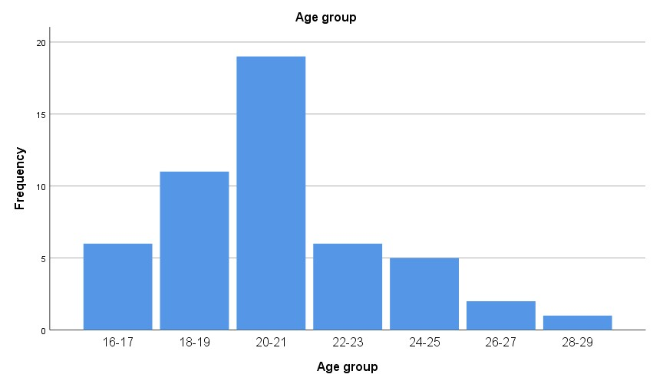
Figure 5.1 Age group of Respondents

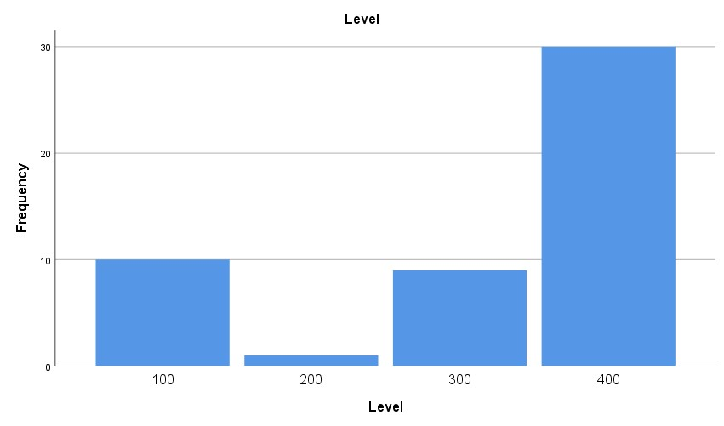
Figure 5.2 Level of Respondents

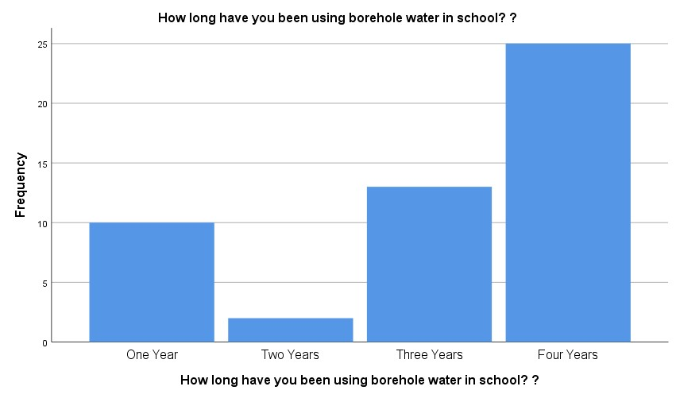
Figure 5.3 Length of using borehole water in school

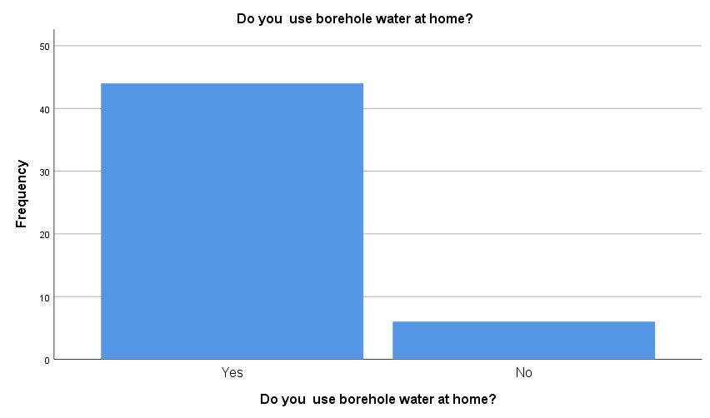
Figure 5.4 Respondents using borehole water at home

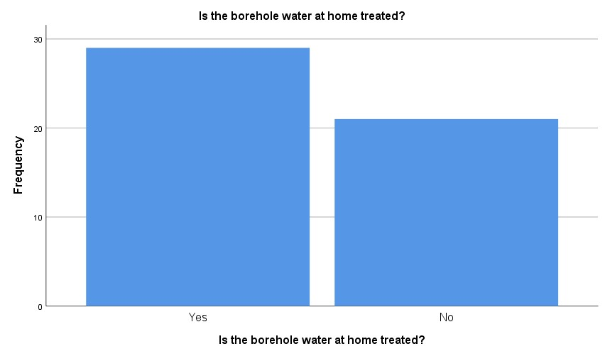
Figure 5.5 If respondents’ borehole water at home is treated

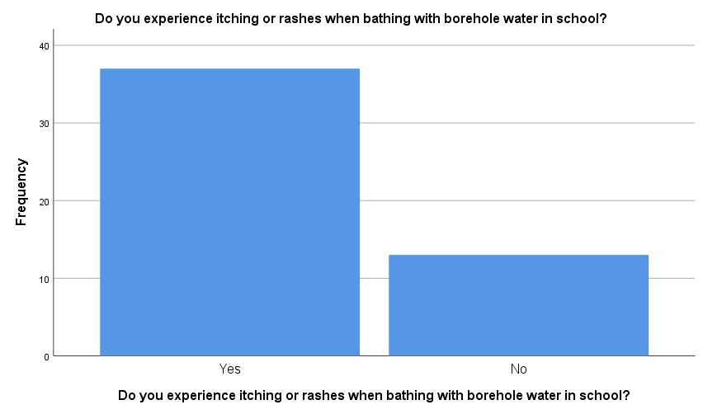
Figure 5.6 Respondents experiencing itching or rashes after bathing with borehole water in school

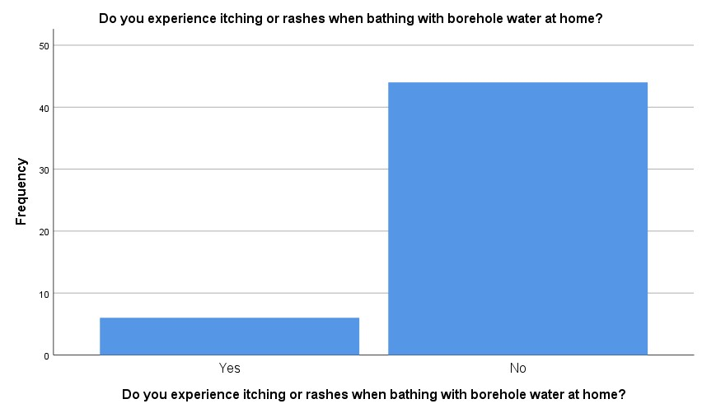
Figure 5.7 Respondents experiencing itching or rashes after bathing with borehole water at home

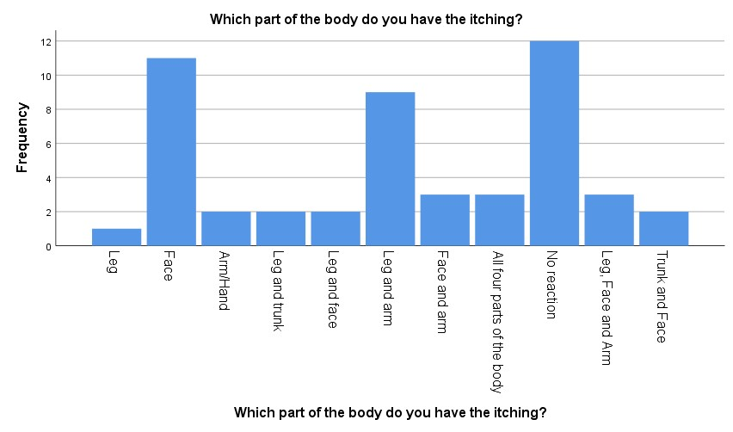
Figure 5.8 Respondents part of the body that itch

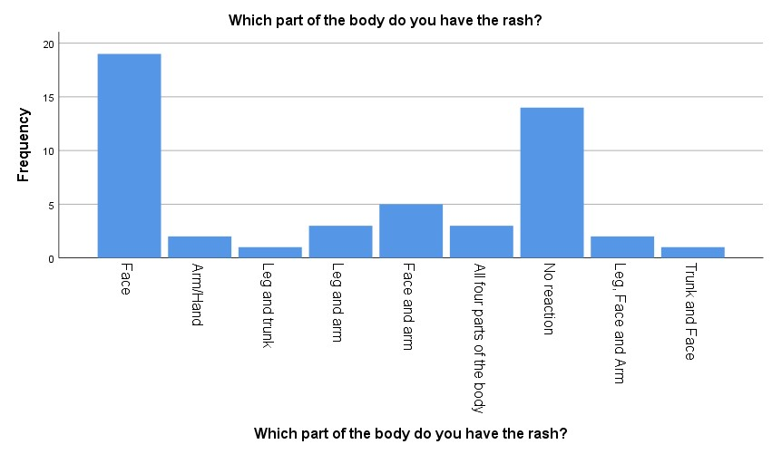
Figure 5.9 Respondents part of the body that have rashes

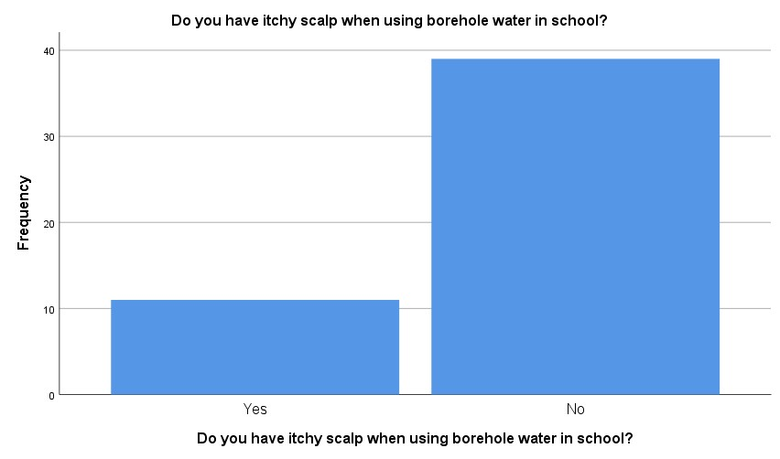
Figure 5.10 Respondents having itchy scalp after using borehole water in school

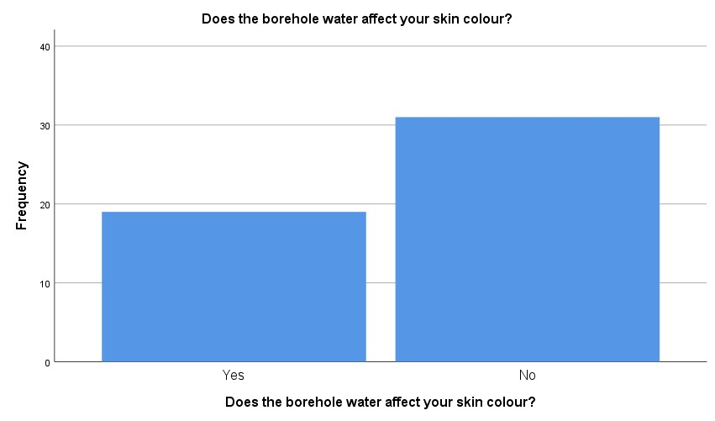
Figure 5.11 Respondents experiencing skin colour change after using borehole water

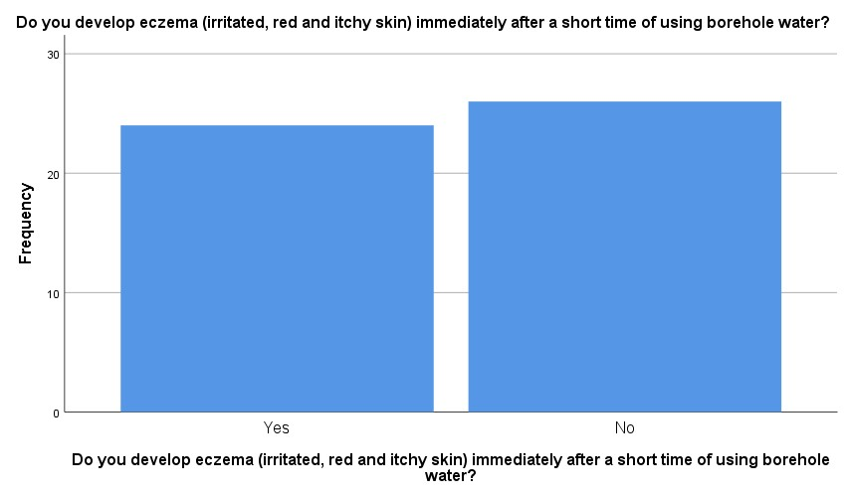
Figure 5.12 Respondents developing eczema (irritated, red and itchy skin) immediately or after a short time of using borehole water
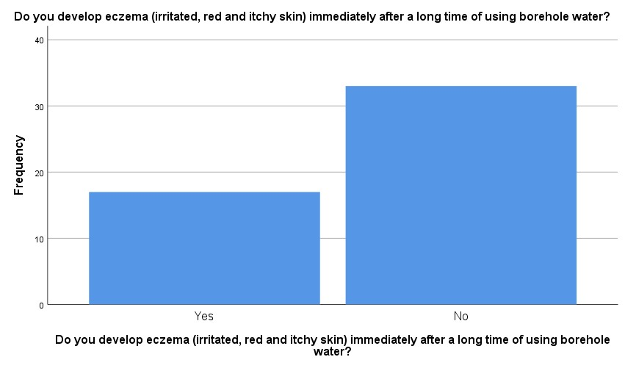
Figure 5.13 Respondents developing eczema (irritated, red and itchy skin) immediately or after a long time of using borehole water

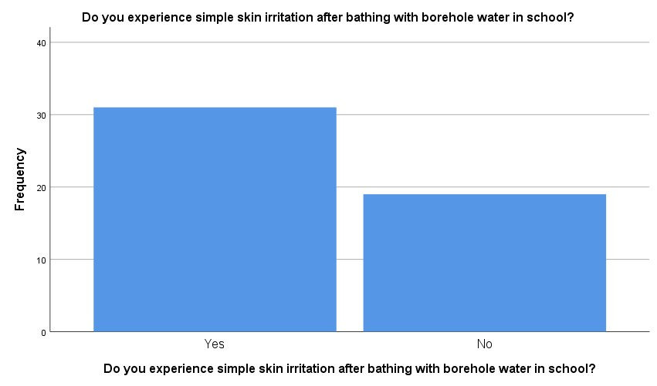
Figure 5.14 Respondents experiencing simple skin irritation after bathing with borehole water in school

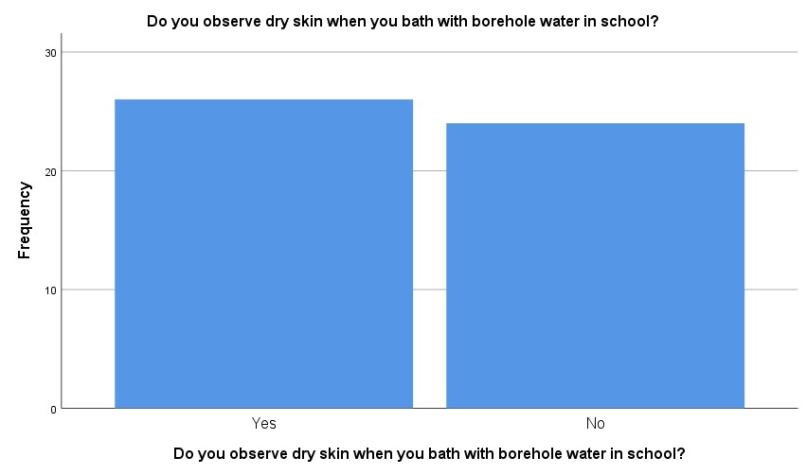
Figure 5.15 Respondents observing dry skin after bathing with borehole water in school

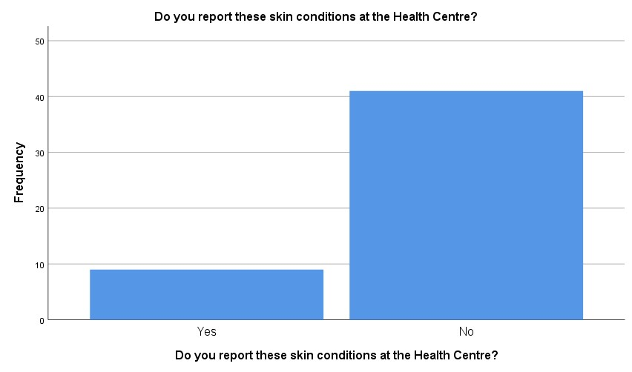
Figure 5.16 Respondents reporting skin conditions at the Health Centre

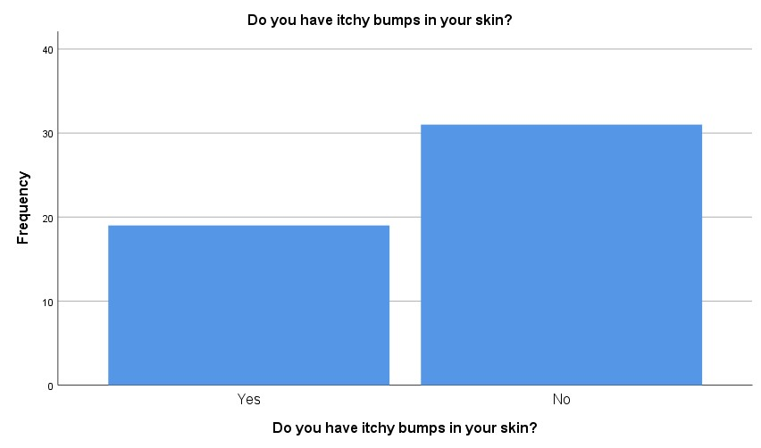
Figure 5.17 Respondents having itchy bumps on their skins

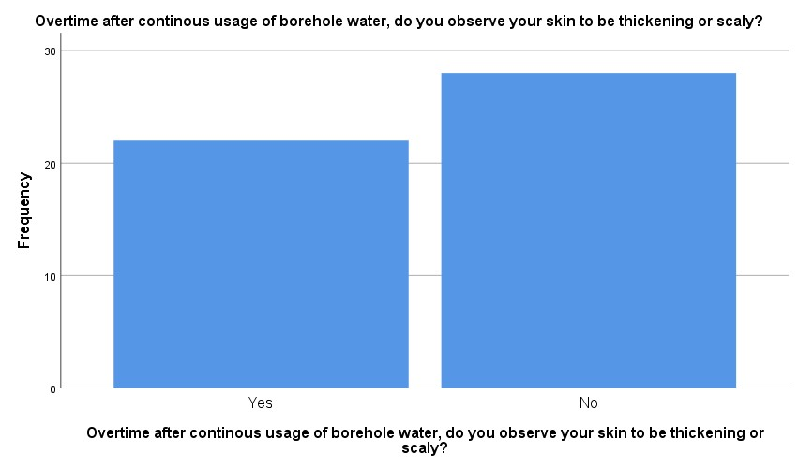
Figure 5:18 Respondents observing thickening or scaly skins overtime of continuous usage of borehole water

APPENDIX 11

CROSS TABULATIONS
