COURSE GUIDE
COURSE TITLE: METABOLISM OF NUCLEIC ACIDS
COURSE CODE: BCH 305
LECTURER: ADEFISAN I.O(Mrs.)

COURSE OBJECTIVES
The course itself is aimed at examining the metabolism of purine and pyrimidine nucleosides and nucleotides and abnormalities in their metabolism.

COURSE CONTENT
LECTURE 1: Introduction and Course Overview: Review of purine and pyrimidine bases; Nucleosides and Nucleotides
LECTURE 2: Synthesis and Degradation of Pyrimidine Nucleotides
LECTURE 3: Regulation of Pyrimidine Metabolism
LECTURE 4: Abnormalities of Nucleic Acid Metabolism

LECTURE 1
- Introduction and Course Overview: Review of purine and pyrimidine bases; Nucleosides and Nucleotides; Structure and Function of Nucleic Acids.
Objectives of the Lecture: At the end of the lecture, the students should be able to:
Define Nucleic Acids
Highlight the components of Nucleic Acids
Differentiate between Nucleosides and Nucleotides
Pre-Test: List the four major bio-molecules.
What are the components of Nucleic Acids?
Content
  - Nucleic acids
Nucleic acids are biopolymers of high molecular weight with mononucleotides as their repeating units i.e. they are linear polymers made of monomers called NUCLEOTIDES held by 3’ and 5’ phosphate bridges. These are of two types:
• Deoxyribonucleic acid (DNA)
• Ribonucleic acid (RNA)
  - Functions of nucleic acids
DNA is the chemical basis of heredity. It serves as reserve bank (store) of genetic information, responsible for maintaining the identity of different species of organisms over millions of years. Cellular function is under the control of DNA. DNA directs the synthesis of RNA, which in turn directs protein synthesis
RNA on the other hand transcribes the genetic information into a form that is easy to understand and read by the cell and assists in protein synthesis.

  - Components of Nucleic Acids
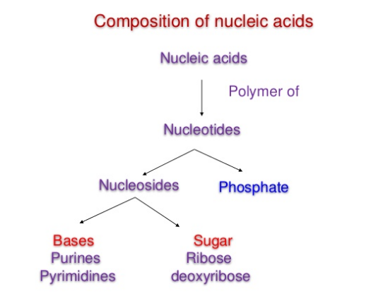
Source: https://www.slideshare.net/YESANNA/nucleic-acid-chemistry-40334502

  - Nucleosides and Nucleotides
Nucleotides are energy-rich compounds that drive metabolic processes (esp., biosynthetic) in all cells. They are phosphate esters of nucleosides.
i.e. Nucleotide= Nucleoside + phosphate
Nucleotides are composed of nitrogenous bases(which could either be a purine or pyrimidine base), pentose sugar and phosphate group.
Nucleosides are composed of nitrogenous bases and sugar. The Nitrogenous bases are of 2 types: Purine bases and Pyrimidine bases
The pentose sugar is: ribose in ribo-nucleosides (for RNA)or 2- deoxyribose in de-oxy-ribonucleosides(for DNA)
Nucleosides containing purine bases are called Purine nucleosides(end with the suffix-sine). Nucleosides containing pyrimidine bases are called Pyrimidine nucleosides (end with the suffix-dine)
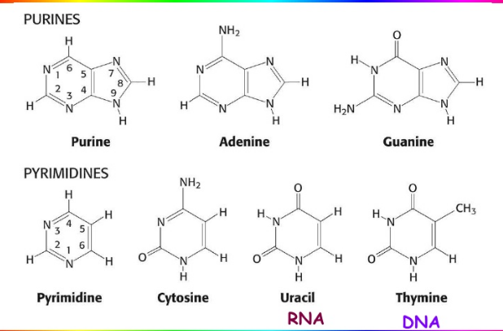
Structure of Purine and Pyrimidine Bases
Source: http://pratclif.com/biologie-moleculaire/dna/bases.htm
Post Test
- Explain the functions of Nucleic Acids
- Differentiate between Nucleosides and Nucleotides
Bibliography
www.cuchd.in/e-library/.../Fundamentals%20of%20Biochemistry/Chap-15.pdf
https://www.slideshare.net/YESANNA/nucleic-acid-chemistry-40334502
http://pratclif.com/biologie-moleculaire/dna/bases.htm

LECTURE 2
  - Metabolism of Pyrimidine Nucleotides
Objectives of the Lecture: At the end of the lecture, students should be able to:
State the end-products of pyrimidine catabolism
State the difference between purine and pyrimidine synthesis
Pre-Test:
What are Nucleotides?
List out the Pyrimidine Bases
Content
Nucleotides are important intracellular molecules of low molecular weight which participate in a wide variety of biochemical processes. The best known role of the purine and pyrimidine nucleotides is to serve as precursors of DNA and RNA. However, the purine nucleotides serve also in biologic systems as high energy source: ATP as regulatory signals(CAMP and CGMP) in different tissues and organisms, and as components of the widely used coenzymes FAD,NAD and NADP. The pyrimidine nucleotides in addition to providing precursors for nucleic acids also serve as high energy intermediates like UDP-glucose and UDP-galactose in carbohydrate metabolism. The3 major pyrimidine bases found in the nucleotides of prokaryotes and eukaryotes are: cytosine, uracil and thymine.
  - Synthesis of Pyrimidine Nucleotides
Pyrimidine Synthesis occurs in both the body and through organic synthesis and their degradation products are more water soluble than that of the purines. Though purines and pyrimidines are nucleic acid components, they are synthesized differently. In pyrimidine synthesis, the ring is synthesized first before combining with PRPP. Although pyrimidine nucleus is simpler with a briefer synthetic pathway, the two share common precursors: PRPP, glutamine CO2 and Aspartate.
The striking difference between the synthesis of both is that the synthesis of purines start with ribose phosphate as an earlier precurssor molecule while attachment of ribose phosphate comes later in the pathway after the formation of the pyrimidine ring.
    - De-novo pathway of Pyrimidine Synthesis
The De novo pyrimidine synthesis pathway can be explained by the following steps.
- Synthesis of Carbamoyl Phosphate
- Synthesis of Carbamoyl Aspartate
- Ring Closure to form dihydro orotate
- Oxidation of Dihydro Orotate
- Addition of ribose Phosphate moiety
- De Carboxylation to form UMP
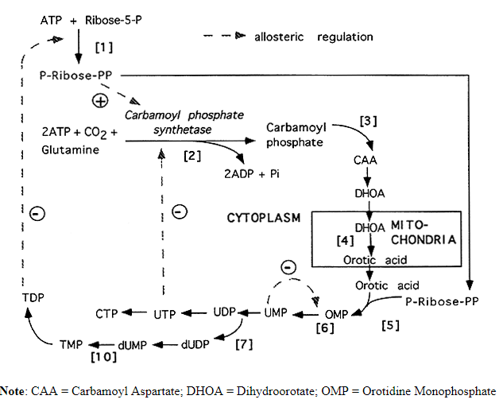 Pathway for pyrimidine Synthesis
Source:
OMP is the first pyrimidine formed and is immediately decarboxylated to produce UMP. Nucleotides are then formed subsequently from UTP via CTP Synthetase. Similar to purine nucleotides, pyrimidine nucleoside monophospahtes are converted to their diphosphate and triphosphate derivatives.
UTP is aminated to CTP (a reaction where glutamine provides the amino group and which requires ATP) The reduction of the pyrimidine nucleoside diphosphates to their resepective 2’ deoxynucleoside diphosphate also occurs as in the case of purines with the help of the enzyme –ribonucleotide reductase
UDP ----> dUDP ---->dUMP
dUMP is methylated by an enzyme: thymidylate synthetase which uses N⁵,N¹⁰-methylene-tetrahydrofolate as the methyl donor to form TMP i.e. dUMP----> TMP
    - Salvage Pathway
Just like the purines, pyrimidine bases can also be recovered from DNA or RNA degradation. This recovery is catalyzed by pyrimidine phosphoribosyl transferase which uses PRPP as source of ribose 1 phosphate. This pathway is important because most tissues cant produce nucleotides through the de-novo pathway. Basically, it involves the reactions of free bases with ribose 1 phosphate(with PRPP as the source)
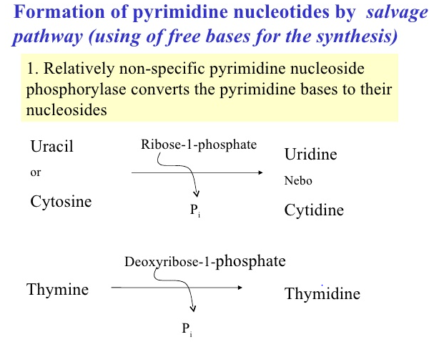
Source:
  - Degradation of Pyrimidine Nucleotides
Degradation occurs mainly in the liver where series of highly soluble end products are formed in contrast to the sparingly soluble end products of purine metabolism(uric acid and sodium urate). After Pyrimidine biosynthesis, the newly synthesized molecules undergoes degradation after certain period. Animal cells degrade pyrimidine nucleotides to their component bases. These reactions, like those of purine nucleotides, occur through dephosphorylation, deamination and glycosidic bond cleavages. The major end products of cytosine, uracil and thymine catabolism are beta-alanine and beta aminoisobutyric acid.
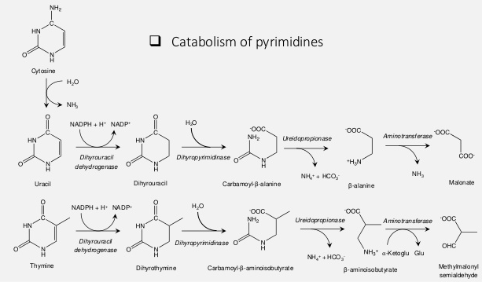
Source: https://www.slideshare.net/sharmapank30/nucleotide-metabolism-70248698

Post Test
- What are the end products of Pyrimidine Metabolism
- Differentiate between de-novo and salvage pathway
- Differentiate between Nucleosides and Nucleotides
Bibliography
www.cuchd.in/e-library/.../Fundamentals%20of%20Biochemistry/Chap-15.pdf
https://www.slideshare.net/YESANNA/nucleic-acid-chemistry-40334502
http://pratclif.com/biologie-moleculaire/dna/bases.htm

LECTURE 3
  - Regulation of pyrimidine Metabolism
Objective of the Study: At the end of the lecture, students should be able to explain the regulation of pyrimidine synthesis
Pre-Test: What is the importance of enzyme Regulation?
Content
The regulation of pyrimidine synthesis occurs mainly at the first step. The ATCase activity of the enzyme is inhibited by CTP and activated by ATP. The carbamoyl synthetase activity of this complex is termed carbamoyl phosphate synthetase II (CPS-II), as opposed to CPS-I which is involved in the urea cycle. The CPS-II domain is activated by ATP and inhibited by UDP, UTP, dUTP, and CTP. ATP levels also regulate pyrimidine nucleotide biosynthesis at the level of PRPP formation. An increase in the level of PRPP results in an activation of pyrimidine synthesis.
There is also regulation of OMP decarboxylase activity of the bi-functional OMP synthase enzyme. The decarboxylase activity domain is competitively inhibited by UMP and, to a lesser degree, by CMP. Finally, CTP synthase is feedback-inhibited by CTP and activated by GTP.

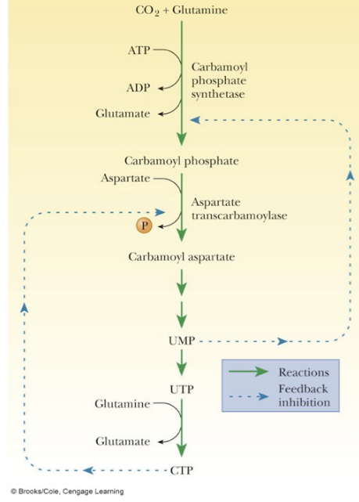
Regulation of pyrimidine synthesis
Source: http://oregonstate.edu/instruct/bb350/textmaterials/ch23.html
  - Inter-conversion of the Nucleotides
This is a fast reversible reaction driven by ATP. During the catabolism of nucleic acids, nucleoside mono- and di-phosphates are released. Nucleoside mono (NMP), di (NDP), and tri (NTP)-phosphate interconvert by trading phosphate groups.
These inter-conversions produce the activated NTPs and dNTPs which are substrates for nucleic acid synthesis. Some inter-conversions require ATP, some just exchange high energy phosphates.
Post-Test
What is Feedback Inhibition?
Bibliography
- https://en.wikipedia.org/wiki/Nucleic_acid_metabolism
- Source:http://www.columbia.edu/cu/biology/courses/w3034/Larry/readings/PurineChapter/PurineChapter.html
- https://en.wikipedia.org/wiki/Nucleic_acid_metabolism
- intranet.tdmu.edu.na
- www.bioinfo.org.cn
- https://themedicalbiochemistrypage.org/nucleotide-metabolism.php
- http://oregonstate.edu/instruct/bb350/textmaterials/ch23.html
- https://www.slideshare.net/sharmapank30/nucleotide-metabolism-70248698
- http://www.bioinfo.org.cn/book/biochemistry/chapt21/bio8.htm

LECTURE 4
4.0. Abnormalities of Nucleic acid metabolism
Purines (adenine and guanine) and pyrimidines (cytosine, thymine, uracil) serve fundamental roles in the replication of genetic material, gene transcription, protein synthesis, and cellular metabolism.
Objectives of the Lecture
At the end of the lecture, the students should be able to:
List the disorders associated with purine and pyrimidine metabolism with their deficient enzymes.
Pre-Test
What are Metabolic Disorders?
List any 2 metabolic disorders
4.1. Metabolic Disorders
Disorders that involve abnormalities of nucleotide metabolism range from relatively common diseases such as hyper-uricemia and gout, in which there is increased production or impaired excretion of a metabolic end product of purine metabolism (uric acid), to rare enzyme deficiencies that affect purine and pyrimidine synthesis or degradation.
Six major diseases caused due to errors in nucleic acid metabolism. The diseases are:
1. Lesch-Nyhan Syndrome
2. Hereditary Xanthinuria
3. Orotic Aciduria
4. Hypouricemia
5. Von Gierke’s Disease
6. Reye’s Syndrome
4.1.1. Lesch-Nyhan Syndrome(inborn error of purine metabolism)
Lesch-Nyhan syndrome (LNS) is a rare genetic disorder characterized by an overproduction of uric acid, neurological disability, and behavioral problems.
This condition is characterized by the complete deficiency of phosphoribosyl transferase, which causes hypoxanthine or guanine to form a nucleotide with PRPP (5′- phosphoribosyl – 1′- pyrophosphate),leading to excessive uric acid production The symptoms of LNS typically appear between ages 3 and 6 months; the presence of orange-colored crystal-like deposits (orange sand) in the child’s diaper is usually the first symptom to appear in those affected with the syndrome. Sometimes, It is accompanied by gout.
It can be prevented or diminished by the administration of allopurinol, an analogue of hypoxanthine. Allopurinol inhibits xanthine oxidase due to which uric acid cannot be formed.
4.1.2. Hereditary Xanthinuria
In this rare genetic disorder, there is the deficiency of xanthine oxidase which leads to the diminished level of blood uric acid (1 mg/100 ml or less). The urinary excretion contains large amounts of xanthine with lesser amounts of hypoxanthine. Urinary calculi composed of xanthine may be produced
4.1.3. Orotic Aciduria(pyrimidine metabolism)
This is an inherited disorder which causes the excessive production of orotic acid due to the deficiency of orotate phosphoribosyl transferase.
The urine becomes cloudy on cooling with the deposition of needle-shaped crystals of orotic acid.
Children affected by this condition develop a severe megaloblastic anemia with physical and mental retardation. Administration of uridine improves this condition significantly.
4.1.4. Von Gierke’s Disease
This disease is associated with the purine overproduction and hyperuricemia and also the deficiency of glucose 6-phosphatase (final enzyme in glycogenolysis pathway) which results in accumulation of glycogen, and hypoglycemia.
4.1.5. Hypo-uricemia
This is due to a genetic defect or to severe liver damage. The deficiency of the enzyme xanthine oxidase causes hypouricemia and increased excretion of hypoxanthine and xanthine.
4.1.6. Reye’s Syndrome:
This syndrome exhibits inability of severely damaged mitochondria to use carbamoyl phosphate which is available for cystosotic over-production of orotic acid.

Post Test
Explain the following terms: Orotic Aciduria
Hypouricemia
Bibliography
www.biologydiscussion.com
biochimica.bio.uniroma1.it/didattica/
www.academia.edu
intranet.tdmu.edu.ua
Wikipedia.org

