MUTAGENICITY OF HELICOBACTER PYLORI

BY
AKIO, MOSES GODSPOWER
MATRIC NO.:16010101010

A TERM PAPER COMPLETED IN PARTIAL FULFILMENT OF THE REQUIREMENTS FOR THE AWARD OF BACHELOR OF SCIENCE IN MICROBIOLOGY IN MOUNTAINTOP UNIVERSITY, IBAFO, OGUN STATE

NOVEMBER, 2020

CERTIFICATION
This is to certify that this term paper titled “MUTAGENICITY OF HELICOBACTER PYLORI” was written by AKIO Moses Godspower, with matriculation number 16010101010. This write up meets the requirements governing the award of Bachelor of Science (B.Sc.) Degree in Microbiology, Department of Biological Sciences of Mountain Top University, Ogun State, Nigeria and is approved for its contribution to knowledge and literary presentation.

……………………………… …………………………….
Dr. B. Opere Date
(Supervisor)

DEDICATION
I dedicate this work to God the Father, Son and the Holy Spirit who saw me through the completion of this write up. And also, to my mummy and sister for their never-ending support, care and prayers towards the successful completion of this work.

ACKNOWLEDGEMENT
My sincere and utmost appreciation goes to my Lord and Redeemer, who in His infinite mercies has given me the wisdom, knowledge, assistance, support and protection to successfully complete this project.
I want to use this medium to appreciate the efforts of my supervisor; Dr. B. Opere and Co-supervisors: Dr. M. A. Abiala, Dr. O. I. Ogunsuyi and Dr. F. Ibadin, who stayed with me through thick and thin during the course of this work, I especially want to thank them for their sacrifices in terms of time, sleep, energy, money and other unquantifiable inputs. My utmost gratitude goes to our fatherly and caring Head of Department (HOD), in person of Dr. Adesina Adeiga, who stood his ground expending his time and energy to see to the end of this project.
I would love to specially honour the efforts of my parents, who showered me with the necessary physical, financial, spiritual and emotional support required for this work. And to my colleagues; Ajose Oyindamola, Esther Tobi, Adegboye Damilola, Dada Tomiwa and Korede Joyce for their understanding and support before and during this work.
I would really like to appreciate my numerous lecturers for all the ways they have been helping me achieve my academic career.

ABSTRACT
Helicobacter pylori is a human pathogen and Gram-negative bacterium that colonizes the stomach of almost half human population. Its colonization can last for life without antibiotic intervention. H. pylori infection typically causes chronic inflammation and cellular injury, which can lead to gastric cancer. H. pylori has evolved to escape and evade immune surveillance/observation. It gradually establishes life lasting inflammation, which makes the host susceptible to genomic instability and DNA damage, particularly double strand breaks. The host cell responds by activating DNA damage repair (DDR) machinery that gradually and eventually gets compromised by the infection. Genetic damage is therefore now accepted as a major/main operation mechanism in cases of H. pylori induced carcinogenesis. This write up reveals the ability of the bacterium Helicobacter pylori to cause DNA damage by chromosomal breakage during cell division; although DNA damage can be efficiently repaired, it has been reported that long-term bacterial infection leads to accumulation of unrepaired breaks due to saturation of repair capabilities. This simply explains the mutagenicity of Helicobacter pylori.

KEYWORDS: Mutation, Carcinogenesis, Inflammation

TABLE OF CONTENTS
CERTIFICATION 1
DEDICATION 2
ACKNOWLEDGEMENT 3
ABSTRACT 4
LIST OF FIGURES 6
LIST OF TABLES 7
CHAPTER 1 8
INTRODUCTION 8
CHAPTER 2 10
2.1 HELICOBACTER PYLORI 10
2.2 VIRULENCE FACTORS 10
2.3 IMMUNE SYSTEM EVASION STRATEGIES 15
4.1.2 Epidemiology 16
4.1.3 Clinical complications 16
CHAPTER 3 19
3.1 MUTATION 19
3.2 TYPES OF MUTATIONS 19
3.3 CAUSES OF MUTATIONS 28
3.3.1 MUTAGENS 28
3.4.2 ERRORS IN DNA REPLICATION 29
3.4.3 ERRORS IN DNA RECOMBINATION 29
3.4.4 CHEMICAL DAMAGE TO DNA 29
3.4.5 RADIATION 29
3.5 HEALTH IMPLICATIONS OF MUTATION 29
CHAPTER 4 31
MUTAGENICITY OF HELICOBACTER PYLORI 31
4.1 INCREASED OXIDATIVE DNA DAMAGE 31
4.1.2 Oxidative stress inducing gastric cancer 33
CONCLUSION 35
References 36

LIST OF FIGURES
Figure 1: The structure of Helicobacter pylori ……………………………………………………………..…….11
Figure 2: Virulence of Helicobacter pylori ………………………………………………………………………….14
Figure 3: Mutation and types of mutations…………………………………………………………………………19
Figure 4: Base substitutions………………………………………………………………………………………………..26
Figure 5: Forms of point mutations………………………………………………………………………………….…27
Figure 6: Production and interconversion of reactive oxygen species …………………………………32
Figure 7: Mechanism of carcinogenesis induced by H. pylori infection ………………………………34

LIST OF TABLES
Table 1: Classification of Helicobacter pylori. …………………………………………………………………….12

CHAPTER 1

INTRODUCTION
Gastric cancer, is the third leading cause of cancer deaths worldwide (Ferlay, 2016.) It is largely due to a Gram-negative, microaerophilic bacterium, Helicobacter pylori. Half of the world’s population is infected with H. pylori. In addition to gastric cancer, H. pylori also contributes to the development of chronic gastritis, peptic ulcers and mucosa-associated lymphoid tissue lymphoma.(Posselt et al., 2013) While the immune system of humans is able to create a sufficient innate and adaptive immune response to the infection, it usually fails to clear H. pylori completely thereby resulting in a persistent infection. The presence of the prolonged infection brings about constant irritation, oxidative stress and DNA damage(Posselt et al., 2013). Cells respond to DNA damage by the inciting or provoking of DNA damage response (DDR) pathways, which then provides enough period of time for specific DNA repair pathways to physically dispose of the damage in a substrate-dependent manner.(Posselt et al., 2013) The damage done on the DNA from the H pylori infection can be as a result of oxidative stress. In vitro studies have shown that cells which possess deficient DNA repair mechanisms and are infected with H pylori will result in more oxidative stress and DNA damage.(Cadamuro et al., 2015; Chmiela et al., 2014)
In-vivo study with mice deficient in part of the base excision repair mechanism displayed serious gastric lesions after H pylori infection(Posselt et al., 2013). Mutations that affect DDR network components are responsible for a lot of cancer predisposition syndromes, showing their overall importance in preventing DNA damage-induced human diseases [Ciccia and Elledge, 2010]. However, DNA repair pathways do not efficiently eradicate all DNA lesions, and this could bring about the building up of mutations or even block metabolic processes such as replication and transcription eventually stimulating ageing and death of cells [Zhu and Wani, 2010.]
There are several H. pylori virulence factors that contribute to its ability to evade the immune system and disrupt the host’s cells. One of the most studied factors is CagA, which is injected into the host cell where it can affect the cell’s shape, motility, and proliferation.(Cadamuro et al., 2015; Chmiela et al., 2014) VacA is another well studied virulence factor which is a toxin secreted by H. pylori and is able to stimulate inflammatory cytokines after invading the host cell. Additionally, VacA has several mechanisms to help the bacteria evade immune response such as the disruption of phagosome maturation and the creation of fused phagosomes called megasomes that prevent the destruction of the bacteria contained within.(Posselt et al., 2013) Although not as well understood, BabA is another virulence factor that is known to induce inflammatory gene transcription and skew the immune response from T helper 2 to T helper 1 with a weakened IL-33 response. These are some examples of the virulence factors in which H. pylori uses to maintain/sustain a prolonged pro-inflammatory response while evading self-destruction.
Ordinary gastric mucosa can create gastritis according to the Correa model hypothesis which advances to dysplasia lastly the development of cancer. (Correa, 1976) There are numerous variables that add to the inception of the gastritis and the movement to disease, for example, host gene polymorphisms, dietary components, and H. pylori strain infection. This write up highlights the host’s responses which generate oxidative stress following H. pylori infection and the resulting DNA damage that may contribute to the development of gastric cancer.

CHAPTER 2

2.1 HELICOBACTER PYLORI
Helicobacter pylori is a human pathogen. It is is a microaerophilic, Gram-negative and spiral shaped bacterium that colonizes the stomach of nearly half of the human population. It was discovered in 1982 and its colonization can last all through an individual’s life as long as there’s no intervention of antibiotics (Cadamuro et al., 2015; Chmiela et al., 2014) H. pylori is identified as the most prevalent human pathogen, and its evolution/mutation is apparently very effective considering the fact that the bacterium has evolved and developed several strategies to cause infection(Chmiela et al., 2017). Substantial alterations have been made concerning the disease causation after serious studies on H. pylori (Posselt et al., 2013). This pathogenic microorganism was first named Campylobacter pyloridis. After encountering important genotypic and phenotypic differences with other bacteria in the Campylobacter genus, a decision was then made to come up with a new genus known as: Helicobacter. Now it is commonly known that this flagellated gram-negative and microaerophilic bacterium causes chronic active gastritis (asymptomatic or symptomatic), peptic ulcer disease and duodenal ulcers in humans; it is also related to Gastric Cancer(Cadamuro et al., 2015; Chmiela et al., 2014).

2.2 VIRULENCE FACTORS
The colonization of epithelial cells of the stomach by H. pylori begins with the binding of these bacteria with epithelial cell receptors. Then the bacteria escape of host defense mechanisms, induce inflammatory responses, which allow acquisition of nutrients for successful replication (Testerman et al., 2001). Significant H. pylori adhesins have a place with the group of proteins limited in external layer of bacterial cells. The blood group antigen-binding adhesin A (BabA) and sialic acid binding adhesin (SabA) are the most significant adhesisns of H. pylori (Alzahrani et al., 2014). Likewise, different Ontology of Microbial Phenotypes (OMPs), for example, HopZ and OipA assume a function of adhesins.It has been shown that OipA induces more intensive inflammatory response due to neutrophil infiltration and promotes the development of duodenal ulcer and gastric cancer (Oleastro & Ménard, 2013). Urease increases the acidic pH of the stomach and unipolar flagella enables passage of mucus (Testerman and Morris, 2014). The capacity of glycosylate to host cholesterol is vital for the virulence and resistance of antibiotics for H. pylori (McGee et al., 2011). H. pylori lipopolysaccharide (LPS), due to its structural features, induces a poor immune response and helps the bacteria develop into a chronic infection (Mnich et al., 2015). H. pylori LPS may carry various human Lewis (Le)-like antigens, which may play a role in autoimmunity.

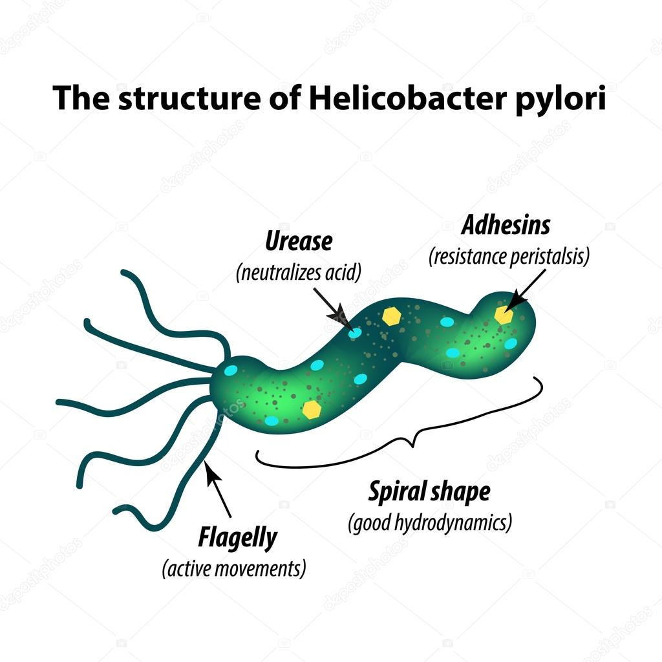
Figure 1: The structure of Helicobacter pylori Source: (Chmiela et al., 2017)

Table 1: Classification of Helicobacter pylori.
Domain: | Bacteria
Phylum: | Proteobacteria
Class: | Epsilonproeobacteria
Order: | Campylobacterales
Family: | Helicobacteraceae
Genus: | Helicobacter
Source: (Posselt et al., 2013)

The H. pylori outer membrane vesicles are an alternative vehicle for the distribution of bacterial virulence factors and antigens (Olofsson et al., 2014). The major virulence factors of H. pylori are encoded by genes within the pathogenicity island (PAI). The cytotoxin-associated gene A (CagA) protein is one of the most important H. pylori virulence factors. CagA is encoded by the CagA gene and translocated to the host gastric epithelial cells through a type IV secretion system (Aziz et al., 2014). A correlation between the presence of CagA in H. pylori strains and more severe inflammatory responses and a higher risk of gastric cancer has been shown (Hatakeyama, 2014). Other virulence proteins include vacuolating cytotoxin A (VacA), BabA and SabA (Ishijima et al., 2011). VacA induces vacuolation of gastric epithelial cells likewise cell apoptosis and then disrupt the function of the gastric epithelial barrier (Aziz et al., 2014). BabA and SabA are adhesins, and SabA is essential for monopsonic activation of human neutrophils (Oleastro & Ménard, 2013). BabA interacts with the Leb blood group antigen on epithelial cells, and the babA2 gene is associated with DU and GC (Ishijima et al., 2011). SabA is known to bind sialyl-dimeric-Lex (Mahdavi et al., n.d.), as well as sialylated Lea (Aspholm et al., 2006). Malignant transformation is linked with pronounced expression of Lea, sialylated Lea and sialyl-dimeric-Lex, however, knowledge about the role of SabA in tumorigenesis is still limited (Aspholm et al., 2006).

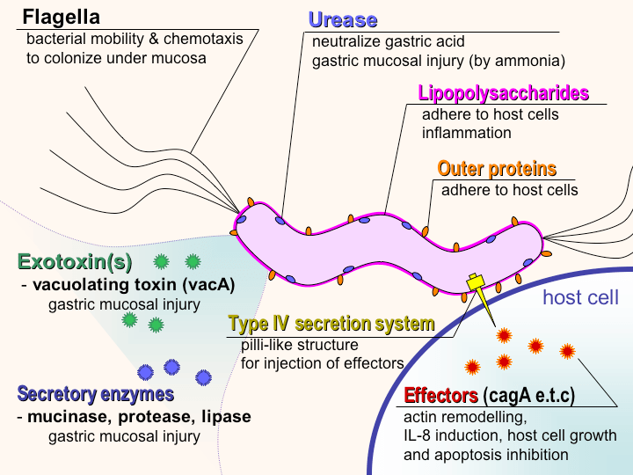 Figure 2 Virulence of Helicobacter pylori Source:(Roesler et al., 2014)

2.3 IMMUNE SYSTEM EVASION STRATEGIES
A model was proposed by Blaser (1993) in which both the host and the parasite adapt to downregulate the inflammatory response to promote survival and to continue colonization of the niche(Cadamuro et al., 2015; Chmiela et al., 2014). Pathogen-associated molecular patterns (PAMPs) are various molecules of pathogenic microorganisms that in normal conditions are recognized by pattern recognition receptors (PRRs) resulting in triggering of the inflammatory response. H. pylori possess different mechanisms which prevent them from being recognized by Toll-like receptors (TLRs): (1) changing and rearranging Lipopolysaccharide (LPS) and flagellin; and (2) mimicry of the molecules between human Lewis and ABO blood group antigens and bacterial compounds, which confuses immune cells and prevents recognition of the pathogen (Chmiela et al., 2017). It has been shown that the H. pylori flagellin is not detected by specific PRRs, and it does not stimulate the production of interleukin (IL)-8. As a result, chemotaxis of immune cells to the site of infection and phagocytosis of H. pylori are diminished (Aziz et al., 2014).
Prevention of phagocytic killing has been demonstrated to be more efficient due to delayed polymerization of actin and inhibition of phagosome and phagolysosome formation (Mnich et al., 2015; Richter et al., 2016; Rudnicka et al., 2015). The primary host immune response mechanisms, such as phagocytosis and natural killer (NK) cell activity, have been found to be downregulated by H. pylori LPS (Lina et al., 2014). Adaptive immunity is also targeted by H. pylori compounds (Mnich et al., 2015). They affect antigen presentation by inducing macrophage apoptosis and by diminishing dendritic cell (DC) and macrophage maturation (Enarsson et al., 2006). The expression of programmed death 1 ligand-1 (B7-H1 integrin) on gastric epithelial cells modulates T cell trafficking during H. pylori infection. The function of B7-H1 is to inhibit effector T lymphocytes and stimulate DCs to increase secretion of the anti-inflammatory cytokine IL-10. B7-H1, by joining programmed cell death receptor 1 on the surface of T cells, inhibits proliferation and differentiation of naïve T lymphocytes and promotes the activity of regulatory cells, which downregulates effector T lymphocytes. Regulatory T cells, which possess the ability to suppress anti-tumor and anti-infectious responses are identified on the basis of cluster differentiation (CD) markers and forkhead box P3 (FOXP3) as CD4(+)CD25(high) and FOXP3-positive.
(Lina et al., 2014)the regulatory T lymphocytes in the tissue of the stomach in patients that test positive with H. pylori in terms of their activity and expression of homing receptors. The increased number of regulatory T cells was detected in gastric tissue of patients with gastric tumor vs non-tumor patients. Regulatory T lymphocytes suppressed H. pylori-induced T-cell proliferation and interferon (IFN)-γ production. Furthermore, these regulatory T- lymphocytes expressed increased levels of l-selectin and C-C chemokine receptor 4, then the cells lacking regulatory function. These receptors may be involved in the infiltration of regulatory lymphocytes specific to H. pylori antigens present in gastric tissue in H. pylori infected individuals. However, low activity of T regulatory cells may promote the maintenance of the infection and potentially the propagation of tumor cells (Lina et al., 2014). The suppression of the activity of memory T lymphocytes, which enables a chronic infection, has been confirmed by other study groups (Bhuiyan et al., 2014). The role of regulatory T-lymphocytes can be related to the inhibition of the inflammatory response driven by IL-17 delivered by T-helper (Th) 17 lymphocytes (Eusebi et al., 2014a).
Different studies have shown that humoral response against H. pylori is less essential in the defense against this pathogen. The study on mice lacking B lymphocytes showed that gastritis, which developed in animals immunized with prophylactic vaccine was not related to B-cells. The response was similar to that of non-immunized mice (Lina et al., 2014). The authors concluded that antibody responses may not promote protection. However, a correlation between high levels of serum anti-H. pylori IgG and IgA and the development of gastritis, duodenal ulcers and gastric cancer has been shown (Eusebi et al., 2014b).

4.1.2 Epidemiology
There is an inverse association between socioeconomic status and the rate of infection (Konno et al., 2008). Analyses have been conducted to test whether animals or water can be sources of H. pylori infection. Only a few of the animal case studies showed positive results, leading to the conclusion that the infection cycle might include humans, the environment and animals. However, the water case studies failed to support the hypothesis that water is an environmental reservoir of H. pylori. The principal method of spreading H. pylori infection is intrapersonal transmission. This has been confirmed by the high percentage of infections that are spread between close relatives, especially between a mother and her children (Abdel-Hady et al., 2007; Kim et al., 2002; Rubenstein et al., 2014; Zhuo et al., 2008).

4.1.3 Clinical complications
The clinical aspects of H. pylori infection vary from gastritis and peptic ulcers to gastric cancer. It has been suggested that the pathogen might also be associated with several extra gastric diseases. Shortly after initial infection of the host, acute gastritis develops that is related to hypochlorhydria and to the loss of acid secretion. Acute gastritis does not last long, but in the majority of subjects, the immune response is unable to eradicate the infection, and as a consequence, chronic gastritis is induced. Based on multiple studies, about half of the world's population suffers from chronic gastritis (Walker & Talley, 2014). It can be manifested in one of three forms:
- antral-predominant
- corpus-predominant
- diffuse.
These pathologies lead to various outcomes, which they well actuate. Specifically, antral-predominant gastritis promotes duodenal ulcers whereas corpus-predominant gastritis promotes gastric ulcers, which may lead to metaplasia and adenocarcinoma; and diffuse gastritis is related to reduced acid secretion in the stomach (Testerman & Morris, 2014). In general H. pylori infections are responsible for 95% of duodenal ulcer cases and 85% of gastric ulcers. Nonsteroidal anti-inflammatory drugs are responsible for the cases that are not related to pathogen-induced inflammation (Kobayashi et al., 2014). Extra gastric diseases potentially related to H. pylori include idiopathic thrombocytopenic purpura and iron deficiency anemia (Fekri et al., 2015). The impact of pathogen-induced inflammation has likewise been considered in a few dermatological issues, diabetes and cardiovascular, and aspiratory illness (Chmiela et al., 2015; Matusiak et al., 2016). The association between H. pylori-initiated inflammation and cardiovascular infection was accounted for in 1994 by Mendall et al, and this work was then trailed by numerous different investigations (Testerman and Morris, 2014). Notwithstanding, the affiliation between H. pylori infection and extra gastric disease remains unclear. Therefore, the recommendation for H. pylori treatment is irrelevant (Abdel-Hady et al., 2007).
According to recent data, H. pylori infection might facilitate the onset of hepatic encephalopathy (Ando et al., 2013). The theory of H. pylori influence in diabetes is very recent. Specifically, CagA+ strains are thought to enhance the risk of diabetic complications (Xie et al., 2013). There is no doubt about the beneficial effect of the infection against endoscopic gastroesophageal reflux disease (Zhuo et al., 2008). However, H. pylori infection may potentially prevent the development of adenocarcinoma of esophagus. Based on a case-control study, infection with H. pylori, particularly the CagA+ strain, has been found to be inversely associated with Barrett's esophagus(Karimi et al., n.d.). H. pylori infection likely has a beneficial role in maturation of the immune system in the early stages of life and prevents asthma development in the future (Wang et al., 2014). The most dangerous clinical aspects of H. pylori are gastric cancer and mucosa-associated lymphoid tissue (MALT) lymphoma (Machado et al., 2013). The role of H. pylori in destruction of epithelial cell nuclei and mitochondrial DNA has been confirmed. This mutagenic impact is to some degree identified with downregulation of the expression, just as the movement, of DNA fix pathways. Machado et al (Machado et al., 2013) exhibited that disease of gastric adenocarcinoma cells with H. pylori induced mutations in mitochondrial DNA and decreased the DNA content. The increased frequency of mutations in mitochondrial DNA was related to diminished effectiveness of DNA repair mechanisms. They revealed that apurinic/apyrimidinic (AP) endonuclease-1 and Y-box-binding protein 1 mitochondrial base excision repair and mismatch repair systems are involved in DNA repair during H. pylori infection (Goldstein & Kastan, 2015).

CHAPTER 3

3.1 MUTATION
A mutation, which may occur during replication and/or recombination, is an irreversible alteration in the nucleotide sequence of DNA. Damaged DNA can be mutated either due to substitution, deletion or insertion of base pairs. Mutation can lead to deleterious situation and possibly death or tumor formation (DNA Mutation and Repair, n.d.). In order to prevent this, cells have mechanisms in place for repairing damaged DNA.(Types of Mutations | Genetics | Microbe Notes, n.d.)
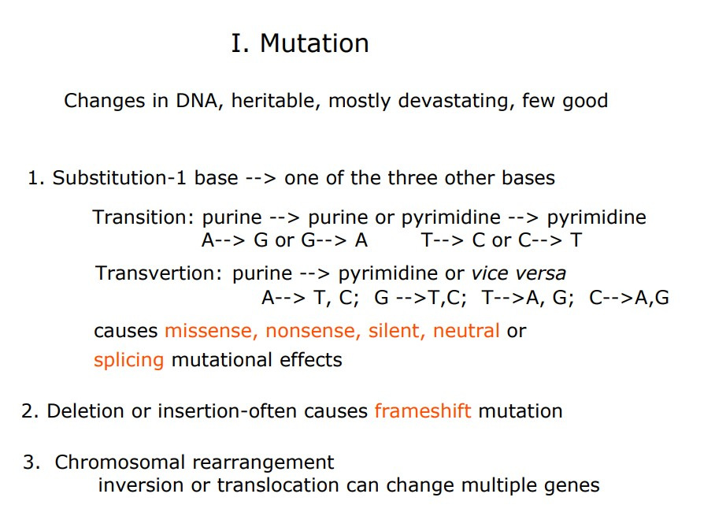 Figure 3: Mutation and types of mutations: Source: (www2.csudh.edu/nsturm/CHEMXL153/DNAMutationRepair.htm)

3.2 TYPES OF MUTATIONS
There are various schemes for classification of different kind of mutations. Depending on (Types of Mutations | Genetics | Microbe Notes, n.d.):
A. The affected type of cell
- Somatic mutations
- Mutations which occur in the somatic tissues of the body.
- Mutations do not get transmitted to progeny.
- The degree of the phenotypic impact relies on whether the mutation is prevailing or passive (dominant mutation by and large have more impact).
- The degree of the phenotypic impact relies on whether it happens early or late being developed (early emerging mutations have more prominent impact).
- Germinal Mutations
- Mutations that occur in the germ tissues of the body.
- Mutations might be transferred to descendants.
- Dominant mutations are found in the first generation after the mutation
- If a female gamete containing an X-connected mutation is fertilized, the mutant phenotype will be shown by the males.
- Recessive mutations might be seen only when mating with an individual conveying the recessive allele as well; hence, the recessive mutation may stay unseen for some ages.
B. Mode of Origin
(1) Spontaneous Mutations
This happens out of nowhere in the nature and their beginning is obscure. They are likewise called "background mutation" and have been accounted for in numerous living beings, for example, Oenothera, maize, bread molds, microorganisms (bacteria and viruses), Drosophila, mice, man, and so on.
(2) Induced mutations
Other than normally happening spontaneous mutations, the mutations can be initiated falsely in the living creatures by presenting them to irregular climate, for example, radiation, certain states of being (i.e., temperature) and chemicals.
C. Direction of Mutation
Based on their directions, following types of mutations have been recognized:
1. Forward mutations
In a living being when mutations make a change from wild sort to unusual phenotype, at that point, those kinds of mutations are known as forward mutations. Most mutations are forward type.t
2. Reverse or back mutations
The forward mutations are in most cases corrected by error correcting mechanism, causing an abnormal phenotype to change into wild type phenotype.
D. Size and Quality
Based on size, the following two types of mutations have been identified:
1. Point mutation
When there is and occurrence of heritable alterations in a very small segment of DNA molecule, i.e., a single nucleotide or nucleotide pair, these mutations are called “point mutations”. They may occur due to following sub nucleotide change types in the DNA and RNA.
– Deletion mutations: The point mutation caused because of loss or erasure of some portion (single nucleotide pair) in a triplet codon of a cistron or gene is called deletion mutation.– Insertion or addition mutation: The point mutations which happen because of addition of at least one additional nucleotide to a gene or cistron are called insertion mutations.
The mutations which emerge from the addition or deletion of individual nucleotides and cause the remainder of the message downstream of the mutation to be perused out of phase, are called frameshift mutations.
– Substitution mutation: A point mutation where a nucleotide of a trio is supplanted by a different nucleotide.
2. Multiple mutations or gross mutations.
When changes involving more than one nucleotide pair, or entire gene, then such mutations are called gross mutations. The gross mutations occur due to rearrangements of genes within the genome. It may be:
- The rearrangement of genes may occur within a gene. Two mutations within the same functional gene can produce different effects depending on gene whether they occur in the cis or trans position.
- The rearrangement of gene may happen in number of genes per chromosome. In the event that the quantities of genes replicas are non-comparable on the homologous chromosomes, they may cause various sorts of phenotypic effects over the living beings.
- Due to development of a gene locus, new sort of phenotypes might be made, particularly when the gene is moved close to heterochromatin. The development of gene loci may happen because of following:
(I) Translocation: movement of a gene may occur to a non-homologous chromosome.
(ii) Inversion: The movement of a gene inside a similar chromosome.
E. Phenotypic Effects
1. Morphological mutations: These are mutations that influence the physically noticeable properties of a creature (for example wavy ears in felines)
2. Lethal Mutations: These are mutations that influence the viability of the creature (for example Manx cat).
3. Conditional mutations: These are mutations in which the mutant allele causes the mutant phenotype just in specific conditions (called the prohibitive condition).
In the lenient condition, the phenotype is not, at this point mutant.
Example. Siamese cat – mutant allele causes albino phenotype at the restrictive temperature of most of the cat body but not at the permissive temperature in the extremities where the body temperatures is lower.
4. Biochemical mutations: These are mutations that may not show visibly nor affect a certain specific morphological characteristic but may generally affect the ability to grow or proliferate.
For example, the bacterium Escherichia coli does not require the amino acid tryptophan for growth because they can synthesize tryptophan. However, there are E. coli mutants that have mutations in the trp genes. These mutants are known as auxotrophic for tryptophan, and tryptophan must be added to the growth media for their nutrition and growth.
F. Magnitude of Phenotypic Effect
According to their phenotypic effects following kinds of mutations may occur:
- Dominant mutations
The mutations which have prevailing phenotypic articulation are called dominant mutation. For instance, in man the mutation infection aniridia (nonappearance of iris of eyes) happens because of a prevailing mutant gene.
- Recessive mutations
Most types of mutations are recessive in nature and so they are not expressed phenotypically immediately. After a generation or more, the effects of the phenotype on mutations of a gene that is recessive is seen, when the mutant gene is able to recombine with a similar recessive gene.
- Isoalleles
Some mutations change the phenotype of an organism in a very little manner that they cannot be detected except only by special techniques. Mutant genes that cause phenotypes that are slightly modified are called isoalleles. They produce phenotypes that are identical in homozygous or heterozygous combinations.
G. Loss of Function or Gain of Function
1. Loss of function mutation
Loss of function mutation, also called inactivating mutations, the gene product end up having less or no function (being partially or completely inactivated).
2. Gain of function mutations
Gaining function mutations is otherwise called actuating mutations, the result of the effect of the gene is then more grounded (enhanced activation) or is in some cases supplanted by an alternate and abnormal function.
H. Type of Chromosome Involved
According to the types of chromosomes, the mutations may be of following two kinds:
- Autosomal mutations. This type of mutation occurs in autosomal chromosomes.
- Sex chromosomal mutations. This type of mutation occurs in sex chromosomes.
I. Chromosomal Mutation and Types
- The changes in the genome involving chromosome parts, whole chromosomes, or whole chromosome sets are called chromosome aberrations or chromosome mutations.
- Chromosome mutations have proved to be of great significance in applied biology— agriculture (including horticulture), animal husbandry and medicine.
Chromosome mutations are inherited once they occur and are of the following types
a. Structural changes in chromosomes:
1. Changes in number of genes
(a) Loss: Deletion which is the loss of broken parts belonging a certain chromosome.
(b) Addition: Duplication which is addition to a chromosome, a part of chromosome.
2. Changes in gene arrangement:
(a) Rotating of a group of genes inside a chromosome: Inversion in which broken chromosome segment is reattached to original chromosome in inverted order.
(b) Exchange of parts between chromosomes of different pairs: Translocation in which the broken segment becomes attached to a non- homologous chromosome resulting in new linkage relations.
b. Changes in number of chromosomes:
1. Euploidy
- It involves the loss, or gain, of whole chromosome set.
- The term euploidy (Gr., eu = even or true; ploid = unit) designates genomes containing chromosomes that are multiples of some basic number (x).
- The euploids are the organisms which contain balanced set or units of chromosomes in any variety.
- The variety of chromosomes in a fundamental set is known as the monoploid number, x.
- Those euploid sorts whose variety of units is more than are known as polyploid.
- Thus, 1x is monoploid, 2x is diploid; and the polyploid sorts are 3x (triploid), 4x (tetraploid), 5x (pentaploid), 6x (hexaploid) and so it continues.
- Mutation because of Euploidy talks about the state of having a chromosome number being a precise multiple of a fundamental chro­mosome set. Meaning the variety of chromosome units is accelerated in euploidy.
2. Polyploidy
Addition of one or greater units of chromosomes.
They can be further:
(a) Autopolyploidy: The autopolyploidy entails polyploidy, wherein the identical fundamental set of chromosomes are multiplied.
(b) Allopolyploidy. The polyploidy effects due the doubling of chromosome variety in a F1 hybrid that is derived from incredibly one of a kind species. The resultant species is known as an allopolyploid.
3. Aneuploidy
- It entails the loss, or benefit, of part of the set of chromosomes.
- It refers to a situation wherein one or some chromosomes are added or deleted from the regular chromosome variety. Hence, the variety of chromosomes in aneuploidy may be more or smaller than the variety of chromosomes withinside the wild type.
- Various styles of aneuploidy may be diagnosed as: nullisomy, monosomy, and trisomy.
1. Nullisomy (2n-2) is the lack of each chromosomes of the homologous pair. This situation can be deadly in most organisms.
2. Monosomy (2n-1) is the loss of a single chromosome of the homologous pair.
3. Trisomy is the benefit of an additional chromosome (2n+1). Klinefelter syndrome (44+XXY/XYY) and Down syndrome are examples of trisomy.(Science1666- A Revision Site for Students from a Student!, n.d.)
Although, in simplification of the types/ forms of mutations, there are three types of DNA Mutations: base substitutions, deletions and insertions.
1. Base Substitutions
Single base substitutions are alluded to as point mutations, remember the point mutation Glu ----> Val results in sickle-cell illness. Point mutations are the most well-known types of mutations and there are types.
Transition: this happens while there is a substitution between a purine and some other purine or while a pyrimidine is subbed with an alternate pyrimidine.
Transversion: while a purine is substituted for a pyrimidine or vice versa.

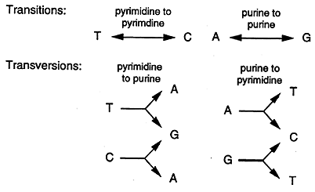
Figure 4 Base substitutions: Source (www2.csudh.edu/nsturm/CHEMXL153/DNAMutationRepair.htm)

Point mutations that takes place inside the encoding proteins of DNA sequences are either silent, missense or nonsense.

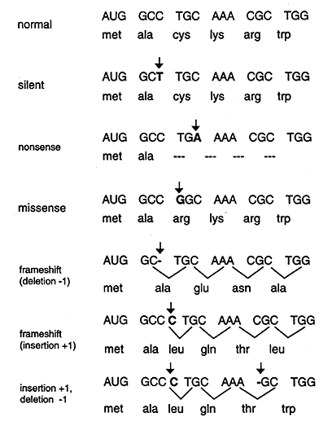 Figure 5: Forms of point mutation: Source: (www2.csudh.edu/nsturm/CHEMXL153/DNAMutationRepair.htm)

Silent: If substitution of a base happens withinside the third position of the codon, there might be a chance that a similar codon can be made. In this way, the succession of the amino acid encoded through the gene is not adjusted and the mutation is expressed to be a silent one.(DNA Mutation and Repair, n.d.)
Missence: When base substitution causes a codon generation that specifies a different amino acid and thereby leads to a different polypeptide sequence. The missense mutation is either conservative or nonconservative, contingent upon the kind of substitution of amino acid. For example, supposing the structure and properties of the amino acid being substituted are really similar to the original amino acid, the mutation is known to be conservative and will most likely have little effect on the resultant proteins’ structure / function. On the off chance that the replacement achieves an amino acid with totally different structure and properties, the mutation is nonconservative and will likely be destructive (terrible) for the resultant proteins' structure/work (for example the sickle cell point mutation).(DNA Mutation and Repair, n.d.)
Nonsense: When a base substitution results in a stop codon ultimately truncating translation and most likely leading to a nonfunctional protein.(Science Safety Vocabulary You’ll Remember | Quizlet, n.d.)

3.3 CAUSES OF MUTATIONS

3.3.1 MUTAGENS
A Mutagen is a physical or chemical agent that changes the genetic material, usually DNA, of an organism and thus increases the frequency of mutations above the natural background level.(Maria et al., n.d.)Mutations can be spontaneous, or result from recombination.(Best CHAPTER 7 MICRO Flashcards | Quizlet, n.d.) Physical or chemical agents called mutagens, which include radiation and several types of DNA altering chemicals, induce mutations. There are also various biological agents (mutagens) which includes the case study: H. pylori. (Best MICROBIOLOGY Ch. 7 Microbial Genetics Flashcards | Quizlet, n.d.)
Chemical mutagens incorporate nucleotide analogs, compounds that are fundamentally like typical nucleotides however, when fused into DNA, cause mutations. Some nucleotide-modifying synthetic compounds change the structure of nucleotides, causing base-pair replacement transformations. Aflatoxins are nucleotide-adjusting synthetics that outcome in missense mutations and malignancy (cancer). (DNA Replication DNA Replication Is a Simple Concept A Cell Separates the Two | Course Hero, n.d.). Other chemicals that possess mutagenicity, inserts or deletes nucleotide base pairs, which then causes frameshift mutations.(Maria et al., n.d.)

3.4.2 ERRORS IN DNA REPLICATION
On extremely, uncommon events DNA polymerase will fuse a noncomplementary base into the daughter strand. During the following round of replication, the miss consolidated base would prompt a change (mutation). This although, is extremely uncommon as the functions of the exonuclease includes a proofreading mechanism used to recognize mismatched base pairs and excising them.

3.4.3 ERRORS IN DNA RECOMBINATION
By a process called recombination, DNA frequently rearranges itself which proceeds through various mechanisms. From time to time, DNA is lost during replication thereby causing mutation.

3.4.4 CHEMICAL DAMAGE TO DNA
Multiple chemical mutagens, including some exogenous ones, man-made and environmental, possess the capability of bringing about damages to DNA. Numerous chemotherapeutic drugs and intercalating agent drugs carry out their functions and operations by causing damages to the DNA.

3.4.5 RADIATION
Gamma rays, X-rays, even UV light can interact with compounds in the cell generating free radicals which cause chemical damage to DNA.(What’s the Gene Mutation and How It Works, n.d.)

3.5 HEALTH IMPLICATIONS OF MUTATION
Harmful mutations may cause genetic disorders or cancer.(Mutation Effects | CK-12 Foundation, n.d.) A genetic disorder is a disease achieved by an adjustment in one or several genes. Cystic fibrosis is an example that occurs in humans. A change in a single gene makes the body produce thick, clingy mucus that stocks up the lungs and blocks channels in digestive organs.(Mutation Effects | CK-12 Foundation, n.d.) Cancer is a disease where cells grow uncontrollably and structure irregular masses of cells. It is commonly brought about by mutations in genes that regulate the cell cycle. Due to the mutations, cells with DNA damages are permitted to partition unbounded. Malignant growth qualities can be generically acquired.(How Can Gene Mutations Affect Health and Development?: MedlinePlus Genetics, n.d.)
In a few cases, gene mutations are serious to such an extent that they keep an embryo from getting by until birth. These progressions happen in genes that are basic for improvement, and frequently upset the advancement of an embryo in its youngest stages. Since these mutations have intense impacts, they are incongruent with life.(Chapter 7: Genetics Lesson 4: Mutations What Causes Albinism?, n.d.) A unique mutation is found in people in a small town in Italy. The mutation prevents them from growing atherosclerosis, that is the harmful buildup of fatty substances in blood vessels. The person wherein the mutation first occurred has even been identified. (15 Helicobacter Pylori (H. Pylori) Symptoms, Causes, Treatment, Cure, n.d.)
Helicobacter pylori (H. pylori) is a gram-negative bacterium that causes persistent inflammation (infection) in the stomach and duodenum, and is a typical infectious reason for ulcers around the world. (DNA Mutation, Variation and Sequencing - DNA Mutation | HowStuffWorks, n.d.) Mutations in DNA can cause rapid growth, uncontrolled cell growth, and the shutting off of self-repairing DNA. The mutation in the blood cell (sickle hemoglobin) may help defend people form malaria.(Zheng et al., 2014)

CHAPTER 4

MUTAGENICITY OF HELICOBACTER PYLORI
H. pylori infection induces active inflammation with neutrophilic infiltration and eventually elicits chronic inflammation with infiltration of plasma cells in the lamina propria of the gastric mucosa (the stomach) which is their target site of humans. The affected neutrophils and monocytes then produce oxygen free radicals that could cause damage to the adjacent cells. Oxygen free radicals cause genomic instability and DNA damage (Notably double strand breaks) which is elaborated on in this chapter.

4.1 INCREASED OXIDATIVE DNA DAMAGE
The oxygen free radicals cause genomic instability and DNA damage (Figure 6 Below), notably double strand breaks. Double strand breaks, in which the two strands in the double helix are cut off, are especially perilous to the cell since they can prompt genome modifications. Noted in certain investigations, double strand breaks and a "cross-linkage joining the two strands at a similar point is irreparable on the grounds that neither one of the strands would then be able to fill in as a template for repair. The cell will pass on in the following mitosis or in some uncommon cases, mutate. Three systems exist to fix double strand breaks (DSBs): non-homologous end joining (NHEJ), microhomology-interceded end joining (MMEJ), and homologous recombination (HR). In an in vitro framework, MMEJ happened in mammalian cells at the percentages of 10–20 of HR when both HR and NHEJ systems were additionally accessible. (Supek and Lehner, 2015) DNA ligase, appears above fixing chromosomal damage, is an enzyme that consolidates broken nucleotides by catalyzing the arrangement of an internucleotide ester bond between the phosphate spine and the deoxyribose nucleotides. (Sellou et al., 2016)
In NHEJ, DNA Ligase IV, a particular DNA ligase that shapes a complex with the cofactor XRCC4, straightforwardly joins the two closures. To control exact fix, NHEJ depends on short homologous successions called microhomologies present on the single-stranded tails of the DNA closures to be joined. On the off chance that these shades are viable, repair is normally accurate. NHEJ can likewise present transformations during fix. Loss of damaged nucleotides at the break site can prompt erasures, and joining of nonmatching ends structures inclusions or movements (Sharma et al., 2015). NHEJ is particularly significant before the cell has reproduced its DNA, since there is no layout accessible for fix by homologous recombination. There are "backup" NHEJ pathways in higher eukaryotes. Other than its part as a genome overseer, NHEJ is needed for joining barrette covered double strand breaks instigated during V(D)J recombination, the cycle that creates variety in B-cell and T-cell receptors in the vertebrate immune system. (Eusebi et al., 2014)

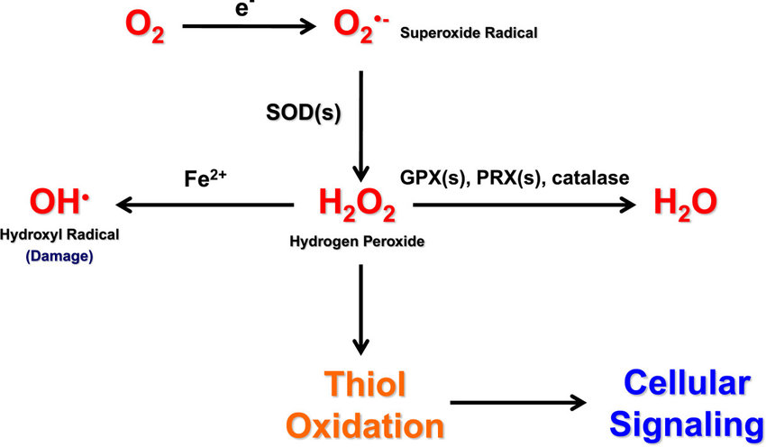 Figure 6: Production and interconversion of reactive oxygen species. Source: (Eusebi et al., 2014)

4.1.2 Oxidative stress inducing gastric cancer
The discovery of H. pylori confirmed that the etiology of chronic gastritis and the "precancerous cascade" resulting in cancer formation is associated with H. pylori infection. Now, it is commonly accepted that H. pylori is a gastric cancer carcinogen since 1994. , H. pylori has been included by the International Agency for Research on Cancer to class I carcinogens. Nearly 60% of intestinal-type gastric cancers are associated with such infections (Aziz et al., 2014; Hatakeyama, 2014). Over years, patients develop acute and then atrophic gastritis, followed by intestinal metaplasia, dysplasia and carcinoma. H. pylori infection also stimulates the development of diffuse type adenocarcinoma by causing pangastritis and rugal hyperplastic gastritis. Cancer risk rises if virulence factors, such as CagA, VacA and BabA, are present in the H. pylori strain (Oleastro & Ménard, 2013). However, infection with H. pylori CagA+ strains may potentially diminish the risk of adenocarcinoma of esophagus and gastric cardia. There is an increasing interest on the role H. pylori oipA positive strains in the pathogenesis of gastric ulcer and cancer. When oipA is present, the functional "on" status of this gene was associated with increased risk of these diseases compared with gastritis and functional dyspepsia controls (Machado et al., 2013).
Environmental factors also stimulate the initiation of atrophic changes and decrease the secretion of hydrochloric acid. Elevated pH of the gastric juice facilitates bacterial colonization, causing further damage to epithelial cells. In addition, nitrates in foods are precursors of nitrosamines, which cause intestinal metaplasia and dysplasia (abnormal epithelial differentiation, in the form of improper development of the cells with the loss of ability to differentiate) (Machado et al., 2013).
Park et al., 2005 proposed three possible mechanisms of initiation of gastric cancer in response to H. pylori infection: harm of epithelial cell DNA joined with downregulation of fix measures, mitochondrial DNA changes, and presence of transient mutator aggregate. After destruction of H. pylori the expression of proteins comprising DNA mismatch fix (MMR) framework was expanded. This demonstrated that gastric inflammation because of H. pylori disease weakens MMR (Kim et al., 2002). A co-culture of gastric cell lines with H. pylori and the proteins (MutS and MutL) of DNA MMR was completed by Kim (Kidane et al., 2014), and analyzed quantitatively RNA levels. RNA of the two proteins was decreased after introduction to H. pylori. Kidane (Toller et al., 2011) showed that damage of epithelial cell DNA due to oxidative stress, which increases during H. pylori infection is under control of base excision repair system and its effectiveness can be crucial for preventing genomic stability in response to H. pylori induced disorders. Toller (Toller et al., 2011) showed that H. pylori strains having the BabA adhesin are very effective in inducing double-strand breaks.

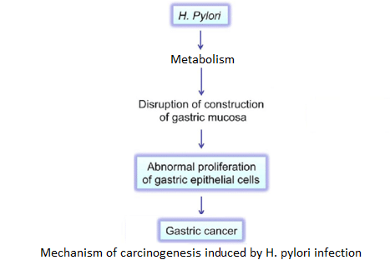
Figure 7: Mechanism of carcinogenesis induced by H. pylori infection. Source: (Machado et al., 2013)

CONCLUSION
H. pylori has evolved during long cohabitation with humans. The colonization of the host stomach at a young age, persistence in this specific niche for its lifetime, subversion of the human immune system by molecular imitation, and induction of gastritis and cancer development make H. pylori a complex pathogen. The clinical aspects of H. pylori depend on several conditions, such as the location of infection, the host susceptibility, the bacterial strain and environmental factors. For years H. pylori infection might remain asymptomatic in spite of the developing condition. Medication for chronic gastritis or peptic ulcers involves antibiotic prescriptions and remedies. To prevent the occurrence of antibiotic resistance, only cases with clinical symptoms or asymptomatic patients in a risk group ought to be treated. Eradication of the infection typically leads to improved patient health, but it may allow the development of gastroesophageal disease and asthma. The intensity of the infection reflects the ability of H. pylori to induce extra gastric diseases. Chronic atrophic gastritis is the precursor condition for ulceration and gastric malignancy. Classified as a group I carcinogen and causing a lot of new cancer cases every year, H. pylori has become a threat to lives. Specific biomarkers are crucial for early diagnosis of gastric cancer. Although H. pylori is one of the most studied pathogens of the upper gastrointestinal tract, many of its mechanisms of action are still yet to be well understood.

