




COLLEGE OF BASIC AND APPLIED SCIENCES

Mountain Top University
Kilometre 12, Lagos-Ibadan Expressway, MFM Prayer City, Ogun State.
PHONE: (+234)8053457707, (+234)7039395024, (+234) 8039505596
EMAIL: support@mtu.edu.ng
Website: www.mtu.edu.ng.

Published By:
Mountain Top University


COURSE GUIDE

COURSE TITLE: General Physics
COURSE CODE: PHY 101
LECTURER(S): Ukagwu K. J. (Ph.D)
Ehinlafa E. O (Ph.D)
Abodunrin W. O (Ph.D)

COURSE OBJECTIVES
GENERAL INTORDUCTION AND COURSE OBJECTIVES
The major aim of this course is to acquaint the students with the basic knowledge of physics. This is achieved by exposing them to the key areas which include: Mechanics and properties of matter, Waves and optics, and Thermal physics. At the end of each module, the students will be allowed to do a self-study work by attempting the exercises. More so, the students will also be given an in-course Test after every major area for their continuous assessment. This course explains the basic approaches to measurements using both derived and fundamental quantities. The characteristics and properties of wave and the behavior of light in various medium is also duly emphasized. The thermal properties of metals is also discussed in details.

COURSE CONTENTS
Lecture One: Measurement, Quantities and Units 6
Lecture Two: Waves 11
Lecture Three: Temperature and Thermometry 16
Lecture Four: Temperature and Thermometry 25

LECTURE ONE
MEASUREMENTS
1.0 Introduction
In this lecture, the focus is more on the fundamental and derived quantities and their units. This units are the most essential in the study of physics because if they are absent in any calculation or written figure, the effort becomes meaningless. The dimensional analysis is also buttressed in this lecture: the various ways of calculating the amount of any quantity using dimensional analysis.
Objectives
At the end of this lecture, students should be able to:
- explain the difference between fundamental and derived units;
- perform dimensional analysis; and
- list the basic and derived quantities and their units, their symbols and dimensional notation.
Pre-Test
- What are fundamental quantities?
- What is the difference between fundamental and derived units?
- What is dimensional analysis?

CONTENT
1.0 Physical Quantities
The quantities by means of which we describe the laws of physics are called physical quantities.
There are two type of physical quantities.
Fundamental quantities and Derived quantities
1.0.1 Fundamental quantities:
Physical quantities which are independent of each other and cannot be further resolved into any other physical quantity are known as fundamental quantities. They are the buiding block of other quantities.
There are seven fundamental quantities.

 | Fundamental Quantity | Units | Symbol | Dimension Formula
1. | Length | Metre | m | L
2. | Mass | Kilogram | kg | M
3. | Time | Second | s | T
4. | Electric current | Ampere | A | A
5. | Thermodynamic temperature | Kelvin | K | θ
6. | Luminous Intensity | Candela | Cd
7. | Amount of Substance | Mole | Mol.

1.0.2 Derived Quantities:
Physical quantities which depend upon fundamental quantities or which can be derived from fundamental quantities are known as derived quantities.
For example Area is a derived quantity i.e. Length × Length
Some derived quantities are a combination of derived and fundamental quantities or both Density is Mass ÷ Volume (Mass ÷ (Length × Length × Length)

- Practise 1.1: Can you give 15 examples of derived quantities?

1.1 Units: Things in which quantity is measured are known as units.
Measurement of physical quantity
= (Magnitude) × (Unit) for example 10 naira (in which 10 is the magnitude while naira is the unit of measurement)
In science, unit is very important in expression and calculation without unit, magnitude are usually senseless. Force is expressed in Newton while the power we consume from the national grid is expressed in KWh (kilo watt hour). Liquids can be quantified in gallons, litres or barrels while gas can be quantified in kg and gas pressure in pascal (psi).
1.1.1 There are two types of units (within the scope of this work)
a) Fundamental or basic units
b) Derived units
1.1.1 a) Basic units:
Units of fundamental quantities are called fundamental or basic units (recall the fundamental quantities earlier mention in section 1.0.1)

Characteristics of Basic units:
(i) They are well defined and are of a suitable size
(ii) They are easily reproducible at all places
(iii) They do not vary with temperature, time pressure etc. i.e. invariable.
(iv) There are seven fundamental units.
Definitions of some fundamental units:
- Metre:
The distance travelled by light in Vacuum in $\frac{1}{299,792,458}$ second is called 1m.
- Kilogram:
The mass of a cylinder made of platinum iridium alloy kept at international bureau of weights and measures is defined as 1kg.
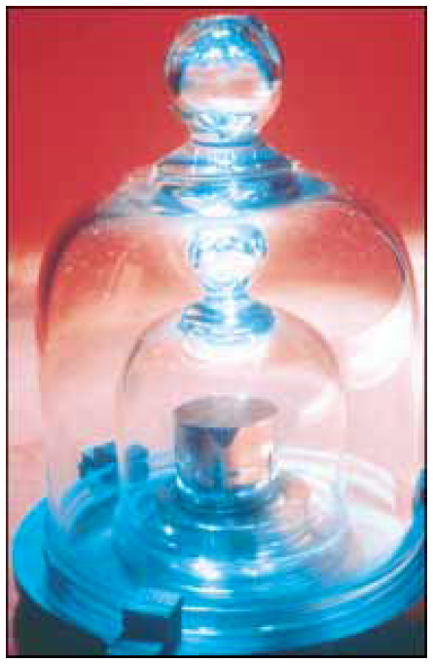
Practice 1.2: Find the definition of other fundamental units
The National Standard Kilogram No. 20, an accurate copy of the International Standard Kilogram kept at Sèvres, France, is housed under a double bell jar in a vault at the National Institute of Standards and Technology.
1.1.1 b) Derived units:
Units of derived quantities are called derived units.
Physical quantity units
Volume = (length × length × length) = m³
Speed = $\frac{distance}{time}$ = m/s or ms⁻¹
1.2 DIMENSIONS
Dimensions of a physical quantity are the powers to which the fundamental quantities must be raised to represent the given physical quantity.
1.2.1 DIMENSIONAL FORMULA
It is an expression which shows how and which of the fundamental units are required to represent the unit of physical quantity.
The equivalent of the dimensions are given in Table 1.1
Example
Force (Quantity) = $mass ×acceleration$
= $mass ×\frac{velocity}{time}=mass × \frac{length}{{(time)}^{2}}$
$=mass ×length×{(time)}^{-2}$
So dimensions of force: 1 in mass
: 1 in length
: -2 in time
Therefore, the dimensional formula is: [MLT⁻²]
Some other units and their dimension formula are listed in Table 1.2
Table 1.2 Different quantities with units, symbol and dimensional formula
Quantity | Symbol | Formula | S.I. Unit | Dimension Formula
Displacement | s | - | Metre or m | L
Area | A | l × b | (Metre)² or m² | L²
Volume | V | l × b ×h | (Metre)³ or m³ | L³
Velocity | v | v = $\frac{∆s}{∆t}$ | m/s | LT⁻¹
Magnetic flux | ϕ | e = $\frac{dϕ}{dt}$ | Weber | ML²T⁻²A⁻¹
Magnetic Intensity | H | B =µH | A/m | L⁻¹A
Current density | J | J = $\frac{I}{A}$ | A/m² | L⁻²A
Magnetic dipole moment | M | M =NIA | Am² | L²A
Energy | K.E or U | $$K.E=\frac{1}{2}mv^{2}$$ | Joule or J | ML²T⁻²
Specific Heat | S | Q = m×S×Δt | $$\frac{Joule}{kg. Kelvin}$$

Post-Test
- Using specific examples, what are fundamental and derived quantities?
- Name any three basic and three derived quantities you know?
- State the dimensions for: Time, Length, Velocity, Volume and Mass?

Bibliography
- Halliday and Resnick, fundamentals of physics, 9th edition, John Wiley &Sons, Inc , USA
- Sears and Zemansky’s University Physics, Young and Freedman, 11th -13th edition Addison-Wisley New York city.
- M. Nelkon and P. Parker, Advance Level Physics, 3rd edition. H.E.B. London.

LECTURE TWO
WAVES
2.1 Introduction
A wave is simply a means of transfer of energy from one point to another by vibrations of either the molecules of a material medium (mechanical waves) or of vibrations of the electric and the magnetic fields (electromagnetic waves). Thus, a mechanical wave will require a material for propagation while an electromagnetic wave will not require a material medium for propagation, it can travel through vacuum.
Objectives
At the end of this lecture, students should be able to:
- identify various cost concepts and their characteristics; and
- graph the major production costs.
Pre-Test
- Define opportunity cost.
- Explain the various production costs you know.
CONTENT
2.2 TYPES OF WAVES
There are two types of waves:
- Transverse waves: These waves travel in directions perpendicular to the vibrations propagating them. Examples are light, waves in strings, radio waves, etc.
- Longitudinal waves: These waves travel in directions parallel to the vibrations propagating them. Examples are seismic P-waves, tidal waves, etc.
2.3 CHARACTERISTICS OF WAVES
Wave motion may follow a repeated pattern and such waves are called periodic waves. Wave motion may also not follow a particular regular pattern (i.e. random), such waves are non-periodic. Since periodic waves are predictable, they will form the basis of our study.
y
x
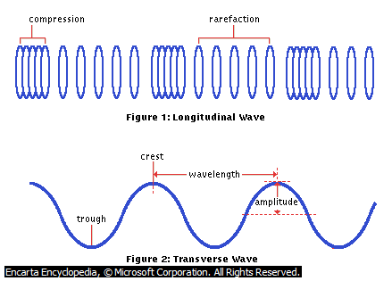

Fig.21.1: A sinusoidal waveform

The followings are terms associated with waves:
- Amplitude (A): This is the maximum displacement of a wave from the equilibrium position and it is measured in meters.
- Wavelength(λ): This is the distance between two identical, successive points on the wave, measured in meters.
- Frequency (f): This is number of complete oscillations or cycles completed by the wave in one second. It is measured in Hertz (Hz).
- Period (T): This is the time it will take a wave to complete an oscillation. It is measured in second.
- Wave speed (v): This is the ratio of the distance travelled by the wave to the time
taken.
That is, $wave speed, v=\frac{distance travelled by wave}{time taken}$
From definition, it will take a wave a time of one period (T) to travel a distance of one wavelength.
$∴ v=\frac{λ}{T}$ 1.1a
Also, from definition, $f=1/T$ 1.1b
Thus, $v=fλ$ 1.1c
This relation is true for all waves.
2.4 WAVE EQUATION
For a sinusoidal travelling waveform as such as in fig.1, there is an equation that represents the displacement of the wave from the equilibrium position at any time:
$y\left(x,t\right)=A\sin\left(ωt±kx\right)$ 1.2a
where the wave number$k=\frac{2π}{λ}$ 1.2b
and the angular frequency, $ω=2πf$ 1.2c
A point at a distance $x$ from the origin corresponds to a phase difference of:
$ϕ=\frac{2πx}{λ}$ 1.2d
The equation takes the – sign when the wave is travelling towards the positive x-axis and + when the wave travels towards the negative x-axis.
The general differential equation which governs the propagation of any type of wave is:
$\frac{∂^{2}y}{∂x^{2}}=\frac{1}{v^{2}}\frac{∂^{2}y}{∂t^{2}}$ 1.2e
2.5 PROPERTIES OF WAVES
(a) Reflection : This phenomenon describes the turning back of a wave when it encounters an obstacle along its path. The nature and direction of the resulting waveform depends on the shape of the reflector and the angle at which the incident wave hits it. e.g. reflection of sun light by a plane mirror.
(b) Refraction : This phenomenon involves the change in the direction and speed of a wave when it travels from one medium to another. For example, you will notice that water waves will move faster when they arrive from a deeper water into a shallower one.
(c) Diffraction : This phenomenon describes the spreading out of a wave when it is made to pass through a narrow aperture. For example if straight water waves are made to pass through a gap less than the wavelength of the waves (as shown in fig.2), the resulting waves are circular.

Fig 21.2: Diffraction of straight water waves by a narrow aperture
(d) Interference: This phenomenon occurs when two waves, produced by two coherent sources and travelling through the same region, are superpositioned. There are two types of interferences: constructive interference and destructive interference. Constructive interference occurs at points where resulting displacement of the wave is twice as before (the waves are exactly in phase) and destructive interference occurs at points where the wave seems to cancel out (the waves are exactly out of phase).
Note: Two wave sources are said to be coherent if the phase difference between the sources is constant.

Example 1.1
Calculate the speed with which a wave travel through a stretched string of length $70 cm$ if the wave goes from one end to the other in $1.2 sec$.
Solution
$$Wave speed=\frac{distance travelled by wave}{time taken}$$
$$v=\frac{0.7m}{1.2s}=0.5833 m/s$$
Example 1.2
Calculate the frequency that a radio station is broadcasting its programs if the wavelength of transmitted radio waves is $2×{10}^{-6} m$. ($speed of light in vacuum, c=3×{10}^{8}{ m}/s$).
Solution
Since $v=fλ$, $f=\frac{v}{λ}=\frac{3×{10}^{8}m/s}{2×{10}^{-6}m}=1.5×{10}^{14} Hz$
Example 1.3
The equation of a plane, progressive wave is given as
$$y=3.5\sin\left(6t+1.5πx\right)$$
where y is in metres and t is in seconds, find :
- the amplitude
- the frequency
- the wavelength.
Solution
- From the equation, amplitude, $A=3.5 m$
- By comparing the equation to the general form of a travelling sinusoidal wave,
$$ω=6=2πf$$
$$=> f=\frac{3}{π}=0.96 Hz$$
- $k=1.5π=\frac{2π}{λ}$
$$=> λ=0.75 m$$
Post-Test
1. A plane progressive wave is represented by the equation
$$y=A\sin{2π\left(\frac{t}{T}-\frac{x}{2λ}\right)}$$
What is the phase difference between a point at a distance $2 m$ from the source?
2. Write an equation to represent a sinusoidal wave travelling in the negative $x$ direction,
with amplitude of $0.55 m$, a frequency of $40 Hz$ and a speed of $250 ms^{-1}$.
3. If the frequency of radio wave emitted by a certain radio station is $101.5 MHz$, determine
the wave’s (a) period of oscillation, (b) wavelength.
4. Ocean waves are travelling to the west at $5 ms^{-1}$ with a distance of $25 m$ between the
troughs. With what frequency do the waves the walls of the harbor?
5. A series of vibrations of amplitude $0.1 m$ are sent down a string that is attached to a post
at one end. The vibrations are reflected at the post and travel back along the string without a loss of amplitude. What is the amplitude at a point on the string where two vibrations are passing, if the string is rigidly attached to the post?
6. The equation of a progressive wave is given by:
$y=5\sin\left(50t-2x\right)$
where y is in $cm$ and t in seconds. Find
- the amplitude,
- the frequency,
- the wavelength,
- the velocity of the wave.
7. Use the wave equation below, to find the speed of the wave
$y=\left(5.0 mm\sin\left[\left(4.0m^{-1}\right)x-\left(7.0s^{-1}\right)\right]\right)$.
8. A keyboard emits sound waves with frequencies that range between $25 Hz$ and $4500 Hz$.
Find the range of wavelengths spanned by the keyboard. (Take the speed of sound in air to be $343 ms^{-1}$).
9. The position of a particle of a wave is given by: $x=0.3m\cos\left(\frac{π}{3}t\right)$
Find (a) the position of the particle at $t=0.6 s$, (b) the frequency of the motion.
10. Find the speed of the wave given by: $y=4.0cm\sin\left[\left(5.0m^{-1}\right)x-\left(6.0s^{-1}\right)t\right]$

Bibliography
- Raymond A. serway and Chris Vuille, College Physics, 9th Edition, Books/Cole Cengage learning, USA.
- Halliday and Resnick, fundamentals of physics, 9th edition, John Wiley &Sons, Inc , USA
- M. Nelkon and P. Parker, Advance Level Physics, 3rd edition. H.E.B. London.

LECTURE THREE
TEMPERATURE AND THERMOMETRY
3.0 Introduction
Temperature is the property of a body that determines whether or not the body will be in thermal equilibrium with other bodies (i.e. no heat exchange). The temperature of a body is high when it is touched, its feel is hotter. The temperature of substances is determined when it is directly related to the movement of the molecules making up its body.
Temperature is a scalar quantity and the S.I. unit is kelvin (K).
Objectives
At the end of this lecture, students should be able to:
- Explain temperature and its units;
- Identify the devices used in measuring temperature; and
- Explain the thermometric properties of substance.
- Perform conversions between the various temperature scales.
Pre-Test
- What is temperature?
- What are the instruments used in measuring temperature?
- What are the various units of temperature?

CONTENT
3.2 MEASUREMENT OF TEMPERATURE
The instrument employed in measuring temperature is thermometer. The thermometer makes use of some physical property of a substance which changes with temperature and this property is called thermometric property of that substance.
A thermometric property is a physical quantity that is monotonic increasing or monotonic decreasing with temperature. Examples of such properties and the types of thermometers in which they are employed are listed below :

Thermometric Property | Thermometric Substance | Type of Thermometer
Volume of a liquid | Expanding liquids, such as, Mercury, etc | Liquids-in-glass thermometer
fixed mass of gas held at contant state variable (Pressure or Volume) | Expanding gases, such as, Hydrogen, Nitrogen, Helium, etc | Gas thermometer
Electrical resistance of a conductor | Conducting wires, such as, Platinum, Bronze, etc | Resistance thermometer
Electromotive force (E.m.f.) of a thermocouple | Conducting of pairs of wires, such as, Platinum/rhodium, Copper/constantan, etc | Thermo-electric thermometer
Illuminance of a very hot body | Radiation of hot source, such as, Electrical lamp | Optical pyrometer

Therefore, a thermometer as a device can measured the temperature of a body directly based on the changes experienced by the easily measurable properties of matter. The advantages and disadvantages of various forms of thermometer with their temperature range are hereby summarised below:

Types of thermometer and temperature range | Advantages | Disadvantages
Liquids in glass thermometer:  (a) Mercury in glass  thermometer: - 39°C  to 360°C  (b) Alcohol in glass  thermometer: -115°C  to 60°C | (i) Direct and easy reading  (ii) Very portable  (iii) Suitable to use  (iv) High Sensitive  (i) Vapourize easily  (ii) High thermal capacity  (iii) Freezes very fast and | (i) Limited range  (ii) Less accurate  (iii) Easily broken  (i) Irregular expansion  (ii) Not easily seen but has  to be coloured
 | easily | (iii) Wet and stick to the  glass wall  (iv) Slow response to  temperature change
Gas thermometer: -270°C to 1500°C | (i) Sensitive  (ii) Accurate  (iii) Wide range  (iv) Easily constructed  (v) Used to graduating other  forms of thermometer  (vi) Used as standard  thermometer for  temperatures below  -183°C | (i) Time consuming and  difficult to use  (ii) Volume of flask is large,  therefore unable to  measure temperature at  isolated confined space
Resistance thermometer:  -200°C to 1200°C | (i) Accurate  (ii) Large range  (iii) Suitable for measuring  constant temperatures  accurately  (iv) Used as standard  thermometer for  temperatures between  -185°C and 630°C | (i) Not suitable for  measuring rapid changes  in temperature because it  takes time to attain  thermal equilibrium with  the surroundings
Thermo-electric thermometer: -250°C to 1200°C | (i) Sensitive  (ii) Wide range  (iii) Most suitable for  measuring rapid changes  of temperature  (iv) Able to measure  temperature of isolated  and small places  (v) Used as standard  thermometer for  temperatures between  630°C and 1063°C | (i) More accurate when  potentiometer is used for  measuring emf. If  millivolt is used, it will be  less accurate for  measuring emf.

3.3 FIXED POINTS ON THERMOMETERS
All thermometers are calibrated by assigning some fixed points whose temperatures are already known. A thermometer will also possess a numerical scale.
(a) Lower fixed point (or ice point) – This is the temperature at which ice and pure water are in equilibrium at standard atmospheric pressure. This temperature on the Celsius scale is 0⁰C.
(b) Upper fixed point (or steam point) – This is the temperature at which pure water and steam are at equilibrium at standard atmospheric pressure.This temperature on the Celsius scale is 100⁰C.
(c) Triple point of water – This is the temperature at which water, water vapor and ice, coexist in equilibrium at standard atmospheric pressure. This has been assigned a value on the Kelvin scale as 273.16 K.
3.4 TEMPERATURE SCALES
There are several temperature scales currently in use in different places and for various purposes but we shall consider the three common temperature scales:
i) Celsius scale – The lower fixed point is 0⁰C and the upper fixed point is 100⁰C.
ii) Fahrenheit scale – The lower fixed point is 32⁰F and the upper fixed point is 212⁰F.
iii) Kelvin scale – The lower fixed point is 273.16 K and the upper fixed point is 373.16 K.
The fundamental interval of a temperature scale is the temperature interval between the upper fixed point and the lower fixed point.
3.5 CONVERSION BETWEEN TEMPERATURE SCALES
The following notations will be made use of :
$T$ to represent temperature in Kelvin,
$T_{C}$ to represent temperature in Celsius,
$T_{F}$ to represent temperature in Fahrenheit.
(a) Celsius to Kelvin :
$$T=\left(T_{C}+273.16\right)$$
(b) Kelvin to Celsius :
$T_{C}=\left(T-273.16\right)$
(c) Celsius to Fahrenheit :
$$T_{F}=\left(\frac{9}{5}T_{C}+32\right)$$
(d) Fahrenheit to Celsius :
$$T_{C}=\frac{5}{9}\left(T_{F}-32\right)$$
3.6 EMPERICAL SCALE OF TEMPERATURE
An empirical scale of temperature is based on experimental measurements of thermometric properties of some substances. For example, volume of a liquid, electrical resistance of a piece of metal wire, etc.
Let the particular thermometric property be X such that, X₀ is the property at ice point, X₁₀₀ is the property at steam point and X_{θ} is the property at an unknown temperature θ⁰C.
$$θ=\frac{X_{θ}-X_{0}}{X_{100}-X_{0}}×{100}^{0}C$$
In applying the various types of thermometer mentioned above, the unknown temperature θ⁰C to be determined relative to a given property of each afore-mentioned thermometer, is stated as follows:
For liquids in glass thermometer, the unknown temperature θ⁰C when the lengths of the mercury thread increases or decreases to a stable state along the column of the glass is expressed as
$$θ=\frac{l_{θ}-l_{0}}{l_{100}-l_{0}}×{100}^{0}C$$
where $l_{0}$ and $l_{100}$ are the lengths of the mercury thread at ice point and stem point respectively.
The resistance scale of the unknown temperature θ⁰C is defined by an equation
$$θ=\frac{R_{θ}-R_{0}}{R_{100}-R_{0}}×{100}^{0}C$$
where $R_{0}$ and $R_{100}$ are the resistances of the conducting wires (e.g. platinum coil) used as thermometric substance at ice point and stem point respectively.
For gas thermometer, e.g., constant volume gas thermometer where pressure P varies with temperature in order to determine the unknown temperature θ⁰C as
$$θ=\frac{P_{θ}-P_{0}}{P_{100}-P_{0}}×{100}^{0}C$$
where $P_{0}$ and $P_{100}$ are the pressures of the gas used as thermometric substance at ice point and stem point respectively.
The emf for the unknown temperature θ⁰C as measured on the thermo-electric scale is defined by an expression
$$θ=\frac{E_{θ}-E_{0}}{E_{100}-E_{0}}×{100}^{0}C$$
where $E_{0}$ and $E_{100}$ are the emfs of the thermocouple (e.g. Copper/Iron) used as thermometric substance at ice point and stem point respectively.
3.7 THERMODYNAMIC TEMPERATURE SCALE
It is kind of temperature scale that is not dependent on thermometric property of a given substance but it is related to the properties of an ideal gas. It is based on the product of the pressure, P, and volume, V, of a fixed mass of a particular ideal gas.
The fixed point in the thermodynamic temperature is the triple point of water vapour that could exist in thermal equilibrium and it is defined as 273.16 K on a scale of thermometer.
If $X_{tr}$ is indicated as the value of the triple point, then for $X$ as the property of a fixed mass of an ideal gas chosen is written as
$θ\left(X\right)=273.16 K ×\frac{X}{X_{tr}}$
where $θ\left(X\right)$ is the temperature in K for a fixed mass of an ideal gas.
For gas thermometer, e.g., constant volume gas thermometer where pressure P of a fixed mass of an ideal gas has relation with $θ$ to determine it value as
$θ\left(P\right)=273.16 K ×\frac{P}{P_{tr}}$
For liquids in glass thermometer, the value of temperature $θ K$ when the lengths of the mercury thread for a fixed mass of an ideal gas along the column of the glass is determined as $θ\left(l\right)=273.16 K ×\frac{l}{l_{tr}}$
The emf for the value of temperature $θ K$ as measured on the thermo-electric scale is defined by an expression
$θ\left(E\right)=273.16 K ×\frac{E}{E_{tr}}$
The resistance scale of temperature $θ K$ for a fixed mass of an ideal gas is defined by the equation $θ\left(R\right)=273.16 K ×\frac{R}{R_{tr}}$
Example 1: Calculate the temperature at which Fahrenheit and Celsius scales record the same reading.
Solution:
The relation between Fahrenheit and Celsius is
$$T_{F}=\left(\frac{9}{5}T_{C}+32\right)$$
If $T_{F}= T_{C}=T$, then $$T=\left(\frac{9}{5}T+32\right)$$
$T= -40$
That is, $-40℉ or -40℃$
Example 2: Convert the measured temperature of $313.66 K$ of a patient in a clinic to (a) $℃$ and (b) $℉$.
Solution:
- The relation between Kelvin and Celsius is
$T_{C}=\left(T-273.16\right)$
$T_{C}=\left(313.66-273.16\right)$
$=40. 5℃$
(b) The relation between Fahrenheit and Celsius is
$T_{F}=\left(\frac{9}{5}T_{C}+32\right)$ $T_{F}=\left(\frac{9}{5}(40.5)+32\right)$
$=72. 9+32$
$=104. 9℉$
Example 3: The resistance of a thermometer at the ice point is 40 Ω and at steam point, 90 Ω. Find the temperature in Celsius when the resistance is 65 Ω.
Solution:
The temperature is
$$θ=\frac{R_{θ}-R_{0}}{R_{100}-R_{0}}×{100}^{0}C$$
$$θ=\frac{65 Ω-40 Ω}{90 Ω-40 Ω}×{100}^{0}C$$
$=50 Ω$
Example 4: A certain platinum resistance thermometer has a resistance, R of 90.35 Ω when its bulb is placed in a triple point. What temperature, if the bulb is placed in an environment, such that, its resistance is 96.28 Ω.
Solution:
The temperature is
$θ\left(R\right)=273.16 K ×\frac{96.28}{96.35}$
$=291.0885$
$=291.09 K$

Post-Test
1. If the cooking temperature is $225℉$, what is its temperature on a Celsius scale?
2. Express $- 36.6℃$ on the (a) Kelvin and Fahrenheit.
3. A constant volume gas thermometer, when in thermal equilibrium with water at
triple point, shows a pressure of 50 atm. What will be the reading of this
thermometer when in equilibrium with a body of $200℃$
4. The pressure of a gas in a constant volume gas thermometer is 680 mmHg at $0℃$,
and 929 mmHg at $100℃$. Calculate the temperature when the pressure is 724 mmHg.
5. A platinum resistance thermometer has a resistance of 4.32 Ω at $0℃$ and a
resistance of 4.86 Ω at $100℃$. Calculate the temperature on the Celsius scale when
the resistance of 4.64 Ω.
6. The e.m.f. of a thermoelectric is given by $E= α\left(∆t\right)+ β(∆t)^{2}$, where
$∆t=t-273.2$, t is being the thermodynamic temperature of the hot junction. The constant $α$ and $β$ are related by the equation $β= -2.5 ×10^{-4}α$. If the temperature of a body determined with the thermoelectric is 523.2 K, calculate the equivalent temperature on the Celsius scale.

Bibliography
- Halliday and Resnick, fundamentals of physics, 9th edition, John Wiley &Sons, Inc , USA
- Halliday and Resnick, fundamentals of physics, 9th edition, John Wiley &Sons, Inc , USA
- M. Nelkon and P. Parker, Advance Level Physics, 3rd edition. H.E.B. London.
- Sears and Zemansky’s University Physics, Young and Freedman, 11th -13th edition Addison-Wisley New York city.

LECTURE FOUR
FUNDAMENTAL LAWS OF MECHANICS (MOTION)
4.0 Introduction
A body can be said to be in motion if it is displaced continuously with time. Ideally, all material possess one type of motion or the other.
As an example, the earth performs Rotation and Revolution Motion.
  - Rotation (about its axis) –causes day and night while
  - Revolution (about the sun) -Creates variation in seasons.
Two Classifications Exist – Kinematics and Dynamics
  - Dynamics refers to objects in motion with respect to the generating force.
  - Kinematics refers to motion without a consideration to the force causing it.
Objectives
At the end of this lecture you should be able to:
- Describe the various types of motion
- Differentiate between distance and displacement, speed and velocity
- Explain acceleration of a body
- Formulate the equations of motion
- The projectile equations as extracted from the equations of motion amongst many others.
Pre-Test
- What are the types of Motion?
- What are the quantities associated with linear motion?
- Calculate the equations of uniformly accelerated motion in a straight line?

CONTENT
  - Types of Motion
4.1.1 Linear or translational Motion
Linear motion is the motion of objects from one point (A) to another point (B) in a straight line.
A typical example is the motion of a car from one end of a straight part to another.

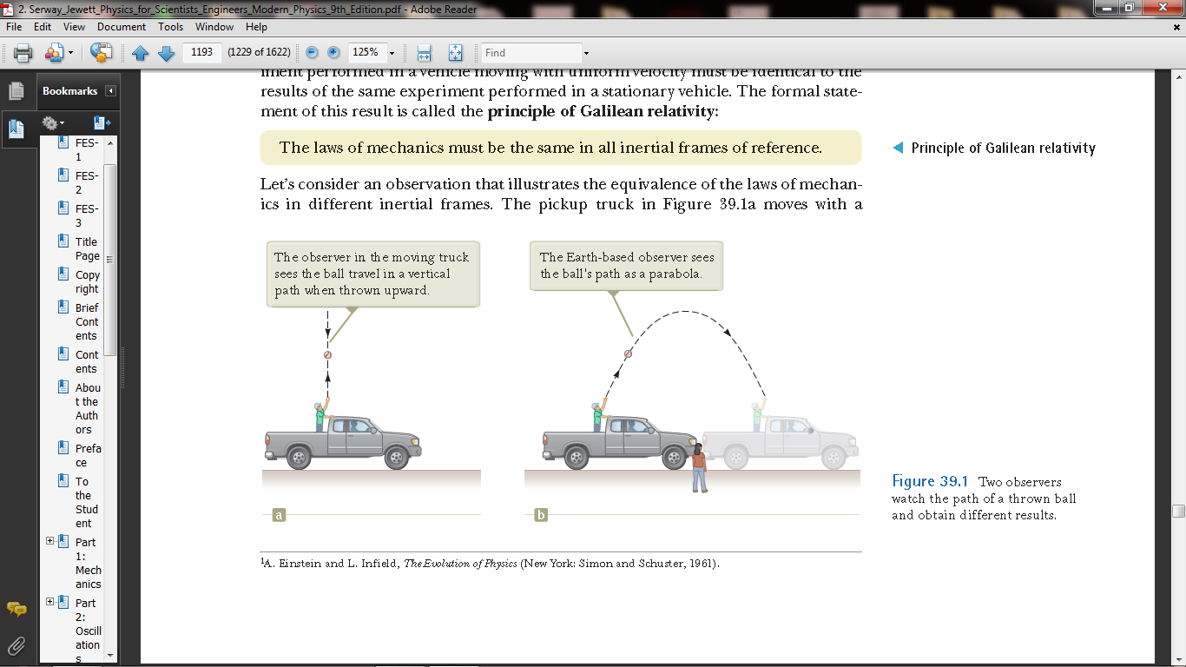
A B
Figure 1. Translational Motion.

    - Circular or Rotational Motion
This is the motion of a body round an axis.
Examples include the rotation of the blades of an electric fan, the movement of the earth about its axis, the movement of a car wheel.

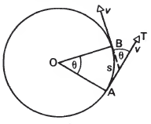
Figure 2. Circular motion.

    - Oscillatory Motion
This is a to- and fro- motion of a body from its equilibrium position
An example is the motion of a simple pendulum and the motion of a car wiper.

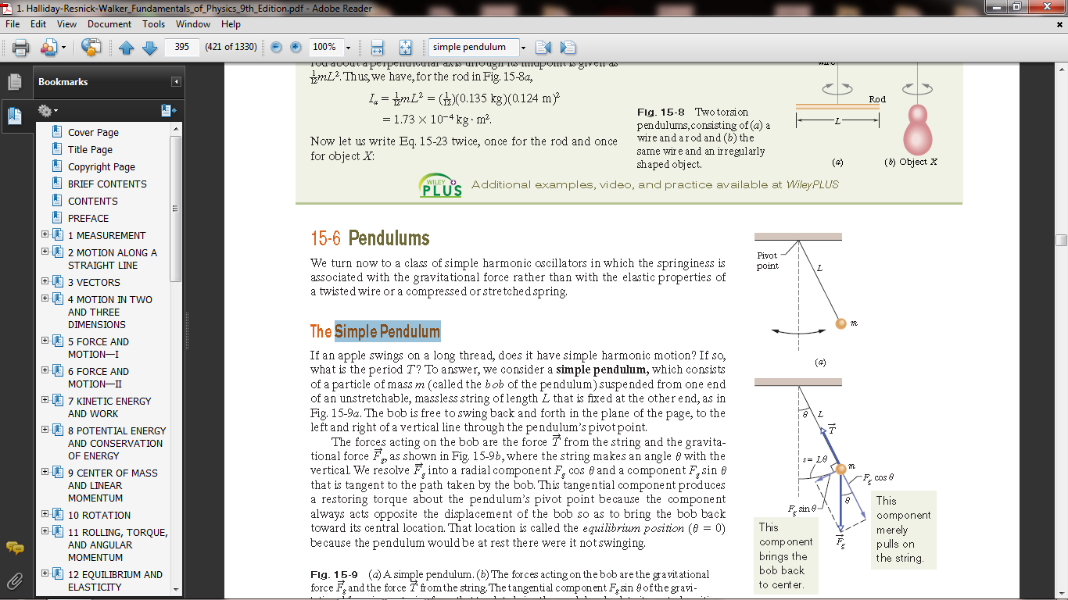
Figure 3. Oscillatory Motion.

    - Random Motion
This is a zig-zag kind of motion without any defined direction.
Examples include the motion of gas molecules, the movement of pollen grains on flowing water, etc.
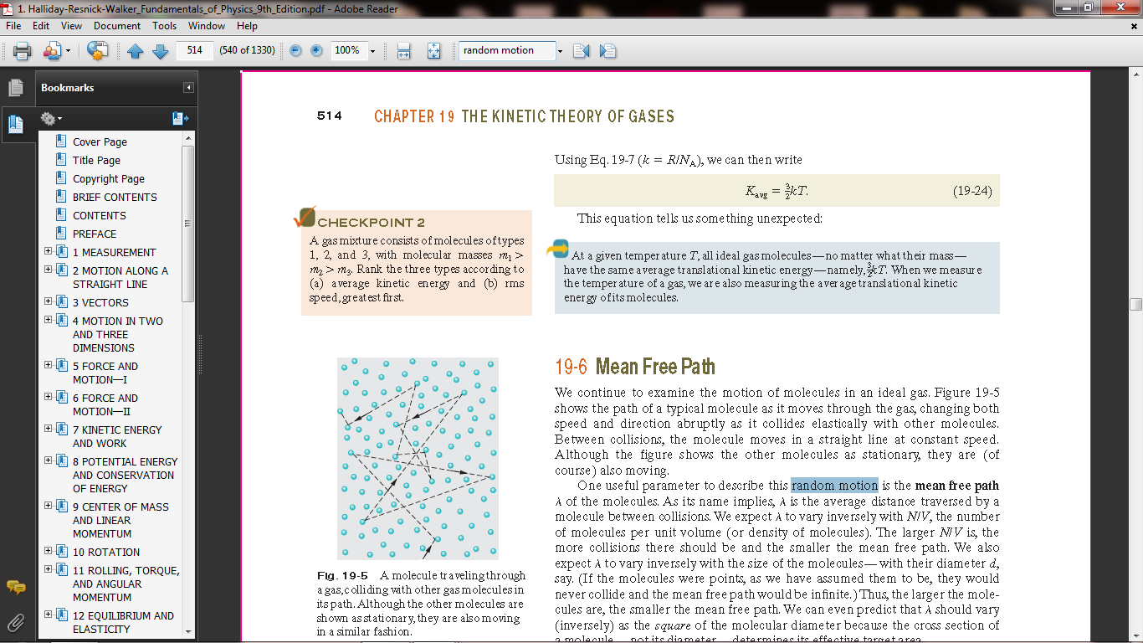
Figure 4. Motion of gas molecules.

    - Relative Motion
This type of motion is basically an assumption reality. An illustration is a person looking down the floor from a moving car, the car will appear stationary to him because he is moving with same speed as the car thus there is no relative motion between them. But if the person looks at stationary objects, they will appear to be moving.
This is due to the relative motion between the person and the objects which is literarily not correct. The implication is that if two bodies are in motion relative to each other, and they move with velocities 200km/h and 100km/h in opposite directions respectively, them their relative velocity will be 100km/h in the direction of the bigger velocity.
But if they move in the same direction, the relative velocity will be the sum of the various velocities (300km/h).

  - Quantities Associated with Linear motion
Some of the physical quantities associated with linear motion include
    - Distance (x)
This can be defined as the separation between two points in space. Its SI unit is the Meter (m). Distance is a scalar quantity because it has only magnitude but no direction. It is a fundamental quantity.
    - Displacement (x)
This is distance moved in a specific direction. It has the same unit as distance, but it is a vector quantity because is possess both magnitude and direction. For example, “MTU is 12 kilometers east of Lagos.
    - Speed (v)
This is the time rate of change of distance. Thus, instantaneous speed of an object is the speed recorded at an instant. However, we will be more concerned about the average speed.
      - $Average Speed=\frac{Total Distance }{Total Time}$
Speed is a scalar quantity derived from the combination of distance and time. The unit is ${ms}^{-1}$ or km/h.
Example. If the total distance covered by a car is 200km/h and the time taken for such tour is 1.30minutes, find the average speed.
Solution
$Average Speed=\frac{Total Distance }{Total Time}$
$v=\frac{200*1000m}{5400s}=37.04{ms}^{-1}$
4.2.4 Velocity
This is define as the time rate of change of displacement. It is a vector quantity. The unit is also ${ms}^{-1}$ or km/h. it is a derived quantity. This is found in bodies in motion. There is also initial, final, instantaneous, average and relative velocities.
Thus a body has initial velocity when it is starting motion, and final velocity when it is concluding motion.
$Average Velocity=\frac{u+v}{2}$ $=\frac{Total displacement}{Total time}$
$$\text{Instantaneous Velocity =}\frac{ x_{2}-x_{1}}{t_{2}-t_{1}}$$
$=\frac{dx}{dt}$
Example 1. Given the following coordinates (x₁,t₁), (x₂,t₂)= (2,5), (4,15), find the velocity at point t=2
Solution.
Draw the graph showing the instantaneous velocities,
Recall that $v=\frac{dx}{dt}$
$$∴v=\frac{4-2}{15-5}=\frac{2}{10}=0.2{ms}^{-1}$$
This implies that the slope of the graph is $5{ms}^{-1}$ which the velocity is also.
Note that if two cars move with relative velocities A and B in opposite directions, then their relative velocity is giving by $v=A-B,$but in the same direction we have $v=A+B.$
Example 2. A car moves with initial velocity of ${3ms}^{-1}$ due east, then attains a velocity of ${4ms}^{-1}$ due south. Find the average velocity of the car.
Solution.
Draw the direction of travel with their velocities,
Use Pythagoras theorem to solve.
Use Pythagoras theorem to solve.
$$c^{2}=a^{2}+b^{2}$$
= $3^{2}+4^{2}$
$$=9+16=25$$
$$c=\sqrt{25}={5ms}^{-1}$$
$$Average Velocity=\frac{u+v}{2}=\frac{5}{2}={2.5ms}^{-1}$$
Example 3. The displacement of a particular body is giving by $x=t^{2}-2t-3.$ Find the instantaneous velocity at t=0 sec. and t=5 sec.
Solution
Start by differentiating the displacement x with respect to time.
$$\frac{dx}{dt}=2t+2$$
At $t=0, v=2×0+2=2ms^{-1}$
At $t=5, \left(2×5\right)+2=12ms^{-1}$

4.2.5 Acceleration
This is the rate of change of velocity with time. It is a derived vector quantity with S I unit as ${ms}^{-2}or \frac{m}{s^{2}}$
  - $a=\frac{change in velocity}{change in time}=\frac{v-u}{t}=\frac{dv}{dt}$
Acceleration is uniform if equal velocity is covered in equal time and if otherwise, it is said to be non-uniform. When it is negative, it is called retardation or deceleration.
The average acceleration of the particle is defined as the change in velocity Δvx divided by the time interval Δt during which that change occurred:

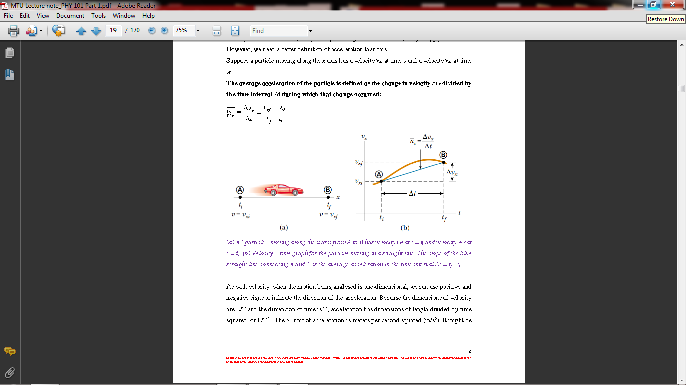
Figure 5. (a) A “particle” moving along the x axis from A to B has velocity vxi at t = ti and velocity vxf at t = tf. (b) Velocity – time graph for the particle moving in a straight line. The slope of the blue straight line connecting A and B is the average acceleration in the time interval Δt = tf - ti.

In some situations, the value of the average acceleration may be different over different time intervals. It is therefore useful to define the instantaneous acceleration as the limit of the average acceleration as Δt approaches zero. This concept is analogous to the definition of instantaneous velocity discussed in the previous section.
If we imagine that point B is brought closer and closer to point A in Figure 5a and take the limit of Δvx /Δt as Δt approaches zero, we obtain the instantaneous acceleration:
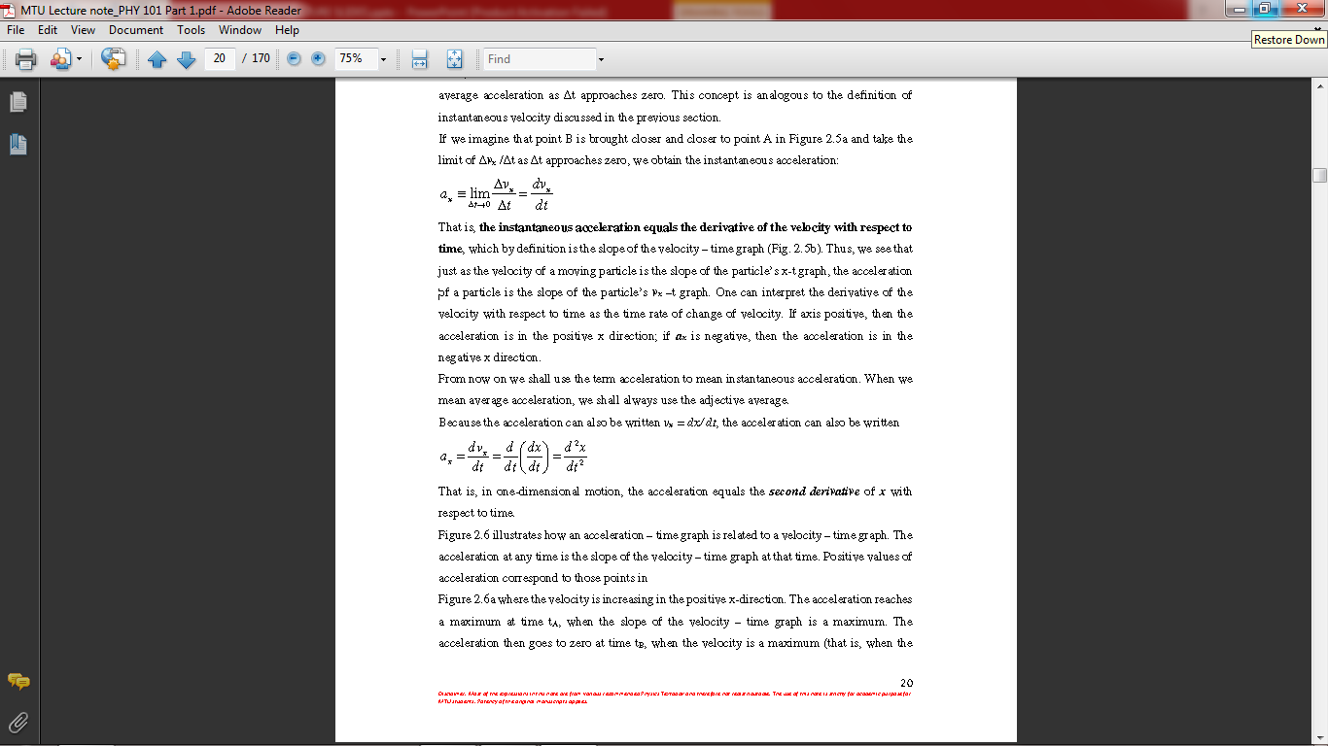
That is, the instantaneous acceleration equals the derivative of the velocity with respect to time, which by definition is the slope of the velocity – time graph (Fig. 5b). Thus, we see that just as the velocity of a moving particle is the slope of the particle’s x-t graph, the acceleration of a particle is the slope of the particle’s vx –t graph. One can interpret the derivative of the velocity with respect to time as the time rate of change of velocity. If axis positive, then the acceleration is in the positive x direction; if ax is negative, then the acceleration is in the negative x direction.
In a null shell, when we take the first derivative of position with respect to time, we get the velocity, taking the second derivative will in turn yield acceleration. Ie:
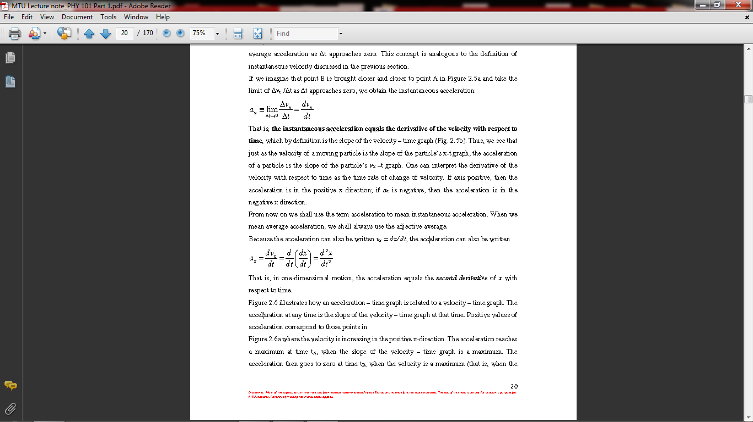

  - Graphical solution of problems in Linear Motion
Example1.3.1. The position of an object moving along the x axis varies with time as in Figure 6a. Graph the velocity versus time and the acceleration versus time for the object.

Solution
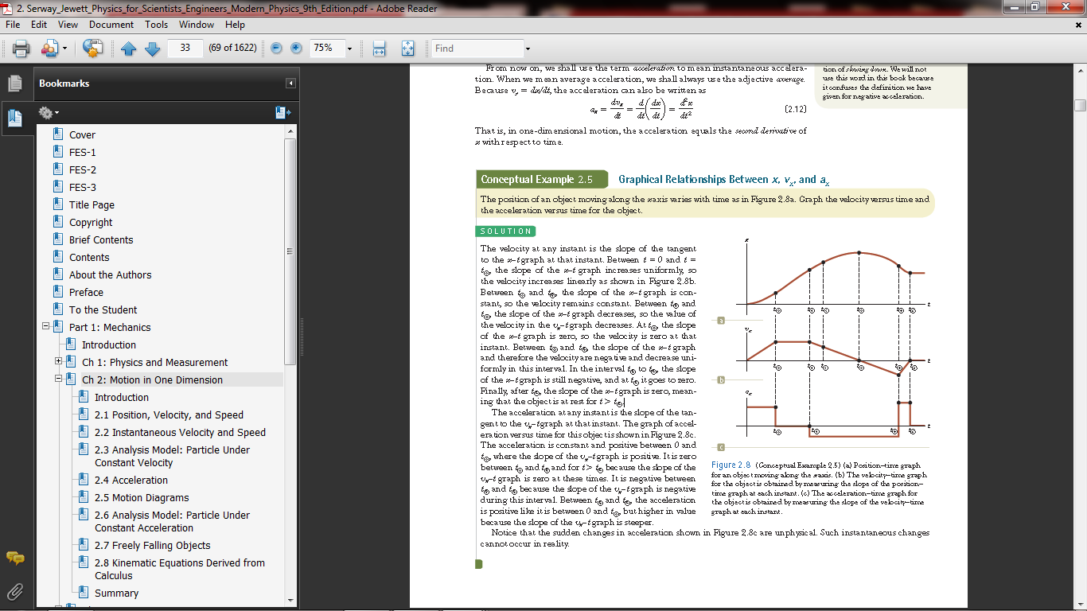
Figure 6. (Conceptual Example 2.5) (a) Position–time graph for an object moving along the x axis. (b) The velocity–time graph for the object is obtained by measuring the slope of the position– time graph at each instant. (c) The acceleration–time graph for the object is obtained by measuring the slope of the velocity–time graph at each instant.

The velocity at any instant is the slope of the tangent to the x–t graph at that instant. Between t =0 and t = t_{A}, the slope of the x–t graph increases uniformly, so the velocity increases linearly as shown in Figure 6b. Between t_{A} and t_{B}, the slope of the x–t graph is constant, so the velocity remains constant. Between t_{B} and t_{D}, the slope of the x–t graph decreases, so the value of the velocity in the vx–t graph decreases. At t_{D}, the slope of the x–t graph is zero, so the velocity is zero at that instant. Between t_{D} and t_{E}, the slope of the x–t graph and therefore the velocity are negative and decrease uniformly in this interval. In the interval t_{E} to t_{F}, the slope of the x–t graph is still negative, and at t_{F} it goes to zero. Finally, after t_{F}, the slope of the x–t graph is zero, meaning that the object is at rest for t $>$t_{F}.
The acceleration at any instant is the slope of the tangent to the vx–t graph at that instant. The graph of acceleration versus time for this object is shown in Figure 6c.
The acceleration is constant and positive between 0 and t_{A}, where the slope of the vx–t graph is positive. It is zero between t_{A} and t_{B} and for t $>$ t_{F} because the slope of the vx–t graph is zero at these times. It is negative between t_{B} and t_{E} because the slope of the vx–t graph is negative during this interval. Between t_{E} and t_{F}, the acceleration is positive like it is between 0 and t_{A}, but higher in value because the slope of the vx–t graph is steeper.
Notice that the sudden changes in acceleration shown in Figure 6c are unphysical. Such instantaneous changes cannot occur in reality.

  - Equations of uniformly accelerated motion in a straight line.
The equations are:
- $v=u+at$
- $x=ut+\frac{1}{2}at^{2}$
- $v^{2}=u^{2}+2ax$
The derivation of the above equations are as follows:
For a body moving with uniform acceleration a, the velocity increases from the initial u, to the final v. thus:
$a=\frac{change in velocity}{ time taken}=\frac{v-u}{t}$
$∴at=v-u or v=u+at.$
This gives us equation (1)
Recall also that average velocity ⊽=$\frac{u+v}{2}$
Putting the value of v in (eq.1) into this, we have
$\frac{u+u+at}{2}$ or
⊽=u+1/2at
But we know that instantanous velocity ⊽=$\frac{Displacement}{time}$
= $\frac{x}{t}$
Substituting the above into equation (2) gives
$\frac{x}{t}=u+\frac{1}{2}at$
$x=ut+\frac{1}{2}ut^{2}$
Recall also equation (1) and square it, we obtain
$v^{2}=u^{2}+2aut+a^{2}t^{2}$
$=u^{2}+2a(ut+\frac{1}{2}at^{2})$
$∴v^{2}=u^{2}+2ax.$ This is equation (3). *note that when we are dealing with gravity, a changes to g in the equations of motion.

  - Motion in two or three dimensions
    - Projectile Motion
Anyone who has observed a baseball in motion (or, for that matter, any other object thrown into the air) has observed projectile motion. The ball moves in a curved path, and its motion is simple to analyze if we make two assumptions:
(1) the free-fall acceleration g is constant over the range of motion and is directed downward,
(2) the effect of air resistance is negligible.
With these assumptions, we find that the path of a projectile, which we call its trajectory, is always a parabola.

    - Definitions of terms
The time of flight (T): this is the time taken by a projectile to travel from the point of projection through the entire route to the point where it hits the projection pane again
(ie T =t1+t2). It is measured in seconds and represented as
$T=\frac{2vsinθ}{g}$
Range (R): this is the horizontal distance measured from the point of projection to the point where it hits the projection plane again. It is measured in meters (m) and represented mathematically as:
$R=\frac{v^{2}\sin\left(2θ\right)}{g}$
The Maximum Height (H): this is the maximum vertical distance measured from the projection plane of the projectile. The SI unit is meters (m) and represented mathematically as:
$R=\frac{v^{2}\sin^{2}θ}{2g}$

    - Derivations of Formulae
To derive the formula for time of flight, we consider the first equation of motion which is giving as $v=u+at .$
Replace v=0, u=vsin$θ;$ a=-g and t=T/2.
Thus equation (1) becomes:
$0=vsinθ-\frac{gT}{2} or\frac{gT}{2}=vsinθ$
$∴T=\frac{2vsinθ}{g}$ (time of flight)
From the second equation also, $x=ut+\frac{1}{2}at^{2}$, put x=R; u=vcos$θ$; t=T; a=g=0
g is zero because gravity does not act horizontally.
Thus the equation becomes
$R=\frac{vcosθ 2vsinθ}{g}+0$ or
$R=\frac{2v^{2}sinθcosθ}{g}$
From trig identities, $2sinθcosθ=sin2θ$
Therefore, $R=\frac{v^{2}sin2θ}{g}$ (Range)

Range becomes maximum when $θ=45°$ ie,$\sin\left(2×45°\right)=90°=1$
Thus $R_{max}=\frac{v^{2}}{g}$ .
To derive the maximum Height (H), we follow the steps above using equation (3) $v^{2}=u^{2}+2ax$, we put v=0; $u=vsinθ;a=-g and x=H.$
we obtain
$0^{2}=(vsinθ)^{2}-2gH$ or
$2gH=(vsin)^{2}$ or
$H=\frac{v^{2}\sin^{2}θ}{2g}$ (Height)

Example 1. A body is projected at an angle of $30°$ to the horizontal from the ground level with initial velocity of 200m/s
Calculate
- The time of flight
- The range
- The maximum Height
- What conditions must be satisfied for the range to be maximum and the value.
(take g=10m/s).
Solution
- Time of flight $T=\frac{2vsinθ}{g}$
$=\frac{2×200×sin30°}{10}=20secs$
(ii) The range $R=\frac{v^{2}\sin\left(2θ\right)}{g}$
$\frac{{200}^{2}{\sin\left(2×30\right)}^{°}}{10}=\frac{40000sin60°}{10}=3464m.$

(iii) The maximum Height $H=\frac{v^{2}\sin^{2}θ}{2g}$
$=\frac{{200}^{2}{sin30}^{2}}{2×10}=500m.$
(vi)The condition that must be fulfilled is that the projection angle must be 45$°$. Thus $R_{max}=\frac{v^{2}}{g}=\frac{{200}^{2}}{10}=4000m.$

Post-Test
1 A stone is projected upwards at an angle of 35$°$ to the horizontal the top of a cliff of height 80m and hits the ground at a point p. if the initial velocity of projection is 300m/s. calculate:
(i)the maximum height of the stone above the ground
(ii)the time it takes to reach the height
(iii)the time of flight
(iv)The horizontal distance from the foot of the cliff to the point p.
(Neglect air resistance and take g=10m/s)
- If the distance travelled by an object at a time t is described by the equation
${10t}^{3}+{12t}^{2}+5t+8.$ find the acceleration at time t=1sec.

Bibliography
- Halliday and Resnick, fundamentals of physics, 9th edition, John Wiley &Sons, Inc , USA
- Halliday and Resnick, fundamentals of physics, 9th edition, John Wiley &Sons, Inc , USA
- M. Nelkon and P. Parker, Advance Level Physics, 3rd edition. H.E.B. London.
- Sears and Zemansky’s University Physics, Young and Freedman, 11th -13th edition Addison-Wisley New York city.

