

PRE-CONSTRUCTION GEOPHYSICAL AND GEOTECHNICAL INVESTIGATION OF SUBSOIL CONDITION FOR THE CONSTRUCTION OF A LIBRARY BUILDING AT THE PERMANENT SITE OF MOUNTAIN TOP UNIVERSITY MAKOGI-OBA, OGUN STATE, SOUTHWESTERN, NIGERIA.

BY
OMSIHAKIN, SOLOMON A.
16010401007

A RESEARCH PROJECT

SUBMITTED TO
THE DEPARTMENT OF GEOPHYSICS, COLLEGE OF BASIC AND APPLIED SCIENCES, MOUNTAIN TOP UNIVERSITY, PRAYER CITY, OGUN STATE IN PARTIAL FULFILMENT OF THE REQUIREMENTS FOR THE AWARD OF A BACHELOR OF SCIENCE (B. Sc.) DEGREE IN GEOPHYSICS

FEBRUARY, 2021
CERTIFICATION
This is to certify that this research project titled “PRE-CONSTRUCTION GEOPHYSICAL AND GEOTECHNICAL INVESTIGATION OF SUBSOIL CONDITION FOR THE CONSTRUCTION OF A LIBRARY BUILDING AT THE PERMANET SITE OF MOUNTAIN TOP UNIVERSITY, MAKOGI OBA, OGUN STATE, SOUTHWESTERN NIGERIA.” was carried out by Omishakin Solomon Akintoye, with matriculation number 16010401007, This project meets the requirements governing the award of Bachelor of Science (B.Sc.) Degree in Geophysics, Geosciences Department of the Mountain Top University, Ogun state, Nigeria and is approved for its contribution to knowledge and literary presentation.

_________________________ _________________________
Mr. M. O. Okunubi Date
Supervisor

_________________________ _________________________
Dr. O. B. Balogun Date
Head of Department

DECLARATION
I hereby declare that this project report written under the supervision of Mr. Okunubi M. O., is a product of my own research work. Information derived from various sources have been duly acknowledged in the text and a list of references provided. This research project report has not been previously presented anywhere for the award of any degree or certificate.

_________________________ _________________________
OMISHAKIN, Solomon A. Date
DEDICATION
I dedicate this Project work to the Almighty God for His ever-continuous mercies, guidance, protection, and favor all through my stay at Mountain Top University, and for the successful completion of this body of work. I also dedicate this work to my parents – Rev. Dr. ‘Banji & Mrs. B. B. Omishakin for their financial, spiritual, psychological, and moral support.
ACKNOWLEDGEMENTS
I am most grateful to the Almighty God for seeing me through my undergraduate study years, it is by His grace that all came to fruition. I must also acknowledge the effort of my parents for their financial and moral support, it won’t have been possible without them.
My heartfelt gratitude goes to my supervisor, Mr. M. O. Okunubi who guided me to the completion of this work. My sincere appreciation also goes to the Vice Chancellor, Professor E. A. Ayolabi. Thank you for your unending support since my first year and seeing to the completion of this research work. Thanks to the Head of Department, Dr. O. B. Balogun for their fatherly advice and professional support through the time of this research.
Also, I won’t fail to acknowledge the American Association of Petroleum Geologists (AAPG) Foundation who supported the funding this research work through the L. Austin Weeks Undergraduate Grant.
I would also like to thank my colleague whom we worked together during this project – David Agbonjaru – for assistance rendered during the fieldwork. I am immensely grateful to all those who assisted during the field data acquisition – Mr. Akinwale, Mr. Dayo – thank you all.
My list is inexhaustible but I won’t fail to acknowledge a few other Persons who have also supported me morally, financially and in psychologically – Mrs. Ajoke Ayeni, Fiyinfoluwa, Olamide, Toluwanimi, Pamilerin, Tolulope, Timilehin, Olaide and a countless other who have supported me in one way or the other.
Finally, I would like to thank the entire staff and students of the Biological Sciences Department, Mountain Top University
TABLE OF CONTENTS
CERTIFICATION ii
DECLARATION iii
DEDICATION iv
ACKNOWLEDGEMENT v
LIST OF FIGURES ix
LIST OF TABLES xii
ABSTRACT xiii
CHAPTER ONE 1
INTRODUCTION 1
1.1 Preamble 1
1.2 Statement of Research Problem 2
1.3 Description of the Study Area 2
1.3.1 Geographic Location and Accessibility 2
1.3.2 Relief, Drainage, Climate and Vegetation 4
1.4 Previous Work 4
1.5 Aim and Objectives 6
1.6 Scope of Work 7
1.9 Contribution to Knowledge 9
CHAPTER TWO 10
LITERATURE REVIEW 10
2.1 Overview 10
2.2 Part One – Elementary Resistivity Method 10
2.2.1 Basic Theory 10
2.2.2 Electrode Configuration 16
2.2.3 Factors Affecting Resistivity of Subsurface Materials 19
2.2.4 Limitations of the Electrical Resistivity Method 21
2.3 Part Two – Basic Theory of Seismic Prospecting Method 22
2.3.1 Introduction 22
2.3.2 Concept of Theories 22
2.3.2.1 Seismic Waves 22
2.3.2.2 Snell’s Law 27
2.3.2.3 Attenuation of Seismic Waves 29
2.3.2.4 Refraction at a Horizontal Interface 31
2.3.2.5 Refraction at an Inclined Interface 34
2.3.2.6 Seismic Wave Velocities of Rocks 36
.3.2.7 Poisson’s ratio 38
2.3.3 Limitations of Seismic Refraction Method 38
2.4 Part Three – Regional Geology of Study Area 40
2.4.1 Stratigraphy of the Dahomey Basin 42
2.4.2 Tectonic History of Dahomey Basin 42
CHAPTER THREE 44
FIELD METHODOLOGY 44
3.1 Introduction 44
3.2 Electrical Resistivity Method 44
3.2.1 Instrumentation 44
3.2.2 Method Employed 45
3.2.3 Data Acquisition 45
3.2.4 Data Processing 45
3.2.4.1 Electrical Resistivity Tomography (ERT) 45
3.2.4.2 Vertical Electrical Sounding (VES) 45
3.3 Seismic Refraction Tomography 47
3.3.1 Instrumentation 48
3.3.2 Field Operation 50
3.3.2.1 Sample Rate 50
3.3.2.2 Stacking 52
3.3.3 Seismic Data Processing 52
3.3.3.1 DC Offset Removal 52
3.3.3.2 Geometry Assignment and Editing 53
3.3.3.4 Picking the First Arrivals and Create the Travel Time Curves 53
3.3.3.5 Velocity Modelling 56
3.4 MASW Method 58
3.4.1 2D MASW 60
3.4.1.1 2D MASW Processing 62
CHAPTER FOUR 64
RESULTS AND DISCUSSIONS 64
4.1 Introduction 64
4.2 Borehole Lithological Logs 64
4.3 Resistivity Type Curves 66
4.4 Geoelectric Sections 66
4.5 Dipole Dipole Profiles 71
4.6 Seismic Refraction Tomography 71
4.7 Multichannel Analysis of Surface Waves (MASW) 86
CHAPTER FIVE 90
SUMMARY AND CONCLUSION 90
5,1 Summary 90
5.2 Conclusion 91
REFERENCES 92
APPENDIX A 95
APPENDIX B 99
APPENDIX C 105
APPENDIX D 109

LIST OF FIGURES
Figure 1.1: Map of Ogun State, Nigeria, Showing the Study Area 4
Figure 2.1: The parameters used in defining Resistivity 12
Figure 2.2: Current Flow from a Single Surface Electrode 14
Figure 2.3: Equipotential and Current lines for a pair of current electrodes A and B on a
homogenous half-space 14
Figure 2.4: The Generalized form of the Electrode Configuration 14
Figure 2.5: Wenner Configuration Array Type 18
Figure 2.6: Schlumberger Configuration Array 18
Figure 2.7: Propagation of a seismic disturbance from a point source 24
Figure 2.8: Propagation of a seismic waves 25
Figure 2.9: Reflected and refracted P- and S-waves 28
Figure 2.10: Critical refracted ray 30
Figure 2.11: Travel-time versus distance curves for horizontal interface 32
Figure 2.12: Travel-time versus distance curves at an inclined interface 35
Figure 2.13: Poisson Ratio Example 39
Figure 2.14: Geological map of Ogun State showing Dahomey Basin and the extracted
study area 41
Figure 3.1a: Picture showing ABEM SuperSting R8 during data acquisition 47
Figure 3.1b: Picture showing ABEM SuperSting R1 during data acquisition 47
Figure 3.2: Picture showing the setup during seismic data acquisition 49
Figure 3.3: Seismic refraction data acquisition geometry 51
Figure 3.4: Seismic trace processing 55
Figure 3.5: First arrival picks 56
Figure 3.6a: Traveltime plot for Traverse TR2 58
Figure 3.6b: Layer assignment for Traverse TR2 58
Figure 3.7: Layered model for Traverse TR2 60
Figure 3.8: MASW Geometry 62
Figure 3.9a: Dispersion curves 64
Figure 3.9b: S-wave velocity model 64
Figure 3.9c: Cross-section of s-wave velocity model 64
Figure 4.1a: Borehole Log 1 66
Figure 4.1b: Borehole Log 2 66
Figure 4.1c: Borehole Log 3 68
Figure 4.2a: WinResist Result for VES 1. HK type curve 69
Figure 4.2b: WinResist Result for VES 2. HK type curve 69
Figure 4.3a: Geoelectric Section for VES 3 – 6 along Traverse 5 71
Figure 4.3b: Geoelectric Section for VES 1 – 7 71
Figure 4.4: Dipole Dipole Pseudosection along Traverse 1 73
Figure 4.5: Dipole Dipole Pseudosection along Traverse 2 75
Figure 4.6: Dipole Dipole Pseudosection along Traverse 3 77
Figure 4.7: Dipole Dipole Pseudosection along Traverse 4 78
Figure 4.8: Dipole Dipole Pseudosection along Traverse 5 79
Figure 4.9: Dipole Dipole Pseudosection along Traverse 6 81
Figure 4.10: Seismic Refraction Tomography along Traverse TR2 83
Figure 4.11: Seismic Refraction Tomography along Traverse TR3 84
Figure 4.12: Seismic Refraction Tomography along Traverse TR4 86
Figure 4.13a: 2D MASW Profile along Traverse TR2 89
Figure 4.13b: 2D MASW Profile along Traverse TR3 89
Figure 4.13c: 2D MASW Profile along Traverse TR4 89

LIST OF TABLES
Table 2.1: Compressional wave velocities in Earth materials…..…………………………. 37
Table 4.1: Summary of Results obtained from VES Curves interpretation…………..….....70
Table 4.3: Compressibility for subsoil materials within the study area…………………….88

ABSTRACT
A geophysical investigation involving resistivity (1-D Vertical Electrical Sounding and 2-D Dipole Dipole Imaging) and seismic (Refraction and Multichannel Analysis of Surface Wave) methods and geotechnical investigation involving borehole drilling was carried out at the proposed site for a library building at the permanent site of Mountain Top University, Ogun State, Nigeria. The investigation was with a view to establishing the competence or otherwise of the subsoil for the civil engineering structure. Three boreholes (BH 1- 3) were drilled, seven (7) VES were carried out at stations distributed over the study area, six (6) 2-D Dipole Dipole imaging were carried out along S-N and W-E traverses established across the study area. Seismic refraction and MASW imaging were carried out along segments of some of the established geophysical traverses. The boreholes identified five layers namely, silty clay, sand, inorganic clay, organic clay and sandy clay. The VES curves interpretation results were used to generate geoelectric sections that imaged four subsurface layers that include topsoil (sandy clay), clay, clayey sand and clay. The resistivity values for the topsoil varies from 16.3 to 108.1 Ωm and its thickness varies from 0.5 to 0.6 m. The clay second layer resistivity values varied from 3.7 to 51.0 Ωm and the thickness value varied from 0.6 to 3.1 m. The clayey sand unit showed resistivity that varied between 33.1 and 152.2 Ωm and thickness value that varied between 3.8 and 34.5 m. The fourth layer was clay with resistivity that ranged between 3.7 and 17.2 Ωm. Depths to the fourth layer varied between 5.7 and 35.6 m. The 2-D resistivity structure delineated four layers namely merged topsoil/clay, sand, sandy clay and clay. The seismic refraction tomography and the MASW imaged the upper two layers. The geoelectric section revealed two high resistivity layers that were interpreted as the upper and lower competent layers. The 2-D resistivity structure identified only the high resistivity lower competent layer. The seismic refraction tomography and the MASW also identified only the lower competent layer. The compressibility of the competent layer varied from 20.63 x 10⁻⁵ to 17.31 x 10⁻⁵ Pa⁻¹ at 4-12 m depths. The survey also identified low resistivity and low velocity incompetent layer that should be avoided. No geologic structure that could be inimical to civil engineering structure was identified. The upper competent layer could host road and light weight civil engineering structure foundations, while, medium to heavy weight civil engineering structures should be anchored on pile foundation placed on the lower competent layer at 6 m depth.
CHAPTER ONE
INTRODUCTION
1.1 PREAMBLE
Research has shown that majority of foundation failures and subsequent building collapse result from incompetent foundation/subsurface geomaterials (soils and rocks) that cause uneven or differential settlements and also from geologic structures (contacts and fractures) that give rise to displacement within the subsurface under loading conditions (Butchibabu et al, 2019; Oyedele et al, 2015). At other times, swelling clays were also commonly reported in many research publications as causes of failures of civil engineering structures (Ayolabi et al., 2013; Blyth and de-Freitas, 1988). Tectonic activities that also birth faults and fractures in the subsurface also result in building failures and collapse of other civil engineering structures. Foundation failure and subsequent building collapse advertently leads to loss of lives and properties.
The increasing rate of collapse of engineering structures necessitates geophysical and geotechnical investigations prior to on-site construction works. The application of geophysical and geotechnical methods in exploration prior to building construction can be used to gather information for early detection of dangerous subsurface conditions (Soupios et al, 2007). Over time geoscientists and engineers have used different geophysical investigation methods (seismic, resistivity, self-potential, ground penetrating radar, electromagnetic, etc. methods) to provide important subsurface information.
It is worthy to note that geophysical methods do not supersede geotechnical methods. They instead supplement geotechnical methods by filling information gaps between borings. While, geophysical methods provide reliable 2-D and 3-D subsurface images, geotechnical methods on the other hand provide more reliable 1-D subsurface information (Oyedele et al, 2015). The combination of geophysical and geotechnical methods offers more reliable subsurface information than a single method alone (Oyedele et al, 2015; Ayolabi et al, 2013; Sirles et al, 2006).
It is in the appreciation of the above that integrated geophysical and geotechnical survey were carried out to investigate the subsurface condition for a proposed library building at the permanent site of Mountain Top University.
1.2 Statement of Research Problem
The proposed site for the construction of a library building at the permanent site of the Mountain Top University is located at around 5 km East of the present-day Ogun River. The site falls within the flood plain of the Ogun River and a tributary of the river crosses it. Recent alluvium deposits of the river underlie the site. These natures of soils often pose big threats to civil engineering structures foundations and they require very detailed soil-types characterization to estimate soil-bearing capacity and to prevent settlement problems, hence, this study.
1.3 Description of the Study Area
1.3.1 Geographic Location and Accessibility
The study area is located at Makogi Oba, Obafemi Owode Local Government Area (LGA), Ogun State. The area is bounded by longitudes $3^{o} 22' 53.4''$ and $3^{o} 23' 02.4''$ and latitudes $6^{o} 44' 35.5''$ and $6^{o} 44' 42.7''$ of the World Geodetic System 1984 (WGS 84). In the Universal Traverse Marcartor (UTM) Zone 31 N also of the WGS 84 datum, the study area lies within Eastings 542156 mE, 542438 mE, Northings 745379 mN, and 745595 mN (Figure 1.1a). The study area is accessible through the Ibadan-Lagos expressway and a minor road linking the expressway from Magboro community.
(b)
(c)
(a)
Figure 1.1: (a) Map of Ogun state within the map of Nigeria (b) Outline of the study area within Google Earth Satellite Imagery and (c) Geophysical data acquisition map of the study area.

1.3.2 Relief, Drainage, Climate and Vegetation
The study area is relatively flat to gently undulating with elevations ranging from 7 m (23 ft) to 11 m (36 ft). From the entrance to the site on the East, the elevation gently reduces to become flat at the centre of the study area. A tributary of the Ogun River that flows in an approximately N-S direction across the entire study area drains the study area. This tributary dries up during the dry season. The Ogun River and its tributaries empty into the Atlantic Ocean, South of Nigeria. The study area falls within the tropical rain forest climatic zone of southwestern Nigeria (Onlinenigeria, 2018). This climatic zone is characterized by raining season between March/April and October/November and a dry season between November/December and March/April. During the raining season, the temperature could be as low as ${24}^{o}C$ and it is relatively higher during the dry season. The vegetation types of the site are the swamp forest and the tropical rain forest. The swamp forest consists the mangrove forest and the coastal vegetation.
1.4 Previous Work
In the past, several authors have carried out engineering study using geophysical and geotechnical methods. Some of the studies are reviewed as follows.
Adelekan and Oladunjoye (2015) integrated geophysical investigation methods that involved Electrical Resistivity (ER) and Ground Penetrating Radar (GPR) methods for engineering site characterization at Ajibode, Ibadan. The study revealed semi-competent to competent subsurface materials.
Ayolabi et al., (2013) applied 2-D Resistivity Tomography and Induced Polarization (IP) Imaging to characterize the subsurface of an engineering site at Gbagada, Lagos. The survey mapped pockets of peat/clay within clayey-sand and sandy materials. The pockets of peals/clay were identified as the causes of differential settlement that resulted in cracks on the buildings walls and fences on most of the building at the study area. The depths to competent materials (17-47 m) mapped by the geophysical methods coincided significantly with depths to competent materials (20 -24 m) from drilling. The study presents the relevance of the resistivity and induced polarization methods in engineering study.
Bekler et al., (2011) carried out seismic refraction and electrical resistivity surveys to investigate a landslide that occurred near the Canakkale-Lapseki-Bursa highway, in northwest Turkey. Hydrometer analyses presented the composition of the slip surface material. Combined interpretation of the different methods applied in the study yielded the mass of the landslide body and the possible subsurface nature of a basal slip plane. The study identified buried failure surface that may be reactivated in future and hence pose threat to road structure and vehicular traffic along presently active Canakkale-Lapseki-Bursa Highway.
Butchibabu et al., (2019) adopted integrated geophysical investigation methods for foundation evaluation and assessment for the possible cause(s) for repeated failure of buildings constructed for oil pumping in the northern part of India. High-resolution imaging were carried out using Electrical Resistivity Tomography (ERT) and Seismic Refraction Tomography (SRT). ERT mapped sandy soil, clay and sandstone subsurface layers and also low resistivity (2 Ωm) water-filled voids beneath the study area. P-wave (Vp) and S-wave (Vs) velocities and modulus values from SRT were used to estimate soil strata compressibility. The near surface layers were characterized by high compressibility (26.673×10⁻⁵ Pa⁻¹) that decreases with depth. The highly compressible clayey layer played a crucial role in differential settlements of the building foundations. The authors concluded that pre-construction investigation involving geophysical and geotechnical technical should have been carried out to determine a suitable foundation type and design for the building foundations.
Germán (2015) investigated the characteristics of soils at an engineering project site in Colombia using multichannel analysis of surface waves (MASW) seismic method to suggest preliminary foundation type for multi-story building constructions. S-wave velocity profiles presented laterally layered soil structure. S-wave velocities and thicknesses of the shallowest layer were below 180 m/s and up to 5 m respectively. The shallowest layer, classified as soft soil was unsuitable for siting civil engineering structure. S-wave velocities and thicknesses of the second layer vary from 100 to 300 m/s and between 5 and 25 m respectively and was classified as stiff soil. The author made a preliminary recommendation of pile foundation anchored on the stiff soil. The author, however, further recommended core drilling and laboratory testing to constrain the seismic derived bearing capacity of the identified soil types and foundation type and design recommended for the buildings.
1.5 Aim and Objectives
The aim of this study is to investigate the competence or otherwise of subsurface materials for foundation type and design recommendation for a proposed library building at the permanent site of Mountain Top University, Makogi Oba, Obafemi/Owode LGA, Ogun State. The specific objectives of the study are to
- carry out extensive review of literature on the geology, engineering geology and hydrogeology of the study area and on the application of geophysical and geotechnical survey for engineering study;
- visit the study area to establish access for geophysical traverses and to georeference features (footpaths, roads and buildings) to generate a detailed base map of the study area;
- acquire seismic (MASW and refraction tomography) and resistivity (2-D dipole-dipole and 1-D VES) geophysical data and also Borehole/SPT and CPT geotechnical data;
- process, interpret and present the seismic (MASW and refraction tomography) and resistivity (2-D dipole-dipole and 1-D VES) geophysical data acquired in iii above;
- interpret the results obtained from the geophysical data interpretation from iv to identify and characterize the subsurface soil-types within the study area and to recommend a preliminary foundation type and design for a proposed library building and
- to refine the identified and characterized soil-types and the preliminary foundation type and design with results obtained from geotechnical survey.
1.6 Scope of Work
An extensive review of literature on the geology, engineering geology, hydrogeology and on the application of geophysical and geotechnical methods in investigating the competence of subsurface materials for civil engineering structures were carried out. Relevant maps (geological and topographical/geomorphological maps) covering the study area were acquired. Site visitations to verify accessibility and means of accessibility, to confirm features identified on the maps and to geo-reference footpaths and buildings (using the Germain Global Position System (GPS)) were carried out. The geographic coordinates along footpaths and of buildings and the Google Earth Satellite Imageries were used to generate a detailed base/data acquisition map (Fig. 1.1) for the study area.
Six (6) geophysical traverses were established across the study area (Fig. 1.1). Four (4) of the traverses (TR 1-4) were oriented along the E-W direction, while the remaining Two (2) traverses (TR 5-6) were perpendicularly oriented (along the N-S direction) to the E-W traverses (Fig. 1.1). The separation distances between the geophysical traverses were 26 to 50 m and the lengths of the traverses were an average of 230 m (Fig. 1.1). Geophysical investigation involving seismic (MASW and refraction tomography) and resistivity (2-D dipole-dipole and 1-D Vertical Electrical Sounding (VES)) methods and geotechnical investigation involving boreholes drilling were carried out. MASW and refraction tomography data were acquired along 128, 132, and 142 m long segments of Traverses TR 2, 3, and 4 respectively (Fig. 1.1). ABEM Terraloc Pro (48 Channel) Seismograph with 4.5 Hz geophones, spaced at 2 m interval, and an accelerated weight seismic energy source were used to carry out the seismic data acquisition. 2-D dipole-dipole resistivity data were acquired along the entire lengths of all the geophysical traverses (TR 1-6) using the SuperSting R8 multielectrode (112) resistivity meter. The 2-D dipole-dipole resistivity data were acquired using electrode spacing of 2 m. Seven (7) 1-D VES data were acquired along Traverses TR 2, 3, and 5 (with minimum of two (2) soundings along each traverse). The SuperSting R1 resistivity meter with Schlumberger electrode array and half-current electrode spacing varying from 1 to 120 m were used to acquire the VES data. The geotechnical data used for this study were secondary data obtained from a drilling company. Three (3) Boreholes (BH) were drilled along four (4) traverses. BH 1, 3 and 2 were drilled along Traverses TR 2, 4 and at the intersection of 4 and 5 respectively (Fig. 1.1).
The MASW and the refraction tomography data were processed, interpreted and presented using the SeisImager and ReflexW software to obtain respective S- and P-wave velocity Profiles that were interpreted to identify the different soil-types, their geometries and their mechanical properties (bulk modulus and compressibility). Based on the soil-types, geometries and mechanical properties, preliminary building foundation type and design were recommended for the proposed library building. The 2-D dipole-dipole data were processed and inverted into 2-D subsurface resistivity structures using the American Geosciences Incorporation (AGI) EarthImager software. The interpretation results of the 2-D resistivity structures revealed and characterized the different soil-types that underlain the study area. The results from the 2-D resistivity structures interpretation were also used to validate the interpretation results obtained from the S- and P-wave velocity Profiles interpretation. The 1-D VES data were processed and presented as sounding curves that were interpreted using the partial curve matching and computer assisted 1-D forward modelling with Winresist software. The 1-D VES interpretation results (layer resistivities and thicknesses) were used to generate 2-D geoelectric sections that were interpreted to also identify and characterize different soil-types beneath the study area. Further validation of the soil-types with their geometries derived from the MASW and refraction tomography study were carried out with the 2-D geoelectric sections interpretation results.
The borehole data presented also revealed the subsurface soil-types and the thicknesses of the soil-types. Results obtained from the geophysical survey were validated with the results obtained from the drilled boreholes.
1.7 Contribution to Knowledge
The study identified and characterized subsurface soil-types beneath the study area and it also recommended foundation type and design for a proposed library building within the study area.
CHAPTER TWO
LITERATURE REVIEW
- OVERVIEW
This chapter will be divided into four parts. First part discusses the basic theory of electrical resistivity method, the electrode configuration, factors affecting resistivity of subsurface materials, and the limitation s of the resistivity method. Second part is devoted to discuss the basics of the seismic refraction method including the concepts and the theories of the method, limitations, and general applications of the method. Third part is devoted to discuss the geotechnical survey methods, which includes cone penetrometer test (CPT) and standard penetration test (SPT). The last part discusses the regional geology of Ogun State as part of the Dahomey Basin including the principle of stratigraphic succession that is found in the Abeokuta formation, the tectonic setting of South Western Nigeria.
- ELECTRICAL RESISTIVITY METHOD
- Basic Theory
Electrical resistivity is a fundamental and diagnostic physical property that can be determined by a wide variety of techniques, including electromagnetic induction (Reynolds, 2011).
The resistance (R) is proportional to the length (L) of the resistive material and inversely proportional to the cross-sectional area (A); the constant of proportionality is the ‘true’ resistivity (ρ). According to Ohm’s law, the ratio of the potential drop to the applied current (V/I) also defines the resistance (R) of the cylinder and these two expressions can be combined to form the product of a resistance (Ω) and a distance (area/length; meters) as shown in equation (2.0); hence, the unit of resistivity is ohms-meter (Ωm).
$ρ=\frac{VA}{IL}\left[Ω/m\right]$ (2.0)
In the resistivity method, artificially generated electric currents are introduced into the ground and the resulting potential differences are measured at the surface. Deviations from the pattern of potential differences expected from homogenous ground provide information on the form and electrical properties of the subsurface inhomogeneity (Kearey et al., 2002).
The resistivity of a material is defined as the resistance in ohms between the opposite faces of a unit cube of the material. For a conducting cylinder of resistance ∂R, length ∂L and cross-sectional area ∂A (Fig. 2.1), the resistivity (ρ) is given by equation (2.1).
$ρ=\frac{∂R∂A}{∂L}$ (2.1)
The SI unit of resistivity is ohms-meter (Ωm) and the reciprocal of resistivity is termed conductivity (Siemens per meter (Sm⁻¹)).
Consider the element of homogenous material shown in Figure 1, current (I) is passed through the cylinder causing a potential drop ∂V between the ends of the element. The potential gradient (∂V/∂L) associated with this current density (j) is represented in equation (2.2):
$\frac{∂V}{∂L}=-\frac{ρl}{∂A}= -ρj$ (2.2)

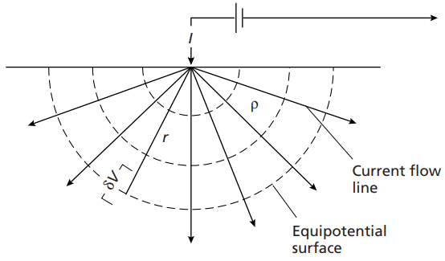
Figure 2.1: The parameters used in defining Resistivity (Reynolds, 2011)

Where ∂V/∂L represents the potential gradient through the element in voltm-1 and j the current density in Am-².
Now consider a single current electrode on the surface of a medium of uniform resistivity ρ (Figure 2.2). The circuit is completed by a current sink at a large distance from the electrode. The current flows radially away from the electrode so that the current distribution is uniform over hemispherical shells centred on the source. At a distance from the electrode, the shell has a surface area of 2πr², so the current density (j) is given by equation (2.3).
$j= \frac{I}{2πr\text{2}}$ (2.3)
From equation (2.2), the potential gradient associated with this current density in equation (2.3) can be written as equation (2.4).
$\frac{∂V}{∂r}= - ρj= -\frac{ρI}{2πr^{2}}$ (2.4)
The potential V_{r} at distance r is then obtained by integration of equation (2.4).
$V_{r}= \int{∂V= -\int{\frac{ρI∂r}{2πr^{2}}=\frac{ρI}{2πr^{2}}}}$ (2.5)
The constant of integration is zero since Vr = 0 when r = Φ. Equation (2.5) allows the calculation of the potential at any point on or below the surface of a homogenous half-space. The hemispherical shells in Figure 2.2 mark surfaces of constant voltage and are termed equipotential surfaces (Kearey et al., 2002). Figure 2.3 shows the flow pattern of the current in a vertical section through ‘tubes’ in a uniform half-space.
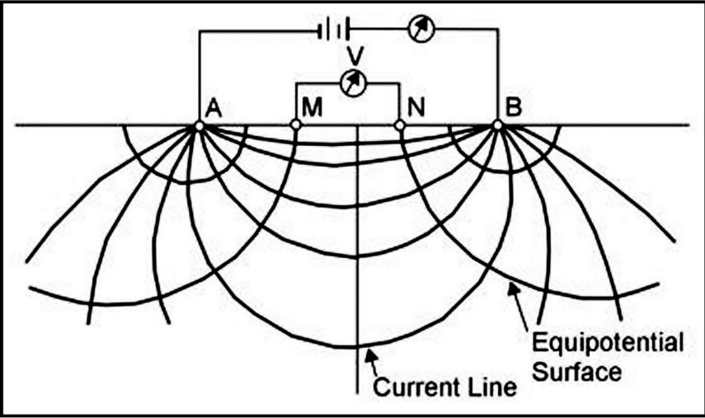
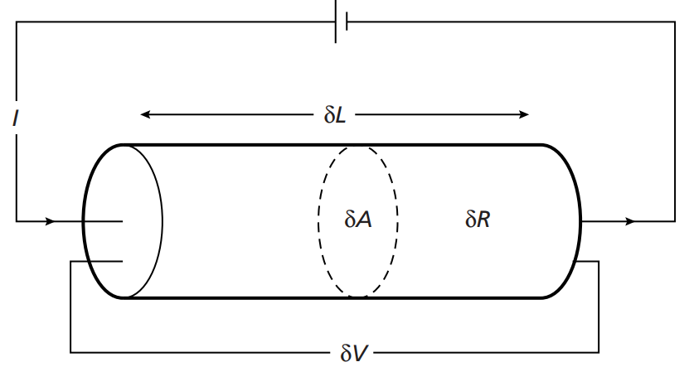
Figure 2.2: Current Flow from a Single Surface Electrode (Reynolds, 2011)
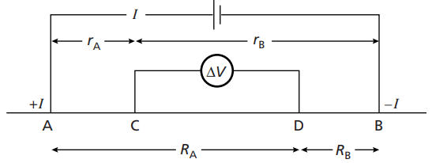
Figure 2.3: Equipotential and Current lines for a pair of current electrodes A and B on a homogenous half-space (Reynolds, 2011)
Figure 2.4: The Generalized form of the Electrode Configuration (Reynolds, 2011
Geometric factors are not affected by interchanging current and voltage electrodes but voltage electrode spacing are normally kept small to minimize the effects of natural potential (John, 2003).
- A and B represents the current electrodes
- C and D represents the potential electrodes
- I represent current
- ΔV represents Potential differences.
The generated form of the electrode configuration used in resistivity measurement was shown in Figure 2.4. V_{C}, at an internal electrode C, is the sum of the potential contributions V_{A} and V_{B} from the current source at A and the sink at B.
$V_{C}=\frac{ρI}{2π}\left[\frac{1}{r_{A}}-\frac{1}{r_{B}}\right]$ (2.6)
Similarly, also V_{D} in equation (2.7) is also generated as:
$V_{D}=\frac{ρI}{2π}\left[\frac{1}{R_{A}}-\frac{1}{R_{B}}\right]$ (2.7)
Absolutely potentials are difficult to monitor so the potential difference ΔV between electrodes C and D is measured as shown in equation (2.8),
$ΔV=V_{C}-V_{D}=\frac{ρI}{2π}\left\{\left[\frac{1}{r_{A}}-\frac{1}{r_{B}}\right]-\left[\frac{1}{R_{A}}-\frac{1}{R_{B}}\right]\right\}$ (2.8)
Thus, equation (2.8) can be written for ρ as stated in equation (2.9),
$ρ= \frac{2πΔV}{I\left[\left[\frac{1}{r_{B}}-\frac{1}{r_{B}}\right]-\left[\frac{1}{R_{A}}-\frac{1}{R_{B}}\right]\right]}$ (2.9)
Where the ground is uniform, the resistivity calculated from equation (2.9) should constant and independent of both electrodes spacing and surface location. When subsurface inhomogeneity exist however, the resistivities will vary with the relative positions of the electrodes. Any computed value is then known as the apparent resistivity $ρ_{a}$and will be a function of the form of the inhomogeneity.
In effect therefore, depth of current penetration increases with increase in current electrode separation in homogenous layers (Telford et al., 1990).
- Electrode Configuration
The electrical resistivity method utilizes different electrode configurations (or arrays) to probe the subsurface and, although several are occasionally employed in specialized surveys, only two are in common use (Kearey et al., 2002). This configuration depends on the mode of arrangement of the current and potential electrodes relative to one another. The various types of electrode configurations include but not limited to Wenner, Schlumberger, Dipole-Dipole, Gradient and Square arrays (Reynolds, 2011).
- Wenner Electrode Array
In the Wenner configuration (Figure 2.5), the current and potential electrode pairs have a common mid-point and the distances between adjacent electrodes are equal to “a”. Substituting this condition into equation (2.9) generates equation (2.10) as shown as:
$ρ_{a}=2πa\frac{∇V}{I}$ (2.10)
During VES, the spacing “a” is gradually increased about a fixed central point and in CST the whole spread is moved along a profile with a fixed value of “a”.
- C1 and C2 – current electrodes
- P1 and P2 – potential electrodes
- k – Geometric factor
- a – Electrode spacing.
- Schlumberger Electrode Array
In the Schlumberger configuration (Figure 6), the current and potential pairs of electrodes often also have a common mid-point, but the distances between adjacent electrodes differs. Let parameter “a” represents the distances between one of the current electrodes to the reference point while “b” denotes the distance between two potential electrodes. In substituting the parameter $\left[a-\frac{b}{2}\right]$ and $\left[a+\frac{b}{2}\right]$ into equation (2.9), yields $ρ_{a}$ as expressed in equation (2.11),
$ρ_{a}=\frac{πa^{2}}{b}\left[1-\frac{b^{2}}{4a^{2}}\right]R$; a ≥ 5b (2.11)
- C1 and C2 – current electrodes
- P1 and P2 – potential electrodes
- a – Distance of the current electrode spacing to the reference point
- b – Distance between the two potential electrodes.
- x – Reference point.
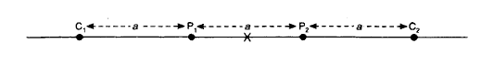
Figure 2.5: Wenner Configuration Array Type (Reynolds, 2011)
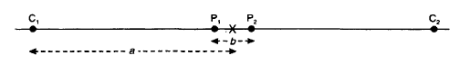
Figure 2.6: Schlumberger Configuration Array Type (Reynolds, 2011)
- Factors Affecting Resistivity of Subsurface Materials
The factors affecting earth resistivity include the following:
- Porosity: The empirical formula developed by Archie (1942) in equation (2.12) for the effective resistivity of a rock formation which takes into account the porosity (φ), the fraction(s) of the pores containing water, and the resistivity of the water $ρ_{w}$ is expressed as:
$ρ=aφ^{-m}s^{-n}ρ_{w}$ (2.12)
Where ρ and $ρ_{w}$ are the effective rock resistivity, and the resistivity of the pore water, respectively; φ is the porosity; s is the volume fraction of pores with water; a, m and n are constants where 0.5 ≤ a ≤2.5, 1.3 ≤ m ≤ 2.5, and n ≈ 2.
The ratio $\frac{ρ}{ρ_{w}}$ is known as the Formation factor (F).
- Permeability: Archie’s relationship notwithstanding, a rock with a non-conducting matrix must be permeable as well as porous to conduct electricity. Permeability (k) has a direct relationship with porosity and logarithmic relationship as shown in equation (2.13) and (2.12) (Olorunfemi and Griffiths, 1985):
$φ=aK^{b}$ (2.13)
$Logφ=Loga+LogK$ (2.14)
φ= porosity, k = permeability, a and b are constants.
These relationships hold for clean sand and saline water saturated shaly sand. The clean sand shows that the resistivity decreases with increase in permeability while the shaly sand resistivity increases with permeability.
- Temperature: The mobility of ion and the viscosity of fluid are affected by temperature. The lower the viscosity the more mobile the ions become which is caused by higher temperature. Hence, the resistivity becomes lower and the conductivity tend to be higher. According to Keller and Frischknecht (1966), the resistivity of rock at temperature t is given by the equation (2.15).
$ρ_{t}=\frac{ρ_{18}}{1+a (t-18)}$ (2.15)
Where $ρ_{t}=$ Resistivity of rock at temperature t
$ρ_{18}=$ Resistivity of rock at 18⁰C
a = Temperature coefficient of resistivity
t = Temperature
- Volume and concentration of electrolyte: From the Archie equation Archie (1942) has expressed in equation (2.16),
$ρ_{r}=aφ^{-m}S^{-n}ρ_{w}$ (2.16)
$S_{w}$is the degree of fluid saturation and $ρ_{w }$is the resistivity of fluid.
As the concentration of ions in the electrolyte, $ρ_{w }$decreases causing the conductivity to increase in the medium.
- Matrix Resistivity: If the matrix resistive, the resistivity of the rock itself increases as shown by the equation (2.15) (Patnode and Wyllie, 1950),
$\frac{1}{ρ_{r}}=\frac{1}{ρ_{m}}+\frac{1}{Fρ_{w}}$ (2.17)
Where $ρ_{r }$ is the resistivity of rock (bulk), $ρ_{m}$ is the matrix resistivity, $ρ_{w}$ is the saturated fluid resistivity and F is the formation factor.
The equation (2.15) is applicable to shaly sand or sandstone.
- Rock Type: Resistivity of rocks varies with one rock type to another due to variation in textural type as well as variations in the geological processes that gave rise to the rock.
2.2.4 Limitations of the Electrical Resistivity Method
- Ambiguity in the interpretation. Thus, there is need for independent geophysical and geological controls to discriminate between valid alternative interpretations of the resistivity data (Kearey et al., 2002).
- Limitation of interpretation to simple structural configurations. Any deviation from these simple situations may be impossible to interpret.
- Effects of near-surface resistivity and topography variations can mask the effects of deeper variations (Kearey et al., 2002).
- Limitation of depth of penetration by the maximum electrical power that can be introduced into the ground and by the physical difficulties of laying out long length of cables (Kearey et al., 2002).

- BASIC THEORY OF SEISMIC PROSPECTING METHOD
- Introduction
In seismic surveying, seismic waves are created by a controlled source and propagate through the subsurface. Some waves will return to the surface after refraction or reflection at geological boundaries within the subsurface. Instruments distributed along the surface detect the ground motion caused by these returning waves and hence measure the arrival times of the waves at different ranges from the source. These travel times may be converted into depth values and, hence, the distribution of subsurface geological interfaces may be systematically mapped.
The most common application of the seismic refraction technique is to resolve variability in the depth to the top of a refractor (e.g., bedrock) and the seismic velocity within it. However, the method can also be used to determine rippability of materials for excavation, the degree of weathering within the top of bedrock, rock strength, thickness of saturated aquifers, location of weathered fault zones, etc.
- Concept of Theories
- Seismic Waves
Seismic waves are parcels of elastic strain energy that propagate outwards from a seismic source such as an earthquake or an explosion. Sources suitable for seismic surveying usually generate short-lived wave trains, known as pulses, which typically contain a wide range of frequencies. The elastic moduli and densities of the materials through which they pass (Telford et al., 1990; Kearey et al., 2002; Reynolds, 2011) determine the propagation velocities of seismic pulses.
When seismic energy is released suddenly at a point (P) near the surface of a homogeneous medium (Figure 2.7), part of the energy propagates through the body of the medium as seismic body waves. The remaining part of the seismic energy spreads out over the surface as a seismic surface wave, analogous to the ripples on the surface of a pool of water into which a stone has been thrown (Lowrie, 2007; Reynolds, 2011).
When a body wave reaches a distance r from its source in a homogeneous medium, the wavefront (defined as the surface in which all particles vibrate with the same phase) has a spherical shape, and the wave is called a spherical wave. The direction perpendicular to the wavefront is called the seismic ray path.
Seismic body waves can be subdivided into two classes of waves:
- P waves: are also called primary waves, because they propagate through the medium faster than the other wave types. In P-waves, particles constituting the medium are displaced in the same direction that the wave propagates, in this case, the radial direction. Thus, material is being extended and compressed as P-waves propagate through the medium. P-waves are analogous to sound waves propagating through the air. P-waves also known as compressional and longitudinal waves (Figure 2.8 a).
The velocity of P-waves V_{p =} $\sqrt{\frac{K + 4/3µ}{ρ}}$ (2.18)
where (K) Bulk modulus, (μ) Shear modulus, and (ρ) density (Kearey et al., 2002; Lowrie, 2007; Reynolds, 2011).

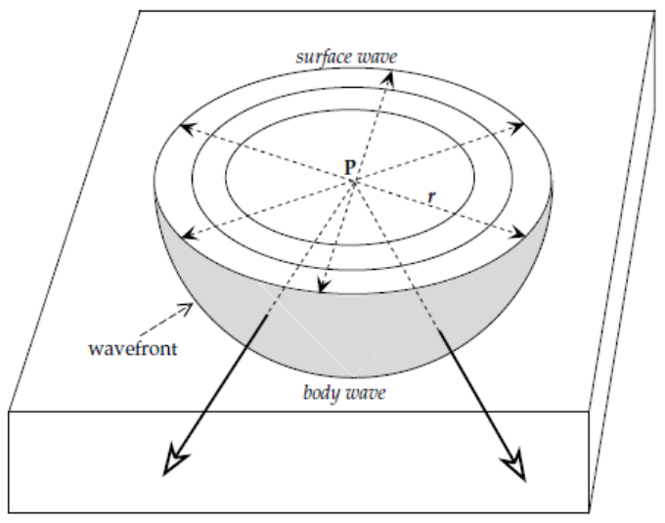
Figure 2.7: Propagation of a seismic disturbance from a point source (P) near the surface of a homogeneous medium; the disturbance travels as a body wave through the medium and as a surface wave along the free surface (Lowrie, 2007).

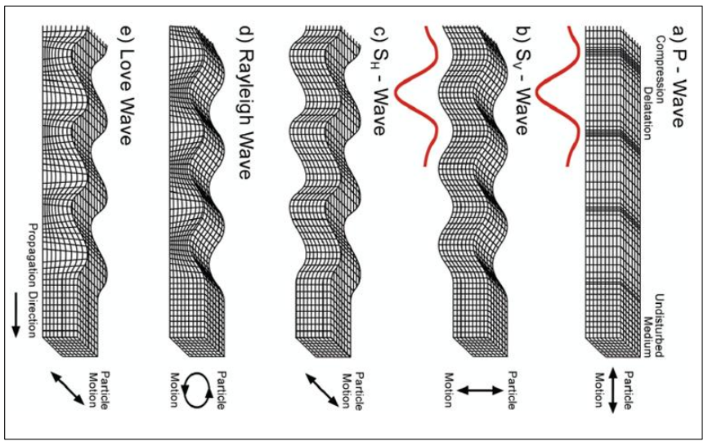
Figure 2.8: Propagation of seismic waves (Kearey et al., 2002).

- S waves: are sometimes called secondary waves, because they propagate through the medium slower than P-waves. In S-waves, particles constituting the medium are displaced in a direction that is perpendicular to the direction that the wave is propagating. In this example, as the wave propagates radially, the medium is being deformed along spherical surfaces. S-waves also called transverse and shear waves (Figure 2.8 c).
The velocity of S-waves V_{s} = $\sqrt{\frac{µ}{ρ}}$ (2.19)
where (μ) Shear modulus, and (ρ) density (Telford et al., 1990; Kearey et al., 2002; Lowrie, 2007; Reynolds, 2011).
Seismic Surface waves travel along the Earth's surface (Telford et al., 1990; Kearey et al., 2002; Lowrie, 2007; Reynolds, 2011). These waves can be subdivided into:
- Rayleigh Waves: also called ground roll, are surface waves that travel as ripples with motions that are similar to those of waves on the surface of water. In a homogenous earth, Rayleigh waves would not be dispersive. In a two-layer earth, Rayleigh waves become dispersive when their wavelengths are in the range of 1 to 30 times the thickness of the top layer. Generally, longer wavelengths penetrate to greater depths and are more sensitive to the elastic properties of deeper layers while shorter wavelengths are sensitive to the elastic properties of shallow layers. They are slower than body waves, roughly 90% of the velocity of S waves for typical homogeneous elastic media (Figure 2.8 d).
- Love Waves: are horizontally polarized shear waves (SH waves), existing only in the presence of a semi-infinite medium overlain by an upper layer of finite thickness. They usually travel slightly faster than Rayleigh waves, about 90% of the S wave velocity, and have the largest amplitude (Figure 2.8 e).
- Snell’s Law
Snell's law also known as the law of refraction is a formula used to describe the relationship between the angles of incidence and refraction rays (Telford et al., 1990; Kearey et al., 2002; Lowrie, 2007).
When a P-wave ray is obliquely incident on an interface of acoustic impedance contrast, reflected and transmitted P-wave rays are generated as in the case of normal incidence. Additionally, some of the incident compressional energy is converted into reflected and transmitted S-wave rays (figure 2.9 a) that are polarized in a vertical plane. The transmitted P-wave ray travels through the lower layer with a changed direction of propagation (figure 2.9 b) and is referred to as a refracted ray (Kearey et al., 2002; Lowrie, 2007).
The generalized form of Snell’s Law states that, along any one ray, the ray parameter remains a constant. For the refracted P-wave ray shown in (figure 2.9 b), therefore:
$\frac{sin θ_{1}}{V_{1}} = \frac{sin θ_{2}}{V_{2}}$ (2.20)
Note that if V₂ > V₁ the ray is refracted away from the normal to the interface; that is, θ₂ > θ₁ (Kearey et al., 2002; Lowrie, 2007; Reynolds, 2011).

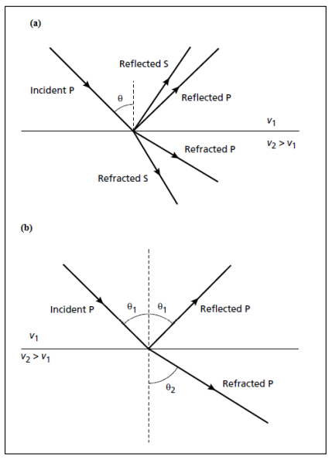
Figure 2.9: (a) Reflected and refracted P- and S-wave rays generated by a P-wave ray obliquely incident on an interface of acoustic impedance contrast., and (b) Reflected and refracted P-wave rays associated with a P-wave rays obliquely incident on an interface of acoustic impedance contrast (Kearey et al., 2002).

When the velocity is higher in the underlying layer there is a particular angle of incidence, known as the critical angle (θ_{c}), for which the angle of refraction is 90° (Kearey et al., 2002; Lowrie, 2007; Reynolds, 2011). This gives rise to a critically refracted ray that travels along the interface at the higher velocity V₂ (figure 2.10). The critical angle is given by
$\frac{sin θ_{c}}{V_{1}}$ = $\frac{sin {90}^{⸰} }{V_{2}}$ = $\frac{1}{V_{2}}$
$∴ θ_{c} = \sin^{-1}\left(\frac{V_{1}}{V_{2}}\right)$ (2.21)
      - Attenuation of Seismic Waves
The further a seismic signal travels from its source the weaker it becomes. The decrease of amplitude with increasing distance from the source is referred to as attenuation. It is partly due to the geometry of propagation of seismic waves, and partly due to anelastic properties of the material through which they travel. (Telford et al., 1990; Lowrie, 2007; Reynolds, 2011)
The most important reduction is due to geometric attenuation. Consider the seismic body waves generated by a seismic source at a point (P) on the surface of a uniform half-space (figure 2.7). If there is no energy loss due to friction, the energy (Eb) in the wavefront at distance (r) from its source is distributed over the surface of a hemisphere with area (2πr²). The intensity (or energy density, I_{b}) of the body waves is the energy per unit area of the wavefront, and at distance (r) is:
$I_{b}(r) = \frac{E_{b}}{{2πr}^{2}}$ (2.22)

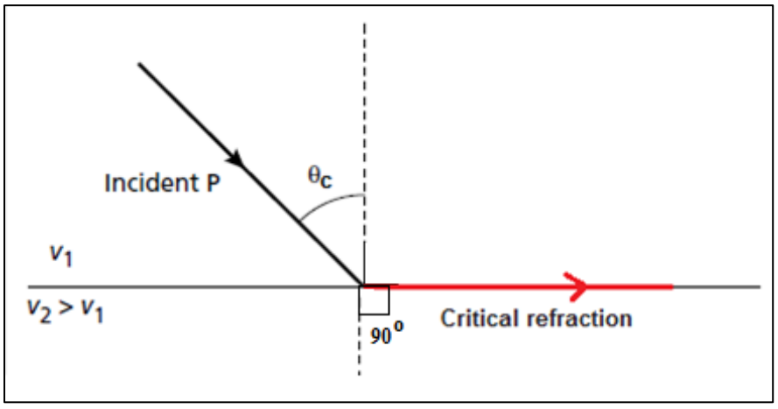
Figure 2.10: Critical refracted ray (Kearey et al., 2002)

The surface wave is constricted to spread out laterally. The disturbance affects not only the free surface but extends downwards into the medium to a depth (d), which we can consider to be constant for a given wave (figure 2.7). When the wavefront of a surface wave reaches a distance r from the source, the initial energy (E_{s}) is distributed over a circular cylindrical surface with area (2πrd). At a distance (r) from its source, the intensity of the surface wave is given by:
$I_{s}(r) = \frac{E_{s}}{2πrd}$ (2.23)
These equations show that the decrease in intensity of body waves is proportional to $\left(\frac{1}{r^{2}}\right)$, while the decrease in surface wave intensity is proportional to $\left(\frac{1}{r}\right)$.
Another reason for attenuation is the absorption of energy due to imperfect elastic properties. If the particles of a medium do not react perfectly elastically with their neighbours, part of the energy in the wave is lost (reappearing, for example, as frictional heat) instead of being transferred through the medium. This type of attenuation of the seismic wave is referred to as anelastic damping (Telford et al., 1990; Kearey et al., 2002).
- Refraction at a Horizontal Interface
The refraction method is illustrated for the case of the flat interface between two horizontal layers in figure 2.11. Let the depth to the interface be (d) and the seismic velocities of the upper and lower layers be (V₁) and (V₂) respectively (V₁<V₂). The direct ray from the shot point at (S) is recorded by a geophone (G) at distance (x) on the surface after time (x ⁄ V₁). The travel-time curve for the direct ray is a straight line through the origin with slope (m₁ = 1 ⁄ V₁). The hyperbolic t–x curve for the reflected ray intersects the time axis at the two-way vertical reflection “echo” time (t₀).
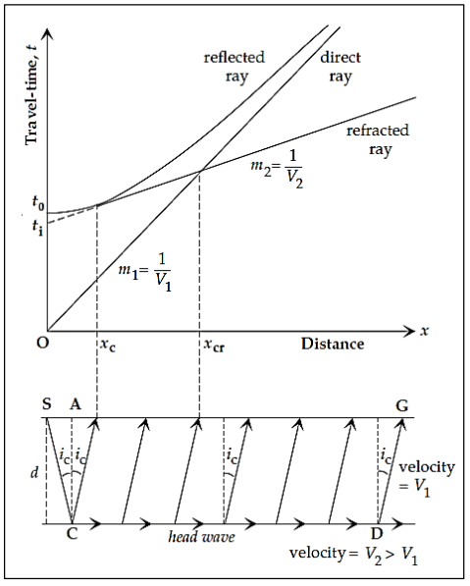
Figure 2.11: Travel-time versus distance curves for the direct ray and the reflected and refracted rays at a horizontal interface between two layers with seismic velocities V₁ and V₂

At great distances from the shot-point, the reflection hyperbola is asymptotic to the straight line for the direct ray (Kearey et al., 2002; Lowrie, 2007; Reynolds, 2011).
The doubly refracted ray travels along the path (SC) with the velocity (V₁) of the upper layer, impinges with critical angle (i_{c}) on the interface at (C), passes along the segment (CD) with velocity (V₂) of the lower layer, and returns to the surface along (DG) with velocity (V₁). The segments (SC) and (DG) are equal, (CD = x – 2SA) and the travel-time for the path (SCDG) can be written:
$t = \frac{2Sc}{V_{1}} + \frac{CD}{V_{2}} = \frac{2d}{V_{1}cos i_{c}} + \frac{x - 2dtani_{c}}{V_{2}}$ (2.24)
Rearranging terms and using Snell’s law (eq. 2.4), we get for the travel-time of the doubly refracted ray:
$t = \frac{x}{V_{2}} + \frac{2d}{V_{1}}cosi_{c}$ (2.25)
The doubly refracted rays are only recorded at distances greater than the critical distance (x_{c}). The first arrival recorded at (x_{c}) can be regarded as both a doubly refracted ray and a reflection. The refraction t–x curve is found to intersect the time axis at the intercept time (t_{i}), given by:
$t_{i}= \frac{2d}{V_{i}}cosi_{c}=2d\frac{\sqrt{V_{2}^{2}- V_{1}^{2}}}{V_{1}∙ V_{2}}$ (2.26)
Close to the shot-point, the direct ray is the first to be recorded. However, the doubly refracted ray travels part of its path at the faster velocity of the lower layer, so that it eventually overtakes the direct ray and becomes the first arrival. The straight lines for the direct and doubly refracted rays cross each other at this distance, which is accordingly called the crossover distance, (x_{cr}):
$x_{cr}=2d ∙ \sqrt{\frac{V_{2}+ V_{1}}{V_{2}- V_{1}}}$ (2.27)
- Refraction at an Inclined Interface
In practice, the refracting interface is often not horizontal. The assumption of flat layers then leads to errors in the velocity and depth estimates. When the refractor is suspected to have a dip, the velocities of the beds and the dip of the interface can be obtained by shooting a second complementary profile in the opposite direction. Suppose a refractor dips at an angle (θ) as in (figure 2.12). Shot-points (A) and (B) are located at the ends of a geophone layout that covers (AB). Let (d_{A}) and (d_{B}) be the perpendicular distances from the shot-points (A) and (B) to the interface at (P) and (Q), respectively (Kearey et al., 2002; Lowrie, 2007; Reynolds, 2011).
For the down-dip shot at A the travel-time to distance x is given by:
$$t_{d}= \frac{AC+DB}{V_{1}}+ \frac{CD}{V_{2}}= \frac{\left(d_{A}+ d_{B}\right)}{V_{1} cosi_{c}}+ \frac{xcosθ-\left(d_{A}+ d_{B}\right)tani_{c}}{V_{2}}$$
$$= \frac{xcosθ}{V_{2}}+ \frac{\left(d_{A}+ d_{B}\right)}{V_{1}}cosi_{c}$$
Since, d_{B} = d_{A} + x sin θ, and sin i_{c} = V₁/ V₂
$$t_{d}= \frac{xsini_{c}cosθ}{V_{1}}+ \frac{xcosi_{c}sinθ}{V_{1}}+ \frac{{2d}_{A}cosi_{c}}{V_{1}}$$
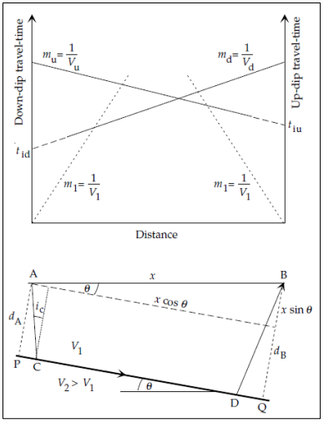
Figure 2.12: Travel-time versus distance curves of direct and refracted rays for up-dip and down-dip profiles when the refracting boundary dips at angle θ (Lowrie, 2007).

$∴ t_{d}= \frac{x}{V_{1}}sin\left(θ+ i_{c}\right)+ t_{id}$ (2.28)
Where (t_{id}) is the intercept time for the down-dip shot.
The analysis for shooting in the up-dip direction is analogous and gives:
$∴ t_{u}= \frac{x}{V_{1}}sin\left(i_{c}- θ\right)+ t_{iu}$ (2.29)
Where (t_{iu}) is the intercept time for the up-dip shot.
- Seismic Wave Velocities of Rocks
By virtue of their various compositions, textures, porosities and contained pore fluids, rocks differ in their elastic moduli and densities and, hence, in their seismic velocities (Telford et al., 1990; Kearey et al., 2002; Reynolds, 2011). Information on the compressional and shear wave velocities, (Vp) and (Vs), of rock layers encountered by seismic surveys is important for two main reasons:
- Firstly, it is necessary for the conversion of seismic wave travel times into depths;
- Secondly, it provides an indication of the lithology of a rock or, in some cases, the nature of the pore fluids contained within it.
Sandstone and shale velocities have a systematic increase with depth of burial and with age, due to the combined effects of progressive compaction and cementation (Telford et al., 1990; Kearey et al., 2002; Lowrie, 2007).
Table 2.1: Compressional wave velocities in Earth materials (Kearey et al., 2002).
Vp(kms⁻¹) |  | Vp(kms⁻¹)
Unconsolidated materials |  | Igneous/Metamorphic rocks
Sand (dry) | 0.2 – 1.0 | Granite | 5.5 – 6.0
Sand (water-saturated) | 1.5 – 2.0 | Gabbro | 6.5 – 7.0
Clay | 1.0 – 2.5 | Ultramafic rocks | 7.5 – 8.5
Glacial till (water-saturated) | 1.5 – 2.5 | Serpentinite | 5.5 – 6.5
Permafrost | 3.5 – 4.0 | Pore fluids
Sedimentary rocks |  | Air | 0.3
Sandstones | 2.0 – 6.0 | Water | 1.4 – 1.5
Tertiary sandstone | 2.0 – 2.5 | Ice | 3.4
Permanent sandstone (Carboniferous) | 4.0 – 4.5 | Petroleum | 1.3 – 1.4
Cambrian quartzite | 5.5 – 6.0 | Other materials
Limestone | 2.0 – 6.0 | Steel | 6.1
Cretaceous chalk | 2.0 – 2.5 | Iron | 5.8
Jurassic oolites and bioclastic limestones | 3.0 – 4.0 | Aluminium | 6.6
Carboniferous limestone | 5.0 – 5.5 | Concrete | 3.6
Dolomites | 2.5 – 6.5
Salt | 4.5 – 5.0
Anhydrite | 4.5 – 6.5
Gypsum | 2.0 – 3.5
Shale | 1.8 – 4.9

- Poisson’s ratio (σ)
Poisson’s ratio (σ) is the ratio of decrease in the thickness (lateral contraction) of a body being pulled (under a tensile load) to its increase in length (longitudinal extension) (Kearey et al., 2002; Lowrie, 2007).
$σ= - \frac{ε lateral}{ε longitudinal}$ (2.30)
The ratio Vp/Vs in any material is determined solely by the value of Poisson’s ratio (σ) for that material.
$\frac{V_{p}}{V_{s}}= \sqrt{\frac{2 (1- σ)}{(1-2σ)}}$ (2.31)
Since Poisson’s ratio for consolidated rocks is typically about 0.25, Vp ≈ 1.73 Vs. (Kearey et al., 2002).
While knowledge of the P-wave velocity is useful, it is a function of three separate properties of the rock and is only a very ambiguous indicator of rock lithology. The Vp/Vs ratio, however, is independent of density and can be used to derive Poisson’s ratio, which is a diagnostic lithological indicator. If this information is required, then both Vp and Vs must be determined in the seismic survey (Kearey et al., 2002).
- Limitations of Seismic Refraction Method
- The existence of certain beds or layers with insufficient velocity contrast or thickness cannot be detected by the refraction method. These layers called hidden layers or blind zones.
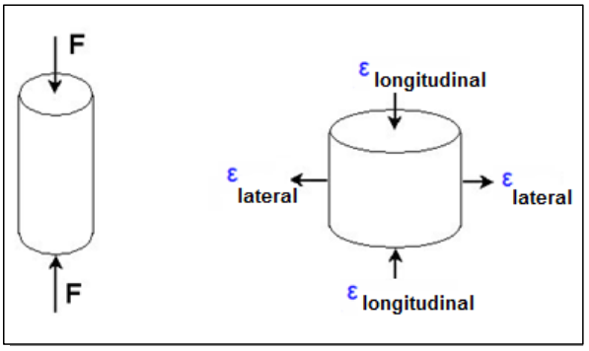
Figure 2.13: Poisson Ratio Example

- Seismic refraction observations require relatively large source-receiver offsets (distances between the source and where the ground motion is recorded, the receiver).
- Seismic refraction only works if the speed at which motions propagate through the Earth increases with depth.
- Seismic refraction observations are generally interpreted in terms of layers. These layers can have dip and topography.
- Seismic refraction observations only use the arrival time of the initial ground motion at different distances from the source (i.e., offsets).
- REGIONAL GEOLOGY OF STUDY AREA
The Quaternary Alluvium deposits of the southwestern Nigeria generally underlie the site. This alluvium deposit consists clayey poorly sorted coarse sand with clay lenses and occasional pebbles. The geology of Ogun State comprises sedimentary and basement complex rocks. The rock is soft and brittle but, in some places, cemented by iron and silicon containing materials. The basement complex is essentially non-porous and water can only be contained in the crevices of the complex. This basement complex primarily underlies the sedimentary layers, which consist of Cretaceous, Tertiary and Quaternary sediments deposited in the coastal basin. The sedimentary rock of Ogun
State consists of the Abeokuta formation, which lies directly above the basement complex and is in turn overlain by the Ewekoro, Oshosun and Ilaro formations. Coastal plain sands (Benin formation) overlie these formations (Fig. 2.14).

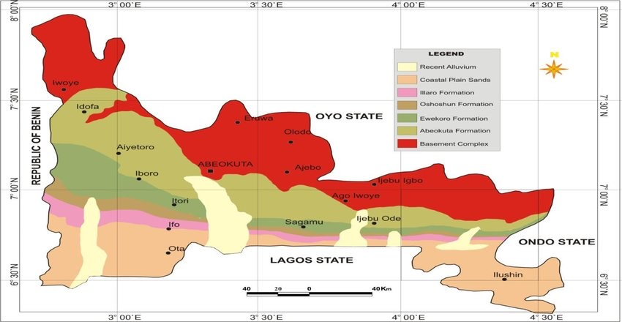
Study Area
Figure 2.14: Geological map of Ogun State showing Dahomey Basin and the extracted study area (NGSA, 2006).

- Stratigraphy of the Dahomey Basin
The tertiary sediments of the Dahomey Basin thin out and are particularly cut off from the sediments of the Niger Delta basin against the Okitipupa ridge of the basement complex (Omatsola and Adegoke, 1981).
The basin is bounded on the west by faults and other tectonic structures associated with the landwards extension of the Romanche fracture zone (Adegoke et al., 1981). The Benin hinge line similarly marks its eastern limit. It is a major fault structure marking the western limit of the Niger Delta basin (Omatsola and Adegoke, 1981). The oldest dated sediments onshore consist of lower cretaceous grits and sandstones with thin inter-bedded mudstones (Omatsola and Adegoke, 1981).
The most recent and detailed Stratigraphy is that of Omatsola and Adegoke, (1981). They proposed three new easily recognized lithostratigraphic units of formation rank which are: The Ise formation, The Afowo formation, and the Araromi formation. These units make up the Abeokuta Group. Others are the Ewekoro formation, Oshosun formation and Ilaro formation.
- Tectonic History of Dahomey Basin
The West-African coastal basins were initiated during the Mesozoic (Jurassic - Cretaceous) in response to the separation of the African – South American landmasses and the subsequent opening of the Atlantic Ocean. Available stratigraphic evidence suggests that the deposition was initiated in the fault-controlled depression on the crystalline basement complex (Omatsola and Adegoke, 1981). Earlier work on Dahomey revealed that rifting generated a basement subsidence, during the lower Cretaceous (Neocomian) resulted in the deposition of a very thick sedimentary sequence of continental grits and pebbly sand over the entire basin (Omatsola and Adegoke, 1981).
Omatsola and Adegoke, (1981), indicated that there was another period of major tectonic activities, which was associated with the closure, and folding of the Benue trough was observed during the late cretaceous (Santonian) time. Rocks such as granite, gneiss and associated pegmatite as well as the sediments in the Dahomey basin were tilted and blocks faulted. The upliftment and block faulting were accompanied by erosional activities.
CHAPTER THREE
FIELD METHODOLOGY
  - INTRODUCTION
This chapter provides a detailed description of the four geophysical techniques and methodology used for data acquisition and data processing. The methods were used because of their ability to delineate the extent of sub-soil variation in both laterally and vertically in depth based on sub-soil physical properties. A detailed description of the data acquisition procedure is discussed as follows.
  - ELECTRICAL RESISTIVITY METHOD
    - Instrumentation
The field materials used are listed below:
- ABEM SuperSting R8
- ABEM SuperSting R1
- Non-polarized electrodes
- Multicore Cable
- Hammer
- Meter Rule
- GPS
    - Method Employed
The Electrical Resistivity method were employed using the 2-D dipole dipole Electrical Resistivity Tomography and the Vertical Electrical Sounding (VES) techniques.

    - Data Acquisition
The ABEM SuperSting R8 (Fig 3.1a) with 112 non-polarized electrodes was used for the 2-D Electrical Resistivity data acquisition along six (6) traverses with a spread of 224 m. Measurements were taken at an electrode spacing of 2 m using the dipole dipole array method.
While, ABEM SuperSting R1 (Fig 3.1b) with two (2) current electrodes and (2) potential electrodes was used for the Vertical Electrical Sounding using the Schlumberger array, the survey was carried out along seven (7) lines and the Resistance (Ω) of the soil at these points were recorded.
    - Data Processing
      - Electrical Resistivity Tomography (ERT)
EarthImager 2D software was used for the inversion of the 2-D resistivity data. The field data pseudo section and the 2D resistivity structure were produced after running the inversion of the raw data to fill out noise.
      - Vertical Electrical Sounding (VES)
The qualitative interpretation of the depth sounding curves was carried out based on distinctive geoelectric characteristics on the number of layers represented by the four types of auxiliary curves (H, K, A and Q) and also from the profiles and maps which involves inspection for patterns/anomaly signatures that are diagnostic of the target. The quantitative interpretation of the depth sounding curves was carried out by adopting the partial curve matching technique (Bhattacharya and Patra, 1968). In order to do this, the VES data were plotted on a transparent overlay. The partial curve matching technique involved the use of a standard two (2) layer master
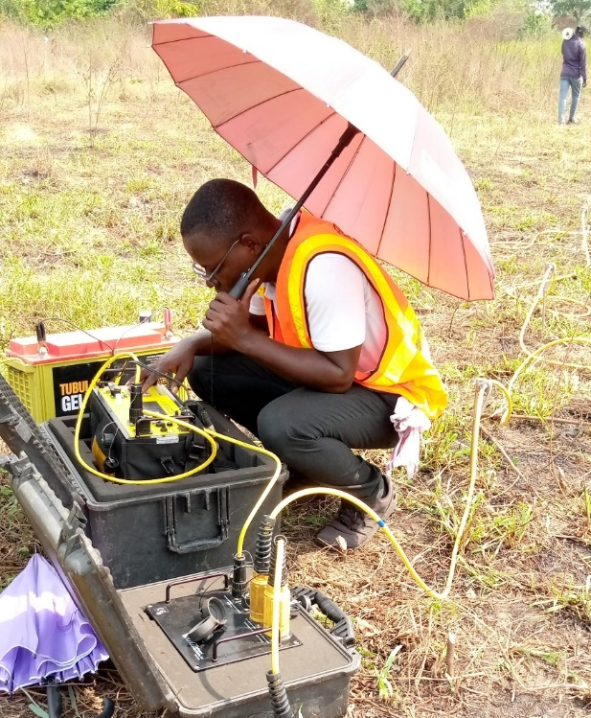
(a)

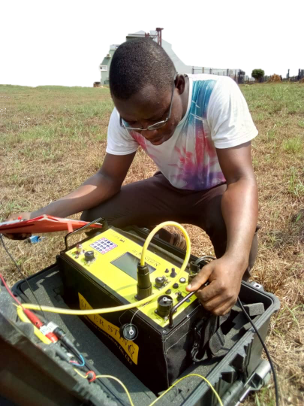
(b)

Figure 3.1: (a) ABEM SuperSting R8, (b) ABEM SuperSting R1
curve and four (4) auxiliary type curves (H, K, A and Q). This procedure requires segment-by- segment curve matching starting from the position with shorter electrode spacing and moving towards those with longer spacing. The result of the VES curves obtained from the partial curve matching were then used to constrain the interpretation by the computer using iteration software known as WINRESIST. This invariably reduces over estimation of depths. The result of the computer iteration shows the qualitative analysis to know the resistivity, thickness and depth. The vertical electrical sounding (VES) results are presented as depth sounding curve obtained from the interpreted data using the WINRESIST software.
  - SEISMIC REFRACTION TOMOGRAPHY
The velocity of sound travelling through the sub-surface varies with material composition and compaction. Seismic energy transmitted from a source at the surface will undergo refraction at boundaries between different media and eventually return to the surface. Seismic refraction surveying makes use of this phenomenon to determine ground structure by observing the time taken for energy to travel through the subsurface (Reynolds, 2011).
Seismic refraction surveying requires three components: a seismic source to generate the signal, a signal-enhancement seismograph to control the survey and record the data, and a series of geophones to detect the arrival of seismic waves at multiple points on the ground surface. Note that for convenience, the passage of seismic energy through the ground is usually represented as raypaths, although the energy is actually travelling as waves.

    - Instrumentation
Seismic refraction surveying requires the following equipment (figure 3.2):
- An accelerated weight drops.
- A group of 48 vertical geophones of 4.5 Hz.
- Seismic land cables and wire reel.
- ABEM Terraloc Pro
- Battery.
- Global Positioning System device (GPS).
Forty-eight (48) geophones are fixed on the ground surface and connected with a two seismic land cables with forty-eight (48) take out. These seismic cables are used for sending the electric pulse from each geophone to the seismograph to record the seismic signals. A 25 kg accelerated weight drop striking on a metal plate generated the seismic source. During the survey, two offset shots and seven split shots were applied to enhance the processing. The seismic spread lines used 2 m of geophone spacing interval for all lines.
The digital seismograph used during the acquisition was ABEM Terraloc Pro, which has a wide range of sampling rates, where the sample rate used during the survey is 100 μs and the window time length is 4096 ms.
After setting up the instrument, the operator adjusts the digital seismograph and confirms the stand-by of the shooter. The operator monitors the noise condition on seismograph and instructs the shooter for shooting during the lowest possible or acceptable noise.

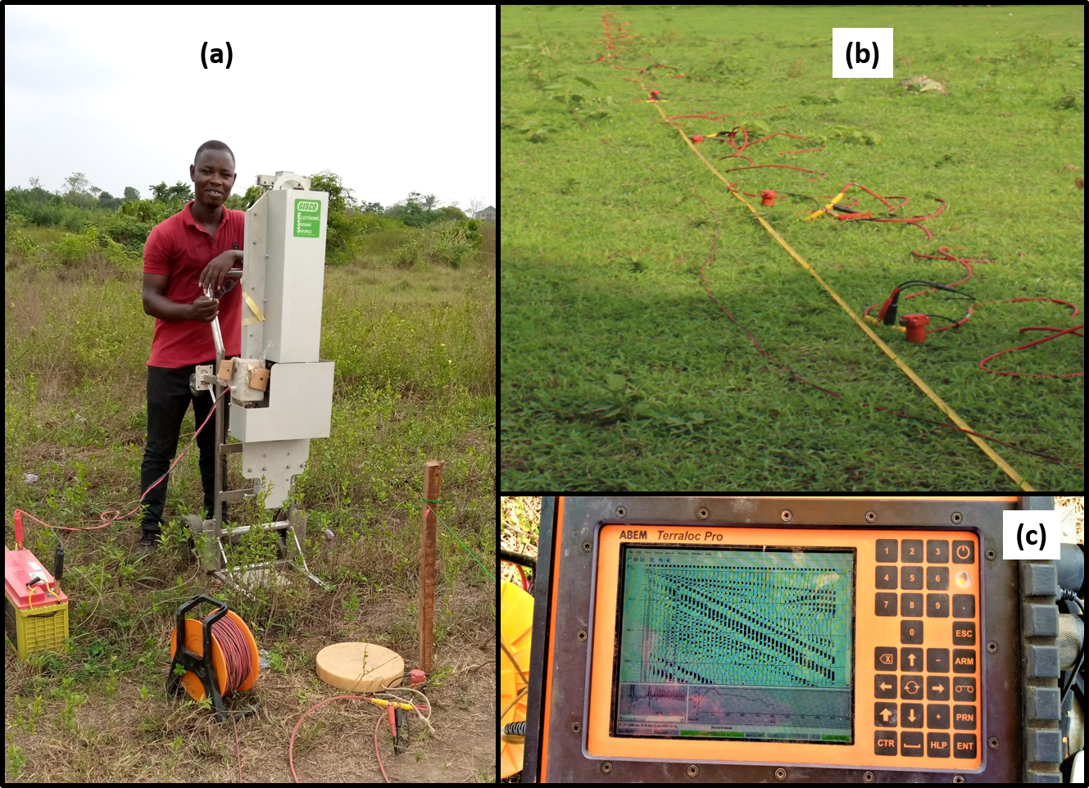
Figure 3.2: (a) Accelerated weight drop, (b) 4.5 Hz Geophones, Seismic and Land Cables, (c) Seismogram

    - Field Operation
The seismic wave travels down and along the different refractor boundaries. Only critically refracted waves are concerned in seismic refraction survey. The refracted energies are detected by the geophones. After that, it is converted to digital signals before storing in the stacking memory. The seismograph amplifies the electrical signal from several thousand to several ten thousand times and recorded the results in the floppy disk as the waveform data.
Three seismic lines were carried out in the study area based on the research objective and interest and pervious work. The seismic lines have been used to investigate the shallow subsurface structures, and to study the variation in the shear wave velocities in the study area. The length of the spread line for Traverse TR2 is 128 m with 17 geophones overlapping in the second profile (figure 3.3 – Case I), Traverse TR3 is 132 m with 19 geophones overlapping (figure 3.3 – Case II), and Traverse TR4 is 142 m with 24 geophones overlapping (figure 3.3 – Case III). During the survey the longitude, latitude, and elevation must be detected for each shot point location by using the GPS.
      - Sample Rate
The seismic is a continuous time function. In digital record, the seismic signal is sampled at fixed time rate called sample interval or sample rate (∆τ). This step is very important to allow digital processing of the signal and to reduce the large data volumes recorded. Nyquist frequency (f_{Nq}) is the highest frequency that can be stored accurately. To ensure no loss of useful signal the sampling frequency must be at least twice the highest frequency contained in the signal. Aliasing is the misrepresentation of the frequencies higher than the Nyquist frequency, where those frequencies fold back into the spectrum of the discrete time and appear as low frequencies.
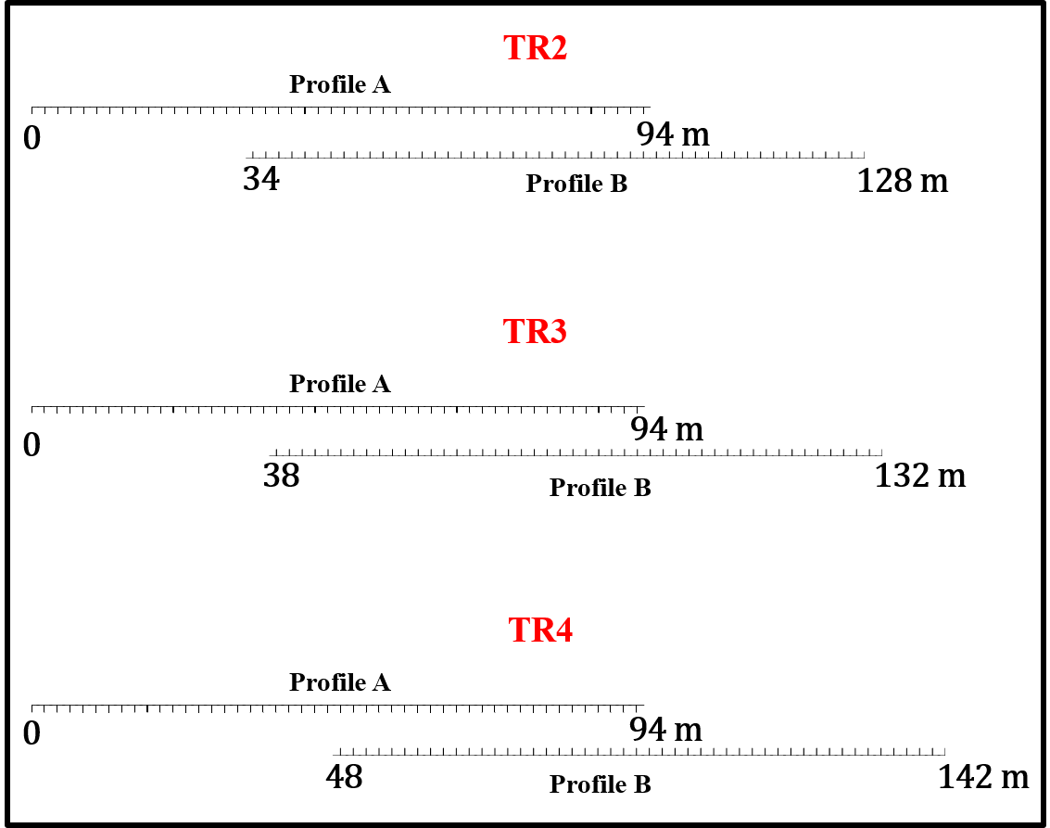
Figure 3.3: Seismic Refraction Data Acquisition Geometry

$$f_{Nq} = \frac{1}{2∆r}$$
Where (∆τ) is the sample rate.
The digital seismograph used during the acquisition was ABEM Terraloc Pro, which has a wide range of sampling rates (from 20 μs to 10 ms). So, the sample rate used during the survey is 100 μs and the window time length is 102.4 ms, so the Nyquist frequency will equal 5 Hz.
      - Stacking
Stacking plays an important role in improving signal-to-noise ratio and imaging quality of seismic data. Seismic traces from the same shot point in each spread line are gathered together and summed, or 'stacked'. The seismograph used during the acquisition able to stack the data automatically until 256 traces.
    - Seismic Data Processing
The seismic refraction surveying method uses seismic energy that returns to the surface after travelling through the ground along refracted ray paths. Unlike in seismic reflection method, in refracted method only few processing steps will be used to enhance the data and eliminate the noises.
      - DC Offset Removal
This step is the first thing applied to the data after gather it from the seismograph. DC offset (also called DC bias, DC component, or DC coefficient) is a frequency component at 0 Hz. The DC offset will be made of very low frequency components, so we should be able to remove this by using a high-pass filter with a cut-off of around 15 Hz. In this thesis, the software used called Reflex2DQuick to remove the DC (or zero frequency) component of the seismic data (Fig. 3.4b).
      - Geometry Assignment and Editing
The geometry of the field is written into the data (trace headers) in order to associate each trace with its respective shot, offset, channel, and CMP. This is done by detect the longitude, latitude, and elevation of each shot point and geophone by using the GPS. After the Geometry assignment and the DC offset removal, we can edit the seismic data to mute the bad traces (noisy channels, poorly planted geophones, channels contaminated by power line noise, etc.) or fixing the polarity problems.
      - Picking the First Arrivals and Create the Travel Time Curves
When performing an exploration refraction experiment, the times of arrival of the first wave is the only information extracted from the recorded seismograms that is used (See figure 3.5). Picking the first arrivals may be difficult at remote geophones where the signal-to-noise ratio is poor. Some of the later peaks and troughs in the same wave train are likely to be stronger, and it is sometimes possible to work back from these to estimate the position of the first break. Picking the first arrivals has been done by using software called REFLEXW 2D-dataanalysis (Fig. 3.5).
The data extracted from a refraction survey consist of sets of first-arrival times measured at geophones at various distances from the source positions. Since these are plotted against vertical time axes and horizontal distance axes (the diagram called travel time curve or time-distance curve), the slope of any line is equal to the reciprocal of a velocity i.e., steep slopes correspond to slow velocities, while the gentle slope correspond to high velocities. All the data for a spread are
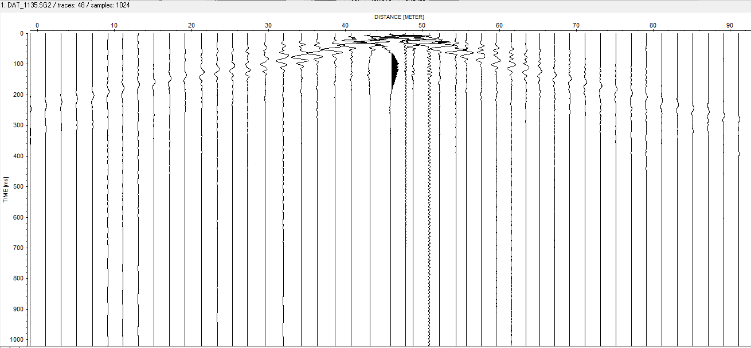
(a)

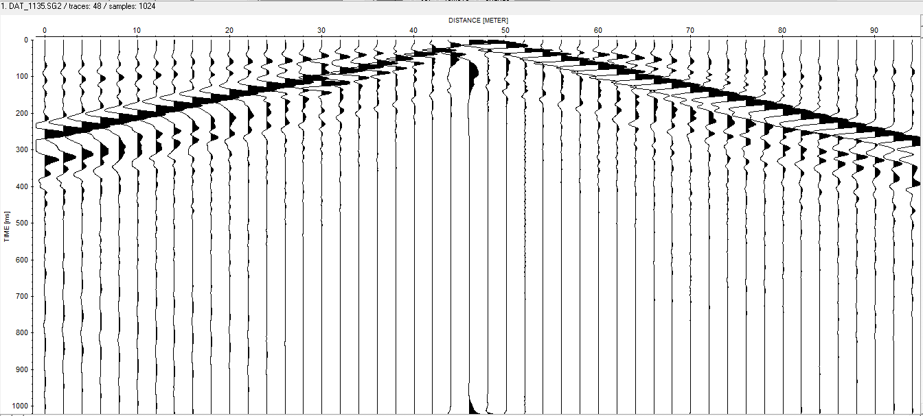
(b)

Figure 3.4: Seismic trace processing (a) Before and (b) after applying DC offset removal and frequency filtering.

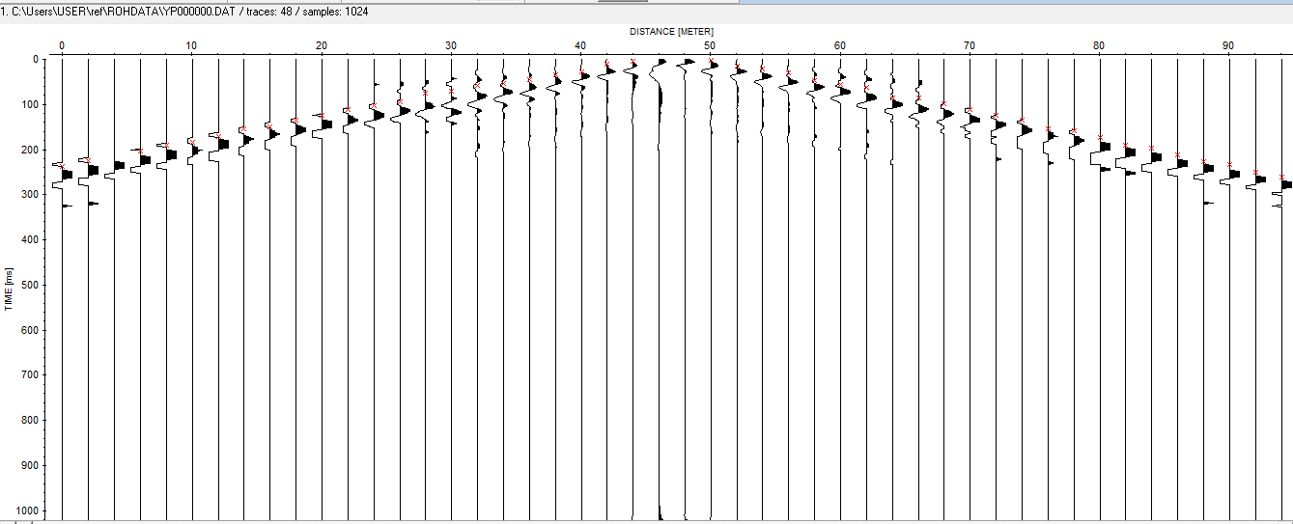
Figure 3.5: First Arrival Picks

plotted on a single diagram (Fig. 3.6a). The travel time curves has been done by using REFLEXW traveltime analysis.
The travel time curves that represent the Traverse TR2 (Figure 3.6b) shows that there are three different layers since there are three different slopes, but then there is other information can be notice from this diagram.
      - Velocity Modelling
The interpretation of seismic refraction data is done by the modelling and inversion of the acquired seismic velocities. Those velocities determined from the traveltime plot for each seismic line. By modelling the paths taken through the subsurface by the seismic energy, or “raytracing”, the thickness and extension of each layer in the model can be adjusted in an iterative manner until a solution is achieved. This produces a cross-sectional velocity model of the subsurface. Borehole records can further calibrate the data to provide levels of the subsurface layers across the survey line.
There are many techniques used for seismic refraction inversion, one of these techniques known as the Tomographic method, which will be applied during this study. The tomographic method, involves the creation of an initial velocity model, and then iteratively tracing rays through the model, comparing the calculated travel times to the measured travel times, modifying the model, and repeating the process until the difference between calculated and measured times is minimized.
The initial velocity model is created by using the time-term technique, which is a linear Least-Squares approach to determining the best discrete-layer solution to the data. The tomographic method provides more realistic profiles where there are gradational vertical changes in velocity
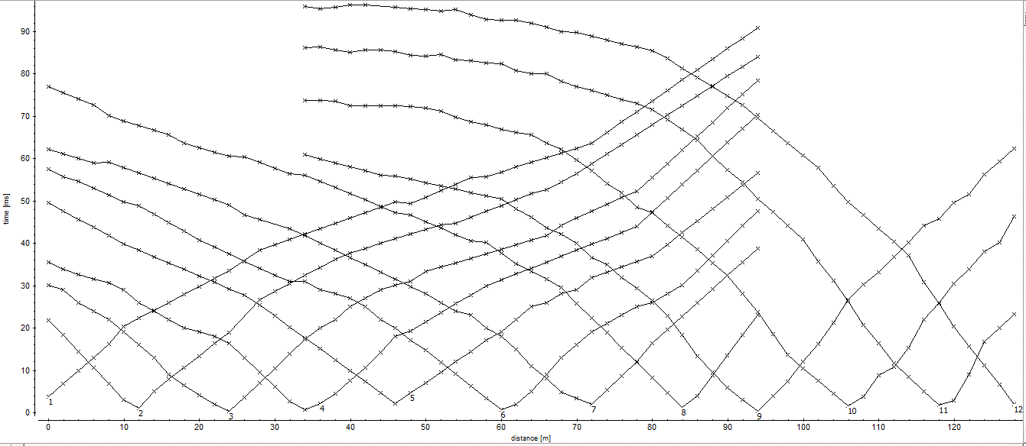
Figure 3.6a: Traveltime Plot for Traverse TR2
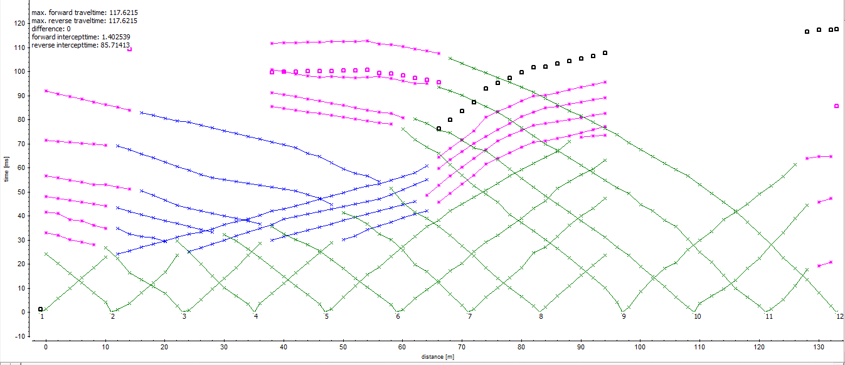

Figure 3.6b: Layer Assignment for Traverse TR2

(e.g., soil grading into saprolite and then into rock), or lateral changes in velocity (e.g., fracture zones, vertical contacts, or solution cavities in rock).
The inversion has been done by using REFLEXW modelling. The horizontal axis represents an along-profile distance in meter, while the vertical axis represents the elevation/depth in meter. The colour contours represent a tomographic model in which the subsurface is treated as a stack of discrete blocks, and the best-fit value of velocity for each block is calculated (Fig. 3.7).
  - MASW METHOD
The Multichannel Analysis of Surface Waves (MASW) method is a geophysical method, which generates a shear-wave velocity (Vs) profile (i.e., Vs versus depth) by analysing Rayleigh-type surface waves on a multichannel record to evaluating the elastic condition (stiffness) of the ground (Reynolds, 2011; Taipodia and Dey, 2012; MASW.com).
MASW first measures seismic surface waves generated from various types of seismic sources, analyses the propagation velocities of those surface waves, and then finally deduces shear wave velocity (Vs) variations below the surveyed area that is most responsible for the analysed propagation velocity pattern of surface waves. The shear wave velocity is related to the stiffness of the medium through which the waves travel. Hence, surface wave surveying is a useful tool for determination of variation in ground stiffness with depth. In comparison to the conventional seismic survey methods such as cross-hole and down-hole, the MASW proves to be less expensive and less time consuming (Reynolds, 2011; Taipodia and Dey, 2012; MASW.com).
Depending on the way surface waves are generated, there are two types (Taipodia and Dey, 2012):

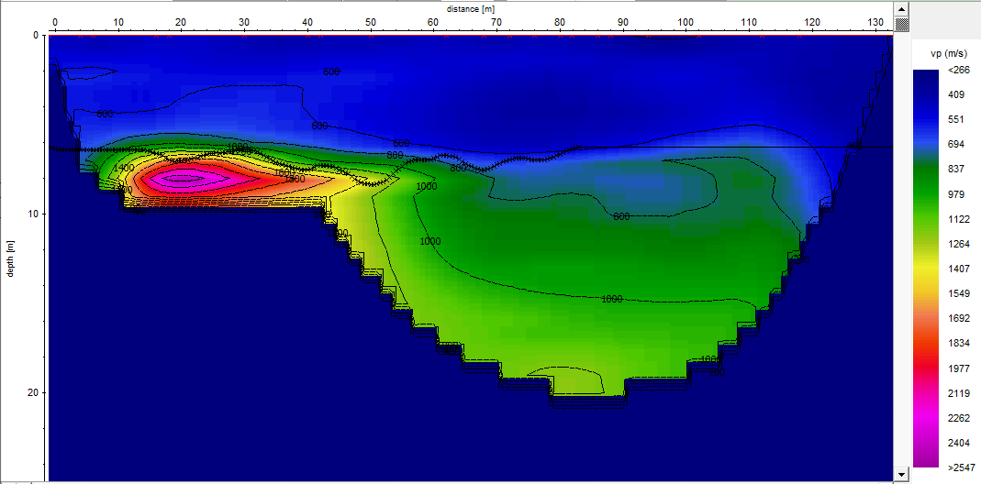
Figure 3.7: Layered Model for Traverse TR2

- Passive MASW: where the surface waves are generated by natural sources unrelated to the survey, such as traffic and tidal motion.
- Active MASW: where the surface waves are generated by impact source such as a sledgehammer or weight drop.
The active MASW method is used during this study, where the seismic source was an accelerated weight drop, and 48-geophones laid out in a linear array and connected to a multi-channel seismograph, collecting data simultaneously in all geophones. The entire procedure for MASW consists of three steps:
- Acquiring multichannel field records.
- Extracting dispersion curves.
- Inverting this dispersion curves to obtain Vs (Shear wave velocity) profile.
    - 2D MASW
2D Vs profile is generated by combining many 1D Vs models together. This technique used at the three locations along Traverses A, B, and C. To generate 2D Vs profile, a new acquisition has been done with vertical low-frequency geophones (e.g., 4.5 Hz), which are sensitive to the surface waves. The source used is an accelerated weight drop, and the geophone interval was 2 m for 48 geophones. The total length of the profile is 128, 132, and 174 m respectively for Transverse TR2, TR3, and TR4 (Figure 3.8). During the survey, 18, 20, and 48 offset shot points have been acquired where the shot point interval was 2 m.

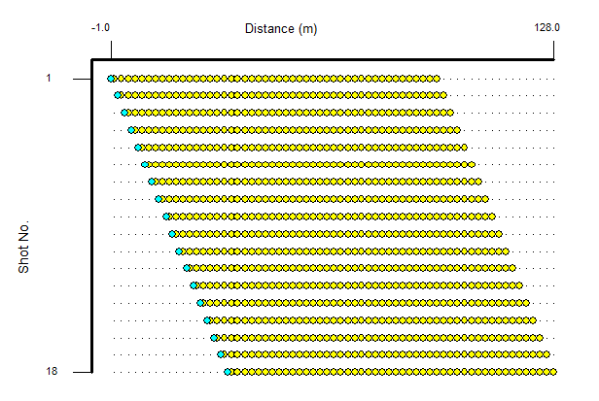
(a)
(b)
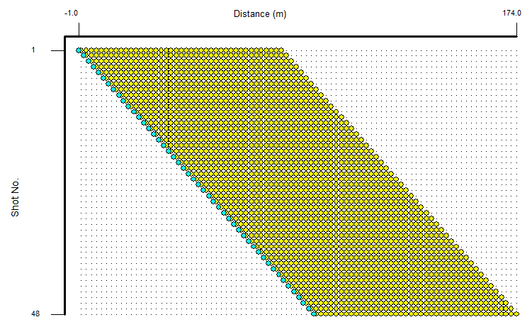
(c)

Figure 3.8: MASW Geometry for Traverse (a) TR2, (b) TR3, (c) TR4.
      - 2D MASW PROCESSING
The 2D MASW was processed using SeisImager/SW. The Surface Wave Wizard was used to calculate the Phase velocity for CMP. The Phase velocity-frequency transformation was then use to obtain dispersion curves (Fig. 3.9a). The dispersion curves were plotted, smoothened and used to obtain a s-wave velocity model (Fig.3.9b), and subsequently a cross-section of the model was gotten after carrying out inversion on the s-wave velocity model (Fig 3.9c).

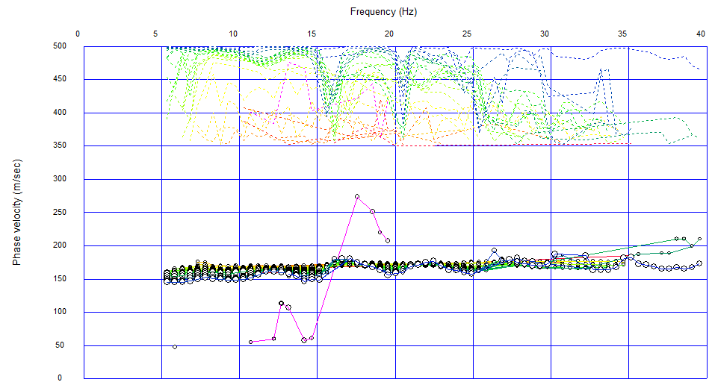
(a)
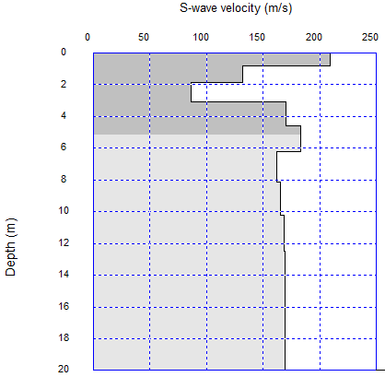
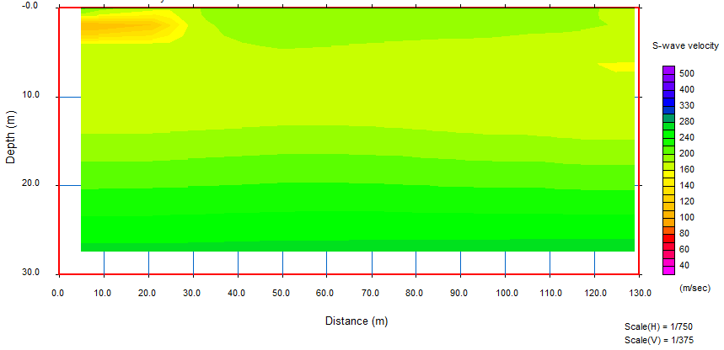
(b)
(c)
Figure 3.9: (a) Dispersion curves (b) S-wave velocity model (c) Cross-section of s-wave velocity model.
CHAPTER FOUR
RESULTS AND DISCUSSION
- INTRODUCTION
In this chapter, the lithological log obtained from boreholes drilled within the study area and the geophysical data acquired along traverse lines within the study area are presented and discussed. The geophysical data include resistivity (2-D dipole-dipole and 1-D VES) and seismic (refraction and MASW) data.
- BOREHOLE LITHOLOGICAL LOGS
Figure 4.1a presents the log for BH 1. The log identified five lithological layers and terminated at a depth of 30 m. The depth of the first layer varies from 0 to 5.25 m and was interpreted as soft/firm becoming stiff dark brownish & greyish silty Clay. The depth to the second subsurface layer is between 5.25 and 10.5 m, this layer was identified as a medium dense greyish coarse fine medium Sand. The depths to the third subsurface horizon varied between 10.5 and 15 m and was identified as a firm dark grey inorganic Clay. The geologic fourth layer occurs at 15 to 25.5 m depths and was identified as firm dark brownish organic Clay. The depth to the fifth layer was from 25.5 m to 30 m and was interpreted as medium dense/stiff greyish silty sand Clay.
Figure 4.1b shows the log for BH 2. BH 2 presented five geologic layers and terminated at 30 m depth. The top layer depth varied from 0 to 3 m and was interpreted as soft/firm becoming stiff dark brownish & greyish silty Clay. The underlying second layer depth was between 3 and 9 m, was identified as medium dense becoming dense dark brown, and grey fine coarse medium Sand. The depths to the third subsurface layer varied between 9 and 12.75 m and it consists firm dark grey inorganic Clay. The fourth layer was interpreted as firm dark organic Clay with depths
Figure 4.1a: Borehole Log 1

Figure 4.1b: Borehole Log 2

between 12.75 and 25 m. The fifth layer was interpreted as medium dense/firm becoming stiff grey silty sandy Clay with depths from 25 to 30 m.
Figure 4.1c reveals the log for BH 3. This borehole terminates at a depth of 30 m and penetrated five geologic layers. The first layer was interpreted as soft/firm becoming stiff dark brownish & greyish silty Clay and its depth varied from 0 to 3 m. The second underlying layer was identified as dense grey/light brown coarse medium Sand with depths varied between 3 and 9 m. A relatively thinner third layer was identified as soft grey silty Clay and was at 9 to 10.5 m depths. The fourth layer was interpreted as soft to firm dark brownish organic Clay, its depths varied from 10.5 to 27.75 m. The depths of the fifth layer varied from 27.75 to 30 m and was interpreted as medium dense/stiff greyish silty Clay.
- RESISTIVITY TYPE CURVES
The HK resistivity type curve was identified from the study area. This type curves depicts four geologic layers. Figure 4.2 presents some of the type curves and the remaining are contained in the Appendix. Table 4.1 presents the summary of the interpretation results of the VES type curves.
- GEOELECTRIC SECTIONS
The subsurface models from the VES curves interpretation were used to generate 2-D geoelectric sections that presented the subsurface images beneath the study area. The 2-D geoelectric section consists four lithological layers. These layers are the topsoil (sandy clay), clay, clayey sand and clay. The 2-D geoelectric section penetrated 15 to 35 m depths.
The S – N geoelectric section relates VES 3 – 6 (Figure 4.3a). The topsoil (sandy clay) resistivities ranged from 16 – 67 Ωm and its thickness ranged from 0.5 to 0.6 m. The second layer consists clay with lower resistivity range of 4 – 8 Ωm, the thickness of this layer varied from 1.4 to 3.1 m.
Figure 4.1c: Borehole Log 3

(a)
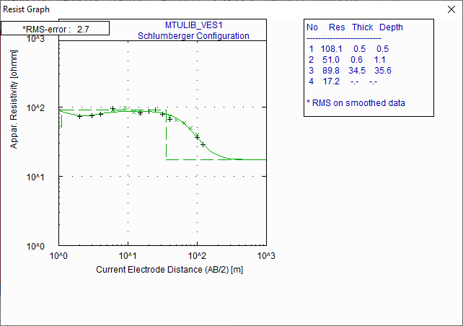

(b)
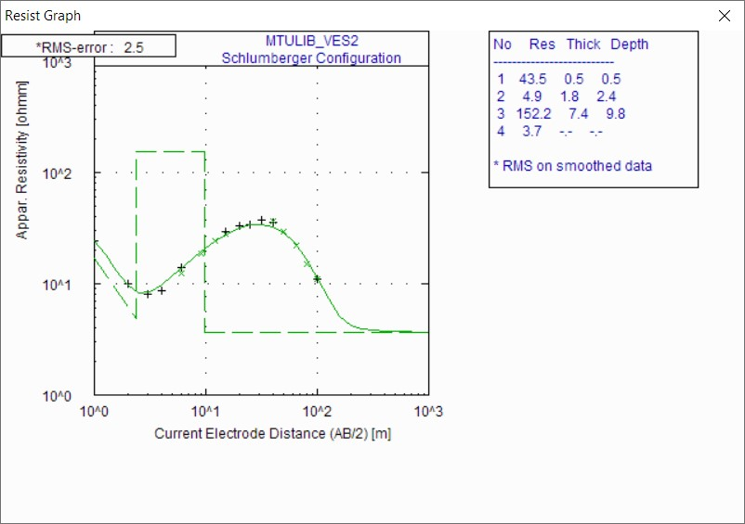
Figure 4.2: WinResist Result for (a) VES 1 and (b) VES 2

VES | Resistivity (Ωm) | Thickness (m) | Depth (m) | Resistivity Relationship | Type Curves | Interpretation
VES 1 | 108.1 / 51.0 / 89.8 / 17.2 | 0.5 / 0.6 / 34.5 / -- | 0.5 / 1.1 / 35.6 / -- | ρ1>ρ2<ρ3>ρ4 | HK | Topsoil / Clay/ Clayey Sand / Clay
VES 2 | 43.5 /4.9 / 152.2 / 3.7 | 0.5 /1.8 / 7.4 / -- | 0.5 / 2.4 / 9.8 / -- | ρ1>ρ2<ρ3>ρ4 | HK | Topsoil / Clay/ Clayey Sand / Clay
VES 3 | 66.7 / 7.5 / 84.4 / 5.0 | 0.6 / 3.1 / 10.3 / -- | 0.6 / 3.7 / 14.1 / -- | ρ1>ρ2<ρ3>ρ4 | HK | Topsoil / Clay/ Clayey Sand / Clay
VES 4 | 34.4 / 8.3 / 33.1 / 12.6 | 0.6 /2.6 / 15.1 / -- | 0.6 / 3.2 / 18.3 / -- | ρ1>ρ2<ρ3>ρ4 | HK | Topsoil / Clay/ Clayey Sand / Clay
VES 5 | 16.3 / 3.7 / 111.2 / 9.7 | 0.5 / 1.4 / 3.8 / -- | 0.5 / 1.9 / 5.7 / -- | ρ1>ρ2<ρ3>ρ4 | HK | Topsoil / Clay/ Clayey Sand / Clay
VES 6 | 35. 1 / 7.6 / 37. 0 / 8.7 | 0.6 / 3.0 / 12.7 / -- | 0.6 / 3.5 / 16.3 / -- | ρ1>ρ2<ρ3>ρ4 | HK | Topsoil / Clay/ Clayey Sand / Clay
VES 7 | 36.3 / 6.9 / 93.4 / 9.6 | 0.5 / 3.1 / 4.8 / -- | 0.5 / 3.6 / 8.4 / -- | ρ1>ρ2<ρ3>ρ4 | HK | Topsoil / Clay/ Clayey Sand / Clay
Table 4.1: Summary of Results Obtained from VES Curves Interpretation

(a)

(b)

Figure 4.3: Geoelectric Section Relating (a) VES 3-6 and (b) VES 1-7

The third layer is a clayey sand layer with resistivity that varied from 33 to 84 Ωm and thickness that varied from 10.3 to 15.1 m. The fourth layer consists clay with resistivity ranging from 5 to 12 Ωm. The depths to the fourth layer varied from 14.1 to 18.3 m.
The SSE – NNW geoelectric section relates VES 1 – 7 (Figure 4.3b). The topsoil (Sandy clay) resistivity values vary from 36 to 108 Ωm and it is 0.5 m thick. The second layer consists clay. The resistivity values of this layer vary between 5 and 51 Ωm and its thickness values vary from 0.6 to 3.1 m. The third layer is clayey sand with resistivity ranging from 90 to 152 Ωm and thickness ranging between 4.8 and 34.5 m. Clay constitutes the fourth layer, the resistivity of this layer varies from 4 to 17 Ωm and the depths to the top of this layer varies between 8.4 and 35.6 m.
Subsoil competence are related directly to resistivity (Idornigie et al., 2006; Fadugba and Olorunfemi, 2011; Fatoba, 2012). The geoelectric sections (Figs. 3a & b) generated from the 1-D VES models delineated two relatively high resistivity layers – the sandy clay topsoil layer 1 and the clayey sand layer 3. Low resistivity highly incompetent layers are sandwiched between the two suspected competent layers 1& 3 and also beneath layer 3. Roads foundations and raft foundations for lightweight civil engineering structures can be placed at depths within layer 1 (i.e. the upper-suspected competent layer). This upper-suspected competent layer may not accommodate excessive overburden cuts and this will place civil engineering structure foundations on the highly incompetent underlying layer. Layer 3 (i.e. the lower competent layer) occurring at depths 1.1 to 3.7 m on the other hand can host medium weight civil engineering structures.
- 2-D DIPOLE DIPOLE PROFILES
The 2-D dipole-dipole data are presented as Pseudosections. The 2-D resistivity structure along Traverse TR1 (Figure 4.4c) presents a resistivity distribution of 2.8 to 1328 Ωm. The 2-D
Figure 4.4: Dipole Dipole Pseudosection along Traverse TR 1 (a) Measured Data (b) Calculated Data (c) 2-D Resistivity Structure

resistivity structure imaged a depth of about 50 m and it identified four distinct subsurface layers. These layers are merged topsoil/clay, sand (with pocket of clay in places), sandy clay, and clay layers. The merged topsoil/Clay layer (with outcropping sand on the eastern parts) is displayed in blue/green/yellow/red colour and shows resistivity values that vary from 2.8 to 283 Ωm and thickness values that vary from 0 to 6.2 m. The second layer in red/yellow/green colour constitutes the sand layer (with pocket of clay in places). The resistivity values of this layer vary from 61 to 1328 Ωm and its thickness values vary from 3.1 to 12.4 m. The sandy clay layer in green represents the third layer. The resistivities of this layer vary from 37.1 to 173 Ωm and the thicknesses of this layer vary from 3.2 to 24.8 m. The fourth layer in blue/green constitutes the clay layer. The resistivities of this layer vary between 2.8 and 40 Ωm and the depths to this layer varies between 12.4 and 31 m.
Along Traverse TR2, the resistivity distribution of the 2-D resistivity structure varied from 3.6 to 919 Ωm (Fig. 4.5c). The resistivity structure delineated a maximum depth of 49.7 m and imaged four distinct layers. The imaged subsurface layers are merged topsoil/clay, sand (with pocket of clay in places), sandy clay, and clay layers. The merged topsoil/clay layers (with sand outcropping in places on the Eastern parts) in blue/green/yellowish/reddish colour show resistivity varying from 3.6 to 229 Ωm and thickness varying from 0 to 6.2 m. The second layer constitutes the sand (with pockets of clay) and it is in red/yellow/green colour. Resistivity values for this layer vary from 57.3 to 919 Ωm and its thickness value vary from 3.1 to 6.9 m. The third layer constitutes the sandy clay layer and it is in green colour. Its resistivities and thicknesses vary from 36 to 143 Ωm and from 3.1 to 10 m respectively. The fourth layer in blue/green constitutes the clay layer. The resistivity and depths to the top of this layer varied from 4 to 57 Ωm and from 12.4 to 31 m respectively.
Figure 4.5: Dipole Dipole Pseudosection along Traverse TR 2 (a) Measured Data (b) Calculated Data (c) 2-D Resistivity Structure

The 2-D resistivity structure along Traverse TR3 shows resistivities distribution of 3.2 to 212 Ωm (Fig. 4.6c). The maximum depth imaged by the resistivity structure is 49.7 m and it imaged four layers, which are merged topsoil/clay, sand, sandy clay, and clay layers. The merged topsoil/clay layer in blue/greenish blue has resistivities and thicknesses varying from 3.2 to 16.9 Ωm and between 5 and 6.2 m respectively. The second layer in red/yellow colour constitutes the sand layer, the resistivities and thicknesses of this layer varied from 61.1 to 212 Ωm and between 6.2 and 18.6 m respectively. The third layer constitutes the sandy clay in green. The resistivities and thicknesses of this layer vary from 17.5 to 50.1 Ωm and between 6 and 8 m respectively. The fourth layer in blue constitutes the clay layer, the resistivity values of this layer vary from 3.2 to 9.2 Ωm and the depths to the top of this layer vary from 12.4 to 31 m.
The 2-D resistivity structure along Traverse TR4 (Figure 4.7c) shows resistivity distribution of 3.7 to 187 Ωm. The resistivity structure penetrated up to 49.7 m and it imaged four distinct layers. It imaged merged topsoil/clay, sand, sandy clay and clay layers. The merged topsoil/clay layer is displayed in blue/greenish blue and shows resistivity values that vary from 3.7 to 18.1 Ωm and thickness values that vary from 5.9 to 7.2 m. The second layer in red/yellow colour constitutes sand. The resistivity values of this layer vary from 48.2 to 187 Ωm and the thickness values of this layer vary from 6 to 10.4 m. The sandy clay layer in green represents the third layer. The resistivities of this layer vary between 18.1 and 48.2 Ωm and its thicknesses vary between 6.2 and 12 m. The fourth layer in blue constitutes the clay layer. The resistivities of this layer vary between 3.7 and 9.9 Ωm and the depths to this layer vary between 20 and 24.8 m.
The 2-D resistivity structure along Traverse TR 5 (Fig. 4.8c) shows resistivity distribution of 3.2 to 172 Ωm. The resistivity structure imaged depths up to 44.4 m and delineated four subsurface layers. These layers are topsoil/clay, sand, clayey sand and clay. The merged topsoil/clay layer is
Figure 4.6: Dipole Dipole Pseudosection along Traverse TR 3 (a) Measured Data (b) Calculated Data (c) 2-D Resistivity Structure

Figure 4.7: Dipole Dipole Pseudosection along Traverse TR 4 (a) Measured Data (b) Calculated Data (c) 2-D Resistivity Structure

Figure 4.8: Dipole Dipole Pseudosection along Traverse TR 5 (a) Measured Data (b) Calculated Data (c) 2-D Resistivity Structure

displayed in blue with resistivities and thicknesses varying from 3.2 to 8.7 Ωm and about 5.6 m respectively. The second layer in red/yellow colour constitutes sand. The resistivity values of this layer vary from 43.8 to 172 Ωm and the thickness values of the layer is about 5.6 m. The sandy clay layer in green represents the third layer. The resistivity and thickness values of this layer vary from 16.1 to 43.8 Ωm and about 5.6 m respectively. The fourth layer in blue constitutes the clay layer. The resistivity values of this layer vary from 3.2 to 8.7 Ωm and the depths to the top of this layer is about 16.7 m.
The resistivity structure along Traverse TR 6 shows resistivity distribution of 3.7 to 344 Ωm (Fig. 4.9c). The resistivity structure imaged a depth of 49.7 m and delineated four layers. The layers are merged topsoil/clay, sand, sandy clay and clay. The merged topsoil/clay layer in blue shows resistivity values varying from 3.7 to 11.5 Ωm and thickness values varying from 1 to 3.1 m. The second layer constitutes the sand and it is in re/yellow colour. The resistivity values for this layer vary from 73.3 to 34 Ωm and the layer thickness values vary from 3.1 to 18.4 m. The third layer constitutes the sandy clay layer and it is in green colour. Its resistivity and thickness values vary from 23.6 to 73.3 Ωm and from 3.1 to 18.8 m respectively. The fourth layer in blue/green constitutes the clay layer. The resistivity and depths to the top of this layer values vary from 3.7 to 35.6 Ωm, 12.4, and 37 m respectively.
The resistivity structure could not distinctively identify the upper competent layer that was imaged by the 2-D geoelectric section. The resistivity structure therefore identified only one suspected competent layer. This layer corresponds to the lower competent layer imaged by the 2-D geoelectric section. Light and medium weight civil engineering structure foundations can be placed on this suspected lower competent layer. The resistivity structure did not reveal any dipping geological structures such as faults and dykes that could be inimical to civil engineering structures,
Figure 4.9: Dipole Dipole Pseudosection along Traverse TR 6 (a) Measured Data (b) Calculated Data (c) 2-D Resistivity Structure

civil engineering structure foundation may be anchored on friction piles on the very thick column of clay beneath the lower suspected competent layer.
4.6 SEISMIC REFRACTION TOMOGRAPHY
Seismic refraction tomography along a segment of the E – W Traverse TR2 is presented in Figure 4.10. The compressional velocity (Vp) along this profile varies from less than 0 to greater than 2189 m/s. The tomography imaged the upper 20 m and delineated two distinct lithological layers. These layers are soft clay and sand. The first layer obtained from the tomography constitutes the soft clay and it is in blue/green. The velocities of the soft clay vary from 271 to 949 m/s and its thickness varies from around 6 to 15 m. At 60 m along the profile, the thickness of the soft clay is around 6 m, this correlates significantly with the thickness of 5 m obtained for silty clay from borehole BH 1 (Fig. 4.1). The second layer obtained from the tomography constitutes sands and it is in yellow/red/purple colour. The velocity values of the sand vary from 1085 to 2169 m/s and the thickness values of the sand vary from 2 to 6 m. At 60 m along the profile, the depth to the sand unit from the tomography is around 8 m, this correlates significantly to depth to sand unit (around 6 m) obtained from the resistivity structure and around 5 m from borehole BH 1.
Seismic refraction tomography carried out along the first segment of the E – W Traverse TR3 is presented in Figure 4.11. The compressional velocity (Vp) distribution along the profile varies from less than 296 to greater than 2547 m/s. The tomography presented two lithological units to a maximum depth of around 20 m. These layers are soft clay and sand. Upper and lower units of soft clay were imaged. The first layer constitutes the upper soft clay in blue. The velocity values of the upper soft clay varied from less than 266 to 765 m/s. The average thickness of the upper soft clay is around 6 m, and this correlates significantly with the merged topsoil/clay layer of the 2-D resistivity structure along this traverse (Figure 4.6c). Since a borehole was not drilled along this
Figure 4.10: Seismic Refraction Tomogram along Traverse TR 2 with Lithological Log of BH 3 Superimposed.

Figure 4.11: Seismic Refraction Tomogram along Traverse TR 3

is around 6 m, and this correlates significantly with the merged topsoil/clay layer of the 2-D resistivity structure along this traverse (Figure 4.6c). Since a borehole was not drilled along this traverse, the tomography and 2-D resistivity structure along this traverse were correlated. The second layer constitutes sand in red/yellow colour and the lower soft clay in green colour. The sand occurred in lenses and it is only about 2 m thick. The velocity values of the sand vary from 1336 to 2547 m/s and the depth to the top of the sand unit is around 6 m. This correlates significantly to the depths to sand imaged by 2-D resistivity structure along this traverse (Figure 4.6c). Due to velocity inversion, the subsoils beneath the high velocity sand were not imaged by the refraction tomography. The velocities of the lower soft clay vary from 800 to 1100 m/s and the depth to its top is around 6.2 m.
Seismic refraction tomography along a segment of the E – W Traverse TR 4 is presented in Figure 4.12. The compressional velocity (Vp) along this profile varies from less than 0 to greater than 1321 m/s. The tomography distinctively delineated three layers and it penetrated a maximum depth of 16 m. The correlation of the tomography first layer with BH 3 (Figure 4.12) and 2-D resistivity structure (Figure 4.7c) along this traverse shows that it is composed of merged clay/sand layer. The merged clay/sand first layer in green shows velocity values varying between 330 and 495 m/s and thickness values varying from 3 to 12 m. The second layer in yellow represents a very thin (about 1.0 m) column of soft clay. The average velocity of this very thin layer is 661 m/s. This layer correlates significantly to the 1.5 m thick soft grey silty clay interval of BH 3 (Fig. 4.1c). The third layer displayed in red/purple constitutes firm clay. The velocity values of this unit vary from 1073 to 1321 m/s. The average depth to the top of this layer is around 10 m. This layer correlates significantly to the lower clay imaged by the 2-D resistivity structure along this traverse (Figure 4.7c) and with the fourth layer of borehole BH 3 (Fig. 4.1c).
Figure: 4.12: Seismic Refraction Tomogram along Traverse TR 4 with Lithological Log of BH 3 Superimposed.

The competence of subsoils depends on elastic constants like Bulk Modulus and Compressibility. These elastic constants can be determined from seismic velocities. Compressibility relates indirectly with competence. Table 4.2 presents compressibility determined for the upper 12 m penetrated by all the seismic tomography carried out at the study area. Compressibility in the upper 4 m ranged from 31.33 x 10⁻⁵ to 40.411 x 10⁻⁵ Pa⁻¹. At 4 – 8 m depths, the compressibility varied between 20.638 x 10⁻⁵ and 25.104 x 10⁻⁵ Pa⁻¹. At depth interval 8 – 12 m, the range of compressibility of subsoil is 12.758 x 10⁻⁵ to 17.312 x 10⁻⁵ Pa⁻¹. The upper 6 m consisting soft clay (see Fig. 4.10-4.12) show high compressibility while the underlying sand (also see Fig. 4.10-4.12) shows lower compressibility. Within the upper 12 m, decrease in compressibility with depths implied increase in competence. In view of this, civil engineering structures are to be anchored on pile foundation placed on the sand at 6 m depth.
4.7 MULTICHANNEL ANALYSIS OF SURFACE WAVE (MASW)
The 2D MASW profile along the E – W trending Traverse TR 2 (129 m long) is presented in Figure 4.13a. This profile indicates S-wave velocity values for Topsoil that ranges from 200 – 240 m/s and thickness of about 3 – 4 m. Beneath the Topsoil, the subsurface layer is composed of Sand/Sandy Clay that has S-wave velocity values that range from 90 – 160 m/s and thickness of about 10 m. The third identified lithological layer is composed of Clay with S-wave velocity values between 200 – 260 m/s and depth of about 14 m.
The 2D MASW profile along the E – W trending Traverse TR 3 (133 m long) is presented in Figure 4.13b. This profile indicates S-wave velocity values for Topsoil that ranges from 160 – 330 m/s and thickness of about 3 – 4 m. Beneath the Topsoil, the subsurface layer is composed of Sand/Sandy Clay that have S-wave velocity values that range from 140 – 240 m/s and thickness of about 10 m. The third identified lithological layer is composed of Clay with S-wave velocity
Table 4.2: Compressibility for Subsoils Materials within the Study Area
Depth (m) | Avg. Vp | Avg. Vs | Avg. Density (𝞺) | Compressibility $(β)$ | Bulk Modulus | RQF
TRAVERSE 2
0 – 4 | 600 | 516.069 | 1.53426 | 31.330E-05 | 3,191.82601 | 0.0013
4 – 8 | 800 | 688.483 | 1.64869 | 20.638E-05 | 4,845.50966 | 0.0020
8 – 12 | 1,100 | 947.103 | 1.78529 | 12.758E-05 | 7838.15280 | 0.0040
TRAVERSE 3
0 – 4 | 500 | 429.862 | 1.46590 | 40.441E-05 | 2,472.74949 | 0.0010
4 – 8 | 700 | 602.276 | 1.59454 | 25.104E-05 | 3,983.40784 | 0.0016
8 – 12 | 1,000 | 860.897 | 1.74326 | 14.761E-05 | 6,774.3858 | 0.0032
TRAVERSE 4
0 – 4 | 600 | 516.069 | 1.53426 | 31.330E-05 | 3,191.82601 | 0.0013
4 – 8 | 800 | 688.483 | 1.64867 | 20.638E-05 | 4,845.50966 | 0.0020
8 – 12 | 900 | 774.690 | 1.69794 | 17.312E-05 | 5,776.36311 | 0.0025

Figure 4.13: 2D MASW Profile along (a) Traverse 2 (b) Traverse 3 and (c) Traverse 4
m/s and thickness of about 3 – 4 m. Beneath the Topsoil, the subsurface layer is composed of Sand/Sandy Clay that have S-wave velocity values that range from 140 – 240 m/s and thickness of about 10 m. The third identified lithological layer is composed of Clay with S-wave velocity values between 280 – 350 m/s and depth of about 14 m.
The 2D MASW profile along the E – W trending Traverse TR 4 (175 m long) is presented in Figure 4.13c. This profile indicates S-wave velocity values for Topsoil that ranges from 160 – 330 m/s and thickness of about 3 – 4 m. Beneath the Topsoil, the subsurface layer is composed of Sand/Sandy Clay that have S-wave velocity values that range from 140 – 240 m/s and thickness of about 10 m. The third identified lithological layer is composed of Clay with S-wave velocity values between 280 – 350 m/s and depth of about 14 m.

CHAPTER FIVE
SUMMARY AND CONCLUSION
- SUMMARY
Preconstruction geophysical and geotechnical investigation involving seismic (refraction and MASW), resistivity (1-D VES and 2-D dipole dipole) geophysical methods and borehole drilling geotechnical method were carried out with the view to investigate the subsoil competence at a proposed site for the construction of a library building at the Mountain Top University Permanent Site at Makogi Oba, Ogun State, Southwestern Nigeria.
Detailed review of literature on the study was carried out. The study area was visited prior to fieldwork to acquire information that was used to plan a comprehensive fieldwork.
At the commencement of the fieldwork, six (6) geophysical traverses were established, two were in the S – N orientation while the remaining four (4) were established approximately perpendicular (in the E – W orientation) to the S – N orientation. 1-D VES and 2-D dipole dipole resistivity data were acquired along the geophysical traverses. Seismic refraction and MASW data were acquired at established traverses. Lithological log was obtained from drilling company.
The 1-D VES was presented and interpreted using partial curve matching and forward modelling using the Winresist software. The 2-D resistivity data were inverted into 2-D resistivity structure using EarthImager by Advanced Geosciences Inc. (AGI). The refraction and MASW seismic data were processed, interpreted, and presented using SeisImager software. The results obtained from the geophysical investigations were constrained by the lithology obtained from drilled boreholes. The geophysical and geotechnical investigation results correlate significantly.
The 1-D VES delineated four subsurface layers, namely, a sandy clay topsoil, clay, clayey sand and clay bottom layer. The topsoil and the clayey sand layers were upper and lower competent layers respectively identified at the study area. The 2-D dipole dipole data delineated four subsurface layers. The first layer was a merged topsoil/clay layer, it is underlain by a clay second layer. The third layer is clayey sand and the fourth layer is clay. The thicknesses of the layers identified from the 2-D dipole dipole strongly correlate significantly with the thickness of layers obtained from the 1-D VES study. The seismic refraction and MASW method also imaged the subsurface satisfactorily. The method delineated and characterized the layers. The lithology from the drilled borehole were used to constrain the geophysical interpretation results.
- CONCLUSION
The study identified two competent layers, a very thin (about 0.7 m) upper competent layer in which road pavement and light civil engineering structures foundations can be placed. The lower competent layer is relatively thicker about 8 m thick in places. The lower competent layer occurred at around 6 m. Heavy civil engineering structures are required to be anchored on pile foundation placed in the lower competent layer at 6 m depth.
REFERENCES
Adegoke O. S, Omatsola M. E, Adediran S. A (1981). “Tectonic evolution and cretaceous stratigraphy of the Dahomey basin”. Journal of African earth Sciences 12 (1-2), 79-84.
Adekeye, O.A., and S.O. Akande, (2006). Depositional environment and reservoir potential assessment of the Paleocene Ewekoro Formation, eastern Dahomey basin, Southwestern Nigeria: Journal of Mining and Geology, v. 42/1, p. 133-140
Adelekan A. O., and Oladunjoye M. A., (2015). Integration of Electrical Resistivity and Ground Penetrating Radar Methods in Engineering Site Characterization: Case Study Around Ajibode, Ibadan, Southwestern Nigeria, SEG Global Meeting Abstracts: 282-285. https://doi.org/10.1190/iceg2015-079
Archie, G.E. (1942). The Electrical Resistivity Log as an Aid in Determining Some Reservoir Characteristics. Transactions of the AIME, 146, 54-62.
Ayolabi E. A., Enoh I. J. E., and Folorunso A. F., (2013). Engineering site characterization using 2-D and 3-D electrical resistivity tomography: Earth Science Research, 2, 133–142.
Bekler T., Ekinci Y. L., Demirci A., Erginal A. E., and Ertekin C., (2011). Characterization of a Landslide using Seismic Refraction, Electrical Resistivity and Hydrometer Methods, Adatepe—Çanakkale, NW Turkey, Journal of Environmental and Engineering Geophysics 16: 115-126.
Bhattacharya P. K and Patra H. P (1968). “Geoelectric sounding: principles and interpretation”, Elsevier publishing company, Amsterdam 135p.
Blyth F. G. H., and de-Freitas M. D., (1988). A geology for engineers. Butler and Tanner Ltd, Frome and London: London, UK, 292–293.
Butchibabu B., Prosanta K. Khan, and Jha P. C., (2019). Foundation Evaluation of a Repeater Installation Building using Electrical Resistivity Tomography and Seismic Refraction Tomography, Journal of Environmental and Engineering Geophysics 24: 27-38.
Germán Rodríguez-Pradilla, (2015). Application of shallow-seismic exploration methods for mechanical characterization of soil and rock bodies at engineering project sites in Colombia. The Leading Edge, 166-168, http://dx.doi.org/10.1190/tle34020166.1
John S., (2003). Electrocatalysis Understanding. Electrochronics Acta 45 (15 – 16). 2377 – 2385.
Keller, G. V., and Frischknecht, F. C. (1966). Electrical Methods in Geophysical Prospecting. Oxford: Pergamon
Kearey P., Brooks M., Hill I., (2002). “An Introduction to Geophysical Exploration”, 3rd ed. Blackwell Science, Oxford.
Lowrie W. (2007), “Fundamentals of Geophysics,” Second Edition, Cambridge University Press, pages 121-139.
Olorunfemi, M. O. and Griffiths, D. H., (1985). A laboratory investigation of the induced polarization of the Triassic Sherwood Sandstone of Lancashire and its hydrogeological application: Geophys. Prospect., v. 32, p.
Omatsola M. E and Adegoke O. S (1981). “Tectonic Evolution and Cretaceous Stratigraphy of the Dahomey basin, Nigeria. Journal Mining and Geology 18(01), 130-137”
Oyedele K. F., Oladele S., and Okoh C., (2015). Assessment of Subsurface Conditions in a Coastal Area of Lagos using Geophysical Methods. Nigerian Journal of Technological Development, Vol. 12, No. 2.
Patnode, H. W., and Wyllie, M. R. J., (1950). The presence of conductive solids in reservoir rocks as a factor in electric log interpretation: Am. Inst. Min. Met. Eng. Trans., v. 189. pp. 47–52.
Reynolds, J.M. (2011), “An Introduction to Applied and Environmental Geophysics”, Second Edition, John Wiley & Sons Ltd.
Sirles P., Rock A., and Haramy K., (2006). Advancements in 3D Subsurface Modelling using Seismic Refraction Data– A New Perspective, in Proceedings for GEOPHYSICS 2006, the 3rd International Conference on Applied Geophysics, St. Louis, MO.
Soupios P. M., Georgakopoulos P., Papadopoulos N., Saltas V., Andreadakis A., Vallianatos F., Sarris A., and Makris J. P., (2007). Use of engineering geophysics to investigate a site for a building foundation, Journal of Geophysics and Engineering, Volume 4, Issue 1, Pages 94–103, https://doi.org/10.1088/1742-2132/4/1/011
Telford W.M., Geldart L.P., and Sheriff R.E. (1990), “Applied Geophysics”, Second Edition, Cambridge University Press, pages 6-50; 209-240; 353-358.
ONLINE SOURCES
MASW.com
Onlinenigeria, (2018). http://www.onlinenigeria,com

APPENDIX A
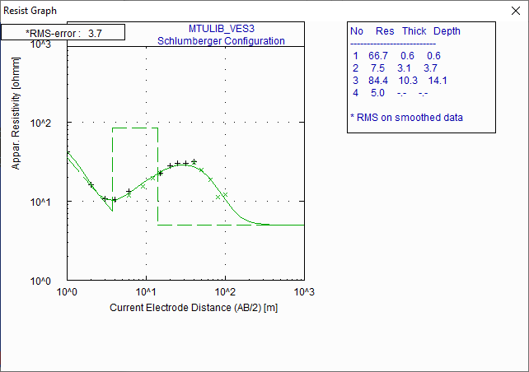
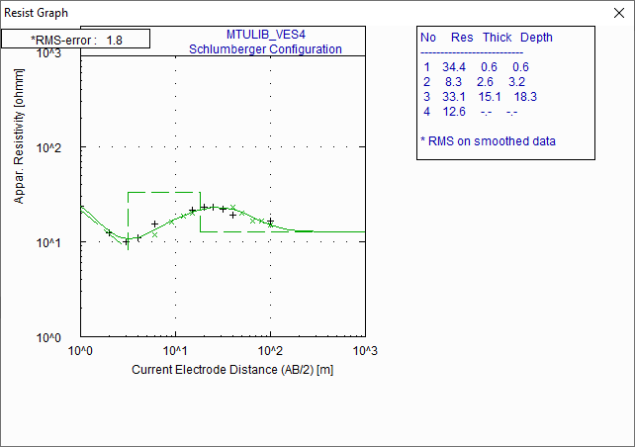
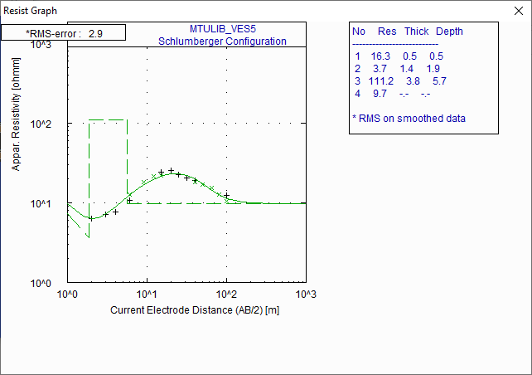
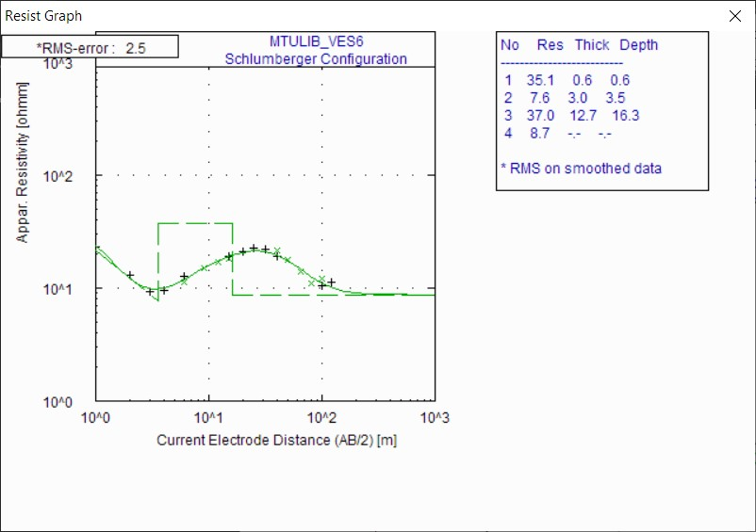
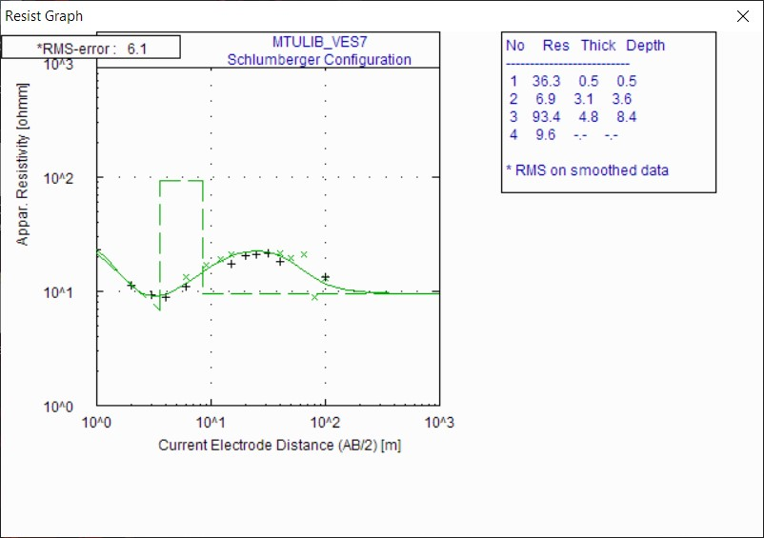

APPENDIX B
RESISTIVITY (VES) DATA SHEET
Date: 12th January 2021 Observer: Geosciences Department
Electrode Array: Schlumberger Instrument: AGI SusperSting R1
Site Location: MTU Permanent Site Geographic Coordinates: Easting: 542309.00
Northing: 745434.00
Elevation:
Static Location: VES 1
Electrode Position | AB/2 (m) | MN/2 (m) | Geometric Factor -K | Resistance – R (Ω) | Resistivity – 𝞺 (Ωm)
1 | 1 | 0.25 | 6.283185 | 14.372 | 90.3
2 | 2 | 0.25 | 25.13274 | 2.901 | 72.9
3 | 3 | 0.25 | 56.54867 | 1.326 | 75
4 | 4 | 0.25 | 100.531 | 0.785 | 78.9
5 | 6 | 0.25 | 226.1947 | 0.423 | 95.6
6 | 6 | 0.5 | 113.0973 | 0.800 | 90.5
7 | 9 | 0.5 | 254.469 | 0.383 | 97.5
8 | 12 | 0.5 | 452.3893 | 0.187 | 84.4
9 | 15 | 0.5 | 706.8583 | 0.115 | 81.4
10 | 15 | 1 | 353.4292 | 0.231 | 81.7
11 | 20 | 1 | 628.3185 | 0.139 | 87.6
12 | 25 | 1 | 981.7477 | 0.092 | 90.6
13 | 32 | 1 | 1608.495 | 0.049 | 78.4
14 | 40 | 1 | 2513.274 | 0.026 | 66.5
15 | 40 | 2.5 | 1005.31 | 0.073 | 72.9
16 | 50 | 2.5 | 1570.796 | 0.041 | 64.6
17 | 65 | 2.5 | 2654.646 | 0.022 | 59.5
18 | 80 | 2.5 | 4021.239 | 0.013 | 50.4
19 | 100 | 2.5 | 6283.185 | 0.006 | 39.9
20 | 100 | 5 | 3141.593 | 0.012 | 36.6
21 | 120 | 5 | 4523.893 | 0.006 | 28.5

RESISTIVITY (VES) DATA SHEET
Date: 12th January 2021 Observer: Geosciences Department
Electrode Array: Schlumberger Instrument: AGI SusperSting R1
Site Location: MTU Permanent Site Geographic Coordinates: Easting: 542292.98
Northing: 745462.93
Elevation:
Static Location: VES 2
Electrode Position | AB/2 (m) | MN/2 (m) | Geometric Factor -K | Resistance – R (Ω) | Resistivity – 𝞺 (Ωm)
1 | 1 | 0.25 | 6.283185 | 3.883 | 24.4
2 | 2 | 0.25 | 25.13274 | 0.394 | 9.9
3 | 3 | 0.25 | 56.54867 | 0.141 | 8
4 | 4 | 0.25 | 100.531 | 0.087 | 8.7
5 | 6 | 0.25 | 226.1947 | 0.062 | 14
6 | 6 | 0.5 | 113.0973 | 0.110 | 12.4
7 | 9 | 0.5 | 254.469 | 0.073 | 18.7
8 | 12 | 0.5 | 452.3893 | 0.053 | 24.1
9 | 15 | 0.5 | 706.8583 | 0.040 | 28.2
10 | 15 | 1 | 353.4292 | 0.083 | 29.4
11 | 20 | 1 | 628.3185 | 0.053 | 33.2
12 | 25 | 1 | 981.7477 | 0.035 | 34.2
13 | 32 | 1 | 1608.495 | 0.023 | 37.3
14 | 40 | 1 | 2513.274 | 0.014 | 35.7
15 | 40 | 2.5 | 1005.31 | 0.036 | 36.3
16 | 50 | 2.5 | 1570.796 | 0.019 | 29.7
17 | 65 | 2.5 | 2654.646 | 0.008 | 22.2
18 | 80 | 2.5 | 4021.239 | 0.004 | 15
19 | 100 | 2.5 | 6283.185 | 0.002 | 10.9
20 | 100 | 5 | 3141.593 | 0.004 | 11.1

RESISTIVITY (VES) DATA SHEET
Date: 12th January 2021 Observer: Geosciences Department
Electrode Array: Schlumberger Instrument: AGI SusperSting R1
Site Location: MTU Permanent Site Geographic Coordinates: Easting: 542221.94
Northing: 745428.93
Elevation:
Static Location: VES 3
Electrode Position | AB/2 (m) | MN/2 (m) | Geometric Factor -K | Resistance – R (Ω) | Resistivity – 𝞺 (Ωm)
1 | 1 | 0.25 | 6.283185 | 6.731 | 42.29
2 | 2 | 0.25 | 25.13274 | 0.645 | 16.22
3 | 3 | 0.25 | 56.54867 | 0.189 | 10.71
4 | 4 | 0.25 | 100.531 | 0.103 | 10.4
5 | 6 | 0.25 | 226.1947 | 0.059 | 13.25
6 | 6 | 0.5 | 113.0973 | 0.104 | 11.79
7 | 9 | 0.5 | 254.469 | 0.061 | 15.56
8 | 12 | 0.5 | 452.3893 | 0.043 | 19.61
9 | 15 | 0.5 | 706.8583 | 0.032 | 22.62
10 | 15 | 1 | 353.4292 | 0.064 | 22.75
11 | 20 | 1 | 628.3185 | 0.044 | 27.74
12 | 25 | 1 | 981.7477 | 0.031 | 29.97
13 | 32 | 1 | 1608.495 | 0.019 | 30.34
14 | 40 | 1 | 2513.274 | 0.013 | 31.72
15 | 40 | 2.5 | 1005.31 | 0.030 | 30.35
16 | 50 | 2.5 | 1570.796 | 0.016 | 24.93
17 | 65 | 2.5 | 2654.646 | 0.007 | 18.64
18 | 80 | 2.5 | 4021.239 | 0.003 | 11.38
19 | 100 | 2.5 | 6283.185 | 0.002 | 12.03

RESISTIVITY (VES) DATA SHEET
Date: 12th January 2021 Observer: Geosciences Department
Electrode Array: Schlumberger Instrument: AGI SusperSting R1
Site Location: MTU Permanent Site Geographic Coordinates: Easting: 542224.00
Northing: 745462.99
Elevation:
Static Location: VES 4
Electrode Position | AB/2 (m) | MN/2 (m) | Geometric Factor -K | Resistance – R (Ω) | Resistivity – 𝞺 (Ωm)
1 | 1 | 0.25 | 6.283185 | 3.782 | 23.76
2 | 2 | 0.25 | 25.13274 | 0.489 | 12.29
3 | 3 | 0.25 | 56.54867 | 0.176 | 9.948
4 | 4 | 0.25 | 100.531 | 0.109 | 10.99
5 | 6 | 0.25 | 226.1947 | 0.069 | 15.53
6 | 6 | 0.5 | 113.0973 | 0.104 | 11.71
7 | 9 | 0.5 | 254.469 | 0.063 | 16.01
8 | 12 | 0.5 | 452.3893 | 0.041 | 18.72
9 | 15 | 0.5 | 706.8583 | 0.028 | 20.11
10 | 15 | 1 | 353.4292 | 0.061 | 21.48
11 | 20 | 1 | 628.3185 | 0.037 | 22.99
12 | 25 | 1 | 981.7477 | 0.023 | 22.91
13 | 32 | 1 | 1608.495 | 0.014 | 21.91
14 | 40 | 1 | 2513.274 | 0.008 | 19.06
15 | 40 | 2.5 | 1005.31 | 0.023 | 22.93
16 | 50 | 2.5 | 1570.796 | 0.013 | 20.01
17 | 65 | 2.5 | 2654.646 | 0.006 | 16.48
18 | 80 | 2.5 | 4021.239 | 0.004 | 16.43
19 | 100 | 2.5 | 6283.185 | 0.002 | 15.12
20 | 100 | 5 | 3141.593 | 0.005 | 16.6

RESISTIVITY (VES) DATA SHEET
Date: 12th January 2021 Observer: Geosciences Department
Electrode Array: Schlumberger Instrument: AGI SusperSting R1
Site Location: MTU Permanent Site Geographic Coordinates: Easting: 542222.00
Northing: 745494.93
Elevation:
Static Location: VES 5
Electrode Position | AB/2 (m) | MN/2 (m) | Geometric Factor -K | Resistance – R (Ω) | Resistivity – 𝞺 (Ωm)
1 | 1 | 0.25 | 6.283185 | 1.576 | 9.9
2 | 2 | 0.25 | 25.13274 | 0.251 | 6.3
3 | 3 | 0.25 | 56.54867 | 0.126 | 7.1
4 | 4 | 0.25 | 100.531 | 0.077 | 7.7
5 | 6 | 0.25 | 226.1947 | 0.048 | 10.8
6 | 6 | 0.5 | 113.0973 | 0.111 | 12.6
7 | 9 | 0.5 | 254.469 | 0.072 | 18.2
8 | 12 | 0.5 | 452.3893 | 0.048 | 21.5
9 | 15 | 0.5 | 706.8583 | 0.031 | 22.1
10 | 15 | 1 | 353.4292 | 0.068 | 24.1
11 | 20 | 1 | 628.3185 | 0.040 | 25.3
12 | 25 | 1 | 981.7477 | 0.023 | 22.8
13 | 32 | 1 | 1608.495 | 0.013 | 20.5
14 | 40 | 1 | 2513.274 | 0.008 | 18.9
15 | 40 | 2.5 | 1005.31 | 0.018 | 18.3
16 | 50 | 2.5 | 1570.796 | 0.011 | 16.9
17 | 65 | 2.5 | 2654.646 | 0.006 | 15.3
18 | 80 | 2.5 | 4021.239 | 0.003 | 12.7
19 | 100 | 2.5 | 6283.185 | 0.002 | 10.4
20 | 100 | 5 | 3141.593 | 0.004 | 12.5

RESISTIVITY (VES) DATA SHEET
Date: 12th January 2021 Observer: Geosciences Department
Electrode Array: Schlumberger Instrument: AGI SusperSting R1
Site Location: MTU Permanent Site Geographic Coordinates: Easting: 542231.02
Northing: 745426.54
Elevation:
Static Location: VES 6
Electrode Position | AB/2 (m) | MN/2 (m) | Geometric Factor -K | Resistance – R (Ω) | Resistivity – 𝞺 (Ωm)
1 | 1 | 0.25 | 6.283185 | 3.645 | 22.9
2 | 2 | 0.25 | 25.13274 | 0.513 | 12.9
3 | 3 | 0.25 | 56.54867 | 0.163 | 9.2
4 | 4 | 0.25 | 100.531 | 0.094 | 9.5
5 | 6 | 0.25 | 226.1947 | 0.056 | 12.7
6 | 6 | 0.5 | 113.0973 | 0.099 | 11.2
7 | 9 | 0.5 | 254.469 | 0.059 | 15
8 | 12 | 0.5 | 452.3893 | 0.037 | 16.8
9 | 15 | 0.5 | 706.8583 | 0.026 | 18.1
10 | 15 | 1 | 353.4292 | 0.053 | 18.9
11 | 20 | 1 | 628.3185 | 0.034 | 21.2
12 | 25 | 1 | 981.7477 | 0.023 | 22.4
13 | 32 | 1 | 1608.495 | 0.014 | 22
14 | 40 | 1 | 2513.274 | 0.008 | 19.2
15 | 40 | 2.5 | 1005.31 | 0.021 | 21.3
16 | 50 | 2.5 | 1570.796 | 0.011 | 17.8
17 | 65 | 2.5 | 2654.646 | 0.005 | 13.9
18 | 80 | 2.5 | 4021.239 | 0.003 | 10.9
19 | 100 | 2.5 | 6283.185 | 0.002 | 12.02
20 | 100 | 5 | 3141.593 | 0.003 | 10.61
21 | 120 | 5 | 4523.893 | 0.002 | 11.24

RESISTIVITY (VES) DATA SHEET
Date: 12th January 2021 Observer: Geosciences Department
Electrode Array: Schlumberger Instrument: AGI SusperSting R1
Site Location: MTU Permanent Site Geographic Coordinates: Easting: 542249.04
Northing: 745548.02
Elevation:
Static Location: VES 7
Electrode Position | AB/2 (m) | MN/2 (m) | Geometric Factor -K | Resistance – R (Ω) | Resistivity – 𝞺 (Ωm)
1 | 1 | 0.25 | 6.283185 | 3.676 | 23.1
2 | 2 | 0.25 | 25.13274 | 0.450 | 11.3
3 | 3 | 0.25 | 56.54867 | 0.163 | 9.2
4 | 4 | 0.25 | 100.531 | 0.088 | 8.8
5 | 6 | 0.25 | 226.1947 | 0.049 | 11
6 | 6 | 0.5 | 113.0973 | 0.118 | 13.3
7 | 9 | 0.5 | 254.469 | 0.066 | 16.9
8 | 12 | 0.5 | 452.3893 | 0.042 | 19.2
9 | 15 | 0.5 | 706.8583 | 0.030 | 21
10 | 15 | 1 | 353.4292 | 0.049 | 17.4
11 | 20 | 1 | 628.3185 | 0.032 | 20.4
12 | 25 | 1 | 981.7477 | 0.022 | 21.2
13 | 32 | 1 | 1608.495 | 0.013 | 21.5
14 | 40 | 1 | 2513.274 | 0.007 | 18.3
15 | 40 | 2.5 | 1005.31 | 0.021 | 21.5
16 | 50 | 2.5 | 1570.796 | 0.013 | 19.7
17 | 65 | 2.5 | 2654.646 | 0.008 | 20.8
18 | 80 | 2.5 | 4021.239 | 0.002 | 8.8
19 | 100 | 2.5 | 6283.185 | 0.002 | 13
20 | 100 | 5 | 3141.593 | 0.004 | 13.3

APPENDIX C
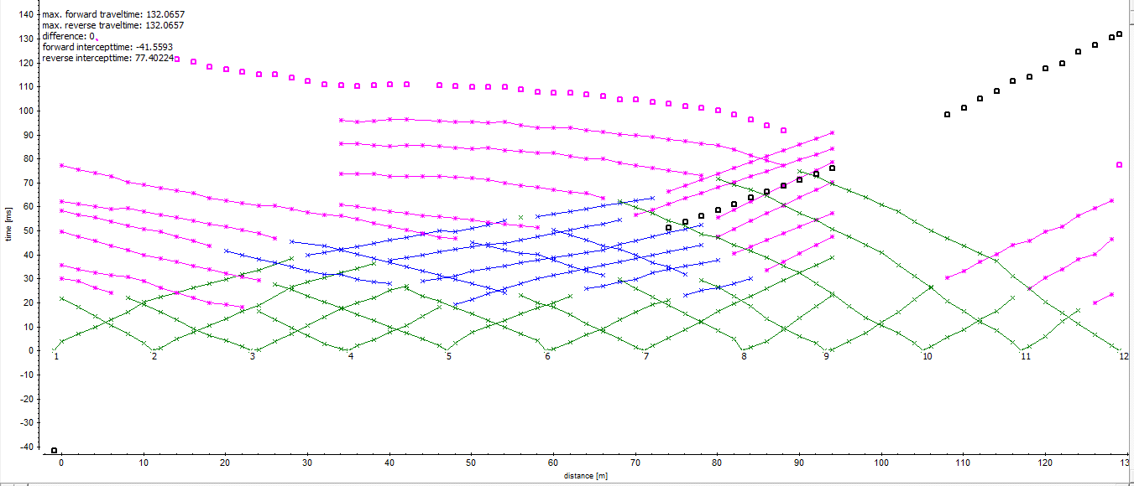
Layer Assignment for TR2

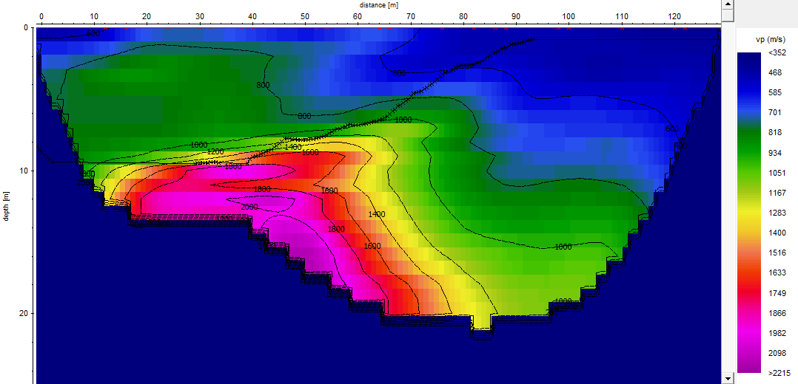
Tomographic Model for TR2

Layer Assignment for TR3

Tomographic Model for TR3

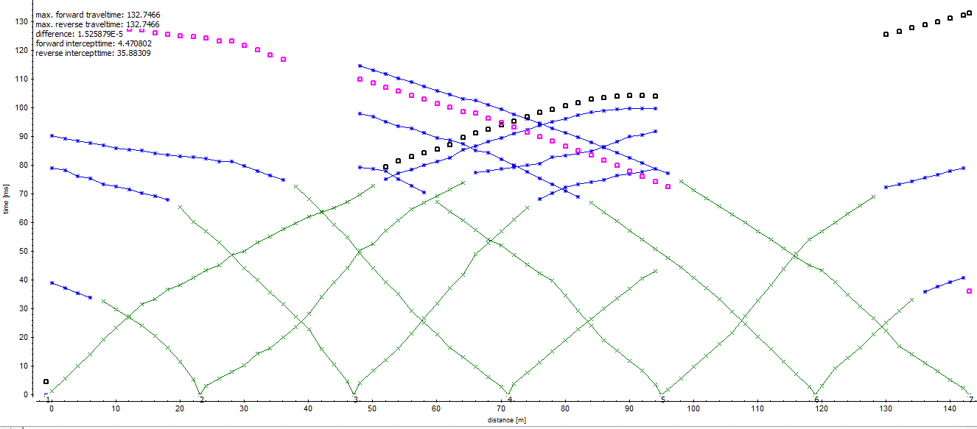
Layer Assignment for TR4

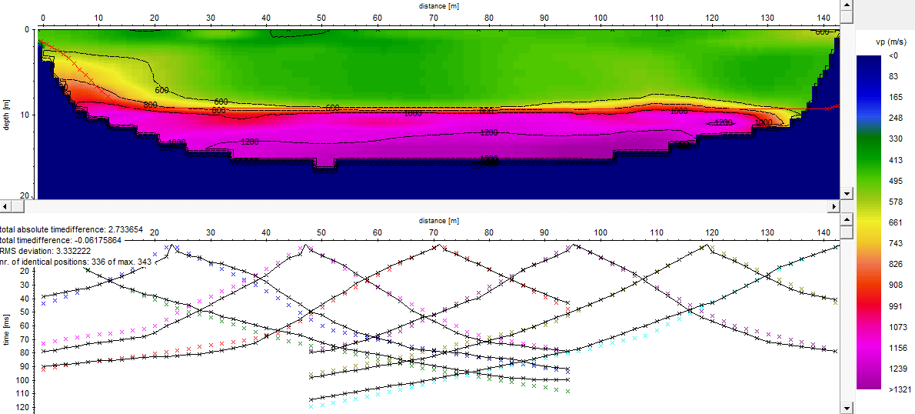
Tomographic Model for TR4

APPENDIX D
Dispersion curves for TR2

S-wave velocity model for TR2

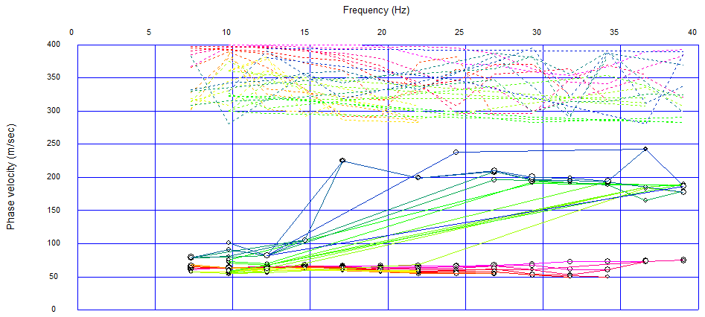
Dispersion curves for TR3

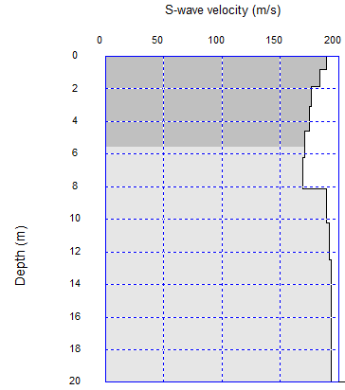
S-wave velocity model for TR3

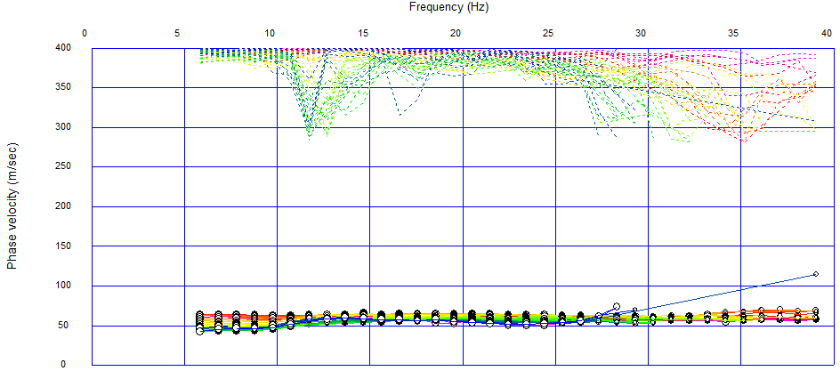
Dispersion curves for TR4

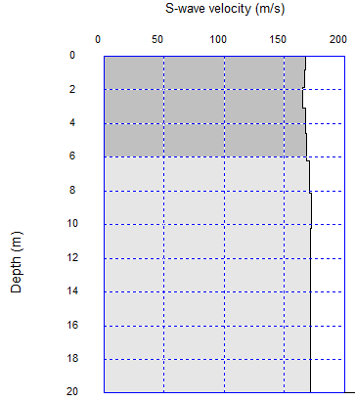
S-wave velocity model for TR4

