RESPONSE OF DROUGHT TOLERANT BACTERIA TO PHYSIOLOGICAL FACTORS
ADEGBOYE, DAMILOLA
16010101012

A PROJECT SUBMITTED TO THE DEPARTMENT OF BIOLOGICAL SCIENCES, COLLEGE OF BASIC AND APPLIED SCIENCES, MOUNTAIN TOP UNIVERSITY, MAKOGI, IBAFO, OGUN STATE, NIGERIA.

IN PARTIAL FULFILMENT OF THE REQUIREMENTS FOR THE AWARD OF BACHELOR OF SCIENCE (B.Sc) IN MICROBIOLOGY

NOVEMBER, 2020

CERTIFICATION
This is to certify that this project titled The Response of Plant Growth Promoting Bacteria to Physiological Factors was carried out by ADEGBOYE DAMILOLA, with matriculation number 16010101012. This seminar report meets the requirements governing the award of Bachelor of Science (B.sc.) Degree in Microbiology department of Biological sciences of mountain Top University, Ogun State, Nigeria and is approved for its contribution to knowledge and literary presentation.

ADEGBOYE DAMILOLA Date

DR. M.A ABIALA Date
(Project Supervisor)

DECLARATION
I hereby announce that this project written under the supervision of Dr. Moses Abiala is a product of my own research work. Information derived from various sources have been duly acknowledged in the text and a list of references provided.

DEDICATION
This work is dedicated to God almighty for his overwhelming love he showers on me daily.

ACKNOWLEDGEMENT
I recognize the superiority of God the creator and finisher of my faith. The one who has consistently helped me through the course of my studies and the completion of this project work. I am profoundly thankful to him for that.
Also, my sincere gratitude goes to my supervisor and also my co-supervisor DR. M.A ABIALA and DR. F.H Ibadin for their interest, encouragement and guidance and encouragement in ensuring that this project is a success.
I also appreciate my parent Mrs. ADEGBOYE for their love and support through this period. My appreciation goes to my sister Dr. Mrs. Teye for her support during this period.
I also want to appreciate my best friend Tobi Olusanya who has always been with me through the rough times and also encouraged me. Thank you for being a blessing.
Finally, to my co-supervisees Olusanya Tobi Esther, Ajose Oyindamola Deborah and Oyebamiji Adebola Eyitayo for their support.

Table Of Contents
CERTIFICATION ii
DECLARATION iii
DEDICATION i
ACKNOWLEDGEMENT ii
Contents iii
ABSTRACT iv
CHAPTER 1 1
1.0 INTRODUCTION 1
CHAPTER 2 3
2.1 DROUGHT 3
2.2 Drought as a Global Problem 5
2.3 Types of drought 6
2.3.1 Agricultural drought 6
2.3.2 Meteorological drought 7
2.3.3 Hydrological Drought 7
2.3.4 Socio-economic Drought 7
2.4 Causes of Drought 7
2.5 Effect of Drought in Agricultural Sector 8
CHAPTER 3 10
3.1 Drought stress and root-related bacterial ecosystems 10
3.2 Soil Bacteria Community Responses to Drought 11
3.3 The Role of Bacteria Promoting Plant Growth under Drought Stress 11
3.4 The Mechanisms of Physiology Bacteria-promoting plant growth 12
3.5 Response Promoting bacteria for plant growth in Plant Growth 13
3.6 Basic Concept of Drought Tolerant Bacteria 15
CHAPTER 4 16
4.1 ADAPTATION PROMOTING RHIZOBACTERIA FROM PLANT GROWTH PGPR UNDER ABIOTIC STRESS 16
4.1.1 Salinity 16
4.1.2 Heat Stress 17
4.1.3 Heavy Metals 18
4.1.4 Importance of Nitrogen fixing PGPR 20
CHAPTER 5 22
5.1 CONCLUSION & RECOMMENDATION 22

ABSTRACT
Drought is an unpleasant environmental stress condition that involves the absence of water due to lack of rainfall. This results in lack of nutrient uptake by the plant and also imbalance of hormone in plant. Some microorganisms are involved in the aid of plant growth and the prevention of disease, these are known as the Plant Growth Promoting Bacteria (PGPR) example of such are Pseudomonas fluorescens. Various droughts affecting plants include Agricultural, Meteorological, Hydrological and Socio-economic. Drought can be caused by different factors such as temperature increase, timing could also have an adverse effect due to difference between the time of planting and the time of rainfall. Plant Growth Promoting Bacteria can also help plants grow in abiotic stress such as drought, salinity. heavy metal, and temperature. These microorganisms secrete an enzyme called 1-aminocyclopropane-1-carboxylate (ACC) deaminase which through breaking down plant ACC, and also increases plant nutrient absorption.

CHAPTER 1

1.0 INTRODUCTION
Drought results from lack of rainfall or lack of precipitation could reduce the growth of the crop which could result to lack of nutrient and hormonal imbalance (Solankey et al.,2014). There are microorganisms that are beneficial to the soil whereby they aid in the growth of plant and also acts as antagonist against soil pathogens which could be harmful to certain crops, these microbes are called Plant Promoting Rhizobacteria (PGPR) (Msizi et al.,2020). PGPR like Pseudomonas fluorescens, P. putida, and P. aeruginosa which helps in the growth of plant and also prevent plant disease (Widnyana et al.,2020). The bacteria around and also in the plant roots (rhizobacteria) are more flexible in converting, mobilizing, solubilizing plant-beneficial nutrients present in the soil (Hayat et al., 2010). Therefore, In the recycling of soil nutrients, rhizobacteria are the primary deriving factors and are thus essential to soil productivity (Glick, 2012). Following an advanced plant nutrient management system, biological approaches to improving crop quality are currently gaining high standing among agronomists and environmentalists. In this sense, a broad variety of rhizobacteria with novel characteristics such as heavy metal detoxifying potential (Ma et al., 2011a; Wani and Khan, 2010), pesticide degradation/tolerance (Ahemad and Khan, 2012a; Ahemad and Khan, 2012b), salinity tolerance (Tank and Saraf, 201; Mayak et al., 2004), pesticide degradation/tolerance (Ahemad and Khan, 2012a;Ahemad and Khan, 2012b), salinity tolerance (Tank and Saraf, 201;, Mayak et al., 2004). Biological control of phytopathogens and insects (Hynes et al., 2008; Russo et al., 2008;Joo et al., 2005; Murphy et al., 2000).Also with the normal plant growth promoting properties such as, phytohormone (Ahemad and Khan, 2012c; Tank and Saraf, 2010), siderophore (Jahanian et al., 2012; Tian et al., 2009), 1-aminocyclopropane-1-carboxylate, Hydrogen cyanate (HCN) and producing ammonia, nitrogenase activity (Glick, 2012, Khan, 2005), solubilization of phosphates (Ahemad and Khan, 2012c), etc. Hence, various symbiotic (Rhizobium, Bradyrhizobium, Mesorhizobium) and non-symbiotic (Pseudomonas, Bacillus, Klebsiella, Azotobacter, Azospirillum, Azomonas) rhizobacteria are also being used as bio-inoculants worldwide to support plant growth and growth under different stresses such as heavy metals. (Ma et al., 2011a; Ma et al., 2011b; Wani and Khan, 2010), herbicides (Ahemad and Khan, 2011; Ahemad and Khan, 2010g), insecticides (Ahemad and Khan, 2011h; Ahemad and Khan, 2011k), fungicides (Ahemad and Khan, 2012; Ahemad and Khan, 2011j), salinity (Mayak et al., 2004), etc.

CHAPTER 2

2.1 DROUGHT
Drought is one of the highly recognized hazards globally that damage an environment. It takes place while there is a significant rainfall deficit that causes hydrological imbalances and affects the land productive systems. In all climatic areas with both high and low mean rainfall, drought happens (Um et al., 2017). Agricultural development as well as the natural world and human civilization can be affected (Gideyet al., 2018).
Drought is known to be a natural disaster because it has a progressive creeping aspect that varies from other natural disasters (Ayoade 1988; Yue et al. 2018). Liu et al. (2018) conclude that with prolonged consequences that steadily escalate in magnitude and begin to continue, drought progresses slowly. The National Aeronautics and Space Administration (NASA) estimated that between the early 1960s and 1986, approximately 900,000 km2 of former savanna grassland in the area in Africa was seriously decertified due to recurrent drought occurrences (O'Connor, 1995). In comparison, Bates et al. (2008) suggest that in drought-prone regions, one third of the African population lives. Since the drought of the early 1970s that ravaged the Sahel region, drought has become a recurring phenomenon in many parts of Africa. Dai et al. (2004) have shown that there is a drop of nearly 40% in the average annual rainfall in West Africa from 1968-1990 relative to the 30 years between 1931 and 1960. Thus, recurrent drought events in African savanna regions are threatening human life and thus making households highly vulnerable to drought over a long period, even after it has ended (Eze et al., 2018).
According to WHO (World Health Organization), an estimated 55 million people globally are affected by droughts every year, and it is the most serious hazard to livestock and crops in nearly every part of the world (WHO, 2019). Drought threatens people’s livelihoods, increases the risk of disease and death, and also fuels mass migration. Water scarcity impacts 40% of the world’s population, and as many as 700 million people are at risk of being displaced as a result of drought by 2030. (WHO,2019)
Drought is a prolonged dry period in the natural climate cycle that can occur anywhere in the
world. It is a slow-onset disaster characterized by the lack of precipitation, resulting in a water
shortage. Drought can have a serious impact on health, agriculture, economies, energy and the
environment. (WHO, 2020). Drought has been a global challenge where it mostly leads to starvation because of the lack of nutrients that aids plant growth and also reduced water supply. Drought stress appears as a threat to crop production globally. This results in reduced uptake of nutrients by plants, photosynthesis, and poor root growth (Danish et al., 2020). It's one of the large numbers that a farmer must handle as a possibility. In numbers, the lowest decile or two of the rising season water supply or the index of intensity of palmer dryness (Hayes, 2006).
Drought occurs in severe financial hardship amidst farmers in underdeveloped countries. If it continues, it can lead to desertification, a high rate of migration, and major social upheaval, not only that the affected region is neglected by its former inhabitants but also excess farming on land may become so degraded that it can no longer keep up with human habitation even after the drought (Passioura, 2006). Drought stress is one of the primary environmental variables is which reduces plant growth; the most common cause of it is that it increases temperature and reduces water supply to plants (Nazaret al., 2015). Water shortage as a factor limiting in the germination stage inhibits growth and also establishes the plant and reduces the production of the crop (Yan, 2015). Rainfall deficiency remains the main factor that leads to the occurrence of drought, whereas its seriousness depends on the time, rainfall intensity, and distribution (Yaduvanshiet al., 2015). Several definitions of drought have not stated direct as well as secondary influences of drought in many places around the world (Tannehill, 1947; Wilhite, 2005; Trambaueret al., 2013; Udmaleet al., 2014; Van Loon and Laaha 2014).

2.2 Drought as a Global Problem
Drought has made a negative impact on society whereby $596 billion (U.S. dollars) has been lost due to drought damages in the early twenty-first century (2000-17) and also affected more than 3.4 billion people during 1995-2015 (UNISDR 2015). Vietnam is among the countries with vast records of climate issues, such as drought and floods which made them the 13thcountry ranked in terms of exposure consequences of climate change (Lohmann and Lechtenfeld, 2015). Impacts can propagate into other sectors due to losses of ecosystem services (Palmer et al., 2009; Mora et al., 2018). Supply chain would be disrupted owing to the exclusion of supply ( Haraguchi and Lall, 2015; in Bäumenet al., 2015; Cottrell et al., 2019), mitigation cost also increases (Kreibichet al. 2017), rate of migration would be on the high side (Perch-Nielsen et al., 2008; Feng et al., 2010; Black et al., 2011; Abel et al., 2019), and also results in conflicts (Gleick, 2014). This causes extreme danger to the the global economy. If the farmer’s crops are being destroyed there will be money loss (NDMC, 2020). Drought can reduce the moisture content in the soil. Companies that supply water may end up increasing the cost of water supplies (NDMC, 2020). The rainfall in Vietnam over the past few decades has been highly variable. Rural communities depend highly on rain-fed agriculture (Nguyen, 2011). Despite economic growth, many citizens live on less than they live on, $1.25 in a day, the high number of houses live below the poverty line (World Bank, 2012). Drought is a challenge that constantly affects farming in Iran (Dariushet al., 2010). The availability of water dropped and the farmer’s resources were depleted whereby humans began to suffer and there was a reduction of crop production. Mitigation of drought and strategies of coping are restricted, due to the government being unable to reduce drought damage (Dariushet al., 2010).
The United States of America (USA) experience drought which affected the levels of water in reservoirs and river (Cook et al., 2007). Drought history of the US reveals a great damage (Sahr, 2005). In 1980,1988 and 2002, there were several scenarios of drought, where that of the year 2002 cost more than $10 billion while that of 1980 and 1988 scenarios cost $48.8 billion and $61.6 billion, respectively (Ross and Lott, 2003). Estimated economic damage costs from 1950-2003 has increased from $5 billion to $35 billion, and are projected to increase from $35-105 billion between 2003- 2050 (Jenkins, 2012).

2.3 Types of drought
Both aspects of drought have diverse causal factors and attributes. However, Drought of all sorts are detrimental to both anthropogenic and natural systems (Lenget al., 2015). Ecosystems need sufficient water for their functioning (for plants to grow and aquatic organisms to survive) (Yaduvanshiet al., 2015). The period of drought normally takes at least 2-3 months to be apparent, after which it can exist for months, years and can also be decades. Distribution areas are usually affected by intense drought gradually evolve over time (Van Loon and Laaha, 2014).

2.3.1 Agricultural drought
This is determined by the availability of soil moisture content to support plants or crop growth and maintain pastures for grazing. Soil moisture content below annual average level decreases crop yield and is described as agricultural drought (Qin et al., 2014).

2.3.2 Meteorological drought
It is a naturally occurring phenomenon that usually starts owing to the exclusion of water caused by climatic factors, and most times causes economic losses (Smakhtin et al., 2007). This kind of drought is similar to water shortage, characterized by unusual weather conditions, such as desiccation and increase in temperatures (Qin et al., 2014).

2.3.3 Hydrological Drought
This is known as inadequate terrestrial availability of precipitation (Van Loon and Laaha, 2014). It normally affects the levels of water bodies from average to low, which makes it inadequate to meet human and ecosystem demands. Stream-flow the most significant element in terms of the consistency of water is (Wander et al., 2013).

2.3.4 Socio-economic Drought
This kind of drought is inadequate precipitation to meet human and environmental demands, it is being set-off by human activities and elements of other types of drought (hydrological, meteorological and agricultural) (Wilhite, 2005).

2.4 Causes of Drought
Increase in temperature evaporates the water and also increases in severe weather conditions (Restuccia, 2016). Water shortage as a factor limiting in the germination stages, inhibits growth and establishment of the plant and reduces the crop production (Yan, 2015). Circulation of air and patterns of weather could also cause drought (Restuccia, 2016). Timing also matters in when it comes to drought and agriculture because if the time of rainfall does not match with agricultural season there might be excess of water and also there can be shortage of water (Restuccia, 2016). Drought reduces agricultural land productivity, which affects the food supply to urban centres (Abdullahi, 2018). Migration to urban areas increases due to drought. Migration from rural to urban areas increases stress on water and other natural resources (Abdullahi, 2018).

2.5 Effect of Drought in Agricultural Sector
Agricultural production is influenced directly by climatic changes such as temperature and rainfall (Ray et al., 2018). These climatic changes dominate the growth, health, yearly crop yield, also the system of cropping over time (Howden et al., 2007; Kang et al., 2009; Lehmann, 2013; Paudelet al., 2014; Liang et al., 2017). Extreme weather conditions affect the crop production negatively (Troy et al., 2015). Shortage of water as a limiting factor limiting in the germination stage prevent growth and establishment of the plant and reduces the product of crops (Yan, 2015). A study conducted by Trnkaet al. (2014) it indicates that an increase in the frequency of drought may neutralize the anticipated positive impact of a longer growing season and can reduce the benefits of dry season development. typical drought mitigation strategies.
Deficiencies in nutrient can also be caused by drought, including fertilized soil, it is due to the decrease in mobility, density of separate nutrients, which results to low diffusion rate from the connected roots, and hence drought is what mostly limit the growth of plants (Ciríaco da Silva et al., 2013).
The plants response to physiology have been greatly affected under changing climate since the chances of experiencing various stresses by crop plants have enlarged due to environmental extremities and climate variability (Thornton et al., 2014).
A dry soil and water loss through high transpiration makes the experience of the plant drought stress which result in turgor loss (Ajumet al., 2011).
In the year 2011, there was a drastic drought in Somalia, which caused huge humanitarian disaster, which had effect on over 10million people; 2 million in the midst of them were children who were malnourished due to lack of food, 380,000 people left to be refugees in Kenya (Vicente-Serrano et al., 2012). One- third of Africa is being reported as desertified and about 73% of agricultural lands are degraded (Abdullahi, 2018). When two to three seasons of drought across those areas, it will lead to severe environmental stress (Lean, 1995). In Africa, drought and floods account for 80% of life loss and economic (Bhavnani et al., 2008). In 1990/1991 the GDP of Zimbabwe decreased by 11% due to drought related issues. In Kenya 1999/2001 drought cost an estimated $2.5 billion (Brown et al., 2011).

CHAPTER 3

3.1 Drought stress and root-related bacterial ecosystems
Plants are closely connected with bacterial communities mostly based in their origins in and around them, which include both the rhizosphere (soils near enough to the root from which to be influenced root exudate release) and the root endosphere (root inside) communities (Berg et al., 2014).
Unfortunately, due to the sophistication and interconnectedness of the forces that control the establishment, it is difficult to explain exactly how drought impacts root-associated bacterial populations. of root micro biome. Plants recruit bacteria from populations of soil and enriched for a host-specific root endophytic community typically of decreased diversity (Bulgarelli et al., 2012). However, this ‘starting drought can influence the inoculum of the soil micro biome, both directly through selection for desiccation-tolerant taxa and indirectly through altered soil chemistry and diffusion rates. Like soils, plants also undergo a set of physiological responses to drought in an effort to shield themselves from its harmful effects. These responses include alterations in the profile of root exudate, the main means by which bacteria are attracted by plants, and in root morphology. Thus, under drought, the root micro biome is dictated by how drought forms both the host plant and the underlying soils. Each of these variables will affect the others to further complicate matters: altered soil nutrient cycles and subsequent changes in the soil micro biome under drought would in turn have repercussions for plant health, as plants depend on bacterial activity to make bioavailable soil nutrients. Similarly, the structure and behaviour of the local soil microbiota can be altered by drought-induced changes in plant exudate profiles, encouraging more alterations in soil geochemistry that in turn modify soil geochemistry magnitude and directionality of soil community shifts. As a result of this complexity, a truly integrated understanding of the effect of drought on the root microbiome is extremely challenging to achieve.

3.2 Soil Bacteria Community Responses to Drought
The drought-treated root is the primary repository from which roots hire their micro biomes, provided that soils are the primary repository micro biome is heavily dependent on the response of soil bacterial communities to moisture limitation. It should be noted that the term ‘soil’ in the context of micro biome studies may be used to refer to root zone soil, rhizosphere soil, or bulk soil, where the latter is assumed to be largely free of direct root influence and has higher diversity than rhizosphere soil (Lundberg et al., 2012). Analysis referenced in this review on soil micro biomes was performed on non-plant-related bulk soil for consistency (except where indicated); however, it should be noted that in some instances, environments, the methodology of bulk soil collection occasionally necessitates removal of root tissue from soil samples, and therefore presence of root tissue may present a potential confounding factor in such analyses.

3.3 The Role of Bacteria Promoting Plant Growth under Drought Stress
Plant recruitment of a drought-specific micro biome could be an evolved trait, where generations of repeated drought events have led to evolution of stable and beneficial plant-microbe interactions that improve the reproductive fitness of both host and microbe. In one study, Brassica rapa plants that had been exposed to generations of drought were better able than control plants to increase bacterial abundance and diversity around roots under dry contemporary environments (TerHorstet al., 2014). Alternatively, a drought-tolerant community may be achieved through soil attenuation, in which bacterial communities in soils exposed to drought have developed resistance, and thus the plant will have no choice but to recruit a beneficial microbiome. This was demonstrated by Lau and Lennon (2012), where plant fitness was highest when grown in previously droughty soils under drought conditions, while plant fitness was highest under well-watered conditions highest in soils where water was historically abundant. Even simply having a sympatric soil (i.e., a soil in which a given plant has been repeatedly grown in) can improve a plant’s performance (in this case, biomass and drought-responsive gene expression) under drought compared with the same conditions in non-sympatric soils (Zolla et al., 2013), suggesting that even when not under stress, plants will recruit beneficial bacteria that remain in the soil and can enhance drought tolerance for other members of their species.

3.4 The Mechanisms of Physiology Bacteria-promoting plant growth
The plant response during abiotic stress is very complex as the tissue of the plant show differences in their growth complexity, exposure and responses towards the prevailing stress (Queitsch et al., 2000).
The loss of crop is mostly caused by drought more also, it is the major type of loss caused by all types of abiotic stress (Placide et al., 2014). Drought can also affect the metabolism of water in plants and also cause major changes in plant morphology, physiology and also biological chemistry (Torres-Ruiz et al., 2015). Drought stress prevents plants from growing by decreasing the rate of photosynthesis (Kebbas et al., 2015; Zhang et al., 2018). There are some factors responsible for reduction in photosynthesis which are; stomatal (stomatal closure due to decreased _{CO2}), nonstomatal (decreased photosynthetic activity in mesophyll tissue), or both (Ghotbi-Ravandi et al., 2014; Varone et al., 2012; Amer et al., 2020). All these variables (stomatal, non-stomatal, or both) also depend on experimental care of the plants being tested, type, cultivar, age, and development status (Liang et al., 2018; Liu et al., 2017). The symptoms of drought are similar to salt stress because the salt concentration is high in the zone of the root which cause water loss from the root due to osmotic effect (Khan et al., 2015). Bacteria which helps in the growth of plants during abiotic stress are Pseudomonas, Bacillus, Acinetobacter, Streptomyces, Micrococcus, Azotobacter, Flavobacterium, and Streptococcus (Prasharet al. 2014).

3.5 Response Promoting bacteria for plant growth in Plant Growth
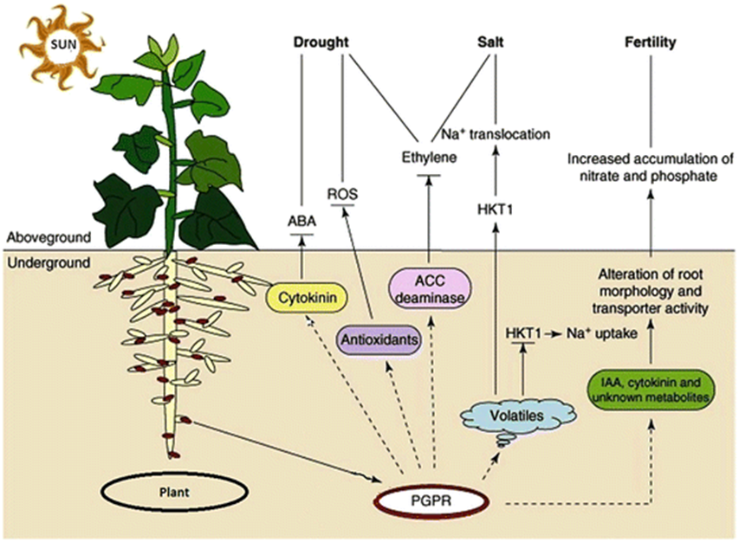
(Prasad et al., 2015)
Fig. 3.1 Diagram show how Bacteria-promoting plant growth aids in plant development

During drought, plant lack nutrient owing to the exclusion of precipitation. There are different methods of preventing plant from being affected by abiotic stress such as physical method, chemical method and biological methods. The most common, efficient and inexpensive method is biological method which entails the use of Rhizobacteria-promoting plant growth (PGPR).
Rhizobacteria stimulating plant growth (PGPR) are characterized by the following: (i) To colonize the root surface, they must be capable of. (ii) At least for the time required to communicate their plant growth promotion/protection behaviors, they must live, reproduce and compete with other micro biota, and (iii) They must encourage plant growth (Kloepper, 1994).
According to Somers et al. (2004) PGPR is being categorized based on their ability to function such as (i) ability in increase the rate of nutritional availability to plant (biofertilizers); (ii) degradation of organic waste (rhizoremediators); (iii) promoting growth through phytohormones (Phyto- stimulators); (iv) disease control by producing antifungal metabolites and antibiotics (biopesticides) (Antoun and Prévost, 2005). Examples of PGPR are Burkholderia, Caulobacter,Chromobacterium, Azotobacter, Azospirillum, Bacillus, etc. Gram-negative rods are most of the rhizobacteria belonging to this category, with a smaller proportion of Gram-positive rods, cocci, or pleomorphic (Bhattacharyya and Jha, 2012).
Pseudomonas spp. group (Rhizobacteria) are plant beneficial, helps to improve soil fertility, and serves as biological control agents for plant pathogens and have the potential of increasing plant resistance (induced systemic resistance; ISR (McMilan, 2007)
An indirect role rhizobacteria plays is by generating plant growth hormones such as indole acetic acid (IAA), gibberellins, cytokinins, ethylene, as a biological fertilizer and biological stimulant, and solubilizing minerals. The microbes also function indirectly to inhibit pathogenic microbes through the formation of siderophores and antibiotics (McMilan, 2007; Sarma, 2009).

3.6 Basic Concept of Drought Tolerant Bacteria
Plant Growth Promoting Rhizobacteria (PGPR) aids in iron sequestration, soil phosphorus mobilization, and exopolysaccharide and beneficial enzyme synthesis, such as 1-aminocyclopropane-1-carboxylate deaminase (ACC), as well as plant growth hormones, especially indole-3-acetic acid. These microbes indirectly promote the development of plants by protecting plants from phytopathogens and producing compounds such as hydrogen cyanide, antibiotics, ACC deaminase synthesis, lytic enzymes, and induced systemic resistance (ISR) (Olanrewaju et al.,2017). Most PGPR have multiple growth-promoting (PGP) plant characteristics that allow their use as bio-inoculants for crop production, even in crop production unfavourable environmental conditions. A variety of PGPR produce ACC leaves deaminase in to ammonia and α-ketobutyrate inhibiting its transition to ethylene. The ACC is produced in larger volumes by plants surviving under abiotic stresses such as water flooding, ultraviolet radiations, temperature, and heavy metals (Ali et al., 2012; Glick 2014). In this way, manufacture of ACC deaminase by PGPR defends plants against detrimental effects of ethylene surviving under abiotic stresses (Glick 2014). Bacterial synthesizing ACC deaminase belongs to genera Pseudomonas, Bacillus, Acinetobacter, Azospirillum, Achromobacter, Enterobacter, Burkholderia, Agrobacterium, Alcaligenes, Rhizobium, Serratia, etc. (Gupta et al., 2015). Vaikuntapu et al. (2014) evaluated the plant growth-promoting potential of selected strains of Pseudomonas, Bacillus, Aeromonas, and Enterobacterwhich revealed their PGP activities including the ACC deaminase production (Ahmed et al., 2017)

CHAPTER 4

4.1 ADAPTATION PROMOTING RHIZOBACTERIA FROM PLANT GROWTH PGPR UNDER ABIOTIC STRESS

4.1.1 Salinity
Salinity is among the element that destroys the crop field or agricultural land and also the growth of the economy and the nourishments (Zameeret al., 2016). All efforts have been made by scientist in order to ensure that salt loving genetic modified crops are attained (Munns et al., 2015). According to Zameer (2016), the physiological, biochemical and molecular aspect of the salt-stress is not yet fully discovered, therefore, the salt-tolerate crops cannot be produced. Proline plays a major role in the osmoadaptation by expanding osmotic stress which moves the presiding osmolyte from glutamate to proline in Azospirillum sp. affected by abiotic stress condition, high proline biosynthesis was analyzed for diverse plant species inoculated with diverse Rhizobacteria-promoting plant growth (Chaudhry et al., 2012).
Abiotic stress affects agricultural crops therefore causing hormonal imbalance, malnutrition, etc.(Nadeem et al., 2014). The use of biological methods has been introduced long time ago (Glick et al., 2007; Yang et al., 2008; Zahiret al., 2008; Adesemoyeet al., 2009; Bhattacharyya and Jha, 2012; Zameeret al.,2016).
These methods are known as usage of Bacteria-promoting plant growth (PGPR), it aids in balancing both hormone and nutrition, alongside solubilizing nutrients, production of regulators in plant growth and production incited opposition in plant. Bacteria Fostering Plant Growth are known to be the greatest restoration for curing soil salinity (Figueiredo et al., 2010). Plant Growth Promoting Bacteria aids in the synthesis of a specific combination, nutritional absorption and function as a plant remedy (Zameer et al., 2015). It is available in the rhizosphere, region around the root of plant go through severe biochemical scheme by the root transpires also microbes take in compounds, aids the development of plant, solubilizing nutrition such as potassium, phosphorus, potassium, etc., whereby they are being inoculated with bacteria-promoting plant growth (Zameer et al., 2016).

4.1.2 Heat Stress
Heat stress is one of the challenges faced in agricultural field owing to the exclusion of precipitation, and there is a need for this problem to be solved in order for high productivity to occur despite being under heat stress (Mukhta et al.,2020). In the course of abiotic stress, the promotion of plant growth has been revealed in many crops including tomatoes (Mayaket al.,2004; Mukhta et al.,2020). The growth of plant is ensured through the help of PGPR because these beneficial microbes help in the absorption of nutrient and minerals (Rafique et al., 2019). Pseudomonas can go through abiotic stress condition, this is as a result of the exopolysaccharide they produce (Sandhy et al., 2009; Mukhta et al., 2020). The exopolysaccharide helps to defend the microbes under abiotic environmental stress condition (Shafiq et al., 2020).
Diversity of microbial habitats in the rhizosphere's microbial hotspot. Discrimination between rhizosphere and root communities of mature plants from unplanted soil profiles is dependent on selective enrichment of individual microbiota bacteria. These enrichment levels demonstrated bias for the members of phyla Bacteroidetes, Actinobacteria, Proteobacteria (including groups Alpha- Beta-, Delta-, and Gamma-proteobacteria and Verrucomicrobia.

4.1.3 Heavy Metals
Heavy metals are pollutants in the environments and can have adverse effect in the agricultural field (Asatiet al., 2016). Examples of such heavy metals are copper (Cu), lead (Pb), cobalt (Co), chromium (Cr), silver (Ag) and silver (Ag), cadmium (Cd), mercury (Hg) (Farlex, 2005; Asati et al., 2016). On the other hand, there are some heavy metals that can serve as micronutrient which in needed in lesser quantities in both plant and microorganism (Bernard et al., 2018).
There are diverse defense mechanisms that can withstand heavy metals by the cell of microorganisms. These mechanisms of actions are extracellular barrier extracellular sequestration, and active transport of metal ions (efflux), intracellular sequestration, and reduction of metal ions (Yang et al., 2015). The bacteria immobilizes heavy-metals alongside secrete metabolites that are beneficial such as arginine decarboxylase, siderophores, and indole-3-acetic acid (IAA), enhancing crop quality, increase the resistance of plant to heavy metals, to enhance growth in plant (Sun et al., 2010;Sharma and Archana, 2016; Singh et al., 2018).
These amount of enrichment shows intolerance for phyla Bacteroidetes, Proteobacteria (and also classes Alpha-, Beta-, Delta-, and Gammaproteobacteria) and Verrucomicrobia.
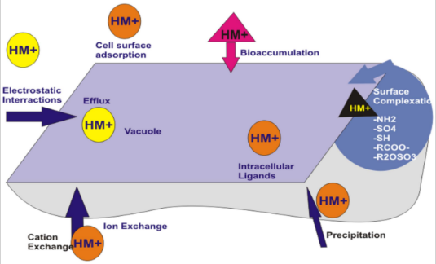
Fig 4.1 Heavy metal absorption by plant growth promoting bacteria
(Source: Ayangbenro et al.,2017

4.1.4 Importance of Nitrogen fixing PGPR
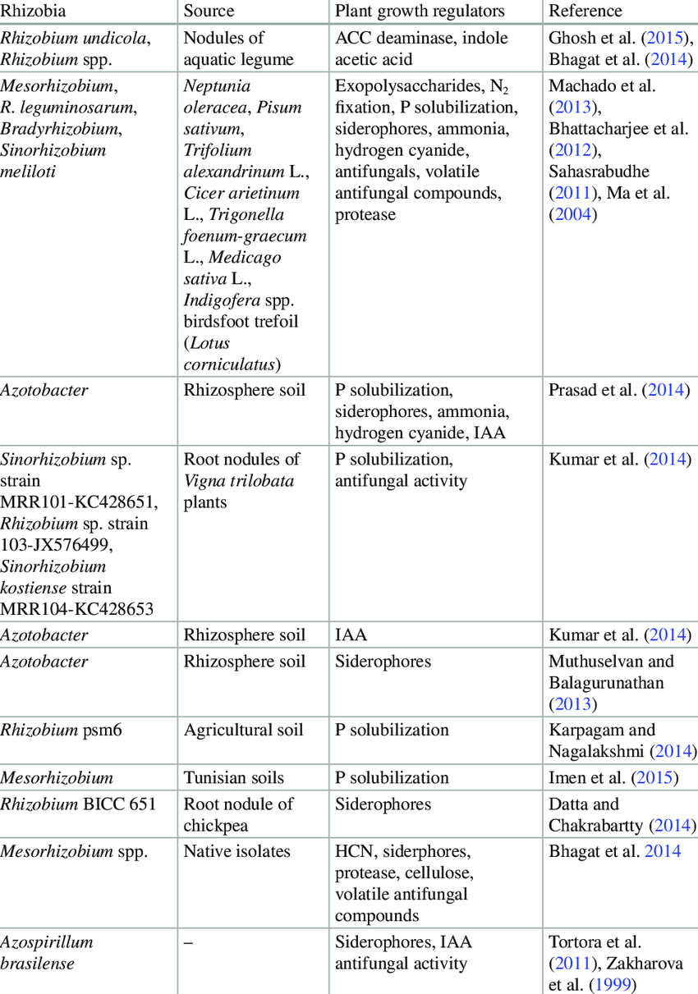
Fig 4.2 Tables Shows Plant Growth Promoting Substance Being Released By Nitrogen Fixing PGPR (Zaidi et al., 2017)
According to Beattie (2015), the research on microorganisms begins to unravel particular microbial plant interaction aided directly in plant nutrients. These microbes help plant to absorb nutrient through diverse kind of mechanisms alongside augmenting the area which is accessed by the root of the plant, nitrogen fixing, phosphorus solubilizing, producing siderophore and producing HCN (Pii et al.,2015).
There are some bacteria-promoting plant growth that helps in promoting plant growth by easing the availability of nutrient through fixing of atmospheric N₂, solubilizing phosphate, normalizing the hormonal balance through producing plant hormonal or enzymes that helps to degrade the precursor of ethylene thereby reducing the hormonal levels of the host (Francis et al., 2015). The antagonism towards different pathogens which it depends on the secretion of sufficient low-sized antimicrobials or the enzymes present in hydrolysis like glucanase and N-acetyl glucosaminidase (Lugtenberet al., 2015).

CHAPTER 5

5.1 CONCLUSION & RECOMMENDATION
Drought is an environmental stress which affect many plants because of lack of rainfall. The plant growth promoting bacteria can be used in diverse ways. These bacteria also help in breaking down nutrient for the uptake of the plant and also helps in preventing plant disease. Analyzing how plant growth promoting bacteria is known to aid in breaking down nutrients for plant use including during the abiotic stress. The plant growth promoting bacteria is highly useful in agriculture. These could be used in place of fertilizers and genetically modified foods. The government should encourage all farmers to imbibe these methods in order to have safe crops for harvest.

