SIMULATION OF A PREDICTIVE MODEL FOR THE CLASSIFICATION OF BACTERIAL DISEASES AFFECTING RICE PLANT USING FUZZY LOGIC

OZAGHA ALEXANDER JOEL
16010301037

BEING A PROJECT SUBMITTED IN THE DEPARTMENT OF COMPUTER SCIENCE AND MATHEMATICS, COLLEGE OF BASIC AND APPLIED SCIENCES

IN PARTIAL FULFILMENT OF THE REQUIREMENTS FOR THE AWARD OF BACHELOR OF SCIENCE (B.Sc.) DEGREE
MOUNTAIN TOP UNIVERSITY, IBAFO, OGUN STATE, NIGERIA

2020

CERTIFICATION
This Project titled, SIMULATION OF A PREDICTIVE MODEL FOR THE CLASSIFICATION OF BACTERIAL DISEASES AFFECTING RICE PLANT USING FUZZY LOGIC, prepared and submitted by OZAGHA ALEXANDER JOEL in partial fulfilment of the requirements for the degree of BACHELOR OF SCIENCE (Computer Science), is hereby accepted.

_________________________ __________________
Mr. J.A. Balogun Date
(Supervisor)

_________________________ __________________
Dr. I. O. Akinyemi Date
(Head of Department)

DEDICATION
This project is dedicated to God, my pillar, my source of inspiration, my wisdom, knowledge and intellect. Ultimately, he was the source of my energy. I also dedicate this study to my Project Supervisor who was of great support during the time of the research. My parents who encouraged me all the way and whose encouragement made sure I gave whatever it took to finish it.

ACKNOWLEDGEMENTS
I owe my profound gratitude to the Almighty God who from the very beginning has given me strength, wisdom and courage, divine support and provision. I thank my Major Supervisor, Mr. J.A Balogun., for his encouragement and support. I deeply appreciate the fatherly advice and guidance of the Dean, College of Basic and Applied Sciences, Dr Akinwande A.I. My sincere appreciation goes to the Head of Department of Computer Science and Mathematics — Dr Akinyemi I.O., and to all other staff members of the Computer Science Department: Dr. (Mrs.) Kasali F.A., Dr. Idowu P.A., Dr. and others to note.
I appreciate the continuous encouragement of my mentors. That's Pastor Olumide A. I am also grateful to my parents who for my success sacrificed money, time and other resources; and my siblings for their prayers. I would also like to thank all colleagues and friends of Mountain Top University for their prayers and encouragement. God bless everyone.

TABLE OF CONTENTS

TITLE PAGE i
CERTIFICATION ii
DEDICATION iii
ACKNOWLEDGEMENTS iv
TABLE OF CONTENTS v
LIST OF TABLES viii
LIST OF FIGURES ix
ABSTRACT x

CHAPTER ONE: INTRODUCTION
1.1 Background of the Study 1
1.2 Statement of the Problem 2
1.3 Aim and Objectives of the Study 3
1.4 Research methodology 3
1.5 Justification of the study 4
1.6 Scope and limitations of the study 4
1.7 Definition of Terms 4

CHAPTER TWO: LITERATURE REVIEW
2.1 Introduction 5
2.2 Predictive modelling 5
2.2.1 Predictive model types 5
2.2.2 Developing a predictive model 6
2.3 The Rice plant 6
2.3.1 Rice plant diseases 7
2.4 Expert systems 15
2.5 Fuzzy logic modelling 16
2.5.1 The concept of fuzzy logic 16
2.5.2 Fuzzy sets and membership functions 16
2.5.3 Fuzzy inference system 17
2.6 Related works 18

CHAPTER THREE: METHODOLOGY
3.1 Introduction 20
3.2 Method of the Identification of Associated Risk factors 20
3.2.1 Description of identified risk factors 20
3.2.2 Crisp and linguistic values of associated variables 22
3.3 Fuzzy Logic Model Formulation for Risk of Rice diseases 25
3.3.1 Fuzzification of the risk of rice diseases 27
3.3.2 Fuzzy inference system design 27
3.4 Simulation Environment used 29

CHAPTER 4: SYSTEM DESIGN AND ANALYSIS
4.1 Introduction 31
4.2 Fuzzy Model for Classification of Rice Plant Diseases 32
4.2.1 Results of variables using the membership function editor 33
4.2.2 Results of the Model for Classification of Rice Plant Diseases 43
4.3 Discussion of Results 43

CHAPTER FIVE: SUMMARY, CONCLUSION AND RECOMMENDATION
5.1 Summary 47
5.2 Conclusion 47
5.3 Recommendation 48
References 49
Appendix 51

LIST OF TABLES
Tables Page
3.1: Identification of crisp and linguistic values of risk factors 24
3.2: Description of Crisp intervals used during Fuzzy Model 26
3.3: Formulation of the Risk of rice diseases 28

LIST OF FIGURES
Figures Page
2.1: Bacterial leaf blight 8
2.2: Leaf blast 9
2.3: Brown spot 10
2.4: Narrow brown leaf spot 11
2.5: Leaf scald 12
2.6: Leaf smut 13
2.7: Stack burn 14
4.1: Workspace of MATLAB for fuzzification of rice diseases 34
4.2: Fuzzification of the presence of discoloured leaves 35
4.3: Fuzzification of the presence of blights 36
4.4: Fuzzification of the presence of water – soaked patches 37
4.5: Fuzzification of the presence of wilted leaves 38
4.6: Fuzzification of the presence of stunted growth 39
4.7: Fuzzification of the classification of Rice Plant Diseases 40
4.8: Source Code of. fis File of Fuzzy Model for Classification 42
4.9: The Inferred Rules located in the Fuzzy Inference Engine 45
4.10: Testing the validity of the inference engine 46

ABSTRACT
This project is based on Simulation of a Predictive Model for The Classification of Bacterial Diseases Affecting Rice Plant Using Fuzzy Logic. The likelihood of detecting disease sooner or before a diseased plant is symptomatic is a key outlook in this work. This project aims to apply fuzzy logic model to the classification of bacterial diseases affecting rice plant based on information about symptoms observed from part of the rice plant.
In order to achieve its aim and objectives, a review of the literature was conducted in order to identify the bacterial diseases affecting rice plant in Nigeria alongside symptoms associated with the risk of the bacterial diseases.
Formulate the fuzzy logic by the fuzzification of the symptoms. The fuzzy logic model was simulated using MATLAB R2018 software.
The predictive model developed will provide a means of early warning signal required for averting damages caused by bacterial infection. The resulting model will reduce the damage caused by bacterial diseases which affect rice and thus mitigating waste.

This would improve the detection of related diseases affecting the rice plant thereby improving the productivity of the plant. It is recommended that the system is improved upon to increase the scope and productivity of the system.

CHAPTER ONE
INTRODUCTION
1.1 Background to the study
According to Anon (2018), Rice with generic name Oryza sativa is the world's most commonly cultivated root crop and a significant source of calories for around two out of five Africans. For small-scale farms, especially in low-income, food-deficit areas, it is considered a food security crop as it provides adequate yields in low soil fertility conditions. Small-scale farmers, representing 85% of farmers worldwide, have a wide range of challenges facing their agricultural production, including climate change, market issues, and outbreaks of pests and diseases. Two arthropod pests were inadvertently introduced in the 1970s, the rice water weevil Lissorhoptrus oryzophilusKuschel and the rice stink bug Oebalus pugnax, being the most economically threatening pests.
According to Arora (2007), rice diseases have a longer history on the continent. The first to be recorded in Africa was Rice bacterial blight. The annual yield losses of Rice bacterial blight at production levels was between 60-80%. To perfect the detection and spread of rice diseases, early identification in the field is a crucial first step. Using visual symptoms that an agricultural specialist is able to refer to specific diseases in the plant is the state-of-the-art method of recognising diseases in plants in the field. Other approaches for conducting field-based diagnoses are a vital need for areas where experts are not available or where farmers' expertise is inadequate. The likelihood of detecting disease sooner or before a diseased plant is symptomatic is a key outlook in this work.
Fuzzy logic translates organised human intelligence into workable algorithms. In order to improve tractability, robustness and low-cost solutions for real world problems, this powerful tool was introduced to solve the problem of uncertainty.

According to Jeon (2000), in the last decade, fuzzy systems have replaced traditional technology in some science forecasting applications and engineering systems. In addition, Fuzzy logic articulates the complexity of human reasoning and transform expert information into computable numerical results.

1.2 Statement of the problem
According to Chen (2006), crop diseases are major causes of starvation and food shortages and it is estimated that annual crop yield losses of up to 38 percent globally can be accounted for by plant pathogens. In addition, existing strategies to combat numerous diseases include the massive use of crop safety products that are harmful to the environment and the consumer. According to Agrawal (2005), unfortunately, it is most difficult to implement such methods as a strategy, especially in developing countries such as Nigeria, where there is no repository available to store image-based rice disease information. There is a need to develop a predictive model which will depend on information about symptoms observed from the rice plant and knowledge elicited from experts about their relationship with bacterial.

1.3 Aims and objectives of the study
The aim of this study is to apply fuzzy logic model to the classification of bacterial diseases affecting rice plant based on information about symptoms observed from parts of the rice plant.
The specific research objectives are to
- elicit knowledge about the symptoms associated with the classification of bacterial diseases affecting rice plant;
- formulate the model based on information collected in (i);
- simulate the model; and
- validate the model.

1.4 Research Methodology
In order to meet up with the aforementioned objectives, the methods which were adopted consist of the following.
- A review of literature was conducted in order to identify the bacterial diseases affecting rice plant in Nigeria alongside symptoms associated with the risk of the bacterial diseases.
- Formulate the fuzzy logic by the fuzzification of the input (symptoms) and output (risk of bacterial diseases) variables.
- The inference engine was formulated by the creation of If-Then rules which adopted the symptoms as the antecedent part and the risk of bacterial diseases as the consequent part.
- The fuzzy logic model was simulated using MATLAB R2018 software.
- Then the model was validated using a simple dataset based on accuracy, such as none, fair and present.

1.5 Justification of the Study
In the formulation of a classification model for the risk of rice disease, the adoption of fuzzy logic will translate the human expert knowledge used on the field into an expert system which can be used by a non-expert. The resulting model will reduce the damage caused by bacterial diseases which affect rice and thus mitigating waste. The predictive model developed will provide a means of early warning signal required for averting damages caused by bacterial infection.

1.6 Scope and Limitations
This study is limited to the use of information observed from the leaves required for the detection of bacterial diseases and classification of diseases which are most popular in Nigeria.

1.7 Arrangement of thesis
The first chapter of the study which includes the study introduction, was introduced. Chapter two provides a literature review consisting of the identification of rice diseases and methods of detection, which described Fuzzy logic modelling in addition to predictive modelling. Chapter three is a summary of the research methods to be followed in this study in order to achieve the study's goals. The findings and discussions of the approaches adopted in this analysis are included in chapter four. The study overview, conclusion and recommendations are discussed in chapter five.

CHAPTER TWO
LITERATURE REVIEW
2.1 Introduction
This section presents the different modelling that were adopted in this study in order to develop the classification model for the risk of rice disease based on expert systems. This section contains the expert systems that are associated with fuzzy logic modelling of rice diseases and its related works.

2.2 Predictive modelling
According to Idowu (2015), Predictive research has become increasingly common in medical research and seeks to predict future events or an outcome based on trends within a collection of variables. Accurate predictive models can warn patients and doctors about the potential course of an illness or the risk of disease development and thereby help direct screening and treatment decisions. Although predictive models provide insight into the outcome of the casualty, the casualty is neither a primary objective nor a variable inclusion prerequisite.
2.2.1 Predictive model types
According to Waijee (2010), using a range of prediction analytical tools, a variety of different techniques exist to build predictive algorithms and have been defined in detail in the literature. When several possible predictors are available and there are interactions between predictors, which are typical in engineering, biological and social causative processes, approaching a predictive problem without a clear causal hypothesis can be very successful.

2.2.2 Developing a predictive model
According to Royston (2009), by using conventional regression analysis, designing a predictive model is to pick appropriate candidate predictor variables for potential inclusion in the model; however, the best approach to do so is not accepted.
Regardless of their statistical significance, important predictor variables previously identified should normally be included in the final model, but the number of variables included is generally constrained by the sample size of the dataset.

2.3 The Rice Plant
According to Gao (2010), rice is the world's largest source of carbohydrates for human consumption, supplying more calories per unit of land for food than any other staple crop. The long-term effects of rice diseases are food security crises and widespread poverty, because rice is mainly grown for food and as a source of income by small-scale farmers. The rice disease pandemic slows the market diversification of rice use in the production of livestock feed, textiles, pharmaceuticals, alcohol and other beverages. Recently, there is continuous management of rice disease incidence, severity and also monitoring and forecasting rice disease prevalence over time and planning appropriate interventions to avert crises.

2.3.1 Rice plant diseases
According to Wang (2012), rice diseases include; Rice bacterial blight, Brown spot, grain rot and many others. These diseases are transmitted by a vector which poses a significant threat to Nigeria's rice community. A large team of experts for the continuous monitoring of crops and the detection of rice disease by visual signs is a more laborious process and can often prove to take longer. According to Luo (2004), in agricultural applications, data mining includes the conceptualization, design, development, estimation and implementation of modern ways of using rural information and communication technologies, including with the main objective of productivity in agriculture. The images below show the different type of rice plant diseases: Fig 2.1 shows the bacterial leaf blight; Fig 2.2 shows the leaf blast; Fig 2.3 shows the brown spot; Fig 2.4 shows the narrow brown leaf spot; Fig 2.5 shows the leaf scald; Fig 2.6 shows the leaf smut and Fig 2.7 shows the stack burn.

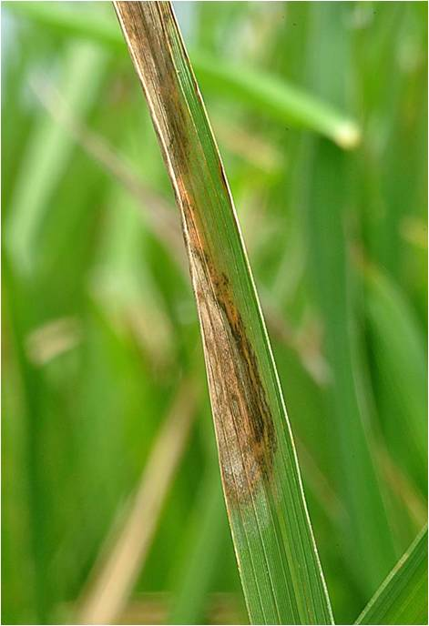
Figure 2.1: Bacterial leaf blight identified on the tip of the leaf (Abdel & Shabdana 2013).

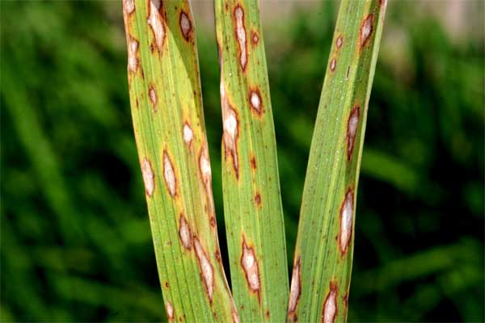
Figure 2.2: Leaf blast identified by its small round, brown spots to oval spots on the leaf (Abdel & Shabdana 2013).

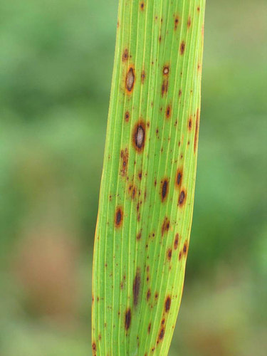
Figure 2.3: Brown spot identified by round to oval, dark-brown spots on the leaf (Abdel & Shabdana 2013).

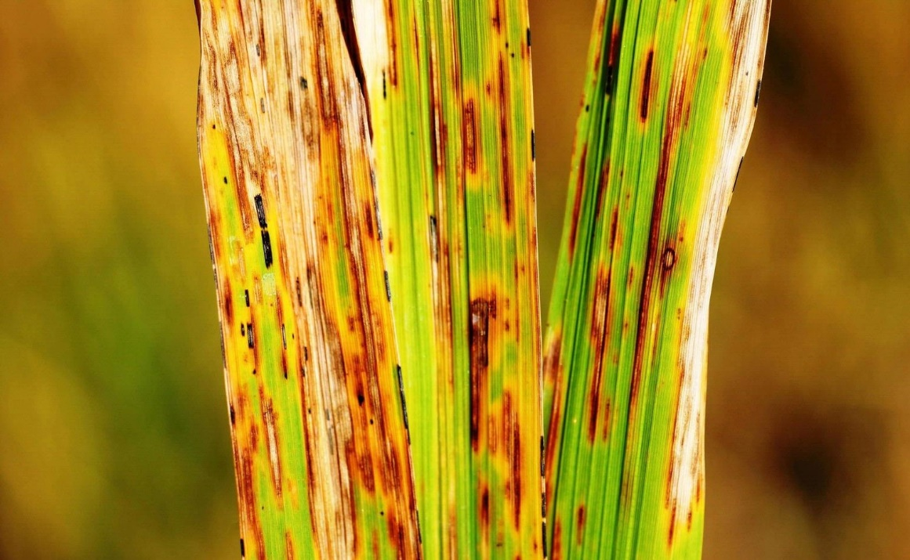
Figure 2.4: Narrow brown leaf spot identified by long narrow brown lesions with white leaf veins (Abdel & Shabdana 2013).

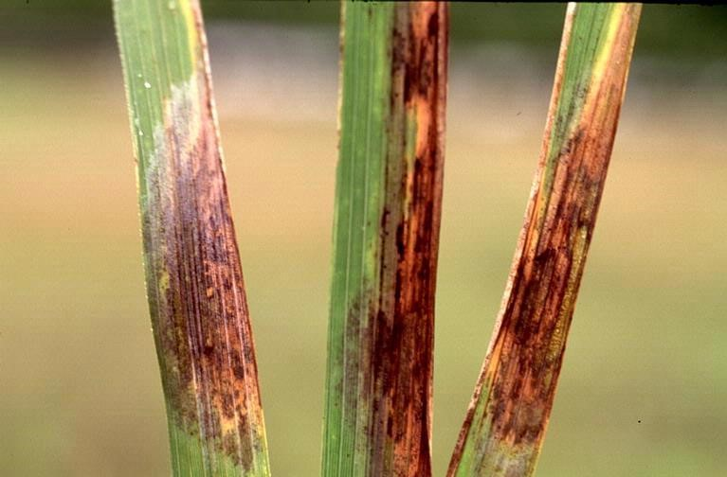
Figure 2.5: Leaf scald identified by wide bands on the leaf tip (Abdel & Shabdana 2013).

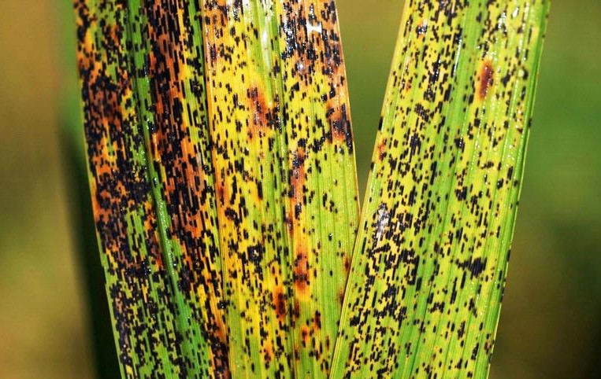
Figure 2.6: Leaf smut identified by small black lesions on the leaf tip (Abdel & Shabdana 2013).

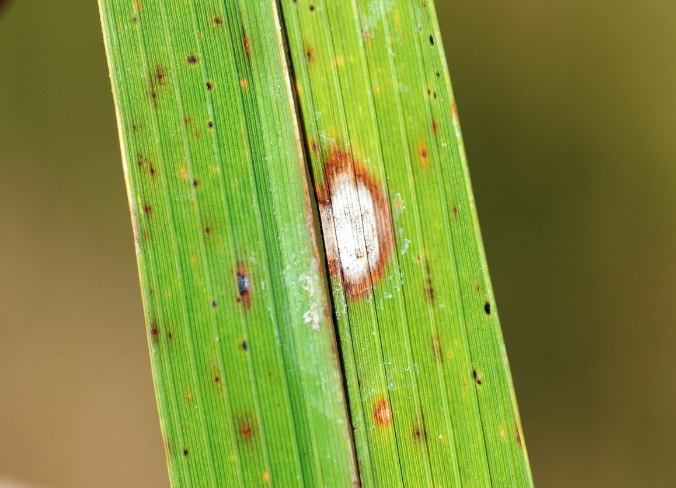
Figure 2.7: Stack burn identified by round white pale spot which is brown in colour on the leaf (Abdel & Shabdana 2013).

2.4 Expert systems
According to Agbonifo (2000), for organisations with knowledge and skills that cannot be easily passed to other stakeholders, expert systems are the most important. They are designed to hold the wisdom contained in the intellect of experts and for problem-solving purposes, offer this experience to other members of the company. Improvements in reliability and quality frequently appear when expert systems distribute expert advice, opinion, and explanation on demand. Expert systems are capable of handling enormously complex tasks and activities as well as an extremely rich knowledge-database structure and content. Expert systems can reduce production downtime and as a result, increase output and quality.
According to Delgado (2008), continuous use of an expert system may be cheaper and more reliable in particular cases than the services of a human expert. Expert systems can track output variables, tabulate statistics, and detect processes that do not fit the trends expected, signalling potential issues. Modern expert-system technology is used as an addition to conventional programming methods, and this hybrid approach allows the strengths of both approaches to be combined.

2.5 Fuzzy Logic Modelling
According to Zadeh (1965), the Law of Aristotle 's popular laws of thought which states that any proposition must either be yes or no attains the foregoing. A three-value logic was introduced in 1965 by Lukasiewicz as a systematic alternative to the bi-value logic of Aristotle. The terms of his method are real and wrong. This approach later led to a four-valued logic, which eventually gave birth to the infinite valued logic. The collection is defined by a membership function that assigns a range to each membership object. To such sets, the theories of convexity, connections, union, intersection, and complement, and so on, are applied. By comparison, in Boolean logic, only integer values of 0 or 1 can be the true values of variables.
2.5.1 Concept of fuzzy logic
According to Sharareh (2009), this powerful tool was introduced to enhance tractability, robustness and low-cost solutions for real-world problems. Fuzzy offers a realistic way to understand the mapping behaviour of functions and manually affect them. Generally speaking, fuzzy logic uses basic rules to identify the scheme of interest and this makes it simple to enforce. The conception of a fuzzy set began with fuzzy logic. In order to grasp the fuzzy set, it can contain components of members. If x is an element of set A, then μA(x) = 1 but if x is not an element of set A, then μA(x) = 0. In fuzzy logic, the truth of any statement becomes a matter of degree. Any statement can be fuzzy.
2.5.2 Fuzzy sets
According to MathWorks (2011), fuzzy set deals with inclusion and exclusion of any given element. Fuzzy sets represent simple linguistic concepts like yes or no, true or false, cold, warm or hot, low, medium or high and so on. A given element can belong to more than one fuzzy set at the same time. All fuzzy sets are characterized by membership functions. A number of membership functions have been proposed in the past few years, namely the triangular, trapezoidal and bell shape membership function. The input value is often referred to as the universe of discourse set, which contain all the possible elements of concern in each particular application. The MATLAB fuzzy logic toolbox includes 11 built-in membership function types. The simplest membership functions are formed using straight lines.
2.5.3 Fuzzy inference system
According to Alayon (2015), fuzzy inference is the process of formulating the mathematical model based on a mapping from an input set to an output value using fuzzy logic theory. The process of fuzzy inference involves logical operations, such as the use of If-Then rules and membership functions. The Fuzzy Inference System is used as a tool for representing different forms of knowledge about a problem. FIS is also used for modelling the interactions and relationships that exits between its variables.
- Fuzzification - Modelling of the controller is data fragmentation into input that can be accepted by fuzzy logic. This is done by calling on some membership function. For example, an interval [a b c] where a and c correspond to the base of the triangle and b corresponds to the point where the apex of the triangle is located.
- Rule production - The rule-based system for the controller uses input variables to formulate possible results for the outputs of each rules formulated. As a result of this, the results of the rule production process are set of rules defined using IF-THEN statements.
- Aggregation - Each fuzzy rule formulated produces a number that represents the truth value of the output for that rule. All the output for each rule must be combined into one single output fuzzified using the process of aggregation. Two methods are commonly used to arrive at aggregation: the minimum and the product operation methods.
- Defuzzification - This involves the conversion of the single aggregated fuzzy output set into a single crisp value. The interval for which the defuzzied value belongs is used to determine the class with which the output is defined. There are several methods of defuzzification like centre of sums, mean of maxima and left-right maxima.

2.6 Related Works
Ramcharan et al. (2017), plant suffers from various diseases during their life span at any stage of growth. For farmers and agricultural expert’s disease management is a critical matter which needs an immediate attention. It needs urgent diagnosis and preventive action in order to maintain quality as well as to minimize the loss. Many researchers contributed technologies for detection as well as classifying plant diseases so as to support quick disease diagnosis.
Awoyelu et al. (2015), developed an expert’s system for the diagnosis of cassava plant diseases. The study identified a number of symptoms that were taken from the leaves, stems and roots of cassava plant required for the diagnosis of 3 different cassava plant diseases. The study adopted the use of 3 triangular membership functions to formulate the 3 symptoms of each diseases identified alongside the level of disease risk.
Suhartono et al. (2013), developed an expert system for detecting coffee plant diseases. The method used is fuzzy logic-based expert systems, and decision tree using a hierarchical classification. Knowledge about coffee, its symptoms, and its disease was extracted from human expert and then converted into a decision tree.
Arowolo et al. (2012), developed an expert system for diagnosing poultry diseases. The study identified the factors that were required for assessing the presence of diseases among poultry animals from experts via interviews. The knowledge about the relationship between the factors was created using IF-THEN rules to create antecedent and consequent rules needed for the diagnosis of diseases among poultry.

CHAPTER THREE
RESEARCH METHODOLOGY
3.1 Introduction
This section presents the various methods that have been implemented in this analysis in order to establish a risk of rice disease classification model based on established associated risk factors. This section involves the identification of various risk of rice diseases.
3.2 Method of the identification of risk factors
A number of associated risk factors were identified for the risk of rice diseases. A variety of associated risk factors have been reported following the process of analysis of similar works over the internet. In addition, crisp values were suggested as a way for a user to quantify the response to each risk factor. As a result, intervals that increased the risk were given higher values, while intervals that reduced the risk of rice disease were given lower values.
3.2.1 Description of identified risk factors
A number of risk factors associated with the risk of rice disease have been defined, as mentioned previously, and have been explained in order to understand their respective risk of rice disease based on the value chosen. The risk of rice disease was measured by cumulating the values of all risk factors evaluated for the risk of rice disease.
- Discoloured leaves
The variables are categorised as None, fair and present in such a way that none was associated with low risk, while Present was associated with high risk.

- Presence of blights
Rice bacterial blight is associated with the presence of blights on the leaves of the rice plant. The variables were therefore classified as none, fair and present in such a way that None was associated with low risk, whereas the Present was associated with high risk.
- Presence of water – soaked patches
Rice bacterial blight is also associated with the presence of water – soaked patches. Therefore, the variables were classified as none, fair and present such that None is associated with low risk while Present is associated with high risk.
- Presence of wilted leaves
This is associated with the Rice bacterial blight. The variables were then categorised as none, fair and present in such a way that None was associated with a low risk, while Present was associated with a high risk.
- Stunted growth
The appearance of stunted growth on the rice plant is associated with Rice bacterial blight. The variables were then categorised as none, fair and present in such a way None was associated with a low risk, while Present was associated with a high risk.
- Risk of Rice diseases
According to this study which involved the classification model for the risk of rice diseases using fuzzy logic, a number of class was defined for the target variable. The target variable was stratified into four (4) classes: No Risk, Low Risk, Moderate Risk and High Risk.

3.2.2 Crisp and linguistic values of variables
A summary of the linguistic values and linguistic variables was rendered after the identification of all the risk of rice disease. For each variable listed, Table 3.1 and Table 3.2 provides a description of the crisp values and linguistic variables. The crisp values for each of the identified risk factor was done by allocating the values 0, 1 and 2 to some risk factors such that the value with the highest association with the risk of rice diseases was given the value of 2 while the value with the lowest risk of rice diseases was given a value of 0.
As a result of this the risk factors were classified as follows. The presence of discoloured leaves was divided in increasing order of risk rice diseases as None, fair and present hence was given 3 linguistic variables; the presence of stunted growth was divided in increasing order of risk as None, fair and present and hence was given 3 linguistic variables; the presence of blights was divided in increasing order of risk as None, fair and present and hence was given 3 linguistic variables; the presence of wilted leaves was divided in increasing order of risk as None, fair and present hence was given 3 linguistic variables; the presence of water-soaked patches was divided in increasing order of risk as None, fair and present hence was given 3 linguistic variables.

3.3 Fuzzy Logic formulation for Risk of Rice Diseases
Each defined variable was fuzzified using a triangular membership function for the purpose of developing a classification model for the risk of rice diseases using fuzzy logic theory. Three parameters consisting of the left base of the triangle (a), the central apex of the triangle (b) and the right base of the triangle (c) were given for the triangular membership function.

Table 3.1: Identification of crisp and linguistic values of risk factors
Risk Factor | Linguistic Variable | Crisp Value
Discoloured leaves | None  Fair  Present | 0  1  2
Presence of blights | None  Fair  Present | 0  1  2
Presence of water – soaked patches | None  Fair  Present | 0  1  2
Wilted leaves | None  Fair  Present | 0  1  2
Stunted growth | None  Fair  Present | 0  1  2
Risk of Rice diseases | No risk  Low risk  Moderate risk  High risk | 0  1  2  3

Table 3.2: Description of Crisp intervals used during Fuzzy Model Formulation
Crisp value | Interval | a | b | C
0 | ( -0.5, 0.5) | -0.5 | 0 | 0.5
1 | (0.5, 1.5) | 0.5 | 1 | 1.5
2 | (1.5, 2.5) | 1.5 | 2 | 2.5

The interval of this parameter was used to define the crisp interval within which the linguistic variable was assigned to each crisp value. As a result of this, for each identified risk factor, there were 3 triangular membership functions, so that each linguistic variable was allocated to each identified risk factor as appropriate.
Variable label (x; a, b, c) = $0;x ≤a$
$\frac{x - a}{b - a};$a < x ≤ b
$$\frac{c-x}{c-b};b<x ≤c$$
0; x > c
The labels of the defined risk factors were formulated using 3 triangular membership functions using the crisp intervals (-0.5, 0.5), (0.5, 1.5) and (1.5, 2.5) to model the linguistic variables for 0, 1 and 2 respectively in such a way that the values 0, 1 and 2 are the centre b of each interval as shown in Table 3.3.
3.3.1 Fuzzification of the risk of rice diseases
There was a need to devise the target variable used to describe the risk of rice diseases. To formulate the target variable, crisp values of 0, 1 and 2 are assigned to target class labels, using the intervals (-0.5, 0.5), (0.5, 1.5), (1.5, 2.5) and (2.5, 3.5) respectively. The relationship between risk factors and the risk of rice disease using the fuzzy inference method was proposed using the definition.
3.3.2 Fuzzy inference system design
The fuzzy inference engine was introduced after formulating triangular membership functions to model the risk factors and the risk of rice diseases. For the purpose of developing a relationship between the non-invasive parameters established, experts have inferred rules.

Table 3.3: Formulation of the Risk of rice diseases
Target class | Interval | A | B | C
No risk | (-0.5. 0.5) | -0.5 | 0 | 0.5
Low risk | (0.5. 1.5) | 0.5 | 1 | 1.5
Moderate risk | (1.5. 2.5) | 1.5 | 2 | 2.5
High risk | (2.5. 3.5) | 2.5 | 3 | 3.5

In order to construct the knowledge base of the classification model using fuzzy logic, a number of IF-THEN rules were used by combining the risk factors as the precedence while the risk of rice diseases was used as the consequent variable. A typical rule that can be inferred is as follows:
IF (Discoloured Leaves = “None”) AND (Presence of Blights = “None”) AND (Presence of Water – Soaked Patches = “None”) AND (Presence of Wilted Leaves = “None”) AND (Stunted Growth = “None”) THEN (Risk of rice Diseases = “No Risk”)
The fuzzy model was calculated for each variable from the product of the number of linguistic variables. Therefore, each of the considered variables has three linguistic variables each. Therefore, 243 (= 3⁵) rules are the total number of rules.
3.4 Simulation environment used
MATLAB is an easy-to-use environment, it integrates computation, visualisation, and programming. Fuzzy Logic Toolbox provides MATLAB for analysing, designing, and simulating systems based on fuzzy logic. There are five main GUI tools (Elements of the MATLAB Fuzzy Logic System) for constructing, editing, and observing fuzzy inference systems in the toolbox for this study.
- Fuzzy Inference System (FIS) Editor: Deals with the system's high-level issues: it was used to describe the names and number of models proposed.
- Membership Function Editor: The shapes of all membership features associated with each element have been used to describe them. The triangular membership feature was to formulate all variables.
- Rule Editor: Using a series of IF-THEN statements that combined the known risk factors with the risk of rice disease labels, the 243 rules that described the actions of the system were used to edit them.
- Rule Viewer: It is an environment-based MATLAB technical computing display of the fuzzy inference diagram that was used as a diagnosis.
- Surface Viewer: Is used to display the dependency of one of the outputs on any one or two of the inputs.

CHAPTER FOUR
RESULTS AND DISCUSSIONS
4.1 Introduction
Based on the crisp intervals defined for each linguistic variable identified in this study, this section presents the results of formulating triangular membership functions. Therefore, since the same crisp interval was used, 3 triangular membership functions with centres 0, 1 and 2 were used to define the labels of each risk factor. The allocation of values was also focused on the increasing impact of the labels of the risk that were identified. Therefore, the results of the mathematical representation of the fuzzy logic model formulation using the triangular membership function for each of the labels is presented in equations (4.1a) to (4.1c)
$$Crisp-label_0\left(x;-0.5, 0, 0.5\right)= \left\{\begin{aligned}0;x≤-0.5 \\ \frac{x+0.5}{0.5} ;-0.5<x≤0 \\ \frac{0.5-x}{0.5};0<x≤0.5 \\ 0;x>0.5\end{aligned}\right. (4.1a)$$
$$Crisp-label_1\left(x;0.5, 1, 1.5\right)= \left\{\begin{aligned}0;x≤0.5 \\ \frac{x-0.5}{0.5} ;0.5<x≤1 \\ \frac{1.5-x}{0.5};1<x≤1.5 \\ 0;x>1.5\end{aligned}\right. (4.1b)$$
$$Crisp-label_2\left(x;1.5, 2, 2.5\right)= \left\{\begin{aligned}0;x≤1.5 \\ \frac{x-1.5}{0.5} ;1.5<x≤2 \\ \frac{2.5-x}{0.5};2<x≤2.5 \\ 0;x>2.5\end{aligned}\right. (4.1c)$$
The linguistic variables for the classification of rice plant diseases were formulated using the 4 triangular membership functions indicated in the equations (4.1d) to (4.1g).
$$Crisp-no\left(x;-0.5, 0, 0.5\right)= \left\{\begin{aligned}0;x≤-0.5 \\ \frac{x+0.5}{0.5} ;-0.5<x≤0 \\ \frac{0.5-x}{0.5};0<x≤0.5 \\ 0;x>0.5\end{aligned}\right. (4.1d) \\ Crisp-low\left(x;0.5, 1, 1.5\right)= \left\{\begin{aligned}0;x≤0.5 \\ \frac{x-0.5}{0.5} ;0.5<x≤1 \\ \frac{1.5-x}{0.5};1<x≤1.5 \\ 0;x>1.5\end{aligned}\right. (4.1e )$$
$$Crisp-moderate\left(x;1.5, 2, 2.5\right)= \left\{\begin{aligned}0;x≤1.5 \\ \frac{x-1.5}{0.5} ;1.5<x≤2 \\ \frac{2.5-x}{0.5};2<x≤2.5 \\ 0;x>2.5\end{aligned}\right. (4.1f)$$
$$Crisp-high\left(x;2.5, 3, 3.5\right)= \left\{\begin{aligned}0;x≤2.5 \\ \frac{x-2.5}{0.5} ;2.5<x≤3 \\ \frac{3.5-x}{0.5};3<x≤3.5 \\ 0;x>3.5\end{aligned}\right. (4.1g)$$

4.2 Fuzzy Model for Classification of Rice Plant Diseases
Simulation of the membership functions and the rules of inference used to generate the final file which are presented in the following sections of the Fuzzy Logic Model.

4.2.1 Results of variables using the membership function editor
The use of MATLAB was used in getting the results of these variables and Fig 4.1 shows the MATLAB workspace. Therefore, simulation of the model for the presence of discoloured leaves is shown in Figure 4.2 such that the interval [-0.5, 0.5] with centre 0 was used to model none, [0.5, 1.5] with centre 1 was used to model fair while [1.5 2.5] with centre 2 was used to model present. Simulation of the model for the presence of blights is shown in Figure 4.3 such that the interval [-0.5, 0.5] with centre 0 was used to model none, [0.5, 1.5] with centre 1 was used to model fair while [1.5 2.5] with centre 2 was used to model present. Simulation of the model for water – soaked patches is shown in Figure 4.4 such that the interval [-0.5, 0.5] with centre 0 was used to model none, [0.5, 1.5] with centre 1 was used to model fair while [1.5 2.5] with centre 2 was used to model present. Simulation of the model for the presence of wilted leaves is shown in Figure 4.5 such that the interval [-0.5, 0.5] with centre 0 was used to model none, [0.5, 1.5] with centre 1 was used to model fair while [1.5 2.5] with centre 2 was used to model present. Simulation of the model for the presence of stunted growth is shown in Figure 4.6 such that the interval [-0.5, 0.5] with centre 0 was used to model none, [0.5, 1.5] with centre 1 was used to model fair while [1.5 2.5] with centre 2 was used to model present. The results of the simulation model for the classification of the risks is shown in Figure 4.7 such that the interval [-0.5, 0.5] with centre 0 was used to model none, [0.5, 1.5] with centre 1 was used to model low risk, [1.5, 2.5] with centre 2 was used to model moderate risk while [2.5, 3.5] with centre 3 was used to model high risk.

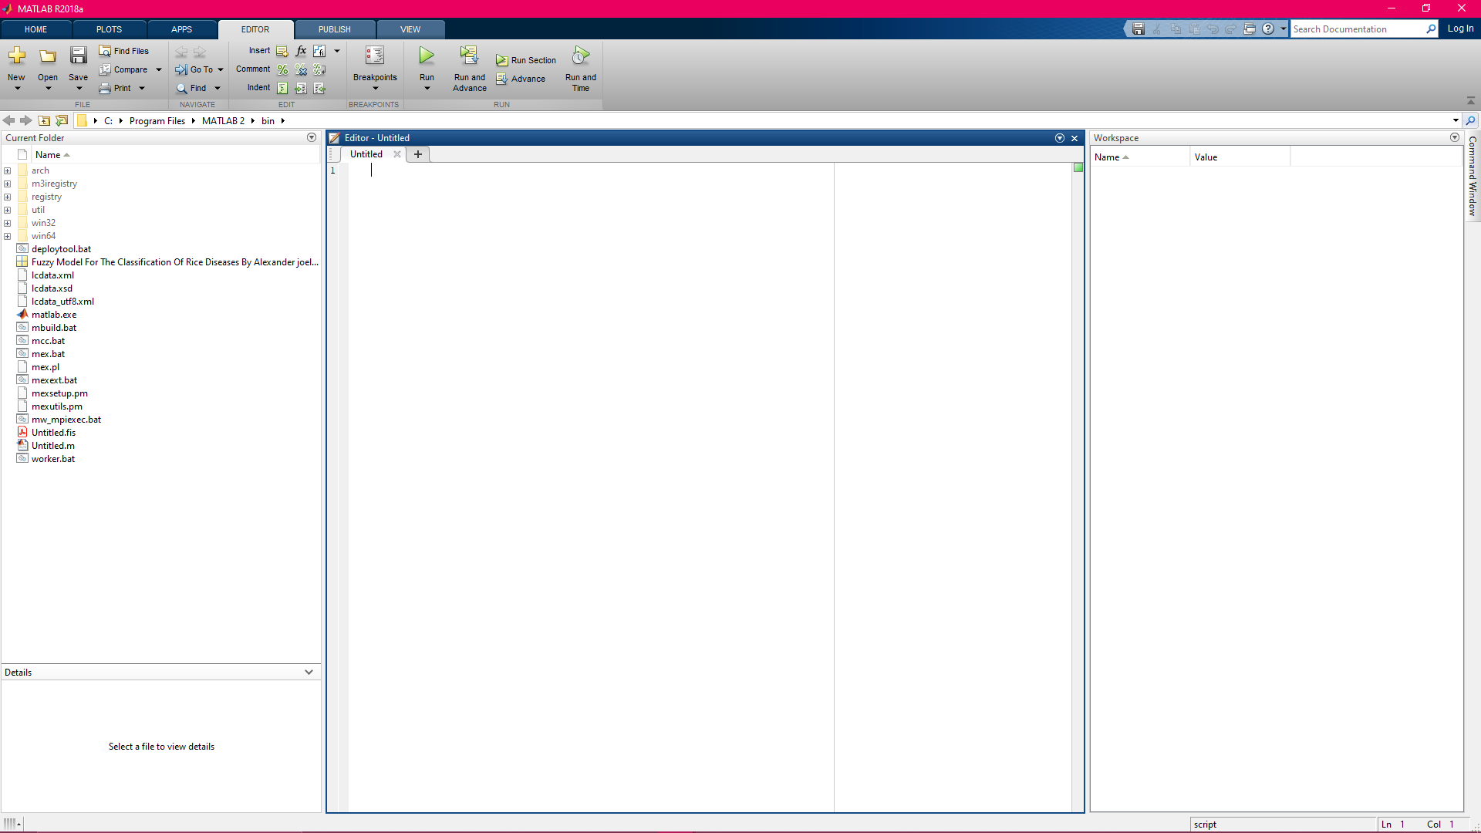
Figure 4.1: Workspace of MATLAB for fuzzification of rice diseases

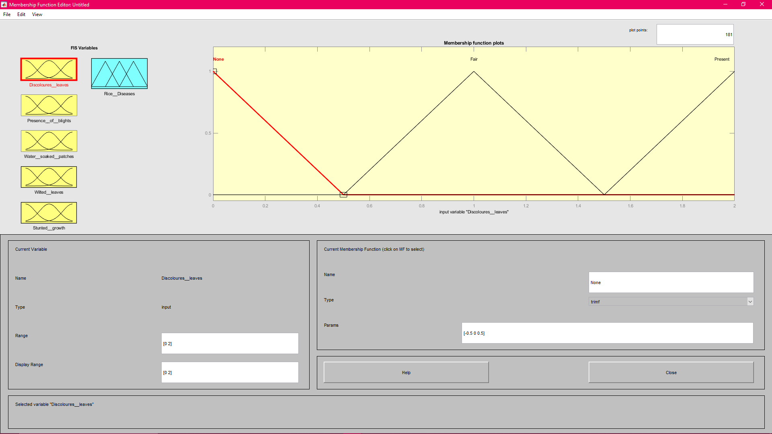
Figure 4.2: Fuzzification of the presence of discoloured leaves

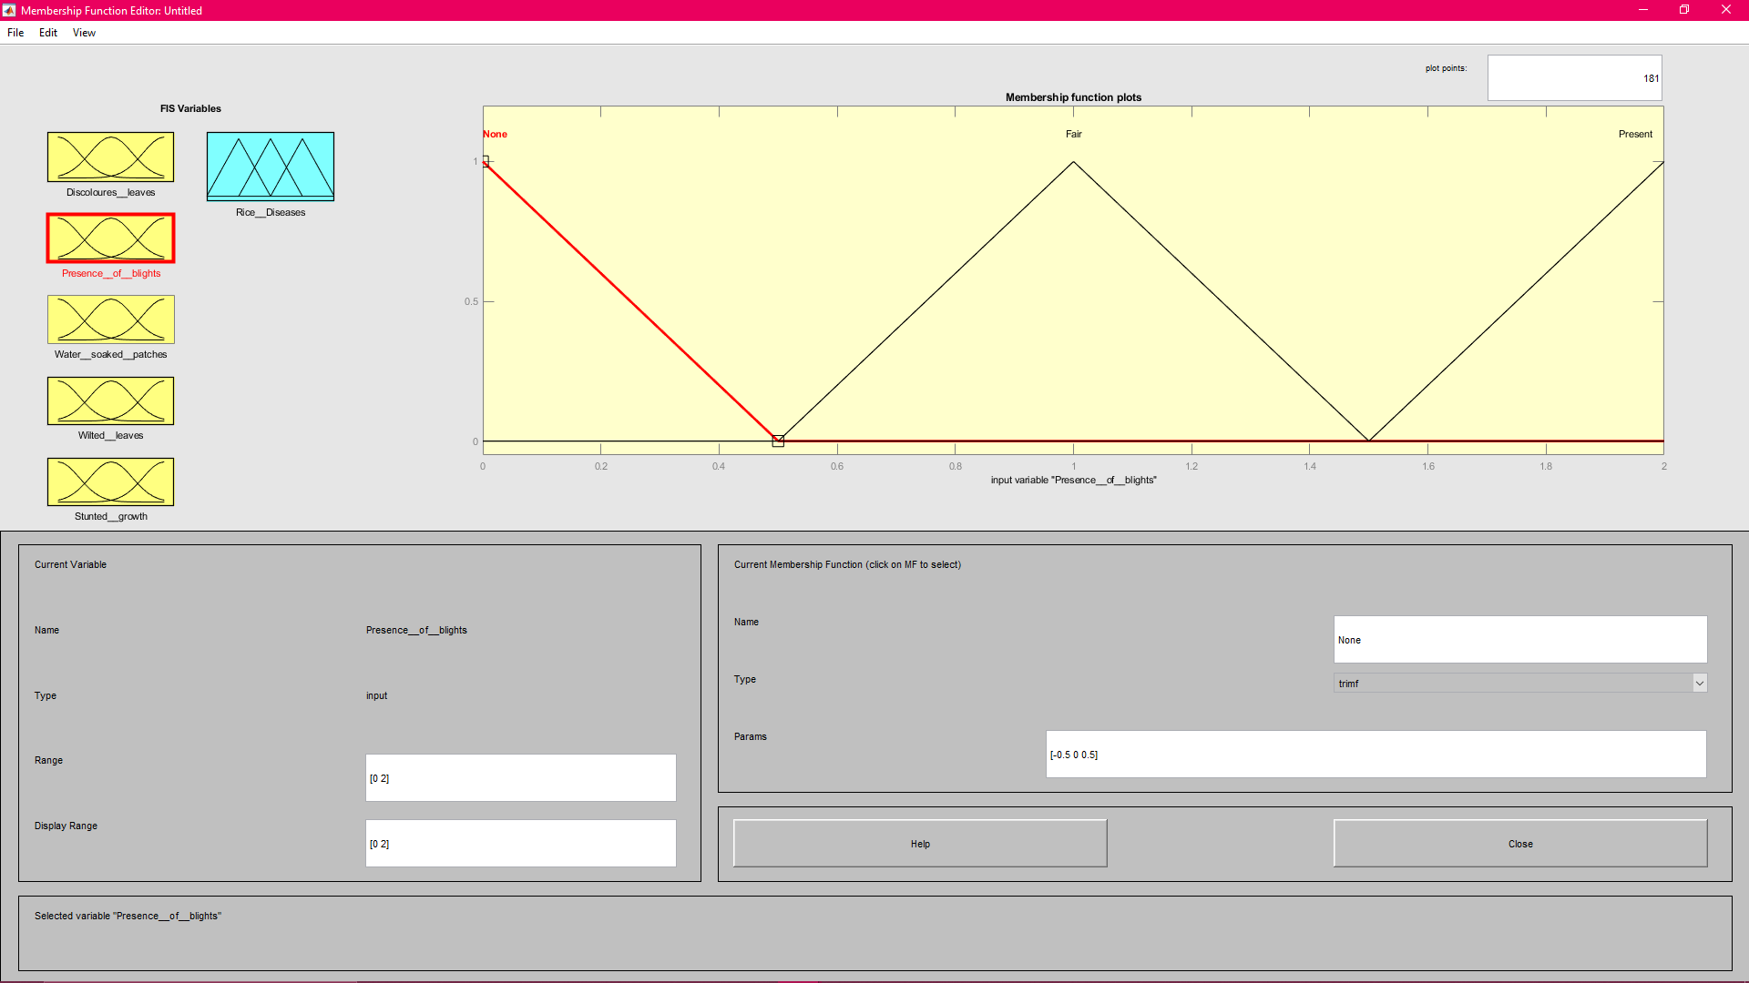
Figure 4.3: Fuzzification of the presence of blights

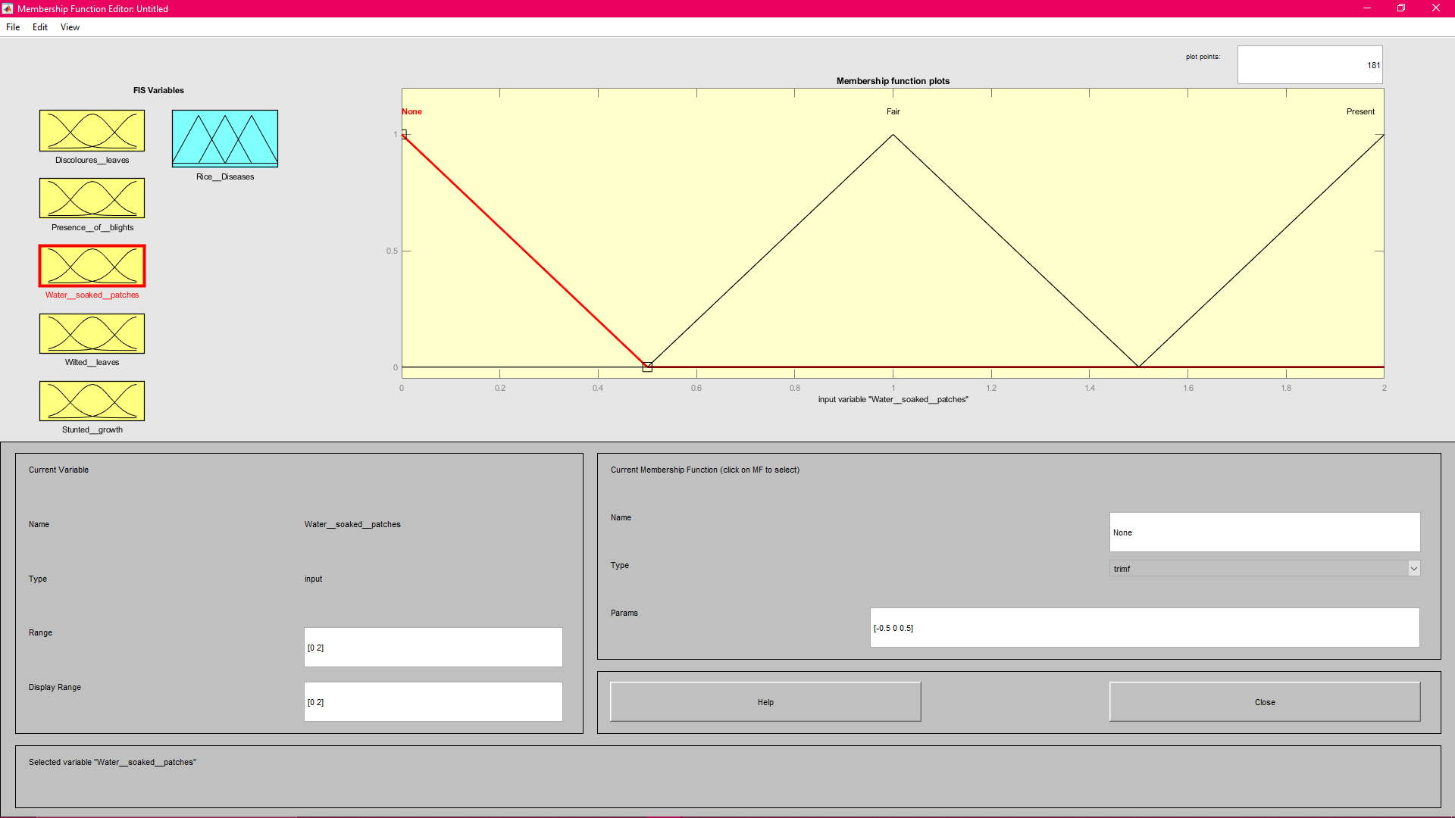
Figure 4.4: Fuzzification of the presence of water – soaked patches

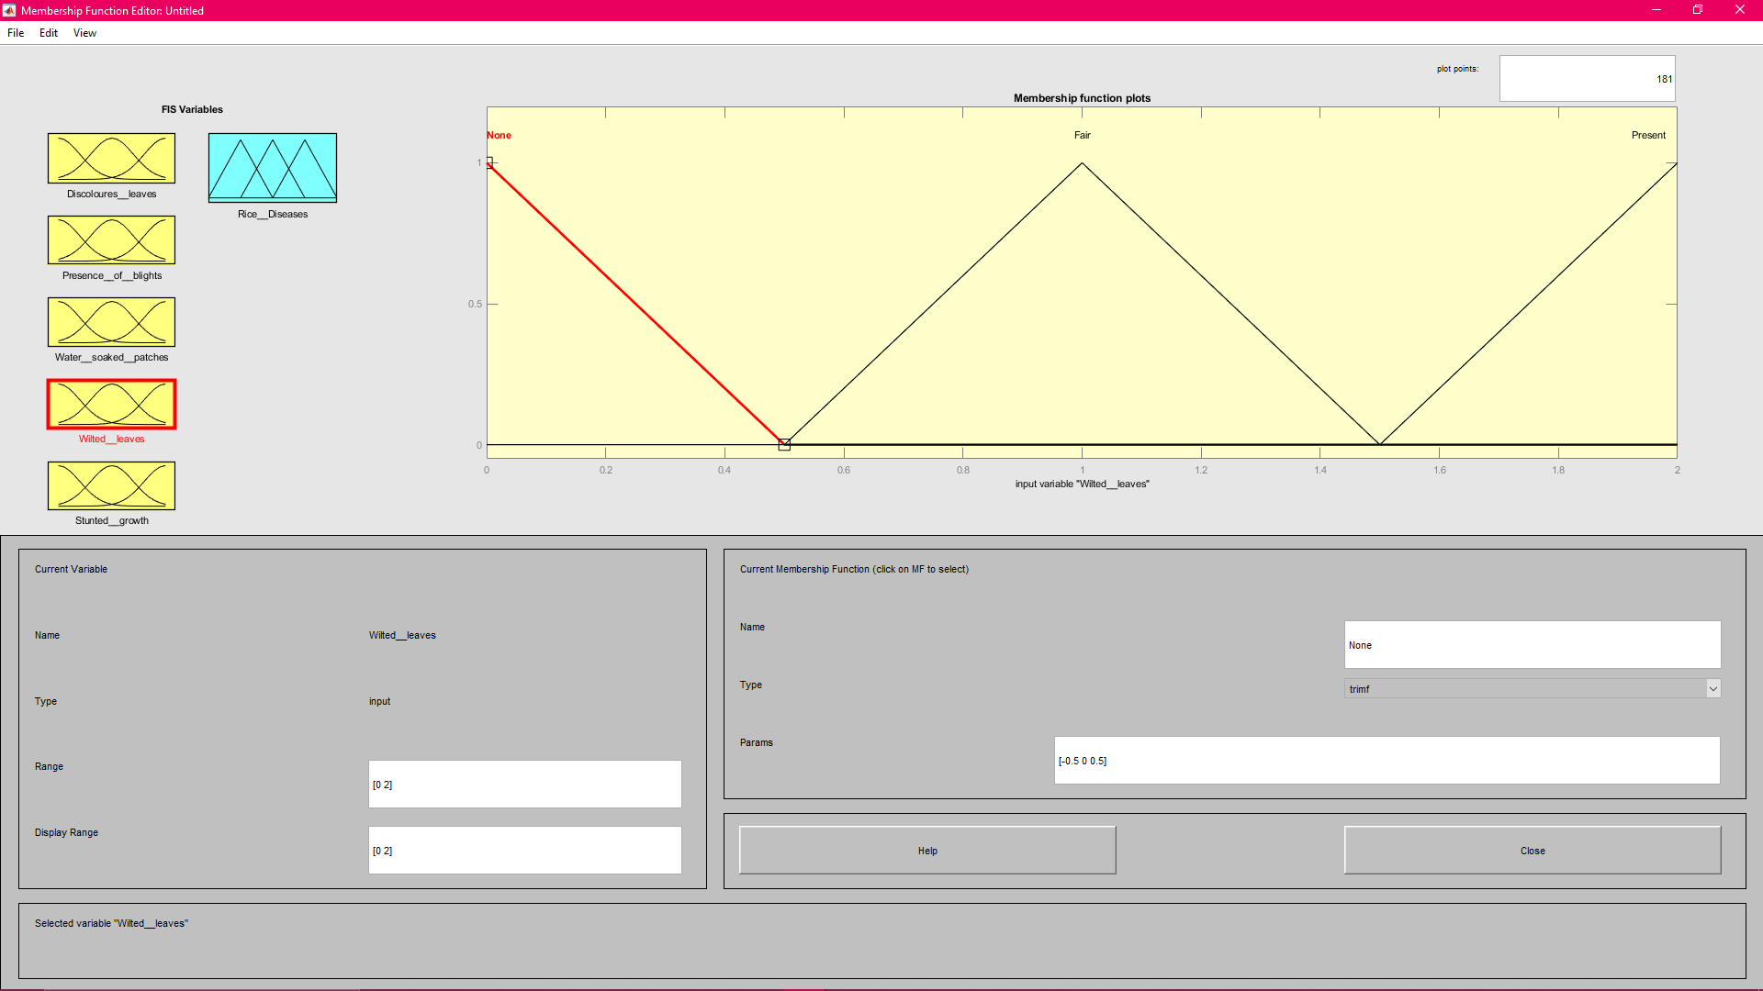
Figure 4.5: Fuzzification of the presence of wilted leaves

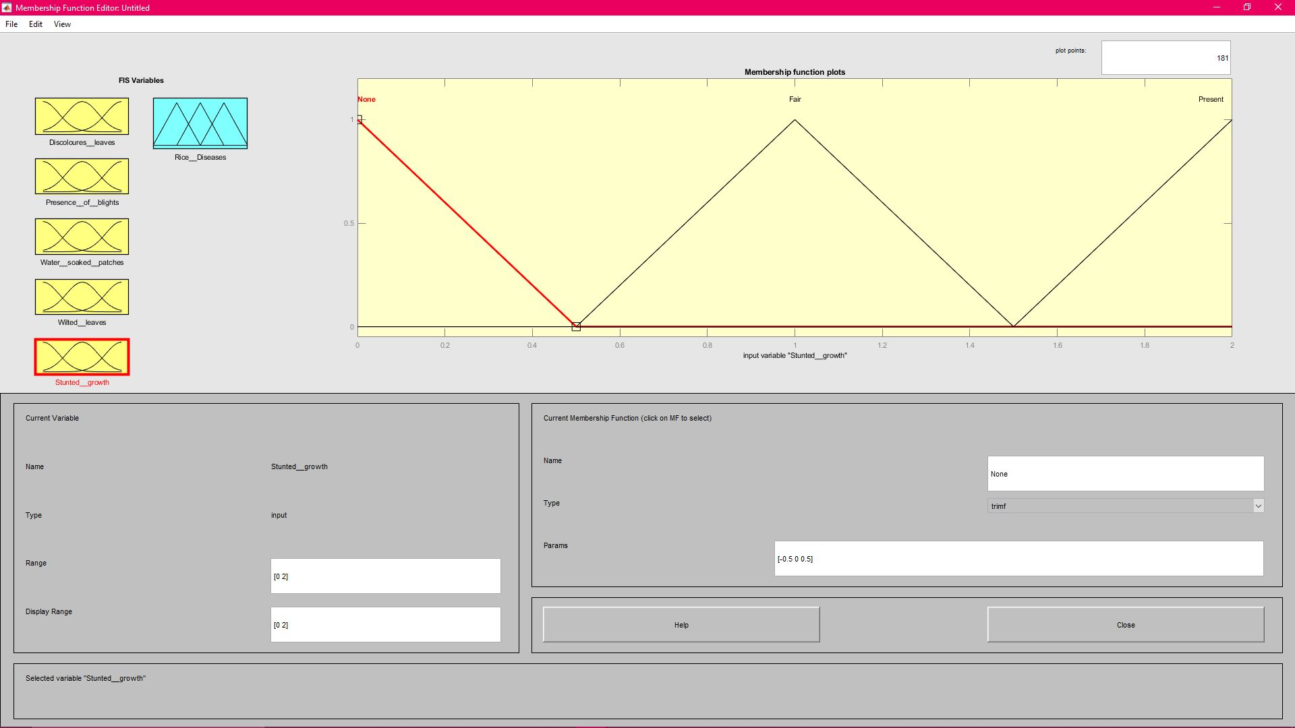
Figure 4.6: Fuzzification of the presence of stunted growth

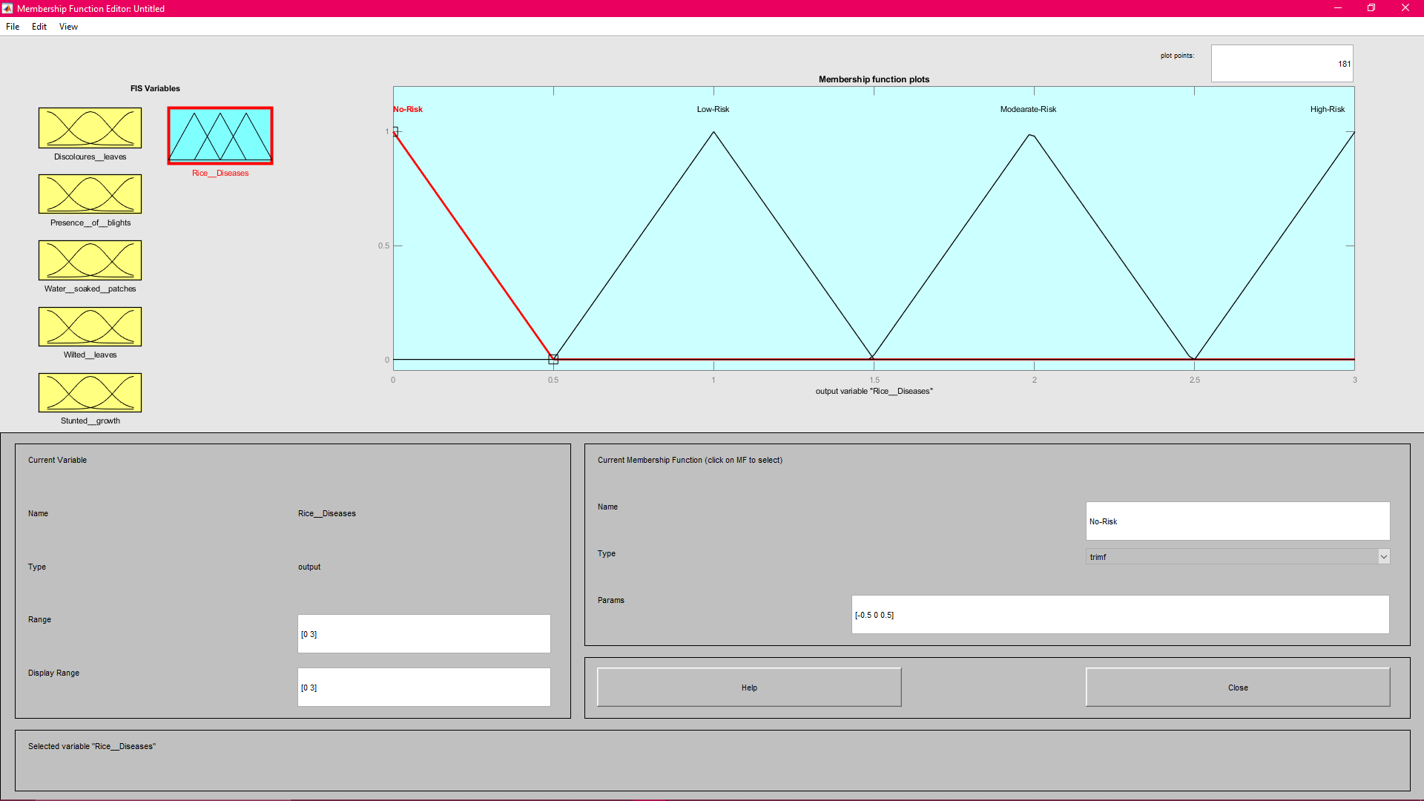
Figure 4.7: Fuzzification of the classification of Rice Plant Diseases

The screenshot of the final source code is shown in Figure 4.8 with A. Fis extension which was built from the simulation. Appendix II provides a detailed explanation of the various components of the .fis file, including the system components that describe the number of Mamdani input, output, model type, followed by the section of variables that define the name and alongside their types with their respective crisp value interval for each linguistic variable.

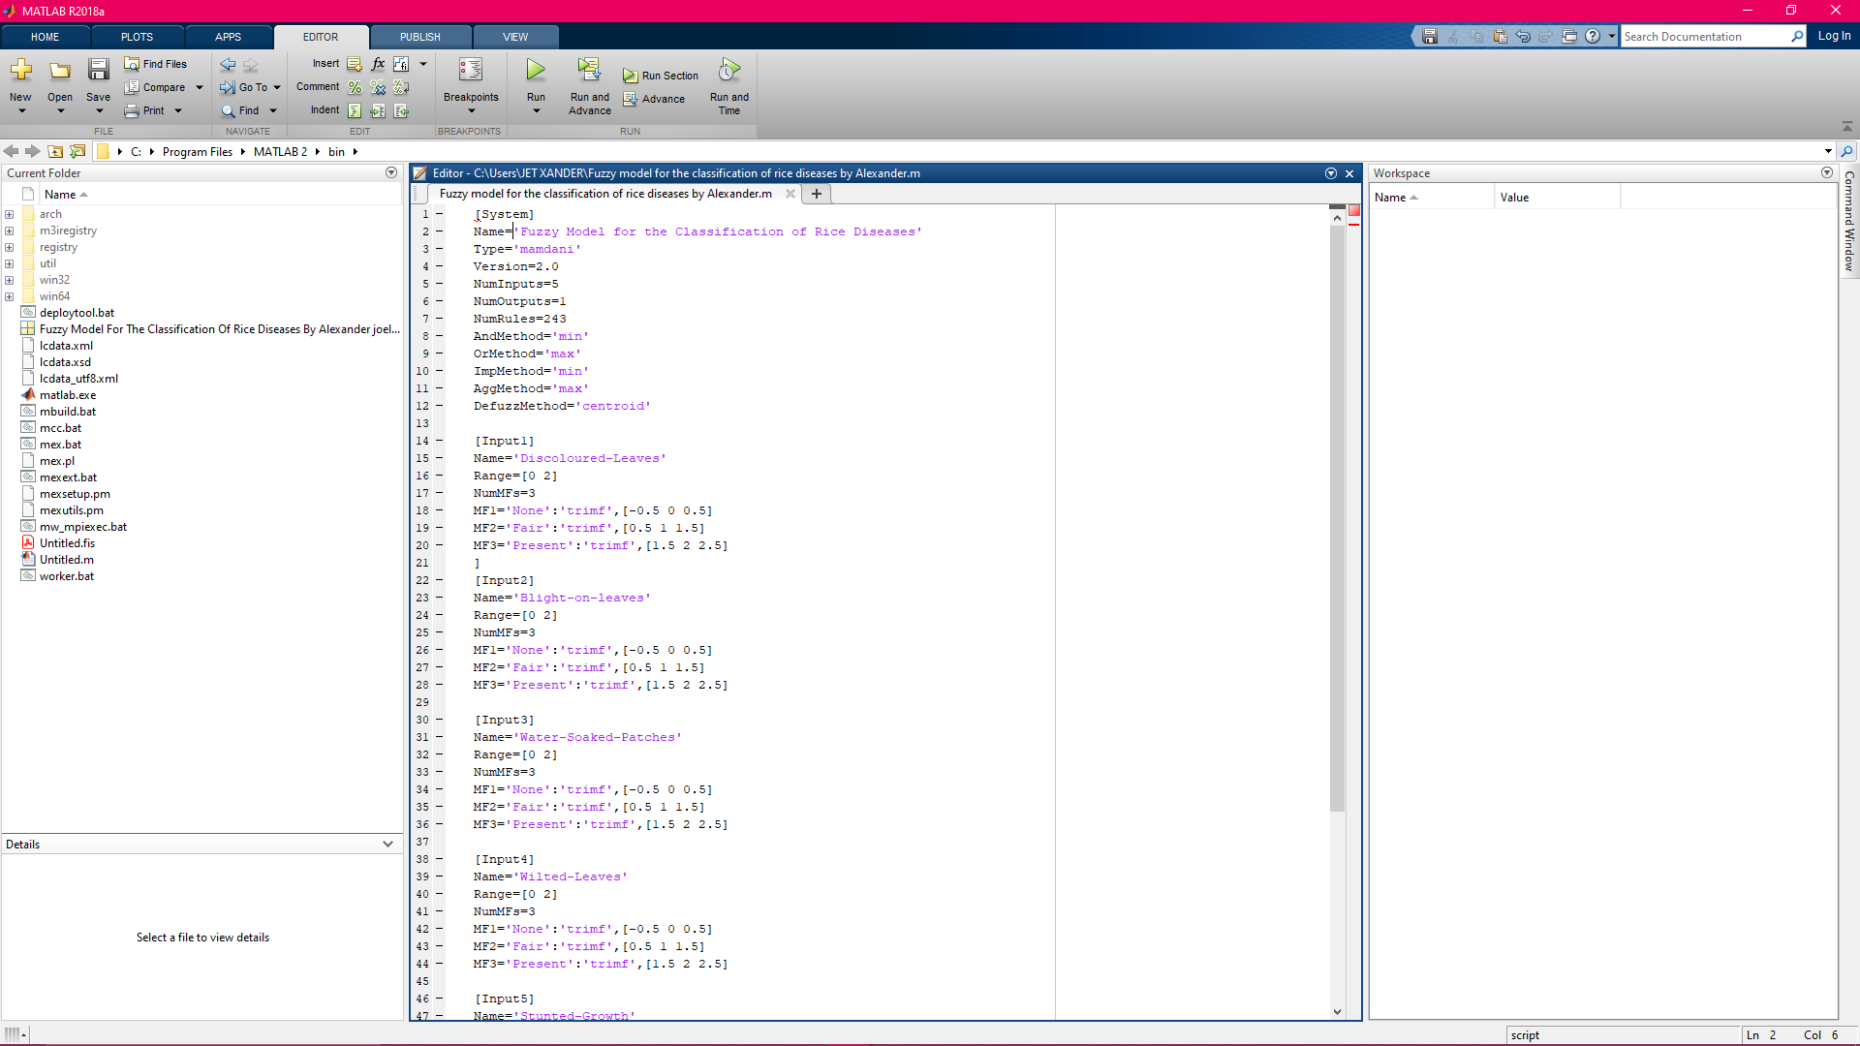Figure 4.8: Source Code of. fis File of Fuzzy Model for Classification of Rice Plant Diseases

4.2.2 Results of the Model for Classification of Rice Plant Diseases
The rule editor interface was used to describe the 243 rules that have been inferred for deciding the classification of rice plant diseases. Figure 4.9 shows the full insertion of the 243 rules for determining the classification of rice plant diseases that have been inferred. It is obvious that each inferred rule is special and does not contain linguistic variables that occur in any of the established rules in the same pattern. The graphical area of each variable chosen by each law is shown in Figure 4.10 with respect to the linguistic variables of the rice plant disease classification.

4.3 Discussion of Results
To devise a classification model that can be used to detect a number of dependent factors observed from different parts of rice plants, this study adopted fuzzy logic. The study identified 5 risk factors for rice plant disease risk classification. A number of linguistic variables for which core crisp values were allocated based on the correlation with the risk used to describe each risk factor. For each of the identified risk factors, crisp values were achieved by assigning 0, 1 and 2 to risk factors with 3 values. Three sections of each risk factor were discretized, so that the values 0, 1 and 2 were assigned to each specified linguistic component.
In order to determine the relationship between the known non-invasive risk factors identified, 243 rules were drawn up to determine the relationship between the identified risk factors and the risk of rice plant diseases. A number of IF-THEN rules were used to build the knowledge base of the classification model using fuzzy logic by combining the risk factors as the precedence, while the risk was used as the resulting variable.

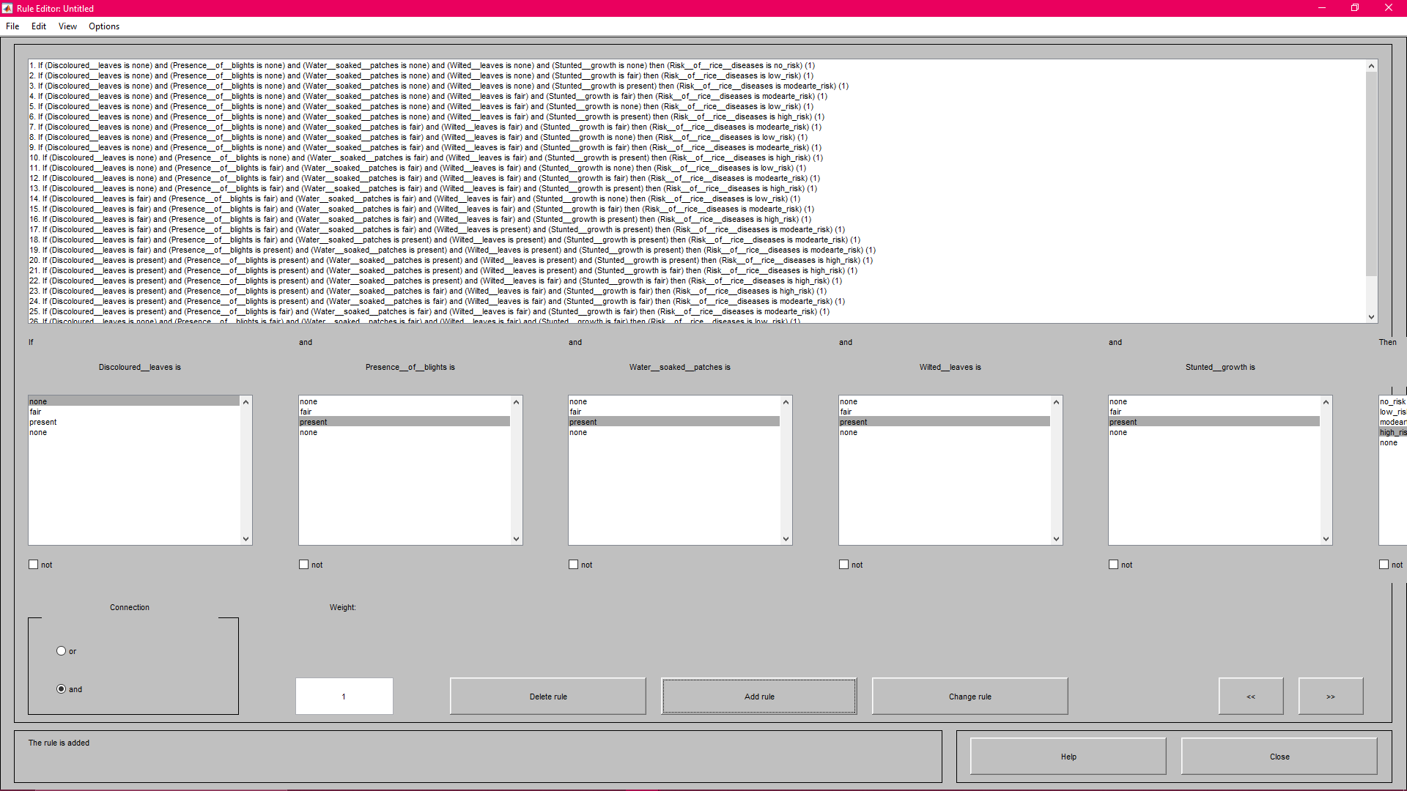
Figure 4.9: The Inferred Rules located in the Fuzzy Inference Engine

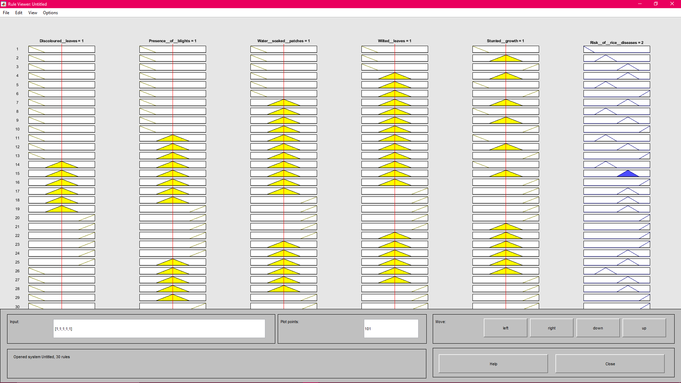
Figure 4.10: Testing the Validity of the Inference Engine

CHAPTER FIVE
SUMMARY, CONCLUSION AND RECOMMENDATION
5.1 Summary
This research was motivated by the need to provide a means by which cost-effective steps could be taken to estimate the risk of rice plant diseases on the basis of certain factors. This was done through the simulation of a fuzzy model used by experts to identify the risk of rice plant diseases using rules. The presence / absence of 5 variables was therefore used to assess the risk of rice disease.
5.2 Conclusion
In order to determine the impact of pests and diseases on the productivity of rice plants, this study developed a fuzzy logic-based model to classify rice plant diseases. The study therefore concluded that the presence and/or absence of risk factors could be used to predict the risk of diseases affecting the rice plant in such a way that the lower the risk of rice plant diseases, the lower the presence of such factors. The study also concluded that discoloured leaves, stunted growth, water-soaked patches, blight on leaves, wilted leaves were the 5 related factors found. For the formulation of the linguistic variables of the factors using acceptable linguistic variables, 3 triangular membership functions were suitable, whereas the goal yield was formulated using 4 triangular membership functions for linguistic variables with no risk, low risk, moderate risk and high risk.

5.3 Recommendation
This study recommends that botanists and agricultural scientists make additional efforts to recognize other important factors associated with rice plant disease risk. This would improve the detection of related diseases affecting the rice plant thereby improving the productivity of the plant.

REFERENCES
Bhatta, N. and Jyoti, K. (2012). A Novel Approach for Still-birth Diagnosis
using Data Mining and Fuzzy Logic. International Journal of Computer Applications 54(17): 16 – 21.
Djam, X.Y. and Kimbi, Y.H. (2011). Fuzzy Expert System for the Management
of Hypertension. The pacific Journal of Science and Technology 12(1): 390 – 402.
Imianvan, A.A. and Obi, J.C. (2012). Cognitive Neuro-Fuzzy Expert System
for Hypotension Control. Computer Engineering and Intelligent Systems 3(6): 21 – 31.
Khormehr, A. and Maihami, V. (2016). A Novel Fuzzy Expert System Design
for Predicting Still-birth. International Journal of Computer Applications 138(4): 33 – 38.
Liu, W., Ma, L. and Wei, D. (2010). Data Mining Based on Rough Sets in Risk
Decision-making: Foundation and Application. Transactions on computers 9(2): 113-121.
Lopez, A.D., Andrea, D. and Carlos, A.R. (2006). Global and regional burden
of disease and risk factors: Systematic analysis of population health data. Lancet 367(9524): 1747 – 1757.
Malu, S., Pal, B.L. and Kumar, S. (2015). Detection of Anemia using Fuzzy
Logic. International Journal of Computer Applications Technology and Research 4(10): 762 – 766.

Obanijesu, O. and Emuoyibofarhe, O. J. (2012). Development of a Neuro-Fuzzy
System for Early Prediction of Heart Attack. International Journal of Information Technology and Computer Science 9: 22 – 28.
Waijee, A.K., Higgings, P.D.R. and Singal, A.G. (2013). A Primer on
Predictive Models. Clinical and Translational Gastroenterology 4(44): 1 – 4.
World Health Organization (WHO) (2002). The World Health Report: 2002:
Reducing the Risks, Promoting Healthy Life. Geneva.

APPENDIX I
Inference Rules for the Risk of Rice Diseases

Rule | Discoloured leaves | Presence of blights | Water soaked patches | Wilted leaves | Stunted growth | Risk of Rice Diseases
1 | None | None | None | None | None | None
2 | Present | None | None | None | None | Low Risk
3 | None | None | None | None | Present | Low Risk
4 | None | None | None | Present | None | Low Risk
5 | None | None | Present | None | None | Low Risk
6 | None | Present | None | None | None | Low Risk
7 | Present | None | None | None | None | Low Risk
8 | None | Present | None | None | None | Low Risk
9 | None | None | Present | None | None | Low Risk
10 | None | None | None | Present | None | Low Risk
11 | None | None | None | None | Present | Low Risk
12 | None | None | None | Present | Present | Moderate Risk
13 | Present | None | None | None | None | Low Risk
14 | None | Present | None | None | None | Low Risk
15 | None | None | Present | None | None | Low Risk
16 | None | None | None | Present | None | Low Risk
17 | None | Fair | None | None | Present | Low Risk
18 | None | Fair | Present | None | None | Moderate Risk
19 | None | None | Present | None | None | Low Risk
20 | None | Fair | None | Present | None | Low Risk
21 | None | None | None | None | Present | Low Risk
22 | Present | Fair | None | None | Present | Moderate Risk
23 | None | None | Present | Present | None | Moderate Risk
24 | Present | Fair | None | None | None | Moderate Risk
25 | None | Fair | None | Present | None | Low Risk
26 | None | None | None | None | Present | Low Risk
27 | Present | Fair | None | None | None | Low Risk
28 | None | Fair | None | None | None | Low Risk
29 | None | Fair | Present | None | None | Low Risk
30 | None | None | None | Present | Present | Moderate Risk
31 | None | Fair | None | None | Present | Low Risk
32 | Present | None | None | None | None | Low Risk
33 | None | Fair | None | None | Present | Low Risk
34 | None | Fair | Present | None | None | Moderate Risk
35 | Present | Fair | None | None | Present | Moderate Risk
36 | None | None | Present | Present | None | Moderate Risk
37 | Present | Fair | None | None | None | Low Risk
38 | None | Fair | None | None | None | Low Risk
39 | None | Fair | Present | None | None | Low Risk
40 | Present | Fair | None | None | None | Moderate Risk
41 | None | None | None | Present | Present | Moderate Risk
42 | Present | Present | Present | None | None | Moderate Risk
43 | None | None | Present | None | None | Low Risk
44 | Present | None | None | Present | Present | Moderate Risk
45 | Present | Present | Present | None | None | Moderate Risk
46 | None | None | Present | Present | Present | Moderate Risk
47 | Present | Present | None | None | Present | Moderate Risk
48 | None | Present | Present | Present | None | Moderate Risk
49 | None | None | None | Present | None | Low Risk
50 | None | None | None | None | Present | Low Risk
51 | Present | None | None | None | None | Low Risk
52 | None | Present | None | None | None | Low Risk
53 | None | None | Present | None | None | Low Risk
54 | Present | None | None | Present | Present | Moderate Risk
55 | None | None | None | Present | None | Low Risk
56 | None | None | None | None | Present | Low Risk
57 | Present | None | None | None | None | Low Risk
58 | Present | Present | Present | None | None | Moderate Risk
59 | None | None | Present | Present | Present | Moderate Risk
60 | Present | Present | None | None | Present | Moderate Risk
61 | None | Present | None | None | None | Low Risk
62 | None | None | Present | None | None | Low Risk
63 | None | None | None | Present | None | Low Risk
64 | None | Present | Present | Present | None | Moderate Risk
65 | Present | None | Fair | Present | Present | Moderate Risk
66 | Present | Present | None | None | None | Moderate Risk
67 | None | None | Fair | None | Present | Low Risk
68 | None | None | None | Present | Present | Moderate Risk
69 | Present | Present | Fair | None | Present | Moderate Risk
70 | None | Present | None | Present | None | Moderate Risk
71 | Present | None | Fair | Present | Present | Moderate Risk
72 | Present | Present | None | None | None | Moderate Risk
73 | Present | None | Fair | None | None | Low Risk
74 | None | Present | None | None | None | Low Risk
75 | None | None | Fair | None | None | Low Risk
76 | None | None | None | Present | Present | Moderate Risk
77 | Present | Present | Fair | None | Present | Moderate Risk
78 | None | Present | None | Present | None | Moderate Risk
79 | None | None | Fair | Present | None | Low Risk
80 | Present | None | None | Present | Present | Moderate Risk
81 | Present | Present | Fair | None | None | Moderate Risk
82 | None | None | None | Present | Present | Moderate Risk
83 | Present | Present | Fair | None | Present | Moderate Risk
84 | None | Present | None | Present | None | Moderate Risk
85 | None | None | Fair | None | Present | Low Risk
86 | Present | None | None | Present | Present | Moderate Risk
87 | Present | Present | Fair | None | None | Moderate Risk
88 | None | None | Fair | Present | Present | Moderate Risk
89 | Present | Present | None | None | None | Moderate Risk
90 | None | None | None | Present | Present | Moderate Risk
91 | None | Present | Present | None | None | Moderate Risk
92 | Present | None | None | None | Present | Moderate Risk
93 | None | None | Present | Present | None | Moderate Risk
94 | Present | Present | None | None | None | Moderate Risk
95 | None | None | None | Present | Present | Moderate Risk
96 | Present | Present | Present | None | Present | High Risk
97 | Present | None | None | None | None | Low Risk
98 | None | Present | None | None | None | Low Risk
99 | None | None | Present | None | None | Low Risk
100 | None | None | None | Present | None | Low Risk
101 | None | None | None | None | Present | Low Risk
102 | None | Present | Present | None | None | Moderate Risk
103 | Present | None | None | None | None | Low Risk
104 | None | Present | None | None | None | Low Risk
105 | None | None | Present | None | None | Low Risk
106 | Present | None | None | None | Present | Moderate Risk
107 | None | None | Present | Present | None | Moderate Risk
108 | Present | Present | None | None | None | Moderate Risk
109 | None | None | None | Present | None | Low Risk
110 | None | None | None | None | Present | Low Risk
111 | Present | None | None | None | None | Low Risk
112 | None | None | None | Present | Present | Moderate Risk
113 | None | Present | Present | Fair | None | Moderate Risk
114 | Present | None | None | None | Present | Moderate Risk
115 | None | Present | None | Fair | None | Low Risk
116 | None | None | Present | Fair | None | Moderate Risk
117 | Present | Present | None | Fair | None | Moderate Risk
118 | None | None | None | Fair | Present | Moderate Risk
119 | None | Present | Present | Fair | None | Moderate Risk
120 | Present | None | None | None | Present | Moderate Risk
121 | None | None | Present | Fair | None | Low Risk
122 | None | None | None | Fair | None | Low Risk
123 | None | None | None | Fair | Present | Low Risk
124 | None | None | Present | Fair | None | Moderate Risk
125 | Present | Present | None | Fair | None | Moderate Risk
126 | None | None | None | Fair | Present | Moderate Risk
127 | Present | None | None | Fair | None | Low Risk
128 | None | Present | Present | None | None | Moderate Risk
129 | Present | None | None | Fair | Present | Moderate Risk
130 | None | None | Present | Fair | None | Moderate Risk
131 | Present | Present | None | Fair | None | Moderate Risk
132 | None | None | None | Fair | Present | Moderate Risk
133 | None | Present | None | Fair | None | Low Risk
134 | None | Present | Present | None | None | Moderate Risk
135 | Present | None | None | Fair | Present | Moderate Risk
136 | None | None | Present | Fair | None | Moderate Risk
137 | Present | Present | None | None | Present | Moderate Risk
138 | None | Present | Present | Present | None | Moderate Risk
139 | Present | None | None | Present | Present | Moderate Risk
140 | Present | Present | Present | None | None | Moderate Risk
141 | None | None | Present | Present | Present | Moderate Risk
142 | Present | Present | None | None | Present | Moderate Risk
143 | None | Present | Present | Present | None | Moderate Risk
144 | Present | Present | Present | Present | Present | High Risk
145 | None | None | Present | None | None | Low Risk
146 | None | None | None | Present | None | Low Risk
147 | None | None | None | None | Present | Low Risk
148 | Present | None | None | Present | Present | Moderate Risk
149 | Present | Present | Present | None | None | Moderate Risk
150 | None | None | Present | Present | Present | Moderate Risk
151 | Present | None | None | None | None | Low Risk
152 | Present | Present | None | None | Present | Moderate Risk
153 | None | Present | Present | Present | None | Moderate Risk
154 | Present | None | None | Present | Present | Moderate Risk
155 | Present | Present | Present | None | None | Moderate Risk
156 | None | None | Present | Present | Present | Moderate Risk
157 | None | Present | None | None | None | Low Risk
158 | Present | Present | None | None | Present | Moderate Risk
159 | None | Present | Present | Present | None | Moderate Risk
160 | Present | None | None | Present | Present | Moderate Risk
161 | Present | Present | Present | None | Fair | Moderate Risk
162 | None | None | Present | Present | None | Moderate Risk
163 | Present | Present | None | None | Fair | Moderate Risk
164 | None | Present | Present | Present | None | Moderate Risk
165 | Present | None | None | Present | Fair | Moderate Risk
166 | Present | Present | Present | None | None | Moderate Risk
167 | None | None | Present | Present | Fair | Moderate Risk
168 | Present | Present | Present | Present | None | High Risk
169 | None | None | Present | None | Fair | Low Risk
170 | Present | Present | None | None | None | Moderate Risk
171 | None | Present | Present | Present | Fair | Moderate Risk
172 | Present | None | None | Present | None | Moderate Risk
173 | Present | Present | Present | None | Fair | Moderate Risk
174 | None | None | Present | Present | None | Moderate Risk
175 | Present | Present | None | None | Fair | Moderate Risk
176 | None | Present | Present | Present | None | Moderate Risk
177 | Present | None | None | Present | Fair | Moderate Risk
178 | Present | Present | Present | None | None | Moderate Risk
179 | None | None | Present | Present | Fair | Moderate Risk
180 | Present | Present | Present | Present | None | High Risk
181 | Present | Present | None | None | Fair | Moderate Risk
182 | None | Present | Present | Present | None | Moderate Risk
183 | Present | None | None | Present | Fair | Moderate Risk
184 | Present | Present | Present | None | Fair | Moderate Risk
185 | None | None | None | Present | Present | Moderate Risk
186 | Present | Present | Present | None | Present | High Risk
187 | None | Present | Present | None | None | Moderate Risk
188 | Present | None | None | None | Present | Moderate Risk
189 | None | None | Present | Present | None | Moderate Risk
190 | Present | Present | Present | Present | Present | High Risk
191 | Present | Present | None | Present | Present | High Risk
192 | Present | Present | Present | Present | Present | High Risk
193 | None | None | None | Present | None | Low Risk
194 | None | None | None | None | Present | Low Risk
195 | Present | None | None | None | None | Low Risk
196 | Present | Present | None | None | None | Moderate Risk
197 | None | None | None | Present | Present | Moderate Risk
198 | None | Present | Present | None | None | Moderate Risk
199 | None | Present | None | None | None | Low Risk
200 | Present | None | None | None | Present | Moderate Risk
201 | None | None | Present | Present | None | Moderate Risk
202 | Present | Present | None | None | None | Moderate Risk
203 | None | None | None | Present | Present | Moderate Risk
204 | None | Present | Present | None | None | Moderate Risk
205 | None | None | Present | None | None | Low Risk
206 | Present | None | None | None | Present | Moderate Risk
207 | Present | None | None | None | Present | Moderate Risk
208 | None | None | Present | Present | None | Moderate Risk
209 | Fair | Present | None | None | None | Moderate Risk
210 | None | None | None | Present | Present | Moderate Risk
211 | Fair | Present | Present | None | None | Moderate Risk
212 | Fair | None | None | None | Present | Moderate Risk
213 | Fair | None | Present | Present | None | Moderate Risk
214 | Fair | Present | None | None | None | Moderate Risk
215 | Fair | None | None | Present | Present | Moderate Risk
216 | Fair | None | Present | Present | Present | High Risk
217 | Fair | None | None | Present | None | Low Risk
218 | None | Present | Present | None | None | Moderate Risk
219 | Fair | None | None | None | Present | Moderate Risk
220 | None | None | Present | Present | None | Moderate Risk
221 | Fair | Present | None | None | None | Moderate Risk
222 | Fair | None | None | Present | Present | Moderate Risk
223 | None | Present | Present | None | None | Moderate Risk
224 | Fair | None | None | None | Present | Moderate Risk
225 | None | None | Present | Present | None | Moderate Risk
226 | Fair | Present | None | None | None | Moderate Risk
227 | None | None | None | Present | Present | Moderate Risk
228 | Fair | Present | Present | Present | Present | High Risk
229 | None | Present | Present | None | None | Moderate Risk
230 | Fair | None | None | None | Present | Moderate Risk
231 | None | None | Present | Present | None | Moderate Risk
232 | Fair | Present | None | None | None | Moderate Risk
233 | None | None | Present | Present | Present | Moderate Risk
234 | None | Present | Present | Present | Present | High Risk
235 | Present | Present | None | None | Present | Moderate Risk
236 | None | Present | Present | Present | None | Moderate Risk
237 | Present | None | None | Present | Present | Moderate Risk
238 | Present | Present | Present | Present | Present | High Risk
239 | Present | Present | Present | Present | None | High Risk
240 | Present | Present | Present | None | Present | High Risk
241 | None | None | None | None | Present | Low Risk
242 | Present | Present | Present | None | None | Moderate Risk
243 | None | Present | Present | Present | Present | Moderate Risk

APPENDIX II
MATLAB Source Code of Fuzzy Model for Classification of Rice Plant Diseases
[System]
Name='Untitled'
Type='mamdani'
Version=2.0
NumInputs=5
NumOutputs=1
NumRules=1
AndMethod='min'
OrMethod='max'
ImpMethod='min'
AggMethod='max'
DefuzzMethod='centroid'

[Input1]
Name='Discoloured__leaves'
Range=[0 2]
NumMFs=3
MF1='None':'trimf',[-0.5 0 0.5]
MF2='Fair':'trimf',[0.5 1 1.5]
MF3='Present':'trimf',[1.5 2 2.5]

[Input2]
Name='Presence__of__blights'
Range=[0 2]
NumMFs=3
MF1='None':'trimf',[-0.5 0 0.5]
MF2='Fair':'trimf',[0.5 1 1.5]
MF3='Present':'trimf',[1.5 2 2.5]

[Input3]
Name='Water__soaked__patches'
Range=[0 2]
NumMFs=3
MF1='None':'trimf',[-0.5 0 0.5]
MF2='Fair':'trimf',[0.5 1 1.5]
MF3='Present':'trimf',[1.5 2 2.5]

[Input4]
Name='Wilted__leaves'
Range=[0 2]
NumMFs=3
MF1='None':'trimf',[-0.5 0 0.5]
MF2='Fair':'trimf',[0.5 1 1.5]
MF3='Present':'trimf',[1.5 2 2.5]

[Input5]
Name='Stunted__growth'
Range=[0 2]
NumMFs=3
MF1='None':'trimf',[-0.5 0 0.5]
MF2='Fair':'trimf',[0.5 1 1.5]
MF3='Present':'trimf',[1.5 2 2.5]

[Output1]
Name='Rice__Diseases'
Range=[0 3]
NumMFs=4
MF1='No-Risk':'trimf',[-0.5 0 0.5]
MF2='Low-Risk':'trimf',[0.5 1 1.5]
MF3='Modearate-Risk':'trimf',[1.49 1.99 2.49]
MF4='High-Risk':'trimf',[2.5 3 3.5]

[Rules]
1 1 1 1 1 1 1, 1 (1) : 1
1 1 1 1 1 1 2, 2 (1) : 1
1 1 1 1 1 2 1, 2 (1) : 1
1 1 1 1 1 2 2, 2 (1) : 1
1 1 1 1 1 3 1, 2 (1) : 1
1 1 1 1 1 3 2, 2 (1) : 1
1 1 1 1 2 1 1, 2 (1) : 1
1 1 1 1 2 1 2, 2 (1) : 1
1 1 1 1 2 2 1, 2 (1) : 1
1 1 1 1 2 2 2, 2 (1) : 1
1 1 1 1 2 3 1, 2 (1) : 1
1 1 1 1 2 3 2, 3 (1) : 1
1 1 1 2 1 1 1, 2 (1) : 1
1 1 1 2 1 1 2, 2 (1) : 1
1 1 1 2 1 2 1, 2 (1) : 1
1 1 1 2 1 2 2, 2 (1) : 1
1 1 1 2 1 3 1, 2 (1) : 1
1 1 1 2 1 3 2, 3 (1) : 1
1 1 1 2 2 1 1, 2 (1) : 1
1 1 1 2 2 1 2, 2 (1) : 1
1 1 1 2 2 2 1, 2 (1) : 1
1 1 1 2 2 2 2, 3 (1) : 1
1 1 1 2 2 3 1, 3 (1) : 1
1 1 1 2 2 3 2, 3 (1) : 1
1 1 2 1 1 1 1, 2 (1) : 1
1 1 2 1 1 1 2, 2 (1) : 1
1 1 2 1 1 2 1, 2 (1) : 1
1 1 2 1 1 2 2, 2 (1) : 1
1 1 2 1 1 3 1, 2 (1) : 1
1 1 2 1 1 3 2, 3 (1) : 1
1 1 2 1 2 1 1, 2 (1) : 1
1 1 2 1 2 1 2, 2 (1) : 1
1 1 2 1 2 2 1, 2 (1) : 1
1 1 2 1 2 2 2, 3 (1) : 1
1 1 2 1 2 3 1, 3 (1) : 1
1 1 2 1 2 3 2, 3 (1) : 1
1 1 2 2 1 1 1, 2 (1) : 1
1 1 2 2 1 1 2, 2 (1) : 1
1 1 2 2 1 2 1, 2 (1) : 1
1 1 2 2 1 2 2, 3 (1) : 1
1 1 2 2 1 3 1, 3 (1) : 1
1 1 2 2 1 3 2, 3 (1) : 1
1 1 2 2 2 1 1, 2 (1) : 1
1 1 2 2 2 1 2, 3 (1) : 1
1 1 2 2 2 2 1, 3 (1) : 1
1 1 2 2 2 2 2, 3 (1) : 1
1 1 2 2 2 3 1, 3 (1) : 1
1 1 2 2 2 3 2, 3 (1) : 1
1 2 1 1 1 1 1, 2 (1) : 1
1 2 1 1 1 1 2, 2 (1) : 1
1 2 1 1 1 2 1, 2 (1) : 1
1 2 1 1 1 2 2, 2 (1) : 1
1 2 1 1 1 3 1, 2 (1) : 1
1 2 1 1 1 3 2, 3 (1) : 1
1 2 1 1 2 1 1, 2 (1) : 1
1 2 1 1 2 1 2, 2 (1) : 1
1 2 1 1 2 2 1, 2 (1) : 1
1 2 1 1 2 2 2, 3 (1) : 1
1 2 1 1 2 3 1, 3 (1) : 1
1 2 1 1 2 3 2, 3 (1) : 1
1 2 1 2 1 1 1, 2 (1) : 1
1 2 1 2 1 1 2, 2 (1) : 1
1 2 1 2 1 2 1, 2 (1) : 1
1 2 1 2 1 2 2, 3 (1) : 1
1 2 1 2 1 3 1, 3 (1) : 1
1 2 1 2 1 3 2, 3 (1) : 1
1 2 1 2 2 1 1, 2 (1) : 1
1 2 1 2 2 1 2, 3 (1) : 1
1 2 1 2 2 2 1, 3 (1) : 1
1 2 1 2 2 2 2, 3 (1) : 1
1 2 1 2 2 3 1, 3 (1) : 1
1 2 1 2 2 3 2, 3 (1) : 1
1 2 2 1 1 1 1, 2 (1) : 1
1 2 2 1 1 1 2, 2 (1) : 1
1 2 2 1 1 2 1, 2 (1) : 1
1 2 2 1 1 2 2, 3 (1) : 1
1 2 2 1 1 3 1, 3 (1) : 1
1 2 2 1 1 3 2, 3 (1) : 1
1 2 2 1 2 1 1, 2 (1) : 1
1 2 2 1 2 1 2, 3 (1) : 1
1 2 2 1 2 2 1, 3 (1) : 1
1 2 2 1 2 2 2, 3 (1) : 1
1 2 2 1 2 3 1, 3 (1) : 1
1 2 2 1 2 3 2, 3 (1) : 1
1 2 2 2 1 1 1, 2 (1) : 1
1 2 2 2 1 1 2, 3 (1) : 1
1 2 2 2 1 2 1, 3 (1) : 1
1 2 2 2 1 2 2, 3 (1) : 1
1 2 2 2 1 3 1, 3 (1) : 1
1 2 2 2 1 3 2, 3 (1) : 1
1 2 2 2 2 1 1, 3 (1) : 1
1 2 2 2 2 1 2, 3 (1) : 1
1 2 2 2 2 2 1, 3 (1) : 1
1 2 2 2 2 2 2, 3 (1) : 1
1 2 2 2 2 3 1, 3 (1) : 1
1 2 2 2 2 3 2, 4 (1) : 1
2 1 1 1 1 1 1, 2 (1) : 1
2 1 1 1 1 1 2, 2 (1) : 1
2 1 1 1 1 2 1, 2 (1) : 1
2 1 1 1 1 2 2, 2 (1) : 1
2 1 1 1 1 3 1, 2 (1) : 1
2 1 1 1 1 3 2, 3 (1) : 1
2 1 1 1 2 1 1, 2 (1) : 1
2 1 1 1 2 1 2, 2 (1) : 1
2 1 1 1 2 2 1, 2 (1) : 1
2 1 1 1 2 2 2, 3 (1) : 1
2 1 1 1 2 3 1, 3 (1) : 1
2 1 1 1 2 3 2, 3 (1) : 1
2 1 1 2 1 1 1, 2 (1) : 1
2 1 1 2 1 1 2, 2 (1) : 1
2 1 1 2 1 2 1, 2 (1) : 1
2 1 1 2 1 2 2, 3 (1) : 1
2 1 1 2 1 3 1, 3 (1) : 1
2 1 1 2 1 3 2, 3 (1) : 1
2 1 1 2 2 1 1, 2 (1) : 1
2 1 1 2 2 1 2, 3 (1) : 1
2 1 1 2 2 2 1, 3 (1) : 1
2 1 1 2 2 2 2, 3 (1) : 1
2 1 1 2 2 3 1, 3 (1) : 1
2 1 1 2 2 3 2, 3 (1) : 1
2 1 2 1 1 1 1, 2 (1) : 1
2 1 2 1 1 1 2, 2 (1) : 1
2 1 2 1 1 2 1, 2 (1) : 1
2 1 2 1 1 2 2, 3 (1) : 1
2 1 2 1 1 3 1, 3 (1) : 1
2 1 2 1 1 3 2, 3 (1) : 1
2 1 2 1 2 1 1, 2 (1) : 1
2 1 2 1 2 1 2, 3 (1) : 1
2 1 2 1 2 2 1, 3 (1) : 1
2 1 2 1 2 2 2, 3 (1) : 1
2 1 2 1 2 3 1, 3 (1) : 1
2 1 2 1 2 3 2, 3 (1) : 1
2 1 2 2 1 1 1, 2 (1) : 1
2 1 2 2 1 1 2, 3 (1) : 1
2 1 2 2 1 2 1, 3 (1) : 1
2 1 2 2 1 2 2, 3 (1) : 1
2 1 2 2 1 3 1, 3 (1) : 1
2 1 2 2 1 3 2, 3 (1) : 1
2 1 2 2 2 1 1, 3 (1) : 1
2 1 2 2 2 1 2, 3 (1) : 1
2 1 2 2 2 2 1, 3 (1) : 1
2 1 2 2 2 2 2, 3 (1) : 1
2 1 2 2 2 3 1, 3 (1) : 1
2 1 2 2 2 3 2, 4 (1) : 1
2 2 1 1 1 1 1, 2 (1) : 1
2 2 1 1 1 1 2, 2 (1) : 1
2 2 1 1 1 2 1, 2 (1) : 1
2 2 1 1 1 2 2, 3 (1) : 1
2 2 1 1 1 3 1, 3 (1) : 1
2 2 1 1 1 3 2, 3 (1) : 1
2 2 1 1 2 1 1, 2 (1) : 1
2 2 1 1 2 1 2, 3 (1) : 1
2 2 1 1 2 2 1, 3 (1) : 1
2 2 1 1 2 2 2, 3 (1) : 1
2 2 1 1 2 3 1, 3 (1) : 1
2 2 1 1 2 3 2, 3 (1) : 1
2 2 1 2 1 1 1, 2 (1) : 1
2 2 1 2 1 1 2, 3 (1) : 1
2 2 1 2 1 2 1, 3 (1) : 1
2 2 1 2 1 2 2, 3 (1) : 1
2 2 1 2 1 3 1, 3 (1) : 1
2 2 1 2 1 3 2, 3 (1) : 1
2 2 1 2 2 1 1, 3 (1) : 1
2 2 1 2 2 1 2, 3 (1) : 1
2 2 1 2 2 2 1, 3 (1) : 1
2 2 1 2 2 2 2, 3 (1) : 1
2 2 1 2 2 3 1, 3 (1) : 1
2 2 1 2 2 3 2, 4 (1) : 1
2 2 2 1 1 1 1, 2 (1) : 1
2 2 2 1 1 1 2, 3 (1) : 1
2 2 2 1 1 2 1, 3 (1) : 1
2 2 2 1 1 2 2, 3 (1) : 1
2 2 2 1 1 3 1, 3 (1) : 1
2 2 2 1 1 3 2, 3 (1) : 1
2 2 2 1 2 1 1, 3 (1) : 1
2 2 2 1 2 1 2, 3 (1) : 1
2 2 2 1 2 2 1, 3 (1) : 1
2 2 2 1 2 2 2, 3 (1) : 1
2 2 2 1 2 3 1, 3 (1) : 1
2 2 2 1 2 3 2, 4 (1) : 1
2 2 2 2 1 1 1, 3 (1) : 1
2 2 2 2 1 1 2, 3 (1) : 1
2 2 2 2 1 2 1, 3 (1) : 1
2 2 2 2 1 2 2, 3 (1) : 1
2 2 2 2 1 3 1, 3 (1) : 1
2 2 2 2 1 3 2, 4 (1) : 1
2 2 2 2 2 1 1, 3 (1) : 1
2 2 2 2 2 1 2, 3 (1) : 1
2 2 2 2 2 2 1, 3 (1) : 1
2 2 2 2 2 2 2, 4 (1) : 1
2 2 2 2 2 3 1, 4 (1) : 1
2 2 2 2 2 3 2, 4 (1) : 1
3 1 1 1 1 1 1, 2 (1) : 1
3 1 1 1 1 1 2, 2 (1) : 1
3 1 1 1 1 2 1, 2 (1) : 1
3 1 1 1 1 2 2, 3 (1) : 1
3 1 1 1 1 3 1, 3 (1) : 1
3 1 1 1 1 3 2, 3 (1) : 1
3 1 1 1 2 1 1, 2 (1) : 1
3 1 1 1 2 1 2, 3 (1) : 1
3 1 1 1 2 2 1, 3 (1) : 1
3 1 1 1 2 2 2, 3 (1) : 1
3 1 1 1 2 3 1, 3 (1) : 1
3 1 1 1 2 3 2, 3 (1) : 1
3 1 1 2 1 1 1, 2 (1) : 1
3 1 1 2 1 1 2, 3 (1) : 1
3 1 1 2 1 2 1, 3 (1) : 1
3 1 1 2 1 2 2, 3 (1) : 1
3 1 1 2 1 3 1, 3 (1) : 1
3 1 1 2 1 3 2, 3 (1) : 1
3 1 1 2 2 1 1, 3 (1) : 1
3 1 1 2 2 1 2, 3 (1) : 1
3 1 1 2 2 2 1, 3 (1) : 1
3 1 1 2 2 2 2, 3 (1) : 1
3 1 1 2 2 3 1, 3 (1) : 1
3 1 1 2 2 3 2, 4 (1) : 1
3 1 2 1 1 1 1, 2 (1) : 1
3 1 2 1 1 1 2, 3 (1) : 1
3 1 2 1 1 2 1, 3 (1) : 1
3 1 2 1 1 2 2, 3 (1) : 1
3 1 2 1 1 3 1, 3 (1) : 1
3 1 2 1 1 3 2, 3 (1) : 1
3 1 2 1 2 1 1, 3 (1) : 1
3 1 2 1 2 1 2, 3 (1) : 1
3 1 2 1 2 2 1, 3 (1) : 1
3 1 2 1 2 2 2, 3 (1) : 1
3 1 2 1 2 3 1, 3 (1) : 1
3 1 2 1 2 3 2, 4 (1) : 1
3 1 2 2 1 1 1, 3 (1) : 1
3 1 2 2 1 1 2, 3 (1) : 1
3 1 2 2 1 2 1, 3 (1) : 1
3 1 2 2 1 2 2, 3 (1) : 1
3 1 2 2 1 3 1, 3 (1) : 1
3 1 2 2 1 3 2, 4 (1) : 1
3 1 2 2 2 1 1, 3 (1) : 1
3 1 2 2 2 1 2, 3 (1) : 1
3 1 2 2 2 2 1, 3 (1) : 1
3 1 2 2 2 2 2, 4 (1) : 1
3 1 2 2 2 3 1, 4 (1) : 1
3 1 2 2 2 3 2, 4 (1) : 1
3 2 1 1 1 1 1, 2 (1) : 1
3 2 1 1 1 1 2, 3 (1) : 1
3 2 1 1 1 2 1, 3 (1) : 1

