THE ADVENT MOLECULAR TECHNIQUES IN THE IDENTIFICATION OF RHIZOBACTERIA

BY

OLUSANYA ESTHER TOBI
16010101002

A DISSERTATION SUBMITTED TO THE DEPARTMENT OF BIOLOGICAL
SCIENCES,
COLLEGE OF BASIC AND APPLIED SCIENCES,
MOUNTAIN TOP UNIVERSITY,
MAKOGI-OBA, OGUN STATE,
NIGERIA.

IN FULFILMENT OF REQUIREMENT FOR THE AWARD OF BACHELOR OF
SCIENCE (B.Sc.) Hons DEGREE IN BIOCHEMISTRY

DECEMBER, 2020.

CERTIFICATION

This is to certify that this project report titled “THE ADVENT OF MOLECULAR TECHNIQUES IN IDENTIFICATION OF BACTERIA” was carried out by OLUSANYA Esther Tobi, with matriculation number 16010101002 of Microbiology in the Department of Biological Sciences, in partial fulfilment of the requirement for the award of Bachelor of Science (B.Sc) degree in Microbiology.

…………………………. ……………………………
OLUSANYA ESTHER TOBI DATE
STUDENT

…………………………… …………………………….
DR. M.A. ABIALA DATE
PROJECT SUPERVISOR

DECLARATION

I hereby declare that this seminar report written under the supervision of Dr. M.O. Abiala is a product of my own research work. Information derived from various sources have been duly acknowledged in the text and a list of references provided.

DEDICATION

This project is dedicated to my father, my hero, Late Pastor Lawrence Toyin Olusanya, this would have been impossible without you. Thank you for being a true father indeed. Thank you for showing me Jesus, and most importantly, thank you for teaching me just how to uphold my integrity always. I miss you Dad, and I Love you, even in death.

ACKNOWLEGMENT
I acknowledge the supremacy of God, the author and finisher of my faith. The one who has constantly helped me throughout the course of my studies, and the completion of this project work. Without you God, there would never be me.
Just as the impact of mentors and supervisors on trainees can never be overemphasized, I cannot but be grateful to God for giving the best among others as my supervisor. God must have really loved me enough to give me to you. I give gratitude to you sir, Dr. M. A. Abiala, and I have learned manners, judgement and diligence. I am thrilled at how efficient, supportive, understanding, and inspiring you are. In all of these, I say a big thanks to you sir. My utmost gratitude goes to our fatherly and caring Head of Department (HOD), in person of Dr. A. A. Adeiga, who stood his ground expending his time and energy to see to the end of this project. I also want to use this opportunity to appreciate all the angels in human form that have been a blessing to me throughout the course of my studies, thank you Dr. F. H Ibadin, Mr, Ogunbiyi, Mr E.O. Ojo, Mr G.E. Adebami, Pastor Olumide Adesina, and Pastor Olumide Tanimowo. I love and celebrate you all.
To my mom, Pastor (Mrs) Rachael Olusanya, you are the best there is of a mother. Your prayers and support have brought me this far. I look back at how far we have come, and I appreciate you more for being my backbone and my prayer warrior. Your strength is enviable, and your love is contagious. Thank you for loving me. I love you mummy. I am still going to buy you the Ferrari.
My acknowledgement will be incomplete without my ever-supportive siblings. Mr. Femi Olusanya, Mrs. Bukola Aire and Mr. Lanre Olusanya, you all are the best I can ask for. Your unwavering support is one that is enviable, and I thank God and my parents every day for the opportunity of being your sibling. Thank you for your financial help and for constantly lifting me in prayers. I love you all. To my sister- in- love, Mrs. Desola Olusanya, thank you sis for all that you do for me. May God continually bless you. I also appreciate my brother-in-love, Mr. Emmanuel Aire, thank you sir for being a brother and a confidant.
A very big thank you to my favorite cousin, Ajeleti Olayemi. Thank you for always being there every time, thank you for being my friend, sister and adviser. I love you. My appreciation extends to my friends, my prayer partners, my advisers and ever available support system Adegboye Damilola, Adekunle Rotimi, thank you for all academic and spiritual support. I celebrate you both.

ABSTRACT
The rhizosphere is the most productive part of the soil in which the biogeochemical cycle of organic matter and mineral nutrients is mainly introduced and affected, as well as a host of landscape and global processes. In view of the role of these bacteria specifically in plant growth in the rhizosphere, it is important to know the exact identity of the (beneficial) rhizobacteria involved before applying for plant growth and development. Conventional method for identification of rhizobacteria have long time been considered as the most accurate until recently that was partially faulted due to advent of molecular techniques. As a consequence of advancement in molecular techniques, numerous questions been answered by the provision of more accurate information about bacteria in their natural habitat, As well as the refining of microbial ecology, this led to the generation of newer questions about the roles and functions of bacteria in the rhizosphere. Going ahead in the fields of microbial taxonomy and systematics, science needs to discuss more thoroughly the problems of clustering, population genomics and the development of innovative approaches to classification and characterization. Therefore, correct identification of rhizobacteria is of fundamental importance to sustainable agricultural microbiology as well as to scientists involved in many other areas of applied research and industry such as pharmaceutical microbiology, microbial biotechnology, food production and climate change. In all, accurate identification requires a sound classification or system of ordering organisms into groups, as well as an unequivocal nomenclature for naming them.

TABLE OF CONTENTS

CERTIFICATION ii
DECLARATION iii
DEDICATION iv
ACKNOWLEGMENT v
ABSTRACT vii
CHAPTER ONE 1
1.0 INTRODUCTION 1
CHAPTER TWO 3
2.0 ECOLOGY OF BACTERIA IN THE RHIZOSPHERE 3
2.1 RHIZOBACTERIA 3
2.2 ABUNDANCE OF RHIZOBACTERIA IN THE SOIL. 3
2.3 IMPORTANCE OF PLANT GROWTH PROMOTING RHIZOBACTERIA 4
2.3.1 Plant Growth Promoting Rhizobacteria Mitigates Plants Stress 4
CHAPTER THREE 7
3.0 METHODS FOR BACTERIAL IDENTIFICATION 7
3.1 CONVENTIONAL METHODS 8
3.1.1 Phenotypic Characterization 8
3.1.2 Biochemical Characterization 9
3.1.3 Limitations of Phenotypic Characterization 9
CHAPTER FOUR 11
4.0 GENETIC (MOLECULAR) METHOD 11
4.1 METHODOLOGIES USED IN MOLECULAR METHOD 11
4.2 IMPORTANCE OF GENOTYPIC/MOLECULAR METHOD OF IDENTIFICATION 11
4.3 METHODOLOGIES USED IN MOLECULAR METHOD 12
4.3.1 Polymerase Chain Reaction (PCR) 12
4.3.2 Fingerprinting techniques 17
4.3.3 Post Genomics 18
CHAPTER FIVE 21
5.0 Conclusion 21
REFERENCE 23

CHAPTER ONE

1.0 INTRODUCTION
Rhizosphere is coined from the Greek word “rhiza”, meaning “root” and therefore defined as the region of the soil occupied by plant roots, this happens to be a site of high microbial activities, which results in diverse physical, chemical and biological changes due to microbial interactions that occur in this region. Microorganisms found in the Rhizosphere are responsible for the transformations of organic matter which aids the conversion of plant nutrients in their biogeochemical cycles, for this reason, they are termed very important. A significant population of bacterial species present in the rhizosphere interact with their host plants exerting either beneficial or detrimental effects on plant growth, nutrition and suppression of disease. (Avis et al., 2008). Rhizobacteria are often referred to as rhizobacteria, or PGPRs, that promote plant growth. Joseph W. Kloepper first used this term PGPRs in the late 1970s and it has been widely used in the scientific literature. Thus, studies have been ongoing to isolate, identify and describe the activities of diverse plant growth−promoting rhizobacteria (PGPR). Some of the major roles played by PGPR are biological N2 fixation, phosphate solubilization, phytopathogen biocontrol, production of phytohormones and enzymes, and many others. In recent times, PGPR substitutes chemical fertilizers and is used as biofertilizers, phytostimulators, rhizoremediators and phytopathogen biocontrol agents (Lugtenberg and Kamilova, 2009). Nevertheless, PGPR is of great importance, their research has shown their possible use around the world in crop production (Morrisey et al., 2004). It’s been recognized that the rhizosphere’s microbiome harbours thousands of different bacterial, archaeal, viruses, fungal and other eukaryotes. On average, 109 microbial units and 106 different taxa will contain a gram of rhizospheric soil (Torsvik et al., 2002; Curtis and Sloan, 2005). Only 1% of soil microorganisms have currently been cultured as a consequence of the shortcomings associated with traditional identification approaches, it is thus advisable to use molecular techniques to better classify unculturable organisms at a level never before seen (Ver Berkmoes et al., 2009; Van Elsas and Boersma, 2011). Molecular techniques which are based on the DNA analysis has provided important tools for the proper identification and characterization of the diverse microbial populate present in the soil and other places to their specie level. It also aids the identification and evaluation of the bacterial community and the abundance of genes that could be involved in rhizosphere processes.
Furthermore, at specific root zones, we can then infer the group composition and its functional relationships with plant growth, nutrient uptake, and plant health. While RNA and proteins (proteomics) are capable of providing some details on gene activity, such as metatranscriptomics, which includes the compilation of complete Rhizosphere RNA from all bacterial soil populations of the rhizosphere, soil-microbial functionality is thus inferred (Bastida et al., 2009). This analysis aims to provide an overview of the various molecular methodologies used in the proper identification of bacteria community (Rhizobacteria) from the rhizosphere, describes the advantages of Molecular methods of over conventional biochemical testing and also revealing the limitations associated with the conventional methods.

CHAPTER TWO

2.0 ECOLOGY OF BACTERIA IN THE RHIZOSPHERE

2.1 RHIZOBACTERIA
Rhizobacteria are coined from the Greek term "rhiza," meaning "root," so they can be defined as plant root-related bacteria and are most frequently in symbiotic relationships with plants. Though sometimes they could be parasitic most times they form a mutualistic relationship with the root which is beneficial for both parties. They are an important group of microorganisms as they are recorded to be the highest populates of the soil.
Microbes residing on the root surface are now said to occupy the rhizoplane, and endophytes are said to be those living inside the root (Gray and Smith, 2005; Zhang et al., 2017). Used in biofertilizer microorganisms. Rhizobacteria are often referred to as rhizobacteria, or PGPRs, that promote growth in plants. The term PGPRs was first used by Joseph W. Kloepper in the late 1970s and Vessy was commonly used in the scientific literature (2003).

2.2 ABUNDANCE OF RHIZOBACTERIA IN THE SOIL.
The soil is one major scientific frontier (Since, 11 June 2004) and the region of the soil that has proximity to the root of the plant is called rhizosphere, this is also The most active section of the frontier wherein the biogeochemical process are initiated and influencing a host of landscape and global-scale processes. Soil is both habitats and is also a graveyard for dead bacteria cells, but ultimately due to the presence of the dead cells, the soil turns into a fertile with the dead cells serving as biofertilizers to a plant the growth which is one of the main importance of the plant growth-promoting bacteria. The population average of bacteria contained in a teaspoon of soil ranges between 100 million to 1 billion bacteria. While they are very small in number, the largest and largest biomass of any soil microorganism is produced by bacteria (Ingham, 2009). This small size possessed by bacteria makes it easy for them to grow and it also enables their adaption to environmental changes compared to larger, more complex microorganisms like fungi involved in a very important role that promotes the growth, nutrient uptake and pathogen biocontrol in plants (Avis et al., 2008; Mendes et al., 2011).

2.3 IMPORTANCE OF PLANT GROWTH PROMOTING RHIZOBACTERIA
In recent times, the development of sustainable agriculture has become an agent of change as it has caused producers to reduce the use of chemical fertilizers to increase crop yield, instead producers opt for biological means by increasing crop inoculation with the growth of a plant, thereby promoting rhizobacteria (PGPR). Azospirillum a well-known example of PGPR has been used worldwide to improve the yield of several crops such as wheat, corn, rice, sugarcane leading to a significant increment of about 30% (Vogel et al., 2013). Many pathways promote plant growth by PGPR, several of which include, among others, nitrogen fixation, phytohormones, polyamines and trehalose production (Rodríguez-Salazar et al., 2009; Bashan and de-Bashan, 2010).

2.3.1 Plant Growth Promoting Rhizobacteria Mitigates Plants Stress
Based on the different studies carried out on the role plant growth-promoting bacteria play in the soil (rhizosphere), it is right to say that they are now being used as Biofertilizers as they have been seen over time to play several beneficial roles. Some of these roles are nitrogen fixation, phytohormones, polyamines and stress mitigation or alleviation (climatic, environmental stress amongst others).

2.3.1.1 Drought
Drought stress which as a result of climate change is a major limitation to optimum crop yield, thereby causing several agricultural losses (Pereyra et al., 2006). Inoculation of plant growth that encourages rhizobacteria in plants that grow under severe conditions could benefit the plant to cope with stress by increasing root length, enabling improved access to water (Kang et al., 2014; Cohen et al., 2015) and the development of some phytohormones (Kang et al., 2014; Cohen et al., 2015) (Indole Acetic Acid, gibberellins, Abscisic Acids etc.). Bacteria may also be affected by this pressure in the same way that plants experience hydric stress when the water supply is low. The adjustments in soil salt concentration, which microorganisms experience as osmotic variations, can affect bacterial growth. In a water scarcity situation, the tolerance of diazotrophs to osmotic stress is of considerable significance, so selecting more resistant bacteria could be beneficial in creating new inoculants to be used in arid areas.
A variety of pathways relieve plant stress through the useful microbiome related to roots and plant tissues (Rolli et al., 2014; Berg et al., 2013). Among them, rhizobacteria that promote plant growth will directly increase matter uptake and have an effect on the physiological condition of phytohormones or indirectly stimulate the plant system toward phytopathogens (Balloi et al., 2010). The PGPR microorganism break down the deaminase catalyst (ACCd) 1-aminocyclopropane-1-carboxylate (ACC) into the plant olefine precursor Air Combat Command, reducing the quantity of olefine in stressed plants (Glick, 2004). Phytohormones like IAA, gibberellins, ethylene, abscisic acid, and cytokinins ar plants that ar essential for his or her growth and production (Barea and Brown, 1974; Frankenberger and Arshad, 1995; Teale et al., 2006; Egamberdieva, 2013). Phytohormones play a task in abiotic stress in plants to evade or survive traumatic stress. Also, PGPRs will synthesize phytohormones that stimulate growth and division of plant cells to become tolerant to environmental stresses (Glick and author, 2003). In-plant growth and development, IAA is the most physiologically active auxin. Different plant species inoculated with IAA-producing bacteria have enhanced root growth and increased lateral root and root hair development (Dimkpa et al., 2009), increasing plant absorption of water and nutrients, helping plants struggle with water deficiency. Therefore, the alternative of more resistant bacteria could be useful for developing new inoculants that can be used in arid zones to help reduce the adverse effect of climate stress on plants. The proper identification of these beneficial bacteria, where we can then infer the composition of the microbial community at specific root zones, and their functional relationships with plant growth, nutrient uptake, and plant health, makes this important. Certain techniques have tested futile within the identification of those useful microbic community and conjointly within the correct understanding of those microbes ( their relationship with each other, with the foundation system of the plants and identification of the microbic activities furthermore as capabilities through their genetic make-up) for instance, polymer (RNA) and proteins (proteomics) will offer some info on cistron activity, like metatranscriptomics which suggests the collation of the full polymer from all microorganism communities of the rhizosphere soils thereby inferring soil‒microbial practicality (Bastida et al., 2009).

CHAPTER THREE

3.0 METHODS FOR BACTERIAL IDENTIFICATION
Identification of bacteria requires the knowledge of their morphological, biochemical, physiological and genetic characteristics. Collectively, these characteristics can be grouped as phenotype and genotype. The identification schemes start with broad categorization (e.g. Gram staining) and then progress to more specific tests. Identification schemes can be classified into one of two categories those that are based on genotypic characteristics of bacteria and those that are based on phenotypic characteristics. Certain schemes rely on both genotypic and phenotypic characteristics. (Bailey& Scott’s Diagnostic microbiology,12th Edition). Some enumerated examples of the techniques used in the two different methods (Phenotypic and Genotypic) are biochemical reaction, serological reactions, restriction enzyme digestion etc. Bacteria have been classified taxonomically, but to furthermore determine the specie of bacteria being investigated or cultured there are methods used ranging from appearances to chemical components of the bacterial cell (Agrawal et al., 2015). In the past, biochemical, chemical and morphological tests/examinations such as Indole's test, PAGE analysis, and Gram staining, respectively, have conventionally classified bacteria. However, biochemical approaches to genetically classify bacteria have been introduced.
Table 3.1: Some Methods used in Microbiological laboratories for Bacterial identification.
Phenotypic Methods | Genotypic Methods
Biochemical reactions | DNA Hybridization
Serological reactions | DNA profiling (fingerprinting)
Susceptibility to phages | Polymerase chain reaction (PCR)
Susceptibility to bacteriocin | Plasmid Profiling
Susceptibility to anti-microbial agents | Analysis of Plasmid polymorphism
Profile of cell proteins | DNA sequencing

3.1 CONVENTIONAL METHODS
These methods can be sub-divided into two
- Phenotypic characterization
- Biochemical characterization

3.1.1 Phenotypic Characterization
This involves the morphological character or appearance of the bacteria, either a single cell or the morphology of a colony and the most common method under this group is Gram Staining, which is based on the reaction of the bacteria with the Gram stain’s other methods include microbial respiration, phospholipid fatty acid analysis, etc. Phenotypic approaches do not have the potential to describe the microorganism at the level of the species, much less at the level of the strain. Phenotypic techniques, despite their limitations, provide an initial identification that enables decision-making and is more accessible in clinical laboratories or hospitals due to their low costs and adequate training of staff in this health field. About Georghiou et al (1995).
Phenotypic detection is based not only on one approach in most situations but also on the combination of more than one method. The sample must come from the site where the microorganism lives and must be reflective of the quickly multiplying site or substance.

3.1.2 Biochemical Characterization
These are tests to investigate the behaviour of certain bacteria in the presence of some chemicals. These tests include the likes of Indole’s test, Catalase test, etc. (Agrawal et al., 2015). API kits, VITEK cards, and Biolog plates are typical examples of Miniaturized biochemical test, as they contain dehydrated reagents in them which when a standard inoculum is being infused and a reaction (growth, enzymatic activity) is initiated result are interpreted and assessable in a short period following the manufacturer’s directions. Some researchers say that only 10 percent (Campbell and Greaves 1990) or 1 percent (or even lower (between 0.2 and 0.8 percent) of bacteria can be cultivated. The number of microorganisms in the soil that can be grown is very low. Thus, the use of non-culturable techniques is embraced where it is not necessary to culture microorganisms on plates. An example of such a technique is the Phospholipid Fatty acid Analysis (PLFA). Phospholipids are integrated into the bacterial cell membranes. Detection of the specific strain of organisms or detection of organisms at their specie level with the use of biochemical methods is usually not possible but variations in the concentration of specific fatty acids can be correlated to changes in specific groups of microorganisms. This is made possible because of the different groups of microorganisms possess different fatty acid patterns. Another approach to non-culturable diversity is through techniques of molecular genetics, which, in the past 20 years, has revealed new information about soil microbial communities (Head et al. 1998).

3.1.3 Limitations of Phenotypic Characterization
1. Inability to reproduce results from the phenotypic examination of different microorganisms in different laboratories is a major challenge. Hence, the only standardized procedure should be used during the execution of the experiment. (Agrawal et al., 2015).
2. The conditional existence of gene expression in which the same organism can exhibit different phenotypic characters in different environmental conditions is another major drawback of phenotypic methods. Therefore, phenotypic data must be compared with a similar set of data from type strain of closely related organism(s). (Agrawal et al., 2015)
3. Phenotypic methods do not identify and characterize the organism to the species level.
4. This approach is also constrained by the complexity of isolation, the slow growth rate, the expense of the tests and their poor detection sensitivity for the identification of certain bacterial species from complex samples.

CHAPTER FOUR

4.0 GENETIC (MOLECULAR) METHOD
In recent years and with the dawn of new methodologies based on molecular methods great advances have been made in the identification of relevant bacteria. (Aguilera et al., 2015). In molecular biology, biochemistry, genetics and biophysics, molecular biology techniques are popular approaches that typically include DNA, RNA, protein, and lipid manipulation and analysis. The use of maintained sequences among phylogenetically informative genetic targets, like the small-subunit (16S) rRNA cistron is that the composition (molecular) microorganism marker. The perfect way to identify and characterize bacteria genetically is to match each gene sequence in a given strain with the gene sequences for each known species.

4.1 METHODOLOGIES USED IN MOLECULAR METHOD
Over the years, a wide range of molecular techniques in the identification and characterization of microorganisms (bacteria) have upwelled in the quest to answer the questions arising from the improper identification, and the inadequate information being supplied by the use of a conventional method for the identification of organisms. These molecular techniques though not proffering 100% solution to these challenges is preferable to the conventional method because it aids the identification of organisms to the specie level.

4.2 IMPORTANCE OF GENOTYPIC/MOLECULAR METHOD OF IDENTIFICATION
This method is of great advantage and some of its advantages over the conventional method are as follows;
- It does not involve culture,
- It is efficient in polymicrobial samples (e.g. Multiplex PCR, Microarray),
- Identification of previously non-characterized microbes,
- It allows proper assigning of bacterial into families, genera, and species or strain,
- It also helps in the detection of some virulent and resistant genes, and typing of the identified microorganism

4.3 METHODOLOGIES USED IN MOLECULAR METHOD
There are several methodologies or techniques used in a molecular method to carry out the proper identification of bacteria, some of which are as follows;
- DNA extraction
- DNA Purification and Quantification
- PCR (polymerase Chain Reaction)
- Agarose Gel Electrophoresis
- DNA sequencing
- DNA profiling (fingerprinting)
- Phylogenetic analysis (tree) etc.

4.3.1 Polymerase Chain Reaction (PCR)
Polymerase chain reaction (PCR) is an in-situ DNA replication process that enables synthetic oligonucleotide primers and a thermostable DNA polymerase to exponentially amplify target DNA in the presence of (Farber 1996; Wang et al. 2000). A large vary of various amounts or units of desoxyribonucleic acid templates (5-25 ng), Taq desoxyribonucleic acid enzyme (0.6-1.25 U), primers (0.11-10 μM), and temperature periods (45-95.8 °C and 30-40 cycles) were wont to sight or verify bacterium isolated from ducks (Boonmar et al. 2007; Rahimi et al. 2011; Su et al. 2011; Adzitey et al. 2012). alternative PCR reaction elements are wont to boost identification limits at totally different concentrations, like deoxyribonucleotide triphosphates (dNTPs), metallic element (Mg2+) and buffer solutions. One PCR will be used for the identification of microorganism isolates through the employment of one PCR or multiple firsts (multiplex PCR) (Table 2). any forms of PCR embrace PCR in time period, nesting PCR, PCR in reverse and plenty of additional.

Table 4.1: PCR Methods used in the identification of pathogenic bacteria from a pig (Adzitey et al., 2013).
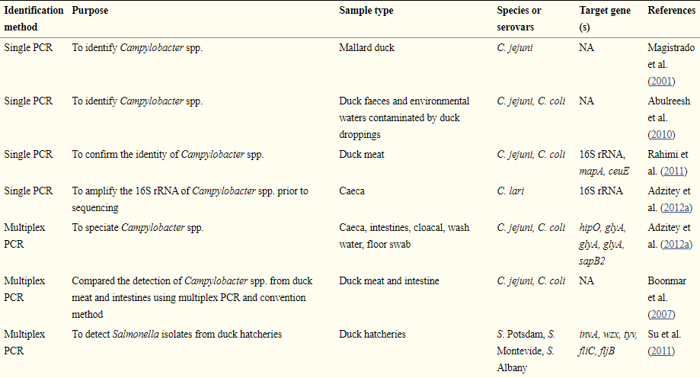
In fields including cloning of DNA, inherited diagnosis, genetic fingerprint recognition, PCR was used. The polymerase chain reaction technology plays an important role in distinguishing the common bacterial strains present in viable but nonculturable coccoids, frequently ignored by the conventional approach (for example, Campylobacter spp) (Magistrado et al., 2001). The technique and its sensitivity and efficacy can be hindered by components of the enrichment broth and DNA extraction solution, concentration of PCR mixtures (primers, DNA templates, dNTP's and Mg2+), and temperature and cycling conditions (Wassenaar and Newell 2000).

Table 4.2: The benefits and drawbacks of certain widely available molecular approaches for the detection of foodborne pathogens (Adzitey et al., 2013)
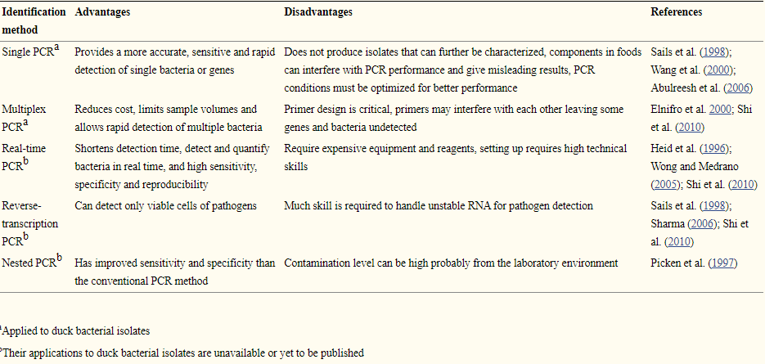

4.3.1.1 Single polymerase chain reaction
This method of polymerase chain reaction (PCR) is distinguished from the others because it involves the use of a single primer set (which targets a specific gene) to detect an organism, this PCR technique is the conventional kind of PCR before improvements occurred which resulted in the new techniques. The validation of bacterial isolates selected directly from agar plates is one of the applications of Single PCR. PCR has previously been used to initially amplify the 16S rRNA bacterial genes with universal or special primers before it was sequenced to further classify obscure or new forms of bacteria. Magistrado et al., (2001) reported that PCR recognized one C correctly. Philippine Mallard Duck Jejuni Isolate. As explained in detail in Fig., PCR is a three-step process or loop. 1. A particular number of times is replicated. These processes, namely denaturation, rinsing and extension, are responsible for the PCR duration. The process in a thermal cycler is automatically controlled by an instrument which alternates the temperature during programmed times with the appropriate number of PCR cycles.

4.3.1.1.1 Denaturation
This is a heat dependent stage, where the temperature is normally more than 90ºC is capable of separating the double-stranded DNA into two single strands. As the hydrogen bonds connecting the bases are weakened, this process is known as "denaturation," so denaturation is made possible. At high temperatures, the hydrogen bonds break, while the bonds between deoxyribose and phosphates stay intact as they are stronger.

4.3.1.1.2 Primer Annealing
The ultimate objective of PCR is to reproduce a target sequence of approximately 100-600 base pairs that are unique to the studied organism. By using primers, targeting the sequence is done. Primers describe the ends of the target series.
AMPLICOR Research primers are short, single-stranded DNA synthetic sequences normally consisting of 20-30 bases, with a 5' end biotin-labelled to assist in identification. Specific PCRs have two primers in the target region of the organism, one for each of the individual DNA strands formed during dermal denaturation. In the DNA objective sequence the initials which anneal (bind) to the complementary sequence mark the beginning of interest. Annealing usually happens between 40oC and 65oC according to the length and base sequence of the primers.

4.3.1.3 Extension
After the primers anneal to the complementary DNA sequences, the temperature required for this stage is roughly 72oC. The enzyme Taq DNA polymerase is used to duplicate the DNA strands as well. In comparison to natural polymerase enzymes, Taq DNA polymerase from the organism Thermus aquatics we are a recombinant thermostable DNA polymerase and is active at high temperatures. The synthesis method synthesizes new double-stranded DNA molecules identical to the original double-stranded objective DNA region, enabling the free-solving binding of the complementary nucleotides (dNTPs). Extension often continues with a double strand from one of the two individual strands at the end of the first 3. Only in 5′ to 3′′ direction does Taq DNA polymerase synthesize. There are currently two additional strands of DNA similar to the original target at the end of the first PCR cycle. For the freshly formed strands, there is a start, which is identified by the 5 'end of the primer, but the 3' end is not specifically specified.
The synthesized DNA strand from such a prototype has a right length which at each end is restricted to the five ends of each of the two primers. These strands of DNA are called AMPLIGON. Strands of DNA that fit the sequence of the goal. After just a few iterations, the variable duration sequences emerge in much larger numbers. The section that is improved is the sequence flanked or identified by the two primers.

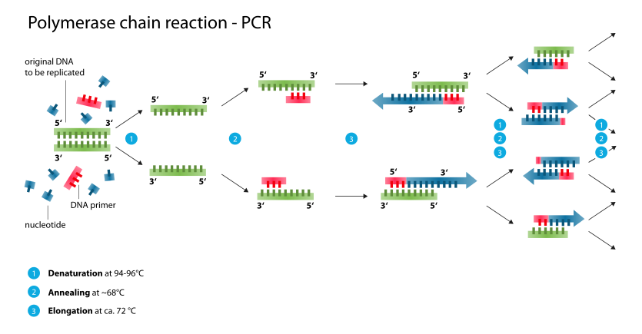
Figure 1: Pictorial Illustration Of Polymerase Chain Reaction (Source: Tankeshuwar, 2016)

4.3.2 Fingerprinting techniques
Fingerprinting technique is a PCR- based technique which another name for DNA profiling, this molecular method aids the knowledge of the relationship between individual organisms by comparing their DNA. This technique is carried out by amplifying the DNA involved using Polymerase Chain Reaction (PCR) after which restriction enzymes are used to cut the DNA into fragments which differ as a result of the difference in the DNA sequences of different organisms and this results in a set of different sizes of DNA fragments which are unique to each organism (their genetic fingerprint). These unique sets of different sized fragments are known as Restriction Fragment Length Polymorphisms (RFLP). Examples of this technique are Terminal Restriction Fragment Length Polymorphism (T‒RFLP), Denaturing Gradient Gel Electrophoresis (DGGE) and Single-Strand Conformation Polymorphism (SSCP). These techniques have been used widely in the study of bacterial communities in the rhizosphere (Berlec, 2012; Ascher et al., 2011). However, in application to the microbial population of the rhizosphere this technique identifies only dominant bacterial populations within the communities, and many of the dominant populate considered both active and inactive bacterial populates (Van Elsas and Boersma, 2011).
According to Smalla et al. (2007), DGGE is more efficient in the assessment of the bacterial diversity from several soils compared to the T‒RFLP technique. The DDGE technique yielded more reproducible results for comparing large numbers of samples. In general, fingerprinting techniques depends on the amplification of 16S rRNA gene fragments using PCR, but 16S rRNA gene copy number per genome vary from 1 up to 15 or more copies depending on the bacterial species. The numbers of rRNA gene copies are related to the life strategy of bacteria; taxa with low copy numbers and inhabit low nutrient environment (oligotrophic) (Větrovský and Baldrian, 2013; Kang et al., 2010).

4.3.3 Post Genomics
Although, conventional molecular techniques are effective when used, still have some constraints which limit the accuracy of their results, which led to the development and improvement of techniques such as metagenomics, metaproteomics, and metatranscriptomics, which have provided more accurate results on the evaluation of the microbial activities present in rhizospheres as well as the composition of microbial communities in rhizospheres, and still led to the generation of new questions on the roles and functions of performed by these microbial communities present in the rhizosphere. (Hirsch et al., 2010; Sørensen et al., 2009).

4.3.3.1 Metagenomics
The knowledge of the ecological roles of each species present in the soil is not trivial for an in-depth understanding and proper assessment of the soil diversity, distribution and operation of microbial populations of both bulk and rhizosphere soils. New molecular methods have demonstrated that bulk and rhizosphere soil bacterial richness is much greater than was thought. Based on a soil metagenome analysis using next-generation sequencing or second-generation sequencing techniques conducted by the 16S rRNA gene and ITS1 microbe region (Niedringhaus et al., 2011, Mendes et al. 2011, Xu et al., 2012, and Schmidt et al., 2013), 1 g soil sample may contain 33,346 bacterial and archaeal OTUs, 3,320 fungal OTUs, 145 to 200 fungal OTUs and 300 arc arcs. The bulk and rhizosphere soils have been discussed with both Roche 454 and Illumina platforms (Table 1). The Roche 454 pyrosequencing platform has longer read lengths (<450 bp) and greater specificity of consensus than the Illumina platform (Unno, 2014). Uroz et al. (2010) contrasted the bacterial diversity of oak rhizosphere and bulk soil by 454 pyrosequencing, discovering that the dominant taxa were Proteobacteria, Acido-bacteria, Actinobacteria, Bacteroidetes. Lagos et al. (2014) recently identified the composition of the bacterial populations of rhizosphere microsites of Lolium perenne (root tips and mature root zones) and discovered that Proteobacteria, Actinobacteria and Acido-bacteria were the dominant phyla. Similarly, Sun et al. (2014) described by Illumina sequencer the variety of bacterial species of the apple rhizosphere and found that the dominant classes were Proteobacteria, Acidobacteria, Bacteroidetes, Gematimonadates and Actinobacteria.

4.3.3.2 Metaproteomics
Metaproteomics is the large-scale detection and quantification of microbial culture proteins and thus offers clear insight into microorganism phenotypes at the molecular stage (Manuel Kleiner 2019). Metaproteomics helps to specifically quantify proteins found in an environmental sample, such as soil, while providing information on the roles and functions of these microorganisms present in the soil, such as biogeochemical processes, degradation or processes of bioremediation (Bastida et al., 2012, Chourey et al., 2010). Proteogenomics consistent with VerBerkmoes et al. (2009) is a very important tool for the finding out of the physiology, ecology and evolution of microorganism populations, communities and consortia in many environments as a method to attach a microorganism species with its operate. This approach is metagenomics whereas genetics the verification of metagenomics studies by macromolecule information. At the instant it's necessary to place into thought the unfinished databases on soil macromolecule identification. the variety of proteins expressed by the interactions between plants and microorganism communities within the soil has, however, been shown by numerous studies in metaproteomics. Lin et al. recently compared the metaproteomic profile of the rhizosphere of Raton sugarcane and plant sugarcane (2013). The findings revealed that sugarcane induced substantial improvements in the function of the soil enzyme, the catabolic diversity of the microbial population, and the extent of expression of soil proteins extracted from plants, fungi, and fauna. This research also stated that 24.77 percent of soil proteins are derived from bacteria, and much of the up-regulated expression of microbial proteins are involved in membrane transport and signal transduction. According to the similar study carried out by Moretti et al. (2012), it was demonstrated that the rhizosphere of lettuce (Lactuca sativa) produced higher amount of proteins related with virulence determinants, energy metabolism, stress/defence response in presence of a pathogenic strain of Fusarium oxysporum which could be related with the interaction the microbial consortium associated to fungi.

CHAPTER FIVE

5.0 Conclusion
Microbial activity is a determinant of most of the reactions that occur in the rhizosphere (biogeochemical cycling, decomposition of dead plants and animals, among others). Knowing how important the functions they perform and how plant growth relies directly and indirectly on their metabolism has made the proper identification of these microorganisms (Rhizobacteria) very important and cannot be overemphasized. It's important that any systems used to classify bacteria, whether phenotypic or genotypic, would have drawbacks and no particular test technique will produce 100% reliable results. (Tim Sandle, 2016) This explains why advances in soil molecular and post-genomic techniques will continue as it will enhance our understanding of the concentrations and behaviours of soil microbial species, to target rare or low-abundance bacterial populations in the rhizosphere, and to anticipate in-situ reactions, movements and development of bacterial species. Until very recently, few soil and rhizosphere soil studies have been conducted using traditional methods of identification, which are very limited when it comes to species-level identification. Advances in this area of research occur from time to time, examples of which are metagenomics, metaproteomics and metatranscriptomics; these approaches may also be limited but they have help in proffering answers to at least 90% of the arising questions. This resulted in the hypothesis that the molecular/genetic identification approaches have proved to be of use in strategies to select indigenous potentially beneficial bacterial strains that can serve as biofertilizers or bioprotectors relative to the phenotypic method of identification, to consider the significance of the rhizosphere microbiome in promoting plant health and to research t (Bakker et al., 2013). Collaborative efforts are therefore required for potential biotechnological advances to allow adequate and successful rhizosphere management strategies to be developed, benefiting from the yield and sustainability of agricultural systems.

