EFFECT OF INTERNET SLANGS ON THE ACADEMIC ACHIEVEMENTS OF SECONDARY SCHOOL STUDENTS IN ESSAY WRITING IN ENGLISH LANGUAGE.

Certification
This is to certify that OLASUBOMI, OLUFUNMILAYO with matriculation number 16020401010 carried out this research work titled EFFECT OF INTERNET SLANGS ON THE ACADEMIC ACHIEVEMENTS OF SECONDARY SCHOOL STUDENTS IN ESSAY WRITING IN ENGLISH LANGUAGE under my supervision and that this research work has not been previously submitted for the award of any degree in this or any other university.

Olasubomi, Olufunmilayo E.
(Researcher) (Signature and Date)

Dr. T. O. Oladejo
(Supervisor) (Signature and Date)

DEDICATION
I want to dedicate this work to God Almighty. The Master of the universe, the beginning and the end, the giver of life and my all in all. Praise be to Him forever.

ACKNOWLEDGEMENTS
I would like to appreciate my supervisor Dr Oladejo, T. O. for her encouragement and never ending help in the project. Also the other esteemed lecturers in the department, Professor Emmanuel Adedun (H.O.D), Dr Senayon Esther, Dr Miriam Anana, Mr Olatunbosun Taofeek and Dr Promise Adiele. Then my course mates and friends who gave support when it was needed: Otitio Esther, Iyanu Ayeobasan, Adekala Israel and Olaseinde Tope-Ajayi.
Last but not least my family, My mom, Mrs. Olasubomi Olufunke, my grandmother Mrs. Olasubomi Olukemi for financial support to get properly equipped for the project and also my siblings for not disturbing while I was working.

ABSTRACT
This project investigates The effect of slangs on secondary school students academic achievements. The introduction of slang and the rise in the use of slang in Nigeria was attempted. Simultaneously, various linguists investigate and address the numerous significances of slang. A corpus of data (slangs) is observed, processed and analyzed that includes student’s discussions. The influence of slangs on high school students' academic performance is also discussed. The study shows the frequency of use of slang, in both formal and informal contexts as well as slang and feature extensions. In the SS3 class, the data collected and evaluated attentively were used to evaluate the validity of the work of students at mountain high school, which the researcher observed through questionnaires. The data analyzed (slangs) indicate the influence of the slangs on the students and their academic achievement, the writing of essays, grammatical errors, etc.

Keywords: Slangs, Writing, Internet.

Table of contents Page

CHAPTER ONE
1.0 Introduction…………………………………………………… 1
1.1 Background to the Study………………………………………1-2
1.2 Statement of the Problem……………………………………….2
1.3 Aims of the Study…………………………………………….2-3
1.4 Research Questions………………………………………………3
1.5 Statement of research hypothesis………………………………3-4
1.6 Significance of the Study………………………………………….. 4
1.7 Scope of the Study……………………………………………….4
1.8 Limitation…………………………………….……………..4
9.0 Definition of terms……………………………………………..4-5

CHAPTER TWO
2.1 Conceptual Framework……………………………………...5-14
2.2 Theoretical Framework……………………………………………14-15
2.2 Empirical Review……………………………………………15-18

CHAPTER THREE
3.1 Research Design…………………………………………..19
3.2 Research Population………………………………………………..19
3.3 Sampling Technique……………………………………………19
3.4 Instrumentation……………………………………………..20
3.5 Validaton of instrument….……….………………………….20
3.6 Administration of Instrument………………………………..20
3.7 Data Analysis Technique…………………………………….20

CHAPTER FOUR
4.0 Data Analysis……………………………………………….21-23
4.1 Finding and Discussion……………………………………..23-28

CHAPTER FIVE
5.0 Summary and Conclusions………………………………………29
5.1 Summary…………………………………………………………29-30
5.2 Conclusion………………………………………………………31
5.4 Recommendation…………………………………………..32
Appendix………………………………………………………31-35
Reference…………………………………………………36-40

CHAPTER ONE
- INTRODUCTION
  - BACKGROUND OF STUDY

The origins of the Internet Slang is from the year 1975, a long time before the Internet itself started. The scholar submits (in 1975) that the "hacker society" started to use slang. "The slang has a subtler appearance among hackers; it may be parallel to the slang of jazz musicians and some kinds of fine artists, but is not detectable in most technological or scientific cultures. Preece (2001) claims that the Internet is an empowering place to be a defining element of utterance without distance and that it can express shared views across the web (p. 29). Social networking networks like Facebook are one of many web sites where people are forming communities and developing new ways to view teenagers' communication today. The Cambridge Online Dictionary describes slang as 'very informal language, used in particular by groups of people and sometimes not respectful' ("Slang" 2015). These groups have been able to create their own language through social networking (Tellaria 2012 p.2).
Further, Internetlang.com has more than 9,000 Internet Slang words currently in use and records the top 10 trend terms (Internetslang.com, 2015). We have created this website. This makes it possible for young people today for their families to understand the Internet Slang language, and literature addresses Internet Slang in the classroom, as well as on academic tasks. The views of teachers on both sides of the subject were noticed during the study of the Internet language. Discussions have taken place between teachers and academics on the effects of the Internet Slang in high schools (Krupnick, 2010; Tilley, 2009). According to a Nielsen poll conducted in late 2008, teens in the United States send and receive, on average, 80 texts daily, a number that doubled in only one year. (Tilley, 2009). Brown, Campbell, & Ling (2011) have noted that teens primarily use smartphones for texting and less for voice calling, pictures, music, and video.
1.2 STATEMENT OF THE PROBLEM
There is a language of today that has grown in popularity with the age of computers, smart phones, and social media platforms. Internet slang has been used by many on line communities and has changed vernaculars through many of these communities during the years of the information highway’s lifespan.
Referring to language such as ROTFL (Rolling on the floor laughing), and the popular OMG (Oh my God), to name a couple of examples, within an extensive library of terms brought about by internet communities. This internet slang has impacted secondary education with teachers and scholars concerned with the writing skills of today’s youth. Finally, several research has been carried out on the influence of text messaging on measures of student writing but not even a single research has been carried out on the influence of internet slangs on the academic achievement of secondary school students in essay writing in English language.
1.3 AIMS AND OBJECTIVES OF STUDY
The main aim of the study is to determine the influence of internet slangs on the academic achievement of secondary school students in essay writing in English language. Other specific objectives of the study include;
- to determine the extent to which internet slangs affects the academic achievement of secondary school students in essay writing in English language.
- to determine the causative factors of internet slangs and its effect on the academic achievement of secondary school students in essay writing in English language.
- to determine the influence of internet slangs over writing of essay in English language.
- to proffer possible solutions to the problems.
1.4 RESEARCH QUESTIONS
- What is the extent to which internet slangs affects the academic achievement of secondary school students in essay writing in English language?
- What are the causative factors of internet slangs and its effect on the academic achievement of secondary school students in essay writing in English language?
- What is the influence of internet slangs over writing of essay in English language?
- What are the possible solutions to the problems?
1.5 STATEMENT OF RESEARCH HYPOTHESIS
H₀: Internet slangs have no significant effect on the academic achievement of secondary school students in essay writing in English language.
H_{1:} Internet slangs have a significant effect on the academic achievement of secondary school students in essay writing in English language.
1.6 SIGNIFICANCE OF STUDY
The study on the influence of internet slangs on the academic achievement of secondary school students in essay writing in English language will be of immense benefit in the sense that it will enable the school authority to take note of the students that are victim of using internet slangs; in that they are placing this internet slang into their academic work; though sometimes it could be difficult to totally eradicate the use of internet slangs among secondary school students but there is always a way of reduction. The study would enable the teachers to give a quality punishment to those that are still involved in the usage of the slangs. Finally, the study will contribute to the body of existing literature and knowledge to this field of study and basis for further research.
1.7 SCOPE OF STUDY
The study on the influence of internet slangs on the academic achievement of secondary school students is limited to essay writing in English language. Mountain top secondary school would be used in getting data, 40 students from ss3, 20 from art department, 10 from science department and 10 from commercial, would be given questionnaires, due to the pandemic society.
1.8 LIMITATION OF STUDY
Financial constraint- Insufficient fund tends to impede the efficiency of the researcher in sourcing for the relevant materials, literature or information and in the process of data collection (internet, questionnaire and interview).
Time constraint- The researcher will simultaneously engage in this study with other academic work. This consequently will cut down on the time devoted for the research work.
1.9 DEFINITION OF TERMS
Influence: The capacity to have an effect on the character, development, or behaviour of someone or something, or the effect itself.
Slangs: A type of language consisting of words and phrases that are regarded as very informal, are more common in speech than writing, and are typically restricted to a particular context or group of people.
Writing: Is a medium of human communication that represents language and emotion with signs and symbols.
Internet: A global computer network providing a variety of information and communication facilities, consisting of interconnected networks using standardized communication protocols.

CHAPTER TWO: REVIEW OF RELATED LITERATURE.
2.0 INTRODUCTION
This chapter gives an insight into various studies conducted by outstanding researchers, as well as explained terminologies with regards to the influence of internet slangs on the academic achievement of secondary school students in essay writing in English language.
2.1 CONCEPTUAL FRAMEWORK
Internet
The Internet was established in the early 1960s and subsequently became a mainstream communication vehicle (Moschovitis, Polle, Schuyler, & Senft, 1999; Schneider, et al., 2006). Since that time, there has been remarkable growth in the Internet‟s functionality, capacity, accessibility and convenience. These improvements have encouraged more people to use it more often, and it has become a powerful application in modern society. As of 2010, 28.7% of the world's population used Internet services (Internet World Stats, 2010b).
The Internet is a massive, computer-linked network system used globally to access and convey information, either by personal or business computer users; it is also used for communication, research, entertainment, education and business transactions (Kraut, et al., 1998; Schneider, et al., 2006). Today, the Internet can link all online computers so that people can use it to communicate throughout the world (Schneider, et al., 2006)
The Internet is a global linking of computers that allows information transfer. The Internet was established in the early 1960s by the U.S. Department of Defence (Schneider, Evans, & Pinard, 2006), primarily for military purposes. Since then, the continual improvement of the Internet technology has provided an extraordinary level of public accessibility to a wide range of forms of communication, e.g. intra-organisational and inter-organisational email; data storage, management and transfer; social websites like Facebook; text messaging such as Twitter, and so forth. There are many benefits associated with Internet use, such as access to needed information, worldwide access to news and events, and interpersonal communication through email.
However, along with the phenomenal growth of the Internet and its use, there has been a growing concern worldwide regarding the risks associated with Internet over-use (Buchholz, 2009; Daily News, 2008, 2009; Fackler, 2008; Janta, 2008; Khaosod, 2007; The Associated Press, 2009). It is now believed that there could be widespread „addiction‟ to it, in particular amongst college and university students (Chou & Hsiao, 2000; Fortson, Scotti, Chen, Malone, & Del Ben, 2007; Kim, et al., 2010; Kubey, Lavin, & Barrows, 2001; Morahan-Martin & Schumacher, 2000; Scherer, 1997; H. Yan, Liu, Ni, & Chen, 2009; M. Yang et al., 2009).
There is an ongoing debate about the appropriateness of applying the concept of addiction to Internet use. This debate centres on disagreements about the definitions of the terms used for IA in the literature, controversy around suggested diagnostic criteria, and whether IA truly exists as a diagnosable addiction in a similar vein to other types of addictions. Indeed, most IA theorists have based their definitions of IA on established addiction conceptual frameworks, such as substance dependence (Anderson, 2001; Black & Shaw, 2008; Griffiths, 1998; Ng & Wiemer-Hastings, 2005; Scherer, 1997), pathological gambling (Greenfield, 1999; Kaltiala-Heino, Lintonen, & Rimpela, 2004; Kubey, et al., 2001; Milani, Di Blasio, & Osualdella, 2009; Niemz, et al., 2005; Thomas & Martin, 2010; Young, 1998; Zboralski, et al., 2009), and technology addiction (e.g., television addiction) (Griffiths, 1995; Schimmenti & Vincenzo, 2010).
For example, some studies purporting to explain the prevalence and consequences of IA have been undertaken, most of them adopting the Diagnostic and Statistical Manual of Mental Disorders, 4th edition (DSM-IV) criteria for both substance dependence and pathological gambling to classify IA (American Psychiatric Association, 1994). One of the more consistent findings from the literature is that students have been identified as more likely to be the most vulnerable group for IA (Lam, et al., 2009; Milani, et al., 2009; Thomas & Martin, 2010; Zboralski, et al., 2009). However, few studies have been conducted evaluating the appropriateness and effectiveness of treatments or solutions for this phenomenon.
Nature of the Internet.
The word Internet emanates from the words “Internet Connection Network” (Greenfield, 1999), connecting computers around the world by the use of a standard protocol. It is believed that the distinctive features of the Internet, such as speed, accessibility, intensity and stimulation of its content, contribute to IA (Greenfield, 1999).
In addition, Chou (2001) indicated that the most appreciated Internet features included interactivity, simplicity, availability, and abundant and updated information. In fact, the Internet‟s attractiveness has increased as a result of its availability, accessibility, and affordability. The development of friendlier interfaces provides users with easier and more comfortable access. Young (1998) also concluded that the interactive features of specific Internet applications influence IA, not the Internet itself.
Nature of Internet users.
Various researchers have sought to understand the reasons some people become addicted to the Internet. For example, Suler (2000) suggests that addictive Internet users are meeting personal needs while on the Internet, including: a sense of belonging; selfactualisation achievement; and sexual images and dialogue.
In a similar vein, Chou, Chou, and Tyan (1999) found that IA users experienced more personal satisfaction in escaping through online communications. Other research has documented that IA users report that the Internet is a relaxing, exciting, and enjoyable avenue for social exchange (Morahan-Martin & Schumacher, 2000). Thus, IA users have been found to express more satisfaction and pleasure in Internet interaction than „normal‟ Internet users.
Referring to language such as ROTFL (Rolling on the floor laughing), and the popular OMG (Oh my God), to name a couple of examples, within an extensive library of terms brought about by internet communities.
This internet slang has impacted secondary education with teachers and scholars concerned with the writing skills of today’s youth. Studies have shown that electronic devices of today are hindering the literacy rate of secondary education students. It is important that the use of Internet Slang be studied to determine its effects on secondary education students’ writing skills and how Internet Slang affects the English language today.

Slang
Slang is something that everybody can recognize but nobody can define. The literal meaning of slang according to the Oxford dictionary is a type of language consisting of words and phrases that are regarded as very informal, are more common in speech than writing, and are typically restricted to a particular context or group of people. Finegan (2008) said that slang is particularly popular among teenagers and college students in general.
Akmajian et al (1998) also added that slang has some salient features, first slang is part of casual informal styles of language use, second slang is like fashions in clothing and popular music, changes quite rapidly, third specific areas of slang are often associated with a particular social group, and hence one can speak of teenage slang, underworld (criminal) slang, the slang of the drug culture and so on.
The speaker uses slang in order to achieve social dynamics with the people to whom he/she is speaking and slang outlines social spaces, and attitudes towards slang helps identify and construct social groups and identity (Adams, 2009:57). It means that when someone uses slang, she/he exposes ideas, feeling, attitude as how she/he wants to perceive the people that talk to and how she/he wants those people to perceive her/him, to infer what she/he means.
Adams believe that slang can just as well be playful and a joking way of rebelling against standard language to mark the difference between e.g. parents and children (in-crowd versus out-crowd), but the children do not necessarily have wicked intentions with the use of slang. He also mentions that slang is not slang until someone recognizes it to be slang (Adams, 2009:62).
It means that the addressee must be able to recognize the speaker’s intent and to determine that what they are hearing is slang. Slang is probably the most famous register if compared with jargon or argot. The different function between slang and jargon is that slang is used to show speaker’s attitude while jargon is used by speakers and addressee who have the same profession in communicating about their profession for example two doctors in hospital talking in medical terms. Meanwhile, argot is a type of secret or code language because it is used to hide speaker’s intention.

Internet slang
Internet slangs is slang that have been developed and used by users of the Internet. Many of these terms originated for saving keystrokes and are often written in lower case. Internet slang is, by its nature, difficult to interpret, especially in chatrooms or on instant messaging, because much of it is quickly input, and many assume, falsely, their audience knows their body language.
For instance; a LOL may be taken as genuine laughter or sarcasm, or as "whatever, stay away from me." So, for the sake of accurate and easily understandable communication, it is best to be as explicit as possible and make an effort to get your point across. Emoticons such as :) can also be used to clarify emotional intent in internet messages.
Conversely, they can add to the confusion, for example the:-P emoticon which can indicate both (positive) joking and (negative) sarcasm; or simply when used in excess. Also, chat acronyms or chap (pronounced "chalk") were initially developed by users of pre-Internet bulletin board systems, and have since been adopted by users of text-messaging wireless telephones. A handful (e.g. ASAP, PO'ed) far pre-date computers. The three-letter acronym (TLA) is the most popular type of abbreviation in computing and telecom terminology and slang.
Some of the Internet Slangs Used
AFAIC — "as far as I'm concerned", or "as far as I care", or "as far as I can..."
AFAIK — "as far as I know"
AFAIR — "as far as I recall", or "as far as I remember"
AKA — "also known as"
ASAP — "as soon as possible"
B4 — "before"
B4N — "bye for now"
BB — "bye bye"
BBIAB — "be back in a bit"
BBL — "be back later"
BC — "because"
BF — "boyfriend"
BFD — "big fucking deal"
BFF — "best friend forever"
CID — "consider it done
CU — "see you"; used as a goodbye.
CSL — "can't stop laughing"
CUWUL — "Catch Up With U Late.
CVQ — "chuckling very quietly"; as an alternative to "LOL"
DBG — "don't be gay"
DGT — "don't go there"
DH — "dear husband". Used by housewives posting on Internet forums.
DH — "dickhead"
E — enlightenment.
EOM — "end of message"
F4G, F4GG0T — "fag/faggot"
FAQ — (formal) "Frequently Asked Question"
FE — "fatal error"
FFS — "for fuck's sake!" (sometimes replaced with FS- "fuck's sake")
FLOABT — "for lack of a better term"
FGI — "fucking google it"; used in response to a common question
FO — "fuck off!"
FOAD — "fuck off and die!"
FOAF — "friend of a friend"; the dubious attribution given to urban legends
FP — "first post"; originally used on Slashdot
frag — To kill or tear to pieces. Its origin comes from fragmentation.
FTF or F2F — "face to face"; referring to a meeting in the real world, not online. In roleplaying
terms, it is the offline predecessor to MMORPGs and MUDs.
G — "grin", normally written *G* or <G> to separate it from the surrounding text
G2G, GTG — "got to go", also "good to go"; popularized in MMORPGs and MUDs.
G4Y, GFY — "good for you", or "go fuck yourself"; the use of this acronym is ambiguous
and not recommended.
GAGF — "go and get fucked"
GAL — "get a life"
GCAD — "Get Cancer And Die"
GF — "girl friend"
GFI — "good fucking idea"
GG — "good going" or "good game"; used sincerely in competitive and cooperative online
games, or used sarcastically when someone has done something foolish. Also "genuine
girl", used on chat sites to indicate that the user is female, rather than simply pretending to
be.
GL — "good luck"
GMTA — "great minds think alike"
GJ — "good job", often sarcastic
GR8 — "great", sometimes spelled gre8t even though it doesn't make the word any shorter.
GTFO — "get the fuck out"
GTG — "got to go"
GTH — "go to hell"
GW — "good work", often used sarcastically.
IANAL — "I am not a lawyer"; usually used before a non-lawyer gives legal advice, as a
humorous disclaimer.
IANARS — "I am not a rocket scientist"
IC — "I see", also "in character" in MMORPG or MUD settings.
ICYDK / ICYDN / ICUDK — "in case you didn't know"
IDK — "I don't know"
ID10T — "idiot"; generally pronounced eye-dee-ten-tee, its meaning is not obvious until
viewed in written form. Example: "We've got an ID10T error!"
IIRC — "if I recall correctly"
IM — "instant message", can be used as a noun ("Send an IM") or a verb ("I'll IM him").
Past tense is "IM'd" or "IMed".
IMO — "in my opinion"
IMHO — "in my humble opinion", or "in my honest opinion"
IMHE — "In my humble experience"
IMNSHO — "in my not so humble opinion"
INMP — "it's not my problem"
IOH — "I'm outta here"
IOW — "in other words"
Lol __ laughing out loud
Lmao__ “laughing my ass out”
Mcm – “Man crush Monday”
Nvm _ Nevermind
Rt _ repost, return
2.2 THEORETICAL FRAMEWORK

Social Presence Theory
Social Presence Theory, developed by Short, Williams, and Christie (1976), explained the effect telecommunications media can have on communications. They theorized that communication media differ in their degree of social presence and that these differences play an important role in how people act. Before the advent of computers, teenagers would spend hours on the telephone. In contrast, today they spend hour after hour texting one another. Online devices have now changed the face of social presence where teens now have developed their own language through the use of Internet Slang, and this medium has changed the way teenagers act.
In this fast-paced world, one thing has not changed: the need to be socially accepted by other human beings. This is no different for teens. Lenhart, et al. (2008) stated, “The vast majority of teens have eagerly embraced written communication with peers as they share messages on their social networks” (p. 2). On a continuum of social presence, face-to-face would be considered to have the most social presence, followed by written, and then text-based communication the least.
2.3 EMPIRICAL REVIEW
A study was conducted on the use of Internet Slang and its effects on secondary education by the Pew Internet & Life Project (Lenhart, et al., 2008, p. 1). The researchers conducted telephone interviews with national representatives of 700 samples on secondary education students ages 12-17, and the study also included their parents. Lenhart, et al. (2008) developed a list with several questions: How do teens define writing? How does writing fit into their lives? What role do electronic technologies such as computers and cell phones, or communication platforms such as email or online social networks, play in the writing process? Do teens consider their electronic communications to be writing, or think that they have an impact on the quality of their writing overall? What do teens find enjoyable about the writing they do for school and personal reasons outside of school? What are teens’ experiences with writing instruction? What suggestion do teens have for ways that schools could improve writing instruction and the experience of learning to write? (p. 2)
The premises behind this study were to fill a gap about the controversy of the use of Internet Slang among teenagers, which was to hear from the students themselves. A total of eight focus groups were also conducted in four cities (Southwest, Northeast, Midwest, West Coast) with boys and girls ages 12-17 (Lenhart, et al., 2008, p. 2). This showed that the researcher used both the qualitative and quantitative methods to establish findings. Results showed teens 50% of the time used informal writing styles on their class assignments, and 38% stated they used shortcuts such as LOL (Laugh Out Loud) on class assignments (Lenhart, et al., 2008, p. 3).
A study conducted by the Department of Library and Information Science, Delta State University, Abraka researchers calculated the impact of text slang or chat room slang on secondary students’ academic performance in a Nigerian secondary school (Ochonogor et al., 2012, p. 1). Using the descriptive survey method researchers administered 330 questionnaires with 324 found usable; the six unaccounted for were not filled out properly (Ochonogor et al., 2012, p. 2).
Further, it was observed that students do in fact send messages during class with a 99.38% finding. Students did show a shortfall in English writing skills, and when asked if students should stop texting in school, 89% said they would not want texting to stop. As well, 63.36% of the students agreed that it would be good to use proper English in their text messaging (Ochonogor et al., 2012, p. 3). The study concluded that Internet Slang did, in fact, affect students in their study.
Also it was determined that Short Message Service, Instant Messaging, and Black Berry Messaging were being used in their classroom assignments. Researchers believed that even though the students knew using Internet Slang in academic work was not appropriate, they did it anyway, showing the researchers that the use of Internet Slang is a possible addictive behavior (Ochonogor, et al., 2012, p. 3). These two studies revealed that Internet Slang is, in fact, being used by secondary education students in classrooms and in their academic work.
It is interesting to note that the word “addiction” was used in the Nigerian study. Neither study was grounded in theory, but these studies did find similar results in establishing that texting and the use of Internet Slang is, in fact, happening in secondary schools. The Pew Study answered and filled a needed gap with regards to finding out what the students actually thought. The Nigerian study and the Pew study both identified a negative impact on the English language via the use of Internet Slang. There are also comparisons to the idea that mobile devices are affecting students’ writing performance in a negative manner.
There are studies that show mobile devices assist the learning of students. Carter (2014) has studied the impact of mobile devices on student performance and their post-test results with the use of media devices in the classroom (p.3). He states, “Implementation of one to one computing (1:1) devices in an agriscience classroom has the potential to have a positive impact on student post-test performance due to easier access to information and increased student motivation” (p. 6).
Further, his results showed, “As a whole, the data gathered from these methods indicated the implementation of 1:1 technology had a significant positive impact on all four of the measured outcomes and was a positive experience for both students and teachers” (Carter, 2014, p.8). It is noted that this study was conducted in a controlled environment where the students were monitored and the mobile devices were used for academic work and not for a social aspect with the use of Internet Slang.
Nonetheless, the use of mobile devices in the classroom, for academic studies, has been proven effective in teaching our teens today. Purcell, Buchanan, and Friedrich (2013) conducted a survey of 2,462 Advanced Placement and National Writing Project teachers where they too found some positive results in the use of digital tools and the effects on the students’ writing skills (p. 2). Purcell et al. (2013) continue with positive statements from teachers, “These teachers see the Internet and digital technologies such as social networking sites, cell phones, and texting, generally facilitating teens’ personal expression and creativity and broadening the audience for their written material” (p.2).
Reading further into the Purcell et al. (2013) study does reveal a warning though: “Teachers describe the unique challenges of teaching writing in the digital age, including the ‘creep’ of informal style into formal writing assignments” (p. 2). These studies show opposing views and opinions about the use of social media devices in the classroom. The general consensus of the educators that feel its use is positive; still warn if not monitored, Internet Slang willbe found in academic writing assignments.

CHAPTER THREE
RESEARCH METHODOLOGY
This chapter is designed to describe the procedures adopted in this research. The procedures involve the following: research design, population of the study, sample and sampling techniques, instrumentation, validation of the instrument, administration of the instrument and data analysis techniques.

3.1 Research Design
This study employed survey research design to evaluate The Effect of internet Slangs on the academic achievements of secondary school students in essay writing in English language in essay writing in English language. According to Nworgu (2006), survey research design that a group of people or items is studied by collecting analyzing data from only a few people or items considered to be representative of the entire group. It uses a questionnaire to determine the opinions, preferences, attitudes and perceptions of people about issues that concern them. A survey design is suitable for this research because it is going to make use of a questionnaire to elicit information from the respondents.

3.2 Population of the Study
The population of the study which consists of about 40 respondents from Mountain Top University were selected based on their knowledge on Effect Of Internet Slangs On The Academic Achievements Of Secondary School Students In Essay Writing In English Language in essay writing in English language. Due to the pandemic in the society.
3.3 Sample and Sampling Techniques
A sample of 40 was selected out of the population of 50 as stated above for the purpose of the study.
3.4 Instrumentation
The instrument for this study is questionnaire constructed by the researcher which was drawn from the research questions. The questionnaire was coded.
3.5 Validation of the Instrument
The validation was determined by the expert judgment of the supervisor. The judgment will seek to guarantee that each of the items in the instrument measured what it was supposed to measure. The final draft was adjudged valid by project supervisor.
3.6 Administration of the Instrument
A total of 40 copies of the questionnaire will be administered to the respondents by hand and 40 would be returned after the exercise.

3.7 Data Analysis Techniques
Quantitative data collected will be analyzed through the use of cross tabulation, analyze the statistical significance, take into consideration causation versus correlation, compare current data with past data.

CHAPTER FOUR.
4.0 DATA ANALYSIS, PRESENTATION, AND DISCUSSION.
INTRODUCTION.
This chapter deals with presentation and analysis of data through the use of questionnaire. Significantly showing the effect of slangs on the academic achievement of secondary school students in Essay writing in English language. The effect of slangs is however analyzed through the use of questionnaire, and data are collected from ages 16 – 25, Male and females. The data gathered would be analyzed through tables, graph and pie chart, for further understanding and data representation.

SLANG QUESTIONNAIRE ANALYSIS
DATA ANALYSIS
DATA 1:
This data was collected from various Mountain Top secondary school students, and although the data is significantly small (40 respondents), it still draws powerful insights as to the use of slangs and also the impact of slangs in English language.
Firstly, we need to know our data. Know the age and gender distribution of the respondents.
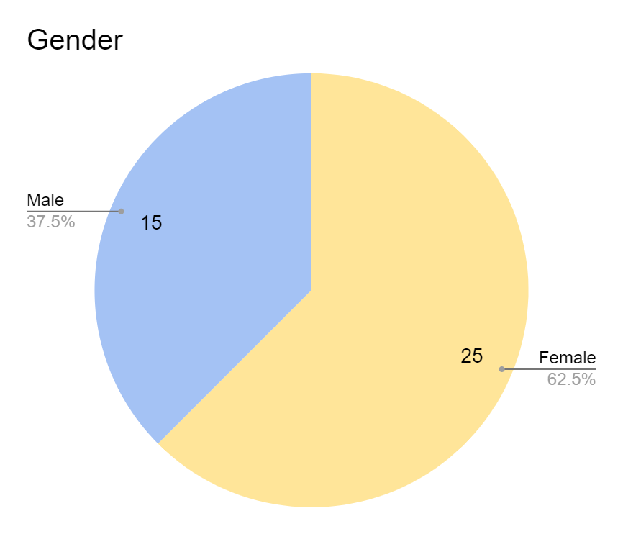
Fig1. Graph showing age distribution.
Majority of the respondents were females as shown above, a staggering 62.5% of the 40 respondents are females.

DATA 2:
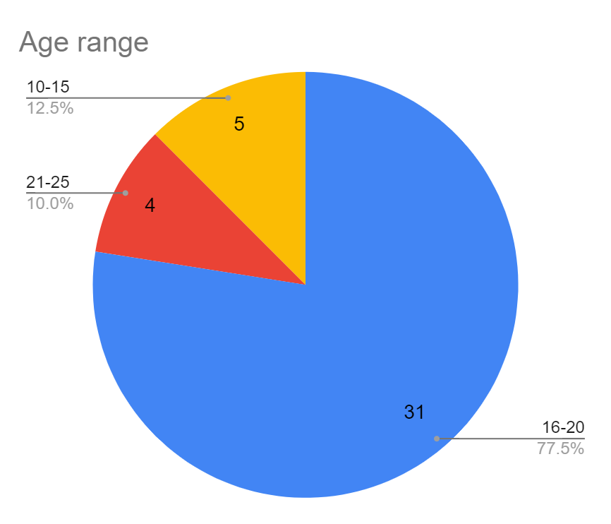
Fig2. Pie chart showing the age distribution.
This pie chart shows that a majority of the students who filled this questionnaires are students in the finishing classes as the age distribution shows that 77.5% are of age 16-20 which is most likely to be students in SS3. This is a very important thing as these are the students who have the capability to efficiently judge the effects of slangs on their English language.

DATA 3:
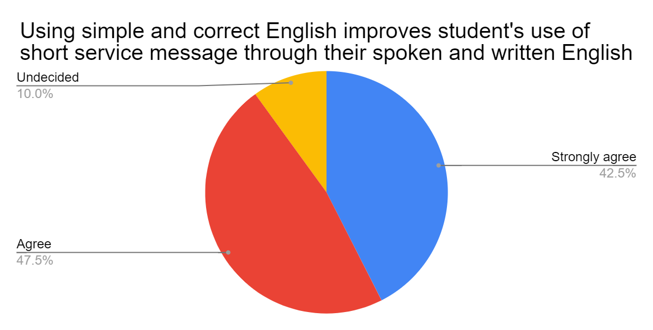
Fig3. Using simple and correct English improves student’s use of Short messge their spoken and written English.
As shown above, a huge majority of the students (90%) believe that simple and correct English improves student’s use of SMS via students spoken and written English. This was previously viewed as the job of slangs in the society. But this data proves that notion wrong.

DATA 4:
 | Agree | Disagree | Undecided | Grand Total
Gender
Female | 12 | 9 | 4 | 25
Male | 11 | 1 | 3 | 15
Grand Total | 23 | 10 | 7 | 40
Table 1. Internet slang is an easy way of communicating with people.

Fig4. Internet slang is an easy way of communicating with people.

We can see here that only 1 male (0.07) disagrees with this while 36% of females disagree. This shows that a higher percentage of males believe slang is an easy way of communicating with people. We can infer that males use slangs more as a large number of them believe it is an easier way of communicating. And hence, if there should be an adverse effect of slangs in English language, male students will suffer more.
In general, according to the data and the table above, people believe slangs are used for easy communication. Therefore, the trade-off here is between easy communication and having good essay writing skills.

DATA 5:
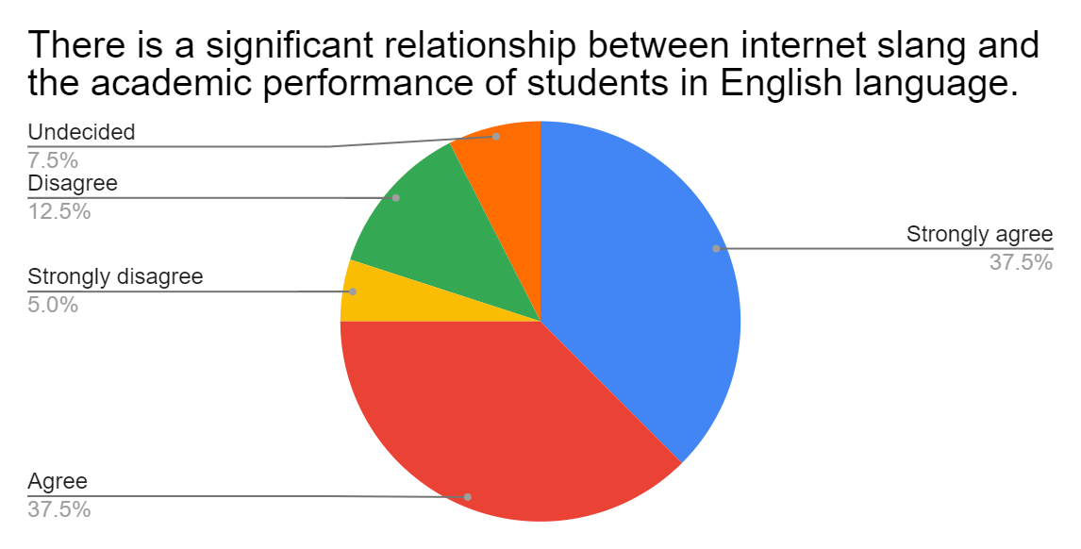
Fig5. There is a significant relationship between internet slang and the academic performance of students in English language.
75% of students believe that there is a significant relationship between internet slang and the academic performance of students in English language. This is an interesting insight but it is very vague. Is the relationship positive or negative? Before I answer that question, we would like to know how this distribution spread alongside the age group distribution.

DATA 6:

Fig6. Distribution of age group along side the column in fig5.
Here we can see that 100% of the oldest students disagreed with this. But we see an immediate change as 60% of students aged 16-20 who are more likely to be in the final classes agrees with this.

 | Agree | Disagree | Undecided | Grand Total
Row Labels
10-15 | 4 | 1 |  | 5
16-20 | 26 | 3 | 2 | 31
21-25 |  | 3 | 1 | 4
Grand Total | 30 | 7 | 3 | 40
Table 2. Internet slang increases the grammatical errors in writing among English language students.

DATA 7:

Fig7. Distribution of age and the column in table 2.
Once again, we see the shift in opinions among age groups. 100% of students aged 21-25 do not agree while 84% of students aged 16-20 agree. As noted earlier, we are inclined to use the decisions of the 16-20 age group because of their class and numbers in this case. So we can say that Slang increases grammatical errors in writing among English language students.
Now, we know that there is a significant relationship between slangs and academic performance as shown in fig5 above. But we do not know about that relationship, if it is positive or a negative relationship.
As shown in fig7, slangs can be seen to have a negative relationship with the academic performance of students as a majority of students believe slangs increases grammatical errors in writing among English language students. The figure below gives a more accurate statement about the relationship between slang and academic performance.

DATA 8:
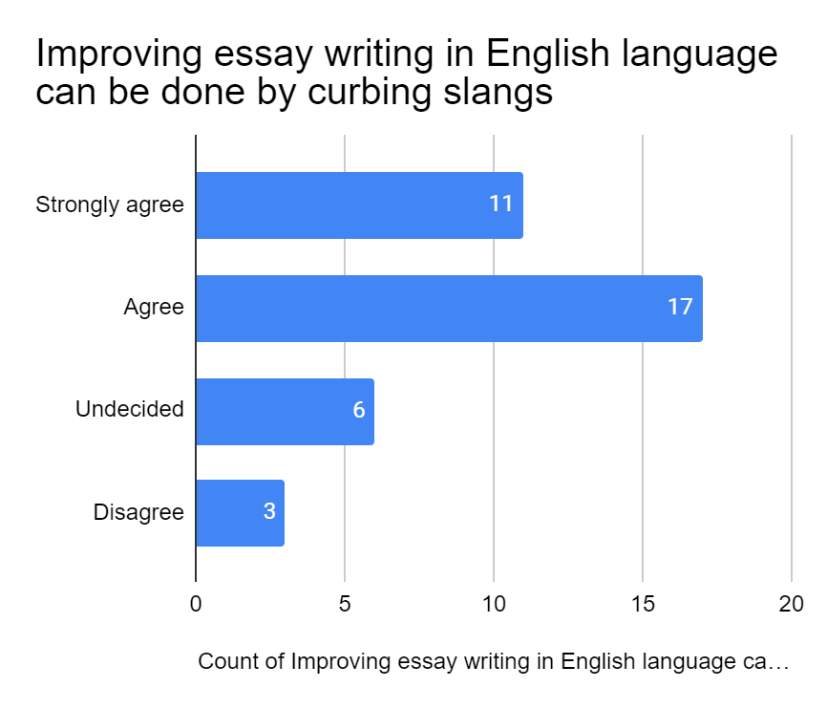
Fig8. Improving essay writing in English language can be done by curbing slangs.
As shown above, only 0.075% of students do not agree to curbing slangs in order to improve essay writing in English language. This, along with the other graphs shown above, makes a clear statement that slang have a negative influence/relationship with the academic performance of English language students.

CHAPTER 5
5.0 Summary, Conclusion and Recommendations.
5.1 Summary
The study's mains and goal is to establish whether Internet slangs affect secondary-school students' academic achievement in the writing of essays in English. The study found that internet slangs significantly influence the academic performance of Secondary school students in English language essay writing. Internet slangs raise the amount of grammatical mistakes made by students who speak English. There is a clear link between the Internet slangs and students' academic success in English. Internet Slangs weakens students English Language and sentence construction. Using clear and accurate English enhances the use of Short Message Service (SMS) visas by students in their written and spoken English
In recent times the study of slangs and their use have taken a new dimension from seeking a proper meaning, classifying it as a diverse language and use and defining it as a language created by social media. Language, a variety of slang-specific languages, is described as a variety used by secondary school students for example to establish an identity for speech (Broom &Levinson: 1978). Although some scientists consider that slangs are the absolute basic of language or some sort of vagabond language which is often considered to be inconvenient and vulgar (Allan & Burridge, 2009), others regard slangs as a great source of language innovation. (Spanish & Money, 1997). This research aims at finding out the influence of Internet slangs on secondary school students' achievement in English.

Slang is a collection of colloquial terms or sentences in one language in this review. The use of extremely informal words and phrases is not common in the language or dialect of the speaker. The language and dialect tend to be unique to a certain area, and it is a vital part of young people's experience, but unlike many adults, the slang is more or less the same as the 'young language.' The language is colloquial in many situations. Slangs, however are unique to language and culture but are also shared between cultures and languages. Recent electronic communications have made a major contribution to this process.
It occurs however that slangs have an effect on secondary school studentswho study in English at secondary school. It affects their characteristics, the writing of essays and effective communication.

5.2 Conclusion
Finally, Internet slangs have a major impact on high school students' academic success in English language essay writing. The findings indicate that statistically significantly strong ties exist among respondents who have reported that internet slangs affect secondary school students' academic achievements in English language essay writing and that internet slangs increase the grammar errors in the writing of English language students. The results show a statistically significant relationship among respondents.

5.3 Recommendation

Schools should put a disciplinary measures in place to deal with errants students found culpable of using Slangs while in school.
Schools should employ competent English Language teachers who can teach the students effectively and insist on using the language always both in school and at home, etc.

APPENDIX
QUESTIONNAIRE ADMINISTRATION.
INSTRUCTION: Please endeavour to complete the questionnaire by ticking the correct answer (s) from the options or supply the information where necessary.
- Gender
- Male
- Female
- Age range
- 10-15
- 16-20
- 21-25
- Educational qualification
- WASSCE
- GCE
- NECO

SECTION B: QUESTIONS ON INFLUENCE OF INTERNET SLANGS ON THE ACADEMIC ACHIEVEMENT OF SECONDARY SCHOOL STUDENTS IN ESSAY WRITING IN ENGLISH LANGUAGE
Internet slangs have a significant effect on the academic achievement of secondary school students in essay writing in English language.
- Strongly agreed
- Agreed
- Undecided
- Disagreed
- Strongly disagreed
Internet slangs increases the grammatical errors in writing among English language students.
- Strongly agreed
- Agreed
- Undecided
- Disagreed
- Strongly disagreed
There is a significant relationship between internet slangs and the academic performance of students in English language
- Strongly agreed
- Agreed
- Undecided
- Disagreed
- Strongly disagreed
Internet slangs increases poor construction of the English language.
- Strongly agreed
- Agreed
- Undecided
- Disagreed
- Strongly disagreed
Using simple and correct English improves student’s use of SMS via their spoken and written English
- Strongly agreed
- Agreed
- Undecided
- Disagreed
- Strongly disagreed

Internet slang is an easy way of communicating with people.
a. Strongly agreed
b. Agree
c. Undecided
d. Disagreed
e. Strongly disagreed
Internet slangs aids essay writing amongst student in English language.
A .Strongly agreed
b. Agreed
c. Undecided
d. Disagreed
e. Strongly agreed

Using of slangs improves the essay writing of students.
a. Strongly agreed
b. Agreed
c. Undecided
d. Disagreed
e. Strongly disagreed

Slangs are used only by students for easy communication.
a. Strongly agreed
b. Agreed
c. Undecided
d. Disagreed
e. Strongly disagreed

Slangs helps better learning and writing English essays.
a. Strongly agreed
b. Agreed
c. undecided
d. Disagreed
e. strongly disagreed

Improving essay writing in English language can be done by curbing slangs.
a.Strongly agreed

b,Agreed
c.Undecided
d.Disagreed
e.Strongly agreed

REFERENCES
Begley, K. (2004). Face to face communication: Making human connections in a technology- driven world.
Boston, MA: Thomson/Course Technology. Bennett-Woods, D. (2005). Ethics at a glance. Retrieved from Regis University website: http://rhchp.regis.edu/hce/ethicsataglance/ethicsataglance.pdf Brown, K., Campbell, S., & Ling,
- (2011). Mobile phones bridging the digital divide for teens in the US? Future Internet, (3), 144-158. doi:10.3390/fi3020144 Carter, L., (2014).
"Impact of mobile devices on student performance in an Agriscience classroom" Instructional Technology Education Specialist Research Papers. Paper 13. http://digitalcommons.georgiasouthern.edu/edu-papers/13 Cingel, D. P., & Sundar, S. S. (2012).
Texting, techspeak, and tweens: The relationship between text messaging and English grammar skills. New Media and Society. doi: 10.1177/1461444812442927 Daft, R. L., & Lengal, R. H. (1986) Organizational information requirements, media richness and structural design. Management Science, 32(5), 554-571. doi: 10.1287/mnse.32.5.554.
Department of Geography University of Alabama [cartographer]. (2015). The U.S.A. [map] Retrieved from http://alabamamaps.ua.edu/contemporarymaps/usa/basemaps/
Fernandez, V., Simo, P., Sallan, J., & Enache, M. (2013). Evolution of online discussion forum data analysis.
Computers & Education, 32-40. Retrieved September 23, 2015, from https://upcommons.upc.edu/bitstream/handle/2117/17725/Evolution of online discussion.pdf?sequence=1 Griffin, E. A., Ledbetter, A., & Sparks, G. G. (2014).
A first look at communication theory, 9 th ed. McGraw-Hill, New York, NY. Glen Ellyn School District. (2015). Retrieved from http://www.d41.dupage.k12.il.us/ images/Acronyms.pdf Guest, G., Namey, E. E., & Mitchell, M. L. (2013). Collecting qualitative data: A field manual for applied research. Thousand Oaks: SAGE Publications. InternetSlang.com. (2015). Retrieved from http://www.internetslang.com/
Jackson, K. M., & Trochim, W. M. (2002). Concept Mapping as an Alternative Approach for the Analysis of Open-Ended Survey Responses. Organizational Research Methods. doi:10.1177/109442802237114
Jacobson, D. (2007). Interpreting instant messaging: Context and meaning in computer- mediated communication. Journal of Anthropological Research, Vol. 63(No. 3), pp. 359-381. Retrieved September 23, 2015, from http://www.jstor.org.proxy.foley. gonzaga.edu/stable/pdf/20479429.pdf?acceptTC=true Krupnick, M. (2010, April 14). Texting slang invading academic work. The Seattle Times. Retrived from http://www.seattletimes.com/life/lifestyle/texting-slang-invading- academic-work/
Lenhart, A. (2012). Teens, smartphones, and texting. Pew Internet & American Life Project. Retrieved September 15, 2015, from http://www.away.gr/wp- content/uploads/2012/ 03/PIP_Teens_Smartphones_and_Texting.pdf Lenhart, A., Arafeh, S., Smith, A., & Macgill, A. R. (2008). Writing technology and teens. Retrieved from http://www. pewinternet.org/pdfs/PIP_ Writing _Report_ FINAL3.pdf Ling, R., Bertel, T., & Sundsoy, P. (2011).
The socio-demographics of texting: An analysis of traffic data. New Media & Society, 281-298. doi:10.1177/1461444811412711 Madden, M., Lenhart, A., Duggan, M., Cortesi, S., & Gasser, U. (2013).
Teens and technology 2013. Pew Research Center. Retrieved from http://www. pewinternet.org/Reports/2013 /Teens-and-Tech.aspx Neuman, W.L. (2012).
Social research methods: Qualitative & quantitative approaches (7th Ed). Upper Saddle River, NJ: Allyn & Bacon. ISBN-10: 0205615961 Newman, O., & Zoysa, R. (1997). Communitarianism: The new panacea? Sociological Perspectives, Vol. 40(No. 4), 623-638. Ochonogor, W. C., Alakpodia, N. O., & Achugbue, I. E. (2012). The impact of text message slang (tms) or chartroom slang on students’ academic performance.
International Journal of Internet of Things 2012, 1(2), 1-4. doi:10.5923/j.ijit.20120102.01 Preece, J. (2001). Sociability and usability in online communities: Determining and measuring success. Behaviour & Information Technology. doi:10.1080/01449290110084683 Purcell, K., Buchanan, J., & Friedrich, L. (2013). The impact of digital tools on student writing and how writing is taught in schools.
National Writing Project. Retrieved September 20, 2015, from http://www.pewinternet.org/files/old-media/Files/Reports/2013/PIP_NWP Writing and Tech.pdf Short, J., Williams, E., & Christie, B. (1976). The social psychology of telecommunications. London: Wiley Singh, A. (2014).
Challenges and issues of generation z. Journal of Business and Management, Vol. 16,(Issue 7), Pp. 59-63. Retrieved November 20, 2015, from http://www.iosrjournals.org/iosr-jbm/papers/Vol16-issue7/Version-1/H016715963.pdf Slang. (2015).
In the Cambridge dictionaries Online. Retrieved from http://dictionary. cambridge.org/us/dictionary/english/slang Survey Monkey. (2015). Retrieved from https://jp.surveymonkey.com/ Telleria, J. M. (2012). English and leetspeak a step towards global nerdism (ISSN 1139-5486).
Retrieved from Univeritat Jaume website: http://repositori.uji.es/xmlui/bitstream/handle/1 0234/76986/-serveis-scp-publ-jfi-xvii-filologia-4.pdf?sequence=1 The Jargon File (2003, December 23).
The Jargon File. Retrieved June 5, 2014, from http://www.catb.org/~esr/jargon/html/index.html Thomas, K., Orthober, C. & Schultz, N. (2009). Using text-messaging in the secondary classroom.
In I. Gibson, R. Weber, K. McFerrin, R. Carlsen & D. Willis (Eds.), Proceedings of Society for Information Technology & Teacher Education International Conference 2009 (pp. 2159-2164).

